Influence of distillery byproducts along with Farm Yard Manure on soil organic carbon pools in rabi sorghum crop in vertisols
Abstract
The field experiment was laid out to know the “Influence of distillery byproducts along with Farm Yard Manure on soil organic carbon pools in rabi sorghum crop in vertisols at Regional Agricultural Research Station (RARS), Vijayapura, Karnataka, during rabi seasons of 2020-21. The experiment comprising 11 treatments was laid out in recommended complete block design with three replications.The treatments consisting FYM @ 3t ha⁻¹; Pressmud@ 3 t ha⁻¹; Spentwash@ 5ml kg⁻¹ of soil (1:10 dilution spentwash: water); 3 t ha⁻¹ (Spentwash+FYM (1:3 mixing and curing for 25 days)); 3 t ha⁻¹ (Spentwash+Pressmud (1:3 mixing and curing for 25 days)); addition of 100% RDF to above treatments and Absolute control. Result revealed that the highest organic carbon pools (DOC, MBC, LFC and HFC) were recorded when spentwash at 5 ml kg⁻¹ of soil (1:10 spentwash and water dilution) applied in conjunction with recommended dose of fertilizers over all other treatments and similar trends were followed at 24, 48, 72 DAS and after harvest and followed by when combined application of spentwash with FYM and same with pressmud (both the combinations were cured and mixed at 1:3 ratios for 25 days) as compared to applied FYM or pressmud alone. Hence, the application spentwash at 5 ml kg⁻¹ of soil (1:10 spentwash and water dilution) applied in conjunction with recommended dose of fertilizers and combined application of spentwash with FYM and same with pressmud are the best options for dryland agricultural production for enhancing the soil as well as crop productivity.
Key words: Distillery spentwash, FYM, DOC, MBC and SOCP.
Introduction
Sorghum (sorghum bicolor) is one of the most important cereal crops widely grown for food, feed, fodder, forage and fuel in the semi-arid tropics of Asia, Africa, America and Australia (Available from: http://faostat,fao.org/site/567/default.aspx#ancor(cited 2009 February 3). Sorghum (sorghum bicolor) is an important grain and forage crop of semi- arid regions due to its high adaptability and suitability to rain-fed low input agriculture. In India, it is mainly dry land crop used as feed for animal and food grain for humans. Main cereal food for people in semi-arid tropical region of Africa, Asia and Latin America.(Anon, 2011). It is the second important crop after paddy in Karnataka. The total area under sorghum cultivation is 26 percent of the cultivated area. Sorghum being cultivated in during Kharif (area 3.20 lakh ha) and rabi (12.19 lakh ha) seasons.
Sugar industry is the major agro-based industry making an appreciable contribution towards the socio-economic development of many countries. Sugar industry is involved in the processing of sugar and many byproducts such as bagasse, press mud and distillery spent wash (DSW). Of these, DSW is produced in a large quantity and contains a large quantity organic load that makes it a potential source as an agricultural input. DSW is the unwanted residual liquid waste produced during alcohol production and causing pollution by it, is one of the critical environmental issues. Also, DSW contains sufficient amount of macronutrients (N, P, K, Ca, Mg, S) and micronutrients (Zn, Cu, Fe, Mn), which in turn improves the growth and yield of crops.
In India there are about 620 sugar mills and about 400 molasses-based distilleries with an installed capacity of 2716 million liter of alcohol and a potential to generate an average of 40697 million liters of spentwash. Among the major states, Karnataka stands 3rd which having the total installed capacity and total effluent generated about 187 millon liter per year and 2799 million liter per year respectively. The spentwash generation depends on fermentation type, process, distillation process, distillation with or without reboiler, evaporation system molasses quality, yeast culture and recycle. (Source: All India distillery Association New Delhi). DSW is acidic in nature and have a brown color due to the pigment called “melanoidin” which is refractory in nature to the biological treatment. And it is used as a source of plant nutrients and organic matter for various agriculture crops. Organic acid such as lactic acid, tartaric acid, succinic acid, acetic acid and malic acid also documented in the DSW. Apart from this, it also contains soluble proteins. The composition of this effluent found is similar to that of farm yard manure. It has high organic matter of 31.50 per cent and has narrow C:N ratio of 15.75 (Rajkkannu and Manikam, 1996) so hastens decomposition of the organic manure and increasing the availability of the nutrients.
Spentwash is non-toxic, biodegradable and of plant origin and contains huge quantities of soluble organic matter and plant nutrients. The salts commonly present in this effluent are of K₂0 and SO₄ apart from Nitrogen, Phosphorus and micronutrients and all these elements are essential nutrients of plants. Therefore, its fertilizer potential can suitably be harnessed in agriculture by controlled land application following proper methods (pre-plant application or with proper dilution). Hence, distillery effluents utilization in agriculture would save fertilizers cost and facilitate reduction in pollution load (Baskar et al., 2003).
Soil organic carbon supplies nutrients through mineralization, improves water holding capacity, aggregation and water transmission characteristics, and act as source of energy for microorganisms. Enrichment of soil organic carbon (SOC) includes soil organic carbon fraction or pools has found to be restored and maintain the soil quality for cropping. Labile soil organic carbon pools like DOC and MBC pools are the fine indicator of soil which influences soil function in specific ways like immobilization and mineralization and are much more sensitive to change in the soil management practices. Because these components can respond rapidly to changes in carbon supply. Labile soil organic fractions such as DOC and MBC decompose relatively easily and their turnover rate is high. They are involved in biochemical transformation of nutrients and also contribute to soil structure and stabilization. Labile organic carbon fraction responds more quickly to a change in soil management and they are sensitive indicator of changes in soil quality. Each of the different carbon pools decomposes, or turn over, at a different rate and is involved in different soil processes.
Materials and Methods
The field experiment was conducted during 2020-21 at Regional Agricultural Research Station, Vijayapura, Karnataka. It comes under Northern Dry Zone of Karnataka (Zone 3), situated at 16⁰ 49’ N latitude and 75⁰ 43’ E longitude and at an altitude of 593.8 m above the mean sea level. A total of 594.4 mm rainfall was received during the cropping period of 2020-21 from April 2020 to March 2021. July and September months were the wettest. The total rainfall and number of rainy days were highest in the month of September. The maximum monthly mean air temperature was the lowest in August (29.7⁰C) while the highest was in May (39.5⁰C). Minimum monthly temperature was the highest in May (24.2⁰C) and was lowest in December (13.4 ⁰C). The experimental soil is clay loam in texture with alkaline in reaction (pH 8.68) and low in soluble salts (0.45 dS m⁻¹). The soil was low in organic carbon (4.28 g kg⁻¹) and available nitrogen (58.0 mg kg⁻¹) and medium in available P (5.8 mg kg⁻¹), while it was high in K (165.8 mg kg⁻¹) and sulphur (15.25 mg kg⁻¹). The exchangeable calcium, magnesium and sodium were 20.20, 13.2 and 5.34 c mol (p⁺) kg⁻¹. The DTPA extractable micronutrient content viz., iron, manganese, zinc and copper were 2.85, 2.21, 0.52 and 1.85 mg kg⁻¹, respectively.
The experiment comprising 11 treatments was laid out in randomized complete block design with three replications. The treatments were consisted of Farm yard manure (FYM) @ 3t ha⁻¹; Pressmud @ 3 t ha⁻¹; Spentwash @ 5ml kg⁻¹ of soil (1:10 dilution spentwash: water); 3 t ha⁻¹ (Spentwash + FYM (1:3 mixing and curing for 25 days)); 3 t ha⁻¹ (Spentwash + Pressmud (1:3 mixing and curing for 25 days)); remaining are 100 % RDF in addition to above treatments and Absolute control. The distillery byproducts such as distillery spentwash and pressmud are taken from the Godavari Biorefinery Ltd. Sameeravadi, Mudhol (T), Bagalkot (D). DSW was mixed and cured with FYM and PM in 1:3 ratio for 25 days before application to the field. The characteristics of the FYM, pressmud (PM), distillery spentwash (DSW) and their combination were presented in the Table 1.
Collection of soil samples and analysis
Composite soil samples from each treatment plot were collected at 24, 48 72 Days after sowing (DAS) and after harvest of crop from 0 -15 cm depth. The samples were completely dried under shade. The airdried samples were processed by gently pounding using wooden pestle and mortar. The ground samples were sieved using 2 mm sieve and they were stored in plastic covers for further analysis.
Dissolved Organic Carbons (DOC) : 50 mL of deionized water was added into 10 g of dry soil and shaken in horizontal shake for one hour. Then it was subjected to centrifuge for 30 minutes at 8000 rpm. The solution was filtered through Whatman no. 1 filter paper and filtrate was collected and stored in the freezer until analysis. Dissolved organic carbon was determined by dichromate acid oxidation method (Ciavatta et al. 1989).
Microbial Biomass Carbon (MBC) : Microbial biomass was determined by the Chloroform (CHCl₃) fumigation method proposed by (Vance et al., 1987). Each moist soil sample (approx. 20 g on oven dry basis) was fumigated with ethanol free CHCl₃ for 24 hours. Following fumigant removal, the soil was extracted with 0.5 M K₂SO₄ (1: 4, soil: solution ratio) by shaking for 30 minutes on an oscillator shaker. It was then filtered through Whatman no. 42 filter paper. The non-fumigated portions were extracted similarly at the time of fumigation commenced. All results are expressed on an oven dry basis (105 ⁰C, 24 h). Biomass carbon is the difference between the extracted carbon in fumigated and non-fumigated soil.
Light and Heavy Fractions Carbon: Light fraction soil organic matter in soil samples was isolated by densiometric method modified by (Janzen et al., 1992). The represented soil samples (10 g) of coarsely ground soil (<2 mm) were dispersed with a NaI solution (40 ml) having specific gravity of 1.70 g cm⁻³. Suspensions were allowed to equilibrate for 48 hours before removing suspended material i.e., light fraction by vacuum. This process was repeated twice for complete recovery of light fraction (LF) in the solution. The unsuspended material represented heavy fraction (HF). The LF and HF was washed with three successive aliquots each of 0.01 M CaCl₂ and distilled water, dried, ground and analyzed for total carbon by dichromate digestion of modified Walkey and Black’s rapid titration method as described by (Nelson and Sommers, 1996).
The data collected from the experiment at different growth stages and from laboratory analysis was subjected to statistical analysis as described by Gomez and Gomez (1984). The level of significance used in ‘F’ test was 0.05. A critical difference value was calculated wherever the ‘F’ test found to be significant.
Results and discussion

Effect of FYM and distillery byproducts on soil organic carbon pools

Soil organic carbon is made up of a number of different pools that very in their chemical composition and stage of decomposition. Management can influence the proportion of different carbon pools present in a soil. Soil organic matter is made up of four major pools – dissolved organic carbon pool, microbial biomass carbon pool, light and heavy fraction carbon pool. These pools vary in their chemical composition, stage of decomposition and role in soil functioning and health.

Mass distribution of different soil organic carbon fractions are influenced by land use and management. Soil organic carbon (SOC) is simultaneously a source and sinks for nutrients and plays a vital role in soil fertility maintenance. Inorganic forms of soil nitrogen (N) constitute 2 to 6 per cent of the total N implying that a major portion is found in the organic forms. The use of inorganic fertilizers in combination with organic manures has been found more advantageous than either of them on their own for sustainable agriculture for long-term basis (Narwal and Antil 2005; Antil et al., 2011). Continuous application of organic manures in conjunction with NP fertilizers for 10 years decreased the soil pH and reverse trend was observed in case of EC, organic C content, and their application also increased the available N, P, K and DTPA extractable Zn, Fe, Mn and Cu content of soil (Antil and Mandeep, 2007). Application of FYM increased the organic C, macro and micronutrient content of soil (Chaudhary & Narwal, 2005); organic C pools (Ranjan laik, 2002) and N balance in soil (Antil et al., 2011).

Dissolved Organic Carbon (DOC)
Dissolved organic carbon content of soil ranged from 65.7 to 192.2, 70.3 to 210.3, and 68.9 to 193.6 and 57.9 to 166.5 mg kg⁻¹ at 24 DAS, 48 DAS, and 72 DAS and after harvest, respectively with various levels and combinations of FYM and distillery byproducts. The DOC was high when only with combination of spentwash with FYM and pressmud (both the combination were cured and mixed at 1:3 ratio (3 t ha⁻¹) for 25 days) as compared to without combinations were applied and similar trends were followed at 24, 48, 72 DAS and after harvest. The DOC content highest with combination of spentwash with both FYM and pressmud at 1:3 ratio for mixing and curing for 25 days were 170.1 and 126.1; 195.1 and 136.7; 173.3 and 132.0; 159.0 and 109.2 higher than without combinations applied at 24 DAS, 48 DAS, 72 DAS and after harvest, respectively. The highest levels of DOC were observed when spent wash (5 ml kg⁻¹ soil; 1:10 dilution) was applied along with the recommended dose of fertilizers over all other treatments and similar trends were followed at 24, 48, 72 DAS and after harvest. Highest accumulation of DOC in soil was observed where only spentwash at 5ml kg⁻¹ of soil (1:10 spentwash and water dilution) applied in conjunction with recommended dose of fertilizers (65.2 %) applied followed by the combinations of FYM + spentwash (64.8 %) and pressmud + spentwash (53.9 %) in both at 3:1 ratio for mixing and curing for 25 days over control after harvest of the crop.
DOC is considered to be the most active component of soil organic matter. It is the main energy source for soil microorganisms and is a primary source of mineralizable N, P and S and it influences the availability of metal ions in soils by forming soluble complexes (Stevenson, 1994). The content of DOC in soil was low in no application or control treatments. However, a significant increase in DOC in soil was observed with the application of organic manure like FYM, PM and Spentwash applied in conjunction with fertilizers. (Zolsnay, 1996) reported that organic manures addition contributed linearly and contributed in more soluble C accumulation in the system. Irrespective of treatments spentwash at 5 ml kg⁻¹ of soil (1:10 spentwash and water dilution) applied in conjunction with recommended dose of fertilizer invariably showed higher content of DOC over all other treatments and similar trend were followed at 24, 48, 72 DAS and at harvest. It might be due to the addition of high C inputs through DSW in soil which liberate more DOC in soil and this DOC was not leached out properly from compact soil. DOC represents only small parts of C pools; it is supposed to be most active and mobile form of organic matter in soil. DOC is believed to be derived from plant roots, litter and soil humus and is a labile substrate for microbial activity. Quantity of organic manures is the main factors influencing the amount and composition of DOC. Addition of organic carbon inputs through DSW could enhance the DOC accumulation. It is suggested that greater biochemical recalcitrance of root litter might have also increased the DOC contents in soil depending upon the root biomass produced.
Microbial Biomass Carbon (MBC)
Microbial biomass carbon content of soil ranged from 101.1 to 220.7, 103.7 to 247.7, 91.4 to 231.7 and 87.2 to 196.5 mg kg⁻¹ at 24 DAS, 48 DAS, and 72 DAS and after harvest, respectively with various levels and combinations of FYM and distillery byproducts. The MBC was high when only with combination of spentwash with FYM and pressmud (both the combination were cured and mixed at 1:3 ratio (3 t ha⁻¹) for 25 days) as compared to without combinations were applied and similar trends were followed at 24, 48, 72 DAS and after harvest. The MBC content highest with combination of spentwash with both FYM and pressmud (both the combination were cured and mixed at 1:3 ratio (3 t ha⁻¹) for 25 days) were 205.5 and 161.5; 232.5 and 172.5; 216.5 and 167.5; 185.2 and 147.2 higher than without combinations applied at 24 DAS, 48 DAS, 72 DAS and after harvest, respectively. The highest levels of MBC were observed when spent wash (5 ml kg⁻¹ soil; 1:10 dilution) was applied along with the recommended dose of fertilizers over all other treatments and similar trends were followed at 24, 48, 72 DAS and after harvest. Highest accumulation of MBC in soil was observed where only spentwash at 5ml kg⁻¹ of soil (1:10 spentwash and water dilution) applied in conjunction with recommended dose of fertilizers (55.6 %) applied followed by the combinations of FYM + spentwash (54.3 %) and pressmud + spentwash (42 %) in both at 3:1 ratio for mixing and curing for 25 days over control after harvest of the crop.
Microbial population composition and density is an important attribute of soil organic manures quality and quantity, as it provides an indication of a soil's ability to store and recycle nutrients and energy. It also serves as a sensitive indicator of change and future trends in organic matter level. Significant increase in MBC in soil was observed when organic manure like FYM, PM and Spentwash and their combinations applied in conjunction with fertilizers over no application or control. Addition of organic manures improved the microbial biomass in soils and enhances the MBC. Soil microbial biomass, acts as an agent of transformation of all substances and reflect on a labile pool of C, N, P, S and micronutrients (Mishara et al., 2008). The MBC is regarded as one of the most sensitive indicators of the sustainability of a management system (Gregorich et al., 1997). MBC is highly correlated with the soil organic matter (Anderson and Domsch, 1980). Addition of carbon to soil through DSW stimulates microbial activity which increased the MBC content of soil. The increase in MBC in soil by the application of DSW might be due to these DSW contains considerable amount of easily degradable organic matter, might have increased the microbial activity and consequently the SMBC of the soil. Application of DSW along with chemical fertilizers recorded higher amount of MBC it may be due to the narrow C:N ratio of the DSW. The composition of DSW was found very similar to the farm yard manure and it has high percentage of organic manure of 31.50, and narrow C:N ratio of 15.75 which helps the faster decomposition of the Distillery Spentwash and release of the nutrients readily (Rajkkannu and Manikam, 1996).
Light fraction Carbon (LFC)
Light fraction carbon content of soil ranged from 0.30 to 0.90, 0.43 to 1.02, and 0.40 to 0.95 and 0.30 to 0.76 g kg⁻¹ at 24 DAS, 48 DAS, and 72 DAS and after harvest, respectively with various levels and combinations of FYM and distillery byproducts. The LFC was high when only with combination of spentwash with FYM and pressmud (both the combination were cured and mixed at 1:3 ratio (3 t ha⁻¹) for 25 days) as compared to without combinations were applied and similar trends were followed at 24, 48, 72 DAS and after harvest. The LFC content highest with combination of spentwash with both FYM and pressmud (both the combination were cured and mixed at 1:3 ratio (3 t ha⁻¹) for 25 days) were 0.84 and 0.65; 0.99 and 0.74; 0.93 and 0.70; 0.74 and 0.61 higher than without combinations applied at 24 DAS, 48 DAS, 72 DAS and after harvest, respectively. The highest levels of LFC were observed when spent wash (5 ml kg⁻¹ soil; 1:10 dilution) was applied along with the recommended dose of fertilizers over all other treatments and similar trends were followed at 24, 48, 72 DAS and after harvest. Highest accumulation of LFC in soil was observed where spentwash was applied in combination with FYM (60.5 %) in 1:3 ratio for mixing and curing for 25 days followed by spentwash at 5ml kg⁻¹ of soil (1:10 spentwash and water dilution) applied in conjunction with recommended dose of fertilizers (59 %) and pressmud + spentwash (55.2 %) in 3:1 ratio for mixing and curing for 25 days over control after harvest of the crop.
The LFC, low specific gravity, wider C:N ratio fraction, and it represents a transitory pool between fresh residues and humified stable organic matter; it consists mainly of decomposing plant and animal residues, contains appreciable amounts of microbial debris and it has rapid turnover in soil. The variable increase in LFC content among different manure treatments may be attributed to the variations of amounts and composition of organic manures added to soil (Campbell et al., 1992). The observed increase in LFC in higher organic input systems could be attributable to differences in inputs of external organic matter. The LFC is highly labile and mainly composed of partially decomposed plant residues. The differences in LFC content are attributable to the variation in total C input applied through different manures and quality and composition of manures subjected to decomposition rates. Increase in LFC may be due to addition of organic matter in the form of DSW due to higher crop yield achieved under improved soil environment. The above results indicated that organic manures application was the most important practice that can be expected to enhance soil each organic C fraction especially light organic C. The observed increase in LFC in higher organic input systems could be attributable to differences in inputs of external organic matter. In addition, chemical fertilization combined with organic manures did not change soil organic C levels, but produced significant higher levels of LFC as compared with organic manures alone. These findings are validating with (Rovira and Vallejo, 2002). In a long-term field trial, (Li et al., 2012) reported that the soil organic C and light fraction of particulate organic C concentrations were considerably greater in soils receiving manures along with NPK fertilizers. Addition of large inputs of organic manures from the crops is an important factor contributing to increases in labile organic matter (Williams et al., 2000). Similarly, reported by (Aziz et al., 2010) that organic manures substantially improved the plant height, leaf area and shoot and root fresh and dry weights and enhance the organic C pools. The hypothesized that crop shoot/roots patterns of allocation, would be the major determinant of the relative vertical distribution of LFC. Signiﬁcant changes in soil organic C proﬁles, which can be differences in root distributions and above and belowground distribution patterns. Root distributions affect the vertical placement of C in the soil, and above and belowground allocation affects the relative amount of LFC in soil. Similar findings are accordance with (Trumbore, 2000 and Allen et al., 2000).
Heavy Fraction Carbon (HFC)
The content of heavy fraction carbon of soil ranged from 0.9 to 3.1, 0.9 to 3.4, and 0.9 to 3.2 and 0.6 to 2.9 g kg⁻¹ at 24 DAS, 48 DAS, and 72 DAS and after harvest, respectively with various levels and combinations of FYM and distillery byproducts. The HFC was high when only with combination of spentwash with FYM and pressmud (both the combination were cured and mixed at 1:3 ratio (3 t ha⁻¹) for 25 days) as compared to without combinations were applied and similar trends were followed at 24, 48, 72 DAS and after harvest. The HFC content highest with combination of spentwash with both FYM and pressmud at 1:3 ratio for mixing and curing for 25 days were 2.9 and 2.3; 3.0 and 2.6; 3.0 and 2.5; 2.7 and 2.1 higher than without combinations applied at 24 DAS, 48 DAS, 72 DAS and after harvest, respectively The highest levels of HFC were observed when spent wash (5 ml kg⁻¹ soil; 1:10 dilution) was applied along with the recommended dose of fertilizers over all other treatments and similar trends were followed at 24, 48, 72 DAS and after harvest. Highest accumulation of HFC in soil was observed where spentwash was applied in combination with FYM (79.3 %) in 3:1 ratio for mixing and curing for 25 days followed by spentwash at 5ml kg⁻¹ of soil (1:10 spentwash and water dilution) applied in conjunction with recommended dose of fertilizers (72.7 %) and pressmud + spentwash (72.7 %) in 1:3 ratio for mixing and curing for 25 days over control after harvest of the crop.
The HFC, defined as recalcitrant C pool, is typically comprised of lignin and related compounds as well as fats, waxes, and resins, and its intimate association with soil particles which could provide clues regarding the potential of SOC sequestration over the long term. The increase in HFC due to its organo-mineral association is protected from its environment and is less prone to further transformation and mineralization, which is useful for sustaining the soil fertility. FYM application increased HFC and humin fractions at a higher rate than chemical fertilizers (Yang et al., 2004). The FYM is less homogenous manure and accumulation of more resistant end products of a variety of reactions then other like slightly homogenous pressmud. Heavy fraction carbon is a more stable and high density organo mineral fraction having lower carbon concentration (Golchin et al., 1995)
Conclusion:
The physicochemical value of the sugar industry effluent is very high which cross the standard limit. If it is not treated, it affects the ecology system. Physico-chemical and biological methods are generally used to treat the sugar industries’ effluent. The treated effluent of sugar industries is well balanced in chemicals if it is diluted with other fresh water and can be used for irrigation purpose. From the present investigation it could be concluded that application of spentwash at 5 ml kg⁻¹ soil in 1:10 dilution with water + 100 percent RDF increased the soil organic carbon pools. Hence, the application of spentwash at 5 ml kg⁻¹ soil in 1:10 dilution with water is recommended for sorghum production and followed by the combinations of FYM + spentwash (both the combinations mixing and curing at 3: 1 ratio for 25 days) in conjunction with full dose of recommended dose of fertilizers. Hence this method could be adopted for the cultivation of the crop.

Disclaimer (Artificial intelligence)
Option 1:
Author(s) hereby declare that NO generative AI technologies such as Large Language Models (ChatGPT, COPILOT, etc.) and text-to-image generators have been used during the writing or editing of this manuscript.
Option 2:
Author(s) hereby declare that generative AI technologies such as Large Language Models, etc. have been used during the writing or editing of manuscripts. This explanation will include the name, version, model, and source of the generative AI technology and as well as all input prompts provided to the generative AI technology
Details of the AI usage are given below:
1. NO AI technology used
2.
3.

References:
Allen, A. S., Andrews, J. A., Finzi, A. C., Matamala, R., Richter, D. D. and Schlesinger, W. H., 2000, Effects of free- air CO2 enrichment (FACE) on belowground processes in a Pinus taeda forest. Ecological Applications, 10: 437–448.

Anderson, J. P. E. and Domsch, K. H.(1980). Quantities of plant nutrients in the microbial biomass of selected soils. Soil Science, 130: 211–216.
Anonymous, 2011. Working paper on mycotoxins in sorghum, Joint FAO/WHO food standards Codex Committee on Contaminants in Food (CCCF).
Baskar, M., Kayalvizhi, C. M. and Subhash, C. B.(2003). Eco-friendly utilization of distillery effluent in Agriculture. Agricultural Reviews, 24(1): 16–30.
Campbell, C. A., Brandt, S. A., Zentner, R. P., Biederbeck, V. O. and Schnitzer, M.(1992). Effect of crop rotations on soil organic matter characteristics of a dark brown Chernozem. Canadian Journal of Soil Science, 72: 377-387.
Ciavatta, C., Vittori, A. L. and Sequi, P. (1989). Determination of organic C in soils and fertilizers. Comm. Soil Sci. Plant Anal. 20: 759-773.

Golchin, A., Clarke, P., Oades, J. M. and Skjemstad, J. O. (1995). The effect of cultivation on the composition of organic matter and structural stability of soils. Aust. J. Soil Res. 33: 975-993.
Gomez, K. A. and Gomez, A. A.(1984). Statistical procedure for agriculture research, 2nd edition. A willey inter-science publication, New York (USA). pp.220-240.
Gregorich, E. G., Carter, M. R., Doran, J. W., Pankhurst, C. E. and Dwyer, L. M.(1997). Biological attributes of soil quality. In: Gregorich EG and Carter MR (eds) Developments in soil science, 25: 81–113.
Mishara, B., Sharma, A., Singh, S. K., Prasad, J. and Singh, B. P.(2008). Influence of continuous application of amendments to maize-wheat cropping system on dynamics of soil microbial biomass in Alfisol of Jharkhand. Journal of the Indian Society of Soil Science, 56: 71-75.
Rajkkannu, K. and Manickam, T. S.(1996). Use of distillery and Sugar Industry Wastes in Agriculture. 28th& 29th October, 1996. AC & RI, Trichy. 23-29.
Stevenson, F. J. (1994). Nitrogen organic forms. In: Methods of Soil Analysis. Part 3. Chemical methods. Agron. Monogr. No. 9. A.L. Page (Eds.), Book Series, Madison, W.I. pp. 625-642.
Trumbore, S., 2000, Age of soil organic matter and soil respiration: radiocarbon constraints on belowground C dynamics. Ecol. Appl., 10: 399-411.
Yang, Z., Singh, B. R. and Sitaula, B. K.(2004). Fractions of organic carbon in soils under different crop rotations, cover crops and fertilization practices. Nutrient Cycling in Agroecosystems, 70: 161-166.
Zolsnay, A.(1996). Dissolved humus in soil waters. In: Humic substances in terrestrial ecosystems. A. Piccolo (ed) Elsevier, Amsterdam, 171-223.

Table 1. Characterization of farm yard manure, pressmud (PM), distillery spentwash (DSW), FYM+DSW, PM+DSW and DSW: Water=1:10 dilution
Sl. No. | Particulars | FYM | Pressmud | DSW | *FYM+DSW | *PM+DSW | *DSW: W =1:10
I | Chemical Properties
1. | pH | 6.9 | 6.5 | 4.2 | 6.5 | 6.0 | 6.8
2. | EC (dS m⁻¹) | 1.08 | 0.34 | 30.5 | 5.5 | 20.02 | 20.12
3. | OC (%) | 22.25 | 35.08 | 35.5 | 28.12 | 33.20 | 22.21
4 | C:N ratio. | 15.1 | 19.44 | 15.8 | 28.12 | 17.47 | 21.77
II | Major Nutrients (%)
4. | Nitrogen | 0.76 | 1.80 | 2.0 | 1.00 | 1.9 | 1.02
5. | Phosphorus | 0.25 | 1.02 | 0.23 | 0.36 | 0.75 | 0.18
6. | Potassium | 0.68 | 1.28 | 9.6 | 4.72 | 7.72 | 3.62
III | Secondary Nutrients (%)
7. | Calcium | 0.82 | 10.25 | 2.05 | 1.25 | 8.02 | 1.08
8. | Magnesium | 0.44 | 3.20 | 1.7 | 0.62 | 2.82 | 0.72
9. | Sulphur | 0.28 | 6.99 | 3.2 | 1.32 | 5.42 | 0.52
10 | Sodium | 0.22 | 0.42 | 0.49 | 0.21 | 0.30 | 0.11
IV | Micro Nutrients (mg kg⁻¹)
12 | Zinc | 58.30 | 119.4 | 17.00 | 55.12 | 100.0 | 6.01
13 | Iron | 1230.00 | 1202 | 54.14 | 1120.21 | 1025.3 | 21.2
14 | Copper | 18.10 | 77.4 | 0.9 | 16.21 | 69.2 | 0.51
15 | Manganese | 424.4 | 253.2 | 9.85 | 400.32 | 214.2 | 3.3
16 | BOD (mg/L) | - | - | 5500 | - | - | -
17 | COD (mg/L) | - | - | 15750 | - | - | -
* FYM+DSW: FYM + Distillery Spentwash (DSW) (3:1 ratio mixing of FYM and DSW and curing for 25 days)
* PM+DSW: Pressmud (PM) + Distillery Spentwash (3:1 ratio mixing of PM and DSW and curing for 25 days)
*DSW: Water =1:10: Dilution with water

Table 2. Effect of farm yard manure and distillery byproducts on Dissolved Organic Carbon (DOC) and Microbial Biomass Carbon (MBC) pools
Treatments | DOC (mg kg⁻¹) |  |  |  | MBC (mg kg⁻¹)
Treatments | 24  DAS | 48  DAS | 72  DAS | After harvest | 24  DAS | 48  DAS | 72  DAS | After harvest
T1: FYM @ 3t ha⁻¹ | 81.9 | 87.8 | 87.2 | 74.1 | 120.6 | 127.4 | 124.9 | 114.0
T2: Pressmud @ 3 t ha⁻¹ | 75.4 | 81.3 | 80.1 | 67.6 | 110.8 | 122.8 | 121.8 | 98.3
T3: Spentwash @ 5ml kg⁻¹ of soil * | 187.1 | 206.1 | 190.6 | 164.3 | 215.8 | 242.8 | 223.5 | 193.6
T4: 3 t ha⁻¹ (Spentwash + FYM)** | 170.1 | 195.1 | 173.3 | 159.0 | 205.5 | 232.5 | 216.5 | 185.2
T5: 3 t ha⁻¹ (Spentwash + Pressmud)** | 126.1 | 136.7 | 132.0 | 109.2 | 161.5 | 172.5 | 167.5 | 147.2
T6: T1 + 100 % RDF | 83.7 | 96.7 | 91.6 | 80.0 | 124.4 | 132.7 | 131.7 | 117.2
T7: T2 + 100 % RDF | 81.0 | 96.3 | 85.2 | 70.2 | 115.4 | 131.0 | 128.7 | 110.1
T8: T3 + 100 % RDF | 192.2 | 210.3 | 193.6 | 166.5 | 220.7 | 247.7 | 231.7 | 196.5
T9: T4 + 100 % RDF | 173.3 | 200.3 | 177.9 | 164.2 | 210.7 | 235.0 | 221.7 | 191.1
T10: T5 + 100 % RDF | 130.2 | 141.8 | 137.7 | 125.7 | 165.6 | 176.6 | 175.9 | 150.3
T11: Absolute control | 65.7 | 70.3 | 68.9 | 57.9 | 101.1 | 103.7 | 91.4 | 87.2
S.Em. ± | 3.0 | 3.0 | 2.7 | 2.9 | 2.8 | 2.1 | 2.3 | 3.5
CD @ 5% | 8.7 | 8.6 | 7.9 | 8.5 | 8.4 | 6.3 | 8.2 | 10.4
1:10: spentwash: water dilution**1:3 ratio for mixing and curing for 25 days

Table 3. Effect of farm yard manure and distillery byproducts on Light Fraction Carbon (LFC) and Heavy Fraction Carbon (HFC) pools
Treatments | LFC (mg kg⁻¹) |  |  |  | HFC (mg kg⁻¹)
Treatments | 24  DAS | 48  DAS | 72  DAS | After harvest | 24  DAS | 48  DAS | 72  DAS | After harvest
T1: FYM @ 3t ha⁻¹ | 0.61 | 0.68 | 0.67 | 0.58 | 2.1 | 2.6 | 2.4 | 1.7
T2: Pressmud @ 3 t ha⁻¹ | 0.57 | 0.64 | 0.61 | 0.53 | 1.9 | 2.2 | 2.2 | 1.6
T3: Spentwash @ 5ml kg⁻¹ of soil * | 0.76 | 0.81 | 0.79 | 0.70 | 2.3 | 2.7 | 2.6 | 2.0
T4: 3 t ha⁻¹ (Spentwash + FYM)** | 0.84 | 0.99 | 0.93 | 0.74 | 2.9 | 3.0 | 3.0 | 2.7
T5: 3 t ha⁻¹ (Spentwash + Pressmud)** | 0.65 | 0.74 | 0.70 | 0.61 | 2.3 | 2.6 | 2.5 | 2.1
T6: T1 + 100 % RDF | 0.63 | 0.77 | 0.72 | 0.61 | 2.3 | 2.7 | 2.6 | 2.1
T7: T2 + 100 % RDF | 0.56 | 0.71 | 0.66 | 0.60 | 2.1 | 2.6 | 2.4 | 1.9
T8: T3 + 100 % RDF | 0.80 | 0.87 | 0.84 | 0.73 | 2.4 | 2.9 | 2.7 | 2.2
T9: T4 + 100 % RDF | 0.90 | 1.02 | 0.95 | 0.76 | 3.1 | 3.4 | 3.2 | 2.9
T10: T5 + 100 % RDF | 0.69 | 0.79 | 0.73 | 0.67 | 2.4 | 2.7 | 2.6 | 2.2
T11: Absolute control | 0.30 | 0.43 | 0.40 | 0.30 | 0.9 | 0.9 | 0.9 | 0.6
S.Em. ± | 0.02 | 0.02 | 0.02 | 0.02 | 0.068 | 0.133 | 0.07 | 0.08
CD @ 5% | 0.06 | 0.07 | 0.07 | 0.05 | 0.203 | 0.402 | 0.20 | 0.27
1:10: spentwash: water dilution**1:3 ratio for mixing and curing for 25 days

Fig. 2: Effect of FYM and distillery byproducts (spentwash and pressmud) on LFC and HFC (g kg⁻¹)
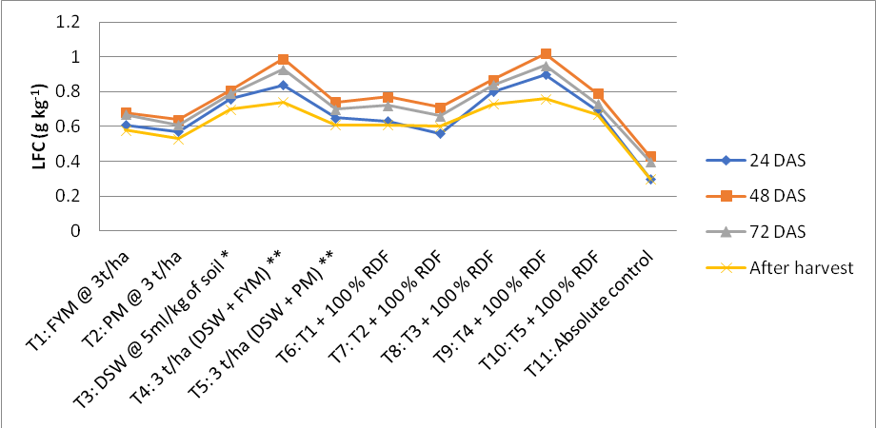
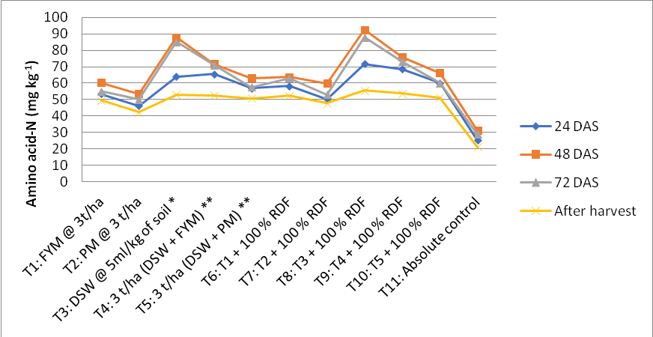

Fig. 1:Effect of FYM and distillery byproducts (spentwash and pressmud) on DOC and MBC(mg kg⁻¹)
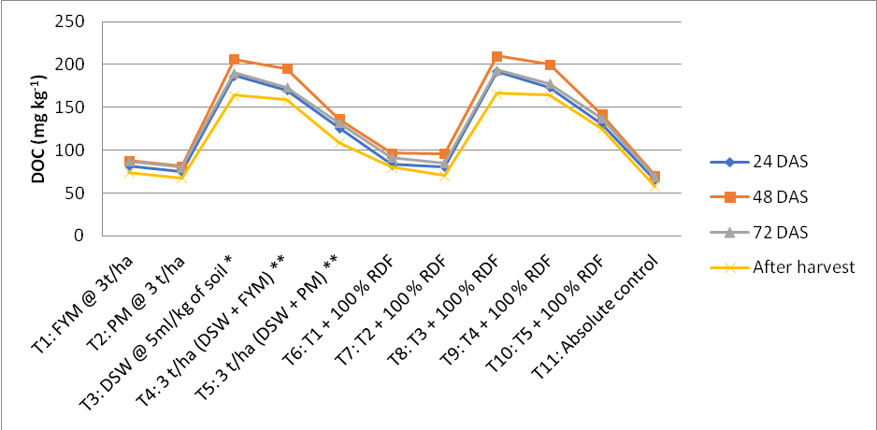
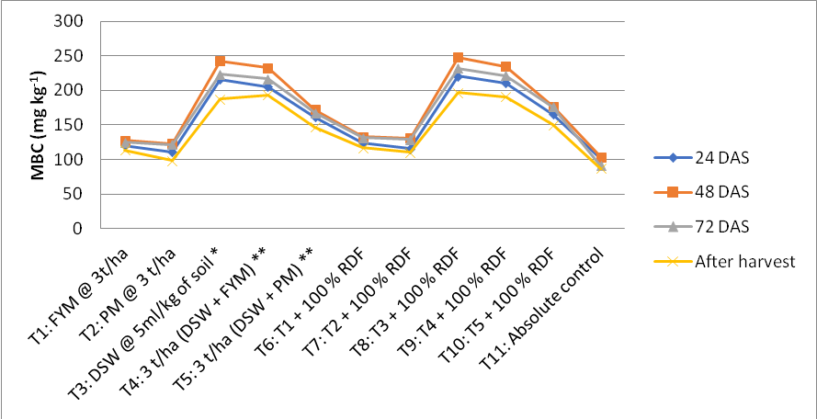
*1:10: spentwash: water dilution**1:3 ratio for mixing and curing for 25 days

*1:10: spentwash: water dilution**1:3 ratio for mixing and curing for 25 da

ys

