*Minireview Article*

No-till farming in the agroecological management approach

.

ABSTRACT

|  |
| --- |
| The intensive use of natural resources such as water and soil through conventional planting systems can cause major problems such as increased water erosion, loss of nutrients, phytosanitary problems and high production costs. Given this, it is important to adopt measures that minimize problems and increase the sustainability of production systems. Therefore, when compared to the conventional system, the use of direct planting presents numerous benefits in the long term. The direct planting system is characterized by the adoption of a set of integrated techniques with less soil disturbance, crop rotation and the maintenance of plant residues to form straw on the soil surface, with the aim of maintaining or improving the characteristics physical, chemical and biological. |

*Keywords: Sustainability; environmental quality; soil protection, phytosanitary*

1. INTRODUCTION

The form of soil management is one of the most important stages for the management of any crop of economic interest, since the physical, chemical and biological properties present in the soil are closely related to the productive potential of the cultivars [1].

Production systems where there is intensive use of soil and water have been generating enormous problems such as increased water erosion, loss of nutrients, phytosanitary problems and high production costs [2]. The conventional tillage system, due to the excessive turning and clearing of the soil generated by agricultural practices, causes soil pulverization and consequently degradation of physical, chemical and biological characteristics [3].

In this way, seeking management systems that reduce soil losses and that generate favor in the availability of water for plants, the no-tillage system allows the farmer to obtain greater stability of soil structures, which, together with the maintenance of crop residues present on the soil surface, provide greater protection against the impacts generated by raindrops. allowing greater infiltration and reduction of the decrease in water content lost by surface runoff. Therefore, in this cultivation system, the significant decrease in erosion is notorious, directly implying the improvement of the physical, chemical and biological conditions of the soil, which will have consequences on its fertility [4]. When compared to the conventional system, no-till generates numerous long-term benefits such as reduced soil erosion, increased organic carbon content, greater soil infiltration capacity, increased biological activity and reduced evaporation [5].

In this context, the adoption of no-till farming is a way of managing soil, water and crops in a conservationist way that has been associated with the processes of agronomic evolution, recognized as an example for cultivation in tropical and subtropical countries, becoming the most appropriate path for competitiveness, sustainability, equity and environmental quality of production systems [6] [7].

2. NO-TILL FARMING WITH A FOCUS ON AGROECOLOGICAL MANAGEMENT

Soil conservation management in agriculture consists of the use of practices that aim to preserve, maintain and/or recover natural resources, through the integrated management of soil, water and biodiversity without the use of external inputs. The implementation of this type of management requires the interaction between human beings and the elements of the biosphere, aiming at not only economic, but also social and environmental benefits, both for the current generation and for future generations. [8]. In view of this, the concept of no-till farming aims at maximum biodiversity, photosynthetic activity, active roots and soil cover, in order to economically generate diversified products and improve environmental quality, thus, the no-till system is fundamental for the achievement of conservation agriculture, an important factor for the transformation of agricultural activity closer to the natural ecosystem. [9].

The no-tillage system encompasses a set of integrated techniques with less soil turnover, crop rotation and the maintenance of plant residues for the formation of straw on the soil surface, with the objective of maintaining or improving physical, chemical and biological characteristics. Agroecological no-tillage combines no-till agricultural techniques with agroecological practices, in this system, unlike conventional no-tillage, no mechanization is used, nor chemical fertilizers and herbicides, thus, through agroecological concepts, no-till is carried out with natural resources, making use of leguminous species as organic fertilizer for the soils [10].

According to Lopes [10], the rural producer must follow the following steps to implement the agroecological no-tillage system:

1. The area to be used for the agroecological no-tillage system should be doubled, in one of the areas the crops of economic interest will be planted. In the second area, the species used for the formation of straw, such as legumes, should be planted.
2. After establishment, the legumes are ready to be managed, so the plants must be clear-cut so that straw is formed.
3. Crops of economic interest should be planted directly on straw, in the case of crops propagated via seed, sowing can be a great challenge, especially when the amount of straw present in the soil is high, so it is essential that the seeds have proper contact with the soil and not between the seed and the straw (Figure 1).
4. New legume plantations should be carried out for the formation of straw via rotation of areas and crops.

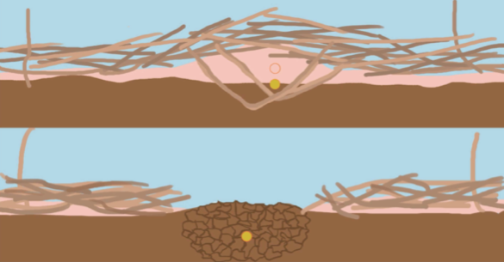

**Figure 1.** Adequate process of positioning the seed in the soil in a system with the presence of straw (bottom image) and seed without adequate contact with soil (top image).

**Source:** Passo et al. [11].

One of the main objectives associated with no-till farming is to protect soils against the direct impact of raindrops achieved through mulch on the soil surface [12]. In soils where there is an absence of vegetation cover, whether alive or dead, there is an increase in susceptibility to erosion, in these conditions there is the phenomenon of splashing generated by the kinetic energy of raindrops and the dragging of soil particles by water from rainfall or even by irrigation (Figure 2) [11]. In addition, the no-tillage and agroecological system causes great improvement in soil fertility, keeping the soil moist due to straw cover, decreases the proliferation of invasive plants, reduces environmental degradation by combating deforestation and fires, reduces labor costs because chemical fertilizers are not used, nor agricultural mechanization, in addition, this system provides greater productive yield, generating greater profit and improving the quality of life for family farmers [10].

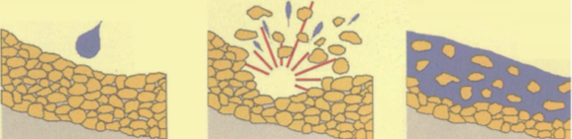

**Figure 2.** Effects of raindrop on bare soil generating water erosion.

**Source:** Passo et al. [11].

This improvement in soil conditions is notoriously observed by several authors. In vegetables, as demonstrated by Melo et al. [2], the adoption of no-tillage reduces soil loss by up to 70% and reduces the rate of water loss by 90% when compared to the conventional tillage system. In conditions of high temperatures, there are production losses and a reduction in the commercial quality of vegetables, however, the straw that accumulates on the soil in the no-tillage system has an insulating effect, reducing the temperature and improving the microclimate, favoring the development of these crops (Figure 3).

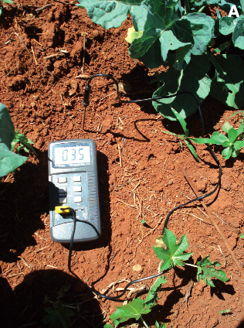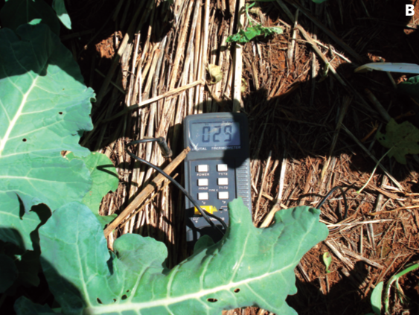

**Figure 3.** Soil temperature at a depth of 5 cm in conventional tillage (A), during the leaf development and expansion phase, compared to the no-tillage system (B).

**Source:** Melo et al. [2].

Another improvement associated with the no-tillage system of vegetables is the ability of the soil to infiltrate. In conventional systems there is greater soil compaction, where, after a period of rain, puddles of water are formed for a long period of time on the soil surface, which results in root deformation and limitation of crop productivity. This compaction can be mitigated through no-till such as the management of plants with deep root systems, in addition, it prevents the loss of surface runoff soil (Figure 4).

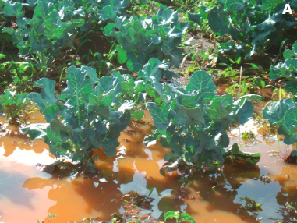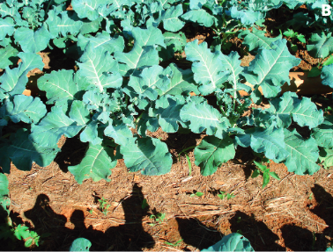

**Figure 4.** Accumulation of water after rainfall on the soil surface in conventional broccoli cultivation (A), compared to no-tillage system (B).

**Source:** Melo et al. [2]

According to Lopes and Alves [13], in the Brazilian Amazon, in the state of Pará, the main system of agriculture employed is mowing, with practices of preparing the area through the felling of the forest or capoeira and subsequent burning (Figure 5.). In this system, the nutrients present in the ashes resulting from the fires are incorporated into the soil, with rapid availability of nutrients for the plants and increased productivity in the first year, however, from the second year onwards there is a drop in production due to the loss of soil fertility due to the loss of nutrients removed by harvesting, leaching and erosion. As a consequence, these areas are abandoned, making the region's agricultural production insufficient, in addition to this practice being aggressive to the environment. In this context, as a more sustainable alternative for family farming, soil management based on the use of herbaceous and shrubby legumes as perennial soil cover and as mulch in the no-tillage system contributes to the reduction of production costs such as labor savings, weed control, recovery of degraded areas and maintenance of fertility through the addition of organic matter to the soil through production of biomass.

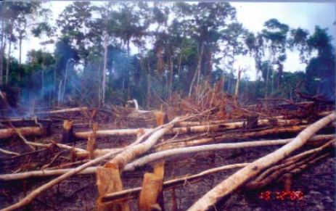

**Figure 5.** Traditional area preparation system for felling and burning and mowing.

**Source:** Lopes and Alves [13].

The positive effects of straw formation by the clear-cutting pigeon pea (*Cajanus cajan*) (Figure 6) on no-tillage of common bean (*Phaseolus vulgaris*) for family farming are notorious, and have been scientifically proven (Figure 7), with a yield of 1,399 kg/ha in soil fertilized with 150 kg/ha of the NPK 10-28-20 formula and 873 kg/ha in soil without fertilizer use. For comparison, in a conventional system, 664 kg/ha was obtained in soil that was fertilized with 150 kg/ha of the NPK 10-28-20 formula and 352 kg/ha in non-fertilized soil. Thus, the results show the beneficial effects of pigeon pea straw on the soil, through the positive response in terms of increasing the productivity of common bean of 110% in relation to the control in fertilized soil and 148% in relation to the control without fertilization. According to the authors, it is believed that these results were due to the transformation of the soil, especially in relation to the organic matter resulting from the decomposition of pigeon pea straw that reduced compaction, recomposing the structure, permeability, aeration and retention of water and nutrients.

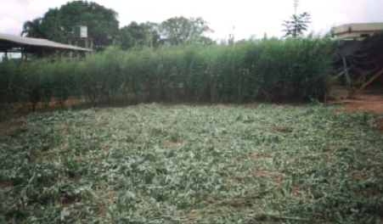

**Figure 6.** Clear-cutting of pigeon pea legumes and straw formation.

**Source:** Lopes and Alves [13].

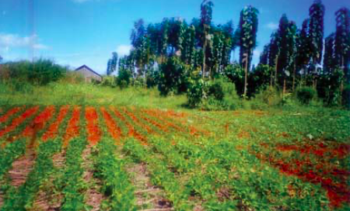

**Figure 7.** Planting of beans in pigeon pea straw (1st plan) and planting in the traditional system, in the background.

**Source:** Lopes and Alves [13].

As a demonstration of the effect of pigeon pea on the soil, samples were taken in the 0 to 20 cm layer only under conditions without chemical fertilization and compared with the control (Table 1). Note that the results show a significant improvement in the chemical characteristics of the soil in the no-tillage system under pigeon pea straw, where only the pH and base saturation (V) did not increase in relation to the conventional system (control).

**Table 1.** Result of soil analysis at a depth of 0-20 cm of structured purple soil under Phaseolus bean no-tillage system on legume straw

|  |  |  |  |  |  |  |  |
| --- | --- | --- | --- | --- | --- | --- | --- |
|  |  | **SAMPLE** | | | |  |  |
|  |  | **I** | **II** | **III** | **IV** | **Average** | **Witness** |
| **ph** | Water | 4.8 | 5.1 | 5.0 | 5.0 | 5.0 | 5.4 |
| **C.O.** | g/dm3 | 18.4 | 24.3 | 18.7 | 19.9 | 20.3 | 11.2 |
| **M.O.** | 31.6 | 41.7 | 32.2 | 34.3 | 35.0 | 19.3 |
| **P** | Mg/dm3 | 1.0 | 1.0 | 1.0 | 2.0 | 1.2 | 1.0 |
| **K** | 139.0 | 127.0 | 65.0 | 108.0 | 109.7 | 67.0 |
| **Ca** | mmolc/d3 | 24.0 | 30.0 | 32.0 | 32.0 | 29.5 | 24.0 |
| **Ca+mg** | 31.0 | 36.0 | 40.0 | 41.0 | 37.0 | 32.0 |
| **AL** | 0.0 | 0.0 | 1.0 | 1.0 | 0.5 | 0.0 |
| **H + Al** | 59.0 | 53.0 | 54.0 | 54.0 | 55.0 | 43.0 |
| **SB** | 36.0 | 40.0 | 43.0 | 45.0 | 41.0 | 35.0 |
| **T** | 95.0 | 93.0 | 97.0 | 99.0 | 96.0 | 78.8 |
| **V** | % | 38.0 | 43.0 | 44.0 | 45.0 | 42.5 | 45.0 |

C.O. = Organic carbon; M.O. = organic matter; P = phosphorus; K = potassium; Ca = calcium; Mg = magnesium; SB = sum of bases; T = CTC and V = base saturation.

**Source:** Lopes and Alves [13].

In the search for sustainability and improvement of corn production in the agricultural system in soils with low fertility, Aguiar [14] studied no-tillage on the combination of legume straw. For this experiment, two species of legumes with high residue quality - *Leucaena leucocephala* (leucaena) and *Cajanus cajan* (pigeon pea), and two species with low residue quality - *Clitoria fairchildiana* (sombrero) and *Acacia mangium* (acacia), combined with each other, in the following treatments: Sombrero + Pigeon pea (S+G); Leucaena + Pigeon Pea (L+G); Acacia + pigeon pea (A+G); Sombrero + Leucaena (S+L); Leucaena + Acacia (L+A) and Control, without the use of legumes.

There was a gradual increase in the mass of the ears (Table 2) and in the mass of 1000 grains (Table 3), which resulted in a significant increase in grain yield (Table 4) in the last year of evaluation. According to the authors, this improvement in productivity is associated with three factors: greater aeration capacity; greater quantity, better use of nitrogen incorporated by the use of legumes; and improved distribution and maintenance of the root system. All these factors are related to the physical benefits of no-tillage on soil density, total porosity and aeration capacity in the fourth year, as shown in Table 5.

**Table 2.** Ear mass (g) of corn long for four years under no-tillage with legume straw and control, without the use of legumes.

|  |  |  |  |  |
| --- | --- | --- | --- | --- |
| **Treatments** | **Year** | | | |
| **Ear mass, g** | | | | |
|  | 2003 | 2004 | 2005 | 2006 |
| **Sombrero + Pigeon Pea** | 39ns | 26ns | 96ns | 115a |
| **Leucaena + Pigeon Pea** | 40ns | 33ns | 90ns | 121a |
| **Acacia + Pigeon Pea** | 44ns | 46ns | 90ns | 120a |
| **Sombrero + Leucaena** | 43ns | 36ns | 110ns | 124a |
| **Leucaena + Acacia** | 32ns | 41ns | 89ns | 110a |
| **Witness** | 57ns | 32ns | 72ns | 68b |

ns = not significant. Different letters in the same column indicate a significant difference at the 5% level by the Tukey test.

**Source:** Aguiar [14].

**Table 3.** Mass of 1000 grains (g) of corn over four years on no-tillage with legume straw and control, without the use of legumes.

|  |  |  |  |  |
| --- | --- | --- | --- | --- |
| **Treatments** | Year | | | |
| **Dough of 1000 grains, g** | | | | |
|  | 2003 | 2004 | 2005 | 2006 |
| **Sombrero + Pigeon Pea** | 200ns | 242ns | 288ns | 258ab |
| **Leucaena + Pigeon Pea** | 200ns | 238ns | 322ns | 312a |
| **Acacia + Pigeon Pea** | 194ns | 266ns | 314ns | 295a |
| **Sombrero + Leucaena** | 198ns | 249ns | 317ns | 310a |
| **Leucaena + Acacia** | 201ns | 254ns | 281ns | 290a |
| **Witness** | 220ns | 217ns | 273ns | 208b |

ns = not significant. Different letters in the same column indicate a significant difference at the 5% level by the Tukey test.

**Source:** Aguiar [14].

**Table 4.** Grain yield (Mg ha-1) of corn over four years under no-tillage with legume straw and control, without the use of legumes.

|  |  |  |  |  |
| --- | --- | --- | --- | --- |
| **Treatments** | Year | | | |
| **Grain yield, Mg ha-1** | | | | |
|  | 2003 | 2004 | 2005 | 2006 |
| **Sombrero + Pigeon Pea** | 1.08ns | 1.77ns | 2.88ns | 3.00a |
| **Leucaena + Pigeon Pea** | 1.28ns | 1.72ns | 2.71ns | 3.75a |
| **Acacia + Pigeon Pea** | 1.39ns | 2.20ns | 2.69ns | 3.50a |
| **Sombrero + Leucaena** | 1.37ns | 2.00ns | 3.33ns | 3.80a |
| **Leucaena + Acacia** | 0.94ns | 2.58ns | 2.66ns | 3.20a |
| **Witness** | 1.72ns | 1.54ns | 1.84ns | 1.50b |

ns = not significant. Different letters in the same column indicate a significant difference at the 5% level by the Tukey test.

**Source:** Aguiar [14].

**Table 5.** Effect of treatments on soil density, aeration capacity and total porosity in 2006.

|  |  |  |  |
| --- | --- | --- | --- |
| Treatments | Soil density | Aeration Capacity | Full porosity |
|  | Mg m-3 | m3 m-3 | |
| **Sombrero + Pigeon Pea** | 1.30a | 0.16a | 0.50a |
| **Leucaena + Pigeon Pea** | 1.32a | 0.17a | 0.50a |
| **Acacia + Pigeon Pea** | 1.30a | 0.16a | 0.50a |
| **Sombrero + Leucaena** | 1.32a | 0.16a | 0.48a |
| **Leucaena + Acacia** | 1.32a | 0.16a | 0.49a |
| **Witness** | 1.40a | 0,10b | 0.46b |

Different letters in the same column indicate a significant difference at the 5% level by the Tukey test.

**Source:** Aguiar [14].

4. Conclusion

Regarding the agroecological no-till system, we must take into account the following factors:

* There is a reduction in production costs, with lower expenses with labor and inputs, since agricultural mechanization, fertilizers and agrochemicals are not used;
* Soil fertility conditions are improved by increasing dead and living organic matter;
* Improvement in soil physical conditions, due to better structuring of soil aggregates;
* Greater diversification of the production system, with less risk of loss of agricultural activity;
* Increased nutrient cycling and recycling;
* Decrease in the proliferation of invasive plants;
* Combats deforestation, reducing the felling and burning of plant matter, resulting in less degradation of the environment;
* Increased productivity, generating higher income and better quality of life for family farmers.

Disclaimer (Artificial intelligence)

Author(s) hereby declare that NO generative AI technologies such as Large Language Models (ChatGPT, COPILOT, etc.) and text-to-image generators have been used during the writing or editing of this manuscript.

References

1. Franchini JC, Torres E, Gonçalves SL, Saraiva OF. Contribution of soil management systems to sustainable soybean production. Technical Circular. Embrapa. 2007.

2. Melo RAC, Madeira NR, Lima CEP. Production of brassicas in a no-tillage system. Brasília, DF: Embrapa, Technical Circular. 2016.

3. Loss A, Basso A, Oliveira BS, Koucher LP, Oliveira RA, Kurtz C, Lovato PE, Curmi P, Brunetto G. Total organic carbon and soil aggregation in agroecological and conventional no-tillage onion systems. Rev. Bras. Soil Science. 2015; 39: 1212-1224.

4. Carvalho MAC, Athayde MLF, Soratto RP. et al. Green manure and soil management systems on cotton productivity. Brazilian Agricultural Research, Brasília. 2004; 39: 1205-1211.

5. Kladivko EJ. Tillage systems and soil ecology. Soil and Tillage Research, Amsterdam. 2001; 61: 61-76.

6. Freitas PL. Harmony with Nature. Agroanalysis, Rio de Janeiro. 2002; 22: 12-17.

7. Hernani LC, Freitas PL, Denardin JE, Kochhann RA, Maria IC, Landers JN. A conservationist response: the impact of the no-tillage system. In: Manzatto CV, Freitas Junior E, Peres JRR. Agricultural use of Brazilian soils. Rio de Janeiro: Embrapa Solos. 2002. 174 p.

8. Denardin JE, Kochhann RA, Faganello A, Santi A, Denardin ND, Wiethölter S. Guidelines for the no-tillage system in the context of conservation agriculture. Passo Fundo: Embrapa Trigo. 2012. 15 p.

9. Hernani LC, Martins AL. Conservation agriculture and the no-tillage system. Embrapa Soils. 2018.

10. Lopes OMN. Agroecological no-tillage system. Folders. Belém: Embrapa Amazônia Oriental, 2011.

11. Passos AMA, Alvarenga RC, Santos FC. No-tillage System. In: Nobre MM, Oliveira IR. Low-carbon agriculture: technologies and implementation strategies. Brasília, DF: Embrapa. 2018. 194 p.

12. Volk LBS, Cogo NP, Streck EV. Water erosion influenced by soil surface and subsurface physical conditions resulting from soil management in the absence of vegetation cover. Brazilian Journal of Soil Science. 2004; 28: 585- 596.

13. Lopes OMN, Alves RNB. Green manure and direct planting: alternatives for agroecological management for sustainable family farming. Belém: Embrapa Amazônia Oriental. 2005. 34 p.

14. Aguiar ACF. Sustainability of the direct planting system in argisol in the humid tropics. Thesis (doctorate) – São Paulo State University, School of Sciences and Agronomy, Botucatu. 2006, 55 p.

15. Cordeau S. Conservation agriculture and agroecological weed management. Agronomy. 2022 Mar 31;12(4):867.

16. Makowski TJ, Sofranko AJ, Van Es JC. Agroecological and policy influences on no‐till adoption. Society & Natural Resources. 1990 Oct 1;3(4):361-71.

17. Somasundaram J, Sinha NK, Dalal RC, Lal R, Mohanty M, Naorem AK, Hati KM, Chaudhary RS, Biswas AK, Patra AK, Chaudhari SK. No-till farming and conservation agriculture in South Asia–issues, challenges, prospects and benefits. Critical Reviews in Plant Sciences. 2020 May 3;39(3):236-79.

18. Nunes MR, van Es HM, Schindelbeck R, Ristow AJ, Ryan M. No-till and cropping system diversification improve soil health and crop yield. Geoderma. 2018 Oct 15;328:30-43.

19. Ouédraogo E, Stroosnijder L, Mando A, Brussaard L, Zougmoré R. Agroecological analysis and economic benefit of organic resources and fertiliser in till and no-till sorghum production after a 6-year fallow in semi-arid West Africa. Nutrient Cycling in Agroecosystems. 2007 Mar;77:245-56.

20. Kumar V, Mahajan G, Dahiya S, Chauhan BS. Challenges and opportunities for weed management in no-till farming systems. No-till Farming Systems for Sustainable Agriculture: Challenges and Opportunities. 2020:107-25.