**Efficacy of Quarrying Activities and Heavy Metals on Nutritional Composition of Water Leaf (*Talinum triangulare* L.)**

**Abstract**

Environmental pollution stands as a significant threat to humanity and it is recognized as a principal cause of diseases and fatalities due to exposure to hazardous substances from both natural and human-induced origins. This research aimed to assess the efficacy of quarrying activities on the nutritional composition, essential characteristics, and heavy metal concentrations in waterleaf (*Talinum triangulare* L.). Waterleaf plant samples were collected from quarrying sites and non-quarrying control sites for comparative analysis. The findings highlighted substantial alterations in the nutritional and elemental makeup of *T. triangulare* sourced from the quarrying site, compared to those from the control site. Notably, the waterleaf from the quarry exhibited a significant (p<0.05) increase in tannin, saponin, carbohydrate, and fibre, as well as concentrations of essential minerals including K+, Mg2+, Ca2+, Fe2+, and Cu2+. However, both manganese (Mn2+) and chromium (Cr2+) levels were undetectable at both sites. Moreover, the chlorophyll content in samples from the quarrying site was significantly reduced (p<0.05). In light of these results, it is inferred that quarrying activities have the potential to enhance the presence of certain minerals and phytochemical compounds in *T. triangulare* grown within the proximity of quarrying environments.

Keywords: Waterleaf (*Talinum triangulare* L.), quarrying activities, proximate analysis, heavy metal content, minerals.

**Introduction**

Exploring and using rocks from the earth's crust is known as quarrying (Keeperman, 2000). According to Nwachukwu *et al*. (2018), it is a land-use technique that involves taking non-fuel and non-metal minerals out of rocks. It is the utilization of different lithologic resources that nature has provided to man. It is a location where ground excavation has produced dimension stones, rocks, building materials, riprap, sand, gravel, or slate (Nartey *et al*., 2012). Sandstones, limestone, perlite, marble, ironstone, slate, granite, rock salt, and phosphate rock are among the end products of quarrying activities. These goods are used as building blocks for rail, road, and other types of industrial and civil construction. Additionally, some of these chemicals are used to create ceramic tiles and Hard floors that are conventional (Lameed and Ayodele, 2010).

Even though stone crushing and quarrying operations have many advantages, they also have destructive activities whose socioeconomic gains may not be sufficient to offset their overall negative impacts on the environment. For example, the industries of quarrying and stone crushing have a strong link to pollution. 2014 Ali and associates. especially in developing nations like Nigeria, where people routinely violate mining laws.

The quarrying process releases dusts into the air that contain various heavy metals and toxicants, which are frequently deposited on the surface of plant leaves. Due to their static nature, plants can't escape a harsh environment, hence they appear to be essential in keeping a check on environmental contamination. They can only adapt to challenging situations, which may result in them producing or not producing sufficient biochemical substances, such as plant antioxidants, to minimize the detrimental impacts of pollution. (Rai, 2016).

An edible leafy vegetable from the *Portulaceae* family is called *T. triangulare*. It is a perennial herbaceous plant that is erect, glabrous, and has purple flowers as well as succulent stems and leaves and bulging, meaty roots (Nya and Eka, 2015).

These meals contain vitamins, essential amino acids, minerals, and antioxidants (Fasuyi, 2006). According to a study on *Talinum triangulare's* nutritional value, the leaves of the plant contain beta-carotene, vitamins, potassium, calcium, magnesium, iron, ash, lipids, amino acids, moisture, crude fiber, ascorbic acid, pectin, and various other nutrients (Mensah *et al*., 2008). The effects of quarrying or stone-crushing operations on plants have been researched. *Talinum triangulare*, however, has not yet been the subject of any recorded publications. The high concentration of tannins, alkaloids, saponins, and flavonoids in waterleaf points to its potential health advantages. The leaves show a reasonable amount of bioactive chemicals, which are necessary for both preventing and treating various diseases such as liver disease, hepatic ailment, (Liang *et al.,* 2011), regulation of blood sugar, cerebral function and digestion (Ofusori *et al.,* 2008; Aja *et al.*, 2010). This study, evaluates the impact of quarrying activities on the plant nutritional composition and heavy metal indices of *Talinum triangulare.*

**Materials and Methods**.

Study Area

This study was carried out at a quarry site in Supare Akoko, Akoko South West, Ondo State Nigeria, located at Latitude 7048'N and Longitude 5075'E, while the control site was at the Adekunle Ajasin University Akungba (AAUA) research farm in Akungba-Akoko, Akoko South West, Ondo State Nigeria, located at Latitude 7023'N and Longitude 5000'E. Comparative studies were done between the water leaves samples taken from the quarry site and those from non-quarry sites.

**Identification and collection of plant samples:**

*Talinum triangulare*, which was located 500 meters distant from the quarry site, was identified and gathered from the research area and the control site. *T. triangulare* fresh samples were randomly chosen in triplicate from the quarry site and the control site. *T. triangulare* became a choice of the project sample because of its well-researched, acceptability, therapeutics, and it’s medicinal characteristicsin that environments(Macfoy and Cline, 1990).

**Sample preparation**:

*Talinum triangulare* was freshly collected, cleaned, and then partition into leaves, stems, and roots before being air-dried individually for eight days at room temperature. To stop the plant from absorbing additional moisture, dried samples of the plant's leaves, stems, and roots were crushed and put in polythene bags with labels. The plant samples were kept in a refrigerator at 4oC after which it was analyzed.

**Phytochemical analysis**:

Using the methods outlined by Parekh and Chanda (2007), Obute (2007), and Stephen (1970), alkaloids, tannin, and saponins in leaves, stems, and roots were determined. The leaves/plant parts were washed under running tap water and dried in an oven at 700C for 24 hours. With the aid of mortar, pestle, miller, and grinder, these plant parts were homogenized to fine powder and stored in airtight bottles or containers for phytochemical analysis. One gram of powder was subjected to qualitative phytochemical tests for alkaloids (Myers Reagent), saponins (chloroform and H2SO4 tests), and tannins (Ferric salt tests).

**Proximate analysis**

Proximate analysis was carried out using the method given by (Onwuka, 2005) to measure the proximate composition (moisture content, crude fiber, crude protein, fat, and total ash) of the leaves, stem, and roots of *T.* Total ash content in the sample was determined by ignition in muffle furnace at 550˚C for 6 h. The total protein in the sample was determined by using Biuret method. The crude fat was determined using the Soxhlet extractor and the solvents used were chloroform and methanol. Crude fiber was estimated in the samples by following acid and alkali treatment methods.

**Assessment of mineral and heavy metal composition of *T. triangulare***

Mineral composition of the leaves, stems and roots of *T. triangulare* comprising of Potassium (K+), Magnesium (Mg2+), calcium (Ca2 +), iron (Fe 2+), copper (Cu2 +), lead (Pb2+) cadmium (Cd2+) manganese (Mn2+) and chromium (Cr2+) were determined using Atomic Absorption Spectrophotometry (AAS) model 210/211 VGP Buck scientific.

**Determination of chlorophyll content**

The method developed by (Mackinney, 1941) was used to measure the amount of chlorophyll. From each sample, the top two leaves of the water leaf plant were used. Fresh plant samples weighing one gram were chopped into pieces and pounded in a mortar, after which the samples were placed in a test tube, and the chlorophyll were continuously extracted using increasing volumes of 100 ml acetone/water (80 20 v/v) until no traces of green colour were visible (residue turned white). The total volume of the extract was recorded at the end of the extraction. Three millimeters (3ml) of the extract were taken and the absorbance were determined with a spectrophotometer (Spectronic 20) at two wavelengths of 663nm and 645nm that corresponds to maximum assumption of chlorophyll ‘a’ and ‘b’ respectively.

**Statistical analysis**

The result obtained from this study were subjected to one-way Analysis of variance (ANOVA) at p<0.05 and significance means were separated using Tukey test.

**RESULTS**

**Mineral and heavy metal composition of *T. triangulare:***

Table 1 shows the composition of minerals in the leaf, stem and root extracts of *T. tria*n*gulare* from quarry mining and control sites, respectively. In comparison to the quarry, the leaf extract from the control site demonstrated a significant (p<0.05) decrease in P, and Ca2+ levels. Mg2+, Cu2+, Fe2+, P, and Ca2+ levels of the stem and root increased significantly (p<0.05) in control site. A very low level of Pb2+, and Cd2+ wereobservedin the leaf, root and stem extract of *T. triangulare* at the quarry and control site. However, Mn2+, and Cr2+ were not detected in the leaf, root and stem of *T. triangulare* at the control and quarry mining site*.*

**Table 1: Mineral compositions (g/100g) of *T. triangulare* from a quarry and control site**

|  |  |  |  |  |  |  |  |  |
| --- | --- | --- | --- | --- | --- | --- | --- | --- |
|  | **Leaf** |  |  | **Stem** |  |  | **root** |  |
| Parameters | Control site | Quarry site |  | Control site | Quarry site |  | Control site | Quarry site |
|  | | | | | | | | |
| P | 2.09a | 1.07b |  | 1.79a | 0.84b |  | 0.53a | 0.09b |
| K+ | 288.82b | 417.81a |  | 283.82a | 192.91b |  | 248.33a | 241.63b |
| Mg2+ | 29.23b | 43.04a |  | 29.23a | 19.87b |  | 25.58a | 24.89b |
| Ca2 + | 109.63b | 161.38a |  | 109.63a | 74.92b |  | 95.92a | 93.33b |
| Fe 2+ | 661.44b | 973.09a |  | 661.44a | 449.62b |  | 578.74a | 563.11b |
| Cu2 + | 92.58b | 136.20a |  | 92.58a | 62.93b |  | 81.00a | 78.81b |

Table 2: Heavy metal Compositions (ppm) of *T. triangulare* from a quarry site and control site.

|  |  |  |  |  |  |  |
| --- | --- | --- | --- | --- | --- | --- |
| Parameter | **Leaf** |  | **Stem** |  | **Root** | |
|  | Control site | Quarry site | Control site | Quarry site | Control site | Quarry site |
|  | | | | | | |
| Pb2+ | 0.01a | 0.02a | 0.00a | 0.01a | 0.01a | 0.01a |
| Cd2+ | 0.01a | 0.01a | 0.00a | 0.01a | 0.01a | 0.01a |
| Mn2+ | BDL | BDL | BDL | BDL | BDL | BDL |
| Cr2+ | BDL | BDL | BDL | BDL | BDL | BDL |

**Phytochemical and proximate composition of T*. triangulare***

The leaf and stem obtained from the quarry and the control location were displayed in Figs.1a-b to demonstrate the proximate composition of T*. triangulare.* The stem extract from the quarry was found to have significantly (P<0.05) higher crude protein and carbohydrate contents than the control site (Fig. 1a). While the lipid fat level was not affected. In contrast, the control site's leaf extract had considerably (P<0.05) higher moisture, lipid protein, ash, and carbohydrate contents than the quarry site (Fig. 1b).

The alkaloid and saponin production were significantly higher in the leaf and stem of the plant collected from the control compared to the quarry site while tannin was higher in the quarry site. (Fig.3a-b). The saponin and tannin demonstrated a significant increase (p<0.05) in the root of the plant (Fig.3c). Whereas, the alkaloid was produced at a significant concentration in the root.

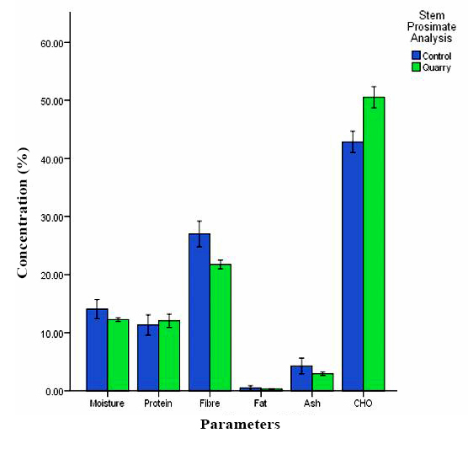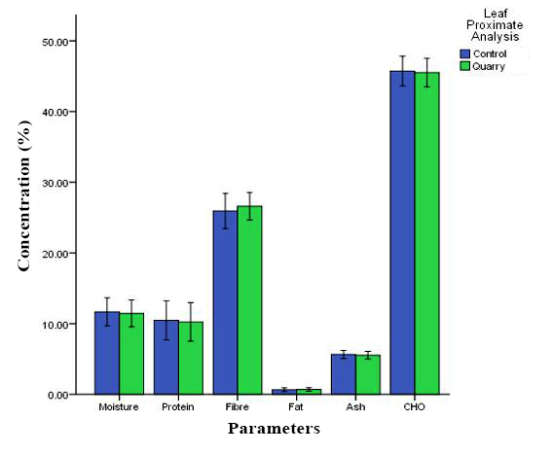

Fig. 1(a-b): Proximate composition of (a) Stem and (b) Leaf extract of T. triangulare from a control and quarry mining site expressed in percentage

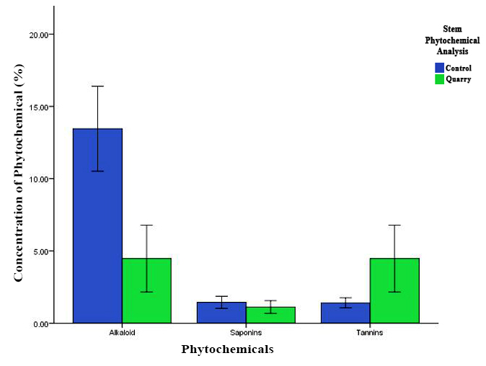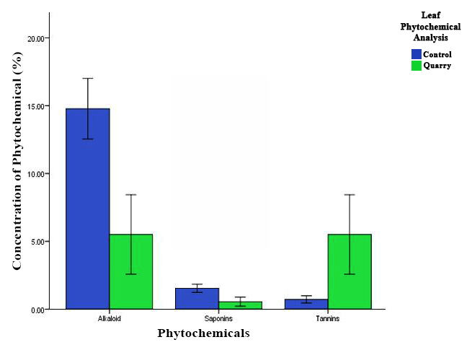

(c)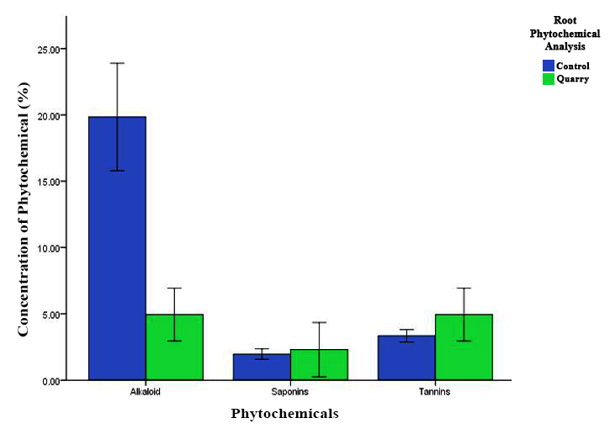

Fig. 2(a-c): Phytochemical analysis of (a) Leaf, (b) Stem and (c) Root extract of T*. triangulare* from a control and quarry mining site expressed in percentage.

**Figure 3**: shows the amount of chlorophyll in the T*. triangulare* leaf that was collected from the quarry mining and the control site. It was observed that the quarry samples were highly significant (P <0.05) when compared to the control location.

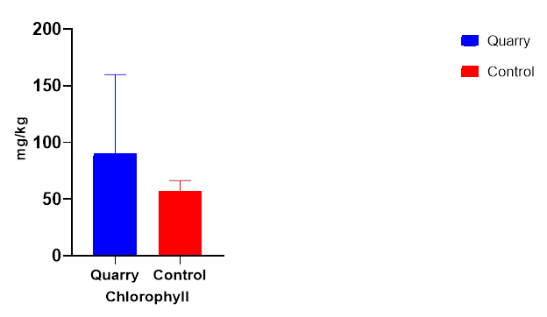

Fig. 3: Leaf chlorophyll content.

**Discussion**

Human activities such as quarrying and stone crushing pose significant threats to both plant biodiversity and overall ecological survival. Moreover, these activities also jeopardize the safety and well-being of both human populations and wildlife.

This study delved into the impact of quarrying activities at the Supare quarry mining sites on T*. triangulare*, specifically examining heavy metal content, plant nutritional composition, and phytochemical indices.

Plant-derived minerals play a vital role in various biological processes, serving as cofactors in enzyme activities, integral components of macromolecules, and regulators of osmotic solutes essential for maintaining proper water potential. However, elevated concentrations of minerals, particularly heavy metals such as K+, Cu2+, Fe2+, and Mg2+, were observed in the leaves of plants from the quarry site compared to the control site. It is important to note that while Zn2+, Cu2+, Mg2+, and Fe2+ are recognized as essential nutrients for plants, participating in enzyme catalysis, redox reactions, and forming crucial components of proteins, including hemoglobin proteins, excessive levels of these elements have been shown by Grushak *et al*. (2001) to induce oxidative stress through the generation of reactive oxygen species (ROS), a decrease in antioxidant levels, or the denaturation of proteins. Moreover, elevated concentrations of heavy metals can disrupt various metabolic processes in plants, potentially leading to a reduction in chlorophyll content.

Concentrations of phosphorus (P) in T. *triangulare* leaves, stems, and roots collected from the control site were significantly higher compared to those from the quarry site. Notably, in samples obtained from the quarry site, there was a notable (p<0.05) increase in the presence of phytochemicals, particularly tannin and saponin, in the roots. This increase in phytochemical secretion could potentially signify an adaptation to the changing environmental conditions.

Furthermore, this investigation found that the leaf extract of quarry plants contained a higher concentration of carbohydrates compared to control plants. This observation aligns with previous research indicating that industrial pollution-induced changes in carbohydrate concentration, as demonstrated in *Callistemon* *citrinus* by Seyyednejad *et al.* (2009). Additionally, alterations in protein content have been established as a valuable indicator for assessing environmental pollution (Tripathi and Guatam, 2007). It's worth noting that the levels of ash, fiber, and moisture in the plant samples were not significantly affected by quarry activities, as depicted in Figure 1.

This study suggests that quarry mining operations may stimulate the production of phytochemicals in the roots of T*. triangulare*. Furthermore, it highlights the sensitivity of T*. triangulare's* roots, making them a potential tool for assessing environmental pollution resulting from quarry mining activities. Future research should focus on investigating the dosage requirements and in vivo effects of T*. triangulare* specifically identified in quarry mining sites.

**Conclusion and Recommendation**

In summary, this study highlights quarry mining as a prominent source of environmental contamination in Africa, with a specific focus on its impact in Nigeria. The detrimental effects of quarry mining on plant life have been clearly demonstrated, underscoring the potential of plants as valuable indicators of human-induced environmental damage. Our investigation revealed a significant reduction in phosphorus absorption due to quarry mining. Moreover, noticeable changes in phytochemical levels, chlorophyll content, and carbohydrate levels were observed as well. Based on these findings, we strongly recommend implementing measures to curtail the adverse effects of quarry mining. A key suggestion is the implementation of controlled blasting practices to mitigate risks that pose threats to both the local plant ecosystem and human inhabitants. These proactive measures will not only help safeguard the environment but also enhance the overall well-being of the affected communities

**References**

Aja, P. M., Okaka, A. N. C., Onu, P. N., Ibiam, U. and Urako, A. J. (2010). Phytochemical Composition of *Talinum triangulare*(Water Leaf) leaves. *Pakistan Journal of Nutrition,* **9(6):** 527-530.

Ali, S. H. (2014). Social and Environmental Impact of the Rare Earth Industries. *Resources*. **3**: 123 – 134.

Nartey, V. K., Nanor, J. N., and Klake, R. K. (2012). Effects of Quarry Activities on Some Selected Communities in the Lower Manya Krobo District of the Eastern Region of Ghana. *Atmospheric and Climate Sciences*, **2**: 362 – 372.

AOAC. (1970). Official Methods of Analysis. 11th Edn., Association of Official Analytical Chemists, Washington, DC.

Fasuyi, A. O. (2006). Nutritional Potentials of Some Tropical Vegetables Leaf Meals: Chemical characterization and functional properties. *African Journal of Biotechnology*, **5(1)**: 49 – 53.

Grusak, M. A., M. R. Broadley and White, P. J. (2001). Plant Macro- and Micronutrient Minerals. In:

eLS, John Wiley & Sons Ltd., Chichester, UK. <https://onlinelibrary.wiley.com/doi/>

abs/10.1002/9780470015902.a0001306.pub2

Keeperman, S. O. (2000). Distribution and Forms of Copper, Zinc, Cadmium, Iron and Manganese in Soils Near a Copper Smelter. *Journal of Soil Science*, **135(2)**: 101 – 109.

Lameed, G. A. and Ayodele, A. E. (2010). Effect of Quarry Activities on Biodiversity: A case study of Ogbere, Ogun State Nigeria. *African Journal of Environmental Science and Technology*, **4**: 740 – 750.

Liang, D., Zhou, Q., Gong, W., Wang, Y., Nie, Z., He, H., Li, J., Wu, J., Wu, C. and Zhang, J. (2011). Studies on the Antioxidant and Hepatoprotective Activities of Polysaccharides from *Talinum triangulare*. *Journal of Ethnopharmacology*. **136(2)**: 316–321.

Macfoy, C. A. and Cline, E. I. (1990). In Vitro Antibacterial Activities of Three Plants Used in Traditional Medicine in Sierra Leone. *Journal of Ethnopharmacology,* **28**:323-327. 18.

Mackinney, G. (1941). Absorption of Light by Chlorophyll Solutions. *Journal of Biological chemistry*. **104**: 312 – 315.

Mensah, J., Okoli, R. I., Ohaju-Obodo, J. O. and Eifediyi, K. (2008). Phytochemical, Nutritional and Medical Properties of Some Leafy Vegetables Consumed by Edo People. *Journal of Biotechnology*, **7**: 2304 – 2309.

Nya, E. J. and Eka, M. J. (2015). Morphological Characterization and Hybridization of *Talinum triangulare* Land Races for Desirable Metric Characters in South Eastern Nigeria. *The International Journal of Science and Technoledge*, **3(7)**: 192 – 197.

Obute, G.C. and Adubor, G.O. (2005). Chemicals Detected I Plats Used for Folk Medicine in south Easter Nigeria. Ethonotaical Leaflets, **11:** 173-194.

Onwuka, G.I. (2005). Food Analysis and Instrumentation: Theory and Practice. Naphthali Print, Lagos, 133-137

Ofusori, D. A., Adelakun, A. E., Ayoka, A. O., Oluwayinka, O. P., Omotoso, E. O., Odukoya, S. A. and Adeyemi, D. O. (2008). Waterleaf (*Talinum triangulare*) Enhances Cerebral Functions in Swiss Albino Mice. *Journal of Neurological Sciences [Turkish]* **25(4)**: 239-246

Parekh, J. and Chanda, S. (2007). In Vitro Antimicrobial Activity and Phytochemical Analysis of Some Indian Medicinal Plants. *Turkish Journal of Biology*, 31: 53-58

Rai, P. K. (2016). Impacts of Particulate Matter Pollution on Plants: Implications for environmental biomonitoring. *Ecotoxicology Environment Safari*, **129**: 120 – 136.

Seyyednejad, S. M., Niknejad, M. and Yusefi, M. (2009). The Effect of Air Pollution on Some

Morphological and Biochemical factors of *Callistemon* *citrinus* in Petrochemical Zone in South

of Iran. *Asian Journal of Plant Sciences*, **8**: 562-565.

Tripathi, A. K. and Gautam, M. (2007). Biochemical Parameters of Plants as Indicators of Air Pollution. *Journal of Environmental Biolology,* **28**: 127-132.