***Original Research Article***

**Bioinformatics of *blaTEM*-1 and *blaSHV* genes of herbal drugs pretreated-*Klebsiella pneumoniae***

**ABSTRACT**

**Background**: Oral intake of herbal medicinal products may ultimately lead to their interaction with the intestinal microbial community in which *Klebsiella pneumoniae* is a resident. **Aim**: This study investigated the effect of some herbal medicinal products consumed on beta-lactamase genes, specifically *blaSHV* and *blaTEM*, present in a key gut pathogen, *K. pneumoniae*. **Methods**: The study adopted an experimental approach with two strains of *K. pneumoniae.* Both strains were treated in four herbal medicinal products (Goko bitters, Goko alcoholic bitter, Ruzu bitters and Beta cleanser). The resistant genes, *blaSHV* and *blaTEM*, were amplified using polymerase chain reaction on both plasmid and chromosomal DNA. These genes were also sequenced, and presence of mutations were evaluated. **Results**: The PCR amplification revealed the presence of chromosomal *blaSHV* gene in four herbal drug conditions, with bands at 477 bp, including ATCC and clinical strains treated with Goko alcoholic bitters, Ruzu bitters, and control conditions. The *blaTEM* gene was detected only in the control condition of the clinical strain, marked by a band at 867 bp. Plasmid DNA analysis further confirmed the presence of *blaSHV* in clinical strains treated with Goko alcoholic bitters and Goko bitters, while *blaTEM*-1 was observed in strains treated with Goko alcoholic bitters, Goko bitters, and Ruzu bitters. Sequence alignment of the genes *blaSHV* and *blaTEM*-1 revealed various nucleotide substitutions, ranging from single nucleotide polymorphisms (SNPs) to length variations when compared to closely related beta-lactamase genes. Mutation analysis indicated that herbal treatments, particularly Goko bitters and Ruzu bitters, induced the highest mutation rates in both *blaSHV* (11%) and *blaTEM* (10%), with notable frameshift and point mutations. Conversely, non-herbal medicine-treated conditions displayed fewer or no mutations. **Conclusion**: These findings suggest that herbal medicinal products induce stress in *K. pneumoniae* through promoting the modification of antibiotic-resistant genes. It may also be responsible for the translocation of resistant genes from chromosome to plasmid and vice versa within the bacterial cell.

*Key words: Plasmid, Resistant genes, Mutation, Herbal medicine, Bioinformatics.*

**1. INTRODUCTION**

For nearly a century, beta-lactam antibiotics have been vital in fighting bacterial infections, revolutionizing how we treat these diseases. However, their widespread use has led to a surge in antibiotic resistance, a serious threat to global health (Muteeb *et al.,* 2023). This resistance makes these key medications less effective, endangering patients and straining healthcare systems. To combat this menace, we need to better understand how resistance to this class of antibiotics develops and spreads, particularly focusing on beta-lactamases, the enzymes that deactivate these antibiotics (Salam *et al.,* 2023).

Since beta-lactams were first introduced, bacteria, especially those in the gut, have evolved significantly, becoming incredibly numerous and diverse (Bush and Jacoby, 2010). This constant evolutionary struggle between antibiotics and bacteria has resulted in many resistance mechanisms, with beta-lactamase production being a major one. These bacterial enzymes break down the core structure of beta-lactam antibiotics, making them have no effect on the pathogens (Baquero *et al.,* 2021). This breakdown is a key factor in beta-lactam resistance, making it harder to treat infections caused by resistant bacteria. The fact that these enzymes are so diverse and adaptable, with new versions constantly appearing, makes the problem even worse (Uddin *et al.,* 2021, Uddin *et al.,* 2022).

The discovery of the first beta-lactamase genes, blaSHV-1 and blaTEM-1, in Klebsiella pneumoniae in the 1960s was a turning point in the history of antibiotic resistance (Liakopoulos *et al.,* 2016). The blaSHV-1 was initially found in K. pneumoniae, while blaTEM-1, also in K. pneumoniae, spread rapidly because it's located on mobile genetic elements like plasmids, which allow bacteria to easily share genetic material (Liakopoulos *et al.,* 2016). The later discovery of blaSHV-2 in K. pneumoniae from an ICU patient showed how serious the problem was becoming (Li *et al.,* 2022). blaSHV-2 can break down a wide range of beta-lactams, including penicillins, third-generation cephalosporins, and monobactams, so it was classified as an extended-spectrum beta-lactamase (ESBL) (Zhang *et al.,* 2021). Another important beta-lactamase gene, blaTEM-3, also carried on plasmids, is active against many beta-lactam drugs (Dameanti, 2023). These initial discoveries were crucial for understanding the complex genetics behind beta-lactam resistance.

In the 1990s, ESBL-producing K. pneumoniae became a major threat in hospitals, causing significant outbreaks and making treatment very difficult. ESBL prevalence rose to alarming levels, with some regions reporting that up to 40% of K. pneumoniae isolates from hospitals produced these enzymes (Navon-Venezia *et al.,* 2017). During this time, K. pneumoniae strains commonly carried blaTEM and blaSHV β-lactamases (Chong *et al.,* 2018), with many different versions spreading worldwide (Liakopoulo *et al.,* 2016). The rapid spread of these ESBLs severely limited treatment options, often leaving doctors with few effective antibiotics. This highlighted the urgent need for new strategies to fight the growing problem of antibiotic resistance.

There is a rise in antibiotic resistance is becoming more prominent in developing nations such as Nigeria which has been reported by many studies (Mbada *et al.,* 2015, Aagaard *et al.,* 2017, Monsi *et al.,* 2018, Orokor *et al.,* 2025). However, due to the financial implication of using conventional antibiotics, most low-and-middle income earners in Nigeria adopt locally made antimicrobial agents. Besides, recent studies are demonstrating the use of traditional medicine to treat resistant pathogens (Xue *et al.,* 2023). The effect of these locally produced drug on bacterial resistance development is yet to be investigated. These drugs are only tested for their ability to kill the agent of interest without understanding the untoward effect on other normal flora within the human system. The observation from previous studies that exposures of bacteria previously sensitized to antibiotic results in the acquisition of resistance to that class of drug serves as the basis for the choice of exposure factors in this research (Monsi *et al.,* 2017a, Monsi *et al.,* 2019, Monsi *et al.,* 2021).

Bioinformatics is now essential for studying how resistance genes like blaTEM-1 and blaSHV evolve and spread in K. pneumoniae (Rozwandowicz *et al.,* 2018). This provides valuable information about how resistance spreads and how new variants emerge. Research on the interaction between herbal drug pretreatments and K. pneumoniae could reveal how natural compounds affect gene expression, mutation rates, and resistance, potentially leading to new ways to combat beta-lactamase-mediated resistance (Sun *et al.,* 2021). Investigating how sub-inhibitory antibiotic concentrations contribute to resistance evolution is also important, as it can help us understand how low-level exposure contributes to the selection and spread of resistant strains (Martinez, 2009). These diverse research approaches are crucial for developing effective strategies to combat the increasing threat of antibiotic resistance.

This study aims to investigate the bioinformatics characteristics of *blaTEM-1* and *blaSHV* genes in *K. pneumoniae* pretreated with herbal drugs. Through sequence analysis this research seeks to provide insights into the genetic adaptations and potential therapeutic implications of herbal-based interventions against resistant *K. pneumoniae* strains.

**2. MATERIALS AND METHODS**

**2.1 Materials**

**2.1.1 Herbal medicines**

Locally made drugs used in this study (Beta cleanser [Bet], Goko alcoholic bitters [Gab], Goko bitters [Gob], Evacuation solution [Eva], Danko solution [Dan], Ruzu bitters [Ruz], and new hope herbal mixture [New]) were purchased from Mile 3 market, Port Harcourt, Rivers State, Nigeria while antibiotics (ceftriaxone, gentamycin, piperacillin/tazobactam and ciprofloxacin) were purchased. While seven herbal medicines were sampled, only those medicines demonstrating some antibacterial potentials were adopted in this study. This is the rationale for adopting Bet, Gab, Gob and Ruz herbal medicines.

**2.1.2 Bacteria strains**

The study used a combination of laboratory and clinical strains of *K. pneumoniae*. The laboratory strains used was *K. pneumoniae* WCDM 0097 purchased from Sigma (United Kingdom). A clinical strain was obtained from the River State University Clinic and confirmed by performing a polymerase chain reaction amplification of 16S rRNA.

**2.2 Exposure Studies**

An overnight bacterial culture at an optical density (OD) of 0.5 was diluted by a ten-fold serial dilution from the overnight culture concentration to 109 in tryptone soy broth (TSB) medium. This final dilution is equivalent to 102 CFU/ml when enumerated on TSA. Five different concentrations of locally made drugs were obtained by serial dilution of locally made drugs in TSB medium containing the overnight bacteria broth as diluents. The final concentrations of the antibacterial agent from the first to fifth Bijou bottle was 100%, 50%, 25%, 12.5% and 6.25%, respectively. These different concentrations were then plated in a 24-well plate (**Figure 1**). The rationale behind these different concentrations is to establish a concentration that will be below the effective anti-bactericidal or static concentration.



**Figure 1. Pattern of the plating of bacteria cultures**

### 2.3 Genomic DNA extraction

For optimal performance, beta-mercaptoethanol was added (user supplied) to the Fungal/Bacterial DNA Binding Buffer to a final dilution of 0.5% (v/v) i.e., 500 µl per 100 ml. A wet weight of about 50-100 mg of *K. pneumoniae* colonies that have been resuspended in up to 200 µl of PBS (phosphate buffered saline) was added into a ZR Bashing Bead Lysis Tube. Lysis Solution of 750 µl was added to the tube. This was secure in a bead beater fitted with a 2 ml tube holder assembly (Disruptor Genie) and process at 12,000 rpm for 5 minutes. The ZR Bashing Bead Lysis Tube spun at 10,000 rpm for 1 minute. Supernatant (400 µl) was transferred to a Zymo-SpinTM IV Spin Filter (orange top) in a Collection Tube and centrifuged at 7,000 rpm for 1 minute. The base of the Zymo-Spin IVTM Spin Filter was snapped off prior to use. A fungal/bacterial DNA binding buffer (1,200 μl) was added to the filtrate in the collection tube from above step. Eight hundred microlitres of the mixture from the above step was added to a Zymo-SpinTM IIC Column in a Collection Tube and Centrifuged at 10,000 rpm for 1 minute. The flow through was discarded from the Collection Tube and the above step was repeated. Two hundred microlitres of DNA Pre-Wash Buffer were added to the Zymo-SpinTM IIC Column in a new Collection Tube and centrifuge at 10,000 rpm for 1 minute. Five hundred microlitres of Fungal/Bacterial DNA Wash Buffer were added to the Zymo-SpinTM IIC Column and centrifuged at 10,000 rpm for 1 minute. The Zymo-SpinTM IIC Column was transferred to a clean 1.5 ml microcentrifuge tube and 100 µl (25 µl minimum) DNA Elution Buffer was added directly to the column matrix and centrifuged at 10,000 rpm for 30 seconds to elute the DNA.

### 2.4 Plasmid DNA extraction

Overnight bacterial culture of 0.5-5 ml in a clear 1.5 ml tube was spun at 12,000 rpm for 15- 20 seconds and the supernatant discarded. Two hundred and fifty microlitres of ZymoPURE™ P1 (Red) was added to the bacterial cell pellet and resuspended completely by vortexing. Two hundred and fifty microlitres of ZymoPURE™ P2 (Green) was added and immediately mixed by gently inverting the tube 6-8 times; no vortexing was involved. The reaction was allowed at room temperature for 2-3 minutes. Cells are completely lysed when the solution appears clear, purple, and viscous and 250 μl of ice cold ZymoPURE P3 (Yellow) was added and mixed thoroughly by inversion but was not vortex. The tube was inverted an additional 3-4 times after the sample turned completely yellow. Complete neutralization is indicated by the sample turning into yellowish precipitate. The lysate was incubated on ice for 5 minutes and centrifuged for 5 minutes at 16,000 rpm. Six hundred microliters of the supernatant of the centrifuged lysate were aliquoted into a clean 1.5 ml Eppendorf tube. Care was taken in order not to disturb the yellow pellet so that cellular debris was not transferred into the new tube. To the clear lysate, 275 μl of ZymoPURE Binding Buffer was added and mixed by inverting the capped tube 8 times. The Zymo-Spin II-P Column was placed in a collection tube and the clear lysate was transferred into the Zymo-Spin II-P Column. The Zymo-Spin II-P/Collection tube assembly was incubated at room temperature for 2 minutes and centrifuged at 5,000 rpm for 1 minute. The flow through was discarded and 800 µl of Zymo-PURE Wash 1 was added to the Zymo-Spin II-P column and spun at 5,000 rpm for 1 minute. The flow through was discarded and 800 µl Zymo-PURE Wash 2 was added to the Zymo-Spin II-P column and spun at 5,000 rpm for 1 minute. The flow through was discarded and 200 µl of Zymo-PURE Wash 2 was added to the Zymo-Spin II-P column and centrifuged at 5,000 rpm for 1 minute. The flow through was discarded and Zymo-Spin II-P column was spun at 12,000 rpm for 1 minute to remove any residual wash buffer. The Zymo-Spin™ II-P column was transferred into a clean 1.5 ml eppendorf tube and 25 µl of Zymo-PURE™ Elution buffer was added to the column matrix. The sample was incubated at room temperature for 2 minutes and then centrifuged at 12,000 rpm for 1 minute. The eluted plasmid DNA was stored at ≤ -20ºC. The entire procedure of plasmid extraction was performed at room temperature (25ºC).

### 2.5 Amplification of Resistance Genes *blaSHV* and *blaTEM*-1

Primers (**Table 1**) were designed based on the most conserved sequences at the end of the *blaSHV* and *blaTEM*-1 genes in Klebsiella. These were used to amplify resistant genes in all the Klebsiella strains. The PCR mixture used contained 1× PCR buffer (50 mM KCl, 10 mM Tris-HCl [pH 8.3]), 2.5 mM MgCl2, 200 μM deoxynucleoside triphosphate, 1.0 U Taq DNA polymerase (TaKaRa Biotechnology [Dalian] Co. Ltd., China), 10 nM each primer, and 100 ng of the DNA template in a final volume of 50 μl. PCR conditions were as follows: initial denaturation at 95°C for 5 minutes; 35 cycles of 94°C for 30 seconds, 50°C for 30 seconds, and 72°C for 1 minute; and a final extension at 72°C for 5 minutes. An aliquot (2 μl) of PCR products was run in an agarose gel to check for amplified fragments. Prior to the gel electrophoresis, DNA concentrations of the amplicons were standardized using Nanodrop 1000.

**Table 1. Primers Used for *K. pneumoniae* 16S rRNA Gene, TEM-1 and SHV Gene Amplification**

|  |  |  |
| --- | --- | --- |
| **Gene** | **Forward Primer** | **Reverse Primer** |
| *blaTEM*-1 | ATGAGTATTCAACATTTCCG | CTGACAGTTACCAATGCT |
| *blaSHV* | CCGCAGCCGCTTGAGCAAA | GCTGGCCGGGGTAGTGGTGTC |
| 16S rRNA | AGAGTTTGATCCTGGCTCAG | GGTTACCTTGTTACGACTT |

### 2.5.1 Preparation Of 1.0% Agarose Gel

One gram of agarose powder was added to 100 ml of TBE (Tris Base, Boric Acid, EDTA) running buffer and heated in a microwave for 3 minutes for complete dissolution of the agarose. The solution was allowed to cool to 56ºC and 2 µl of 1 μg/ml ethidium bromide was added. The gel solution was cast in a mould with the gel comb properly inserted. The agarose gel was allowed to solidify for 45 minutes at room temperature.

### 2.5.2 Agarose Gel Electrophoresis

Ten microlitres of DNA ladder (molecular marker) mixed with loading dye were loaded in the first well of the solidified gel immersed in TBE buffer in Gel electrophoresis chamber. When quick load PCR master mix was used and 10 µl of PCR products (amplicon) were loaded in each well of agarose gel. The reaction was performed at 90 volts for 60 minutes. Gel was viewed under documentation system with UV trans-illuminator.

### 2.6 Sequencing of the PCR amplified products

PCR products were purified using EXOSAP-IT (Ambion, CA) prior to bi-directional sequencing. Purified products were injected on the ABI3500XL analysers (Applied Biosystems) with a 50 cm array, using POP7. Other protocols of the experiment were adopted from Singh et al. (2019). The sequencing data obtained were then analyzed to confirm and identify the genes.

### 2.7 Ethical Consideration

Collection of samples of *Enterobacteriaceae* microorganisms were performed in strict accordance with the ethical recommendations of the Ethical Committee under the jurisdiction of the Rivers State Ministry of Health in Port Harcourt of Nigeria.

### 2.8 Data Analysis

All experiments were performed at least in duplicate and on at least two independent occasions. Results were presented as mean ± standard deviation where necessary. Where appropriate, statistical analyses were performed using an unpaired t test in which a two-tailed *P*-value was calculated (GraphPad Prism Software Version 5.03, San Diego, CA). Statistical significance was defined as a *P*-value of less than 0.05 at 95% confidence interval. Initially nucleotide sequences were observed and corrected manually in Chromas-Lite, Version 2.1.1. Geneious version 9.0.5 was used to analyze the sequence data generated.

**3. RESULTS**

### 3.1 Amplification of *blaTEM* -1 and *blaSHV* in *K. pneumoniae* isolates exposed to herbal drugs

The amplicons of the *blaSHV* and *blaTEM* genes of the beta–lactamase family are shown in **Figures 2-4**. The electrophoretic patterns of the PCR products revealed that the presence of the *blaSHV* gene was found in five conditions of herbal drugs (**Figure 2**). For Genomic DNA amplification templates, *K. pneumoniae* strain ATCC in beta cleanser and control conditions demonstrated the presence of the *blaSHV* gene on the chromosome with bands at 477 bp. On the other hand, the clinical strain demonstrated the presence of the *blaSHV* on Goko alcoholic bitters, Ruzu bitters and control conditions. For genomic DNA amplification only the control condition of the clinical strain demonstrated visible a band at 867 bp which signifies the detection of the *blaTEM* gene (**Figure 3**). However, conditions: clinical Beta cleanser, clinical Goko alcoholic bitters, control ATCC, and ATCC beta cleanser showed faint bands that appear as smears across the agar. For the plasmid detection of beta-lactamase (**Figure 4**), the *blaSHV* gene was present in the clinical strain of *K. pneumoniae* treated in Goko alcoholic bitters, Goko bitters conditions with a band size of 477 bp which are shown on the left side of the gel is the *blaSHV* while the *blaTEM*-1 gene was present in the clinical strains of *K. pneumoniae* treated in Goko alcoholic bitters, Goko bitters, and Ruzu bitters which are shown on the right side with a band size at 867 bp.

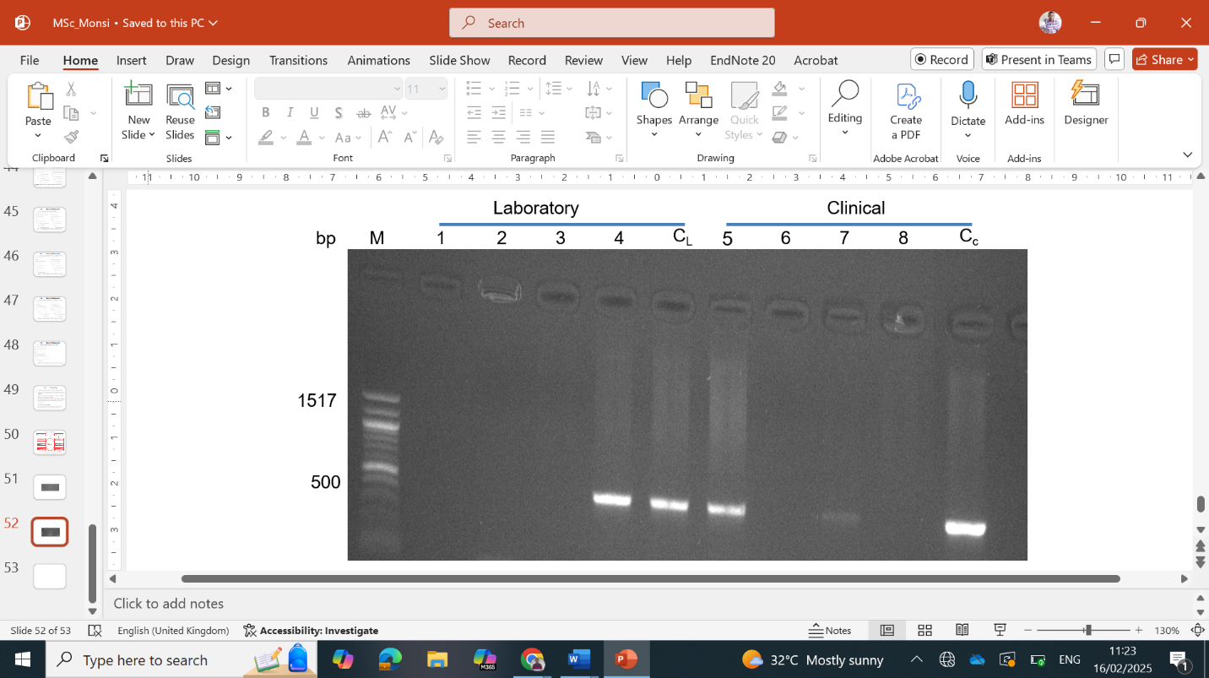

**Figure 2. PCR amplification products of *blaSHV* gene in *K. pneumoniae* exposed to herbal drugs.** Lane M: DNA ladder (molecular marker). Keys: 1 - ATCC Gab, 2 - ATCC Gob, 3 - ATCC Ruz, 4 - ATCC Bet, CL - ATCC control, 5 - clinical Gab, 6 clinical Gob, 7 - clinical Ruz, 8 - clinical Bet and Cc - clinical control.

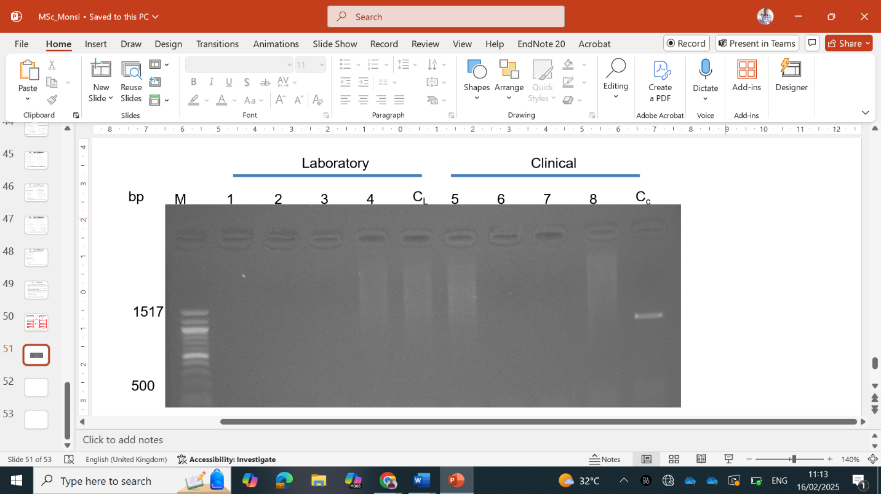

**Figure 3. Amplification products of *blaTEM*-1 gene of *K. pneumoniae***. M is a 100-1517 bp DNA ladder (molecular marker). Keys: 1 - ATCC Gab, 2 - ATCC Gob, 3 - ATCC Ruz, 4 - ATCC Bet, CL - ATCC control, 5 - clinical Gab, 6 clinical Gob, 7 - clinical Ruz, 8 - clinical Bet and Cc - clinical control.

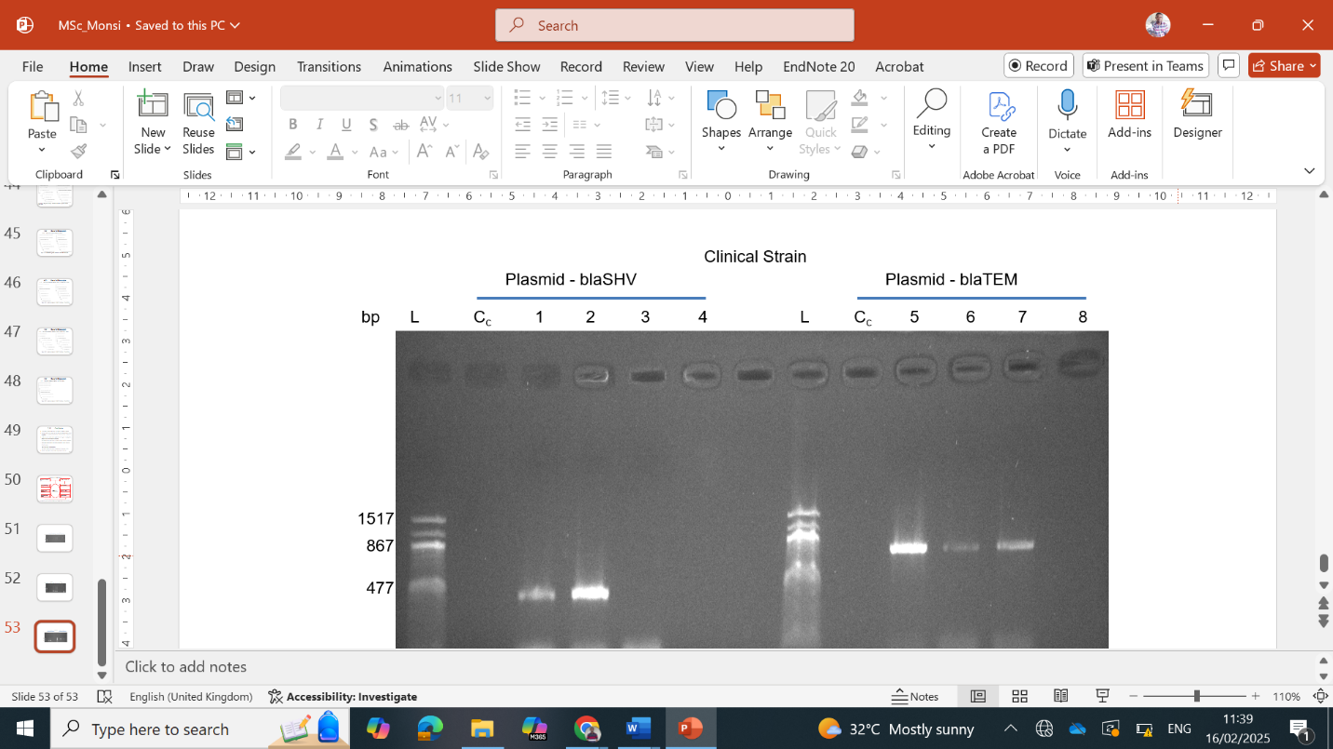

**Figure 4. Amplification of plasmid *blaTEM*-1 and *blaSHV* genes in clinical *K. pneumoniae***. L is 100-1517 bp DNA ladder (molecular marker). Keys: 1 - clinical Gab, 2 clinical Gob, 3 - clinical Ruz, 4 - clinical Bet and Cc - clinical control, 5 - clinical Gab, 6 clinical Gob, 7 - clinical Ruz, 7 - clinical Bet.

### 3.2 Analyses of nucleotide sequence alignment *blaSHV* and *blaTEM*-1 Genes

**Appendices 1 to 8** show the alignment of nucleotide sequences of *blaSHV* and *blaTEM*-1 genes in *K. pneumoniae* with genes closely related to the beta-lactamase genes. Generally, most sequenced genes had nucleotide substitutions in the beta-lactamase genes. These varied from single nucleotide substitution (also known as single nucleotide polymorphism [SNP]) to several length nucleotide substitutions. The resistance genes were compared to seven closely related genes. Dots represent nucleotides conserved in all gene sequences while dashes show gaps that have been inserted to generate optimal sequence alignment. Summarized in **Table 2** are the number and types of mutations observed in the beta-lactamase gene in *K. pneumoniae* clinical and laboratory strains exposed to different herbal medicines. The highest number of mutations were noted in the GOB condition (11%) in the *blaSHV* gene of the clinical isolate and laboratory *K. pneumoniae* treated in Ruzu bitters *blaTEM* (10%). Both conditions caused frameshift and point mutations. The lowest mutations observed were noted in non-herbal medicine-treated conditions.

**Table 2. Number and types of mutations beta-lactamase in genes**

|  |  |  |  |
| --- | --- | --- | --- |
| **Isolate** | **Resistant genes** | **Mutations n (%)** | **Nucleotides range** |
| Clinical control | *blaSHV* | 1 (1.3%) (Point) | 80 (1-80) |
| Laboratory control | *blaSHV* | - | - (60-110) |
| Clinical GAB | *blaSHV* | - | - (160-310) |
| Clinical GOB | *blaSHV* | 11 (11%) (Frameshift/Point) | 100 (1-100) |
| Clinical Ruz | *blaSHV* | 5 (7.1%) (Frameshift/Point) | 70 (70-140) |
| Laboratory GAB | *blaTEM* | 11 (7.9%) (Point) | 140 (10-150) |
| Laboratory GOB | *blaTEM* | 9 (10.6) (Point) | 85 (1-85) |
| Laboratory Ruz | *blaTEM* | 10 (10%) (Frameshift/Point) | 100 (1-100) |

**3. DISCUSSION**

Gram-negative pathogens possess complex resistance gene regulatory systems that enable rapid adaptation to several environmental signals that have not yet been studied (Bhagirath *et al.,* 2019, Manisha *et al.,* 2024). The *blaSHV* and *blaTEM* genes encode 204 and 750 amino acid long polypeptides respectively. The alignment of nucleotide sequences of the *blaSHV* and *blaTEM* genes in *K pneumoniae* with closely related beta-lactamase genes revealed significant genetic variability, primarily in the form of single nucleotide polymorphisms (SNPs) and nucleotide substitutions in all *K. pneumoniae* isolates exposed to the herbal drugs. These beta-lactamase genes are common genes widely known to be associated with resistance to beta–lactamase class of antibiotics especially in gram-negative bacteria (Pishtiwan and Khadija, 2019). These SNPs were mostly found in herbal medicine-treated conditions except for the 1.3% rate noted for one of the controls. This finding is consistent with previous studies that have reported mutations in beta-lactamase genes as a mechanism for antibiotic resistance (do Nascimento *et al.,* 2020, Rocha *et al.,* 2022). The observed nucleotide substitutions, which included both point mutations and frameshift mutations, suggest that these genetic alterations may contribute to the evolution of resistance against beta-lactam antibiotics in *K. pneumoniae*.

The highest mutation frequency was recorded under the GOB condition (11%) in the *blaSHV* gene of the clinical isolate, while the *blaTEM* gene exhibited a 10% mutation rate in *K. pneumoniae* exposed to Ruzu bitters. The occurrence of both frameshift and point mutations in these conditions suggests that exposure to certain herbal medicines may induce genetic alterations, potentially impacting beta-lactamase expression and function (Kumarasamy *et al.,* 2010). This aligns with previous research highlighting the role of environmental and selective pressures in shaping resistance determinants in bacterial populations (Monsi *et al*., 2017b, Monsi *et al.,* 2018, Anga *et al*., 2020). Their studies demonstrated that when there is a change in the environmental condition of a pathogen, such as exposure to herbal drugs, *S. aureus* and *E. coli* showed alteration in some virulent genes. This implies that pathogenic bacteria can sense environmental changes and alter the gene expression that will promote their pathogenicity.

Since *K. pneumoniae* commonly reside in the gut which makes it to be exposed to these herbal drugs become sensitized. This indicates that herbal drugs act as a stressor that alters the gene sequence of the beta–lactamase drug. These polymorphisms seen in some of the herbal drug treatment conditions could be responsible for these mutational changes for the bacteria to survive through natural selection. This is because according to the principle of natural selection, when an organism is in an environment or condition that is harsh, they survive through exhibiting adaptive changes such as production of new virulence factors, alteration of active sites and migration from the region of high exposure, all of which could be detrimental to the host. Similar mutational outcomes were noted in Singh et al. (2019) where beta-lactamase genes obtained from clinical isolates of *E. coli* showed remarkably numerous mutations which portray a diverse nature of the enzymes. In addition, our study agrees with an *in vitro* study by Webber *et al.* (2015) on the effect of biocide on *Salmonella*. Their study demonstrated that mutations were detected in three genes (*fabI*, *ramR*, and *gyrA*) after exposure to biocide.

Conversely, the lowest mutation rates were observed in non-herbal medicine-treated conditions, indicating a reduced selective pressure in the absence of external compounds. These results suggest that exposure to herbal medicines may contribute to genetic modifications in resistance genes, warranting further investigation into the molecular mechanisms driving these changes. Future studies should explore the functional consequences of these mutations on beta-lactamase activity and their potential clinical implications.

A noteworthy observation in our study is that beta–lactamase was present on either chromosome or plasmid DNA or both. A proposed phenomenon to this observation is the ability of the *blaTEM*-1 and *blaSHV* to act as transposable genetic elements. This study shows that resistance inducement due to herbal drugs exposure could either be chromosomal or plasmid mediated. The chromosomal-mediated resistance has previously been reported in fluoroquinolones due to amino acid substitution in DNA gyrase gene (Jacoby, 2009). Also, Domokos *et al.* (2016) identified several genes (*qnrB, qnrS, qnrC* and *qnrD*) to be responsible for fluoroquinolone resistance. Similar substitutions were noted in this current study.

However, resistance to beta-lactam antibiotics is not limited to mutations in betalactamase enzymes. A report has revealed that efflux pumps located on the membrane of most gram-negative bacteria cause resistance. Their main function is to remove antibiotics or toxic substances from within the bacterial cell. Mutations of these proteins have been identified to be responsible for the resistance of *Enterobacteriaceae* to beta-lactam drugs (Ogbolu *et al.,* 2015).

**5. CONCLUSION**

Herbal medication has the potential of inducing bacterial resistance through migration of beta-lactamase gene from chromosome to plasmid and vice versa. The observation of mutations in exposed isolates implies this could alter the enzymatic activity based on the exposed conditions.

**Disclaimer (Artificial intelligence)**

Authors hereby declare that NO generative AI technologies such as Large Language Models (ChatGPT, COPILOT, etc.) and text-to-image generators have been used during the writing or editing of this manuscript.

**REFERENCES**

Aagaard SK, Larsen A, Andreasen MF, Uldbjerg N, Bor P. 2017. Use of complementary and herbal medicine in the general population and among pregnant women. Ugeskr Laeger. 179(5): V08160586. PMID: 28397669.

Anga OG, Monsi TP, Konne FE, Mike-Ogburia MI 2020. In vitro quantitative assessment of some virulence factors produced by Escherichia coli in different pH, temperature and oxygen conditions. Advances in Microbiology. 10(12):647-62. <https://doi.org/10.4236/aim.2020.1012046>

Baquero, F, Martínez, JL, Lanza, VF, Rodríguez-Beltrán, J, Galán, JC, San Millán, A et al. 2021. Evolutionary pathways and trajectories in antibiotic resistance. Clinical Microbiology Reviews, 34(3), e00050-19. <https://doi.org/10.1128/CMR.00050-19>

Bhagirath AY, Li Y, Patidar R, Yerex K, Ma X, Kumar A, Duan K. 2019. Two component regulatory systems and antibiotic resistance in Gram-negative pathogens. International journal of molecular sciences, 20(7):1781. <https://doi.org/10.3390/ijms20071781>

Bush, K, Jacoby, GA 2010. Updated functional classification of β-lactamases. Antimicrobial Agents and Chemotherapy, 54(3), 969–976. <https://doi.org/10.1128/aac.01009-09>

Chong Y, Shimoda S, Shimono N. 2018. Current epidemiology, genetic evolution and clinical impact of extended-spectrum β-lactamase-producing *Escherichia coli* and *Klebsiella pneumoniae*. Infection, Genetics and Evolution. 61:185-8. <https://doi.org/10.1016/j.meegid.2018.04.005>

Dameanti, F.N.A.E.P., Yanestria, S.M., Effendi, M.H., Plumeriastuti, H., Tyasningsih, W., Ugbo, E.N. et al. 2023. Identification of blaSHV and blaTEM extended spectrum beta-lactamase genes in *Klebsiella pneumoniae* in the dairy wastewater, East Java Province, Indonesia. Biodiversitas Journal of Biological Diversity, 24(11). <https://doi.org/10.13057/biodiv/d241130>

do Nascimento AP, Medeiros Filho F, Pauer H, Antunes LC, Sousa H, Senger H et al. 2020. Characterization of a SPM-1 metallo-beta-lactamase-producing *Pseudomonas aeruginosa* by comparative genomics and phenotypic analysis. Scientific Reports. 10(1):13192. <https://doi.org/10.1038/s41598-020-69944-6>

Domokos J, Kristóf K, Szabó D. 2016. Plasmid-mediated quinolone resistance among extended spectrum beta lactase producing Enterobacteriaceae from bloodstream infections. Acta microbiologica et immunologica Hungarica. 63(3):313-23. <https://doi.org/10.1556/030.63.2016.002>

Kumarasamy KK, Toleman MA, Walsh TR, Bagaria J, Butt F, Balakrishnan R et al. 2010. Emergence of a new antibiotic resistance mechanism in India, Pakistan, and the UK: a molecular, biological, and epidemiological study. The Lancet infectious diseases. 10(9):597-602. <https://doi.org/10.1016/S1473-3099(10)70143-2>

Li, S, Shen, S, Ding, L, Han, R, Guo, Y, Yin, D et al. 2022. First Report of blaCTX–M–167, blaSHV–1, and blaTEM–1B Carrying *Klebsiella pneumoniae* Showing High-Level Resistance to Carbapenems. Frontiers in Microbiology, 13:916304. <https://doi.org/10.3389/fmicb.2022.916304>

Liakopoulos, A, Mevius, D, Ceccarelli, DA 2016. Review of SHV Extended-Spectrum β-Lactamases: Neglected Yet Ubiquitous. Front Microbiol. 7:1374. <https://doi.org/10.3389/fmicb.2016.01374>

Manisha Y, Srinivasan M, Jobichen C, Rosenshine I, Sivaraman J 2024. Sensing for survival: specialised regulatory mechanisms of Type III secretion systems in Gram‐negative pathogens. Biological Reviews. 99(3):837-63. <https://doi.org/10.1111/brv.13047>

Martinez, JL 2009. The role of natural environments in the evolution of resistance traits in pathogenic bacteria. Proceedings of the Royal Society B: Biological Sciences, 276(1667), 2521–2530. <https://doi.org/10.1098/rspb.2009.0320>

Mbada CE, Adeyemi TL, Adedoyin RA, Badmus HD, Awotidebe TO, Arije OO et al. 2015. Prevalence and modes of complementary and alternative medicine use among peasant farmers with musculoskeletal pain in a rural community in South-Western Nigeria. BMC complementary and alternative medicine, 15:1-7. <https://doi.org/10.1186/s12906-015-0695-3>

Monsi TP, Abbey SD, Wachukwu CK, Wokem GN 2018. Levels of biofilm expression in Klebsiella pneumoniae isolates exposed to herbal drugs. Journal of Advances in Microbiology. 4(5): 6. <https://doi.org/10.9734/JAMB/2018/42685>

Monsi TP, Amala SE, Ugoaru NF. 2017a. Acquisition of antibiotic resistance in *Escherichia coli* exposed to a locally produced herbal drug. Microbiology Research Journal International. 22(2):1-7. <https://doi.org/10.9734/MRJI/2017/34812>

Monsi TP, Wokem GN, Aleruchi PC 2017b. Development of antibiotic resistance in herbal drug-sensitized *Staphylococcus aureus* isolate. Journal of Advances in Microbiology, 7(4):1-7. <https://doi.org/10.9734/JAMB/2017/37893>

Monsi, TP, Abbey, SD, Wachukwu, CK, Wokem, GN. 2019. Plasmid-mediated resistance in extended spectrum beta–lactamase–producing *Klebsiella pneumoniae* isolates at Rivers State University Teaching Hospital. European Journal of Pharmaceutical and Medical Research 6 (2), 75-82.

Monsi, TP, Somkene, OC, Nyenke, CU, and Amala, SE 2021. Antibiotics Sensitivity of *Escherichia coli* to Different Concentrations of Combined Herbal Drugs. South Asian Journal of Research in Microbiology, 11(4), pp. 37-43. <https://doi.org/10.9734/sajrm/2021/v11i430260>

Muteeb, G, Rehman, MT, Shahwan, M, Aatif, M 2023. Origin of antibiotics and antibiotic resistance, and their impacts on drug development: A narrative review. Pharmaceuticals, 16(11), 1615. <https://doi.org/10.3390/ph16111615>

Navon-Venezia S, Kondratyeva K, Carattoli A. 2017. *Klebsiella pneumoniae*: a major worldwide source and shuttle for antibiotic resistance. FEMS microbiology reviews. 41(3):252-75.

Ogbolu DO, Daini OA, Alli AT, Webber MA 2015. Reduced intracellular drug accumulation augments fluoroquinolone and β-lactam drugs resistance in clinical Gram-negative bacteria from Nigeria. African Journal of Microbiology Research, 9:1082-8. <https://doi.org/10.5897/AJMR2013.5573>

Orokor, WO, Mbata CA, Monsi, TP 2025. Molecular Profiling of Antibiotic-resistant Pseudomonas aeruginosa Isolated from Patients with Urinary Tract Infections in Rivers State University Teaching Hospital. International Journal of Pathogen Research, 14(1); 27-41. <https://doi.org/10.9734/ijpr/2025/v14i1338>

Pishtiwan AH, Khadija KM. 2019. Prevalence of blaTEM, blaSHV, and blaCTX-M Genes among ESBL-Producing *Klebsiella pneumoniae* and *Escherichia coli* Isolated from Thalassemia Patients in Erbil, Iraq. Mediterr J Hematol Infect Dis. 11(1):e2019041. <https://doi.org/10.4084/MJHID>

Rocha GD, Nogueira JF, Dos Santos MV, Boaventura JA, Soares RA, de Simoni Gouveia JJ et al. 2022. Impact of polymorphisms in blaZ, blaR1 and blaI genes and their relationship with β-lactam resistance in *S. aureus* strains isolated from bovine mastitis. Microbial pathogenesis. 165:105453. <https://doi.org/10.1016/j.micpath.2022.105453>

Rozwandowicz, M, Brouwer, MSM, Fischer, J, Wagenaar, JA, Gonzalez-Zorn, B, Guerra, B, Mevius, DJ, Hordijk, J 2018. Plasmids carrying antimicrobial resistance genes in Enterobacteriaceae. Journal of Antimicrobial Chemotherapy, 73(5), 1121–1137. <https://doi.org/10.1093/jac/dkx488>

Salam, MA, Al-Amin, MY, Salam, MT, Pawar, JS, Akhter, N, Rabaan, AA, Alqumber, MAA 2023. Antimicrobial resistance: A growing serious threat for global public health. Healthcare, 11(13), 1946. <https://doi.org/10.3390/healthcare11131946>

Singh, T., Singh, P.K., Das, S. et al. 2019. Transcriptome analysis of beta-lactamase genes in diarrheagenic *Escherichia coli*. Sci Rep 9, 3626. <https://doi.org/10.1038/s41598-019-40279-1>

Strahilevitz J, Jacoby GA, Hooper DC, Robicsek A 2009. Plasmid-mediated quinolone resistance: a multifaceted threat. Clinical microbiology reviews. 22(4):664-89. <https://doi.org/10.1128/CMR.00016-09>

Sun, L., Li, H., Wang, Q., Liu, Y., & Cao, B. 2021. Increased gene expression and copy number of mutated blaKPC lead to high-level ceftazidime/avibactam resistance in *Klebsiella pneumoniae*. BMC Microbiology, 21(1), 230. <https://doi.org/10.1186/s12866-021-02293-0>

Uddin F, Sohail M, Shaikh QH, Ahmed S, Khan S, Roulston K, McHugh TD 2021. PCR and microarray analysis of AmpC and ESBLs producing *Pseudomonas aeruginosa* isolates from intensive care units. Gene Reports. 23:101178. <https://doi.org/10.1016/j.genrep.2021.101178>

Uddin F, Sohail M, Shaikh QH, Hussain MT, Roulston K, McHugh TD 2022. Verona integron encoded metallo Beta lactamase (VIM) and Vietnam extended spectrum Beta lactamase (VEB) producing *Pseudomonas balearica* from a clinical specimen. JPMA. The Journal of the Pakistan Medical Association. 72(4):761-3. <https://doi.org/10.47391/JPMA.3890>

Webber MA, Whitehead RN, Mount M, Loman NJ, Pallen MJ, Piddock LJ 2015. Parallel evolutionary pathways to antibiotic resistance selected by biocide exposure. Journal of antimicrobial chemotherapy. 70(8):2241-8. <https://doi.org/10.1093/jac/dkv109>

Xue, P, Sang, R, Li, N, Du, S, Kong, X, Tai, M, Jiang, Z, Chen, Y 2023. A new approach to overcoming antibiotic-resistant bacteria: Traditional Chinese medicine therapy based on the gut microbiota. Frontiers in Cellular and Infection Microbiology, 13, 1119037. <https://doi.org/10.3389/fcimb.2023.1119037>

Zhang YL, Huang FY, Gan LL, Yu X, Cai DJ, Fang J et al. 2021. High prevalence of blaCTX-M and blaSHV among ESBL producing *E. coli* isolates from beef cattle in China's Sichuan-Chongqing Circle. Sci Rep. 11(1):13725. <https://doi.org/10.1038/s41598-021-93201-z>

**APPENDIX**

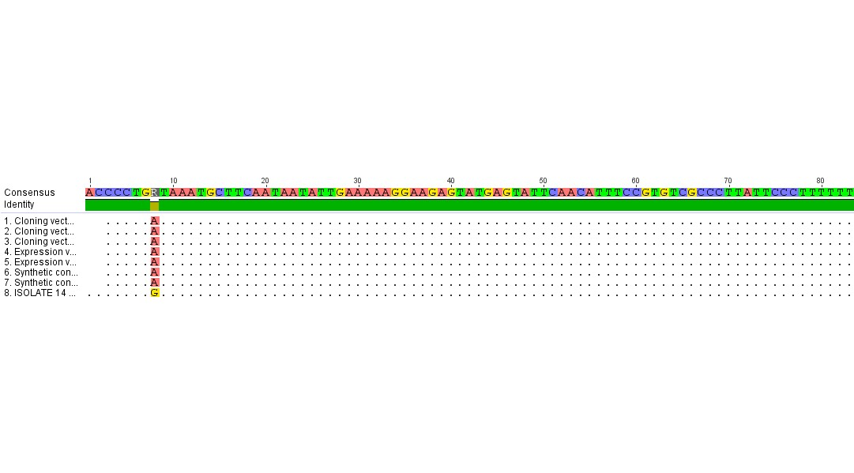

**Appendix 1. Control clinical strain - *blaSHV***

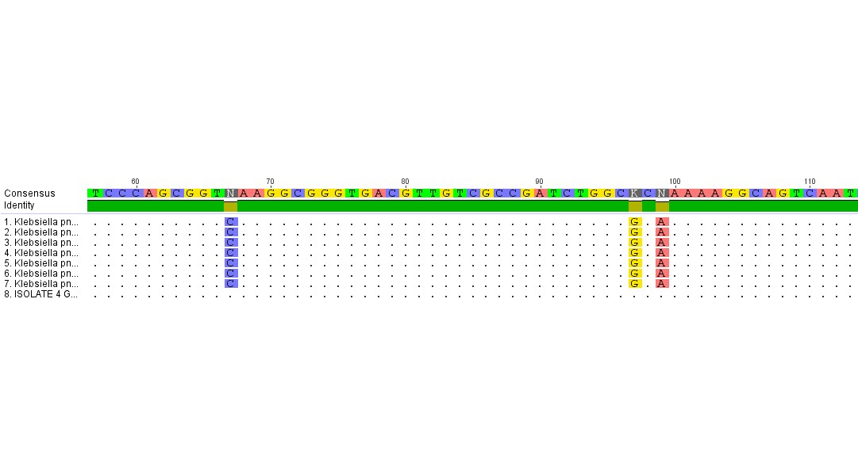

**Appendix 2. Control laboratory strain - *blaSHV***

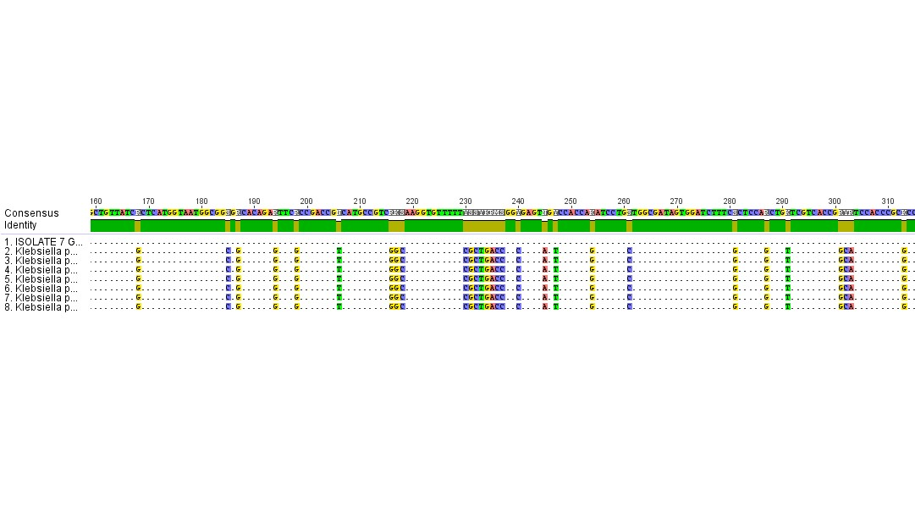**Appendix 3. Clinical strain in Goko alcoholic bitters - *blaSHV***

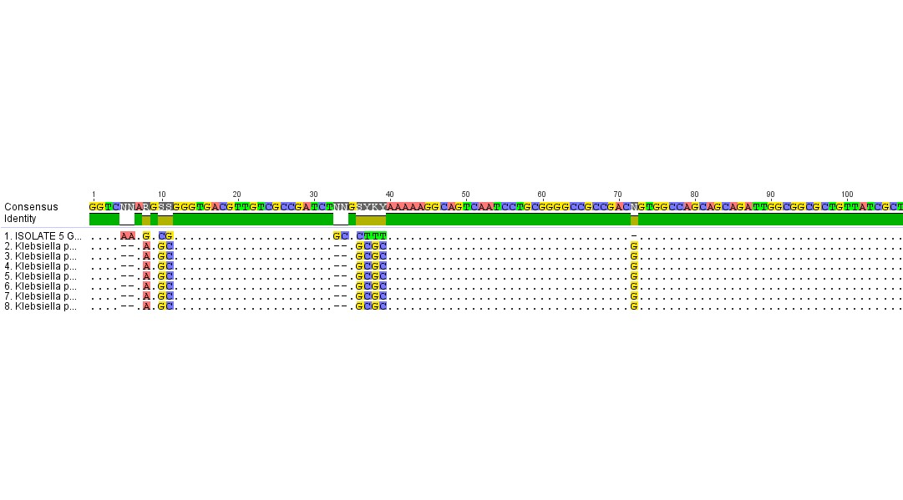

**Appendix 4. Clinical strain in Goko bitters - *blaSHV***

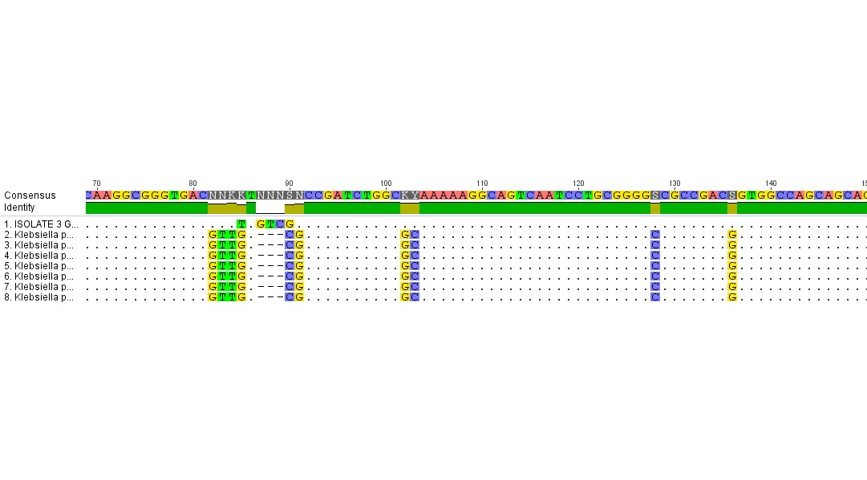

**Appendix 5. Clinical strain in Ruzu bitters - *blaSHV***

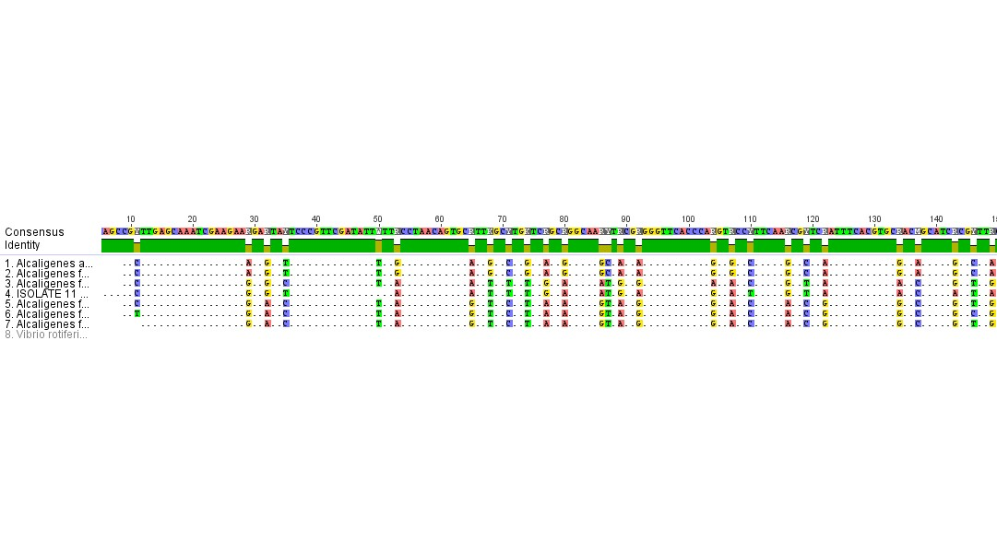

**Appendix 6. Laboratory strain in Goko alcoholic bitters - *blaTEM***

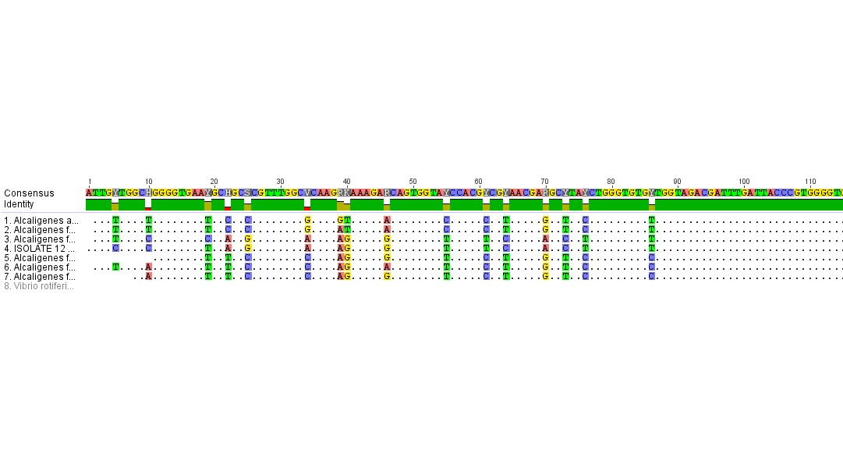

**Appendix 7. Laboratory strain in Goko bitters - *blaTEM*.**

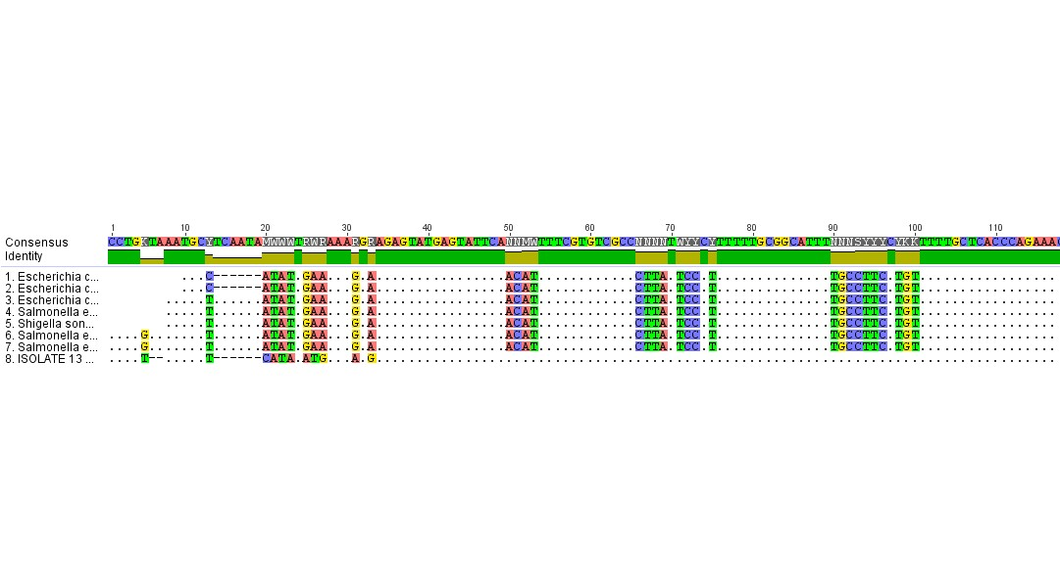**Appendix 8. Laboratory strain in Ruzu bitters - *blaTEM*.**

Nucleotide alignment of the beta-lactamase genes was compared to seven closely related genes. Dots represent nucleotides conserved in all gene sequences while dashes show gaps that have been inserted to generate optimal sequence alignment.