***Original Research Article***

**Molecular Identification and Antibiotic Resistance Pattern of *Vibrio* Speciesfrom Clinical and Environmental Sources in Buguma, Nigeria**

## **ABSTRACT**

|  |
| --- |
| **Aim:** To Molecularly Characterize *Vibrio* SpeciesIsolated from Clinical Sources and Water Bodies in Buguma.  **Study Design:** This was a cross-sectional study with simple randomized sampling technique.  **Methodology:** The study used a total of 80 samples comprising of 40 stool and 40 water samples from different water bodies where public toilets were collected in Buguma community in Rivers State, Nigeria. The *Vibrio* species were isolated from samples using thiosulphate citrate bile salt agar (TCBS), and blood agar as a confirmatory after which biochemical tests and 16S rRNA detection were carried out for further identification. Antibiotic sensitivity test was performed according to Kirby-Bauer disk diffusion method and conventional polymerase chain reaction was used to detect *blaTEM* and *AMPC* antibiotic resistance gene.  **Results:** The resistance profiles of the isolates showed the highest rate of resistance observed by the Vibrio spp was noted with cefpodoxime and amoxicillin + clavulanic acid while some other isolates were 100 percent susceptible to ciprofloxacin. With a MAR score higher than 0.2, it also indicates high use of antibiotics in the research area. The prevalence of *AMPC* resistant genes in human stools was 66.6% while that of *blaTEM* was Nil. The prevalence of *AMPC* resistant genes in water samples was 100% while that of *blaTEM* was 33.3%  **Conclusion:** The discovery of isolates containing genes for antibiotic resistance and many drug-resistant Vibrio species suggests possible health danger to the public. |

Key words: *Vibrio*, resistance, prevalence and virulence genes,

**INTRODUCTION**

Pathogens belonging to the *Vibrio* species are known to cause high case-fatality ratios and mortality rates worldwide for both cholera and non-cholera illnesses. Several *Vibrio* species and strains have the potential to cause outbreaks which have been made worse in recent years by climatic and global change [1,2]. Among these species, *Vibrio cholerae* is responsible for well over 4,000,000 infections and 143,000 fatalities annually [3]. Notable among the *V. cholera* serotypes that cause severe human infections are those belonging to the serogroups of O1 and O139 [4]. *Vibrio* infections can result in septic shock, gastroenteritis, severe bacterial cellulitis, or necrotizing fasciitis and in extremely cases, fatal. Patients with various underlying diseases, such as liver disease, heart failure, diabetes, liver cirrhosis, alcohol addiction, and immunocompromising disorders, are more likely to get infected [5]. Younger individuals are more prone to suffer from mild illnesses such recurrent ear infections, which are also caused by *Vibrio* spp. [6]. After consuming tainted raw seafood, particularly oysters, or after being exposed to the maritime environment, humans can get *Vibrio* infections [7]. *Vibrio*-borne infection is common during summer periods which is more likely to be caused by the warmness of the aquatic habitat [8].

The global incidence rate of *Vibrio* spp. infections other than *V. cholerae* O1/O139 is underestimated since Vibriosis is a relatively uncommon disease and is not recorded in most national surveillance systems. A significant seasonal distribution and rising incidence rate have been noted in the United States, where such infections are reportable [9]. In most regions affected, *Vibrio* infections usually go unnoticed hence, most likely underdiagnosed due to their rare nature. There have been reports of delays in therapeutic care, namely in the prescription of a focused antibiotic regimen [10]. This investigation aimed to characterize *Vibrio* speciesisolated from clinical sources and water bodies in Buguma using molecular methods.

**MATERIALS AND METHODS**

**2.1 Study Design**

The investigations were carried out using a cross-sectional study design with simple randomized sampling technique.

**2.2 Study Area**

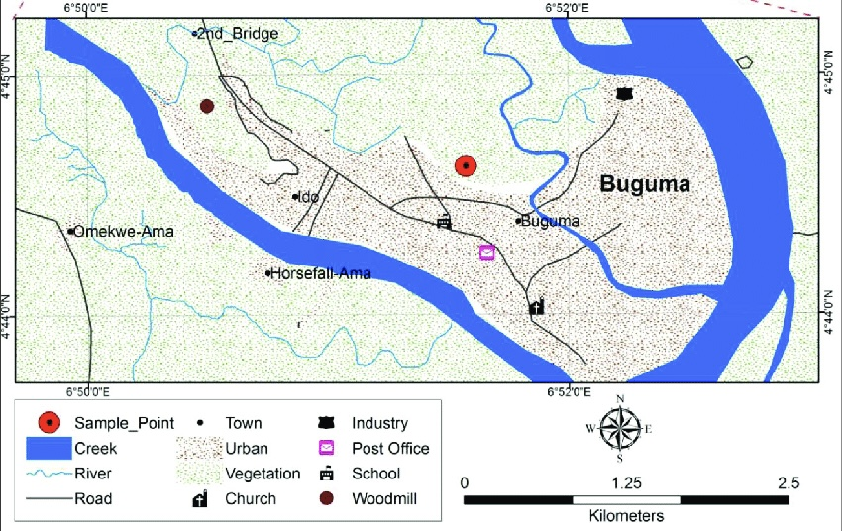

**Figure 1. Map showing study location**

Buguma shown in Figure 1 (4°45 N, 6°53 E) is chosen for this study because the populace are predominately fishers and the inhabitant have a lot to do with water bodies, i.e. they get some of their foods from the water such as sea foods like fish, periwinkle, prawn etc. also they have their toilet, dumpsite and sometimes effluent discharged in the water. It is the headquarters of Asari-Toru local government area and base of Kalabari kingdom in Rivers State. Buguma is an island that is surrounded by water and hosts to a large supply of mangrove forest. The Kalabari are a distinct part of the Ijaw-speaking peoples of the Niger Delta and live in thirty-three villages and three major towns in the mangrove swamps of the eastern part of the region. The three major cities are Abonnema, Bakana, and Buguma, which were settled in 1882, 1881 and 1884, respectively. According to the King of Kalabari Kingdom, the Kalabari formerly lived in Elem-Ama, or Old Calabar, from where they later migrated to their various towns in different parts of the eastern Niger Delta.

**2.3 Study Population**

The study comprised patients who visited the Buguma Health Center between May and August 2022 who had suspected diarrhea. Individuals who are suspected of having diarrhea may exhibit a unique set of symptoms associated with food poisoning, including fatigue, generalized body weakness, pain or cramping in the abdomen, and frequent stools.

**2.4 Stool Sample Collection**

40 stool samples were taken from both inpatients and outpatients who exhibited diarrheal infection signs and symptoms. All stool samples were collected aseptically from patients and placed into universal wide-neck containers. These stool samples were collected, and they were sent right away for culture. Samples were kept in a refrigerator at 4°C when delays were anticipated. The normal bacteriological procedures were applied to all obtained samples, and the morphological features of culture medium and biochemical tests were utilized to identify isolates.

**2.5 Water Sample Collection, Isolation and Identification of Presumptive *Vibrio Species***

A total of 40 sampling locations were included, and water was collected from all water bodies that had public toilets where open defecation into the rivers is practiced. The water samples were gathered throughout the month of April in 2022. After being supplemented with alkaline peptone water, each water sample was incubated for 18 to 24 hours at 37 °C. Ten thiosulphate citrate bile salts sucrose (TCBS) agar plates were inoculated with a loopful of the alkaline peptone water, and the plates were then incubated for an additional twenty-four hours at 37 °C. 1 mL of buffer peptone solution (1:10 dilution) was enhanced in nutritional broth at 37 °C for 16 hours in order to isolate bacteria. The mixture was then transferred to a selective medium (TCBS agar plate) and incubated for 24 hours at 37 °C. Then one colony was randomly selected from each plate for biochemical analysis and hemolysis test.

**2.6 Microscopic Examination**

To ascertain the size, shape, and staining characteristics of bacteria, microscopic examination is essential. Gram staining was used to identify the chosen *Vibrio* species initially, and then several biochemical assays were conducted. Selected isolates' physical and cultural traits were determined using accepted microbiological procedures [11].

**2.6 Biochemical Tests**

The biochemical test used to detect *Vibrio* species include indole, MR test, VP test, citrate utilization and urease test described by Talukder et al. [12].

**2.7 Microbial Analyses**

According to a prior description (WHO, 2016), a loop full of surface growth was streaked on a pre-made thiosulfate-citrate-bile salt-sucrose (TCBS) agar plate and incubated at 37°C for 18–24 hours. Following incubation, bacterial colonies' morphology, including their size, shape, and color led to a provisional identification as *Vibrio* spp. For additional purification, a single, distinct colony (yellow or green in color) was streaked over recently made TCBS and blood agar plates.

**2.8 Motility test**

To observe the motility of the *Vibrio* spp., hanging drop slide method was used as described by [13]. Pure culture of the isolated samples was grown on nutrient broth. One drop of broth culture was taken over the coverslip and placed inverted over the concave depression of the hanging drop slide to make a hanging drop. Vaseline was used around the concave depression of the hanging drop slide for better attachment of the cover slip to prevent air current and evaporation of the fluid. The motile and nonmotile organisms were identified by observing the slide under ×100 of a compound microscope using immersion oil.

**2.9. Antibiotic susceptibility test**

antibiotic sensitivity test was performed according to Kirby-Bauer disc diffusion method [14] and following the guideline of clinical and laboratory standards institute [15] a total of 12 commercially available antibiotics were used in this research to assess drug susceptibility and resistance of isolated species (mast diagnostics Mersey side, UK). a single colony of pure culture isolated from the samples was incubated in nutrient broth at 37 °C for 16 hours. Then 0.1 ml of broth was spread on Mueller Hinton agar plate using a cell spreader and an antibiotic disc was placed on top. The plates were then incubated in 37°C for 24 hours. after incubation, the zone of inhibition near the discs was measured using a millimeter scale and categorized as resistant or sensitive according to the manufacturer's recommendation

* 1. **Molecular Procedures**

**2.10.1 DNA Extraction**

Using a ZR fungal/bacterial DNA mini-prep extraction reagent supplied by Inqaba South Africa, DNA was extracted. In a ZR Bashing Bead lysate tube, a pure culture of the isolates was suspended in 200 microliters of isotonic buffer, and 750 microliters of lysate solution were added. The tubes were placed in a bead beater equipped with a 2 ml tube holder assembly and processed at top speed for 5 minutes. The ZR bashing particle lysis vial was centrifuged for one minute at 10,000 x g.

400 microliters of supernatant were transferred to a Zymo-spin IV spin Filter (orange top) in a collection receptacle and centrifuged at 8000 x g for one minute. 1200 microliters of fungal/bacterial DNA binding buffer were added to the filtrate in the collection tubes, bringing the total volume to 1600 microliters. 800 microliters were then transferred to a Zymo-Spin IIC column in a collection tube and centrifuged at 10,000 x g for 1 minute. The remaining volume was transferred and spun using the same Zymo-spin. In a new collection tube, 200 microliters of the DNA Pre-Was buffer were added to the Zymo-spin IIC and spun at 10,000xg for one minute, followed by the addition of 500 microliters of the fungal/bacterial DNA Wash Buffer and centrifugation at 10,000 x g for one minute.

The DNA was eluted by transferring the Zymo-spin IIC column to a clean 1.5 microliter centrifuge tube, adding 100 microliters of DNA elution buffer to the column matrix, and centrifuging at 10,000xg microliter for 30 seconds. The ultrapure DNA was then frozen at -20 degrees for use in subsequent procedures.

* + 1. **DNA Quantification**

The Nano drop 1000 spectrophotometer was used to quantify the extracted genomic DNA. The equipment's software was launched by double-clicking on the Nanodrop icon. The apparatus was blanked with normal saline after being initialized with 2 µl of sterile distilled water. After loading two microliters of extracted DNA onto the lower pedestal, the higher pedestal was lowered to contact the extracted DNA on the lower pedestal. The DNA concentration was determined by pressing the "measure" button.

**2.10.3 16S rRNA Amplification**

The isolates' 16s rRNA region was amplified using the 27F: 5'-AGAGTTTGATCMTGGCTCAG-3' and 1492R: 5'-CGGTTACCTTGTTACGACTT-3' primers on an ABI 9700 Applied Biosystems thermal cycler for 35 cycles at a final volume of 40 microlitres. The PCR mix includes the Inqaba, South Africa-supplied X2 Dream taq Master mix (taq polymerase, DNTPs, MgCl), the primers at 0.5 µM concentration, and the extracted DNA as a template. The following were the PCR conditions: Initial denaturation at 95°C for 5 minutes; denaturation at 95oC for 40 seconds; annealing at 52°C for 40 seconds for 35 cycles; and final extension at 72°C for 5 minutes. The result was resolved with a 1% agarose gel for 30 minutes at 130 V and then visualized using a blue light transilluminator.

**2.10.4 Amplification of *blaTEM* genes**

On an ABI 9700, TEM genes were amplified from the isolates using the TEMF: 5'-ATGAGTATTCAACATTTCCGTG-3' and TEMR: 5'-TTACCAATGCTTAATCAGTGAG-3' primers. 35 cycles on an Applied Biosystems thermal cycler with a final volume of 40 microliters. The PCR mix contained the X2 Dream Taq Master mix supplied by Inqaba, South Africa (Taq polymerase, DNTPs, MgCl2), primers at a concentration of 0.4 M, and 50 ng of extracted DNA as the template. The following PCR conditions were utilized: Initial denaturation at 95°C for 5 minutes, followed by denaturation at 95°C for 30 seconds, annealing at 58°C for 30 seconds, and extension at 72°C for 30 seconds for 35 cycles, with a final extension at 72°C for 5 minutes. The product was resolved with a 1% agarose gel at 200 V for 15 minutes and visualized with an ultraviolet transilluminator.

**Table 1: Primer Sequences and Base Pairs**

|  |  |  |
| --- | --- | --- |
| **Gene** | **Primer Sequences** | **Amplicon Size** |
| 16S rRNA | Forward: 5'-AGAGTTTGATCMTGGCTCAG-3’  Reverse: 5'-CGGTTACCTTGTTACGACTT-3’ | 1500 |
| *AMPC* | Forward: 5′-AACACACTGATTGCGTCTGAC-3′  Reverse: 5-CTGGGCCTCATCGTCAGTTA-3′ | 1200 |
| *blaTEM* | Forward: 5′-TTGCGATGCTCTATGAGTGGCTA-3′  Reverse: 5′-CTCGAATGCCTGGCGTGTTT-3′ | 400 |

**2.11 Data Analyses**

The data generated from this study was represented as frequency and percentages, and inferential statistics were carried out using chi-square with the aid of GraphPad Prism Software Version 9. Statistical significance was defined as a *p*-value of less than 0.05 at a 95% confidence interval.

**3. Results**

**3.1 Antibiogram of *Vibrio* Isolates**

The susceptibility patterns of the *Vibrio* cholera are shown in Table 2. From this table, Amoxicillin + Clavulanic Acid and Cefpodoxime exhibited the highest levels of resistance by the pathogens with resistance prevalence of 85.7 and 74.1% respectively. Ofloxacin and Ciprofloxacin did not show any resistance nor sensitivity, implying that they were moderately resistant to these antibiotics.

**Table 2.** **Antimicrobial Susceptibility Pattern of *Vibrio* Isolates**

|  |  |  |  |
| --- | --- | --- | --- |
| **Antibiotics**  **(Zone of Inhibition Range in mm)** | **Antibiotic Class** | **Resistant (%)**  **Human (N = 3)** | **Resistant (%)**  **Water (N = 14)** |
| Amikacin 30 µg (AK)  (< 18 = R; ≥ 18 = S) | Aminoglycoside | 1 (33.3) | 5 (35.7) |
| Gentamicin 120 µg (CN)  (< 17 = R; ≥ 17 = S) | Aminoglycoside | 2 (66.6) | 3 (21.4) |
| Ofloxacin 5 µg (OFX)  (< 22 = R; ≥ 24 = S) | Fluoroquinolone | 0 (0) | 0 (0) |
| Ciprofloxacin 5 µg (CIP)  (< 22 = R; ≥ 25 = S) | Fluoroquinolone | 0 (0) | 0 (0) |
| Cefepime 30 µg (FEP)  (< 19 = R; ≥ 19 = S) | Cephalosporin | 2 (66.6) | 4 (28.5) |
| Cefuroxime Sodium (CXM)  (< 19 = R; ≥ 19 = S) | Cephalosporin | 1 (33.3) | 4 (28.5) |
| Cefpodoxime 10 µg (CPD)  (< 21 = R; ≥ 21 = S) | Cephalosporin | 3 (100) | 10 (71.4) |
| Ceftazidime 30 µg (CAZ)  (< 19 = R; ≥ 22 = S) | Cephalosporin | 2 (66.6) | 8 (57.1) |
| Amoxicillin + Clavulanic Acid 30 µg (AMC)  (< 19 = R; ≥ 19 = S) | β-lactam and  β-lactamase inhibitor | 3 (100) | 12 (85.7) |
| Cefotaxime 30 µg (CTX)  (< 17 = R; ≥ 20 = S) | β-lactam | 2 (66.6) | 4 (28.5) |
| Imipenem 10 µg (IPM)  (< 19 = R; ≥ 22 = S) | Carbapenem | 0 (0) | 1 (7.1) |
| Tetracycline 30 µg (TE)  (< 19 = R; ≥ 19 = S) | Tetracycline | 1 (33.3) | 3 (21.4) |

**Key**: S - Sensitive; R – Resistant

**3.2 Multiple Antimicrobial Resistance (MAR) index**

The multiple antimicrobial resistance (MAR) index of *Vibrio* isolates was analyzed, revealing various patterns of antibiotic resistance. One isolate (5.9%) exhibited resistance to 10 antibiotics, covering five antibiotic classes. The antibiotics resisted included gentamicin CN, AK, CXM, CTX, CPD, CAZ, FEP, AMC, TE, and IPM. This pattern resulted in the MAR index of 0.83. Three isolates (17.6%) showed resistance to nine antibiotics across four antibiotic classes. The resisted antibiotics were CN, AK, CXM, CTX, CPD, CAZ, FEP, AMC, and TE. This pattern had a MAR index of 0.75. Five isolates (29.4%) resisted six antibiotics, encompassing four antibiotic classes. These antibiotics were AK, CTX, CPD, CAZ, AMC, and TE, with a MAR index of 0.50. Another set of five isolates (29.4%) demonstrated resistance to five antibiotics within two antibiotic classes. The antibiotics resisted were CXM, CTX, CPD, CAZ, and AMC. This pattern resulted in a MAR index of 0.42. Two isolates (11.8%) showed resistance to five antibiotics *species* spanning three antibiotic classes. The antibiotics in this pattern were CXM, CTX, CPD, AMC, and TE, with a MAR index of 0.42. Lastly, one isolate (5.9%) was resistant to three antibiotics across three antibiotic classes. The antibiotics were AK, CPD, and AMC, resulting in a MAR index of 0.25 as shown in Table 3.

**Table 3: Multiple Antimicrobial Resistance Index (MAR) of the *Vibrio* Isolates**

|  |  |  |  |  |  |
| --- | --- | --- | --- | --- | --- |
| **S/N** | **Antimicrobial Resistance Patterns** | **Antibiotic Classes Represented** | **Antibiotics Resisted** | **MAR Index** | **Frequency**  **(%)** |
| 1 | CN, AK, CXM, CTX, CPD, CAZ, FEP, AMC, TE, IPM | 5 | 10 | 0.83 | 1 (5.9) |
| 2 | CN, AK, CXM, CTX, CPD, CAZ, FEP, AMC, TE | 4 | 9 | 0.75 | 3 (17.6) |
| 3 | AK, CTX, CPD, CAZ, AMC, TE | 4 | 6 | 0.50 | 5 (29.4) |
| 4 | CXM, CTX, CPD, CAZ, AMC | 2 | 5 | 0.42 | 5 (29.4) |
| 5 | CXM, CTX, CPD, AMC, TE | 3 | 5 | 0.42 | 2 (11.8) |
| 6 | AK, CPD, AMC | 3 | 3 | 0.25 | 1 (5.9) |

**Key**: AK - Amikacin 30 µg, CN - Gentamicin 120 µg, OFX - Ofloxacin 5 µg, CIP - Ciprofloxacin 5 µg, FEP - Cefepime 30 µg , CXM - Cefuroxime Sodium, CPD - Cefpodoxime 10 µg, CAZ - Ceftazidime 30 µg, AMC - Amoxicillin + Clavulanic Acid 30 µg, CTX - Cefotaxime 30 µg, IPM - Imipenem 10 µg, TE - Tetracycline 30 µg.

* 1. Confirmation of 16S Ribosomal RNA of Bacterial Isolates

The outcome of the 16S rRNA region amplification of the rRNA gene for the molecular characterization of bacteria 16S genes. All the six representatives (3 from water and 3 from human stool) bacterial isolates were positive for 16S rRNA gene, confirming that they are all bacteria. The 16S status of the tested isolates was 100% as shown in Table 4 and Figure 2.

**Table 4: Confirmation of 16S Ribosomal RNA of Bacterial Isolates**

|  |  |
| --- | --- |
| **Isolates** | **16S rRNA Status** |
| 1 – H1 | Positive |
| 2 – H2 | Positive |
| 3 – H3 | Positive |
| 4 – W1 | Positive |
| 5 – W2 | Positive |
| 6 – W3 | Positive |

*All samples were positive at 1500 base pairs*

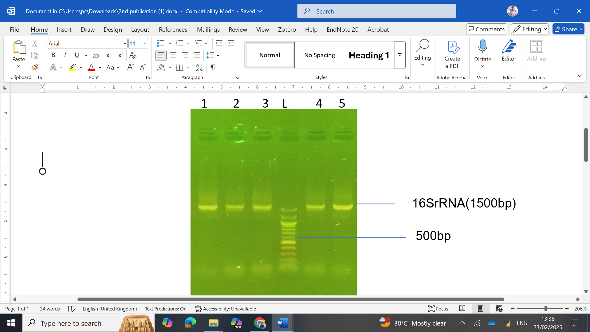

**Figure 2. Agarose gel electrophoresis sowing the amplified 16S rRNA fragment.**

Lanes 1-5 represent the amplified 16S rRNA bands at 1500 bp while L represents the 100 bp molecular ladder.

3.4 Prevalence of Antimicrobial Resistant Genes

The 6 representative *Vibrio species* were assessed for the presence of *AMPC* and *blaTEM* antimicrobial resistance genes (Figures 3 and 4). The *AMPC* resistance gene was found in all stool isolates (100%) and 2 isolates out of 3 in water samples (66.6%). The *AMPC* resistance gene was found in isolates 1, 3, 4, 5 and 6 the *blaTEM* resistance gene was found in isolates 4 in water sample with a frequency of 1 (33.3%) as shown Table 5.

**Table 5:** **Prevalence of Antimicrobial Resistant Genes in *Vibrio species***

|  |  |  |
| --- | --- | --- |
| **Isolates** | ***AMPC*** | ***TEM*** |
|  | **Human** |  |
| 1 – W1 | **+** | **-** |
| 2 – W2 | **-** | **-** |
| 3 – W3 | **+** | **-** |
| Total | **2 (66.6)** | **0 (0)** |
|  | **Water** |  |
| 4 – H1 | **+** | **+** |
| 5 – H2 | **+** | **-** |
| 6 – H3 | **+** | **-** |
| Total | **3(100)** | **1(33.3)** |
| p-value | **.2733** | **.2733** |

*p-values represent comparisons between human and control*

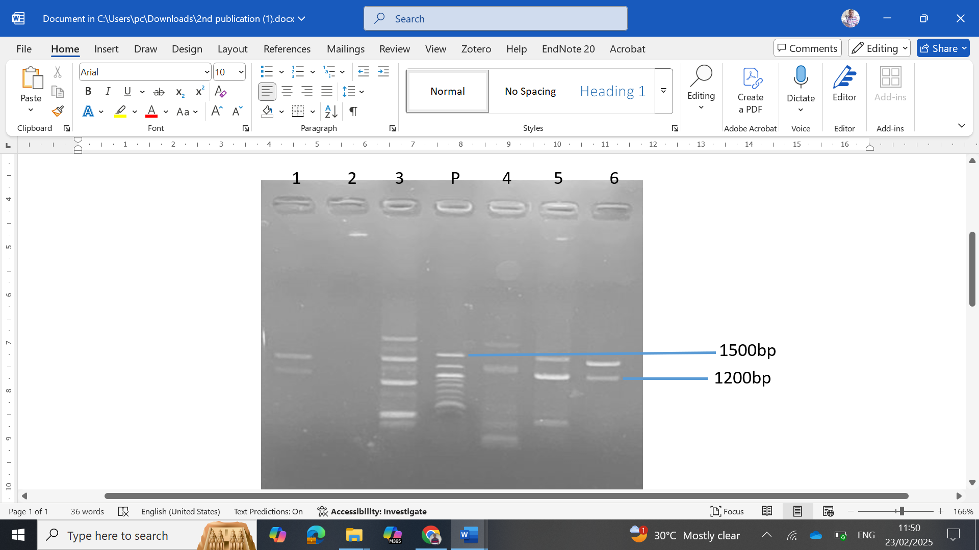

**Figure 3. Agarose gel electrophoresis of some selected bacteria isolates**.

*Lanes 1, 3, 4, 5, and 6 represent AMPC gene (1200 bp), lane P represents 100 bp DNA ladder*

**Figure 4. Agarose gel electrophoresis of some selected bacteria isolates**.

*Lane 4 represents the blaTEM gene (400 bp), lane P represent 100 bp DNA ladder.*

**3. DISCUSSION**

*Vibrio* species are typically found in estuaries and coastal areas, and they can cause serious infections in both humans and animals. The demographic composition of aquatic *Vibrio* isolates in Nigerian cities is poorly understood, despite increased knowledge of dangerous *Vibrio* isolates in aquatic environments. We looked at bacterial isolates from various aquatic habitats and human samples in Buguma, Rivers state, Nigeria, to gain a better understanding of the antibiotic susceptibility pattern and prevalence of resistant genes of these *Vibrio* strains. The current investigation was aimed at characterizing *Vibrio* speciesIsolated from Clinical Sources and Water Bodies in Buguma using molecular methods. *Vibrio* spp. was cultured and isolated using a *Vibrio*-specific selective medium (TCBS). Similar to the results of Choopun et al. [16], it was discovered that three (3) out of 40 human samples and fourteen (14) out of 40 water samples produced yellow button-shaped flattened colonies on TCBS agar. The presence of pathogens in waterbodies is frequently caused by the aftermath of animals and human fecal pollution [17]. This was consistent with our observations that the water bodies in Buguma function as both a dump and a place for human and animal stool.

On blood agar, all six isolates produced hemolytic colonies suggesting their ability to produce infection. The isolated *Vibrio* spp. was observed as motile also reported by Kaper et al. [18]. PCR is a highly sensitive molecular technique. It is frequently used for the detection of certain bacteria targeting specific genes. Specifically, the confirmation of *Vibrio* isolates from the culture in this study was achieved by molecular amplification of the 16S rRNA gene. Similar molecular techniques have also been used in earlier research to confirm and define *Vibrio* [19, 20]. In agreement with a recent study that reported that *Vibrio* species are facultative anaerobes with motility that are star-shaped or curved rods that measure 2–3 μm in length and 0.5–0.8 μm in width, our investigation's microscopy revealed that the *Vibrio* isolates were curve rods, motile, and gram-negative [21].

One of the impending threats to world health is antibiotic resistance, and given the existing patterns of rising environmental pollutants, including genes for antibiotic resistance, natural settings may serve as possible breeding grounds for antibiotic resistance [22]. The most widely used family of antimicrobial drugs are beta lactams, which are used to treat a variety of bacterial illnesses, including those caused by several *Vibrio* species, and have low toxicity [23]. It appears that beta-lactam medication resistance is still on the rise. It has been shown that plasmids contain a large distribution of the broad-spectrum TEM beta-lactamase [24]. In this study, TEM-resistant genes were not found in any of the bacteria isolated from human stool samples and were found in one of the bacteria isolated from the water sample, although phenotypically they were resistant to beta-lactam drugs. This observation could arise from other resistance mechanisms of the drug and not necessarily the acquisition of the resistant gene. Our study also noted that *AMPC* resistant genes were found in two (2) of three (3) human stool samples and found in three (3) out of three (3) in water samples this result agreed with the result of [19] who detected the presence of *TEM* and *AMPC-*resistant genes in *Vibrio species* isolated from water bodies in their studies. The detection of resistance genes from this study also correlates with a recent report [25].

The presence of this bacterium species in the aquatic environment raises worries about food safety because it can produce sickness outbreaks depending on the environment [26]. The Centers for Disease Control (CDC) recommends the use of antibiotics in conjunction with fluid replenishment to treat *Vibrio* infections [27]. Many researched antibiotics, including ampicillin, chloramphenicol, ciprofloxacin, gentamicin, erythromycin, quinolone, and tetracycline, are advised as first-line therapy for *Vibrio* infections [28]. Antibiotic resistance is a complex problem that often links environmental, pathogen, and human characteristics [29].

The antibiotic sensitivity patterns among the *Vibrio* isolates recorded showed varying degrees of resistance pattern.  Strains resistant to amoxicillin + clavulanic Acid were found to be 3 (100%) in human samples and 12 (85.7%) in water, according to susceptibility testing. Similar findings were made by Hoefler et al. [27] who found the greatest number of amoxicillin + clavulanic acid resistances in their antibiogram. One of the most successful antibiotics in primary care has had its effectiveness limited in recent years due to the emergence of bacteria resistant to the penicillin antibiotic class [30]. Conversely, the isolates in this study demonstrated 100 susceptibilities to ciprofloxacin, which contrasted with the results of Ahmed et al., who reported ciprofloxacin resistance [31]. Additionally, research on [32] Erythromycin, penicillin, cephalexin, and vancomycin was shown to be ineffective against *Vibrio* spp., whereas gentamycin, sulfamethoxazole, and chloramphenicol were found to be more effective. Nevertheless, nitrofurantoin and ciprofloxacin demonstrated a moderate level of effectiveness. Tetracycline demonstrated the least effectiveness, suggesting that it may soon develop resistance to *Vibrio* spp.

The MAR score in this study ranged from 0.25 to 0.83, indicating that areas where antibiotics are often administered are a high-risk source of contamination. The results showed that the isolated *Vibrio* spp demonstrated that gram-negative bacteria isolated from shrimp samples and aquatic habitats exhibited multidrug resistance [33]. The high prevalence of *V. cholera* spp. has been linked to the consumption of seafoods and meat products [34]. This corroborates the higher antibiotic resistance noted in bacteria from animals and other natural habitats [35, 36]. The widespread, unmonitored use of antimicrobials in the treatment of infections may enhance the likelihood that resistance genes on plasmids may be transferred horizontally among environmental isolates, leading to elevated levels of MDR [37].

A MAR higher than 0.2 indicates that high-risk sources, like farmers and farm animals that regularly take antibiotics, are the source of contamination, posing a threat to consumers. The current study found high MAR indices in water isolates, suggesting that these isolates came from high-risk sources; thus, antimicrobial resistance monitoring is critical for ascertaining the efficacy of new antibiotics and ensuring food safety [38]. Municipal and industrial wastewater has been outlined as a potential source of resistant isolates in the aquatic ecosystem. A significant amount of the antibiotics that people take for medical reasons are expelled in their feces and urine in an active biological form [39] and between 30 to 90% of the antibiotics that animals consume are also eliminated in feces and urine [40]. Antibiotic-resistant bacteria and antibiotics were found to pollute the environment through animal excreta [41]. This phenomenon was newly confirmed in a study of 20 calf farms in the Netherlands. Antibiotics were found in 75% and 95% of the calf feces and cattle farms, respectively, and the most common residual antibiotics recovered were oxytetracycline, doxycycline, and sulfadiazine [42]. It is a possible scenario for water contamination and subsequent contamination of milk and dairy products with antibiotic-resistant pathogens. Future studies are necessary to further analyze other resistance genes that have been reported in other bacteria [43, 44]. This could suggest horizontal gene transfer or uptake of naked DNA.

**4. CONCLUSION**

The antibiotic susceptibility of many *Vibrio species* that were successfully recovered from water samples and human samples is evaluated in-depth in the current study. Finding isolates with several drug-resistant *Vibrio* *species*, and antibiotic resistance genes all point to a potential risk to the public's health. This study shows the detection of two resistance genes in both human and water samples, because it is considered as pathogenic, and its infection is life threatening. Additional studies need to be carried out to ascertain whether the human infection of *Vibrio* in the study population is due to the presence of *Vibrio* in the water or the presence of *Vibrio* in the water is because the study populace defecates directly into the water which can pose to be a source of point infection.

**Ethical approval and Consent**

All authors declare that Departmental Ethical Approval and written informed consent was obtained from the patient.

Disclaimer (Artificial intelligence)

Authors hereby declare that NO generative AI technologies such as Large Language Models (ChatGPT, COPILOT, etc.) and text-to-image generators have been used during the writing or editing of this manuscript.

**References**

1. Deeb R, Tufford D, Scott GI, Moore JG, Dow K. 2018. Impact of climate change on *Vibrio* vulnificus abundance and exposure risk. Estuaries and Coasts, 41: 2289-2303.
2. Vezzulli L, Grande C, Reid PC, Hélaouët P, Edwards M, Höfle MG et al. 2016. Climate influence on *Vibrio* and associated human diseases during the past half-century in the coastal North Atlantic. Proceedings of the National Academy of Sciences, 113(34): E5062-71.
3. Ali, M, Nelson, AR, Lopez, AL, Sack, DA. 2015. Updated global burden of cholera in endemic countries. PLoS Neglected Tropical Diseases, 9(6): e0003832.
4. Vezzulli L, Colwell RR, Pruzzo C. 2013. Ocean warming and spread of pathogenic *Vibrio*s in the aquatic environment. Microbial Ecology, 65: 817-825.
5. Liao Y, Li Y, Wu S, Mou J, Xu Z, Cui R et al. 2015. Risk factors for *Vibrio* parahaemolyticus infection in a southern coastal region of China. Foodborne Pathogens and Disease, 12(11): 881-886.
6. Dechet AM, Yu PA, Koram N, Painter J. 2008. Nonfoodborne *Vibrio* infections: an important cause of morbidity and mortality in the United States, 1997–2006. Clinical Infectious Diseases, 46(7): 970-976.
7. Morris Jr JG, Acheson D. 2003. Cholera and other types of *Vibrio*sis: a story of human pandemics and oysters on the half shell. Clinical Infectious Diseases, 37(2): 272-280.
8. Centers for Disease Control and Prevention. Foodborne Diseases Active Surveillance Network: FoodNet 2011 surveillance report. 2012.
9. Newton A, Kendall M, Vugia DJ, Henao OL, Mahon BE. 2012. Increasing rates of *Vibrio*sis in the United States, 1996–2010: review of surveillance data from 2 systems. Clinical Infectious Diseases, 54(5): 391-395.
10. Weis KE, Hammond RM, Hutchinson R, Blackmore CG. 2011. *Vibrio* illness in Florida, 1998–2007. Epidemiology & Infection, 139(4): 591-598.
11. Addis T, Mekonnen Y, Ayenew Z, Fentaw S, Biazin H. 2021. Bacterial uropathogens and burden of antimicrobial resistance pattern in urine specimens referred to Ethiopian Public Health Institute. PloS one, 16(11): e0259602.
12. Talukder B, Chakma F, Sabuj AA, Haque ZF, Rahman MT, Saha S. 2019. Identification, prevalence and antimicrobial susceptibility of major pathogenic bacteria in exportable shrimp (Penaeus monodon) of southern Bangladesh. Int J Fish Aquat Stud, 7(1):96.
13. Cheesbrough M. Medical Laboratory Manual for Tropical Countries, Vol. 2: Microbiology. Tropical Health Technology; 1984.
14. Bauer AW, Kirby WM, Sherris JC, Turck M. 1966. Antibiotic susceptibility testing by a standardized single disk method. American journal of clinical pathology, 45(4): 493-496.
15. Clinical and laboratory standards institute. Performance standards for antimicrobial susceptibility testing. 30th Edition, 2020
16. Choopun N, Louis V, Huq A, Colwell RR. 2002. Simple procedure for rapid identification of *Vibrio* cholerae from the aquatic environment. Applied and environmental microbiology, 68(2): 995-998.
17. Penakalapati G, Swarthout J, Delahoy MJ, McAliley L, Wodnik B, Levy K et al. 2017. Exposure to animal feces and human health: a systematic review and proposed research priorities. Environmental science & technology, 51(20): 11537-11552.
18. Kaper JB, Nataro JP, Mobley HL. 2004. Pathogenic Escherichia coli. Nature Reviews Microbiology, 2(2): 123-40.
19. Gxalo O, Digban TO, Igere BE, Olapade OA, Okoh AI, Nwodo UU. 2021. Virulence and antibiotic resistance characteristics of *Vibrio* isolates from rustic environmental freshwaters. Frontiers in Cellular and Infection Microbiology, 11: 732001.
20. Guardiola-Avila I, Acedo-Felix E, Sifuentes-Romero I, Yepiz-Plascencia G, Gomez-Gil B, Noriega-Orozco L. 2016. Molecular and genomic characterization of *Vibrio* mimicus isolated from a frozen shrimp processing facility in Mexico. PLoS One, 11(1): e0144885.
21. Ruwandeepika HA, Madushanka DN, Jayaweera TS. 2023. Foodborne Organisms: General Characteristics, Virulence Factors, and Clinical Manifestations. InFood Microbial and Molecular Biology, 8: 213-285.
22. Hernando-Amado S, Coque TM, Baquero F, Martínez JL. 2020. Antibiotic resistance: moving from individual health norms to social norms in one health and global health. Frontiers in Microbiology, 11: 1914.
23. Bush K, Bradford PA. 2016. β-Lactams and β-lactamase inhibitors: an overview. Cold Spring Harbor perspectives in medicine, 6(8): a025247.
24. Tooke CL, Hinchliffe P, Bragginton EC, Colenso CK, Hirvonen VH, Takebayashi Y et al. 2019. β-Lactamases and β-Lactamase Inhibitors in the 21st Century. Journal of molecular biology, 431(18): 3472-500.
25. Elbadawi HS, Elhag KM, Mahgoub E, Altayb HN, Ntoumi F, Elton L et al. 2021. Detection and characterization of carbapenem resistant Gram‐negative bacilli isolates recovered from hospitalized patients at Soba University Hospital, Sudan. BMC microbiology, 21(1): 136.
26. Xu W, Gong L, Yang S, Gao Y, Ma X, Xu L et al. 2020. Spatiotemporal dynamics of *Vibrio* communities and abundance in Dongshan Bay, South of China. Frontiers in microbiology, 11:575287.
27. Hoefler F, Pouget-Abadie X, Roncato-Saberan M, Lemarié R, Takoudju EM, Raffi F et al. 2022. Clinical and epidemiologic characteristics and therapeutic management of patients with *Vibrio* infections, bay of biscay, France, 2001–2019. Emerging Infectious Diseases, 28(12): 2367.
28. Kendall PA, Val Hillers V, Medeiros LC. 2006. Food safety guidance for older adults. Clinical Infectious Diseases, 42(9): 1298-1304.
29. Butt AA, Aldridge KE, Sanders CV. 2004. Infections related to the ingestion of seafood Part I: viral and bacterial infections. The Lancet infectious diseases, 4(4):201-212.
30. Okocha RC, Olatoye IO, Adedeji OB. 2018. Food safety impacts of antimicrobial use and their residues in aquaculture. Public health reviews, 39: 1-22.
31. Centers for Disease Control and Prevention. Antibiotic resistance threats in the United States, 2019. US Department of Health and Human Services, Centres for Disease Control and Prevention; 2019.
32. Hosen MA, Ovi FK, Rashid H, Hasan MH, Khalek MA, Hasan M et al. 2021. Characterization of *Vibrio* spp. in environmental water samples collected from flood prone areas of Bangladesh and their antibiotic resistance profile. AIMS microbiology. 7(4) :471.
33. Kitaoka M, Miyata ST, Unterweger D, Pukatzki S. 2011. Antibiotic resistance mechanisms of *Vibrio* cholerae. Journal of Medical Microbiology, 60(4): 397-407.
34. Angala, PO, Mbata, CA, Monsi, TP 2024. Prevalence of *Vibrio* Species Isolated from Water Bodies in Buguma Community in Rivers State, Nigeria. International Journal of Pathogen Research, 13(6), 21–31. <https://doi.org/10.9734/ijpr/2024/v13i6318>.
35. Miller K, O’Neill AJ, Chopra I. 2002. Response of *Escherichia coli* hypermutators to selection pressure with antimicrobial agents from different classes. Journal of Antimicrobial Chemotherapy. 49(6): 925-934. <https://doi.org/10.1093/jac/dkf044>
36. Vezzulli, L, Grande, C, Reid, PC, Hélaouët, P, Edwards, M, Höfle, MG et al. 2016. Climate influence on Vibrio and associated human diseases during the past half-century in the coastal North Atlantic. Proceedings of the National Academy of Sciences of the United States of America, 113(34), 5062–5071. <https://doi.org/10.1073/pnas.1609157113>
37. Ghosh AK, Panda SK, Luyten W. 2021. Anti-*Vibrio* and immune-enhancing activity of medicinal plants in shrimp: A comprehensive review. Fish & Shellfish Immunology. 2021 Oct 1;117:192-210.
38. Matyar F, Kaya A, Dinçer S. 2008. Antibacterial agents and heavy metal resistance in Gram-negative bacteria isolated from seawater, shrimp and sediment in Iskenderun Bay, Turkey. Science of the Total Environment, 407(1): 279-285.
39. Baker-Austin C, Oliver JD, Alam M, Ali A, Waldor MK, Qadri F, Martinez-Urtaza J. *Vibrio* spp. infections. Nature Reviews Disease Primers. 2018 Dec;4(1):1-9.
40. Shivakumaraswamy SK, Deekshit VK, Vittal R, Akhila DS, Mundanda DM, Raj JR, Chakraborty A, Karunasagar I. Phenotypic & genotypic study of antimicrobial profile of bacteria isolates from environmental samples. Indian Journal of Medical Research. 2019 Feb 1;149(2):232-9.
41. Ottaviani D, Leoni F, Talevi G, Masini L, Santarelli S, Rocchegiani E et al. 2013. Extensive investigation of antimicrobial resistance in *Vibrio* parahaemolyticus from shellfish and clinical sources, Italy. International journal of antimicrobial agents. 42(2): 191-193.
42. Yu Q, Niu M, Yu M, Liu Y, Wang D, Shi X. 2016. Prevalence and antimicrobial susceptibility of *Vibrio* parahaemolyticus isolated from retail shellfish in Shanghai. Food control, 60:263-8.
43. Ordu, OW, Mbata, CA, Monsi, TP 2025. Molecular Profiling of Antibiotic-resistant *Pseudomonas aeruginosa* Isolated from Patients with Urinary Tract Infections in Rivers State University Teaching Hospital. International Journal of Pathogen Research, 14(1), 27–41. <https://doi.org/10.9734/ijpr/2025/v14i1338>.
44. Okogeri EI, Amala SE, Nwokah EG, Monsi TP. 2020. Cross-sectional study of extended spectrum β-lactamase genes (SHV, TEM, CTX-M and OXA) in *Klebsiella* species from clinical specimens in Port Hacourt, Nigeria. Am. J. Med. Sci. Med. 8:180-6.