**PHENOTYPIC AND GENOTYPIC DETECTION OF EXTENDED SPECTRUM BETA LACTAMASE GENES IN *Klebsiella pneumoniae* ISOLATES FROM URINE AND SPUTUM SPECIMEN IN NASARAWA STATE, NIGERIA**

**ABSTRACT**

The rise of extended spectrum beta-lactamase (ESBL) producing *Klebsiella pneumoniae* presents a considerable challenge to healthcare systems globally, including those in Nasarawa State, Nigeria. This study aimed at determine the phenotypic and genotypic detection of extended spectrum beta-lactamase genes in *K. pneumoniae* isolates from urine and sputum specimenin Nasarawa state. Out of the twenty eight (28) *Klebsiella pneumoniae* isolates subjected for ESBL production using Double Dics Synergy Test and were confirmed by combine Disc Method, 12 *Klebsiella* *pneumoniae* isolates were ESBL producers. Genomic DNA from ESBL producing *K*. *pneumoniae* isolates were extracted and amplified using the Polymerase Chain Reaction (PCR) with universal primer for 16srRNA while specific primers of blaCTX-M, blaTEM, and blaSHV were used. Molecular analysis identified blaCTX-M and blaSHV as the predominant ESBL gene, detected in all 12(100%) ESBL producing isolates followed by blaTEM 9(75.0%). This study underscores the urgent need for enhanced surveillance and infection control measures to curb the spread of ESBL-producing *Klebsiella pneumoniae* in Nasarawa State. Furthermore, efforts to optimize antibiotic stewardship programs and promote rational antimicrobial use are essential to preserve the efficacy of existing antibiotics.

**Keywords:** *Klebsiella pneumoniae*, antibioticresistanceand PCR

1. **INTRODUCTION**

“Extended-Spectrum Beta-Lactamase (ESBL)-producing Klebsiella pneumoniae has emerged as a critical cause of hospital-acquired infections worldwide, significantly complicating treatment options and increasing both morbidity and mortality rates” [29]. ESBLs are capable of hydrolyzing penicillins, monobactams, and cephalosporins, with the exception of cephamycins. However, as noted by [11], “these enzymes do not affect beta-lactamase inhibitors (BLIs) or carbapenems. Globally, at least 13 families of ESBLs have been identified, including CTX-M, OXA-type, TEM-type, SHV-type, IRT, CMT, GES, PER, VEB, BEL, TLA, SFO, and OXY. Among these, CTX-M, SHV-type, TEM-type, and OXA-type ESBLs are recognized as the most prevalent and active families” [4].

“ESBL genes are often found on mobile genetic elements, including plasmids, integrons, and transposons, in addition to being present on the bacterial chromosome. These mobile genetic elements play a vital role in the transfer of bacterial genes both intra- and inter-species, greatly facilitating the worldwide dissemination of antibiotic resistance” [16, 22].

Detection of ESBL production in K. pneumoniae is crucial for effective infection management. Phenotypic methods, such as the double-disc synergy test (DDST) and the combined disc test (CDT), are widely employed due to their cost-effectiveness and ease of implementation. However, these methods may not detect all types of ESBLs and can be influenced by various factors, including the quality of bacterial cultures and reagents [8]. To address these limitations, genotypic methods such as Polymerase Chain Reaction (PCR) are increasingly being used to identify specific genes responsible for ESBL production, including TEM, SHV, and CTX-M. These molecular techniques offer greater accuracy and can identify a wider range of ESBL-producing strains, which is essential for understanding the molecular epidemiology of resistance in specific regions [9].

Despite growing awareness of the problem, the prevalence of ESBL-producing K. pneumoniae in Nasarawa State remains understudied, with limited data available on both phenotypic and genotypic detection in clinical isolates. Given the increasing reports of AMR in Nigeria, it is imperative to assess the local burden of ESBL-producing K. pneumoniae using both phenotypic and molecular techniques. This research could inform local healthcare strategies and contribute to broader national efforts to combat antimicrobial resistance.

1. **MATERIALS AND METHEODS**

**2.1 CONFIRMATION OF *Klebsiella pneumoniae* isolates**

The isolates of *Klebsiella pneumoniae* were isolated from urine and sputum specimen and confirmed using Gram staining and Biochemical tests including motility test, indole test, urease test and citrate test [5]

**2.3 Double Disc Synergy Test**

Screening for ESBL-producing *K. pneumoniae* was conducted using discs of ceftriaxone, cefotaxime, ceftazidime, and Amoxicillin/Clavulanic acid (20/10 µg), in accordance with the guidelines set forth by [6]. *K*. *pneumoniae* isolates were inoculated onto Mueller-Hinton agar plates. The antibiotic discs employed included Ceftriaxone (30 µg), Cefotaxime (30 µg), Ceftazidime (30 µg), and Amoxicillin/Clavulanic acid (20/10 µg). The three cephalosporin discs were positioned 30 mm away from the clavulanate disc, which was centrally located on the plate. Following a 24-hour incubation period, a positive test result was indicated by an enhanced zone of inhibition of at least 5mm between any of the cephalosporin antibiotics and the amoxicillin/clavulanic acid disc, suggesting synergistic activity with clavulanic acid and confirming the presence of an ESBL.

**2.3 Phenotypic Confirmatory Disk Diffusion Test**

For the phenotypic confirmatory disk diffusion test, a Ceftazidime (30 µg) disc was utilized both independently and in conjunction with Amoxicillin/Clavulanic acid (20/10 µg) [6]. The antibiotic discs were positioned within 20 mm of the agar surface and incubated for 24 hours at 37°C. *K. pneumoniae* isolates were classified as ESBL producers if there was a ≥ 5 mm increase in the zone diameter for either the Ceftazidime discs or the corresponding Ceftazidime-Clavulanate discs.

**2.4 Bacterial Genomic DNA Extraction**

Extraction was done using a (Zymo Research, USA) bacteria DNA mini prep extraction kit supplied by Inqaba, South Africa. A heavy growth of the pure culture of the suspectedisolates was suspended in 200 microliters of isotonic buffer into a ZR Bashing Bead Lysis tubes, and 750 microliter of lysis solution added to the tube. The tubes were secured in a bead beater fitted with a 2ml tube holder assembly and processed at maximum speed for 5 minutes. The ZR bashing bead lysis tube were centrifuged at 10,000x*g* for 1 minute.

Four hundred (400) microliters of supernatant were transferred to a Zymo-Spin IV spin Filter (orange top) in a collection tube and centrifuged at 7000 x*g* for 1 minute. One thousand two hundred (1200) microliters of fungal/bacterial DNA binding buffer were added to the filtrate in the collection tubes bringing the final volume to 1600 microliter, 800 microliter was then transferred to a Zymo-Spin IIC column in a collection tube and centrifuged at 10,000x*g* for 1 minute, the flow through was discarded from the collection tube. The remaining volume was transferred to the same Zymo-spin and spun. Two hundred (200) microliter of the DNA Pre-Was buffer was added to the Zymo-spin IIC in a new collection tube and spun at 10,000x*g* for 1 minute followed by the addition of 500 microliter of fungal/bacterial DNA Wash Buffer and centrifuged at 10,000x*g* for 1 minute.

The Zymo-spin IIC column was transferred to a clean 1.5 microliter centrifuge tube, 100 microliter of DNA elution buffer was added to the column matrix and centrifuged at 10,000x*g* microliter for 30 seconds to elute the DNA. The ultra-pure DNA was then stored at -20 degree for other downstream reaction.

**2.5 DNA Quantification**

The extracted genomic DNA was quantified using Nano drop 1000 Spectrophotometer. The software of the equipment was launched by double clicking on the Nano drop icon. The equipmentwas initialized with 2µl of sterile nuclease free water and blanked using normal saline. Twomicrolitres of the extracted DNA was loaded onto the lower pedestal, and the upper pedestal brought down to contact the extracted DNA on the lower pedestal. The DNA concentration wasmeasured by clicking on the “measure” button.

#### **2.6 Detection of Antibiotic Resistance Genes**

#### The extracted DNA of the K. pneumoniae isolates were subjected to PCR amplification to detect blaTEM, blaSHV, and bla CTX-M genes [18]. Polymerase Chain Reaction mix included: the X2 Dream taq Master Mix (Inqaba, South Africa) (taq polymerase, DNTPs, MgCl), the primers at a concentration of 0.4M and 50ng of the extracted DNA as template. The PCR conditions were as follows: Initial denaturation, 95ºC for 5minutes; denaturation, 95ºC for 40 seconds; annealing, 56ºC for 40 seconds; extension, 68ºC for 40 seconds for 35 cycles and final extension, 68ºC for 5 minutes. The product was resolved on a 1% agarose gel at 200V for 15 minutes and visualized on blue light imaging system for a product size.

**2.7 Sequencing**

Sequencing was done using the BigDye Terminator kit on a 3510 ABI sequencer by (Inqaba Biotechnological, Pretoria South Africa). The sequencing was done at a final volume of 10µl, the components included 0.25 µl BigDye® terminator v1.1/v3.1, 2.25µl of 5 x BigDye sequencing buffer, 10µM Primer PCR primer, and 2-10ng PCR template per 100bp. The sequencing conditions were as follows 32 cycles of 96°C for 10s, 55°C for 5s and 60°C for 4min.

**2.8 Phylogenetic Analysis**

Obtained sequences were edited using the bioinformatics algorithm Trace edit, similar sequences were downloaded from the National Center for Biotechnology Information (NCBI) data base using BLASTN. These sequences were aligned using Clusta lX. The evolutionary history was inferred using the Neighbor-Joining method in MEGA 6.0 [25]. The bootstrap consensus tree inferred from 500 replicates by [11] was taken to represent the evolutionary history of the taxa analysed. The evolutionary distances were computed using the Jukes-Cantor method [15].

**3. RESULTS**

**3.2 Confirmation of** ***K. pneumoniae* ESβ**L **Producers using Combined Disc Diffusion Method**

Table 2 shows Confirmation of K. pneumoniae ESβL producers using the Double Disc Synergy Test (DDST) and Confirmed by the Combined Disc Method. The overall prevalence of ESβL producers in K. pneumoniae is 42.9%.

**3.3 Distribution of *K. pneumoniae* ESβ**L **Producers Based on Health Facility**

The distribution of K. pneumoniae extended spectrum beta-lactamases producers based on health facility. Dalhatu Araf Specialist Hospital Lafia had 45.5% prevalence of K. pneumoniae producers. General Hospital Akwanga had 42.9% prevalence K. pneumoniae producers. Federal Medical Center Keffi had 40.0% prevalence of K. pneumoniae producers. There was no significant difference in distribution of K. pneumoniae extended spectrum beta-lactamases producers based on health facility at p>0.05.

**3.4 Molecular Detection of extended spectrum beta-Lactamase Resistance Genes in Phenotypically Confirmed ESBL producing *K. pneumoniae***

Molecular detection of extended spectrum beta- lactamase resistance genes in Phenotypically Confirmed ESβL producing K. pneumoniae isolates were SHV and CTX-M genes had 12(100%) detection each, while TEM had 9(75.0%).

**Table 1. Primer sets for amplification of ESBLs resistance genes**

Gene Primer sequence (5’ 3’) TM (0C) Amplicons size (bp)

BlaSHV Forward: CGCCTGTGTATTATCTCCCT 68 293

Reverse: CGAGTAGTCCACCAGATCCT

BlaTEM Forward: TTTCGTGTCGCCCTTATTCC 72 401

Reverse: ATCGTTGTCAGAAGTAAGTTGG

BlaCTX-M Forward: CGCTTTGCGATGTGCAG 68 550

Reverse: ACCGCGATATCGTTGGT

**Table 2: Confirmation of** ***K. pneumoniae* ESβ**L **Producers using Combined Disc Diffusion Method**

|  |  |  |
| --- | --- | --- |
| Antibiotic | *K.pneumoniae* isolates  ESβL producers  No. (%) | (n=28)  Non ESβL producers  No. (%) |
| Ceftazidime (30 μg)  + 12(42.9) 16(57.1)  Ceftazidime/clavulanic  acid disc (30/10μg) | | |

**Table 3: Distribution of *K. pneumoniae* ESβ**L **Producers Based on Health Facility**

|  |  |  |
| --- | --- | --- |
| Facilities | No. Examined  *K. pneumonia isolate* | ESβL producers Non ESβL producers No. (%) No. (%) |
| DASHL 70 11 5 (45.5) 6 (54.5)    GHA 70 7 3(42.9) 4(57.1)    FMCK 70 10 4(40.0) 6(60.0)    TOTAL 210 28 12(42.9) 16(57.1) | | |

χ2 = 0.064, Df = 2, P = 0.969

Key**:** DASHL= Dalhatu Araf Specialist Hospital, Lafia

GHA = General Hospital, Akwanga

FMCK = Federal Medical Center, Keffi

**Table 4: Molecular Detection of extended spectrum beta-Lactamase Resistance Genes in**

**Phenotypically Confirmed ESBL producing *K. pneumoniae***

|  |  |  |
| --- | --- | --- |
| Gene | Frequency n =12  No. (%) |  |
| blaSHV 12(100)  blaTEM 10(83.3)  blaCTX-M 12(100) | | |

**3.4. Agarose Gel Electrophoresis of Antibiotic Resistance Genes**

*Klebsiella pneumoniae* isolates were molecularly confirmed using universal primer of 16srRNA as shown in plate 1. Agarose gel electrophoresis showed SHV gene was detected in all 12(100%) ESβLs K. pneumoniae producers as shown in Plate 2. Agarose gel electrophoresis showed TEM gene was detected in 9(75.0%) ESβLs K. pneumoniae producers as shown in plate 3.  The CTX-M gene was detected in all 12(100%) ESβLs K. pneumoniae producers as shown in Plate 4.

The obtained 16s rRNA sequence from the isolates produced an exact match during the megablast search for highly similar sequences from the NCBI non-redundant nucleotide (nr/nt) database. The 16S rRNA of the isolates showed a 100% similarity to other species. The evolutionary distances computed using the Jukes-Cantor method were in agreement with the phylogenetic placement of the 16S rRNA of the isolates within Klebsiella sp. and revealed close relatedness to Klebsiella pneumoniae, Klebsiella quasipneumoniae, Klebsiella oxytoca, and Klebsiella verricola (Plate 5).

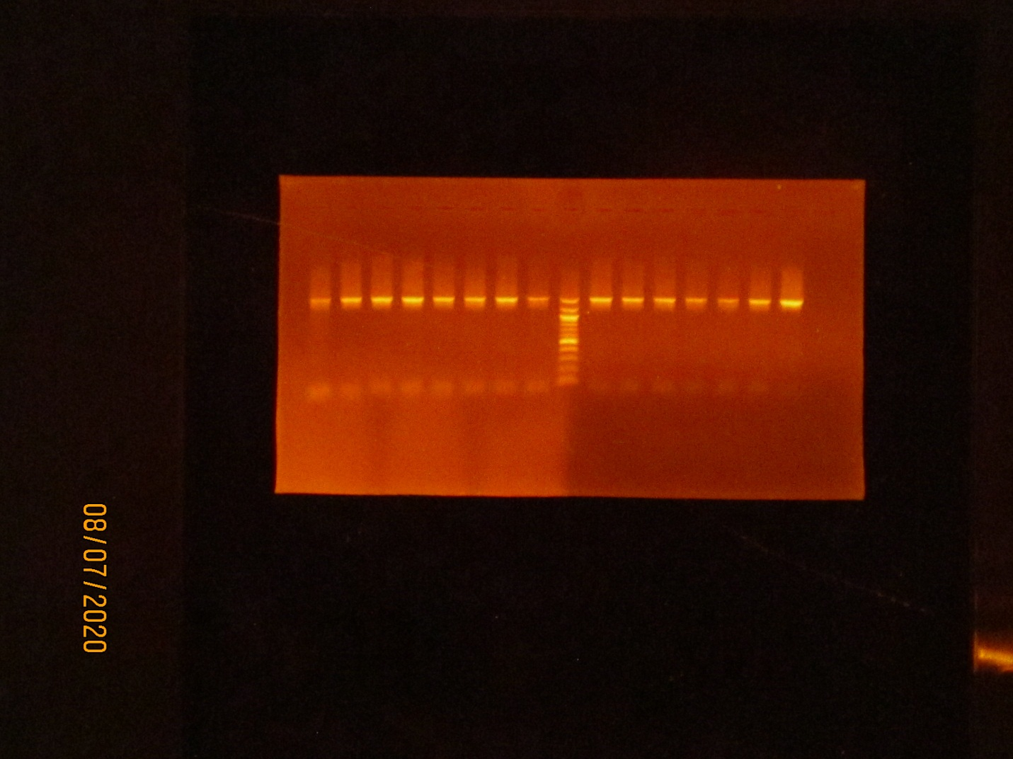

1 2 3 4 5 6 7 8 G 9 10 11 12

1500bp

500bp

Plate 1: Agarose gel electrophoresis of the isolates. Lanes 1 – 12 represent 16SrRNA gene bands (1500bp). Lane G represents the 100bp Molecular ladder shown at 500bp.

1 2 3 4 5 6 G 7 8 9 10 11 12

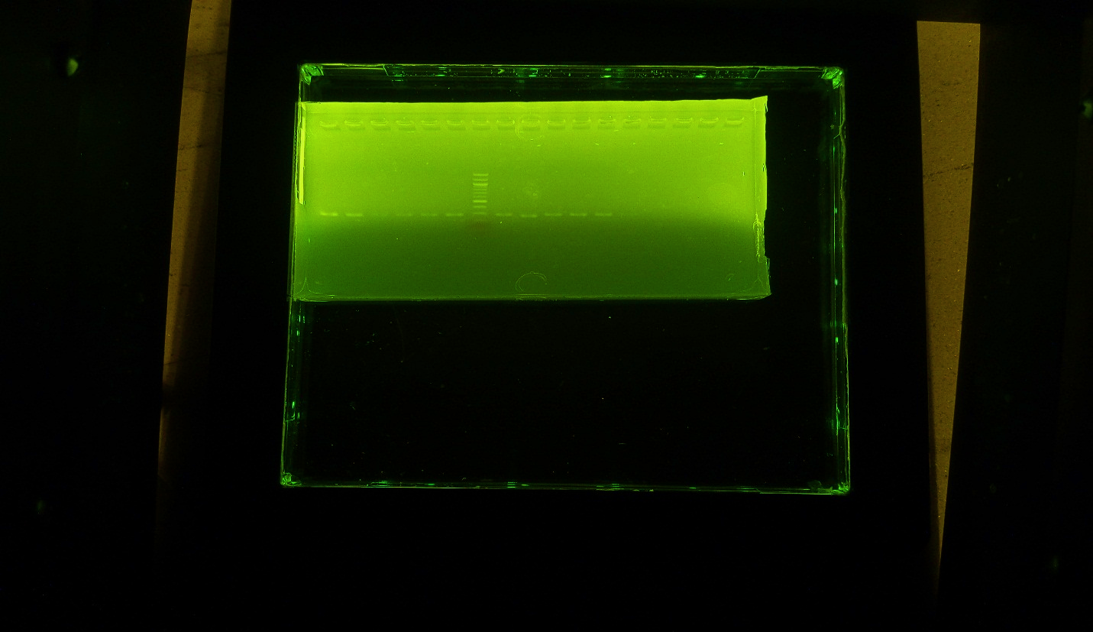

293bp

293bP

1500bp 1500bp

Plate 2: Agarose Gel Electrophoresis of SHV Gene of the Isolates. (Lanes 1 – 12

are positive genes of SHV at 293bp).

1 2 3 4 5 6 7 G 8 9 10 11 12

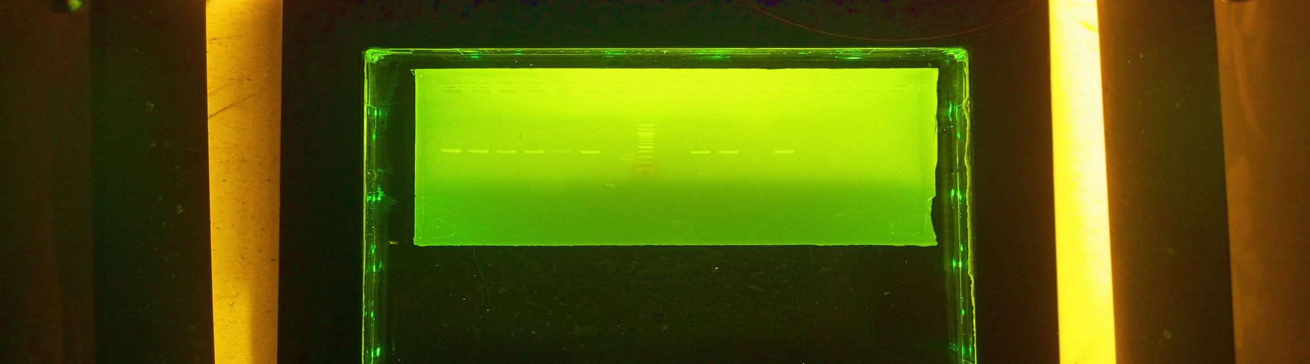

Plate 3: Agarose Gel Electrophoresis showing BlaTEM Gene of the Isolates.

(Lanes 1-6, 9-10 and 12 are positive BlaTEM Gene at 401bp).

1500bp

401bp 400bp

400bpp

400bp

1 2 3 4 5 6 7 G 8 9 10 11 12 12

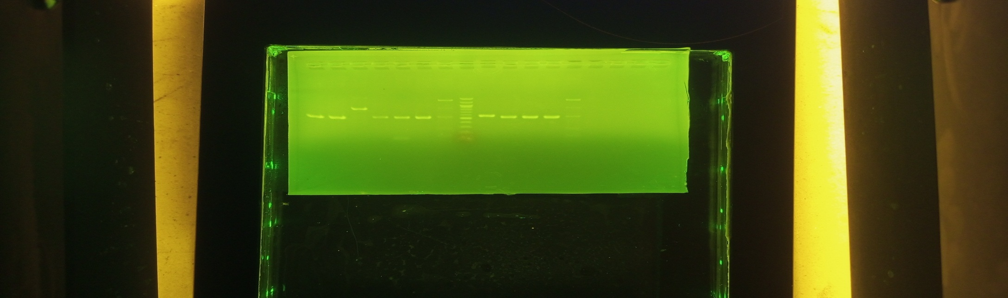

1500bp

550bp

Plate 4: Agarose Gel Electrophoresis of CTX-M Gene of the Isolates. (Lanes 1-12 are

the CTX-M Gene bands at 550bp).

1500bp

500bp

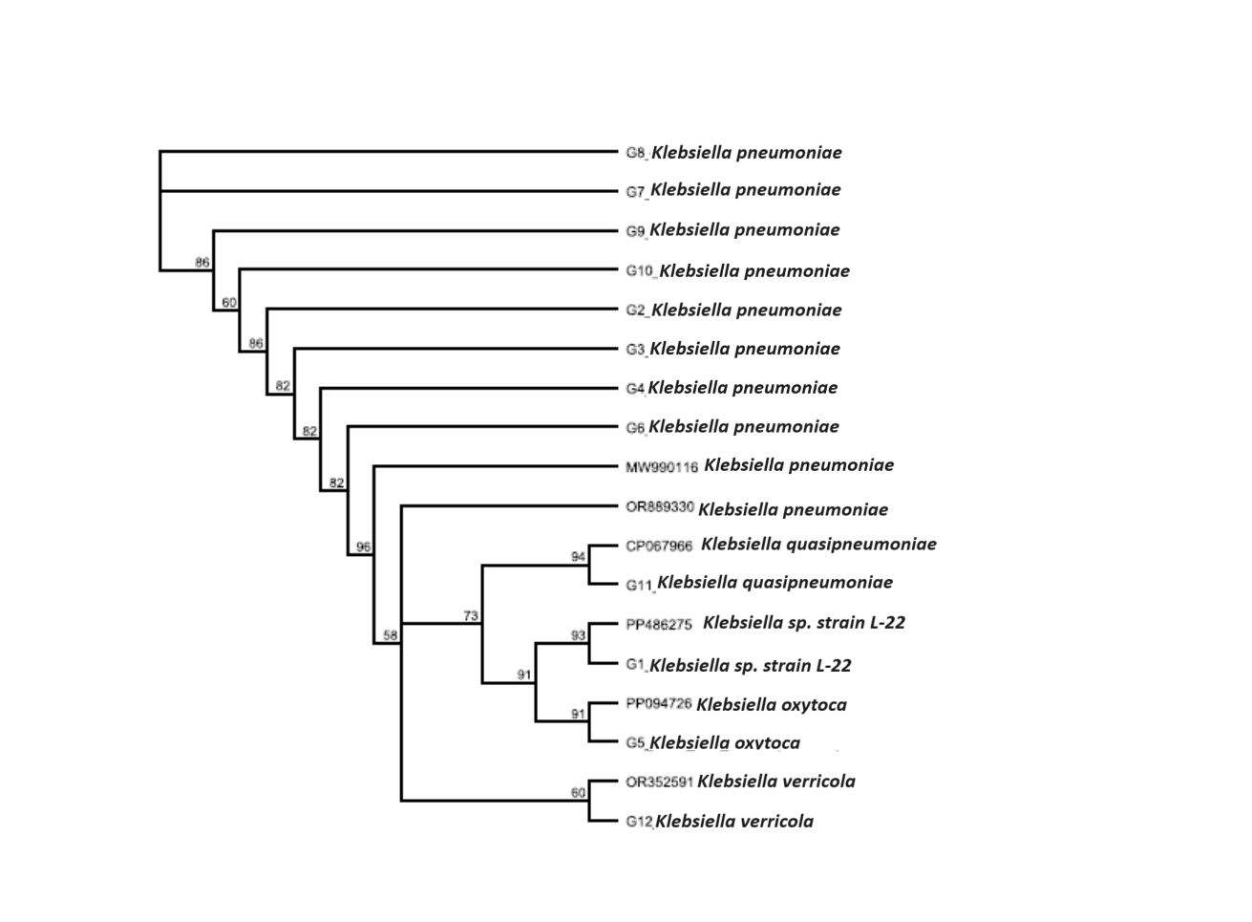Plate 5: Phylogenetic Tree showing the Evolutionary Relationship between the Bacteria

Isolates

**4. DISCUSSION**

This study showed high prevalence of ESBL-producing *Klebsiella pneumoniae* isolates of (42.9%) in urine and sputum specimen in three selected hospital in Nasarawa State, Nigeria. The ESBL prevalence reported is higher compared to prevalence of 30% and 31.6% reported by [23] in Lagos and prevalence of 28.5% in Central Nigeria [10], “26.0% previously observed for ESBL-producing *K. pneumoniae* in human samples from South Côte d’Ivoire” [26]. “In contrast, it is lower compared to ESBL prevalence of 61.2% and 62.9% among *Klebsiella* isolates reported in South-East and North-Western Nigeria in 2009 and 2017 respectively” [14, 13]. The differences between this finding and others could be attributed to the variation in antibiotic use, sensitivity and specificity of test methods compared to the other study sites of the aforementioned studies. This high prevalence suggests a significant challenge in treating infections caused by this bacterium.

The widespread and varied resistance to antibiotics presents a significant challenge, particularly in resource-limited settings. In this study, meropenem, despite its higher cost, demonstrated superior efficacy against *K. pneumoniae* isolates compared to other antibiotics. Given the notable prevalence of ESBL-producing *K. pneumoniae* identified, meropenem, amikacin, and gentamicin appear to be the preferred treatment options for critically ill patients in Nasarawa State, Nigeria. While ampicillin and amoxicillin are more affordable and readily accessible, this may have contributed to the increased resistance observed in *Klebsiella pneumoniae* against these drugs.

“A global rise in the prevalence of ESBL-producing bacteria has been documented; however, there is significant variation in the specific patterns and rates observed across different countries and regions” [2, 21]. These differences may stem from variations in the sources and volume of isolates analyzed. Unlike this study, which focused on three moderately sized hospitals in Nasarawa State, Nigeria, the research conducted in Iran involved a surveillance approach, pooling isolates from seven major teaching hospitals nationwide. The widespread presence of multidrug-resistant bacteria poses serious public health challenges, particularly within healthcare settings.

“In addition to their therapeutic implications, multidrug-resistant pathogens possess a significant capacity to develop further resistance and can spread extensively within hospital settings, thereby increasing the risk to infection control efforts” [27]. “These organisms are associated with a rise in admissions to intensive care units (ICUs), as well as increased morbidity and mortality rates, along with a higher incidence of bloodstream infections, surgical site infections, hospital-acquired pneumonia, and other healthcare-associated infections” [3]

“Antibiotic resistance is increasingly associated with various β-lactamase variants, including TEM, SHV, CTX-M, PER, and KPC” [7]. “Screening for resistance genes revealed that CTX-M and SHV were present in all ESBL-producing *K. pneumoniae* isolates, while TEM was found in a smaller number of these isolates. These results align with recent studies conducted in North-Eastern Nigeria, which identified the SHV gene as the most prevalent” [21], and in Chad, where “CTX-M was the most frequently reported resistant gene among ESBL-producing Enterobacteriaceae” [19]. The presence of *K. pneumoniae* isolates supports the global dissemination of the CTX-M β-lactamase enzyme, as documented in regions such as America [32], Europe [17] the Middle East [30], Asia [33], and Africa [20]. Research in Nigeria by [14, 23] and [1] “further corroborates the high prevalence of the blaCTX-M type. The presence of ESBLs mediated by blaCTX-M type β-lactamase genes is clearly the most widespread among *K. pneumoniae*. The significant number of ESBL producers carrying multiple genes in this study raises concerns and may help explain the observed high levels of drug resistance, even in the presence of β-lactamase inhibitors. It is probable that these isolates produce β-lactamase enzymes in excess, thereby neutralizing the effects of the inhibitors” [24].The presence of these genes on plasmids facilitates their transmission, highlighting the necessity for effective infection control measures to curb their spread. Conversely, a multi-center study from tertiary care hospitals in India indicated that TEM was the most prevalent ESBL gene among clinical isolates of *Klebsiella pneumoniae*. This discrepancy in the distribution of ESBL resistance genes across different geographical areas underscores the importance of ongoing surveillance to inform antimicrobial treatment choices.

The genes responsible for extended-spectrum beta-lactamases (ESBL) are carried on plasmids, which significantly increases the risk of resistant gene transfer between bacterial species. Containing outbreaks of ESBL-producing bacteria presents a considerable challenge, particularly in many developing countries where treatment options are often limited. Furthermore, inadequate infection prevention and control (IPC) practices, along with insufficient antibiotic stewardship in numerous healthcare facilities, may facilitate the global emergence and dissemination of resistant bacteria [31].

**CONCLUSION**

The prevalence of ESBL-producing *Klebsiella pneumoniae* isolates at 42.9% in Nasarawa State is a significant public health concern. The predominant ESBL gene were blaCTX-M and blaSHV. The high incidence of these multidrug-resistant pathogens highlights the urgent need for comprehensive strategies to combat antimicrobial resistance and improve patient outcomes. For the detection, the phenotypic confirmatory disc diffusion test is simple, sensitive, and cost effective. Effective measures must be implemented to enhance infection control practices, optimize antibiotic stewardship programs, and strengthen surveillance efforts to monitor and mitigate the spread of ESBL-producing bacteria. Furthermore, investment in research and development is crucial to identify alternative treatment options and develop innovative solutions to address the growing threat of antimicrobial resistance in Nasarawa State and beyond.

Disclaimer (Artificial intelligence)

Option 1:

Author(s) hereby declare that NO generative AI technologies such as Large Language Models (ChatGPT, COPILOT, etc.) and text-to-image generators have been used during the writing or editing of this manuscript.

Option 2:

Author(s) hereby declare that generative AI technologies such as Large Language Models, etc. have been used during the writing or editing of manuscripts. This explanation will include the name, version, model, and source of the generative AI technology and as well as all input prompts provided to the generative AI technology

Details of the AI usage are given below:

1.

2.

3.

**REFERENCE**

1. Aibinu, I., Odugbemi, T., Koenig, W. and Ghebremedhin B. (2012). Sequence Type ST131 and ST10 Complex (ST617) predominant among CTX-M-15-producing *Escherichia coli* isolates from Nigeria. *Clinical Microbiology and Infectious,* 18(3): 49–51
2. Begum, S., Salam, M.A., Alam, K.F., Begum, N., Hassan, P. and Haq, J.A. (2013) Detection of extended spectrum β-lactamase in Pseudomonasspp. Isolated from two tertiary care hospitals in Bangladesh. *BMC Research Notes*, 6:7-26.
3. Cairns, S., Reilly, J. and Booth, M. (2010). Prevalence of healthcare-associated infection in Scottish intensive careunits. *Journal Hospital Infection,* 76(4):308–10.
4. Castanheira, M., Simner, P.J. and Bradford, P.A. (2021). Extended-spectrum β-lactamases: An update on their characteristics, epidemiology and detection. *JAC- Antimicrobial Resistance,* 3(3):092.
5. Cheesbrough, M. (2016). *Medical laboratory manual for tropical countries,* 2 nd ed.; Cambridge Press: Cambridge, England; pp. 292–308
6. Clinical and Laboratory Standards Institute (2022). M100: Performance Standards for Antimicrobial Susceptibility Testing*.* 32nd ed. Clinical and Laboratory Standards Institute; Wayne, PA, USA.
7. Coque TM, Baquero F, Canto´n R. (2008). Increasing prevalence of ESBL-producing Enterobacteriaceae in Europe. *Europe Surveillance*, 13(47): 19044
8. Duggett, N., Ellington, M. J., Hopkins, K. L., Ellaby, N., Randall, L., Lemma, F., Teale, C., & Anjum, M. F. (2021). Detection in livestock of the human pandemic *Escherichia coli* ST131 fimH30(R) clone carrying blaCTX-M-27. Journal of Antimicrobial Chemotherapy, 76(1), 263–265.
9. El Aila, N. A., Al Laham, N. A., and Ayesh, B. M. (2023). Prevalence of extended spectrum beta lactamase and molecular detection of blaTEM, blaSHV and blaCTX-M genotypes among Gram negative bacilli isolates from pediatric patient population in Gaza strip. BMC Infectious Diseases, 23(1), 99.
10. Enyinnaya, S.O., Iregbu, K.C., Uwaezuoke, N.S, Abdullahi, N and Lawson, S.D. (2021). Molecular Detection and Antibiotic Susceptibility profile of ESBL-producing *Klebsiella pneumoniae* isolates in a Centaln Nigerian Tertiary Hospital***.*** *Journal of Medical Science,* 11(2): 81-186*.*
11. Felsenstein, J. (1985). Confidence limits on phylogenies: An approach using the bootstrap. *Evolution,* 39: 783-791. Gilbert, G.L. and Kerridge, I. (2020). Hospital Infection Prevention and Control (IPC) and Antimicroial Stewarship (AMS): Dual Strategies to Reduce Antibiotic Resistance (ABR) in Hospitals, pp 89–108
12. Ghafourian, S., Sadeghifard, N., Soheili, S. and Sekawi, Z. (2015). Extended Spectrum Beta Lactamases producing Enterobacteriaceaes in the USA dairy cattle farms and implications for public health. *Antibiotics*, 11:13132
13. Ibrahim, Y., Sani, Y., Saleh, Q., Saleh, A. and Hakeem, G. (2017). Phenotypic Detection of Extended Spectrum Beta lactamase and Carbapenemase Co-producing Clinical Isolates from Two Tertiary Hospitals in Kano, North West Nigeria. *Ethiopia Journal of Health Science*, 27:3–10
14. Iroha, I., Ezeifeke, G., Amadi, E. and Umezurike, C. (2009). Occurrence of ESBL producing Resistant *E. coli* and *K. pneumoniae* in clinical isolates and associated risks factors. *Research Journal of Biological Sciences,* 4:588–592.
15. Jukes, T.H. and Cantor, C.R. (1969). Evolution of protein molecules. In Munro HN, editor, Mammalian Protein Metabolism. Academic Press, New York, pp 21-132
16. Juraschek, K., Malekzadah, J., Malorny, B., Kasbohrer, A., Schwarz, S., Meemken, D. (2022). Characterization of qnrB-carrying plasmids from ESBL- and non-ESBL-producing *Escherichia coli*. *BMC Genom.* 23:365.
17. Livermore, D.M. (2008). Defining an extended-spectrum b-lactamase. *Clinical Microbiology and Infection*, 1: 3–10
18. Magiorakos, A.P.; Srinivasan, A.; Carey, R.B.; Carmeli, Y.; Falagas, M.E.; Giske, C.G.; Harbarth, S.; Hindler, J.F.; Kahlmeter, G.; Olsson-Liljequist, B.(2012). Multidrug-Resistant, Extensively Drug-Resistant and Pandrug-Resistant Bacteria: An International Expert Proposal for Interim Standard Definitions for Acquired Resistance. *Clininical Microbiology Infectious*, *18*, 268–281.
19. Mahamat, O.O., Lounnas, M., Hide, M., Dumont, Y., Tidjani, A. and Kamougam, K. (2019). High prevalence and characterization of Extended-spectrum ß-lactamase producing Enterobacteriaceae in Chadian hospitals. *BMC Infectious Diseases,* 19: 205
20. Mshana, S.E., Hain, T., Domann, E., Lyamuya, E.F., Chakraborty, T., Imirzalioglu, C. (2013). Predominance of *Klebsiella pneumoniae* ST14 carrying CTX-M-15 causing neonatal sepsis in Tanzania*. BMC Infectious Diseases*; 13:466
21. Odumosu, B.T., Ajetunmobi, O., Dada-Adegbola, H. and Odutayo, I. (2016). Antibiotic susceptibility pattern and analysis of plasmid profiles of *Pseudomonas aeruginosa* from human, animal and plant sources. Springerplus; 5:1381
22. Partridge, S.R., Kwong, S.M., Firth, N. and Jensen, S.O. (2018).Mobile Genetic Elements Associated with Antimicrobial Resistance. *Clinical Microbiology Review*, 31(4): 22-34
23. Raji, M.A., Jamal, W., Ojemeh, O. and Rotimi, V.O. (2015). Sequence analysis of genes mediating extended-spectrum beta-lactamase (ESBL) production in isolates of Enterobacteriaceae in a Lagos Teaching Hospital, Nigeria*. BMC Infectious Diseases,* 15, 259
24. Rawat, D and Nair, D. (2010). Extended-spectrum β-lactamases in gram negative bacteria. *J Glob Infectious Diseases,* 2(3): 263–274.
25. Saitou, N. and Nei, M. (1987). The neighbor-joining method: A new method for reconstructing phylogenetic trees. *Molecular Biology and Evolution,* 4: 406-425.
26. Tahou, J.E., Guessennd, N.K., Sokouri, P.D., Gbonon, V., Konan, F. and Kouadio, J. (2017). Antimicrobial resistance of *Klebsiella pneumoniae* – ESBL producing strains isolated from clinical specimens in Abidjan (Côte d’Ivoire). *Microbiology Research Journal International,* 20(2): 1-7.
27. Weiner, L.M., Webb, A.K., Limbago, B., Dudeck, M.A., Patel, J., Kallen, A.J. (2016).Antimicrobial-Resistant Pathogens Associated with Healthcare-Associated Infections: Summary of Data Reported o the National Healthcare Safety Network at the Centers for Disease Control and Prevention, 2011-2014. *Infection Control Hospital Epidemiology*, 37(11): 301-1288.
28. Yarima, A., Haroun, A.A., Bulus, T. and Manga, M.M. (2020). Occurrence of Extended Spectrum Beta Lactamase Encoding Genes among Urinary Pathogenic *Escherichia coli* and *Klebsiella pneumoniae* Isolate*s* obtained from a Tertiary Hospital in Gombe Nigeria. *Journal of Bioscience and Medicine*, 8(9): 42–55
29. Zong, Z., Liu, L., Feng, Y., Wei, L., Xiao, Y. (2021). KPC-2-Producing Carbapenem-Resistant Klebsiella pneumoniae of the Uncommon ST29 Type Carrying OXA-926, a Novel Narrow-Spectrum OXA β-Lactamase. Frontiers in Microbiology, 12, 701513
30. Al Hashem, G., Al Sweih, N., Jamal, W. and Rotimi, V.O. (2011). Sequence analysis of blaCTX-M genes carried by clinically significant *Escherichia coli* isolates in Kuwait hospitals. *Medical Principles and Practice*, 20(3): 213–219
31. Gilbert, G.L. and Kerridge, I. (2020). Hospital Infection Prevention and Control (IPC) and Antimicroial Stewarship (AMS): Dual Strategies to Reduce Antibiotic Resistance (ABR) in Hospitals, pp 89–108
32. Boyd, D.A., Tyler, S., Christianson, S., McGeer, A., Muller, M.P. and Willey, B.M. (2004). Complete nucleotide sequence of a 92-kilobase plasmid harboring the CTX-M-15 extended-spectrum beta-lactamase involved in an outbreak in long-term-care facilities in Toronto, Canada *Antimicrobial Agents Chemotherapy*, 48(10): 64-3758
33. Hawkey, P.M. (2008). Prevalence and clonality of extended-spectrum beta-lactamases in *Asia Clinical Microbiology and Infection,* 14(1): 65-159.