Growth performance of Maize (Zea mays L.) under different micro-climatic regimes

.

ABSTRACT

A field experiment was carried out during rabi, 2021-22 at the Instructional-Cum-Research (ICR) Farm of Assam Agricultural University, Jorhat to study the influence of weather on rabi maize (cv. DKC-9081) grown under different micro-climatic regime (MRI: 15th October, MR-II: 30th October, MR-III:15th November, MR-IV: 30th November and MR-V: 15th December), following a randomized block design (RBD) with four replications. Biometric observations, viz., leaf area index, plant height, total dry weight production, number of cobs per plant, cob weight, cob length, cob girth, number of rows per cob, number of grains per row, 1000 grain wt., and grain yield were recorded. The optimum sown crop (15th October) took 130 days from sowing to maturity, while the 15th December sown crop took 155 days to mature. A gradual increase in the duration of the total growing period was observed in late-sown crops. The PAR interception was maximum in the case of the crops sown under MR-I (81.21%) followed by MR-II (79.60%), MR-III (60.0%), MR-IV (56.05%) and MR-V (42.97%). The higher number of cobs per plant (1.57) and higher cob weight (201.8g) were observed under MR-I. The leaf area index (LAI) and total dry weight were found to be highest under MR-I and the lowest under MR-V. Overall, the highest grain yield was recorded for the crops sown on 15th October (5106.25 kg/ha) as compared to other dates of sowing. The grain yield declined up to 33 per cent when seeds were sown during the first fortnight of December (MR-V) compared to the early sowing (MR-I). Correlation studies revealed that there is a significant relationship between grain yield, maximum LAI, total biomass, and cob weight with meteorological parameters computed for different growth stages of the crop. It shows that the grain yield was significantly negatively associated with minimum temperature during the reproductive (-0.96**) and maturity (-0.94**) phase and rainfall during the maturity (-0.87*) phase.

Keywords: Maize, DKC-9081, Microclimatic regime, RBD, Biometric observations

1. INTRODUCTION

Maize (Zea mays L.) is considered to be one of the most important cereal crops, which ranks second in terms of acreage and third in terms of production globally (Sanodiya et. al., 2023). It is popularly known as the “Queen of cereals”, “Contingent crop”, “Miracle crop” and an emerging industrial crop, belonging to the grass family commonly known as Poaceae. The crop is less water demanding compared to other similar cereals and being a C₄ as well as a ‘day neutral plant’, it gives a higher yield per hectare in a shorter period and can be grown in any season. India ranks 4th in area and 7th in production among countries that cultivate maize (Indiastat, 2025). Traditionally, maize has been cultivated as a rain-fed crop extensively throughout the country during the kharif season, but recent research coupled with emerging technologies have enabled the maize crop to adapt itself to other growing seasons. Even though the crop has benefited from better crop management in both kharif and rabi seasons, nowadays, rabi maize is becoming a significant crop in non-traditional locations and seasons in India.
The influence of sowing time and the effect of varying weather parameters on the different stages of the maize growing cycle will provide valuable knowledge regarding the significant impact on the growth and yield of this crop. Sowing of the crop at the right time ensures better plant growth, development, and yield due to exposure of the crop to a favorable microclimate needed for better utilization of available resources and also inhibits weed growth. There is evidence that the optimum time of sowing is one of the several cultural manipulations and plays a vital role in boosting the yield, particularly in the Indian sub-continent, where the optimum time of sowing varies to a great extent due to widely varying agro-climatic conditions, depending on fluctuations in temperature and soil moisture content particularly during the rabi season. Liu et al. (2025) in their investigation on the impacts of future climate change on summer maize production under different IPCC-SSPs revealed a variation of 12.8 and 18.0 per cent, due to a projected rise in temperature by 2.2 °C and 3.3 °C, respectively along with an increase in the solar radiation by 7.0 and 14.4 per cent, respectively. Such findings were also in consonance with that of Hasson and Ahmed (2025) and Şimon et al. (2025) who reported considerable variation in plant height, leaf area index, grains per cob and grain yield with slight alteration in the sowing dates of maize.

The optimum sowing time of rabi maize may vary from one variety to another and also from one region to another due to variations in the agroclimatic conditions. Further, the phenotypic coefficient of variation generally exceeds the genotypic coefficient of variation in maize, indicating substantial influence of environmental interactions on the crop (Hasan et. al., 2025). So, the determination of the optimum sowing time for rabi maize is very crucial for determining the final yield of the crop. Therefore, it was felt necessary to conduct this experiment to determine of appropriate time of sowing of rabi maize and to study the influence of different microclimatic regimes on growth and yield of the crop.

2. material and methods

2.1 Study Area-
The present study was carried out in ICR (Instructional-Cum-Research) farm Assam Agricultural University, Jorhat, Assam. The research farm is located at a latitude of 26°47' N and a longitude of 94°12' E. The altitude of the farm is 87 m above the mean sea level. Jorhat is located in a sub-tropical belt with hot and humid summers and cold and dry winters. The mean annual rainfall is nearly 1900 mm, of which 62.6 per cent is received during south-west monsoon from June to September. During post monsoon, pre-monsoon and winter season, the station receives 7.5, 26.2 and 3.7 per cent of annual rainfall, respectively. The rainy season starts in the mid of March and quantum of rainfall as well as number of rainy days increase gradually and reach maximum in the month of July and then decline to minimum during December. Monthly morning relative humidity of the station always remains above 85 per cent, whereas monthly evening relative humidity varies from 61 to 76 per cent throughout the year. The monthly average maximum and minimum temperatures vary from 22.6 to 32.7°C and 9.7 to 25.2°C, respectively.

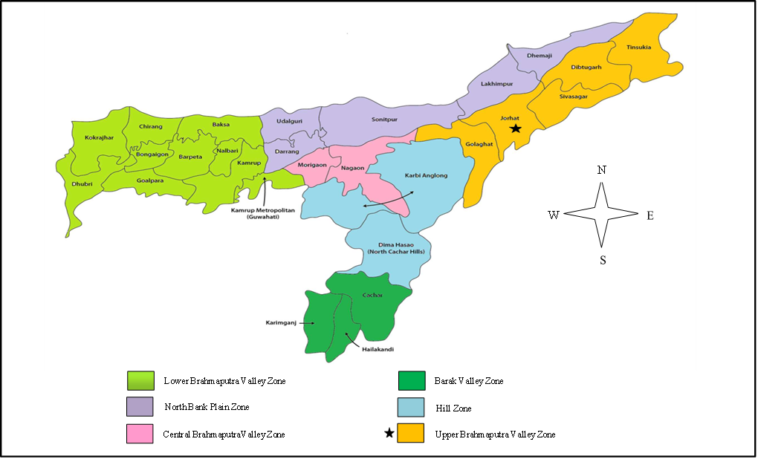
Fig 1: Map of Assam showing the location of the experimental site
2.2 Experimental Design-
The experiment was carried out following a Randomized Block Design (RBD) with 4 replications. The treatments consisted of one variety (DKC-9081) and five different Microclimatic Regimes (MR) (i.e., dates of sowing). The treatments details are: MR-I (1st sowing): 15th October, 2021, MR-II (2nd sowing): 30th October, 2021, MR-III (3rd sowing): 15th November, 2021, MR-IV (4th sowing): 30th November, 2021, MR-V (5th sowing): 15th December, 2021. The district Jorhat is located in a sub-tropical belt with hot and humid summers and cold and dry winters. The soil at the experiment location was sandy loam in type and had a pH of 5.9. The crop variety was DKC-9081 having very high yield potential.
Layout of the experiment:
Design : RBD
Variety : DKC-9081
Plot size : 4.2m × 3m
Total number of plots : 20
Treatments : 5 Nos. (viz., MR-I, MR-II, MR-III, MR-IV & MR-V)
MR-I (1st sowing) : 15th Oct, 2021
MR-II (2nd sowing) : 30th Oct, 2021
MR-III (3rd sowing) : 15th Nov, 2021
MR-IV (4th sowing) : 30th Nov, 2021
MR-V (5th sowing) :15th Dec, 2021
Replication (R) : 4 Nos.
Net area : 252 m²
Gross area : 392.4 m²

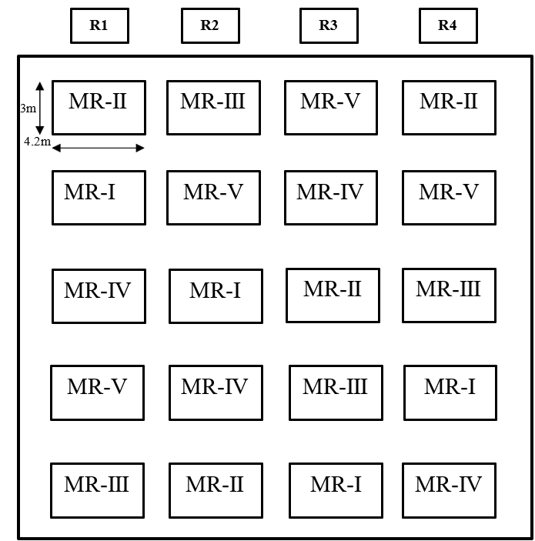
Fig 2: Layout of Experiment
To determine the physical and chemical properties of the experimental field representatives of soil samples were collected randomly from the above 0-15 cm soil layer before starting the experiment and were tested. It was observed that the soil of the area was loamy with medium organic carbon content (0.62%), acidic in nature (pH 5.9) with low available N (220.7 Kg ha⁻¹), medium P₂O₅ (28.7 Kg ha⁻¹) and low K₂O (130.5 Kg ha⁻¹) content.
After field preparation, the layout of the experiment was laid out and fertilizers were applied as per the recommendation for the crop i.e., in a dose of 60:40:40 kg of N: P₂O₅:K₂O per ha land area. Before sowing, half of the nitrogenous fertilizers (urea), full dose of phosphatic (SSP), and potassic (MOP) fertilizers were applied as uniformly as possible. During the earthing-up process, the remaining half of the nitrogen fertilizer (urea) was applied as a top dressing. After applying the basal dose of fertilizer in the rows, the seed was sown as per the treatment manually. After sowing, the lines were closed with the soil and pressed slightly to have good contact with the seed with the soil. Gap filling was done 7 DAS by dibbling method to maintain the required plant population as per spacing. To eliminate weeds from the field, two hand weeding at knee height and tasselling stage were performed.

2.3 Meteorological observation-
Daily data of weather variables, viz. maximum and minimum temperature, relative humidity during morning and evening hours, rainfall, pan evaporation, wind speed, and bright sunshine hours (BSSH) for the entire crop growing season were collected from the Agrometeorological Observatory of the Department of Agrometeorology, AAU, Jorhat.
2.4 Micrometeorological observation-
Photosynthetically Active Radiation (PAR)
The components of PAR viz. incident PAR (IPAR), reflected PAR (RPAR), and transmitted PAR (TPAR) were measured on each plot at an interval of 15 days starting from 15 DAP with the help of Line Quantum Sensor (Made: Apogee, Model: MQ301, Serial:1288) at the local solar noon hours (around 11:30 am) in order to eliminate the effect of solar elevation following Sivakumar and Virmani (1984). The observations on PAR were recorded only on bright sunny days and three readings of each component from each of the plots were taken and their averages were considered for more accuracy.

Intercepted Photosynthetically Active Radiation

Intercepted PAR (iPAR) by a crop canopy is the difference between incoming PAR flux density at the top of the canopy (IPAR) and PAR flux density transmitted (TPAR) through the crop canopy to the soil surface (Gallo and Daughtry, 1986). Reflected (RPAR), is to be considered to work out the amount of PAR absorbed in the canopy. Percent intercepted PAR (i.e., iPAR) in the crop canopy in this study was calculated by using the formula given below following Kumar et al. (2008) and Dhaliwal et al. (2019).

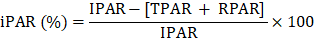 Eq. No. 1
where, IPAR = Incident photosynthetically active radiation
RPAR = Reflected photosynthetically active radiation
TPAR = Transmitted photosynthetically active radiation

IPAR was recorded by holding the sensor horizontally over the crop stand
RPAR was recorded by holding the sensor inverted over the crop stand
TPAR was recorded at bottom of the canopy by placing the sensor across the row

2.5 Biometric observations
Biometric observations were recorded during the crop experimentation period. The plant height, crop phenology, leaf area, and plant dry weight were taken at different intervals after sowing. Phenological events were identified by observing the plants on alternate days- Emergence, 6 leaf stage, anthesis, silking, dough, and physiological maturity. Then the No. of days taken to attain various phenological events was worked out. For leaf area measurement, observations were taken at 15 days intervals starting from 30 days after sowing. The mean value per plant was used in calculating the LAI using the formula given by Watson (1952) as follows:

Eq. No. 2

Yield and yield attributing parameters such as number of cobs per plant, cob length, cob girth, cob weight, number of rows per cob, number of grains per row, 1000 grain wt., grain yield, and plant dry weight, were calculated at the time of maturity.
To calculate grain yield, cobs were randomly collected from each plot according to the treatment and weighed without the husk to estimate the yield and expressed in kg ha⁻¹. To obtain the Plant Dry Weight, five plant samples were selected randomly in each plot leaving 30 cm from the border and then cut close to ground level, The plant sample was kept in a well-labeled brown paper bag and dried in the sun. After sun-dried then it was kept in the oven at 80 °C and dry weight was recorded, when the sample attained a constant weight.

2.6 Correlation analysis
To observe the influence and association between yield and yield attributes with weather variables under the Agro-climatic condition of Jorhat, Karl Pearson’s coefficient of correlation was performed and significance was tested.
The correlation coefficient between ‘x’ and ‘y’ usually denoted by the symbol ‘r_{(x, y)’} is mathematically represented as:

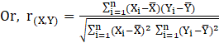 Eq. No. 3
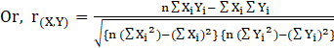 Eq. No. 4
where,
‘x_{i}’ and ‘y_{i}’ are two dataset x₁, x₂, x₃………x_{n} and y₁, y₂, y₃…….y_{n} respectively, each containing ‘n’ observations.
2.7 Test of significance for ‘r’
A 't-test' was done to test the significance of the observed sample correlation coefficient. If ‘r’ is the observed correlation coefficient in a sample of ‘n’ pairs of observation from a bivariate normal population then, under the Null Hypothesis (H_{o}) i.e., the population correlation is zero, ‘t’ is given by,
t = 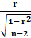 with (n-2) degrees of freedom Eq. No. 5

3. results and discussion

Biometric observation:

In order to study the occurrence of various phenological events in maize and the dates at which a particular phenological event occurred, phenophase-wise data were recorded throughout the crop growth period by observing the ten numbers of randomly selected tagged plants from each plot. Then the No. of days taken to attain various phenological events i.e., emergence, six-leaf stage, anthesis, silking, dough, and physiological maturity under five different growing environments were worked out and presented in Table 1.
It was observed that, when sowing was delayed, there was a significant increase in the number of days needed for the crop to mature. The maximum number of days to attain different phenological events in the case of the crop sown on 15th December (MR-Ⅴ) was probably due to exposure of the different phenophases to the lower daily maximum and minimum temperatures as compared to that experienced by the other dates of sowings. Air temperature, particularly the minimum temperature (range of 6.2-20.1 ℃) that prevailed during late sowing windows, significantly delayed germination, extending the number of days for emergence. The temperature gradient experiment done by Khaeim et al., 2022, established that temperature significantly affected germination duration and seedling growth, and 20 °C was found to be ideal, with an optimal range of less than 30 °C. Seeds sown early had a short emergence period lasting only a few days that increased with each delay in sowings. Also, the early sown crops took minimum days for tasseling and silking as compared to the late sown crop might be due to early germination and emergence, optimum maximum and minimum temperature, which might have increased crop growth rate, and initiated early tasseling and silking. The optimal temperature for both tassel initiation and anthesis was 28 degrees Celsius, above which the development rate slowed (Warrington and Kanemasu, 1983). This result also supports that of the findings of Prasad et al. (2017), who reported delay in days to 50 per cent tasseling and 50 per cent silking with delay in sowing time by twenty days from normal sowing time as compared to ten days advance, normal, and ten days delayed sowings. Days from silking to physiological maturity decreased with the subsequent delay in sowing because the crop experienced higher temperatures during the later stages. This result also confirms the findings of Sutaliya and Singh (2005). They reported that the crop sown on December 30th experienced higher temperatures throughout later growth stages than the crop sown on December 15th, there was a shorter maturity period for the 30th December sown maize crop compared to the crop sown on 15th December.
The data on the LAI of maize under various treatments were collected starting from 30 DAS at an interval of 15 days and continued up to harvesting. Data of leaf area index (LAI) for each micro-climatic regime are presented in Fig 3. At all growth phases, the LAI differed significantly as a result of various growing environments. The highest LAI was found under 15th October (MR-I), measuring 7.50, 8.01, and 7.61 respectively for 75 DAS, 90 DAS, and 105 DAS as compared to the crop sown on later dates (30th October, 15th November, 30th November, and 15th December). Relatively higher leaf area index recorded on the first date of sowing might be due to better vegetative growth (emergence to tasseling) of the crop under the prevailing temperature range of 16.4-30.5 ℃ as compared to later sowings with temperature range of 14.2-27 ℃. With each further delay in sowing, the crop was exposed to lower temperatures, which affects vegetative growth and thus reduces relative leaf expansion as well as the value of LAI. Similar results were also reported by Moosavi et al. (2012).
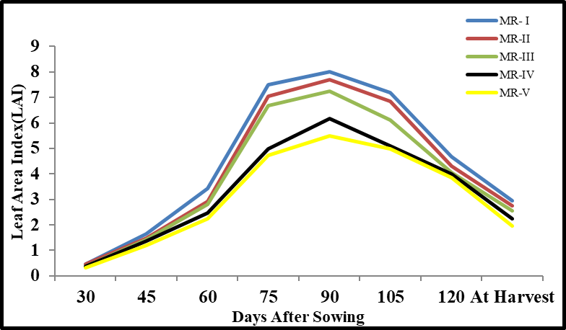
Fig. 3: LAI under different microclimatic regimes in maize during rabi, 2021-22
At all growth phases, the plant height differed significantly as a result of various growing environments. The rabi maize sown under 15th October (MR-I), resulted in maximum plant height at all the stages as compared to later dates of sowing. The maximum plant height observed in optimum sowing (207.13 cm) could be explained by the predominance of ideal temperature regimes during the early phases that support rapid cell division and multiplication, resulting in stover elongation of plants. The observation is also in accordance with Prodhan (2001). Sarvari et al. (2007) reported that early sowing had a significant impact on plant stature, where taller plants were seen as compared to late sowing. Similarly, the plant biomass was highest under 15th October (MR-I) i.e., 14.58, 143.58, 426.92, 887.50, 1450.92, 1596.33, 2069.92, 2762.50 g m⁻² at 30 DAS, 45 DAS, 60 DAS, 75 DAS, 90 DAS, 105 DAS, 120 DAS and at harvest, respectively. While lowest was found in 15th December (MR-V) sown crop (1858.33 g m⁻²).
Variation of PAR interception under different micro-climatic regimes
With the help of a Line Quantum Sensor (Made: Apogee, Model: MQ301, Serial:1288) from 20 plots, different components of Photosynthetically Active Radiation (PAR), including Incident PAR (IPAR), Reflected PAR (RPAR) and Transmitted PAR (TPAR), were measured over the crop at an interval of 15 days beginning on 15 DAS at about noon (around 11:30 am) local time.
The data pertaining to interception of photo-synthetically active radiation (iPAR) by maize as influenced by different micro-climatic regimes were worked out from incident PAR (IPAR), reflected PAR (RPAR), and transmitted PAR (TPAR) and were expressed in percentage (Eq. No. 1). The PAR interception was maximum in the case of the crops sown on 15th October (81.21%) followed by 30th October (79.60%), 15th November (60.0%), 30th November (56.05%) and 15th December (42.97%) which is presented in Fig. 4(a-e). Comparatively higher PAR interception recorded on the first date of planting was probably due to a higher rate of foliar expansion with a greater number of leaves per plant as it was exposed to a better thermal environment. Similar results were found by Barutcular et al. (2005) who opined that there was a consistent decrease in intercepted PAR in late sowing crops as compared to early sowing.

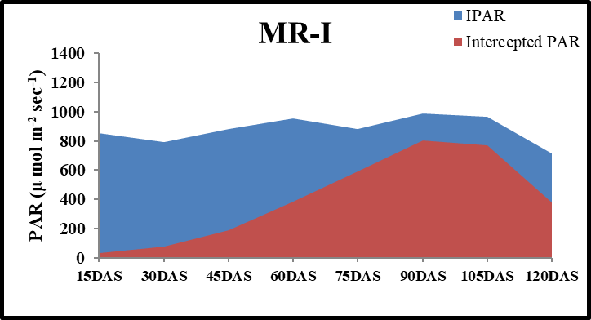
(a)
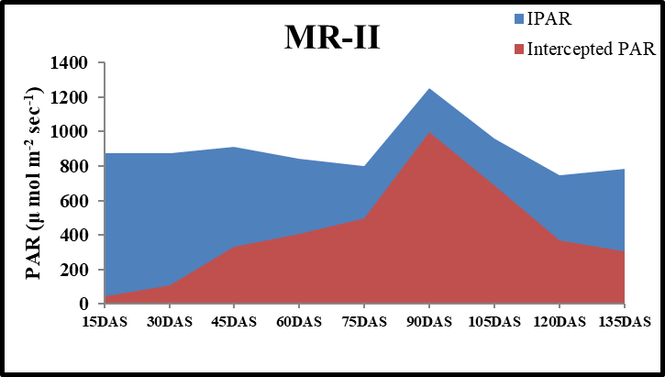
(b)

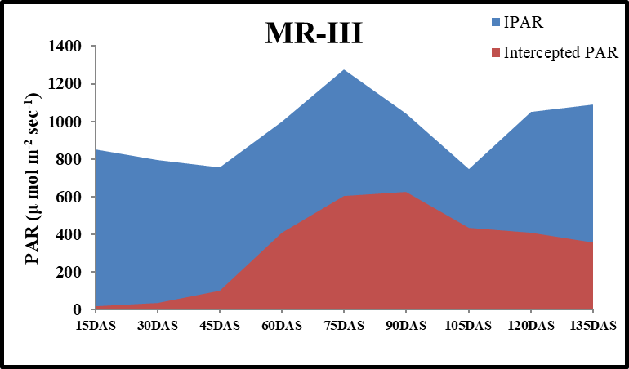
(c)

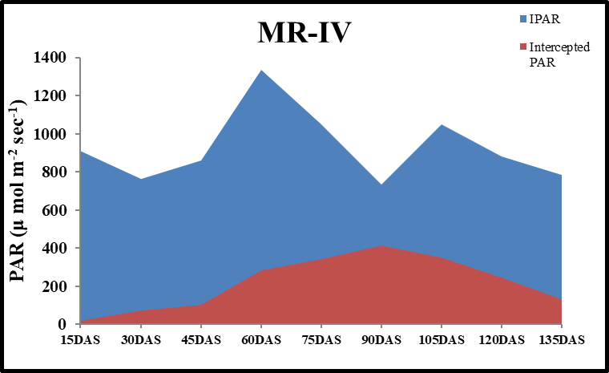
(d)
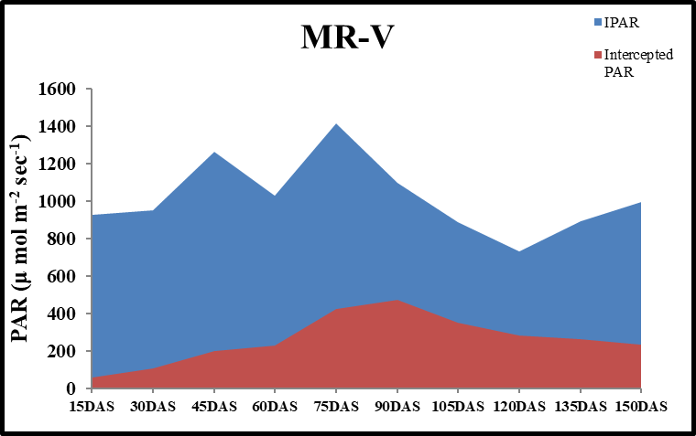
(e)
Fig. 4(a-e): Variation of PAR interception under different micro-climatic regimes viz., MR-I, MR-II, MR-III, MR-IV, MR-V
Yield attributing parameters and yield under different micro-climatic regimes
The effect of different microclimatic regimes on yield attributing parameters viz., number of cobs per plant, cob weight, cob length, cob girth, number of rows per cob, number of grains per row, 1000 grain weight, and grain yield are presented in Table 1.
Table 1: Yield attributing parameters and yield under different micro-climatic regimes
Treatment | No. of cobs/plant | Cob weight  (g) | Cob length(cm) |  | Cob girth  (cm) | Number of |  | 1000 grain weight  (g) | Grain yield  (kgha⁻¹)
Treatment | No. of cobs/plant | Cob weight  (g) | With husk | Without husk | Cob girth  (cm) | rows/  cob | grains/  row | 1000 grain weight  (g) | Grain yield  (kgha⁻¹)
MR- I | 1.57 | 201.88 | 30.40 | 20.88 | 17.53 | 20.28 | 35.35 | 449.65 | 5106.25
MR-II | 1.34 | 192.98 | 25.20 | 19.34 | 15.27 | 17.13 | 32.25 | 321.83 | 4719.75
MR-III | 1.28 | 190.73 | 24.87 | 18.43 | 14.42 | 16.75 | 31.78 | 313.73 | 4523.75
MR-IV | 1.06 | 162.85 | 21.45 | 17.53 | 14.40 | 15.40 | 30.11 | 304.63 | 4037.50
MR-V | 1.00 | 144.08 | 19.55 | 16.58 | 12.46 | 13.63 | 27.68 | 286.75 | 3413.75
Mean | 1.25 | 178.50 | 24.29 | 18.55 | 14.81 | 16.64 | 31.43 | 335.32 | 21801.0
SE(d) | 0.15 | 1.24 | 0.34 | 0.25 | 0.18 | 0.29 | 0.46 | 2.08 | 217.68
CD_{(p≤0.05)} | 0.33 | 2.73 | 0.75 | 0.55 | 0.39 | 0.64 | 1.01 | 4.58 | 4360.20

Cob length (without husk) varied from 20.88 cm to 16.58 cm in all the microclimatic regimes. Cob length (without husk) was highest in case of 15th October sown crop (MR-I) followed by 30th October, 15th November, 30th November and 15th December. With delay in sowing, the length of the cob drastically decreases; that is why the maize sown on December 15th produced the shortest cob (16.58 cm). The sowing of maize under MR-I seems to be the optimum time which resulted in the development of cobs with superior girth as compared to the other MRs with subsequent delay in sowing. The cob girth and cob weight were highest in the case of the 15th October sown crop (MR-I) as compared to other dates of sowing. The result is similar to the findings of Maryam et al. (2011) who found that maize cob length and weight decreased with delay in planting of maize. The number of grains per row and number of rows per cob were recorded at harvest. The highest number of grains per row and the number of rows per cob was recorded under 15th October (MR-I) which was 20.28 and 35.35 respectively as compared to delayed sowings. In general, earlier sowing of maize recorded higher values for the number of grains per row and number of rows per cob than delayed sowing, which may be proportionate to unfavorable weather conditions, especially during the early growth stages of late sown crop that affected plant growth and development and also resulted in lower photosynthate synthesis and portioning. Similar findings were also found by Jasemi et al. (2013) in their study. The higher number of cobs per plant was observed under 15th October sown crops (MR-I) (1.57) which was found to be at par with 30th October (MR-II) (1.34). However, the lowest number of cobs per plant was observed under the 15th December sown crop (MR-V) which was found to be at par with MR-III (1.28) and MR-IV (1.06).
1000 grain weight
The 1000-grain weight and grain yield were considerably influenced by different growing environments. The higher 1000 grain weight found with early sowing may have been caused by favorable weather conditions combined with more growth days during the reproductive stage, which helped in better partitioning of more photosynthates from source to sink and subsequently development of bold kernels during early sowing. Whereas, higher temperatures, especially at night, and fewer days during the reproductive stages may have caused less grain development with delayed sowing as presented in Table 1. These findings are also in conformity with the findings of Jasemi et al. (2013).
Grain yield
The highest grain yield was recorded for the crops sown on 15th October (MR-I) sown crop (5106.25 kg ha⁻¹) as compared to other dates of sowing. The lowest grain yield was observed when the crop was sown on 15th December (MR-V). The higher grain yield of the optimum sown crop might be due to the combined effects of higher values of yield-attributing characters such as number of grains cob-1, 1000 grain wt. (g), grain weight cob⁻¹, and higher values of growth characters (plant height, higher dry matter accumulation, LAI) as well as favorable weather conditions that prevailed during the crop plant's flowering, grain-filling and physiological maturity stages. A similar result was also reported by Dekhane and Dumbre (2017). They found higher values of yield-attributing parameters on the early sown crop compared to delayed sowing.
Plant Dry Weight
Data on plant dry weight as influenced by micro climatic regimes are shown in the Fig 5. The effect of different growing environments on plant dry weight was found to be substantial at all the stages. The plant biomass was highest under 15th October (MR-I) i.e., 14.58, 143.58, 426.92, 887.50, 1450.92, 1596.33, 2069.92, 2762.50 g m⁻² at 30 DAS, 45 DAS, 60 DAS, 75 DAS, 90 DAS, 105 DAS, 120 DAS and at harvest, respectively. While lowest was found in 15th December (MR-V) sown crop (1858.33 g m⁻²). As planting was postponed, it was seen that the overall biomass production decreased. This was likely because the crop sown during 30th October (MR-II) to 15th December (MR-V) was exposed to lower temperatures range of 6.2-20.1 ℃ during their early growing stage, which led to lower vegetative growth and less photosynthetic accumulation. Similar result was reported by Swanson et al. (1996), who opined that planting maize too early or too late affects the yield, dry matter production, leaf area index, and leaf area.
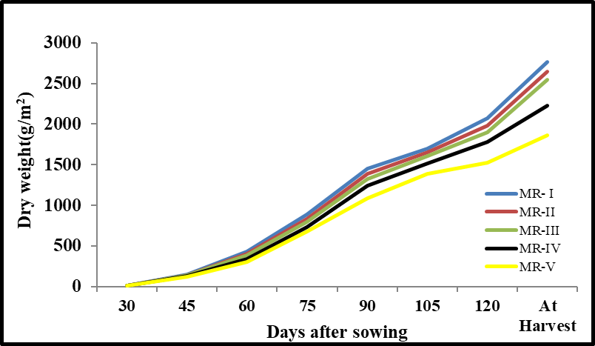
Fig 5. Plant dry weight (g m⁻²) under different microclimatic regimes in maize during rabi, 2021-22
Correlation analysis
The phase-wise mean and a total of various meteorological parameters corresponding to the maize cultivar DKC-9081 sown under different dates during rabi, 2021-22 were computed and performed correlation study with grain yield, maximum leaf area index, total dry weight, and cob weight. The meteorological parameters computed were mean daily maximum and minimum temperature, morning and evening relative humidity, total rainfall, mean BSSH, accumulated evaporation, and mean wind speed for vegetative, reproductive, and physiological maturity stages. The results of the correlation are presented in Table 2.
According to correlation studies between grain yield and yield attributing parameters (LAI, biomass production, and cob weight) and weather parameters it is seen from Table 2 that grain yield was significantly and positively correlated with LAI (r = 0.99), total dry weight (r = 0.99), cob weight (r = 0.98), RH-I (Reproductive) and RH-II (Vegetative). While grain yield was significantly, but negatively correlated with minimum temperature during reproductive (at 1% level) and maturity (at 5% level), rainfall during maturity (at 5% level), and wind speed during vegetative and reproductive stages (at 5% level).
As the minimum temperature during the reproductive and maturity stages are significantly and negatively correlated with grain yield and yield attributing characters, thus it indicated that with decrease in the minimum temperature not beyond the threshold limit led to an increase in yield and yield attributing traits. The reproductive phase of maize includes flowering and grain filling, which are highly sensitive to temperature and higher minimum temperatures can lead to increased night time respiration, reducing the energy available for grain development. During maturity phase, the maize crop undergoes final grain development and drying. Higher night time temperatures during this phase can increase respiration rates, leading to a loss of stored carbohydrates that would otherwise contribute to low grain weight. Besides, the analyzed correlation of rainfall during maturity and wind speed during vegetative and reproductive with yield and yield attributing characters also depicted a similar negative trend thus indicating that with the increase in rainfall during maturity and wind speed during vegetative and reproductive stage, the yield and yield attributing characters decreased. Excess rainfall during maturity leads to disease risk, delayed drying, and potential physical damage to plants, reducing overall yield. Maize is particularly sensitive to high and extreme temperatures in the phase before and during anthesis, especially pollination which may get seriously affected. Ren et al. (2022) in their study found that among the climatic factors, solar radiation and the lowest temperature have significant effects on the yield of maize. Plant heights, ear heights, double ear rate, ear length, ear rows, line grain number, grain number per ear, ear diameter, cob diameter, and 1000 grains weight were significantly positively correlated with maize yield. Further, solar radiation before and after silking had a significantly positive correlation with the yield. However, the morning relative humidity during the reproductive stage and evening relative humidity during the vegetative stage showed a strong positive correlation, indicating that an increase in morning relative humidity during the reproductive stage and evening relative humidity during the vegetative stage had a positive impact on yield and yield attributes.
Table 2: Correlation coefficients of grain yield, maximum LAI, total dry weight, and cob weight with different weather parameters
Variables | Grain yield | Max LAI | Total dry weight | Cob weight
Grain yield | 1
Max LAI | 0.992** | 1
Total dry weight | 0.992** | 0.999** | 1
Cob weight | 0.985** | 0.993** | 0.994** | 1
Tmax_vegetative | 0.676 | 0.636 | 0.607 | 0.615
Tmax_reproductive | -0.660 | -0.709 | -0.680 | -0.727
Tmax_maturity | -0.544 | -0.446 | -0.447 | -0.395
Tmin_vegetative | 0.750 | 0.693 | 0.673 | 0.679
Tmin_reproductive | -0.964** | -0.988** | -0.986** | -0.992**
Tmin_maturity | -0.946* | -0.925* | -0.913* | -0.900*
RH-I_vegetative | -0.662 | -0.611 | -0.584 | -0.585
RH-I_reproductive | 0.911* | 0.931* | 0.914* | 0.935*
RH-I_maturity | 0.877 | 0.824 | 0.824 | 0.780
RH-II_vegetative | 0.932* | 0.925* | 0.943* | 0.933*
RH-II_reproductive | -0.552 | -0.559 | -0.595 | -0.553
RH-II_maturity | -0.809 | -0.867 | -0.850 | -0.873
BSSH_vegetative | 0.745 | 0.727 | 0.698 | 0.685
BSSH_reproductive | 0.661 | 0.677 | 0.710 | 0.686
BSSH_maturity | 0.596 | 0.651 | 0.615 | 0.633
Rainfall_vegetative | 0.101 | -0.021 | -0.021 | -0.035
Rainfall_reproductive | -0.869 | -0.860 | -0.881* | -0.843
Rainfall_maturity | -0.879* | -0.926* | -0.916* | -0.938*
EVP_vegetative | -0.764 | -0.800 | -0.823 | -0.815
EVP_reproductive | -0.781 | -0.777 | -0.750 | -0.784
EVP_maturity | -0.040 | 0.070 | 0.065 | 0.131
Wind Speed_vegetative | -0.894* | -0.943* | -0.936* | -0.939*
Wind Speed _reproductive | -0.898* | -0.855 | -0.867 | -0.821
Wind Speed _maturity | -0.719 | -0.780 | -0.760 | -0.803
* and ** significant at p≤0.05 and p≤0.01 percent levels, respectively
4. Conclusion

Fluctuations in the weather parameters under different dates of sowing had a significant impact on the growth, development, and yield of rabi maize. The crop sown on 15th October was found to be a suitable sowing date for the region attributed to the exposure of crops to an optimum weather condition corresponding to various phenological phases during the entire crop growing season. Delays in sowing had a negative impact on plant growth parameters and yield components, which considerably decreased grain production in the end. Therefore, it is advised to sow the DKC-9081 rabi maize variety on October 15 to obtain a higher grain yield.

Disclaimer (Artificial intelligence)

Author(s) hereby declare that NO generative AI technologies such as Large Language Models (ChatGPT, COPILOT, etc.) and text-to-image generators have been used during the writing or editing of this manuscript.

References

Barutcular, C., Koc, M., Unlu, M., Kanber, R., Ozekici, B., Yano, T. and Watanabe, T. (2005). Maize Photosynthesis and Productivity in Relation to Sowing Time in a Mediterranean Environment, Cukurova. Asian Journal of Plant Sciences., 4: 550-554. DOI: 10.3923/ajps.2005.550.554
Dhaliwal, L.K., Buttar, G.S., Kingra, P.K., Singh, S. and Kaur, S. (2019). Effect of mulching, row direction and spacing on microclimate and wheat yield at Ludhiana. Journal of Agrometeorology., 21(1): 42-45.DOI: https://doi.org/10.54386/jam.v21i1.202
Gallo, K.P. and Daughtry, C.S.T. (1986). Techniques for measuring intercepted and absorbed photosynthetically active radiation in corn canopies. Agronomy Journal., 78: 752-756. https://doi.org/10.2134/agronj1986.00021962007800040039x
Hasan, N., Jone M.J.H., Das, B., Siddique, M.N.A., Islam, Y. and Kashem, M.A. (2025). Genetic parameter analysis and evaluation of maize hybrids under local climatic condition of Mymensingh, Bangladesh. Heliyon, 11 (2025) e41481. https://doi.org/10.1016/j.heliyon.2024.e41481
Hasson, M. I., and Ahmed, K. K. (2025, February). The Impact of Planting Date and Thermal Requirement on the Growth Characteristics, Yield, and Its Components for Genetic Structures of Maize (Zea Maize L.). In IOP Conference Series: Earth and Environmental Science (Vol. 1449, No. 1, p. 012062). IOP Publishing. https://doi.org/10.1088/1755-1315/1449/1/012062
Indiastat. (2025). Season wise area, production and productivity of Maize in India (1949-1950 to 2024-25-1st Estimate. Datanet India Private Limited. https://www.indiastat.com/table/ template/agriculture/season-wise-area-production-productivity-maize-ind/7269; retrieved on 13.02.2025
Jasemi, M., Darabi, F., Naseri, R., Naserirad, H. and Bazdar, S. (2013). Effect of planting date and nitrogen fertilizer application on grain yield and yield components in maize (SC 704). American-Eurasian Journal of Agriculture and Environmental Science., 13: 914- 919. http://www.idosi.org/aejaes/jaes13(7)13/5.pdf
Khaeim, H., Kende, Z., Jolánkai, M., Kovács, G. P., Gyuricza, C., & Tarnawa, Á. (2022). Impact of temperature and water on seed germination and seedling growth of maize (Zea mays L.). Agronomy, 12(2), 397. https://doi.org/10.3390/agronomy12020397
Kumar, A., Pandey, V., Shekh, A. M. and Kumar, M. (2008). Radiation use efficiency and weather parameter influence during life cycle of soybean (Glycine max. [L.] Mirrll) production as well accumulation of dry matter. American-Eurasian Journal of Agronomy., 1(2): 41-44.
Liu, Z., Wei, S., Shangguan, X., Wang, X., Yuan, M., Zong, R., & Li, Q. (2025). A case study on facing climate change: optimizing planting density and date of summer maize for stable grain yield in the North China Plain. Regional Environmental Change, 25(2), 42. https://doi.org/10.1007/s10113-025-02379-9
Maryam, A.B., Saeeid, K.K., Mohammad, S.N., Fatehmeh, N., & Elham, Z. (2011). Study yield stability of commercial corn hybrids (Zea mays L.) evaluated in two planting dates in Iran. African Journal of Agricultural Research., 6(13): 3161-3166.
Moosavi, S.G., Seghatoleslami, M.J. and Moazeni, A. (2012). Effect of planting date and plant density on morphological traits, LAI and forage corn (Sc. 370) yield in second cultivation. International Research Journal of Applied and Basic Sciences., 3(1): 57- 63. DOI: 10.22271/chemi.2020.v8.i4u.9924
Prasad, Govind, Chand Mehar, Kumar Pawan and Rinwa, Ran Singh (2017). Performance of Maize (Zea mays L.) Hybrids with Respect to Growth Parameters and Phenological stages under Different Sowing Dates in Kharif Season. International Journal of Current Microbiology and Applied Sciences, 6(10): 5079-5087.DOI: https://doi.org/10.20546/ijcmas.2017.610.482
Prodhan, H.S. (2001). Influence of appropriate cultivar and sowing dates on Rabi maize productivity. Indian Journal of Agriculture Sciences., 71(1): 55-56. https://epubs.icar.org.in/index.php/IJAgS/article/view/39506
Ren, H., Liu, M., Zhang, J., Liu, P., & Liu, C. (2022). Effects of agronomic traits and climatic factors on yield and yield stability of summer maize (Zea mays L) in the Huang-Huai-Hai Plain in China. Frontiers in plant science, 13, 1050064. https://doi.org/10.3389/fpls.2022.1050064
Sanodiya Pratik,Tiwari, Prashant and Gupta Chinmay (2023).Maize (Zea mays L.) - The future potential cereal crop of an indispensable significance in agro-forestry system. Maize Journal, 12(2): 61-71
Sarvari, M., Molnar, Z. and Hallof, N. (2007). Influence of different sowing time and nutrient supply on the productivity of maize hybrids. Analele University din Oradea, Department of Plant Production and Applied Ecology., 4(12): 134-141.
Şimon, A., Cheţan, F., Ceclan, A., Urdă, C., Popa, A., Russu, F., Tritean, N., Varga, A., Filip, E. and Aipătioaie, M. (2025). Stability of Yield and Quality Parameters in Maize Hybrids Cultivated at Different Sowing Dates. Romanian Agricultural Research, No. 42, 2025. Nardi Fundulea, Romania . https://www.incda-fundulea.ro/rar/nr42/rar42.23.pdf
Sivakumar, M.V.K. and Virmani, S.M. (1984). Crop productivity in relation to interception of photosynthetically active radiation. Agricultural and Forest Meteorology., 31(2): 131- 141. https://doi.org/10.1016/0168-1923(84)90015-7
Sutaliya, R. and Singh. R.N. (2005). Effect of planting time, fertility level and phosphate- solubilizing bacteria on growth, yield and yield attributes of winter maize (Zeya mays) under rice (Oryza sativa) - maize cropping system. Indian Journal of Agronomy., 50(3): 173-175. DOI: https://doi.org/10.59797/ija.v50i3.5097
Warrington, I.J. and Kanemasu, E.T. (1983). Corn Growth Response to Temperature and Photoperiod Seedling Emergence, Tassel Initiation, and Anthesis. Agronomy journal., 75(5): 749-754.
Watson, D.J. (1952). The physiological basis of variation in yield. Advances in Agronomy., 4: 101-145. https://doi.org/10.1016/S0065-2113(08)60307-7

