Urban land vulnerability in a Sahelian city in West Africa: the case of the Niamey 5 Communal District, Niger
Abstract
Urban land vulnerability leads to many socioeconomic and environmental problems. Sahelian cities face this problem due to the non-respect of urban planning documents. Therefore, this study tries to determine the different forms of household land vulnerability and their differentiating factors among urban households in the Niamey 5 municipal district. A total of 388 households were surveyed based on a stratified random sample. Chi-squared test and the percentage were used for data analysis. The results of the statistical analysis reveal that 55.4% of households occupy informally divided spaces (informal housing development, squatter, village core). Only 16.98% of household owners have a definitive land title, compared to 83.73% who only have precarious security documents: customary ownership (38.20%), transfer deed (17.92%), sale deed (16.98%), and no papers (9.91%). Few tenant households (17.3%) have a lease agreement that can secure their tenure status, while 88.7% do not. Land vulnerability varies from one household to another depending on the household's tenure status. Households in a low land vulnerability situation are 96.90% owners and 3.10% co-owners. On the other hand, the 40.6% of households in a high vulnerability situation are tenants and 12.8% are rent-free. This study provides a baseline for policy makers to improve urban planning conditions.
Keywords: Land insecury, Sahelian cities,Households, land vulnerability, urban planning

- Introduction
Urban land vulnerability is a factor in urban risks. For example, it exposes urban households to flood risks (Ballo, 2015 and Traoré et al. 2024) and various urban diseases (Sy et al. 2011). Furthermore, urban land vulnerability creates social inequalities and conflicts (Zango and Mathieu, 2000, Oura, 2022). Adding to this urban land vulnerability refers to the question of the urban living environment (Chindji, 2021).
Urban land vulnerability constitutes a major socioeconomic and environmental challenge. Most studies have focused on the modes of urban land acquisition (Kossi, 2022) and the actors of urban land production (Yapi-Diahou, 2023). Thus, this study examined household land vulnerability arising from the urban land production process in the Niamey 5 communal district in Niger to fill this gap. Furthermore, this study is carried out in the city of Niamey, a Sahelian city with unique demographic and spatial constraints in West Africa.
2. Materials and methods
2.1 The study site
The study site is the Niamey5 communal district (ACN5). It is bordered to the north by the river, to the south and west by the commune of Bitinkodji and to the east by the commune of Youri (Figure 1). It is located on the right bank of the Niger River and is connected to the left bank by three bridges (the Kennedy Bridge, the China-Niger Friendship Bridge and the Seyni Bridge). Kountché ), built respectively in 1970, 2011 and 2021. It is bordered to the north by the municipal districts 1, 2, 3, 4 and the rural commune of Bintinkodji , to the east and south by the rural commune of Youri as shown in figure 1.

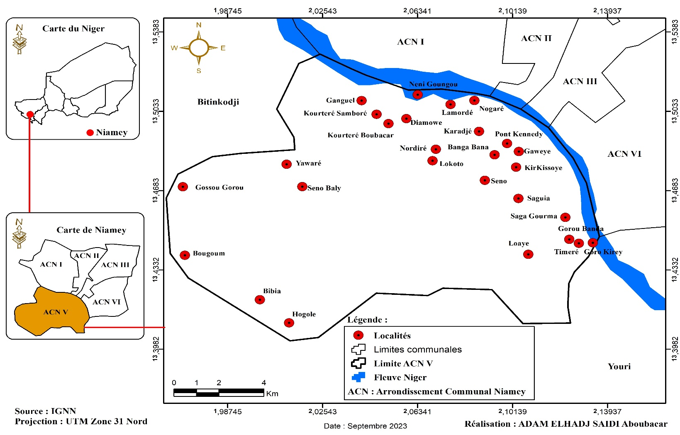

Figure 1: Presentation of the Niamey 5 municipal district
2.2. Data collection
As part of this study, surveys were conducted among a wide variety of stakeholders, including households, real estate developers, canvassers, technical departments of the Niamey 5 Communal District (land affairs, land use planning, and water and sanitation departments), technical departments of the Ministry of Urban Planning and Land Registry, and resource persons. These surveys are both quantitative and qualitative.
household surveys
Quantitative surveys involve households. To conduct these surveys, it was first necessary to define the sample and develop the questionnaires.
- Choice of neighborhoods and villages to investigate
Before administering a questionnaire, it is necessary to define the population that will be consulted. For quantitative surveys conducted using a questionnaire, the sample concerns households-residents and customary landowners in villages and neighborhoods affected by peri-urbanization.
For the household survey, the sampling of sites to be surveyed among the 7 districts and 12 villages affected by peri-urbanization obeyed the reality that the peri-urban space is not homogeneous. " There is always a disproportionate mix of urban and rural [within it ] " ( Yemmafo , p.58). For this purpose, the peri-urban space of the Niamey 5 municipal district is subdivided into three crowns.
The first ring is made up of neighborhoods from villages already integrated into the dense city. These are the Lamordé , Nogaré , Kirkiossye , Bangabana , Gaweye , Pont Kennedy and Karadjé neighborhoods . In this ring, the Nogaré and Bangabana neighborhoods were chosen.
The second crown is made up of administrative villages that are moderately integrated into the city, these are the villages of Diamyowé , Nordiré , Kourteré Boubacar, Kourteré Samboré and Neni Goungou , Saga Gourma, Saguia , Ganguel , Kossèye , Goroubanda , Timéré and Gorou Kirey and Kosseye . In this crown, the villages of Nordiré , Seno and Saguia were chosen for the survey. Here, it should be noted that Seno is a hamlet attached to the Kirkissoye district . But the scale of urbanization following the 2012 floods, with the rehousing of victims, shows that this hamlet has now become a de facto district. This is why it was chosen for the survey of the second crown (figure 2).
Finally, the third ring is made up of rural localities which are mainly hamlets. In this ring , surveys were not carried out because the area remains rural. In total, five districts/villages were chosen to conduct household surveys.
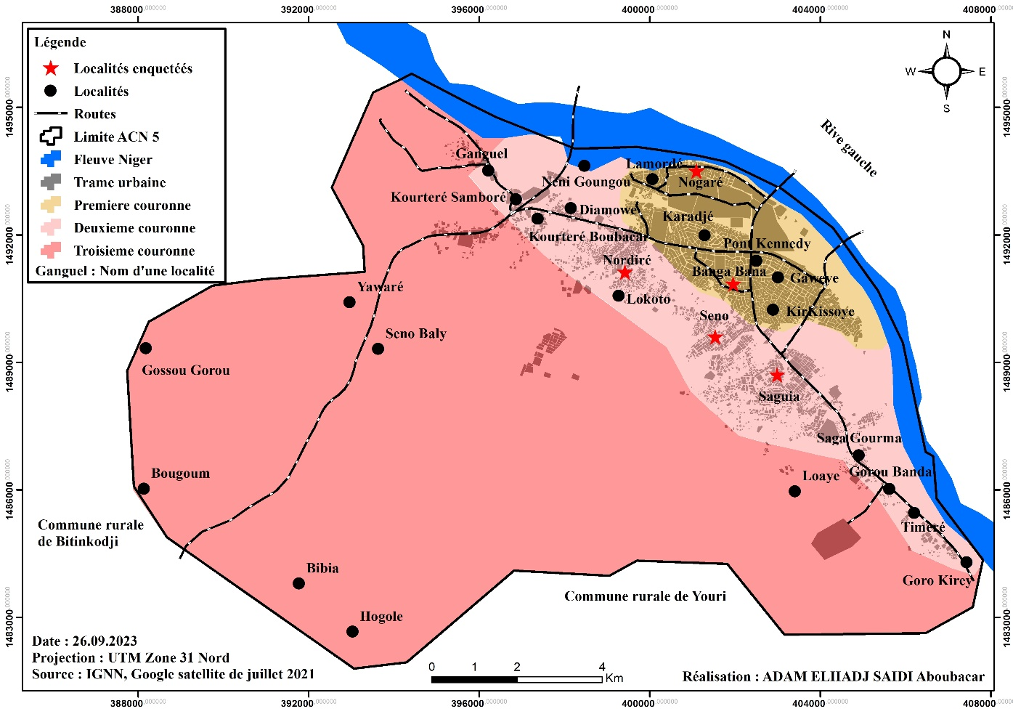
Figure 2: Locations chosen for the household survey
- Stratified random sampling
Household surveys are conducted in villages and peri-urban neighborhoods. Given that villages and neighborhoods do not have the same proportions of populations and households, and to ensure good representativeness of the sample, the stratified sampling method was adopted. This technique makes it possible to consider the size of each of the spatial units by giving each element the chance to be surveyed based on the size of its parent population.
The selection of households to be surveyed is random, meaning that all households included in the sample have an equal chance of being selected for the survey. The sample was calculated using the standard formula for calculating the sample in statistics. The formula is as follows:
Sample size = [z2*p (1-p)] / e2 / 1 + [z2*p (1-p)] / e2*N] *deff*TNR.
N = population size: in the context of this study, this refers to the number of households living in the districts or urban villages determined during the 2012 census.
Z = z-score: means the confidence interval, it indicates to what extent the results of the sample are close to the true value of the overall population in question in our study. The confidence interval is 95% or 1.96.
E = margin of error: the margin of error in this sample is set at 0.05.
P = a pessimistic estimate of the proportion of 0.5 is chosen.
Deff: or sampling effect. To achieve the same level of precision as a Simple Random Sampling Survey, we need to multiply the sample size by Deff. Deff allows us to adjust the sample size based on the sampling strategy. The chosen deff is 1.
TNR: TNR is the Non-Response Rate. In this study, a non-response rate of 5% is expected.
Applying the formula cited and explained above, the sample size is 383 households for a parent population of 6502 households in 2012.
To determine the number of households to be interviewed per (neighborhood), the rule of three in proportion to the total number of households in the neighborhoods (N) of the sample (n) was applied. Thus, to determine the size of each neighborhood, the following procedure was followed: Nordiré (659 households): 659 x 388/6502 = 38.81 or 39 households to be interviewed Seno (262 households): 262 x 383 /6502 = 15 households to be interviewed. The results are recorded in the following table.
Table 1: Number of households surveyed by district
Neighborhood | Number of Households |  | Number of respondents
NORDIRE | 659 | 38.81 | 42
SENO | 262 | 15.43 | 15
NOGARE | 1009 | 59.43 | 61
BANGA BANA | 4115 | 242.39 | 242
SAGUIA | 457 | 26.91 | 28
Total | 6502 | 382.97 = 383 | 388

Ultimately , 388 households were surveyed with a desired margin of error of 5% for a confidence level of 95%, a deff of 1 and a non-response rate of 5% is expected.
Households are selected randomly. The individual surveyed is the head of the household. If it is not possible to interview the head of the household, a family member capable of answering the questions is interviewed. Generally, in this study, it is the wife of the head of the household who answers in their absence.
The questionnaire, once developed and validated, was entered in XLS Form format , then integrated into the ODK application. This application was configured on Android phones given to the investigators.
The household survey was conducted with the support of six interviewers, all of whom are Master's students in Geography. They were first trained on the questionnaire content and administration techniques before conducting a pre-test day. After the pre-test, comments and observations were made to improve the questionnaire. These were then incorporated into the questionnaire. The data collection operation lasted one week from October 24, 2020 to November 6, 2020.
At the end of the collection, the data were retrieved and then transferred to the IBM SPSS STATISTICS.20 and SPHINX PLUS ² (V5) software for the purpose of data processing and analysis.
The household questionnaire is structured into nine main sections. Each section contains detailed questions related to the research topic. Some sections are specifically addressed to the type of housing tenure, i.e., owners, tenants, or households housed rent-free, while other sections concern all households surveyed. The sections of the household questionnaire are organized as follows:
- Socio-demographic characteristics of households (to be asked of all households)
- Method of acquiring the plot (to be asked if the household is the owner or co-owner)
- Legal status of the plot (to be asked if the household is the owner or co-owner)
- Housing production method;
- Rental method (to be asked if the household is a tenant);
- Free accommodation (to be asked to the household staying free of charge);
- Housing characteristics (to be asked of all households);
- Mode of transport (to be asked of all households) ;
- Housing and risks (to be asked of all households).
The indicators for measuring household land vulnerability are contained in the following table:
Table 2: Vulnerability level construction indicators
Land Vulnerability Indicator
Variables | Modality | Vulnerability indicators
Type of land ownership security document | Subdivided area with land title | Low vulnerability
Type of land ownership security document | - Sector built without any papers  - Subdivided area with sales certificate  - Customary detention subdivided sector  - Undeveloped or village sector, no papers  - Undivided sector customary detention, sale attention  - Squat | High vulnerability
Type of land ownership security document | - Subdivided area with deed of transfer  - Undivided area with deed of transfer and land title | Medium vulnerability
Type of rental contract security document | Contract signed | Medium vulnerability
Type of rental contract security document | Absence of contract | High vulnerability
 | Stay for free | High vulnerability

3. Results and discussion
3.1 Land vulnerability of households in the Niamey 5 municipal district
3.1.1 Land vulnerability linked to the legal status of occupied and subdivided spaces
Legal vulnerability in land matters takes several forms, including, for example, the unlawful occupation of public property. In this case, it becomes the most serious form because public property has a special status that characterizes it. It is imprescriptible, non-transferable, and inalienable. In this sense, even the State must declassify it for private use. The declassification act is pronounced during the deliberations of the Council of Ministers. Given the specific regime of state property and its sacred nature, the installation of dwellings on these spaces reflects an unprecedented legal vulnerability that could sooner or later lead to evictions. In Niamey, it is very common to see these types of occupations on public road rights-of-way, in the green belt, in and around public institutions. The eviction operations of 2016 affected a large portion of these spaces, especially commercial establishments.
In our study, occupations of state property without prior authorization are observed in the Nogare neighborhood, where households squat on the land and inside the Abdou Moumouni University of Niamey and the Amirou Boubacar Diallo National Hospital. Indeed, even if the populations claim to have certificates of customary ownership, it remains true that they are occupying state property. As a result, they can be evicted at any time because legal acts to establish proof of ownership of state property are null and void. No one can establish an act of securing private property on state property by virtue of the characteristics of these state lands that we have cited.
Beyond housing, there are subdivisions on state-owned land (grazing areas and animal runs) which, according to their status, also fall under the public domain of the State. These are pastoral areas in the localities of Yawaré and Bougoum. These subdivisions have made headlines, especially with associations of pastoralists and breeders such as the Association for the Revitalization of Livestock (AREN). Also, it is necessary to highlight the diversion of several public spaces for housing or other private uses.
Legal insecurity may arise from the legal status of the subdivision. Indeed, any residential space must be subdivided. However, to subdivide, it is necessary to follow the steps prescribed by law, in order to obtain authorization from the competent authorities, in particular the Ministry of Urban Planning. According to Decree No. 97-304 of August 8, 1997, establishing the creation, responsibilities, and organization of advisory bodies in matters of urban planning and housing, the steps to obtain subdivision authorization are:
- Preparation of a technical file containing the project presentation note, graphic documents and a subdivision request addressed to the ministry responsible for urban planning;
- Examination of the file at the municipal level by the local urban planning commission for an opinion (mandatory);
- Review and adoption of the project by the departmental commission for urban planning and housing. The project is then subject to a public inquiry;
- Sending of the file comprising all the deliberations and the conclusion of the public inquiry to the Ministry of Urban Planning and Housing, in particular to the technical committee for urban planning and housing;
If the file is technically and legally admissible, it is sent to the National Commission for Urban Planning and Housing for a final check of the subdivision project;
Finally, the file approved with the mention “favorable opinion” is returned to the community or the promoter for its execution.
Urban land that has not been subject to subdivision authorization is considered an informal settlement, and therefore illegal under the law. Informal subdivision areas, created by customary landowners and informal private developers, face undeniable legal vulnerability because they did not follow any urban planning standards before their subdivision.
The results of the household survey reveal that 45.10% and 4.90% of the households surveyed occupy inhabited spaces where urban planning standards are not respected at all because they have not followed any urban planning procedure in force (Figure 3). These are informally divided spaces, that is, divided by customary owners in the form of fields and often in the form of plots imitating those produced by the town hall and approved private developers. These are also squatted spaces which constitute invasions of public spaces as we have highlighted above. Indeed, in addition to the problems of land security, the vast majority of built spaces in the Niamey 5 municipal district do not respect the urban planning standards in force. These are however described in the various texts which frame the principles of urban planning in Niger.
Figure 3: Type of sector occupied by households
Source: Field data in October and November 2020
Undertaking urban restructuring operations in the informal settlements of the city of Niamey represents a real challenge for the population that must be analyzed in order to avoid causing social tensions. This is all the more true since we know that some homes are built on legally precarious spaces in terms of subdivision. These are informal spaces for which the subdivision procedure has not been subject to any authorization. These so-called spontaneous spaces are commonplace in the outskirts of the right bank of Niamey. The homes built at this level only have a customary certificate generally issued by the village chiefs. Figure 4 gives us the legal status of different built spaces in the Niamey 5 municipal district. It shows that informally developed spaces and squats constitute a significant portion of residential built spaces, up to 33.4% compared to 66.48% of formally developed spaces. The Niamey 5 municipal district is known to be the space par excellence where informal housing developments have taken on greater proportions. In almost all the districts of the commune, there are informal fragments adjoining the officially developed part. This constitutes a significant problem in the context of improving the living conditions of households.

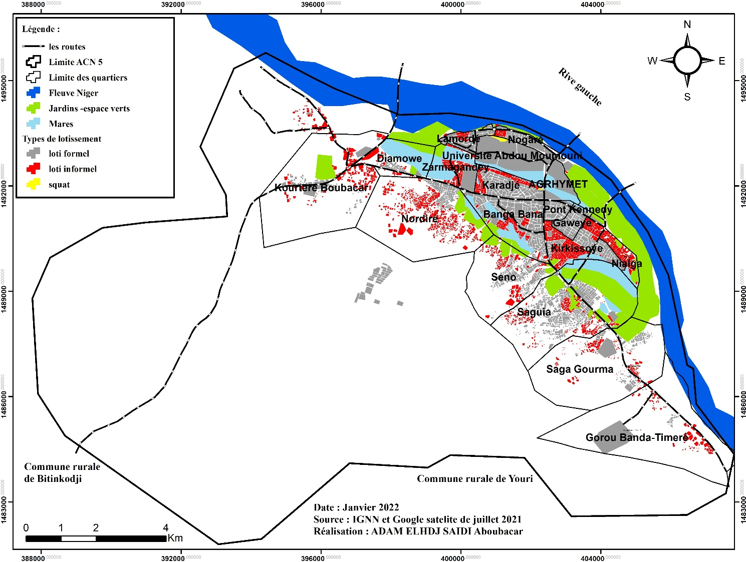
Figure 4: Type of subdivision of built-up areas in AC N5
In addition to the precariousness of land security measures, the lack of building permit applications in Niamey, which is a requirement in urban planning practice, is a reality. Indeed, very few landowners apply for a building permit. Yet, this legal document is one of the important tools for controlling urban land use. According to the law, a building permit is an administrative act that authorizes construction after verifying its compliance with urban planning regulations, public utility services affecting land use, and certain construction standards. Article 88 of this law stipulates that:
"Anyone who wishes to undertake a construction or a set of constructions, even if it does not include foundations, must first obtain a building permit. This provision of the law applies to the State, local authorities, public institutions, public service concessionaires and private individuals."

In the 1978 planning law cited by Motcho , 2004:
"The objective of the building permit is therefore to subject the generality of construction projects to the requirements of the general interest as expressed by land law, that is to say the rules contained in the master plan, the general town planning rules, public utility easements as well as certain construction rules."
Once construction is complete, the municipality verifies whether the current urban planning standards are respected. Compliance with the current standards entitles the applicant to a certificate of conformity, authorizing them to occupy the building. However, the reality on the ground is quite different, especially since almost all plot owners develop their land without a building permit. Thus, according to the results of the field survey, 87.7% of households did not apply for a building permit before building their homes. Only 12.3% applied for and received a building permit before constructing their home.
Another form of land vulnerability relates to the precariousness of acts of securing ownership and occupation. It is well known that to prove full ownership and be legally protected, one must have a title deed (the land title).
Legal status conditions full land ownership with the possession of a land title. However, the procedure for obtaining a land title is long, expensive, and overly codified. This puts it out of reach for a significant portion of the population. The amount of money required to obtain one amounts to more than 400,000 CFA francs. This is why more than 80% of owner households surveyed on the reasons for not registering their property with a land title cite the lengthy procedure and the exorbitant cost associated with the process of obtaining it as the main reasons. Owners or co-owners are legally vulnerable if the documents proving ownership are not entirely in order. For some heirs, occupation of the home is not necessarily a sign of security, as conflicts between heirs can arise. This can lead to legal action and, as a result, leads to the deterioration of the cohesion of the family unit.
To facilitate access to land titles and ensure legal security of ownership, the State of Niger undertook a reform of its land legislation by introducing the simplified land title " Sheda " in 2006 , which means witness. This reform follows that promoted by the West African Economic and Monetary Union (WAEMU). Indeed, the sub-regional organization has defined a land reform framework that aims to facilitate the obtaining of a definitive Land Title (TF) in its member states.
This Sheda title (witness in Hausa) corresponds to a simplified TF and attempts to respond to the land insecurity which prevails for the majority of Nigerien city dwellers, caused by the aforementioned difficulties in obtaining a definitive title and which is only very rarely held by city owners.
Despite this simplification of the procedure, securing land ownership with a definitive title remains very insignificant in Nigerien society. Today, across the entire national territory, only 11.1% of owners have a land title or a property deed (Sow, 2022).
In the context of this research, as shown in Figure 5, only 16.98% of landed properties have a land title justifying full irrevocable private ownership, 17.92% have deeds of transfer while 38.20%, 16.98%, 9.91% have respectively only customary detention deeds, sales certificates or have no papers. These figures demonstrate the legal precariousness of residential spaces in the different districts surveyed in the Niamey 5 Communal District.

Figure 5: Actions to secure occupied plots
Source: Field data in October and November 2020
Looking at the situation regarding property security, it is safe to say that the vast majority of the population uses illegal means to access land (plots). These are mostly private arrangements with customary owners.
The land insecurity situation means that, in some cases, people are reluctant to make suitable investments to develop and consolidate their living environment. In the un-subdivided areas (informal subdivisions) of Bangabana , some residents have pointed out that the legal insecurity of their plot prevents them from investing in improving their housing such as building with permanent materials, which confirms the idea that "Land insecurity does not encourage (...) the so-called land owners to invest in improving housing conditions." (Dos Santos and Sangli, 2016). Indeed, in the collective memory of these residents, they can be evicted at any time. These representations internalized by the populations then hinder any costly investment that could be destroyed in all directions one day. Thus, a certain internalization of land insecurity certainly explains why households do not invest in sustainable materials (Simonneau, 2018). Land insecurity is a barrier to household investment in housing, whether in rural or urban areas.
6.1.2 Land vulnerability of households housed rent-free
rent-free households constitute 13.4% (38 households) of the households surveyed. They are in most cases low-income households that cannot rent a house. They find housing through family relationships or some proximity to owners of houses or plots. It appears that 78.9% of rent-free households occupy a house whose owner is a relative, 10.5% of rent-free households occupy a house whose owner is from the same locality as them and 10.5% have a friendly relationship with the owner (Figure 6).

Figure 6: Free accommodation relationship and relationship with the owner,
Source: Field data in October and November 2020
In return, the households housed free of charge provide services to the owners such as caretaking, watering the plants and maintaining the premises.
Households housed rent-free are in a situation of proven vulnerability because their occupancy rights can end at any time. Their vulnerability is more accentuated in the case where the owners repossess their housing and they (those housed rent-free) have no secure alternative. Indeed, more than 31.60% of households housed rent-free think that when the owners repossess their housing, they have no alternative and think that they will still look for other housing of the same status. It is in the same vein that Cartier-Bresson (2020) states that "People housed are also in a situation of uncertainty regarding the occupation of housing in certain circumstances (conflicts, economic or family constraints, etc.) ". However, more than 36.80% of ACN5 households housed free of charge say they can rent a house, while 7.90% think they can move into their purchased plots (Figure 7). This indicates a good residential outlook for these households. The outlook for rent-free households is shown in the figure below.

Figure 7: Alternative of free housed households,
Source: Field data in October and November 2020
6.1.3 Land vulnerability of tenant households
Living in rental homes constitutes a form of land vulnerability. This is all the more so because rental conditions are not always formal. Most often, no contract is signed between landlords and tenants. 88.3% of tenant households do not have a signed contract with their landlords, compared to 11.7% (Figure 8).
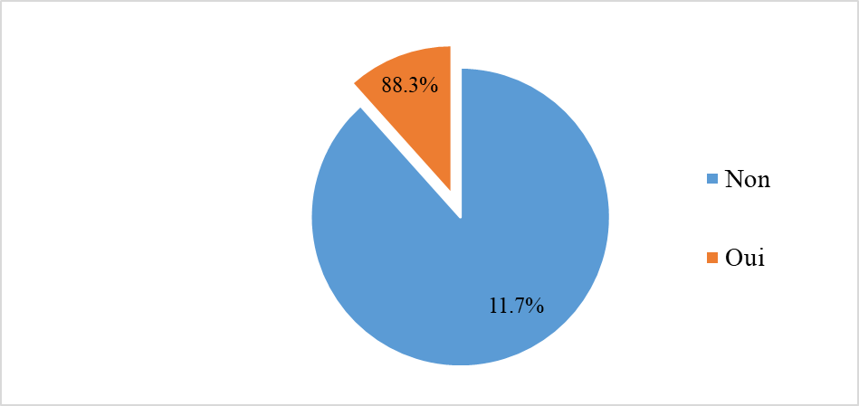
Figure 8: Signature of rental contract, land data
Source: Field data in October and November 2020
The lease contract, even if it exists , does not spare households from the whim of landlords who unilaterally set the rent price. They (landlords) can also claim their accommodation at any time without notice. Such a situation is related to the informal nature of the lease contract which can secure both the landlord and the tenant. The absence of effective regulation in this regard favors conflicts between the two actors (Adamou, 2012).
In most cases, tenants live in proven rental insecurity. This is the case of Ibrahim, a resident of Saguia . In 2012, after flooding in his neighborhood, he rented a house in Kirkissoye . A year later, as the summer holidays approached, the owner of the house ordered him to leave as quickly as possible because, she said, one of her daughters who is in the interior of the country will be coming for the summer holidays. Ibrahim was forced to move to his plot in Saguia to build a tent. Ibrahim's case is not isolated; situations of this kind are legion in Niamey and in almost all cities in Niger, and for good reason in that the texts relating to leases are not respected or often even unknown by tenants. The tense relations between landlords and tenants are subjects often covered by the newspapers:
"That's how he ordered us to empty his common courtyard, he put forward the pretext of wanting to carry out colossal work in all the houses. He gave two months to have another house to free up his courtyard. However, in Niamey you can go three months without having a house so you have to involve an intermediary in the mission and it was only after the third month that we finally left the premises. In reality, the landlord wanted to get rid of us, the former tenants, to find others who would pay more. Today, he is renting his houses for 30,000 francs instead of 20,000 francs," laments Ms. Aicha, a supervisor at a local school." (Actu Niger, 2016).
"I've been paying 60,000 francs for this tiny villa for over a year, and one day our landlord, whom I don't even know, showed up. He told me that starting this month the rent would go up to 80,000 francs, or 20,000 francs more. Without further ado, he told me it was just information, and if I couldn't pay, it was time to find another house. I was very shocked because he hadn't done anything in the house that could at least justify this sudden increase," this young doctor from the Tillabéry Hospital Center, who owns a rental apartment in Niamey, Route Filingué, told us. ( Actu Niger, 2016).
The implementation of new property taxes most often results in the transfer of costs to tenants. Indeed, this strategy is well known in Niamey, where landlords often unilaterally increase rental prices, due to rising property or real estate taxes. This is a classic way for landlords to not only recoup the capital gain, but also to shift their tax burden onto tenants.
Rental houses are also in most cases houses of conflicting cohabitation which would be due either to the use of shared showers or to the payment of water or electricity bills in the case of a shared meter. Cohabitation between neighbors, if it is not well perceived, becomes a headache. It can lead to a lamentable situation or extreme open conflict between neighbors. It constitutes a reason for moving for several households. Thus, among the reasons which pushed households to move from the last residence, disagreement between neighbors occupies more than 45% of the reasons. According to the results of the surveys carried out (Figure 9), 17.9% of moves come from promiscuity, 25.6% are linked to the use and maintenance of shared showers and 41.1% to the payment of water or electricity bills and 15.4% linked to neighborhood conflicts (fights between children and others).
Figure 9: Problems encountered in rental houses,
Source: Field data in October and November 2020

The main form of vulnerability for tenant households is that linked to the insecurity of their housing occupancy status. This particularly concerns households whose rent costs increasingly expose them to a situation of non-payment, indebtedness, or even eviction. This is especially true since the landlord can increase rent prices, which creates a distressing situation for households. Tenants who mention rent increases do so with discontent and, in a way, refute their legitimacy.
The inaccessibility of housing, in terms of rental costs, is a reality in the city of Niamey. While access to property ownership is a difficult and long journey, the step that must be taken to get there is not as advantageous for tenants. Indeed, the rental issue, as we have highlighted, is very poorly managed and not monitored by the authorities; landlords are kings and do what suits them. The rental price is very often set unilaterally and without consideration of the concerns of applicants. This is why, when asked, "Is the price of your rental affordable?", it clearly emerged that for most, the rental price is unaffordable compared to their purchasing power. Indeed, 51.8% find rental costs unaffordable compared to 48.2% who consider the price affordable (Figure 10).
This state of affairs shows that tenants are subjected to financial violence that only they know how to manage, especially since neither the authorities nor civil society are addressing these issues for inclusive regulation (i.e. regulation that takes into account the interests of all (landlords and tenants).
The high cost of renting relative to residents' purchasing power is a significant factor of vulnerability in a context of job insecurity and uncertainty due to the coronavirus pandemic. In this context, many residents working in the informal sector have seen their activities slow down due to the measures taken by the government.
"Rental prices are constantly rising. In all categories, from bachelor apartments to apartments, landlords are constantly raising the stakes. A sort of natural selection is increasingly taking hold: the poorest are resolutely finding themselves on the periphery" (Actu Niger, 2016).

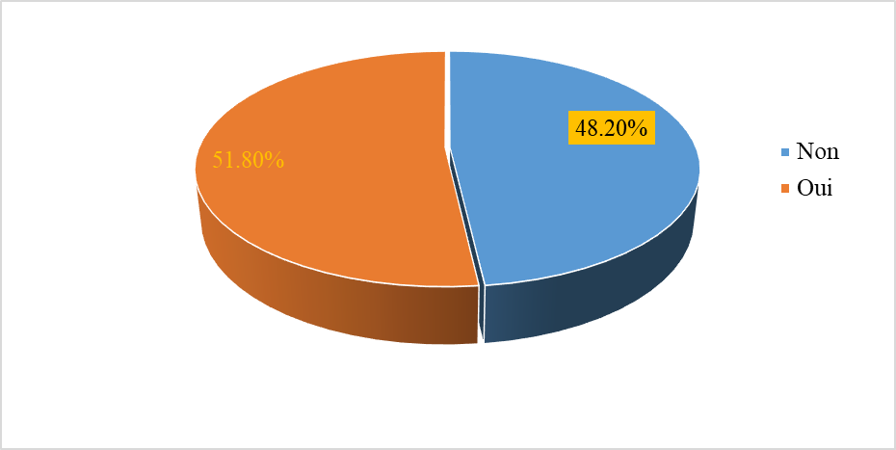
Figure 10: Accessibility of rental prices,
Source: Field data in October and November 2020
The texts that govern rental issues in Niger are very little known and remain difficult to apply because the implementing decrees have not yet been issued. This lack of awareness is explained by the absence of tenant rights organizations and also by the low level of education of a portion of the population. Indeed, of all tenant households that responded to the question, 92.7% stated that they were not familiar with the texts that govern rental in Niger, compared to 7.3% of households that were familiar with the subject (Figure 11). Indeed, the issue of the right to housing and the right to the city is often severely tested by real estate investors regardless of their profile. The laxity of public authorities is the main cause when they do not ensure that those involved in implementation can adequately comply with the relevant texts. People living in rental housing are faced with unsanitary conditions in their homes and the threat of eviction. They lack the necessary means of recourse to assert their rights (Gallié and Besner , 2017). The issue of rental is poorly regulated in most African cities. Tenants and their landlords are left in an unequal power relationship.

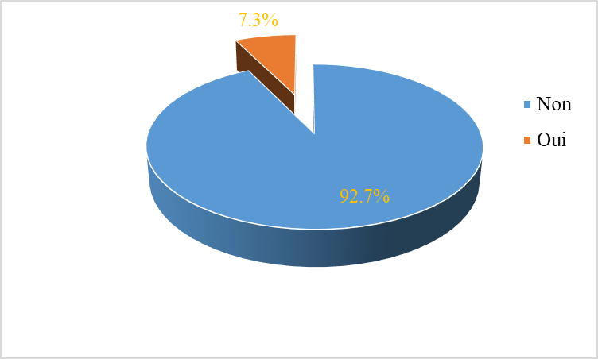
Figure 11: Knowledge of texts regulating rental in Niger
Source: Field data in October and November 2020
6.1.4 Land vulnerability indicator and factors differentiating between households
The land vulnerability indicator is calculated based on the types of subdivision and the acts of securing property or use rights available to households. Overall, residential built-up areas in the Niamey 5 municipal district are in a situation of land insecurity. Indeed, according to the vulnerability indicator calculation, only 8.2% of households, regardless of tenure status, are in low vulnerability, 78.8% in high vulnerability, and 14.9% in medium vulnerability (Figure 12). The almost widespread situation of land vulnerability is explained by the difficult conditions to meet to have formal ownership or to be in a situation of occupation or uses of formal land rights (rental and rent-free accommodation). Indeed, neither the land registration and urban planning procedures nor the lease rules make life easier for urban households. The duality of land tenure systems, the high cost and length of procedures are all factors that limit the formalization of property rights among the population. The high price of land forces many city dwellers to turn to customary owners to benefit from a plot of land, regardless of the status it may have in terms of urban planning. The procedure for securing property from above, introduced during colonization and continued by independent states almost everywhere in French-speaking Africa , constitutes the source of the land security problems experienced by the populations. States should have adapted the security process to the local context in order to avoid any dualism in access and security of property rights. As for the right of use (rental in the context of this work), the texts must be followed , operational actions can be used to regulate rents in order to avoid the exposure of tenants to the whims of landlords.
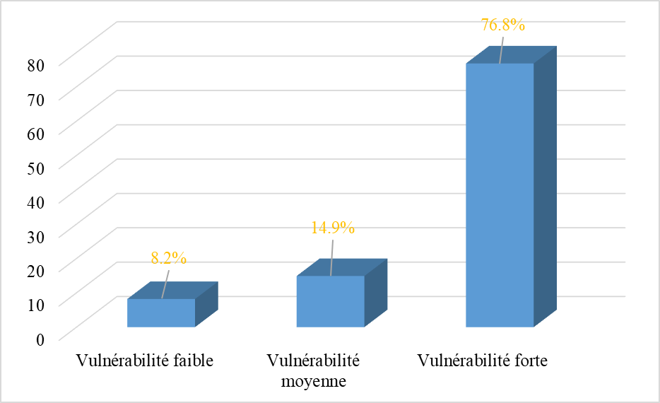
Figure 12: Level of household land vulnerability
Source: Field data in October and November 2020
However, there is a disparity between occupation status and the level of legal vulnerability. Indeed, households in a low land vulnerability situation are 96.90% owners and 3.10% co-owners. On the other hand, the 40.6% of households in a high vulnerability situation are tenants and 12.8% are rent-free tenants (Table 3 ). This situation is normal because, as we have already emphasized, the texts are not in favor of tenants who constantly suffer the dictates of landlords without any regulation being made by the public authorities. In addition to the unbearable costs of rents and the often difficult cohabitation conditions, tenant households are not sufficiently protected legally. They are subject to permanent threats from landlords. As we have emphasized above, they bear all the costs of the property tax. As for rent-free households, they are automatically in a high legal vulnerability due to their situation.
Table 2: Correlation between housing occupancy status and land vulnerability
 | Legal vulnerability
Occupation status | Low vulnerability | Medium vulnerability | High vulnerability
Owner | 31(96.90%) | 38(65.50%) | 126(42.30%)
Co-owner (family home) | 1(3.10%) | 4(6.90%) | 13(4.40%)
Tenant | 0 | 16(27.60%) | 121 (40.60%)
Free accommodation | 0 | 0(0.00%) | 38(12.80%)
Total | 32(100) | 58(100) | 298(100)
Source: Field data in October and November 2020
Also, the lower the level of education, the greater the household land vulnerability (Table 4). Indeed, households whose heads have a low level of education (no level, primary level) are respectively 78.80% and 83.80% in high vulnerability compared to 65.10% of households with a higher level.
Having a certain level of education is a guarantee, in most cases, of a better quality of life, not only because of the opportunities it offers but also because of the awareness it implies in the context of securing land rights. Thus, it is obvious that the higher one's level, the more one recognizes the benefits of having one's legitimate rights protected.
Table 3: Correlation between educational level and legal vulnerability
 | Educational level
Vulnerability type | None | Koranic | Primary | Secondary | Superior
Low vulnerability | 5(5.60%) | 5(4.80%) | 1(1.40%) | 14(22.20%) | 7(11.70%)
Medium vulnerability | 14(15.60%) | 12(11.40%) | 10(14.30%) | 8(12.70%) | 14(23.30%)
High vulnerability | 71(78.90%) | 88(83.80%) | 59(84.30%) | 41(65.10%) | 39(65.00%)
Total | 90(100%) | 105(100%) | 70(100%) | 63(100%) | 60(100%)
Source: Field data in October and November 2020
Failure to comply with urban planning standards in the process of urban land production leads households to settle in vulnerable geographical areas.

Conclusion
The lack of operational urban planning, coupled with difficulties in applying legal and regulatory tools, the liberalization of control over urban land production, and the financial strain on municipalities, are all factors that contribute to household vulnerability. Households in the neighborhoods of the Niamey 5 municipal district are experiencing the sad phenomenon in other forms. The first form of vulnerability experienced by households is that linked to the land status of the inhabited space. Indeed, non-compliance with land regulations and urban planning standards in the production of urban land is a reality in ACN5; it is marked by informal occupation of spaces and precarious acts of securing property and use rights. These land and urban planning vulnerabilities ultimately translate into residential vulnerability characterized by precarious housing conditions. In fact, the homes of ACN5 households are built, for the most part, in areas prone to flooding and/or difficult to access (hillsides, steep and gentle slopes) and constructed from non-durable materials (banco and semi-hard). To overcome land vulnerability in the Niamey 5 municipal district, it is important to establish an urban land registry and to comply with urban planning regulations in all urban land production processes. It is also necessary to raise public awareness of the importance of land security by disseminating the relevant regulations.
Disclaimer (Artificial intelligence)
Option 1:
We hereby declare that No generative AI technologies such as large language models (ChatGPT, COPILOT,etc,) and text-to-image generators have been used during the writing or editing of this manuscript.

References
ADAMOU Abdoulaye,2012, Mobilité résidentielle et processus d’étalement de la ville de Niamey (Niger). Thèse de doctorat unique Université Abdou Moumouni de Niamey, 301p. https://www.memoireonline.com/06/20/11858/Mobilite-residentielle-et-processus-d-etalement-de-la-ville-de-Niamey-Niger.html.

Ballo, S. (2015). Urban Dynamics and Flooding in Bamako: Study of a Vulnerability Process in Commune IV of the District. African Research.
TRAORE, K. M., & TAMBOURA, A. T. (2024). Mapping Vulnerabilities to Flood Risk in the City of Issia (Central-West Côte d'Ivoire). International Journal of Researchers, 5(2).
GALLIE Martin et BESNER Louis-Simon, 2017, « De la lutte contre les délais judiciaires à l’organisation d’une justice à deux vitesses : la gestion du rôle à la Régie du logement du Québec ». Les Cahiers de droit 58, no 4 (2017) : 711–747. https://doi.org/10.7202/1042756ar.
Sy, I., Koita, M., Traoré, D., Keita, M., Lo, B., Tanner, M., & Cisse, G. (2011). Health and Environmental Vulnerability in Disadvantaged Neighborhoods of Nouakchott (Mauritania): Analysis of the Conditions for the Emergence and Development of Diseases in Sahelian Urban Environments. VertigO - The Electronic Journal of Environmental Sciences, 11(2).
Zongo, M., & Mathieu, P. (2000). Commercial land transactions in western Burkina Faso: vulnerability, conflicts, security, and insecurity. APAD Bulletin, (19).
OURA, K. R. (2022). Land conflicts around former sites of displaced villages in Béoumi: land grabbing or weakness of post-AVB land policy? African Journal of Land Policy and Geospatial Sciences, 5(3), 608-620.
CHINDJI, R. M. (2021). Land tenure issues related to land use around the Mbankolo and Akok-Ndoué mountains in Yaoundé. African Journal of Land Policy and Geospatial Sciences, 4(4), 5.
KOSSI, A. (2022). LAND SPECULATION IN SECONDARY CITIES OF TOGO: THE CASE OF ADETA. BULLETIN CITIES, TRANSPORT, LOCAL DEVELOPMENT, 1(6), 11-26.52-570. Yapi-Diahou, A. (2023). Land in Capitals: West African Capitals Facing the Land Challenge, Abidjan Bamako Ouagadougou (p. 240). Paari.
DOS SANTOS Stéphanie et SANGLI Geraldine, 2020, « Tous les ménages vivant dans les zones informelles sont vulnérables aux risques environnementaux ? » Adjamagbo, Agnès (ed.) ; Gastineau, Bénédicte (ed.) ; Golaz, V. (ed.) ; Ouattara, Fatoumata (ed.). La vulnérabilité à l'encontre des idées reçues, 6, LPED, p. 78-89, 2020, Les Impromptus du LPED (FRA), 979-10-967630-8-5. ⟨hal-02954096⟩
SIMONNEAU Claire, 2018, Communs fonciers urbains : étude exploratoire des dispositifs collectifs d’accès au sol dans les villes du Sud global, Regards sur le foncier N°5, Comité technique « Foncier & développement », AFD, MEAE, Paris
SOW El hadji Souleymane, (2022), Annuaire sur le Financement du Logement en Afrique 2022, Niger, pages 4. https://housingfinanceafrica.org/app/uploads/2023/01/NIGER.pdf.

YEMMAFOUO Aristide, 2013. Urbanisation et espaces périurbains en Afrique subsaharienne. Pratiques à l’Ouest-Cameroun. Le Harmattan, 2013. 264 p. https://www.editions-harmattan.fr/catalogue/livre/urbanisation-et-espaces-periurbains-en-afrique.

