A Non-Parametric Trend Evaluation Approach of Rainfall Data for Biswanath Chariali Weather Station and Nasa Power

Abstract
Rainfalldataisimportantinclimaticplanningandresearchendeavors.Itisimperativethatrainfall data be recorded continually because it needs to be accessible at all times. Here, in this study rainfall data were collected from NASA Power and Biswanath Chariali weather station on a monthly and annual basis between 1981 and 2021. The average yearly rainfall as reported by NASA power and the Biswanath Chariali weather station was found to differ significantly. Additionally,thestudyattemptedtoanalyzetheseasonalandannualtrendsintherainfalldatathat were obtained from these two data sources. The analysis showed that the yearly rainfall trend, as measured by NASA power data, is significantly increasing. While evident, the seasonal trend for the pre-, during-, and post-monsoon was not statistically significant. The study has able to notify thatNASA Power data could also be considered as a reliable data source alongwith BiswanathChariali weather station data to study the trend behavior of Biswanath district. .

Keywords: Rainfall; trend; seasonal; NASAPower; Biswanath Chariali weather station.

Introduction
The majority of nations, particularly the developing ones, continue to struggle with a lack of meteorological data collected at surface weather stations, despite significant improvements in climate databases in recent decades [1]. Under these circumstances, satellite-provided synthetic meteorologicaldatahave emergedasa viablesubstituteforacquiring extended anduninterrupted data sets, which can be employed to offset inadequate measurement observations [3]. By simulating numerical weather prediction models based on meteorological observations, the reanalysis approach [4] can be used to provide long-term series of atmospheric and land surface variables from atmospheric and sea surface observations. The National Aeronautics and Space Administration Prediction of Worldwide Energy Resources (NASA Power) is one of the many reanalysis datasets thatareutilised as sources of climatedata, and ithas received attention lately. Theplatformoffersinformationonanumberofmeteorologicalfactors,includingsolarfluxes,air temperature, relative humidity, precipitation, wind direction and speed, and soil-related characteristics including moisture in the soil profile and on the surface and root zones [2]. From 1980tothepresent,thedatais availableon anhourly,daily, monthly,and annualtime scale;as a result, it is sufficiently accurate for trustworthy measurements of the sun and weather [9]. The availabilityofthisdataspeedsupandsimplifiesthecompletionoftechnicalandscientificresearch that call for climate data. The majority of satellite reanalysis data in the literature relate to air temperature [10], solar radiation [11], and reference evapo transpiration calculated using the Penman-Monteith method [7-8]. Few research, however, evaluate the performance of data from NASA Power with that of measurements made at surface weather stations under various global climaticcircumstances.Researchstudiesfocusedontrendanalysisofmeteorologicalvariables[6] and the impact of climate change are noticed in Assam, in northeastern India [5]. However, there arenostudiesthatcomparedistrictweatherstationsandNASAPowerdatatoassesshowwellthe data performs. The prime objective of the present research was to compare BiswanathChariali district weather station and NASA Power data. This study was undertook to give conclusions regarding reliable use of data from the respective two databases. It assess annualandseasonalrainfalldatafrom1981to2021obtainedfromtheBiswanathCharialiweather stationandNASAPower.In order to evaluate the two data sources,thestudyattemptedtoobserve yearly and seasonal trend analysis of rainfall data from each one.

Material and Methods Study area
On the north bank of the Brahmaputra River, the district of Biswanath in Assam spans an area of 1100 square kilometres. On August 15, 2015, it was split off from Sonitpur district and officially constitutedadistrict.Theregionliesbetween26°14'00"and27°0'00"Northlongitudeandbetween 92°52'30"and93°50'0"Eastlongitude.ThedistrictsofLakhimpurontheeast,Sonitpurontheeast, Arunachal Pradesh on the north, and Golaghat district on the south encircle the district. The district'sadministrativecentreissituatedinBiswanathChariali.Thesevendevelopmentblocksin the district are PubChaiduar, Baghmari, Behali, Biswanath, Sakomatha, Sootea, and Chaiduar. Accordingtothe2011census,thedistricthas 947villagesandatotalruralpopulationof780567.
Therearenumerous ethnic clans and tribes residing in the district. Themain indigenous tribes in the area include the Mishings, Bodo, Rabha, and Deuri.

Data
Secondary data were used is this study. Therainfalldataweregatheredfromtwodifferent data records, NASA Power and the BiswanathChariali weather station, in consideration of the study's objective. Rainfall data were gathered on a monthly and annual basis between 1981 and 2021. The length of the monsoon season before, during, and after was taken into consideration when collecting the monthly data.
Thefollowingstatisticalmethodswereusedinthestudyarediscussedbelow:

Mann-WhitneyU test
Thenon-parametricalternative totheindependentsamplet-testistheMann-WhitneyUtest [12]. This non-parametric test compares two sample means from the same population and determines whether or not the two sample means are equal. When the t-test assumptions are not met or the data are ordinal, the Mann-Whitney U test is typically employed.

𝑈=𝑛𝑛
+𝑛2(𝑛2+1)−∑𝑛2
𝑅 (i)

12 2
Where,
𝑖=𝑛1+1𝑖

U=Mann-WhitneyUtest n₁ = Sample size one
n₂=Samplesizetwo
R_{i}=Rankofthesamplesize

Mann-Kendalltest
The Mann-Kendall (MK) test is used to determine if the variable of interest has a monotonic upward or decreasing trend over time using statistical analysis [13]. When a variable exhibits a monotonic upward (downward) trend, it indicates a constant increase (reduction) across time, although the trend may or may not be linear. To determine whether the slope of the calculated linearregressionlinedeviatesfromzero,aparametriclinearregressionanalysiscanbesubstituted withtheMKtest.TheMKtest isanon-parametric(distribution-free)test,whereastheregression analysis requires that the residuals from the fitted regression line be regularly distributed.

TheMKtesttestswhethertoreject thenullhypothesis(𝐻₀)andacceptthe alternativehypothesis (𝐻₁), where

𝐻₀:Nomonotonictrend

𝐻₁:Monotonictrendis present
Theinitialassumptionof theMKtestisthatthe 𝐻₀istrueandthatthedata mustbeconvincing beyond a reasonable doubt before 𝐻₀ is rejected and 𝐻₁ is accepted.

Sen’sslope estimator

Sencreatedthistestfirstinordertoverifystatisticallinearcorrelations.Inthelong-termtemporal data, it is employed to compute the magnitude of trends [14]. Due to its insensitivity to data outliers, Sen's slope is seen to be a superior method for identifying linear relationships. The following equation is used to estimate each individual slope:

Qi=𝑌𝑗−𝑌𝑖
𝑗−1
(ii)

Wherei=1to n −1,j=2to n, Y_{j}and Y_{i}aredatavaluesattime jand i(j>i),respectively.Ifin
the time series,therearenvaluesofY_{j},estimatesofthe slopewill beN=^{𝑛(𝑛−2)}.Theslopeofthe
2
Senestimatoristhemeanslopeofsuchslopes'Nvalues.TheSen's slopeis:
𝑌𝑗−𝑌𝑖𝑖𝑓𝑛𝑖𝑠𝑜𝑑𝑑

𝑄𝑖𝑗
={
1(𝑄𝑁
2 2

+𝑄[
𝑗−1
𝑁+22

])𝑖𝑓𝑛𝑖𝑠𝑒𝑣𝑒𝑛
- (iii)

ModifiedMann-Kendalltest
Serial correlation frequently has an impact on time series data. Modified Mann-Kendall tests can beused for trend detection when autocorrelation is presentand thedataarenotrandom. To solve the problem of serial correlation in Trend analysis, [15] presented a variance correction approach. After first detrending the data, the rankings of significant serial correlation coefficientsareutilisedto calculatetheeffectivesamplesize andcorrecttheinflated(ordeflated) variance of the test statistic.

Results and Discussion:
Thedescriptivestatisticsofannualrainfallfrom1981-2021ofBiswanathCharialidistrictstation and NASA Power is given as follows:
Table1: Descriptive statistics of annual rainfall from 1981-2021 Biswanath Chariali weather station

Statistics
Mean | 1923.30
Median | 1898.50
Std. Deviation | 314.82
Skewness | .019
Kurtosis | .029
Minimum | 1117.0
Maximum | 2572.9

Table2: Descriptive statistics of annual rainfall from1981-2021 of BiswanathChariali district collected from NASA Power.
Statistics

Mean | 1547.36
Median | 1539.84
Std. Deviation | 244.13
Skewness | -.022
Kurtosis | -.617
Minimum | 1081.05
Maximum | 2056.64

Graphical representation of annual rainfall from 1981-2021 of Biswanath Chariali district
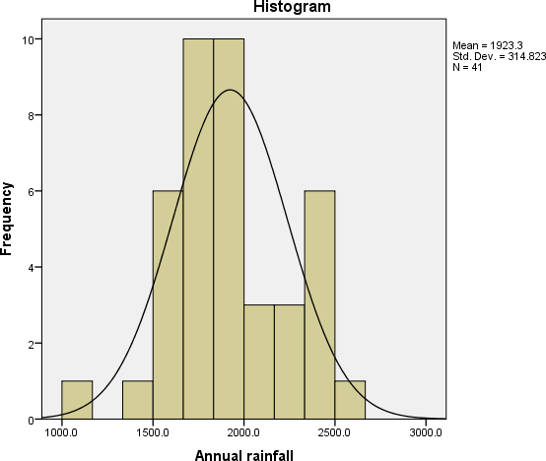

Figure1: Histogram of annual rainfall from 1981-2021 from Biswanath Chariali weather station
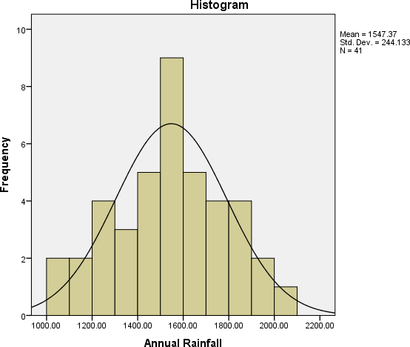
.

Figure2: Histogram of annual rainfall from 1981-2021 from NASA Power
From the above table 1 and table 2, it is observed that measures of central tendency (mean and median) and measures of dispersion (standarddeviation) values differ widely between the two data sources. Further, from the tables, skewness, kurtosis, maximum and minimum values also differ. ThehistogramandnormalcurveobtainedfromNASAPowerofBiswanathdistrictannualrainfall is comparatively less skewed than Biswanthchariali weather station.

Table 3: Summary of Mann Whitney U-test between data sources of BiswanathChariali district annual rainfall from 1981-2021.

Null Hypothesis | P-value | Decision
The distribution of annual rainfall of BiswanathChariali district from 1981-2021 is same across two data sources, | 0.000 | Rejectnullthenullhypothesis.
*Thesignificancelevelis 0.05
From the above table 3, it is observed that there is significant difference in distribution of annual rainfall of BiswanathChariali district from 1981-2021 between NASA Power and Biswanathchariali weather station.
Graphical representation of annual rainfall from 1981-2021 of Biswanath Chariali district from Biswanath Chariali weather station and NASA Power
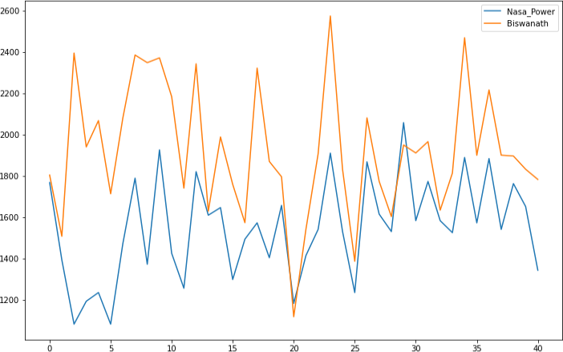
Figure 3:Annual rain fallfrom 1981-2021 of Biswanath Chariali district

Table 4: Summary of Mann-Kendall Annual Monotonic Trend Analysis of Biswanath Chariali district rainfall from 1981-2021.

Datasource | Kendall rank correlation coefficient | Sen’s slope | P-value | Significance
NASAPower | 0.253 | 7.73 | 0.02 | Significant
Biswanath Charialidistrict Station | -0.078 | -3.80 | 0.479 | Not significant
*Thesignificancelevelis 0.05
The yearly rainfall trend analysis summary from the two data sources differs, as can be seen in table 4above. When comparingtheNASAPowerdatato theBiswanathCharialiweather station, itispossibletoseeanincreasingtrendwithapositiveSen’sslopevalue(7.73).Theannualrainfall data from Biswanathchariali weather station indicates a negative trend with slope value (-3.80). In contrast to the BiswanathChariali weather station's p-value of 0.479, the NASA power data source's p-value of 0.02 is significant.

Table 5: Summary of Modified Mann-Kendall (Hamed-Rao approach) Annual Monotonic Trend Analysis of BiswanathChariali district rainfall from 1981-2021.

Datasource | Kendall rank correlation coefficient | Sen’s slope | P-value | Significance

NASAPower | 0.253 | 7.73 | 0.006 | Significant
Biswanath Charialidistrict Station | -0.07 | -3.80 | 0.479 | Not significant
*Thesignificancelevelis 0.05
It is evident from table 5 above that the yearly rainfall trend analysis summary from the two data sources differs. Compared to the BiswanathChariali weather station, the NASA Power data was able to demonstrate a rising trend with a positive Sen’s slope value (7.73). Compared to the p- value(0.479) oftheBiswanathChariali weather station,thep-value (0.006)fortheNASApower data source is highly significant.

Graphicalrepresentationofannualrainfalltrendfrom1981-2021ofBiswanathChariali district from NASA Power
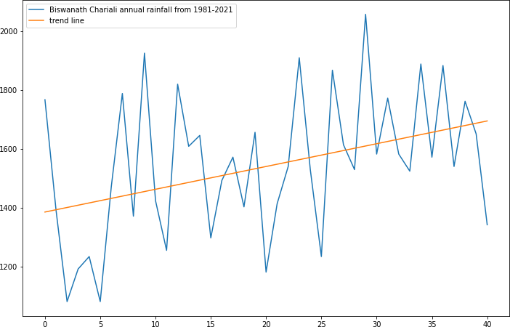

Figure4:AnUpwardtrendofannualrainfallfrom1981-2021ofBiswanathCharialidistrict from NASA Power
Figure4aboveshowsthattheBiswanathCharialidistrict'syearly rainfallfrom1981 to2021was abletoshowan increasing trend.Seasonalfactorshavebeen takenintoaccountin this increasing trend.

Table 6: Summary of Mann-Kendall Seasonal Monotonic Trend Analysis of BiswanathChariali district rainfall from 1981-2021.

Season | DataSource | P-value | Sen’sslope | Significance
Pre-monsoon | Biswanath  CharialiStation | 0.74 | 1.04 | Not significant
Pre-monsoon | NASAPower | 0.16 | 0.10 | Not significant

Monsoon | BiswanathCharialiStation | 0.35 | 0.09 | Not significant
Monsoon | NASAPower | 0.23 | -2.66 | Not significant
Post- monsoon | BiswanathCharialiStation | 0.53 | 0.60 | Notsignificant
Post- monsoon | NASAPower | 0.81 | 0.11 | Not significant
*Thesignificancelevelis 0.05
Table 6 shows that, when it comes to rainfall data from two sources for the BiswanathChariali district from 1981 to 2021 for the three periods of pre-, monsoon, and post-monsoon, there is no significantmonotonictrend.Duringthepre-monsoonseason,therainfalldatafromtheBiswanathChariali station exhibit a positive slope value (1.04), indicating a positive trend. Similarly, a positive trend with a slope value of 0.10 is indicated by rainfall data obtained from the NASA Powerdatasource.Throughoutthemonsoonseason,therainfalldataacquiredfromNASAPower source shows a negative slope value (-2.66), indicating a negative trend. The BiswanathChariali station shows a positive trend with slope value (0.09), in contrast to NASA Power rainfall data. Additionally, the length of the post-monsoon can be determined by a positive slope value of 0.61 and 0.11 for the BiswanathChariali weather station and NASAPower rainfall data, respectively.

Conclusion
This research has statistically examined rainfall data obtained from NASA power and the Biswanath Chariali weather station.The averagey early rainfall from1981 to 2021 as reported by NASA power and the Biswanath Chariali weather station was found to differ significantly. Additionally, the studyattemptedtoanalysetheseasonalandannualtrendsintherainfalldatathat were obtained from these two data sources. The analysis showed that the yearly rainfall trend, as measured by NASA power, is significantly increasing. While evident, the seasonal trend for the pre-, during-, and post-monsoon was not statistically significant. Based on these non- parametric trend analysis observations, it comes to notice that NASA Powerdata couldalsobeconsideredas a reliable data source alongwith BiswanathChariali weather stations data to study the trend behavior of rainfall of Biswanath district.

Future Prospect
This research work could be used as a preliminary study in evaluation of performance of data from NASA Power and Biswanathchariali weather station. The study has usedonlyrainfalldataforevaluation;itcouldbegeneralizedtootherweathervariables.Infuture, the study could be generalized to other weather stations of Assam.

Author statement (Disclaimer) –
Thecontentsandviewsexpressedinthisresearchpaper/articlearetheviewsoftheauthorsanddo not necessarily reflect the views of the Assam Agriculture University.

Disclaimer (Artificial intelligence)

Author(s) hereby declare that NO generative AI technologies such as Large Language Models (ChatGPT, COPILOT, etc.) and text-to-image generators have been used during the writing or editing of this manuscript.

REFERENCE

- H.Aboelkhair,M.Morsy,andG.ElAfandi,“AssessmentofagroclimatologyNASA POWERreanalysisdatasetsfortemperaturetypesandrelativehumidityat2magainstground
observationsoverEgypt,”Adv.SpaceRes.,vol.64,no.1,pp.129–142,2019.doi: 10.1016/j.asr.2019.03.032.

- NASA and National Aeronautics and Space Administration, Power Data Access Viewer: Prediction of Worldwide Energy Resource. Available at:.

- G. C. Rodrigues and R. P. Braga, “Estimation of daily reference evapotranspiration from NASAPOWERreanalysisproductsinahotsummerMediterraneanclimate,”Agronomy,vol.11, no. 10, Art.2077, 2021a. doi: 10.3390/agronomy11102077.

- J.Sheffield,G.Goteti,andE.F.Wood,“Developmentofa50-yearhigh-resolutionglobal datasetofmeteorologicalforcingsforlandsurfacemodeling,”J.Clim.,vol.19,no.13,pp.3088– 3111, 2006. doi: 10.1175/JCLI3790.1.
- D. Das, “Changing climate and its impact on Assam, Northeast India,” Bandung J. Glob. S., vol. 2, no. 1, 1–13, 2015. doi: 10.1186/s40728-015-0028-4.

- K.GogoiandK.N.Rao,“AnalysisofrainfalltrendsoverAssam,NorthEastIndia,”Curr. World Environ., vol. 17, no. 2, pp. 435–446, 2022. doi: 10.12944/CWE.17.2.15.

- A. Negm, J. Jabro, and G. Provenzano, “Assessing the suitability of American National Aeronautics and Space Administration (NASA) agro-climatology archive to predict daily meteorological variables and reference evapotranspiration in Sicily, Italy,” Agric. Forest Meteorol., vol. 244/245, pp. 111–121, 2017. doi: 10.1016/j. agrformet.2017.05.022.

- P. M. Ndiaye et al., “Trend and sensitivity analysis of reference evapotranspiration in the SenegalriverbasinusingNASAmeteorologicaldata,”Water,vol.12,no.7,Art.1957,2020.doi: 10.3390/w12071957.

- O.A.Marzouk,“AssessmentofglobalwarminginAlBuraimi,sultanateofOmanbased on statistical analysis of NASA POWER data over 39 years, and testing the reliability of NASA POWER against meteorological measurements,” Heliyon, vol. 7, no. 3, p. e06625, 2021. doi: 10.1016/j.heliyon.2021.e06625.

- F. D. Bender and P. C. Sentelhas, “Solar radiation models and gridded databases to fill gaps in weather series and to project climate change in Brazil,” Adv. Meteorol., vol. 2018, Art.6204382, 2018. doi: 10.1155/2018/6204382.

- A. D. Quansah et al., “Assessment of solar radiation NASA Power and surface weather stationsonevapotranspirationestimation11”Pesqui.Agropec.Bras.,Brasília,vol.58,2023DOI: 10.1590/S1678-3921.pab2023.v58.03261 resource from the NASA-POWER reanalysis products fortropicalclimatesinGhanatowardscleanenergyapplication[Scientificreport],v.12,p.e03261, Art.10684, 2022. doi: 10.1038/s41598-022-14126-9.

- N. Nachar, “ The Mann-Whitney U: A Test for Assessing Whether Two Independent Samples Come from the Same Distribution”, Tutorials in Quantitative Methods of Psychology, vol. 4, no.1, pp. 13-20, 2008.

- R. Yadav et al., “Trend Analysis by Mann-Kendall test for Precipitation and Temperature for Thirteen Districts of Uttarkhand”, Journal of Agrometeorology, vol. 16, no.2, pp. 164-171, 2014.

- N. Kamal and S. Pachauri, “Mann-Kendall, and Sen’s Slope Estimators for Precipitation Trend Analysis in North-Eastern States of India”, International Journal of Computer Applications, vol. 177, no.11, pp. 7-16, 2019.

- K.H. Hamed and A.R. Rao, “A Modified Mann-Kendall Trend Test for Auto-correlated Data”,
Journal of Hydrology, 204, pp. 182-196, 1998.

