Assessment of Length of Growing Period for efficient crop planning in the
Tarai and mid Himalayan regions of Uttarakhand, India

ABSTRACT
The Tarai region, with 55-60% of its agricultural area under rainfed farming, and the mid-Himalayan region, with 80-90%, experience humid to Perhumid climatic conditions. However, erratic rainfall distribution in the Tarai and significant topographical variations in the mid-Himalayas contribute to yield losses. This study aims to determine the length of the growing period (LGP) and assess moisture suitability for various crops in both regions of Uttarakhand for the period 1981-2020 (Tarai) and 1985-2020 (mid-Himalayan). Three methodologies were employed to estimate the LGP: the NBSSLUP criteria (PPT, PET, 0.5PET), the RF/PET ratio, and the Moisture Adequacy Index (MAI) based on Thornthwaite’s water balance method on a weekly scale.
The average LGP was determined to be approximately 227 days in the Tarai region and 313 days in the mid-Himalayan region with Humid-Perhumid type of climate in the both the regions. To mitigate water stress during the post-monsoon and summer seasons, appropriate irrigation strategies must be implemented in the Tarai region to ensure optimal crop yields. Conversely, in the mid-Himalayan region, rainfed crops can be cultivated year-round, supplemented by irrigation from natural springs during dry spells in October and May. The primary crops in these regions include rice, wheat, soybean, maize, pulses, vegetables, fruits, and minor millets.
Keywords: Thornthwaite, MAI, PET, Dry spells, Erratic.
- INTRODUCTION
The availability of water in the right quantity and at the appropriate time, along with effective management, is crucial for ensuring optimal crop growth and yield. The duration of water availability in a given location varies annually and across different soil types, significantly influencing agricultural productivity (Ekka et al., 2020). A comprehensive assessment of water availability is a fundamental prerequisite for crop planning, particularly in rainfed conditions. Micro-level agroclimatic potential and climate risk assessments demand immediate attention to enhance resource allocation and improve the management of rainfed agricultural systems efficiently.
The Length of Growing Period (LGP) refers to the number of days in a year when moisture stored in the root zone is sufficient to meet crop water requirements. Accurate knowledge of rainfall onset and cessation periods facilitates timely land preparation, resource mobilization, and input application, thereby minimizing the risks associated with premature or delayed sowing (Dugal et al., 2022). A similar study conducted by Sathyamoorthy et al. (2017) in the northwestern zone (NWZ) of Tamil Nadu examined rainfall variability and the duration of the growing season to optimize crop planning. Soil moisture stress during the active crop growth period is a primary cause of low and highly unstable agricultural yields (Lagnajeet et al., 2023). Rainfall serves as the primary water source in soil, and its effective distribution is crucial for fulfilling plant transpiration and soil dissipation requirements (Developments in Agricultural and Managed Forest Ecology, 1992).
Rainfed agriculture constitutes over 60% of India’s net sown area and nearly 48% of its total food production (Department of Agriculture, Cooperation, and Farmers Welfare, Government of India, 2016). The seasonal variability of rainfall in India is closely linked to uncertainties in both the amount and distribution of precipitation. Moisture availability in soil is quantified using the Moisture Adequacy Index (MAI) (Kokilavani et al., 2016). However, due to the unpredictable nature of rainfall distribution, MAI also exhibits significant variability. Hargreaves (1975) defined MAI as the ratio between assured rainfall, expected with a 75% probability, and projected potential evapotranspiration for the given period. Thornthwaite and Mather (1955) derived MAI using a water balance equation similar to the model proposed by Subramaniam and Rao (1984). Raman and Murthy (1971) calculated MAI based on average monthly rainfall, although they noted that monthly MAI values were insufficient for planning agricultural operations due to the extended timeframe. Sarker and Biswas (1980) recommended calculating MAI on a weekly basis, considering dependable rainfall at a 50% probability level and utilizing different MAI values suited to various crop periods. MAI plays a crucial role in crop planning, particularly in dryland agriculture, where monthly values may not accurately represent conditions due to intermittent dry spells that cause crop losses (Makwana et al., 2021).
The primary crops cultivated in the Tarai region include rice, wheat, mustard, maize, and pulses, whereas the mid-Himalayan region supports off-season vegetables, rice, wheat, millets, amaranth, and buckwheat (Murthy et al., 2004). This study aims to provide agrometeorological advisories to farmers based on rainfall patterns, potential evapotranspiration (PET), and actual evapotranspiration (AET) to facilitate informed decisions on cropping patterns, ultimately enhancing productivity. Effective planning and management of agricultural operations require a thorough understanding of the growing period of a specific region.
Despite significant advancements in technology and improved irrigation facilities, Indian farmers remain highly dependent on seasonal rainfall, which exhibits considerable variability in both time and space. Extreme weather events such as droughts, floods, cold and heat waves, hailstorms, and tropical cyclones severely impact agricultural productivity. The adverse effects of these weather events can be mitigated if they are accurately predicted in advance, allowing farmers to take preventive measures. Consequently, weather forecasting assumes critical importance in agricultural planning.
Traditional weather forecasts, which rely on subjective methods, typically provide predictions only a day in advance. While useful for certain applications, these forecasts are inadequate for implementing weather-based agricultural strategies that require longer lead times. Effective planning of modern agricultural practices, including sowing weather-sensitive high-yielding seed varieties, applying fertilizers and pesticides based on need, optimizing irrigation, and scheduling harvests, necessitates weather forecasts with extended lead times.
- MATERIALS AND METHODOLOGY
2.1. Study Area:
This investigation was conducted at the experimental farm of N. E. Borlaug Crop Research Centre, G. B. Pant University of Agriculture & Technology, Pantnagar (29.02°N, 79.48°E; altitude: 244 m), and VCSG Uttarakhand University of Horticulture & Forestry, Ranichauri (30.30°N, 78.40°E; altitude: 1864 m) as depicted in Fig. 1. The study utilized weather data from the periods 1981–2020 and 1985–2020, respectively, depending on the availability of relevant parameters. The collected meteorological parameters included maximum temperature (°C), minimum temperature (°C), relative humidity (morning and evening, %), sunshine hours (hr.), rainfall (mm/day), rainy days, wind speed (km/hr.), and evaporation (mm). Statistical analysis was performed using MS Excel, WeatherCock software, and the PET Calculator.
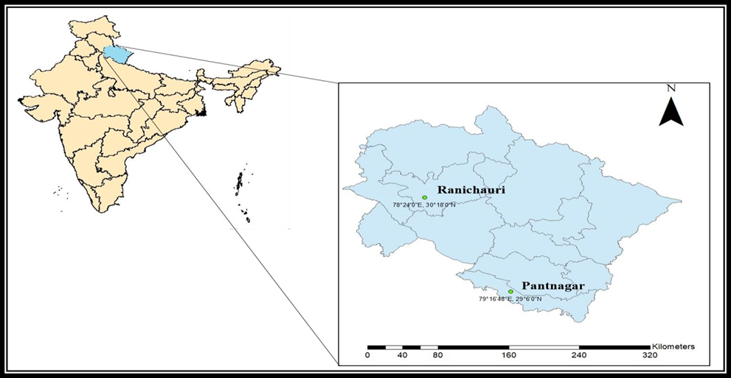Fig. 1: The study area depicting Pantnagar (Tarai) and Ranichauri (mid Himalayan) regions of
Uttarakhand
WeatherCock software is developed by the AICRPAM Unit of CRIDA, Hyderabad, for the agroclimatic analysis of an area. This software is based on Visual Basic (VB) and is easy to operate even for beginners.
2.2. Estimation of the Length of Growing Period
The length of the growing period is defined as the duration during which the available soil moisture is sufficient to meet the evapotranspiration requirements of dryland crops, thereby ensuring agroclimatic productivity. It is determined primarily by water availability and temperature. In other words, the growing period is defined as the period (in days) during the year when precipitation exceeds half of the potential evapotranspiration (PET) value, plus an additional period required to evapotranspire up to 100 mm of water from the excess precipitation stored in the soil profile. The growing period can be quantified based on the water balance components—precipitation (P), PET, and available soil moisture (ASM = 100 mm or as measured).
The LGP is a valuable concept for calculating agricultural potential and can be used as a criterion for classifying regions and roughly determining crop cycle lengths. Its calculation is based on a simple water balance model that compares monthly precipitation with PET. Based on the length of the growing period, different cropping systems have been adopted as per the following:
Table 1: Agroecological Region Classification Based on Length of Growing Period (LGP)
Letters | Type of Agroecological region/ecosystem | LGP (in days) | Types of cropping
A. | Arid ecosystem | <90 | Monocropping
B. | Semi-Arid ecosystem | 90-150 | intercropping
C. | Sub- Humid ecosystem | 150-180 | intercropping
D. | Humid-Perhumid ecosystem | 210+ days of soil moisture  utilization | Double cropping
E. | Coastal ecosystem | 90-210 + days | Double cropping,  intercropping
F. | Island ecosystem | 210 + days | Double cropping
The following methods can be used to calculate the length of the growing period:
    - NBSSLUP Criteria
The different stages of the growing period—such as the start of the humid period, the beginning of rains and the growing period, the end of the monsoon season, and the end of the growing period with storage—are determined based on PET, 0.5 PET, and precipitation (PPT), as described by NBSSLUP (1992). PET is calculated using the PET Calculator software, which employs the Penman-Monteith equation and the following weather parameters: maximum temperature (°C), minimum temperature (°C), relative humidity (morning and evening, %), sunshine hours (hr.), wind speed (km/hr.), and evaporation (mm).
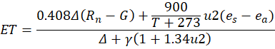

Where:
- ET₀ = Reference evapotranspiration (mm day⁻¹)
- Rn = Net radiation at the crop surface (MJ m⁻² day⁻¹)
- G = Soil heat flux density (MJ m⁻² day⁻¹)
- T = Mean daily air temperature (°C)
- u₂ = Wind speed at 2 m height (m s⁻¹)
- eₛ = Saturation vapour pressure (kPa)
- eₐ = Actual vapour pressure (kPa)
- Δ = Slope of the vapour pressure curve (kPa °C⁻¹)
- γ = Psychrometric constant (kPa °C⁻¹)
    - RF/PET Ratio Method
The length of the growing period is also determined by plotting the Standard Meteorological Week (SMW) against the RF/PET ratio to identify wet and dry spells in both the Tarai and mid-Himalayan regions.
    - Moisture Adequacy Index (MAI) Method
In this approach, the Moisture Adequacy Index (MAI) is defined as the ratio of actual evapotranspiration (AET) to potential evapotranspiration (PET). This index effectively represents the moisture effectivity required for sustaining crops or vegetation species and can be used in correlative studies of vegetation in relation to climate.
    - Moisture Adequacy Index (MAI) = AET / PET
Thornthwaite and Mather’s method (1955) has been used for its computation. For the calculation, the following weekly water balance components are required:
- a. Weekly Rainfall (mm)
- b. Weekly Potential Evapotranspiration (mm)
- c. Available water holding capacity of the soil (mm)
Water balance components (Sattar et al., 2016) were calculated using WeatherCock software from CRIDA, Hyderabad. The Thornthwaite approach was employed to assess water availability in the Tarai and mid-Himalayan regions of Uttarakhand. Because temperature is considerably easier to measure than other meteorological variables, this method facilitates the estimation of Actual Evapotranspiration (AET), Water Surplus (WS), Water Deficit (WD), Soil Moisture (SM), and the Moisture Adequacy Index (MAI).
- RESULT AND DISCUSSION
The length of the growing period is defined as a period in which the available soil moisture is enough to meet the evapotranspiration requirement of dryland crops, ensuring dryland productivity. It is determined when rainfall exceeds or equals 0.5 PET (Potential Evapotranspiration) and soil moisture reserve. As per the criteria given by NBSSLUP (1992), LGP is calculated by plotting PPT, PET & 0.5 PET, as presented in Fig. 2.
The symbols e1 & e2 refer to the moist period due to western disturbances, which are additional tropical cyclones that form in the Mediterranean and move westward up to northern Bangladesh and southeastern Nepal. These disturbances bring sudden winter rain to the northern portions of the Indian subcontinent and generally occur in December, January, and February, as depicted in Table 2. The start of rain, represented by the symbol a (when PPT > 0.5 PET), occurs in SMW 22 (30th May–3rd June), and the end of the growing season with storage (represented by d) occurs up to SMW 44 (4th November). Overall, the LGP in the Tarai region comes out to be 225 days.
The ratio of RF/PET was plotted against standard weeks in a graph to determine the length of the growing period (Fig. 3). The growing period was calculated based on the number of consecutive standard weeks where the RF/PET ratio exceeded 0.50, following the approach of Mahadevaswamy et al. (2016). Dry spells (DS) were identified as periods where the RF/PET ratio was below 0.50, while wet spells (WS) were determined for weeks with an RF/PET ratio exceeding 1.50. As observed in Fig. 4, the growing period, defined by an RF/PET ratio of 0.50 or higher, begins in SMW 23 and continues uninterrupted until the 39th standard week (4th June–30th September). Additionally, growing periods are observed during SMW 50 (10th–16th December), 52 (24th–31st December), 1–3 (1st–21st January), and 6–9 (5th February–4th March). In total, the length of the growing period amounts to 29 weeks or 203 days.
Table 2: Different growing stages based on symbols and standard week no. for Tarai region
of Uttarakhand
Symbols/ notations | Point on graph where it cuts | Standard Meteorological Week (SMW) | No. of Days | Date
e2 | PPT=0.5PET | 1-2, 4-5, 8-9 | 42 | 1-14th Jan, 22nd Jan – 4th Feb & 19th Feb-4th Mar
a | PPT=0.5PET | 22 | - | 30th May- 3rd Jun
b1 | PPT=PET | Between 24-25 | - | 14-Jun
b2 | PPT=PET | Between 39-40 | - | 3- Oct
c | PPT=0.5PET | 40 | - | 7-Oct
d | 0.5PET>PPT | 40-44 | 155 | 1st Oct-4th Nov
e1 | PPT=PET | 49-52 | 28 | 3-31st Dec
 |  |  | 225
# e1 & e2: moist period due to western disturbances, b1: Start of humid period b2: End of humid period, a: Beginning of rains and growing period, c: End of monsoon season, d: End of growing period with storage
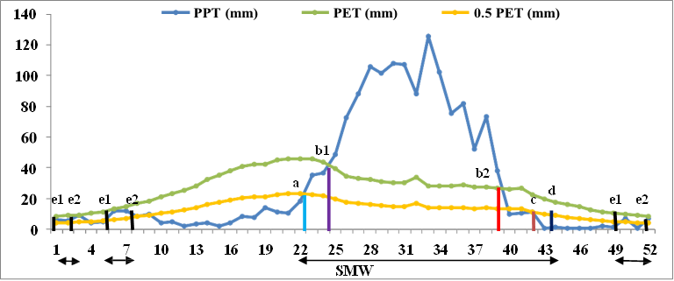
a: Beginning of rains and growing period c: End of monsoon season
b1: Start of humid period a-d, e1-e2: LGP
b2: End of humid period
d: End of growing period with storage
e1 & e2: moist period due to western disturbances
a-b1, e1 & e2: Moist period, b1-b2: Humid period, c-d: Moderately dry period

Fig. 2: Different stages of growing periods based on PET, 0.5 PET, PPT and agroecological
regionalization for Tarai region of Uttarakhand (NBSSLUP, 1992)

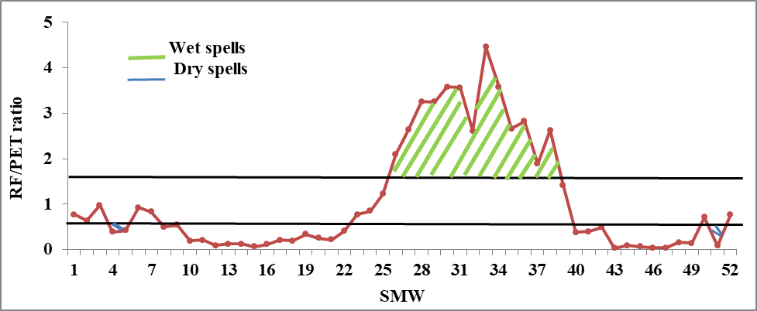

Fig. 3: Length of Growing Period (LGP) based on RF/PET ratio for each standard
meteorological week in the Tarai region of Uttarakhand

The length of the growing season extends from the 23rd to the 39th standard week (119 days), corresponding to the southwest monsoon season, and from the 50th to the 9th standard week (84 days), representing the winter season. Only the 51st, 4th, and 5th standard weeks fall marginally below the 0.50 RF/PET ratio required to qualify as a growing week. Consequently, the total length of the growing season in the Tarai region is considered to be 29 weeks (203 days). Similar findings were reported by Mahadevaswamy et al. (2016), who analyzed the length of the growing period (LGP) in the southern transitional zone of Karnataka for effective crop planning.
During the growing season from the 23rd to the 39th standard week and the 50th to the 9th standard week, certain periods are categorized as dry spells (RF/PET ratio < 0.50), while others are classified as wet spells (RF/PET ratio > 1.50). The 4th and 5th standard weeks (22nd January–4th February) and the 51st standard week (17th–23rd December) fall under dry spells, whereas the 26th to 38th standard weeks experience consecutive wet spells. This indicates that erratic rainfall distribution occurs during the 4th week of January and the 3rd week of December, potentially leading to meteorological drought periods where precipitation is insufficient to meet crop evaporative demands. However, adopting appropriate drought management practices can mitigate any significant impact on crop growth, as dry spells are not continuous. Crop cultivation is feasible depending on soil type and residual moisture availability in the region.
Kumari et al. (2019) suggested that when the Moisture Adequacy Index (MAI) exceeds 50%, it marks the growing season, as illustrated in Fig. 4, with an estimated LGP of 252 days. The MAI, calculated using Thornthwaite’s water balance method, represents the ratio of actual evapotranspiration (AET) to potential evapotranspiration (PET). Since AET can never exceed PET, it reaches its maximum when the soil reaches field capacity (140 mm), which occurs approximately two weeks after the onset of rainfall. The MAI peaks at 100% from the 25th to the 39th standard week (18th June–30th September) during the southwest monsoon season and is lowest in March, April, and May. However, continuous rainfall during certain periods can lead to runoff losses, emphasizing the need for strategic planning regarding crop selection based on climatic, topographic, and soil characteristics.
Table 3: Calculation of LGP by considering 0.5 MAI as standard value for Tarai region of
SMW | Date | No of Days
1-9 | 1st Jan-4th Mar | 63
23-46 | 4th jun-12th Nov | 168
48 | 26th Nov-2nd Dec | 7
50, 52 | 10-16th Dec, 24-31st Dec | 14
Total |  | 252
Uttarakhand
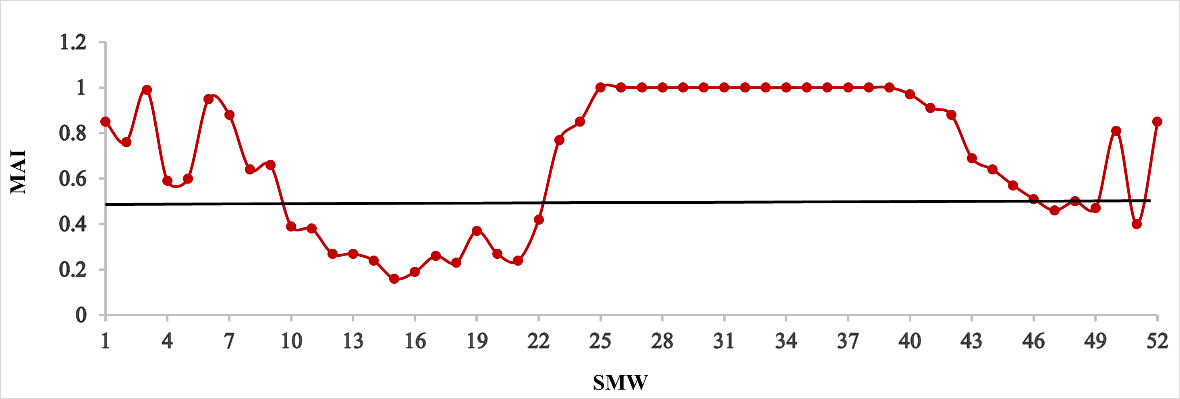 Fig. 4: Moisture Adequacy Index versus SMW for Tarai region of Uttarakhand
The discussion above indicates that, on average, the Length of Growing Period (LGP) determined by both methods is approximately 227 days (considering 252, 225, and 203 days). This suggests that the region falls within the D. Humid-Perhumid ecosystem, as per Table 1 (Balasubramanian, 2014), making it suitable for double cropping.
Agricultural activities can commence in the first week of June, particularly with nursery preparation for paddy cultivation. A preparatory phase of 1-2 weeks is required for land preparation and cultural operations such as plowing and sowing, which typically begin around the 25th standard week (third week of June). Rice, a water-intensive crop, thrives under high temperatures, with a growing season ranging from 90 to 150 days and an irrigation requirement of 450 to 750 mm (Gautam et al., 2013). In the Tarai region, rice is predominantly cultivated during the southwest monsoon season when rainfall is abundant.
Following the monsoon season, chickpea can be cultivated as a post-monsoon crop in October, benefiting from a growing period of 40-90 days and an irrigation requirement of 225-250 mm as a rainfed crop. The residual soil moisture after rice harvest is sufficient to support chickpea growth. Similarly, soybean can be cultivated in the kharif season, with an LGP of 90-100 days and an irrigation requirement of 450-700 mm. After soybean harvest, wheat is sown in the rabi season, which thrives under low temperatures and requires minimal irrigation (350-600 mm). It can be grown as a rainfed crop with one or two light irrigations during the flowering stage, as the Tarai region receives adequate winter rainfall due to western disturbances.
Table 4: Different growing stages based on symbols and standard week no. for mid
Himalayan region of Uttarakhand
Symbols/ notations | Point on graph where it cuts | Standard Meteorological Week (SMW) | No. of Days | Date
e2 | PPT=0.5PET | 48, 52 | - | 26th Nov-2nd Dec, 24th-31st Dec
a | PPT=0.5PET | 18 | - | 30th Apr- 6th May
b1 | PPT=PET | 1, 25 | - | 1-7th Jan, 18-24th Jun
b2 | PPT=PET | 11, 39 | - | 12-18th Mar, 24-30th Sept
c | PPT=0.5PET | 42 | - | 15-21st Oct
d | 0.5PET>PPT | 43-45 | 14 | 22nd Oct-11th Nov
e1 | PPT=PET | 47, 50 | - | 19-25th Nov, 10-16th Dec
 |  |  | 308
# e1 & e2: moist period due to western disturbances, b1: Start of humid period b2: End of humid period, a: Beginning of rains and growing period, c: End of monsoon season, d: End of growing period with storage
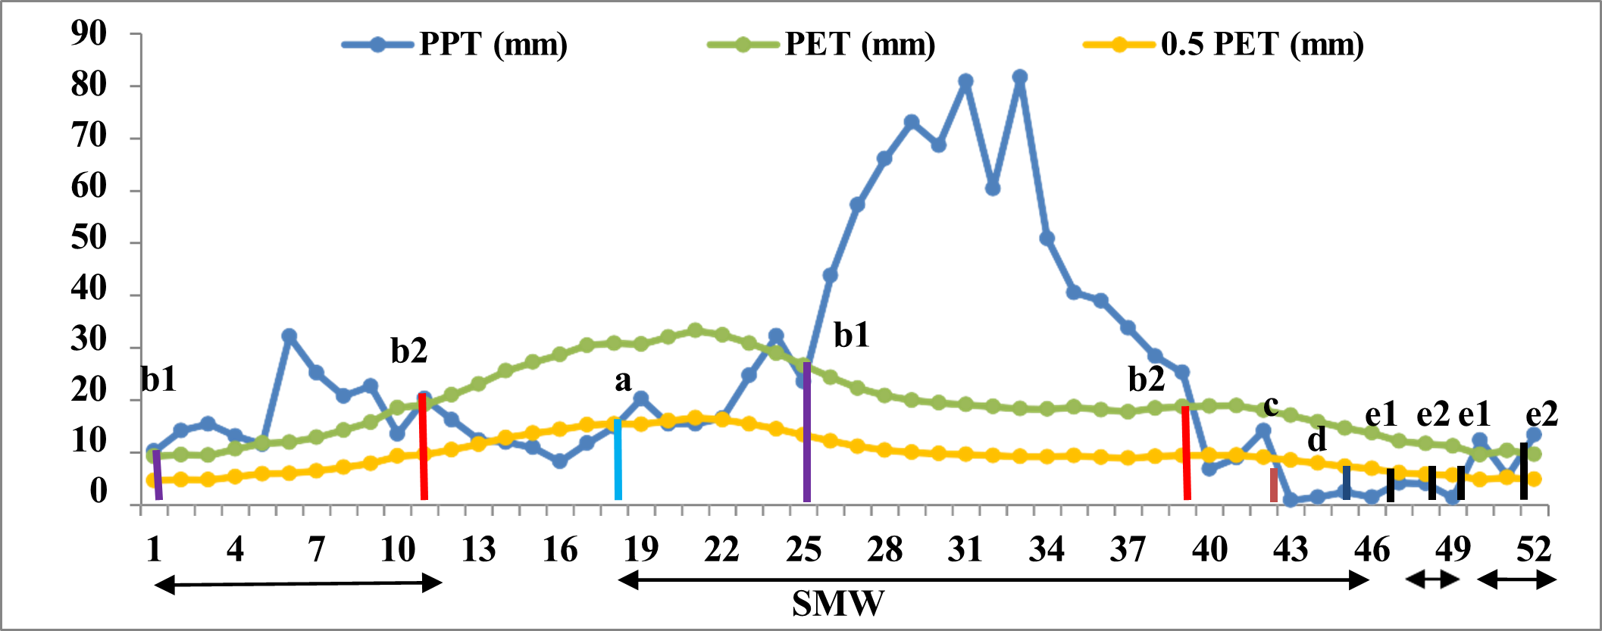
a: Beginning of rains and growing period c: End of monsoon season
b1: Start of humid period a-d, e1-e2: LGP
b2: End of humid period
d: End of growing period with storage
e1 & e2: moist period due to western disturbances
a-b1, e1 & e2: Moist period, b1-b2: Humid period, c-d: Moderately dry period

Fig. 5: Different stages of growing periods based on PET, 0.5 PET, PPT and agroecological
regionalization for mid Himalayan region of Uttarakhand (NBSSLUP, 1992)

The Length of Growing Period (LGP), as determined using the criteria established by NBSSLUP (1992), is presented in Table 4 and illustrated in Fig. 5, amounting to 308 days. The humid period, defined as the duration when precipitation (PPT) exceeds potential evapotranspiration (PET), occurs during Standard Meteorological Weeks (SMW) 1-11 (January 1st – March 18th) and 25-39 (June 18th – September 30th), symbolically represented as b1-b2. Rainfall associated with western disturbances is primarily received during the winter season. The growing season initiates in the 18th standard week (April 30th – May 6th), when PPT exceeds 0.5 PET, denoted by the symbol c, and extends until the 45th standard week (November 5th – 11th) with moisture storage. Fig. 5 clearly depicts dry conditions in March, April, and parts of the post-monsoon season, while crops can generally be cultivated throughout the year in the mid-Himalayan region.
The LGP has also been estimated using the rainfall-to-potential evapotranspiration (RF/PET) ratio for the mid-Himalayan region, as shown in Fig. 6. A ratio of 0.50 and above, which indicates viable growing conditions, is observed from SMW 18-42 (April 30th – October 21st) and again from SMW 50-14 (December 10th – April 8th), amounting to a total of 294 days. The growing season spans 175 days from the 18th to the 42nd standard week and 119 days from the 50th to the 14th standard week. Only SMW 20-21 and 40-41 marginally fall below the 0.50 threshold, marking short dry spells. Additionally, distinct wet spells, where the RF/PET ratio exceeds 1.50, occur continuously from SMW 26-39 (June 25th – September 30th) during the southwest monsoon, as well as in SMW 3 (January 15th – 21st) and SMW 6-8 (February 5th – 25th).
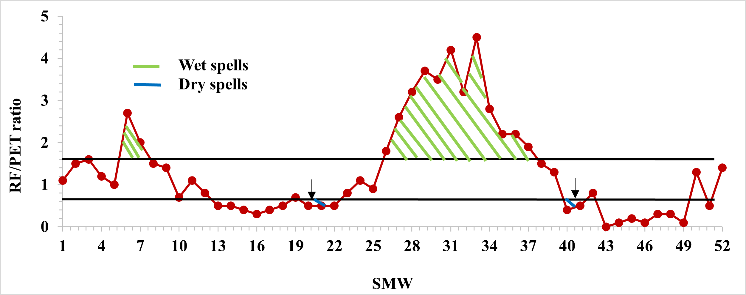Fig. 6: Length of Growing Period (LGP) based on RF/PET ratio for each standard
meteorological week in mid Himalayan region of Uttarakhand
Another approach used to determine the Length of Growing Period (LGP) is the Moisture Adequacy Index (MAI = AET/PET), calculated using Thornthwaite’s water balance method. As illustrated in Fig. 7, the MAI remains above 50% throughout the year, except during the 22nd to 25th standard weeks (May 28th – June 24th). Consequently, the total LGP amounts to 48 weeks or 336 days. The MAI reaches 100% from SMW 29-39 (July 16th – September 30th), approximately three weeks after the onset of the southwest monsoon, when soil moisture attains its field capacity (250 mm). However, it never drops below 40%, indicating that crops can be cultivated year-round with minimal irrigation. Additionally, water from natural springs in the mid-Himalayan region can be utilized during the drier months of May and June to support agricultural activities (Kushwaha et al., 2008).
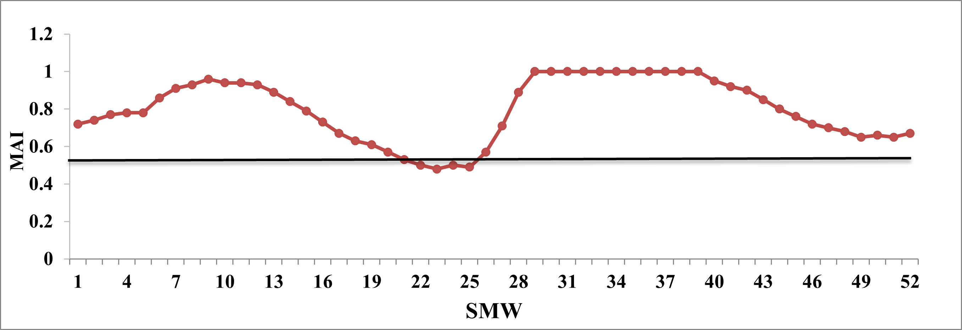Fig. 7: Moisture Adequacy Index versus SMW for mid Himalayan region of Uttarakhand
Based on the analysis, the average length of the growing season in the mid-Himalayan region is estimated to be 313 days, considering values of 301, 294, and 336 days. This is approximately three months longer than in the Tarai region of Uttarakhand. The region experiences a Humid-Perhumid climate (as per Table 1), making it well-suited for double cropping. With adequate rainfall throughout the year, diverse cropping patterns can be adopted. During the Kharif season, rice is cultivated, followed by an early wheat crop after harvest, leveraging the residual soil moisture from winter. Minor millets, such as barnyard millet, can be grown as a short-duration rainfed crop (60–70 days) during summer, followed by French beans in July, which have a growing period of 45–72 days as a second crop.
In the Rabi season, crops such as mustard or lentil (with a growing period of 100–110 days and a water requirement of 300–450 mm) can be cultivated. Finger millet, another prominent Rabi crop, has a growing period of 90–110 days, requiring 300–350 mm of irrigation when grown under rainfed conditions. Other significant crops in the mid-Himalayan region include small millets and underutilized crops such as amaranth, rice bean, and buckwheat. Additionally, the region supports off-season vegetable cultivation, which is more profitable for farmers (Kushwaha et al., 2008).
The temperatures drop rapidly in October, reaching subzero levels during winter. However, various vegetable crops such as spinach, tomato, potato, coriander, peas, cabbage, cauliflower, capsicum, and cowpea can still be grown successfully. Furthermore, the region is ideal for cultivating temperate fruit crops like apple, peach, plum, and citrus fruits. Other pulses, including urd bean, green gram, horse gram, and black soybean, are also well-suited to the climatic conditions of the mid-Himalayan region.
- CONCLUSION
The comparative analysis of the Length of Growing Period (LGP) in the Tarai and mid-Himalayan regions of Uttarakhand highlights significant differences in agro-climatic conditions, influencing cropping patterns and agricultural sustainability. The average LGP in the Tarai region is approximately 227 days, whereas the mid-Himalayan region experiences an extended LGP of around 313 days. This variation is primarily attributed to differences in altitude, temperature regimes, and precipitation patterns.
In the Tarai region, the climate is classified as D. Humid-Perhumid, making it highly suitable for double cropping. Agricultural activities typically begin in early June with nursery preparation for paddy cultivation, followed by the main cropping season during the southwest monsoon. Rice, soybean, and maize dominate the Kharif season, while wheat, mustard, and chickpea are the primary Rabi crops. The availability of residual soil moisture after rice cultivation supports post-monsoon crops such as chickpea, reducing dependency on irrigation. Adequate winter rainfall from western disturbances further supports Rabi crops with minimal irrigation requirements.
In contrast, the mid-Himalayan region, with an LGP of approximately 313 days, supports a more diverse and extended cropping system. The region experiences a Humid-Perhumid climate with significant rainfall throughout the year, facilitating multi-cropping practices. The cropping pattern includes rice during Kharif, followed by wheat, lentil, mustard, and millets in the Rabi season. Additionally, the region supports off-season vegetable cultivation, making it more economically viable for farmers. The temperate climate also favors the cultivation of fruit crops such as apple, peach, and citrus, along with pulses like black soybean and horse gram. Overall, the Tarai region, with its shorter LGP and reliance on monsoon rainfall (Thirupathi et al., 2015), supports intensive double cropping. The mid-Himalayan region, benefiting from an extended growing season, offers greater agricultural diversification and resilience, making it ideal for sustainable and profitable farming practices.
Disclaimer:
Author(s) hereby declare that NO generative AI technologies such as Large Language Models (ChatGPT, COPILOT, etc.) and text-to-image generators have been used during the writing or editing of this manuscript.
- REFERENCES
Balasubramanian, A. (2014). Agro Ecological Zone. Centre for Advanced Studies in Earth Science, University of Mysore, Mysore, India.
Dept. of Agriculture, Cooperation and Farmers Welfare, Govt. of India (2016) https://agricoop.nic.in
Dept. of Agriculture & Farmers Welfare (2022) Agriculture reforms 2022 https://agricoop.nic.in
Developments in Agricultural and Managed Forest Ecology (1992) 26:181-228.
Dugal, D., Mohanty, T. R., Panigrahi, G., Mohapatra, A. K. B., Nanda, A., Swain, S. K., & Samant, P. K. (2022). Determining Length of Growing Period for Crop Planning in East and South Eastern Coastal Plain Agroclimatic Zone of Odisha. International Journal of Environment & Climate Change, 12(12), 1093-1099.
Ekka, A. P., Kumari, P., Kumar, S., & Wadood, A. (2020). Estimation of the water balance and length of growing period under Gumla District of Jharkhand for efficient crop planning. Agricultural Science Digest-A Research Journal, 40(3), 234-241.
Gautam, S., Roy, S., Murty, N. S., & Nain, A. S. (2013). Climatic water balance and moisture adequacy index in Tarai region of Uttarakhand. Pantnagar Journal of Research, 11(3), 317.
Hargreaves, G. H. (1975). Moisture availability and crop production. Transactions of the ASAE, 18(5), 980-0984.
Kokilavani, S., Panneerselvam, S., & Balasubramanian, T. N. (2016). Rainfall study for dry land areas of selected districts of Tamil Nadu for crop planning. Mausam, 67(4), 869-878.
Kumari, P., Balmuchu, S. A., Tirkey, D. A., & Wadood, A. (2019). Climatic water balance and length of growing period for efficient crop planning under different agrotopo-climate in Ranchi, Jharkhand. Journal of Soil and Water Conservation, 18(1), 59-63.
Kushwaha, G.S., & Singh, R.K. (2008) Agriculture Portal Development Template for Uttarakhand. GBPUA&T, Pantnagar, Uttarakhand, pp 60.
Lagnajeet, L. R., Khanikar, P. G. K. P. G., & Sarmah, M. K. S. K. (2023). Rainfall and Moisture Adequacy Index (MAI) based crop planning in Lower Brahmaputra Valley Zone (LBVZ) of Assam.
Mahadevaswamy, M., Ramesh, S., & Sreenivas, S. S. (2016). Determining the Length of Growing Period (LGP) for efficient crop planning and sustaining farm productivity in the rainfed STZ of Karnataka. Tobacco Research, 42(1), 20-23.
Makwana, J. J., Deora, B. S., Patel, C. K., Parmar, B. S., & Saini, A. K. (2021). Analysis of rainfall characteristics and moisture availability index for crop planning in semi arid region of north Gujarat. Journal of Agrometeorology, 23(4), 409-415.
Murty, N. S., Gaira, K. S., & Singh, R. K. (2004). Temperature variations at Ranichauri in the mid Himalayan region of Uttaranchal. Journal of Agrometeorology, 227-232.
Raman, C.R.V., & Murthy, S.B. (1971). Water availability periods for crop planning. Sci Rep, Division of Agril. Meteorology, IMD, Pune, pp 1-9.
Sathyamoorthy, N.K., Ramaraj, A.P., Dheebakaran, G., Arthirani, B., Senthilraja, K., & Jagannathan, R. (2017). Characterization of rainfall and length of growing period over North Western Zone of Tamil Nadu. Indian J of Ecology 44:232-238.
Sattar, A. B. D. U. S., & Khan, S. A. (2016). Assessing climatic water balance and growing period length for crop planning under rainfed condition. Indian journal of soil conservation, 44(1), 37-43.
Subramanium, A.R., & Kesava, A.V.R. (1984). Water balance and crops in Karnataka. Mausam 35:55-60. https://doi.org/10.54302/mausam.v35i1.1910
Subrahmanyam, V.P. (1982). Water balance and its applications. Andhra University Press, pp 102.
Thirupathi, M., Shashikala, A. V., & Prabhakar, M. (2015). Variability study on the length of growing period (LGP) using ground and space based (MODIS) data for the selected mandals of Warangal district. International Journal of Advancement in Remote Sensing, GIS and Geography, 3(2), 48-58.
Thornthwaite, C.W., & Mather, J.R. (1955) The water balance publication in Climatology. Drexel Institute of Technology, Laboratory of Climatology, Centerton, NJ, pp 104-110.

