Climate Variability in Temperature Trends and Change Point in Yenagoa, Nigeria

Abstract
This study aims to analyse temperature trend, variation, and change point patterns in Bayelsa State, Nigeria over a 31-year period (1992-2022). The daily temperature data used for the study were obtained from the Nigerian Meteorological Agency (NIMET). The daily maximum and minimum temperature data were further processed to obtain the annual maximum, minimum, and mean temperatures. Several statistical tests were utilized to investigate the temperature trend and to detect change point year. Linear regression and Mann-Kendall tests were utilized to establish if there are significant trend in the temperature data series. Distribution-free CUSUM test and Sequential Mann-Kendall test were used to identify the change point year. The results reveal a statistically significant increasing trend in annual mean temperature at a rate of 0.020°C per year (0.2°C per decade or 2.0°C per century). Annual maximum temperature showed a marginally significant positive trend of 0.037°C per year, while annual minimum temperature exhibited a non-significant negative trend of -0.043°C per year. Change point analysis identified significant shifts in annual mean temperature patterns around 2007 and 2015. The findings indicate that Bayelsa State is experiencing warming consistently with global climate change patterns. However, cooler temperature is still experienced during the early hours and evening session as not significant increasing trend was observed in the annual minimum temperature.
Keywords: Climate change; Temperature trend; Change point analysis; Mann-Kendall test; Global warming; Environmental monitoring; CUSUM test; Bayelsa State.
- Introduction
The increase in temperature worldwide has been an issue that constantly causes worry among world agencies responsible for monitoring and ensuring that the earth does not get warmer. The Intergovernmental Panel on Climate Change (IPCC, 2014) has consistently reported that global mean surface temperature has increased over the past century by 0.74°C between 1951 and 2012. IPCC (2021) projected that there could be a 3.3 to 5.7ºC increase in the global mean temperature by 2100. This global phenomenon manifests differently across various regions, with some areas experiencing more pronounced temperature changes than others (Karabulut et al., 2008; Kothawale et al., 2010; Jain et al., 2013; Tamarin-Brodsky, 2020). Such an increase would result in the daily temperature in some cities being around 40ºC which will cause heat waves in those cities. A one-degree rise in the global mean temperature can result in significant adverse effects (Suhaila & Yusop, 2017). Rising temperatures can significantly impact the ecosystems, agricultural productivity, sea levels, and human activities in coastal areas (Bisai et al., 2014; Zarenistanak et al., 2014). High sun intensity would result in the death of plants and rising sea levels would result in coastline erosion (Morice et al., 2021; Olonscheck et al., 2021). In Nigeria, most coastlines are threatened by the ever-rising sea level, and Bayelsa is one of the coastal states in Nigeria. Understanding temperature change and trends might help curb the negative effect it has on the climate.
Previous studies on temperature trends in Nigeria have shown mixed results across different regions. Efe and Ojo (2013) observed significant temperature increases in the Warri metropolis, with annual mean temperature rising by 1.3°C from 1907 to 2009. Akpodiogag and Odjugo (2010) reported increasing temperature trends across Nigeria. They reported that there was a 1.1ºC increase in the temperature from 1901 to 2005. Akinsanola and Ogunjobi (2014) analyzed temperature variability over Nigeria and found increasing trends in annual mean temperatures across most stations. The findings from the various studies indicate that the rate of temperature increase varies from location to location. Therefore, location-specific temperature analyses are needed to understand regional climate change impacts (Wai et al., 2005; Tangang et al., 2007). Most studies done in Nigeria tried to understand the temperature trend only without incorporating change point analyses. Understanding the temperature trend gives a partial picture of climate change in a specific region. Understanding when there was a significant change in the trend can be used to pinpoint activities or changes that occurred during the change point year that must have resulted in the trend change. Suhaila & Yusop (2017) in their study stated that the maximum and minimum annual temperatures in Peninsular Malaysia were on the rise and identified the change point year to be around 1996 to 1998. The identification of the change point year enabled them to detect that the El Nino event that occurred from 1997 to 1998 must be one of the causes of the significant increase in the temperature experienced in Peninsular Malayasia. This study aims to analyse the temporal trends, variations, and change point patterns in temperature data for Bayelsa State over 31 years (1992-2022).
2. Materials and Methods
2.1 Study Area
Yenagoa is the capital of Bayelsa State which is one of the Niger Delta states in Nigeria. The region lies between latitudes 4°15' N to 5°23' N and longitudes 5°22' E and 6°45' E. The state was created on October 1, 1996 from the former Rivers State. Bayelsa has a land area of approximately 10,773 km² and has a population of about 1.7 million (National Population Commission, 2006). The estimated population as of 2024 is evaluated using P₂₀₂₄ = P₂₀₀₆ (1 + r/100)¹⁸. Where P₂₀₀₆ = 1.7 million and r = 2%, yields P₂₀₂₄ = 2.427 million.
The state is administratively divided into eight local government areas with Yenagoa as its capital (Bayelsa State Government, 2019). Geographically, about 75% of Bayelsa State consists of water bodies and wetlands (Bariweni et al., 2012). The landscape is predominantly low-lying, with elevations rarely exceeding 15 meters above sea level, making it vulnerable to flooding and sea-level rise (Amangabara & Obenade, 2015). The climate is tropical with two distinct seasons: a rainy season (April-October) and a dry season (November-March). Vegetation is dominated by mangrove forests along coastal areas and freshwater swamp forests inland, supporting rich biodiversity and providing important ecosystem services (Numbere, 2018). Economically, Bayelsa is known for its significant oil and gas reserves, while traditional livelihoods such as fishing and farming remain important in rural areas.
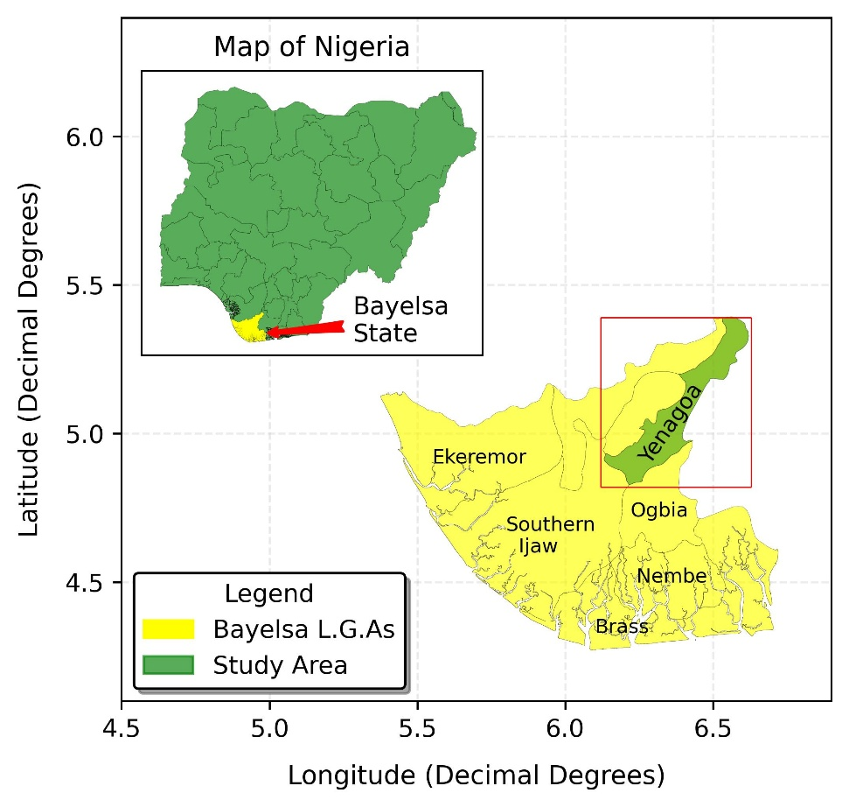
Figure 1: Map of Study Area, Bayelsa State in Niger Delta Nigeria

2.2 Data Collection
The data used for analysing the temperature trend and change point were records of (1992-2022) in Yenagoa, Bayelsa State. The data were acquired from the Nigerian Meteorological Agency (NIMET), a Nigeria Federal Agency responsible for the collation of meteorological data in Nigeria. The two-temperature data obtained from NIMET were the daily maximum and minimum temperatures throughout the study period. From these daily measurements, three key parameters were derived: annual maximum temperature (the highest value among the daily maximum temperatures for each year), annual minimum temperature (the lowest value among the daily minimum temperatures for each year), and mean temperature (calculated from the average of the maximum temperatures).
Temperature dynamics in Bayelsa State were evaluated using multiple statistical approaches. For trend detection, both linear regression and the Mann-Kendall test were employed (Sam et al., 2023; Suhaila & Yusop, 2017). Linear regression which is a parametric test was used to identify trends in the temperature data (Nwaogazie, 2020; Suhaila & Yusop, 2017). The simple linear regression model as shown in Equation 1 provides both direction and magnitude of trends through the slope parameter (a₁). The slope and intercept of the model were obtained by solving the normal equations as shown in Equations (2 - 3) to obtain $a_{o}$ and $a_{1}$. Statistical significance of the model parameter ($a_{1}$) indicates evidence of either a positive or negative temperature trend.
$y= a_{o}+ a_{1}x$ (1)
Where x = years, $a_{o}$ = intercept, $a_{1}$ = slope, and y = temperature
$\sum_{i=1}^{n}{y}$ = n$a_{o}$ + $a_{1}\sum{x}$ (2)
$\sum_{i=1}^{n}{xy}$ = $a_{o}\sum{x}$ + $a_{1}\sum{x^{2}}$ (3)
In contrast, the Mann-Kendall test is a non-parametric alternative that does not require the temperature data to be normally distributed, making it a more robust test for temperature data with extreme skewness (Sam et al., 2023; Ekwueme et al., 2024). To quantify the magnitude of identified trends, Theil Sen's Slope estimation was utilized. For detecting years with abrupt changes in temperature patterns, two complementary non-parametric methods were employed: Distribution-free CUSUM test and Sequential Mann Kendall test. The Distribution-free CUSUM test examines differences in mean values before and after potential change points, while the Sequential Mann-Kendall analyses temperature data in both forward and backward directions, with intersection points indicating potential change points. Both methods were implemented using the "trendchange" package in R (Team R Core, 2021; Patakamuri, 2022).

3. Results
3.1 Summary Statistics and Temperature Dynamic in Bayelsa
The temperature time series for Bayelsa from 1992 to 2022 is presented in Figure 2. The result from Figure 2 showed that the annual mean temperature for the study duration was the most stable. The annual mean temperature in Yenagoa for the study duration ranged from 30.86 - 32.39ºC. The annual maximum temperature for the study duration ranged from 34.50 - 38.50ºC. The most fluctuation was observed in the annual minimum temperature with temperature ranging from 13.10 - 20.88ºC. Figure 3 shows the distribution plots and summary statistics for the three-temperature series. The mean temperature for the annual maximum, annual minimum, and annual mean temperature distributions were 36.43, 17.82, and 31.60ºC, respectively. It was also confirmed that annual mean temperature had the highest variability with coefficients of variance of 9.86%. This indicates that the annual mean temperature tends to vary a lot with very low and high minimum temperatures recorded in the annual minimum temperature. The distribution plot shown in Figure 3, indicate that the three-temperature series have some sort of bell curve which represents a normally distributed dataset. However, the normality of the temperature series data were confirmed by conducting statistical tests and the result is presented in Table 1. The p-values from both normality tests (Shapiro Wilk and Anderson Darling) were greater than 0.05 for all temperature variables, indicating that the null hypothesis of normal distribution cannot be rejected. Therefore, the three temperature data series were normally distributed. The skewness values range from -0.729 for minimum temperature to 0.283 for mean temperature, with standardized skewness (Z-skewness) values falling within the ±1.96 range, further confirming that the data do not significantly depart from normality. Gbasemi & Zahediasl (2012) reported that data with standardized skewness (skewness/standard error of skew) ranging between -1.96 to 1.96 are normally distributed.
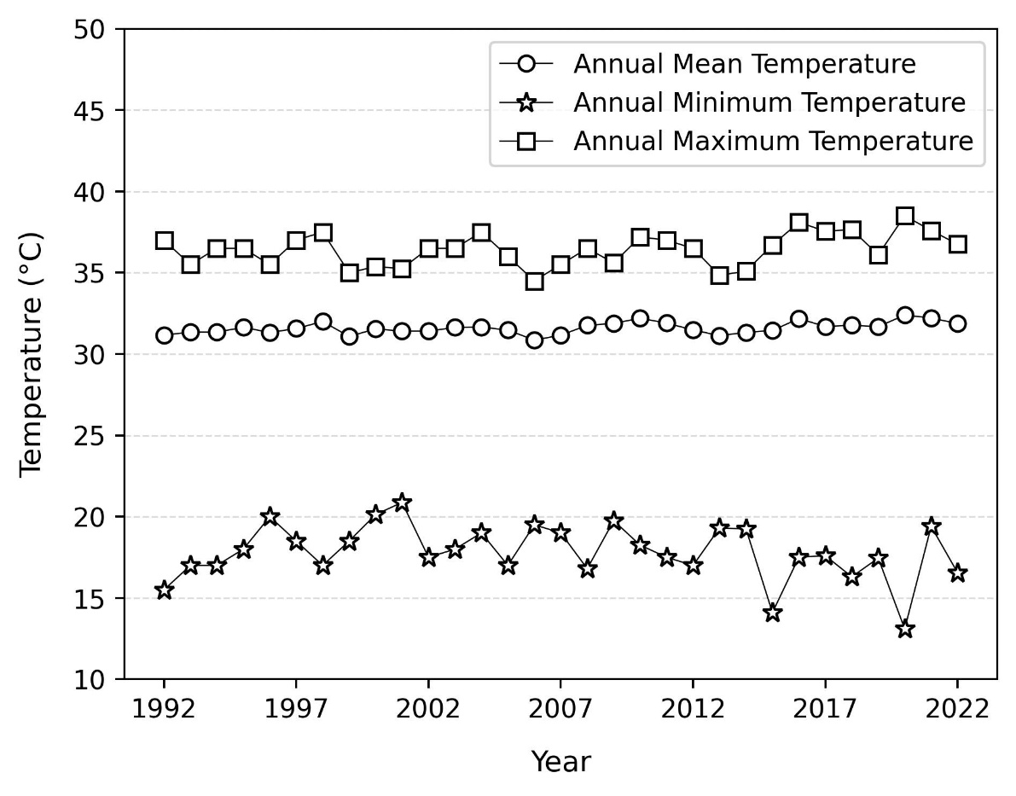
Figure 2: Plot of annual temperature series for the study for Yenagoa

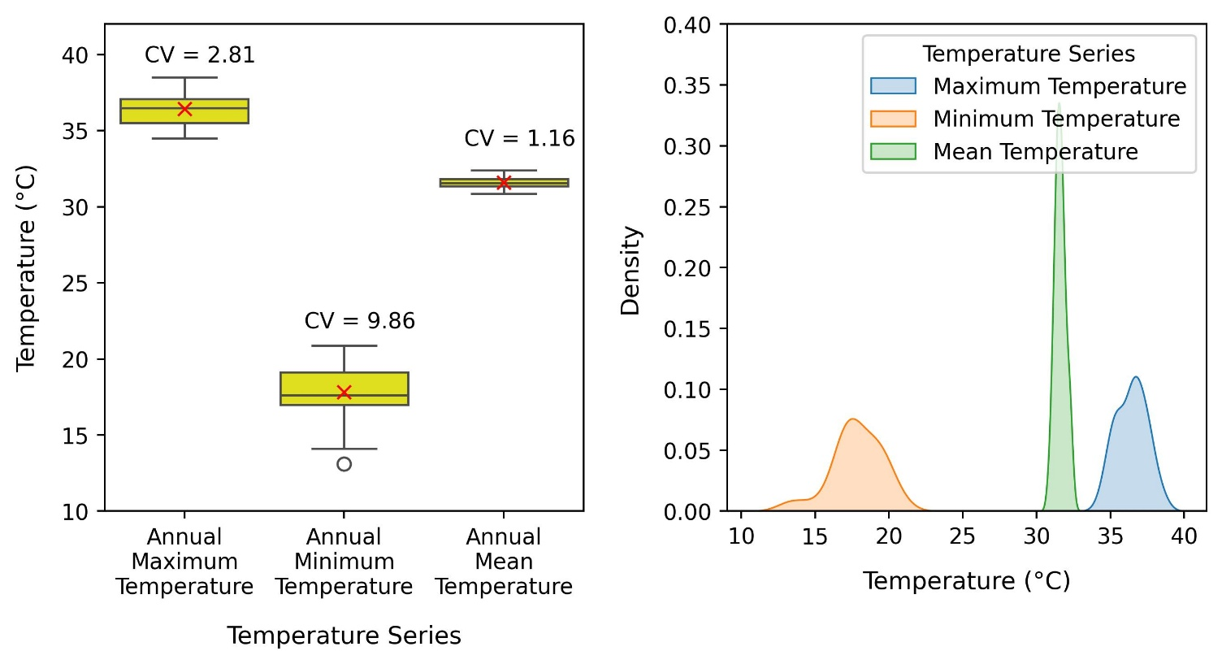
Figure 3: Distribution and summary statistics of temperature series

Table 1: Skewness and Normality tests
Annual Temperature Series | Shapiro-Wilk | Anderson-Darling | Skewness | Standard Error of Skewness | Z-skewness
Maximum Temperature | 0.584 | 0.402 | -0.017 | 0.421 | -0.041
Minimum Temperature | 0.188 | 0.248 | -0.729 | 0.421 | -1.733
Mean Temperature | 0.841 | 0.775 | 0.283 | 0.421 | 0.673
Values in the Shapiro-Wilk and Anderson-Darling represent the p-values
3.2 Trend Analysis using Linear regression
The normality test result provided sufficient evidence that linear regression can be used to analyse the temperature trend, and the result is presented in Table 2. The annual maximum temperature showed a positive slope of 0.037°C per year, although this trend was not significant at a 5% level of significance (p-value = 0.067). However, at a 10% level of significance, there exists an increasing trend in the annual maximum series. The annual minimum temperature exhibits a negative slope of -0.043°C per year, but this trend is not statistically significant (p-value= 0.209). In contrast, the annual mean temperature demonstrates a statistically significant positive trend of 0.020°C per year (p = 0.005), equivalent to an increase of 0.2°C per decade or 2.0°C per century.
Table 2: Linear regression for temperature series in Yenagoa
Statistic | Annual Maximum Temperature |  | Annual Minimum Temperature |  | Annual Mean Temperature
Statistic | Intercept | Year | Intercept | Year | Intercept | Year
Value | -38.732 | 0.037 | 105.118 | -0.043 | -8.257 | 0.020
Standard error | 39.559 | 0.020 | 67.877 | 0.034 | 13.056 | 0.007
t | -0.979 | 1.900 | 1.549 | -1.286 | -0.632 | 3.053
Pr > |t| | 0.336 | 0.067 | 0.132 | 0.209 | 0.532 | 0.005
Lower bound (95%) | -119.639 | -0.003 | -33.707 | -0.113 | -34.960 | 0.007
Upper bound (95%) | 42.175 | 0.078 | 243.943 | 0.026 | 18.446 | 0.033

3.3 Trend Analysis using Mann-Kendall (MK)
Mann Kendall test was also used for the temperature trend analysis. Before applying the Mann-Kendall test, the autocorrelation function (ACF) test was done on the temperature series data to detect potential serial correlation in the temperature data and the result is presented in Figure 4. The results indicate that all temperature series did not exhibit significant autocorrelation at lag 1, allowing for direct application of the Mann-Kendall test without pre-whitening.
Table 3 presents the Mann-Kendall test results for the three-temperature series. The annual maximum temperature shows a positive trend with Kendall's tau of 0.240, though marginally significant (p = 0.065). The result obtained for the trend analyses for annual maximum temperature using Mann Kendall mirrored what was obtained using linear regression. The annual minimum temperature displays a negative trend with Kendall's tau of -0.116, but this trend is not statistically significant (p = 0.375). The annual mean temperature exhibits a statistically significant positive trend with Kendall's tau of 0.363 (p = 0.004). The Sen's slope estimator indicates magnitudes of 0.042°C/year for maximum temperature, -0.026°C/year for minimum temperature, and 0.020°C/year for mean temperature, consistent with the linear regression results.
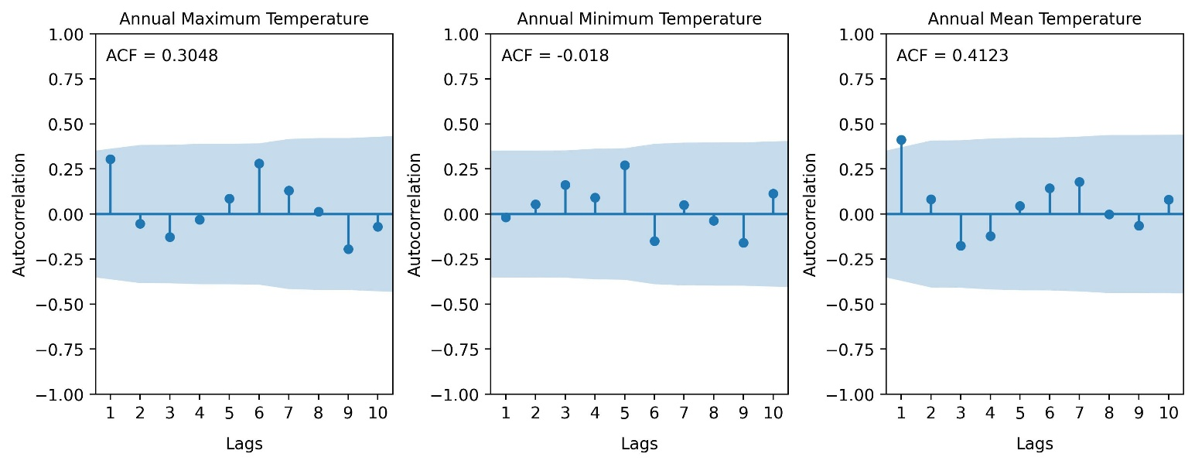
Figure 4: Rainfall precipitation correlogram of ACF for Yenagoa

Table 3: Mann-Kendall Test Results for Different Time Scales in Bayelsa (1992-2022)
Statistic | Annual Maximum Temperature | Annual Minimum Temperature | Annual Mean Temperature
Kendall's tau | 0.240 | -0.116 | 0.363
S | 109.000 | -53.000 | 169.000
Var(S) | 3425.000 | 3438.333 | 3461.667
p-value (Two-tailed) | 0.065 | 0.375 | 0.004
Sen Slope | 0.042 | -0.026 | 0.02
alpha | 0.05 | 0.05 | 0.05

3.4 Trend Change-Point Analysis
The result for the Distribution-free CUSUM test when applied to the annual maximum, minimum, and mean temperature series is presented in Figures 5 to 7. For annual maximum temperature, the maximum CUSUM value obtained was 5, which was less than the critical threshold values at the 90%, 95%, and 99% confidence intervals as presented in Table 4. The result indicates that no significant change point year was identified for the annual maximum temperature. Although potential change points were detected in 2009 and 2014, these change point years were not statistically significant. For annual minimum temperature, as shown in Figure 6, the maximum CUSUM value was also 5, which was less than the critical thresholds at all confidence levels. The result obtained indicate no statistically significant change point year. The annual mean temperature series, as presented in Figure 7, yielded a maximum CUSUM value of 7, which exceeded the 90% confidence interval critical value (6.7927). This indicates a significant change in the annual mean temperature pattern. The change points were identified in 2007 and 2015, suggesting a possible shift in the temperature regime during this period.
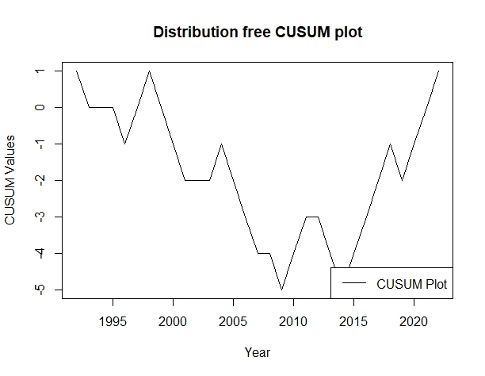
Figure 5: Distribution-free CUSUM plot for Annual Maximum temperature series for Yenagoa
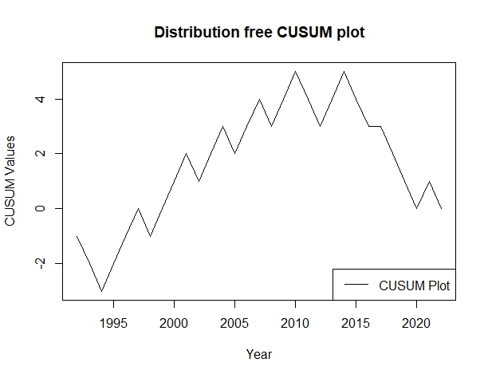
Figure 6: Distribution-free CUSUM plot for Annual Minimum temperature series for Yenagoa
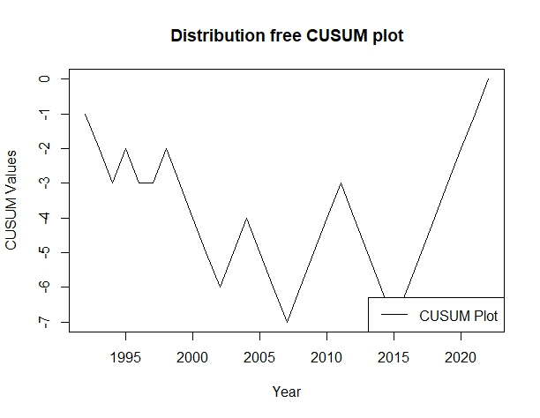
Figure 7: Distribution-free CUSUM plot for Annual Mean temperature series for Yenagoa

Table 4: Distribution free CUSUM Change Point
Temperature Series | Maximum CUSUM Value | Critical Values | Change Point Year (s) | Remark
Annual Maximum Temperature | 5 | CI @ 90%: 6.7927 CI @ 95%: 7.5722 CI @ 99%: 9.0755 | 2009, 2014 | No Significant change point
Annual Minimum Temperature | 5 | CI @ 90%: 6.7927 CI @ 95%: 7.5722 CI @ 99%: 9.0755 | 2010, 2014 | No significant change point
Annual Mean Temperature | 7 | CI @ 90%: 6.7927 CI @ 95%: 7.5722 CI @ 99%: 9.0755 | 2007, 2015 | Significant change point

The result of the Sequential Mann Kendall is presented in Figures 8 - 10. For the annual maximum temperature, the prograde and retrograde crossed in the year 2016. The crossing at this point indicates that 2016 might be the probable change point year. The probable change point year in 2016 might indicate a shift in the temperature trend. However, there is no significant change point year identified by CUSUM. This might suggest that care should be taken to state that there was a potential shift in the temperature trend in 2016. The moderate positive rather than a strong positive trend detected by Mann Kendall for the annual maximum temperature further suggests that 2016 should be interpreted with caution but changes might have been developing before 2016. For annual minimum temperature, the multiple crossings were observed in 2015, 2016, 2018, and 2021 as shown in Figure 9. The presence of multiple crossings indicates that no definitive change point year can be established for the annual minimum temperature series. Similarly, the annual mean temperature series presented in Figure 10 exhibited multiple crossings in 2009, 2012, and 2016, suggesting the absence of a single clear change point year. However, CUSUM noted that 2007 and 2015 were significant change point years.
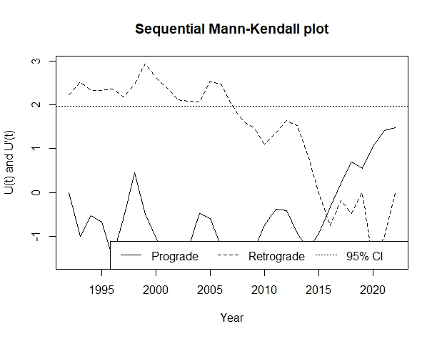
Figure 8: Sequential Mann-Kendall plot for Annual Maximum Temperature

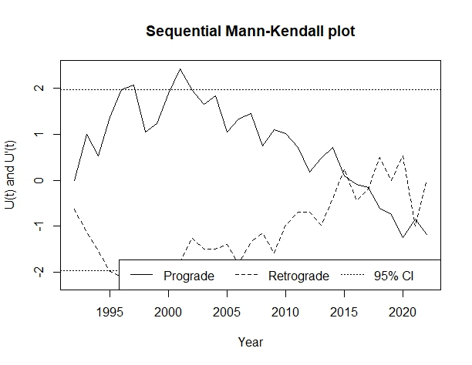
Figure 9: Sequential Mann-Kendall plot for Annual Minimum Temperature
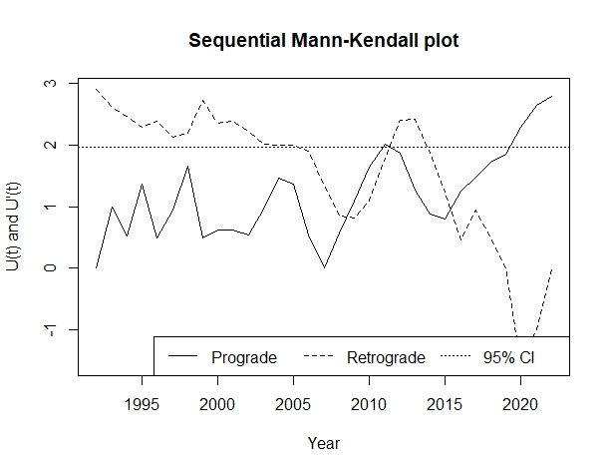
Figure 10: Sequential Mann-Kendall plot for Annual Mean Temperature

Table 5: Sequential Mann Kendall Change Point
Temperature Series | Change  Point Year(s) | Crossing Pattern | Remark
Annual Maximum Temperature | 2016 | Single crossing | Probable change point
Annual Minimum Temperature | 2015, 2016,  2018, 2021 | Multiple crossings | No change point
Annual Mean Temperature | 2009, 2012, 2016 | Multiple crossings | No change point

4. Discussion
The result of the temperature trends and change-points analysis in Yenagoa over the period of 1992-2022 revealed interesting findings. The result showed that the annual mean temperature exhibited a significant increasing trend of 0.020°C per year. The annual mean temperature rate projected for a century would be around 2.0°C/100years. Oguntunde et al. (2012) found that the annual mean temperature in the Mangrove and freshwater swamp zone had a positive significant temperature trend from 1901 to 2000. Yenagoa fall into these zones, thereby corroborating findings from the present study that the annual mean temperature is on an increasing positive trend. Oguntunde et al. (2012) reported a lower temperature rate of 0.006°C per year which was lower than the 0.020°C per year obtained for the present study which indicate Yenagoa might be getting warmer. The annual mean temperature was also reported to be on the rise in the neighbouring state. Efe and Ojoh (2013) observed significant annual mean temperature increases in Warri, with the annual mean temperature rising by 1.3°C from 1907-2009. The annual maximum and minimum temperatures showed non-significant trends at 5% level of significance. However, the rate of temperature rise per year for the annual maximum and minimum temperatures were estimated to be 0.037°C/year and -0.043°C/year, respectively. The non-significant trends in the annual maximum and minimum temperatures contrast with findings from other Niger Delta regions. Ragatoa et al. (2018) found that there was a significant increasing trend in the annual maximum temperature in Warri. The non-significant annual minimum temperature suggest that Yenagoa might still be experiencing cooler temperature in the early hours of the day and evening hours. Bayelsa's coastal location likely moderates temperature fluctuations and probably result in significant cooling of the atmosphere especially at night. The significant warming trend in annual mean temperature, even without significant trends in maximum and minimum temperatures, has important implications for agriculture and water management in Bayelsa State. Increased mean temperatures can affect evapotranspiration rates and water requirements, potentially compounding challenges related to water management and agricultural productivity in Yenagoa.
5. Conclusion
This study has provided comprehensive insights into the temperature trends and change point patterns in Yenagoa from 1992 to 2022. This study revealed significant increasing trends in annual mean temperature in Bayelsa State at a rate of 0.020°C per year (2.0°C per century), while annual maximum and minimum temperatures showed non-significant trends. Change point analysis identified shifts in temperature patterns around 2007 and 2015 for the annual mean temperature. These findings indicate that Bayelsa is experiencing warming consistently with global climate change patterns, though moderated by its coastal location. The warming trends have important implications for agriculture, water resources, and the region's fragile wetland ecosystems.

Disclaimer (Artificial intelligence)
Option 1:
Author(s) hereby declare that NO generative AI technologies such as Large Language Models (ChatGPT, COPILOT, etc.) and text-to-image generators have been used during the writing or editing of this manuscript.

References
Akinsanola, A.A., & Ogunjobi, K.O. (2014). Analysis of rainfall and temperature variability over Nigeria. Global Journal of Human-Social Science: B Geography, Geo-Sciences, Environmental Disaster Management, 14(3), 1-18.
Akpodiogaga, P., & Odjugo, O. (2010). General overview of climate change impacts in Nigeria. Journal of Human Ecology, 29(1), 47-55.
Amangabara, G.T., & Obenade, M. (2015). Flood vulnerability assessment of Niger Delta states relative to 2012 flood disaster in Nigeria. American Journal of Environmental Protection, 3(3), 76-83.
Bariweni, P.A., Tawari, C.C., & Abowei, J.F.N. (2012). Some environmental effects of flooding in the Niger Delta region of Nigeria. International Journal of Fisheries and Aquatic Sciences, 1(1), 35-46.
Bisai, D., Chatterjee, S., Khan, A., & Barman, N.K. (2014). Long term temperature trend and change point: A statistical approach. Open Journal of Atmospheric and Climate Change, 1(1), 32-42.
Efe, S. I., & Ojoh, C. O. (2013). Climate variation and malaria prevalence in Warri Metropolis.
Ekwueme, C. M., Nwaogazie, I. F & Ikebude, C. (2024). “Assessing Rainfall Trends and Change Points in Owerri, Nigeria: Implications of Climate Change”. Asian Journal of Advanced Research and Reports 18 (11):225-34. https://doi.org/10.9734/ajarr/2024/v18i11790.
Ghasemi, A., & Zahediasl, S. (2012). Normality tests for statistical analysis: a guide for non-statisticians. International journal of endocrinology and metabolism, 10(2), 486.
PCC. (2014). Climate Change 2014: Synthesis Report. Contribution of Working Groups I, II and III to the Fifth Assessment Report of the Intergovernmental Panel on Climate Change [Core Writing Team, R.K. Pachauri and L.A. Meyer (eds.)]. IPCC, Geneva, Switzerland, 151 pp.
IPCC. (2021). Climate Change 2021: The Physical Science Basis. Contribution of Working Group I to the Sixth Assessment Report of the Intergovernmental Panel on Climate Change [Masson-Delmotte, V., Zhai, P., Pirani, A., Connors, S. L., Péan, C., Berger, S., Caud, N., Zhou, Y., Mulder, L., Matthews, J., ... & Waterfield, T. (Eds.)]. Cambridge University Press.
Jain, S.K., Kumar, V., & Saharia, M. (2013). Analysis of rainfall and temperature trends in northeast India. International Journal of Climatology, 33(4), 968-978.
Karabulut, M., Gürbüz, M., & Korkmaz, H. (2008). Precipitation and temperature trend analyses in Samsun. Journal of International Environmental Application & Science, 3(5), 399-408.
Kothawale, D.R., Munot, A.A., & Kumar, K.K. (2010). Surface air temperature variability over India during 1901-2007, and its association with ENSO. Climate Research, 42(2), 89-104.
Morice, C. et al. An updated assessment of near-surface temperature change from 1850: the HadCRUT5 data set. J. Geophys. Res. 126, e2019JD032361 (2021). https://agupubs.onlinelibrary.wiley.com/doi/10.1029/2019JD032361
National Population Commission. (2006). Population and Housing Census of the Federal Republic of Nigeria. Priority Tables (Volume I). National Population Commission, Abuja, Nigeria.
Numbere, A.O. (2018). Mangrove species distribution and composition, adaptive strategies and ecosystem services in the Niger River Delta, Nigeria. In Mangrove Ecosystem Ecology and Function. IntechOpen.
Numbere, A.O., & Camilo, G.R. (2018). Structural characteristics, above-ground biomass and productivity of mangrove forest situated in areas with different levels of pollution in the Niger Delta, Nigeria. African Journal of Ecology, 56(4), 917-927.
Nwaogazie, I.L. (2020). Statistical method for environmental pollution analysis. Spring Publishers Limited, Nigeria.
Oguntunde, P. G., Abiodun, B. J., & Lischeid, G. (2012). Spatial and temporal temperature trends in Nigeria, 1901–2000. Meteorology and Atmospheric Physics, 118, 95-105.
Olonscheck, D., Schurer, A.P., Lücke, L. et al. Large-scale emergence of regional changes in year-to-year temperature variability by the end of the 21st century. Nat Commun 12, 7237 (2021). https://doi.org/10.1038/s41467-021-27515-x
Patakamuri, S.K. (2022). trendchange: Change Point and Trend Analysis in R. R Package Version 1.1.1.9000. Available at: https://github.com/patakamuri/trendchange.
Ragatoa, D.S., Ogunjobi, K.O., Okhimamhe, A.A., Francis, S.D., & Adet, L. (2018). A trend analysis of temperature in selected stations in Nigeria using three different approaches. Open Journal of Atmospheric and Climate Change, 1(1), 1-18.
Tamarin-Brodsky, T., Hodges, K., Hoskins, B. J. & Shepherd, T. G. Changes in Northern Hemisphere temperature variability shaped by regional warming patterns. Nat. Geosci. 13, 414–421 (2020). Available at: https://www.nature.com/articles/s41561-020-0576-3
Sam, M. G., Nwaogazie, I. L., & Ikebude, C. (2023). Establishing Climatic Change on Rainfall Trend, Variation and Change Point Pattern in Benin City, Nigeria. International Journal of Environment and Climate Change, 13(5), 202-212.
Suhaila, J., & Yusop, Z. (2017). Trend analysis and change point detection of annual and seasonal temperature series in Peninsular Malaysia. Meteorology and Atmospheric Physics, 131(2), 201-215.
Tangang, F.T., Juneng, L., & Ahmad, S. (2007). Trend and interannual variability of temperature in Malaysia: 1961-2002. Theoretical and Applied Climatology, 89(3), 127-141.
Team R Core. (2021). R: A language and environment for statistical computing. R Foundation for Statistical Computing, Vienna, Austria.
Wai, N.M., Camerlengo, A., & Wahab, A.K.A. (2005). A study of global warming in Malaysia. Jurnal Teknologi, 42(1), 1-10.
Zarenistanak, M., Dhorde, A.G., & Kripalani, R.H. (2014). Trend analysis and change point detection of annual and seasonal precipitation and temperature series over southwest Iran. Journal of Earth System Science, 123(2), 281-295.

