Impact of Coastal Hazards on Agricultural Lands in Casiguran, Aurora, Philippines

.
ABSTRACT

Aims: This study aims to assess the impact of climate-related coastal hazards on agricultural lands in Casiguran, Aurora. Specifically, it evaluates the direct and indirect effects of sea level rise, storm surges, and typhoons on coastal farming communities and provides insights for adaptive solutions.
Study Design: The study employed a quantitative research approach using a survey-based assessment to gather data from farmers on the effects of coastal hazards on agriculture. The Garrett Ranking Method was used to analyze and prioritize the ranked impacts.
Place and Duration of the Study: The study was conducted in 12 coastal barangays of Casiguran, Aurora. The data collection period spanned December 2, 2024, to January 12, 2025.
Methodology: A total of 145 farmers were surveyed using stratified random sampling to ensure representation across different barangays. Farmers ranked the perceived direct and indirect impacts of coastal hazards on their agricultural practices. The collected responses were analyzed using the Garrett Ranking Method to determine the most critical challenges faced by coastal farmers.
Results: Among the direct impacts, extreme climatic events had the highest mean score (66.14), followed by changes in soil pH (61.90), soil fertility decline (59.00), sedimentation (47.30), soil erosion (43.66), saltwater intrusion (39.19), and land use changes (33.05). For indirect impacts, variability in crop production was the most significant (64.94), followed by pests and diseases (61.07), rising farming costs (58.98), social impacts (56.51), water competition (40.85), market fluctuations (37.30), and farming practice changes (30.88).
Conclusion: The study highlights the need for adaptive strategies to mitigate the impact of coastal hazards on agriculture. Addressing soil degradation requires sustainable management practices like organic amendments and crop rotation, while extreme climatic events necessitate climate-resilient infrastructure such as flood controls and improved irrigation and drainage channels. To tackle economic challenges, financial aid, crop insurance, and farmer training in adaptive techniques like saline-tolerant crops and agroforestry are essential. Integrating these solutions into local policies will enhance resilience and sustainability. Future research should utilize spatial analysis to map vulnerability hotspots and predict agricultural risks due to sea level rise and extreme weather events, providing a data-driven basis for more targeted adaptation strategies.

Keywords: Garrett’s ranking; climate change; coastal agriculture; soil productivity; sustainability

1. INTRODUCTION

Coastal regions, serving as transition zones between land and sea, hold significant ecological and economic value (Singh, 2020). Despite covering only 4% of the global land area, these regions support over a third of the worldwide population and produce 90% of marine fishery catches (Barbier, 2017). However, these areas are particularly vulnerable to climate-related hazards such as sea level rise, flooding, storm surges, coastal erosion, seawater intrusion, and ocean warming. These hazards pose significant threats to local ecosystems and the socioeconomic stability of communities that rely on agriculture as a primary livelihood (Paice & Chamber, 2016).

Southeast Asia is highly vulnerable to climate change due to its extensive coastlines and ecological pressures (Zhang & Hou, 2020). From 1999 to 2018, Myanmar, the Philippines, Vietnam, and Thailand ranked among the ten most affected countries on the Global Climate Risk Index (CRI), which measures mortality and economic losses from extreme weather events (Eckstein et al., 2019).

The Philippines, located along the western rim of the Pacific Ring of Fire and within the Pacific typhoon belt, is highly prone to natural disasters. With a fragmented coastline stretching 2,400 kilometers, the longest in the world, it is especially vulnerable to climate change impacts. The country faces frequent typhoons, floods, landslides, droughts, volcanic eruptions, and earthquakes, making it one of the most disaster-prone nations globally due to its exposure to multiple natural hazards (Dait, 2015).

According to the Department of Agriculture's Annual Report 2023, the agri-fishery sector incurred Php 24.44 billion in damage and losses due to various disasters. Php 19.57 billion, or 80.1 percent, was attributed to typhoons and other climate-related events. Luzon got the highest losses, accounting for 65.2% or Php 15.94 billion. These figures highlight the agriculture sector's continued vulnerability to the impacts of climate change.

Aurora, a province located in the eastern part of the Central Luzon region, faces the Philippine Sea and is particularly vulnerable to the impacts of climate change. Aurora shares the broader challenges the region faces due to its exposure to frequent typhoons and other natural disasters, making it one of the hardest-hit provinces in climate change-induced disasters.

The combined pressures of climate change and coastal vulnerability necessitate a comprehensive understanding of how these hazards affect agricultural productivity, sustainability, and local livelihoods. While the global impacts of climate change on agriculture and food security are well documented, the specific effects on coastal agricultural lands remain insufficiently studied. This research specifically investigates the direct and indirect impacts of coastal hazards on agricultural lands in Casiguran, Aurora. A detailed understanding of these impacts is crucial for developing targeted interventions that protect both the agricultural sector and the livelihoods of coastal communities, ensuring the resilience of agricultural production in Casiguran in the face of increasingly frequent and severe climate-related events.

2. methodology

2.1 Study Area

The Municipality of Casiguran, located in the Province of Aurora, Philippines, has been selected as the study area (Figure 1). It is geographically bounded by Dilasag to the northeast, Dinalungan to the southwest, Quirino to the northwest, and the Philippine Sea to the southeast. Casiguran covers a land area of 715.43 square kilometers (276.23 square miles), accounting for 22.83% of Aurora's total area. Casiguran comprises 24 barangays, 12 of which are considered coastal barangays or have agricultural lands near the shore. This study focuses on these coastal areas due to their heightened exposure to climate change and coastal hazards.

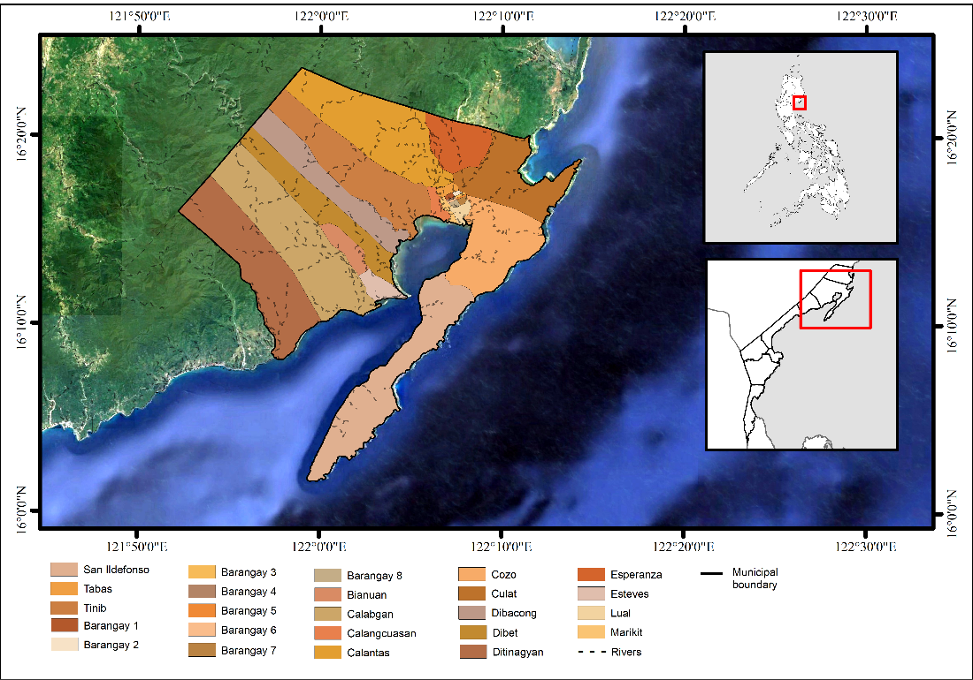

Figure 1. Location of the study area

The terrain of Casiguran is predominantly level to undulating, with slopes ranging from 0–8%, making it suitable for both agricultural activities and urbanization. The municipality falls under a Type II climate classification, characterized by the absence of a dry season and a pronounced maximum rainfall from November to January (FAO, 2019).

Agriculture is the primary livelihood in Casiguran, with rice, coconut, and banana as the main crops. The land use/cover map (Figure 2) reveals that while forest lands dominate the municipality, a significant portion of its agricultural land is concentrated near the coastline. This proximity increases the susceptibility of agricultural areas to damage and losses caused by weather disturbances and climate change-induced hazards.

Casiguran’s geographic location and its significant reliance on coastal agriculture and frequent exposure to climate change-induced and natural hazards make it an ideal site for this study. The municipality provides a representative context for examining the direct and indirect impacts of coastal hazards on agricultural lands and the broader implications for local livelihoods and economic stability. This setting ensures the findings will be locally relevant and applicable to other similarly situated coastal regions.

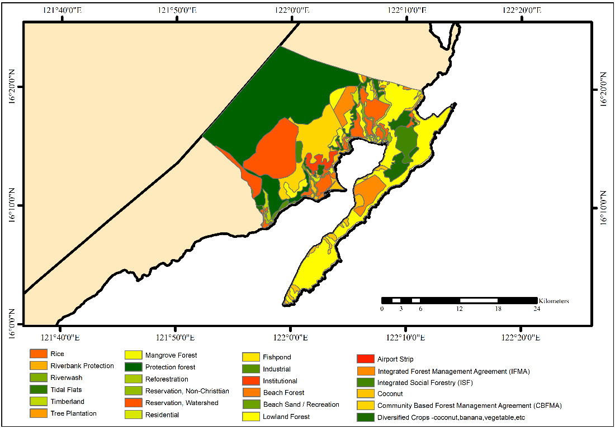

Figure 2. Land use/cover map of Casiguran, Aurora

2.2 Survey Design

The study collected data using a six-page questionnaire, ensuring alignment with its objectives. The questionnaire consisted of three main parts: a profile of the respondents, identification of direct impacts on agricultural land, and indirect impacts on agricultural land. The content of the questionnaire was created by a thorough review of the literature and tailored to suit the study's context. Questions were translated into the local language (Tagalog) to minimize language barriers and ensure clarity for respondents.

2.2.1 Preliminary Survey

To contextualize and refine the identification of key challenges encountered by coastal farmers in Casiguran, a preliminary survey was conducted among 30 farmers from selected coastal barangays. This step aimed to validate the relevance and comprehensiveness of the problems identified through literature review while capturing context-specific issues.

Subsequently, a pilot survey was administered to evaluate the validity and reliability of the questionnaire. The participants, comprising 30 coastal farmers, were selected from the most accessible barangays—Ditinagyan, Calabgan, and Dibet—based on logistical considerations and their active involvement in agricultural activities. The pilot survey was conducted from December 2–4, 2024.

Feedback from the pilot survey was systematically reviewed, and necessary adjustments were made to address any identified shortcomings. This iterative process ensured the development of a refined and enriched questionnaire suited to the specific context of coastal farming in Casiguran. Based on these inputs, a finalized and enriched questionnaire was developed for the main survey.

2.2.2 Sampling Framework

The study employed stratified random sampling, where each coastal barangay in Casiguran was treated as a distinct stratum (Iliyasu & Etikan, 2021). This approach ensured that all barangays were adequately represented in the sample. Farmers were randomly selected within each barangay using simple random sampling (SRS), provided they were farming within 500 meters of the coastline. A complete list of eligible farmers in each barangay was compiled, and participants were randomly chosen from this list, ensuring that each farmer had an equal chance of being selected.

Using Cochran’s formula (Ahmed, 2024), the total sample size was determined from a total population of 231 farmers.

${\text{n}}_{\text{O}}\text{=(}{\text{Z}}^{\text{2}}\text{∙p∙(1-p))/}{\text{E}}^{\text{2}}$ (1)

Where n₀ = initial sample size for large populations (before any adjustments for finite populations), Z = z-value (1.96 for 95% confidence), p = estimated population proportion (0.5), E = margin of error.

Once the initial sample size was calculated, an adjustment for the finite population was applied using the formula:

${\text{n}}_{\text{adj}}\text{=}{\text{n}}_{\text{o}}\text{/(1+(}{\text{n}}_{\text{o}}\text{-1))}$ (2)

Where n_{adj} = adjusted sample size, n₀ = initial sample size for large populations (before any adjustments for finite populations),
Using Equation 3 (Ahmed, 2024), the sample size was allocated proportionally to the number of farmers in each barangay. Table 1 presents a detailed breakdown of the number of respondents per barangay. This method ensured that each barangay was represented proportionately to its population size.

${ \text{n}}_{\text{h}}\text{=}{\text{ (n}}_{\text{h}}\text{/N)∙n}$ (3)

Where n_{h} = sample size for stratum h, N_{h} = population size for stratum h, N = total population size, n = overall sample size.

Table 1. Number of respondents from each coastal barangay

Coastal Barangay | Total Population of Qualified Respondents | Proportion (%) | Number of respondents
Calabgan | 16 | 6.93 | 10
Calangcuasan | 19 | 8.23 | 12
Culat | 18 | 7.79 | 11
Cozo | 24 | 10.39 | 15
Dibacong | 18 | 7.79 | 11
Dibet | 16 | 6.93 | 10
Ditinagyan | 16 | 6.93 | 10
Esteves | 25 | 10.82 | 16
Lual | 22 | 9.52 | 14
Marikit | 16 | 6.93 | 10
San Ildefonso | 24 | 10.39 | 15
Tinib | 17 | 7.36 | 11

2.2.3 Survey Administration

The refined questionnaire was used for the final survey, which was conducted between December 9, 2024, and January 12, 2025. Farmers were presented with separate lists of coastal hazards' direct and indirect impacts on their agricultural land.

Respondents ranked these impacts separately based on the intensity and frequency of the problems they encountered. Rankings were assigned on a scale from 1 to 7, where Rank 1 represented the most significant problem, and Rank 7 represented the least significant problem. Standardized definitions for each problem were explained to the respondents to ensure consistency and accuracy before they provided their rankings.

Data collection was conducted through face-to-face interviews, allowing respondents to ask questions or seek clarification. To minimize bias, anonymity was assured for all responses, and uniform explanations were provided to all participants.

2.3 Garrett Ranking

The collected data were analyzed using the Garrett Ranking Method, which enables farmers to rank various impacts based on their perceived severity. This approach provides a systematic and quantifiable framework for prioritizing challenges encountered by coastal farming communities. By converting rank orders into weighted scores, the Garrett Ranking Method objectively identifies the most critical issues, ensuring that the findings reflect the collective experiences of farmers and effectively highlight factors requiring urgent intervention. The ranks provided by the farmers were converted into Garrett scores using Equation 4 (Garret, 1981).

Percent position = $\left(\text{100}\left({\text{R}}_{\text{ij}}\text{-0.5}\right)\right)\text{/}{\text{N}}_{\text{j}}$ (4)

Where R_{ij} is the rank given for the ith problem by the jth respondent; Nj is the number of problems ranked by the jth respondent.

The percentage position estimated was converted into scores using Garrett’s Table (Table 2). The higher the percentage position, the lower the Garrett scores. Using these scores, total and mean scores were calculated for each problem. The factors having the highest mean value were the most important. The corresponding Garrett score for each rank is detailed in Table 3.

Table 2. Garrett Ranking Conversion Table

Percent | Score | Percent | Score | Percent | Score | Percent | Score | Percent | Score
0.09 | 99 | 6.81 | 79 | 32.42 | 59 | 71.14 | 39 | 94.49 | 19
0.20 | 98 | 7.55 | 78 | 34.25 | 58 | 72.85 | 38 | 95.08 | 18
0.32 | 97 | 8.33 | 77 | 36.15 | 57 | 74.52 | 37 | 95.62 | 17
0.45 | 96 | 9.17 | 76 | 38.06 | 56 | 76.12 | 36 | 96.11 | 16
0.61 | 95 | 10.06 | 75 | 40.01 | 55 | 77.68 | 35 | 96.57 | 15
0.78 | 94 | 11.03 | 74 | 41.97 | 54 | 79.17 | 34 | 96.99 | 14
0.97 | 93 | 12.04 | 73 | 43.97 | 53 | 80.61 | 33 | 97.37 | 13
1.18 | 92 | 13.11 | 72 | 45.97 | 52 | 81.99 | 32 | 97.72 | 12
1.42 | 91 | 14.25 | 71 | 47.98 | 51 | 83.31 | 31 | 98.04 | 11
1.68 | 90 | 15.44 | 70 | 50.00 | 50 | 84.56 | 30 | 98.32 | 10
1.96 | 89 | 16.09 | 69 | 52.02 | 49 | 85.75 | 29 | 98.58 | 9
2.28 | 88 | 18.01 | 68 | 54.03 | 48 | 86.89 | 28 | 98.82 | 8
2.69 | 87 | 19.39 | 67 | 56.03 | 47 | 87.96 | 27 | 99.03 | 7
3.01 | 86 | 20.93 | 66 | 58.03 | 46 | 88.97 | 26 | 99.22 | 6
3.43 | 85 | 22.32 | 65 | 59.99 | 45 | 89.94 | 25 | 99.39 | 5
3.89 | 84 | 23.88 | 64 | 61.94 | 44 | 90.83 | 24 | 99.55 | 4
4.38 | 83 | 25.48 | 63 | 63.85 | 43 | 91.67 | 23 | 99.68 | 3
4.92 | 82 | 27.15 | 62 | 65.75 | 42 | 92.45 | 22 | 99.80 | 2
5.51 | 81 | 28.86 | 61 | 67.48 | 41 | 93.19 | 21 | 99.91 | 1
6.14 | 80 | 30.61 | 60 | 69.39 | 40 | 93.86 | 20 | 100.00 | 0

Table 3. Corresponding Garrett score for each rank

Rank | Formula | Calculated Percentile Position | Garrett Score
1 | 100(1-0.5)/7 | 7.14 | 78
2 | 100(2-0.5)/7 | 21.43 | 66
3 | 100(3-0.5)/7 | 35.71 | 57
4 | 100(4-0.5)/7 | 50 | 50
5 | 100(5-0.5)/7 | 64.29 | 42
6 | 100(6-0.5)/7 | 78.57 | 35
7 | 100(7-0.5)/7 | 92.86 | 22

3. results and discussion

3.1 Profile of Respondents

The survey respondents were profiled based on their socioeconomic background, farming characteristics, and practices, revealing important insights into their agricultural livelihoods. A significant portion of the respondents were from older age groups, with 28.28% in the 36-45 age bracket and 55.17% aged 56 and above, reflecting a mature farming population with extensive experience. The finding further supports this by stating that 68.28% of respondents had more than 20 years of farming experience, indicating a deep-rooted connection to agriculture. The majority (68%) were male, and most were married (87.59%), with household sizes predominantly ranging from 5 to 10 members (51.03%), showing a family-centered agricultural livelihood. Educationally, 54.48% of respondents had attained a high school education.

Regarding farming characteristics, the farm sizes varied, with the majority cultivating 1-3 hectares (37.24%) and 3-5 hectares (35.17%). More than half of the farmers (51.03%) owned their land, while 48.97% were tenants, sharing farm inputs and harvest with landowners. Irrigation played a key role in agricultural productivity, with 72.41% of the land being irrigated, primarily sourced from rivers and streams (88.35%). The primary crops grown were rice (75.86%) and coconut (19.31%), with smaller portions growing other crops like corn, banana, cassava, and abaca (4.83%). These crop choices indicate a reliance on staple food crops and cash crops for income generation.

Agriculture was a central livelihood source for the respondents, making them highly relevant for a survey focused on coastal farming. Nearly half (46.21%) of the respondents relied on agriculture for 75%-100% of their income, while 29.66% depended on it for 50%-75% and 22.76% for 25%-50%. These figures indicate the importance of agriculture in the community, positioning the respondents as key individuals whose experiences directly reflect the challenges faced by coastal farmers. Many were engaged in various agricultural activities, such as “pagtatalok” (hired rice planters), “taga-gapas ng palay” (hired rice harvester), livestock farming, and “pag-aararo” (hired plowman), all of which are closely linked to coastal farming practices. In addition to these farming-related tasks, some respondents supplemented their income through alternative livelihoods, including sari-sari store ownership, construction work, and “paggawa ng pawid” (nipa thatcher).

3.2 Direct Effects of Coastal Hazards on Agricultural Lands

The reported problems faced by the coastal farmers due to coastal hazards on agricultural lands were changes in soil pH, climatic issues such as irregular rainfall, coastal floods, storms, decline in soil fertility, land use changes, saltwater intrusion, sedimentation, and soil erosion and loss. Table 4 and Figure 3 detail the rank rendered by the respondents and the direct impact’s ranking.

Table 4. Rank rendered by the respondents for identified direct impacts of coastal hazards on agricultural lands

Direct Impacts | Rank rendered by the Respondents |  |  |  |  |  |  | TOTAL
 | 1st | 2nd | 3rd | 4th | 5th | 6th | 7th
Change in Soil Ph | 780 | 6,138 | 1,368 | 100 | 420 | 105 | 66 | 8,977
Decline in Soil Fertility | 2,574 | 264 | 3,705 | 1,500 | 420 | 70 | 22 | 8,555
Extreme climatic events (excessive rainfall, wind disturbances, typhoons) | 5,694 | 1,518 | 1,254 | 700 | 210 | 105 | 110 | 9,591
Land use change (Abandonment/  conversion) | 390 | 198 | 285 | 400 | 378 | 1,645 | 1,496 | 4,792
Saltwater Intrusion | 1,092 | 528 | 114 | 0 | 1,554 | 1,470 | 924 | 5,682
Sedimentation | 624 | 594 | 855 | 3,250 | 378 | 805 | 352 | 6,858
Soil Erosion and Loss | 156 | 330 | 684 | 1,350 | 2,772 | 840 | 198 | 6,330

Figure 3. Ranking of the direct effects of coastal hazards on agricultural lands using the Garrett Ranking Method.

Extreme climatic events ranked as the most pressing issue, with a mean score of 66.14. Casiguran's exposure to typhoons and storm surges has led to recurrent crop losses, particularly in rice, cassava, and corn cultivation. For instance, Typhoon Enteng in 2024 caused Php 5.2 million in rice crop damages, contributing to Php 25 million in provincial losses (Business Week National, 2024). Compared to the Php 2.9 million in damages from Typhoon Karding in 2022 (De Asis, 2022), the escalating impact of extreme weather highlights the increasing vulnerability of agricultural land. Similarly, strong winds from these events have severely damaged coconut plantations in San Ildefonso, Cozo, and Dibacong, reducing both short-term yields and long-term plantation productivity. Since coconut trees take years to mature, such damage leads to prolonged economic losses for affected farmers.

Closely linked to climatic disturbances, changes in soil pH, with a mean score of 61.90, emerged as the second most critical impact. Acidification has been a growing concern among farmers. Respondents stated that this issue has been confirmed by the Department of Agriculture (DA) through various soil tests conducted in the area. Farmers reported symptoms such as poor root development, stunted crop growth, and leaf yellowing, which are clear indicators of nutrient imbalances due to soil acidification (O'Kennedy, 2022). The primary causes identified were excessive rainfall and the long-term use of nitrogen-based fertilizers, particularly urea and ammonium sulfate, which contribute to soil acidification when converted to nitrates (Arnall, 2024).

As soil pH declines, soil fertility also deteriorates, ranking third among the identified impacts with a mean score of 59.00. Farmers have observed consistent crop productivity reductions despite farm inputs' continued use. The main drivers of declining soil fertility include sedimentation, coastal flooding, and nutrient depletion. Farmers in Dibacong and Dibet attributed declining fertility to sediment-laden irrigation water, while those in Brgy. Esteves linked it to coastal flooding, which deposits saline sediments on their fields. Farmers have increased fertilizer use to mitigate these losses, adding to their production costs and financial burden.

Sedimentation ranked fourth with a mean score of 51.28, further amplifying soil degradation and hydrological inefficiencies. Farmers identified unlined irrigation channels as a primary source of sediment transport, particularly during extreme rainfall events. According to farmers, this problem worsened after typhoons. For instance, three consecutive typhoons—Nika, Ofel, and Pepito—in late 2024 led to widespread sediment deposition on farmlands (Figure 4). Both waterborne and wind-driven sedimentation were identified as long-term threats to agricultural productivity, as the wind gradually deposits fine particles on exposed fields.

Compounding these issues, soil erosion and land loss ranked fifth, with a mean score of 43.66, particularly severe in flood-prone areas like Brgy. Esteves. Erosion is driven by uncontrolled irrigation flows, coastal flooding, and riverbank overflow during heavy rains. Farmers growing coconuts, bananas, and abaca in Dibet, Dibacong, Calancuasan, and Tinib reported significant land loss due to the lack of effective flood control measures. This erosion not only reduces arable land but also threatens long-term agricultural viability.

Adding to these challenges, saltwater intrusion ranked sixth, with a mean score of 39.19, and has affected specific barangays, particularly Dibet, Tinib, Dibacong, and Esteves. Data from the Municipal Agricultural Office (MAO) indicate that approximately 12.5 hectares of rice farmland in Casiguran are impacted by salinity (Figure 4). Farmers attributed this issue to seawater entering irrigation sources during high tides, leading to the gradual salinization of agricultural soils. While not the most pressing issue for all farmers, those relying on freshwater irrigation view saltwater intrusion as a critical factor in reducing rice yields.

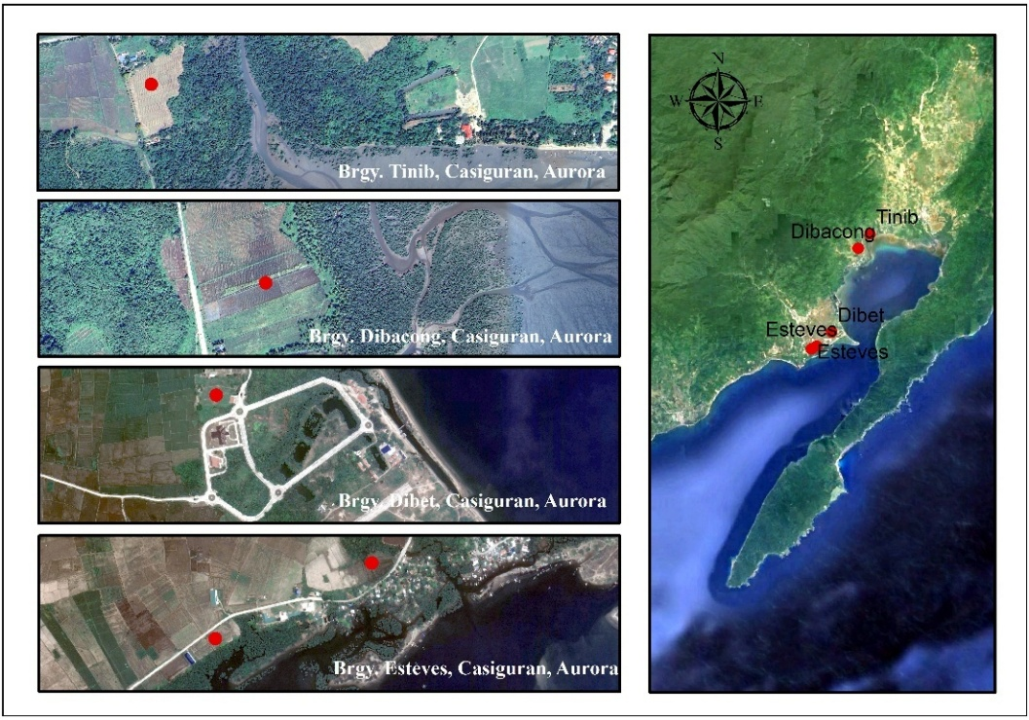

Figure 4. Distribution of confirmed saline-affected farm areas in Casiguran, Aurora.

Despite the increasing severity of coastal hazards, land use/cover changes ranked the lowest mean score of 33.05 among the identified impacts. Most farmers continue cultivating their land rather than abandoning it due to financial constraints. Instead, they have adopted various strategies, such as planting alternative crops in erosion-prone areas and using coconut trees as buffer zones for rice farms. Others have repurposed degraded lands for livestock grazing, demonstrating the resilience and adaptability of Casiguran’s farming communities.

Overall, the results reveal a strong interconnection between these impacts. Extreme climatic events act as catalysts, triggering soil degradation processes such as erosion, sedimentation, and acidification. These changes lead to declining soil fertility and reduced agricultural productivity, compelling farmers to invest in costly farm inputs or repurpose the affected land. The hydrological impacts of coastal hazards, particularly saltwater intrusion, further compromise soil and water quality, making agricultural land less viable over time.

Strengthening community-level preparedness plans is essential to mitigate these impacts effectively. Prioritizing soil health monitoring and management is crucial. Given Casiguran's remoteness from the nearest soil testing laboratory in Pampanga, the local government should promote accessible solutions, such as providing soil analysis toolkits or supporting local soil testing programs. Soil testing is vital in improving agricultural productivity by evaluating fertility, pH levels, and overall soil health, allowing farmers to optimize yields, reduce input costs, and implement targeted solutions (Tiwari et al., 2023).

Finally, addressing sedimentation and soil erosion is critical. Protective infrastructure, such as reinforced irrigation channels and flood control measures, can help safeguard agricultural lands from storm surges and strong winds. These initiatives reduce crop damage and minimize farmers' financial losses. Infrastructure upgrades, such as lining irrigation channels, can stabilize canal structures, reduce maintenance costs, and prevent bed and bank erosion. This is particularly important in the brackish water environment of Casiguran, where seepage control is necessary to conserve water, prevent waterlogging, and protect groundwater quality (Swamee & Chahar, 2015). Additionally, implementing soil conservation techniques, such as planting vegetative buffers along riverbanks, can significantly reduce further land degradation, ensuring the long-term sustainability of agricultural lands.

3.3 Indirect Effects of Coastal Hazards on Agricultural Lands

Indirect effects of coastal hazards refer to the consequences of the direct impacts on agricultural lands. In the coastal barangays of Casiguran, local-specific indirect effects of coastal hazards are changes in farming practices, competition for water resources, increased cost of farming inputs, increased vulnerability to market/price fluctuations, pests and disease, social and well-being of farmers, and variability in crop production. Table 5 details the rank rendered by respondents, while Figure 5 shows the ranking of the indirect effects.

Table 5. Rank rendered by the respondents for identified indirect impacts of coastal hazards on agricultural lands

Indirect Impacts | Rank rendered by the Respondents |  |  |  |  |  |  | Total
 | 1st | 2nd | 3rd | 4th | 5th | 6th | 7th
Changes in farming practices | 468 | 132 | 57 | 50 | 1218 | 595 | 1958 | 4478
Competition for water resources | 156 | 1056 | 171 | 100 | 1176 | 3220 | 44 | 5923
Increased cost of farming inputs | 2808 | 1254 | 1026 | 3050 | 252 | 140 | 22 | 8552
Increased vulnerability to market/price fluctuations | 780 | 198 | 114 | 100 | 2394 | 700 | 1122 | 5408
Pests and disease | 2028 | 1980 | 3819 | 650 | 378 | 0 | 0 | 8855
Social and well-being of farmers | 858 | 2838 | 1824 | 2000 | 210 | 420 | 44 | 8194
Variability in crop production | 4212 | 2508 | 1026 | 1250 | 420 | 0 | 0 | 9416

Figure 5. Ranking of the indirect effects of coastal hazards on agricultural lands using the Garrett Ranking Method

Variability in crop production emerged as the most significant indirect effect of coastal hazards, with a mean score of 64.94. The fluctuations in production, particularly for rice farmers, are closely linked to seasonal typhoons, which frequently hit the region during the second half of the year. According to farmers, under optimal conditions, farmers with 3 hectares of land can harvest approximately 200–250 bags of palay (50 kg each), translating to 4.17 metric tons per hectare. However, prolonged exposure to coastal hazards has progressively degraded soil health, leading to reduced fertility, lower water-holding capacity, and increased susceptibility to erosion and water pollution (Kumar, Mahale, & Patil, 2020), all contributing to declining yields. Extreme weather events, pest infestations, and crop diseases can further reduce this yield to as low as 1.67 metric tons per hectare, less than half of the optimal harvest. This decline mirrors findings from the Philippine Rice Information System or PRISm (PRISm, 2024), which shows a downward trend in rice yield per hectare in Casiguran (Figure 6).

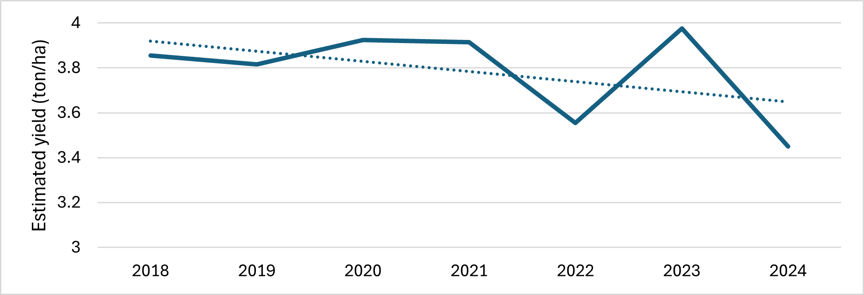

Figure 6. Estimated rice yield in Casiguran, Aurora based on PRISm

Beyond rice, other crops are not spared from the impacts of coastal hazards. While specific yield data is unavailable for coconut and corn, farmers reported similar challenges. Typhoons cause severe damage to coconut plantations, leading to uprooted trees and reduced long-term productivity. Likewise, excessive rainfall and strong winds result in lodging and breakage of corn stalks, further heightened yield losses. These findings indicate that variability in production is a shared concern across different crop types, directly impacting income stability and food security in coastal communities.

Pest and disease outbreaks are closely linked to production variability, ranking second among indirect effects, with a mean score of 61.07. Rice farmers face infestations from rodents, yellow stem borers (Scirpophaga incertulas), brown planthoppers (Nilaparvata lugens), and rice black bugs (Scotinophara coarctata), all of which thrive in humid, marshy environments common in coastal areas (IRRI, 2024). Coconut farmers also face pest and disease challenges, though with a different profile. Reports indicate occurrences of coconut scale insects (Aspidiotus rigidus), while rodent infestations remain a persistent threat to nut production.

Another major challenge linked to coastal hazards is the rising cost of farming inputs, ranking third in significance. Soil acidification and sedimentation force farmers to use more synthetic fertilizers and pesticides to sustain yields. However, overreliance on synthetic inputs depletes soil fertility, causes nutrient imbalances, and increases dependency on costly external inputs (Jones, 2023) and initial production costs, posing a significant burden on farming communities worldwide (Kumar, Mahale & Patil, 2020). In remote areas like Casiguran, input costs have risen by Php 5–10 annually, with spikes of up to Php 20 after calamities. Rising labor costs further strain farmers, with daily wages increasing from Php 450 to Php 500 in 2024. Small-scale farmers, in response, are cutting hired labor, causing inefficiencies and delays. While coconut farmers face lower fertilizer costs, harvesting labor expenses continue to climb. Implementing soil test-based nutrient management plans can help farmers optimize fertilizer use, reducing costs and preventing soil degradation.

The financial burden associated with farming costs inevitably spills over into broader socioeconomic struggles. Farmers frequently turn to private lenders, borrowing Php 30,000–40,000 per hectare at high interest rates (15–20%) due to the slow processing of government credit programs. This financial insecurity often results in land sales as farmers attempt to repay debts, further diminishing their long-term stability. Additionally, social conflicts arise, particularly after typhoons, when fallen crops such as coconuts and bananas are stolen. These losses intensify financial difficulties and deepen tensions within farming communities.

Beyond financial stress, coastal hazards also heighten competition for water resources, ranking fifth among indirect impacts. Survey results show that 72.41% of farmers depend on irrigation from rivers and streams, while 27.9% rely solely on rainfed systems. During water-scarce periods, such as the dry season or El Niño events, competition for irrigation intensifies, leading to conflicts and cropping delays. Facing even greater uncertainty, rainfed farmers often skip planting cycles until weather conditions improve. This disruption forces some farmers to seek alternative livelihoods, highlighting the economic impact of water resource scarcity in coastal communities.

Adding to these challenges, increased vulnerability to the market ranks sixth, exposing coastal farmers to price fluctuations. Limited access to buyers forces farmers to rely on intermediaries who dictate lower prices, reducing profitability. Rice farmers report that palay harvested in the first half of the year sells for Php 16–20 per sack, while second-half harvests, despite fetching higher prices (Php 20–25), coincide with typhoon damage that reduces yields. Similarly, coconut farmers face fluctuating prices, with fresh coconuts selling for Php 12–15 and mature coconuts for Php 20–25. However, typhoon-related production shortages can raise prices by Php 5–10. Additionally, immature coconuts knocked down by typhoons, known as "batingol," are unsuitable for direct sale and are instead processed into copra over several weeks. While this provides some income, the lower market value limits farmers' profitability and threatens their livelihoods.

Despite these numerous challenges, changes in farming practices ranked lowest among indirect impacts, with a mean score of 30.88. In Casiguran, the older age of farmers (56 and above), comprising 55.17% of respondents, strongly correlates with their reliance on traditional methods. This reluctance to adopt modern techniques, such as soil analysis and hybrid crops, stems from cultural norms and a preference for familiar practices. Efforts are being made, however, to encourage adaptation. The local government unit (LGU), in collaboration with the Department of Agriculture (DA), has promoted hybrid rice, which offers a 15–20% yield advantage over traditional varieties. Farmers have also been invited to training sessions on managing soil pH, incorporating organic fertilizers, and adopting innovative pest management practices.

Addressing climate change hazards requires both agricultural adaptation and enhanced farmer education. In Casiguran, an aging farming population complicates adopting modern practices, highlighting the need for more inclusive, farmer-centered approaches to promote sustainable agricultural techniques. Programs like Farmer Field Schools (FFSs), successful in Jamaica (Tomlinson & Rhiney, 2018), could be adopted locally in partnership with the local government to enhance climate awareness and knowledge sharing. Farmer-to-farmer communication can also complement formal extension services (Izuchukwu, Erezi, & David Emeka, 2023).

Beyond education, a comprehensive approach, including policy support, financial access, and infrastructure development, is essential (Moser & Dilling, 2011). Integrating climate adaptation into agricultural policies, subsidizing climate-resilient crops, and enforcing microfinance interest rate regulations under the Agri-Agra Reform Credit Act can improve financial resilience (Villegas & Mendoza, 2015). Expanding community-based credit models like the CATAFA system in Negros Occidental (CPSU, 2023) could further support farmers.

Equally important is the development of farm-to-market roads and post-harvest facilities, which can improve market access, minimize losses, and sustain agricultural productivity (Paracale et al., 2024). Communities with strong self-organized institutions often adapt more effectively to climate challenges, experiencing fewer losses in well-being and population displacement. In contrast, communities lacking these networks face greater struggles (Berman et al.,2019). Therefore, the success of these interventions relies on coordinated efforts among local government units, agricultural experts, and farmers. Strengthening these initiatives will enhance the farming sector and foster long-term resilience in Casiguran’s coastal agrarian communities.

4. Conclusion

The findings from the study on the direct and indirect impacts of coastal hazards on agricultural land in Casiguran underscore the complex challenges faced by local farmers. The direct effects on agricultural land include extreme climatic events, changes in soil pH, declining soil fertility, sedimentation, soil erosion and loss, saltwater intrusion, and land use/cover changes. These direct changes collectively contribute to significant issues in agricultural productivity and the sustainability of farming practices in the coastal barangays of Casiguran.

The indirect effects of coastal hazards are equally severe, manifesting as variability in crop production, pest and disease outbreaks, increased farming input costs, and social and well-being challenges for farmers. Additional issues such as competition for water resources, vulnerability to market and price fluctuations, and shifts in farming practices further intensify the difficulties faced by the community.

To mitigate these impacts, strengthening community preparedness, enhancing soil health monitoring, and establishing accessible soil testing programs are essential. Investing in protective infrastructure, such as reinforced irrigation channels and flood control systems, can help safeguard farmland and minimize economic losses. Additionally, promoting farmer education through capacity-building programs like Farmer Field Schools and farmer-to-farmer learning will enhance climate resilience.

Policy support, financial assistance, and infrastructure investments, such as farm-to-market roads and post-harvest facilities, are crucial for long-term agricultural sustainability. A coordinated effort among local governments, agricultural experts, and farming communities is necessary to implement targeted interventions that ensure resilience against climate change. By adopting these strategies, Casiguran’s coastal farming sector can be better equipped to withstand future environmental challenges.

Disclaimer (Artificial intelligence)
The authors hereby declare that generative AI technologies, such as Grammarly, were used during the writing and editing of this manuscript.
Details of the AI usage are given below:
1. Grammar checking
2. Stylistic review of the entire manuscript

References

- Singh, A. K. (2020). Coastal agriculture and future challenges. In A. Singh, R. L. S. Fernando, & N. P. Haran (Eds.), Development in coastal zones and disaster management (pp. 61–86). Palgrave Macmillan.
- Barbier, E. B. (2017). Marine ecosystem services. Current Biology, 27(11), R507–R510. https://doi.org/10.1016/j.cub.2017.03.020
- Paice, R., & Chambers, J. (2016). Climate change adaptation planning for protection of coastal ecosystems. CoastAdapt Information Manual 10. National Climate Change Adaptation Research Facility, Gold Coast.
- Zhang, Y., & Hou, X. (2020). Characteristics of coastline changes on Southeast Asia islands from 2000 to 2015. Remote Sensing, 12(3), 519. https://doi.org/10.3390/rs12030519
- Eckstein, D., Kunzel, V., Schäfer, L., & Winges, M. (2019). Global Climate Risk Index 2020. Germanwatch.
- Dait, J. M. G. (2015). Effect of climate change on Philippine agriculture. International Journal of Science and Research, 4(9), 1922-1924. https://doi.org/10.21275/SUB158497
- FAO (Food and Agriculture Organization). (2019). Weather or climatic conditions. In Brackishwater Aquaculture Development and Training Project Republic of the Philippines. https://www.fao.org/4/ac061e/AC061E00.htm
- Iliyasu, R., & Etikan, I. (2021). Comparison of quota sampling and stratified random sampling. Biometrics & Biostatistics International Journal, 10(1), 24-27. https://doi.org/10.15406/bbij.2021.10.00326
- Ahmed, S. K. (2024). How to choose a sampling technique and determine sample size for research: A simplified guide for researchers. Oral Oncology Reports, 12. https://doi.org/10.1016/j.oor.2024.100662
- Garrett, H. E. (1981). Statistics in psychology and education. Vakils, Feffer and Simons Ltd.
- Business Week National. (2024). Aurora faces over P44.5M in agricultural damage from Typhoon “Enteng.” https://businessweekmindanao.com/aurora-faces-over-p44-5m-in-agricultural-damage-from-typhoon-enteng/
- De Asis, J. (2022). Aurora incurs over P182-M loss in agri, infra due to “Karding.” Philippine News Agency. https://www.pna.gov.ph/articles/1184765
- O' Kennedy, S. (2022). Soil pH and its impact on nutrient availability and crop growth. International Journal of Geography, Geology, and Environment, 4(2), 236-238.
- Arnall, B. (2024). Oklahoma Cooperative Extension Service: Cause and effects of soil acidity. Retrieved from https://eeo.okstate.edu
- Tiwari, T., Sharma, S., Singh, K., & Sachan, R. (2023). Importance of soil testing in sustainable agriculture. In Sustainable Agriculture (pp. 173–185).
- Swamee, P. K., & Chahar, B. R. (2015). General principles of canal design. Springer Transactions in Civil and Environmental Engineering, 59–77. https://doi.org/10.1007/978-81-322-2322-1_4
- International Rice Research Institute. (2024). Pest management. Knowledge Bank. http://www.knowledgebank.irri.org/training/fact-sheets/pest-management
- Kumar, S. S., Mahale, A. G., & Patil, A. C. (2020). Mitigation of Climate Change through Approached Agriculture-Soil Carbon Sequestration (A Review). Current Journal of Applied Science and Technology, 39(33), 47–64. https://doi.org/10.9734/cjast/2020/v39i3331017
- Philippine Rice Information System. (2024). Estimated yield in Aurora. https://prism.philrice.gov.ph/dataproducts/
- Jones, C. (2023). Fertilizers: Its importance in modern agriculture, crop yields, and ensuring food security. Journal of Agricultural Science and Food Research, 14, 155.
- Tomlinson, J., & Rhiney, K. (2018). Assessing the role of farmer field schools in promoting pro-adaptive behaviour towards climate change among Jamaican farmers. Journal of Environmental Studies and Sciences, 8(1), 86–98.
- Izuchukwu, A., Erezi, E., & David Emeka, E. (2023). Assessing the impact of farmer-to-farmer communication networks on knowledge sharing and adoption of sustainable agricultural practices in Africa. International Journal of Agriculture and Earth Sciences, 9(1), 58–76.
- Moser, S. C., & Dilling, L. (2011). Communicating climate change: Closing the science-action gap. In J. S. Dryzek, R. B. Norgaard, & D. Schlosberg (Eds.), The Oxford handbook of climate change and society (pp. 161–174). Oxford University Press.
- Villegas, O. M., & Mendoza, T. C. (2015). Opportunities and challenges for green agriculture in the ASEAN: Focus on the Philippines. Proceedings of the 50th PAEDA Convention, Legaspi, Albay.
- Central Philippines State University. (2023). CPSU’s CATAFA has begun the village banking system to facilitate rural prosperity. Retrieved from https://www.cpsu.edu.ph/view-article/132
- Paracale, M. I. P., Abante, M. V., & Vigonte, F. G. (2024). Fields of struggle: An in-depth study on the socio-economic issues encountered by Filipino rice farmers. SSRN Electronic Journal. https://doi.org/10.2139/ssrn.4731163
- Berman, M., Baztan, J., Kofinas, G., Vanderlinden, J.-P., Chouinard, O., Huctin, J.-M., Thomson, K. (2019). Adaptation to climate change in coastal communities: findings from seven sites on four continents. Climatic Change. doi:10.1007/s10584-019-02571-x

APPENDIX:

Table A1. Socio-demographic profile of the respondents

Category | Sub-category | Frequency | Percentage (%)
Age | 18-25 | 0 | 0
 | 26-35 | 7 | 4.83
 | 36-45 | 17 | 11.72
 | 46-55 | 41 | 28.28
 | 56 and above | 80 | 55.17
Sex | Male | 98 | 68
 | Female | 47 | 32
Civil Status | Single | 6 | 4.14
 | Married | 127 | 87.59
 | Widow/Widower | 12 | 8.28
Family Size | Small (2-4) | 67 | 46.21
 | Medium (5-10) | 74 | 51.03
 | Large (more than 10) | 4 | 2.76
Educational Attainment | Elementary | 54 | 37.24
 | High School | 79 | 54.48
 | College | 12 | 8.28

Table A2. Farm Characteristics and Practices of the Respondents

Category | Sub-category | Frequency | Percentage (%)
Farming Experience | Less than 5 years | 9 | 6.21
 | 5-10 years | 19 | 13.10
 | 11-20 years | 18 | 12.41
 | More than 20 years | 99 | 68.28
Farm Size | Less than 1 hectare | 29 | 20
 | 1-3 hectares | 54 | 37.24
 | 3-5 hectares | 51 | 35.17
 | More than 5 hectares | 11 | 7.59
Land Ownership | Own | 74 | 51.03
 | Amortization | 0 | 0
 | Tenant | 71 | 48.97
 | Others | 0 | 0
Crops Grown | Rice | 110 | 75.86
 | Coconut | 28 | 19.31
 | Others (Corn, Banana, Abaca) | 7 | 4.83
Irrigation Type | Rainfed | 40 | 27.59
 | Irrigated | 105 | 72.41
Source of Irrigation | Rivers and streams | 91 | 88.35
 | Reservoir | 0 | 0
 | Groundwater | 12 | 11.65
 | Others | 0 | 0
Percentage of Agriculture as a Source of Income | 0%-25% | 2 | 1.38
 | 25%-50% | 33 | 22.76
 | 50%-75% | 43 | 29.66
 | 75%-100% | 67 | 46.21

