**Automatic Sprinkler in Controlled Atmosphere**

**ABSTRACT**:

This paper proposes a cost-effective smart sprinkler irrigation system for farmers to use in farm divisions. Automation plays a crucial role in modern life, providing comfort, increasing efficiency, and saving time. However, most industries use expensive automation and control mechanisms that may not be suitable for our needs. Watering the plants is the most significant cultural activity and one of the most labor-intensive duties in the daily operation of the greenhouse. Watering systems reduce the burden of delivering water to plants when they require it. Knowing when and how much to water are two critical components of the watering process. The purpose of the automatic plant watering system is to simplify gardening. These days, there are shortages of food and water because of population growth. We must support the agriculture industry in order to prevent the issue. The farming industry wastes more water. We can conserve water by employing this kind of technique when irrigating the fields. Sprinkler systems, tubes, nozzles, and other parts are used in a variety of automatic watering system types. This technique irrigates the plants in the pots using a watering sprinkler system. This project uses relay, Arduino and moisture sensor which consists of ATmega328 Microcontroller. Then Arduino works as per instruction of moisture sensor and system control. It is programmed in such a way that it will sense the moisture level of the soil, plants and supply the water when required. This type of system is commonly used for general plant maintenance, both in small and large gardens. Normally, plants should be watered twice a day, in the morning and evening. So, the microcontroller must be programmed to water the plants in the garden or farm twice every day. People like plants for their health benefits and the satisfaction that comes with caring for them. However, most people find it difficult to stay healthy and living. To address this difficulty, we created a prototype that allows a plant to irrigate itself from a big water tank and get artificial sunshine. The prototype displays the status of its present circumstances and advises the user to refill the water tank. The system created an automatic Plant watering system to minimize manual activities and making gardener’s work easier.

**Key words:** Automatic Watering System, Sprinkler Robot, Arduino, Water Pump.

**I. INTRODUCTION**

Providing people all over the world with essential products and sustenance, agriculture is one of the pillars of human civilization. However, this crucial industry faces a significant obstacle because of its heavy reliance on water supplies. As the problem of water scarcity spreads over different areas, the search for the need for farmers to manage water resources sustainably has never been greater. In order to increase crop yields and conserve water, automatic irrigation systems are growing in popularity.

“In the fast paced world human beings require everything to be automated. Our life style demands everything to be remote controlled. Apart from few things man has made his life automated. In the modern society is now fully dependent upon technology and the technological approach has brought a revolutionary change in each and every field. This project a multipurpose robot to be used in the battle field. This robotic vehicle is an agricultural machine of a considerable power and great soil clearing capacity. The machine will cultivate the farm by considering particular rows and specific column at fixed distance depending on crop. Moreover, the vehicle can be controlled through Bluetooth using an Android smart phone. In India, people depend upon the farming sector. In the summer farming production is decrease and the cost of the product is increased significantly in monsoon the production is increase and cost will be decreased. It causes farmers to be disappointing. This effect because of lack of water. different type of technique is available to save wastage of water. Automation plays a major role in the present days. In the world of advance electronics life of human beings should be simpler hence to make life simpler and convenient, so we have made Automatic Plant Watering System. Automatic plant watering system is designed to water the plants automatically without any human interference” [2,3].

These systems can automatically turn on or off irrigation water supplies based on weather and soil moisture levels, which are monitored by sensors. By ensuring that crops receive the appropriate amount of water at the appropriate time, this can help to boost profitability and production. The installation of an automated irrigation system appears to be a viable way to handle the urgent issues of labour efficiency and water conservation in agriculture in this environment. By implementing such cutting-edge technologies, farmers can transform their irrigation methods and greatly increase agricultural productivity and water efficiency.

The overarching goal of this study is to explore how the automatic irrigation system, based on the Arduino Uno, can facilitate resource-efficient farming practices. These systems can automatically turn on or off irrigation water supplies based on weather and soil moisture levels, which are monitored by sensors. By ensuring that crops receive the appropriate amount of water at the appropriate time, this can help to boost profitability and production. The installation of an automated irrigation system appears to be a viable way to handle the urgent issues of labor efficiency and water conservation in agriculture in this environment. Through this project, we delve into the multifaceted benefits of embracing an automatic irrigation system in modern agriculture. As we uncover the potential advantages of water savings, labor optimization, and sustainable farming, we emphasize the transformative impact that this technology can have on the agriculture sector, paving the way towards a more resilient and ecologically responsible future.

**II.LITERATURE REVIEW**

**Mathivanan. S, et al., (2023) presented the “Plant Irrigation water Sprinkler Robot”,** In this research paper, The sprinkler system could not meet the needs with presence and monitoring during the growing season. From this literature, we are decided to use advanced Technology in sprinkler Irrigation system to maximize water productivity and minimize costs of keeping farms.

**Pavan kumar.C.S et al., (2021). “A smart Irrigation system using Arduino”** This Technology specializes in the proper application of water to in Agriculture Land. Arduino, Relay, Motor, Pump, Bluetooth module are included in this machine. From this literature we have Selected Components such as Arduino, Relay, Motor, Pump, Bluetooth module for operation and controlling the vehicle.

**Ahmed hassan et al., (2021) presented the “Design and development of an irrigation mobile robot”.** The Arduino UNO framework was used for the development of the control unit with use of ATMEGA328P microcontroller that allowed the machine to use a suitable amount of water that prevent Irrigation. From this literature, we are decided to use ATMEGA328P micro-controller for automatic Water supply.

**Ipin prasojan et al., (2020) represent the “**Design of Automatic watering system based on Aurdino.The author implements the system by using a soil moisture sensor, microcontrollers and solenoid valve. By using electric magnet principal the valve is operated. Moisture sensor sense then sends to the reading aurdino. By referring to the reading solenoid valve is operate it means the water supply is off or ON for this system atmega, 328 used”.

**Devika et al., “**Automatic plant irrigation system using Arduino. This paper is discussed about automatic plant irrigation system operated based on moisture content in soil by voltage division rule. in this system at mega 328 is used which programmed in such a way that for 0 it sense that fully wet condition and for 1023 it senses dry condition .by detecting these two value we can predict that whether the pump is turned an on or off. This system also used atmega 328 i.e Arduino UNO and moisture sensors”.

**Sampa Das, et al., (2023)** reported **“**Smart Irrigation System Using IOT State, the use of Arduino Uno for automatic irrigation systems has been gaining popularity in recent years. This is due to the fact that Arduino is a relatively inexpensive and easy to use microcontroller that can be programmed to control a variety of components, including soil moisture sensors, water pumps, and valves. One of the most popular applications of Arduino Uno for automatic irrigation systems is in agriculture. In agriculture, automatic irrigation systems can be used to water crops at the optimal time and frequency, which can help to increase crop yields and reduce water waste.This technology is also being used to develop sprinkler irrigation systems that can automatically control the irrigating of crops based on soil moisture level”.

**III. METHODOLOGY**

Problem Identification

Fabrication of the Machine

Collection of Materials

Test Working of the Machine

Final Project

Design of the Model

Literature Survey

**Fig 1: Flow chart of Study protocol**

**3.1 Problem Identification**

* Conventional method of Irrigation requires more Water.
* High Growth of Weed .
* Soil Erosion may occurs while using Furrow Irrigation.
* Uneven Distribution of Water.
* Installation of Sprinkler in Poly Houses is More Expensive.

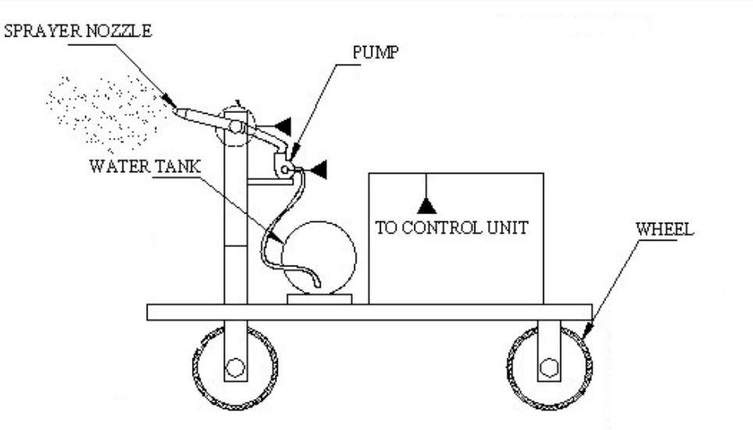**3.2 Design of the Model**

Figure 2: Design of Automatic Sprinkler

**3.3 Collection of Materials**

We collect the materials like Adeno UNO, Battery, DC Motor, HC-05 Bluetooth Module, Relay, Convertor, Water Pump, Sprinkler, Wheel, Water Tank and Connecting wires.

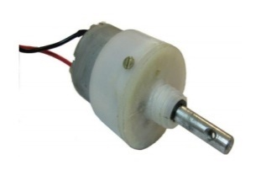**3.3.1.DC Motor**

Figure 3. DC motor

Permanent magnet DC motor responds to both voltage and current. The steady state voltage across a motor determines the motor’s running speed, and the current through its armature windings determines the torque. Apply a voltage and the motor will start running in one direction; reverse the polarity and the direction will be reversed.

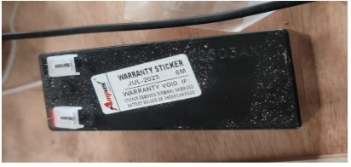**3.3.2. Battery**

Figure 4. Battery

In our project we are using secondary type battery. It is rechargeable type. A battery is one or more electrochemical cells, which store chemical energy and make it available as electric current. There are two types of batteries, primary (disposable) and secondary (rechargeable), both of which convert chemical energy to electrical energy.

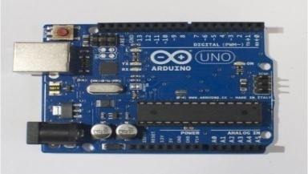**3.3.3. Arduino UNO**

Figure 5. Arduino board

Arduino is a single-board microcontroller to make using electronics in multidisciplinary projects more accessible. The hardware consists of an open-source hardware board designed around an 8-bit Atmel AVR microcontroller, or a 32-bit Atmel ARM.

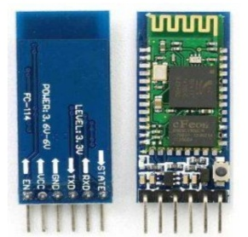**3.3.4. Bluetooth Module**

Figure 6. Bluetooth module

The HC05 bluetooth module is used as UART serial converter module and can easily transfer the UART data through the wireless bluetooth. The Bluetooth module has a Frequency: 2.4GHz ISM band, PIO control and comes with an integrated antenna and edge connector.

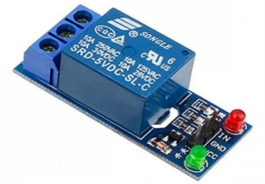**3.3.5. Relay**

Figure 7. Relay

A relay is an electrically operated switch. Current flowing through the coil of the relay creates a magnetic field which attracts a lever and changes the switch contacts. The coil current can be on or off so relays have two switch positions and they are double throw (changeover) switches.

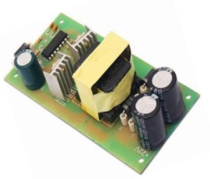**3.3.6. Convertor**

Figure 8. Convertor

A power converter, also known as a power supply or power adapter, serves the function of converting electrical power from one form to another Power converters are often used to convert electrical voltage from one level to another.

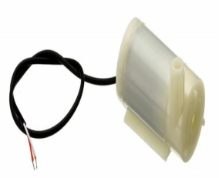**3.3.7. Water Pump**

Figure 9. Water pump

Pump is a device that moves fluids (liquids or gases), or sometimes slurries, by mechanical action. Pumps can be classified into three major groups according to the method they use to move the fluid: direct lift, displacement, and gravity pumps.

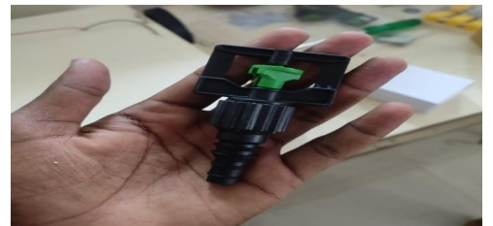**3.3.8. Sprinkler**

Figure 10. Sprinkler

An irrigation sprinkler, sometimes referred to as a water sprinkler or just a sprinkler, is a tool used to irrigate lawns, landscapes, crops, and other areas. They are also employed for airborne dust management and cooling. Sprinkler irrigation is a controlled technique that applies water in a manner akin to rainfall. A network that may include sprinklers, pipes, pumps, and valves distributes the water.

**3.3.9. Water Tank**

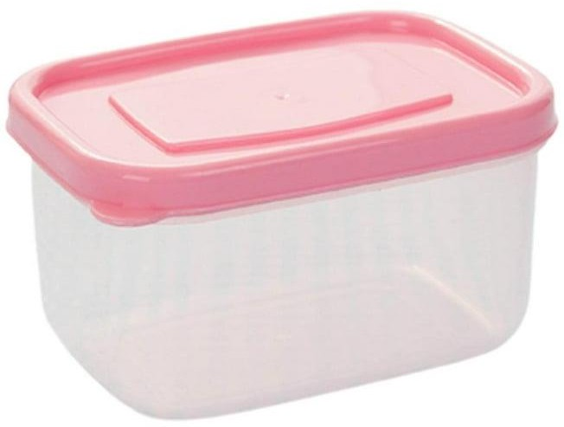A water tank is a container for storing water. The need for a water tank is as old as civilization, to provide storage of water for use in many applications, drinking water, irrigation agriculture, agricultural farming, both for plants and livestock as well as many other uses. The tank holds the water about 3.5liters.

### 

### Figure 11. Water Tank

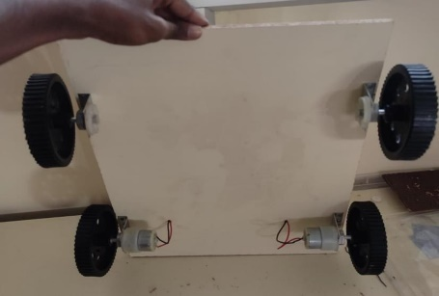**3.3.10. Wheel**

### Figure 12. Wheels

In order to facilitate movement, transit, or machine labor, a wheel is a circular device that can rotate on its axis. Through rolling, a wheel and axle reduce friction and enable motion. A moment must be delivered to the wheel about its axis in order for it to revolve, either by gravity or by the application of another external force. Applications in transportation are typical examples. In a broader sense, the term can also refer to various circular rotating or turning items, like a ship's wheel or flywheel.

**3.4. Fabrication of the Machine**

Fabrication of an automatic sprinkler machine involves combining mechanical, electrical and programming components. It involves Designing of frame and assemble the frame. The Sprinkler head is connected to Water Pump through pipe. The Water motor is connected to relay module of 12v power. The Battery(12v) is the power source for all components. The Bluetooth board is connected to Arduino board. A convertor which is connected to battery and relay to convert 12v into 5v. Write a program for the microcontroller to control the system based on sensor inputs. Secure all connections and components. Make any necessary adjustments and finalize the installation.

**3.5. Working of the Machine**

Actually, this consists of a Rover which moves around and sprays pesticides, water etc. Initially the 12v battery is connected with dc motor and a 4channel relay. This 4-channel relay used for forward, backward, right, left motion of rover. And battery also connected with Arduino board, receiver and one channel relay. In Arduino Uno board all functions are programmed. One channel relay used to on off the sprinkler which is placed at tank on the top of the rover. By filling pesticides or water in tank. Then sprinkler should turn on. It sprays it around. Then the rover motion controlled by mobile phone. It sprays wherever the signal is processed manually.

**IV. PROGRAM**

**Programing Language: “C”**

#include <LiquidCrystal.h> int Relay1 = 3;

int Relay2 = 4; int Relay3 = 5; int Relay4 = 6; int Relay5 = 2;

LiquidCrystal lcd(13, 12, 11, 10, 9, 8);

unsigned long previousMillis = 0; // will store last time LED was updated const long interval = 1000;

int ult,tu,tur;

char rcv[100], ip[20], remote_ip[20], remot_number[20]; int temp, mois, y = 0;

char s_val[20], countt, q = 0;

int r = 0, ip_count = 0, ri = 0, rn = 0, i = 150, a = 1, at = 2,att=0,sec,se,secc; int pos = 90,pos1 = 90;

void setup() {

// pinMode(A1, OUTPUT);

// pinMode(A0, INPUT);

pinMode(Relay1, OUTPUT); pinMode(Relay2, OUTPUT); pinMode(Relay3, OUTPUT); pinMode(Relay4, OUTPUT); pinMode(Relay5, OUTPUT);

digitalWrite(Relay1, LOW); digitalWrite(Relay2, LOW); digitalWrite(Relay3, LOW); digitalWrite(Relay4, LOW); digitalWrite(Relay5, HIGH);

// myservo.write(0); lcd.begin(16, 2);

//6 GSM BASEDFLING VOICE CONTROL QUAD COPTER ROBOT WITH WIRELESS VEDIO CAMERA

lcd.setCursor(0, 0); lcd.print(" ");

lcd.setCursor(0, 1); lcd.print(" ");

Serial.begin(9600); lcd.clear(); lcd.setCursor(0, 0);

lcd.print(" STOP ");

//Serial.print("Arduino Received: ");

}

void loop() {

while (Serial.available())

{

unsigned int rec = Serial.read(); s_val[countt] = rec;

if (s_val[0] == '*') { countt++;

}

else {

countt = 0;

}

}

if (countt > 1)

{

countt = 0;

if (s_val[1] == '1' && at==2)

{ //lcd.clear(); lcd.setCursor(0, 0);

lcd.print(" FORWARD "); //Serial.print("up"); digitalWrite(Relay1, LOW);

digitalWrite(Relay2, HIGH); digitalWrite(Relay3, LOW); digitalWrite(Relay4, HIGH);

if (s_val[1] == '2' && at==2)

{ //lcd.clear(); lcd.setCursor(0, 0);

lcd.print(" REVERSE "); //Serial.print("up"); digitalWrite(Relay2, LOW);

digitalWrite(Relay1, HIGH); digitalWrite(Relay4, LOW); digitalWrite(Relay3, HIGH);

}

if (s_val[1] == '4' && at==2)

{ //lcd.clear(); lcd.setCursor(0, 0);

lcd.print(" LEFT "); //Serial.print("up"); digitalWrite(Relay1, HIGH);

digitalWrite(Relay2, LOW); digitalWrite(Relay3, LOW); digitalWrite(Relay4, HIGH);

}

if (s_val[1] == '3' && at==2)

{ //lcd.clear(); lcd.setCursor(0, 0);

lcd.print(" RIGHT "); //Serial.print("up"); digitalWrite(Relay1, LOW);

digitalWrite(Relay2, HIGH); digitalWrite(Relay3, HIGH); digitalWrite(Relay4, LOW);

}

if (s_val[1] == '5' )

{ //lcd.clear(); lcd.setCursor(0, 0);

lcd.print(" STOP "); //Serial.print("up"); digitalWrite(Relay1, LOW);

digitalWrite(Relay2, LOW); digitalWrite(Relay3, LOW); digitalWrite(Relay4, LOW);

}

if (s_val[1] == '6' && at==2)

{ //lcd.clear(); digitalWrite(Relay5, LOW);

lcd.setCursor(0, 0);

lcd.print(" PUMP ON "); //Serial.print("up");

}

if (s_val[1] == '7' && at==2)

{ //lcd.clear(); digitalWrite(Relay5, HIGH); lcd.setCursor(0, 0);

lcd.print(" PUMP OFF "); //Serial.print("up");

}

if (s_val[1] == '9')

{ //lcd.clear();

//digitalWrite(Relay6, HIGH); lcd.setCursor(0, 0);

lcd.print(" AUTO MODE ");at=1;secc=0; //Serial.print("up");

}

if (s_val[1] == '8')

{ //lcd.clear();

// digitalWrite(Relay6, LOW); lcd.setCursor(0, 0);

lcd.print(" MANUAL ");at=0; //Serial.print("up");

}

}

if(at==1)

{

digitalWrite(Relay5, LOW);

unsigned long currentMillis = millis();

if (currentMillis - previousMillis >= interval) { previousMillis = currentMillis;

secc++; }

if (secc >= 0 && secc<10)

{

lcd.setCursor(0, 0);

lcd.print(" FORWARD "); //Serial.print("up"); digitalWrite(Relay1, LOW);

digitalWrite(Relay2, HIGH); digitalWrite(Relay3, LOW); digitalWrite(Relay4, HIGH);

}

if (secc >= 10 && secc<14)

{

lcd.setCursor(0, 0);

lcd.print(" RIGHT "); //Serial.print("up"); digitalWrite(Relay1, HIGH);

digitalWrite(Relay2, LOW);

digitalWrite (Relay3, LOW); digitalWrite (Relay4, HIGH);

}

if (secc >= 14 && secc<30)

{

lcd.setCursor(0, 0);

lcd.print(" FORWARD "); //Serial.print("up"); digitalWrite(Relay1, LOW);

digitalWrite(Relay2, HIGH); digitalWrite(Relay3, LOW); digitalWrite(Relay4, HIGH);

}

if(secc>30){secc=0;}

}

if(at==0)

{

digitalWrite(Relay1, LOW); digitalWrite(Relay2, LOW); digitalWrite(Relay3, LOW); digitalWrite(Relay4, LOW); digitalWrite(Relay5, HIGH);at=2;

}

}

**V. RESULT and Discussion:**

Our project was automatic sprinkler in controlled atmosphere. The controlled atmosphere includes Greenhouse, polyhouse, shade nets, nursery gardens etc., Irrigation becomes easy, accurate and practical with the idea above shared and can be implemented in agricultural fields in future to promote agriculture to next level. The output from moisture sensor and level system plays major role in producing the output. The primary applications for this project are for farmers and gardeners who do not have enough time to water their crops/plants. To make the gardener works easily, the automatic plant watering system is created. This is a miniature version of an automatic sprinkler system for plants. Two types of soil are used to evaluate this system: dry soil and moist soil. The moisture sensor detects how wet or dry the soil is. The project will save water during irrigation since the pump will start when the ground gets dry and the plants need more water to grow properly. If the soil is wet, the pump won't function and the soil won't require any water.

|  |  |  |
| --- | --- | --- |
| **Soil condition** | **Relay Switch** | **Pump** |
| Wet | OFF | OFF |
| Dry | ON | ON |

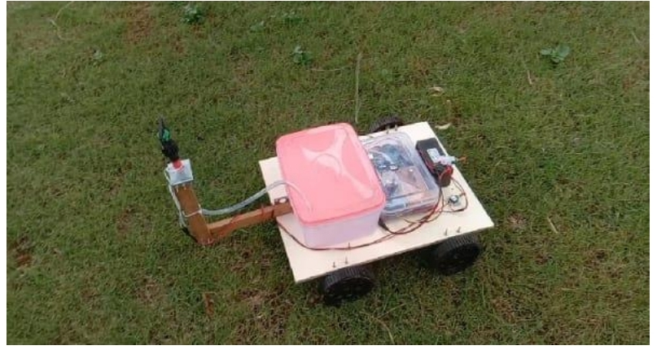Table 1: Project Result

Figure 13. Schematic view of Automatic Sprinkle

**VI. CONCLUSION**

In conclusion, the implementation of an automatic irrigation system using Arduino Uno proves to be a simple yet highly effective method to ensure optimal plant hydration. By employing a moisture sensor to monitor soil moisture levels, this system intelligently activates the water pump only when necessary, minimizing water wastage and promoting sustainable irrigation practices. The ease of building and adapting the system makes it suitable for a wide range of applications, from small-scale gardens to expansive farms and greenhouses. Its efficiency in delivering water precisely to plants when needed not only conserves water but also reduces the overall cost of irrigation, benefiting farmers and gardeners alike. The automatic irrigation system using Arduino Uno emerges as a valuable tool in agriculture, yielding a multitude of advantages. Incorporating automatic irrigation systems into agriculture presents an innovative approach that fosters sustainable practices and resource efficient farming. By enhancing crop yields, conserving water, improving soil health, and optimizing labour, the automatic irrigation system using Arduino Uno stands as a crucial tool in the quest for sustainable and productive agricultural practices. As farmers and gardeners embrace this technology, they not only ensure the well-being of their crops but also play an essential role in safeguarding the planet's precious water resources and promoting a more resilient and thriving agricultural ecosystem. Therefore, the adoption of automatic irrigation systems represents a significant step towards a greener and more food-secure future.

**ACKNOWLEDGEMENTS**

The authors are highly thankful to Dr.B.Kailashkumar, Associate professor and Head, Department of Agriculture Engineering, Paavai Engineering College, Namakkal for providing the basic facilities and for valuable help and support during the study.

**Disclaimer (Artificial intelligence)**

Option 1:

Author(s) hereby declare that NO generative AI technologies such as Large Language Models (ChatGPT, COPILOT, etc.) and text-to-image generators have been used during the writing or editing of this manuscript.

Option 2:

Author(s) hereby declare that generative AI technologies such as Large Language Models, etc. have been used during the writing or editing of manuscripts. This explanation will include the name, version, model, and source of the generative AI technology and as well as all input prompts provided to the generative AI technology

Details of the AI usage are given below:

1.

2.

3.

**VII. REFERENCES**

1. S.Mathivanan, Vishnudas.C, SidhinKrishna.M.S, Suraj.R, et al.,2023 “Plant Irrigation water Sprinkler Robot”, International Journal of Engineering & technology, ETEST 2023: Volume 11, Issue 03, ISSN:2278-0181
2. Pavan kumar.C.S, Nainika .A, Chandrashekar.C,et al.,2021 “Review paper on(Robotics in smart farming)”, Advance in Electronic and Electric Engineering, 2021, ISSN 2320-2882: IJCRT 2021, volume
3. Ahmed hassan, Rao, Ateeq rehmeen, Moh Kaabar, Zuhaib Nishtar, et al.,2021“Design and development of an irrigation mobile robot”, IJRA:June 2021, ISSN: 2722-2586, Volume: 10. No 2.
4. Vikethozotsira, gypsy nandi, et al., 2014“Bluetooth technology: Security and its prevention”, IJCCTA:2014, ISSN: 2229-6093, Volume: (5)
5. M.Gayathri, Arun.D, A.Ishwariya,et al.,2021 “Smart Irrigation system using IoT”, IJIRMPS 2021: volume 9, Issue 3, ISSN:2349-7300.
6. Anitha, A., Sampath, N., & Jerlin, M. A.et al., (2020, February). Smart irrigation system using Internet of Things. In 2020 International Conference on Emerging Trends in Information Technology and Engineering (icETITE) (pp. 1-7). IEEE.
7. S.M. Wange, sanket, Akshay Pendurkar, pranav, et el., 2018, “Automatic sprinkler system”, IRJET (International Research Journal), vol-5. No 6.
8. Sampa Das,Puja Bose, Sanjugh Guha Thakurata, “Smart Irrigation System Using IOT”, February, 2023.
9. Supachai Puengsungwan, “IoT based Soil Moisture Sensor for Smart Farming”, International Conference on Power, Energy and Innovations, pp. 221- 224, 2020.
10. Abhishek Kumar, Magesh.S, “Automated irrigation system based on soil moisture using arduino”, International Journal of Pure and Applied Mathematics, Volume 116 No. 21, pp. 319-323, 2017.
11. Devika CM, Kartika Bose, Vijayalakshmi S,” Automatic plant irrigation system using Arduino.” IEEE international conference on circuit and system (ICCS2017).
12. Ipin prasoja, Andino maseleno, Omar tonne,” Design of Automatic watering system based on aurdino.” Journal of robotics and control (JRC)
13. https://www.elprocus.com/ATmega328 microcontroller architecture-and-applications.
14. S. K. Abdullah and R. F. Chisab, “Programing and Implementation of Wireless Monitoring Automatic Control System for Irrigation Greenhouse using ATMEGA328P-PU-AVR Microcontroller,” J. Univ. Kerbala, vol. 15, no. 4, pp. 302–311, 2017.
15. Sahana D Gowda, Dr Minavati. “Smart irrigation system and pest detection using IoT.”IJCMC.Vol 7.Issue5,may2018.
16. Ashish Upadhyay, Prem Kumar, and Ravikant Yadav, “Automatic Irrigation Systems with SCADA: A Future Prospective”, LAP LAMBERT Academic Publishing, October, 2015.
17. Parameswaran, G., &K.Sivaprasath. (2016). Arduino Based Smart Drip Irrigation System Using Internet of Things. International Journal of Engineering Science and Computing, 6(5), 5518–5521. https://doi.org/10.4010/2016.1348.