**Identification of compounds present in the ethyl acetate fraction of young unopened leaves of *Piliostigma thonningii* by Liquid Chromatography – Mass Spectrometry**

**Abstract**

*Piliostigma thonningii* (Schumach Mile-Redh) is a species of the Fabaceae family. In Côte d'Ivoire, the young, unopened leaves of this species are used to treat certain pathologies. The aim of this study was to determine the compounds present in the ethyl acetate fraction of young, unopened leaves of *Piliostigma thonningii*. Successive fractionation of the hydroethanol extract resulted in the ethyl acetate fraction. LC-MS analysis identified seven (7) compounds in this fraction. These analyses revealed that young, unopened leaves of *Piliostigma thonningii* are rich in unidentified chemical compounds.

**Key words:** *Piliostigma thonningii*, Fabaceae, LC-MS, Pathology

1. **INTRODUCTION**

Plants are of great importance to mankind as a source of complex organic molecules with biological activities **(Hurtel, 2006)**. The flora of Côte d’Ivoire abounds in several plant species with real pharmacological properties, which have been little studied or not at all. Among these is *Piliostigma thonningii*, a leguminous plant belonging to the Fabaceae family and comprising some 133 species. *Piliostigma thonningii* is known in traditional medicine for its many biological properties. Its fresh mature leaves are effective in treating diarrhea, dysentery, coughs, diabetes and wounds **(Dro *et al.,* 2013)**. The roots are used to treat dysentery, fever, infections, snakebites, skin diseases and haemorrhoids **(Ajali, 2004; Jimoh and Oladiji, 2005; Paulin *et al.,* 2006)**. In addition, they possess purgative, antifungal, anti-inflammatory and antibacterial **(Ouattara *et al.,* 2020)**, antituberculosis and antimicrobial **(Sospeter *et al.,* 2015)**, antimalarial, analgesic and antioxidant properties **(ben *et al.,* 2020; Madara *et al.,* 2010; Sylla and Dongui, 2022).** Traditional medicine practitioners in Côte d’Ivoire to treat certain ailments traditionally use the young, unopened leaves of *Piliostigma thonningii*. This study aims to identify the phytocompounds present in these young unopened leaves using the LC-MS method.

**2. MATERIALS AND METHODS**

**2.1. Plant material**

Young, unopened leaves of *Piliostigma thonningii* were collected before sunrise in May 2018 in Bouaké (6047'18.762“North and 5015’25.9992” West) in central Côte d'Ivoire and identified by Mr. Amani N’Guessan, botanist at the Institut National Polytechnique Félix HOUPHOUËT-BOIGNY (INP-HB) in Yamoussoukro.

**2.2 Technical hardware**

MassHunter is a software package for analyzing spectrometric data (HPLC-ESI-MS) provided by Agilent's Quadripole Time of Flight (Q-TOF) instrument, Q-TOF 6200, TOF/6500 series Q-TOF B.08.00 (B8058.0).

**3. METHODS**

**3.1. Sample preparation**

Leaves were shade-dried at ambient laboratory temperature (26-30°C) for 14 days, then ground. The resulting powders were sieved through a 0.4 µm mesh sieve and stored in colored jars at 4°C, protected from light and humidity, until further use.

**3.2. Plant material extraction and fractionation procedure**

Plant material was extracted in an ethanol/water mixture (70/30) according to the method described by**(Kassi *et al.,* 2014)**. After extraction, a 25 g mass of the hydroethanol extract was dissolved in 250 mL of water at 60°C and fractionated successively with 2 x 250 mL of hexane, dichloromethane and ethyl acetate. The resulting aqueous phase was evaporated to remove water and oven-dried at 50°C for 4 h. The various organic phases obtained were dried separately over anhydrous sodium sulfate. After filtration and removal of the solvents under reduced pressure, the hexane, dichloromethane and ethyl acetate fractions were obtained. The ethyl acetate fraction was used for HPLC-ESI-Q-TOF-MS analysis.

**4. LC-MS ANALYSIS**

To carry out the HPLC-ESI-Q-TOF-MS analysis of the fractions, we used an Agilent LC-MS system combined with an Agilent 1260 Infinity HPLC system coupled to a mass spectrometer (Agilent 6530 Q-TOF-MS) equipped with an ESI source. Analyses were performed in positive mode. A Sunfire® C18 Waters analytical column 150 mm long, 2.1 mm in diameter and 3.5 μm in diameter was used, with a flow rate of 250 μL/min and a two-way linear gradient: Lane A (95-0% H2O + 0.1% formic acid), Lane B (5-100% ACN) for 40 minutes. A linear gradient was used in the following proportions: 0-5% B (0-5 min), 5-95% B (5-15 min), 95-100% B (15-25 min), 100% B (25-30 min), 100-0% B (30-32 min) and 0% B (32-41 min). Sample injection volume was set at 5 µL. Data analysis was performed using Agilient MassHunter Workstation software.

**5. RESULTS AND DISCUSSION**

**5.1. Derivative analysis of the ethyl acetate fraction**

Derivative analysis of the ethyl acetate fraction enabled the detection of peaks associated with both previously identified and unidentified molecules. To achieve this result, automated processing of the raw HPLC-ESI-MS data was carried out using Mass Hunter software. This presents a list of data that is graphically translated into peaks, each representing a compound contained in the ethyl acetate fraction. **Fig.1** shows the overall chromatographic profile of all ions detected in positive mode.

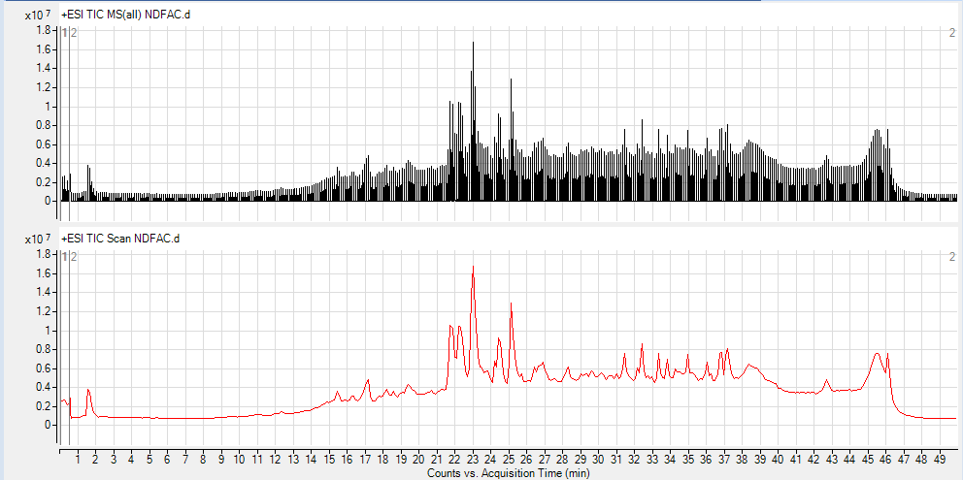

**Fig. 1. Total chromatographic profile by electrospray ionization mass spectrometry of the ethyl acetate fraction of young, unopened leaves of *Piliostigma thonningii***

**5.2. HPLC-ESI-Q-TOF-MS analysis of the ethyl acetate fraction**

HPLC-ESI-Q-TOF-MS analysis of the ethyl acetate fraction detected a number of compounds. These include phenolic acids, alkaloids, sterols, terpenes and flavonoids. Peaks 3,4,17 and 18, justifying the typical fragment pattern observed, show the coexistence of phenolic compounds. Peaks 6, 8, 9 and 10, identify flavonoids. Peaks 17 and 18 respectively highlighted sterols, terpenes, and alkaloids, justifying the fragmentation mode. Intense peak 8, with a retention time of 23 min, is consistent with a compound whose fragments do not correspond to the fragmentation mode of the compounds identified. The structure of the compounds identified in the ethyl acetate fraction is shown in **Fig. 2**.

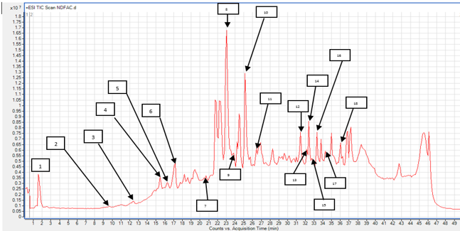

**Fig. 2. MS chromatographic profile of the ethyl acetate fraction of young unopened leaves of *Piliostigma thonningii***

**5.3. UV analysis**

The chromatographic profiles of HPLC-ESI-Q-TOF analysis of the ethyl acetate fraction of young, unopened leaves of *Piliostigma thonningii* are shown in **Figs. 3 and 4**. Intense chromatographic profiles indicate that the fraction contains several different groups of secondary metabolites, some of which are present in significant quantities. UV visualization at wavelengths λmax 254 and 280 nm gives strong peaks in the retention time intervals 12- 27 min **(Figs. 3 and 4)**. Observation of these compounds at these wavelengths assumes that they possess at least two conjugated double bonds (C=C-C=C or C=C-C=O) in their carbon chain **(Qu *et al.,* 2007)**.

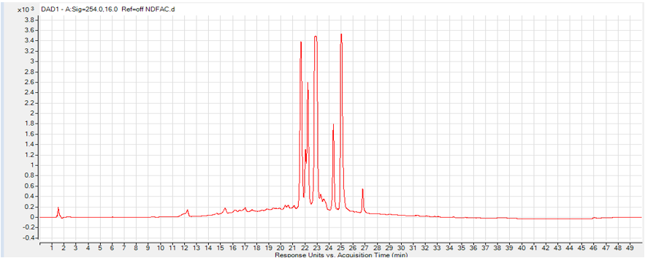

**Fig. 3. UV chromatographic profile at 254 nm of the ethyl acetate fraction of young, unopened *Piliostigma thonningii* leaves.**

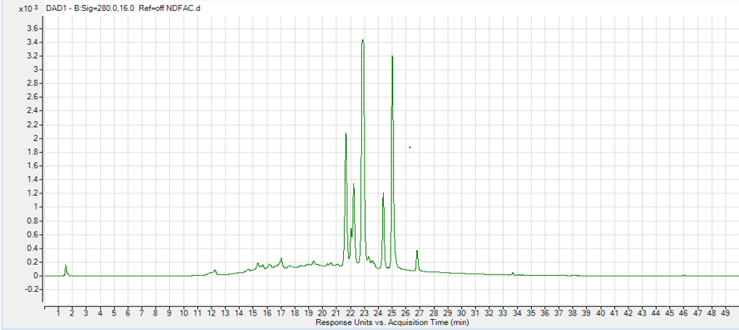

**Fig. 4. UV chromatographic profile at 280 nm of the ethyl acetate fraction of young, unopened *Piliostigma thonningii* leaves.**

**5.4. LC-MS analysis of the ethyl acetate fraction**

HPLC-ESI-Q-TOF-MS analysis of the ethyl acetate fraction revealed the coexistence of several phytocompounds shown on the chromatogram in **Fig.1**. The structural characteristics of these compounds are presented in **Table 1**. The presence of these phytocompounds is indicated by several peaks (1,2,3,4,5,6,7,8,9,10,11,12, 13,14,15,16,17 and 18). Peak 3 highlights the presence of methyl n-octadecanoate. It is characterized by the quasi-molecular ion m/z = 299 [M+H]+ suggesting a molar mass of 298 amu and a most probable empirical formula C19H38O2. Analysis of the fragmentation spectrum of peak 3 shows the presence of characteristic fragments at m/z = 241 [M+H-57], m/z = 171 [M+H-127], m/z = 142 [M+H-156], m/z = 184 [M+H-114], m/z = 200 [M+H-98], m/z= 109 [M+H-189] (base peak) **(Fig. 5)**. This compound has been identified in the leaves of *Piliostigma thonningii* in Nigeria **(Igwe and Nwamezie, 2016)**. The fragmentation pattern of methyl n-octadecanoate is shown in **Fig. 6**.

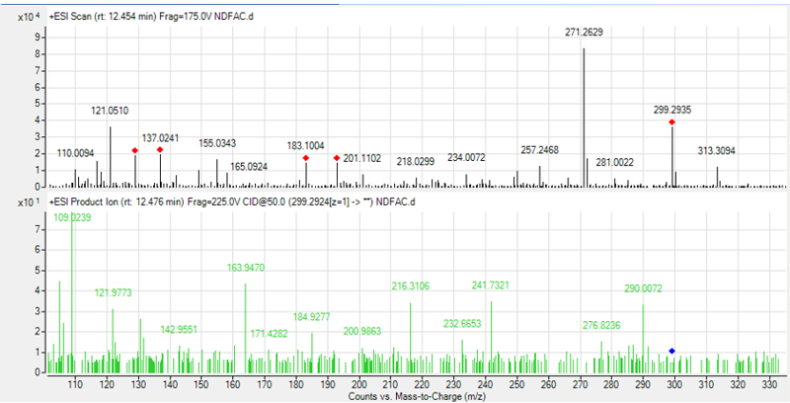

**Fig. 5. MS and MS/MS mass spectra of peak 3**



**Fig. 6. Fragmentation diagram for methyl n-octadecanoate**

At peak 4, we identified proanthocyanidin B2. This compound is characterized by the quasi-molecular ion m/z = 579 [M+H]+ suggesting a molar mass of 578 amu and a most probable molecular formula of C30H26O12. Analysis of the fragmentation spectrum of peak 4 shows the presence of characteristic fragments at m/z = 163 [M+H- 415], m/z = 171 [M+H-127], m/z = 229 [M+H-151-183-19], m/z = 193 [M+H-151-127-109] and m/z= 127 [M+H-453] (base peak) **(Fig. 7)**. This compound has been isolated from the leaves of *Piliostigma thonningii* **(Bombardelli *et al.,* 1992)**. The fragmentation pattern of proanthocyanidin B2 is shown in **Fig. 8.**

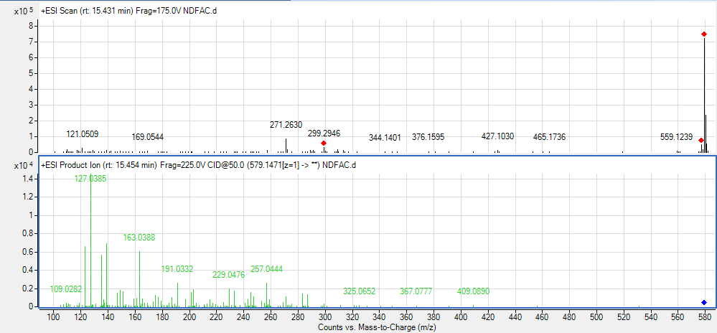

**Fig. 7. MS and MS/MS mass spectra of peak 4**



**Fig. 8. Fragmentation diagram for proanthocyanidinB2**

The compound in peak 6 is *(-)*-epicatechin, which has a quasi-molecular ion m/z = 291[M+H]+ suggesting a molar mass of 290 amu and a most probable gross formula C15H14O6. Analysis of the fragmentation spectrum of peak 6 shows the presence of characteristic fragments at m/z = 139 [M+H-151], m/z = 179 [M+H-111], m/z = 123 [M+H-167] (base peak) **(Fig. 9)**. This compound was isolated from the stem bark of *Piliostigma thonningii* **(Ezennaka *et al.,* 2022)**. The fragmentation pattern of *(-)*-epicatechin is shown in **Fig. 10**.

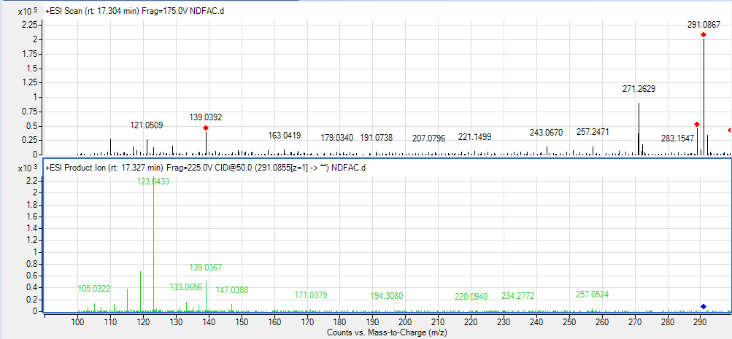

**Fig. 9. MS and MS/MS mass spectra of peak 6**



**Figure 10. Fragmentation diagram for *(-)*-epicatechin**

Peak 10 mentions the presence of quercetin and its chromatographic profile SM shows a quasi-molecular ion m/z = 303 [M+H]+ suggesting a molar mass of 302 amu and a most probable gross formula C15H10O7. Analysis of the fragmentation spectrum of peak 10 shows the presence of characteristic fragments at m/z = 285 [M+H-17], m/z = 125 [M+H-179], m/z = 109 [M+H-193], m/z = 247 [M+H-56], m/z = 201 [M+H-71-17], m/z = 229 [M+H-41-17], m/z = 153 [M+H-149] (base peak) **Fig. 11**. This compound was isolated from mature leaves of *Piliostigma thonningii* and flowers of Vernonia galamensis **(Keïta *et al.,* 2016)**. The quercetin fragmentation scheme is shown in **Fig. 12**.

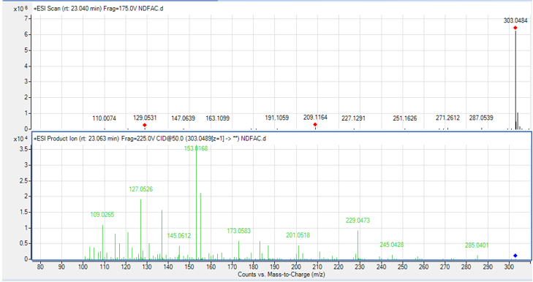

**Fig. 11. MS and MS/MS mass spectra of peak 10**



**Fig. 12. Fragmentation diagram for quercetin**

Peak 17 highlights the presence of the following compounds kaur-16-en-19-oic acid and trans-communic acid. The SM chromatographic profile shows a quasi-molecular ion of m/z = 303 [M+H]+ suggesting a molar mass of 302 amu and a most probable molecular formula of C20H30O2. Analysis of the fragmentation spectrum of peak 17 shows the presence of characteristic fragments at m/z = 183 [M+H-119], m/z = 215 [M+H-85], m/z = 229 [M+H-73], m/z = 119 [M+H-183], m/z = 201 [M+H-101], m/z = 105 [M+H-183-15] (base peak) for the kaur-16-en-19-oic acid isomer and m/z = 181 [M+H-121], m/z = 215 [M+H-85], m/z = 229 [M+H-71], m/z = 119 [M+H-183], m/z = 105 [M+H-165-18-15] (base peak) for the trans-communic acid isomer **(Fig. 13)**. This isomer (kaur-16-en-19-oic acid) was isolated from *Piliostigma thonningii* pods and Polyalthia sclerophylla leaves **(Saepou *et al.,* 2010)** and trans-communic acid was isolated by Noguera et al in 2014 **(Noguera *et al.,* 2014)**. This compound is a mixture of two isomers, their fragmentation pattern shown in **Figs. 14 and 15**.

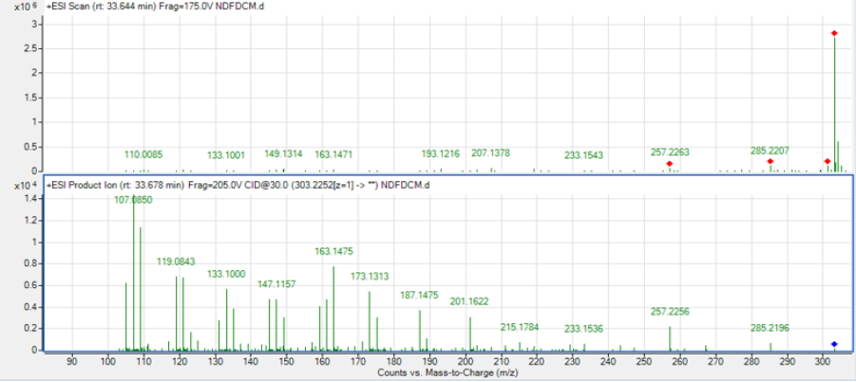

**Fig. 13. MS and MS/MS mass spectra of peak 17**



**Fig. 14. Fragmentation diagram for kaur-16-en-19-oic acid**



**Fig. 15. Fragmentation diagram for trans-communic acid**

Peak 18 highlights the presence of the oleic acid amide compound. The SM chromatographic profile shows a quasi-molecular ion m/z = 282 [M+H]+ suggesting a molar mass of 281 amu and a most probable empirical formula C18H35NO. Analysis of the fragmentation spectrum of peak 18 shows the presence of characteristic fragments at m/z = 142 [M+H-139], m/z = 215 [M+H-85], m/z = 181 [M+H-100], m/z = 110 [M+H-85-86], m/z = 125 [M+H-156] (base peak) **(Fig. 16)**. This compound has been identified from *Piliostigma thonningii* flowers in Nigeria **(Igwe and Nwamezie, 2016)**. The fragmentation pattern of the oleic acid amide is shown in **Fig. 17**.

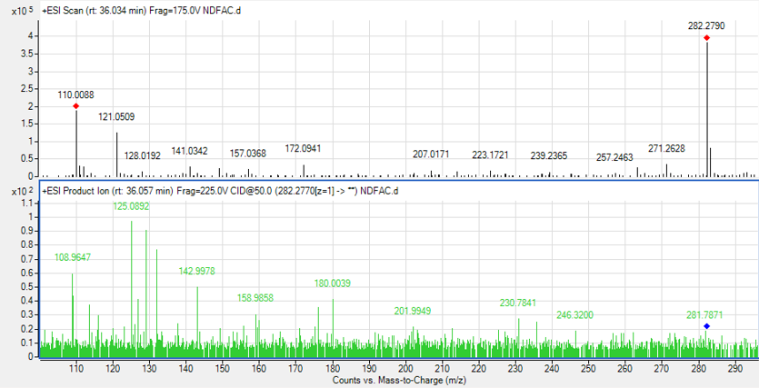

**Fig. 16. MS and MS/MS mass spectra of peak 18**



**Fig. 17. Fragmentation diagram for Oleic acid amide**

**Table 1. Identification of phytochemical composition by LC-MS/MS of the ethyl acetate fraction of young unopened leaves of *Piliostigma thonningii*.**

|  |  |  |  |  |  |  |  |
| --- | --- | --- | --- | --- | --- | --- | --- |
| **Pic** | **Retention time (mn)** | **Gross formula** | **Molar mass (g/mol)** | **Ion MS(m/z)**  **[M+H]+** | **Diff**  **(ppm)** | **Score** | **Molécule name** |
| 1 | 1,57 | C14H16O2 | 216 | 217 | - | - | - |
| 2 | 9,41 | C13H26O2 | 214 | 215 | - | - | - |
| 3 | 12,15 | *C19H38O2 | 298 | 299 | 3,41 | 93,78 | Methyl n-octadecanoate |
| 4 | 15,08 | ⃰ C30H26O12 | 578 | 579 | -1,76 | 45,86 | Proanthocyanidin B2 |
| 5 | 16,37 | C12H18O | 178 | 179 | - | - | - |
| 6 | 17,19 | *C15H14O6 | 290 | 291 | -1,56 | 98,94 | *(-)*-epicatechin |
| 7 | 20,46 | C6H12O6 | 180 | 181 | - | - | - |
| 8 | 23,04 | *C15H10O7 | 302 | 303 | 4,61 | 92,91 | Quercetin |
| 9 | 23,86 | *C15H10O7 | 302 | 303 | -1,55 | 99,02 | Quercetin |
| 10 | 25,15 | *C15H10O7 | 302 | 303 | 0,32 | 99,19 | Quercetin |
| 11 | 26,43 | C10H12O | 148 | 149 | - | - | - |
| 12 | 31,47 | C17H32O4 | 300 | 301 | - | - | - |
| 13 | 32,40 | C10H12O | 148 | 149 | - | - | - |
| 14 | 32,40 | C11H16 | 148 | 149 | - | - | - |
| 15 | 32,76 | C10H12O | 148 | 149 | - | - | - |
| 16 | 33,34 | C14H30 | 198 | 199 | - | - | - |
| 17 | 34,28 | *C20H30O2 | 302 | 303 | 1,95 | 84,56 | Trans-communic acid |
| kaur-16-en-19-oic acid |
| 18 | 36,03 | ⃰ C18H35NO | 281 | 282 | 1,06 | 97,33 | Oleic acid amide |

**\*: compounds identified in the young leaves of *Piliostigma thonningii***

**6. CONCLUSION**

At the end of our study, we can say that young unopened leaves of *Piliostigma thonningii* contain numerous phytocompounds. Using LC-MS analysis, we were able to identify eighteen (18) compounds in the ethyl acetate fraction. Very few of these phytocompounds remain unidentified. Consequently, these phytocompounds could be at the origin of the plant’s therapeutic properties. This highlights the use of young, unopened leaves of *Piliostigma thonningii* to treat certain diseases. This fraction could also be exploited to isolate unidentified molecules.

**CONFLICT OF INTEREST**

The authors declare that there is no conflict of interest between them or any other party in relation to this article.

**DISCLAIMER (ARTIFICIAL INTELLIGENCE)**

The authors of work (article) declare that they did not use Artificial Intelligence and text-image generator the writing of this manuscript.

**AUTHOR’S CONTRIBUTIONS**

We declare that the authors cited in this article carried out this work and any liability for claims relating to the content of this article will be borne by the authors. Thomas Konan KOUAMÉ harvested the leaves of the plant used, extracted and fractionated the plant material and performed the various methods. Amon Diane Marina N’TAMON performed analysis of the ethyl acetate fraction. The work was supervised and the article written by Sorho SIAKA and Yaya SORO.

**REFERENCE**

Ajali, U., 2004. Chemistry of biocompounds, 1ère édition, Rhyce Kerex, Nigeria.

ben, olela, James, M., Timothy, W., Gervason, M., 2020. Acute Oral Toxicity and Anti-inflammatory and Analgesic Effects of Aqueous and Methanolic Stem Bark Extracts of *Piliostigma thonningii* (Schumach.) (Toxicité orale aiguë et effets anti-inflammatoires et analgésiques des extraits aqueux et méthanoliques de l'écorce de la tige de *Piliostigma thonningii*). Evidence-Based Complementary and Alternative Medicine 2020, 10. <https://doi.org/10.1155/2020/5651390>

Bombardelli, E., Lolla, A., Pace, R., Willmann, R., Piretti, M.V., 1992. Proanthocyanidins from *Piliostigma thonningii*: Chemical and pharmacologital properties. Planta Med 58, 590. https://doi.org/DOI: 10.1055 / s-2006-961579

Dro, B., Soro, D., Koné, M.W., Bkayoko, A., Kamanzi, K., 2013. Assessment of the abundance of medicinal plants used in traditional medicine in northern Côte d’Ivoire. Journal of Animal &Plant Sciences, 17, 2631-2646.

Ezennaka, C.N., Srivedavyasasri, R., Sofidiya, M.O., Asekun, O.T., Ross, S.A., 2022. Chemical constituents from methanolic stem bark extracts of *Piliostigma thonningii* belonging to fabaceae. J. Chem. Soc. Nigeria 47, 115-128.

Hurtel, J., 2006. Essential oils and medicine. Phytotherapy, medical plants, aromatherapy, essential oils. Phytomania.

Igwe, O.U., Nwamezie, F., 2016. Études comparatives des composés phytochimiques des extraits de feuilles et de fleurs de *Piliostigma thonningii* et de leur efficacité antibactérienne. International Journal of Biological Sciences and Technology 8, 11-15.

Jimoh, F., Oladiji, A., 2005. Preliminary studies on *Piliostigma thonningii* seeds : proximate analysis, mineral composition and phytochemical screening. African Journal of Biotechnology 4, 1439-1442.

Kassi, A.B., Soro, Y., Fante, B., Golly, K.J., Sorho, S., Toure, A.S., Coustard, J.-M., 2014. Isolation et identification des composés bioactifs du tourteau de graines de mangue (*Mangifera indica Lam*). International Journal of Biological and Chemical Sciences 8, 1885-1895. https://doi.org/10.4314 / ijbcs.v8i4.48

Keïta, J.N., Koné, D., Tounkara, H., Doucouré, A., Garcia, J., 2016. Isolation et identification de trois flavonoïdes mono-glycosylés issus de fleurs de *Vernonia galamensis* Ssp. galamensis Var. galamensis M. Gilbert. (Isolement et identification de trois flavonols monoglycosylés des fleurs de Vernonia galamensis Ssp. galamensis Var. galamensis M. Gilbert). Revue maghrébine des sciences pures et appliquées 2, 39-46.

Madara, A., Ajayi, J., Salawu, O., Tijani, A., 2010. Anti-malarial activity of ethanolic leaf extract of *Piliostigma thonningii* Schum.(Caesalpiniacea) in mice infected with Plasmodium berghei berghei. African Journal of Biotechnology 9, 3475-3480. https://doi.org/10.4314 / njpar.v31i2.69476

Noguera, J.R., Sánchez, I.M., Carbó, M.T.D., Cortina, L.O., Miras, M.M.L., Galiano, F.B., 2014. Caractérisation analytique de la biodétérioration des vernis labdaniques diterpénoïdes utilisés dans les techniques picturales : Sandarac et Manila copal. International Biodeterioration & Biodegradation 90, 99-105. http://dx.doi.org/10.1016/j.ibiod.2014.01.017

Ouattara, E.K., Coulibaly, K., Etien, T.D., Zirihi, N.G., 2020. Etude ethnobotanique de plantes antifongiques utilisées traditionnellement en Côte d'Ivoire et du potentiel de *Piliostigma Thonningii* (schumach.) milneredh.(Fabaceae) dans le contrôle de souches telluriques. International Journal of Biological and Chemical Sciences 14, 239-253.

Paulin, O., Anne, M.L., Joseph, B., Sita, G., 2006. La flore médicinale de la Forêt Classée de Niangoloko (Burkina Faso). Etudes flor. vég. Burkina Faso 10, 5-16.

Qu, J., Wang, Y.-H., Li, J.-B., Yu, S.-S., Li, Y., Liu, Y.-B., 2007. Rapid structural determination of new trace cassaine-type diterpenoid amides in fractions from Erythrophleum fordii by liquid chromatography-diode-array detection/electrospray ionization tandem mass spectrometry and liquid chromatography/nuclear magnetic resonance. Rapid Communications in Mass Spectrometry : An International Journal Devoted to the Rapid Dissemination of Up-to-the-Minute Research in Mass Spectrometry 21, 2109-2119.

Saepou, S., Pohmakotr, M., Reutrakul, V., Yoosook, C., 2010. Anti-HIV-1 Diterpenoids from Leaves and Twigs of *Polyalthia sclerophylla*. Planta Med 76, 721-725.

Sospeter, N.N., Meshack, A.O., Silas, M.N., Samwel, N.O., John, M.N., Paul, K.K., 2015. Antituberculeux, antimicrobien, cytotoxicité et étude de l'activité phytochimique des fractions extraites de *Piliostigma thonningii*. J. Med. Plants Res. 9, 655-663. https://doi.org/10.5897/JMPR2015.5822

Sylla, tahiri, Dongui, B.K., 2022. Antioxidant And Anti-Inflammatory Effects Of Ethanolic And Aqueous Root Extracts of *Piliostigma Thonningii* (Schumach.) Milne-Redhead. European Scientific Journal, ESJ 18, 101–112. https://doi.org/10.19044/esj.2022.v18n3p101