**Original Research Article**

**Heavy Metals Contamination in Selected Rice Brands Sold in Port Harcourt, Nigeria**

**Abstract**

**Introduction**: Potentially harmful substances contaminating agricultural soil and crops pose a risk to human health and food safety. One of the main elements causing pollution in agriculture is heavy metals. Heavy metals can be found in cereal grains including rice, which absorb and store toxic metals including Lead (Pb), Cadmium (Cd), and Arsenic (As).

**Objective**: the objective of the study was to determine the concentration of heavy metals in selected rice brands sold in Port Harcourt, Nigeria.

**Methods**: A total of ten samples of five local rice designated as Lo1, Lo2, Lo3, Lo4, and Lo5 and five foreign rice designated as Fo1, Fo2, Fo3, F04, and F05 were used for the study. Heavy metals were determined using Perkin Elmer atomic absorption spectrophotometer in Flame atomic absorption mode.

**Results**: The concentration of heavy metals (µg/kg) in selected local rice, showed that arsenic in Lo2 (4.20) was significantly higher than other rice brand while Lo3 (7 x 10-5)had the lowest value. The rice with the highest Pb concentration was Lo2(89.73). The concentration of Cr was significantly lower in Lo4 (1.3 x 10-4) in comparison to other groups. Finally, for Cd, Lo2 (7 x 10-5) had the lowest value, which was significant. While for foreign rice, arsenic concentration was significantly lower for Fo4 (0.88 µg/kg) in comparison to other groups. For Pb levels (µg/kg), Fo3 (61.30) and Fo4 (61.30) had higher concentrations. Fo2 (23.76) and Fo3 (25.76) were significantly lower than Fo1 (33.96) and Fo5 (47.63) for Cr levels. And for Cd, Fo1 (1.0 x 10-4) was lower than Fo2 (2.50), Fo5(2.70), Fo3(6.10), and Fo4(5.63). Overall, the concentration of Arsenic was lowest in Lo3 (7 x10-5) and highest in Lo2 (4.20), Lead was lowest in Fo1 (6.7 x 10-5) and highest in Lo2 (89.73), Chromium had the least value in Lo4 (1.3 x10-4) and the highest value in Fo5 (47.63) while cadmium was least in Fo2 (1 x 10-4) and highest in Fo3(6.10), all of which were significantly different (p<0.05).

**Conclusion**: the concentration of heavy metals in the samples was in no particular preference of either foreign or local rice. Although the concentration of the heavy metals was below the standard permissible limits, caution needs to be taken to avoid future possible bioaccumulation.

Keywords: heavy metals, bioaccumulation, food safety, plant irrigation

**Introduction**

In recent years, contamination of agricultural soil and water has grown to be a serious environmental issue in many developed and developing nations1. Potentially harmful substances contaminating agricultural soil and crops pose a risk to human health and food safety2. One of the main elements causing pollution in agriculture is heavy metals3. The easiest way for humans to be exposed to metals is through soil contamination. Consumption of fruits, vegetables, and crops grown in contaminated soil can lead to the build-up of these heavy metals in human tissues and pose a serious risk to health. The roots or shoots of crops can carry heavy metals from the soil4. Crops that have heavy metal contamination, are likely to result from contaminated soil. According to Fu et al.5, crops growing in or near contaminated areas have the ability to absorb and accumulate heavy metals, which may pose a threat to human health and animals [30].

Plants can absorb heavy metals from the atmosphere, pesticides, fertilizers and sewage deposits from urban and industrial areas into the soil and water used for plant irrigation6. Cereal grains absorb and store toxic metals including Lead (Pb), Cadmium (Cd), and Arsenic (As). Exposure to cadmium can have harmful health effects on the kidney, bones and even fractures. Prolonged exposure to lead can cause cognitive decline, slower reaction times, and impaired understanding. Children may experience learning and concentration difficulties, as well as behavioural disturbances7. Even at low concentrations, prolonged exposure to arsenic raises the risk of bladder, kidney, urinary tract, skin, and pulmonary cancers. Chronic poisoning, generalized muscle weakness, appetite loss, nausea, vomiting, diarrhoea, inflammation of the eye mucous membranes, skin lesions, anemia, and a decrease in white blood cells and malignant tumours are among the side effects of arsenic8.

Rice (Oryza sativa) is one of the most widely grown cereal crops in the world9 and the most vital staple food for roughly half of the human population 10, making it one of the most produced agricultural crop after maize and sugarcane11,12. Rice is the most important food crop for human nutrition and calorie consumption, accounting for more than one-fifth of all the calories consumed globally12. It is becoming an increasingly important crop in Nigeria10. Growing rice is one of the most profitable farming strategies in Nigeria, as it is one of Nigeria's largest and most extensively consumed grains, as well as primary crop. The country’s annual rice consumption is anticipated to be around 7 million metric tonnes13. Rice can be contaminated with pollutants such as heavy metals. In the recent years, the health risks posed by heavy metals had been reported in rice from several countries13.

For instance, in Asia, rice has been recognized as some of the chief sources of Cd and Pb for human existence14. There is clear evidence linking human renal tubular dysfunction with contamination of rice with Cd in subsistence farms in Asia15. In Japan, the main source of cadmium contamination in humans was specifically identified as rice, however, efforts are being made to reduce pollution of food crops on contaminated soil to plant safe cultivars, which are varieties that are less efficient heavy metals accumulators 15. As a result, it is necessary to assess the rice sold in Port Harcourt for any significant evidence of heavy metals present in them.

**Materials and Methods**

**Sample Collection**

Ten different brands of rice grain samples were purchased from Rumuokoro market, Port Harcourt, Nigeria. They were five local rice designated as Lo1, Lo2, Lo3, Lo4, and Lo5 and five foreign rice designated as Fo1, Fo2, Fo3, F04, and F05. The samples were ground and kept in an airtight container for use in heavy metals determination.

**Experimental Procedure**

The samples underwent three washes with tap water, followed by two washes with distilled water. The samples were air dried for 12 hours overnight, and then oven dried at 65 °C for 2 hours. The samples were ground into a uniform size, using a blender and placed in a sealed plastic bags after sieving through a 428 μm sieve. The samples were digested in accordance with the method of Zeng et al16. Ground rice samples (3g) were placed in labelled flask designated as L01, L02, L03, L04, L05 and F01, F02, F03, F04, F05 and the blank. An anti-bumping grain was added to the flasks. To each flask was added 20ml of 65% nitric acid and then 10ml perchloric acid. These were then gently shaken to mix. This was allowed to stand in the fume hood at room temperature for 24 hours. After this, it was then vigorously agitated to ensure thorough mixing and heated for 3 hours at 100oC, which was later allowed to cool and 30ml of deionized water was added to the samples to dilute them. This was using whatman filter paper (No 1). The filtrate was used for the determination of the heavy metals.

**Heavy metals determination**

Determination of Cadmium (Cd), Arsenic (As), Chromium (Cr), and Lead (Pb) was done using Perkin Elmer atomic absorption spectrophotometer in Flame atomic absorption mode. Acetylene was used as fuel while compressed air was used as oxidant. Hollow cathode lamps of the elements were used while the slit width was set at 0.7 nm. Calibration standards series was prepared for each element by serial dilution of certified calibration standards for atomic absorption spectrophotometry. The instrument was optimized for lamp alignment, fuel-oxidant ratio, wavelength, and flame height. The wavelengths used for analysis along with their respective sensitivity and detection limits are shown below (Table 1).

Table 1 Wavelengths used for analysis along with their respective sensitivity and detection limits

|  |  |  |  |
| --- | --- | --- | --- |
| Heavy  Metals | Wavelength  nm | Sensitivity  mg L-1 | Detection  Limits  mg L-1 |
| Cd | 228.8 | 0.028 | 0.0005 |
| Pb | 217 | 0.19 | 0.01 |
| Cr | 357.9 | 0.078 | 0.002 |
| As | 324.8 | 0.077 | 0.001 |

**Statistical analysis**

Values are denoted as mean ± standard deviation. ANOVA (homogeneity of variances) was used to determine if the data are significantly different within the groups at p < 0.05 of the SPSS package (version 21).

**Results**

|  |  |  |  |  |
| --- | --- | --- | --- | --- |
| Table 2. Heavy metals concentration(µg/kg) in selected local rice sold in Port Harcourt, Nigeria | | | | |
| Rice Samples | As | Pb | Cr | Cd |
| Lo1 | 3.0 x 10-3 ±1.7 x 10-3a | 17.90±3.04 a | 1.36±0.37 a | 2.65±0.852 a |
| Lo2 | 4.20±0.90 b | 89.73±8.08 b | 1.83±0.11 a | 7 x 10-5± 1.1 x 10-4 b |
| Lo3 | 7.0 x 10-5 ± 5.8 x 10-5 a | 24.13±6.90 a | 2.23±0.11 a | 2.96±1.41 a |
| Lo4 | 0.566±0.40 a | 63.00±1.00 d | 1.3 x 10-4±5.8 x 10-5 d | 1.3 x 10-4± 5.8 x 10-5 b |
| Lo5 | 1.40±0.43 a | 63.03±2.60 d | 2.93±0.41 a | 2.73±1.01 a |
|  |  |  |  |  |
| Codex17 | 0.2mg/~~kg~~ polished rice and 0.35mg/kg husked rice | 0.2mg/kg for cereal grains | - | 0.4mg/kg |

Values are expressed as Mean ± STD. Within the columns, values with different alphabetical letter are statistically different at p<0.05

The concentration of heavy metals in selected local rice, showed that Arsenic level in Lo2 (4.20) was significantly higher than other rice brand while Lo3 had the lowest value. The rice with the highest Pb concentration was Lo2(89.73). The concentration of Cr was significantly lower in Lo4 (1.3 x 10-4) in comparison to other groups. Finally, for Cd, Lo2 (7 x 10-5) and Lo4 (1.3 x 10-4) were significantly lower than Lo1 (2.65), Lo5 (2.73), and Lo3(2.96).

|  |  |  |  |  |
| --- | --- | --- | --- | --- |
| Table 3 . Heavy metals concentration(µg/kg) in selected foreign rice sold in Port Harcourt, Nigeria | | | | |
| Rice Samples | As | Pb | Cr | Cd |
| Fo1 | 3.13±1.47a | 6.7 x 10-5± a | 33.96±0.76 a | 1.0 x 10-4 ±1.0 x 10-4a |
| Fo2 | 1.53±0.25 a | 25.63±0.60 b | 23.76±3.83 b | 2.50±0.30 b |
| Fo3 | 1.66±0.208 a | 73.1±5.00 c | 25.76±5.05 b | 6.10±0.45 c |
| Fo4 | 0.88±0.25 b | 61.30±3.55 c | 28.30±0.91 ab | 5.63±0.45 c |
| Fo5 | 2.53±0.77 a | 1.3 x 10-3 ±1.5 x 10-3 a | 47.63±1.05 c | 2.70±0.26 b |
|  |  |  |  |  |
| Codex17 | 0.2mg/kg polished rice and 0.35mg/kg husked rice | 0.2mg/kg for cereal grains | - | 0.4mg/kg |

Values are expressed as Mean ± STD. Within the columns, values with different alphabetical letter are statistically different at p<0.05

Arsenic concentration was significantly lower for Fo4 (0.88 µg/kg) in comparison with other groups. For Pb levels (µg/kg), Fo3 (61.30) and Fo4 (61.30) had higher concentrations. Fo2 (23.76) and Fo3 (25.76) were significantly lower than Fo1 (33.96) and Fo5 (47.63) for Cr levels. And for Cd, Fo1 (1.0 x 10-4) was lower than Fo2 (2.50), Fo5(2.70), Fo3(6.10), and Fo4(5.63).

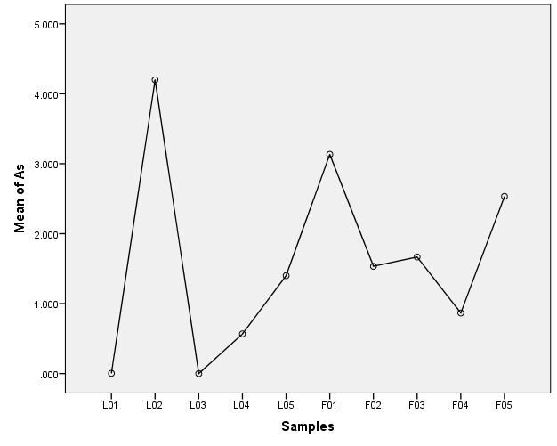

Figure 1. Concentration of Arsenic (µg/kg) in Local and foreign rice sold in Port Harcourt, Nigeria

The concentration of arsenic present in selected rice brand sold in Port Harcourt, Nigeria (Figure 1) showed that Lo2 (4.20) was the highest, followed by Fo1(3.13), while Lo1 (3.0 x 10-3) and Lo3 (7.0 x 10-5), had the least values which were all significantly different. Fo5 was not significantly different from Lo2 and Fo1. There was also no significant difference between Lo1, Lo3, Lo4, Lo5, Fo2, Fo3, and Fo4.

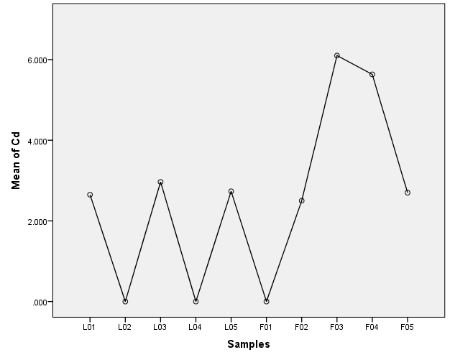

Figure 2. Concentration of Cadmium (µg/kg) in Local and foreign rice sold in Port Harcourt, Nigeria

Cadmium concentration of selected rice brand sold in Port Harcourt, Nigeria (figure 2) showed high concentration of Fo3 and Fo4 while Lo2, Lo4 and Fo1 had the least values which was significant. Lo1, Lo3, Lo5, Fo2 and Fo5 showed no significant difference between them.

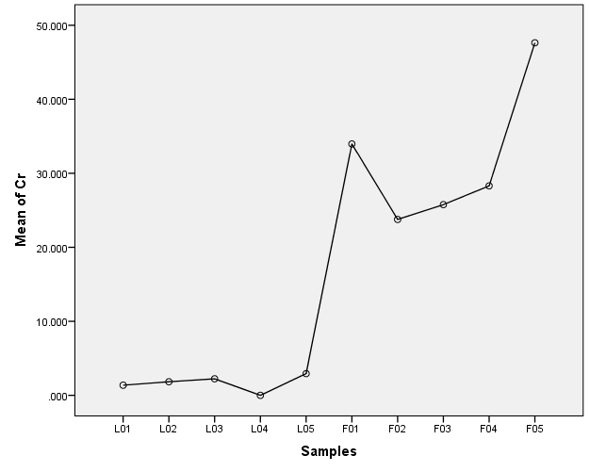

Figure 3. Concentration of Chromium (µg/kg) in Local and foreign rice sold in Port Harcourt, Nigeria

The concentration of chromium (figure 3) was significantly lower in the local rice samples in comparison to the foreign rice samples. Fo2 and Fo3 was significantly different from the rest. Fo5 was also significantly higher than other groups.

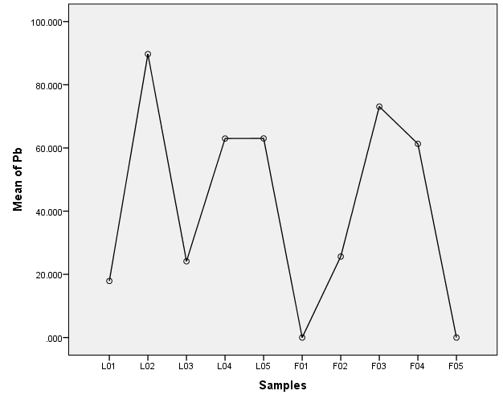

Figure 4. Concentration of Lead (µg/kg) in Local and foreign rice sold in Port Harcourt, Nigeria

The concentration of Lead (Figure 4) was significantly lower in Fo1 and Fo5 and highest in Lo2, which was significant. Lo1, Lo3 and Fo2 showed no significant difference between them. Lo4, Lo5, Fo3 and Fo4 were significantly different from other groups.

**Discussion**

One of the major health risks to people and the environment is the presence of toxic heavy metals in cereal grains like rice. Their high half-life, bioaccumulation ability in the human body, and non-biodegradability makes them of great importance and concern8. The concentration of heavy metals in selected local rice sold in Port Harcourt, Nigeria (Table 2) showed that the Lo2(4.20±0.90 µg/kg)had significantly higher Arsenic concentration when compared to other locally produced rice. For Lead concentration, it was in the order Lo2 > Lo5> Lo4> Lo3> Lo1. While for Chromium concentration, the local rice with the statistically lowest value was Lo4 when compared to others. Lo2 and Lo4, were also statistically lower when compared to other groups for Cd concentration. The concentration (µg/kg) of heavy metals were in the ranges; Arsenic (0.00007-4.20), Pb (17.90-89.73), Cr (0.00013-2.93), and Cd (0.00007-2.96). In comparison to this study, the value of Pb and Cr was within the range obtained by Ovonramwen et al.12 who had 0.02-0.043 mg/kg and 0.003-0.367 mg/kg for Pb and Cr respectively. The values obtained in this research was less than those obtained by Oyawaluja et al18 for As (0.080-0.207 µg/g) and Cd (0.255-0.650 µg/g) concentrations, although their Pb (0.054-0.139 µg/g) value was within the range of this study.

Table 2 displays the concentration of heavy metals present in selected foreign rice sold in Port Harcourt, Nigeria. Fo4 was statistically different from other foreign rice for the concentration of Arsenic. Fo1 (6.7x 10-5 µg/kg) had the least Pb concentration. For Cr levels Fo5 (47.63 µg/kg) had the highest value which was significant when compared to other foreign rice. While for Cd levels, Fo1(0.0001) had the least value which was significant at p<0.05. The ranges of heavy metals concentration in the foreign rice were, Arsenic (0.88-3.13), Pb (0.000067-73.10), Cr (23.76-47.63), and Cd (0.0001-6.10). The values obtained by Cao et al.7, were within Pb (0.054 mg/kg) range but higher Cd (0.014 mg/kg) and Cr (0.75 mg/kg) concentrations when compared to this study. Rezaei et al. 8 also had similar Pb (0.057 mg/kg) value but higher Asernic (0.045 mg/kg) and Cd (0.022 mg/kg) concentrations.

The concentration of Arsenic (Figure 1) in selected local and foreign rice sold in Port Harcourt, Nigeria had Lo3 having the lowest value and Lo2 as the highest. The range was 0.00007-4.20 µg/kg. The concentration of Cd in selected local and foreign rice sold in Port Harcourt, Nigeria (Figure 2), had Lo2 having the lowest value and Fo3 as the highest. The range was 0.00007-6.10 µg/kg. The range for chromium concentration present in selected local and foreign rice sold in Port Harcourt, Nigeria (Figure 3) was 0.00013-47.63 µg/kg. For lead concentration Fo1 had the least value while Lo2 had the highest value. The range of Lead concentration for selected local and foreign rice sold in Port Harcourt, Nigeria (Figure 4) was 0.00067-89.73 µg/kg. The values obtained in this study was within the range for Pb and Cd but lower for As when compared to those gotten by Nwachoko et al.19 (Pb 0.002-0.1455; Cd <0.0011-0.065; and As (0.6284-4.86 mg/kg) respectively. Similarly, Akan et al.9 had higher Pb (1.06-3.24), As (1.32-4.65), Cr (0.59-3.65), and Cd (0.065-1.54 mg/kg) values in comparison to this present study. Hasan et al.,4 also had higher values of Cd (0.98-1.61 mg/kg) and Cr (11.54-23.67 mg/kg) and Rahimi et al1, had higher Pb (12.32 mg/kg) and Cd (1.27 mg/kg) values when compared to this present study. Shahriar et al.20, also had higher Pb (6.87), Cr (0.43) and Cd (1.13 mg/kg) concentrations in comparison to this study.

Cadmium is a hazardous heavy metal present in very low concentrations in the environment. Air and water are known to be the primary sources of Cd exposure 21. The concentration of Cd gotten from this study was lower than that obtained by Jaydan et al22 (11.3 mg/kg), Adamu et al23(2.10 - 4.30 mg/kg), and Isabelle et al24 (2.02 mg/kg).

Higher levels of arsenic in food can harm the skin and pulmonary nervous system, as well as causing peripheral neuropathy, nasal septal perforation, and respiratory tract cancer. Severe risks from lower-level exposure can include heart rhythm abnormalities, nausea, and vomiting. Prolonged low-level exposure may result in skin darkening and the development of tiny warts on the palms, and soles25. The arsenic concentration in this investigation was lower than that found by Gwamna et al.26, who had a range of 0.0597-0.383 mg/kg.

Chromium damages the lungs and causes ulcers, a rupture or discontinuity in a body membrane, and nasal septal perforation, which mostly happens along the anterior cartilaginous septum25. The concentration of Chromium found in this investigation were less than Giao27 who had 0057-5.67mg/kg. It was also lower than the USDA28 standard of 1.0mg/kg.

Lead damages the kidney, hematopoietic, and nervous systems as well as causes anaemia 29. The concentration of lead as determined by Otitoju et al.10 (0.001-0.812 mg/kg), Budaraga and Salihat6 (0.0196-0.025 mg/kg), and Wang et al.29 (0.017-0.03 mg/kg) was within the range of what this study had. Additionally, it was lower than the FAO/WHO17 limit of 0.3mg/kg.

**Conclusion**

This study evaluated the concentration of heavy metals in local and foreign rice sold in Port Harcourt, Nigeria and observed that all the metals (As, Cr, Cd, and Pb) analysed were within the WHO/FAO permissible limits, making it safe for consumption. The study draws conclusion to a serious public health concern about toxic heavy metal contamination specifically in Port Harcourt, Nigeria in prolonged conditions. These metals’ non-biodegradable and bio-accumulative characteristics make their presence in cereals grains extremely dangerous to human health, with the potential to cause chronic illnesses and detrimental effects on the environment. To reduce the risk of heavy metal contamination in rice, it is advised that local farming methods be evaluated and enhanced. Reducing exposure can be achieved by enforcing stronger laws and regulations regarding soil and water quality used in farming as well as teaching farmers about safe agricultural methods. Campaigns for consumer awareness should also be started to educate the public about the possible health risks linked to contaminated rice. To gain a deeper understanding of the patterns in heavy metal concentrations over time, longer period of studies is required. It can also help with the formulation of soil remediation and public relations strategies.

Disclaimer (Artificial intelligence)

Option 1:

Author(s) hereby declare that NO generative AI technologies such as Large Language Models (ChatGPT, COPILOT, etc.) and text-to-image generators have been used during the writing or editing of this manuscript.

Option 2:

Author(s) hereby declare that generative AI technologies such as Large Language Models, etc. have been used during the writing or editing of manuscripts. This explanation will include the name, version, model, and source of the generative AI technology and as well as all input prompts provided to the generative AI technology

Details of the AI usage are given below:

1.

2.

3.

**References**

1. Rahimi G., Kolahchi Z., & Charkhabi A.(2017). Uptake And Translocation Of Some Heavy Metals By Rice Crop (Oryza Sativa) In Paddy Soils, Agriculture (Poľnohospodárstvo), 63 (4): 163−175. Doi: 10.1515/Agri-2017-001
2. Feka, D. P., Anhwange, B. A. and Adie P. A. (2022). Toxic Metals Contamination of Paddy (Oryza Sativa) and Imported Rice Sold in Kaduna and Its Human Health Risk Assessment. *Research Square*, DOI: https://doi.org/10.21203/rs.3.rs-1953036/v1
3. Kumar, V., Singh, J. and Kumar, P. (2019). Heavy metals accumulation in crop plants: Sources, response mechanisms, stress tolerance and their effects. In: Kumar, V., Kumar, R., Singh, J. and Kumar, P. (eds) Contaminants in Agriculture and Environment: Health Risks and Remediation, Agro Environ Media, 1: 38-57, <https://doi.org/10.26832/AESA-2019-CAE-0161-04>
4. Hasan G. M. M. A., Das, A. K. & Satter M. A. (2022). Accumulation of Heavy Metals in Rice (Oryza sativa. L) Grains Cultivated in Three Major Industrial Areas of Bangladesh. Journal of Environmental and Public Health ,1-8. <https://doi.org/10.1155/2022/1836597>
5. Fu J., zhou Q., Liu J., Liu W., Wang T., Zhang Q. & Jiang G. (2008). High levels of heavy metals in rice (Oryza sativa L.) from a typical E-waste recycling ara in Southeast China and its potential risk to human health. *Chemosphere* , 71:1269-1275. doi:10.1016/j.chemosphere.2007.11.065
6. Budaraga K. & Salihat R. A. (2021). Analysis of metals (Pb, Mn, Cd, Zn, Cu) in Purple Rice and Purple Rice Stems Cultivated Organically using Biogas Slug in Padang Pariaman, West Sumatra Province. IOP Conf. Series: Earth and Environmental Science 709 (012071):1-9. doi:10.1088/1755-1315/709/1/012071
7. Cao, H., Chen, J. , Zhang J., , Zhang, H. , Qiao L., & Men, Y. (2010). Heavy metals in rice and garden vegetables and their potential health risks to inhabitants in the vicinity of an industrial zone in Jiangsu, China. Journal of Environmental Sciences, 22(11)1792–1799. [www.sciencedirect.com](http://www.sciencedirect.com)
8. Rezaei, L. Alipour, V., Sharafi P., Ghaffari, H., Nematollahi, A., Pesarakloo V., Fakhri Y. (2021). Concentration of cadmium, arsenic, and lead in rice (Oryza sativa) and probabilistic health risk assessment: A case study in Hormozgan province, Iran. Environmental Health Engineering and Management Journal 2021, 8(2), 67-75
9. Akan J. C., Zakari Mohammed, Ayuba M. Jatau, Haruna B. Wayar and Mohammed A. Shettima (2021). Levels and Health Risk Assessment of Heavy Metal Contamination in Soil and Different Varieties of Rice from Jere Agricultural Locations, Borno State, Northeastern Nigeria . Journal of Chemistry Letters, 2(2021): 96-113. [www.jchemlett.com](http://www.jchemlett.com)
10. Otitoju G. T. O., O Otitoju2, CP Ezenwa1, BB Emmanuel Omale3, RO Abdussalaam3 and JE Ali(2019). Heavy Metal Levels in Locally Produced Rice in the South West Region of Nigeria. Acta Scientific Nutritional Health 3.2 (2019): 120-124
11. **Zakaria, Z., Zulkafflee, N.S., Mohd Redzuan, N.A., Selamat, J., Ismail, M.R., Praveena, S.M., Tóth, G.& Abdull Razis, A.F. (2021). Understanding Potential Heavy Metal Contamination, Absorption, Translocation and Accumulation in Rice and Human Health Risks. *Plants*, *10*, 1070. https://doi.org/ 10.3390/plants10061070**
12. Ovonramwen, O. B., Awulor, C. F., Ukpebor, J. E., Ukpebor, E. E. (2023). Assessment of Some Toxic Heavy Metals in Rice and Beans Sold in Benin City, Nigeria. Dutse Journal of Pure and Applied Sciences (DUJOPAS), 9(4):204-210. https://dx.doi.org/10.4314/dujopas.v9i4a.19
13. Zhao Y., Li D., Xiao D., Xiang Z., Yang X., Xiao Y., Xiao X., Cheng J., Lu Q & Zhang Q. (2023). Co-exposure of heavy metals in rice and corn reveals a probabilistic health risk in Guizhou province, China. *Food Chemistry*, 20:101043. Doi:10.1016/j.fochx.20
14. Pateriya A., Kumar V. R., Sankhla M. S., & Kumar R. (2021). Heavy Metal Toxicity in Rice and its Effects on Human Health. *Letters in Applied NanoBioscience*, 10(1): 1833 – 1845. <https://doi.org/10.33263/LIANBS101.18331845>
15. Machiwa J. F. (2010). Heavy Metal Levels In Paddy Soils And Rice (Oryza Sativa (L)) From Wetlands Of Lake Victoria Basin, Tanzania. Tanz. J. Sci. 36:59-72
16. **Zeng, F., Wei W., Li, M., Huang, R., Yang, F. and Duan, Y. (2015). Heavy Metal Contamination in Rice-Producing Soils of Hunan Province, China and Potential Health Risks. I*nternational. Journal of Environmental Research & Public Health* 2015, *12*, 15584–15593; doi:10.3390/ijerph121215005**
17. Codex Alimentarius Commission (2022). GENERAL STANDARD FOR CONTAMINANTS AND TOXINS IN FOOD AND FEED. CXC193-1995 .www.codexalimentarius.org
18. Oyawaluja B. O. , Aderonke A. Adepoju-Bello, & Doyinsola G. Sosanya (2019). Analysis Of Some Selected Toxic Metals And Pesticide Residues In Ofada Rice (Oryza Sativa L.) Samples Produced In South Western Region Of Nigeria. Journal of Industrial Research and Technology,8(1):27-44
19. Nwachoko N, Tetam JG, Orakpo E & Egbunefu C.O. (2022). Proximate Composition, Minerals and Heavy Metals Concentration of Some Foreign and Locally Produced Rice in Nigeria. International Journal of Biochemistry & Physiology, 7(1):1-5. DOI:10.23880/ijbp-16000201
20. Shahriar, S. M. S.,. Munshi1, M., Hossain, M. S., Zakir, H. M. and Salam S. M. A. (2023). RISK ASSESSMENT OF SELECTED HEAVY METALS CONTAMINATION IN RICE GRAINS IN THE RAJSHAHI CITY OF BANGLADESH. Journal of Engineering Science 14(1), 2023, 29 -41 DOI: <https://doi.org/10.3329/jes.v14i1.67633>
21. Mohanty S, Nayak RK, Jena B, Padhan K, Mohapatra KK, Sahoo SK, Dash PK, Das J, Behera SK, Sahu A, Nayak JK, Padhan S and Datta D (2023), Heavy metal contamination in rice, pulses, and vegetables from CKDu-endemic areas in Cuttack district, India: a health risk assessment. Front. Environ. Sci. 11:1248373. doi: 10.3389/fenvs.2023.1248373
22. Javdan, G. ID, Hamid Reza Ghaffari1, Masoomeh Nahidi1, Nahid Zeraei1, Somayeh Hoseinvandtabar3, Mehrdad Ahmadi1, Fateme Pourramezani1, Zoha Heidarinejad (2021). Health Risk Assessment of Heavy Metals (Arsenic and Cadmium) in Rice (Oryza sativa L.) Brands Imported to Iran: Using Monte-Carlo Simulation. Hormozgan Medical Journal. 25(3):104-110. 10.34172/hmj.2021.12`
23. Adamu, U. H. U., Alonge, S.O. & Adelanwa, E.B. (2022). Assessment of Heavy Metals Bioaccumulation in Rice ( *Oryza Sativa* L.) Seeds Grown Along Zaria-Kankara Road, Northwestern Nigeria. *Bayero Journal of Pure and Applied Sciences*, 13(1): 503 – 507. <http://dx.doi.org/10.4314/bajopas.v13i1.76S>
24. Isabelle, A. G. B., K.W., Dongo, P.K., Nya, E. and Togouet, S.H.Z. (2024) Accumulation of Heavy Metals in Maga-Pouss Rice Fields (Far-North Region, Cameroon) and Transfer to Rice Grains. Agricultural Sciences , 15, 311-326. <https://doi.org/10.4236/as.2024.153018>
25. Monira S. and Mostafa, M. G. (2023). Heavy Metals in Agricultural Soil and Their Impacts on Rice Production and Human Health: A Review. Asian Journal of Applied Science and Technology, 7(2):204-216. DOI: <https://doi.org/10.38177/ajast.2023.7222>
26. Gwamna, Y., kabiru, M.Y., Abdullahi, S. M.,1Zakaria, C.D., 2Yerima, J.,3Bello, B. K.(2024). Comparative assessment of heavy metals in on farm paddy and parboiled rice in Gashua, Yobe state. African Journal of Biological Science, 6:217-231. 10.48047/AFJBS.6.12.2024.216-231

1. Giao N. T. (2020). Potential Health Risk Assessment for the Occurrence of Heavy Metals in Rice field Influenced by Landfill Activity in Can Tho City, Vietnam. International Journal of Environment, Agriculture and Biotechnology, 5(4) 928-935. https://dx.doi.org/10.22161/ijeab.54.12
2. USDA (2018). China releases the standard for maximum levels of contaminants in foods. Global Agricultural information network. USDA foreign Agricultural Services
3. WANG X., SONG X., CAO, D., ZHANG D., Li Z., & ZHANG C. (2023). Distribution and health risk evaluation of heavy metal lead in the main production area of rice in Heilongjiang Province. Food Science and Technology, 43, e000623, <https://doi.org/10.1590/fst.000623>
4. Tegegne, B.; Chandravanshi, B.S.; Zewge, F. (2017). Levels of selected metals in commercially available rice in Ethiopia, International Food Research Journal, 2017, 24, 711-719.