**Mitigating Effect of Aqueous Extract of *Andrographis paniculata* Against Sodium Arsenite Induced Hepatotoxicity and Clastogenicty In Rats**

**ABSTRACT**

Arsenic toxicity has been linked to liver cancer and medicinal plants are possible sources of antidote to arsenicosis. *Andrographis paniculata* (AP), generally known as king of bitters has various pharmacological as well as medicinal properties. In the present study, the protective effect of AP leaves on sodium arsenite (SA) induced hepatotoxicity and clastogenicity in albino wistar rats was evaluated. Forty male albino rats were randomly divided into eight groups. Group 1 received distilled water only, group 2 was given 5 mg/kg body weight of sodium arsenite orally on 7th 14th, 21st and 28th day of the experiment while group 3, group 4 and group 5 were administered daily with 200mg/kg bwt, 500mg/kg bwt and 1000mg/kg bwt of aqueous extract of AP respectively simultaneously with 5 mg/kg bwt of SA once a week. Groups 6, 7 and 8 were treated with only extracts at 200 mg/kg bwt, 500 mg/kg bwt and 1000 mg/kg bwt respectively daily. Finding from the study indicated that SA significantly increased the number of micronucleated polychromatic erythrocyte cells (mPCEs) formation by 2.5 folds relative to control. The number of mPCEs scored was significantly reduced by pretreatment with all doses of AP. Also, there was a significant (p <0.05) increase in serum γ-GT, ALT, AST and ALP enzymes activities in SA treated group relative to the control group. However, rats treated with AP and SA had significantly decreased values of γ-GT, ALT, AST and ALP relative to SA alone treated group. Histological analysis showed that AP at 200 and 500 mg/kg is non- toxic and elicited hepatoprotective effect. Therefore, revealed the aqueous extracts of AP leaves ameliorated SA induced hepatotoxicity and clastogenicity in wistar male rats.

Keywords*: Andrographis paniculata*, hepatoprotective, micronuclei, sodium arsenite

**INTRODUCTION**

Liver diseases have become a worldwide problem with increasing exposure to environmental hepatotoxicants such as aflatoxin and heavy metals like arsenic, cadmium and lead. Human and animals in certain regions of the world are unavoidably exposed to inorganic arsenic through ground water which is the primary source of drinking water (1,2). Sodium arsenite is the most toxic among the arsenics and has been reported to have genotoxic, hepatotoxic, tumorigenic and carcinogenic effects (3,4,5). Toxicity of sodium arsenite has been linked with the generation of reactive oxygen species (6). Antioxidants used in food industries prevent deterioration, nutritional losses and off-flavoring in various foods especially those containing polyunsaturated fatty acids. Of recent, there have been considerable increase in the search for naturally occurring antioxidants for use in foods because of their potential in health promotion and disease prevention, their high margin safety and consumer acceptability (7,8). Several epidemiological studies have indicated an inverse relationship between plant-based diet and the risk of development of chronic pathological processes associated with oxidative stress including cancer and cardiovascular diseases.

*Andrographis paniculata* (AP), also known as “king of bitters” belong to the family Acanthaceae. It has a surprisingly broad range of pharmacological effect including anti-inflammatory (9,10), anti-dirrhoeal (11), anti-microbial (12), anti-malarial (13), Cardiovascular protective (14), anti- cancer (15) and immunostimulatory activities (16). Mostly the leaves and roots have been traditionally used for different medicinal purposes in Asia and Europe as a folklore (Avani and Rao, 2008; Das et al., 2021; Bahadur et al., 2024).

Research findings have shown andrographolide, a major bioactive compound of *Andrographis paniculata* to inhibit the expression of inducible nitric oxide synthase (17). Also, aqueous extracts of AP has been shown to protect aginst chemical induced toxicities in mammalian models (18,19). Also, activity of AP against carbon tetrachloride, galactosamine and paracetamol intoxication in animal models has been reported (20). The effects of AP extracts on SA toxicities have not been reported. The study was therefore designed to assess the effects of AP on sodium arsenite induced clastogenic and hepatotoxicity in rats.

**MATERIALS AND METHODS**

**Chemicals**

Sodium arsenite (NaAsO2; BDH chemicals Ltd poole England), aspartate aminotransferase (AST), alanine aminotransferase (ALT), and gamma glutamyltransferase (γGT) kits were obtained from Randox Laboratories, Crumlin, UK. All other chemicals and reagents were of analytical grade products of Sigma- Aldrich Chemical Co. St. Louis, MO., USA or BDH Chemical Ltd, Poole, England

**Experimental Animals**

Forty male albino Wistar rats (150g-180g) were obtained from Central Animal House, University College Hospital, Ibadan, Nigeria and kept in the experimental animal facility of the Department of Biochemistry, University of Ibadan. They were acclimatised under a 12/12h light/dark cycle for two weeks, fed standard pellets diets with clean tap water *ad libitum.*

**Preparation of Plant Materials:**

The fresh AP leaves were collected from Abadina, University of Ibadan, Ibadan and authenticated at the Department of Botany, University of Ibadan, (voucher No FIH 108967). The leaves were washed with clean water and air-dried. 100 g of the powdered dry leaves were soak in 500 ml of distilled water for 24 hours. The filtrates were pooled and concentrated using rotary evaporator at 40OC to obtain the crude extract. The extract so obtained was then lyophilized using facilities at the International Institute of Tropical Agriculture (IITA), Ibadan.

**Phytochemical Screening**

The extract obtained above was subjected to the phytochemical screening using standard methods for flavonoids, alkaloids, tannins, anthraquinones, saponins and phenols according to the method of Kokate (21).

**Test for Alkaloids**

A small portion of the extract is stirred with few drops of 1% hydrochloric acid and filtered. The filtrate is treated with Wagner′s reagent. Reddish brown precipitate indicates the presence of alkaloids.

**Test for Saponins**

One ml of extract is diluted with 20ml of distilled water and shaken vigorously for 15 min. Formation of stable foam indicates the presence of saponin.

**Test for Tannins**

One ml of extract is treated with ferric chloride. Formation of blue green color indicates the presence of tannins.

**Test for Phenols**

A small portion of the extract is diluted with 5% ferric chloride solution. Development of intense color indicates the presence of phenol.

**Test for Steroids**

One ml of extract is treated with 50% sulphuric acid and a few drops of acetic anhydride are added. The development of reddish-brown ring indicates the presence of steroids.

**Test for Flavonoids**

One ml of the extract is treated with few drops of 5% ferric chloride. The appearance of blackish green color indicates the presence of flavonoids.

**Test for triterpenes and steroids**

0.5g of plant sample was dissolved in chloroform (3ml) and a few drops of acetic anhydride and concentrated H 2 SO 4 were added. A purple coloration indicated the presence of triterpenes while bluish-green coloration indicated the presence of steroids. The formation of two layers upon addition of H2SO4 is characteristic of the presence of both triterpenes and steroids.  
**Test for cardiac glycosides**

One milligram of plant sample was suspended in 5ml of glacial acetic acid containing one drop of ferric chloride solution. Then 1ml of concentrated sulphuric acid was added gradually along the wall of the test tube. The formation of a brown ring at the interface indicated the presence of a deoxysugar, characteristics of cardenolides.

**Experimental protocol**

Forty male rats were randomly divided into eight groups of five rats each. The extract was calculated (mg/kg body weight of rat) and dissolved in water and administered orally using a metal cannula attached to a 2ml syringe.

1: Group of rats given distilled water only

2: Group of rats given sodium arsenite at 5.0 mg/kg body wt.

3: Group of rats given sodium arsenite (5.0 mg/kg bwt) and AP extract at 200mg/kg bwt.

4: Group of rats given sodium arsenite (5.0 mg/kg bwt) and AP extract at 500mg/ kg bwt.

5: Group of rats given sodium arsenite (5.0 mg/kg bwt) and AP extract at 1000mg/kg bwt.

6: Group of rats given AP leaf extract at 200mg/kg bwt only.

7: Group of rats given AP leaf extract at 500mg/kg bwt only.

8: Group of rats given AP leaf extract at 1000mg/kg bwt only.

The sodium arsenite was administered orally on 7th, 14th, 21st and 28th day of the experiment before the animals were sacrificed though the AP extract was administered orally on a daily basis for 28 days. All rats were sacrificed by cervical dislocation 24 hrs after the last exposure to sodium arsenite. The femur and blood samples were collected from each rat. Bone marrow from femurs were used for micronucleus assay.

**Preparation of Serum and Tissue homogenate**

Blood was allowed to clot at room temperature. The clotted blood was then centrifuged at 3000rpm for 30 mins, serum were discanted and used for the estimation of biochemical parameters like gamma Glutamyltransferase (γ-GT), Alanine aminotransferase (ALT), Aspartate aminotransferase(AST) and Alkaline phosphatase (ALP) using commercial kits obtained from Randox. The livers were harvested and weighed. A small portion of the liver were fixed in 10% formalin for histopathlogical examination.

**Micronuclei Test**

Clastogenic effects of the extract and toxicant were evaluated in the rats bone marrow cells using the micronucleus assay as described by Heddle and Salmone, (22). Bone marrow from femurs were used for preparing the slides. The slides were air-dried and pretreated with May-Grunwald solution and later stained with 5% Giemsa solution. The slides were scored for the presence of micronucleated polychromatic erythrocytes (mPCEs) in 1000 cells according to standard procedure.

**Enzyme Assay**

Gamma glutamyltransferase (γ-GT) activity was assayed in the serum using the reconstituted γ-GT diagnostic reagent, following the method of Szasz (23). Serum alanine aminotransferase (ALT) and aspartate aminotransferase (AST) activities were assayed according to Reitman and Frankel (24) using commercial diagnostic kits. This involves the reaction of pyruvate, the product of transamination reaction catalysed by ALT or AST, with 2, 4-dinitrophenyl hydrazine to produce intensely coloured hydrazone read at 546 nm using spectronic-20 spectrophotometer. Alkaline phosphatase (ALP) assay was based on the method of Williamson (25). This is based on spectrophotometric (405 nm) determination of concentration of p-nitrophenol formed by the dephosphorylation of p-nitrophenyl phosphate (PNPP) catalysed by ALP.

**Histology**  
Liver samples were harvested from all the animals and fixed with 10% formaldehyde in phosphate-buffered saline for 24 h. Tissue pieces were washed with distilled water, dehydrated in alcohol, and embedded in paraffin. Approximately 5μm sections were mounted on glass slides and stained with haematoxylin–eosin dye and finally observed under a microscope.

**Statistical Analysis:**

The results are expressed as mean ± standard deviation. Data obtained was subjected to One-way analysis variances (ANOVA) using Statistcal Package for Social Science (SPSS) software Inc. Chicago, Standard version. The values p <0.05 were considered statistically significant using the least significant difference (LSD).

**Results**

**Table 1: Results of preliminary screening of aqueous *Andrographis paniculata* leaf extract**

|  |  |  |
| --- | --- | --- |
| **Phytoconstituents** | **Test/Reagent** | **Aqueous extract** |
| Alkaloids | Wagner Reagent | ++++ |
| Flavonoids | Acid-Alcohol test | +++ |
| Terpenoids | Sulphuric acid reagent | + |
| Tannis | Ferric chloride reagent | ++ |
| Saponins | Frothing test | + |
| Reducing Sugar | Fehling’s reagent | _ |
| Phenolics | Ferric chloride test | +++ |
| Steroids | Leibermann-Burchard Test | ++ |
| Anthraquinones | Borntrager’s test | ++ |
| Carotenoids | Acid test | + |

Key: +++ = abundance, ++ = Moderately present, + = present, - = absent

Phytochemical profile of AP indicated the presence of phenolics, flavonoids, saponins, anthraquinones, alkaloids as shown on Table 1.

**Table 2: Body and organ weight (g) of experimental animals before and after exposure to sodium arsenite and *Andrographis paniculata* (AP) extracts**

|  |  |  |  |
| --- | --- | --- | --- |
| **Treatments** | **% weight change** | **Relative liver wt (%)** | **Relative kidney wt (%)** |
| Distilled water only | 15.38 ± 1.15 | 3.09 ± 0.51 | 0.59±0.09 |
| SA only (5.0mg/kg bwt) | 7.69 ± 0.35 # | 2.75± 0.48# | 0.62±0.13 |
| SA+200mg/kg bwt extract | 23.43± 1.38* | 3.12± 0.41# | 0.62±0.06 |
| SA+500mg/kg bwt extract | 25.00± 0.69* | 2.97±0.41 | 0.65±0.08 |
| SA+1000mg/kg bwt extract | 27.98±1.47* | 3.03 ± 0.40 | 0.61±0.03 |
| 200mg/kg bwt extract only | 12.20±0.58 | 2.78±0.39 | 0.66±0.24 |
| 500mg/kg bwt extract only | 14.63±0.27 | 2.99 ± 0.58 | 0.67±0.13 |
| 1000mg/kg bwt extract only | 28.04±1.08* | 2.91±0.74 | 0.66±0.24 |

Values are mean ± SD of 5 rats

# = The mean difference is significant (p< 0.05) when compared with negative control

Within column values with *are significantly (p <0.05) different from positive control

|  |
| --- |
| There was no significant (p<0.05) difference in the relative kidney weight. However, administration of sodium arsenite caused a significant (p<0.05) reduction in the percentage weight change as compared with the negative control. There was no significant (p>0.05) change in the body weight in other groups when compared with the negative control (Table 2). Also, changes in the relative liver weights of rats of the extract only groups (200 mg/kg and 500 mg/kg) were not significant (p> 0.05) when compared with the negative control. Consequently, the effect of pre-treatment with AP showed an increased in liver weights similar to those of the control, indicative of AP exhibiting a potent protective effect on hepatocytes. |
|  |

**Table 3: Induction of micronucleated polychromatic erythrocytes (mPCEs) in bone marrow cells in the rats exposed/treated with sodium arsenite**

|  |  |
| --- | --- |
| Treatments | mPCE/1000PCE |
| Distilled water only | 2.44 ± 0.48* |
| SA only (5.0mg/kg bwt) | 6.09 ± 1.44# |
| SA + 200mg/kg bwt extract | 3.13 ± 0.62* |
| SA +500mg/kg bwt extract | 3.63 ± 0.68* |
| SA + 1000mg bwt extract | 3.40 ± 1.01* |
| 200mg/kg bwt extract only | 3.10 ± 0.34* |
| 500mg/kg bwt extract only | 3.08 ± 1.54* |
| 1000mg/kg bwt extract only | 3.10 ± 0.24* |

Values are mean ± SD of 5 rats

# = The mean difference is significant (p< 0.05) when compared with negative control

Within column values with *are significantly (p < 0.05) different from positive control.

The results clearly demonstrates that SA treated group significantly (*p* < 0.05) induced the formation of micronuclei in the polychromatic erythrocytes (mPCEs) of the rat bone marrow cells as shown on Table 3. The mean number of mPCEs scored in the groups of rats treated with sodium arsenite was significantly (*p* < 0.05) more when compared with the mPCEs scored in the bone marrow of the control group. On the other hand, there was a significant (*p* < 0.05) decrease in mPCEs induction in the bone marrow in SA and *AP-*treated rats compared with the group treated with sodium arsenite only.

**Table 4: Effect of *Andrographis paniculata* (AP) administration on serum level of hepatic transaminases (γ- GT, AST, ALT, ALP and ALT) in rats treated with sodium arsenite**

|  |  |  |  |  |
| --- | --- | --- | --- | --- |
| Treatments | ALP/ (U/L) | AST/ (U/L) | ALT/ (U/L) | ɣ-GT(U/L) |
| Distilled water only | 19.32 ± 7.30* | 13.30 ± 1.08* | 20.26 ± 2.27* | 8.49 ± 1.34* |
| SA only  (5.0mg/kg bwt) | 40.48 ± 0.45# | 26.00 ± 3.37# | 29.10 ± 3.32# | 22.00 ±11.05# |
| SA+200mg/kg  bwt extract | 12.88 ± 4.22* | 17.70 ± 4.80* | 24.80 ± 2.64* | 7.68 ± 3.75* |
| SA+500mg/kg  bwt extract | 16.56 ± 5.52* | 19.10 ± 5.13* | 23.84 ± 3.22* | 10.04 ± 1.77* |
| SA+1000mgbwt  Extract | 18.40 ± 3.19* | 18.20 ± 4.21* | 23.93 ± 3.74* | 12.75± 3.06* |
| 200mg/kg bwt  extract only | 8.29 ± 2.76* | 15.74 ± 3.19* | 21.56 ± 1.94* | 12.74 ± 2.01* |
| 500mg/kg bwt  extract only | 13.80 ±4.78* | 14.73 ± 0.87* | 22.92 ± 3.46* | 10.42 ± 4.63* |
| 1000mg/kg bwt  extract only | 13.64 ± 6.95* | 17.38 ± 1.65* | 25.05 ± 1.71* | 5.79 ± 4.01* |

Values are mean ± SD of 5 rats

SA = Sodium Arsenite,# = The mean difference is significant (p< 0.05) when compared with negative control

Within column values with *are significantly (p < 0.05) different from positive control treated with SA only

The administration of sodium arsenite only resulted in a significant (p < 0.05) increase of the level of γ -GT, ALT, AST and ALP in the serum of the rats when compared with the negative control. Pre-treatment with leaf extracts of *Andrographis paiculata* (200, 500 and 1000 mg/kg body weight*)* after exposure to sodium arsenite led to significant (p < 0.05) reduction in the mean liver and serum γGT, ALT, ALP and AST activities when compared with groups administered with sodium arsenite only.

|  |
| --- |
|  |
|  |

**Figure 1: The photomicrograph of liver sections of rats treated with AP and/ SA**.

(A) Negative control, no visible lesions (B) SA only (5mg/kg), severe portal central and venous congestion with moderate portal cellular infiltration by mononuclear cells. (C) SA + 200mg/kg bwt AP, mild portal central and venous congestion with moderate portal cellular infiltration by mononuclear cells. (D) SA + 500mg/kg bwt AP, moderate portal congestion. (E) SA + 1000mg/kg bwt AP, mild portal congestion and cellular infiltration by mononuclear cells. (F) 200mg/kg bwt AP only, no visible lesions. (G) 500mg/kg bwt AP only, no visible lesions seen.   
 (H) 1000mg/kg bwt AP only, mild portal cellular infiltration by mononuclear cells.

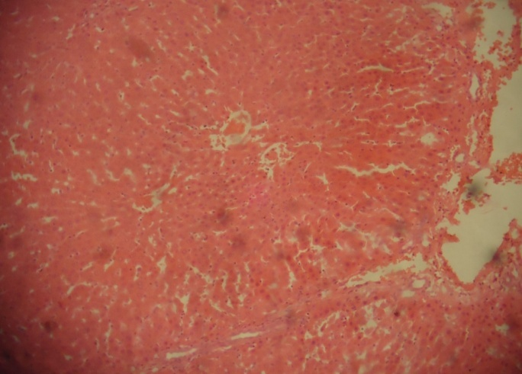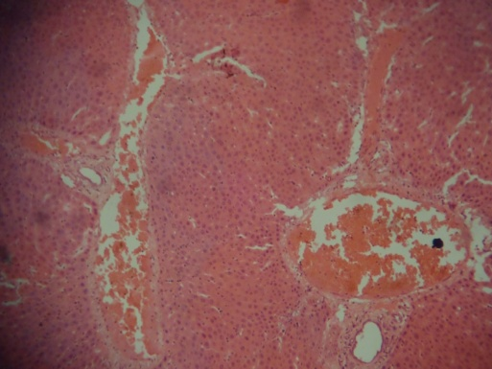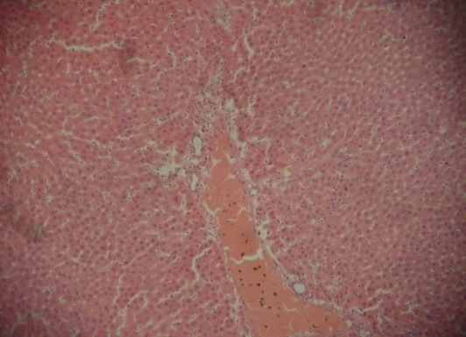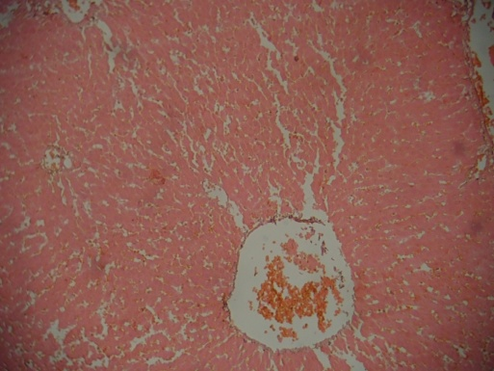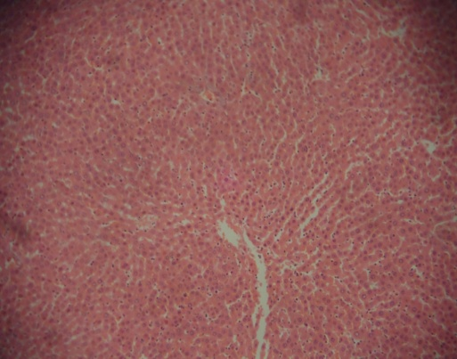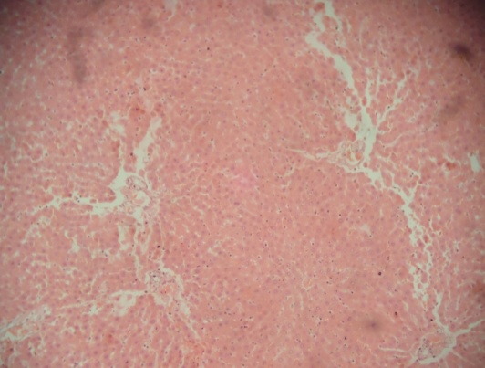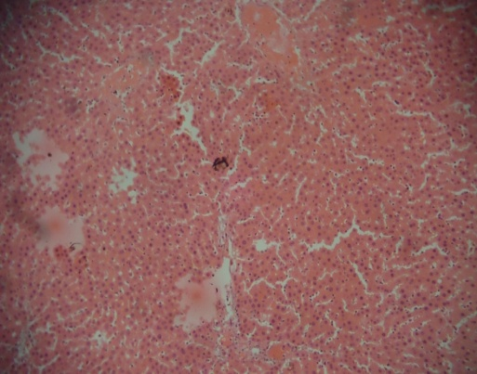

B

C

D

E

G

H

A

F

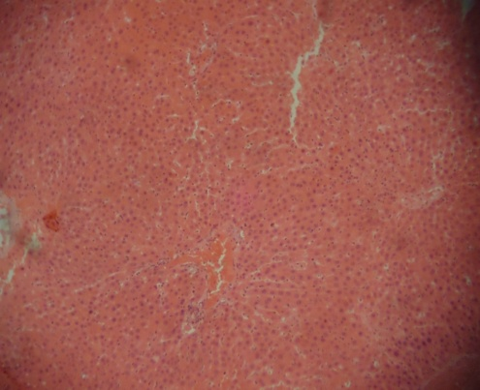

E

The histological examination of the liver sections of negative control and extracts only rats showed no visible lesions when compared with the SA only group which showed severe portal central and venous congestion, moderate hepatic degeneration and necrosis and also moderate portal cellular infiltration by mononuclear cells. Pretreatments with graded doses of AP extract showed a reduction in portal congestion and marked reduction in periportal necrosis.

**Discussion:**

Continuous exposure of human to arsenic through long term ingestion of contaminated drinking water and its attendant health problems have been widely reported as a proof of the latter carcinogenicity (2). Also the frequent use of sodium arsenite in herbicides, insecticides, rodenticides and wood preservatives has become a major challenge to the environment (26). Recent studies have shown that sodium arsenite is hepatotoxic and clastogenic in experimental animals (5, 27, 28). Inefficient liver protective drug in modern medicine have resulted in a number of researches for hepatoprotective constituents from natural sources (29). The phytochemicals such as phenolic compounds, flavonoids, polyphenols, tannis were detected in appreciable amount in the aqueous extract of *Andrographis paniculata* with high levels of alkaloids and saponins. These phytochemicals could counteract the free radicals generated by SA through effective scavenging. Also, there was no significant increase in body weight throughout the study. However, there was a significant decrease in the relative liver weights of group 2 animals treated with SA only compared with other treatment groups.

SA significantly induced micronuclei formation in the rat polychromatic erythrocytes when compared with control group. This observation is consistent with earlier findings in our laboratory and those of others on the clastogenic potentials of sodium arsenite in the bone marrow (6,7). The observed SA-induced mPCEs was however lowered significantly by AP pretreatment. This may be due to the fact that arsenite generates free radicals that can attack DNA leading to chromosomal breakage based on observation of (29). The increase in the frequency of micronucleated polychromatic erythrocytes in the animals treated in SA is indicative of the clastogenic effect of SA, however pretreatment with AP extract reduced the mPCEs by about 2 folds. This may reveal that the extract of AP has anticlastogenic activity.

In the present study, we observed that serum γGT, serum ALP, AST and ALT activities of experimental rats treated with sodium arsenite only have significantly higher (p < 0.05) than the value observed for the negative control group and the extracts only groups. Thus, the elevated levels of the liver function enzymes in SA treated group in this study may be indicative of cellular leakage and loss of functional integrity of cell membrane in liver (30). The arsenic-induced liver dysfunction, hepatomegaly and liver fibrosis can advance to malignancy. However, the simultaneous treatment of rats with aqueous *Andrographis paniculata* extracts significantly (p<0.05) reduced the levels of γ-GT, AST, ALT and ALP in rats intoxicated with sodium arsenite to near normal. This suggests that AP plant extract could repair or prevent the hepatic injury and/or restore the cellular permeability, thus reducing the toxic effect of SA induced liver toxicity. The prevention of enzymes leakage into the blood circulation demonstrated that *Andrographis paniculata* extracts has hepatoprotective effect on sodium arsenite induced liver injury.

Histological observations were in correlation with the biochemical results showing there was no pathologic abnormality in the groups of rats given extract only at 200 and 500 mg/kg body weight and the negative control group. Also, the liver histology revealed that AP at 200 and 500 mg/kg were able to reverse the severe lesions caused by SA thereby indicating that AP extract has a potential hepatoprotective activity. The phytochemicals along with flavonoids may have counteracted the free radicals generated by SA through effective scavenging. Therefore, the hepatoprotective action of *Andrographis paniculata* may be due to its natural antioxidants content that protected the structural integrity of hepatocellular membrane thus preventing enzymes leakage into the blood circulation and consequently enhance the recovery from hepatic damage.

**Conclusion**

In conclusion, the aqueous extracts of *Andrographis paniculata* ameliorated sodium arsenite induced hepatotoxicity and clastogenicity. Therefore, *Andrographis paniculata* extract can be useful in the management of arsenic toxicity and may be exploited for the treatment of liver diseases.

**Disclaimer (Artificial intelligence)**

Option 1:

Author(s) hereby declare that NO generative AI technologies such as Large Language Models (ChatGPT, COPILOT, etc.) and text-to-image generators have been used during the writing or editing of this manuscript.

Option 2:

Author(s) hereby declare that generative AI technologies such as Large Language Models, etc. have been used during the writing or editing of manuscripts. This explanation will include the name, version, model, and source of the generative AI technology and as well as all input prompts provided to the generative AI technology

Details of the AI usage are given below:

1.

2.

3.

REFERENCES

1. Saha K.C (1995): Chronic arsenical dermatosis from tube well in west Bengal during 1983 -1987 *Indian J*. *Dermatol*. 40,1-12.
2. Waalkes, M.P., Ward, J. M., Liu,J. and Diwan, B,A. (2003): Tranplacental carcinogenicity of inorganic arsenic in the drinking water, induction of hepatic, ovarian,pulmonary and adrenal tumors in mice. *Toxicol. Appl*. *Pharmacol*.186,7-17.
3. Mass, M,. J. (1999): Human Carcinogenesis by arsenic Environ. Geo. Chem Health; 14:49-59.
4. Nickson, R., McArthur, J., Burges,W., Ahamed, K. M., Ravenserof, P., and Rahman, M (1998): Arsenic poisoning of Bangladesh ground water, *Nature 395,338-338.*
5. Odunola OA, Kazeem A, Akinwumi Babatunde (2007): Interaction and Enhancement of the Toxic Effects of Sodium Arsenite and Lead Acetate in Wister Rats. *African Journal of Biomedical Research*10: 59-65
6. Usoh, I. F., Akpan, E. J., Etim, E. O. & Farombi, E. O. (2005). Antioxidant actions of dried flower extracts of Hibiscus sabdariffa L. on sodium arsenite-induced oxidative stress in rats. *Pak. J. Nutr.* 4: 135-141.
7. Gorinstein S, Yamamoto K, Katrich E, Leontowicz H, Lojek A, Leontowicz M, Ciz M, Goshev I, Shalev U and Trakhtenberg S (2003) Antioxidative properties of Jaffa sweeties and grapefruit and their influence on lipid metabolism and plasma antioxidative potential in rats. *Biosci Biotechnol Biochem* 67: 907–910.
8. Odunola, O.A. (2003). Comparative effects of some local food condiments on sodium arsenite-induced clastogenicity*.  Afr. J. Med. Med. Sci.* 32, 75-80.
9. Shen, Y.C. Chen, C.F and Chion, W.F. (2000): Suppression of rat neutrophil reactive oxygen species production and adhesion by the diterpeniod lactone andrographolide. *Plant med,* 66, 314-317.
10. Shen, Y.C, Chen, C.F and Chiou, W.F (2002): Andrographolide prevents oxygen radical production by human neutrophils: possible mechanism (s) involved in its anti-inflammatory effect. *Bio.J.Pharmacol,* 135; 399-406.
11. Caupta, S., Choudhry, M.A., Yadava, J.N.S., Srivastava, Y. and Tandon, J.S (1990): Antidiarrhoeal activity of diterpenes of Andrographis paniculata (Kadmegh) against Escherichia Coli enterotoxin in vivo modes. *Int.J Crude Drug Res*; 28, 273-283.
12. Singha PK, Roy S, Dey S (2003): Antimicrobial activity of Andrographis paniculata. *Fitoterapia* 74:692-694.
13. Rahman, NNN.A., Furuta, T., Kojima, S., Tabane, K and Ali-Mohd, M (1999): Antimalaria acitivity of extracts of malaysion medicinal plants. *J.Ethnopharmacol*, 64, 249-254.
14. Tan, B.K. H and Zhang, C.Y (2004): Andrographis paniculata and the cardiovascular system. In Herbal and tradition Medicine: Molecular Aspects on Health (Packer, L., Ong. C.N and Halliwell, B., Eds). CRCPres, Taipei pp.441-456.
15. Kumar, R.A., Sridevi, K. Kumar, N.V. Nanduri,S.and Rajagopal, S. (2004): Anticancer and immunostimulatory compounds from Andrographis paniculata. *J. Ethnopharmacol.,* 92,291-295.
16. Iruretagoneya MI, Tobar JA, Gonzalez PA, Sepulveda SE, Figuerra CA, Burgos RA, Hancke JL and Kalergi AM. (2005): Andrographolide interferes with T cell activation and reduces experimental autoimmune encephalomyelitis in the mouse. *J Pharmacol ExpTher* 312:366-372.
17. Chion W.F, Chen, C.F and Lin, J.J (2000): Mechanisms of suppression of inducible nitric oxide synthase (iNOS) expression in RAW 264.7 cells by andrographolide *B.J Pharmacol,* 129, 1553-1560.
18. Trivedi, N and Rawal, .M (2001): Hepatoprotective and antioxidant property of Androphraphis paniculata (Nees) in BHC induced liver damage in mice. *Indian J. ExpBiol* 39,41-46.
19. Trivedi, N and Rawal, U.M (2000): Hepatoprotective and toxicological evaluation of Andrographis paniculata on severe liver damage. *Indian J. Pharmacol*. 32, 228-293.
20. Handa, S.S and Sharma, A (1990): Hepatoprotective activity of Andrographilide against galactosamine and paracetamol intoxication in rats. *Indian J.med Res*, 92;284-292.
21. Kokate CK. Practical Pharmacognosy. 4th ed. New Delhi, India: Vallabh Prakashan; 1994. pp. 112–20.
22. Heddle, J. A. and Salmone, M. F. (1981): The micronucleus assay I: In vivo. In Stitch, H. F. and San, R. H. C (eds). Topics in Environmental Physiology and Medicine.Short Test for Chemical Carcinogens. Springer Verlag, New York, Heidelberg, Berlin, pp. 243-249.
23. Szasz, G. (1969): A kinetic photometric method for serum gamma glutamyltranspeptidase. *Clin Chem,* 15, 124-36.
24. Reitman S and Frankel A: In vitro determination of transaminase activity in serum. *Ami.J. Clin Path* 1957; 28:56-60.
25. Williamson, T. (1972). A comparison between the phosphastrate and phenyl phosphate methods of alkaline phosphatase assay. *Med Lab Technol,* 29, 182-7.
26. Tozen M, Saygi KO, Karaman I and Soylak M. (2010): Selective speciation and determination of inorganic arsenic in water, food and biological samples. *Food Chemical Toxicology* 48: 41-6
27. El-demerdash, F. M., Yousef, M. I. and Radwan, F. M. E. (2009) Ameliorating effect of curcumin on sodium arsenite induced oxidative damage and lipid peroxidation in different rat organs. *Food and Chemical Toxicology* 47: 249-254.
28. Chattopadhyay S, Deb B and Maiti S. (2012): Hepatoprotective role of vitamin B (12) and folic acid in arsenic intoxicated rats. *Drug Chem Toxicol*.;35(1):81-8.
29. Liu, J. Kaduska, M. B., Liu, Y. Lu, T., Qu, W., and Waalkes, M. P. (2001): B-stress related gene expression in mice treated with inorganic arsenicals. *Toxicological Science* 61: 314-320.
30. Drotman R and Lawhan G. (1978): Serum enzymes are indications of chemical induced liver damage. *Drug Chem Toxicol 1*;163-171

Sharmal A, KrishanL, Handa SS, (1992): Standardization of the Indian crude drug Kalmegh by high pressure liquid chromatographic determination of andrographolide, *Phytochem, Anal,* 3;129-131.

Sheeja K, Kuttan G. (2006): Protective effects of andrographis paniculata and andrographolide on cyclophosphamide induced Urothelial toxicity, *Inter.Cancer Ther* 5,244-251.

Akbarsha MA and Murugaian P. (2000): Aspects of the male reproductive toxicity/male antifertility property of andrographolide in albino rats: Effects on the testis and the caudaepididymidal spermatozoa. *Phytother Res14*:432-435.

Huang B, Ban XQ, He JS,Tong J,Tian J and Wang YW.(2010): Hepatoprotective and antioxidant activity of ethanolic extracts of lotus (*Nelumbonuciferagaertn*)leaves*. Food Chem*: 120(3):873-878.

Jin YS, Sa JH, ShimTH, Rhee HI and Wang MH (2005): Hepatoprotective and antioxidant effects of *morusbombyciskoidzum*i on CCL4 induced liver damage. Biochem *Biophys Res Commun,*329(3):991-995.

Kestersib JW, Graneman GR and Machinist JM (1984): The hepatotoxicity of valproic acid and

its metabolites in rats. Toxicological biochemical and histopathologic studies, *Hepatology* 4, 1143-1152.

Nanduri A, Nyavanandi VK,Thynuguntla SR, Kasu A, Palleria MK, Ram PS, Rajagopal S, Kumar R.A, Ramanujam R, Basu JM,Vyas K, Devi AS, Reddy GO and Akella V, (2004): Synthesis and structure- activity relationships of andrographolide analogues as novel cytotoxic agents. *Bioorg Med Chem. Lett.*14:4711-4717.

Vinoth kumar P, Sivaraj A, Devi K, Senthil kumar B. (2010): Hepatoprotective and antioxidant properties of aqueous rhizome extracts of *Picrorhizakurroa*on CCl4 induced liver toxicity in *albino* rats. *J.Pharmacy.* 3(6): 1280-1282.

Wiart, C., kumar K., Yusof, M.Y, Hamimah, H., Fauz, Z.M and Sulaiman, M (2005): Antiviral properties of ent-labdonediterpenes of Andrographis paniculata Nees Inhibitors of herps simplex virux type 1. *Phytother. Res.*19,1069-1070.

Avani G, Rao MV. In vitro cytogenetic effects of Andrographis paniculata (kalmegh) on arsenic. Phytomedicine. 2008 Mar 10;15(3):221-5.

Das P, Khare P, Singh RP, Yadav V, Tripathi P, Kumar A, Pandey V, Gaur P, Singh A, Das R, Hiremath C. Arsenic-induced differential expression of oxidative stress and secondary metabolite content in two genotypes of Andrographis paniculata. Journal of Hazardous Materials. 2021 Mar 15;406:124302.

Bahadur L, Kannaujia R, Saxena A, Srivastava DK, Sinam GG. Evaluation of Andrographis paniculata Wall. Ex Nees for Cultivation Under Sodicity Stress. Communications in Soil Science and Plant Analysis. 2024 Oct 10;55(18):2697-709.