***Case study***

**Understanding balance between advertent healing and inadvertent harm by traditional remedies: A Case series of Naphthalene-Induced Acute Kidney Injury in Northwest India.**

**ABSTRACT**

**Aim**

This study aims to highlight the risks associated with unsanctioned indigenous medical practices and advocate for increased awareness and medical oversight.

**Case presentation**

We present four cases that presented to Nephrology department of SMS medical college & hospital, Jaipur, Rajasthan between January 2024 to July 2024 who developed anuria after ingesting a naphthalene ball mixed with a sweet as a home based remedy for treatment of haemorrhoids. They had pronounced renal dysfunction and evidence of hemolysis. All four cases were in age group ranging from 23 to 35 years, with three being males and one female. Comprehensive care was provided, encompassing supportive measures such as hemodialysis to address the renal impairment. Subsequent renal biopsy unveiled pigment cast nephropathy as the underlying etiology of AKI in all the patients. With continuous treatment and vigilant observation, urine output of all patients progressively recovered in 11 to 16 days, and all patients were discharged in a stable condition with declining trend of serum creatinine. All patients had normal renal function at 3 month follow up.

**Discussion**

Naphthalene is an aromatic hydrocarbon with two condensed rings. It is used to manufacture moth balls, insecticides, dyes and toilet deodorant blocks. Naphthalene is known to have toxic effects, particularly on the hematological system which occurs through the generation of free oxygen radicals, causing headache, nausea, vomiting, diarrhoea, abdominal pain, fever and altered mental status. This case series serves as a poignant reminder of the imperative need for circumspection when utilizing indigenous remedies, highlighting the potential hazards of home based remedies. Furthermore, it underscores the significance of high index of suspicion, expeditious diagnosis, patient and doctor education, and the administration of appropriate therapeutics in instances of AKI linked to toxic exposures, thus ensuring favourable patient outcomes.

**Conclusion**

We conclude that unsanctioned home based remedies should be used after thorough circumspection and, after consultation with a registered medical practitioner. The importance of regulatory oversight on traditional medicine usage should never be overlooked considering inadvertent harm such remedies can have on health if taken above a specified dose.

*Keywords: acute kidney injury, naphthalene, methemoglobinemia, traditional remedies, haemorrhoids*

**INTRODUCTION**

In the realm of traditional remedies, there exists a delicate balance between healing and inadvertent harm. Naphthalene (C10H8) is an aromatic hydrocarbon which is used to manufacture moth balls, insecticides and toilet deodorant blocks. Accidental or intentional poisoning has been reported by swallowing, skin contact and inhalation. The metabolite α-naphthol is the main cause of poisoning.1 In the Indian context, a study analyzing calls to the National Poisons Information Centre at the All India Institute of Medical Sciences (AIIMS), New Delhi, reported that 3.9% of acute poisoning cases were due to naphthalene ball ingestion.2 A retrospective study conducted over a decade (2008–2018) in Iran, analyzed 52 cases of naphthalene poisoning. The study found that the highest prevalence was among children under five years and individuals aged 20–25 years. Notably, 65% of these cases were intentional, and 35% were accidental.3 Naphthalene toxicity mainly occurs through the generation of free oxygen radicals, leading to lipid peroxidation, DNA fragmentation and mitochondrial damage.4 This leads to formation of the non-oxygen-binding form of hemoglobin (i.e., metHb), leading to methemoglobinemia.5 Exposure to naphthalene causes headache, nausea, vomiting, diarrhea, abdominal pain, fever, and altered mental status. Hemolysis and methemoglobinemia usually become clinically evident by 24 to 48 hours post-exposure.1 The estimated lethal dose is 5-15 grams for adults and 2-3 grams for children.6 In a study in India, prevalence was reported at 5% in home poisoning cases over 10 years.7 This case series unfolds the narrative of four patients of Rajasthan state of India who encountered medical crossroads after embracing indigenous medicine for the treatment of haemorrhoids. Unbeknownst to them, this well-intentioned choice led to AKI accompanied by hemolysis. In this case series, we embark on a journey that unravels the complexities of AKI, hemolysis, methemoglobinemia and the pivotal role of timely intervention and informed medical choices while using traditional healing practices.

**CASE SERIES**

These patients presented to Nephrology department of SMS medical college & hospital, Jaipur, Rajasthan between January 2024 to July 2024. All patients were traced from hospital records and contacted telephonically. They were informed about the study and necessary informed consent was taken from all patients. This retrospective case study was done after approval from ethical committee. All four cases were in age group ranging from 23 to 35 years, with three being males and one female.

**CASE 1**: A 23 year old male presented to our Nephrology department with history of decreased urine output and shortness of breath over 3 days. Upon evaluation, laboratory results revealed profoundly elevated serum creatinine level of 5.5mg/dL and hemoglobin of 7.1g/dL. His LDH was elevated at 3766IU/L, and PBF showed schistocytes, and liver function tests (LFTs) displayed mild abnormalities, with indirect bilirubin 1.9mg/dL, SGOT 142IU/L and SGPT 90IU/L suggesting hemolysis as the underlying cause. The patient’s initial workup for tropical fever profile, Coomb’s test and glucose-6-phosphate dehydrogenase (G6PD) level yielded normal results and ABG analysis revealed severe metabolic acidosis and metHb level of 1.3%.

Further, renal biopsy revealed presence of hemoglobin cast nephropathy with concomitant severe acute tubular necrosis (ATN). (Figure 1, 2) On deeper questioning, patient revealed ingestion of a single naphthalene ball mixed with some sweet, as a home remedy for haemorrhoids. This led to an unusual diagnosis of Naphthalene toxicity in this patient. The patient's management included a series of hemodialysis sessions. Gradually the patient began to exhibit signs of recovery and was later discharged in stable condition, with normal urine output and creatinine of 2.9 mg/dL. Serum haemoglobin, LDH and LFTs had returned to normal. On follow-up visit, the patient displayed normal urine output and a creatinine level of 0.8 mg/dL.

**CASE 2**: A 26 year male presented with shortness of breath, bluish discolouration of skin and progressively declining urine output of 4 days. This patient also exhibited signs of hemolysis with LDH 2390IU/L and methemoglobinemia (metHb level 6.7%). This patient was managed with supportive treatment requiring i.v. methylene blue and oxygen support in addition to hemodialysis and biopsy revealed hemoglobin cast nephropathy with severe ATN. This patient also gave history of consuming naphthalene ball mixed with banana as treatment of haemorrhoids. Patient improved and was discharged with normal urine output and declining creatinine levels and on further follow up had normal RFTs.

**CASE 3**: A 35 year male, presented with alarming rise in creatinine levels with sudden onset anuria, severe abdominal pain and bloody diarrhoea. His lab reports pointed to hemolysis with LDH 2789IU/L, Hb 8.1g/dL and normal platelets. After ruling out obvious causes of AKI, this patient underwent renal biopsy, which showed haemoglobin cast nephropathy, despite having atypical HUS like presentation. He also had history of naphthalene consumption. Patient was managed with hemodialysis and showed gradual signs of recovery over next 2-3 weeks. On follow up, patient had creatinine 1.1mg/dL with normal BP.

**CASE 4**: A 25 year female presented with declining urine output and pain abdomen from 3 days associated with bloody stools from 1 month. She gave history of naphthalene ball intake for haemorrhoids. She showed all signs of naphthalene toxicity with Hb 8.7, LDH 1563, mild LFT derangement and biopsy showing haemoglobin cast nephropathy. She was managed conservatively and improved over next 2 weeks and follow up creatinine 0.7mg/dL. (Table 1)

**Table 1: Clinical profile and laboratory parameters of all cases.**

|  |  |  |  |  |  |  |  |  |  |  |  |  |
| --- | --- | --- | --- | --- | --- | --- | --- | --- | --- | --- | --- | --- |
| S. No. | Hb (g/dL) | | LDH (IU/L) | Bil/Indirect BIL/SGOT/SGPT | Creatinine (mg/dL) | | | | Days to develop Oliguria/ Anuria | Days to normal urine output | Met Hb level (%) | No. of Naphthalene ball ingested (wt 0.5-0.9 gm) |
| Presentation | Discharge |  | Presentation | Discharge | Follow up after 1 week | Follow up after 3 months |  |
| Case 1 (23/M) | 7.1 | 11.4 | 3766 | 4/1.9/142/90 | 5.5 | 2.9 | 0.8 | 0.78 | 3 | 11 | 1.3 | 1 |
| Case 2 (26/M) | 5.5 | 10.5 | 2390 | 3.2/1.7/198/123 | 5.9 | 3.1 | 1.2 | 0.81 | 2 | 16 | 6.7 | 1 |
| Case 3 (35/M) | 8.1 | 11.1 | 2789 | 2.0/1.2/88/68 | 7.7 | 2.3 | 1.1 | 0.9 | 3 | 12 | 1.1 | 1 |
| Case 4 (25/F) | 8.7 | 12.4 | 1563 | 2.5/1.7/210/147 | 6.5 | 2.6 | 0.7 | 0.72 | 3 | 14 | 1.3 | 1 |

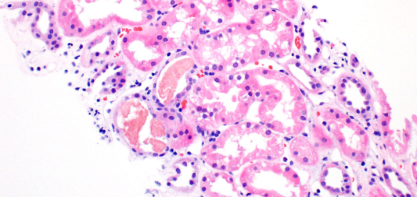

**Figure 1: Pigment Cast on Light Microscopy (hematoxylin & eosin stain)**

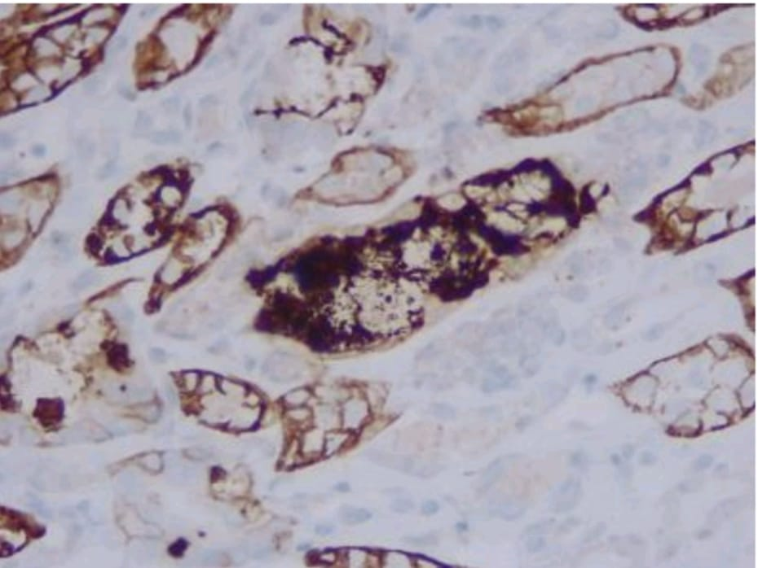

**Figure 2: Hemoglobin A immunohistochemical stain positive**

**DISCUSSION:**

Naphthalene, an aromatic compound with two condensed rings, is a key component of indigenous medicine in our case series. It is known to have toxic effects, particularly on the hematological system which occurs through the generation of free oxygen radicals, causing headache, nausea, vomiting, diarrhoea, abdominal pain, fever and altered mental status.1

All the four patients had history of naphthalene intake mixed with sweets as a home remedy for haemorrhoids, with progressive oligoanuria, elevated creatinine, and the subsequent diagnosis of haemoglobin cast nephropathy with severe ATN on biopsy illustrating the severe impact of hemolysis on the kidneys. Intravascular hemolysis leads to excessive free haemoglobin in the plasma, which is broken down into heme and globin. This heme forms an intratubular muddy brown pigment cast with Tamm–Horsfall protein and has a direct cytopathic effect because of its oxidant and pro-inflammatory properties8 and also causes lipid oxidation, protein denaturation, enzyme impairment, cytoskeletal disintegration, and DNA denaturation.9

The initial evaluation to rule out G6PD deficiency, autoimmune and infectious causes is mandatory as these are important and common differentials in hemolysis.The slightly elevated LFTs indicate hepatic involvement due to the direct toxic effects of naphthalene or to the evidence of hemolysis. All patients with unexplained acute renal dysfunction must be evaluated further for appropriate diagnose and timely management of reversible causes. All four patients showed complete recovery, which can be possibly attributed to timely intervention and low dose of naphthalene intake i.e. a single naphthalene ball weighing 0.5-0.9 grams compared to toxic dose of 5-15 grams for adults.

The presented case series is both intriguing and educational because in a short span of 6 months, we diagnosed four cases of Naphthalene toxicity at a tertiary care centre. So, we can imagine the load of such cases at primary or secondary referral hospitals with limited facilities, where such cases could be prevelant, and being easily misdiagnosed or mismanaged if this etiology of AKI is not highlighted.

Reviewing literature, we found a case report of 10-year-old boy who after accidental ingestion of uncertain amount of naphthalene ball, developed methemoglobinemia and hemolysis after 48 hours of taking it.10 In another case report, naphthalene poisoning in a woman resulted in AKI and pulmonary edema, in addition to hemolysis.11 In yet another report, a one-year-old child was affected by hemolysis, AKI, and pigmented nephropathy following ingestion of naphthalene balls.12 Also, a systematic review evaluated human and animal studies on naphthalene exposure, focusing on health outcomes and dose–response relationships. The analysis highlighted the need for updated toxicity reference values and identified gaps in current research, particularly concerning chronic exposure effects.13 In another case report, a 2-year-old boy with undiagnosed G6PD deficiency ingested a mothball containing naphthalene. He developed acute intravascular hemolysis, methemoglobinemia, and ischemic cardiac injury. The child was treated with intravenous fluids, blood transfusions, and supportive care, leading to a full recovery.14 In yet another recent report, a 5-year-old boy accidentally ingested a naphthalene mothball, resulting in intravascular hemolysis and acute kidney injury (AKI). Management involved intravenous fluids, blood transfusions, and hemodialysis, culminating in a favorable outcome.15 A case series on six adult patients who intentionally ingested naphthalene balls was reported. All patients were managed conservatively and there was complete recovery without any long-term complications.16 A study by **Baeza-Trinidad et al.** highlights role of **creatinine as a marker** for predicting AKI severity and mortality, thus reinforcing its importance in suspected naphthalene poisoning cases **not just as a diagnostic tool but also as a prognostic marker.17**

The use of unwarranted home based remedies might be harmful, if taken without proper knowledge and guidance. Hence, patient awareness and doctor education is of utmost important, regarding potential harms of such remedies. Patient awareness by using help of local media channels and print media can be sort and also by building doctor-patient relationship and easy accessibility of trained doctors for all patients. Another important point to note is that, with supportive management, all patients made a remarkable recovery and achieved normal health, highlighting potentially reversible nature. And to best of our knowledge, no such case series highlighting harms of naphthalene based home remedy for haemorrhoid treatment has been reported in past from Rajasthan or adjoining areas. Even though enlightening, our case series is limited by small sample size and lack of knowledge on exact dose ingestion of naphthalene on case by case basis.

**CONCLUSION:**

This case series highlights the importance of recognizing the potential hazards associated with indigenous medicines and the severe consequences of naphthalene ingestion, especially in the state of Rajasthan, where it is used as a traditional remedy for haemorrhoids in some areas. Through early intervention, accurate diagnosis, and comprehensive medical care, these patients made a remarkable recovery, with restored renal function and overall health. The importance of regulatory oversight on traditional medicine usage should never be overlooked considering inadvertent harm such remedies can have on health if taken above a specified dose.

Disclaimer (Artificial intelligence)

Option 1:

Author(s) hereby declare that NO generative AI technologies such as Large Language Models (ChatGPT, COPILOT, etc.) and text-to-image generators have been used during the writing or editing of this manuscript.

Option 2:

Author(s) hereby declare that generative AI technologies such as Large Language Models, etc. have been used during the writing or editing of manuscripts. This explanation will include the name, version, model, and source of the generative AI technology and as well as all input prompts provided to the generative AI technology

Details of the AI usage are given below:

1.

2.

3.

**REFERENCES**:

1. El-Masri, H., Agency for Toxic Substances and Disease Registry, Environmental Protection Agency, & Syracuse Research Corporation. (2005). Toxicological profile for naphthalene, 1-methylnaphthalene, and 2-methylnaphthalene. Agency for Toxic Substances and Disease Registry.
2. Srivastava, R., Peshin, S. S., Kaleekal, T., & Gupta, Y. K. (2005). Acute poisoning cases reported to a National Poisons Information Centre in Northern India. Human & Experimental Toxicology, 24(6), 279–285. <https://journals.sagepub.com/doi/pdf/10.1191/0960327105ht527oa>.
3. Salehian, S., Moradi, R., & Ghazanfari, A. (2021). Naphthalene toxicity: A ten-year retrospective study. Addiction & Health Journal. Retrieved from https://brieflands.com/articles/jai-118974.
4. Bagchi, M., Balmoori, J., Ye, X., Bagchi, D., Ray, S. D., & Stohs, S. J. (2001). Protective effect of melatonin on naphthalene-induced oxidative stress and DNA damage in cultured macrophage J774A.1 cells. *Molecular and cellular biochemistry*, *221*(1-2), 49–55. <https://doi.org/10.1023/a:1010946517651>
5. Wright, R. O., Lewander, W. J., & Woolf, A. D. (1999). Methemoglobinemia: etiology, pharmacology, and clinical management. *Annals of emergency medicine*, *34*(5), 646–656. <https://doi.org/10.1016/s0196-0644(99)70167-8>
6. Assessment, U. E. N. C. for E. (2009). *Patty’s industrial hygiene and toxicology: Volume 2A: Toxicology*. Hero.epa.gov. <https://hero.epa.gov/hero/index.cfm/reference/details/reference_id/2919563>
7. Peshin, S. S., & Gupta, Y. K. (2018). Poisoning due to household products: A ten years retrospective analysis of telephone calls to the National Poisons Information Centre, All India Institute of Medical Sciences, New Delhi, India. *Journal of forensic and legal medicine*, *58*, 205–211. <https://doi.org/10.1016/j.jflm.2018.07.005>
8. Qian, Q., Nath, K. A., Wu, Y., Daoud, T. M., & Sethi, S. (2010). Hemolysis and acute kidney failure. *American journal of kidney diseases : the official journal of the National Kidney Foundation*, *56*(4), 780–784. <https://doi.org/10.1053/j.ajkd.2010.03.025>
9. Deuel, J. W., Schaer, C. A., Boretti, F. S., Opitz, L., Garcia-Rubio, I., Baek, J. H., Spahn, D. R., Buehler, P. W., & Schaer, D. J. (2016). Hemoglobinuria-related acute kidney injury is driven by intrarenal oxidative reactions triggering a heme toxicity response. *Cell Death & Disease*, *7*(1), e2064. <https://doi.org/10.1038/cddis.2015.392>
10. Volney, G., Tatusov, M., Yen, A. C., & Karamyan, N. (2018). Naphthalene Toxicity: Methemoglobinemia and Acute Intravascular Hemolysis. *Cureus*, *10*(8), e3147. <https://doi.org/10.7759/cureus.3147>
11. Kundra, T. S., Bhutatani, V., Gupta, R., & Kaur, P. (2015). Naphthalene Poisoning following Ingestion of Mothballs: A Case Report. *Journal of clinical and diagnostic research : JCDR*, *9*(8), UD01–UD2. <https://doi.org/10.7860/JCDR/2015/15503.6274>
12. Ekambaram, S., Chandan Kumar, K. M., & Mahalingam, V. (2017). Acute kidney injury: A rare complication of mothball (Naphthalene) poisoning. *Saudi journal of kidney diseases and transplantation : an official publication of the Saudi Center for Organ Transplantation, Saudi Arabia*, *28*(6), 1412–1415. <https://doi.org/10.4103/1319-2442.220858>
13. Yost, E. E., Galizia, A., Kapraun, D. F., Persad, A. S., Vulimiri, S. V., Angrish, M., Lee, J. S., & Druwe, I. L. (2021). Health effects of naphthalene exposure: A systematic evidence map and analysis of potential considerations for dose–response evaluation. Environmental Health Perspectives, 129(7), 076002. <https://doi.org/10.1289/EHP7381>.
14. Dissanayake, K., Amarasinghe, G., & Tennakoon, V. (2024). Acute hemolytic crisis complicated with ischemic cardiac injury and methemoglobinemia following naphthalene ingestion in a child with G6PD deficiency: A case report. Journal of Medical Case Reports, 18, Article 67. <https://doi.org/10.1186/s13256-023-03767-9>.
15. Sravanthi, K., Patil, M. G., Mane, S., & Garlapati, S. (2024). Naphthalene ball ingestion leading to intravascular hemolysis and acute kidney injury. Cureus, 16(5), e31245. <https://doi.org/10.7759/cureus.31245>.
16. Chand, S., Rao, P., & Raina, S. (2023). Mothball (naphthalene) poisoning in adults: A case series. Medical Journal of Dr. D.Y. Patil Vidyapeeth, 17(2), 40–44. <https://doi.org/10.4103/mjdrdypu.mjdrdypu_828_22>.
17. Baeza‐Trinidad R, Brea‐Hernando A, Morera‐Rodriguez S, Brito‐Diaz Y, Sanchez‐Hernandez S, El Bikri L, Ramalle‐Gomara E, Garcia‐Alvarez JL. Creatinine as predictor value of mortality and acute kidney injury in rhabdomyolysis. Internal Medicine Journal. 2015 Nov;45(11):1173-8.