*Original Research Article*

Evaluation of physico-chemical and biochemical parameters of sugarcane molasses and cashew apple juice from six locations in Côte d'Ivoire

ABSTRACT

|  |
| --- |
| **Introduction:** Côte d'Ivoire has an underutilized agricultural potential, notably the cashew apple (*Anacardium occidentale L.*) and sugarcane molasses. These by-products, though abundant, remain undervalued and represent a significant opportunity for promoting a circular economy.  **Prolems:** Despite their potential, cashew apple juice (CAJ) and sugarcane molasses (SCM) are underutilized due to a lack of data on their physico-chemical and biochemical properties, which hinders their industrial exploitation.  **Aims:** This study aims to characterize the physico-chemical and biochemical properties of CAJ and SCM collected from various localities in Côte d'Ivoire, with the goal of evaluating their valorization potential and proposing innovative solutions to reduce agricultural losses.  **Methods:** Cashew apples were harvested from six localities (Yamoussoukro, Dimbokro, Bouake, Mankono, Vavoua, and Korhogo), and molasses was supplied by the SIFCA group. Seven samples were analyzed: six for CAJ and one for SCM. Physico-chemical and biochemical parameters were analyzed using recognized standard methods.  **Results:** The analysis demonstrates that cashew apple juice (CAJ) and molasses possess excellent overall quality. CAJ has an acidic pH ranging from 4.05 ± 0.02 to 5.00 ± 0.02 and a high vitamin C concentration (181.61 ± 0.37 to 188.45 ± 0.64 mg/100 ml), compared to the lower vitamin C content in molasses (0.35 ± 0.57 mg/100 ml). CAJ contains significant glucose (48.82 ± 0.05 to 55.84 ± 0.01 g/l) and fructose (42.79 ± 0.06 to 48.98 ± 0.01 g/l) levels, whereas molasses has lower amounts of glucose (26.94 ± 0.02 g/l) and fructose (17.67 ± 0.06 g/l). Total sugars are higher in CAJ (104.76 ± 0.02 to 111.31 ± 0.02 g/l) compared to molasses (59.13 ± 0.03 g/l). Both agro-resources are rich in essential minerals (Ca, Mg, Fe, Na, K, P), with concentrations ranging from 23.77 ± 0.02 to 1203.01 ± 0.03 mg/l for CAJ and from 4.59 ± 0.04 to 5431.35 ± 0.02 mg/l for molasses.  **Novelty:** This study represents a crucial initial step towards the valorization of Ivorian agricultural by-products. It highlights their nutritional richness and viability as key ingredients in innovative agro-industrial product formulations.  **Conclusion:** These findings highlight their significant potential for valorization. |

*Keywords****:*** *Cashew apple juice, physico-chemical, biochemical parameters and sugarcane molasses*

1. INTRODUCTION

The cashew tree (Anacardium occidentale L.) belongs to the Anacardiaceae family. It is a tropical tree native to Brazil. It produces two fruits: the cashew nut, which represents the "true fruit," and the cashew apple, the "false fruit" (Lautié *et al*., 2001). The introduction of the cashew tree to the African continent was intended to combat soil erosion. Today, cashew cultivation primarily aims at the production of cashew nuts, which represent a significant source of income for many farmers (Ndiaye *et al*., 2021). In recent decades, cashew nut production in Côte d'Ivoire has seen a substantial increase, placing the country first among producing nations, with an estimated production of 1.2 million tons in 2023 (Lebailly *et al*., 2023). This corresponds to over 9 million tons of cashew apples produced in Côte d'Ivoire. As a reminder, in Côte d'Ivoire, the cashew sector employs approximately four hundred thousand (400,000) producers and represents the third-largest source of foreign exchange in the agricultural sector, after cocoa and rubber (MADR, 2021). However, after the nut harvest, the apples are abandoned in the plantations where they undergo natural decomposition. The underutilization of cashew apples in Côte d'Ivoire is mainly due to the astringency of this fruit and certain ancestral taboos (Soro *et al*., 2012).

Furthermore, another product, namely sugarcane molasses (SCM), undergoes the same treatment as cashew apples. Sugarcane molasses is a viscous residue of a blackish color that comes from the refining of sugarcane juice during sugar production (Palmonari *et al*., 2020). In Côte d'Ivoire, the annual sugarcane production is estimated to average 1.6 million tons, which represents about 150,000 to 180,000 tons of sugar with 68,000 tons of sugarcane molasses (Toure *et al*., 2010). The underutilization or the low interest given to this product (molasses) causes a loss of products with high commercial and technological potential (Toure *et al*., 2010).

Indeed, cashew apples and sugarcane molasses are products that are underutilized in Côte d'Ivoire due to their lack of representation in the national economy and certain ancestral taboos regarding cashew apples (Soro *et al*., 2012). Indeed, in many sub-Saharan African countries, the consumption of milk accompanied by cashew apple juice is considered harmful to health (Soro *et al*., 2012). Cashew apple and sugarcane molasses are agro-resources rich in mineralogical and biochemical compounds (Ouattara *et al*., 2017; Palmonari *et al*., 2020). Regarding cashew apple, it contains important nutrients, including reducing sugars (glucose and fructose), vitamin C, and phenolic compounds that promote its valorization (Honorato *et al*., 2007). Molasses presents the same nutritional characteristics due to its richness in minerals, vitamin B, and carbohydrate and phenolic compounds (Palmonari *et al*., 2020).

The characterization of cashew apple juice and sugarcane molasses is a prerequisite for their valorization. Therefore, the objective of this study is to evaluate the physical, chemical, and biochemical parameters of cashew apple juice and sugarcane molasses for their valorization into other products of economic interest.

2. material

**2.1. Biological Materials and Sampling Areas**

The biological substrates used consisted of cashew apples and sugarcane molasses. The cashew apples came from six (6) localities in Côte d'Ivoire (Yamoussoukro, Dimbokro, Bouake, Mankono, Vavoua, and Korhogo). As for the sugarcane molasses, it was graciously provided by the Sucre Ivoire company of the SIFCA group.

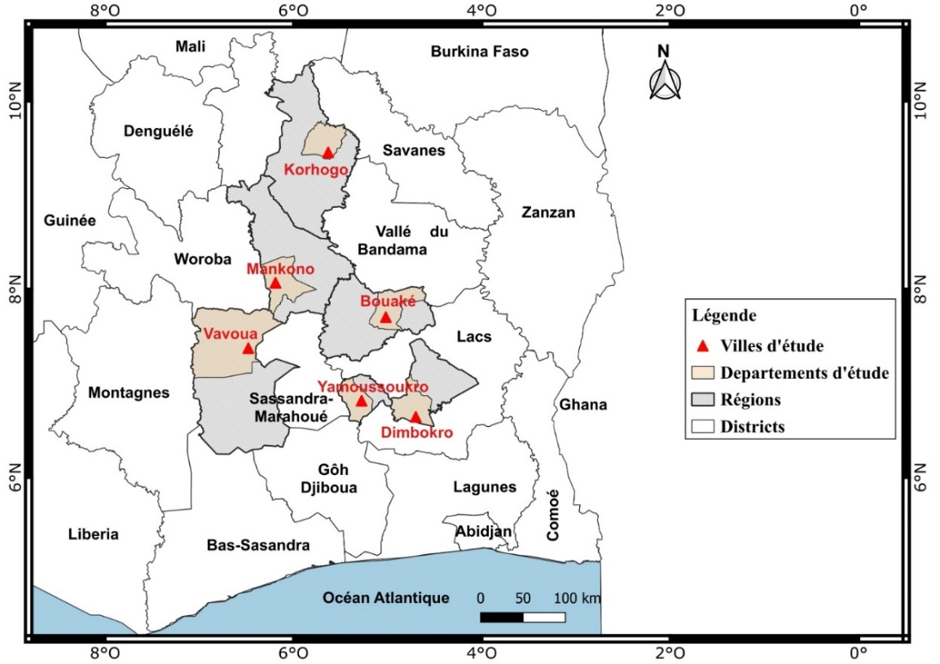

Figure 1 : Cashew apple sampling areas

**3. METHODS**

**3.1. Collection of cashew apples and sugarcane molasses**

Cashew apples were collected from cashew plantations located in six localities in Côte d'Ivoire (Yamoussoukro, Dimbokro, Bouake, Mankono, Vavoua, and Korhogo). The apples were picked directly from the cashew trees (Anacardium occidentale L.), and then the cashew nuts were carefully removed from the apples using nylon threads (Soro *et al*., 2017b). These apples were subsequently transported at room temperature in vials, by truck, to the school factory of the Félix Houphouët-Boigny National Polytechnic Institute of Yamoussoukro. These vials were previously washed with bleach water. As for the sugarcane molasses, it was graciously provided by the Sucre Ivoire company of the SIFCA group.

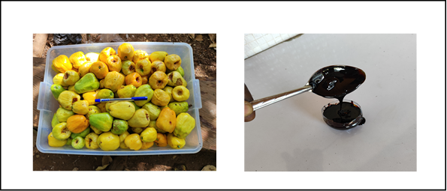

**A**

**B**

**Figure 2** : Cashew apples (A) and Sugarcane molasses (B)

**3.2. Extraction of cashew apple juice**

Once at the factory, the cashew apples are unloaded, then cleaned, thoroughly washed with tap water, and disinfected with water containing bleach (at 100 ppm of active chlorine) for 15 minutes. After 15 minutes of disinfection, they are thoroughly rinsed with tap water, and this was carried out four times in succession. Subsequently, the cashew apples are packed into burlap sacks and placed under the pulp press, whose pressure power is 4.4 kW, for the extraction of cashew apple juice. The juice obtained was then clarified using gelatin (1% v/v) and filtered using a white cloth, and stored at -20°C in a cold room for three (3) days before being characterized (Ouattara *et al*., 2017a ; Soro *et al*., 2017a). The extraction of cashew apple juice was carried out according to the diagram in Figure 2. As for the sugarcane molasses, it did not undergo any particular treatment before its characterization.

**Figure 2** : Cashew apples (A) and Sugarcane molasses (B)

**Figure 2** : Cashew apples (A) and Sugarcane molasses (B)

**Figure 2** : Cashew apples (A) and Sugarcane molasses (B)

**Figure 2** : Cashew apples (A) and Sugarcane molasses (B)

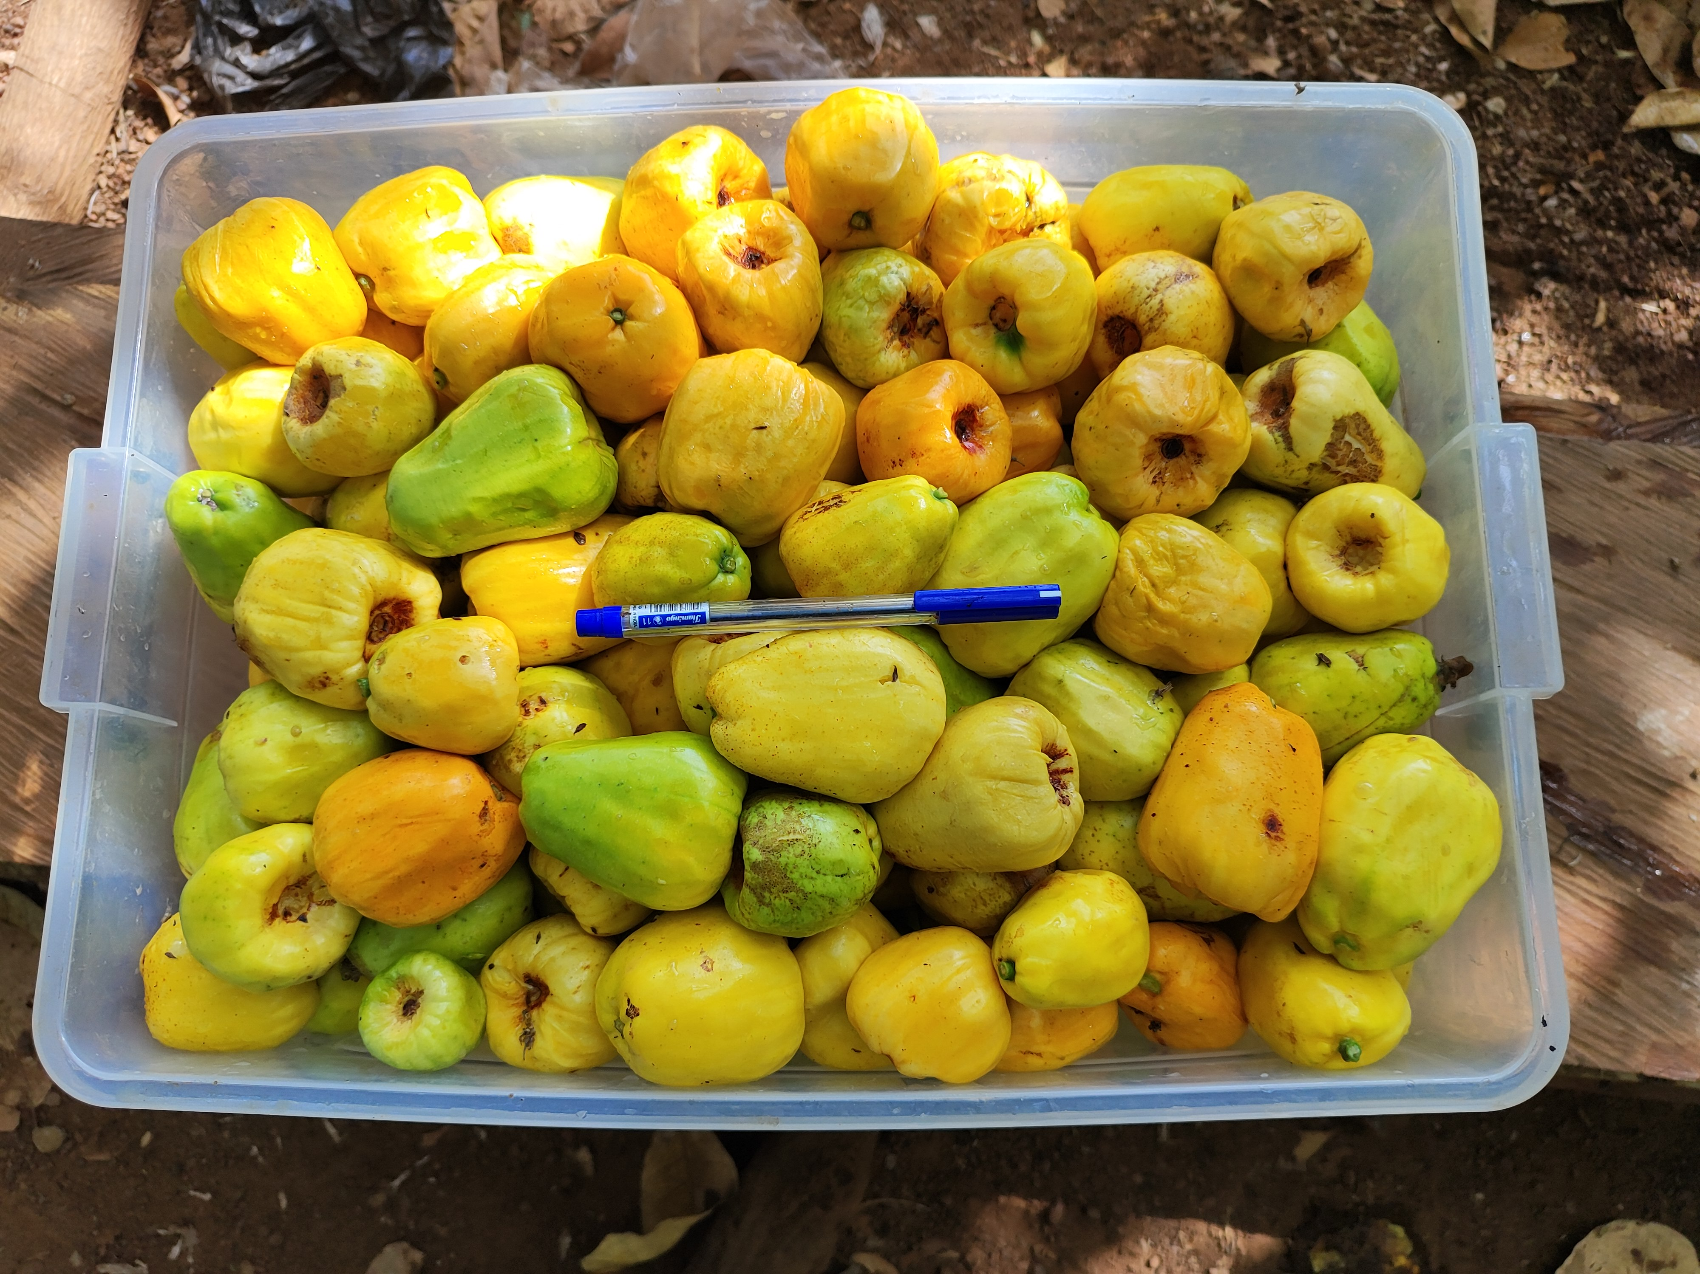 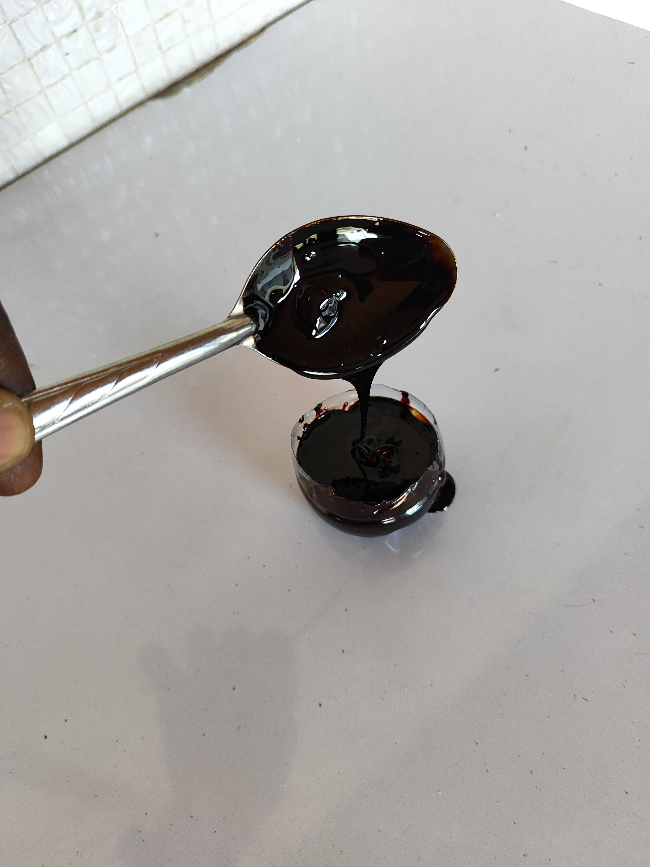

Sorting/Washing

Disinfection/Rinsing

Pressing

Clarification

Filtration

**Figure 3** : Cashew apple juice production diagram (Ouattara et al., 2017a)

**3.3. Physico-chemical and biochemical characterization of substrates**

For the characterization of the substrates, it is important to note that the tasks were performed three times in succession for each sample.

**3.3.1. Measuring the pH of samples**

The pH of the samples was determined by the AOAC (1990) method, based on potentiometry and described by (Askari *et al*., 2012). This consists first of calibrating the pH meter, then immersing the pH meter electrode in the solution (substrate), and the pH value is displayed on the device screen.

**3.3.2. Determination of titratable acidity**

The total titratable acidity of the samples was determined by a titrimetric analysis at pH 8.1 with a 0.1N sodium hydroxide (NaOH) solution according to the AOAC (1990) method, described by (Askari *et al*., 2012).

**3.3.3. Determination of total nitrogen**

For the determination of total nitrogen, the Kjeldahl method (Lynch *et al*., 2002) was used. The method consists of transforming nitrogenous organic matter into ammonia. This involves first mineralizing the nitrogenous organic matter in the form of ammonium. The degradation of nitrogenous organic matter was carried out using sulfuric acid (0.1N).

**3.3.4. Determination of protein**

The protein content of the samples was determined by the Kjeldahl method (Lynch *et al.*, 2002). This method consists of determining total nitrogen by the Kjeldahl method by first mineralizing the nitrogenous organic matter in the form of ammonium. The degradation of nitrogenous organic matter was carried out using sulfuric acid with selenium as a catalyst. Then, the protein nitrogen conversion coefficient (6.25) was applied to find the protein concentration (QP) of the samples, according to the following relationship:

**(Eq.1)**

*QP = 6.25 × QN*

With, QN: quantity of nitrogen (g/100ml)

**3.3.5. Determination of vitamin C**

Regarding the determination of vitamin C, the method described by (Tillmans *et* *al*., 1932) was used. It is based on the titration of 2,6-dichlorophenol indophenol (2,6-DCPIP), which consists of the reduction of 2,6-DCPIP and the oxidation of ascorbic acid to give dehydroascorbic acid. In practice, 30g of metaphosphoric acid (HPO3) were dissolved in 200 ml of distilled water, then 80ml of acetic acid were added. Subsequently, the resulting solution is made up to 1000 ml with distilled water and stored in the refrigerator at 4°C for 5 days. The quantity of vitamin C, in mg/100 ml, is obtained by the following relationship:



**(Eq.2)**

With,

fd: dilution factor;

P: mass of pressed apples;

Vo: volume of 2,6-DCPIP poured to titrate the vitamin C solution;

Ve: volume of 2,6-DCPIP poured to titrate the supernatant;

Vc: volume of 2,6-DCPIP poured to titrate the metaphosphoric/acetic acid solution.

**3.3.6. Dosage of reducing sugars**

The determination of reducing sugars (glucose and fructose) was carried out according to the method described by Chanfreau *et al*., (2010). In a test tube containing 1 ml of the sample, 1ml of 3,5-dinitrosalicylic acid (DNS or DNSA) or 2-hydroxy-3,5-dinitrobenzoic acid is added and placed in a water bath at 100°C for 15 minutes. After this step, 10 ml of distilled water are added to the mixture and then vortexed to homogenize. Finally, the tube is placed in the dark in a dark chamber for 50 minutes, followed by reading the optical density (OD) at 540 nm with a JASCO V-530 spectrophotometer against a blank.

**3.3.7. Dosage of total sugars**

The determination of total sugars was carried out according to the method described by (Dubois *et al*., 1952). This method consists of introducing 100 µL of water-soluble sugar extracts into a test tube, then respectively adding 1 ml of phenol (5% w/v), 0.9 ml of distilled water, and 5 ml of concentrated sulfuric acid at 95%. Subsequently, the tubes were mechanically shaken, followed by cooling in a dark chamber. The optical density at 540 nm was read with a JASCO V-530 spectrophotometer against a blank. A standard curve was made from a glucose stock solution (1mg/ml). The total sugar concentration of the samples was determined using the regression line equation from the standard curve.

**3.3.8. Determination of minerals**

The determination of minerals in the samples was made possible by the technique of inductively coupled plasma mass spectrometry (Thermo Fisher Scientific Chromatography and Mass Spectrometry Hanna-Kunath-Strasse 11, Bremen, Germany), known as ICP-MS. This consisted of adding 10 ml of hydrochloric acid (0.1 N) to 20 ml of each sample in a 200 ml flask. Then, 20 ml of deionized water were added to the flask to bring the mixture to 50 ml. Subsequently, the mixture underwent filtration using a 0.45 µm syringe filter into test tubes. Finally, 10 ml of each final solution were taken for the determination of minerals in the samples using ICP-MS (Poitevin, 2016).

**3.4. Statistical analysis**

One-way analysis of variance (ANOVA) associated with Duncan's test was performed using STATISTICA version 7.0 software to compare the variables measured on the different samples. Differences were considered significant for P values < 0.05. This software also allowed the calculation of means and standard deviations of the analyzed parameters.

**4. RESULTS**

The key results of the physico-chemical and biochemical parameters of this study are summarized in Tables 1 and 2.

**Table 1** : Physical and chemical parameters of cashew apple juice and sugarcane molasses

|  |  |  |  |  |  |  |  |
| --- | --- | --- | --- | --- | --- | --- | --- |
|  |  |  |  | **Samples** |  |  |  |
| **Parameters** | **CAJ-YAK** | **CAJ-DIM** | **CAJ-BKE** | **CAJ-MKN** | **CAJ-VVA** | **CAJ-KRG** | **SCM** |
| pH | 4.05±0.02a | 4.07±0.02a | 4.08±0.02a | 4.05±0.02a | 4.10±0.01a | 4.08±0.02a | 5.00±0.02b |
| Acidity (g/l) | 2.02±0.01a | 1.97±0.03 a | 2.74±0.32b | 2.93±0.07b | 2.94±0.02b | 2.73±0.15b | 4.13±0.1c |
| Calcium (mg/l) | 178.03±0.07b | 177.76± 0.01b | 178.40±0.03c | 176.95±0.03a | 178.45±0.03c | 177.97±0.02b | 7610.42±0.02d |
| Magnesium (mg/l) | 176.47±0.03d | 175.58±0.01c | 176.99±0.06e | 177.03 ±0.04e | 174.63±0.04b | 176.21±0.03d | 48.79±0.02a |
| Iron (mg/l) | 46.84±0.05c | 45.32±0.02b | 47.44±0.02d | 45.23±0.02b | 47.18±0.03d | 46.47±0.03c | 4.59±0.04a |
| Sodium (mg/l) | 24.05±0.03b | 23.79±0.05a | 24.02±0.04b | 24.13±0.02b | 23.95±0.03a | 23.77±0.02a | 1860.43±0.03c |
| Potassium (mg/l) | 1162.11±0.74a | 1201.12±0.32e | 1177.32±0.04c | 1164.76±0.02b | 1203.01±0.03f | 1197.20±0.03d | 5431.35±0.02g |
| Phosphorus (mg/l) | 172.75±0.24e | 173.45± 0.01f | 167.73±0.02d | 166.83±0.03c | 165.35±0.02b | 162.15±0.02a | 675.91±0.47g |

**Table 2** : Biochemical parameters of cashew apple juice and sugarcane molasses

|  |  |  |  |  |  |  |  |
| --- | --- | --- | --- | --- | --- | --- | --- |
|  |  |  |  | **Samples** |  |  |  |
| **Parameters** | **CAJ-YAK** | **CAJ-DIM** | **CAJ-BKE** | **CAJ-MKN** | **CAJ-VVA** | **CAJ-KRG** | **SCM** |
| Nitrogen (g/100ml) | 0.13±0.33a | 0.14±0.28a | 0.13±0.28a | 0.13±0.05a | 0.12±0.16a | 0.13±0.55a | 0.12±0.06a |
| Protein (g/100ml) | 0.81±0.05b | 0.88±0.07b | 0.81±0.02b | 0.81±0.04b | 0.75±0.06a | 0.81±0.02b | 0.75±0.03a |
| Vitamin C (mg/100ml) | 187.26±0.92e | 185.96±0.32d | 187.10±0.22e | 188.45±0.64f | 181.61±0.37b | 182.59± 0.48c | 0.35±0.57a |
| Glucose (g/l) | 52.02± 0.05d | 51.80±0.03c | 51.72±0.04c | 51.98±0.03c | 48.82±0.05b | 55.84±0.01e | 26.94±0.02a |
| Fructose (g/l) | 42.79±0.06b | 44.91±0.02c | 46.17±0.03e | 45.65±0.05d | 44.89±0.04c | 48.98±0.01f | 17.67±0.06a |
| Total sugars (g/l) | 110.07±0.02e | 105.41±0.03c | 109.02±0.05d | 104.76±0.02b | 110.67±0.55f | 111.31±0.02g | 59.13±0.03a |

Within the same row, mean values with different letters are significantly different; P < 0.05 (Duncan's test).

* CAJ-YAK : Cashew Apple Juice from Yamoussoukro ;
* CAJ-DIM : Cashew Apple Juice from Dimbokro ;
* CAJ-BKE : Cashew Apple Juice from Bouaké ;
* CAJ-MKN : Cashew Apple Juice from Mankono ;
* CAJ-VVA : Cashew Apple Juice from Vavoua ;
* CAJ-KRG : Cashew Apple Juice from Korhogo ;
* SCM : Sugarcane molasses

**Table 1** presents the physico-chemical characteristics of cashew apple juice and sugarcane molasses. The analysis of the results shows that all samples are acidic substances with pH values ranging from 4.05 ± 0.02 to 5.00 ± 0.02. This analysis reveals that there is no significant difference in the pH of the cashew apple juice samples. However, compared to the sugarcane molasses sample, there is a significant difference. This is reflected in the variable acidity of all samples (from 1.97 ± 0.03 to 4.13 ± 0.1 g/L).

Regarding minerals (Ca, Mg, Fe, Na, K, and P), the results show that cashew apple juice and sugarcane molasses have significant concentrations, with values ranging from 23.77 ± 0.02 to 7610.42 ± 0.02 mg/L. In cashew apple juice, sodium is the least represented mineral, with a concentration ranging from 23.77 ± 0.02 to 24.13 ± 0.02 mg/L, while potassium is the most represented mineral, with proportions ranging from 1162.11 ± 0.74 to 1203.01 ± 0.03 mg/L. These values show that there is a significant difference (P<0.05) in the mineral composition of all cashew apple juice samples. As for the mineral composition of sugarcane molasses, iron is the element with the lowest concentration, with a value around 4.59 ± 0.04 mg/L, while calcium is the element with the highest concentration, with a value of approximately 7610.42 ± 0.02 mg/L. Table 1 also reveals that the mineral composition of sugarcane molasses is higher than that of cashew apple juice.

**Table 2** presents the biochemical composition of the two substrates. The results show that the nitrogen contents of all analyzed samples range from 0.12 ± 0.06 to 0.14 ± 0.28 g/100 mL. The sample with the highest nitrogen concentration is from Dimbokro (CAJ-DIM), and the lowest concentration was recorded in the Vavoua sample (CAJ-VVA) and sugarcane molasses (SCM) with identical values (0.12 ± 0.06 g/100 mL). Statistical analysis revealed that there is no significant difference in the nitrogen concentration of all samples.

The protein content of cashew apple juice samples varies from 0.75 ± 0.06 to 0.88 ± 0.07 g/100 mL, while that of sugarcane molasses is around 0.75 ± 0.03 g/100 mL. These results show that cashew apple juice and sugarcane molasses are low in protein. The analysis of the samples reveals that there is a significant difference (P<0.05) between the protein contents of these samples.

The vitamin C content of cashew apple juice samples varies from 181.61 ± 0.37 to 188.45 ± 0.64 mg/100 mL. Thus, the cashew apple juice richest in vitamin C is from Mankono (CAJ-MKN), while the Vavoua juice (CAJ-VVA) has the lowest vitamin C content. Furthermore, the vitamin C content of sugarcane molasses is around 0.35 ± 0.57 mg/100 mL, which shows that molasses is low in vitamin C. Therefore, the results indicate that cashew apple juice is richer in vitamin C compared to sugarcane molasses. The analysis revealed a significant difference (P<0.05) between the vitamin C contents of all samples.

The reducing sugar content of the samples is summarized in Table 2. The glucose content of cashew apple juice samples varies from 48.82 ± 0.05 to 55.84 ± 0.01 g/L, while that of molasses is around 26.94 ± 0.02 g/L. Regarding the glucose concentration of cashew apple juices, the highest was observed in Korhogo (55.84 ± 0.01 g/L), while the lowest was from Vavoua (48.82 ± 0.05 g/L). The analysis reveals a significant difference (P<0.05) between the glucose contents of all samples. In contrast, the fructose content of cashew apple juice samples varies from 42.79 ± 0.06 to 48.98 ± 0.01 g/L, and that of sugarcane molasses is around 17.67 ± 0.06 g/L. These values show that there is a significant difference (P<0.05) in the fructose content of cashew apple juice and sugarcane molasses.

The total sugar content of cashew apple juice varies from 104.76 ± 0.02 to 111.31 ± 0.02 g/L. As for sugarcane molasses, its total sugar content is around 59.13 ± 0.03 g/L. For cashew apple juice, Korhogo (CAJ-KRG) has the highest total sugar content, and the lowest value was observed in Mankono (CAJ-MKN) (Table 2). Statistical analysis revealed a significant difference (P<0.05) between the total sugar contents of all samples.

**5. DISCUSSION**

The results showed that all samples have an acidic pH. The acidic nature of cashew apple juice may be due to its richness in ascorbic acid and phenolic compounds (flavonoids and condensed tannins). Similar findings were reported by (N'cho *et al*., 2024) during studies conducted on cashew apple juice for the formulation of dairy beverages. This similarity with the results of the aforementioned authors could be explained by the identical origin (Côte d'Ivoire) of the cashew apples used in both studies. Similar observations were made by (Ouattara *et al*., 2017) during studies on various formulations of cashew apple juice. Regarding sugarcane molasses, its acidity may be attributed to the presence of organic acids such as citric acid and malic acid. Similar results were recorded by (Palmonari *et al*., 2020) during analyses on the chemical composition of sugarcane and beet molasses.

The mineral richness observed in cashew apple juice may be due to the natural composition of cashew apples (Ouattara *et al*., 2017a). Minerals such as Calcium (Ca), Magnesium (Mg), Iron (Fe), Sodium (Na), Potassium (K), and Phosphorus (P) are naturally present in the soil, where they are absorbed by the plant during its growth. Subsequently, at maturity, these minerals become concentrated in the fruits (Adou *et al*., 2012a) of these plants. As for sugarcane molasses, its mineral richness may be explained by the sugar production process, where minerals accumulate in the molasses, while cashew apple juice primarily contains sugars and water (Geremew Kassa *et al*., 2024). Similar findings were recorded by (Dedehou *et al*., 2015) for cashew apple juice during studies conducted on cashew apple juice transformation in Benin, and by (Palmonari *et al*., 2020) for sugarcane molasses during studies on the characterization of sugarcane and beet molasses. Furthermore, other authors have obtained similar characteristics during research on the therapeutic valorization of molasses (Jamir *et al*., 2021). The presence of these minerals (Ca, Mg, Fe, Na, K, and P) in cashew apple juice and sugarcane molasses indicates that these agro-resources can serve as substrates for lactic fermentations, particularly in contributing to the nutrition of lactobacilli and also stimulating their growth (Yeboah *et al*., 2023).

The results revealed a low protein content in both substrates. This may be due to the natural composition of these two substrates. Indeed, cashew apples and sugarcane primarily contain carbohydrate compounds, water, and fibers. Additionally, their processing methods, which require pressing and heat, denature nutrients like proteins (Mangwanda *et al*., 2021). Furthermore, cultivation conditions, such as phytosanitary treatments of plants and soil quality, can influence the protein content of these products (Adou *et al*., 2012a). Similar findings were recorded by (Geremew Kassa et al., 2024) during studies on the characterization of sugarcane molasses.

The results revealed that cashew apple juice is rich in vitamin C. Indeed, cashew apple juice typically has a higher vitamin C content compared to other citrus fruits like oranges. This richness may be attributed to cultivation conditions such as growth conditions. Other factors, such as sunlight, climate, soil quality, and agricultural practices, may also play a role in vitamin C concentration (Adou *et a*l., 2012b). Furthermore, the results revealed that sugarcane molasses is poor in vitamin C. This may be due to the production process, which involves pressing and heat that denature the proteins. Similar results were reported by (Jamir *et al*., 2021), who observed that molasses is almost devoid of vitamin C.

The results revealed a high concentration of reducing sugars, with higher glucose levels compared to fructose in all samples. This may be explained by the fact that naturally in fruits, glucose concentration is higher than fructose concentration. Additionally, during processing, sucrose is partially hydrolyzed, releasing more glucose than fructose (Mangwanda *et al*., 2021). The chemical stability of the two molecules (glucose and fructose) may also explain the higher glucose concentration. Indeed, glucose is chemically more stable than fructose, meaning it is less likely to degrade or react with other compounds during the processing or storage of these two substrates (Zafar *et al*., 2021). Similar findings were recorded by (Jamir *et al*., 2021) during studies on the therapeutic valorization of molasses.

The results revealed a high total sugar content in all samples. The richness in total sugars of cashew apple juice and sugarcane molasses may be due to their plant origin (Geremew Kassa *et al*., 2024). Cashew apples, being fleshy fruits, contain simple and complex carbohydrates, which are naturally transformed into total sugars (glucose, fructose, sucrose) during maturation (Soro, 2012). Similarly, sugarcane molasses is a concentrated by-product of the sugar extraction process, which makes it naturally rich in total sugars (Palmonari *et al*., 2020). These results are comparable to those obtained by (Jamir *et al.,* 2021). The nutritional and biochemical composition of these substrates necessitates their valorization into other products of economic interest.

**4. CONCLUSION**

The study of the physico-chemical and biochemical parameters of cashew apple juice and sugarcane molasses is a prerequisite for their valorization into other products of economic interest. The analysis focused on six (6) samples of cashew apples from different cashew nut production areas in Côte d'Ivoire (Yamoussoukro, Dimbokro, Bouake, Mankono, Vavoua, and Korhogo) and one (1) sample of sugarcane molasses provided by the Sucre Ivoire company of the SIFCA group. The results showed good mineralogical and biochemical quality of these two substrates, particularly in vitamin C and carbohydrate compounds. Indeed, the richness in carbohydrates, vitamin C, and minerals of these substrates shows that they can be used as substitutes in human and animal feed. These substrates can also be used in microbial fermentation for the production of biomolecules of interest.

Disclaimer (Artificial intelligence)

Author(s) hereby declare that NO generative AI technologies such as Large Language Models (ChatGPT, COPILOT, etc.) and text-to-image generators have been used during the writing or editing of this manuscript.

REFERENCES

Anonymous, (2021). Report of the Cotton and Cashew Council of Côte d'Ivoire; Ministry of Agriculture and Rural Development of the Republic of Côte d'Ivoire, Abidjan.

Adou, M., Tetchi, F. A., Gbané, M., Kouassi, K. N., & Amani, N. G. (2012a). Physico-chemical characterization of cashew apple juice (anacardiumouest, L.) from yamoussoukro (ivory coast).

Adou, M., Tetchi, F. A., Gbané, M., Kouassi, K. N., & Amani, N. G. (2012b). Physico-chemical characterization of cashew apple juice (anacardiumouest, l.) from yamoussoukro (Ivory Coast).

Adou, M., Tetchi, F. A., Gbané, M., Kouassi, K. N., & Amani, N. G. G. (2012c). Physicochemical characterization of cashew apple juice (Anacardium occidentale) from Yamoussoukro (Côte d'Ivoire).

Askari, G. A., Kahouadji, A., Khedid, K., Charof, R., & Mennane, Z. (2012). Physicochemical and microbiological characterization of dried figs collected from the markets of Rabat-Salé, Temara, and Casablanca. 7.

Chanfreau, S., Mena, M., Porras-Domínguez, J. R., Ramírez-Gilly, M., Gimeno, M., Roquero, P., Tecante, A., & Bárzana, E. (2010). Enzymatic synthesis of poly-l-lactide and poly-l-lactide-co-glycolide in an ionic liquid. Bioprocess and Biosystems Engineering, 33(5), 629-638. https://doi.org/10.1007/s00449-009-0388-8

Dedehou, E., Dossou, J., & Soumanou, M. (2015). Diagnostic study of cashew apple processing technologies into juice in Benin. International Journal of Biological and Chemical Sciences, 9(1), 371. https://doi.org/10.4314/ijbcs.v9i1.32

Geremew Kassa, M., Asemu, A. M., Belachew, M. T., Satheesh, N., Abera, B. D., & Alemu Teferi, D. (2024). Review on the application, health usage, and negative effects of molasses. *CyTA - Journal of Food*, *22*(1), 2321984. https://doi.org/10.1080/19476337.2024.2321984

Honorato, T. L., Rabelo, M. C., Gonçalves, L. R. B., Pinto, G. A. S., & Rodrigues, S. (2007). Fermentation of cashew apple juice to produce high added value products. World Journal of Microbiology and Biotechnology, 23(10), 1409-1415. <https://doi.org/10.1007/s11274-007-9381-z>

Jamir, L., Kumar, V., Kaur, J., Kumar, S., & Singh, H. (2021). Composition, valorization and therapeutical potential of molasses : A critical review. *Environmental Technology Reviews*, *10*(1), 131‑142. https://doi.org/10.1080/21622515.2021.1892203

Lautié, E., Dornier, M., M. de Souza Filho, & Reynes, M. (2001). Cashew tree products: Characteristics, valorization routes and markets. Fruits, 56(4), 235-248. https://doi.org/10.1051/fruits:2001126

Lebailly, P., Lynn, S., and Seri, H. (2023). Analysis of the cashew chain in Côte d’Ivoire. Report for the European Union, DG-INTPA. Value Chain Analysis for Development Project (VCA4D CTR 2017/392-417),. 128 pp.

Lynch, J. M., Barbano, D. M., Fleming, J. R. (2002). Determination of the Total Nitrogen Content of Hard, Semihard, and Processed Cheese by the Kjeldahl Method: Collaborative Study. Journal of AOAC INTERNATIONAL, 85(2), 445-455. https://doi.org/10.1093/jaoac/85.2.445

Mangwanda, T., Johnson, J. B., Mani, J. S., Jackson, S., Chandra, S., McKeown, T., White, S., & Naiker, M. (2021). Processes, Challenges and Optimisation of Rum Production from Molasses—A Contemporary Review. *Fermentation*, *7*(1), 21. https://doi.org/10.3390/fermentation7010021

Michel Dubois, E. F., K. A. Gilles, M. R., J. K. Hamilton, C. W. P., P. A. Rebers, O., & Fred Smith, L. M. F. (1952). Colorimetric Method for Determination of Sugars and Related Substances. International Journal of Biological Macromolecules, 146, 285-289. <https://doi.org/10.1016/j.ijbiomac.2019.12.180>

N’cho, C., Soro, D., Konan, Y. N., & Koffi, E. K. (2024). Sensory characterization of dairy beverage formulations based on cashew milk and pineapple juice. *International Journal of Biological and Chemical Sciences*, *17*(7), 2885‑2897. https://doi.org/10.4314/ijbcs.v17i7.22

Ndiaye, S., Charahabil, M. M., & Diatta, M. (2021). Characteristics of cashew plantations (Anacardium occidentale L.) and economic determinants of farms in Casamance. VertigO. https://doi.org/10.4000/vertigo.28723

Ouattara, G. S., Soro, D., Chatigre, K. O., & Koffi, E. K. (2017a). Physicochemical and sensory characterization of various cashew apple and pineapple juice formulations. International Journal of Biological and Chemical Sciences, 10(6), 2447. https://doi.org/10.4314/ijbcs.v10i6.4

Ouattara, G. S., Soro, D., Chatigre, K. O., & Koffi, E. K. (2017b). Physicochemical and sensory characterization of various cashew apple and pineapple juice formulations. International Journal of Biological and Chemical Sciences, 10(6), 2447. https://doi.org/10.4314/ijbcs.v10i6.4

Palmonari, A., Cavallini, D., Sniffen, C. J., Fernandes, L., Holder, P., Fagioli, L., Fusaro, I., Biagi, G., Formigoni, A., & Mammi, L. (2020). Short communication: Characterization of molasses chemical composition. Journal of Dairy Science, 103(7), 6244-6249. https://doi.org/10.3168/jds.2019-17644

Poitevin, E. (2016). Official Methods for the Determination of Minerals and Trace Elements in Infant Formula and Milk Products: A Review. Journal of AOAC International, 99(1), 42-52. https://doi.org/10.5740/jaoacint.15-0246

Soro, D., Dornier, M., Abreu, F., Assidjo, E., Yao, B., & Reynes, M. (2012). Publications and Communications.

Soro, D., Moctar, C., Kone, Y. K., Assidjo, E. N., Yao, B. K., & Dornier, M. (2017a). Valorization of cashew apple (Anacardium occidentale) and impact of vacuum concentration at different temperatures on juice quality. 19(1).

Soro, D., Moctar, C., Kone, Y. K., Assidjo, E. N., Yao, B. K., & Dornier, M. (2017b). Valorization of cashew apple (Anacardiumouest) and impact of vacuum concentration at different temperatures on juice quality. 19(1).

Tillmans, J., Hirseh, P., & Hirseh, W. (1932.). Das Reduktionsvermiigen pflanzlieher Lebensmittel und seine B e z i e h u n g zum Vitamin C. I. Der reduzierende Stoff des Citronensaftes.

Toure, F.K., Koffi, E., & Agbo, G. N. (2010). Yield-related factors in the cane refinery of the Ferke 1 sugar perimeter in Ivory Coast. African Agronomy, 22(1), 85-95. https://doi.org/10.4314/aga.v22i1.62322

Yeboah, P. J., Ibrahim, S. A., & Krastonov, A. (2023). A review of fermentation and the nutritional requirements for effective growth media for lactic acid bacteria. *Food Science and Applied Biotechnology*, *6*(2), 215. https://doi.org/10.30721/fsab2023.v6.i2.269

Zafar, M. I., Frese, M., & Mills, K. E. (2021). Chronic Fructose Substitution for Glucose or Sucrose in Food or Beverages and Metabolic Outcomes : An Updated Systematic Review and Meta-Analysis. *Frontiers in Nutrition*, *8*, 647600. https://doi.org/10.3389/fnut.2021.647600