ZINC IN HUMAN NUTRITION: AN OVERVIEW
ABSTRACT
Zinc is an essential trace element crucial for numerous biological processes, including cellular growth, immune function, and enzymatic activities. It plays a significant role in human health, with its deficiency linked to impaired growth, weakened immunity, and increased susceptibility to infections. Zinc is widely distributed in various food sources, including meat, seafood, dairy, and plant-based options such as nuts and legumes. Despite its availability, zinc deficiency remains a global concern, particularly in regions where dietary intake is insufficient. Bioavailability is influenced by dietary components, with inhibitors like phytic acid reducing absorption and enhancers like amino acids improving it. Zinc supplementation and food fortification strategies are critical in addressing deficiency-related health issues. Additionally, zinc has therapeutic implications in immune function, cardiovascular diseases, diabetes, neurodegenerative disorders, and mental health. It has also been demonstrated that adequate zinc levels lower the chance of acquiring problems from diabetes with its role in glucose metabolism. Ensuring adequate zinc intake is essential for optimal health across all life stages.
Key words: zinc, nutrition, deficiency, bioavailability, supplementation
INTRODUCTION
Zinc is a bluish-white metallic element with atomic number 30 and atomic weight of 65.4. It is the twenty third most abundant elements and is the second most abundant element after iron (Fe) and it makes up 0.02% of the earth’s crust (Brown et al.,2001; Lubna and Ahmad, 2023). The second most prevalent trace element in the human body, zinc is also one of the most vital elements needed for the body's general health (Katimba et al. 2024). It is an essential trace element having a complex biology, highlighting its great ubiquity and adaptability (Hambidge,2000; Camara and Amaro,2003). More than 125 years ago, zinc was identified as a crucial component for bacteria. Nevertheless, signs of human zinc insufficiency started to show up in the 1960s, when Egyptian teenagers were the first to be diagnosed with dwarfism responsive to zinc and delayed sexual maturation. More than 50 different metalloenzymes with a variety of functions, including the creation of nucleic acids and certain proteins like hormones and their receptors, are connected to zinc. Zinc is crucial for cellular development, differentiation, and many metabolic processes in human (Brown et al., 2001; Dijkhuizen et al.,2001). It is an essential element that helps with cellular functions, boost immunity and cures infections (Jin et al., 2024). All of the body's tissues, fluids, and organs contain zinc. An adult human's total body zinc content ranges between 1.5 and 2.0 grams, or roughly 0.003% of their total weight (Despande et al., 2013).
ZINC REQUIREMENTS
Consistent dietary intake, particularly during infancy, adolescence, and pregnancy, is required to support the processes of cellular growth and tissue differentiation and also to maintain the exchangeable zinc pool because the human body lacks a long-term storage system for zinc (Sangeetha et al., 2022). Zinc is required in relatively high amount in infants and children to support growth and development. More zinc is necessary for children's developing immune systems (Gondal et al., 2021). The requirements for zinc peak during adolescence at the time of the pubertal growth spurt and the demand for zinc increased during pregnancy and lactation. With ageing, there is evidence of decreased zinc absorption efficiency which lead to increase in requirement (Roohani et al., 2013).

Table1: RDA and Tolerable Upper Limit (TUL) for Zinc (RDA,2020)
Age group | Category of work | RDA (mg/day) | UL (mg/day)
Men | All | 17 | 40
Women | Normal | 13.2 | 40
Women | Pregnant | 14.5 | 40
Women | Lactating | 14 | 40
Infants | 0-6m | - | 4
Infants | 6-12m | 2.5 | 5
Children | 1-3yr | 3.0 | 7
Children | 4-6 yr | 4.5 | 12
Children | 7-9 yr | 5.9 | 12
Boys & Girls | 10-12yr | 8.5 | 23
Boys | 13-15yr | 14.3 | 34
Girls | 13-15yr | 12.8 | 34
Boys | 16-18yr | 17.6 | 34
Girls | 16-18yr | 14.2 | 34

SOURCES OF ZINC
Zinc is available in meat, liver, kidney, fish, shellfish, chicken and cereals. Cooked dried beans, sea vegetables, fortified cereals, soyfoods, almonds, peas, and seeds are important plant sources of zinc. Mushrooms, day lily blossoms, edible fungi, cabbage, black sesame, black rice, dates, hazelnuts, ebony, and other plants, food crops, and fruit are all excellent sources of zinc. Beans, nuts, almonds, whole grains, pumpkin seeds, sunflower seeds, and blackcurrants are additional sources of zinc (Despande et al.,2013)
Table 2: Zinc content of some foods
Foods | Zn content (mg/100g)
Egg, yolk, dried | 7.11
Seeds, pumpkin seeds (pepitas), raw | 6.34
Nuts, pine nuts, raw | 5.71
Beef, flank, steak, boneless, choice, raw | 5.56
Egg, whole, dried | 5.02
Flaxseed, ground | 4.74
Cheese, parmesan, grated, refrigerated | 4.62
Flour, soy, defatted | 4.44
Lentils, dry | 3.86
Beans, dry, medium red (0% moisture) | 3.82
(Source:Jin et al., 2024)
ZINC DEFICIENCY
Zinc has crucial structural and functional roles in numerous enzyme systems that are involved in gene expression, cell division and growth, as well as immunologic and reproductive activities, making adequate zinc nutrition vital for human health. Zinc deficiency consequently impacts children's physical development as well as the likelihood and severity of a number of infections. A significant risk factor for the morbidity and mortality of children is a zinc deficiency (Hess et al., 2009). For healthy pregnancy outcomes, child growth, immunological function, and neurobehavioral and sexual development, enough zinc diet is required (Wessells and Brown,2012; Verma et al., 2024). It is more common in regions where the consumption of cereal and animal foods is low (Bhandari et al., 2007; Roohani et al., 2013).
One of the main reasons of zinc insufficiency is inadequate dietary intake of absorbable zinc and low bioavailability. Low-income nations are more likely to experience zinc deficiency due to three primary causes:
- insufficient dietary zinc intake or absorption from diets primarily composed of plants,
- diseases that either cause high zinc losses or hinder its use, and
- physiological conditions that enhance the need for zinc, such as times of fast growth in adolescence and pregnancy (Hess et al., 2009).
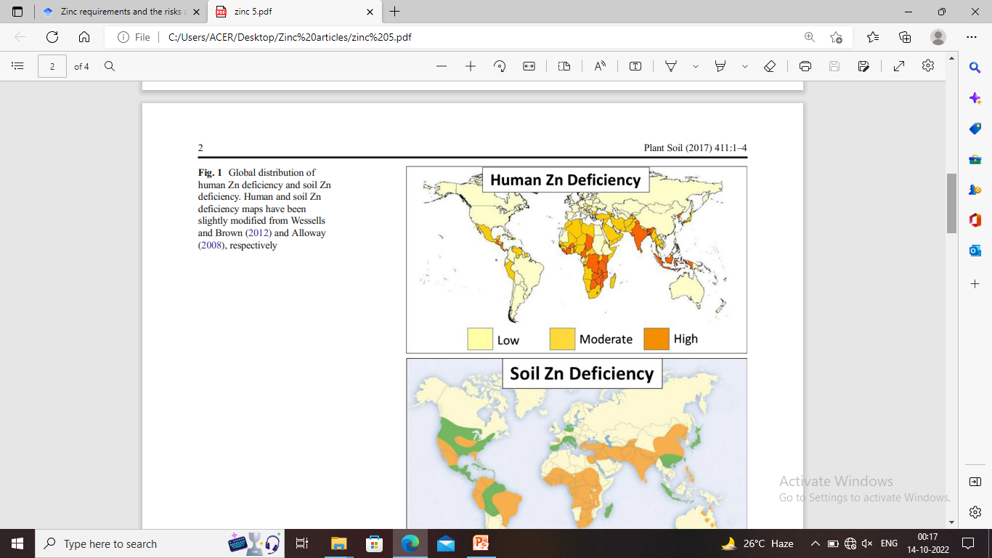
Fig 1: Global distribution of human Zn Deficiency (Cakmak et al., 2017)
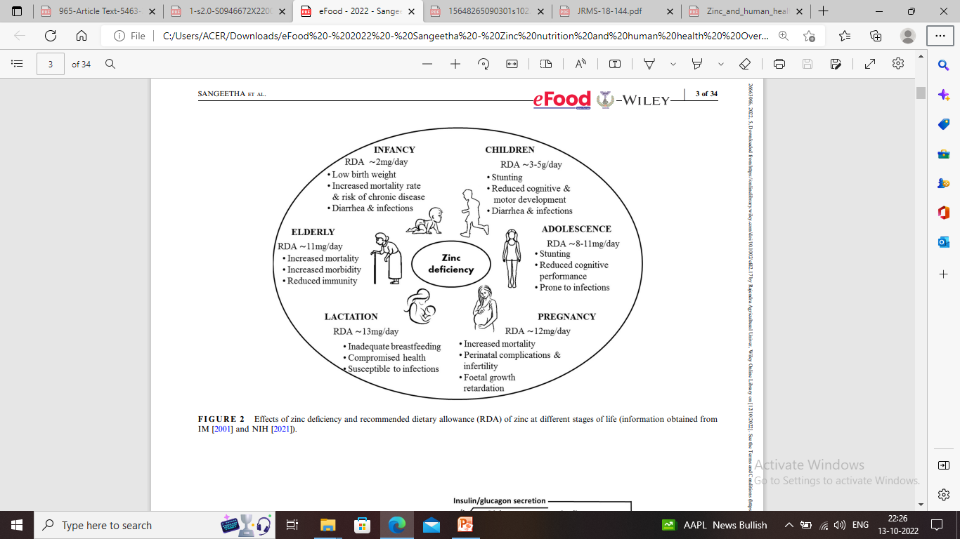
Fig 2: Effects of zinc deficiency and recommended dietary allowance (RDA) of zinc at different stages of life (Sangeetha et al., 2022).

DEFICIENCY SYMPTOMS
Growth retardation, malabsorption syndrome, impaired immunity, low blood pressure, weakened bones, loss of appetite, loss of taste and smell, weight loss, pale skin, skin lesions, diarrhoea, hair loss, fatigue, and white spots beneath the fingernails are some of the signs of zinc deficiency (Despande et al.,2013; Shi et al., 2024). Poor growth, immunocompetence and delayed development in children and adolescents may be seen before other symptoms of zinc deficiency are noticed (Dijkhuizen et al., 2001; Sazawal et al., 2014). An apparent early sign of zinc deficiency is the inhibition of certain components of cell-mediated immunity. Dermatitis, failure to thrive, anorexia, dysgeusia, hypogonadism are some clinical manifestations of zinc deficiency (Silva et al., 2006). Patients may have slow healing of skin wounds without other visible indicators of zinc deficiency, their hair may be easy to pull out and they may have alopecia, black hair turns to reddish brown hair. Reduced nerve conduction, ataxia, confusion, and poor neuropsychological function are just a few symptoms of nervous system effects. Initial symptoms of a zinc deficiency are vague or non-specific. Other signs of insufficiency may be noticed after it has been present for a while (Maret and Sandstead,2006).
ZINC ABSORPTION
Muscles and bones store the majority of the body's zinc (60% and 30% respectively), followed by the liver (5%), and other tissues (23%) (Sangeetha et al., 2022; Lubna and Ahmad, 2023). A wide variety of dietary zinc concentrations that support the body's systemic homeostatic mechanism can be used to establish balanced zinc content in the body. The key mechanisms for preserving its homeostasis are its absorption and excretion (Sangeetha et al., 2022). The condition of a person's body with regard to this trace element is one of the major influencing variables of zinc availability. The amount of zinc absorbed depends on the diet consumed previously. Based on the kind of diet, amount of zinc, and phytate (a key inhibitor of zinc absorption), as well as owing to disorders that impede intestinal absorption or increase the intestinal loss of zinc, or both, absorption rates vary among various demographic groups (Cunha et al.,2022).
Zinc is absorbed all along the small intestine. The jejunum absorbs zinc at the highest rate (Sangeetha et al., 2022). Unabsorbed zinc is expelled in faeces and urine while zinc is absorbed in the small intestine and its metabolism is primarily carried out in the liver (Lubna and Ahmad, 2023). Children who had previously consumed smaller amounts of zinc had higher percentages of zinc absorbed (Camara and Amaro, 2003). In young adults, zinc absorption was almost 64% when consumed in amounts of 2.8 to 5 mg per day, but only 39% when consumed in amounts of 12.8 to 15 mg per day (Roohani et al., 2013). There is effect of Ca+2, Mg+2, Fe+2, Cu+2 and Mn+2 on zinc absorption and inhibit Zn+2 uptake at various concentration (Camara and Amaro, 2003). Fasting subjects get zinc in aqueous solutions that are readily absorbed (60–70%); however, zinc absorption from solid foods is less effective and varies depending on zinc amount and diet composition. Depending on the kind of diet and phytate: zinc molar ratio, different population groups have varying rates of absorption (Roohani et al., 2013; Cunha et al., 2022).
Zinc absorption is dependent on its concentration and escalates with increasing dietary zinc up to a maximum rate. Humans who are deficient in zinc absorb this element more effectively, whereas those who consume a diet abundant in zinc have less effective absorption. During digestion, zinc is liberated from food as free ions, which binds to endogenously secreted ligands before being transported into the enterocytes of the duodenum and jejunum. Certain specific transport proteins may make it easier for zinc to cross cell membranes and enter the portal circulation. When intakes are high, zinc is also absorbed passively through the paracellular pathway. There is direct transfer of absorbed zinc to the liver via the portal system, where it is subsequently released into the bloodstream to be distributed to other tissues. The majority of the zinc in the blood is bound to albumin to an extent of around 70%, therefore any circumstances that changes the serum albumin concentration can also affect serum zinc levels (Roohani et al., 2013). Adults typically absorb zinc from their food between 15% and 35% effectively, depending on how much they ingest (Hess et al., 2009).
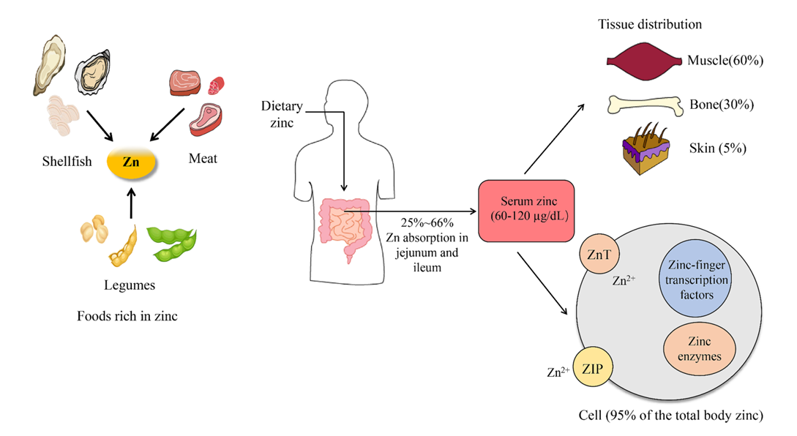
Fig 3: Zinc absorption and uptake (Jin et al., 2024)
ZINC INHIBITORS AND ENHANCERS
The main dietary component known to restrict zinc bioavailability is phytic acid, which binds zinc firmly in the digestive tract. The molar ratios of phytate:zinc in the diet can be used to anticipate the inhibitory effects of phytic acid (PA) on zinc. According to the World Health Organisation (WHO) and the International Zinc Nutrition Consultative Group (IZiNCG), molar ratios above 15:1 or 18:1 have been linked to poor zinc levels in humans. These ratios gradually impede zinc absorption (Roohani et al., 2013).
In whole grain cereals and legumes, processes like soaking, germination, and fermentation encourage the enzymatic hydrolysis of PA by increasing the activity of the native or exogenous phytase enzyme. Phytic acid concentration in plant-based staples has been successfully decreased using non-enzymatic techniques like grinding (Sangeetha et al., 2022). High inorganic iron dosages reduced the amount of zinc that was absorbed, as shown by variations in plasma zinc over the following 4 hours after an oral dose. With increased iron dose, plasma zinc was considerably lowered. Only in aqueous solutions and at very high iron to zinc ratios does iron have an impact on zinc. When the iron/zinc ratio is greater than 3:1 and when humans consume more than 25 mg of total iron, the inhibitory impact is typically observed. Zinc absorption is unaffected by iron fortification (Solomons, 2001; Roohani et al., 2013).
Since protein intake tends to boost zinc absorption, proteins often have a beneficial impact on zinc absorption. The bioavailability of zinc from plant food sources is increased by consuming animal proteins, such as beef, eggs, and cheese, probably because the amino acids produced from the animal protein keep zinc in solution. Zinc absorption is improved by the binding of zinc to soluble ligands or chelators because they make zinc more soluble (Roohani et al., 2013; Sangeetha et al., 2022). Picolinic acid, lactic acid, citrate, and amino acids such as glycine, lysine, cysteine, methionine and histidine are a few substances that improve the absorption of zinc. Protein not only is it increasing zinc availability, but it is also increasing the presence of zinc in the diet (Solomons, 2001; Camara and Amaro, 2003).
ZINC SUPPLEMENTATION
Supplementation is one process of addressing micronutrient deficiency in humans. Targeting vulnerable population subgroups that are particularly at risk of micronutrient deficiencies with supplementation programmes is helpful (Sangeetha et al., 2022). In a population at danger of depleting mineral levels, supplementation works effectively as an urgent measure to replenish zinc appropriately. It is an effective way to reach the target populations who cannot acquire foods high in dietary zinc (Roohani et al., 2013). Zinc supplementation is the best defence against unfavourable pregnancy outcomes for women as well as mortality in infants, pneumonia, and other lung-related illnesses. Zinc supplementations prevented growth retardation and reduced morbidity in infants between the ages of 6 to 24 months and also help in gaining weight in malnourished children. Zinc increases weight gain and linear growth because it is essential for cellular growth, as demonstrated by enteral zinc supplementation in infants. Elderly healthy people who take zinc supplements have better cell-mediated immune responses. Supplementation thus is a more realistic approach to address zinc deficiency (Silva et al., 2006; Sangeetha et al., 2022; Lind et al., 2003).
ZINC IN HEALTH AND DISEASE
Zinc is an essential trace mineral essential for protecting human health at its best. 300 of the body's enzymes need zinc to function properly, and it is also necessary for the creation of DNA and protein, as well as cell division. Several biological processes, including signal transmission and gene expression, are regulated. Zinc is also essential for bone mineralization, healthy thyroid function, blood coagulation, cognitive abilities, sperm generation, taste acuity, connective tissue growth and maintenance, immune system function, prostaglandin formation, tissue growth, and other processes. Zinc is required to keep serum testosterone levels balanced. Zinc stimulates brain regions that receive and interpret data from taste and smell receptors. Zinc levels in plasma have been demonstrated to affect hunger and taste preferences (Despande et al.,2013; Chasapis et al., 2012; Lubna and Ahmad, 2023). Thus, zinc nutrition is essential for overall health throughout life. Additionally, zinc insufficiency is among the most prevalent types of micronutrient malnutrition in the world (Hall and King., 2023; Lowe et al., 2024).
Zinc is such a vital component for maintaining human health that even a slight shortage can be fatal. Out of our body’s total zinc content, 85% is found in bones and muscles, 11% is found in the liver and skin, and the remaining is found in various other tissues (Prasad, 2009; Bhowmik et al., 2010). According to estimates, a third of the world's population is at danger for zinc deficiency. Children (under the age of five) are most at danger because they require more zinc to complete their growth and development than adults do (Wessells & Brown, 2012). Zinc deficiency causes many children to die each year, for example around half a million annually (Black et al., 2008; & Krebs et al., 2014). Micronutrient deficits, particularly those of zinc, are one of the main causes of economic loss in poor nations (Gondal et al., 2021).
Zinc and the immune system
Zinc is considered critical for immune responses. It binds to proteins, peptides, and enzymes with varying degrees of binding affinity. Immune dysfunction in innate immunity is caused by zinc deficiency. Zinc deficiency affects the neuroendocrine immune route, cell cytotoxicity, immunological signalling, and the lytic activity of natural killer cells. Mast cell cytokine production is changed by zinc deprivation. Chronic stress, such as ageing, limits the release of zinc, resulting in decreased intracellular zinc bioavailability and therefore lowered immunity (Chasapis et al., 2012). Zinc is an essential structural component, regulatory ion, and catalyst in numerous immunological processes. It helps avoid inflammation, which may be harmful and even fatal, and helps regulate infections by regulating immune responses. Natural killer cells and neutrophils, which are cells that mediate innate immunity, depend on zinc for proper growth and operation (Jin et al., 2024).
Zinc and Cardiovascular diseases (CVDs)
In the world, cardiovascular disease (CVD) is the leading cause of death. Zinc has an effect on cardiovascular cells. As human aged plasma zinc level declines and have a high correlation with developing CVD. Diabetes, coronary artery disease, and a number of related risk factors for hypertension, including hypertriglyceridemia and insulin resistance, were all linked to lower serum zinc levels. Patients with heart failure may potentially have negative effects from zinc deficiency (Chasapis et al., 2012).
Zinc and Cancer
Numerous nutrients, including zinc, which is essential for host defence against the onset and spread of numerous cancers, have been implicated in cancer prevention. Zinc levels in the serum and malignant tissues of patients with different forms of cancer are aberrant, supporting zinc's role in the development of cancer. Patients with cancer of the breast, gallbladder, lung, colon, and bronchus had lower serum zinc levels. Greater zinc content can be found in the peripheral tissue around liver, kidney, and lung metastasis than in the corresponding normal tissue or the tumour itself. The severity of cancer can be increased by changes in intracellular zinc homeostasis (Chasapis et al., 2012).

Zinc and aging
Ageing is a natural biological process that brings about progressive, spontaneous changes in the body's biochemistry and physiology as well as a higher risk of developing diseases. Loss of immunological responses with age may result from a number of factors, including changes in neuroendocrine function and an increase in apoptosis, which is controlled by zinc shortage and results in reduced zinc ion bioavailability. Metallothionein (MT) favourably bind zinc over copper and are unable to release zinc which leads to less free intracellular zinc availability. A chronic stress-like environment during ageing causes intracellular zinc to be sequestered, which leads to reduced zinc ion bioavailability for immunological function and the activity of Zn-dependent enzymes and proteins. High MTs levels and reduced zinc ion bioavailability are risk factors for infection relapses in the elderly. It is clear that because zinc impacts thyroid hormone receptors and brain function (synaptic transmission), reduced zinc ion bioavailability may potentially result in altered thyroid hormone turnover and impaired cognitive processes (Chasapis et al., 2012).
Zinc and Alzheimer’s disease
There is evidence that Alzheimer's disease (AD) and other neurodegenerative disorders disrupt zinc metabolism. A growing body of research has shown that abnormal zinc homeostasis plays a role in the development of AD. The abnormal distribution and changed expression of zinc-regulating metalloproteins, including as metallothionein (MT) and zinc transporters, are linked to the disruption of zinc homeostasis in the AD brain. It was discovered that brain extracts from people with Alzheimer's disease lacked MT-3. It was discovered that consuming too much dietary zinc could impair cognitive function. Overconsumption of dietary zinc may have an impact on the pathogenesis of AD (Chasapis et al., 2012).
Zinc and diabetes mellitus
Zinc and insulin have a physical chemistry link that has long been understood. If zinc were added to insulin, the time course of the impact of a particular dose of insulin would shift. Since two zinc ions are located at the centre of each insulin hexameric unit, zinc binding to insulin is crucial for the hormone to crystallise. It has been thought that this would guarantee that enough insulin could be stored in pancreatic b-cells to enable a sufficient release after a meal. It appears that Zn and both Type 1 and Type 2 diabetes have complicated relationships with one another. Increased intracellular oxidants and free radicals may be linked to problems of diabetes, along with decreased intracellular zinc and Zn-dependent antioxidant enzymes. The zinc transporter ZnT8 is a potential participant in the regulation of insulin secretion. Having an insulinomimetic effect, zinc also guards against the disease's oxidative damage. In diabetic retinopathy, zinc guards against oxidative stress (Maret and Sandstead, 2006; Chasapis et al., 2012). It is a vital element for the regulation of blood glucose levels and also functions as a co- factor in the formation, storage and release of insulin by the pancreas. Zinc is essential for insulin action, glucose homeostasis, and the healthy operation of β-cells demonstrating its role in diabetes (Ahmad et al., 2024).
Zinc and depression
Zinc deficiency affects the homeostasis of zinc in the brain, altering behaviour, cognition, mental function, and susceptibility to epileptic convulsions. Zinc plays a significant impact in depression, social behaviour, anxiety and aggression. It was shown that human depression may be accompanied by reduced serum zinc concentrations in depressed individuals. Previous studies on both humans and animals suggested that dietary zinc consumption may reduce depressive symptoms. Clinical investigations showed that adding zinc to antidepressant treatment for major depressive disorder was beneficial. Zinc blood levels are positively correlated with dietary consumption of zinc. Zinc is required for the control of cellular immune responses and hormones, both of which may be key players in the pathophysiology of depression. By enhancing the serotonergic system's functionality, which is another system associated to depression and that may be directly controlled by zinc, zinc may be able to reduce the symptoms of depression (Chasapis et al., 2012; Lubna and Ahmad, 2023; Azargoonjahromi, 2024).
ZINC BIOAVAILABILITY
Bioavailability is a term used to describe how quickly and how much of a substance is absorbed and made available for host cellular metabolism. The "fraction of nutrient from ingested dose that is absorbed,” is what is meant by bioavailability in other words (Santos et al., 2019). It is the portion of nutrient that can be utilized. The percentage of a nutrient that is absorbed from the gastrointestinal tract is a key factor of bioavailability (Bosscher et al., 2001). The percentage of zinc in the diet that is eventually used for zinc-dependent processes is known as zinc bioavailability (Hall and King., 2023). The percentage of an intake that may be utilised by the body for physiologic processes is referred to as bioavailability. It is governed by three elements: the amount of soluble zinc present in the diet's food components, the individual's status with regard to zinc, and the total amount of zinc in the diet. The solubility of zinc in the intestinal lumen, which is influenced by zinc's chemical form and the presence of certain inhibitors and enhancers of zinc absorption, determines how much zinc is absorbed. Absorption of dietary zinc can also be impacted by long-term zinc consumption, or zinc status. All age groups absorb more zinc when fed low zinc diets, and homeostatic processes limit zinc absorption and retention. Therefore, investigations on zinc bioavailability may be impacted by previous ingestion of zinc (Sangeetha et al., 2022; Roohani et al.,2013).
Factors affecting zinc bioavailability
A number of variables, including the nutrient's chemical state, release from the food matrix, potential interactions with other food ingredients, the presence of cofactors or suppressors, and the creation of stable molecules that undergo slow in vivo metabolism, might affect bioavailability (Khan et al., 2024). The acronym, SLAMENGH has been developed to guide analysis of nutrient bioavailability. SLAMENG factors for bioavailability:
Species of the metal
Linkages, molecular
Amount of zinc consumed in a meal
Matrix into which zinc is incorporated
Effectors of absorption
Nutrient (zinc) status of the host
Genetic factors
Host-related factors (Solomons, 2001)
Species of the metal
The periodic table of elements classifies zinc as a transition element with an atomic weight of 65.37 and an atomic number of 30. It has five stable isotopes: ⁶⁴Zn, ⁶⁶Zn, ⁶⁷Zn, ⁶⁸Zn and ⁷⁰Zn. It has two radioisotopes useful in human and animal research, ⁶⁵Zn and ⁶⁹Zn. It combines with acids and other negatively charged substances to generate inorganic salts and organic complexes. Its functions in biology have been attributed to the special stability of its valence, its adaptable coordination chemistry, and its ionic radius (Solomons, 2001).
Molecular linkages
Zinc's chemical makeup prevents it from creating covalent bonds with other substances in molecules. Electronic coordination is the foundation of its chemistry. Inorganic salts (zinc chloride, zinc sulphate, zinc oxide, zinc carbonate, zinc ammoniate), organic acids (zinc acetate, zinc citrate, zinc gluconate, zinc lactate, zinc stearate, zinc picolinate, zinc ascorbate), and amino acids (zinc-histidine complex, zinc-methionine complex, zinc-lysine complex) have all been studied to determine the biological availability of zinc to animals and humans. Zinc sulphate has always been the benchmark. Colour, taste, odour, aqueous solubility, and solubility in other liquids were properties that could be used in food fortification. The solubility of the oxide, stearate, lactate, and citrate are all extremely low. The most bioavailable substance is a soluble salt, while the least is an insoluble compound (Solomons, 2001).

Amount of zinc consumed in a meal
The amount of zinc that is supplied overall affects how much zinc is absorbed fractionally (the proportion of an oral dose that is absorbed). Less zinc is absorbed fractionally when there is more zinc in a meal (or in an isolated oral dose). Although the net absorption keeps rising as a function of dose, there is a decreasing return in the efficiency of uptake of zinc as more zinc is consumed (Solomons, 2001).
Matrix into which zinc is incorporated
Zinc is found in foods and, to a lesser extent, in beverages like milk, yoghurt, or blood libations either in its practical form in the zinc metalloenzymes or in intracellular storage forms linked to metallothionein. Food's protein-associated zinc is released during routine digestion. The bioavailability of free zinc into the presence of phytic acid in the gut may be higher than that of zinc that has previously been complexed with phytate in vivo in plants (Solomons, 2001).
Effectors of absorption
Human food components that are both naturally occurring and synthetically made can prevent the body from absorbing or using dietary zinc, or both. It has been noted that some foods and diets, such as those high in soy and whole-grain cereals, are linked to inadequate intestinal zinc absorption. Several chemically characterized plant components have been recognized as inhibitors of zinc. In most animal and human investigations, phytic acid inhibits the absorption of zinc. In an animal model using soy protein as the source, ethylenediamine tetraacetic acid (EDTA) enhanced zinc absorption; however, when administered to people as sodium-iron-EDTA, it either behaved as an inhibitor or an enhancer. A lack or excess of another metal with a similar chemistry make certain metals more difficult for the intestines to absorb. However, iron shortage does not lead to increased zinc absorption in people (Solomons, 2001).
Enhancers of zinc uptake may function at the level of enterocytes or in the intestine's lumen, either by liberating zinc from inhibitory compounds or by directly helping in the transport of the metal across the intestinal membrane. Red Zinfandel wine, however, is the only food or drink that has been demonstrated to improve zinc absorption. Methionine, cysteine, cysteine-containing peptides, citric acid, and lactic acid have all been suggested as potential boosters of zinc absorption (Solomons, 2001).
Nutrient (zinc) status of the host
The host's nutritional requirements have an impact on absorption. In order to supply the foetus, products of conception and maternal tissues with more zinc to maintain the pregnancy, up-regulating zinc absorption appear to be a process of adaptation in pregnancy. According to Fung et al., there was a clear tendency towards increased fractional absorption during the three trimesters of pregnancy. Yet, this conclusion was somewhat complicated by an unintentional spontaneous rise of 3 mg in daily zinc consumption (Solomons, 2001).
Genetic factors
Based on genetic makeup, both verified zinc malabsorption and potential excessive zinc absorption have been observed. Smith et al. described a familial hyperzincemia in which the individuals in this lineage had circulation zinc values more than 300 g/dl. Skin rashes, hair loss, immunological weaknesses, chronic diarrhoea, and malabsorption are all signs of the deadly dermatological condition acrodermatitis enteropathica. High intakes of oral bioavailable zinc can make up for the decreased intestinal zinc-absorption efficiency associated with acrodermatitis enteropathica (Solomons, 2001).
Host-related factors
The absorption of dietary zinc is impacted by intestinal conditions that cause malabsorptive states, such as celiac disease, Crohn's disease, protein-energy deficiency, and intestinal parasites. An important barrier to effective zinc uptake may be protozoal infection of the gut. Acute diarrhoea is linked to a net gastrointestinal loss of zinc. Since ligating the pancreatic duct prevents zinc absorption, pancreatic insufficiency is a factor in zinc absorption. Cystic fibrosis patients showed a decrease in food-based zinc uptake, which was reversed with the addition of supplementary digestive enzymes. Fever and systemic illnesses may momentarily boost the absorption of zinc (Solomons, 2001).
ZINC FORTIFICATION
The process of boosting the concentration and/or bioavailability of nutrients in a plant's edible component is referred to as biofortification. It is also the practise of breeding nutrients into food crops. More micronutrients can be delivered over a long period of time and at a relatively low cost by biofortification. A long-lasting and affordable intervention to increase people's intake of micronutrients is to increase the concentration of those nutrients in staple foods. Rural people that are undernourished and may have limited access to a variety of diets, supplements, and commercially fortified foods may benefit from biofortification. There are two approaches of biofortification, agronomic biofortification and genetic biofortification (Praharaj et al.,2021; Saltzman et al., 2013).
- Argonomic biofortification: The plant cannot absorb enough Zn to satisfy its physiological or metabolic needs when the soil is naturally low in Zn concentration or when soil Zn solubility is poor. As a result, the grains of crops cultivated in those soils have low Zn concentrations. Agronomic biofortification is a straightforward method of crop fertilisation with Zn-based fertilisers to increase grain Zn concentration (Praharaj et al.,2021). Through fertilisation techniques used during crop plants' sensitive growth stages, agronomic biofortification enables an increase in the mineral density of grains or fruits (Bhatt et al.,2020).
- Genetic biofortification: Breeding-based genetic biofortification is used to boost the content and bioavailability of grain Zn. Zn insufficiency can be treated effectively and affordably through genetic biofortification. Once produced, a superior genotype can be used for many years without incurring any further recurrent costs. By creating genotypes with a high level of zinc in the edible plant portions, it offers a positive and long-term plan to combat micronutrient malnutrition although genotype development is expensive and time-consuming (Praharaj et al.,2021).
CONCLUSION
Zinc is an essential micronutrient and is vital for many metabolic processes. It has a variety of biological and clinical effects on our physiological system, playing a key role in enzyme function, DNA synthesis, and cell division. Its deficiency is associated with poor immune function and an increased risk of infection. Deficit has been linked to adverse effects on the health of pregnant women, newborns, and children as well as impairments in growth, immunity, reproductive function, and neurobehavioral development. Zinc is used to treat and prevent a number of medical disorders, including chronic inflammatory conditions and age-related diseases. Zinc deficiency can be reduced by supplementation, national and targeted supplementation, and biofortification. It is an essential trace element in human nutrition. A crucial element should be ensuring appropriate intake of zinc. A proper contribution of zinc is required because it is crucial for the maintenance of various metabolic processes, especially during times of life when growth and cellular differentiation are at their peak.
Disclaimer (Artificial intelligence)
Option 1: No
Author(s) hereby declare that NO generative AI technologies such as Large Language Models (ChatGPT, COPILOT, etc.) and text-to-image generators have been used during the writing or editing of this manuscript.
Option 2:
Author(s) hereby declare that generative AI technologies such as Large Language Models, etc. have been used during the writing or editing of manuscripts. This explanation will include the name, version, model, and source of the generative AI technology and as well as all input prompts provided to the generative AI technology
Details of the AI usage are given below:
1.
2.
3.

REFERENCE
Ahmad, R.; Shaju, R.; Atfi, A.; Razzaque, M.S. Zinc and Diabetes: AConnection between Micronutrient and Metabolism. Cells 2024, 13, 1359. https://doi.org/10.3390/ cells13161359
Azargoonjahromi, A. (2024). A systematic review of the association between zinc and anxiety. Nutrition Reviews, 82(5), 612-621.
Bhandari, N., Taneja,S., Mazumder, S., Bahl,R., Fontaine, O., Bhan,M.K. and other members of the Zinc Study Group.(2007). Adding zinc to supplemental iron and folic acid does not affect mortality and severe morbidity in young children. The Journal of Nutrition, 137(1), 112-117.
Bhatt, R., Hossain, A., & Sharma, P. (2020). Zinc biofortification as an innovative technology to alleviate the zinc deficiency in human health: A review. Open Agriculture, 5(1), 176-187.
Bhowmik, D., Chiranjib, K., & Kumar, S. (2010). A potential medicinal importance of zinc in human health and chronic. Int J Pharm Biomed Sci, 1(1), 05-11.
Black, R. E., Allen, L. H., Bhutta, Z. A., Caulfield, L. E., De Onis, M., Ezzati, M., & Maternal and Child Undernutrition Study Group. (2008). Maternal and child undernutrition: global and regional exposures and health consequences. The lancet, 371(9608), 243-260.
Bosscher, Zhengli Lu, Rudy Van Cauwenbergh, Micheline Van Caillie-Bertrand, Harry Robberecht, Hendrik Deelstra, D. (2001). A method for in vitro determination of calcium, iron and zinc availability from first-age infant formula and human milk. International Journal of Food Sciences and Nutrition, 52(2), 173-182.
Brown, K. H., Wuehler, S. E., & Peerson, J. M. (2001). The importance of zinc in human nutrition and estimation of the global prevalence of zinc deficiency. Food and Nutrition Bulletin, 22(2), 113-125.
Cakmak, I., McLaughlin, M. J., & White, P. (2017). Zinc for better crop production and human health. Plant and Soil, 411(1), 1-4.
Cámara, F., & Amaro, M. A. (2003). Nutrional aspect of zinc availability. International Journal of Food Sciences and Nutrition, 54(2), 143-151.
Chasapis, C. T., Loutsidou, A. C., Spiliopoulou, C. A., & Stefanidou, M. E. (2012). Zinc and human health: an update. Archives of toxicology, 86(4), 521-534.
Cunha, T. A., Vermeulen-Serpa, K. M., Grilo, E. C., Leite-Lais, L., Brandão-Neto, J., & Vale, S. H. (2022). Association between zinc and body composition: An integrative review. Journal of Trace Elements in Medicine and Biology, 126940.
Deshpande, J. D., Joshi, M. M., & Giri, P. A. (2013). Zinc: The trace element of major importance in human nutrition and health. Int J Med Sci Public Health, 2(1), 1-6.
Dijkhuizen, M. A., Wieringa, F. T., West, C. E., Martuti, S., & Muhilal. (2001). Effects of iron and zinc supplementation in Indonesian infants on micronutrient status and growth. The Journal of Nutrition, 131(11), 2860-2865.
Gondal, A. H., Zafar, A., Zainab, D., Toor, M. D., Sohail, S., Ameen, S., Ijaz, A. B., Imran B.Ch, Hussain, I., Haider, S., Ahmad, I. A., Rehman, B., & Younas, N. (2021). A Detailed Review Study of Zinc Involvement in Animal, Plant and Human Nutrition, Ind. J. Pure App. Biosci. 9(2), 262-271. doi: http://dx.doi.org/10.18782/2582-2845.8652
Hall, A.G.; King, J.C. The Molecular Basis for Zinc Bioavailability. Int. J. Mol. Sci. 2023, 24, 6561. https://doi.org/10.3390/ ijms24076561
Hambidge, M. (2000). Human zinc deficiency. The Journal of nutrition, 130(5), 1344S-1349S.
Hess, S. Y., Lönnerdal, B., Hotz, C., Rivera, J. A., & Brown, K. H. (2009). Recent advances in knowledge of zinc nutrition and human health. Food and Nutrition Bulletin, 30(1_suppl1), S5-S11.
Jin D, Wei X, He Y, Zhong L, Lu H, Lan J, Wei Y, Liu Z and Liu H (2024) The nutritional roles of zinc for immune system and COVID-19 patients. Front. Nutr. 11:1385591. doi: 10.3389/fnut.2024.1385591
Katimba, H. A., Wang, R., Cheng, C., Zhang, Y., Lu, W., & Ma, Y. (2024). Zinc absorption & homeostasis in the human body: a general overview. Food Reviews International, 40(2), 715-739.
Khan, M., Ahmad, N., Nisa, M. U., & Jadaan, A. (2024). Optimal Food Matrix Model for Digestibility and Bioavailability of Calcium and Zinc. Journal of Food Quality, 2024(1), 6622819.
Krebs, N. F., Miller, L. V., & Michael Hambidge, K. (2014). Zinc deficiency in infants and children: a review of its complex and synergistic interactions. Paediatrics and International Child Health, 34(4), 279- 288.
Lind, T., Lönnerdal, B., Stenlund, H., Ismail, D., Seswandhana, R., Ekström, E. C., & Persson, L. Å. (2003). A community-based randomized controlled trial of iron and zinc supplementation in Indonesian infants: interactions between iron and zinc. The American Journal of Clinical Nutrition, 77(4), 883-890.
Lubna, S., & Ahmad, R. (2023). Clinical and biochemical understanding of Zinc interaction during liver diseases: A paradigm shift. Journal of Trace Elements in Medicine and Biology, 127130.
Lowe, N. M., Hall, A. G., Broadley, M. R., Foley, J., Boy, E., & Bhutta, Z. A. (2024). Preventing and controlling zinc deficiency across the life course: A call to action. Advances in Nutrition, 15(3), 100181.
Maret, W., & Sandstead, H. H. (2006). Zinc requirements and the risks and benefits of zinc supplementation. Journal of Trace Elements in Medicine and Biology, 20(1), 3-18.
Praharaj, S., Skalicky, M., Maitra, S., Bhadra, P., Shankar, T., Brestic, M., ... & Hossain, A. (2021). Zinc biofortification in food crops could alleviate the zinc malnutrition in human health. Molecules, 26(12), 3509.
Prasad, A. S. (2009). Zinc: role in immunity, oxidative stress and chronic inflammation. Curr Opinion Clin Nutr Metab Care 12, 646-652
Roohani, N., Hurrell, R., Kelishadi, R., & Schulin, R. (2013). Zinc and its importance for human health: An integrative review. Journal of Research in Medical Sciences: The Official Journal of Isfahan University of Medical Sciences, 18(2), 144.
Saltzman, A., Birol, E., Bouis, H. E., Boy, E., De Moura, F. F., Islam, Y., & Pfeiffer, W. H. (2013). Biofortification: progress toward a more nourishing future. Global food security, 2(1), 9-17.
Sangeetha, V. J., Dutta, S., Moses, J. A., & Anandharamakrishnan, C. (2022). Zinc nutrition and human health: Overview and implications. eFood, 3(5), e17. https://doi.org/10.1002/efd2.17
Santos, D. I., Saraiva, J. M. A., Vicente, A. A., & Moldão-Martins, M. (2019). Methods for determining bioavailability and bioaccessibility of bioactive compounds and nutrients. In Innovative thermal and non-thermal processing, bioaccessibility and bioavailability of nutrients and bioactive compounds (pp. 23-54). Woodhead Publishing.
Sazawal, S., Dhingra, P., Dhingra, U., Gupta, S., Iyengar, V., Menon, V. P., and Black, R. E. 2014. Compliance with home-based fortification strategies for delivery of iron and zinc: its effect on haematological and growth markers among 6-24 months old children in north India. Journal of Health, Population, and Nutrition, 32(2): 217-226
Shi, Y., Hao, R., Ji, H., Gao, L., & Yang, J. (2024). Dietary zinc supplements: beneficial health effects and application in food, medicine and animals. Journal of the Science of Food and Agriculture, 104(10), 5660-5674.
Silva, A. P., Vitolo, M. R., Zara, L. F., and Castro, C. F. S. 2006. Effect of zinc supplementation on 1to 5years old children. Jornal de Pediatria, 82: 227-231.
Solomons, N. W. (2001). Dietary sources of zinc and factors affecting its bioavailability. Food and Nutrition Bulletin, 22(2), 138-154.
Verma, S., Kumar, S., & Sharma, S. (2024). Exploring the importance of trace elements in nutrition: understanding their vital role in health and well-being. In E3S Web of Conferences (Vol. 509, p. 03016). EDP Sciences.
Wessells KR, Brown KH (2012) Estimating the Global Prevalence of Zinc Deficiency: Results Based on Zinc Availability in National Food Supplies and the Prevalence of Stunting. PLoS ONE 7(11): e50568. doi:10.1371/journal.pone.0050568

