Biosorption of Pb, Ni, and Cr ions From Industrial Wastewater Using Melon Seed Peels *(Cucumeropsis Mannii)*

.

ABSTRACT

|  |
| --- |
| Increased industrialization, among other human activities, is of significant concern as it is a source of heavy metals and other environmental pollutants. These heavy metals tend to bioaccumulate in human and aquatic life, causing serious health issues. On the other hand, the underutilization of agricultural waste such as Melon seed peels has resulted in environmental pollution due to improper disposal. In this study, melon seed peels (Cucumeropsis Mannii) were carbonized, activated, and used to adsorb heavy metals from wastewater. The physicochemical characteristics of the melon seed peel adsorbent were determined using Fourier Transform infrared (FTIR), Brunauer-Emmett-Teller (BET), and Scanning Electron Microscopy (SEM). The efficiency of the adsorbent was tested on a simulated Lead, nickel, and chromium solution using batch adsorption at varied Time, pH, Concentration, and adsorbent dosage. The adsorbent was also tested on a paint effluent to see its industrial applicability. The data's adsorption kinetics were also described using a pseudo-first-order model, pseudo-second-order models, and an intra-particle diffusion model. The results show strong correspondence to a pseudo-second-order kinetics model with the correlation coefficient (R2 = 0.99, 0.87, and 0.97 for Pb, Ni, and Cr, respectively. This study’s findings provide insight into the effective utilization of the abundant melon seed peels as adsorbent to remove heavy metals from wastewater to consequently reduce environmental pollution. |

*Keywords: Adsorbent, carbonized, activated, wastewater, melon seed peels*

1. INTRODUCTION

One of the problems with science, technology, and industrialization is the pollution that is dumped into the environment as waste. Human activities related to agriculture, industry, and cities are frequently the cause of the increased heavy metal contamination we encounter (Hokkanen et al., 2016; Uddin, 2017). During its use, water, one of the most important natural resources, collects various chemicals that make it unfit for reuse and effluent. Due to their inability to biodegrade, heavy metals and other pollutants found in domestic and industrial wastewater are increasingly being released into the environment, where they tend to bio-accumulate in living things and cause a variety of illnesses and conditions (Tounsadi et al., 2019, Ali et al., 2019, Simón et al., 2022). These metals pose a threat to the environment and public health due to their toxicity, and mobility in the environment, which determines their bioavailability, which is determined by the type of compound or metabolite that each metal can form, as well as the features of each particular environment (Ojedokun & Bello, 2016; Rahman & Singh, 2019). Their persistence and concentration also affect exposure. Long-term exposure to lead, in particular, can have detrimental effects on children's health, affecting the brain and central nervous system and leading to coma, seizures, and even death. (2013) Kemp et al. Chromium can be poisonous, mutagenic, and carcinogenic to living things, making it a priority contaminant. Tariq and colleagues (2018). According to Zamora-Ledezma et al. (2021) and Bilal et al. (2022), for instance, excessive exposure to zinc can result in fever, vomiting, anemia, and skin issues in humans, while excessive exposure to nickel can cause cancer, dry cough and lung issues, dermatitis, nausea, gastrointestinal, and renal difficulties. A plentiful supply of inexpensive adsorbents that are attracting scientific attention is agricultural waste, in addition to natural materials and industrial leftovers (Sen, 2023). Although agricultural waste is commonly accessible, it has limited commercial use. Examples of this include sawdust, rice husk, peanut husk, and wheat bran. Additionally, it presents serious disposal issues (Nandal et al., 2014; Hussein et al., 2023). According to Ahmed et al. (2023), a variety of materials have been studied, such as microbial biomass, peat, compost, leaf mold, palm press fibers, coal, sugarcane bagasse, straw, corncob, wool fibers, and byproducts of rice mill, soybean, and cottonseed hulls, tea waste, leaf powder, pomegranate peel, olive bagasse, and hazelnut. There has been a lot of interest in industrial byproducts or agricultural residues that exhibit biological activity. In an aqueous solution, the effectiveness of rice straw, sugarcane bagasse, soybean, and cottonseed byproducts as metal ion adsorbents was investigated. Metal sorption has been discovered to benefit from biological materials and agricultural byproducts. According to Nandal et al. (2014) and Buah et al. (2016), these wastes are thought to be effective metal scavengers from solutions and wastewater because they contain specific functional groups.

Melon seed peels' lignocellulose, pectin, and fiber content make them highly promising for application as adsorbents (Charkarty et al, 2008). Because of their nutritional worth, melons are produced in vast amounts; nevertheless, when they are not disposed of properly, the skins of the seeds pollute the environment. Therefore, this inexpensive agricultural waste must be used to treat industrial trash. This research aims to create materials that will help remove heavy metals and turn agricultural waste into valuable resources. Melon seed peels (Egusi) were investigated as a possible wastewater adsorbent for Pb, Ni, and Cr. It investigated how the pH, dose, contact time, and initial concentration affected the behavior of metal ion adsorption onto the investigated bio-adsorbent. The work was extended to study the kinetic parameters for the adsorption processes.

2. experimental details

**2.1 Melon Seed Peel Adsorbent Preparation**

The Melon seeds were obtained from Wadata market, Makurdi of Benue state Nigeria, and hand peeled to get the outer peels.The melon seed peels were thoroughly washed and dried in an oven at 70°C to dryness. The muffle furnace was preheated to the desired carbonization temperature of 300°C. The weighed melon seed peels were placed in a crucible and transferred into the preheated furnace. The melon seed peels were carbonized in an oxygen-limited environment to prevent combustion for only 1 hour to retain the organic properties of the MSP. After carbonization, the furnace was turned off and allowed to cool down naturally. It was not opened until it cooled sufficiently to avoid oxidation of the carbonized material. The carbonized MSP was weighed to determine the weight lost.

$$\% weight lost=\frac{Initial weight-Final weight}{Initial weight}×100 (1)$$

The carbonized MSP adsorbent was washed with distilled water to remove any impurities or ash residues. It was filtered and dried in an oven at a low temperature (60 °C), and stored in a dry, airtight container for further use.

**2.2 Characterization of Adsorbents**

**2.2.1 Fourier Transform InfraRed Spectroscopy (FTIR) Analysis**

The Fourier Transform InfraRed (FTIR) Spectrophotometer was employed to ascertain the functional groups present in the samples. The machine used was Agilent Technology, FTIR (Cary 630) Fourier Transform Infrared Spectrophotometer. 650 – 4000 cm-1 wave number was used to scan the sample during the analysis.

**2.2.2 Brunauer-Emmett-Teller (BET) Analysis**

Characteristics of potential adsorbents were determined from the Brunauer-Emmett-Teller (BET) (Micromeritics Accusorb, model 2100),

**2.2.3 Scanning Electron Microscope (SEM) Analysis**

SEM was used to ascertain the structural characteristics of the nanocomposite acquired. The dried samples were affixed to a sample holder using double conductive tape at room temperature. To enhance conductivity, a layer of platinum-gold coating was administered onto the samples. Subsequently, the samples were subjected to visualization using an 80 kV voltage.

**2.3 Batch Adsorption process**

The batch experiments were performed using adsorbent material placed in Erlenmeyer flasks, which were sealed with glass stoppers to minimize evaporation. The mixtures were stirred using a mechanical magnetic stirrer operating at a speed of 200 revolutions per minute. The objective was to determine the optimal conditions in terms of pH, adsorbent type, and Pb, Ni, and Cr ion concentrations (Petrov *et al*., 2020, and Olaoye *et al*., 2020).

**2.3.1 Effect of pH**

In order to determine the effect of pH on the adsorption of Pb, Ni, and Cr ions onto Avocado pear silver nanocomposite, the adsorption mixture was brought into equilibrium with a 20 ml solution containing 150 mg/dm−3 of Pb, Ni, and Cr ions and dried adsorbent. The experiment was conducted at pH levels of 3, 5, 7, 8, and 10. The pH was adjusted by employing 0.1 M hydrochloric acid (HCl) and 0.1 M sodium hydroxide (NaOH) solutions. The experiment involved the regulation of the adsorbent quantity to 0.5 g, the temperature to 300 °C, and the duration to 60 minutes.

**2.3.2 Effect of adsorbent dosage**

The impact of adsorbent dose was investigated by manipulating the weights of the Nano composites within the range of 0.5 g, 1.0 g, 1.5 g, 2.0 g, and 2.5 g. Subsequently, these samples were subjected to testing under the specified experimental circumstances. The experimental conditions included a duration of 60 minutes, a temperature of 300 °C, a pH value of 6, and a concentration of 150 mg/L.

**2.3.3 Effect of time**

The study investigated the impact of time by manipulating the duration at intervals of 30 minutes, namely at 40, 60, 80, 100, and 120 minutes. These variations were examined under the specified experimental settings. The experimental conditions included a temperature of 300 °C, a pH value of 6, a dosage of 0.5 g, and a concentration of 150 mg/L.

**2.3.4 Effect of initial metal ion concentration**

The impact of the initial metal ion concentration was investigated by manipulating concentrations at 100 mg/L, 150 mg/L, 200 mg/L, 250 mg/L, and 300 mg/L under the specified experimental settings. The experimental conditions included a time duration of 60 minutes, a dosage of 0.5 g, a temperature of 300 °C, and a pH level of 6. The metal solutions' concentrations were determined using atomic absorption spectroscopy, specifically utilizing the AA500F Atomic absorption spectrophotometer. Additionally, a control experiment was conducted utilizing identical solution and equipment, with the exception of the nano-composite adsorbents.

**2.3.5 Adsorption Capacity**

Simulated wastewater containing Pb, Ni, and Cr was prepared from lead nitrate (Pb(NO3)2), Nickel (ii) chloride (NiCl2), and Chromium (iii) sulfate, (Cr(SO4)3) respectively. This solution was further diluted at the desired varied concentration for the batch adsorption. The actual concentrations were verified using atomic absorption spectroscopy. The batch experiment was performed in 5 variations, by the steps outlined in previous studies (Petrov *et al*., 2020, and Olaoye *et al*., 2020).

The removal efficiency of heavy metals by the adsorbent from the simulated wastewater and industrial effluents from a paint factory was estimated using the formula.

$$\% A=\frac{C_{O}-C_{e}}{C_{o}}×100 (3)$$

Where A is the Adsorption capacity.

The experimental adsorption capacity (qe mg/g) after equilibrium was calculated as follows:

$$q_{e}=\frac{(C_{O}-C_{e})}{m}×V (2)$$

Where Co and Ce are the initial and equilibrium concentration (mg/L) of Pb, Ni, and Cr respectively. “V” is the volume of the solution and “m” is the amount of adsorbent.

**2.4 Kinetic Studies**

The kinetic studies were carried out with different concentrations (10 mg L-1, 20 mg L-1, 30 mg L-1) of solutions at room temperature (300 K) in contact with the optimum dosage prepared nanoparticle (adsorbent). Samples of Pb, Ni, and Cr ions were removed at different time intervals (20 to 100 min) and the metal concentration was measured. The metal uptake was calculated using kinetic equations. The sorption kinetic data of Pb, Ni, and Cr ions on the adsorbent was analysed in terms of pseudo first order and pseudo second order sorption equations. The pseudo first order equation was first suggested by Lagergren and the equation is below.

**2.5 Application on industrial effluents**

To determine the applicability of the prepared adsorbent on industrial wastewater, the effluent was obtained from a paint factory, and filtered to remove solid and colloidal particles. 50 ml of the effluent was treated using 1 g of the adsorbent for 60 minutes at a neutral pH. The residual concentration of several heavy metals in the treated wastewater from the batch was compared with the concentration of the metals in the original wastewater to determine the effectiveness of the adsorbent.

3. results and discussion

**3.1 Scanning Electron Microscopy (SEM)**

The surface morphology of the carbonized melon seed peels and that of the sample is seen in Figures 1(a & b) and 2(a & b) respectively below. It shows a high degree of irregularity and porous nature, with a seemingly rough surface. The numerous small, irregularly shaped features scattered across the surface are an indication of high surface area. It can also be seen that there is an increase in the number and sizes of the pores on the activated sample depicting an increased surface area as confirmed by the BET result. The differences observed in the structure and morphology of the activated sample are caused by the swelling and expansion of the existing pores due to the NaOH, resulting in higher surface area and consequently, responsible for the enhancement of the adsorbent’s surface properties.

|  |  |
| --- | --- |
| C:\Users\Administrator\Desktop\SEM RESULT\MSP UNMODIFIED-300x.tif  **Fig. 1a. The Morphology of Carbonized MSP 100X** | C:\Users\Administrator\Desktop\SEM RESULT\MSP UNMODIFIED 100x.tif  **Fig. 1b. The Morphology of Carbonized MSP 500X** |

|  |  |
| --- | --- |
| C:\Users\Administrator\Desktop\SEM RESULT\MODIFIED-B200x.tif  **Fig. 2a. The Morphology of Activated MSP 200** | C:\Users\Administrator\Desktop\SEM RESULT\MODIFIED-B40x.tif  **Fig. 2b. The Morphology of Activated MSP 500X** |

**3.2 Brunauer-Emmett-Teller (BET) Analysis**

The surface area measurements of the carbonized and activated sample show that the surface area, total pore volume, and micropore volume of the activated improved as against the carbonized MSP. The activated sample has a higher BET surface area of 318.797 m2/g, as against the carbonized sample which has a surface area of 270.014 m2/g. The pore diameter, pore volume, and microspore volume were similarly increased after the adsorbent was activated. This confirms the seemingly increased porosity and pore size from the SEM result above.

**3.3 Fourier Transformed Infra-Red (FTIR) Studies**

The FTIR analysis on the raw Melon seed peels and carbonized melon seed peels shows the functional group on the melon seed peels and their behavior after carbonization. The peak broad peak at 3287 cm-1 is characteristic of O-H stretching vibrations. The broad nature indicates hydrogen bonding, likely due to hydroxyl groups (alcohols or carboxylic acids). The peak at 3697 cm-1 can be attributed to the O-H, The peak at 2922 cm-1 is a C-H stretch, The sharp peak at 1725 cm-1 is indicative of C=O stretching vibrations, suggesting the presence of carbonyl groups (aldehydes, ketones, or carboxylic acids). The peak at 1725 cm-1 is the CO stretch of ester, 1640 cm-1 is C=C or N=O of Nitro group C-O of ethers. These peaks indicate the presence of aromatic rings or alkenes.

After carbonization, the broadband at 3406 cm-1 is attributed to O-H or N-H stretch, the peak at 1580 cm-1 is attributed C=O stretch of a carbonyl group or N=O of a Nitro group, the peak at 1703 is a C=O stretch of an ester. The weak vibration at 1032-1192 cm-1 are C-C bonds. Broad Peak 2850-3500 cm-1 indicates the presence of O-H stretching vibrations. This is likely due to hydroxyl groups (alcohols or carboxylic acids). The Sharp Peak at 1725 cm-1 suggests the presence of carbonyl groups (aldehydes, ketones, or carboxylic acids. It can be seen that Melon seed Peels can contain Cellulose, Hemicellulose, Lignin, Protein, Ash, Flavonoids, Hydroxyl benzoic Acid, Carotene, carbohydrates, etc. Hence the functional groups can be linked to any of these compounds.

The obvious distinction between the two spectra is in the shift and reduced intensity of the absorption band in the carbonized sample as against the un-carbonized sample. It can be concluded that the organic properties of the melon seed peels were not destroyed after carbonization at 300 oC, which means, both Physisorption and chemisorption are possible.

|  |
| --- |
| **Fig. 3. FTIR spectra of the raw melon seed peels** |

|  |
| --- |
| **Fig. 4. FTIR spectra of the carbonized melon seed peels** |

**3.4 Adsorption process**

**3.4.1 Effect of pH**

pH is an important parameter that affects the adsorption of metals on adsorbents because It influences the protonation of functional groups and controls the metal chemistry of the adsorbent. In this study, the impact of pH was investigated using a constant adsorbent dosage of 1 g, and volume of solution of 50 cm3, and a time of 60 minutes. The percentage adsorption obtained is plotted in Figure 5. From the results obtained, it was observed that lead has a very good adsorption percentage followed by Nickel, while chromium showed a poor adsorption percentage. The trend of the adsorption percentage at varied pH was in agreement with the trends in the literature. The adsorption increased as the pH increased and optimized at pH 7 (Pb = 99.8 %, Ni = 87.9 % and Cr = 37 %) before a decline occurred. The nearly identical pattern of the result is similar to Batagarawa, & Dayo, (2017). This could be explained considering the electrostatic interaction between the surfaces of the Melon Seed Peel adsorbent and the metal ions. At pH 3, relatively less adsorption occurs which is caused by the protonation of the active sites by H+ ions. The rise in pH makes the surface charge of the adsorbent more negatively charged, resulting in greater adsorption of Pb, Ni, and Cr, which reached equilibrium at pH 7. The Ion adsorption diminishes at higher pH (>7), which could be attributed to the development of soluble hydroxyl complexity of the metals.

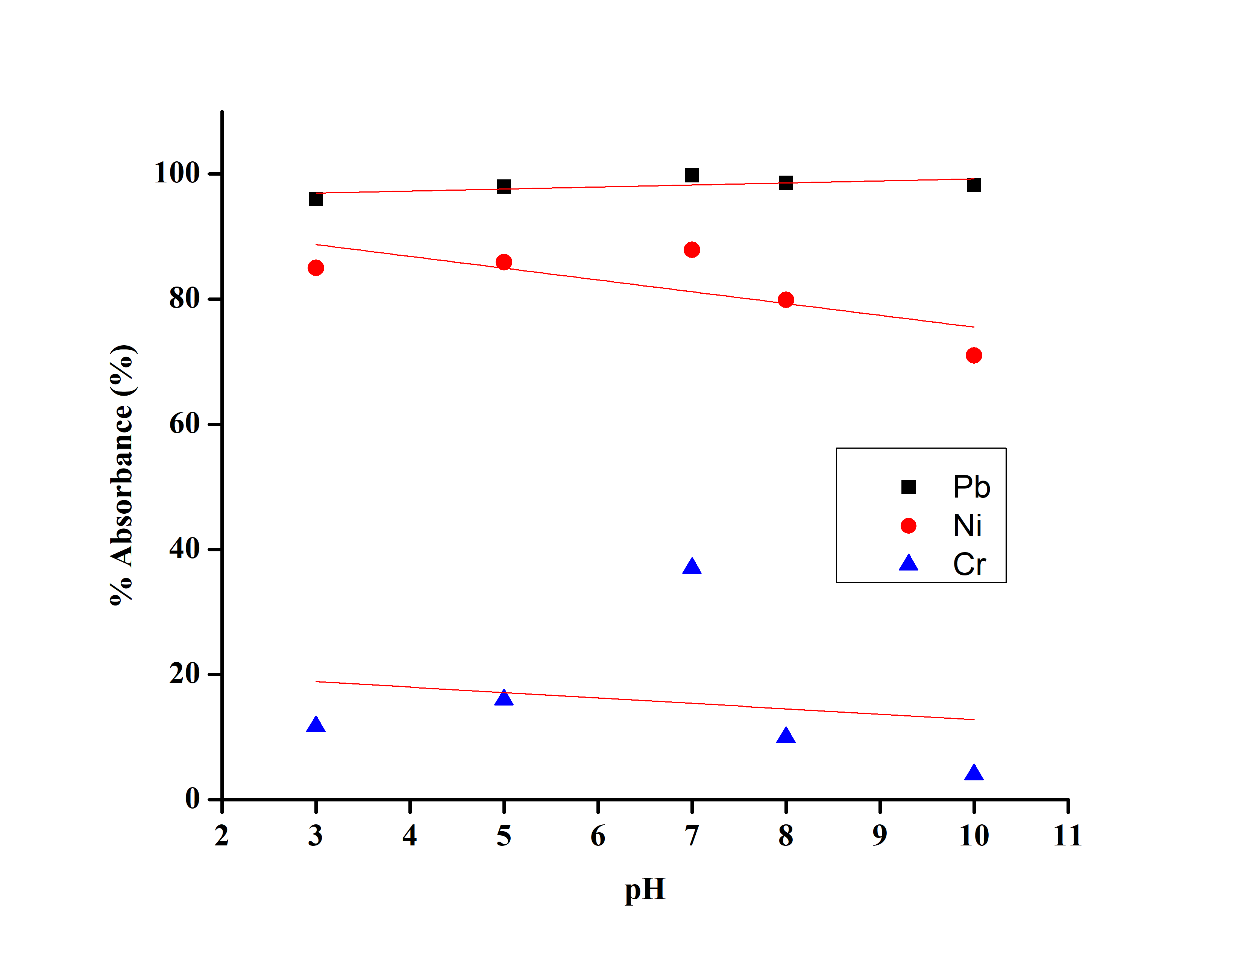

**Fig. 5. Graph of % adsorption against pH for Pb, Ni, and Cr**

**3.4.2 Effect of Adsorbent Dosage**

The dependence of adsorption of the Pb, Ni, and Cr on the adsorbent dosage was studied by varying the adsorbent dosage from 0.5 g to 2.5 g while keeping other parameters (contact time, initial concentration, and pH) constant. The result obtained as seen in Figure 6 below shows that, as the adsorbent dosage increased, the percentage adsorption increased until an optimal performance was obtained at 1 g for Pb, and 1.5 g for both Ni and Cr. At optimal performance, the percentage adsorption recorded were, 99.8 % for Pb, 86.9 % for Ni, and 31 % for chromium.

This trend can be attributed to the fact that, at a very small adsorbent dosage, very little adsorption/ active sites are available for the pickup of the Metals, therefore an increase in the dosage causes an increase in the percentage adsorption until optimum, beyond which the crowdedness of the adsorbent particles at higher dosage caused a decline in the percentage adsorption (Kabir, et al 2022). This trend is in agreement with Olaoye et al., (2021).

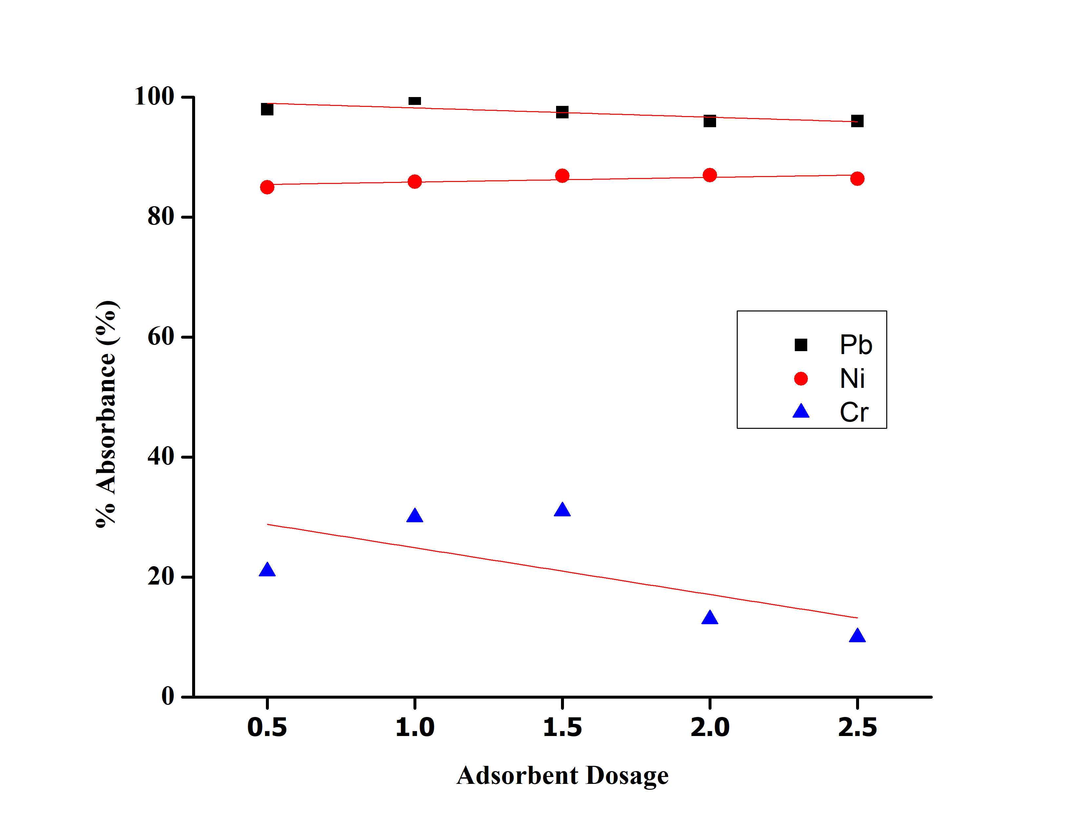

**Fig. 6. Graph of % Adsorption against adsorbent dosage for Pb, Ni, and Cr**

**3.4.3 Effect of Time**

In this study, the contact time was varied from 40 – 120 minutes at a constant dosage, pH, and initial concentration for each metal. From the result shown in Figure 7, The removal efficiency rapidly increased to an optimal performance at 80 minutes for Pb, which did not decline until after 100 min. Ni and Cr optimize at 40 minutes and a decline was observed in the percentage adsorption. The optimal percentage adsorption was 99.6 % for Pb, 92.8 % for Ni, and 55.9 % for Cr. The above trend where there is a decrease in percentage adsorption is in line with Olaoye et al., (2021) and Batagarawa, & Dayo, (2017). This trend can be attributed to the fact that, at further increased time beyond optimum there is an equilibrium saturation leading to a decrease in adsorption rate. By further increasing the time, the adsorbed metal ions tend to desorb, resulting in overall reduction in percentage adsorption.

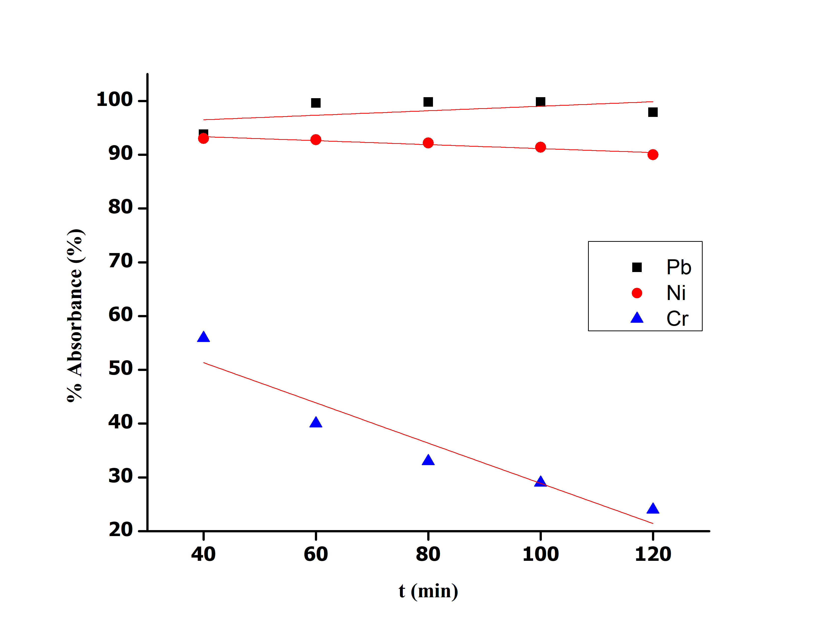

**Fig. 7. Plot of % Adsorption against Time for Pb, Ni and Cr**

**3.4.4 Batch Adsorption for the Paint Industrial Effluents**

A grab sample of effluent from a paint-producing factory was treated using the melon seed peel adsorbent. The concentration of the three metals was first checked to determine the initial concentration. Lead had 0.7251 mg/L, Nickel had 0.6359 mg/L and Chromium had 1.2013 mg/L. The concentration of other metals (Cobalt, Manganese, Zinc, Iron, Copper, and Arsenic) in the effluent was also checked to ascertain the interplay between the metals. An adsorption experiment was performed on the effluent using a constant mass of 1.5g, the volume of the effluent was 50 cm3, the adsorption time of 60 minutes, and the pH was maintained at 7. The result is shown in Figure 8. It can be seen from the result that, the adsorbent was highly efficient adsorption on Lead, Nickel and copper, cobalt and Chromium also showed good adsorption while other metals had poor adsorption. The adsorbent can be said to have a fairly good industrial application for most heavy metals.

|  |
| --- |
|  |

**Fig. 8. The adsorption percentage of the metals in the affluent**

**4.5 Adsorption Kinetics**

Chemical kinetics being the study of rates of reactions, offers a solid foundation for the forecasting of adsorption behavior. The kinetic models reveal the adsorption mechanism and the adsorption resistance obtained. In this study, three kinetic models (Pseudo first order, Pseudo second order, and intra-particle Diffusion Model) were used to analyze the adsorption behavior of the adsorbate on the adsorbent as indicated in figures 9 -11. The applicability of the kinetic models is compared by judging the correlation coefficients, (R2), and the agreement between the calculated and the experimental Qe values. The best model for the adsorption process was chosen using the correlation coefficient (R2).

**4.5.1 Pseudo First Order Plot**

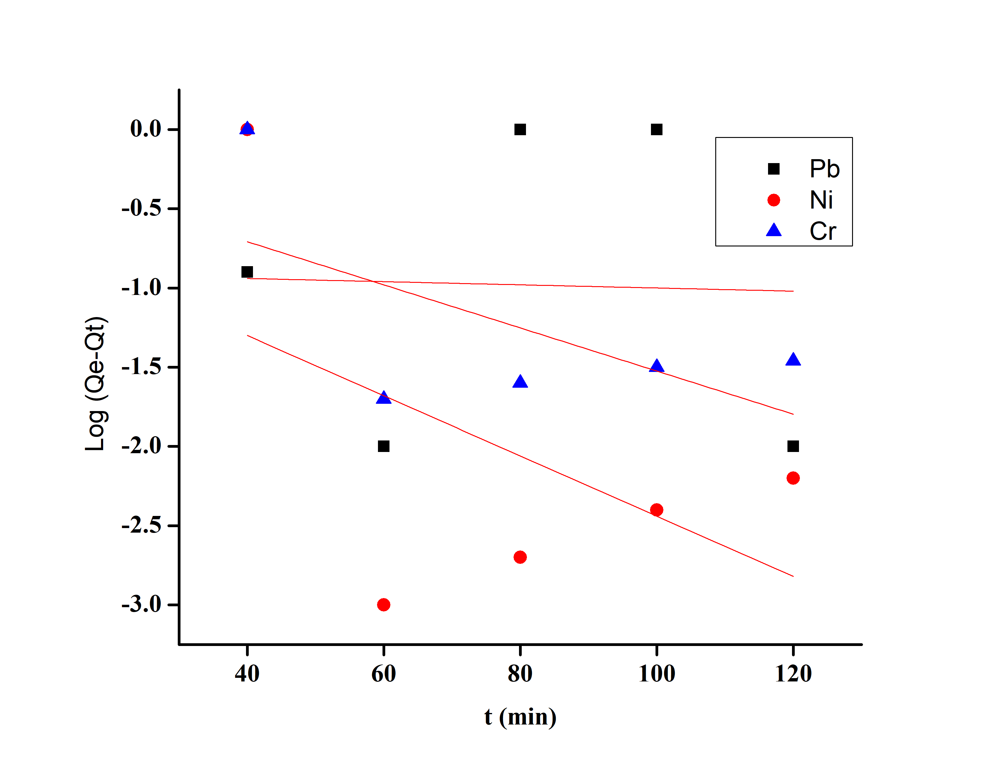

**Fig. 9. The combined plot of Log(Qe-Qt) against time for Pb, Ni, and Cr.**

**4.5.2 Pseudo Second Order**

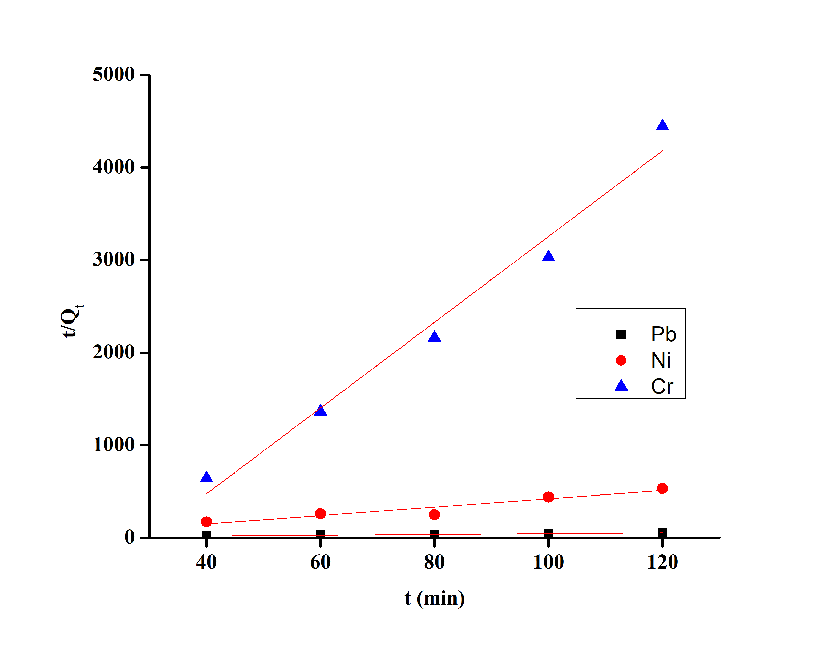

**Fig. 10. The combined plot of t/Qt against time for Pb, Ni, Cr.**

**4.5.3 Intraparticle Diffusion Model**

Theoretical treatments of intra-particle diffusion yield are complex mathematical relationships A functional relationship common to most treatments of intraparticle diffusion is that uptake varies almost proportionately with the half-power of time, t1/2, rather than t; a nearly linear variation in the quantity bios orbed with t1/2 is predicted for a large initial fraction of reactions controlled by rates of intraparticle diffusion. Therefore, from the equation Qt = kidt1/2 + C, Qt was plotted against t1/2 as shown in figure 11.

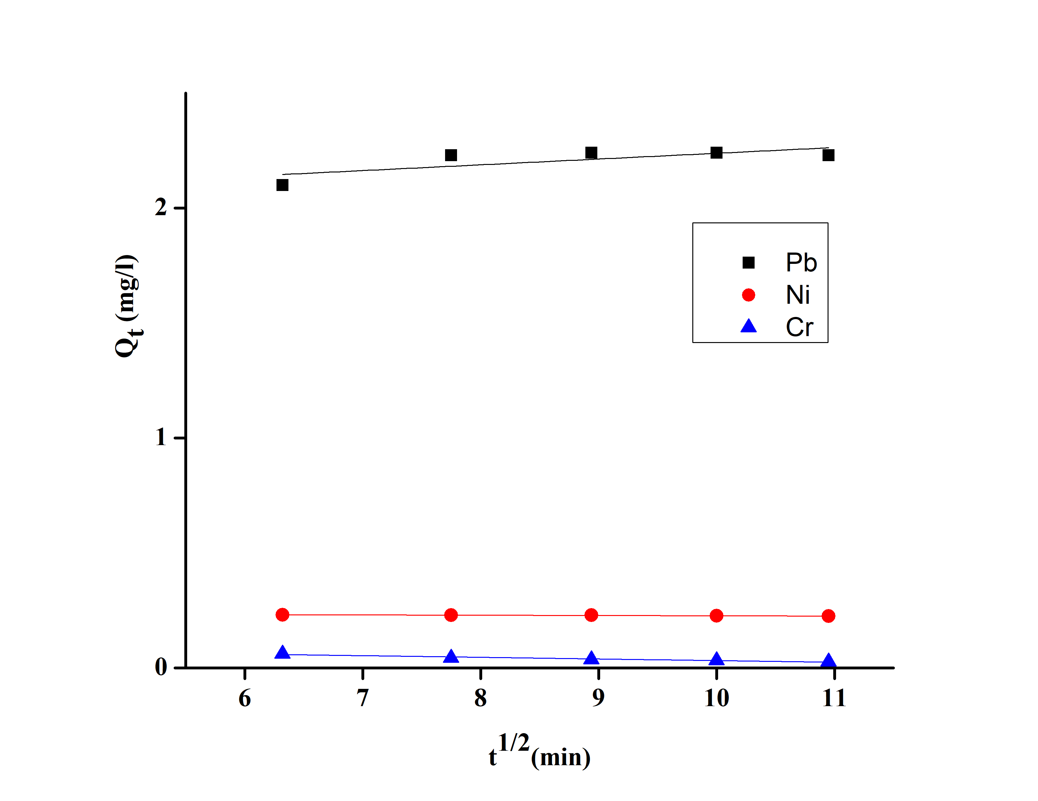

**Fig. 11. The combined plot of Qt against t1/2 for Pb, Ni, Cr.**

**4.5.4 Combined Results of the Kinetic Models**

**Table 1 combines results of Pseudo first order, Pseudo second order an intra-particle diffusion model for Pb, Ni, and Chromium.**

|  |  |  |  |  |  |  |  |
| --- | --- | --- | --- | --- | --- | --- | --- |
| Metal | Quantity | Pseudo first order | | Pseudo second order | | Intra-particle diffusion models | |
|  | Qe | R2 | K1 | R2 | K2 | R2 | Kin |
| Pb | 2.24 | -0.33 | 0.002 | 0.99 | 0.19 | 0.43 | 0.025 |
| Ni | 0.23 | 0.006 | -0.04 | 0.87 | -529.9 | 0.99 | -0.0013 |
| Cr | 0.06 | 0.16 | -0.03 | 0.97 | -358194 | 0.92 | -0.0071 |

From the above table, it can be seen that there is a poor fit for the adsorption of Pb, Ni, and Chromium into the pseudo-first-order plot, hence their Correlation Coefficient R2 is not near unity. The good linearized plots of t/qt vs. t indicate the validity of the Pseudo Second order model. From the correlation coefficient, it can be seen that Pb fitted best into the second-order reaction followed by Ni and Chromium the least. However, Ni shows more applicability to the intra-particle diffusion model than the Pseudo second order. The good fit into the Pseudo second-order model is indicative that, the adsorption process was controlled by two mechanisms, chemical and physical sorption.

4. Conclusion

Heavy metals in wastewater are toxic and should be treated before discharge since they are not biodegradable. Based on the results obtained within the scope of this study, the Melon seed peel has proven to be an effective and cheap option for the removal of heavy metals from wastewater. The melon Seed peels can be said to have complex organic compounds whose organic properties are not distorted at 300 oC of carbonization. The study also reveals the positive impact of modification/activation of adsorbents for better surface properties. It also affirms that the efficiency of the adsorbent is affected by certain parameters such as time, pH, adsorbent dosage, and concentration. The chemical kinetic shows that, the adsorption process followed pseudo-second-order kinetics which suggests a complex adsorption mechanism, involving both chemical and physical sorption processes.

AcknowledgEments

The authors would like to acknowledge the Bingham University Karu. Nasarawa state, for creating an enabling environment for this research work.

Competing interests

Competing interests The authors declare no conflict of interest.

Authors’ Contributions

The manuscript was written with contributions from all authors. All authors read and approved the final manuscript.

References

Ahmed, H., El-Khateeb, M., & Ahmed, N. (2022). Effective granular activated carbon for greywater treatment prepared from corncobs,” *Egyptian Journal of Chemistry*, vol. 10, Article ID 117621.

Ahmed, H.M., Sobhy, N.A., Hefny M.M., Abdel-Haleem, F.M., El-Khatee. M.A. (2023). Evaluation of Agrowaste Species for Removal of Heavy Metals from Synthetic Wastewater. *Journal of Environmental and Public Health*, 7419015, 1-20. https://doi.org/10.1155/2023/7419015

Ali, H., Khan, E., & Ilahi, I. (2019). Environmental Chemistry and Ecotoxicology of Hazardous Heavy Metals: Environmental Persistence, Toxicity, and Bioaccumulation. *Journal of Chemistry*, 6730305.

Batagarawa, S. M., & Dayo, L. Y. (2017). Millet husk is an efficient adsorbent for the removal of lead, Cadmium, and nickel ions from aqueous solution. *Dutse Journal of Pure and Applied Sciences (DUJOPAS) 3*, 337-348.

Bilal, M., Ihsanullah, I., Younas, M., Hassan, U., & Shah, M. (2022). Recent Advances in Applications of Low-Cost Adsorbents for the Removal of Heavy Metals from Water: A Critical Review. *Seperation aan. Purification Technology*, 278, 119510.

Buah, W., MacCarthy, J., & Ndur, S. (2016). Conversion of corn cobs waste into activated carbons for adsorption of heavy metals from minerals processing wastewater, *International Journal of Environmental Protection and Policy,* 4(4), 98–103.

Chakraborty, S., Pimple, S., Chaturvedi, H. T., Singh, S., & Gupta, K. K. (2008). Removal of Copper from aqueous solution using newspaper pulp as an adsorbent. *Journal of hazardous materials*, *159*(2-3), 396-403.

Hokkanen, S., Bhatnagar, A., & Sillanpää, M. A. (2016). Review on Modification Methods to Cellulose-Based Adsorbents to Improve Adsorption Capacity. *Water Resources*, 91, 156–173.

Kabir, M. M., Akter, M. M., Khandaker, S., Gilroyed, B. H., Didar-ul-Alam, M., Hakim, M., & Awual, M. R. (2022). Highly effective agro-waste-based functional green adsorbents for toxic chromium (VI) ion removal from wastewater. *Journal of Molecular Liquids*, *347*, 118327.

Nandal, M., Hooda, R., & Dhania, G. (2014). Tea wastes as a sorbent for removal of heavy metals from wastewater, *International Journal of Current Engineering Technology,* 4(1), 244–247.

Ojedokun, A.T., & Bello, O.S. (2016). Sequestering Heavy Metals from Wastewater Using Cow Dung. *Water Resource Industry*, 13, 7–13.

Olaoye, R. A., Ojoawo, S. O., Bamigbade, O., Alimi, N., Rasaq, I. O., & Oladejo, T. (2021). Remediation of heavy metals from galvanic wastewater using cow bone char as a low-cost adsorbent. *Iranian (Iranica) Journal of Energy & Environment*, *12*(4), 318-326.

Petrov, O., Petrichenko, S., Yushchishina, A., Mitryasova, O., & Pohrebennyk, V. (2020).Electrospark method in galvanic wastewater treatment for heavy metal removal. *Applied Sciences*, *10*(15), 5148.

Rahman, Z., & Singh, V.P. (2019). The Relative Impact of Toxic Heavy Metals (THMs) (Arsenic (As), Cadmium (Cd), Chromium (Cr)(VI), Mercury (Hg), and Lead (Pb)) on the Total Environment: An Overview. *Environmental Monitoring* Assessment, 191, 419.

Sen, T.K. (2023). Agricultural Solid Wastes Based Adsorbent Materials in the Remediation of Heavy Metal Ions from water and wastewater by Adsorption: A Review. *Molecules*, 28, 5575. <https://doi.org/> 10.3390/molecules28145575

Simón, D., Palet, C., Costas, A., & Cristóbal, A. (2022). Agro-Industrial Waste as Potential Heavy Metal Adsorbents and Subsequent Safe Disposal of Spent Adsorbents. *Water.* 14, 3298. <https://doi.org/> 10.3390/w14203298

Tariq, W., Saifullah, M., Anjum, T., Javed, M., Tayyab, N. & Shoukat, I. (2018). Removal of heavy metals from chemical industrial wastewater using agro-based bio-sorbents. *Acta Chemica Malaysia* (ACMY)2(2), 09-14. *http://doi.org/10.26480/acmy.02.2018.09.14*

Tounsadi, H., Khalidi, A., Machrouhi, A., Farnane, M., Elmoubarki, R., Elhalil, A., Sadiq, M., & Barka, N. (2016). Highly Efficient Activated Carbon from Glebionis coronaria L. Biomass: Optimization of Preparation Conditions and Heavy Metals Removal Using Experimental Design Approach. *Journal of Environmental and. Chemical Engineering,* 4, 4549–4564.

Uddin, M. K. (2017). A Review on the Adsorption of Heavy Metals by Clay Minerals, with Special Focus on the Past Decade. *Chemical Engineering Journal*, 308, 438–462.

Zamora-Ledezma, C., Negrete-Bolagay, D., Figueroa, F., Zamora-Ledezma, E., Ni, M., Alexis, F., & Guerrero, V.H. (2021). Heavy Metal Water Pollution: A Fresh Look about Hazards, Novel and Conventional Remediation Methods. *Environmental Technology and Innovations*, 22, 101504.