**Original Research Article**

**Improving Manufacturing with Adaptive Learning in Industry 4.0: Case Studies, Challenges, and Policy Implications.**

# **Abstract**

This research examines the role of adaptive learning in modern manufacturing, highlighting its capacity to enhance workforce productivity, streamline production processes, and foster innovation within the industry 4.0 framework. By leveraging artificial intelligence (AI), the Internet of Things (IoT), and digital twin technologies, adaptive learning enables personalized workforce training, optimizes real-time decision-making, and strengthens human-machine collaboration. Case studies from leading manufacturers illustrate the measurable impact of adaptive learning. BMW’s AI-driven robotic systems have improved welding and assembly precision, reducing defects by 25%, while Toyota’s “Digital Andon” system has led to a 30% decrease in assembly errors through real-time guidance. Lockheed Martin’s augmented reality (AR)-integrated adaptive learning framework has accelerated technician proficiency, shortening assembly time by 40%. Predictive analytics within adaptive learning models have also demonstrated 92% accuracy in failure prediction, a 35% reduction in unplanned downtime, and an 8.5% increase in energy efficiency across manufacturing operations. SME applications, such as a Taiwanese injection molding firm, reported a 41% improvement in process capability, while Robovic achieved enhanced agility through modular adaptive systems. Despite these advancements, widespread adoption faces notable challenges, including high implementation costs, legacy system integration, workforce skill gaps, and cybersecurity concerns. This paper critically evaluates these barriers and explores policy considerations, emphasizing the need for government incentives, AI governance frameworks, and workforce development initiatives. Finally, it identifies key research priorities AI interpretability, long-term workforce adaptability, and the economic impact of adaptive learning to inform future investigations and support the evolution of intelligent, sustainable manufacturing ecosystems.

**Keywords**: AI-Driven Adaptive Learning; AI-Driven Manufacturing; Human-Machine Collaboration; Digital Twins; IoT in Manufacturing: AI in Industry 4.0

**1.Introductions**

The global manufacturing sector is undergoing a profound transformation, driven by the emergence of Industry 4.0. This paradigm shift is fueled by the need for increased operational efficiency, reduced maintenance costs, higher throughput, and greater adaptability in a competitive market (Tsaramirsis et al., 2022). By converging advanced technologies such as robotics, IoT, cloud computing, and Artificial Intelligence (AI), Industry 4.0 enables the creation of highly interconnected and intelligent factories. However, manufacturers face significant challenges in optimizing production efficiency, ensuring seamless technology adoption, and equipping their workforce with the necessary skills to thrive in these digitized environments (Sharma, Paliwal and Baniwal, 2024). Adaptive learning, an AI-driven approach that personalizes training and operational strategies based on real-time feedback and performance analytics, offers a promising solution to these challenges. By continuously analyzing human-machine interactions and identifying inefficiencies, adaptive learning tailors learning experiences to individual workers and optimizes production processes. This not only enhances workforce proficiency but also enables predictive maintenance, automated quality control, and efficient resource allocation leading to increased productivity, reduced downtime, and improved product quality (Yang and Liu, 2024). The integration of adaptive learning into manufacturing has far-reaching implications. By fostering a culture of continuous improvement and empowering manufacturers to swiftly respond to market fluctuations and technological disruptions, it plays a crucial role in enhancing competitiveness and ensuring long-term success in the industry 4.0 era (Agarwal et al., 2022). This article provides a comprehensive exploration of adaptive learning’s role in modern manufacturing, examining its core principles, technological enablers, and real-world applications. By optimizing the synergy between human workers and intelligent machines, adaptive learning is poised to transform the future of industrial innovation.

## **1.1 Background and Context**

Traditional manufacturing systems were built on manual labor, rudimentary mechanization, and fixed operational workflows. While these approaches were sufficient in an era of stable market demands and linear production models, they lacked the agility required to handle rapid technological advancements, mass customization, and volatile global supply chains (Calignano and Mercurio, 2023). The late 20th-century shift toward automation and digitization driven by robotics, computer-aided design (CAD), enterprise resource planning (ERP), and computer numerical control (CNC) systems marked a significant leap forward. However, these innovations, while enhancing productivity and precision, remained largely static, with limited ability to dynamically respond to real-time changes and optimize operations in response to market fluctuations. For instance, CNC machines typically operated based on pre-programmed instructions, limiting their ability to dynamically adjust parameters in response to real-time changes, such as machine wear and tear or fluctuating material properties (Sousa et al., 2020).

The advent of Industry 4.0 has redefined manufacturing, introducing cyber-physical systems, industrial IoT (IIoT), artificial intelligence (AI), and real-time data analytics (Pivoto et al., 2021). These technologies have transformed factories into intelligent, interconnected ecosystems capable of autonomous decision-making, predictive maintenance, and adaptive process control. However, this transition introduces several critical challenges:

* **Workforce Skill Gaps**: The rapid shift toward AI-driven automation has outpaced traditional workforce training models, creating a competency gap that hinders adoption.
* **Challenges in Integrating and Scaling New Technologies**: Integrating and scaling new technologies like AI, IoT, and big data analytics while maintaining operational continuity can be complex and disruptive.
* **Resistance to Change**: Employees and management often hesitate to embrace adaptive AI-driven workflows, fearing complexity, job displacement, or uncertainty in performance outcomes.

In this dynamic environment, adaptive learning emerges as a critical enabler for overcoming these barriers. By leveraging AI, machine learning (ML), and real-time data-driven insights, adaptive learning personalizes workforce training, enhances process optimization, and dynamically adjusts operational parameters, ensuring that both human operators and intelligent machines evolve synchronously. This fosters a more agile, productive, and resilient manufacturing environment in the industry 4.0 era.

## **1.2 Definition, Scope and Importance**

Adaptive learning, an AI-driven and data-centric approach, customizes training based on individual performance, skill level, and real-time interaction with digital systems (Yambal and Waykar, 2025). Leveraging machine learning, cognitive computing, and predictive analytics, these systems continuously assess competency gaps and optimize learning pathways, ensuring targeted training and maximizing operational proficiency. Beyond workforce training, adaptive learning extends to optimize broader efficiencies within Industry 4.0 environments. For example, personalized training modules can be tailored based on worker performance in simulations or real-world tasks, providing targeted feedback (Viterouli et al., 2024).

The integration of cyber-physical systems (CPS) necessitates both dynamic skill development and intelligent process adaptation (Kaur et al., 2025). Adaptive systems analyze operator performance, monitor machine utilization, and detect process deviations in real time, enabling feedback for both human and automated systems. This facilitates self-adjustment of production parameters and, through AI-powered diagnostics, enhances predictive maintenance and quality assurance, minimizing downtime and defects (Fatima et al., 2024).

Ultimately, adaptive learning accelerates the adoption of Industry 4.0 technologies by enhancing workforce agility and mitigating skill gaps (Babashahi et al., 2024). This bridging of human expertise and automation fosters a resilient, intelligent manufacturing ecosystem, ensuring seamless human-machine evolution in a dynamic, technology-driven landscape.

## **1.3 Objectives and Structure of the Review**

The primary objective of this paper is to critically review existing research on adaptive learning in manufacturing, focusing on its potential to address key challenges in workforce development such as skill gaps, reskilling needs, and the integration of human workers with AI-powered systems, and process optimization such as improving production efficiency, reducing downtime, and enhancing product quality. By synthesizing findings from various studies, the paper aims to provide a comprehensive understanding of how adaptive learning supports the transition to Industry 4.0. Additionally, it identifies gaps in the current literature and highlights areas for further exploration to advance the effective integration of adaptive learning in smart manufacturing.

The structure of the paper is organized as follows:

**Section 1**: Introduction This introduction outlines the background, scope, and objectives of the review.

**Section 2**: Literature Review A detailed literature review examines the historical evolution of adaptive learning, its theoretical foundations, and its applications across industries, identifying gaps and challenges in the application of adaptive learning specifically within the manufacturing context.

**Section 3**: Applications in Manufacturing The practical applications of adaptive learning in manufacturing are explored, including case studies and models for integrating adaptive learning into Industry 4.0 technologies.

**Section 4**: Workforce Productivity and Industry 4.0 Workforce productivity is analyzed, focusing on how adaptive learning enhances skills, addresses implementation challenges, and aligns with emerging trends in Industry 4.0.

**Section 5**: Conclusion The review concludes with a synthesis of findings, implications for industry and policymakers, and recommendations for future research.

**2. Literature Review**

Adaptive learning has emerged as a critical driver of both workforce competence and process optimization in modern manufacturing as traditional training models which rely on standardized instruction, often fail to accommodate individual learning needs or adapt to dynamic production demands (Nagy, Lăzăroiu and Valaskova, 2023). The increasing integration of cyber-physical systems (CPS), the fusion of physical manufacturing equipment with digital computing and communication networks along with industrial IoT and AI-driven automation, has rendered static training approaches inadequate (Qian et al., 2024). As manufacturing environments grow more complex, the need for dynamic, responsive learning frameworks becomes increasingly evident, allowing both human operators and intelligent machines to adapt alongside technological advancements. AI-driven adaptive learning systems address this challenge by leveraging machine learning algorithms, cognitive computing, and real-time analytics to enhance skill development and optimize industrial processes (Doskenov & Okuyelu, 2025). Unlike fixed training curricula, adaptive learning systems continuously adjust to user performance, operational feedback, and contextual data, making them an essential component of intelligent manufacturing (Aravind Kumar Kalusivalingam et al., 2022).

The theoretical foundations of adaptive learning are deeply rooted in cognitive and computational learning models. Self-regulated learning (SRL) theory, which emphasizes iterative goal setting and performance monitoring, informs the adaptive mechanisms that personalize training pathways (Sharma, Nguyen and Hong, 2024). Additionally, reinforcement learning (RL) enables AI models to refine decision-making strategies through real-time interactions with manufacturing systems (Aravind Kumar Kalusivalingam et al., 2022). Bayesian optimization further enhances training precision by dynamically adjusting content delivery based on evolving competency levels (Hvarfner, 2025). Advances in cognitive load theory (CLT) have also influenced AI-driven instructional design, ensuring that learning models optimize information retention without overwhelming users (Evgenia Gkintoni et al., 2025). Collectively, these theoretical advancements have enabled adaptive learning systems to transition from static instructional platforms to intelligent, predictive training environments that actively enhance both workforce capabilities and production efficiency.

Empirical research consistently demonstrates the impact of adaptive learning across various manufacturing domains. AI-powered training systems, when integrated with industrial analytics, have led to significant improvements in knowledge retention and task execution. A study by Mahankali (2025) found that adaptive learning reduced training time while increasing operator proficiency and minimizing errors in high-precision manufacturing settings. Differing from standardized instruction, AI-driven training systems enhance skill acquisition and workforce readiness by dynamically tailoring content to address specific competency gaps, reducing learning inefficiencies (Yoo et al., 2024)

Case studies further illustrate the transformative potential of adaptive learning in industrial applications. For instance, Bosch implemented adaptive learning in its smart factories to train assembly line workers for high-complexity tasks (Estrada-Jimenez et al., 2023). To further enhance workforce training on operational processes and skill development, the company adopted Synthesia’s AI-driven platform, which streamlined content creation, enabled easy updates, and improved accessibility. This shift resulted in a 70% reduction in video production costs, a 30% increase in employee engagement, and over 30,000 web views, highlighting the efficiency of AI-powered training solutions (Alster, 2024).

Case studies found that AI-driven adaptive learning models optimized operational parameters in wind, solar, and hydroelectric plants, achieving 92% accuracy in failure prediction, a 35% reduction in unplanned downtime, and an 8.5% increase in energy output, demonstrating adaptability across diverse conditions (Bello et al., 2024).

The integration of adaptive learning extends beyond workforce training and maintenance, significantly influencing human-machine collaboration and digital twin technology. Ren and Li (2022) Found that adaptive learning improved human-machine interaction detection accuracy by up to 12.5% within cyber-physical production systems, indicating potential for enhanced operator decision-making.

AI-driven learning models refine control settings and optimize human-AI coordination, ensuring a balanced interaction between automation and human oversight, while digital twins enhance simulation accuracy by incorporating real-world production data, enabling manufacturers to test process modifications in a risk-free environment (Nechesov, Dorokhov and Ruponen, 2025). A case study by Siemens demonstrated how its partnership with a global PCB manufacturer reduced defect rates by 25% over six months by integrating AI algorithms with existing execution systems, while its MindSphere platform enabled manufacturers to collect and analyze data from multiple sources, facilitating predictive maintenance and real-time quality monitoring to enhance overall production efficiency. (leone, 2024).

Despite its advantages, the widespread adoption of adaptive learning in manufacturing faces several technical and human challenges. One major obstacle is the complexity of industrial data, as AI models must integrate vast, heterogeneous datasets while maintaining interpretability and reliability (Jagatheesaperumal et al., 2021). Research by Yao et al. (2023) highlights the need for explainable AI (XAI) frameworks to ensure transparency in AI-driven decision-making, particularly in mission-critical manufacturing applications (Dimitris Mourtzis and Angelopoulos, 2024). Additionally, integrating adaptive learning with legacy automation infrastructure presents compatibility challenges, while cybersecurity concerns continue to grow (Hider and Aslam, 2024). Orabi, Emam and Fahmy (2025) suggest that federated learning and blockchain-based security frameworks could strengthen the resilience of adaptive learning systems. These technical hurdles are further compounded by workforce-related challenges, as employees accustomed to traditional training methods may resist AI-driven learning. Xu et al. (2025) found that incorporating human-in-the-loop adaptive models where operators actively refine AI-driven learning recommendations significantly improved engagement and acceptance, demonstrating the importance of integrating user input into adaptive systems.

Table 1: Comparison of Traditional Learning vs. Adaptive Learning

|  |  |  |
| --- | --- | --- |
| **Aspect** | **Traditional Learning** | **Adaptive Learning** |
| **Learning Structure** | Follows a standardized curriculum for all learners. | Adjusts based on individual skill levels and learning progress. |
| **Learning Speed** | Set pace for all participants, regardless of understanding | Adapts dynamically to match each learner’s comprehension speed |
| **Content Delivery** | Predefined, static instructional materials | Responsive and evolving content based on real-time data |
| **Learner Engagement** | May vary significantly, often lower due to generic instruction | Typically higher, as content is tailored to individual needs |
| **Feedback Mechanism** | Delayed and often generalized feedback | Instant, personalized feedback to improve learning outcomes |
| **Instruction Method** | Instructor-driven, with a fixed teaching approach | Learner-focused, fostering independent skill development |
| **Evaluation System** | Standardized assessments at predefined intervals | Ongoing assessments, personalized to the learner’s progress. |

Looking ahead, several emerging trends are expected to further advance adaptive learning in manufacturing. Federated learning, edge computing, and multi-agent AI systems will enable decentralized AI training, improve the responsiveness of adaptive learning models, and facilitate more sophisticated coordination among autonomous manufacturing subsystems (Liu et al., 2024). Future research should focus on balancing automation with human oversight, ensuring that adaptive learning frameworks prioritize both workforce development and operational efficiency (Joseph et al., 2024). Ultimately, adaptive learning represents a paradigm shift in manufacturing, fostering agility, resilience, and sustained technological innovation. By leveraging AI, machine learning, and real-time data analytics, adaptive learning enhances workforce readiness, optimizes production workflows, and improves predictive maintenance strategies (Kruger, 2020). While challenges such as cybersecurity vulnerabilities, legacy system integration, and workforce resistance remain, ongoing advancements in reinforcement learning, digital twins, and federated AI continue to expand the capabilities of adaptive learning in smart manufacturing. As industrial systems grow increasingly complex, adaptive learning will play a central role in shaping the future of intelligent manufacturing.

**3. Adaptive Learning Applications in Smart Manufacturing**

Adaptive learning is a key enabler of smart manufacturing, aligning workforce development and process optimization with Industry 4.0 (ElMaraghy & ElMaraghy, 2022). By leveraging AI-driven personalization, real-time feedback, and predictive analytics, it dynamically tailors training and operational workflows, enhancing human-machine collaboration and efficiency. Unlike traditional static training models, adaptive learning prepares workers for digitized production environments while also minimizing downtime and ensuring operational resilience.

## **3.1 The Role of Adaptive Learning in Smart Manufacturing.**

Smart manufacturing integrates IoT, AI, robotics, and cyber-physical systems (CPS) to create self-regulating, data-driven production ecosystems. Within this context, adaptive learning serves as a critical enabler by facilitating dynamic skill development, continuous process improvement, and real-time operational adjustments (Bettoni et al., 2020). AI-driven adaptive learning platforms continuously analyze operator performance, machine diagnostics, and production workflows, ensuring that both workers and automated systems are optimized in real time.

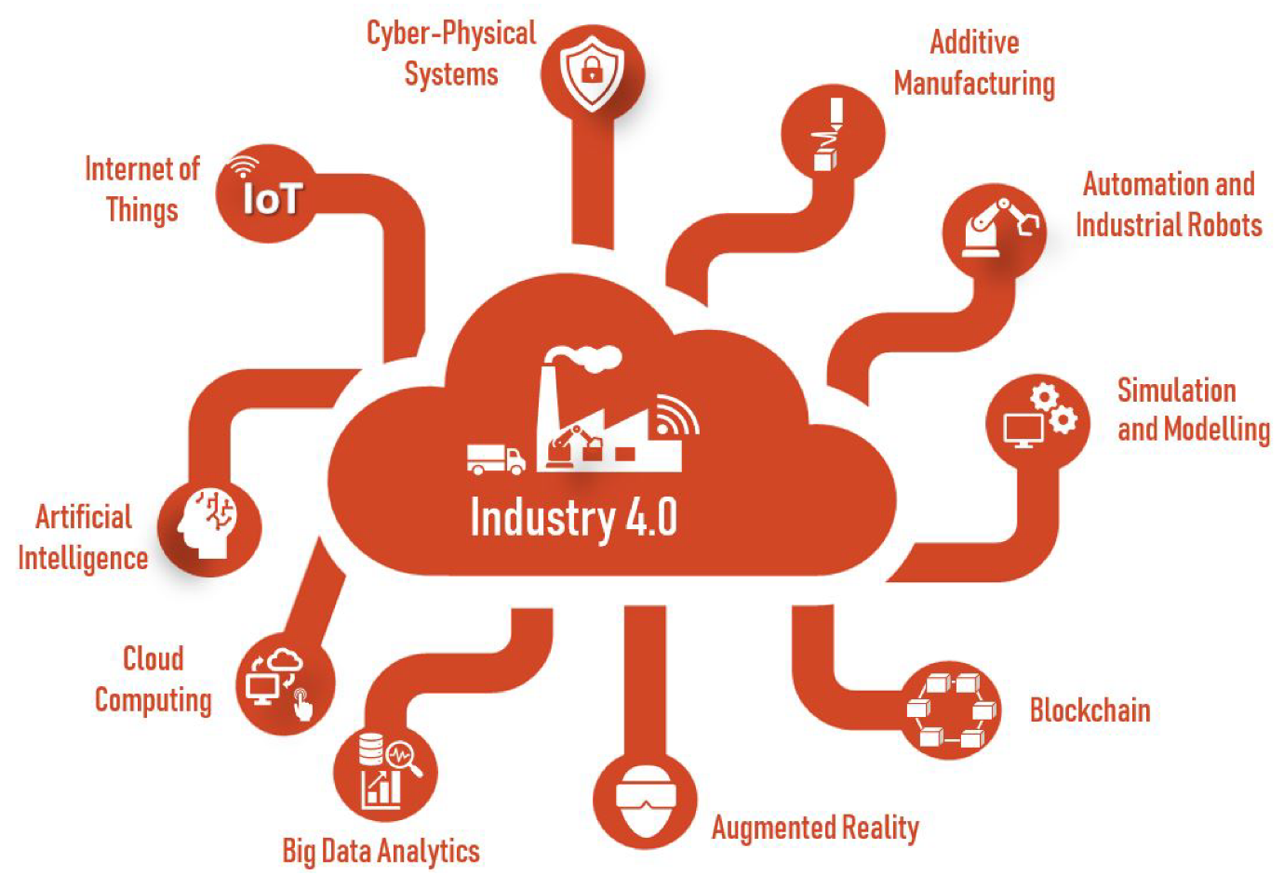

Figure 1: Components of Smart Manufacturing In Industry 4.0 (Ryalat et al. 2023).

A key differentiator of adaptive learning is its ability to provide personalized, AI-driven workforce training while simultaneously optimizing industrial processes (Omokhafe et al., 2024). Traditional training methods often struggle to keep pace with rapidly changing industrial technologies, leading to workforce skill gaps and inefficiencies. Adaptive learning addresses this by leveraging real-time data from IoT sensors and Cyber-Physical Systems (CPS) to ensure both humans and machines operate at peak efficiency. This synergy between adaptive learning and Industry 4.0 technologies is particularly impactful in enhancing human-machine collaboration (Wang et al., 2022). AI-driven algorithms continuously optimize both machine and human performance, ensuring seamless integration of automated and manual processes. This fosters an agile manufacturing environment where workers and systems can adapt to new challenges and technological advancements.

Specific examples of adaptive learning applications in smart manufacturing include:

* **Predictive maintenance**: AI-powered algorithms analyze sensor data to predict equipment failures, minimizing downtime and optimizing maintenance schedules (Joy et al., 2024).
* **Quality control**: AI-powered vision systems, integrated with adaptive learning, are used to identify and classify defects in real-time, dynamically adjusting production parameters to reduce error rates (Mohsen Soori et al., 2025).
* **Supply chain optimization**: Adaptive learning algorithms are used to optimize inventory levels, predict demand fluctuations, and improve the efficiency of logistics operations (Pasupuleti et al., 2024).

Another critical application is digital twin technology, which bridges the gap between data analytics and actionable insights. Digital twins create real-time virtual replicas of physical production systems, allowing manufacturers to simulate, test, and refine workflows before implementing changes on the factory floor (Javaid, Haleem and Suman, 2023). Foxconn, a leading electronics manufacturer, employs AI-powered digital twins to simulate factory operations, enabling process optimization and workforce training in a risk-free virtual environment. This approach significantly reduces ramp-up times for new production lines and minimizes disruption (Huang, 2024).

## **3.2 Case Studies: Adaptive Learning in Action**

The integration of AI-driven adaptive learning has transformed manufacturing across diverse sectors, including automotive, aerospace, electronics, heavy manufacturing, pharmaceuticals, and consumer goods, optimizing both workforce training and operational efficiency.

* **Automotive Industry:**

BMW employs AI-enhanced robotic systems in its body shop operations, utilizing deep learning for real-time path planning and adaptive force control to optimize precision in welding, assembly, and quality inspection. Simultaneously, human operators receive real-time, adaptive training modules, ensuring seamless collaboration with these advanced robotic systems (Bongard, 2024). Toyota has implemented its “Digital Andon” system, integrating AI-driven adaptive learning, to provide assembly line workers with real-time guidance and feedback when anomalies are detected in production, dynamically adjusting training content based on worker performance (Toyota, 2023).

* **Aerospace Manufacturing:**

Lockheed Martin integrates augmented reality (AR) with adaptive learning frameworks to assist technicians in assembling complex aircraft wiring harnesses, using AR overlays to provide tailored step-by-step instructions based on their skill level and experience. Airbus leverages AI-driven adaptive learning in its aircraft assembly plants through its “Factory of the Future” initiative, employing real-time adaptive learning modules integrated with IoT-enabled workstations to provide personalized guidance and optimize assembly procedures (Airbus, 2024).

* **Electronics Manufacturing:**

Intel deploys AI-driven adaptive learning systems in its chip fabrication plants, utilizing recommendation systems and reinforcement learning algorithms to provide personalized microlearning sessions to technicians who must continuously update their skills in the rapidly evolving semiconductor industry (orcalean, 2025). Samsung integrates adaptive learning modules into manufacturing execution systems (MES) to provide technicians with real-time instructions for precise tasks such as lithography, etching, and deposition in semiconductor production (Taylor, 2025).

* **Heavy Manufacturing:**

Caterpillar integrates sensor data from IoT-enabled heavy equipment with adaptive learning platforms, providing on-demand troubleshooting guidance to machine operators when performance deviations occur. General Electric (GE) uses digital twin models combined with AI-driven learning platforms within its “Brilliant Factories” initiative to analyze production line inefficiencies and provide real-time feedback and corrective measures (Fei, 2024).

* **Pharmaceutical Manufacturing:**

In biopharmaceutical manufacturing, adaptive learning optimizes process control and quality. Pfizer integrates adaptive learning with AI-driven process control to dynamically adjust process parameters, ensuring consistent drug formulation. Johnson & Johnson uses AI-enhanced adaptive learning to optimize the manufacturing of medical devices and biologics, ensuring regulation-compliant training updates and improving product consistency (Taylor, 2025).

* **Consumer Goods Manufacturing:**

Procter & Gamble (P&G) is implementing AI-driven solutions to refine manufacturing processes, utilizing the WISE initiative and the SmartBox, an edge computing device, to integrate AI and machine learning at the equipment level, improving operational efficiency (Zaytsev, 2023).

* **Injection Molding -SME Application:**

A small to medium-sized enterprise in the injection molding sector implemented a hybrid adaptive learning framework using machine learning techniques to support digital transformation and enhance product quality. The system combined XGBoost for feature selection, Gated Recurrent Unit (GRU) models for time series parameter prediction, and Support Vector Machines (SVM) for quality classification. This adaptive learning approach enabled real-time optimization of production parameters and significantly improved process capability by 41%, while also enhancing yield prediction accuracy and operational efficiency (Chiu & Huang, 2023).

* **Manufacturing – SME Application:**

Robovic, a small to medium-sized manufacturing enterprise, adopted an adaptive Industry 4.0 strategy focused on agility and modular system design. By integrating Internet of Things (IoT) sensors and cloud-based control systems, the company enabled real-time monitoring, adaptive feedback, and continuous process optimization. This tailored approach enhanced production flexibility, improved decision-making through real-time data exchange, and positioned Robovic competitively in the advanced manufacturing sector (Roy, Georges Abdul-Nour, & Gamache, 2023).

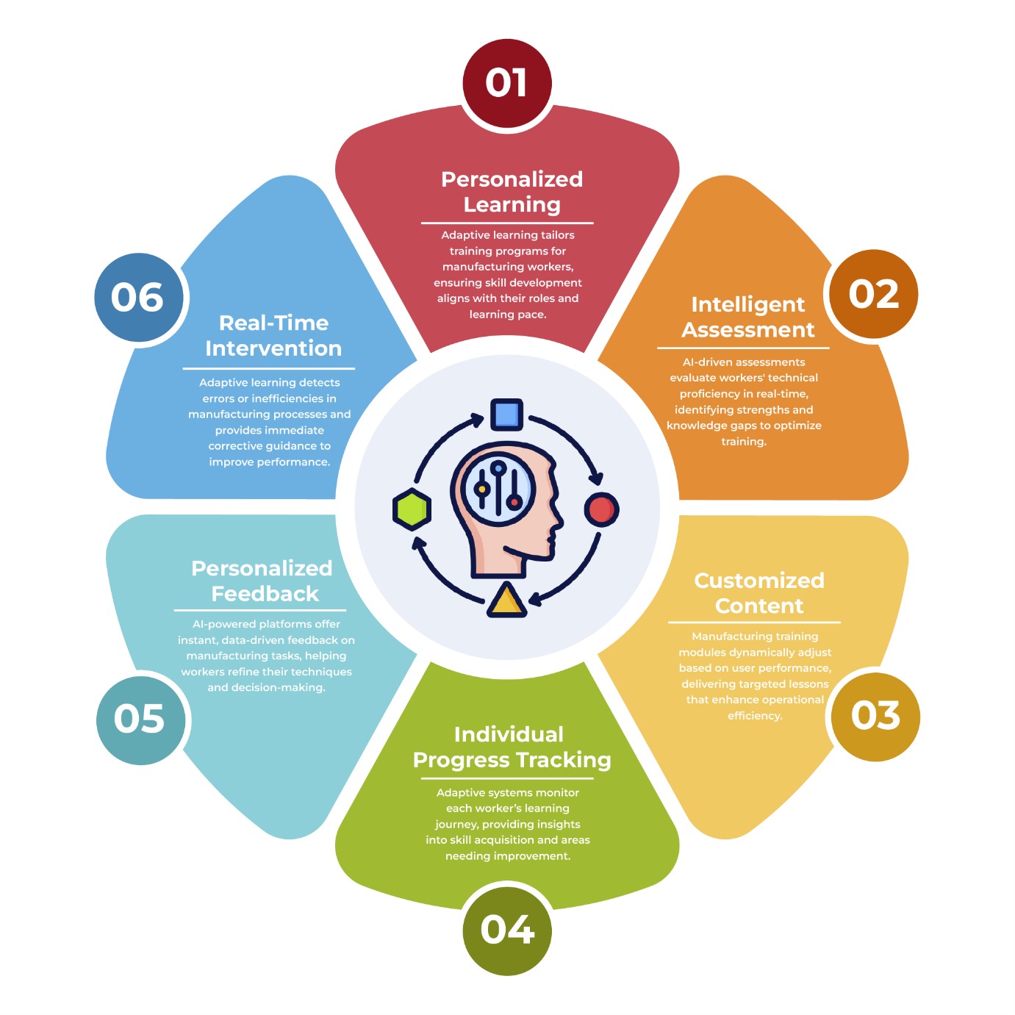

Figure 2: Applications Of Adaptive Learning in Manufacturing (Author’s Own)

## **3.3 Benefits of Adaptive Learning in Smart Manufacturing**

The integration of adaptive learning into smart manufacturing yields significant benefits in workforce development and operational efficiency. By leveraging AI-driven platforms, companies can minimize production downtime through predictive maintenance and just-in-time training, enabling operators to proactively address potential malfunctions (Sadasivan, Vasumathi and Jayanthi, 2024). This not only sustains production continuity but also reduces operating costs. Furthermore, adaptive learning enhances human-machine collaboration by providing workers with personalized training for managing AI-enhanced systems, leading to improved decision-making and operational agility (T. Archana and R. Kingsly Stephen, 2024). This approach fosters a culture of continuous learning, allowing both employees and systems to adapt to evolving demands. Adaptive learning also offers scalability and flexibility, delivering modular, on-demand training that ensures workforce competency across diverse production environments (Viterouli et al., 2024). Beyond training, it supports continuous process optimization through real-time feedback loops, minimizing waste and improving product quality. The widespread adoption of adaptive learning across industries, as evidenced by its implementation in companies like those in the automotive, aerospace, and pharmaceutical sectors, underscores its transformative impact. By utilizing technologies such as AI, IoT, and predictive analytics, manufacturers are optimizing training, enhancing collaboration, and fostering a self-improving industrial ecosystem, positioning adaptive learning as a cornerstone of Industry 4.0.

Table 2: Comparison of Adaptive Learning Models in Smart Manufacturing

|  |  |  |  |  |  |
| --- | --- | --- | --- | --- | --- |
| **Model** | **Features** | **Data Sources** | **Applications** | **Advantages** | **Potential Limitations** |
| **Digital Twins** | Virtual replication of physical systems | CAD models, sensor data, simulation data | Risk-free training, process optimization, simulating design changes, factory layout optimization, predicting equipment lifespan based on virtual wear and tear simulations. | Realistic simulations, safe environment for testing and training, improved design and planning, reduced physical prototyping costs, ability to test scenarios that would be dangerous or costly in the real world. | Requires accurate and detailed models, high computational resources for complex simulations, maintaining model accuracy over time. |
| **Real-Time Process Sims** | IoT-driven, real-time feedback | Sensor data (temperature, pressure, vibration), machine logs, process parameters, operator input | Operator training on responding to real-time events, workflow adjustments, adjusting robotic welding parameters based on real-time temperature readings, optimizing machining parameters, dynamically adjusting production schedules based on real-time demand and resource availability. | Dynamic adaptability, immediate feedback, optimized control of processes, reduced waste and improved quality, real-time response to changing conditions, improved responsiveness to unexpected events and changes in demand. | Relies on reliable sensor data and communication infrastructure, potential for data overload, requires robust data processing and analysis capabilities. |
| **AI-Enhanced Systems** | Predictive analytics, personalization | Machine learning models, historical data, operator performance data, training records | Skill gap identification, predictive maintenance, personalized learning paths, automated quality control, optimizing energy consumption based on real-time production data and environmental conditions. | Continuous improvement, proactive interventions, targeted skill development, optimized resource allocation, improved prediction accuracy with more data, ability to identify hidden patterns and correlations in complex datasets. | Requires large amounts of high-quality data for training AI models, potential for bias in data affecting model accuracy, explainability of AI decisions can be challenging. |

Table 2 provides a comparative analysis of three prominent adaptive learning models used in smart manufacturing: digital twins, real-time process simulations, and AI-enhanced adaptive systems. Each model plays a distinct role in enhancing operational efficiency and workforce training, leveraging advanced technologies to address specific manufacturing needs. Digital twins create virtual replicas of physical systems, allowing for risk-free experimentation, process optimization, and prediction of equipment lifespan through virtual simulations. Real-time process simulations utilize IoT-driven feedback to dynamically adjust workflows and train operators in live scenarios, enabling real-time responses to changing conditions and optimizing process control. AI-enhanced adaptive systems leverage predictive analytics and personalized learning to bridge skill gaps, support proactive maintenance, and optimize resource allocation, including energy consumption. The table highlights the unique features, data sources, applications, advantages, and potential limitations of these models, illustrating their diverse contributions to improving manufacturing processes in Industry 4.0 environments. By considering the data sources and potential limitations of each model, manufacturers can make informed decisions about which approach is most suitable for their specific needs and context.

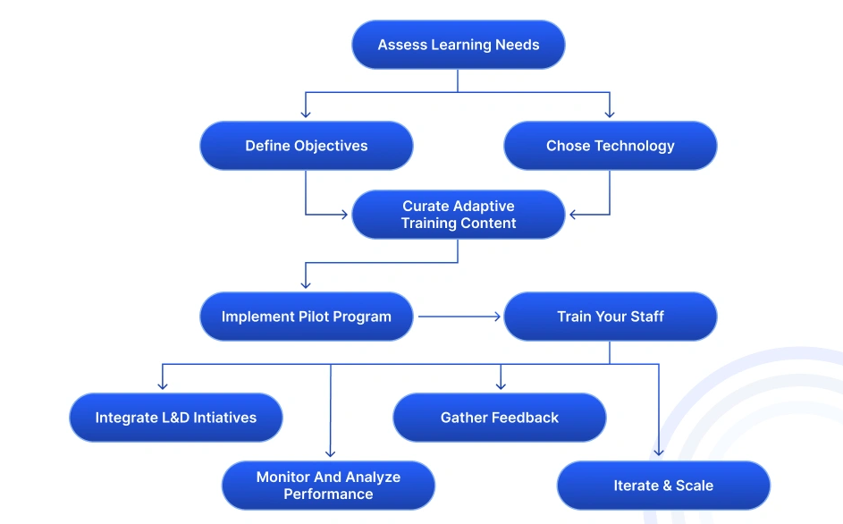

Figure 3: Implementing Adaptive Learning In Manufacturing (Mitchel 2025)

To fully realize the potential of adaptive learning, manufacturers must prioritize strategic implementation. Initiatives such as pilot programs, cloud-based platforms for scalability, and fostering collaboration across departments are essential. By aligning these practices with organizational goals, manufacturers can unlock transformative efficiencies, enhance workforce engagement, and drive sustained innovation in smart manufacturing.

**4. Enhancing Workforce Productivity and Overcoming Challenges**

The rapid technological advancements brought about by Industry 4.0 have necessitated a significant transformation in the manufacturing workforce. Adaptive learning has emerged as a pivotal tool in addressing this transformation, providing personalized training solutions and real-time feedback to enhance productivity, efficiency, and workforce engagement. This chapter explores the role of adaptive learning in workforce development, the mechanisms for delivering personalized training, the challenges faced during implementation, and emerging trends shaping the future of workforce productivity in smart manufacturing.

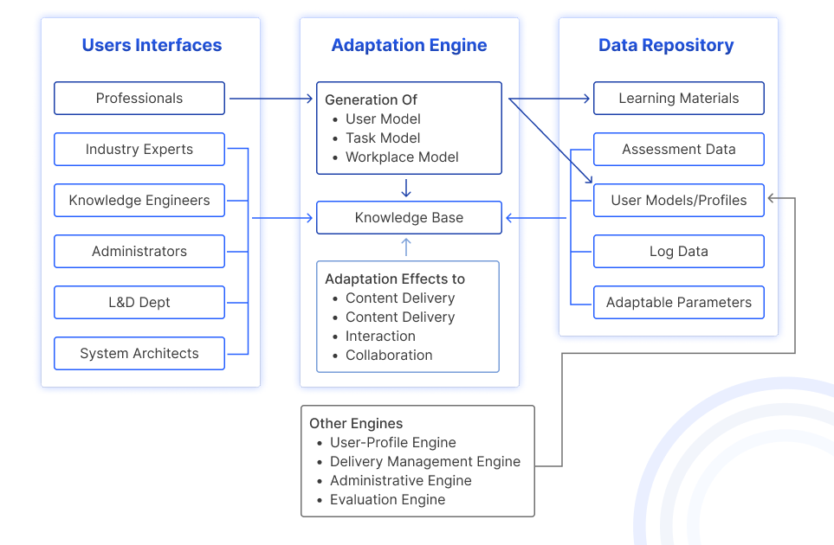

Figure 4: Adaptive Learning Architecture for Organizations (Mitchel 2025)

## **4.1 Workforce Development through Adaptive Learning**

Integrating adaptive learning into workforce development is essential for addressing the widening skill gap caused by automation and digitalization. As manufacturing transitions toward smart factories, job roles are shifting from routine tasks to more complex, technology-focused responsibilities. Adaptive learning addresses this transition by offering:

* **Upskilling and Reskilling Opportunities**: Adaptive learning platforms tailor content to individual employee needs, ensuring they gain the specific skills required to operate advanced manufacturing systems (Rane et al. 2023). For example, platforms can be used to train workers on operating and maintaining collaborative robots (cobots), including programming, troubleshooting, and safety procedures (Rahman et al. 2024). Additionally, they can be used to train workers on analyzing production data, identifying trends, and making data-driven decisions to improve efficiency and quality (Demartini et al. 2024).
* **Real-Time Learning for On-the-Job Efficiency**: These dynamic systems enable workers to access relevant training materials and receive real-time feedback while performing their tasks (Isaeva et al. 2025). For instance, real-time alerts from IoT devices can prompt workers to access relevant training modules on handling specific machine errors, minimizing downtime and improving responsiveness to production issues (Badshah et al. 2023).
* **Automation-Driven Workforce Redesign**: Automation is reshaping manufacturing roles, repetitive tasks with analytical and decision-making responsibilities. Personalized learning equips workers with the critical thinking and problem-solving skills needed to collaborate effectively with AI and robotics, enhancing their value to the organization and increasing employee engagement (Swarup 2024).

A compelling example of workforce development through personalized learning is Magna’s partnership with PTC’s Vuforia platform, which provides augmented reality (AR)-enabled training. This system allows technicians to visualize internal machine operations through AR overlays while receiving step-by-step guidance. The AR-based training has led to improved technician efficiency and reduced error rates during assembly and maintenance, resulting in increased productivity and improved customer satisfaction (PTC 2024).

## **4.2 Personalized Training and Real Time Feedback**

A key strength of adaptive learning in manufacturing is its ability to deliver personalized training and immediate feedback based on individual performance. These systems use AI and IoT-enabled monitoring to identify skill gaps and customize learning pathways.

### 4.2.1 Mechanisms for Personalization

According to Khine (2024), adaptive learning platforms rely on several mechanisms to deliver personalized training:

* **Performance Analytics**: Data from IoT sensors, machine performance metrics, and employee interactions are analyzed to identify learning needs and areas for improvement.
* **Dynamic Content Delivery**: Based on individual progress, these systems adjust the difficulty level and type of training content. For example, an operator struggling with robotic programming might receive simplified tutorials and interactive exercises, while advanced users are presented with more complex programming scenarios and challenges.
* **Scenario-Based Simulations**: Virtual reality (VR) and digital twins simulate real-world challenges, allowing workers to gain hands-on experience in a controlled environment and develop critical thinking and problem-solving skills.

### 4.2.2 Real Time Feedback Integration

Immediate feedback, facilitated by IoT and AI, ensures that workers receive prompt guidance during tasks, minimizing errors and reinforcing learning. Fanuc’s Zero Down Time (ZDT) system, previously discussed, exemplifies this by providing technicians with predictive alerts and troubleshooting advice, enabling proactive responses to potential machine failures (Biradar et al. 2023).

Real-time feedback also enhances safety in manufacturing environments. AR-enabled systems, such as those used by Lockheed Martin (also mentioned in Chapter 3), provide technicians with live overlays of assembly instructions and warnings about potential hazards, ensuring precision and safety during operations (Foster et al. 2024).

## **4.3 Implementation Challenges and Solutions**

Despite its transformative potential, implementing adaptive learning in manufacturing presents several challenges. Overcoming these barriers requires a strategic approach tailored to organizational and technological realities.

* **Financial Constraints and ROI Considerations**

The high upfront cost of implementing adaptive learning systems, including investments in IoT infrastructure, AI technologies, and training content development, is a major barrier for many organizations (Enstroem and Bhawna 2025), particularly small and medium enterprises (SMEs).

Proposed Solution: Organizations can consider adopting cloud-based Learning Management Systems (LMS) with integrated adaptive learning modules (Mehta et al. 2025), such as those offered by platforms like Docebo or Absorb LMS, which reduce infrastructure costs and provide access to a wide range of pre-built content and functionalities. Exploring government grants and partnerships with technology providers, like those facilitated by Germany’s "Mittelstand-Digital" program, can further alleviate financial constraints (Bella et al. 2024).

* **Organizational Resistance to Change**

According to Morandini et al. (2023), resistance to adopting new learning technologies can arise from both workers and management due to concerns about complexity, potential job displacement, or lack of familiarity.

Proposed Solution: Early stakeholder involvement and transparent communication about the benefits of adaptive learning are essential. Pilot programs with clearly defined metrics can demonstrate tangible results (such as improved productivity, reduced errors, and increased employee satisfaction) and build confidence in the system’s effectiveness (Pletcher 2023).

* **Technological Barriers**

Integrating adaptive learning systems with existing (legacy) manufacturing systems can present technical challenges related to data compatibility, system integration, and cyber security (Adepoju et al. 2024).

Proposed Solution: A phased implementation approach, where adaptive systems are integrated alongside legacy systems, can ease the transition. Robust cybersecurity protocols, regular security audits, and data encryption are essential for addressing data privacy and security concerns.

The Volkswagen Group’s transition to adaptive learning platforms provides a practical example of overcoming these challenges (Ali Mert Erdoğan 2024). By starting with pilot projects in specific plants and gradually scaling the deployment, Volkswagen minimized resistance, controlled costs, and demonstrated measurable improvements in productivity.

* **Scalability and Data Dependency**

While adaptive learning systems offer significant potential, scaling them beyond pilot implementations remains a major challenge for many manufacturers. As Ngwu et al. (2025) observe, effective deployment at scale often demands ongoing data acquisition, local content localization, and regular algorithm recalibration activities that can be time-consuming and cost-prohibitive, particularly in global or multi-plant operations. Additionally, adaptive learning relies heavily on accurate and consistent input data. Poor sensor calibration, incomplete datasets, or inconsistent annotations can reduce model effectiveness and undermine trust in system outputs (Nabeel, 2024).

Proposed Solution: To address scalability, manufacturers can adopt modular, cloud-based adaptive learning architectures that facilitate central governance while allowing for localized content delivery. Platforms with multi-tenant capabilities, such as SAP SuccessFactors integrated with adaptive AI modules, enable this balance between standardization and flexibility. To mitigate data dependency risks, implementing robust data quality assurance practices is essential. These include automated anomaly detection, regular sensor calibration, and real-time feedback validation. Incorporating explainable AI (XAI) features further enhances transparency, allowing users to understand and trust the system's decisions (Moosavi et al., 2024).

A practical example of successful implementation is Schneider Electric's deployment strategy. The company scaled its adaptive learning initiatives across multiple smart factories by utilizing a hybrid cloud infrastructure combined with real-time data cleansing mechanisms. This approach led to a 20% increase in training consistency and significantly reduced the risk of error propagation across learning modules (Strielkowski et al., 2024).

* **Cybersecurity Risks in AI-Driven Adaptive Learning**

As adaptive learning systems become increasingly embedded in smart manufacturing environments, their reliance on cloud infrastructure, IoT connectivity, and continuous data exchange heightens the risk of data breaches. These systems often handle sensitive information including employee training profiles, operational metrics, and proprietary process data which, if exposed, can compromise workforce privacy, disrupt production planning, and lead to significant reputational and financial damage (Dosumu, 2025).

Proposed Solution: To address these risks, manufacturers must implement multilayered security strategies that include encrypted data pipelines, federated learning approaches to decentralize data training, and routine penetration testing to identify system vulnerabilities. Additionally, incorporating explainable AI (XAI) principles can help detect anomalous behavior in adaptive learning outputs and improve auditability in case of a breach (Moosavi et al., 2024).

A notable example is Bosch’s implementation of federated learning in its connected manufacturing systems, which enabled model training across decentralized nodes without exposing sensitive data to central servers—enhancing both security and compliance (Bosch Global, 2023).

## **4.4 Future Trends in Workforce Productivity**

As Industry 4.0 continues to evolve, several trends are shaping the future of adaptive learning and workforce productivity:

* **AI-Driven Adaptive Learning Platforms**: Advanced AI algorithms enable deeper personalization, with systems capable of predicting future skill needs based on industry trends and individual performance data. These platforms integrate predictive analytics with workforce planning to proactively prepare workers for emerging technologies and ensure the organization has the necessary skills to remain competitive (Rane et al. 2023).
* **Integration with AR/VR Technologies**: AR/VR-enhanced learning systems are becoming more prevalent, offering immersive, hands-on training experiences. For example, Boeing has used VR training modules for technicians, resulting in a reported reduction of assembly time for complex aircraft components (Koc 2024).

**5. Synthesis of Findings, Industry Implications, and Future Research Directions**

The integration of adaptive learning in manufacturing has proven to be a transformative force, reshaping workforce training, production efficiency, and human-machine collaboration in the industry 4.0 era. Across multiple industries—including automotive, aerospace, electronics, heavy manufacturing, pharmaceuticals, and consumer goods—adaptive learning has facilitated personalized skill development, predictive maintenance, and real-time operational adjustments, ensuring that both human workers and intelligent automation systems evolve in tandem (Dehbozorgi and CONTESTABILE 2023).

In Section 2, the literature review established the theoretical foundations of adaptive learning, highlighting reinforcement learning, Bayesian optimization, and cognitive load theory as key drivers behind AI-enhanced workforce development. Research confirmed that adaptive AI-driven training significantly reduces training duration, enhances worker proficiency, and minimizes operational inefficiencies. Case studies from Siemens, Intel, and Lockheed Martin demonstrated the measurable benefits of real-time learning frameworks in highly complex manufacturing environments, particularly in automated production lines and aerospace assembly tasks.

Section 3 explored the practical applications of adaptive learning, demonstrating how it integrates with digital twins, IoT-enabled monitoring, and predictive maintenance systems to optimize production workflows and drive continuous process improvement. Companies such as BMW, Toyota, and Airbus have successfully deployed AI-driven training platforms, leading to fewer assembly errors, improved efficiency, and accelerated upskilling for highly technical roles. The integration of augmented reality (AR) and virtual reality (VR) in interactive workforce training has further underscored adaptive learning’s role in bridging skill gaps and enhancing worker engagement.

Section 4 examines the critical role of adaptive learning in navigating the workforce transformations driven by Industry 4.0. It details how adaptive learning facilitates personalized training and real-time feedback, addressing skill gaps and enhancing on-the-job efficiency through AI and IoT integration. The section further explores implementation challenges, such as financial constraints and organizational resistance, and proposes solutions like cloud-based LMS and phased deployment strategies. Finally, it highlights future trends, including AI-driven platforms for predictive skill development and the integration of AR/VR technologies, showcasing adaptive learning as a vital component of future smart manufacturing environments

## **5.2 Implications for Industry and Policymakers**

The widespread adoption of adaptive learning in manufacturing carries several critical implications for industry leaders, corporate strategists, and policymakers. As smart manufacturing continues to evolve with AI-driven automation, the following factors must be considered:

* **Strategic Workforce Transformation**: As adaptive learning accelerates upskilling and reskilling, manufacturing companies must develop long-term workforce strategies that integrate AI-driven training into employee career pathways. Organizations that fail to invest in adaptive learning risk skills obsolescence, production inefficiencies, and difficulty in attracting and retaining talent.
* **Adoption of Human-Centric AI**: Industry leaders must ensure that AI-driven adaptive learning platforms are designed for inclusive workforce development. Ethical considerations such as bias reduction in AI training models, explainable AI (XAI), and human-in-the-loop learning should be prioritized to ensure fair and equitable access to training opportunities for all employees.
* **Cost-Benefit Analysis for SMEs**: Large enterprises like Siemens and Caterpillar have successfully implemented adaptive learning, but small and medium enterprises (SMEs) face financial and infrastructure challenges. Industry leaders must advocate for scalable, cloud-based adaptive learning solutions tailored to SMEs, ensuring that technological advancements are accessible to smaller manufacturers and that they can remain competitive in the global market.
* **Integration with Industry 5.0 Trends**: As manufacturing shifts toward Industry 5.0, where human-machine collaboration is emphasized, adaptive learning must align with emerging cobotics (collaborative robots), hyper automation, and intelligent supply chains to support holistic workforce development and ensure seamless integration of human expertise with advanced technologies.

### 5.2.2 Policy Implications

* **Investment in National AI Workforce Programs**: Governments must prioritize public-private partnerships to subsidize AI-driven workforce development programs, similar to Germany’s "Mittelstand-Digital" initiative that provides funding for SMEs adopting digital manufacturing training. This will ensure that all sectors of the manufacturing industry have access to the necessary resources and support to implement and benefit from adaptive learning technologies.
* **Regulatory Standards for AI-Driven Training**: Policymakers must establish standards for AI-enhanced workforce learning, ensuring data privacy, cybersecurity, and ethical AI deployment. Countries such as Singapore and South Korea have already enacted policies requiring AI training platforms to meet transparency and accountability benchmarks (Lund et al. 2025). These standards will help build trust in AI-driven learning systems and ensure that they are used responsibly and ethically.
* **Educational Reform for Workforce Readiness**: National education systems must integrate AI-based adaptive learning into vocational and technical training programs, preparing future workers for Industry 4.0 and AI-integrated environments. Collaborative initiatives between universities, AI research labs, and manufacturing firms should be expanded to ensure a seamless transition from education to industry and equip graduates with the skills and knowledge necessary to thrive in the modern manufacturing landscape.
* **Incentives for Adaptive Learning Adoption**: Governments can introduce tax incentives, grants, and innovation credits for manufacturing companies investing in AI-driven workforce development. Policies modeled after the European Union’s Digital Skills and Jobs Coalition (Aksenova et al. 2024), and can be expanded to support cross-sector adoption of adaptive learning in manufacturing, driving innovation and economic growth across the entire industry.

## **5.3 Recommendations for Future Research**

While the current body of research demonstrates the potential of adaptive learning in manufacturing, several gaps remain that warrant further exploration:

* **AI Explainability and Bias in Adaptive Learning**: More research is needed to develop transparent, interpretable AI-driven learning models, ensuring that adaptive training platforms are unbiased and ethical. Future studies should explore how AI bias impacts skill assessment in diverse workforce populations and develop strategies to mitigate potential biases.
* **Longitudinal Studies on Workforce Adaptability**: While short-term benefits of adaptive learning (e.g., reduced training time, enhanced efficiency) are well-documented, long-term workforce adaptability metrics remain underexplored. Future research should investigate how AI-driven learning impacts worker retention, job satisfaction, career progression, and overall employee well-being over time.
* **Comparative Effectiveness of AI-Driven vs. Traditional Training Models**: Studies should compare adaptive learning frameworks against traditional vocational training to determine long-term knowledge retention, skill application, and productivity outcomes across various manufacturing settings. This will provide empirical evidence to support the adoption of adaptive learning and demonstrate its superior effectiveness compared to traditional training methods.
* **Cybersecurity and Data Privacy in AI-Driven Training Systems**: As manufacturing increasingly integrates cloud-based and IoT-enabled adaptive learning platforms, cybersecurity risks must be analyzed. Future research should explore the vulnerabilities of AI-driven training ecosystems and develop robust security models, such as federated learning and blockchain-based solutions, to mitigate threats and ensure the confidentiality and integrity of sensitive employee data.
* **Economic Impact of Adaptive Learning on Global Manufacturing Competitiveness**: Policymakers and industry leaders need quantitative economic analyses on how adaptive learning influences global manufacturing competitiveness, labor markets, and productivity.

## **5.4 Conclusion**

The integration of adaptive learning in manufacturing has redefined workforce training, operational agility, and human-machine collaboration. This review has demonstrated that by leveraging AI, IoT, digital twins, and predictive analytics, companies can optimize workforce productivity, enhance training efficiency, and minimize production downtime.

By addressing the research gaps identified in this chapter and by fostering collaboration between industry, academia, and policymakers, the full potential of adaptive learning can be realized. As Industry 4.0 continues to evolve and Industry 5.0 emerges, adaptive learning will play a pivotal role in driving innovation, enhancing workforce resilience, and ensuring the long-term sustainability and competitiveness of the global manufacturing sector.

Disclaimer (Artificial intelligence)

Option 1:

Author(s) hereby declare that NO generative AI technologies such as Large Language Models (ChatGPT, COPILOT, etc.) and text-to-image generators have been used during the writing or editing of this manuscript.

## **References**

1. Agarwal, V., Hameed, A.Z., Malhotra, S., Mathiyazhagan, K., Alathur, S. and Appolloni, A. (2022). Role of Industry 4.0 in agile manufacturing to achieve sustainable development. Business Strategy and the Environment, 32(6). doi:https://doi.org/10.1002/bse.3321.
2. Airbus (2024). How Airbus uses generative artificial intelligence to reinvent itself | Airbus. [online] www.airbus.com. Available at: https://www.airbus.com/en/newsroom/stories/2024-05-how-airbus-uses-generative-artificial-intelligence-to-reinvent-itself.
3. Aksenova, Z. A., Yashin, S. N., Markova, O. M., Chudaeva, A. A. and Alieva, P. R., 2024. Assessing the impact of digital economy programs on alleviating skill shortages in the EU labor market for digital professionals. *Journal of the Knowledge Economy*, 1-23.
4. Ali Mert Erdoğan, O. H., Abdulkadir Hiziroglu, 2024. *An In-Depth Case Study of Volkswagen's AI Integration* [online]. Available from: <https://ceur-ws.org/Vol-3698/paper7.pdf> [Accessed 03 March 2025].
5. Alster, K. (2024). *Why and How To Use AI for Training and Development in 2023*. [online] www.synthesia.io. Available at: https://www.synthesia.io/post/why-and-how-to-use-ai-for-training-and-development.
6. Aravind Kumar Kalusivalingam, Sharma, A., Patel, N. and Singh, V. (2022). Leveraging Reinforcement Learning and Predictive Analytics for Continuous Improvement in Smart Manufacturing. *International Journal of AI and ML*, [online] 3(9). Available at: https://cognitivecomputingjournal.com/index.php/IJAIML-V1/article/view/71.
7. Babashahi, L., Barbosa, C.E., Lima, Y., Lyra, A., Salazar, H., Argôlo, M., Almeida, M.A. de and Souza, J.M. de (2024). AI in the Workplace: a Systematic Review of Skill Transformation in the Industry. *Administrative Sciences*, 14(6), p.127. doi:https://doi.org/10.3390/admsci14060127.
8. Badshah, A., Ghani, A., Daud, A., Jalal, A., Bilal, M. and Crowcroft, J., 2023. Towards smart education through internet of things: A survey. *ACM Computing Surveys*,56 (2), 1-33.
9. Bella, R. L., Leal Filho, W., Sigahi, T. F., Rampasso, I. S., Quelhas, O. L., Bella, L. F., Moraes, G. H. S. M. d. and Anholon, R., 2024. Small-and Medium-Sized Enterprises: trends and future perspectives for sustainability and digitalization in Germany. *Sustainability*,16 (16), 6900.
10. Bello, F., Wada, U., Ige, B., Chianumba, E.C. and Adetunji, S. (2024). AI-driven predictive maintenance and optimization of renewable energy systems for enhanced operational efficiency and longevity. *International Journal of Science and Research Archive*, 13(1), pp.2823–2837. doi:https://doi.org/10.30574/ijsra.2024.13.1.1992.
11. Bettoni, A., Montini, E., Righi, M., Villani, V., Tsvetanov, R., Borgia, S., Secchi, C. and Carpanzano, E. (2020). Mutualistic and Adaptive Human-Machine Collaboration Based on Machine Learning in an Injection Moulding Manufacturing Line. *Procedia CIRP*, 93, pp.395–400. doi:https://doi.org/10.1016/j.procir.2020.04.119.
12. Biradar, R. C., Tabassum, N., Hegde, N. and Lazarescu, M., 2023. *AI and blockchain applications in industrial robotics*. IGI Global.
13. Bongard, L. (2024). *Test Deployment of Humanoid Robots at BMW Group Plant Spartanburg - BMW Group iFACTORY EXPERIENCE*. [online] BMW Group iFACTORY EXPERIENCE. Available at: https://www.visit-bmwgroup.com/en/test-deployment-of-humanoid-robots-at-bmw-group-plant-spartanburg/ [Accessed 10 Mar. 2025].
14. Bosch Global. (2023). Federated Learning. Bosch Global. https://www.bosch.com/research/news/federated-learning/
15. Calignano, F. and Mercurio, V. (2023). An overview of the impact of additive manufacturing on supply chain, reshoring, and sustainability. *Cleaner Logistics and Supply Chain*, 7, p.100103. doi:https://doi.org/10.1016/j.clscn.2023.100103.
16. Chiu, M.-C., & Huang, Y.-J. (2023). Applying Hybrid Machine Learning Models to Assist Small and Medium Enterprises in Achieving Quality Prediction and Adaptive Digital Transformation: A Case Study of Injection Molding Industry. Advances in Transdisciplinary Engineering. https://doi.org/10.3233/atde230636
17. Dehbozorgi, M. and CONTESTABILE, D., 2023. Bridging the Skill Gap in Engineering Education: Designing Learning Factories for Industry 4.0 and 5.0.
18. Demartini, C. G., Sciascia, L., Bosso, A. and Manuri, F., 2024. Artificial intelligence bringing improvements to adaptive learning in education: A case study. *Sustainability*,16 (3), 1347.
19. Dimitris Mourtzis and Angelopoulos, J. (2024). Artificial intelligence for human–cyber-physical production systems. *Elsevier eBooks*, pp.343–378. doi:https://doi.org/10.1016/b978-0-443-13924-6.00012-0.
20. Doskenov, B., & Okuyelu, O. (2025). Advancing Production Systems with Online Reinforcement Learning: Real-time Monitoring, Control, and Optimization. Current Journal of Applied Science and Technology, 44(2), 1–22. https://doi.org/10.9734/cjast/2025/v44i24480
21. Dosumu, R. (2025). MOVEit Data Breach: A Case Study in ZeroDay Exploits and Organizational Cybersecurity Preparedness. https://doi.org/10.13140/RG.2.2.17029.26081
22. ElMaraghy, H. and ElMaraghy, W. (2022). Adaptive Cognitive Manufacturing System (ACMS) – a new paradigm. *International Journal of Production Research*, pp.1–14. doi:https://doi.org/10.1080/00207543.2022.2078248.
23. Enstroem, R. and Bhawna, B., 2025. AI and VR: Shaping the Next Generation of Adaptive Learning and Development Programmes. *The Future of HRM in a World of Persistent Virtual Reality.* Emerald Publishing Limited, 141-163.
24. Estrada-Jimenez, L.A., Pulikottil, T., Nikghadam-Hojjati, S. and Barata, J. (2023). Self-Organization in Smart Manufacturing— Background, Systematic Review, Challenges and Outlook. *IEEE Access*, [online] 11, pp.10107–10136. doi:https://doi.org/10.1109/ACCESS.2023.3240433.
25. Evgenia Gkintoni, Hera Antonopoulou, Sortwell, A. and Constantinos Halkiopoulos (2025). Challenging Cognitive Load Theory: The Role of Educational Neuroscience and Artificial Intelligence in Redefining Learning Efficacy. *Brain Sciences*, [online] 15(2), pp.203–203. doi:https://doi.org/10.3390/brainsci15020203.
26. Fatima, M., Reddy, R. Aarti and Ali (2024). Shaping Industry 4.0 and 5.0 Landscapes by Navigating Technological Shifts with Soft Computing Expertise. pp.1–43. doi:https://doi.org/10.1007/978-3-031-69336-6_1.
27. Fei, H. (2024). General Electric’s (GE) Companywide Digital Overhaul for Enhanced Productivity.
28. Foster, T. C., Moroney, W. F., Phillips, H. L. and Lilienthal, M. G., 2024. Human Factors in Simulation and Training: An Overview. *Human Factors in Simulation and Training*, 1-64.
29. Hider, U. and Aslam, R. (2024). Google Cloud and Adaptive Machine Learning: Advancing Cybersecurity in the Age of Digitalization. *INTERNATIONAL BULLETIN OF LINGUISTICS AND LITERATURE (IBLL)*, 7(3), pp.48–57.
30. Huang, M. (2024). *Foxconn Expands Blackwell Testing and Production With New Factories in U.S., Mexico and Taiwan*. [online] NVIDIA Blog. Available at: https://blogs.nvidia.com/blog/foxconn-blackwell-omniverse/.
31. Hvarfner, C. (2025). Bayesian Optimization Across the Spectrum of Knowledge: Enhancing Efficiency through Beliefs, Information and Assumptions.
32. HVI (2024). *Predictive Maintenance for Caterpillar Equipment with HVI Integration*. [online] HVI. Available at: https://heavyvehicleinspection.com/blog/post/predictive-maintenance-for-caterpillar-equipment-with-hvi-integration.
33. Isaeva, R., Karasartova, N., Dznunusnalieva, K., Mirzoeva, K. and Mokliuk, M., 2025. Enhancing learning effectiveness through adaptive learning platforms and emerging computer technologies in education. *Jurnal Ilmiah Ilmu Terapan Universitas Jambi*,9 (1), 144-160.
34. Jagatheesaperumal, S.K., Rahouti, M., Ahmad, K., Al-Fuqaha, A. and Guizani, M. (2021). The Duo of Artificial Intelligence and Big Data for Industry 4.0: Applications, Techniques, Challenges, and Future Research Directions. *IEEE Internet of Things Journal*, 9(15), pp.1–1. doi:https://doi.org/10.1109/jiot.2021.3139827.
35. Javaid, M., Haleem, A. and Suman, R. (2023). Digital twin applications toward industry 4.0: A review. *Cognitive Robotics*, [online] 3. doi:https://doi.org/10.1016/j.cogr.2023.04.003.
36. Joseph, S.A., Titilayo Modupe Kolade, Val, O.O., Adebiyi, O.O., Olumide Samuel Ogungbemi and Oluwaseun Oladeji Olaniyi (2024). AI-Powered Information Governance: Balancing Automation and Human Oversight for Optimal Organization Productivity. *Asian Journal of Research in Computer Science*, 17(10), pp.110–131. doi:https://doi.org/10.9734/ajrcos/2024/v17i10513.
37. Joy, B., Muhammed, A., John, A. and Balil, M. (2024). AIPowered Predictive Maintenance: Optimizing Industrial Efficiency.
38. Kaur, N., Dhillon, G.S., Rani, S. and Elngar, A.A. (2025). *Intelligent Manufacturing*. CRC Press.
39. Khine, M. S., 2024. Using AI for Adaptive Learning and Adaptive Assessment. *Artificial Intelligence in Education: A Machine-Generated Literature Overview.* Springer, 341-466.
40. Koc, B., 2024. 8 Augmented Reality and Virtual Reality Solutions in Aviation Industry. *Smart and Sustainable Operations Management in the Aviation Industry: A Supply Chain 4.0 Perspective*, 106.
41. Kruger, D. (2020). Adaptive learning technology to enhance selfdirected learning. *Selfdirected multimodal learning in higher education (NWU selfdirected learning series)*, 5, pp.93–116.
42. leone, G. (2024). *How electronics manufacturers are rethinking quality in the AI era - Electronics & Semiconductors*. [online] Electronics & Semiconductors. Available at: https://blogs.sw.siemens.com/en-US/electronics-semiconductors/2024/12/12/how-electronics-manufacturers-are-rethinking-quality-in-the-ai-era/.
43. Liu, H., Li, S., Li, W. and Sun, W. (2024). Efficient decentralized optimization for edge-enabled smart manufacturing: A federated learning-based framework. *Future Generation Computer Systems*, 157, pp.422–435. doi:https://doi.org/10.1016/j.future.2024.03.043.
44. lockheedmartin (2024). *Augmented Reality is Transforming Space Technology*. [online] Lockheed Martin. Available at: https://www.lockheedmartin.com/en-us/news/features/2024/augmented-reality-transforms-space-technology.html.
45. Lund, B., Orhan, Z., Mannuru, N. R., Bevara, R. V. K., Porter, B., Vinaih, M. K. and Bhaskara, P., 2025. Standards, frameworks, and legislation for artificial intelligence (AI) transparency. *AI and Ethics*, 1-17.
46. Mahankali, R. (2025). AIDRIVEN ADAPTIVE MANUFACTURING SYSTEMS: AN ENTERPRISE ARCHITECTURE FRAMEWORK FOR COGNITIVE MANUFACTURING. *Technology (IJRCAIT)*, 8(1).
47. Mehta, P. S., Doshi, S. T., Butle, S. N., Inamdar, S. C. and Shinde, S. D., 2025. The Fusion of Academia and Industry via Cloud Integration in Education: Customized Learning and Adaptive Systems. *Bridging Academia and Industry Through Cloud Integration in Education.* IGI Global Scientific Publishing, 109-144.
48. Mitchel, H., 2025. *Adaptive Learning In 2025: Insights and Key Trends* [online]. Ed Stellar. Available from: <https://www.edstellar.com/blog/what-is-adaptive-learning> [Accessed 02 March 2025].
49. Mohsen Soori, Roza Dastres, Karimi, F. and Kolamroudi, M.K. (2025). Smart quality control of Industry 4.0 by artificial intelligence-powered robot vision, a review. *Elsevier eBooks*, pp.255–285. doi:https://doi.org/10.1016/b978-0-443-26482-5.00025-0.
50. Moosavi, S., Farajzadeh-Zanjani, M., Roozbeh Razavi-Far, Vasile Palade, & Saif, M. (2024). Explainable AI in Manufacturing and Industrial Cyber–Physical Systems: A Survey. Electronics, 13(17), 3497–3497. https://doi.org/10.3390/electronics13173497
51. Morandini, S., Fraboni, F., De Angelis, M., Puzzo, G., Giusino, D. and Pietrantoni, L., 2023. The impact of artificial intelligence on workers’ skills: Upskilling and reskilling in organisations. *Informing Science*,26, 39-68.
52. Nabeel, M. Z. (2024). AI-Enhanced Project Management Systems for Optimizing Resource Allocation and Risk Mitigation. Asian Journal of Multidisciplinary Research & Review, 5(5), 53–91. https://doi.org/10.55662/ajmrr.2024.5502.
53. Nagy, M., Lăzăroiu, G. and Valaskova, K. (2023). Machine Intelligence and Autonomous Robotic Technologies in the Corporate Context of SMEs: Deep Learning and Virtual Simulation Algorithms, Cyber-Physical Production Networks, and Industry 4.0-Based Manufacturing Systems. *Applied Sciences*, 13(3), p.1681. doi:https://doi.org/10.3390/app13031681.
54. Nechesov, A., Dorokhov, I. and Ruponen, J. (2025). Virtual Cities: From Digital Twins to Autonomous AI Societies. *IEEE Access*, 13, pp.13866–13903. doi:https://doi.org/10.1109/access.2025.3531222.
55. Ngwu, C., Liu, Y., & Wu, R. (2025). Reinforcement learning in dynamic job shop scheduling: a comprehensive review of AI-driven approaches in modern manufacturing. Journal of Intelligent Manufacturing. https://doi.org/10.1007/s10845-025-02585-6.
56. Omokhafe, S., Eweala, J., Durodola, L., None Godbless Ocran, None Adedamola Hadassah Paul-Adeleye and Prosper, N. (2024). Impact of AI on continuous learning and skill development in the workplace: A comparative study with traditional methods. *World Journal of Advanced Research and Reviews*, 23(2), pp.1129–1140. doi:https://doi.org/10.30574/wjarr.2024.23.2.2439.
57. Orabi, M.M., Emam, O. and Fahmy, H. (2025). Adapting security and decentralized knowledge enhancement in federated learning using blockchain technology: literature review. *Journal of Big Data*, 12(1). doi:https://doi.org/10.1186/s40537-025-01099-5.
58. orcalean (2025). *https://www.orcalean.com/article/intel’s-smart-factory-approach:-how-ai-and-iot-are-revolutionizing-semiconductor-production*. www.orcalean.com.
59. Pasupuleti, V., Thuraka, B., Kodete, C.S. and Malisetty, S. (2024). Enhancing Supply Chain Agility and Sustainability through Machine Learning: Optimization Techniques for Logistics and Inventory Management. *Logistics*, 8(3), p.73.
60. Pivoto, D.G.S., de Almeida, L.F.F., da Rosa Righi, R., Rodrigues, J.J.P.C., Lugli, A.B. and Alberti, A.M. (2021). Cyber-physical systems architectures for industrial internet of things applications in Industry 4.0: A literature review. *Journal of Manufacturing Systems*, 58, pp.176–192. doi:https://doi.org/10.1016/j.jmsy.2020.11.017.
61. Pletcher, S. N., 2023. Starting Slowly to Go Fast Deep Dive in the Context of AI Pilot Projects.
62. PTC, 2024. *Magna Supercharges Its Quality Control and Training Processes with AR* [online]. PTC. Available from: <https://www.ptc.com/en/case-studies/magna-supercharges-quality-and-training-with-ar> [Accessed 28 February 2025].
63. Qian, C., Guo, Y., Hussaini, A., Musa, A., Sai, A. and Yu, W. (2024). A New Layer Structure of Cyber-Physical Systems under the Era of Digital Twin. *ACM Transactions on Internet Technology*. doi:https://doi.org/10.1145/3674974.
64. Rahman, M. M., Khatun, F., Jahan, I., Devnath, R. and Bhuiyan, M. A.-A., 2024. Cobotics: The Evolving Roles and Prospects of Next‐Generation Collaborative Robots in Industry 5.0. *Journal of Robotics*,2024 (1), 2918089.
65. Rane, N., Choudhary, S. and Rane, J., 2023. Education 4.0 and 5.0: Integrating artificial intelligence (AI) for personalized and adaptive learning: Nov.
66. Ren, Y. and Li, G.-P. (2022). An Interactive and Adaptive Learning Cyber Physical Human System for Manufacturing With a Case Study in Worker Machine Interactions. 18(10), pp.6723–6732. doi:https://doi.org/10.1109/tii.2022.3150795.
67. Roy, M.-A., Georges Abdul-Nour, & Gamache, S. (2023). Implementation of an Industry 4.0 Strategy Adapted to Manufacturing SMEs: Simulation and Case Study. Sustainability, 15(21), 15423–15423. https://doi.org/10.3390/su152115423.
68. Ryalat, M., ElMoaqet, H. and AlFaouri, M., 2023. Design of a smart factory based on cyber-physical systems and Internet of Things towards Industry 4.0. *Applied Sciences*,13 (4), 2156.
69. Sadasivan, M., Vasumathi, M. and Jayanthi, M. (2024). Artificial intelligence for smart manufacturing using digital twin technology. In: *Artificial Intelligence based Solutions for Industrial Applications*. CRC Press, pp.176–194.
70. Sharma, K., Nguyen, A. and Hong, Y. (2024). Self‐regulation and shared regulation in collaborative learning in adaptive digital learning environments: A systematic review of empirical studies. *British journal of educational technology*. doi:https://doi.org/10.1111/bjet.13459.
71. Sharma, M., Paliwal, T. and Baniwal, P. (2024). Challenges in Digital Transformation and Automation for Industry 4.0. In: *AIDriven IoT Systems for Industry 4.0*. CRC Press, pp.143–163.
72. Sousa, V.F.C., Silva, F.J.G., Fecheira, J.S., Lopes, H.M., Martinho, R.P., Casais, R.B. and Ferreira, L.P. (2020). Cutting Forces Assessment in CNC Machining Processes: A Critical Review. *Sensors*, [online] 20(16), p.4536. doi:https://doi.org/10.3390/s20164536.
73. Strielkowski, W., Grebennikova, V., Lisovskiy, A., Rakhimova, G., & Vasileva, T. (2024). AI-driven adaptive learning for sustainable educational transformation. Sustainable Development. https://doi.org/10.1002/sd.3221.
74. Swarup, R. R., 2024. Designing Education 4.0: Harnessing the power of Design Thinking. Development, 6 (7), 8.
75. T. Archana and R. Kingsly Stephen (2024). The Future of Artificial Intelligence in Manufacturing Industries. Advances in logistics, operations, and management science book series, pp.98–117. doi:https://doi.org/10.4018/979-8-3693-4276-3.ch004
76. Taylor, A. (2025a). *How Johnson & Johnson and Pfizer Use AI to Enhance Pharmaceutical Production Efficiency*. [online] Cleverence.com. Available at: https://www.cleverence.com/articles/business-blogs/how-johnson-and-johnson-and-pfizer-use-ai-to-enhance-pharmaceutical-production-efficiency/ [Accessed 15 Mar. 2025].
77. Taylor, A. (2025b). *How Samsung and Intel Optimize Semiconductor Production with Smart Automation*. [online] Cleverence.com. Available at: https://www.cleverence.com/articles/business-blogs/how-samsung-and-intel-optimize-semiconductor-production-with-smart-automation/ [Accessed 11 Mar. 2025].
78. Team DigitalDefynd (2024a). *5 ways BMW is using AI [Case Study] [2024]*. [online] DigitalDefynd. Available at: https://digitaldefynd.com/IQ/bmw-using-ai-case-study/.
79. Team DigitalDefynd (2024b). *5 ways Toyota is using AI [Case Study] [2024]*. [online] DigitalDefynd. Available at: https://digitaldefynd.com/IQ/toyota-using-ai-case-study/.
80. Toyota (2023). *Toyota and Generative AI: It’s Here, and This is How We’re Using It*. [online] Toyota USA Newsroom. Available at: https://pressroom.toyota.com/toyota-and-generative-ai-its-here-and-this-is-how-were-using-it/.
81. Tsaramirsis, G., Kantaros, A., Al-Darraji, I., Piromalis, D., Apostolopoulos, C., Pavlopoulou, A., Alrammal, M., Ismail, Z., Buhari, S.M., Stojmenovic, M., Tamimi, H., Randhawa, P., Patel, A. and Khan, F.Q. (2022). A Modern Approach towards an Industry 4.0 Model: From Driving Technologies to Management. *Journal of Sensors*, 2022, pp.1–18. doi:https://doi.org/10.1155/2022/5023011.
82. Viterouli, M., Dimitrios Belias, Athanasios Koustelios, Nikolaos Tsigilis and Christos Papademetriou (2024). Time for Change. *Advances in human resources management and organizational development book series*, pp.267–307. doi:https://doi.org/10.4018/979-8-3693-3466-9.ch014.
83. Wang, B., Zheng, P., Yin, Y., Shih, A. and Wang, L. (2022). Toward human-centric smart manufacturing: A human-cyber-physical systems (HCPS) perspective. *Journal of Manufacturing Systems*, 63, pp.471–490. doi:https://doi.org/10.1016/j.jmsy.2022.05.005.
84. Xu, J., Sun, Q., Han, Q.-L. and Tang, Y. (2025). When Embodied AI Meets Industry 5.0: Human-Centered Smart Manufacturing. *IEEE/CAA Journal of Automatica Sinica*, 12(3), pp.485–501. doi:https://doi.org/10.1109/jas.2025.125327.
85. Yambal, S. and Waykar, Y.A. (2025). Future of Education Using Adaptive AI, Intelligent Systems, and Ethical Challenges. *Advances in Educational Technologies and Instructional Design*, [online] pp.171–202. doi:https://doi.org/10.4018/979-8-3693-6527-4.ch006.
86. Yang, Y. and Liu, Y. (2024). Adaptive Optimization Control Strategy for Intelligent Manufacturing Systems Based on Deep Reinforcement Learning. pp.305–309. doi:https://doi.org/10.1109/iist62526.2024.00044.
87. Yoo, S., Reza, S., Hamid Tarashiyoun, Akhil Ajikumar and Moghaddam, M. (2024). AI-Integrated AR as an Intelligent Companion for Industrial Workers: A Systematic Review. *IEEE Access*, pp.1–1. doi:https://doi.org/10.1109/access.2024.3516536.
88. Zaytsev, A. (2023). *Case Study: How AI is Transforming Procter & Gamble’s Global Operations*. [online] AIX | AI Expert Network. Available at: https://aiexpert.network/case-study-how-ai-is-transforming-procter-gambles-global-operations/.