Swelling and Shrinkage Performance of Expansive Soils Under Repeated Moisture Variations

.

ABSTRACT

|  |
| --- |
| Expansive soils increase in volume when they absorb water and contract as they dry out. This continuous variation in volume can cause uneven settlement, leading to cracks in light structures. The expansive soils under lightly loaded constructions, such as light buildings, pavements, are subjected to almost two cyclic shrink-swell per annum in the tropical zone due to the seasonal climatic variation. Expansive clay soils, characterized by high concentrations of montmorillonite, smectite, or other clay minerals, tend to shrink and swell with changes in moisture content. These volume changes can lead to notable deterioration in lightly loaded constructions if not properly addressed. This study aims to analyse the behaviour of expansive clays under shrink-swell cycles by means of direct shear and oedometer tests. The soil samples were collected in the region of Pobè (Issaba, Ahoyèyè) of Zogbodomey (Koto, Zoukou) and of Sèhouè Massi in the La Lama depression in the Republic of Benin. Soil characterization was carried out by means of geotechnical physical and mechanical tests. It was found that soil samples significantly swell for the first two cycles of alternated drying-wetting, after which the magnitude of swelling decreased. However, the cracking magnitude increased with increasing cyclic number of alternated swell-shrink, that result in the increasing of the mesopore of the samples.  Direct shear and oedometer tests were performed on samples of expansive soils subjected to alternated drying-wetting cycles. The results of direct shear tests under unconsolidated undrained conditions showed a notable decline in shear strength, indicated by a decrease in internal friction angle and cohesion, and an increase in void ratio with the increasing number of cycles. Furthermore, the paths of the undrained internal friction angle and the cohesion in function of the number of cyclic alternated wetting- drying converged to an L–shaped curve. Hereby, equilibrium condition was reached beyond 3 to 4 cycles. Most of the degradation of the shear strength occurred almost for the first three cycles of drying-wetting. Undrained internal friction angle decreases to 30% of the initial undrained internal friction angle, while undrained cohesion decreases to 35% of the initial undrained cohesion.  The results of oedometer tests showed an increase in void ratio *e*, in compressibility index *Cc* und in constrained modulus *Eoed* with increasing number of cyclic alternated drying-wetting. However, the swelling index *Cs* decreased with increasing number of cyclic alternated drying-wetting. Therefore, this study improves the comprehension of these complex processes underlying the behaviour of expansive clays under cyclic drying-wetting conditions and provides a basis for developing effective strategies to manage and mitigate their impact on infrastructure.  . |

*Keywords: Expansive soils, cyclic drying-wetting, shear, consolidation behaviour*

1. INTRODUCTION

Expansive soils are soils that undergo volume change (increase or decrease) when subjected to varying moisture content, Adeoti et al. (2023) [1]. When the moisture content of expansive soils increases, its volume increases and the soil can swell. On the other hand, when the moisture content of expansive soils decreases, its volume decreases and the soil can shrink. Therefore, the expansive soils under lightly loaded constructions such as light buildings, pavements are subjected to almost two cyclic shrink-swell per annum in the tropical zone due to the seasonal climatic variation (two alternated drying-raining periods per annum). In the context of sustainability, projects assume key roles for the development and implementation of sustainable technologies and practices. The designer, in this case, must recognize the impacts of each choice, seeking sustainability requirements applicable throughout the different phases of the life cycle of the building, from its conception, during its useful life, to management of building waste in the phase, for example (Alves et al., 2021).

Expansive clay soils, characterized by high concentrations of montmorillonite, smectite, or other clay minerals, tend to shrink and swell with changes in moisture content. These volume changes can lead to notable deterioration in lightly loaded constructions if not properly addressed. Due to the strong physicochemical interactions between the soil skeleton and pore water, expansive soil exhibits significant swelling or shrinkage during wetting and drying cycles (MA et al., 2024). Expansive clay soils are prevalent over wide areas worldwide, and they present risks to lightly loaded structures because they undergo differential deformations mainly due to variations in moisture content. Climate conditions potentially exert significant effect on soil moisture change, particularly evapotranspiration in the drought season and infiltration in the rainfall season (Furtak & Wolińska, 2023). In this context, it is necessary to investigate the cyclic shrink-swell effect on the behaviour of expansive soil.

Adeoti et al. (2023) [1] investigated the effect of cyclic wetting-drying on the shear strength, the compressibility, and the consolidation of expansive soils in the La Lama depression in the Republic of Benin. Hereby, the oedometer and the direct shear tests were carried out on soil samples subjected to a maximum 3 cycles of alternated wetting-drying. As a result, the unconsolidated and undrained shear strength in trends decreases with increasing cycle of wetting-drying, leading to degradation of the soil matrix characterised with significant cracks. However, this study was limited to only one location and 3 cycles.

Md et al. (2016) [2] investigated the impact of drying-wetting cycles on the saturated shear strength of undisturbed residual soil. For that, the authors performed a series of consolidated drained triaxial tests on multiple drying-wetting residual soil samples collected at areas around Kaiping, Guangdong in China and analysed the saturated shear strength. The test results reveal that the stress-strain relationships exhibit strain-hardening behaviour. The deviatoric stress and initial stiffness of saturated soils increase, and the soil volume becomes more contracting as the net normal stress rises. However, deviatoric stress and initial stiffness of saturated soils both decrease with increasing number of drying-wetting cycles. The cohesion and internal friction angle decrease with increasing cycle number, but the attenuation rate of the friction angle is less than the cohesion. Md et al. (2016) [2] stated that the variations of the internal friction angle and cohesion as a function of drying-wetting cycles can be described using an exponential equation.

Basma et al. (1996) [3] explored the cyclic swelling-shrinkage behaviour of natural expansive clays establishing that cyclic swelling-shrinkage has a significant influence on the expansive behaviour of clays. Basma et al. (1996) [3] observed a decrease in the swelling ability of clays, along with reduced water absorption capacity, when the soils were subjected to alternated wetting and partial shrinking. However, an increase in swelling potential was observed when the soils were fully shrunk. In both cases, equilibrium can be reached after several cycles. As the number of cycles increases, further destruction of large aggregates and disorientation of structural elements occur. After approximately the fifth cycle, the fabric becomes nearly disoriented, causing any further changes in expansibility to cease. A study demonstrated that cyclic swelling and shrinkage reduce the water absorption capacity of clays and disrupt their internal structure after multiple cycles. Another study showed that compressibility increases and swelling potential decreases with more drying-wetting cycles. Factors such as evapotranspiration during dry periods and infiltration during rainy seasons significantly influence the soil’s moisture content (Chabi et al., 2025).

Louati et al. (2018) [4] studied the influence of wetting-drying cycles and cracks on the hydraulic conductivity of compacted clayey soil. Their results showed that predicted and measured values of saturated hydraulic conductivity were in good agreement. When cracking occurs, permeability can increase to a threshold, and the influence of initial density becomes negligible after seven drying-wetting cycles.

Gbaffonou et al. (2021) [5] and Gbaffonou et al. (2022) [6] performed oedometer tests on expansive clay subjected to four cyclic wetting-drying. The test results showed that the compressibility index of the soil increases while the swelling index decreases with increasing cyclic number. The permeability of the soil increases when the number of cycles increases. However, Abbas et al. (2023) [7] reported that the cyclic wetting-drying process under constant stress conditions resulted in shrinkage accumulation and reduction in saturated hydraulic conductivity. On the other hand, cyclic wetting-drying under constant volume conditions causes reduction of swell pressure while that has almost no impact on saturated hydraulic conductivity. The increase or decrease of the hydraulic conductivity of expansive soils with increasing cyclic drying-wetting can depend on the clay minerals, the boundary conditions (stress, volume).

The review of the above references showed that many factors govern the mechanism of shrink-swell of expansive soils due to seasonal moisture changes, amount and type of clay minerals, specific surface area, amount of non-expansive materials, and water content. Furthermore, the cyclic swell-shrink influence the physical and mechanical performance of expansive soils. However, most of the previous investigations on the effects of alternated drying-wetting cycles on engineering properties are based on expansive soil or artificial soils (soil mixed with fly ash, cement, lime or organic polymers) or reconstructed soils for slope stability analysis or soil stabilization. Then, the effects of alternated drying-wetting cycles on shear, compressibility and consolidation behaviour of undisturbed expansive clay are not well understood yet. Therefore, this study aims to evaluate the effects of drying-wetting cycles on the shear strength (internal angle of friction and cohesion) and the compressibility and consolidation behaviour of undisturbed expansive clay.

2. Material and methods

**2.1 Material**

The soil samples were collected in the region of Pobè (Issaba, Ahoyèyè) of Zogbodomey (Koto, Zoukou) and of Sèhouè Massi in the La Lama depression in Republic of Benin, as depicted in Fig. 1. To identify sampling locations, on-site visits were conducted, with a focus on areas where shrink-swell effects are most evident, particularly in buildings and pavements showing significant damage and cracks. The soil samples were gathered within the Pobè and Zogbodomey municipality, specifically within the districts of Issaba, Ahoyèyè, Sèhouè and Massi. Table 1 provides the geographical coordinates of each designated sampling site.

**Table 1. Geolocation of the sampling sites**

|  |  |  |
| --- | --- | --- |
| **Locations** | **Coordinates** | |
| **Latitude** | **Longitude** |
| ISSABA | N 07°05'23.8" | E 02°38'04.9" |
| AHOYEYE | N 07°00'33.9" | E 02°38'04.9" |
| SEHOUE MASSI | N 09°44´98" | E 02°26´31,7 " |
| ZOUKOU | N 7°02’ 57’’ | E 2°10’ 31’’ |
| KOTO | N 6°59’ 57’’ | E 2°6’ 43’’ |

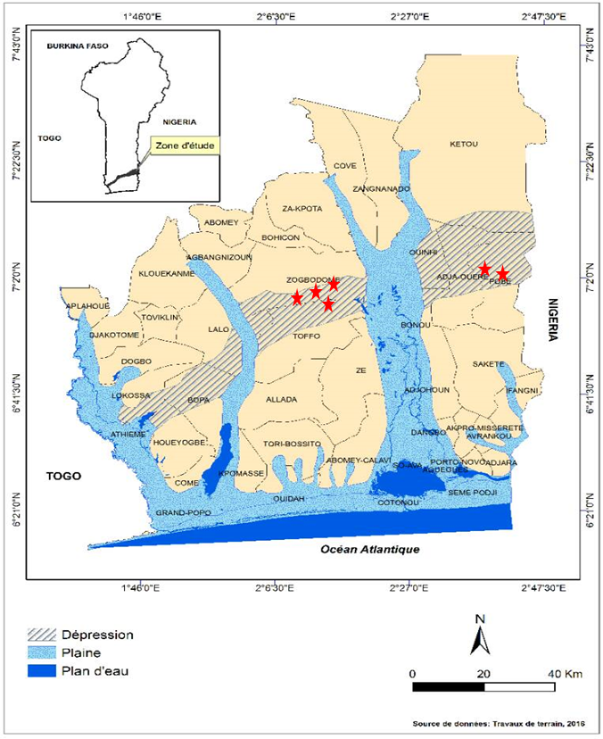

**Fig. 1. Pedological map of La Lama depression: sample locations.**

Disturbed and undisturbed soil samples were gathered for physical and mechanical tests. The undisturbed samples were cored using cubic thin-wall steel boxes with internal size of 20x20x20 cm3 designed for collecting undisturbed samples. For that, the open-ended box was driven into the ground. The collected samples were stored in plastic bags for transportation. In the study area, undisturbed and disturbed samples were gathered at a depth of 3 m. Note that the influence zone is located at the depth ranges from 0 to 2.5 m with respect to ground level. Below depth of 2.5 m, both moisture content and liquidity index were approximately constant.

**2.2 Methods**

Soil characterization was carried out by means of geotechnical physical and mechanical tests. Table 2 presents physical identification tests performed on soil samples.

**Table 2: Physical identification tests performed**

|  |  |
| --- | --- |
| **Physical identification tests** | **Standards applied** |
| Moisture content | NF EN ISO 17892-1 [8] (BS EN ISO 17892-12, 2018) |
| Atterberg Limits tests | NF EN ISO 17892-12 [9] (CEN ISO TS 17892-1: 2014) |
| Specific gravity of solid particles | Standard NF EN ISO 17892-3 [10] |
| Organic Matter Content | ISO 14235 [11] |
| Particle size distribution | NF EN ISO 17892-4 [12] (EN ISO 17892-10: 2018) |

Oedometer test in accordance with NF EN ISO 17892-5 [13] and direct shear test in accordance with NF EN ISO 17892-10 [14] were carried out on undisturbed soil samples subjected to drying-wetting cycles. The cyclic drying-wetting sequence begins with the drying stage, as is typical in most studies, Basma et al. (1996) [3], Gbaffonou et al. (2022) [6], Louati et al. (2021) [4], Abbas et al. (2023) [7].

**2.2.1. Drying phase**

Undisturbed samples in 20x20x20 cm3 boxes were cored within shear and oedometer rings. These rings are weighed empty and with the core sample. For each sample type, a core served as a control for determining the moisture content. Moreover, pre-rings with size larger than shear and oedometer rings for the drying and wetting phases, were also used to avoid gap between the sample and shear or oedometer rings after the shrink due to drying.

Drying of samples was performed in sunlight at temperatures ranging approximately from +26°C to +36°C. The minimum temperature in the morning hovers around 26°C, while the maximum temperature of around 36°C is typically reached in the afternoon, as indicated by temperature measurements taken over a 3-day period. The samples still in rings are exposed to sunlight for about 9 hours each day to undergo the drying phase. The drying phase was continued until a limit moisture content of 14% was reached. This specific moisture content value is determined for expansive soils in the depression of La Lama during the dry season, and is confirmed in Tankpinou (2016) [15]. Note that the control sample was used for determining the limit moisture content.

**2.2.2. Wetting phase**

The drying phase was followed by the wetting phase to simulate the swell phenomenon occurring during the rainy season.

• Previous dried cores were placed inside containers (Fig. 2), with a label beneath each core containing soil material details, ring weight, ring and material weight. Samples of control of moisture content and degree of saturation were placed into another container. Each container was equipped at its bottom with a perforated plate that served as a support for the samples. This perforated plate allowed water inside the containers to flow upward through the orifices of the perforated plate and to moisten the samples (Fig. 2).

• The containers were sealed with their lids and water flows upward into the container until the samples are submerged.

• Control samples undergo weighing every hour throughout 48 hours. To minimize the impact of water flow on sample mass, the rings containing the sample were carefully handled during removal. During the weighing process, the relationship between mass and time was generated for each core to monitor its mass change over time. The samples for testing remained untouched to avoid disturbances. When three consecutive measures of mass for the control sample showed no significant change in mass or mass variation smaller than 0.2g, the degree of saturation was taken to be 100%. For each sample type, the control sample was placed in the oven to measure the moisture content.

Oedometer and direct shear tests were carried out on the undisturbed samples for assessing the impact of drying-wetting cycles on consolidation, compressibility and shear behaviour of expansive soils. Each sample underwent the following number of cycles N:

N=0: Undisturbed sample under no cycle

N=1: Undisturbed sample under one alternated drying-wetting cycle

N=x: Undisturbed sample under x alternated drying-wetting cycles

For the present study, alternated drying-wetting cycles up to N=8 were performed. The alternated drying-wetting cycles were applied to the soil samples within the pre-rings with a large section. Thereafter, the samples were cored by means of oedometer rings (76 mm in diameter and 25 mm in height) and rings of the direct shear test device (60 mm x 60 mm in cross section and 21.5 mm in height). Then, the samples were subjected to oedometer tests to analyse the compressibility and consolidation behaviour for the expansive soil, and to direct shear tests to analyse the shear behaviour and the shear resistance of the expansive soil under cyclic alternated drying-wetting conditions.

For the direct shear test, the soil sample previously subjected to cyclic drying-wetting was placed into a shear box consisting of two half-boxes, which can slide horizontally over each other. The tests were performed under unconsolidated undrained conditions. Therefore, two porous stones allowing for soil drainage were replaced by solid plates that prohibit the drainage of the sample. The vertical loading system consists of physical weights and a lever system, that maintain the required vertical load constant during the test. Four series of direct shear tests were conducted applying the following normal stress: 50 kPa, 100 kPa, 200 kPa and 400 kPa. The bottom half-box was fixed while the top half-box was subjected to a constant velocity of 1.5 mm/min. Hence, the soil sample sheared in the plane formed by the interface of two half-boxes. The shearing was extended up to shear strain of about 8%. The shear force and the shear displacement were recorded using a force gauge and dial gauge, respectively. The shear tests were carried out under unconsolidated and undrained conditions, which depicted the short-term behaviour of the expansive soils that governs the saturated very soft to medium stiff expansive soils.

For oedometer test, the soil sample previously subjected to cyclic drying-wetting and cored by means of an oedometer ring was placed into the oedometer apparatus. Porous stones were added on the top and bottom for drainage. Incremental loads were applied to the soil sample, and each load increment was maintained for 24 hours or until primary consolidation is completed. The load was incrementally reduced to assess the loading-unloading behaviour of expansive soil. Vertical deformation of soil sample over time was measured using a dial gauge.

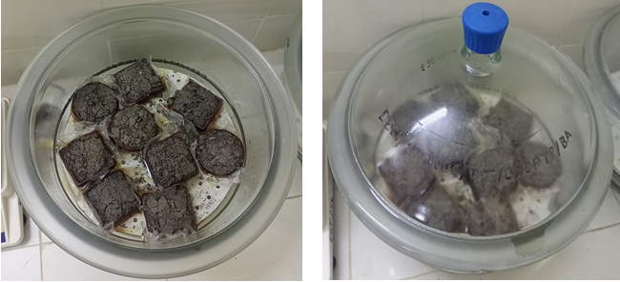

**Fig. 2: Sample moistening device**

3. Results and Discussions

**3.1 Identification Tests**

Fig. 3 presents the grain-size distribution of the expansive soils gathered in the study area. The soil consists predominantly of high plastic over-consolidated silty clay with a small fraction of sand. The classification used to delineate the nature of these soils includes the American soil classification termed Highway Research Board (HRB), which considers percentages passing through sieves of 0.2 mm, 0.4 mm, and 80μm; the plasticity index (PI); and the liquid limit (LL). Additionally, the GTR classification (NF P11-300) was conducted. This classification is based on granulometric characteristics such as the largest grain size dmax, the percentage passing through the 80µm sieve, as well as the methylene blue value and/or the plasticity index (PI). The diverse outcomes from these distinct identification tests are delineated in Table 2.

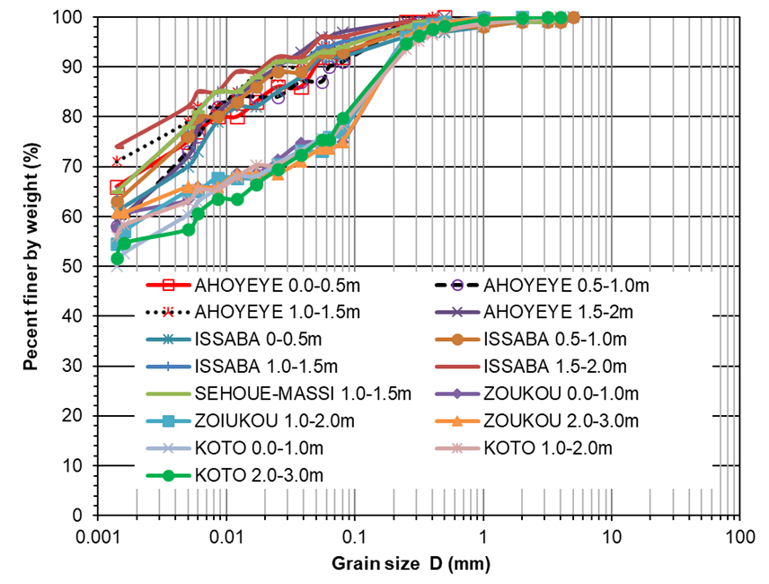

**Fig. 3. Grain size distribution of expansive clay**

**Table 3. Identification test results**

|  |  |
| --- | --- |
| **Parameter** | **Value** |
| Passing by 80µm (%) | 92-96 |
| In-situ moisture content w (%) | 42-57 |
| Liquidity Limit LL (%) | 92-95 |
| Plasticity Limit PL (%) | 51-57 |
| Plasticity Index PI (%) | 38-41 |
| Organic Matter OM (%) | 0.6-0.8 |
| Wet weight per unit volume γh | 15.37-19.19 |
| Class acc. GTR | A3-A4 |
| Class acc. HRB | A7-5 |

In accordance with the GTR classification, the soils of Issaba are categorized as A4 (highly plastic clays and clay marls). The soil of Ahoyeye belongs to class A3 (clay marls and clays, highly plastic silts). According to the Highway Research Board (HRB) classification, Sehoue-Massi samples are classified as A7-5, indicating a clayey soil.

**3.2 Visual aspects and textures of soil samples during drying-wetting cycles**

Observations of the samples subjected to alternated shrink-swell cycles reveal distinct patterns in their texture.

The samples subjected to cycle 0 were in an initial state with natural moisture content of about 40%. These samples showed hardly visual cracks, as illustrated in Fig. 4. After the wetting stage for the first cycle, minor swelling was observed, followed by cracking and shrinkage after the drying stage (Fig. 4). This trend was also observed in the subsequent cycles. Swelling and cracking were significantly pronounced for cycle n compared to cycle n-1.

Since the drying phase led to nearly complete shrinkage, most of the free water likely evaporated. As water was removed, clay particles were pushed apart, increasing the apparent voids. This, in turn, increases pores that can absorb water when the samples are rewetted, thereby increasing the potential of compressibility and consolidation.

Sample degradation continued for the second and third cycle, for which the swell and the shrink magnitude increased. The cracks magnitudes, the cracks patterns and the brittleness increase with increasing number of shrink-swell cycles. As a result, the structure of the clay samples was degraded as also observed by Basma et al. (1993) [3] by means of the scanning electron microscope (SEM) of clay samples subjected to cyclic swell-shrink. Louati et al. (2021) [4] reported also continuous reorganisation of particles for low dense samples, followed by sample densification or compaction of interaggregate and increase in both the number and the width of the micro-cracks with increasing number of cyclic wetting-drying.

The increase of the crack magnitude with increasing cyclic number of alternated swell-shrink can result in the increase of the mesopore of the sample, Fig. 4. As a result, the permeability can also increase with increasing number of shrink-swell cycles, as cracks develop and mesopores are preferential flow paths. The increase in saturated hydraulic conductivity with alternated wetting-shrinking was also stated by Shear et al. (1992) [16], Albrecht and Benson (2001) [17], Akcanca and Aytekin (2014) [18], Day (1994, 1997, 1998) [19][20][21], Louati et al. (2018) [4], Azizi et al. (2020) [22]. However, a decrease of saturated hydraulic conductivity of expansive clay was reported for a sample subjected to cyclic swell-shrink under constant stress condition in oedometer cell, Abbas et al. (2023) [7], Albrecht and Benson (2001) [17]. The discrepancy can be attributed to the predominant type of clay mineral, which

affects its ability of soil swell-crack caused by cyclic drying-wetting to heal themselves upon wetting, Day (1998) [21], Abbas et al. (2023) [7]. Hereby, high content of montmorillonite clay in the tested soils can contribute to partial or complete healing of cracks that occurred during drying. Furthermore, accumulation of shrinkage observed during cyclic swell-shrink, resulting in a decrease of void ratio. Day (1997) [20] stated that upon continued rewetting, the expansive character of clay assists in the healing completion of the desiccation cracks, consequently reducing hydraulic conductivity.

Other parameters that affect the behaviour of expansive clay under cyclic swell-shrink condition are clay mineral prevailing, placement condition (moisture content and dry density), and level of surcharge applied.

These observations presented in this paper highlight the progressive deterioration and degradation of the structure of expansive soils undergoing alternated shrink-swell cycles.

|  |  |
| --- | --- |
|  |  |
| Cycle N=0 | Cycle N=1 |
|  |  |
| Cycle N=2 | Cycle N=3 |
|  |  |
| Cycle N=4 | Cycle N=5 |

**Fig. 4: Development for swelling, shrinkage, cracks and mesopores with increasing cyclic alternated drying-swelling**

**3.3. Shear behaviour under cyclic drying-wetting**

The shear behaviour of the expansive soil under drying-wetting cycles was analysed by means of direct shear tests. Fig. 5 presents the shear stress depending on shear strain for expansive clay in direct shear test under cyclic alternated drying-wetting condition. Hereby, non-linear behaviour of the investigated expansive soils can be noted. The samples show some hardening effect in the plastic zone. The shear stress increases with increasing normal stress σ2 for a given cyclic number. The shear stress decreases with increasing cyclic number of drying-wetting for a given normal stress σ2. Hereby, the most significant diminishing or degradation of the shear strength is observed for cyclic number up to 3 or 4. Beyond 4 cycles, the diminishing of the shear strength is not significant, which indicates the equilibrium state of the sample. Moreover, the stress-strain curves do not have pronounced peaks, indicating hardening failure that does not tend towards brittle type.

|  |  |
| --- | --- |
|  |  |
|  |  |
|  |  |

**Fig. 5. Shear stress depending on shear strain for expansive clay in direct shear test**

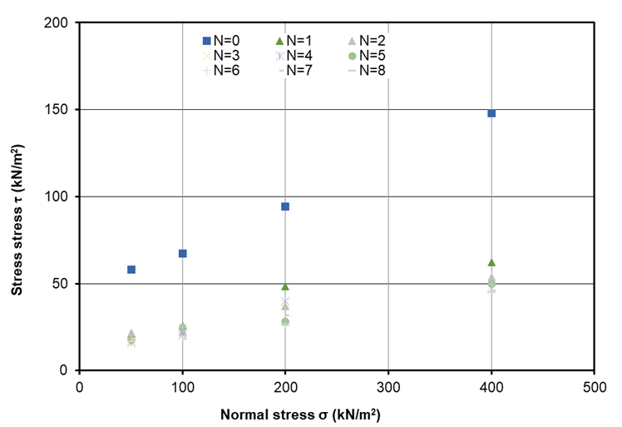

**Fig. 6. Shear failure envelope for expansive clay in direct shear test**

The unconsolidated undrained shear failure envelope is presented in Fig. 6, which provides the shear parameters of the soil, i.e., the angle of internal friction and the cohesion. The value of the angle of internal friction is the angle between the straight line of the failure envelope and the abscissa axis, while the value of the cohesion is the ordinate at the abscissa equal to zero. The straight lines of shear envelope drop down with increasing number of cyclic drying-wetting. As a result, the soil fabric mobilizes lower shear strength with increasing cyclic drying-wetting under unconsolidated undrained condition, i.e. short-term behaviour of expansive soil. That can be explained with the degradation of the soil fabric due to increasing cracks and decreasing swelling potential as the number of alternated cyclic drying-wetting increases.

The shear parameters decrease significantly from 0 cycle to 2 cycles, beyond which the diminishing of the shear parameter is not significant. The undrained angle of internal friction for the sample with no cycle is 15° for Sehoue-Massi (Fig. 7), that is consistent with the calculated drained angle of internal friction of 23° for plasticity index of 40% as per Sorensen and Okkels (2013) [30]. Indeed, the undrained shear parameter are smaller than the drained shear parameter due to excess pore water pressure.

The angle of internal friction and the cohesion decrease with increasing number of cyclic alternated drying-wetting. The undrained angle of internal friction was decreased to 30% of the initial angle of internal friction (Fig. 7), while the undrained cohesion was attenuated to 35% of the initial cohesion (Fig. 8). These results are consistent with degradation of the internal friction angle and the cohesion reported by Gbaffonou et al. (2021), Gbaffonou (2022) for expansive soil in direct shear test in the city of Houehogbe in the la Lama depression. However, Md et al. (2016) observed attenuation to 95% of the initial internal angle of friction and 80% of the initial cohesion for expansive soil of Kaiping, Guangdong in China under the cyclic swell-shrink triaxial shear tests in consolidated drained condition. This discrepancy in degradation percent can be explained with the test conditions, unconsolidated undrained, consolidated drained condition, the microstructure, and the clay minerals contents of the expansive clay. Indeed, montmorillonite like minerals experience significant degradation in comparison to kaolinite and illite like minerals due to the T-O-T microstructure of the montmorillonite and the resulting high activity. In fact, montmorillonite has a three-layered structure composed of two fundamental units: a silicon tetrahedral sheet (T) and an alumina octahedral sheet (O). The basal spacing, which is the distance between the outermost silica layer of one T-O-T sheet and the corresponding silica layer of a close T-O-T sheet, is the largest for montmorillonite among clay minerals and is influenced by hydration. This basal spacing can range from 9.3 to 20 Å (Qin et al., 2019 [31]) due to montmorillonite's ability to adsorb varying amounts of polar water molecules between its clay platelets. As a result, montmorillonite exhibits significant volume expansion in the presence of water.

The undrained shear strength of expansive soils studied significantly decreases from 0 cycle to 3 cycles of alternated shrink-swell. Hence, lightly loaded structures, i.e. buildings and pavements on expansive soils will be exposed to lower bearing capacity and settlement from second cycle onwards, potentially resulting in premature cracks and damages. This could be an indication for the cracks and disorders often observed 2 years after the construction and commissioning of civil infrastructures onto expansive clay in the La Lama depression.

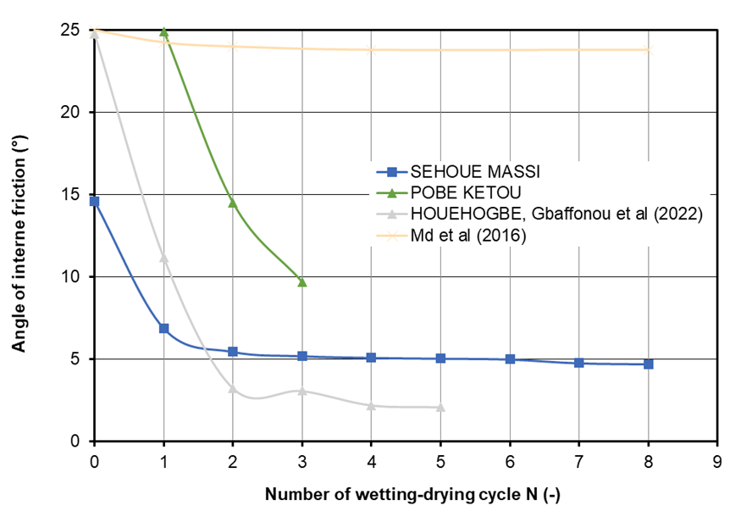

**Fig. 7. Dependence of undrained internal friction angle with cycle number**

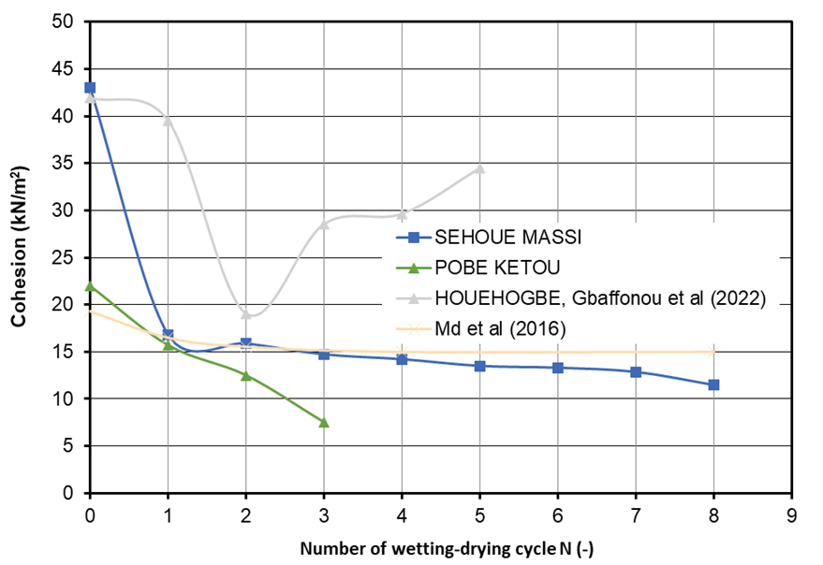

**Fig. 8. Dependence of undrained cohesion with cycle number**

**3.4. Compressibility and consolidation behaviour under cyclic drying-wetting**

The compressibility and the consolidation behaviour of expansive soils under cyclic drying-wetting was analysed by means of the oedometer tests.

The test results showed almost linear increase in void ratio from 1.3 for cycle 0 to 3.4 for cycle 8 (Fig. 9). The increase in void ratio between two consecutive cycles of drying-wetting ranges from 6% to 30%. This increase in void ratio can be explained with increasing in development of the cracks observed on the soil samples, and therefore the increasing of the macropores with increasing number of alternated cyclic drying-wetting.

The oedometer test results, as depicted in Fig. 10 and Fig. 11, present critical insights into the behaviour of soil samples under loading-unloading and cyclic drying-wetting conditions. These results are pivotal in understanding the soil's mechanical properties and its response to different environmental conditions. Increase in the void ratio with the increasing cyclic drying-wetting was observed (Fig. 10 and Fig. 11). The results were consistent with the increase of the hydraulic conductivity with increasing cyclic wetting-drying, Shear et al. (1992) [16], Albrecht and Benson (2001) [17], Akcanca and Aytekin (2014) [18], Day (1998) [21], Louati et al. (2018) [4], Azizi et al. (2020) [22], Day (1997) [20]. The increase of the void ratio with increasing drying-wetting can be explained with the observed macropores due to the cracking of the soil sample under drying condition.

The subsequent analysis is based on the examination of the compressibility index (Cc), swelling index (Cs), and oedometer modulus (Eoed).

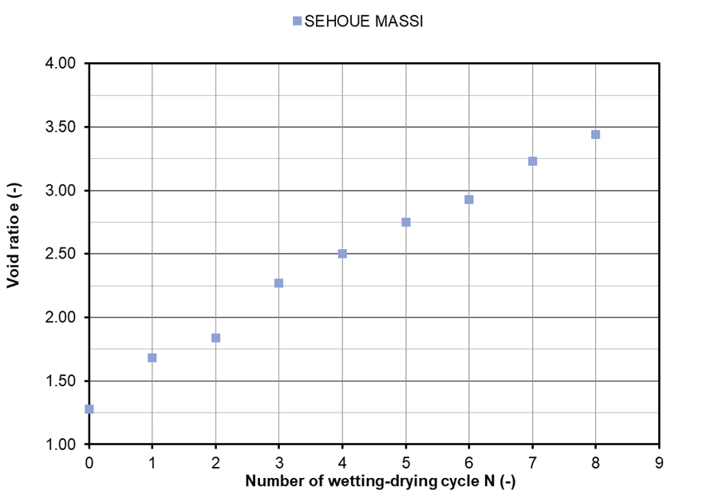

**Fig. 9: Increase of void ratio with increasing number of cyclic wetting-drying**

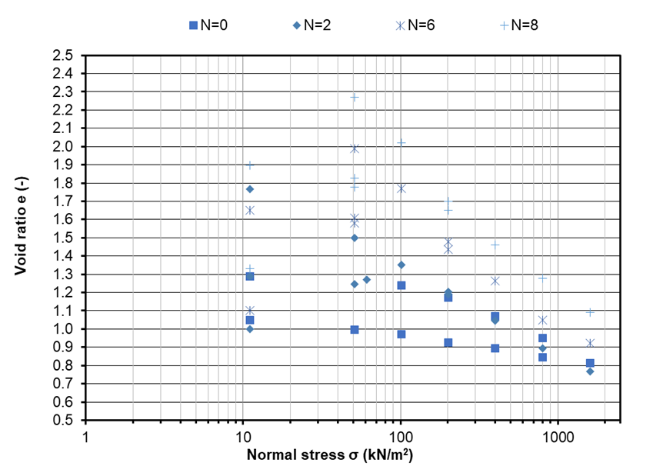

**Fig. 10: Evolution of void ratio with normal stress for cyclic number N=0, N=2, N=6, N=8**

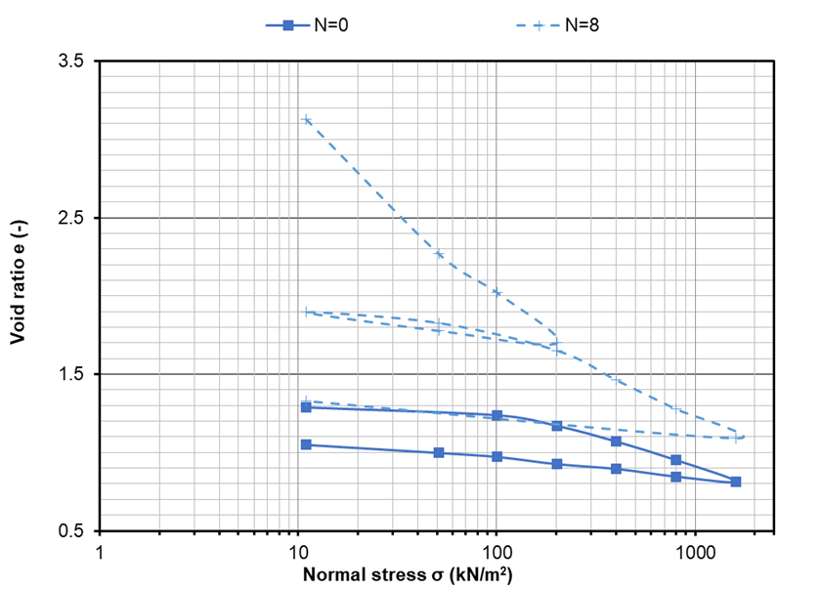

**Fig. 11. Evolution of void ratio with normal stress for N=0, N=8**

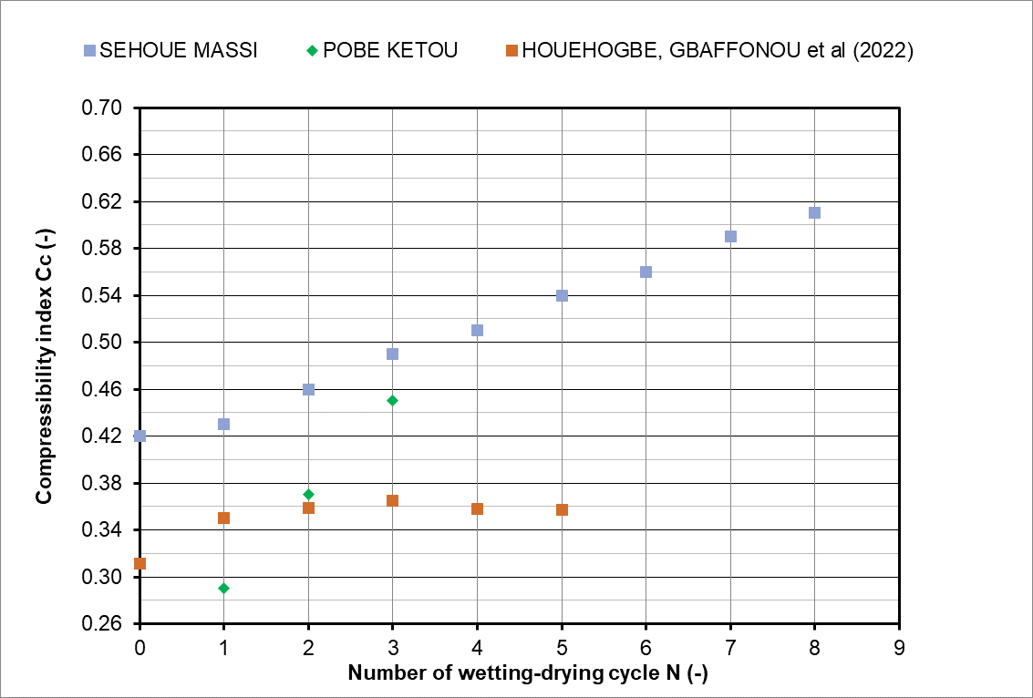

**Fig. 12. Evolution of compressibility index Cc with number of cycles**

Fig. 12 depicts the compressibility index over the number of cyclic alternated drying-wetting. There is an increase in the compressibility index with increasing number of cyclic drying-wetting. This indicates that after each drying-wetting cycle, the soil becomes more compressible. These results are consistent with those reported by Gbaffonou et al. (2021) [5] and Gbaffonou (2022) [6]. This behaviour might be attributed to the rearrangement of soil particles, which leads to a looser packing and increased void ratio after each cycle. The increase of the compressibility index will lead to an increase of the settlement that can compromise the serviceability and the durability of the infrastructure built on expansive soils.

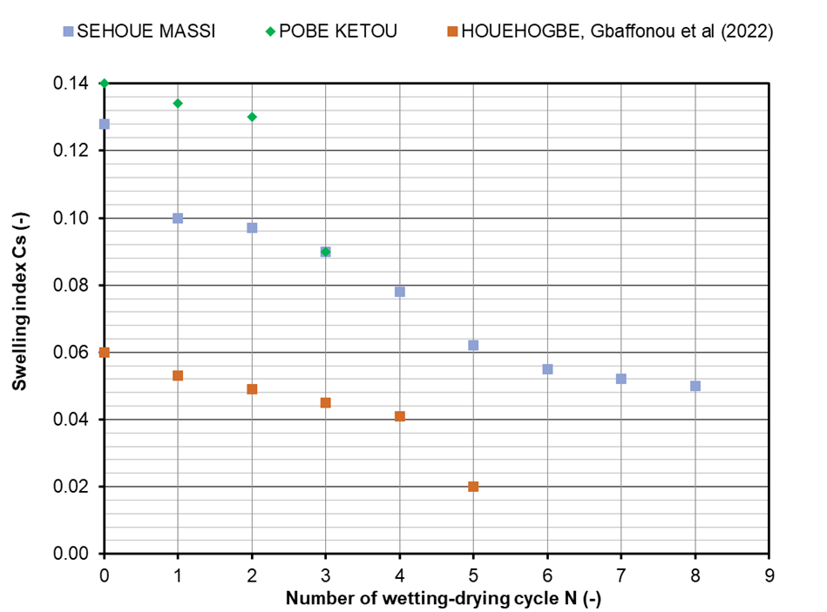

**Fig. 13. Evolution of swelling index Cs with number of cyclic wetting-drying**

Fig. 13 showcases the evolution of the swelling index with the number of cycles. There is a decrease of the swelling index with increasing number of cycles, implying a greater propensity of the soil to undergo volume contraction when exposed to cyclic drying-wetting. While the expansive soil shows less swelling potential with increasing cyclic drying-wetting than its initial state, the diminishing of swelling potential seems to be almost stabilised after the fourth cycle. This could result from the deterioration of soil aggregates and the potential development of new macropores and or micropores. These results are consistent with the results reported by Gbaffonou et al. (2022) [6], Soltani et al. (2022) [23], Dif and Bluemel (1991) [24], Al-Homoud et al. (1995) [25], Basma et al. (1996) [3], Tripathy et al. (2002) [26], Estabragh et al. (2015) [27]. These researchers found that the potential of swelling is reduced by increasing the number of cyclic alternated drying-wetting until it reaches almost constant value. This behaviour can be explained by the continuous rearrangement of soil particles. However, researchers such as Popescu (1979) [28], Osipov et al. (1987) [29] and Day (1994) [19] have reported an opposite effect in which the magnitude of swelling is increased with the number of cycles. The increase or decrease of the potential of swelling may depend on geological formation, clay mineral and stress conditions of the expansive soil.

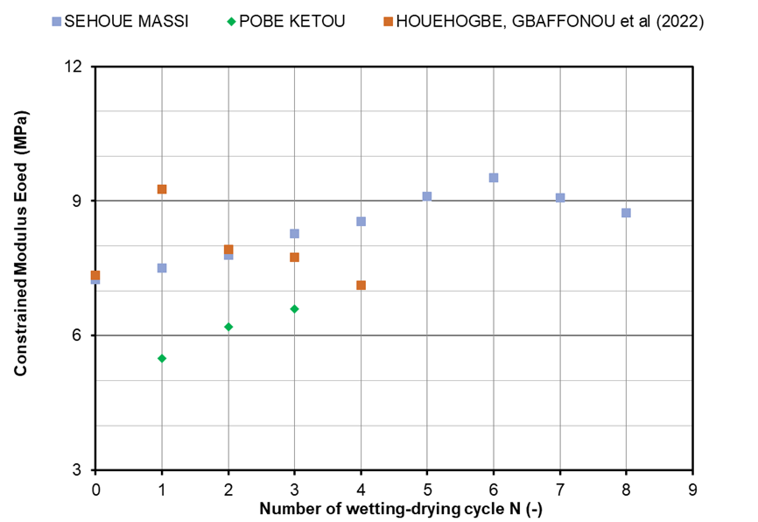

**Fig. 14. Evolution of oedometer modulus with number of cyclic drying-wetting**

Fig. 14 delineates the evolution of the constrained or oedometer modulus with a number of cyclic drying-wetting. There is an increase in the constrained modulus with increasing cyclic drying-wetting, indicating hardening and stiffer response of the soil. The increase in constrained modulus between two consecutive cycles of drying-wetting ranges from 3% to 7%. This increase in constrained modulus could be attributed to the initial densification or rearrangement of soil particles. This result is consistent with the findings reported by Liu et al. (2020) [32]. However, the soils of Houehogbe showed an increase in constrained modulus from the first to second cycle, thereafter a decrease in constrained modulus, Gbaffonou et al. (2022) [5]. This softening behaviour could be attributed to the progressive breakdown of soil structures or the weakening of bonds between particles due to repeated drying-wetting.

4. CONCLUSIONS

This study presents the effects of alternated drying-wetting cycles on saturated undrained shear strength of undisturbed expansive clay using series of oedometer and direct shear tests.

The cyclic alternated drying-wetting and the corresponding shrink-swell leads to the degradation of the expansive clay in terms of soil fabric, of unconsolidated undrained angle of internal friction and cohesion. This can be explained with the degradation or the reduction of the physico-mechanical and or microstructural properties of the expansive clay when the cycles increase.

The expansive soil subjected to cyclic alternated drying-wetting showed that the magnitude of the cracks and mesopores increases with increasing cyclic drying-wetting. The soil fabric becomes more brittle with increasing cyclic wetting-drying so that the degradation of the soil fabric can be stated.

The results of the direct shear tests showed that the unconsolidated undrained shear strength (angle of internal friction and cohesion) decreases with increasing cyclic number. The unconsolidated undrained angle of internal friction decreased to 30% of the initial angle of internal friction, while the unconsolidated undrained cohesion decreases to 35% of the initial cohesion.

Moreover, oedometer tests were carried out to investigate the compressibility and the consolidation behaviour of expansive soils. The results of the oedometer tests showed that:

• The void ratio of the soil fabric increases from 6% to 30% with increasing cyclic alternated drying-wetting, that can be explained with the cracks observed during drying.

• The stiffness of the soil fabric increases from 3% to 7% with cyclic alternated drying-wetting, as is seen from the increases in the initial tangent modulus. The brittleness of the soil also increases as cyclic alternated drying-wetting increases.

• Increases in compressibility of the soil fabric with increasing cyclic drying-wetting occur due to the increasing brittleness of the soil fabric with the cyclic wetting-drying.

• Decrease of the swelling index with the number of cycles, implying a greater propensity of the soil to undergo volume contraction when exposed to cyclic wetting-drying.

The results of this study have shown that cyclic swelling process leads to a gradual destruction of the contacts in the clay structure. At the same time, it leads to reconstruction, reorganisation and reorientation of the structure of the large micro-aggregates by disorientation of structural elements. All these phenomena result in change in expansion behaviour with increasing number of drying-wetting cycles.

Disclaimer (Artificial intelligence)

Author(s) hereby declare that NO generative AI technologies such as Large Language Models (ChatGPT, COPILOT, etc.) and text-to-image generators have been used during the writing or editing of this manuscript.

References

[1] G.O. Adeoti, M.F. Ahlinhan, E. Chabi (2023) Behavior Assessment of Pavement over Expansive Clay Soils Undergoing Cyclic Shrinkage and Swelling Conditions. In International Conference on Studies in Engineering, Science, and Technology ICSEST, October 20-23, 2023 Antalya, Turkey

[2] S.H. Md, K. Ling-wei, Y. Song, Effect of drying-wetting cycles on saturated shear strength of undisturbed residual soils, American Journal of Civil Engineering. 4 (2016) 143–150.

[3] A.A. Basma, A.S. Al-Homoud, A.I.H. Malkawi, M.A. Al-Bashabsheh, Swelling-shrinkage behavior of natural expansive clays, Applied Clay Science. 11 (1996) 211–227.

[4] F. Louati, H. Trabelsi, M. Jamei, S. Taibi, Impact of wetting-drying cycles and cracks on the permeability of compacted clayey soil, European Journal of Environmental and Civil Engineering. 25 (2018) 696–721.

[5] B. Gbaffonou, Y. Tankpinou Kiki, V. Tohoungba, V.S. Gbaguidi, Influence of drying-wetting cycles on the compressibility of clay soils in the commune of Houeyogbe, IJESRT. 10 (2021) 11. https://doi.org/10.29121/ijesrt.v10.i5.2021.1.

[6] B. Gbaffonou, Influence des cycles de séchage-humidification sur les paramètres mécaniques des sols argileux : Cas de la commune de Houéyogbé (2022), Thèse de doctorat de l´université d´Abomey-Calavi

[7] Abbas, M.F., Shakerc, AA, Al-Shamrani, M,A, (2023) Hydraulic and volume change behaviors of compacted highly expansive soil under cyclic wetting and drying Journal of Rock Mechanics and Geotechnical Engineering 15, 486-499.

[8] NF EN ISO 17892-1 Reconnaissance et essais géotechniques - Essais de laboratoire sur les sols - Partie 1 : détermination de la teneur en eau, Association Française de Normalisation. (2014).

[9] NF EN ISO 17892-12 Reconnaissance et essais géotechniques - Essais de laboratoire sur les sols - Partie 12 : détermination des limites de liquidité et de plasticité, Association Française de Normalisation. (2018).

[10] NF EN ISO 17892-3 Reconnaissance et essais géotechniques - Essais de laboratoire sur les sols - Partie 3 : détermination de la masse volumique des particules solides, Association Française de Normalisation. (2015).

[11] ISO 14235 Soil quality — Determination of organic carbon by sulfochromic oxidation, International Standard Organization (1998)

[12] NF EN ISO 17892-4 Reconnaissance et essais géotechniques - Essais de laboratoire sur les sols - Partie 4 : Détermination de la distribution granulométrie des particules, Association Française de Normalisation. (2018).

[13] NF EN ISO 17892-5 Reconnaissance et essais géotechniques - Essais de laboratoire sur les sols - Partie 5 : Essai de chargement par palier à l’œdomètre, Association Française de Normalisation. (2017).

[14] NF EN ISO 17892-10 Reconnaissance et essais géotechniques - Essais de laboratoire des sols - Partie 10 : Essai de cisaillement direct, Association Française de Normalisation. (2018).

[15] Tankpinou Kiki S.T. (2016) Caractérisation minéralogique, thermique er microscopique des sols fins en technique routièr. Thése de doctorat de l´université d´Abomey-Calavi et de l´université de Bordeaux,

[16] Shear, D., Olsen, H., Nelson, K., 1992. Effects of desiccation on the hydraulic conductivity versus void ratio relationship for a natural clay. Transport. Res. Rec. 1369, 130-135.

[17] Albrecht, B.A., Benson, C.H., 2001. Effect of desiccation on compacted natural clays. J. Geotech. Geoenviron. Eng. 127, 67-75.

[18] Akcanca, F., Aytekin, M., 2014. Impact of wetting-drying cycles on the hydraulic conductivity of liners made of lime-stabilized sand-bentonite mixtures for sanitary landfills. Environ. Earth Sci. 72, 59-66.

[19] Day, R.W., 1994. Swell-shrink behavior of compacted clay. J. Geotech. Geoenviron. Eng. ASCE 120, 618-623.

[20] Day, R.W.,1997. Discussion of hydraulic conductivity of desiccated geosynthetic clay liners. J. Geotech. Geoenviron. Eng. 123, 484-486.

[21] Day, R.W., 1998. Discussion: infiltration tests on fractured compacted clay. J. Geotech. Geoenviron. Eng. 124, 1149-1152.

[22] Azizi, A., Musso, G., Jommi, C., 2020. Effects of repeated hydraulic loads on microstructure and hydraulic behaviour of a compacted clayeysilt. Can. Geotech. J. 57, 100-114.

[23] Soltani A, Raeesi R and O’Kelly BC (2022) Cyclic swell–shrink behaviour of an expansive soil treated with a sulfonated oil. Proceedings of the Institution of Civil Engineers – Ground Improvement 175(3): 166–179, https://doi.org/10.1680/jgrim.19.00084

[24] Dif, A., Bluemel, W., 1991. Expansive soils under cyclic drying and wetting. Geotech.Test J. 14, 96-102.

[25] Al-Homoud, A.S., Basma, A.A., Husein Malkawi, A.I., Al Bashabsheh, M.A., 1995. Cyclic swelling behavior of clays. J. Geotech. Eng. 121, 562-565.

[26] Tripathy, S., Rao, K.S., Fredlund, D.G., 2002. Water content void ratio swell-shrink paths of compacted expansive soils. Can. Geotech. J. 39, 938-959.

[27] Estabragh A.R., Parsaei J.B., Javadi A.A., (2015) Laboratory investigation of the effect of cyclic wetting and drying on the behaviour of an expansive soil. Soils and Foundations, 2015; 55 (2): 304-314

[28] Popescu, M.E., 1980. Behaviour of expansive soils with crumb structures. In: Proceedings of the 4th International Conference on Expansive Soils, 158-171

[29] Osipov, V.I., Bik, N.N., Rumjantseva, N.A., 1987. Cyclic swelling of clays. Appl. Clay Sci. 2, 363-374.

[30] Sorensen K.K., Okkels N. (2013) Correlation between drained shear strength and plasticity index of undisturbed overconsolidated clays. In Proceedings of the 18th International Conference on Soil Mechanics and Geotechnical Engineering, Paris, France.

[31] X. Qin, D.-H. Han, L. Zhao. (2019) Elastic characteristics of overpressure due to smectite-to-illite transition based on micromechanism analysis, geophysics, vol. 84, No. 4.

[32] P. Liu; R.-P. Chen, K. Wu, X. Kang (2020) Effects of drying-wetting cycles on the mechanical behavior of reconstituted granite-residual soils, J. Mater. Civ. Eng., 2020, 32(8): 04020199.

[33] Alves, J. L., Borges, I. B., & Nadae, J. D. (2021). Sustainability in complex projects of civil construction: Bibliometric and bibliographic review. *Gestão & Produção*, *28*, e5389.

[34] MA, T. T., YU, H. W., WEI, C. F., YI, P. P., & YAO, C. Q. (2024). Mechanism of physicochemical effect on the shrinkage of expansive soil. *Rock and Soil Mechanics*, *45*(3), 2.

[35] Furtak, K., & Wolińska, A. (2023). The impact of extreme weather events as a consequence of climate change on the soil moisture and on the quality of the soil environment and agriculture–A review. *Catena*, *231*, 107378.

[36] Chabi, E., Adéoti , O.G., Ahlinhan, M. F., & Agassoussi M.L. (2025). Evaluating Pavement Performance on Expansive Clay Soils Subjected to Cyclic Shrinkage and Swelling. *Open Journal of Applied Sciences*, *15*(1), 70-97.