Predictive value of Improved and Non-Improved LV Global longitudinal strain in Revascularized Acute Myocardial Infarction Patients

ABSTRACT
Background: Echocardiographic measures predict adverse outcomes in cardiac disease patients including prior ST-segment elevation myocardial infarction (STEMI).
Aim: To assess the association between improved and non-improved global longitudinal strain (GLS) after three months of percutaneous coronary intervention (PCI)-treated acute myocardial infarction (AMI) and clinical outcomes over one year.
Patients and methods: A prospective observational study was conducted at Damietta Cardiology Center (Jan 2022 – June 2023) on 100 patients (44–73 years). They were divided into Group A (improved GLS after revascularized AMI) and Group B (non-improved GLS)
Results: GLS improvement, anterior STEMI, baseline Ejection Fraction (EF%) versus EF% after 3 months, baseline E/e ratio versus E/e ratio after 3 months, maximum Troponin T level, symptoms-to-needle time, and number of implanted stents are statistically significant predictors of Cardiovascular and Cerebrovascular Events (CCVE) occurrence (P<0.05), with an overall prediction accuracy of 92%. However, age, sex, and medical history are not statistically significant predictors of CCVE occurrence (P>0.05).
Baseline (GLS) and GLS after 3 months are statistically significant predictors of CCVE occurrence (P=0.001), with cutoff points of -7.5 and -13.0, respectively. The sensitivity and specificity for predicting CCVE occurrence are 98.4% and 86.0% for baseline GLS, and 100.0% for both sensitivity and specificity for GLS after 3 months.
Conclusion: GLS proved superior to LVEF in predicting CCVE in revascularized AMI, with baseline (-7.5) and 3-month GLS (-13) as key predictors. Improvement correlated with age, prior MI, and inferior STEMI, while non-improvement linked to anterior STEMI.
Key words: STEMI, Troponin, AMI, GLS.

INTRODUCTION
Echocardiographic measures of cardiac structure and function predict adverse outcomes in patients with cardiac diseases including prior ST-segment elevation myocardial infarction (STEMI) (1, 2).
Post-STEMI, these patients face a significantly increased risk for heart failure with concomitant high morbidity and mortality (3).
In the past decade, new echocardiographic parameters have been introduced and investigated for their prognostic value. Global longitudinal strain (GLS), especially, has proved to add valuable information about prognosis in patients with cardiac disease (4).
Reduced global longitudinal strain (GLS) serves as a more sensitive indicator for cardiac events and remodeling compared to left ventricular ejection fraction (LVEF) following acute myocardial infarction (AMI), particularly in patients who do not exhibit a decrease in LVEF.(5) Myocardial infarction (MI) is defined by the presence of myocardial necrosis, formerly known as a heart attack. Acute myocardial infarction (AMI) is a condition characterized by ischemic injury and necrosis of the myocardial cells which usually occurs on the basis of coronary artery lesions (6). A sharp decrease or interruption in coronary blood supply triggers severe and persistent myocardial ischemia. After 6–8 weeks of AMI, chronic myocardial infarction is formed by scar tissue after gradual resorption of the necrotic myocardial tissue (7). MI is generally grouped into two major entities: ST segment elevation myocardial infarction (STEMI) and non-ST segment elevation myocardial infarction (NSTEMI). Unstable angina, meaning typical chest pain without exertion and negative cardiac biomarkers, is usually also considered an acute coronary syndrome (ACS), because it is believed to occur imminently before myocardial infarction (8) (9). Furthermore, MI can be classified into five types depending on pathophysiological characteristics, prognosis, as well as clinical presentation (Table 1) (10, 11).
Type I MI, or spontaneous MI, is defined as myocyte necrosis due to atherothrombotic coronary artery disease (CAD) and usually precipitation by atherosclerotic plaque disruption (rupture or erosion).
Type II MI is defined by an imbalance of myocardial oxygen supply and demand. The presence of CAD is specifically not required (but can be present) in type II MI.
Type III MI is reserved for patients who suffer cardiac death with symptoms suggestive of myocardial ischemia but who decease before cardiac biomarkers can be evaluated or MI is detected post-mortem by autopsy.
Type IV and V MI are designated for patients suffering from procedure-related myocardial infarctions in a PCI setting (IVa), related to acute stent thrombosis (IVb), related in-stent restenosis or after coronary artery bypass grafting (V).
In a study of patients undergoing percutaneous coronary intervention (PCI) for ST-segment elevation myocardial infarction (STEMI), GLS was reported to improve significantly at 3 months and between 3 and 12 months (7). Also, another study was conducted on patients with STEMI treated with PCI showed that LV global strains measured after primary PCI can predict the extent of myocardial recovery (12). Left anterior descending artery, peak cardiac troponin T level, and diastolic function were independent predictors of improvement. (8,9) studied patients after AMI, 47% of whom had STEMI and 90% who underwent PCI. GLS improved significantly over the next 12 months, with independent predictors being initial impairment of LV function, including GLS assessment, male sex, nonsmoking, and beta-blocker therapy. However, none of these studies examined the association between improvement or lack of GLS and subsequent composite cardiovascular events (CCVE). The aim of this work was to explore the association between improved and non improved GLS after 3 months following PCI treated AMI and clinical out -come during follow up for 1 year.

PATIENTS AND METHODS

A prospective observational follow-up study was conducted at the cardiovascular department of Damietta Cardiology Center from January 2022 to June 2023, including 100 patients aged 44 to 73 years. Patients were classified into two groups: Group A, comprising those with improved global longitudinal strain after revascularized acute myocardial infarction, and Group B, consisting of those with non-improved global longitudinal strain after revascularized acute myocardial infarction.
Inclusion criteria: The study included patients presenting with acute myocardial infarction (AMI), including ST-elevation myocardial infarction (STEMI) and non-ST-elevation myocardial infarction (NSTEMI), who had sinus rhythm, good echocardiographic images, a life expectancy of more than one year, were willing to attend the second examination, and were hemodynamically stable.
Exclusion criteria: hemodynamically unstable patients, those with atrial fibrillation or flutter, poor echocardiographic images, a life expectancy of less than one year, or those unwilling to attend the second examination.

Study protocol:

medical history assessment, including age, sex, special habits, and ischemic heart disease risk factors such as hypertension, diabetes mellitus, dyslipidemia, and previous myocardial revascularization. Clinical examination included blood pressure measurement and auscultation for gallop, S3, and murmurs. A 12-lead ECG was performed to detect ischemic changes, chamber enlargement, and arrhythmias. Conventional transthoracic echocardiography assessed LV systolic and diastolic function, chamber enlargement, and valvulopathies, while 2D speckle tracking echocardiography measured global longitudinal strain at baseline and three months post-revascularization. Patients were followed for one year to monitor cardiovascular events, including reinfarction, hospitalization for heart failure, angina, ventricular arrhythmias, new-onset atrial fibrillation, stroke/TIA, and death. Transthoracic and 2D speckle tracking echocardiography were performed using the GE Vingmed Ultrasound M5Sc system.
The 2D speckle tracking echocardiography technique: Involved acquiring images from apical four-chamber, two-chamber, and three-chamber views, optimizing gain settings, reducing depth for better visualization, and maintaining a frame rate between 30 and 70 fps. Proper ECG gating was ensured, and images were acquired in breath-hold to minimize artifacts. Image analysis was conducted using dedicated software, beginning with the apical long-axis view to time aortic valve closure. The endocardial border was manually traced, and a region of interest (ROI) was carefully adjusted to exclude echogenic pericardium. The software tracked myocardial speckles frame by frame, generating moving images, strain curves, and segmental/global longitudinal strain (GLS). GLS values were classified as <16% abnormal, 16–18% borderline, and >18% normal. ECG was performed using the Biocare IE-300 system, while coronary angiography and PCI were conducted using Siemens Artis Zee Ceiling and GE IGS520 systems.

Statistical analysis and data interpretation

Data analysis was conducted utilizing SPSS version 18. Qualitative data were represented in terms of numbers and percentages, whereas quantitative data were reported as median (IQR) or mean ± SD, contingent upon the assessment of normality. The statistical tests employed comprised Chi-Square, Fisher’s exact test, Mann-Whitney U test, paired t-test, and Spearman's correlation. Receiver Operating Characteristic (ROC) curves were utilized to evaluate sensitivity, specificity, and cut-off points, while binary logistic regression was employed to examine the influence of multiple variables on outcomes. A significance level of p<0.05 was established.

RESULTS
Table 1: Demographic Characteristics, Mean Ejection Fraction, and E/e at Baseline and After 3 Months Follow-Up
 | N=100 | %
Age/ years | 58.3±7.33  (44-75)
Sex  Male  Female | 73  27 | 73.0  27.0
TTE | Mean ± SD
Base line EF % | 45.42±8.35
EF% after 3 months | 49.24±9.45
T | 15.08
P value | <0.001*
Basel E/e | 9.99±2.57
E/e after 3 months | 9.40±2.58
T | 8.46
P value | <0.001*
t: Paired t test, *statistically significant, N refers to numbers of stents implemented.

Table 1 shows that mean age of studied cases is 58.3±7.33. Males represent 73% of the cases while females represent 27% and there is statistically significant difference between baseline and after 3 months follow up as regard EF% and E/e (P<0.001) (45.42±8.35 vs 49.24±9.45 and 9.99±2.57 vs 9.40±2.58, respectively

Table 2: Troponin Levels, Symptoms-to-Needle Time, Number of Implanted Stents, and Incidence of CCVE Among Studied Cases
CCVE | N=100 | %
Recurrent MI  STEMI  NSTEMI | 13  2  11 | 13.0  2.0  11.0
Heart failure hospitalization | 29 | 29.0
VT hospitalization | 13 | 13.0
AP hospitalization | 46 | 46.0
New onset AF | 27 | 27.0
TIA/Stroke hospitalization | 7 | 7.0
Death | 2 | 2.0
Total CCVE events | 1.0(0.0-5.0)
Troponin T max (ng/ml)  Mean ±SD | 23.78±13.38
Symptoms to needle time  Mean ±SD | 23.70±19.67
≤10  >10 | 31  69 | 31.0  69.0
No of stent implanted  Median (range) | 2(1-3)
VT: Ventricular tachycardia, AP: Angina pectoris, AF: Atrial fibrillation, TIA:Transient ischemia attack
Table 2 shows that 13% of the studied cases had recurrent MI, 29% had Heart failure hospitalization, 46% AP hospitalization, 13% VT hospitalization, 27% New onset AF, 7% TIA/Stroke hospitalization and 2% died and mean Troponin is 23.78±13.38, mean symptoms to needle time is 23.70±19.67 and median number of implanted stent among studied cases is 2(1-3).

Table 3: Demographic characteristics according to improvement in GLS.
 | Not improved  (n=36) | Improved  (n=64) | Test of significance | P value
Age/ years  Mean ±SD | 55.89±5.89 | 59.66±7.74 | 2.54 | 0.013*
Sex  Male  Female | 28(77.8)  8(22.2) | 45(70.3)  19(29.7) | 0.651 | 0.420
Used test: Student t test, Chi-Square test, *statistically significant
Table 3 shows that there is statistically significant difference between improved (improvement in GLS) cases and non-improved cases regarding age (P=0.013), where improved cases were older, but there is non-statistically significant difference as regard sex (P=0.42).

Table 4: Relation between CCVE incidence and demographic, clinical and laboratory findings.
 | CCVE |  | Test of significance | P value
 | NO event  N=49 | ≥one event  N=51
GLS  Not improved  Improved | 4(8.2)  45(91.8) | 32(62.7)  19(37.3) | 32.31 | <0.001*
Age/ years | 59.12±7.06 | 57.5±17.56 | 1.11 | 0.273
Sex  Male  Female | 35(71.4)  14(28.6) | 38(74.5)  13(25.5) | 0.120 | 0.729
Medical history  Diabetes mellitus  Hypertension  Smoking  Previous MI | 22(44.9)  29(59.2)  30(61.2)  0 | 27(52.9)  31(60.8)  30(58.8)  16(31.4) | 0.647  0.027  0.06  18.30 | 0.421  0.870  0.806  <0.001*
AMI  NSTEMI  Lateral STEMI  Inferior STEMI  Anterior STEMI | 25(51.0)  3(6.1)  19(38.8)  2(4.1) | 19(37.3)  0  13(25.5)  19(37.3) | 18.67 | <0.001*
TTE  Base line EF %  EF% after 3 months | 50.26±4.31  54.82±4.94 | 40.76±8.66  43.88±9.68 | 6.90  7.07 | <0.001*  <0.001*
Basel E/e  E/e after 3 months | 8.67±1.48  8.10±1.34 | 11.25±2.77  10.65±2.86 | 5.78  5.65 | <0.001*  <0.001*
Troponin T max  (ng/ml) | 16(11-19) | 33(20-42) | 6.01 | <0.001*
Symptoms to needle time  ≤10  >10 | 23(46.9)  26(53.1) | 8(15.7)  43(84.3) | 11.41 | 0.001*
Number of stent implanted | 1(1-1) | 2(2-3) | 8.15 | 0.001*
Used test: Mann Whitney U test, Chi-Square and Fisher exact test, *statistically significant
Table 4 shows that there is statistically significant relation between CCVE incidence and (GLS improvement, Previous MI, STEMI vs NSTEMI, Base line EF % vs EF% after 3 months, Basel E/e vs E/e after 3 months, Troponin T max, Symptoms to needle time and Number of stent implanted) (P<0.05), but there is non-statistically significant relation between CCVE incidence and Diabetes mellitus, Hypertension and Smoking (P>0.05).

Table 5: Predictors of CCVE occurrence among studied cases.
 | Univariate analysis |  | Multivariate analysis
 | P value | COR(95%CI) | P value | AOR(95%CI)
GLS  Not improved  Improved (R) | <0.001* | 18.95(10.88-25.02)  1 | 0.001* | 17.98(10.7-20.1)  1
Age/ years | 0.271 | 0.970(0.918-1.02)
Sex  Male  Female ( R) | 0.729 | 1.17(0.483-2.83)  1
Medical history  Diabetes mellitus  Hypertension  Smoking  Previous MI | 0.422  0.870  0.806  0.998 | 1.38(0.629-3.03)  1.07(0.480-2.38)  0.905(0.406-2.02)  Undefined
AMI  NSTEMI( R)  Lateral STEMI  Inferior STEMI  Anterior STEMI | .999  .824  .002* | 1  .000(undefined)  .900(0.357-2.27)  12.5(9.59-22.35) | 0.01* | 10.15(8.7-13.8)
TTE  Base line EF %  EF% after 3 months | 0.001*  0.001* | 0.818(0.752-0.889)  0.829(0.765-0.898) | 0.001*  0.001* | 0.800(0.722-0.875)  0.822(0.688-0.900)
Basel E/e  E/e after 3 months | 0.001*  0.001* | 1.64(1.32-2.04)  1.66(1.32-2.09) | 0.001*  0.001* | 1.55(1.1-2.1)  1.54(1.10-2.4)
Troponin T max  (ng/ml) | 0.001* | 1.18(1.10-1.25) | 0.001* | 1.58(1.0-3.1)
Symptoms to needle time  ≤10(R)  >10 | 0.001* | 1  4.76(1.86-12.17) | 0.001* | 1  3.77(1.45-10.25)
Number of stent implanted | 0.001* | 13(10.25-15.08) | 0.001* | 12(9.8-14.2)
Overall% Predicted =92%
R: reference, AOR:Adjusted odds ratio , COR:Crude odds ratio
Table 5 shows that (GLS improvement, anterior STEMI, Base line EF % vs EF% after 3 months, Basel E/e vs E/e after 3 months, Troponin T max, Symptoms to needle time and Number of stent implanted) are statistically significant predictors of CCVE occurrence (P<0.05) with Overall Predicted %=92%, but age, sex and medical history are statistically significant predictors of CCVE occurrence (P>0.05).

Table 6: Validity of GLS in predicting CCVE among studied cases
Test Result Variable(s) | Area | P value | Asymptotic 95% Confidence Interval |  | Cut off point | Sensitivity % | Specificity %
Test Result Variable(s) | Area | P value | Lower Bound | Upper Bound | Cut off point | Sensitivity % | Specificity %
GLS.  BASELINE | .995 | .001* | .987 | 1.003 | -7.5 | 98.4 | 86.0
GLS3 | 1.000 | .001* | 1.000 | 1.000 | -13.0 | 100.0 | 100.0
GLS:Global longitudinal strain

Table 6 shows that (GLS.BASE LINE and GLS3) are statistically significant predictors of CCVE occurrence (P=0.001) with Cutoff point (-7.5 and -13.0, respectively), Sensitivity % (98.4 and 100.0, respectively) and Specificity % (86.0 and 100.0, respectively).

CASE PRESENTATION

Case No.1 (improved GLS)
age :55 yrs
sex : male +
: female -

Medical History:
Diabetes mellitus: +
Hypertension: +
Smoking: +
Previous MI: -
ECG: ST segment elevation at anterior leads
Troponin T max: 7 ng/ml
Transthorathic ECHO parameters:
Basal EF:46%
EF after 3 months: 57%
Basal E/e: 8
E/e after 3 months: 7
2d speckle tracking ECHO:
Basal GLS -9%
GLS after 3 months -18%

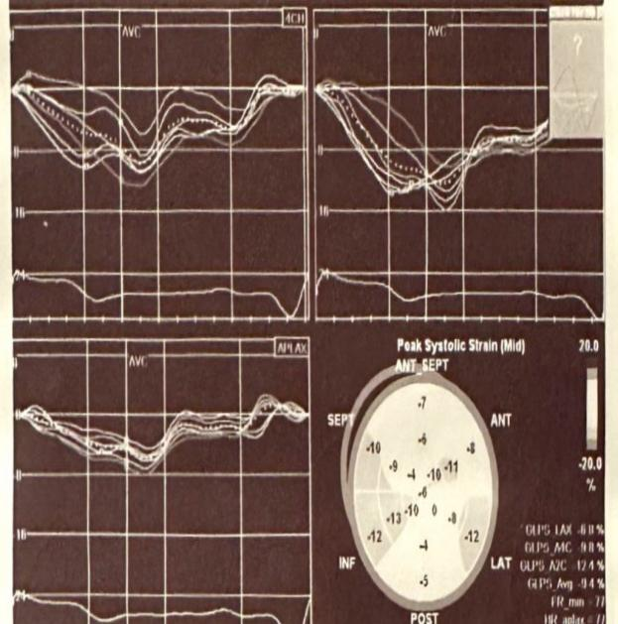  A | 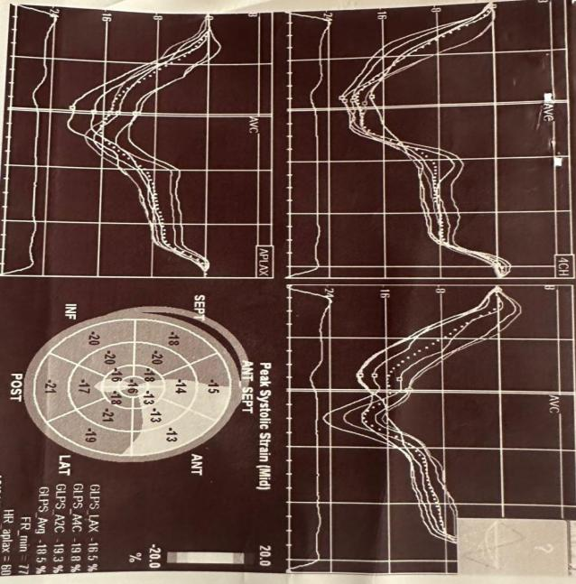  B

Symptoms to needle time: 7 hours
Coronary angiography: showed proximal LAD subtotal 99% occlusion
Number of stent implanted: 2

CCVE:
Reccurent MI -
HF hospitalization -
VT hospitalization -
AP hospitalization -
New onset AF -
TIA/Stroke -
Death -
Total CCVE 0

Figure 1: (A): basal GLS. (B): GLS3
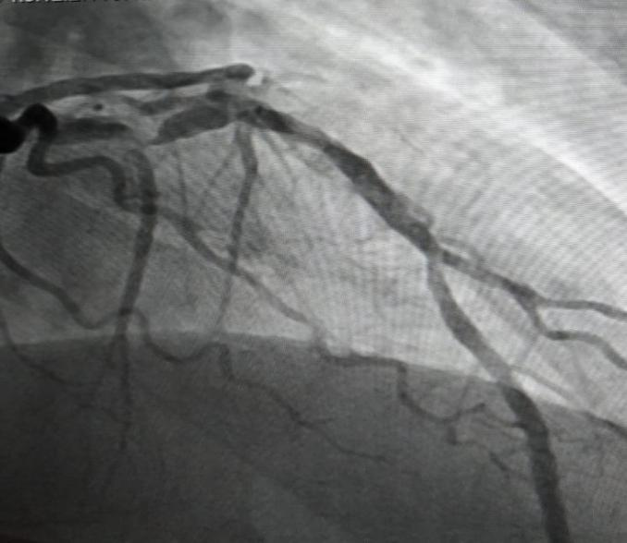 | 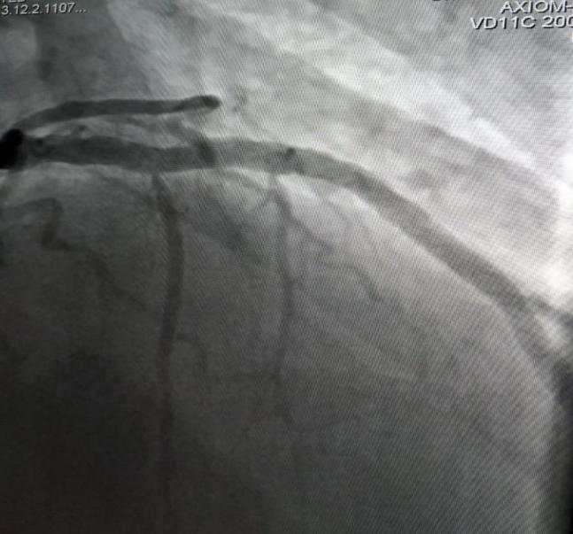

Figure (2) Longitudinal strain in Revascularized Acute Myocardial Infarction Patients

DISCUSSION

The present study found that mean age of studied cases was 58.3±7.33. Males represented 73% of the cases while females represented 27%. Majority of studied cases were hypertensive and smokers (60%), 49% were diabetic and 16% had Previous MI.
Majority of studied cases had NSTEMI (44%), 32% had Inferior STEMI, 21% Anterior STEMI and 3% had Lateral STEMI.
In harmony, Otterstad et al, (10) The objective of this study was to investigate whether the lack of improvement in GLS after a three-month period was linked to an increased risk of subsequent composite cardiovascular events (CCVE). The average age of participants in the study was 65 years (±10), with 25% being female and 17% having a history of myocardial infarction (MI). Among the participants, 53% had ST-elevation myocardial infarction (STEMI), all of whom received primary percutaneous coronary intervention (PCI) at a median time of 4.0 hours (interquartile range 3.0) following the onset of symptoms.
Additionally, the present study showed that there was statistically significant difference between baseline and after 3 months follow up as regard EF% and E/e (P<0.001) (45.42±8.35 vs 49.24±9.45 and 9.99±2.57 vs 9.40±2.58, respectively).
In Antoni et al, (11) A study involving patients who underwent percutaneous coronary intervention (PCI) for ST-segment elevation myocardial infarction (STEMI) indicated a notable enhancement in global longitudinal strain (GLS) at the three-month mark, as well as between the three and twelve-month intervals.
Our study shows that mean Troponin is 23.78±13.38, mean symptoms to needle time is 23.70±19.67 and median number of implanted stent among studied cases is 2(1-3).
Our study shows that 13% of the studied cases had recurrent MI, 29% had Heart failure hospitalization, 46% AP hospitalization, 13% VT hospitalization, 27% New onset AF, 7% TIA/Stroke hospitalization and 2% died. Interestingly, the present study showed statistically significant difference between improved (improvement in GLS) cases and non-improved cases regarding age (P=0.013), where improved cases were older, but there is non-statistically significant difference as regard sex (P=0.42).Also, there was statistically significant difference between improved (improvement in GLS) cases and non-improved cases regarding Previous MI (P=0.001), where improved cases had no Previous MI, but there is non-statistically significant difference as regard DM, HTN and smoking (P>0.05).
In disagreement with current findings, Attar et al, (12) showed statistically significant difference between improved (improvement in GLS) cases and non-improved cases regarding age (P=0.008), where improved cases were younger, but, in agreement with current results, there was non-statistically significant difference as regard sex, DM, hyperlipidemia and smoking (P>0.05). (P=0.99).
Specifically, the present study found statistically significant relation between CCVE incidence and (GLS improvement, Previous MI, STEMI vs NSTEMI, Base line EF % vs EF% after 3 months, Basel E/e vs E/e after3 months, Troponin T max, Symptoms to needle time and No.of stent implanted) (P<0.05), but there was non-statistically significant relation between CCVE incidence and Diabetes mellitus, Hypertension and Smoking (P>0.05).Consequently, (GLS improvement, anterior STEMI, Base line EF % vs EF% after 3 months, Basel E/e vs E/e after 3 months, Troponin T max, Symptoms to needle time and No.of stent implanted) were statistically significant predictors of CCVE occurrence (P<0.05) with Overall Predicted %=92%, but age, sex and medical history were non-statistically significant predictors of CCVE occurrence (P>0.05).
In agreement with our findings, Otterstad et al, (10) The study established that baseline global longitudinal strain (GLS) serves as a predictor for all cardiovascular events (CCVE); however, its significance was not upheld. Additionally, several critical confounding factors, including baseline left ventricular ejection fraction (LVEF), anterior wall ST-elevation myocardial infarction (STEMI), and notably, prior acute myocardial infarction (AMI), may have impacted the prognostic value of baseline GLS, contrasting with the results observed in the majority of other research.
The present study showed that (GLS.BASE LINE and GLS3) are statistically significant predictors of CCVE occurrence (P=0.001) with Cutoff point (-7.5 and -13.0, respectively), Sensitivity % (98.4 and 100.0, respectively) and Specificity % (86.0 and 100.0, respectively).Therefore, (GLS.BASE LINE, GLS3, age, Base line EF % vs EF% after 3 months, Basel E/e vs E/e after 3 months, Troponin T max and No.of stent implanted) were statistically significant predictors of total CCVE events (P<0.05), but Symptoms to needle time was non-statistically significant predictors of total CCVE events (P>0.05).
In agreement, Sverre et al, (13) A non-linear relationship between CCVE and age was identified. The youngest cohort of patients, specifically those aged 40 to 50 years, appeared to exhibit a markedly elevated risk of recurrent CCVE compared to their middle-aged counterparts, particularly those aged 50 to 60 and, to some extent, 60 to 70 years. This phenomenon may be attributed to a more severe manifestation of the disease in individuals experiencing AMI at a younger age, or a greater prevalence of unhealthy lifestyle choices among this group.
Antoni et al, (11) The left anterior descending artery was identified as the culprit vessel, while peak cardiac troponin T levels and diastolic function emerged as independent predictors of improvement.
Baron et al, (14) It was reported that GLS showed significant improvement over the subsequent 12 months, with independent predictors identified as the initial impairment of left ventricular function, which included evaluation through GLS, male gender, non-smoking status, and the administration of beta-blockers.

CONCLUSIONS
This study confirmed that GLS is a more sensitive prognostic factor than LVEF in cardiac diseases. Baseline GLS (-7.5) and GLS after 3 months (-13) predicted CCVE in revascularized AMI patients. GLS improvement was associated with age, previous MI, and inferior STEMI, while non-improvement was linked to anterior STEMI, with no association with NSTEMI, lateral STEMI, DM, HTN, or smoking. Improved GLS cases had higher Troponin T max and more stents implanted, but no difference in symptom-to-needle time.

LIMITATION
This study was limited by a small sample size, single-center design, difficulty of randomization and reliance on coronary angiography instead of intracoronary ultrasound for stent evaluation. Additionally, LV strain measurements were affected by physiological factors, technical factors, and inter-vendor variability, preventing standardized normal values
RECOMMENDATIONS
This study, based on a small Egyptian sample, highlights the need for larger studies to strengthen the findings. Although routine repeated GLS measurements are not currently supported, further research is needed to evaluate their clinical value.

CONSENT
All authors affirm that 'informed written consent was acquired from the patients (or other authorized individuals) for the publication of this study and the associated images. A copy of the written consent is accessible for examination by the Editorial office, Chief Editor, or members of the Editorial Board of this journal.

ETHICAL APPROVAL
All authors affirm that all experiments have undergone review and received approval from the relevant ethics committee, and as such, have been conducted in compliance with the ethical standards established in the 1964 Declaration of Helsinki.
Disclaimer (Artificial intelligence)
Option 1:
Author(s) hereby declare that NO generative AI technologies such as Large Language Models (ChatGPT, COPILOT, etc.) and text-to-image generators have been used during the writing or editing of this manuscript.
Option 2:
Author(s) hereby declare that generative AI technologies such as Large Language Models, etc. have been used during the writing or editing of manuscripts. This explanation will include the name, version, model, and source of the generative AI technology and as well as all input prompts provided to the generative AI technology
Details of the AI usage are given below:
1.
2.
3.

REFERENCES
- Olsen F J, Jensen J, Pedersen S, et al. (2016): A NOVEL ECHOCARDIOGRAPHIC RISK STRATIFICATION SCHEME FOR PREDICTING HEART FAILURE HOSPITALIZATION AND CARDIOVASCULAR MORTALITY AFTER ST-SEGMENT ELEVATION MYOCARDIAL INFARCTION. Journal of the American College of Cardiology; 67: (13), 480.
- Pecherina, T., Kutikhin, A., Kashtalap, V., Karetnikova, V., Gruzdeva, O., Hryachkova, O.,et al. (2020). Serum and echocardiographic markers may synergistically predict adverse cardiac remodeling after ST-segment elevation myocardial infarction in patients with preserved ejection fraction. Diagnostics, 10(5), 301.
- Members W G, Mozaffarian D, Benjamin E J, et al. (2016): Heart disease and stroke statistics-2016 update: a report from the American Heart Association. Circulation; 133: (4), e38-e360.
- Alnemer, K. A. (2024). In-Hospital Mortality in Patients With Acute Myocardial Infarction: A Literature Overview. Cureus, 16(8).
- Biering-Sørensen T and Solomon S D (2015): Assessing Contractile Function When Ejection Fraction Is Normal. Circulation: Cardiovascular Imaging; 8: (11).
- Potter E and Marwick T H (2018): Assessment of left ventricular function by echocardiography: the case for routinely adding global longitudinal strain to ejection fraction. JACC: Cardiovascular Imaging; 11: (2 Part 1), 260-274.
- Antoni M L, Mollema S A, Atary J Z, et al. (2010a): Time course of global left ventricular strain after acute myocardial infarction. European heart journal; 31: (16), 2006-2013.
- Baron T, Christersson C, Hjorthén G, et al. (2017): Changes in global longitudinal strain and left ventricular ejection fraction during the first year after myocardial infarction: results from a large consecutive cohort. European Heart Journal - Cardiovascular Imaging; 19: (10), 1165-1173.\
- Bendary, A., Tawfeek, W., Mahros, M., & Salem, M. (2018). The predictive value of global longitudinal strain on clinical outcome in patients with ST‐segment elevation myocardial infarction and preserved systolic function. Echocardiography, 35(7), 915-921.
- Otterstad, J. E., Norum, I. B., Ruddox, V., Le, A. C. M., Bendz, B., Munkhaugen, J., et al (2021). Prognostic impact of non-improvement of global longitudinal strain in patients with revascularized acute myocardial infarction. The International Journal of Cardiovascular Imaging, 37(12), 3477-3487.
- Antoni M L, Mollema S A, Delgado V, et al. (2010b): Prognostic importance of strain and strain rate after acute myocardial infarction. European heart journal; 31: (13), 1640-1647.
- Attar, A., Zahed, M., Hosseinpour, A., Azami, P., Kamalpour, J., & Zamirian, M. (2024). Predictive Value of Global Longitudinal Strain on the Recovery of Left Ventricular Function Following ST-Segment Elevation Myocardial Infarction. Shiraz E-Medical Journal, 25(4).
- Sverre, E., Peersen, K., Husebye, E., Gjertsen, E., Gullestad, L., Moum, T., ... & Munkhaugen, J. (2017). Unfavourable risk factor control after coronary events in routine clinical practice. BMC Cardiovascular Disorders, 17, 1-8.
- Baron, T., Christersson, C., Hjorthén, G., Hedin, E. M., & Flachskampf, F. A. (2018). Changes in global longitudinal strain and left ventricular ejection fraction during the first year after myocardial infarction: results from a large consecutive cohort. European Heart Journal-Cardiovascular Imaging, 19(10), 1165-1173.

2. Martin SS, Aday AW, Almarzooq ZI, Anderson CAM, Arora P, Avery CL, et al. 2024 Heart Disease and Stroke Statistics: A Report of US and Global Data From the American Heart Association. Circulation. 2024;149(8):e347-e913.
3. .
4.
5. .
6. Saleh M, Ambrose JA. Understanding myocardial infarction. F1000Research. 2018;7.
7. Ibanez B, James S, Agewall S, Antunes MJ, Bucciarelli-Ducci C, Bueno H, et al. 2017 ESC Guidelines for the management of acute myocardial infarction in patients presenting with ST-segment elevation: The Task Force for the management of acute myocardial infarction in patients presenting with ST-segment elevation of the European Society of Cardiology (ESC). European heart journal. 2018;39(2):119-77.
8. Mitsis A, Gragnano F. Myocardial Infarction with and without ST-segment Elevation: a Contemporary Reappraisal of Similarities and Differences. Curr Cardiol Rev. 2021;17(4):e230421189013.
9.
10. Thygesen K, Alpert JS, Jaffe AS, Chaitman BR, Bax JJ, Morrow DA, et al. Fourth universal definition of myocardial infarction (2018). Circulation. 2018;138(20):e618-e51.
11. Westphal JG, Schulze PC. Myocardial Infarction. In: Offermanns S, Rosenthal W, editors. Encyclopedia of Molecular Pharmacology. Cham: Springer International Publishing; 2021. p. 1028-36.
12. Taha MB, Jeng EI, Salerno M, Moguillansky D, Keeley EC, Al-Ani MA. Left Ventricular Strain Is Associated With Myocardial Recovery Following ST-Elevation Myocardial Infarction, a Prospective Longitudinal CMR Study. Front Cardiovasc Med. 2022;9:842619.

