**Beyond the Kidneys: Cardiac Involvement in Anca Vasculitis**

|  |
| --- |
| ABSTRACT :  Introduction: ANCA-associated vasculitis (AAV) is an autoimmune disease primarily affecting the kidneys and lungs; however, cardiac involvement, though rare, can present a significant diagnostic challenge. This complication is often underestimated and may manifest as myocarditis or heart failure, necessitating a thorough cardiological assessment. Diagnosis relies on echocardiography and advanced imaging techniques, while therapeutic management involves a combination of corticosteroids and immunosuppressants.  Aim: This case report highlights the importance of rigorous cardiac monitoring in this systemic disease.  Case report: We report the case of a 40-year-old patient with seronegative ANCA-associated vasculitis complicated by severe renal insufficiency, previously treated with corticosteroids and immunosuppressants. The patient presented with worsening chronic dyspnea, episodes of hemoptysis, and a deterioration of general health status.  Investigations revealed severe anemia, acute renal failure, and signs of alveolar hemorrhage on thoracic imaging. Cardiac assessment demonstrated a dilated hypokinetic cardiomyopathy with severe left ventricular dysfunction (LVEF of 36%), without evidence of right heart failure.  The patient was managed with emergency hemodialysis, blood transfusion, corticosteroid therapy, and methotrexate, in addition to heart failure treatment with beta-blockers and angiotensin-converting enzyme inhibitors (ACEIs). A significant improvement in cardiac function was observed at the three-month follow-up, with an LVEF of 45-50%.  Discussion and Conclusion: Cardiac involvement in ANCA-associated vasculitis is a rare but serious complication that requires early detection and a multidisciplinary approach. This case emphasizes the importance of systematic cardiac monitoring to improve patient prognosis. Echocardiographic evaluation and treatment with corticosteroids and immunosuppressants resulted in significant clinical improvement, highlighting the need for an appropriate diagnostic and therapeutic strategy. |

**Key words:** Heart failure, Echocardiography, Autoimmune disease, Dilated cardiomyopathy, Corticosteroid therapy.

**INTRODUCTION:**

ANCA-associated vasculitis (AAV) is a heterogeneous group of autoimmune diseases characterized by inflammation of small blood vessels, primarily affecting the kidneys and lungs. However, cardiac involvement in AAV remains a rare and often underdiagnosed manifestation. This cardiac complication can present in various forms, ranging from myocarditis to heart failure, and poses a significant diagnostic challenge due to its nonspecific clinical presentation.Early diagnosis of cardiac involvement is crucial to improving prognosis and optimizing therapeutic management. Echocardiography, combined with biological markers and advanced imaging techniques such as cardiac MRI, plays a pivotal role in assessing myocardial function. The management of cardiac involvement primarily relies on the combination of corticosteroids and immunosuppressants, requiring close collaboration between cardiology and nephrology specialists [20].

Herein, we report the case of a patient with ANCA-associated vasculitis in whom cardiac involvement was incidentally discovered in the context of chronic renal insufficiency, highlighting the importance of comprehensive cardiac evaluation in this systemic disease.

**CASE PRESENTATION:**

We report the case of a 40-year-old patient with a cardiovascular risk factor of hypertension diagnosed five years ago, treated with losartan 50 mg/day. The patient had no known history of diabetes (HbA1c: 4.5%) and reported exposure to passive smoking. He had been followed since 2018 for severe renal insufficiency secondary to extracapillary glomerulonephritis with seronegative ANCA-associated vasculitis. The initial management included four boluses of Solumedrol and six boluses of Endoxan, resulting in a marked improvement in renal function (creatinine: 167 → 19 µmol/L), allowing discharge under prednisone 60 mg/day, furosemide 40 mg/day, and losartan 50 mg/day. The patient was subsequently lost to follow-up. A family history revealed an uncle with end-stage renal disease of undocumented etiology.

The patient presented with New York Heart Association (NYHA) class III dyspnea evolving over 20 days in a context of chronic dyspnea, associated with three episodes of moderate hemoptysis, along with a background of general health deterioration.

Clinical examination revealed a hemodynamically and respiratory stable patient with pale conjunctiva. The vital signs at admission were: blood pressure 130/74 mmHg, heart rate 112 bpm, respiratory rate 28 breaths/min, and oxygen saturation of 92% on ambient air. Pulmonary examination revealed asymmetrical basithoracic crackles.

An emergency chest X-ray showed a poorly defined opacity of fluid density, bilaterally distributed, with a few diffuse micronodular opacities. Cardiomegaly was also observed, with a cardiothoracic index of 0.67 (Figure 1).

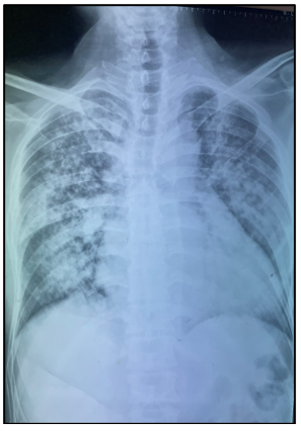

**Figure 1: Chest X-ray**

In figure 1 Chest X-ray showing alveolo-interstitial involvement associated with cardiomegaly. The biological workup revealed severe anemia with a hemoglobin level of 5 g/dL, uremia of 3.8 mmol/L, and serum creatinine of 69 µmol/L, corresponding to an estimated glomerular filtration rate of 9 mL/min. Metabolic acidosis was identified, with bicarbonate reserves at 12 mmol/L, along with hyperkalemia at 5.8 mmol/L. Given this clinico-biological picture, emergency management was initiated, consisting of a hemodialysis session combined with a blood transfusion. Troponin levels were slightly elevated with a decreasing trend, suggesting no ongoing ischemic event.

After the patient's stabilization, a follow-up chest CT scan was performed, revealing ground-glass opacities and diffuse bilateral nodular consolidations, predominantly in the central perihilar regions, with subpleural sparing. These findings were associated with thickening of both septal and non-septal lines, suggestive of alveolar hemorrhage. In addition, the scan revealed cardiomegaly predominantly affecting the left heart chambers, as well as a small bilateral pleural effusion, consistent with the diagnosis of alveolar hemorrhage (Figure 2).

The patient underwent bronchoalveolar lavage, followed by the initiation of corticosteroid therapy.

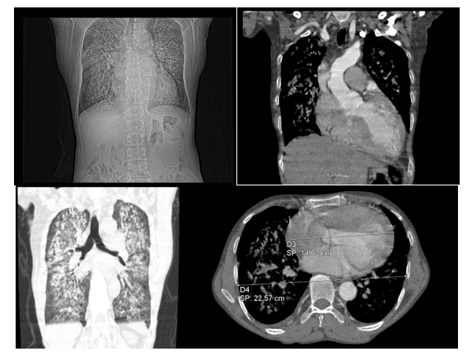

**Figure 2: CT scan image of Lungs**

In figure 2 CT scan image showing bilateral and diffuse ground-glass opacities and nodular consolidations in both lung fields with a central perihilar distribution and subpleural sparing. These findings are associated with thickening of some septal and non-septal lines, suggestive of alveolar hemorrhage. Cardiovascular assessment revealed a normal clinical examination, with no signs of right or left heart failure. The electrocardiogram (ECG) showed sinus tachycardia, a normal atrial tracing, and left ventricular hypertrophy (LVH) as indicated by a Sokolow index of 38 mm. Additionally, negative T waves were observed in the high lateral leads.

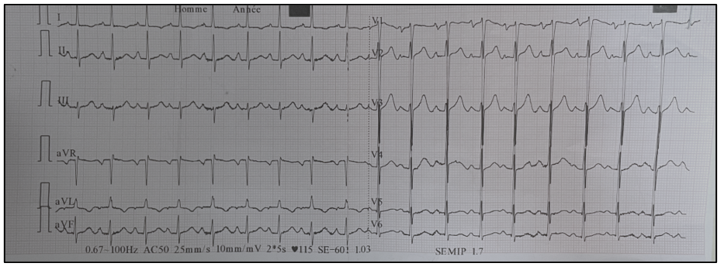

**Figure 3: Image of Electrocardiogram**

In figure 3 Electrocardiogram showing sinus tachycardia, a normal atrial tracing, left ventricular hypertrophy (LVH), and negative T waves in the high lateral leads.

Transthoracic echocardiography revealed a globally hypokinetic dilated cardiomyopathy with severe left ventricular dysfunction, as indicated by a left ventricular ejection fraction (LVEF) of 36%, with a global longitudinal strain altered to -12.4% . Moderate mitral regurgitation was also observed. The right ventricle showed preserved size and systolic function, with no evidence of pulmonary hypertension. No pericardial effusion was detected (figure 4).

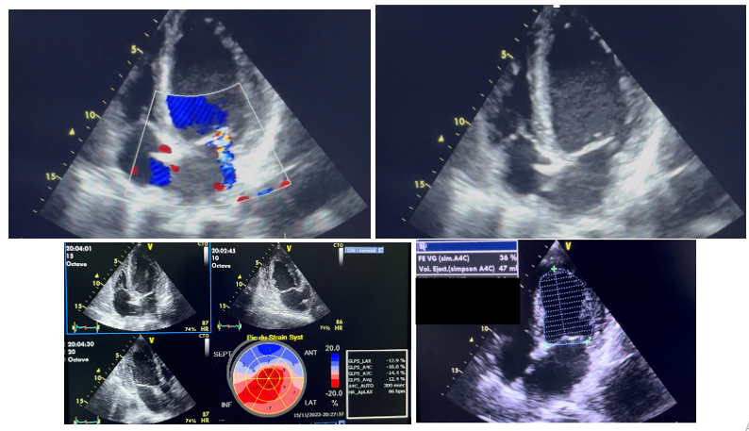

**Figure 4: 4-cave echocardiographic image**

In figure 4 4-cave echocardiographic image revealing hypokinetic heart disease with 36% impaired systolic function and -12.4% impaired global longitudinal strain, associated with moderate mitral regurgitation.From a therapeutic standpoint, and in response to this clinical presentation, heart failure treatment with beta-blockers and angiotensin-converting enzyme inhibitors (ACEIs) was initiated in collaboration with the nephrology team. Additionally, the patient received bolus corticosteroid therapy combined with methotrexate.

In figure 5 Control echocardiographic image taken at 6 months showing an improvement in LVEF to 52%. Echocardiographic evaluation at six months showed an improvement in left ventricular ejection fraction (LVEF), reaching 52%, with a slight improvement in overall longitudinal strain to -14.1% (Figure5).

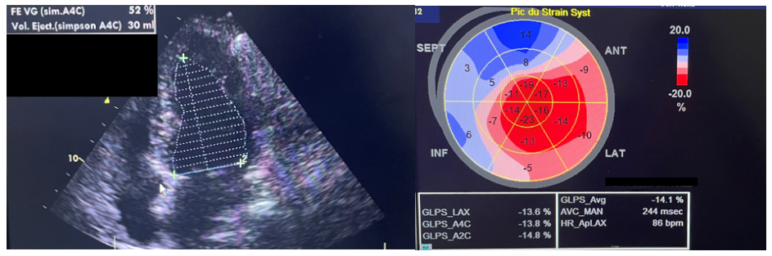

**Figure 5:** **Control echocardiographic image**

**DISCUSSION:**

Antineutrophil cytoplasmic antibody (ANCA)-associated vasculitides are necrotizing vasculitides that primarily affect small-caliber vessels. They include granulomatosis with polyangiitis, microscopic polyangiitis, and eosinophilic granulomatosis with polyangiitis. The diagnosis of these vasculitides is based on a combination of criteria, including clinical presentation, detection of ANCA targeting proteinase 3 or myeloperoxidase, and, whenever possible, histological confirmation of vasculitis (1).

Cardiac involvement in ANCA-associated vasculitides represents one of the most severe manifestations, significantly impacting the prognosis of these diseases (2,3). In our case, microscopic polyangiitis (MPA) is the most frequent etiology. It is a necrotizing vasculitis with minimal or no immune deposits, primarily affecting small vessels (capillaries, venules, arterioles) but also capable of involving small- and medium-sized arteries. Typical manifestations include necrotizing glomerulonephritis, which is common, as well as pulmonary capillaritis, frequently observed in affected patients.

Histologically, glomerular lesions predominate in microscopic polyangiitis (MPA), characterized by necrosis of the glomerular tuft, which may be partial or total, affecting a variable number of glomeruli. These lesions are often associated with secondary epithelial proliferation, sometimes predominant, as well as glomerular fibrosis or sclerotic hyalinosis. Necrotizing vasculitis lesions are primarily localized in small-caliber arterioles, particularly in the distal portions of interlobular arteries and glomerular afferent arterioles. Venular and capillary involvement is also observed, reflecting the widespread nature of the vasculitis.

Clinically, MPA primarily manifests with glomerular, pulmonary, muscular, cutaneous, and cardiac involvement, with the latter being particularly concerning due to its severity (3,4,5).

Cardiac involvement in ANCA-associated vasculitides can manifest in various forms:

* **Heart Failure:** Often severe, it can be an early or initial presentation of the disease. The underlying mechanisms include coronary artery vasculitis, extravascular granulomas, and eosinophilic interstitial infiltrates. Epicardial and myocardial granulomas may also be present, while endomyocardial fibrosis is rare (6), typically reported in hypereosinophilic syndrome and, less frequently, in Churg-Strauss syndrome, despite high eosinophil counts. Heart failure is primarily caused by myocardial ischemia due to small vessel vasculitis (arterioles, capillaries, and venules) (7). It may also result from severe or malignant hypertension of renal origin, typically affecting the left ventricle but sometimes presenting as global heart failure.
* **Coronary Involvement:** Although all vasculitides can theoretically affect coronary arteries, such involvement remains rare and poorly documented. Coronary imaging often reveals alternating stenoses and dilatations, either localized or diffuse. In patients with angina, coronary angiography is essential, though it may underestimate distal coronary involvement. The evolution of angiographic lesions remains unclear but appears similar to that seen in other medium-sized vessel vasculitides. Rarely, coronary vasculitis may present as sudden cardiac death, likely due to arrhythmia (8,9), or as hemopericardium secondary to coronary aneurysm rupture (10).
* **Pericarditis:** Pericardial effusion is commonly observed in heart failure patients but lacks specific characteristics. In rare cases, rapidly progressive pericarditis can lead to cardiac tamponade, requiring drainage and simultaneous biopsy to confirm vasculitic involvement.
* **Pulmonary Arterial Hypertension (PAH):** This complication is infrequently reported in vasculitides, particularly in polyarteritis nodosa (PAN) (11) and granulomatosis with polyangiitis.
* **Endocardial Involvement:** Endocarditis is generally absent in vasculitides, and its presence should prompt consideration of alternative diagnoses, such as infectious or marantic endocarditis. However, rare cases of valvular involvement, particularly affecting the tricuspid valve, have been documented (12).

The treatment of vasculitides is guided by the specific type of vasculitis, clinical manifestations, and the extent of organ involvement.

Symptomatic management of heart failure in vasculitis follows the same principles as in heart failure with reduced ejection fraction (HFrEF). Renin-angiotensin system inhibitors (ACE inhibitors, ARBs) and beta-blockers are recommended to reduce mortality and hospitalizations, with close monitoring in patients with renal impairment. Mineralocorticoid receptor antagonists and SGLT-2 inhibitors complement the therapeutic approach, provided renal function is preserved. Diuretics are indicated for fluid overload, while the hydralazine-isosorbide dinitrate combination serves as an alternative in patients intolerant to ACE inhibitors. Rigorous monitoring is essential to prevent hyperkalemia, hypotension, and bradycardia, particularly in advanced nephropathy (13).

The etiological treatment of vasculitides primarily relies on corticosteroids and, in selected cases, immunosuppressive agents such as cyclophosphamide.

**Table 1:** etiological treatment of vasculitides

|  |  |
| --- | --- |
| **Corticosteroids** | The initial treatment consists of a dose of 1 mg/kg/day, sometimes preceded by methylprednisolone boluses (15 mg/kg/day). After 3 to 4 weeks, the dosage is gradually tapered to the minimum effective dose, with a potential discontinuation between 12 and 18 months (3). |
| **Cyclophosphamide** | Its use is determined by the Five Factor Score (FFS), which is indicated for FFS ≥ 1 to assess disease severity based on criteria such as proteinuria, creatinine levels, cardiac involvement, and severe gastrointestinal or central nervous system manifestations. Intravenous administration is preferred due to its faster onset of action and lower toxicity, with a treatment duration of 4 to 6 months. This is followed by maintenance therapy with methotrexate or azathioprine, recommended for 12 to 18 months (14,15). |
| **Intravenous Immunoglobulins (IVIG)** | Used in certain severe forms, particularly Wegener's granulomatosis and microscopic polyangiitis, they exhibit good tolerance and are based on their demonstrated efficacy in Kawasaki disease (16,17). |

The therapeutic strategy aims to control inflammation, prevent complications, and improve the prognosis of severe vasculitides. Cardiac involvement requires an intensive treatment approach combining corticosteroids and immunosuppressants, as this strategy significantly enhances patient survival (18).

The prognosis of systemic vasculitides depends on the extent of visceral involvement, with cardiac manifestations being a major determinant of poor outcomes. The introduction of corticosteroids and immunosuppressive therapy, particularly cyclophosphamide, has significantly improved survival rates. The combination of corticosteroids and immunosuppressants has increased the 5-year survival rate from 82% in the 1970s to over 90% today (19).

Mortality is primarily associated with uncontrolled acute heart failure, arrhythmic events, or refractory heart failure unresponsive to standard therapies, including vasodilators, cardiotonic agents, and diuretics.

**CONCLUSION:**

Cardiac involvement in ANCA-associated vasculitis is a rare but potentially severe complication, requiring early recognition and multidisciplinary management. This case report highlights the importance of rigorous cardiological monitoring in patients with vasculitis, particularly in the presence of symptoms suggestive of heart failure.

The integration of systematic echocardiographic evaluation, in addition to conventional diagnostic tools, can help improve the prognosis of these patients by enabling early and tailored management. Finally, the favorable response to treatment with corticosteroids and immunosuppressive agents underscores the importance of a targeted and personalized therapeutic approach.

**Disclaimer (Artificial intelligence)**

Option 1:

Author(s) hereby declare that NO generative AI technologies such as Large Language Models (ChatGPT, COPILOT, etc.) and text-to-image generators have been used during the writing or editing of this manuscript.

Option 2:

Author(s) hereby declare that generative AI technologies such as Large Language Models, etc. have been used during the writing or editing of manuscripts. This explanation will include the name, version, model, and source of the generative AI technology and as well as all input prompts provided to the generative AI technology

Details of the AI usage are given below:

1.

2.

3.

**REFERENCES**

**(1) Terrier, B. (2019), Treatment of ANCA vasculitis: certainties and controversies. Nephrology & Therapeutics, 15, S7-12.doi: 10.1016/].nephro.2019.1**

**(2) Fekih, A., Mami, Jebali, H., Hiba, G., Fathi, B. H., Lamia, R., Karim, Z. (2021). Cardiac involvement in ANCA vasculitis. Nephrology & Therapeutics, 17(5), 347-348, doi:10.1016/j.nephro.2021.07.254**

**(3) L. GUILLEVIN, Cardiac manifestations of necrotizing vasculitis, Heart and Internal Medicine, reality in cardiology, 2010**

**(4) GROSS WL. Systemic necrotizing vasculitis. Baillieres Clin Rheum atol, 1997; 11: 259-84.**

**(5) SABLE-FOURTASSOU R, COHEN P, MAHR A et al. Antineutrophil cytoplasmic antibodies and the Churg-Strauss syndrome. A nn Inter Med, 2005; 143: 632-8.**

**(6) CHURG J, STRAUSS L. Allergic granulomatosis, allergic angiitis and periarteritis nodosa. A m J Pathol, 1951; 27: 277-94.**

**(7) BLETRY O, GODEAU P, CHARPENTIER G et al. Cardiac manifestations of periarteritis nodosa. Frequency of nonhypertensive cardiomyopathy. Archives of Heart and Vessel Diseases, 1980; 73:1027-35.**

**(8)TANG P, SEGAL A. Polyarteritis nodosa of infancy. JA MA, 1971; 217:1666.**

**(9) AHRONHEIM J. Isolated coronary periarteritis: report of a case of unexpected death in a young pregnant woman. A m J Cardiol, 1977; 40:287-90.**

**(10) HOLT S, JACKSON P. Ru p tu red coronary aneurysm and valvulitis in an infant with polyarteritis nodosa. J Pathol, 1975; 117:83-7.**

**(11) ROSE G, SPENCER H. Polyarteritis nodosa. Q J Med, 1957; 26:43-81.**

**(12) PAGNOUX C, GUILLEVIN I. The heart in vasculitis. The heart in Autoimmune diseases, Asherson and Doria A, ed. 2004.**

**(13) 2023 Focused Update of the 2021 ESC Guidelines for the diagnosis and treatment of acute and chronic heart failure, ESC Clinical Practice Guidelines.**

**(14) JAYNE D, RASMUSSEN N, ANDRASSY K et al. A randomized trial of maintenance therapy for vasculitis associated with antineutrophil cytoplasmic autoantibodies. N Engl J Med, 2003; 349:36-44. 40.**

**(15) PAGNOUX C, MAHR A, HAMIDOU MA et al. Azathioprine or methotrexate maintenance for ANCA-associated vasculitis. N Engl J Med, 2008; 359:2790-803.**

**(16) JAYNE D, GASKIN G, RASMUSSEN N et al. Randomized trial of plasma exchange versus methyl prednisolone for severe renal vasculitis. J A m Soc Nephrol, 2007; 18:2**

**(17)180-8. 42. MARTINEZ V, COHEN P, PAGNOUX C et al. Intravenous immunoglobulins for relapses of systemic vasculitis associated with antineutrophil cytoplasmic autoantibodies: results of a multicenter, prospective, open-label study of twenty-two patients. A rthritis Rheum 2008; 58:308-17**

**(18) LEIB ES, RESTIVO C, PAULUS HE. Immunosuppressive and corticosteroid therapy of polyarteritis nodosa. A m J Med, 1979; 67:941-7.**

**(19) GAYRAUD M, GUILLEVIN L, LE TOUMELIN P et al. Long-term follow-up of polyarteritis nodosa, microscopic polyangiitis, and Churg-Strauss syndrome: analysis of four prospective trials including 278 patients.**

20. Sahu, M. R., Wairagade, T. D., Wairagade, S. D., Ambad, R. S. and Chandi, D. H. (2021) “Evolving Trends and Changing Perspectives in ANCA Associated Vasculitis– A Review”, Journal of Pharmaceutical Research International, 33(37B), pp. 207–212. doi: 10.9734/jpri/2021/v33i37B32041.