**Mapping Human-Wildlife Conflict Hotspots in Odisha, India: Trends, Impacts, and Mitigation Strategies**

**Abstract**

India's ironic wild biota is in jeopardy as human-animal confrontations have surged, propelled by habitat loss, illegal trafficking poaching domestication etc. The threat demands urgent conservation through holistic approaches and legalities. The present study aims to collect information about Human-Wildlife conflict (HWC) incidents, fatalities, and economic impacts, which is a concern in Odisha.

It integrates a decade of data on deaths, economic losses, and species-specific conflicts (elephants, tigers, crocodiles, sloth bears) and uses cutting-edge geospatial techniques (RS/GIS, ERDAS) to identify hotspots. The study closes gaps in Indigenous HWC research, relates findings to the Sustainable Development Goals (SDGs 6, 12 and 14), and delivers actionable mitigation tactics, thereby proving helpful for policymakers, ecologists, and conservationists working within biodiverse, human-dominated environments. The evaluation shows that sloth bears and crocodiles are increasing in number, in contrast, the elephant population diminishing and tigers changing colour Melania (black and white) due to genetic diversity like inbreeding or siblings. It is observed that government and community participation have instigated conservation mitigation practices.

The study highlights significant district-level findings, such as Angul and Dhenkanal being principal conflict hotspots. Briefly summarize the recommended mitigation strategies (e.g., habitat restoration, community engagement, AI monitoring) to enhance practical utility for policymakers and conservationists. The HWC have multifaceted impacts on people, communities, properties, and the wildlife itself.

K**eywords:** Biodiversity Conservation, game farming, Human-wildlife conflict, Livestock depredation, Habitat loss.

**Introduction**

The Human-wildlife conflict (HWC) clash is focused on sustainable global challenges between people and wildlife, Braczkowski et al.,( 2023)[1]. It yields crop loss, bovine predation, human deaths and traumas. The HWC ensues anthropogenic actions like urbanisation, industrialisation, poaching, predation, deforestation etc. The human interventions in wildlife habitation and encroaching forests for food and agriculture have threatened, the ecosystems, and socio-economic values, and posed impediments to wildlife conservation and livelihoods. The surging human populations during running Anthropocene epoch have encroached on the habitation area of the large carnivores, omnivores, and herbivores. Snowballing contraction, fragmentation, or degradation have occurred. The emergence of HWC emerged from owning territory for food and habitation or safe dwelling, Schell et al., 2021[2]. Somu et al., (2022)[3], Bomberi et al., (2023)[4].

**Background**: India responds to a conservation issue of international concern. The deaths caused by HWC and negative activities have succumbed to ≈2853 in the last five years (2019-2023) in India, out of which 628 deaths occurred during 2023. Elephants and human skirmishes have caused human deaths recorded 587 in 2019, 471 in 2020, 557 in 2021, 610 in 2022, and 628 in 2023 (PTI: July 26, 2024, 15:17 IST). Commonly HWC occurs between people by elephants, Tigers, bears, leopards, snakes and Crocodiles (Sambad Oct 01, 2024). The elephant population in Odisha marginally surged from 1976 (2017) to 2098 (2024), but human deaths increased from 105 to 154 during the same period.

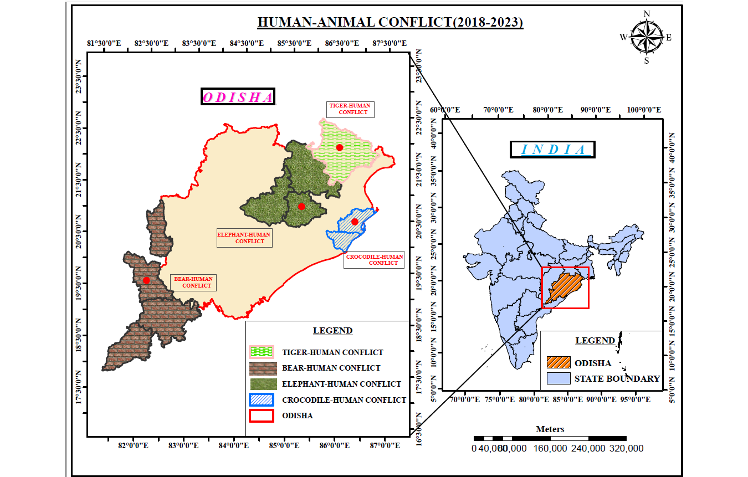

**Fig 1: The Human-animal conflict areas (****Elephant, Tiger, Crocodile, Bear ) of Odisha**

The forests of Odisha have sizable numbers of flora and fauna, and aboriginal people. Most plants have ethnobotanical values and are used as herbal medicine. (Mishra et al., 2018[5]; Nenungwi et al., 2024[6]). Regular HWC has urged a detailed study of their census study, hotspot locations, and confrontation management (Fig 1). The study identifies hotspot conflicting areas and corridors for elephant, Tiger, Sloth Bear and salt-water crocodiles (ETBC) by probing district-wise data through various literatures, field visits, and media/departmental information up to 2024.

**Review of Literature:**

Unfurling the past 50 years of Human-wildlife history, the conflict between them is exponentially increasing today. The space between settlements, dense populations and animal habitats has diminished due to climate change, and anthropogenic activities for their sustenance Schell et al., (2020)[2], Dash et al., (2024)[7]. Matanzima et al. (2024)[8], Alam et al. (2024)[9]. The unexpected rising HWC have negative results accompanied by death and trauma, Gulati et al. (2021)[10], Braczkowski et al., 2023[1], Narayan et al., 2023[11], Galley et al., 2024[12]. The HWC arises when people and wildlife cohabit and part common possessions, including food, fodder, roads, and shelter Pant et al., (2023)[13].

HWC have options for interstate transboundary issues, management interventions at times linking convergence, or large mammals Sharma et al., 2021[14]; Adhikari et al., 2024[15]. Loss of predators, harvest, human, omnivore, or carnivore, and a heavy burden are outcrops of HWC. That results in loss of loss of bovines, loss of ecology and deterioration of the environment. It is essential to map the connectivity and convergence interface and alter the cohabitating attitude towards this wildlife, Su et al., (2020)[16], Mishra et al, 2022[17], Basudev et al., 2023[18], Rawal et al., 2024[19]. Urban agglomeration increases co-habitation and surges HWC have consequences of wildlife-vehicle accidents. Wildlife tourism, zoonotic disease spread, causes deaths of both crop/ property loss, Mishra et al, (2020)[20], Cui et al, 2021[21]. Significant causalities are reported attributing to mainly elephants, Leopards/ Royal Bengal Tigers (RBTs), sloth bears and snake bites and crocodiles (Mishra et al, 2023[22], Dertien et al., 2023[23]).

The places of human-wildlife confrontation are grazing grounds and urban peripheries,(Mishra 2020[24]; Singh et al., 2021[25]; Tripathy et al., 2024[26]). Medical personnel report snake bite deaths are common everywhere, followed by elephants, tigers and leopards, black sloth bears and saltwater crocodile attacks in Odisha. The elephants from Chandaka Jungle intrude on the capital city, Bhubaneswar, of Odisha, regularly. The report of HWC was taken casually in the 20th century and needs prioritisation in the current milieu.

**Objective**:

The aim of the study is to:

1. To quantify the extent of human-animal conflicts in Odisha from 2014 to 2023, identify the most affected districts, and assess the effectiveness of present mitigation strategies.
2. The study shall provide insights to help policymakers, conservationists, and local communities implement better conflict management strategies.
3. To search for steps to reduce Human-wildlife conflict and legalities associated with cruelty to animals.

**Methodology**

Homosapiens cohabitated with wild animals from ancient days. In the present human-dominated epoch, the HWC has emerged challenging as humans and wild animals have shared their food, shelter, and resources. The Forest Dept. (FD) is vigilant about the predator’s habits, active time, and basic needs for the conservation of these wild animals. They fail to protect humans and their property; from these predators ( ETBCs. snakes, etc.).



Fig 2: The flow diagram of preparation of Thematic maps

Data was collected from government reports, news articles, and official statistics covering incidents from 2014 to 2023. Key data sources include Odisha Diary, Hindustan Times, and Odisha TV, submitted by various line departments in honourable courts. The gathered data were statistically studied. The results of the Statistical analysis, geographical mapping, and trend analysis were used to evaluate the data. Tools like Excel, SPSS and GIS were employed to represent conflict hotspots and trends visually.

The study focuses on conflicts involving people with predators of Odisha's Asian elephant (*Elephas maximus*), Royal Bengal tigers (RBTs), Odisha tigers/leopards (*Panthera Tigris*), vulnerable sloth bears (*Melursus ursinus*), and least concerned saltwater crocodiles (*Crocodylus porosus*) of IUCN red list. The IUCN SSC Guidelines on Human-Wildlife Conflict and Coexistence, one has to save these wild animals from fatalities, biosphere reserves, Zoos, sanctuaries, zoos, etc., are protected areas for the wilds as per the Indian Wildlife (Protection) Act, 1972, updated 2023[27], Mishra (2020)[28].

The present study expresses unambiguously the mixed-methods strategy, including reviews from literature, field observations, and geospatial technology (GIS, ERDAS, Excel) to enhance transparency. Highlight significant district-level findings, such as Angul and Dhenkanal being principal conflict hotspots. Briefly summarize the recommended mitigation strategies (e.g., habitat restoration, community engagement, AI monitoring) to enhance practical utility for policymakers and conservationists.

**Forest Status in India and Odisha:**

India's Odisha state(17. 49’N and 22.34’N lat. and 81.27’E and 87.29’E long.), terrestrial area of 155707 sq. Km (4.47% of the country’s area) is most affected by the HWC conflict. The state Odisha houses total forests in FSI 2011/ 2021 of 48855/52156 km2, including 21366/20995 sq. km of moderately dense, 20477/28872 sq. km of open/scrub, 7066/ 7213sq km of very dense forests and 259 sq. km of mangroves. These types are unclassified (28.01%), Reserve forests (45.29%), and protected (26.7%) (<https://fsi.nic.in/forest-report-2011>; <https://fsi.nic.in/forest-report-2021>). The mangroves along Odisha's coasts cover crocodiles of 258.98 sq. Km. Mishra et al, 2024[29] Fig 3 ( a to e).

Figure 3(a) Total Forest areas of Odisha, inclusive of mangroves along the East Coast of India

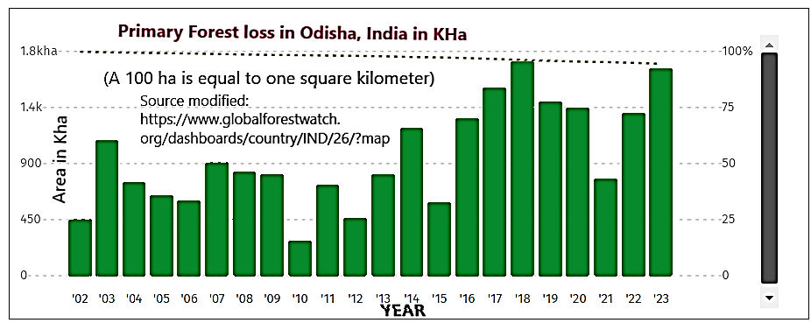

Figure 3(b): Year-wise, Odisha’s Forest loss from 2002 to 2023 (sour: Global Forest Watch)

**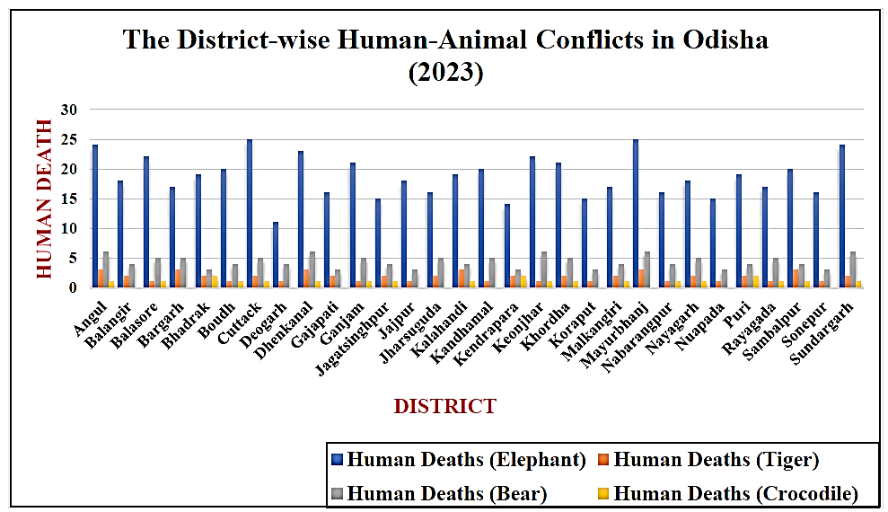**

Fig 3(c) The district-wise human-wildlife conflict (ETBC) reports/depths in Odisha 2014-23

Fig 3(d) 10-year Information of Animal Death due to Human Influence in Odisha 2014-2023

Fig 3(e) Major District HWC conflicts/deaths reported in Odisha. (Source various literatures and https://orissadiary.com/addressing-human-wildlife-conflict-hwc-in-odisha/)

**Conserving and protecting ETBC in Odisha**

The Odisha State has 21 Sanctuaries and five national parks. The earmarked national parks are the coastal National Park (Bhitarkanika) and the inland National Park (Similipal), created as per the Indian Wildlife (Protection) Act, 1972. One large Zoological Park (Nandan Kanan), three Small Zoos and seven Mini Zoos (Mishra et al., 2020[30])

The biotic interstate movement of the ETBs over the wild corridors is HWC vibrant and warrants a drop in human-animal transfer. Present-located interstate corridors in Odisha are at Dhoba-Dhabani (Badam Pahada), Karida, Deuli-Suliapada (Mayurbhanj Dist.), and Karo-Saranda (Keonjhar-Jharkhand). The inter-district corridors are Similipal-Hadagada-Kuldiha, Telkoi-Palalahada, Jiridamali-Anantapur, Kanheijena-Anantpur; Buguda- Nayagada, Nuagaon-Barun; Tala-Kolhagarh; Barapahar -Tarabha -Kantamal; Kotagarh-Chandrapur and Karlapat-Urladani Corridors, Udgata et al (2011[31]), Singh BB et al, 2014[25].

The Odisha state witnessed recorded 149 deaths in 2023-24 in elephant attacks. The districts that reported such human deaths were Dhenkanal (31), Angul (24), Sundergarh (22), Keonjhar (18) Mayurbhanj (10) etc. (Maharana 20233[32]). Elephants invade villagers and croplands, and when people molest them with cruelty, they stump and kill them due to their size and weight Figure 3(a) and (b). Sometimes, these wild animals are carrying Zoonotic diseases. Mishra et al., (2020)[30] Fig 3 a, b and c

Inter-state wise, Odisha reported 322 elephant-stumping deaths, followed by 291 in Jharkhand, 240 in West Bengal, 229 in Assam, 183 in Chhattisgarh, and 152 in Tamil Nadu in the last three years from 2019-2020 to 2021-22.  Out of 198 elephant deaths in India, Odisha has reported 30 while Assam tops with 36 jumbos by electrocutions and eight elephants fatalities in train accidents between 2019-20 and 2021-22 (Maharana 2023[32])

.**Overview of Human-wildlife conflict (HWC):**

**Population Overview**: Odisha has a population of over 40 million. A significant portion of the population lives within/ near forest areas. Populous districts like Khordha, Cuttack, Dhenkanal, Keonjhar, Nayagarh and Ganjam have increased chances of more HWC.

**Wildlife Distribution**:

The elephant population in India during 2007, 2012, and 2017 was 27669-27719, 29391-30711, and 29964, and it is rising. They include around 1976 elephants, thirty Royal Bengal Tigers (RBTs), Leopards (≈700 inclusive *Black Panther*), 1811 number saltwater crocodiles (*Crocodylus porosus*) and unrecorded widespread black sloth bears. Critical wildlife habitats are in Similipal National Park, Satkosia Tiger Reserve, Debrigarh and Bhitarkanika National Park. As per Hindustan Times, Oct 03, 2024, Odisha housed leopards 760 in 2018, 568 in 2022-23 and 696 leopards in 2024, (the National Tiger Conservation Authority (NTCA), inclusive of three rare melanistic (Bisoyi 2024 and Sambad October 7th 2024[33] ). The saltwater crocodiles in the 2024 crocodile census in Bhitarkanika National Park, Odisha are 1826 crocodiles. They included 582 hatchlings, 327 juveniles, 387 yearlings, 167 sub-adults, and 348 adults. About 200 leopards are dwelling in the Mayurbhanj and Kendujhar districts (Hadgarda and Kuldiha sanctuary), and the same numbers in Sunabeda, Atha Mallick, Nayagarh, Angul and Boudh Forest Divisions. More than 55% of leopards live in sanctuaries. Sloth bears are widespread in all districts of Odisha but statistics are unavailable.

**Conflict Hotspots and Timings**: The Angul, Dhenkanal, and Mayurbhanj districts are hotspots for the retaliatory killing of elephants. It was 149 people (highest recorded) in 2023-24. There are significant human and wildlife casualties and more economic losses. Odisha has sloth bear-human conflict periods at dawn, day, dusk, and night, with 94, 41, 42, and 15 cases covering 192 cases. Deaths from ETBC attacks have been recorded in 2023; there were 51, 91, 59 (total of 201 cases) in 2021-22 no season (Sharp et al., 2022[34]). Wild animals are optimally violent when they are with newborn babies. Some collected photographs of importance after the HWC with ETBC are in Fig 4. (a-d).

**Elephant -Human conflicts:**

The hot corridors of movement of these wild HTBCs where HWC occur are due to electrocution, jungle settlements and railway accidents. The fatal places for elephant deaths in Odisha are Rambha hills, Athagarh forests, and Jajpur-road Keonjhar Rail lines. 120 elephants were electrocuted ( 2009 and 2019), and during 2023-24 it was 15 elephants in Odisha Other contributing factors are Poaching and accidents. (Maharana S., The New Indian Express, Oct 21, 20248: 16 PM. Tripathy et al. (2022[35]). The Humans and elephants conflict resulted in 2853 people deaths during 2019-2024 and a five-year high of 628 during 2023 (Govt data)

State-wise human and HTBC deaths by HWC in 2018-19 to 2023-24 are in (Fig 5 a-c). Elephant census-2024 reports about 2103 elephants, (including 474 male and 1,030 female), are inhabiting the forests of Odisha. As per the elephant census (2024) report 334 tuskers (adult Males), 12 makhanas (adult), 678 females (adults), 186 tuskers (sub-adult), 04 makhanas (sub-adult), 181 juveniles, and 403 calves in Odisha.

(a)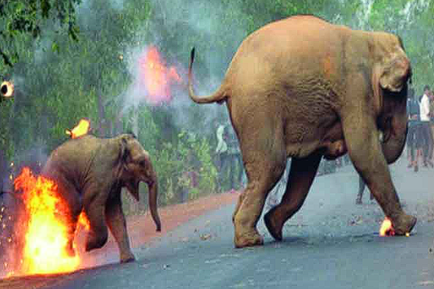(b)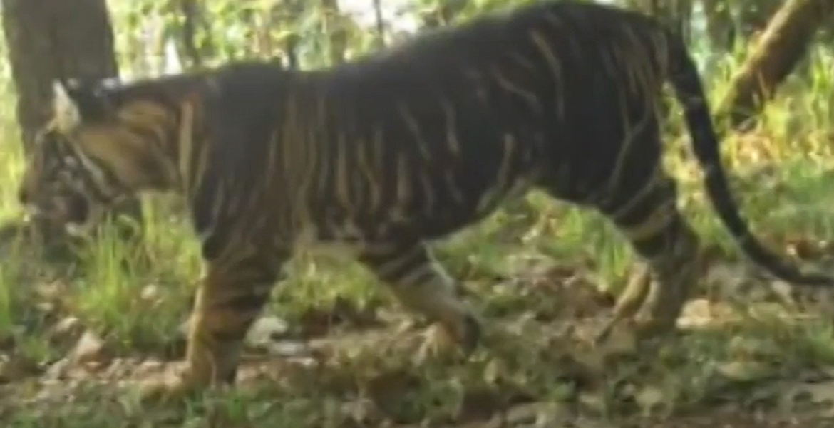

(c)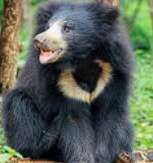(d)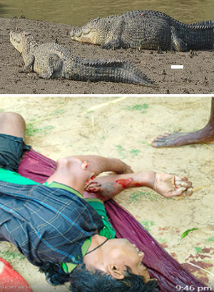)

Figure 4 (a to d): (a) Elephants are attacked to disperse by using fireballs(Source-Think Wildlife Foundation, (b)Melania tigers in Similipal Tiger Reserve(STR) (c) Sloth bears found in all districts of Odisha. (d) A boy named Dakhinbeda village, Kendra Pada, was attacked dead by a Baula crocodile.

Fig 5 (a) Human deaths caused by elephants in India 2018-19 to 2023-24

Fig 5 (b) The fatalities of elephants and humans resulting from HWC (b) Human deaths caused by Elephants in India 2014 to 2023 (Data: Rajya Sabha Unstarred Question No. 672 answer)

Fig 5 (C ): District-wise human-elephant conflict in Odisha 2014-2023

**The Cultural Icons, Natural Gardeners of Odisha:** Elephants are the herbivorous terrestrial large mammals in Asia. They have important religious activities as cultural icons. They also disperse plants through their physical activities so they are the signatures of Gardeners of nature. The data on elephants are trifling due to the interstate migration of elephants between the interstate corridors.

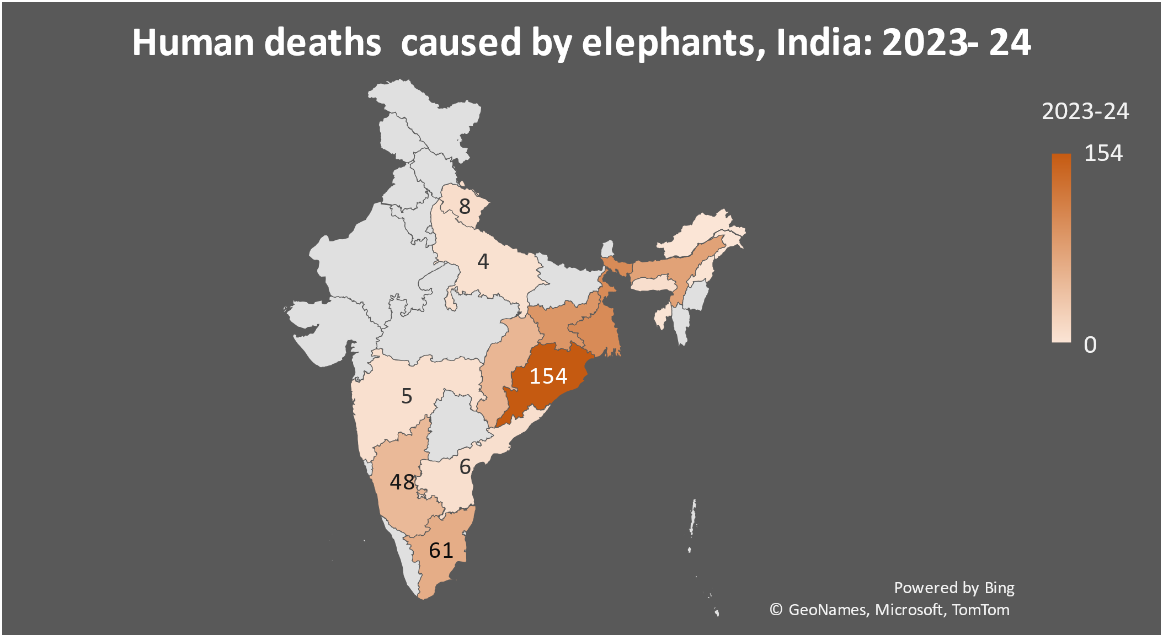

Fig 6: The deaths caused by Human- Elephant conflict in different states of Odisha

Elephants die in hundreds and are prey to looming threats for ivory tusks and teeth. However, 1145 anthropogenic elephant deaths were reported in confrontation from 2013-14 to 2023-24 (Dash C. 2024). while in 2023, Human-elephant combat results were 154 fatalities (Fig 6)

Table 1: The various age groups of elephants show Male: Female ratio is rising so more HWC

|  |  |  |  |  |  |  |  |  |  |
| --- | --- | --- | --- | --- | --- | --- | --- | --- | --- |
| Year | Total | Adult (male) | Sub-adult | | Mak  hana | Adult cow | Not Known | Elephants | |
|  |  | Tuskers | Male | Female |  | Female | sex | Juvenile | Calf |
| 2017 | 1976 | 212 | 122 | 276 | 10 | 816 | 38 | 203 | 299 |
| 2024 | 2098 | 313 | 148 | 282 | 13 | 748 | NA | 209 | 385 |
| Tuskers: male elephants; Makhana: tusk-less males; The cows that can milk a calf, | | | | | | | | | |

Source: Tathya, received from PCCF-Odisha Forest Dept.,

(a)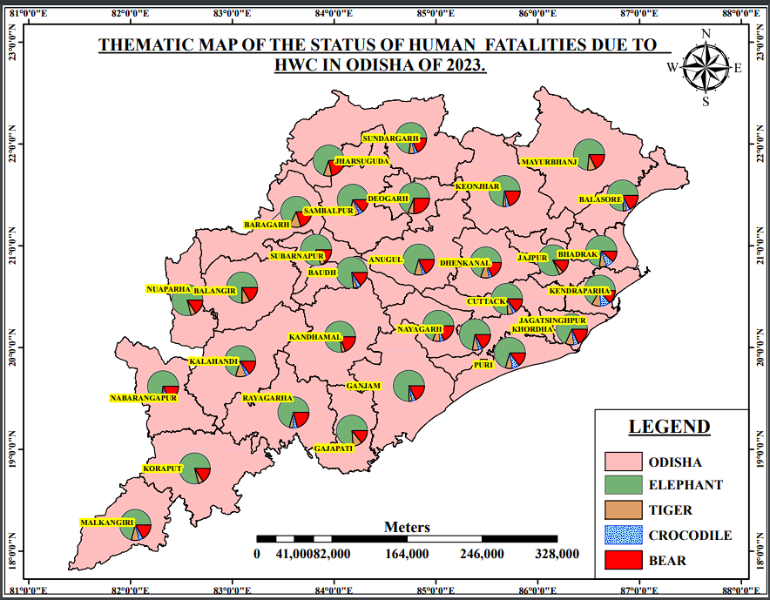(b)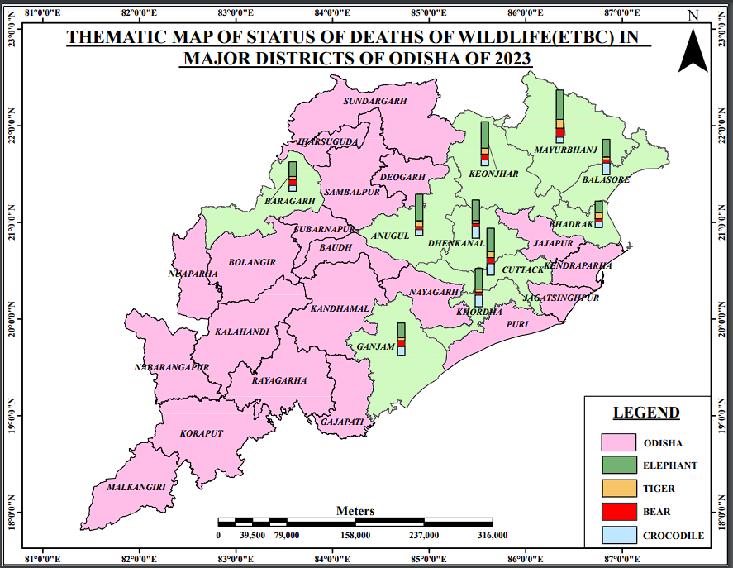

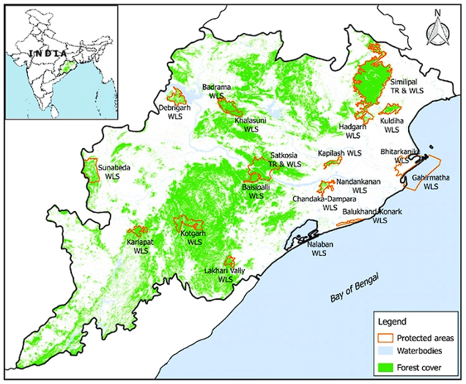d.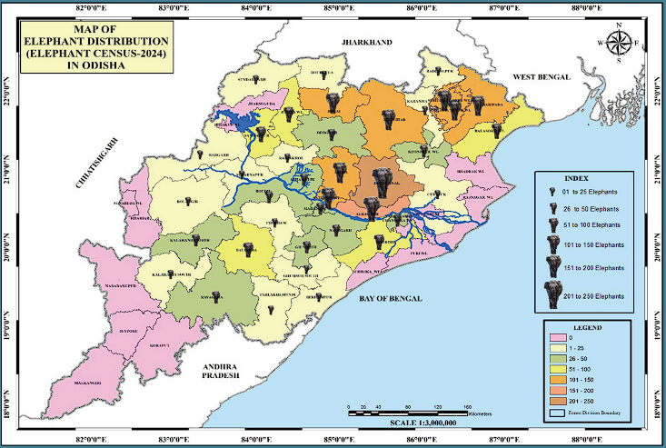

Fig 7 (a-d): (a ) Thematic map of human fatalities, (b) Elephant deaths distribution Odisha (Source: modified: Palita et al., 2007[36] (b) Tiger Reserves and WLS in Odisha.(c) Protected areas in Odisha (d)Element distribution in Odisha (source: all Odisha elephant census 2024)

The causes of the deaths of elephants in Odisha are commonly due to electrocution (natural /intentional), poisoning, poaching and train accidents. Sometimes, the electrocution is man-made, and the elephant sometimes creates it. In the last 11 years, the number of elephants dead is 142. Out of the 142 elephants, 37 are haunted, 22 are in train accidents, six by road accidents, three numbers are poisoned, and numbers of deaths by falling from hills and natural deaths by suffering from Anthrax (54), Herpes (11), and death due to other diseases are unknown (forest department data). The Human deaths were highest in 2022-23 and a total 624people died in HEC in Odisha between 2019 to 2025 (Table 2)

Table 2: Human deaths of elephants in Odisha by electrocution, accidents, haunting, etc.

|  |  |  |  |  |  |  |  |  |  |  |  |  |
| --- | --- | --- | --- | --- | --- | --- | --- | --- | --- | --- | --- | --- |
| Year/ Elephants | 2013  -14 | 2014  -15 | 2015 - 16 | 2016 - 17 | 2017 -18 | 2018 - 19 | 2019 -20 | 2020 -21 | 2021 -22 | 2022 - 23 | 2023 -24 | 2024 -25 |
| Elephants dead | 6 | 4 | 14 | 6 | 9 | 24 | 7 | 8 | 13 | 26 | 16 | ≈50 |

*Source: Odiya Sambad on 08.09.2024; The Hindu Feb 2025; 04 November 2024, 15:32 IST*

The analysis reveals that districts like Angul, Dhenkanal, Keonjhar and Mayurbhanj are the hotspots for Human-elephant conflict. Appropriate action with adequate planning can prevent conflicts. Ensuring timely and adequate victim compensation schemes reduces economic burdens and promotes coexistence. Also, it is essential for future research in multifarious areas and to plan for the long-term effectiveness of HWC strategies under the impact of climate change and human activities.

**Human Tiger conflicts:**

The reported cases of Human carnivore conflict have surged over time, in lower-income countries. Due to Human–Wildlife Coexistence, Tampakis et al, 2023[37], Bomberi et al, 2023[38]. The Odisha state had 142 tigers in 1972, which was 7.77% of the 1827 total tigers in India). The melanistic black tiger in Odisha was discovered on July 21, 1993 (when Salku killed it when Surai Besra (father) was demised). Eleven (between 1993 and 1998) melanistic tigers (Black and white) were seen in the Similipal Tiger Reserve (STR). However, leopards (*Panthera pardus*) are common and more in numbers in Odisha. In STR, the genetical offspring of tigers is improved by genetic diversity by the Government, which is inbreeding ( mating of individuals who are closely related genetically, such as siblings or parent-offspring pairs. and an increase in pseudo-melanistic black tigers).

By 2004, Odisha Forests/Tiger Reserve had 132 adults amongst 192 tigers in Orissa. The presence of tigers was recorded in Koraput, Nawarangapur, Kalahandi, Sundergarh, Baragada, Keonjhar, Talcher and Phulbani. The statistics (2006 and 2010) are under doubt. The National Tiger Conservation Authority (NTCA) adopted the present counting method in Odisha in 2010, were 32only including the Royal Bengal Tigers (RBTs) in Odisha. The National Tiger Conservation Agency (WII-NTCA) estimates that the melanin types and leopards in Odisha Forest Department are 760 in 2018, 568 in 2022, and 696 in 2024, respectively. There was a sudden decline in the number of tigers in Odisha forests in 2006 due to a change in census architecture that used the NTCA double sampling method. However, modern embedded AI camera-alert systems, GIS technology, and camera traps are required and validated through field surveys for the census of the big cats(Singh LN. 2023[39]) Fig 8 (a and b)

Fig 8 (a) Human tiger conflicts in some states of India (2018-19 to 2022-23)

Fig 8 (b)The number of tigers as per census years in Odisha forests, India, from 1972 to 2024

Fig 8(c) Human tiger conflicts and corresponding deaths in 2023 in Odisha.

**Human- crocodile Conflict:**

The geospatial changes during the Holocene erratic Indian summer monsoon and global warming during the Anthropocene have shifted the coastwards, and there is a formation of a Lateral channel along the coast and more anastomosed along the Odisha coast are the estuaries of the Brahmani River Mishra at all, (2016[40]). The conflict between humans and estuarine crocodiles in the Bhitarkanika in the anastomosed estuarine channels at Dangmal, Keredagada, Bhitargada, Hatiagadi, Dakshina Beda, Ali, Khola Jhar-pada, and Pattamundai and areas of Kendra pada and Jagatsinghpur district has been extended up to adjoining Jajpur and Cuttack, and the death toll is rising year after year. The Census on Estuarine crocodile census in 2024 reported that in the Bhtarkania area, 582 hatchlings, 387 yearlings, 327 juveniles, 167 sub-adults and 348 adults are counted, slightly higher side than in 2023. In 2024, only 608 crocodiles are capable of attacking humans out of 1826 Crocodiles in Bhitarkanika.

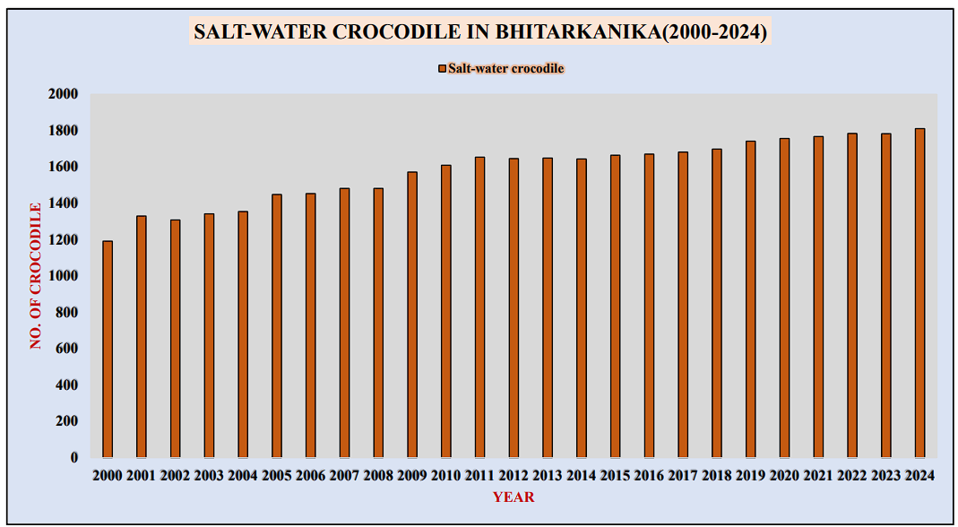

Fig 10: Saltwater crocodiles Status in Bhitarkanika estuaries of Brahmani/ Baitarani R. mouth

Crocodile attacks are reported from the Jajpur and Bhadrak districts (≈ 70 to 100 km away from Bhitarkanika) and far from the park's territory. The census 2022-23 reports that Bhitarkanika estuary has three types of crocodiles: *Crocodyluspalustris* (freshwater Mugger), *Crocodylus porosus*(saltwater crocodile or Baula), and *Gavialis gangeticus* (Gharial). Out of 1831 crocodiles traced in Bhitarkanika (2022-23), the varieties are at stages Hatchling (571 numbers), Yearling (389 numbers), Juvenile and adults (335 species), sub-adult (173 numbers), and Adults (363 numbers) only. Only adult and sub-adult crocodiles can kill human beings. About 515 of Bhitarkanika out of 1811 crocodiles can attack human beings as per census 2023-24, **Source**: https://odisha forest. In/admin/data/ documents/publication\_ file\_1735278100.pdf,

**Sloth bears and Human conflict in Odisha**

Odisha's sloth bear (Melursus ursinus) is India's most ubiquitous bear species and is vulnerable per IUCN. Habitat Loss and changes in land use patterns are the main causes of Human-bear conflict, leading to Human fatalities and Injuries. Human-bear conflict along forest edges in Odisha is diverse and occurs at different times of day or night, depending on the season. They stand up and attack like lightning if somebody confronts a sloth bear. These animals live on insects in caves, grasslands and forests Sharp et al., 2024. Loss of habitats and fragmentation in corridors are causes of a surge in Human-sloth bear conflict in Odisha, Debata et al, (2016)[41]; Palei et al., (2021)[42], Mishra et al, (2021)[43], Bargali IIFM (2022)[44]

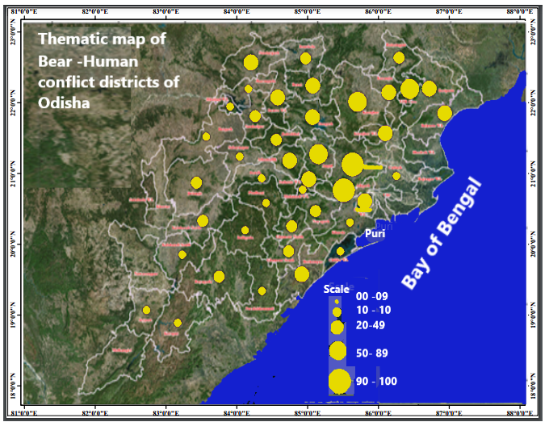

Fig 11. Existence, conflicts and deaths of sloth bears due to HWC in Odisha, from 2013-14 to 2022-23 (Source: State Wildlife Organization. Wildlife Odisha 2023[45])

Sloth bears, which play a vital role in ecosystem conservation, are enlisted as ‘Vulnerable’ in Appendix I of CITES. They are well protected under Schedule I of the Indian Wildlife (Protection) Act, 1972 and are endemic today. The sloth bears and other species have notable populations in Dhenkanal, Kandhamal, and Mayurbhanj. Sloth bears can comprise and live up to 2% of a tiger's diet and need caves for habitation to save them from sun and rain. In Odisha, 716 attacks were reported between 2014 and 2018 by sloth bears on humans, the maximum number of human casualties due to wild sloth bears in the state. These arduous predators, like tigers, observed as mothers with cubs, can go to extremes to protect themselves from predators.

Odisha is home to 30 tigers (RBT or Panthera Tigris). , eight cubs (27 in Similipal tiger reserve forests), and the rest are wild (Tiger survey 2023-24). The population of saltwater crocodiles ( Crocodylus porosus) out of three types available, mainly in Odisha's Bhitarkanika National Park, was 1811 in 2024, a marginal hike from 1783 in 2023. A recent study reveals that the jungle state Odisha, the Similipal, Debrigada Satkoshia, and Sunabeda forests have home to700 -800 leopards, either indigenous or migrated from the forests of Chhattisgarh, Andhra and Jharkhand and settled in Odisha. The sloth bears in Odisha forests are unpredictable and, protruding, and omnivorous are found in all districts, more or less.

**Table 3: Human-ETBC Conflict Reported Data in Odisha between 2014 to 2023.**

|  |  |  |  |  |  |  |  |  |  |  |
| --- | --- | --- | --- | --- | --- | --- | --- | --- | --- | --- |
| Year | Total | Total | Elephants | | Tigers | | Bears | | Baula Crocodile | |
| fights | death | fight | death | fight | deaths | fight | death | fight | death |
| 2014 | 1130 | 93 | 512 | 68 | 45 | 5 | 78 | 9 | 495 | 11 |
| 2015 | 1257 | 97 | 548 | 72 | 49 | 6 | 84 | 11 | 576 | 8 |
| 2016 | 1365 | 105 | 599 | 81 | 52 | 7 | 89 | 12 | 625 | 10 |
| 2017 | 1410 | 108 | 620 | 85 | 55 | 8 | 93 | 13 | 642 | 9 |
| 2018 | 1543 | 116 | 675 | 90 | 61 | 10 | 101 | 14 | 706 | 12 |
| 2019 | 1602 | 120 | 698 | 95 | 63 | 12 | 105 | 15 | 736 | 11 |
| 2020 | 1720 | 125 | 735 | 99 | 68 | 13 | 112 | 17 | 805 | 14 |
| 2021 | 1860 | 130 | 799 | 103 | 71 | 14 | 119 | 18 | 871 | 15 |
| 2022 | 1930 | 134 | 825 | 107 | 75 | 15 | 123 | 19 | 907 | 16 |
| 2023 | 2005 | 140 | 860 | 110 | 79 | 17 | 128 | 21 | 938 | 18 |

Source: Government reports and news articles information; you can refer to sources such as the Hindustan Times and Odisha TV​ ([Hindustan Times](https://www.hindustantimes.com/india-news/odishas-toll-in-human-elephant-conflict-at-its-highestdata-101710010660260.html" \t "_blank))​​ ([Odisha TV](https://odishatv.in/news/miscellaneous/human-price-of-shrinking-forests-odisha-tops-casualties-inflicted-by-elephants-186332))​.

**Results and Findings**

a. 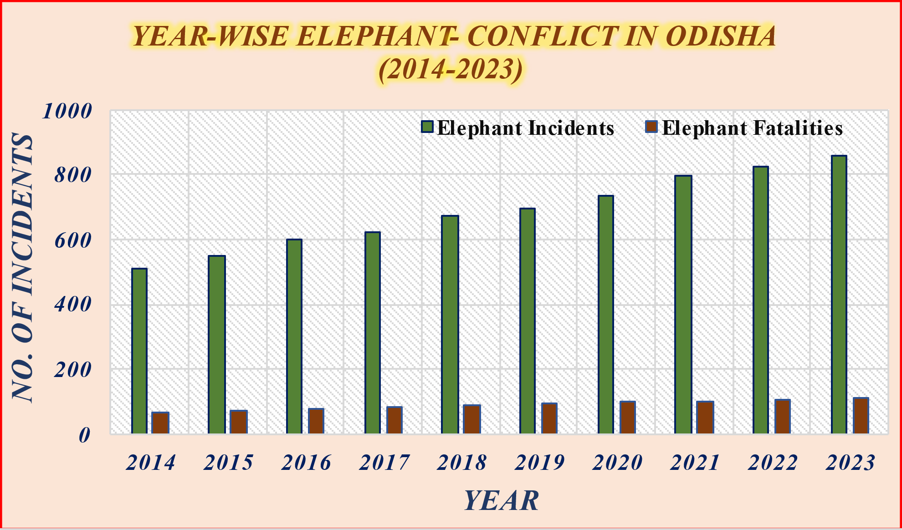

b.

(c)

d.

e.

Fig 12 (a-e): The ETBC conflicts reported in Odisha forests and estuaries 2014-23

Table 4: The total reported events and deaths due to ETBCs in Odisha during 2023

|  |  |  |  |  |  |  |  |  |  |  |
| --- | --- | --- | --- | --- | --- | --- | --- | --- | --- | --- |
| District | Total Events | Total deaths | Elephant events | Elephant deaths | Tiger events | Tigers dead | Bears event | Bears dead | C-dile  events | C-dile Fatalities |
| Angul | 180 | 14 | 90 | 9 | 6 | 2 | 30 | 1 | 54 | 2 |
| Balasore | 150 | 12 | 65 | 6 | 5 | 1 | 20 | 1 | 60 | 4 |
| Bargarh | 130 | 10 | 55 | 5 | 4 | 1 | 18 | 2 | 53 | 2 |
| Bhadrak | 115 | 9 | 45 | 4 | 5 | 2 | 15 | 1 | 50 | 2 |
| Cuttack | 200 | 16 | 85 | 8 | 7 | 2 | 28 | 2 | 80 | 4 |
| D-nal | 170 | 13 | 75 | 7 | 6 | 1 | 22 | 1 | 67 | 4 |
| Ganjam | 140 | 11 | 60 | 5 | 4 | 1 | 18 | 2 | 58 | 3 |
| Keonjhar | 190 | 15 | 85 | 9 | 6 | 2 | 27 | 2 | 72 | 2 |
| Khurda | 160 | 13 | 70 | 7 | 5 | 1 | 20 | 1 | 65 | 4 |
| M-bhanj | 250 | 18 | 110 | 10 | 8 | 3 | 35 | 3 | 97 | 2 |
| Abbreviation: Dhenkanal: D-nal; M-Bhanj: Mayurbhanj; C-dile: Crocodile: | | | | | | | | | | |

**Sources:** District-Wise Data (2023); Odisha Diary ([www.orissadiary.com](http://www.orissadiary.com)), Hindustan Times

This data provides a comprehensive view of the human-animal conflict situation in Odisha, highlighting the incidents, fatalities, and district-wise distribution, which can help in planning and implementing effective mitigation strategies.

**Elephant Attacks**: Odisha has seen many human-elephant conflicts, with human deaths ranging from 84 in 2014 to 125 in 2023. The injuries have also been high throughout the years​ ([Orissa Post](https://www.orissapost.com/elephant-attacks-odisha-tops-in-human-casualties/" \t "_blank))​​ ([Federal News](https://thefederal.com/category/news/human-elephant-conflicts-over-2500-people-died-in-five-years-says-govt-data-135404)). **Tiger Attacks**: These incidents have been relatively rare, with a maximum of 3 deaths in 2016 and low injury rates across the years​ by royal Bengal Tigers (Panthera Tigris), ([The New Indian Express](https://www.newindianexpress.com/states/odisha/2021/mar/08/artificial-habitats-to-prevent-man-animal-conflict-in-odishasnabarangpur-2273704.html))​. **Sloth Bear Attacks**: Bear attacks have caused numerous injuries, particularly in Nawarangapur, where 295 people were injured in the last decade. Deaths have been fewer but still significant​ ([The New Indian Express](https://www.newindianexpress.com/states/odisha/2021/mar/08/artificial-habitats-to-prevent-man-animal-conflict-in-odishasnabarangpur-2273704.html" \t "_blank))​. **Crocodile attacks** have become common within the anastomosed estuarine channels of the Mahanadi Tri Delta. Due to increased tourism around the cloud of crocodiles, tourists and local people have come to a close, which has increased the human-crocodile conflicts and reported deaths have escalated. Crocodile-related incidents have shown a steady increase, with injuries peaking in recent years (Orissa Post) (Federal News).

Table 5: Human-animal conflicts (ETBC) in Odisha 2014-2023

|  |  |  |  |  |
| --- | --- | --- | --- | --- |
| **Year** | **Elephant Attacks (Deaths/Injuries)** | **Tiger Attacks (Deaths/Injuries)** | **Bear Attacks (Deaths/Injuries)** | **Crocodile Attacks (Deaths/Injuries)** |
| 2014 | 84 / 120 | 1 / 3 | 1 / 15 | 5 / 9 |
| 2015 | 90 / 130 | 2 / 4 | 2 / 18 | 6 / 10 |
| 2016 | 95 / 140 | 3 / 5 | 1 / 20 | 7 / 12 |
| 2017 | 100 / 150 | 2 / 4 | 2 / 25 | 8 / 14 |
| 2018 | 110 / 160 | 1 / 3 | 3 / 30 | 9 / 16 |
| 2019 | 110 / 160 | 0 / 2 | 1 / 30 | 10 / 18 |
| 2020 | 105 / 150 | 1 / 3 | 2 / 28 | 11 / 20 |
| 2021 | 115 / 160 | 0 / 1 | 1 / 25 | 10 / 17 |
| 2022 | 120 / 170 | 1 / 3 | 2 / 25 | 12 / 22 |
| 2023 | 125 / 180 | 1 / 4 | 1 / 24 | 11 / 21 |

*Notes:* *Elephants are the major predators and killers in Odisha*

**Discussion:**

High dependency on natural resources and shifting land use (LU) patterns bring the human and animal species close interaction, yielding human-wildlife conflict mostly in susceptible low-income countries. Modifying human-wildlife conflict and regular monitoring of endangered carnivores must be emphasized. The study warrants conflict mitigation strategies, including habitat restoration, better land-use planning, and engaging community champions for data dissemination and awareness to improve habitat connectivity and create safe wildlife corridors. Local communities should be employed in conservation exertions and training about conflict extenuation strategies.

**Behavioural change in carnivore movement:**

There is less rise in the number of elephants recorded in Odisha State. The distribution has changed in the forests of Chandaka, Khordha, Athagarh, Angul, Dhenkanal, Baripada, Bonai, and Keonjhar etc., whereas their numbers have decreased in Similipal (Mayurbhanj) Rairangapur and Parlakhemundi.The trespassing route, movement pattern, and time have changed based on land use and land cover (LULC) patterns. Furthermore, the male-to-female ratio has altered with fewer mothers.

**Behavioural changes of people:**

People are hostile towards wild animals and have vents for retaliatory killings. For crop loss, personal economic gain, intolerance and negative perception towards wildlife affect community emotion. They either attack, poach or kill them for a safe dwelling. It is necessary to develop sympathy towards wilds and implement compensation schemes for socio-economic losses.

**Causes of Human-wildlife conflict in Odisha:**

The traits HWC are urbanisation, industrialisation, deforestation, and modernisation. Due to increasing habitat loss, population growth, conversion of forests to agricultural land, and climate change. The state's diverse wildlife and densified population near forests contribute to frequent encounters between humans and wildlife. The issues are heightening due to growing demography, urbanisation, migration, overcrowding, deforestation, poaching, food, and climate change.

Odisha has augmented its irrigation potential and hydropower sector, encouraging its farmers to go for diversified and cash crops. When the forests are diminishing, the animals are attracted to loiter on the outskirts of villages and casing human-elephant encounters.

An elephant, tiger, bear or crocodile (ETBC) covers about 100 to 300sqkm in search of food, water and mating. Our ancestors knew the density and coverage of the forests around their settlements, haunting ground, time and place of attack. These strong and great warriors can fight with these wilds. The crusade and the corridors are now disjointed due to urbanisation, industrialisation, roads, settlements, and deforestation.

The elephants intrude on settlements during paddy harvesting time, leopards, tigers and Hyenas if the bovines and pets kept open, their carcases thrown in accessible spaces or during grazing, bears at the time of Mohua/Jackfruit/Kendu leaves areas, and saltwater crocodiles in the villages near the estuaries of the rivers Mahanadi-Brahmani and Baitarani delta.

With the spread of connectivity, there are encroachments in the trespassing tracks, such as highways, railway tracks, and electrical transmission lines. Odisha faces road accidents and electrocutions, common in the Keonjhar and Ganjam districts (at Rambha), Similipal-Hadagada-Kuldiha, and Athagarh-Angul corridor.

The common fatal diseases for these ETBCs are bacterial, herpes viruses, haemorrhagic septicaemia or Pasteurellosis, leptospirosis, Anthrax, scrub typhus, rabies, Japanese encephalitis, brucellosis, etc.

**Demographic interference:**

Migration from rural areas to urban has exponentially surged. The expanse mostly encroaches on forests on the outskirts of towns. Humans and wild animals have come close. They cohabitate under space constraints, habitat fragmentation and destruction. Animals enter human settlements searching for resources like food, fodder, water, and shelter. The Human coexistence and conflict with wildlife as per the demographic analysis 2021, ~ 65% of the people in Rural India (~900 million) share space with protected areas (national parks, wildlife sanctuaries and biosphere reserves), which is approximately 5% of the total geographical surface area and three times lower than the world average of ~ 16%, Carroll et al.( 2021)[46], Rana et al., 2023[47]. The negative interactions are fuelled by changing climate, natural resource reduction, and animal and movement route alterations.

**Steps to reduce HWC:**

The Wildlife Institute (WI) of India, Dehradun and the Ministry of Environment Forest, and Climate Change(MoEF&CC), National Highway Authority (NHAI), National Tiger Conservation Authority (NTCA), in 2016 and the World Bank Group have generated a booklet as “‘Eco-friendly Measures to Mitigate Impacts of Linear Infrastructure’ in 2016 to assist the zoonotic project authorities which reports about the infrastructural and policy to reduces HWCs. A field manual for forest staff and champions to address the elephant Conflict has been in force accepted on the 16th meeting of the Steering Committee on April 29, 2022 (Lok Sabha Unstarred Question No. 1128, To Be Answered On 29.07.2024 on Human-Elephant Conflict.

The steps to reduce human-wildlife conflict include developing meadows and barricades, preventing forest fires, growing and rejuvenating water bodies, developing animal pass corridors, constituting anti-poaching squads, special protection vehicles for rescuing wild animals, night railway traffic controls, forest training camps and building local champions, Educating people not to disturb wildlife, Elephant from beehives, pre-warning and empowering local people treat wilds with the mechanism and resilience as cohabitate.

*The Tigers/Big Cats in Odisha are demanded to kill for their skins, bones and other parts of the animal as it is looming large and establishing a ‘Forensic Laboratory’ in Odisha for wildlife crimes. Further, State and Central collaborative Committees should coordinate with State and Central Enforcement agencies to prevent and detect wildlife crimes.*

The use of embedded AI camera-alert systems, GIS technology, camera traps, and NTCA double sampling method is required and validated through field surveys to avoid confusing census of wild animals. The large animals are nomadic and change places with transboundary problems. It is essential to close the connectivity-conflict interface between humans and wildlife with the potential usage of Aversive Geofencing Devices to reduce HWCs Cabral De Mel et al., 2023[48].

**Possibilities of Ecotourism and Game Farming:**

Like other states in India, attempts have been made to augment ecotourism, but there are no activities to ward off game farming or wildlife ranching in a country like South Africa. Privately owned land has boomed in South Africa due to land use and cover changes. They are transforming the nonproductive or less agricultural land into forestry and encouraging game farming. Game farming has spawned issues like biodiversity degradation, hunting, negative tourism, land, and agriculture, affecting the economic growth of stakeholders (Makumbe et al, 2022[49]; Xu et al., (2023)[50]; von Slom et al., (2023)[51]. This is possible that Odisha State has an increasing trend in agroforestry and mangrove cover Mardaraj PC. 2015[52], Pandey K., 2024[53].

**Legal perspective:**

HWC Management is a federal (State or Central Government) affair. Information on the pecuniary losses caused is to be collected and reported to the authority. Encroaching the animals' habitats under an escalating population, HWCs are a rising trend in many states in India. The problems of wildlife laws and judicial trials for peaceful cohabitation remain unsolved, NPCC 2016[54], Rana et al., (2023)[55] which can be addressed by promoting Human-Elephant Cohabitation by fitting in AI, Real-Time Alerts, and Rapid Response. (Rastogi et al 2024[56], GOO 2023[57]) Towards compensation as gracias towards death against HWC has been augmented by the Ministry, awarded vide WL-21/4/2023 on Sept 23, December 2023, rising from five lakhs to ten lakhs INR in case of death by wild animals. The rising HAC particularly with sloth bears (*Melursus ursinus*), Saltwater crocodiles and elephants have been overweighed by snake bites and viral/ bacterial infections. (Reddy 2024[58], Mardaraj et al, 2023[59], Senapati 2024[60], Dash 2024[61].

Protected Areas like National Parks, Sanctuaries, Conservation Reserves, and Community Reserves are constituted in India and Odisha under “The Wild Life (Protection) Act of 1972. They aim to conserve wild animals that cause losses to humans and the wild. Schemes like “‘Project Tiger”, “Development of Wildlife Habitats”, and “Project Elephant” are safe and secured so that they can efficiently manage wildlife, habitats and human life. Physical barriers like trenches, barbed wire fences, and bio or solar-powered electric fences can prevent wild animals from entering human habitats as attempted successfully in the Karnataka state. The Indian Constitution reinforces its people from the flora and fauna around them through Article 51A(g). The 2006 amendment to the Wildlife Protection Act of 1972 has indirect reference to wildlife corridors, which allows for the safe movement of tigers and other wild animals from one area to another.

The Wildlife Corridors Bill was also introduced in Lok Sabha in 2019 by Member of Parliament Rahul Shewale to tackle the issue of HWC. In February 2021, the Ministry of Forests (MoEF and CC) about the HWC recommended advising coordinated, integrated departmental action to identify conflict hotspots, adhere to standard operating procedures, and establish rapid response teams. The advisory recommends integrated action, identifying conflict hot spots, adhering to Standard Operating Procedures (SOPs), constituting rapid response teams, and forming State and District level committees, providing adequate funds for a suitable portion of ex-gratia relief to be paid. The Ministry of Environment, Forest and Climate Change (MOEFCC) issued Guidelines on June 3rd, 2022, on managing Human-Wildlife conflict, including crop damage and promoting game farming in crops in forest fringes for the wild animal food (Business Standard, July 26, 2024). The Ministry also released Guidelines for HWC with a harmonious coexistence Approach, preventing electrocution (2023) for train-elephants convergence under the project in 2024 as “Project Tiger & Elephant”. As such the conflict or coexistence runs simultaneously if the society lives with the wildlife (Thapa et al, 2016[62])

Despite being strongly allied to the Sustainable Development Goals SDG 2 (Zero Hunger), SDG -15 (life on Land animals), SGDs 12 (Responsible Consumption and Production), and 14 (Life below Water), the human-animal conflict remains unnoticed by policymakers. The globe’s natural ecosystem protection, management and sustainability need the safety of both human and wildlife populations.

**Conclusion:**

Man-animal conflict can negatively impact sustainable development goals (SDGs). This requires a multifaceted approach involving collaboration between government agencies, wildlife organisations, local communities, and legal and judicial stakeholders.

By embracing a holistic approach that balances the rights and interests of both humans and animals, India can pave the way for harmonious coexistence, ensuring the preservation of its rich biodiversity while safeguarding the well-being of its citizens.

Understanding the HWC designs and drivers, categorizing key conflict species and areas, and having less-explored regions of Odisha are essential. Continuous monitoring, census, research, and adaptive management strategies are essential to meet the evolving demands of sustainable development and wildlife conservation.

**Highlights: (i)** Odisha, India houses a proportionately high percentage of wild forest habitats popularly elephants, tigers, Crocodiles(Baula), leopards, Sloth bears, etc.

**(ii)** Regular forest and habitat loss, Elephants have turned out major predators. They die by electrocution, Poaching, Train-wreck and Retaliatory killings.

(**iii) The** Indiantiger population is decreasing at a faster rate. Melania Tigers are increasing in Similipal Tiger Reserve.

**(iv)** Verities ofSaltwater Crocodiles are found in Odisha, The Baula variety increasing gradually and the worst predators are at lower deltas.

**(v)** Sloth bears (Black) domicile in all districts of Odisha and their census is warranted for their conservation.

**COMPETING INTERESTS DISCLAIMER:**

Authors have declared that they have no known competing financial interests non-financial interests OR personal relationships that could have appeared to influence the work reported in this paper.

**Disclaimer (Artificial intelligence)**

Option 1:

Author(s) hereby declare that NO generative AI technologies such as Large Language Models (ChatGPT, COPILOT, etc.) and text-to-image generators have been used during the writing or editing of this manuscript.

Option 2:

Author(s) hereby declare that generative AI technologies such as Large Language Models, etc. have been used during the writing or editing of manuscripts. This explanation will include the name, version, model, and source of the generative AI technology and as well as all input prompts provided to the generative AI technology

Details of the AI usage are given below:

1.

2.

3.

**References**:

1. Braczkowski AR, O'Bryan CJ, Lessmann C, Rondinini C, Crysell AP, Gilbert S, Stringer M, Gibson L, Biggs D. The unequal burden of human-wildlife conflict. Commun Biol. 2023, 23;6(1):182. doi: 10.1038/s42003-023-04493-y.
2. Schell CJ, Stanton LA, Young JK, Angeloni LM, Lambert JE, Breck SW, Murray MH. The evolutionary consequences of human-wildlife conflict in cities. Evol Appl. 2020, 29;14(1):178-197. doi: 10.1111/eva.13131
3. Somu, Y., Selvaraj, P., Human-wildlife conflict. In book: Animal welfare new insights, Chapter: Human-wildlife conflict, Publisher: Intech open,(2022). DOI: 10.5772/intechopen.107891
4. Bombieri G, Pinterian V, Almasieh K, Ambarlı H, Ashrafzadeh MR, Das CS, et al. A worldwide perspective on large carnivore attacks on humans. PLoS Biol, (2023). 21(1): e3001946. https://doi.org/10.1371/journal.pbio.3001946
5. Mishra S. P., Panigrahi P. K., Das Sweta, Parida Tapasi, 2018, Endemism, ethnobotany, and invasive allied species of Odisha - a bio-geo-diversity study. Int. Journal of Advance Research, Vol- 6(9), pp-401-423, DOI 10.21474/IJAR01/7691
6. Nenungwi, L., Mokotjomela, T. M., Vukeya, L. R., Slabbert, M. M., & Prinsloo, K. L. A human-wildlife conflict: potential impacts of fatal harvesting approaches on medicinal plants in Free State Province, South Africa. South African Geographical J., (2024)., 1–19. https://doi.org/10.1080 /03736245.2024. 2315955
7. Dash, S. K., Ghosh, S., Das, R., Das, D., Nandy, S., Das, T., & Sonker, G. . Human-elephant conflict: attitudes of local people toward elephants and the conflict management authority in a shared landscape of India. Human Dimensions of Wildlife, (2024),1–16. https://doi.org/10.1080/10871209.2024.2372106
8. Matanzima, J. (2024). Human–Wildlife Conflict, Drought and Chieftainship Illegitimacy in the Zambezi Valley, Northwestern Zimbabwe. Journal of Southern African Studies, 50(1), 91–109. https://doi.org/10.1080/03057070.2024.2365553
9. Alam, R., & Nayak, D. (2024). Examining human-wildlife conflict and management strategies in Indian protected areas: evidence from Jim Corbett Tiger Reserve. Human Dimensions of Wildlife, 1–18. https://doi.org/10.1080/10871209.2024.2303364
10. Gulati S, Karanth KK, Le NA, Noack F. Human casualties are the dominant cost of human-wildlife conflict in India. Proc Natl Acad Sci USA. 2021 Feb 23;118(8):e1921338118. doi: 10.1073/pnas.1921338118
11. Narayan E, Rana N. Human-wildlife interaction: past, present, and future. BMC Zool. 2023 May 11;8(1):5. doi: 10.1186/s40850-023-00168-7.
12. Galley, W., Anthony, B.P. Beyond Crop-Raiding: Unravelling the Broader Impacts of Human-Wildlife Conflict on Rural Communities. Environmental Management 74, 590–608 (2024). https://doi.org/10.1007/s00267-024-02018-9
13. Pant B, Sharma HP, Dahal BR, Regmi S, Belant JL. Spatio-temporal patterns of human-wildlife conflicts and effectiveness of mitigation in Shuklaphanta National Park, Nepal. PLoS One. 2023 Apr 17;18(4):e0282654. doi: 10.1371/journal.pone.0282654.
14. Sharma P, Chettri N, Wangchuk K. Human-wildlife conflict in the roof of the world: Understanding multidimensional perspectives through a systematic review. Ecol Evol. 2021 Aug 2;11(17):11569-11586. doi: 10.1002/ece3.7980.
15. Adhikari JN, Bhattarai BP, Thapa TB. Correlates and impacts of human-mammal conflict in the central part of Chitwan Annapurna Landscape, Nepal. Heliyon. 2024 Feb 16;10(4):e26386. doi: 10.1016/j.heliyon.2024.e26386.
16. Su K, Ren J, Yang J, Hou Y, Wen Y. Human-Elephant Conflicts and Villagers' Attitudes and Knowledge in the Xishuangbanna Nature Reserve, China. Int J Environ Res Public Health. 2020 Nov 30;17(23):8910. doi: 10.3390/ijerph17238910.
17. Mishra, S. P., Mishra, A., Kumar, C., Sahu, D. K., & Mishra, S. (2022). Distressed Lives and Livelihood in Biosphere Reserves during Anthropocene; Similipal Forest Blaze -2021. CJAST, 41(25), 17-27. https://doi.org/10.9734/cjast/2022/v41i2531772
18. Vasudev D, Fletcher RJ Jr, Srinivas N, Marx AJ, Goswami VR. Mapping the connectivity-conflict interface to inform conservation. Proc Natl Acad Sci USA. 2023 Jan 3;120(1):e2211482119. doi: 10.1073/pnas.2211482119.
19. Rawal AK, Timilsina S, Gautam S, Lamichhane S, Adhikari H. Asiatic Black Bear-Human Conflict: A Case Study from Guthichaur Rural Municipality, Jumla, Nepal. Animals (Basel). 2024 Apr 17;14(8):1206. doi: 10.3390/ani14081206.
20. Mishra S. P., July 2020; Human Evolution/Extermination up to Present Anthropocene: India; Journal of Shanghai Jiaotong University; JSJ.U-2222.14-F (1).pdf; 16 (7); 115-133
21. Cui Q, Ren Y, Xu H. The Escalating Effects of Wildlife Tourism on Human-Wildlife Conflict. Animals (Basel). 2021 May 12;11(5):1378. doi: 10.3390/ani11051378.
22. Mishra SP, Chakraborty T., Barik KK., 2023, Geomorphologic Changes and Ethnobotany Losses of Indian Sundarbans in Anthropocene. Current Journal of Applied Science and Technology, 42(41), 28-47, DOI: 10.9734/CJAT/2023/v42i414265.
23. Dertien JS, Negi H, Dinerstein E, Krishnamurthy R, Negi HS, Gopal R, Gulick S, Pathak SK, et al. Mitigating human-wildlife conflict and monitoring endangered tigers using a real-time camera-based alert system. Bioscience. 2023 14;73(10):748-757. doi: 10.1093/biosci/biad076.
24. Mishra S. P., July 2020; Human Evolution/Extermination up to Present Anthropocene: India; Journal of Shanghai Jiaotong University; JSJ.U-2222.14-F (1).16 (7); 115-133
25. Singh BB, Gajadhar AA. Role of India's wildlife in the emergence and re-emergence of zoonotic pathogens, risk factors and public health implications. Acta Trop. 2014 Oct;138:67-77. doi: 10.1016/j.actatropica.2014.06.009.
26. Tripathy S., Prusty KC., Living on the Edge: Understanding Human -Elephant Conflict in Keonjhar, Odisha. 4International Journal of Science and Research (IJSR), 2024; 13(5):1028-1034: DOI: 10.21275/SR24513171754
27. Anon., (1972). The Indian Wildlife (Protection) Act. Ministry of Environment and Forests, Government of India, New Delhi, updated 2023
28. Mishra SP., Mishra S., Epidemiology of Zoonoses Geared by Domestication with Reference to COVID-19 during Anthropocene; India. 2020; Annual Research & Review in Biology 35(9):55-75, DOI: 10.9734/ARRB/2020/v35i930271
29. Mishra SP., Mohapatra S., Mishra, S. (2024). Quest for Mangroves in Anthropocene, South Odisha Coast. Afr.J.Bio.Sc.6.12(2024), 2712-2731, <https://doi.org/10.48047/AFJBS>. 6.12.2024.2712-2731
30. Mishra S. P., Mishra S., 2020, Epidemiology of Zoonoses Geared by Domestication concerning COVID-19 during Anthropocene; India, Annual Research & Review in Biology; 35(9):55-75, NAAS, Web of Science and UGC, DOI: 10.9734/ARRB/2020/v35i930271
31. Udgata HB. Man-wild animal conflict in Orissa, Odisha review, Feb-March - 2011, 59-64.
32. Maharana S., 2023. Man-animal conflict in Odisha: Too much pain, too little relief. The new Indian Express. Apr 24, 2023, 10:26 am
33. Bisoyi Sujit, 2024. Rare black panthers confirmed in 3 out of Odisha’s 47 forest divisions, The Indian Express, BBSR, Updated: October 4, 2024, 08:14 IST
34. Sharp, T.R., Smith, T.S., Swaminathan, S. et al. Sloth bear attacks: regional differences and safety messaging. Sci Rep 12, 3943 (2022). <https://doi.org/10.1038/s41598-022-07974-y>
35. Tripathy BR, Liu X, Ranga V. Demographic Circumstances and People’s Sentiments towards Elephants in the Human–Elephant Conflict Hotspot Villages of Keonjhar Forest Division in Eastern India. Diversity. 2022; 14(5):311. https://doi.org/10.3390/d14050311
36. Palita S.K. , Purohit K.L., (2007).Human-Elephant Conflict: Case Studies from Orissa and Suggested Measures for Mitigation. Human-Elephant Conflict: Case Studies from Orissa and Suggested Measures for Mitigation, Conference: HADP sponsored National Seminar on “Endemic and Endangered Species of Nilgiris”, DOI: 10.13140/RG.2.1.3326.6007
37. Tampakis S, Andrea V, Panagopoulos T, Karanikola P, Gkarmiri R, Georgoula T. Managing the Conflict of Human-Wildlife Coexistence: A Community-Based Approach. Land. 2023; 12(4):832. <https://doi.org/10.3390/land12040832>
38. Bombieri G, Penteriani V, Almasieh K, Ambarlı H, Ashrafzadeh MR, Das CS, et al. (2023)A worldwide perspective on large carnivore attacks on humans. PLoS Biol , 21(1): e3001946
39. Singh AK. Odisha Tigers: Why And How Through 50 Years (1972-2023). Odisha Tigers 50 years. Why and how, text in Souvenir-2023 Wildlife Conclave World Wildlife Day, Odisha Wildlife Conclave, Nature of wildlife conservation of Odisha.
40. Mishra S. P., 2016, Estuaries and lateral channel development along the east coast of India, International Journal of Advance Research, Vol. 4(12), pp- 2360-2371
41. Debata, S., Swain, KK., Sahu, KK., Palei HS., Human–sloth bear conflict in a human-dominated landscape of northern Odisha, India. (2016), Ursus 27(2):90-98, DOI: 10.2192/URSUS-D-16-00007.1
42. Palei NC., Rath PB., Behera DR., Mortality Patterns of Asian Elephants in Odisha, Eastern India, Gajah 54 (2021) 11-15
43. Mishra, SP., Barik, KK., Pattanaik, SK, (2021). The Vulnerability and Management to the Blue Carbon Ecosystem: Coastal Odisha, International Journal of Lakes and Rivers., 14(1); 43-70
44. Bargali HS., Lack of scientific intervention and increasing human-bear conflicts pose serious threats to the future survival of bears in India, Managing Human-Wildlife Conflict: an Approach to Mitigation & Co-Existence, Indian Institute of Forest Management, 2022
45. State Wildlife Organization. Wildlife Odisha 2023. Published on the occasion of State Level Celebration of 69th Wildlife Week – 2023, Forest, Environment and Climate Change Dept., Government of Odisha, Editor: Sushil Kumar Popli, Manoj V. Nair, Bikash Ranjan Dash
46. Carroll C, Noss RF. How percentage-protected targets can support positive biodiversity outcomes. Conserv Biol. 2021;36:e13869. doi: 10.1111/cobi.13869
47. Rana AK, Kumar N. Current wildlife crime (Indian scenario): major challenges and prevention approaches. Biodiverse Conserv. 2023;32(5):1473-1491. doi: 10.1007/s10531-023-02577-z.
48. Cabral de Mel SJ, Seneweera S, Dangolla A, Weerakoon DK, Maraseni T, Allen BL. Attitudes towards the Potential Use of Aversive Geofencing Devices to Manage Wild Elephant Movement. Animals. 2023; 13(16):2657. <https://doi.org/10.3390/ani13162657>
49. Xu L, Ao C, Liu B, Cai Z. Ecotourism and sustainable development: a scientometric review of global research trends. Environ Dev Sustain. 2023;25(4):2977-3003. doi: 10.1007/s10668-022-02190-0.
50. von Solms, Woudi and van der Merwe, Peet. "Farm size and its impact on land use: The case of the South African private wildlife industry". Open Agriculture, vol. 5, no. 1, 2020, pp. 844-856. https://doi.org/10.1515/opag-2020-0081
51. Makumbe P, Mapurazi S, Jaravani S, Matsilele I. HWC in Save Valley Conservancy: Residents' Attitude Toward Wildlife Conservation. Scientifica (Cairo). 2022 Apr 28;2022:2107711.
52. Mardaraj, P. C. (2015). Identifying key issues for the conservation of sloth bear (Melursis ursinus) in Rajnilgiri, Odisha, eastern India. Rufford Small Grants Foundation. pp. 38.
53. Pandey K., Forest Survey reveals India’s shift towards plantations, a threat to natural ecosystems, 27 Dec 2024, India, The Indian Forest Story.
54. NPPC and WWF-Bhutan (2016).Human Wildlife Conflict Strategy: Nine Gewogs, of Bhutan, National Plant Protection Centre (NPPC), and WWF Thimphu, Bhutan.
55. Rana AK, Kumar N. Current wildlife crime (Indian scenario): major challenges & prevention approaches. Biodiverse Cons. 2023; 32(5):1473-1491. doi: 10.1007/s10531-023-02577-z.
56. Rastogi, S.; Bhattacharya, S.; Vimal, K.; Yadav, P.; Singh Negi, H.; Dinerstein, E.; Shah, et al., (2024). Promoting Human-Elephant Coexistence through Integrating AI, Real-Time Alerts, and Rapid Response. https://doi.org/10.20944/preprints202406.2065.v1
57. Government of Odisha, 2023. Highlights of Odisha Forestry Sector, Odisha Forest., 2023, <https://odishaforest.in/admin/data/documents/publication_file_1735278100.pdf>
58. Mardaraj PC., Sethy J., Behera S., Pirie T., Community stance towards sloth bear (Melursus ursinus) conservation in Odisha, India, 2023, Biodiversitas Journal of Biological Diversity 24(5):2521-2526; DOI: 10.13057/biodiv/d240503
59. Reddy, V. S., 2024. Explained: Rising man-animal conflicts in India. The analysis, Apr 29, 2024.
60. Senapati Ashis, 2024. Marginal increase: The annual census reveals 1,811 saltwater crocodiles in Odisha’s Bhitarkanika. Wildlife and Biodiversity, Down to earth, 13 Jan 2024,
61. Dash Chinmay, 1145 people killed in human-elephant conflict in last decade in Odisha, Sambad, Updated 10 Sep 2024 12:49 IST
62. Thapa R., Living with Wildlife: Conflict or Coexistence?&quot; (Rakshya, T. et al. (2016)) for theoretical framing. Acta Ecologica Sinica, 36(6), 509-514