**Assessment of various bee attractants on *Apis* *florea* Fabricius and their influence on seed yield of niger [*Guizotia abyssinica* (L.f.) Cass]**

**Abstract**

A research study was conducted in *Kharif* 2021 at the PC Unit Sesame and Niger experimental farm in the College of Agriculture, Jawaharlal Nehru Krishi Vishwa Vidyalaya, Jabalpur, Madhya Pradesh to study bee attractants on *Apis florea* attractiveness and seed yield of niger crops, using a Randomized Block Design consisting of nine treatments and three replications. Research found that during 10% and 50% flowering stages of the crop, *Apis florea* visit was numerically the highest with rose water 10% (12.83 individual/m2/5min) and sugar solution 10% (14.33 individual/m2/5min) treatments, respectively. The population of *Apis florea* was received from controlled conditions were 2.67 and 3.75 individual/m 2 /5min at 10% and 50% flowering stage, respectively. This was followed by water spray (4.75 and 5.83 individual/m 2 /5min) at 10% and 50% flowering stage, respectively. The foliar spray of rose water 10%, sugar solution 10%, and flower extract of *M. longifolia* 10% solution were found significantly superior over others in respect to record higher seed yield and with a recorded seed yield of 6.90q, 6.70 q, and 6.30 q/ha seed yield, respectively.

**Keywords:** Rose water, *Apis florea*, flower extract of *Madhuca longifolia* and significantly superior.

**1. Introduction**

Native to Tropical Africa, Niger [*Guizotia abyssinica* (L.f.) Cass.] is a member of the Asteraceae (Compositae) family. In India, it is referred to as the backbone of tribal agriculture and the economy. Tribal people cultivate it in rainfed circumstances on marginal and sub-marginal soils with very little input (Ranganatha *et al.,* 2009). With an average yield of 357.2 kg per hectare and a production of 40.3 thousand tons, Niger is grown on 112.8 thousand hectares in India. With an annual output of 4.9 thousand tons and a seed productivity of 308.8 kg per hectare, Madhya Pradesh provides about 16,000 hectares of land (Anonymous, 2021-22). In India, it is grown as an oilseed crop, contributing around 3% of the edible oil. The niger seed contain 32-40% oil and 18 - 24% protein in the seeds. Niger oil, is pale yellow with a nutty taste and a pleasant odour (Dwarka *et al.,* 2024a,b,c,d,e). The oil and seeds are free from any toxin and taste of oil is similar to desi ghee.

Crops that are 100% cross-pollinated are incompatible with Niger (Dwarka *et al.,* 2022). In addition to guaranteeing higher seed yields for a variety of cross-pollinated crops, including niger, insect pollination also enhances the quality of the seeds. It guarantees early crop harvest and consistent crop maturity. A straightforward yet crucial input is the establishment of bee colonies throughout the crop's flowering season (Dwarka *et al.,* 2022). Even at the current level of oil crop land use, a planned national bee pollination program greatly helps to address the issue of edible oil scarcity in the nation (Mohana Rao *et al.,* 1981). Research on the impact of honey bee pollinators on niger crops showed that their output decreased by 11–78% when they weren't there. “An additional income of Rs. 252 to Rs. 2125 including Rs. 1015/ha from honey, was estimated through beekeeping with niger over open pollinated crops” (Anonymous, 2005). “Honey bees are considered as the most effective and ideal pollinators. Success of pollination with the help of honey bees depends on their performance to the target crop over other following plants in the vicinity. Commercial and local bee attractants *viz.,* bee line, bee here, bee scent, bee scent plus, fruit boost, Bee-Q, sugar solution, sugarcane juice, jaggery solution, Molasses, etc. are being used to boost the foraging activities of niger in Jabalpur, Madhya Pradesh” Dwarka *et al.,* (2022;2023a,b,c). However, the related studies on the use of bee attractants in India are scanty. The conservation and management of insect pollinators is gaining importance day by day. In this regard, the present experiment was conducted to evaluate the effect of different bee attractants on *Apis florea* and their impact on seed yield.

**2. Material and methods**

Jabalpur, a city located in Madhya Pradesh, is on the bank of the river Narmada. The city lies geographically is located between from 22° 49’’ N and to 24° 8’’ north latitude and 78° 21’’ E, with longitude and at an altitude of 411.78 m. above the mean sea level. The studies study on the effect of different bee attractants on the foraging activities of *Apis florea* in niger crop was conducted on a randomized block design with three replication the experimental farm of the PC Unit (ICAR) Sesame and Niger, College of Agriculture, JNKVV, Jabalpur, Madhya Pradesh, during *Kharif* 2021 season.

**Table. 1: List of attractants evaluated**

|  |  |
| --- | --- |
| **Sl. No.** | **Treatments/attractants** |
| 1. | T1- Flower extract of *Madhuca longifolia* 10% |
| 2. | T2 –Juice of *Sachharum officinarum* 10% |
| 3. | T3 -Jaggery solution 10% |
| 4. | T4 -Honey solution 10% |
| 5. | T5 -Fruit extract of *Phoenix dactylifera* 10% |
| 6. | T6-Sugar solution 10% |
| 7. | T7 -Rose water (Marketed) 10% |
| 8. | T8 -Water spray. |
| 9. | T9-Control |

The above mentioned attractants were sprayed two times, first at 10% and second at 50% flowering stage of the crops. The recommended agronomical package of practices were followed for raising good and healthy crop. From each plot, one-meter square areas were selected randomly, and the number of *Apis florea* visited visiting the niger flowers for 5 minute duration within that demarcated one-meter square areas were were recorded noted. The observations were recorded a day before and 1st, 3rd, 5th and 7th days after both first and second sprayings. and seed yield obtained from different treatments were recorded separately. The identification of insects were verified with the help of Regional Centre, ZSI, Jabalpur, Madhya Pradesh.

**3. Results and discussion**

The results of the present investigation revealed that all the bee attractants sprayed had significant effect on the foraging activities of *Apis florea* in niger crop. They proved superior in recorded parameters over control *i.e.,* unsprayed and without pollinators.

The result revealed that all the treatments were differed significantly to from each other in respect to attracting the population of *Apis florea*. At 10% flowering stage, *Apis florea* visit was numerically highest with rose water 10% (12.83 individual/m2/5min) treatment followed by *M. longifolia* solution 10% flower extract spray (12.67 individual/m2/5min) flower extract of *M. longifolia* solution 10% spray. In the case of control treatment, abundance was and fruit extract of *Phoenix dactylifera* 10% solution (12.17 individual/m2/5min) while it was lowest on control (2.67 individual/m2/5min) followed by the treatment with water spray (4.75 individual/m2/5min) and 10% honey solution (7.42 individual/m2/5min).

At 50% flowering stage the highest population of *Apis florea* was attracted with sugar solution 10% (14.33 individual/m2/5min) and rose water 10% (14.25 individual/m2/5min), flower extract of *Madhuca longifolia* 10% (14.17 individual/m2/5min) Here also, the population in control treatment was lowest (3.75 individual/m2/5min) and 10% honey solution spray (10.25 individual/m2/5min). Present findings are also supported by the findings of Singh (2015) who reported that bees were observed that visiting the flowers *Apis florae*. Present findings are corroborated with the findings of Manchare *et al.,* (2019) showed that “honey solution 10 per cent flowering has highest (2.32 bees/m2/min) ability to attract *Apis cerena indica* towards it followed by jaggery solution 10 per cent (2.16 bees/m2/min) and molasses 10 % (2.04 bees/m2/min)”.

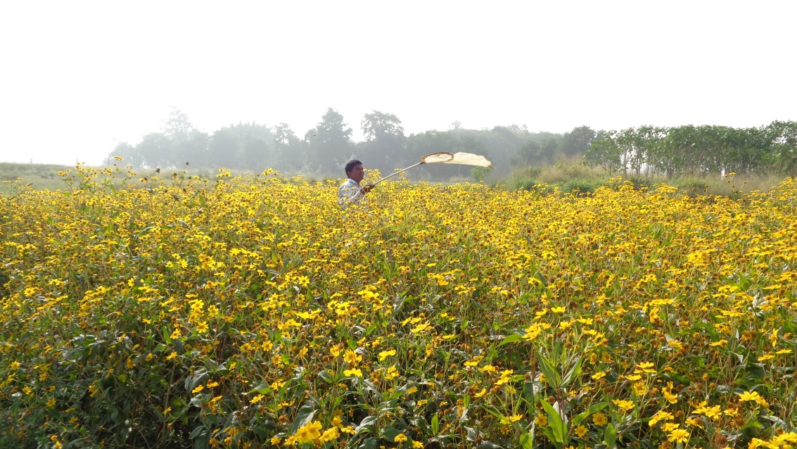

**Plate: 1. Experimental field**

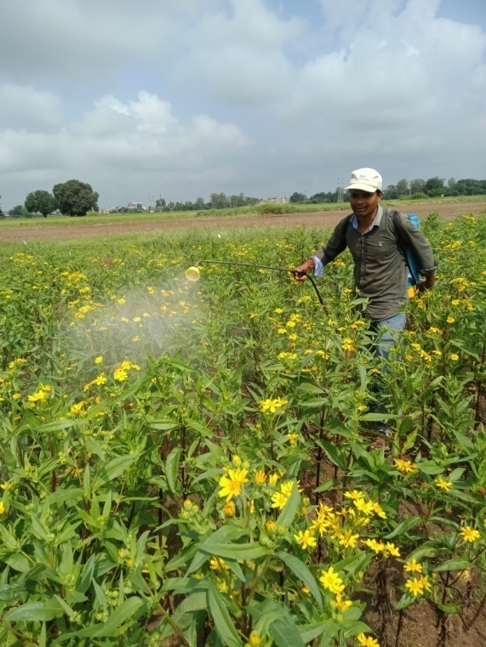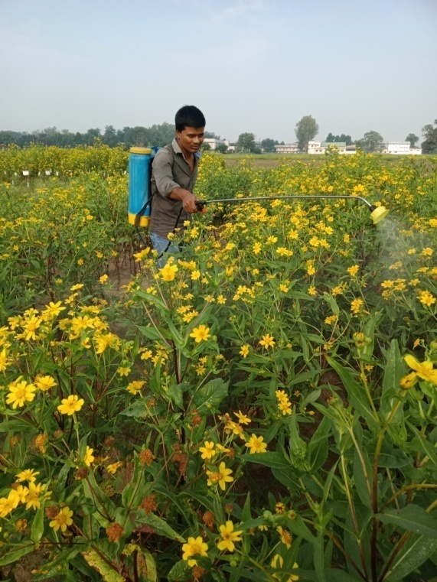

**Plate: 2. 10% flowering stage Plate: 3. 50% flowering stage**

**3.3. Seed yield (q/ha)**

The seed yield data indicated that there were significant differences occasions from each treatment in terms of higher seed yield. Accordingly, the highest seed yield was observed from the treatment in which 10% foliar spray of rose water (6.90 q/ha) was applied ,followed by a (6.70 q/ha) 10 % sugar solution and a (6.30 q/ha) flower extract of *Phoenix dactylifera* spray treatment. While the lowest seed yield, was obtained from the control (3.15 q/ha), followed by a (4.40 q/ha) treatment in which 10% jiggery solution was sprayed and a water spray treatment, which produced (4.80 q/ha). These findings corroborated with the findings of Chandrashekhar and Sattigi (Anonymous) as they have also observed that “spraying of bee attractant like cacambe (10%) and jaggary solution (10%) were significantly superior in enhancing both quantitative and qualitative parameters of radish seed”. These findings are in close conformity with the earlier reports of Dwarka *et al.,* (2022) who have reported they reported that highest seed yield (6.90 q/ha) was recorded in the case of treatment with the foliar spray of *Madhuca longifolia* 10% flower extract treatment in which foliar spray of flower extract of *Madhuca longifolia* 10%. Similarly Jayaramappa *et al.,* (2011), Dwarka *et*

*al.,* (2023 a,b,c ).

**4. Conclusion**

Based on the results presented above, it can be concluded that for attracting *Apis* *florea*, 10% rose water was the best preparations when tested at 10% and 50% flowering stage, while the second best preparation was 10% flower extract of *M. longifolia* followed by 10% fruit extract of *Phoenix dactylifera*. These preparations were capable of attracting a considerably higher number of *Apis florea* while also recording higher seed yields.

**Table 2: Effect of different attractants on the attraction of *Apis florea* and their impact of seed yield in niger crop *Kharif* 2021.**

|  |  |  |  |  |  |  |  |  |  |  |  |  |  |
| --- | --- | --- | --- | --- | --- | --- | --- | --- | --- | --- | --- | --- | --- |
| **Treatment** | **Population of *Apis florea*/m2/5minutes** | | | | | | | | | | | | **Yield**  **(q/ha)** |
| **1st spray at 10% flowering** | | | | | | **2nd spray at 50% flowering** | | | | | |
| **1DBS** | **Days after spray** | | | | **Mean** | **1DBS** | **Days after spray** | | | | **Mean** |
| **1DAS** | **3DAS** | **5DAS** | **7DAS** | **1DAS** | **3DAS** | **5DAS** | **7DAS** |
| T1-Flower extract of *M. longifolia* 10% | 5.00  (2.34) | 11.00  (3.37) | 18.00  (4.30) | 11.67  (3.48) | 10.00  (3.24) | 12.67  (3.63) | 6.33  (2.61) | 12.33  (3.56) | 18.00  (4.29) | 17.67  (4.26) | 8.67  (3.01) | 14.17  (3.83) | 6.30  (2.61) |
| T2-Juice of *S. officinarum* 10% | 3.67  (2.04) | 9.67  (3.18) | 11.00  (3.35) | 9.33  (3.11) | 7.33  (2.78) | 9.33  (3.13) | 4.33  (2.20) | 11.67  (3.48) | 12.00  (3.52) | 15.67  (4.01) | 10.33  (3.29) | 12.42  (3.59) | 5.82  (2.51) |
| T3-Jaggery solution 10% | 4.00  (2.11) | 12.33  (3.56) | 13.67  (3.74) | 7.67  (2.78) | 6.67  (2.67) | 10.08  (3.24) | 5.00  (2.34) | 13.33  (3.69) | 14.00  (3.80) | 13.33  (3.69) | 9.33  (3.13) | 12.50  (3.60) | 4.40  (2.21) |
| T4-Honey solution 10% | 2.67  (1.77) | 6.33  (2.58) | 11.67  (3.48) | 6.00  (2.40) | 5.67  (2.46) | 7.42  (2.81) | 3.33  (1.95) | 8.00  (2.90) | 11.67  (3.48) | 13.67  (3.72) | 7.67  (2.84) | 10.25  (3.28) | 5.45  (2.44) |
| T5- Fruit extract of *Phoenix dactylifera* 10% | 3.00  (1.86) | 13.67  (3.70) | 15.33  (3.95) | 10.00  (3.24) | 9.67  (3.18) | 12.17  (3.56) | 5.33  (2.40) | 10.33  (3.28) | 13.00  (3.67) | 16.67  (4.14) | 10.67  (3.33) | 12.67  (3.63) | 6.00  (2.55) |
| T6-Sugar solution 10% | 4.33  (2.18) | 10.33  (3.28) | 13.00  (3.66) | 11.00  (3.38) | 11.33  (3.41) | 11.42  (3.45) | 3.00  (1.86) | 14.67  (3.86) | 15.33  (3.98) | 18.33  (4.33) | 9.00  (3.06) | 14.33  (3.85) | 6.70  (2.68) |
| T7-Rose water 10% | 2.00  (1.56) | 14.33  (3.80) | 16.33  (4.10) | 12.33  (3.56) | 8.33  (2.96) | 12.83  (3.65) | 4.00  (2.11) | 15.00  (3.90) | 14.33  (3.82) | 16.00  (4.06) | 11.67  (3.48) | 14.25  (3.84) | 6.90  (2.72) |
| T8-Water spray | 1.67  (1.46) | 5.67  (2.46) | 6.33  (2.60) | 4.67  (2.21) | 2.33  (1.66) | 4.75  (2.28) | 2.33  (1.68) | 6.33  (2.58) | 5.33  (2.40) | 5.67  (2.43) | 6.00  (2.54) | 5.83  (2.51) | 4.80  (2.30) |
| T9-Control | 1.33  (1.34) | 3.00  (1.81) | 4.00  (2.08) | 1.67  (1.35) | 2.00  (1.56) | 2.67  (1.77) | 2.33  (1.68) | 4.33  (2.16) | 3.33  (1.93) | 3.00  (1.82) | 4.33  (2.20) | 3.75  (2.06) | 3.15  (1.92) |
| **SEm±** | 0.14 | 0.29 | 0.26 | 0.34 | 0.21 | 0.10 | 0.12 | 0.29 | 0.23 | 0.26 | 0.19 | 0.09 | 0.03 |
| **CD at 5%** | 0.43 | 0.88 | 0.78 | 1.03 | 0.63 | 0.30 | 0.35 | 0.86 | 0.70 | 0.79 | 0.58 | 0.28 | 0.09 |

*Figures in parenthesis are square root of √ x+0.5 transformed value.

**Disclaimer (Artificial intelligence)**

Option 1: NO

Author(s) hereby declare that NO generative AI technologies such as Large Language Models (ChatGPT, COPILOT, etc.) and text-to-image generators have been used during the writing or editing of this manuscript.

**5. References**

Abrol DP. Foraging behavior of *Apis florea* F. an important pollinator of *Allium cepa* L. Journal of Apicultural Research. 2010;49(4):318-325.

Anonymous. 2005. observations made during “national seminar on strategies for enhancing production and export of sesame and niger” and “annual workshop of AICRP on sesame and niger research workers, 2005”.

Anonymous. 2020-21. 4th Advance Estimate, Agriculture Statistics Division, Directorate of Economics and statistics, New Delhi. Indian Journal of Natural Products and Resources, 2:221-226.

Dwarka, Chadar N, Katara VK , Thakur S, Shukla S, Parveen S, Maneesha and Ahirwar MK. Introduction to Insect Pests of Niger [*Guizotia abyssinica* (L.f.) Cass.] and Their Management: A Review. Journal of Experimental Agriculture International. 2024a;46(11): 835-841.

Dwarka, Ghugal SG, Thakur S, Panday AK. Evaluation of Various Bee Attractants on the Foraging Behavior of Indian Honey Bee (*Apis cerana indica*) and their Impact on the Seed Yield of Niger [*Guizotia abyssinica* (*L.f.*) Cass]. Advances in Research. 2024b;25(6);528-534.

Dwarka, Panday AK , Thakur S , Katara VK , Patel DK and Kurmi JP. Impact of different bee attractants on the attraction of Indian honey bee, *Apis cerana indica* and their impact on seed yield of niger, *Guizotia abyssinica* (L.f.) Cass, crop. Plant Archives. 2024c;24(2); 255-258.

Dwarka, Panday AK , Thakur S and Katara VK. Study on the Effect of Bee Attractants on the Giant Honey Bee, *Apis dorsata* and their Effect on Niger [*Guizotia abyssinica* (L.f.) Cass] Seed Yield Journal of Experimental Agriculture International. 2024d;46(7); 903-908.

Dwarka, Panday AK and Saxena AK. To study the effect of bee attractants on the attraction of giant honey bees (*Apis dorsata*) and their impact on seed yield of Niger (*Guizotia abyssinica*) crop. The Pharma Innovation Journal. 2022;11(12): 866-868.

Dwarka, Panday AK, Saxena AK, Jain S, Marabi RS and Sahu R. Impact of different weather parameters on the population of pollinators visited on Niger flowers. The Pharma Innovation Journal. 2023a;12(7): 619-621.

Dwarka, Panday AK, Saxena AK, Jain S, Sahu R and Marabi RS. The relative abundance of insect pollinators/visitors in Niger (*Guizotia abyssinica*) crop. The Pharma Innovation Journal. 2023b;12(2): 3579-3581.

Dwarka, Panday AK, Tare S, Thakur S, Katara VK. Effect of Bee Attractants on the Attraction of *Apis dorsata* and their Impact on Seed Yield of Niger *Guizotia abyssinica* (L.f.) Cass Crop. Journal of Scientific Research and Reports. 2024e;30(6):420- 426.

Dwarka, Saxena AK, Panday AK, Jain A and Marabi RS. Succession of different insect pollinators on Niger flowers grown under different dates of sowing. The Pharma Innovation Journal. 2023c;12(7): 622-627.

Getinet A and Sharma SM. 1996. Niger, *Guizotia abyssinica (L.f.)* Cass. Promoting the conservation and use of underutilized and neglected crops. Institute of Plant Genetics and Crop Plant Research. International Plant Genetic Resources Institute, Rome.

Jayaramappa Kract V, Pattibhiramaiah M and Bhargava HR. Influence of bee attractants on yield parameters of Ridge gourd (*Luffa acutangulus* L.) (Cucurbitaceae).World Applied Science Journal. 2011;15(4);547-462.

Kalmath BS and Sattigi HN. Effect of different attractants on attracting the bees to onion (*Alium cepa*) crop. Indian Bee Journal. 2002;64(6): 68-71.

Manchare RR, Kulkarni SR and Chormale TS. Effect of bee attractants on foraging activities of Indian bees *Apis cerena indica* in bitter gourd (*Momordica charantia* L.). Journal of Entomology and Zoology Studies. 2019;7(5); 468-472.

Mohana Rao, GM, Lazar M and Suryanarayana MC. Foraging behaviour of honeybees in sesame (*Sesamum indicum* L.). Indian Bee Journal. 1981;43:97-100.

Ranganatha ARG, Tripathi A, Jyotishi A, Paroha S, Deshmukh MR and Shrivastava N. 2009. Strategies to enhance the productivity of sesame, linseed and niger. In: Proceedings of Platinum Jubilee Celebrations*,* UAS,Raichur*.*

Singh RS, Amrendra Pratap B, Singh Singh DV. Abundance and foraging activity of bee visitors to pigeonpea. Progressive Agriculture. 2015;15(1):116- 119.

Venkataramegowda S, Koragandahalli VJ, Menon A and Ruben MC. Use of Bee-attractants in Increasing Crop Productivity in Niger (*Guizotia abyssinica*. L). Braz. Arch. Biol. Technol. 2013;56(3):365-370.