**Isolation of *Staphylococcus Aureus* in Zobo Drink Sold Within Terminus Market in Jos, Plateau State, Nigeria**

**ABSTRACT**

**Introduction:** Zobo drink is a red non-alcoholic local beverage made from different varieties of dried petals of *Roselle calyx* through aqueous extraction. It is rich in protein, calcium iron and other antioxidants. The increase in Religious and health campaign against alcoholic beverages in Nigeria has made Zobo drink an alternative to imported red wine. But unfortunately, this drink is sometimes contaminated by microbes which can cause varying number of infections if left untreated.

**Materials and Methods:** This research was therefore carried out to determine the contamination rate of *Staphylococcus aureus* in Zobo drink sold within Terminus market of Jos. A total of 160 samples was collected, forty samples from each area.

**Results:** Of the 160 samples, 7 Zobo samples were positive for *Staphylococcus aureus* with overall prevalence of 4.4%. One sample was positive in Ahamadu Bello area 1(2.5%), 2(5.0%) were positive in Terminus roundabout, only 1(2.5%) sample was positive in Railway area while 3(7.5%) samples inside the market were positive. The 7 positive samples were subjected to catalase and coagulase tests and all the 7 were positive for both tests suggesting that the organisms were *Staphylococcus aureus.*

**Conclusion:** The isolation of *Stapylococcus aureus* from Zobo drink is a health concern, this therefore stresses the urgent need for public enlightenment campaigns by the appropriate authorities to educate the masses on the danger of consuming contaminated Zobo as well as the need to improve hygienic condition during production. The results obtained from this study could be used to raise awareness about the importance of food safety also provide useful information for regulatory agencies to enforce food safety standards.

**Key words:** Zobo drink, *Staphylococcus aureus*, Microbial Contamination, Jos Terminus Market, Hygienic

**Introduction**

Zobo drink also known as Sorrel or Roselle is a popular beverage that originates from West Africa, particularly Nigeria (Ayandele, 2015). It is made from the dried calyces of the Roselle plant which are boiled in water together with various other ingredients such as ginger, cloves, and sometimes mint leaves or citrus fruits. “Zobo is a name derived from “Zoborodo” which is an Hausa language for edible plant *Hibiscus Sabdariffa”* (Ayandele, 2015). “Hibiscus sabdariffa has other names such as “Gongura” in Hindi, “Krajeab” in Thailand, "Bissap" in Senegal, "Sorrel" in Carribean” (Okereke *et al.,* 2015). The resulting drink is a deep red colour that has a sweet -tart flavour with a slightly tangy aftertaste. In addition to its refreshing taste, zobo drink is also believed to have several health benefits due to the antioxidant properties of the Hibiscus plant which includes; lowering blood pressure, reducing inflammation and improving digestion (Egbere *et al.,* 2007). It is expected that consumption of Zobo drink is of more health benefits but the recent increase in food infections and poisoning around the world affected the derivatives of these benefits due to contamination with diverse group of microorganisms which could be harmful to individuals who consumed it. Ayandele reported that spices usually added being an agricultural commodity may contain high level of microbial load. Process of production and Packaging materials may also serve as a source of contamination if not well sterilized (Balakarami *et al.,* 2016).

“The consumption of contaminated Zobo drink is of public health significance as the local drink may serve as vehicle for zoonotic and food-borne diseases for possible transmission of pathogens such as *Staphylococcosis, Salmonellosis, Brucelosis, Tuberculosis, Escherichia coli* etc” (Ayandele, 2015). *Staphylococcus aureus* is a type of Gram positive cocci and aerobe that is commonly found as a nonpathogenic normal flora of the skin and in the nasal passages of healthy individuals which can contaminate ready to eat food such as Zobo drinks but when opportuned, may cause many infections (Bamishaiye *al.,* 2011). *Staphylococcus aureus* is one of the leading causes of skin and soft tissue infections such as abscesses (boils), furuncles, and cellulitis. Although most staph infections are not serious but recent reports from Nigeria have indicated that the prevalence of hospital-associated MRSA varies in health care institutions which can cause serious infections such as bloodstream infections (sepsis), pneumonia, or bone and joint infections. These bacteria can cause foodborne illness when it contaminates Zobo drinks that are normally consumed in many countries, especially in Africa it’s known for its many health benefits. “For effective treatment of infections, adequate information and data on susceptibility patterns and characterization of the causative organism are of great importance” (Okon *et al.,* 2009).

This study was carried out to determine the prevalence of *Staphylococcus aureus* in Zobo drink sold within Terminus Market in Jos, Plateau State, Nigeria. The study does not cover other food or drink products sold within the market, nor does it cover other markets or locations outside the market. It does not tend to examine other microorganism found in zobo only focused on isolation of *Staphylococcus aureus.*

**Methodology**

**Sampling:** The method used in this study was a random sampling method. Equal sample (40 each) were randomly collected from the four major areas of Terminus market; (Ahmadu Bello area of the market, Terminus roundabout, Railway area of the market and inside the market). A total of160 Samples were examined. 40 samples were collected on each day from one major area of the market into sterile labeled universal bottles in an iced cooler and immediately transferred to the College laboratory for microbiological culturing and analysis as describe by (Ayandele, 2015). This was repeated on several days until 160 samples were collected from the four different areas of the market.

**Sterilization of material**: All materials that were used in the course of this project such as glass-wares were properly washed with detergent and water to remove dirty and contaminations and dried properly. The washed glass-wares were sterilized in a portable laboratory autoclave at a temperature of 1210C for 15 minutes as described by (Bukar *et al.,* 2015). All media used were also sterilized in the autoclave at a temperature of 121oC for 15minutes (Nwachukwu and Ezejiaku 2014)

**Preparation of Blood Agar:** The blood agar was prepared according to manufactures instructions. 28g of Nutrient agar powder was dissolved in 1000 mls of distilled water and autoclaved at 121°C for 15 minutes. The media was allowed to cool to 55°C in a water bath. Sterile 5% (vol/vol) defibrinated sheep blood obtained from Abattoir was aseptically added and mixed properly. After this, the media was then dispensed aseptically into sterile petri-dishes and was allowed to set on the bench before storing in the refrigerator.

**Preparation of Chocolate Agar:** The nutrient agar base was prepared according to manufactures instructions. It was sterilized by autoclaving at 121°C for 15 minutes. 5% v/v of defibrinated sheep blood obtained from Abattoir was added and placed in a hot water bath at 80°C, and kept swirling gently until the colour changes to dark brown. It was poured into sterile Petri dishes under aseptic conditions after the media has cooled to 55°C. The plates were labelled with the name of the media, and date of preparation, and stored inverted at 8°C until use.

**Culturing and incubation of samples:** A sterile wire loop was used to pick a well-mixed zobo drink aseptically. It was used to make a pool on the agar plate and spread it over the first quadrant (approximately 1/4 of the plate) using close parallel streaks. A wire loop was flamed and allowed to cool. The plate was turned 90° and lightly sweeps the loop 1-2 times through the inoculated area; it was then streaked into the next quadrant without overlapping the previous streaks. The wire loop was flamed. The plate was Turn 90°, overlap the previous area 1-2 times, and streak into the next quadrant. The wire loop was flamed and allowed to cool. It was repeated, streaking the remaining of the plate. The plate was incubated at 37°C for 24 hr. This was done for each sample

**Morphological Examination of culture Plates:** Culture plates were examined macroscopically for colonial characteristics of the organisms. The colonies were examined macroscopically the following day. The morphological appearances of the organisms were those described by Cruick *et al.,* (2006) which include: colour, shape, size, edge, pigmentation, consistency and opacity.

**Preparation of Smear:** On a well labelled grease free slide, a drop of normal saline was placed. Using a sterile wire loop, a colony was picked and emulsified on the normal saline. It was allow to air dry.

**Procedures for Gram Staining:** Each smear was fixed with gentle heat by passing the slide three times on a Bunsen flame. The slide was placed on a staining rack and was stained with crystal violet for 60 seconds and rinsed with clean water. A mordant (Lugol's iodine) was applied to the stained slide and was left for 60 seconds and washed with clean water. It was then decolourized briefly with acetone and rinsed with clean water. It was counterstained with neutral red for 60 seconds and rinsed with clean water. It was blotted carefully with a dry cotton wool and allowed to dry on the draining rack. It was examined microscopically using oil immersion objective (×100) (Ochei *et al.,* 2008).

**Biochemical test:** Biochemical tests were used for the identifications of *Staphylococcus aureus* based on the differences in the biochemical activities of the bacteria.

**Catalase Test:** On a clean grease free slide, a drop of 3% hydrogen peroxide was placed. A sterile wire loop was used to transfer a small amount of the colony growth and emulsify on the 3% hydrogen peroxide. It was examined for bubbles.

**Coagulase Test:** On a clean grease free slide, a drop of normal saline was place**.** A sterile wire loop was use to pick a colony of the organism and emulsify on the drop of normal saline. A drop of plasma was added using a Pasteur pipette on the suspension and it was mix gently. The presence of clumps was observed within 10 seconds.

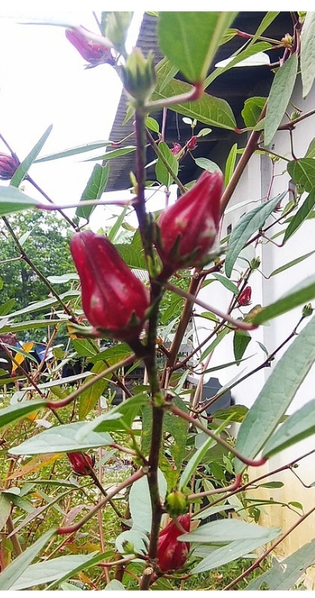 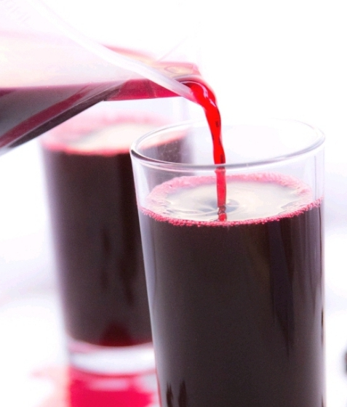 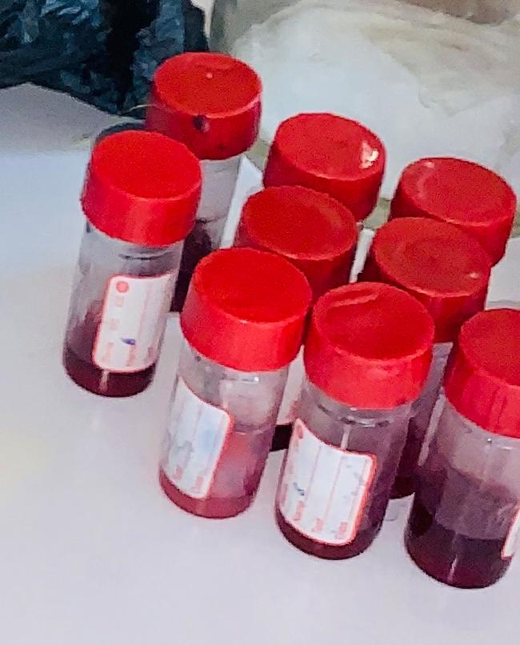

Figures 1: a. Zobo Plant b. Zobo drink c. Zobo Samples

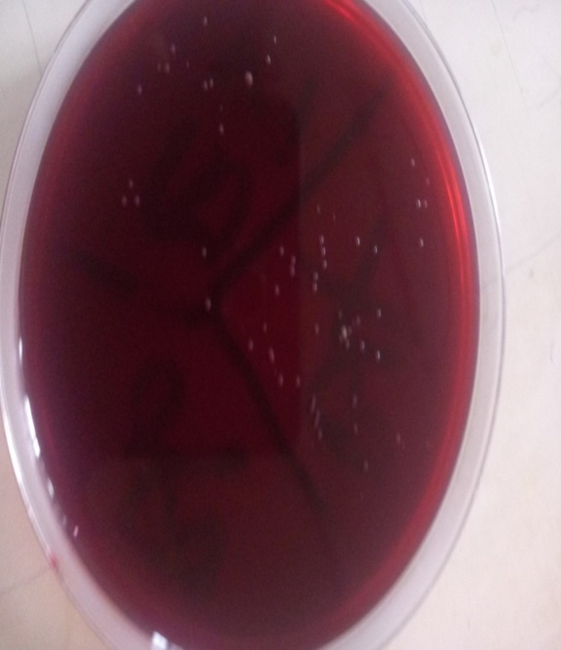 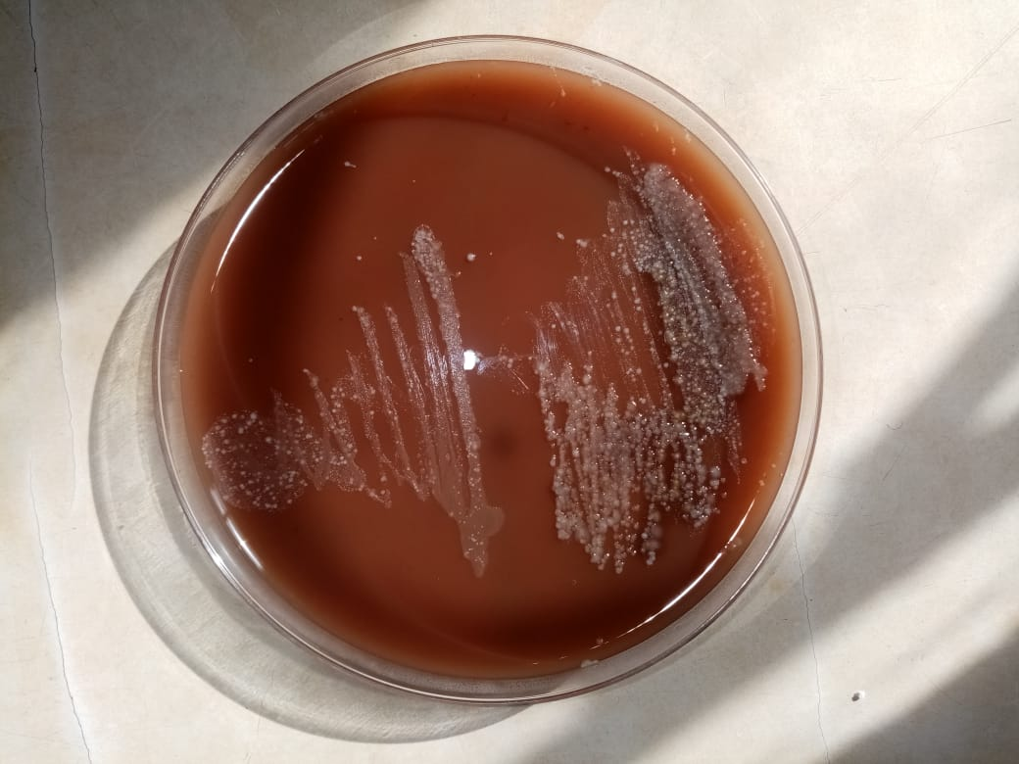

Plates 1: a. Microbial Growth on Blood Agar b. Microbial Growth on Chocolate Agar

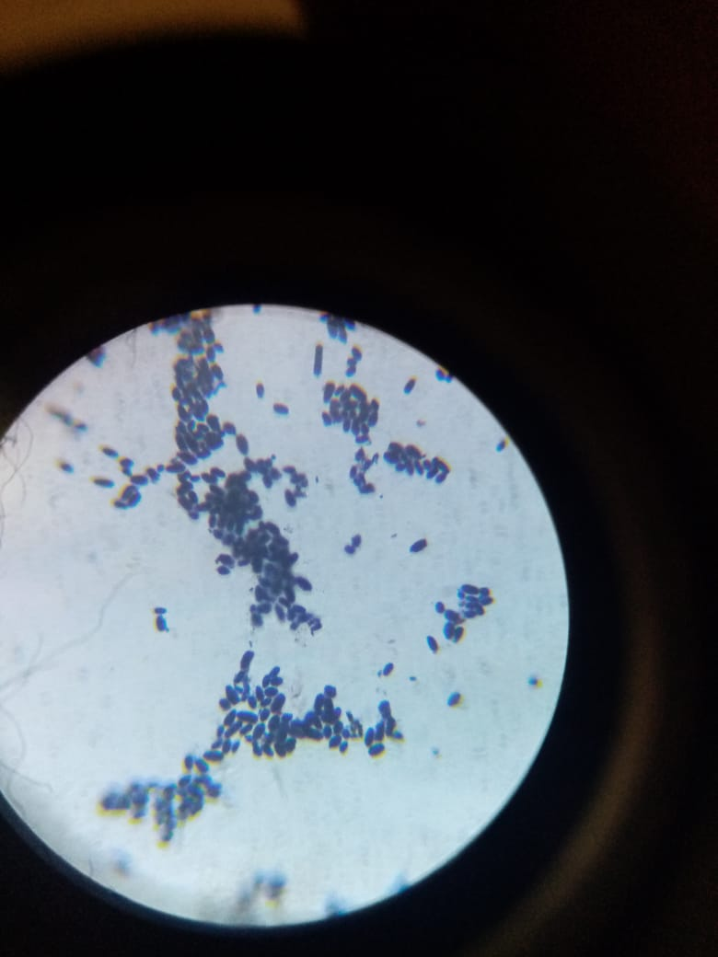

Plate 2: *Staphylococcus aureus* seen under x100 objective of the Microscope

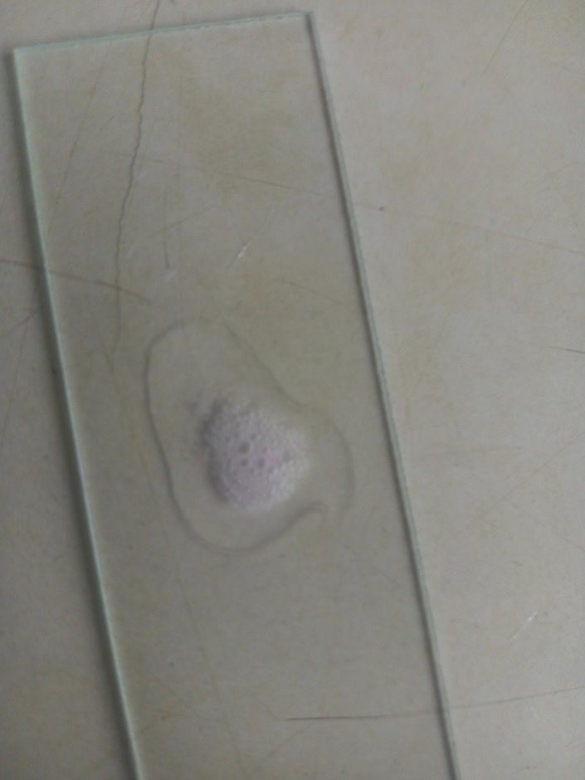

Plate 3:Positive Catalase Test observed in the research

**Data analysis:** All data obtained from this research were analyzed statistically using percentage prevalence method.

**Results**

It was observed that out of the 160 samples examined, 142 were non contaminated by bacteria (no growth) while 18 (11 gram negative and 7 gram positive organisms) were contaminated with bacteria as can be seen in Pie chart below. Table 1 shows the distribution of *Staphylococcus aureus* in respect to different areas of Terminus market. Out of the 40 samples examined in Ahamadu Bello area of Terminus, one was positive 1(2.5%) while 2 were positive in Terminus roundabout out of the 40 samples examined with prevalence of 2(5.0%). Meanwhile, only 1 sample was positive in Railway area of the market with prevalence of 1(2.5%) while 3 samples out of 40 samples examined inside the market were positive to *Staphyloccoccus aureus* with prevalence of 3(7.5%). Table 2 shows the result of the Gram stain of the colonies. 11 were Gram negative bacilli while 7 were Gram positive cocci in clusters. Table 3 shows the Biochemical tests used for identifying *Staphylococcus aureus*. Only the 7 samples that were Gram positive cocci in clusters were subjected to specific biochemical tests (Catalase and Coagulase tests respectively). The 7 organisms were both catalase and coagulase positive suggesting that the 7 organisms were *Staphylococcus aureus* because it has fuifill both the morphological and biochemical characteristics of *Staphylococcus aureus*.

Figures 2: Pie chart representing the ratio between contaminated and non-contaminated Zobo drinks samples collected within Terminus market

**Table 1: Distribution of Staphylococcus aureus in respect to different areas of Terminus Market**

|  |  |  |  |
| --- | --- | --- | --- |
| **SOURCES** | **No. Examined** | **No. Positive** | **Positive**  **%** |
| Ahamadu Bello area of Terminus | 40 | 1 | 2.5 |
| Terminus roundabout | 40 | 2 | 5.0 |
| Railway area of the market | 40 | 1 | 2.5 |
| Inside Terminus market | 40 | 3 | 7.5 |
| **Total** | **160** | **7** | **4.4** |

**Table 2: Result of the Gram stain of the Colonies**

|  |  |  |  |  |  |
| --- | --- | --- | --- | --- | --- |
| **SOURCE** | **No. Examined** | **No. Negative** | **Gram Negative** | **Gram Positive** | **Prevalence**  **(%)** |
| Ahmadu Bello area of the market  Terminus roundabout  Railway area of the market  Inside the market | 40  40  40  40 | 39  35  37  32 | 0  3  2  5 | 1  2  1  3 | 2.5  5.0  2.5  7.5 |
| **TOTAL** | **160** | **142** | **11** | **7** | **4.4** |

**Table 3: Biochemical tests used for identifying *Staphylococcus aureus***

|  |  |  |  |
| --- | --- | --- | --- |
| **Gram positive Samples** | **Catalase test** | **Coagulase test** | **Isolate** |
| 2 | + | + | *S. aureus* |
| 12 | + | + | *S. aureus* |
| 133 | + | + | *S. aureus* |
| 108 | + | + | *S. aureus* |
| 150 | + | + | *S. aureus* |
| 157 | + | + | *S. aureus* |
| 158 | + | + | *S. aureus* |

**Discussion**

This study discovered that there was a low contamination rate of *Staphylococcus aureus* in zobo sold within terminus market of Jos with a prevalence rate of (4.4%). Even with the low prevalence, the isolation of *Staphylococcus aureus* from zobo drink is not proper because the drink is meant to be free from any form of contaminant. The contamination may be due to poor hygienic practices during the preparation and storage of the drink and inadequate washing of packaging materials. It is therefore advised that proper hygienic practices by vendors and consumers should be adhered to help prevent the spread of foodborne illnesses associated with *Staphylococcus aureus* contamination of zobo drink (Musa and Hamza 2013).

The prevalence of 4.4% of *Staphylococcus* obtained from Zobo drink sold within the terminus market signifies a health threat. It was discovered that 142 out of the 160 samples examined were not contaminated, while 18 Zobo samples were contaminated showing that the rate of contamination was low. This could be as a result of area of study knowing fully well that terminus is an old and neat market, this may be a different case in other small small markets in the villages and other location. Secondly only *Staphyloccoccus aureus* was the organism of interest in this study, this doesn’t mean that the zobo drink is free from other contaminant. It is therefore suggested that other studies should go ahead and carry out general microbial contamination of zobo drinks in different markets and areas in order to get the exact contaminants of zobo drink in Nigeria.

However, the prevalence (4.4%) in this study is lower than the work of Bukar *et al.,* (2015) who found out that 80% of the samples he analyzed were contaminated with *Staphylococcus aureus*. It is also higher than that of Nwachukwu and Ezejiaku (2014) who conducted a study in Ibadan, Nigeria, where samples of zobo drink were collected from different vendors and analyzed for the presence of *Staphylococcus aureus* using standard microbiological techniques. The study found that 67% of the samples were contaminated with *Staphylococcus aureus.* This could be attributed to different geographical areas of study.

According to the different areas of the market, is was observed that out of the 40 samples examined in Ahamadu Bello area of Terminus, one was positive 1(2.5%) this could be attributed to the fact that this particular region is a street and its neater than the other areas of the market. Two samples were positive in Terminus roundabout out of the 40 samples examined with prevalence of 2(5.0%) , only 1 sample was positive in Railway area of the market with prevalence of 1(2.5%) while 2 samples out of 40 samples examined inside the market were positive to *Staphyloccoccus aureus* with prevalence of 3(7.5%).

Meanwhile, all samples indicated significant level of contamination. Their presence may be due to both pre and post contamination. Although all the samples were contaminated with varying levels of bacterial counts that can be classified as unsatisfactory. It is possible that the occurrence of these pathogens occurred during processing, which was reported as the major source of contamination of locally made drinks by Fowoyo, (2012). Necessary precautions might have been neglected and as such contamination could be inevitable as reported by Musa and Hamza (2013). *Staphylococcus aureus* was also isolated from the samples. It is a normal floral of the skin, nose, and throat Musa and Hamza (2013). The presence of *Staphylococcus aureus* could cause diseases like fever, food poisoning and food intoxication.

Also, their percentage occurrences from the different areas were also observed. This study reviled facts about possible exposure of consumers of commercial Zobo to health hazard. So, a good hygienic practice during its processing is recommended to eliminate contaminants. The use of modern technology for its processing would also reduce this health risk.

The isolation *staphylococcus aureus* from Zobos sold within Terminus market Jos should not be surprised since the market is congested and the zobo are touched and selected by different costumers and as a result of this, the bacteria can easily be distributed on on the bottles and can also the drink. Though the packaged, a single contaminated bottle if handled anyhow can lead to the contamination of others according to (Chambers *et al.,* 2001).

Isolating *Staphylococcus aureus* from Zobo drnks could be attributed to the fact that the producers of the drink are not hygienic. This organisms might have entered via the skin as a result of not wearing hand glove during preparation since *staphylococcus aureus* are found on the skin of a healthy individual where it is not pathogenic but when someone drink this contaminated zobo, these bacteria will then enter places where they are not used to and as a result, becomes pathogenic thereby causing many diseases. Also the bottles used for bottling the drinks are not properly sterilized, most of the customers confirmed that they only washed it well with detergent and rinse. Infract, with this method not all organisms would be destroyed as some can hide under the covers of the bottle. It is therefore advised that preventive measures such as improved personal hygiene and sterilization of the bottles should be paramount.

**Conclusion**

*Staphyloccoccus aureus* was isolated from zobo drink sold within Terminus market in Jos Plateau State. Though with a low prevalence of 4.4%, the presence of *Staphyloccoccus aureus* is an indicator of public health risk. It is therefore advised that the producers should practice a good hygiene during its preparation in order to eliminate contaminants. The use of modern technology for its processing would also reduce some health risk. The general public should be made aware of the possible risk factors associated with drinking unhygienic prepared zobo and the health implications.

**Limitations of the study**

Only *Stapylococcus aureus* was the organism of interest in this study due to logistics and time frame.

**Ethical Approval and Consent:**

This study was approved by the research committee of the Department of medical microbiology Federal College of Medical Laboratory Science and Technology Jos. Written informed consents were also signed by all participants before enrolment in the study. A verbal consent was obtained from the vendors before collecting their samples.

**Disclaimer (Artificial intelligence):**

Authors hereby declare that NO generative AI technologies such as Large Language Models (ChatGPT, COPILOT, etc.) and text-to-image generators have been used during the writing or editing of this manuscript.

**References**

Ahmad, D., Gambo, A. and Clement, T. D. (2022). Quality evaluation of some local beverages (zobo drink, kunun zaki, kunun aya and tamarind juice) sold in sabon gari market kano state. *Journal of Advanced Science and Optimization Research* 23(9): 297 - 310.

Ayandele, A. A. (2015). Microbiological analysis of hawked kanun and Zobo drink within LAUTECH campus, Ogbomoso, Oyo state Nigeria. IOSR Journal of Environmental Science, Toxicology, and Food Technology, *9*(10), 52-56.

Balakarami, A. U., Umarazulum, & Mustafa, A. I. (2016). Microbiological analysis of drinking water in Maiduguri Metropolis, Nigeria. *International Journal of Research,* (8).

Bamishaiye, E. I., Olayemi, F. F., & Bamishaiye, O. M. (2011). Effect of boiling time on mineral and vitamin C content of three varieties of Hibiscus sabdariffa drink in Nigeria. *World Journal of Agricultural Science,* 7(10), 62-67.

Bello, O. O., Bello, T. K., Fashola, M. O., & Oluwadan, A. (2014). Microbiological quality of some locally produced fruit juice in Ogun state, South West Nigeria. *Journal of Microbiology Research, 2*(1), 001-008.

Bukar, A. M., Isa Y. M., Garba, Muhammad A. A,. Suleiman M. M,. (2015). Bacteriological quality assessment of some snacks sold in fast food shops within Maiduguri Metropolitan council. *Applied Research Journal* 1(10), 501-505.

Fowoyo, P. T., (2012). Microbiological quality Assessment of Air contamination of Ended Food sold in the main market in Lokoja, Kogi state, Nigeria. *Research Journal of Biological 7*(9-12), 355-360.

Hamza, A., Musa A. A. (2013). Comparative Analysis of locally prepared Kunun Aya Tiger nut milk consumed by student in Kaduna slate university Kaduna Nigeria. *Science World Journal 8*(2).

Idowu-Adebayo, F., Toohey, M. J., Fogliano, V. & Linnemann, A. R (2021). Enriching street vended zobo (Hibiscus sabdariffa) drink with turmeric (Curcuma longa) to increase its health-supporting properties. *Food & Function,* 12**,** 761-770.

Kehinde, S. & Augustine, I. (2022). Fortification of ‘Zobo’ (Hibiscus sabdariffa) Drink with Pineapple and Watermelon enhances its Nutritional Qualities and Phytochemical Compositions. *Acta Scientific Nutritional Health,* 6**,** 03-12.

Keshinro, O. M., Ogbe, A. A., Oreshile, K. Y. & Omolokun, K. T. (2023). The Effects of Foliar Application Of Some Selected Phytohormones On The Proximate, Phytochemical, And Mineral Compositions Of Roselle (*Hibiscus Sabdariffa L*.) Leaves. *Fudma Journal OfSciences,* 7**,** 249-256.

Kolo, S., Dadi-Mamud, N., Aliyu-Paiko, M. & Jubril, B. (2022). Shea (Vitellaria paradoxa) Pulp Juice Production and Quality Evaluation via Proximate and Mineral Composition Analyses. *Journal of Applied Sciences and Environmental Management,* 26**,** 1727-1731.

Lami Sadiq, (2012). Nigeria: Jos Main Market - A Forgotten Legacy. *Daily Trust, All Africa*. *4*(3), 37-40.

Nwachukwu E., Ezejiaku F. C., (2014). Microbial and physic chemical characteristics of locally produce pineapple juice treated with ginger and garlic. *International journal of current microbiology and applied sciences. 3*(4), 895-901.

Okereke, C. N., Iroka, F. C., Chukuruma, M. O., (2015). Phytochemical analysis and Medicinal uses of Hibiscus sabdariffa. *International Journal of Herbal Medicine 2*(6), 16-19.

Rugayya, H. M., Clement A. Y., Musa B. B., Jamilu A. Z., Adedayo M. R., (2016). Assessment of bacteria associated with ready to eat sold at Federal university Dutse, Jigawa state Nigeria. *International journal of current research in biosciences and plant biology 3*(4), 5-14.

Sebastia N, E. l., Shenawy M. Manes J. Soriano J. M. (2012). Assessment of microbial quality of commercial and house made tiger-nut beverages. *Letters in Applied Microbiology 5*(54), 299-305.

Sylvester C. I., Langlcy A. O., Lovet T. K. (2015). A review of the quality assessment of Zobo drink consumed in Nigeria. *ASIO journal of Microbiology Food Science and Biotechnological Innovation 1*(1), 34-43.

Willey, Sherwood and Wollveston. (2011). Dairy Microbiology*: The Microbiology of staphylococcus*. *8,* 341-400.

Chambers, E. C., Monago E. A., Edit, (2001). Evaluation of nutritional and microbiological quality of Nunu in River State. *Nigeria international Journal nutrition. 8,* 68-69**.**

Chidi F., Ezcama, Caroline II, (2006). Microbiological and Sensory evaluation of Fermented rice snack (masa) supplemented with soybeans. *Journal of Food technology 4*(4):354 349.

Cruick Shank, Boyle-veura S., and Daum R. S. (2006). Community Acquired Methicillin Resistant *Staphylococcus aureus.* *The role of parto-voln tireleakocidin-laboratory invents*. *2,* 76-79**.**

Egbere, O. J., Anuonye J. C., Challom P. F., Kpara P. V. (2007). Effect of some preservation Techniques on the quality and storage stability of Zobo drink A Nigerian nonalcoholic beverage from Hibiscus Sabdariffa. *Journal of Food Technology 5*(3):225-228.

Enright, M.C., D. A., Robinson G., Randle E. J., Feil and H. Grundmann. (2002). The evolutionary history of Methicillin-Resistant *Staphylococcus aureus* (MRSA). *Proc. National Academic Science., U.S.A.*  *28,* 7687-7692**.**

Jarraud, Flock and Peilindberg, (2003). A fibrinogen binding protein of *Staphylococcus. epidermis infection and immunity*. *66*, 2606-2673

Kleven, R. N., J. R., Edwards, F. C., Tenover, L. C., McDonald and T. Huran. (2007). Changes in the epidemiology of methicillin-resistant *Staphylococcus aurues* in intensive care unit in US hospitals. *Clinical Infectious Dis*eases. 42: 389-391.

Lowney, I. E., and Melnick, J. L. (2000). The Changing of Epidemiology of Staphylococcus *aureus. Emerging infectious disease.* ***7***, 178-182.

Ochei, (2008).*Medical Laboratory Science Theory and Practice*. Pg 6.

Ochei. (2000). Enterabacteriacease in Sheri's Medical Microbiology: *An Introduction to Infectious Diseases. 3rd Edition of Appleton and large*. P 2606-2673

Okon, K.O., P. Basset, A. Uba, J. Lin and B. Oyawoye. (2009). Co-occurrence of predominant panton valentine leukocidin-positive Sequence Type (ST) 152 and multidrug-resistant ST241 Staphylococcus aureus clones in Nigerian hospitals. *Journal of Clinical Microbiology.* *47,* 3000-3003.

Roseline, E. U., Regina E. O., Ayodeji K. R. (2006). Microbiological and nutritional quality of diary product nono and wara. *Microbiology nature and science 4*(3): 37-40.

Uzomoh R. E., Ohenhen R. E. and Rojughokan A. K. (2006). Microbiological and Nutritional Qualities of Dietary Product National science.  *4*(3), 37-40.