Effect of Fertilizers on Nitrogen Fixing Bacteria from Root Nodules of Pea Plant

# ABSTRACT

**Background:** Nitrogen-fixing bacteria such as *Rhizobium* spp. are vital for enhancing soil fertility and promoting plant growth. These bacteria inhabit the root nodules of legumes like pea (*Pisum sativum*) and contribute to sustainable agricultural practices. However, the application of fertilizers may interfere with their beneficial effects.

**Objectives:** This study investigates the effects of organic and inorganic fertilizers on nitrogen-fixing *Rhizobium* spp. isolated from pea plant root nodules and evaluates their role in promoting plant growth through indole acetic acid (IAA) production**.**

**Methods:** Bacteria were isolated from root nodules of pea plants and identified based on colony morphology and biochemical tests. Their sensitivity to NaCl, pH, tetracycline, and chloramphenicol was assessed. Pea plants inoculated with *Rhizobium* were monitored for stem length over a period of 4–7 days under various fertilizer treatments. The production of IAA by the bacterial isolates was quantified.

**Results:** The isolated *Rhizobium* spp. exhibited small, translucent, mucoid colonies and were sensitive to NaCl, pH variations, tetracycline, and chloramphenicol. Inoculated pea plants demonstrated increased stem length compared to non-inoculated controls; however, the use of fertilizers reduced this growth-promoting effect. The isolates produced 4.10 g/mL of IAA, highlighting their potential role in plant growth enhancement**.**

**Conclusion:** Nitrogen-fixing *Rhizobium* spp. significantly promotes plant growth through IAA production. However, the application of organic and inorganic fertilizers may inhibit these effects, suggesting that careful management of fertilizers is necessary for optimizing the benefits of biofertilizers in sustainable agriculture.

**Keywords:** *Pisum sativum*, Root nodules*,* Nitrogen-fixing bacteria, Fertilizer

1

# INTRODUCTION

Plants are multicellular organisms belonging to the kingdom Plantae. They typically have roots for anchorage, stems for support, leaves for photosynthesis and reproductive structures for producing seeds or spores (Endress, 2010). They play a crucial role in ecosystems, as they are the primary producers (Smith and Brown, 2018) providing food and oxygen (Falkowski, 2022), habitat for animals, stabilize soil by Nitrogen fixation, regulate the water cycle, improve air quality and contribute to biodiversity. Humans have cultivated and utilized plants for various purposes throughout history, including food, medicine, clothing, shelter, and decoration (Fabricant & Farnsworth, 2001). Agriculture is the practice of cultivating plants for food, fiber, and other products, and it has been crucial for human civilization's development (Basra & Malik, 2019). They play a vital role in maintaining the balance and health of ecosystem as well as supporting life on earth. There is a large variety of plants, one among them is Pea plant (Oldroyd & Dixon, 2014).

Pea plant, scientifically known as *Pisum sativum (P. sativum),* are legumes belonging to the family Fabaceae (Weeden, 2007). They have diverse applications across agriculture, nutrition, and sustainable development (Franklin, 2010). As a valuable crop, peas are cultivated for

their edible seeds, which are rich in protein, fiber, vitamins, and minerals (Souza, 2015). They are consumed fresh, dried, or processed into various food products, including soups, snacks, and flours (Dalgaard and Borgesen, 2012). Additionally, pea serve as essential ingredients in animal feed, contributing to the nutritional requirements of livestock (Spa, 2015). Furthermore, they have a unique ability to engage in a symbiotic relationship with nitrogen fixing bacteria called *Rhizobia*. This process occurs within specialized structures called root nodules. *Rhizobia* bacteria colonize the roots of pea plants and form nodules, where they convert atmospheric nitrogen (N2) into a form that can be utilized by the plant, primarily ammonia (NH3) through the process of Nitrogen fixation (Udvardi and Poole, 2013). In return, the pea plant provides rhizobia with sugars and metabolism. This symbiotic relationship allows pea plants to thrive in N2 deficient soils and reduces the need for nitrogen fertilizers in agriculture. By harnessing the natural nitrogen fixing ability of pea plants, farmers can improve soil fertility, enhance crop yields, promote sustainable farming practices (Dahl *et al*.,2022).

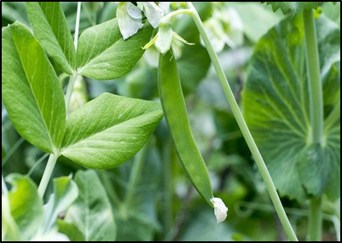

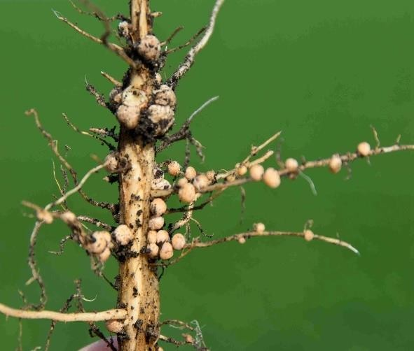

**Fig. 1. Root nodules Fig. 2. Pea plant**

N2 is crucial for plant growth development due to its essential role in various biological processes (Vessey, 2003). N2 can be obtained by plants through the decomposition of organic matter, atmospheric deposition, and symbiotic relationship with nitrogen fixing bacteria (Gyaneshwar *et al*., 2001). One example of nitrogen fixing bacteria is *Rhizobium* bacteria which convert atmospheric N2 into NH3, where the plant can use for growth (Wang *et al*.,2012). Another example is Azotobacter, a free-living soil bacterium that fixes N2 independently to soil fertility and plant growth (Das *et al.,*2023). These bacteria can also reduce the damage caused by soil borne plant pathogens and has been used as a potential nitrogenous fertilizer to increase crop yield (Brady & Weil, 2008).

Fertilizer is a substance applied to soil or plants to supply essential nutrients that promote growth (Khan, 2011). These nutrients typically include N2, phosphorus (P), and potassium (K), often

Biological fertilizers, also known as biofertilizers, are natural or organic substances containing living microorganisms like bacteria, fungi, or other beneficial microbes. These microorganisms establish symbiotic relationships with plants, promoting nutrient availability, enhancing soil fertility, and supporting plant growth. One example of a biological fertilizer is *Rhizobium* inoculant, which contains nitrogen-fixing bacteria that establish symbiotic relationships with the roots of leguminous plants like peas (Vessey, 2003). In the context of nitrogen fixation in pea plants, biological fertilizers play a pivotal role. *Rhizobium* bacteria colonize the root nodules of pea plants and initiate a symbiotic relationship. Within these nodules, *Rhizobium* bacteria convert atmospheric N2 into NH3 through a process called nitrogen fixation (Shu, 2022). This NH3 is then assimilated by the pea plant and utilized for growth and development. The influence of biological fertilizers on nitrogen fixation in pea plants is profound. By hosting nitrogen-fixing bacteria in their root nodules, pea plants gain access to a sustainable source of N2, significantly reducing their dependence on synthetic nitrogen fertilizers (Graham and Vance, 2003). This not only enhances soil fertility but also minimizes environmental pollution associated with nitrogen fertilizer runoff and leaching. Moreover, the symbiotic relationship between *Rhizobium* bacteria and pea plants benefits both parties. The bacteria receive carbohydrates and

referred to as NPK fertilizers. They also contain micronutrients like zinc (Zn), iron (Fe), and magnesium (Mg), depending on the specific needs of the soil or plant (Brady and Weil, 2008). The influence of fertilizers on nitrogen-fixing bacteria is significant. Nitrogen-fixing bacteria are microorganisms that play a crucial role in the nitrogen fixation, and are vital for maintaining soil fertility and supporting plant growth (Bhattacharyya *et al*., 2012). However, excessive or improper use of fertilizers can have both positive and negative effects on nitrogen-fixing bacteria. Positive effects include increased nitrogen availability, enhanced plant growth, and support for legumes. Negative effects may include nitrogen overload, decreased biodiversity, and soil acidification. These impacts highlight the importance of responsible fertilizer management practices to maintain a healthy balance of nutrients in the soil and support the activity of nitrogen-fixing bacteria. There are mainly two categories of fertilizers, they are biological and chemical fertilizers.

Other nutrients from the pea plant, while the plant gain access to a direct and efficient source of nitrogen fixation. This mutualistic interaction enhances the growth, vigor, and productivity of pea plants, ultimately leading to increased yields and improved agricultural sustainability (Giller, 2009). On the other hand, chemical fertilizers are synthetic or inorganic substances formulated to provide specific concentrations of essential nutrients, such as N2, P, and K, as well as micronutrients like calcium (Ca), Mg, and sulfur (S), to support plant growth. They are commonly used in agriculture to provide plants with immediate and targeted nutrient supplementation (Taiz and Zeiger, 2010). One example of a chemical fertilizer is urea, which is a widely used nitrogen fertilizer in agriculture (Savci, 2012 and Hadi, 2009). They can influence nitrogen fixation in pea plants by supplying readily available N2. N2 is a crucial nutrient for plant growth, and adequate N2 availability is essential for nitrogen fixation processes (Nadeem *et al*., 2019). While chemical fertilizers can provide pea plants with immediate access to N2, excessive or imbalanced application of chemical fertilizers can lead to negative consequences.

Nitrogen-fixing plants possess a remarkable ability to develop resistance against both chemical and biological fertilizers, including antibiotics. This resistance stems from various mechanisms, such as alterations in the plant's

genetic makeup or metabolic pathways, which render them less susceptible to the effects of these fertilizers (Dellagi and Brisset, 2011). Additionally, the symbiotic relationship between nitrogen-fixing plants and nitrogen-fixing bacteria provides a natural buffer against external interventions, allowing the plants to thrive even in the presence of fertilizers that would typically inhibit their growth (Fuentes and Caballero, 2005). While specific studies on antibiotic resistance in nitrogen-fixing plants are limited, research in related fields, such as plant-microbe interactions and antibiotic resistance in bacteria, provides insights into potential mechanisms underlying this resistance. Understanding these mechanisms is crucial for sustainable agriculture practices, as it can inform strategies to mitigate the spread of antibiotic resistance while maintaining the efficacy of nitrogen-fixing plants as crucial components of agricultural ecosystems (Schloter and Hartmann, 1998). The study included a thorough examination of the impact of fertilizer on nitrogen-fixing bacteria.

# MATERIALS AND METHODS

## SAMPLE COLLECTION

The fresh and plump root nodules of Pea plant (*P. sativum*) were collected from the local area of Thiruvalla.

## ISOLATION OF ORGANISM FROM THE ROOT NODULES

The collected root nodules were washed under running tap water to remove the adhesive soil particles. Then, 95 percentage (%) ethanol was used for surface sterilization, respectively and washed thoroughly with distilled water and repeated for 7 times. Transfer a few nodules into a sterile mortar and pestle. Gently grind the nodules to release the bacteria and the serial dilution from 10-1, 10-2, 10-3, 10-4, 10-5 and 10-6. Transfer 0.1 milliliter (ml) from each dilution to sterile nutrient agar. The sample was evenly spread on the media using a sterile L-rod. Incubate the plates at 37 Degree Celsius (°C) for

24 hours (hrs). Well isolated typical single colonies were streaked onto freshly prepared nutrient agar plates in order to obtain pure culture.

## IDENTIFICATION

* + 1. **GRAM STAINING**

Firstly, a bacterial smear is prepared on a glass slide from a culture grown on agar. The smear was then heat-fixed by passing the slide through a flame to adhere the bacteria to the slide and prevent them from washing away during staining. Next, the slide is flooded with crystal violet, a primary stain, which allowed to stand for about one minute (min). Excess stain is then gently rinsed off with water. The slide was then flooded with Gram’s iodine solution, which serves as a mordant, helping to fix the crystal violet to the bacterial cell wall. After about one min, the Gram’s iodine solution was washed off with water. The slide is then decolorized with Decolorizer. Finally, the slide was counterstained with safranin, a reddish-pink dye, for about 30 sec. The slide was then washed with water, air-dried, examined under 40X and oil immersion objectives and record observation.

## MOTILITY TEST

After incubating the peptone broth culture overnight and visually confirming the presence of bacterial growth through turbidity, a hanging drop chamber was prepared on a clean cavity slide. Vaseline was applied around the edges of a cover slip, and a loopful of turbid broth culture was meticulously transferred to the center of the cover slip. Gently inverting the cover slip, it was carefully positioned onto the cavity slide, effectively sealing the bacterial culture within a hanging drop chamber. Under the microscope, initially observed at 10x magnification, the edge of the hanging drop revealed the presence of bacterial cells. Subsequently increasing the magnification to 40x allowed for a closer examination of bacterial motility.

## BIOCHEMICAL TEST

* + 1. **Indole test**

Tryptophan broth was prepared and sterilized. After sterilization, the tubes were inoculated with the organism. The test tube was incubated at 37°C for 24 hrs. After incubation, 10 drops of Kovac’s reagent were added to the test tube. A red color ring at the top of the medium indicates positive result, while the absence of ring indicates negative result.

* + 1. **Methyl-red test**

MR-VP broth was prepared and poured into test tubes. The media was sterilized. The organism was inoculated. The broth culture was incubated at 37°C overnight. Five drops of methyl red

indicator were added directly to the medium at the end of incubation. The medium turned red, indicates positive result, while no red color indicates negative result.

* + 1. **Voges-Proskauer test**

MR-VP broth was prepared and poured into test tube. The media was sterilized. The organism was inoculated. The broth culture was incubated at 37°C overnight. Added 0.5ml of solution A, followed by 0.2ml of solution B at the end of incubation. The tube was gently shaken to expose the medium to atmospheric O2 and allowed to stand for 10-15 mins. A pinkish-red color in the medium indicates positive result.

* + 1. **Citrate utilization test**

Using sterile techniques, the organism was inoculated into Simmons citrate agar slant and the tube was incubated for 24 hrs. After incubation, the slant was examined for growth, where a color change from green to Prussian blue indicates positive result, while no color change indicates negative result.

## CONFIRMATORY TEST

Prepared Congo red yeast extract mannitol agar (CRYEMA) by mixing YEMA with Congo red dye. Autoclaved the medium to sterilize it and then poured onto sterile petri plates. Aseptically a loopful of the culture taken and streaked onto the CRYEMA plate. Incubated the inoculated plates at 37°C for 5 days.

* + 1. **NaCl VARIATION ASSAY**

To analyze the effect of NaCl variation on the growth of *rhizobium*, CRYEMA agar media plates were prepared and inoculation was done with NaCl variation i.e. 0.5%, 2%, and 4%. After inoculation, incubation was done and growth was determined after 48 hrs.

## PH VARIATION ASSAY

To analyze the effect of pH variation on the growth of *rhizobium*, CRYEMA broth was prepared with pH 2, 5, 7 and 9. After inoculation, incubation was done and growth was determined after 48 hrs.

## ANTIBIOTIC RESISTANCE TEST

To begin, a pure bacterial culture was used to prepare an inoculum by picking 3-5 well-isolated colonies and suspending them in broth. After

incubation, a sterile cotton swab was then dipped into this suspension, and the entire surface of a nutrient agar plate was uniformly inoculated in three directions to ensure even coverage. After allowing the plate to dry for 3-5 mins, tetracycline, chloramphenicol discs and a negative control (DW) are placed on the surface using sterile forceps, ensuring sufficient spacing between discs. The plate has kept inverted and incubated at 35-37°C for 18hrs. Post-incubation, the diameter of zone of inhibition was measured.

## THE IMPACT OF NITROGEN-FIXING BACTERIA FOR THE GROWTH OF PLANTS

An experiment was conducted to assess the impact of nitrogen-fixing bacterial inoculation on the growth of pea plants. Pea seeds were inoculated for 30 mins in a peptone broth culture that had been incubated overnight, confirming bacterial growth through visual turbidity. Another set of pea seeds was planted without bacterial inoculation to serve as control group. Both sets of seed were then planted under identical soil and environmental conditions. After 4 days, the plants were observed by measuring the stem length to determine the effect of bacterial inoculation.

## THE EFFECT OF ORGANIC FERTILIZER IN PLANTS HAVING NITROGEN FIXING BACTERIA

To investigate the influence of fertilizers on nitrogen-fixing bacteria isolated from the root nodules of pea plants, a peptone broth culture was incubated overnight, and bacterial growth was confirmed through visual turbidity. Then, two sets of pea seeds were inoculated in this broth culture for 30 mins. These inoculated seeds were subsequently planted under two distinct conditions: one set with organic fertilizer and the other without any fertilizer, serving as the control. After 4 days, the stem length of the plants was measured to assess the impact of different fertilizers on plant growth.

## THE EFFECT OF INORGANIC FERTILIZER IN PLANTS HAVING NITROGEN FIXING BACTERIA

To investigate the influence of fertilizers on nitrogen-fixing bacteria isolated from the root nodules of pea plants, a peptone broth culture was incubated overnight, and bacterial growth was confirmed through visual turbidity. Then, two sets of pea seeds were inoculated in this broth

culture for 30 mins. These inoculated seeds were subsequently planted under two distinct conditions: one set with inorganic fertilizer and the other without any fertilizer, serving as the control. After 4 days, the stem length of the plants was measured to assess the impact of the different fertilizers on plant growth.

## ESTIMATION OF INDOLE ACETIC ACID (IAA) PRODUCTION BY ISOLATED NITROGEN-FIXING BACTERIA

To estimate the quantity of IAA produced by isolated nitrogen-fixing bacteria, the bacteria were first inoculated into nutrient broth. After incubation, the culture was centrifuged at 10,000 rpm for 15 mins to remove the bacterial cells, and the supernatant was collected. 1ml of this supernatant were then mixed with 1ml of Salkowski reagent and incubated at room temperature in the dark for 30 mins and measured at 530 nm using a spectrophotometer.

# RESULTS AND DISCUSSION

## SAMPLE COLLECTION

The root nodules were collected from pea plants and grounded using a mortar and pestle for further tests.

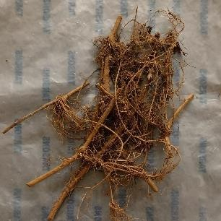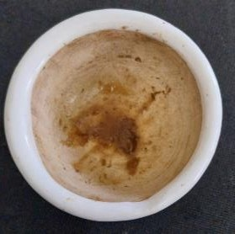

**B**

**A**

**Fig.3. A) Crushed root nodules B) Root nodules**

## ISOLATION OF ORGANISMS FROM ROOT NODULES

Isolating organisms from root nodules involves a methodical procedure to ensure the purity and viability of the obtained bacterial cultures. In order to obtain pure culture, well isolated typical single colonies were streaked onto freshly prepared nutrient agar plates. Pure cultures are essential for accurate characterization and further experimental studies.

**Fig. 4. Organisms segregated from root nodules. (A) Cream colored colonies, (B) White colored colonies and (C) Translucent mucoid colonies**

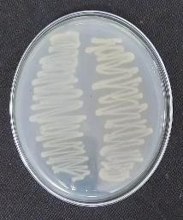

**A**

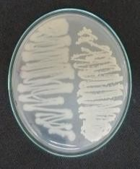

**B**

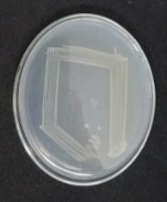

**C**

## IDENTIFICATION TESTS FOR THE ISOLATED ORGANISMS

* + 1. **GRAM STAINING**

Gram staining of isolated colonies performed and identified purple colored rod shaped gram positive (A), purple colored cocci shaped gram positive bacteria (B) pink colored rod shaped gram negative (C) under 40X objective.

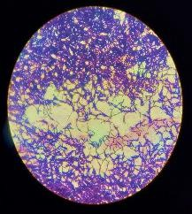

**A**

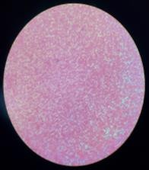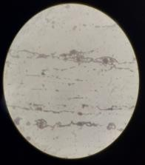

**C**

**B**

**Fig. 5. Gram staining results (A) rod-shaped gram-positive bacteria, (B) cocci-shaped gram- positive bacteria and (C) rod-shaped gram-negative bacteria.**

## MOTILITY TEST

The motility test results confimed the presence of motile gram negative rod shaped bacteria.

This suggests the presence of nitrogen-fixing bacteria such as *rhizobium* and Azotobacter spp.

## BIOCHEMICAL TESTS

* + 1. **Indole test**

The presence of yellow ring on the top of the media after adding Kovac’s reagent indicated negative result.

* + 1. **Methyl-red test**

The presence of yellow color in the MR-VP broth after adding methyl red indicator indicated negative result.

* + 1. **Voges-Proskauer test**

The presence of yellow color in the MR-VP broth after adding Barritt’s solution A and B indicated negative result.

* + 1. **Citrate utilization test**

After incubation, no color change was observed in the medium, indicated negative result.

**v**

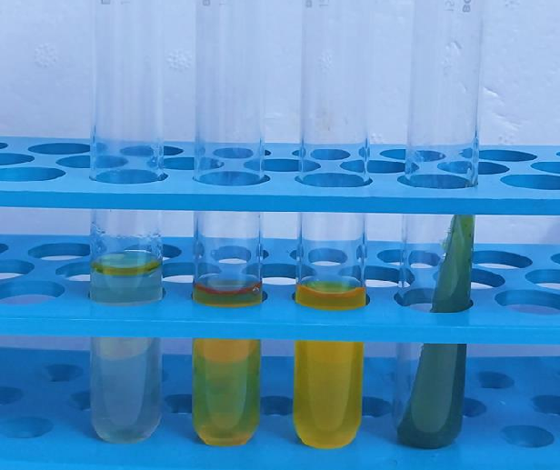

**A B C D**

**Fig.6. Biochemical characterization of isolates (A) Indole (-), (B) Methyl Red (-), (C) Voges-Proskauer (-) and (D) Citrate utilization test (-).**

## CONFIRMATORY TEST

The organism demonstrated a slow utilization of Congo red dye, forming small, creamy white, circular, smooth and raised colonies. This growth pattern was consistent with the presence of *Rhizobium* spp.

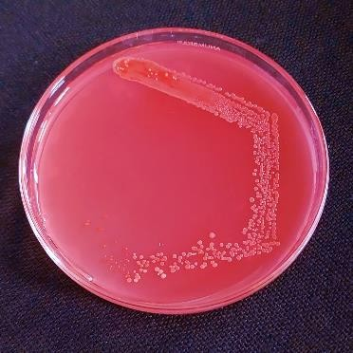

**Fig. 7. *Rhizobium* colonies on CRYEMA media**

* + 1. **NaCl VARIATION ASSAY**

The isolated *rhizobium* was able to grow on 0.5% NaCl containing medium but it was unable to grow on higher concentrations like 2% and 4%.

|  |  |  |  |  |  |
| --- | --- | --- | --- | --- | --- |
| **A** |  | **B** |  | **C** |  |
|  | |  | |  | |

**Fig. 8. Growth of isolated *Rhizobium* in media with different NaCl concentrations (A) 0.5%, (B) 2% and (C) 4%**

* + 1. **pH VARIATION ASSAY**

Superior growth of *rhizobium* has been reported at neutral pH. Results showed that cells were able to grow only at pH 7. No growth was observed in medium with pH 2, 5 and 9.

the observation period from 4 to 7 days, excluding the initial days to reduce transplant shock and soil adjustment variability.

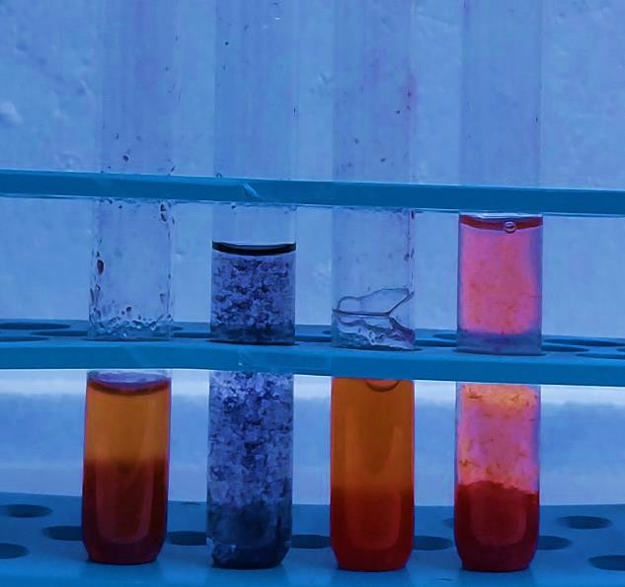

**A B C D**

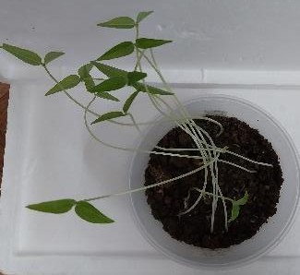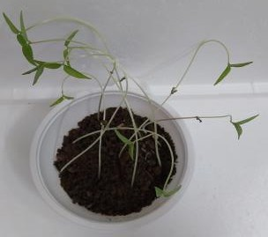

**B**

**A**

**Fig. 9. Effect of varying pH (A) 5 (B) 2 (C) 7**

**and (D) 9**

## ANTIBIOTIC RESISTANCE OF ISOLATED ORGANISM

*Rhizobium* isolates showed sensitivity against tetracycline and chloramphenicol antibiotics. The diameter of zone of inhibition of *rhizobium* isolates against tetracycline and chloramphenicol was found to be 2.5cm and 2.6cm respectively.



**Fig.10. Antibiotic sensitivity of *rhizobium* isolates against (A) tetracycline, (B) chloramphenicol and (C) negative control**

## THE IMPACT OF NITROGEN-FIXING BACTERIA ON THE GROWTH OF PLANTS

Plants inoculated with nitrogen-fixing bacteria displayed greater stem lengths compared to those without inoculation (control) plants during

**Fig. 11. Plants after 7 days of growth (A) Control and (B) Inoculated with Nitrogen- Fixing Bacteria**

|  |  |  |
| --- | --- | --- |
| **Days** | **Inoculated with nitrogen-fixing bacteria (cm)** | **Control (cm)** |
| **4** | **12.9** | **10.8** |
| **5** | **18** | **16.5** |
| **6** | **22.3** | **20.1** |
| **7** | **23.7** | **23.3** |

**Table 1. The measured stem length of plants after 4 days of growth**.

## THE EFFECT OF ORGANIC FERTILIZER IN PLANTS HAVING NITROGEN FIXING BACTERIA

Plants inoculated with nitrogen-fixing bacteria and grown without any fertilizer (control) displayed greater length for stem compared to those grown with organic fertilizer. The control group consistently showed superior growth from 4 to 7 days compared to organic fertilizer group. This suggests that the presence of nitrogen-fixing bacteria alone is more beneficial for pea plant growth than when combined with organic fertilizer.

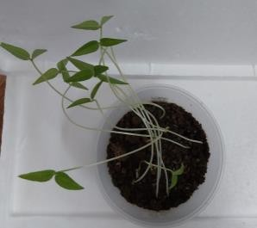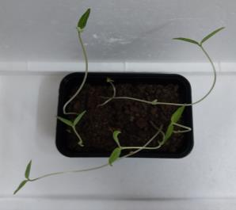

**B**

**A**

**Fig. 12. Plants after 7 days of growth (A) Control and (B) Organic fertilizer**

|  |  |  |
| --- | --- | --- |
| **Days** | **Inoculated with nitrogen-fixing bacteria (cm)** | **Control (cm)** |
| **4** | **10.9** | **12.9** |
| **5** | **15.7** | **18** |
| **6** | **20.6** | **22.3** |
| **7** | **22.4** | **23.7** |

**Table 2. The measured stem length of plants after 4 days of growth**.

## THE EFFECT OF INORGANIC FERTILIZER IN PLANTS HAVING NITROGEN FIXING BACTERIA

The experiment showed that pea plants inoculated with nitrogen-fixing bacteria and grown without any fertilizer (control) had greater length for stem compared to those grown with inorganic fertilizer. The control group consistently showed superior growth from 4 to 7 days compared to the inorganic fertilizer group. This suggests that the presence of nitrogen-fixing bacteria alone is more beneficial for pea plant growth than when combined with inorganic fertilizer.

Fig: 13. Plants after 7 days of growth (A) Control and (B) Inorganic fertilizer

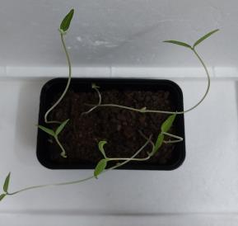

**B**

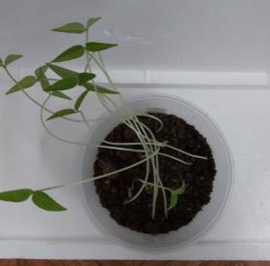

**A**

**Table 3. The measured stem length of plants after 4 days of growth**.

|  |  |  |
| --- | --- | --- |
| **Days** | **Inoculated with nitrogen-fixing bacteria (cm)** | **Control (cm)** |
| **4** | **8.9** | **12.9** |
| **5** | **12.5** | **18** |
| **6** | **16.5** | **22.3** |
| **7** | **19.9** | **23.7** |

## ESTIMATION OF INDOLE ACETIC ACID (IAA) PRODUCTION BY ISOLATED NITROGEN-FIXING BACTERIA

The isolated nitrogen fixing bacteria sample showed an absorbance measurement of

**0.064 at 530 nm.** Based on standard calibration graph correlating absorbance readings to known concentrations of IAA, the estimated concentration of IAA in the sample was approximately **4.10g** (Spaepen *et al.,* 2007).

## CONCLUSION

The study on the influence of organic and inorganic fertilizers on nitrogen-fixing bacteria isolated from the root nodules of pea plants revealed the presence of a gram negative, motile rod that was IMViC negative. Confirmatory tests identified this bacterium as a *Rhizobium* spp. It was found to be sensitive to NaCl, pH, tetracycline and chloramphenicol. Pea plants inoculated with *rhizobium* exhibited greater stem length over 4 - 7 days compared to normal plant. However, the growth-promoting effect of *rhizobium* was diminished by the presence of organic and inorganic fertilizers. Rhizobium produced 4.10 g of IAA, ensures its role in stimulating plant growth. These findings emphasize the importance of nutrient management strategies in optimizing the symbiotic relationship between nitrogen fixing bacteria and plants for enhanced agricultural productivity.

# COMPETING INTERESTS

Authors have declared that no competing interests exist.

COMPETING INTERESTS DISCLAIMER:

Authors have declared that they have no known competing financial interests OR non-financial interests OR personal relationships that could have appeared to influence the work reported in this paper.

Disclaimer (Artificial intelligence)

Option 1:

Author(s) hereby declare that NO generative AI technologies such as Large Language Models (ChatGPT, COPILOT, etc.) and text-to-image generators have been used during the writing or editing of this manuscript.

Option 2:

Author(s) hereby declare that generative AI technologies such as Large Language Models, etc. have been used during the writing or editing of manuscripts. This explanation will include the name, version, model, and source of the generative AI technology and as well as all input prompts provided to the generative AI technology

Details of the AI usage are given below:

1.

2.

3.

**REFERENCES**

1. BASHAN, Y., DE-BASHAN, L. E., PRABHU, S. R & HERNANDEZ, J. P. 2016. Advances in Agronomy. *Academic Press*, 138, 123 - 234.
2. BASRA, A. S & MALIK, C. P. 2019. Handbook of Fiber Biology. *Springer*, 2, 13 - 18.
3. **Berendonk, T. U., Manaia, C. M., Merlin, C., Fatta-Kassinos, D., Cytryn, E., Walsh, F., & Kreuzinger, N. (2015).** Tackling antibiotic resistance: The environmental framework. Nature Reviews Microbiology, 13, 310 -317.
4. BERG, G. 2017. Plant-microbe interactions promoting plant growth and health: perspectives for controlled use of microorganisms in agriculture. *Applied Microbiology and Biotechnology*, 84, 11 - 18.
5. BHATTACHARYYA, P. N & JHA, D. K. 2012. Plant Growth-Promoting Rhizobacteria (PGPR): Emergence in Agriculture. *World Journal of Microbiology and Biotechnology*, 28, 1327 - 1350.
6. BRADY, N. C & WEIL, R. R. 2008. The Nature and Properties of Soils. *Pearson Prentice Hall, 15*, 1 *-* 18.
7. CHOWDHURY, P. R. 2018. Antibiotic resistance mechanisms in bacteria: Relationships between resistance determinants of antibiotic producers, environmental bacteria, and clinical pathogens. *Frontiers in Microbiology*, 9, 2928.
8. DAHL, W. J., FOSTER, L. M., & TYLER, R. T. (2022). Review of the health benefits of peas (Pisum sativum L.). Nutrients, 14, 1423.
9. DALGAARD, T. S & BORGESEN, C. D. 2012. Screening of accessions of Pea plant for high tolerance to terminal drought. *Euphytica*, 185, 15 - 25.
10. DAS, H., DEVI, N. S., VENU, N., & BORAH, A. (2023). Chemical fertilizer and its effects on the soil environment. In Research and Review in Agriculture Sciences, 7, 31–51.
11. **DE SOUZA, R., AMBROSINI, A., & PASSAGLIA, L. M. 2015. Plant growth-promoting bacteria as inoculants in agricultural soils.** Frontiers in Microbiology, 6, 815.
12. DELLAGI, A & BRISSET, M. N. 2011. Biological control of plant diseases: The European situation. *European Journal of Plant Pathology*, 131, 51 - 61.
13. DIXON, R & KAHN, D. 2004. Genetic regulation of biological nitrogen fixation. *Nature Reviews Microbiology*, 2, 621 - 631.
14. ENDRESS, P. K. 2010. Evolutionary Diversification of the Flowers in Angiosperms. *American Journal of Botany*, 97, 63 - 81.
15. FABRICANT, D. S & FARNSWORTH, N.R. 2001. The value of plants used in traditional medicine for drug discovery. Environmental Health Perspectives, 109, 69 - 75.
16. FALIGOWSKA, A., KALEMBASA, S., KALEMBASA, D., PANASIEWICZ, K., SZYMAŃSKA, G., RATAJCZAK, K., & SKRZYPCZAK, G. 2022. The nitrogen fixation and yielding of pea in different soil tillage systems. Agronomy, 12, 352.
17. FALKOWSKI, P. G. 2008. The evolution of modern eukaryotic phytoplankton. *Science*, 305, 354 - 360.
18. **FRANKLIN, K. A., & QUAIL, P. H. 2010.** Phytochrome functions in Arabidopsis development. Journal of Experimental Botany, 61, 11 - 24.
19. FUENTES, L. E & CABALLERO, J. 2005. Bacterial biofertilizers. *In Advances in agronomy*, 81, 245 - 279.
20. GILLER. 2009. Biological Nitrogen Fixation: An Efficient Source of Nitrogen for Sustainable Agricultural Production. *Plant and Soil*, 322, 1 - 18.
21. GRAHAM, P. H & VANCE, C. P. 2003. Legumes: Importance and Constraints to Greater Use. *Plant Physiology*, 131, 872 - 877.
22. GSMITH, F. A & BROWN, J. H. 2018. Patterns of diversity, depth range and body size among pelagic fishes along a gradient of depth. *Global Ecology and Biogeography*, 11, 313 - 322.
23. GYANESHWAR, P., JAMES, E. K., MATHAN, N., REDDY, P. M., REINHOLD, B & LADHA, J. K. 2001.Endophytic Colonization of Rice by a Diazotrophic Strain of serritia marcescens. *Journal of Bacteriology*, 183, 2634 - 2645.
24. ISLAM, S., AKANDA, A. M., PROVA, A., ISLAM, M. T., & HOSSAIN, M. M. 2016. Isolation and identification of plant growth-promoting rhizobacteria from cucumber rhizosphere and their effect on plant growth promotion and disease suppression. Frontiers in Microbiology, 6, 1360.
25. KNAPP, C.W. 2010. Antibiotic resistance gene abundances correlate with metal and geochemical conditions in archived Scottish soils*, plos* one, 5, 12111.
26. KUCUK, C., KIVANC, M. and KINAC, I.E. 2006. Characterization of rhizobium sp. Isolated from bean. Turkish journal of biology, 30, 127 - 132.
27. KUMAR, R., DAS, D., GUPTA, S. B., SONI, R& SINGH, A. K 2017. Inoculation effect of Rhizobium and phosphorous solubilizing bacteria on growth and nodulation of Acacia Nilotic a. *International Journal of Current Microbiology and Applied Sciences*, 6, 2444 - 2453.
28. **LASSALETTA, L., BILLEN, G., GRIZZETTI, B., ANGLADE, J., & GARNIER, J. 2019.** Nitrogen use efficiency and the European nitrogen directive: The need for improved agronomic management. Agricultural Systems,176, 102 - 115.
29. LUDWIG, W., & SCHLEIFER, K. H. 1994. Bacterial phylogeny based on 16S and 23S rRNA sequence analysis. FEMS Microbiology Reviews, 15, 155 - 173.
30. MALHI, S. S & LEMKE, R. L. 2007.Tillage, nitrogen and crop residue effects on crop yield, nutrient uptake, soil quality, and greenhouse gas emissions. *Soil and Tillage Research*, 95, 28 - 41.
31. **MITTER, E. K., TOSI, M., OBREGÓN, D., DUNFIELD, K. E., & GERMIDA, J. J. 2021.** Rethinking crop nutrition in times of modern microbiology: Innovative biofertilizer technologies. Frontiers in Sustainable Food Systems, 5, 1 - 23.
32. MUS, F., CROOK, M. B., GARCIA, K., GARCIA COSTAS, A., GEDDES, B. A., KOURI, E. D., & ANÉ, J. M. 2016. Symbiotic nitrogen fixation and the challenges to its extension to non-legumes. Applied and Environmental Microbiology,82, 3698 - 3710.
33. **NADEEM, M., AHMAD, W., AHMAD, S., ULLAH, R., AHMAD, B., & HAFEEZ, A..** Effect of nitrogen and phosphorus fertilization on growth, nodulation, and yield of pea (Pisum sativum L.). Journal of Plant Nutrition, 42, 2031 - 2044.
34. Oldroyd, G. E., & Dixon, R. 2014. Biotechnological solutions to the nitrogen problem. *Current Opinion in Biotechnology, 26*, 19 - 24.
35. O'NEILL, D. P., & ROSS, J. J. 2002. Auxin regulation of the gibberellin pathway in pea. Plant Physiology, 130, 1974 - 1982.
36. RICHARDSON,A. E. 2009 Soil microorganisms mediating phosphorus availability update on microbial phosphorus*. Plant Physiology*, 156, 989 - 996.
37. SAVCI, S. 2012. Investigation of effect of chemical fertilizers on environment.*APCBEE Procedia, 1*, 287 - 292.
38. SCHLOTER, M & HARTMANN, A. 1998. Endophytic and surface colonization of wheat roots (Triticumaestivum) by different Azospirillum brasilense strains studied with strain-specific monoclonal antibodies. *Symbiosis*, 25, 159 – 176.
39. SHU, W.-S., & HUANG, L.-N. 2022. Microbial diversity in extreme environments. Nature Reviews Microbiology, 20, 219 - 235.
40. SIVOJIENE, D., KACERGIUS, A., BAKSIENE, E., MASEVICIENE, A., & ZICKIENE, L. 2021. The influence of organic fertilizers on the abundance of soil microorganism communities, agrochemical indicators, and yield in East Lithuanian light soils. Plants, 10, 2648.
41. SMITH, A. M & COUPLAND, G. 2009. Comparative Plant Genomics: Methods and Protocols. *Humana Press*, 1, 3 - 12.
42. SMITH, S. E & READ, D. J. 2008. Mycorrhizal Symbiosis. *Academic Press*, 3, 345 - 356.
43. **SPAEPEN, S., VANDERLEYDEN, J., & REMANS, R. (2020).** Indole-3-acetic acid in microbial and plant growth interactions. FEMS Microbiology Reviews, 44(5), 603-632
44. SPAEPEN, S., VANDERLEYDEN, J., & REMANS, R. 2007. Indole-3-acetic acid in microbial and microorganism-plant signaling. FEMS Microbiology Reviews, 31, 425 - 448.
45. TAIZ, L & ZEIGER, E. 2010. PlantPhysiology. *Sinauer Associates*. 5, 456 - 459.
46. TILMAN, D. 2002. Agricultural sustainability and intensive production practices. *Nature,* 418, 671 - 677.
47. UDVARDI, M & POOLE, P. S. 2013.Transport and metabolism in legume- rhizobia symbioses. *Annual Review of Plant Biology*, 64, 781 - 805.
48. VESSEY, J. K. 2003. Plant growth promoting rhizobacteria as biofertilizers. *Plant and Soil*, 255, 571 - 586.
49. **VOISIN, A. S., SALON, C., MUNIER-JOLAIN, N. G., & NEY, B. (2021).** Nitrogen fixation and yield in pea and lentil: Environmental and agronomic influences. Agronomy Journal, 113, 2789 - 2803.
50. WANG, D., YANG, S., TANG, F., & ZHU, H. 2012. Symbiosis specificity in the legume: rhizobial mutualism. Cellular Microbiology, 14, 334-342.
51. WANG, X., WANG, X., HU, Q., DAI, X., YAN, Y., YANG, A., & CHEN, X. (2021). Mechanisms of salt tolerance in legumes and their applications in crop improvement. Frontiers in Plant Science, 12, 687536.
52. WEEDEN, N. F. 2007. Genetic changes accompanying the domestication of Pisum sativum: is there a common genetic basis to the 'domestication syndrome' for legumes. *Annals of Botany*, 100, 1017 - 1025.
53. WHITE, P. J & HAMMOND, J. P. 2008.Phosphorus nutrition of terrestrial plants.*In The Ecophysiology of Plant- Phosphorus Interactions*, 3, 51 - 81.
54. ZAHRAN, H. 1999. Rhizobium-legume symbiosis and nitrogen fixation under severe conditions and in an arid climate. Microbiology and Molecular Biology Reviews, 63, 968 - 989.
55. **ZHANG, X., DAVIDSON, E. A., MAUZERALL, D. L., SEARCHINGER, T. D., DUMAS, P., & SHEN, Y. (2015).** Managing nitrogen for sustainable development. Nature, 528(7580), 51- 59.
56. ZHOU, J., DENG, Y., SHEN, L., WEN, C., YAN, Q., NING, D., QIN, Y., XUE, K., WU, L., HE, Z., VOORDECKERS, J. W., VAN NOSTRAND, J. D., BUZZARD, V., MICHALETZ, S. T., ENQUIST, B. J., WEISER, M. D., KASPARI, M., WAIDE, R., YANG, Y., & BROWN, J. H. 2016. Temperature mediates continental-scale diversity of microbes in forest soils. Nature Communications, 7, 12083.