**Morphological variability and disease resistance levels in cardamom field gene bank accessions (*Elettaria cardamomum* Maton.)**

**Abstract**

Cardamom, a highly valued spice, faces major challenges in cultivation due to diseases like leaf blight and rhizome rot, which lead to significant yield losses. The study aims to determine the morphological variation and disease resistance level in cardamom. This study was carried out to characterize 80 field gene bank accessions of cardamom, sourced from diverse ecotypes in South India, based on their morphological traits, yield potential and resistance to biotic stresses. The accessions were evaluated for two years (2020-21 and 2021-22) under field conditions. Significant variation was observed in traits such as plant height, bearing tillers, panicle count and capsule yield, indicating substantial genetic diversity within the germplasm. The highest plant height (333.70 cm), number of bearing tillers (33.53), number of panicles (37.41), maximum capsules (293.60) and highest fresh capsule yield (1085.50 g) were recorded in accession FGB203. Multivariate cluster analysis grouped the accessions into three clusters, with the second cluster showing the most desirable agronomic traits. Resistance screening for leaf blight and rhizome rot revealed that 27 genotypes exhibited resistance to leaf blight, but all accessions were susceptible to rhizome rot. The findings highlight the potential for selecting superior genotypes with desirable morphological traits and disease resistance, providing valuable genetic resources for breeding programs aimed at enhancing cardamom yield and sustainability.

***Keywords*:** *Elettaria cardamomum* Maton, variability, characterization, leaf blight, rhizome rot

**Introduction**

Cardamom (Elettaria cardamomum Maton), is the most valuable and export-oriented spice crop. It is known as the "Queen of Spices," and is the second most expensive spice after saffron and vanilla. Belonging to the genus *Elettaria* and species *cardamomum*, it is an herbaceous plant of the Zingiberaceae family, native to the Western Ghats. The dried fruit is prized for its aroma and flavour. As a cross-pollinated crop, cardamom is propagated through seeds and suckers, leading to significant genetic diversity. This diversity is evident in various traits observed in natural populations, such as differences in panicle types, branched racemes, female sterility and cleistogamy (Madhusoodanan *et al*., 1994). Cardamom is their main source of income generation. However, the production of cardamom has declined over the past years and farmers claim that climate change is the main reason (Wangchuk et al. 2023). Padmini *et al*., 2001 documented significant variability within and among cardamom cultivars for key economic traits. However, the cultivation of small cardamom faces major challenges due to various diseases caused by fungi, viruses and nematodes. Among these, leaf blight and rhizome rot are the most widespread, destructive fungal diseases. These diseases are prevalent in all cardamom-growing regions and lead to considerable yield losses. Leaf blight damages the photosynthetic area, while rhizome rot causes rotting and eventual collapse of the tillers. The development of rhizome rot is promoted by the presence of inoculum in the soil and crop debris, overcrowding of plants and dense shade. Although plant protection chemicals can manage these diseases, the growing demand for organically produced spices, coupled with concerns over the health hazards posed by biomagnification, environmental pollution from chemical residues and the development of fungicide-resistant pathogens, necessitates the development of alternative disease control strategies (Thomas and Bhai, 2002). Regmi (2014), and Shrestha et al. (2004) stated that elevation; moisture and shade are the fundamental factors for successful cultivation of cardamom, which are being declined over time causing poor plant growth and development and eventually low yield (Pun, 2019). Studying the genetic variability of a crop’s resources is the first step toward understanding the genetic diversity within its gene pool, which is essential for crop improvement programs. The conservation and characterization of cardamom germplasm are critical for developing improved varieties with desirable traits. This study aimed to characterize cardamom accessions based on their morphological traits and yield potential and to identify sources of resistance to biotic stresses such as leaf blight and rhizome rot within the germplasm under natural screening.

**Materials and Methods**

The eighty-field gene bank accessions collection comprises sourced from cardamom-growing regions in South India, representing the Malabar, Mysore and Vazhukka ecotypes. These accessions were evaluated for two years (2020-21 and 2021-22) at ICAR- Indian Institute of Spices Research, Regional Station, Appangala, Madikeri, Karnataka which is located in a high rainfall area (2000-2500 mm/ year) at an elevation of 950 m above MSL. The accessions were planted (five clumps/accession) under uniform shade with a spacing of 2×2 M. The recommended package of practices was applied consistently across all accessions. Data on morphological traits and yield-related characteristics were collected from five plants per accession over two consecutive years, with the average used for analysis. The mean, standard deviation coefficient of variation and correlation of quantitative characters were calculated using standard procedures. The pooled data were subjected to multivariate cluster analysis using R version 4.0.1 with facto extra package for visualization. Intra and inter-cluster distances were estimated using the clv package and a dendrogram was generated to group the accessions into clusters and assess genetic similarities among them using R software. Field screening of the cardamom germplasm for leaf blight and rhizome rot diseases was conducted through visual observation. Leaf blight incidence was assessed by observing foliar symptoms on the inner tillers (a minimum of 8-12 tillers). The Percent Disease Index (PDI) for each plant within an accession was calculated and the average PDI was determined for each genotype (Praveena *et al*., 2013). The incidence of rhizome rot was determined using a 1-5 rating scale (Venugopal *et al*., 2006), with higher scores indicating a greater number of infected tillers per clump. Disease incidence was recorded from five clumps per accession, and the PDI was determined using the formula outlined by Biju *et al*., 2018.

**Results and discussion**

**Phenotypic characterization**

The morphological characterization of eighty selected cardamom field gene bank accessions was conducted by evaluating various traits, including plant height, bearing tillers, leaf attributes, panicle count, panicle length, number of capsules, seed count, and fresh and dry yields. The results revealed significant differences among the germplasm accessions for all traits, indicating substantial variability (Table 1). The plant height ranged from 159.34 to 333.70 cm. The genotype FGB203 exhibited the highest plant height (333.70 cm), number of bearing tillers (33.53), number of panicles (37.41), capsules per plant (293.60), fresh yield (1085.50 g) and dry yield (207.88 g) of capsules. Sharon *et al*. (2020), Akhila *et al*. (2017), Senthil Kumar *et al*. (2018) and Backiyarani *et al*. (2002) reported significant variability among the accessions concerning the number of bearing tillers, capsules, and fresh and dry yields. Variability among the field gene bank accessions for quantitative characters was indicated by the coefficient of variation, with the highest coefficient of variation shown by the dry yield of capsules (53.86%), followed by the fresh yield (53.54%). The lowest coefficient of variation was for dry recovery of capsules (4.74%), followed by leaf length (7.32%). Anisha *et al*. (2020) found variability among the released cardamom varieties for quantitative and qualitative traits. Among the morphological characters, the number of capsules per plant recorded the highest coefficient of variation (39.81%), followed by the number of panicles (39.39%) and panicle length (38.88%). Sharon *et al*. (2020) and Korikanthimath *et al.* (2000) reported significant differences among cardamom genotypes, particularly in the capsules per plant and fresh and dry weight of capsules. The morphological and phenotypic data from this study underscore the considerable variability within the field gene bank accessions, indicating significant potential for selecting promising genotypes for breeding programs.

**Table 1.** Variability of phenotypic traits in field gene bank accessions of cardamom

|  |  |  |  |  |  |  |
| --- | --- | --- | --- | --- | --- | --- |
| **Characters** | **Range** | **Mean** | **SD** | **CV (%)** | | **Promising Genotypes** |
| Plant height (cm) | 159.34-333.70 | 248.12 | 35.94 | 14.48 | FGB203, FGB202, FGB201, FGB190, FGB199, FGB197, FGB160 | |
| No. of bearing tillers | 4.41-33.53 | 16.40 | 6.38 | 38.88 | FGB203, FGB202, FGB201, FGB200, FGB196, FGB194 | |
| No. of leaves | 59.05-275.32 | 184.26 | 60.55 | 32.86 | FGB201, FGB202, FGB203, FGB204, FGB200, FGB199, FGB194, FGB179 | |
| Leaf length (cm) | 41.99-67.63 | 58.22 | 4.26 | 7.32 | FGB123, FGB122, FGB124, FGB162, FGB155, FGB195 | |
| Leaf breadth (cm) | 8.46-14.10 | 10.77 | 1.17 | 10.88 | FGB195, FGB122, FGB123, FGB188 | |
| No. of panicles | 4.45-37.41 | 20.01 | 7.88 | 39.39 | FGB203, FGB201, FGB202, FGB196, FGB199, FGB202, FGB204, FGB199 | |
| Panicle length (cm) | 18.84-81.62 | 53.15 | 12.41 | 23.34 | FGB122, FGB124, FGB123, FGB202, FGB185, FGB203 | |
| No. of capsules | 31.95-293.60 | 175.69 | 69.94 | 39.81 | FGB 203, FGB204, FGB201, FGB202, FGB196, FGB190, FGB124, FGB125 | |
| No. of seeds | 12.9.-24.91 | 17.28 | 2.99 | 17.33 | FGB196, FGB197, FGB152, FGB201, FGB174, FGB128 | |
| Fresh yield (g) | 47.00-1085.50 | 514.65 | 275.53 | 53.54 | FGB203, FGB196, FGB201, FGB200, FGB199, FGB202, FGB190, FGB179, FGB162 | |
| Dry yield (g) | 8.75-207.88 | 100.39 | 54.06 | 53.86 | FGB203, FGB199, FGB201, FGB196, FGB200, FGB190, FGB179, FGB162 | |
| Dry recovery (%) | 16.89-20.80 | 18.87 | 0.89 | 4.74 | FGB141, FGB156, FGB122, FGB135 | |

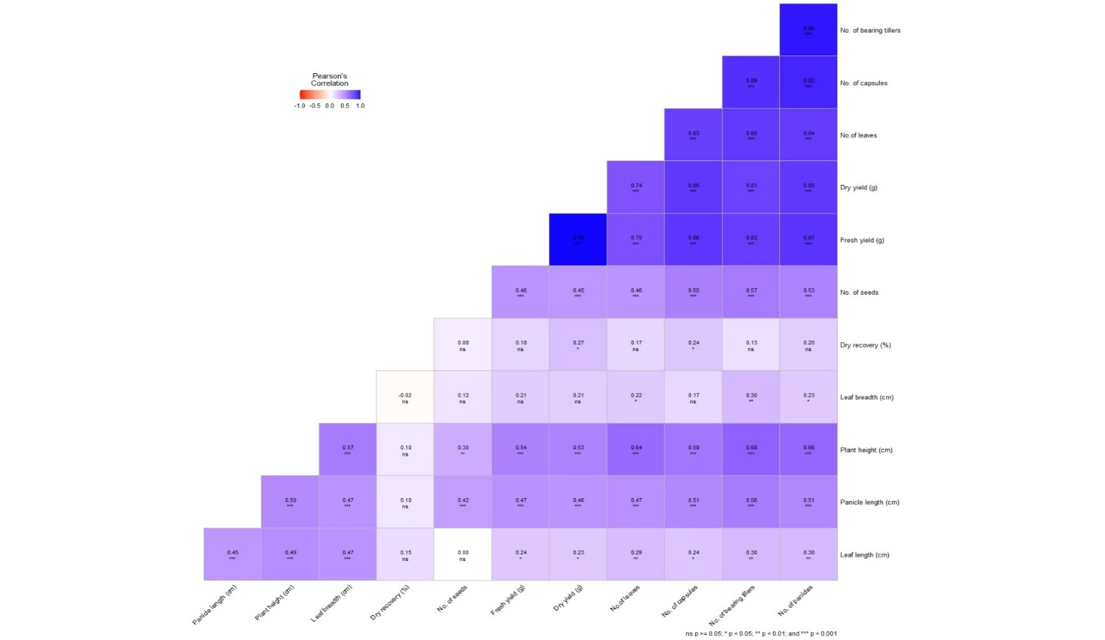

**Fig.1:** Evaluations of correlation coefficients between characters in cardamom

Most traits exhibited significant positive correlations with each other (Fig. 1). Especially, fresh yield per plant was highly and positively correlated with the number of leaves, bearing tillers, panicles, capsules and dry yield. Dry recovery percentage showed weak correlations with most other traits, suggesting that it is not profoundly influenced by other agronomic factors and is likely not a primary contributor to overall yield efficiency. As anticipated, fresh yield was strongly positively correlated with dry yield (0.99). Additionally, due to the strong positive correlation between yield and bearing tillers and capsules per plant, selecting these traits could be an effective strategy to enhance cardamom yield. Backiyarani *et al*. (2002) found a significant positive correlation between yield and panicle number, panicle length, plant height and tiller number, while Korikanthimath *et al*. (2000) observed a positive correlation between the number of capsules, bearing tillers and panicles.

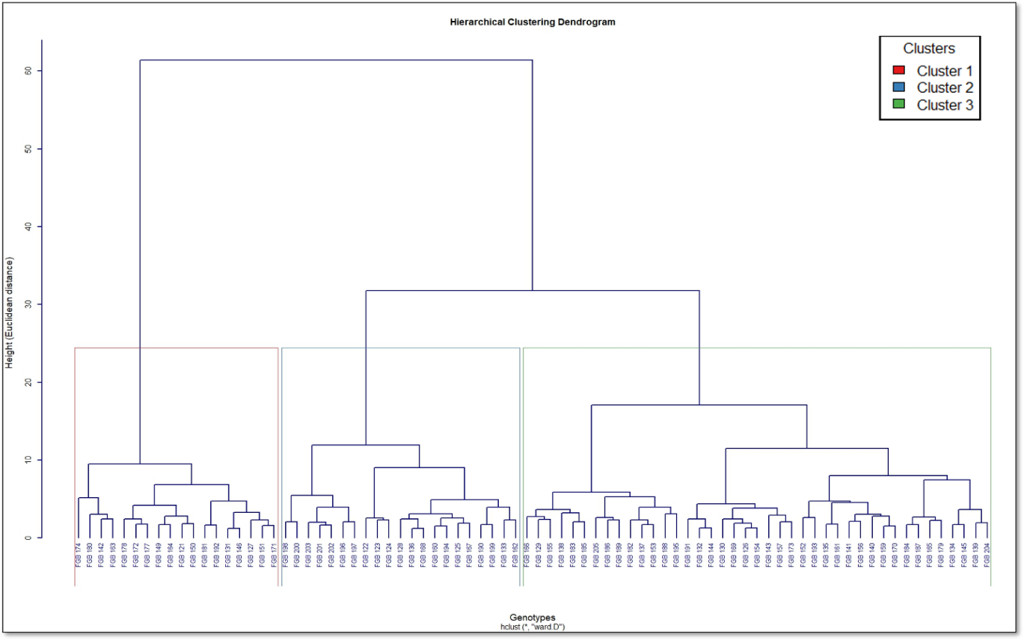 **Fig. 2:** Clusters of field gene bank accessions of cardamom using the “ward D” method

The significant genetic diversity observed among and within the three clusters was evident. Cluster analysis grouped the accessions into distinct categories based on their traits. These clusters represent specific trait combinations and provide a systematic approach to identifying accessions with desirable characteristics. Multivariate cluster analysis grouped the accessions into three distinct clusters, each displaying significant diversity (Fig. 2). Cluster 1 included 18 accessions, cluster 2 comprised 21 genotypes and cluster 3 contained 41 field gene bank accessions. Despite the inclusion of accessions from the Malabar, Mysore and Vazhukka ecotypes, no distinct clusters emerged based solely on ecotype. Accessions from the same ecotypes were found across different clusters, indicating a close genetic relationship among these ecotypes. This suggests that geographical origin may not be the primary factor influencing genetic divergence in cardamom. Similar findings were reported by Anisha *et al*. (2020) and Sharon *et al*. (2020), who also observed variability in quantitative traits among cardamom varieties. Trait-wise cluster means provided in Table 2 highlighted that cluster 2 exhibited the highest mean for all traits, including plant height (274.39 cm), number of bearing tillers (23.07), leaves (238.30), panicles (28.62), capsules (248.86), number of seeds per capsule (19.13), fresh yield (833.48 g) and dry yield (161.38 g). Cluster 1 represents genotypes with relatively low productivity and cluster 2 genotypes possess the most desirable agronomic characteristics, making them prime candidates for breeding programs.

**Table 2.** Trait-wise cluster means of field gene bank accessions of cardamom

|  |  |  |  |  |  |  |  |  |  |  |  |
| --- | --- | --- | --- | --- | --- | --- | --- | --- | --- | --- | --- |
|  | Plant height (cm) | No. of bearing tillers | No leaves | Leaf length (cm) | Leaf width (cm) | No. of panicles | Panicle length (cm) | No. of capsules | No. of seeds | Fresh yield (g) | Dry yield (g) |
| C1 | 216.73 | 9.33 | 106.87 | 55.96 | 10.16 | 11.02 | 42.65 | 87.75 | 14.85 | 233.40 | 44.63 |
| C2 | 274.39 | 23.07 | 238.30 | 59.25 | 10.94 | 28.62 | 59.50 | 248.86 | 19.13 | 833.48 | 161.38 |
| C3 | 248.33 | 15.83 | 193.55 | 58.93 | 11.03 | 19.19 | 55.20 | 176.69 | 17.43 | 448.94 | 89.149 |

**Table 3.** Distribution pattern of accessions into five clusters and estimate of average inter and intra-cluster distances

|  |  |  |  |  |
| --- | --- | --- | --- | --- |
| **Intercluster distance in average method** | | | | |
| **Clusters** | **Cluster 1** | **Cluster 2** | **Cluster 3** | **No. of genotypes** |
| Cluster 1 | 0.00 | 11.96 | 9.84 | 18 |
| Cluster 2 | 11.96 | 0.00 | 8.20 | 21 |
| Cluster 3 | 9.84 | 8.20 | 0.00 | 41 |
| **Intra cluster distances in average method** | | | | |
|  | 7.03 | 5.74 | 6.18 |  |

The distribution of accessions across the clusters and the estimation of average inter and intra-cluster distances (Table 3) provided further insights into the genetic diversity. Cluster 1 exhibited the highest intra-cluster variation (7.03), indicating significant diversity within this cluster. Cluster 2, with the smallest intra-cluster distance (5.74), showed the least genetic variability, suggesting more uniformity within the cluster. Cluster 3 exhibited an intra-cluster distance of 6.18, which falls between the values of cluster 1 and cluster 2, reflecting moderate variability within this group of accessions. Inter-cluster distances, which reflect genetic dissimilarity between clusters, revealed that the highest inter-cluster distance (11.96) occurred between cluster 1 and cluster 2, indicating that these two clusters are genetically the most distinct. This significant distance suggests that the accessions in these clusters differ substantially in terms of key traits. The distance between cluster 1 and cluster 3 was also notable at 9.84, while the smallest distance (8.20) was observed between cluster 2 and cluster 3. This indicates that cluster 3, which includes the largest number of accessions (41), is genetically closer to cluster 2, possibly due to a shared set of traits or genetic backgrounds. The variation in inter-cluster distances supports the idea of substantial genetic diversity within the cardamom germplasm.

**Table 4.** Categorization of cardamom field gene bank accessions based on reaction towards leaf blight

|  |  |  |
| --- | --- | --- |
| **Per cent Disease Index (%)** | **Category** | **Accessions** |
| < 10 % | Highly resistant  (HR) | Nil |
| 11-20 % | Resistant  (R) 27 | FGB127, FGB129, FGB132, FGB134, FGB137, FGB151, FGB152, FGB164, FGB167, FGB184, FGB185, FGB186, FGB187, FGB188, FGB190, FGB194, FGB195, FGB196, FGB197, FGB198, FGB199, FGB200, FGB201, FGB202, FGB203, FGB204, FGB205 |
| 21- 30 % | Moderately resistant (MR) 52 | FGB121, FGB122, FGB123, FGB124, FGB125, FGB126, FGB128, FGB130, FGB131, FGB133, FGB135, FGB136, FGB138, FGB139, FGB140, FGB141, FGB142, FGB144, FGB145, FGB146, FGB149, FGB150, FGB153, FGB154, FGB155, FGB156, FGB157, FGB159, FGB160, FGB161, FGB162, FGB163, FGB165, FGB166, FGB168, FGB169, FGB170, FGB171, FGB172, FGB173, FGB174, FGB177, FGB178, FGB179, FGB180, FGB181, FGB182, FGB183, FGB189, FGB191, FGB192, FGB193 |
| 31-40 % | Moderately susceptible (MS) | FGB143 |
| 41-50 % | Susceptible (S) | Nil |
| > 51 % | Highly Susceptible (HS) | Nil |

They evaluated 80 accessions of cardamom for leaf blight and rhizome rot diseases under natural field conditions. Among the accessions, 27 genotypes were identified as resistant, with disease indices ranging from 11 to 20%. The majority of the accessions (52 genotypes) exhibited moderate resistance, with PDIs ranging from 21 to 30%. One accession (FGB143) was categorized as moderately susceptible, with a PDI ranging from 31 to 40% (Table 4). In the case of rhizome rot disease, all the genotypes were classified as moderately susceptible to susceptible categories. Thirty-eight accessions showed moderate susceptibility, with PDIs ranging from 10.1 to 25%, while 42 genotypes were observed in the susceptible category, with PDIs ranging from 25.1 to 50% (Table 5). This classification highlights the varying levels of resistance exhibited by the genotypes against leaf blight while emphasizing the shared susceptibility to rhizome rot across all genotypes. Therefore, these accessions hold promise as potential sources of resistance to leaf blight disease. These findings are consistent with other studies that have reported variability in disease resistance across cardamom genotypes, underscoring the importance of identifying resistant accessions for sustainable cultivation practices (Sharon *et al*., 2020; Praveena *et al*., 2013; Thomas and Bhai, 2002).

**Table 5.** Categorization of cardamom field gene bank accessions based on the reaction towards rhizome rot

|  |  |  |
| --- | --- | --- |
| **Per cent Disease Index (%)** | **Category** | **Accessions** |
| 0-5% | Highly resistant  (HR) | Nil |
| 5.1-10 % | Resistant (R) | Nil |
| 10.1- 25 % | Moderately susceptible (MS) 38 | FGB121, FGB123, FGB124, FGB125, FGB126, FGB130, FGB134, FGB135, FGB136, FGB139, FGB140, FGB143, FGB144, FGB146, FGB147, FGB149, FGB157, FGB159, FGB160, FGB166, FGB167, FGB168, FGB171, FGB172, FGB174, FGB177, FGB179, FGB180, FGB181, FGB182, FGB187, FGB191, FGB192, FGB193, FGB196, FGB197, FGB204, FGB205 |
| 25.1-50 % | Susceptible (S) 42 | FGB122, FGB127, FGB128, FGB129, FGB131, FGB132, FGB133, FGB137, FGB138, FGB141, FGB142, FGB145, FGB150, FGB151, FGB152, FGB153, FGB154, FGB155, FGB156, FGB161, FGB162, FGB163, FGB164, FGB165, FGB169, FGB170, FGB173, FGB178, FGB183, FGB184, FGB185, FGB186, FGB188, FGB189, FGB190, FGB194, FGB195, FGB198, FGB199, FGB200, FGB201, FGB202, FGB203 |
| > 51 % | Highly Susceptible HS) | Nil |

**Conclusion**

The significant genetic diversity within the 80 cardamom accessions, with notable variation in key agronomic traits and resistance to biotic stresses. Genotypes such as FGB203 exhibited superior performance across multiple traits, making them ideal candidates for future breeding programs. Cluster analysis revealed distinct groupings of accessions based on morphological traits, and the identification of resistant genotypes against leaf blight offers promising avenues for sustainable cultivation. The results underscore the importance of conserving and characterizing cardamom germplasm to develop improved varieties with enhanced yield potential and disease resistance. These findings provide valuable insights for the development of high-yielding and disease-resistant cardamom cultivars.

**Disclaimer (Artificial intelligence)**

Option 1:

Author(s) hereby declare that NO generative AI technologies such as Large Language Models (ChatGPT, COPILOT, etc.) and text-to-image generators have been used during the writing or editing of this manuscript.

Option 2:

Author(s) hereby declare that generative AI technologies such as Large Language Models, etc. have been used during the writing or editing of manuscripts. This explanation will include the name, version, model, and source of the generative AI technology as well as all input prompts provided to the generative AI technology.

Details of the AI usage are given below:

1.

2.

3.

**References**

Akhila PR, Radhakrishnan VV, Pradipkumar K and Mohanan KV. (2017). Assessment of variability and performance of new landraces of small cardamom (*Elettaria cardamomum* Maton). *J Plant Crops*. 45:43-48.

Anisha CS, Mary M K, Swapna S, Sherin J, Rithin VC, Reshma R, Geethu M, Rao YS and Remashree AB. 2020. Diversity analysis of released varieties of Indian cardamom using ISSR markers reveal narrowing genetic base. Indian Journal of Biotechnology.19: 311-322

Backiyarani S, Sainamoie K, Josephrajkumar AJ and Murugan M. (2002). Evaluation of high yielding accessions of small cardamom (*Elettaria cardamomum* Maton) for suitability in the high ranges of Idukki District. *J Spices Arom Crops*. 11(2):93-96.

Biju CN, Peeran MF, Gowri R, Praveena R, Sharon A and Ankegowda SJ. (2018). Epidemiological parameters to delineate weather-disease interactions and host plant resistance against leaf blight in small cardamom (*Elettaria cardamomum* Maton). *J Spices Arom Crops*. 27:22-31.

Korikanthimath VS, Prasath D and Mohamed Sayed AA. (2000). Association of yield attributes among quantitative characters of cardamom (*Elettaria cardamomum* Maton). *J Spices Arom Crops*. 9(2): 155-156.

Madhusoodanan KJ, Kuruvilla KM and Priyadarshan PM. (1994). Improvement of cardamom. In: Advances in Horticulture, Vol. 9. Plantation Crops and Spices. (Eds.) Chadha, K. L. and Rethinam, P. Malhotra Publishing House, New Delhi. pp. 307-314.

Padmini K, Venugopal MN and Ankegowda SJ. (2001). Heterosis for seedling characters in cardamom (*Elettaria cardamomum* Maton.). *J Spices Arom Crops*. 9(2):145-151.

Praveena R, Biju CN, Senthil Kumar R, Darshana CN and Jashmi KC. (2013). Preliminary evaluation of cardamom accessions against leaf blight/Chenthal disease. *Indian Phytopathol*. 66:112-113.

Senthil KR, Prasath D, Sharon A, Leela NK, Venugopal MN, Ankegowda SJ, Biju CN and Anandaraj M. (2017). Evaluation of elite cardamom (*Elettaria cardamomum* Maton) genotypes for yield, quality and resistance to Cardamom mosaic virus. *J Plant Crops*. 45:129-134.

Senthil KR, Sharon A, Biju CN and Ankegowda SJ. (2018). Characterization of genotypes of small cardamom (*Elettaria cardamomum* Maton) for yield parameters and disease resistance. *J Plant Crops*. 46:143-146.

Sharon A, Biju CN, Ankegowda SJ, Shivakumar MS, Senthil KR. and Peeran MF. (2020). Screening small cardamom (*Elettaria cardamomum* Maton) field gene bank accessions for phenotypic characters, yield potential and disease resistance. *J Spices Arom Crops*. 29 (2): 105-112.

Thomas J, Bhai RS. (2002). Diseases of cardamom (Fungal, bacterial and nematode diseases). In: Ravindran PN, Madhusoodanan KJ, editors. Cardamom - The genus *Elettaria*. London and New York: *Taylor & Francis*.160-179.

Venugopal MN, Prasath D and Mulge R. (2006). IISR Avinash- a rhizome rots resistant and high yielding variety of cardamom (*Elettaria cardamomum* Maton). *J Spices Arom Crops*. 15:14-18.

Wangchuk, C., Dem, K., Nidup, K., Pelden, T., Wangdi, D., & Dorji, K. (2023). Impact of Climate Change on the Production of Cardamom in one of the Chiwog under Samtse Dzongkhag, Bhutan. International Journal of Scientific Research in Engineering and Management (IJSREM) 7(12), 1-16

Pun, A. B. (2019). A Review on Different Factors of Large Cardamom Decline in Nepal. Asian Journal of Research in Crop Science, 2(4), 1–6. <https://doi.org/10.9734/AJRCS/2018/46732>

Regmi HR. Alainchi Production in Nepal and other aspects. In: Savior Cardamom 2071 (2014). Federation of Large Cardamom Enterpreneurs of Nepal, Central Office, Birtamod, Jhapa, Nepal; 2014.

Shrestha KP, Chapagain TR, Karna PL. Situation of large cardamom production and marketing in Nepal. In Khatri BB, Sharma BP, Khatiwada PP, Paudyal KP, Khadge BR and Regmi HN (eds.), Proceeding of the Fourth National Workshop on Horticulture, March 2-4, 2004, Organized by Horticulture Research Division, Nepal Agricultural Research Council, Khumaltar, Lalitpur; 2004.