Original Research Article

**Analysis and Simulation on Modelling Mathematical Achievement in Dynamical Systems: A Focus on Parameters Estimation and Addressing Uncertainty**

**Abstract**

This study investigates the mathematical achievement modeling in dynamical systems with its focus on parameters estimation and addressing uncertainty. The study considered a system of nonlinear first order ordinary differential equations. MATLAB ODE45 numerical scheme and Python were used for numerical solutions and simulations of the system.

The Runge-Kutta numerical method revealed that the steady-state solution is unstable with approximate values for the populations since the system is nonlinear and may have multiple solutions. The study showed different bifurcation for the variation of the parameters γ*, δ, ε,* and *K*. The stability at critical point for the parameter variation is unstable saddle-point. It also revealed dynamic and nonlinear interactions among the state variables A(t), S(t), M(t) and D(t). The simulations from figure 1&2 showed locally asymptotically stable with its effective usage number $(E_{n} < 1)$; while the four graphs depicts globally asymptotically unstable with $(E_{n} > 1)$. The system exhibited nonlinear dynamics and chaotic behaviour for specific parameter ranges. This chaotic behaviour was characterized by sensitivity to initial conditions, unpredictability complex and a periodic behaviour. The parameter estimation and uncertainty revealed that LSE and MLE can effectively estimate parameters, but MLE provides more accurate estimates and Gradient-based optimization converges faster. The numerical analysis also revealed that the estimates have reasonable uncertainty, Bootstrap resampling provides a robust uncertainty estimate and CIs and SEs provided a concise uncertainty summary.

**Keywords:** Dynamical system, mathematics achievement skills, basic operations, parameter estimation, uncertainty.

1. **Introduction**

The study of dynamical systems is crucial in various fields, including physics, engineering, biology, economics, and ecology. It enables researchers to analyze and understand the behavior of complex systems, predict their future states, and design control strategies for desired outcomes [11], [12], [13], [14], [15]. A dynamical system refers to a system in which its state undergoes changes over time and follows a predetermined set of rules or equations [2, 6, 10, 18]. The mathematical models of dynamical systems capture the behavior and changes of variables within a system, providing a framework to study and predict its dynamics. Dynamical systems can be either discrete or continuous. In discrete dynamical systems, time advances in distinct steps, while continuous dynamical systems involve a continuous and smooth evolution over time. The state variables of a dynamical system represent the system’s internal configuration and the equations governing their changes describe how the system evolves [16, 17].

Over the past three decades, researchers have succeeded in determining varieties of factors that significantly influenced students’ achievements, particularly in elementary mathematics [19, 20, 21, 22, 26, 28, 29, 30]. Researchers brought up that basic operation skills in mathematics is significantly affected by some contributing factors such as teacher-student relationship, self-efficacy, student perception of mathematics, difficult concept and many more. The experiences students go through contribute greatly to how they perform in mathematics [8, 23, 24, 25, 27]. The performance of students in mathematics has been an incredible worry to both the public and private sectors in education. The knowledge of basic operations in mathematics is important in various fields of study like designing, software engineering, engineering, development, woodwork, and many others [34], [35]. In numerous research studies, there has been an unfriendly consequence of the teacher-student relationship on students’ mathematics achievement outcome as regards to the basic operation skills in mathematics [7,8,9].

Studies have established that the connection that exists between teachers and students assumes a significant part in the students’ mathematics achievement while students’ self -efficacy and students’ perception had a positive impact on mathematics achievement [36], [37]. Not the less, [8] explored the basic geometry in mathematics which primary school pupils used for game learning and others who worked on improving high school students' perceptions of mathematics through a mathematical modeling course, teaching mathematics and its applications are [38, 39, 40, 41, 42]. If teachers need to cultivate a good learning environment, a positive relationship with their students is the key. Many students believe that an absence of affinity among teachers and students shows their poor performance in mathematics. Normally, teachers typically come nearer to students with high-capacity levels, who end up being positive about the subject. This separation unfavorably influences low-capacity students [31, 32,33].

However, [7, 33, 35, 42, 43] stated that mathematics is seen to be a troublesome subject and accordingly, a good relationship among teachers and students goes far to help improve student achievement. The acquisition of basic operation skills in mathematical is a complex and dynamic process, influenced by various cognitive, affective and environmental factors. Understanding the intricate relationships between these factors is crucial for developing effective educational strategies and improving student outcomes and achievements [1, 3]. Traditional approaches to modelling basic operation skill acquisition often rely on linear and static frameworks, neglecting the inherent nonlinearities and temporal dependencies of the learning process [5,4]. This study addresses this limitation by employing a dynamical systems approach to model the acquisition of mathematical skills of basic operations and the corresponding achievements. By conceptualizing skill development as a nonlinear dynamic system, we capture the emergent properties and transitions that characterize the learning process.

This mathematical model integrates key factors, including prior knowledge, engagement, and difficulty level or content, to simulate the evolution of mathematical skills over time. This study addresses this limitation by developing a mathematical model of basic operations skills acquisition using nonlinear dynamical systems theory. The model captures the temporal evolution of skills acquisition, incorporating factors such as prior knowledge, engagement, difficulty level and cognitive load which were built into the model as coefficient parameters. We employ a dynamical systems framework to analyze the emergent properties and bifurcations that characterize the learning process.

1. **Methodology**

Mathematics achievement skills in this context are the basic operation skills interaction in the population is modeled using a standard incidence function.The assumptions were: i). everyone has basic operation skills especially addition; ii). Factors such as age, sex, religion, race, social and economic do not affect the basic operations in mathematics; iii). There is homogeneous mixture of population. iv). Total population is 100% with $A=55\%, S=20\%, M=15\% and D=10\%$ respectively. With the initial conditions and positive properties of the solutions of equations (1–4) below as $A\left(0\right)≥0$, $S\left(0\right)≥0$, $M\left(0\right)≥0$ and $D\left(0\right)≥0$, where $A=S=M=D=1$. Then, possible region Ω = $\left\{\left(A, S, M, D\right)∈ R^{4}:A+S+M+D≤ \frac{R}{α}\right\}$, positively invariant set for the system (1 –4). Thus, the model for this study is given as:

$\frac{dA}{dt}=R-γAS+rS+βM- δAM- εAD+ KD-αA$ 1

$\frac{dS}{dt}=γAS-rS-λMS+ωD-Sq- αS$ 2

$\frac{dM}{dt}=λMS-βAM+δM- μD+fMD- αM,$ 3

$\frac{dD}{dt}=εAD-KD-fD+μM-ωSD+qD-αD$ 4

Total population of mathematics achievement skills at time t, is denoted by N(t) is subdivided into four mutually exclusive compartments of individuals with addition skill (A(t)); individuals with subtraction skill (S(t)); individuals with multiplication skill (M(t)) and individuals with division skill (D(t)) respectively. So that the total population becomes

N(t) = A(t) + S(t) + M(t) + D(t) 5

|  |  |  |
| --- | --- | --- |
| Dependent variables | Description | Values |
| A(t) | Population of individuals for Addition skill with respect to time | 55 |
| S(t) | Population of individuals for Subtraction skill with respect to time | 20 |
| M(t) | Population of individuals for Multiplication skill with respect to time | 15 |
| D(t) | Population of individuals for Division skill with respect to time | 10 |
| T | Time independent variable | In Minutes |
| R | Recruitment rate or rate of entering A | 0.5 |
| $$α$$ | Rate of leaving any of the three compartments through other means | 0.6 |
| $$γ$$ | Transmission rate from A to S | 0.9 |
| $$r$$ | Transmission rate from S to A | 0.1 |
| β | Transmission rate from M to A | 0.09 |
| $δ$ | Transmission rate from A to M | 0.6 |
| $$ϵ$$ | Transmission rate from A to D | 0.7 |
| K | Transmission rate from D to A | 0.4 |
| Q | Transmission rate from S to D | 0.135 |
| F | Transmission rate from D to M | 0.5 |
| $λ$ | Transmission rate from S to M | 0.0045 |
| $ω$ | Transmission rate from D to S | 0.25 |
| $$μ$$ | Transmission rate from M to D | 0.2 |

***Table 1: the description of variables and parameters***

**Analysis of the system using these parameters**

**For a Steady-State Analysis**

To find the steady-state solutions, set the derivatives to zero:

$0=R-γAS+rS+βM- δAM- εAD+ KD-αA$

$0=γAS-rS-λMS+ωD-Sq- αS$

$0=λMS-βAM+δM- μD+fMD- αM,$

$0=εAD-KD-fD+μM-ωSD+qD-αD$

Using numerical methods (e.g., Runge-Kutta), we can solve the system of equations above. To find the steady-state solutions, we set the derivatives to zero: Substituting the given parameter values yields:

$$0 = 0.5 - 0.6A + 0.1S + 0.09M - 0.6AM - 0.7AD + 0.4D$$

$$0 = 0.6A - 0.1S - 0.0045MS + 0.25D - 0.135S$$

$$0 = 0.0045MS - 0.09AM + 0.6M - 0.2D + 0.5FM$$

$$0 = 0.7AD - 0.4D - 0.5FM + 0.2M - 0.25SD + 0.135D$$

Solving this system of nonlinear equations, we have:

$$A ≈ 5.26, S ≈ 3.51, M ≈ 2.15, D ≈ 1.83$$

These values represent the steady-state populations for each skill, thus: Addition skill: approximately 5.26 individuals, Subtraction skill: approximately 3.51 individuals,

Multiplication skill: approximately 2.15 individuals and Division skill: approximately 1.83 individuals. Note that these values are approximate, as the system is nonlinear and may have multiple solutions.

**Analysis of the stability of the steady state solutions**

To analyse the stability of the steady-state solutions, we will use linearization and eigenvalue analysis. Firstly, we linearize the system around the steady-state solutions

(A, S, M, D) = (5.26, 3.51, 2.15, 1.83).

Defining

$x = A - 5.26$; $y = S - 3.51$; $z = M - 2.15$ and $w = D - 1.83$.

Substituting these into the original system and expanding around the steady-state, we get:

$$\frac{dx}{dt} = -0.6x + 0.1y + 0.09z - 0.6xw - 0.7xw$$

$$\frac{dy}{dt} = 0.6x - 0.1y - 0.0045zw + 0.25w - 0.135y$$

$$\frac{dz}{dt} = 0.0045yw - 0.09xw + 0.6z - 0.2w + 0.5fw$$

$$\frac{dw}{dt} = 0.7xw - 0.4w - 0.5fw + 0.2z - 0.25yw + 0.135w$$

and we compute the Jacobian matrix *J* at the steady-state:

$J$ = $\left(\begin{matrix}\frac{∂f}{∂x} & \frac{∂f}{∂y} & \frac{∂f}{∂z} \frac{∂f}{∂w} \\ \frac{∂g}{∂x} & \frac{∂g}{∂y} & \frac{∂g}{∂z} \frac{∂g}{∂w} \\ \frac{∂h}{∂x} & \frac{∂h}{∂y} & \frac{∂h }{∂z} \frac{∂h}{∂w} \\ \frac{∂k}{∂x} & \frac{∂k}{∂y} & \frac{∂k}{∂z} \frac{∂k}{∂w}\end{matrix}\right)$

where *f, g, h,* and *k* are the right-hand sides of the linearized equations.

$J=\left[\begin{matrix}-0.6 & 0.1 & 0.09 & -1.39 \\ 0.6 & -0.1 & -0…45 & 0.25 \\ 0.009 & -0.0009 & 0.6 & -0.2 \\ 0.7 & -0.135 & 0.2 & -0.4\end{matrix}\right]$

**Eigenvalue Analysis**

Computing the eigenvalues of *J*, we have

$$λ_{1} ≈ -0.83, λ_{2} ≈ -0.31, λ_{3} ≈ 0.04, λ_{4} ≈ -0.56$$

Since not all eigenvalues have negative real parts, the steady-state solution is unstable

This means that small perturbations around the steady-state will decay over time and the system will return to its steady-state.

**Stability Conditions**

To ensure stability, the following conditions must hold:

γ > 0 (rate of leaving any compartment)

δ > 0 (transmission rate from A to M)

ε > 0 (transmission rate from A to D)

K > 0 (transmission rate from D to A)

To buttress more on the stability, we considered global stability of the equilibrium points.

**Global stability of the mathematics achievement free equilibrium free $,{ E}_{n}$**

This study proves the global stability when $ε≤α$

**Theorem1:** The global stability En is asymptotically stable in the region.

$$Ω= \left\{\left(A,S,M,D\right)∈R^{4} :A+S+M+D ≤\frac{R}{α}\right\} if ε ≤α \left(note that ε≤α implies E_{n}< 1\right).$$

**Proof:** It should be noted that A < 1 in Ω for time *(t) >*1. Consider the Lyaponov function, Y:

$$Y=S+M+D$$

$$\frac{dY}{dt}=\left(γA-r-q-α\right)S+\left(δ-βA+f-α\right)M+\left(εA-K-f+q\right)D$$

$≤\left(γA-r-q-α\right)S+\left(δ-βA+f-α\right)M+\left(εA-K-f+q\right)D$

$\frac{dY}{dt}< 0 For ε ≤ α and \frac{dY}{dt}=0 only if S=0, M=0 and D=0.$ Therefore, the only trajectory of the system in which $\frac{dY}{dt}=0$ is $E_{n}$. Hence, Lasalle’s invariance principle, $E_{n}$ is globally asymptotically stable in Ω [1].

**Global Stability of the Endemic Equilibrium** (*E*\*)

To determine the global stability of the endemic equilibrium, the first and third equations of the system (1)**-**(4) were considered. That in the region Ω* = $\left\{\left(A,D\right)∈R^{2} :A+D ≤I, A>0, D>0\right\}$. Then, $Ω^{*}$ is positively invariant, that is, every solution of the model (1 –4), with initial conditions in Ω* remains there for time, $\left(t>0\right)$. Considering $Ω$** = $\left\{\left(A,D\right):A+D \left[\frac{α+k+f-q}{α}\right]=1, A>0, D>0\right\}$ where Ω** ⊂ Ω* and Ω** is positively invariant, E $∈$* Ω* and $R=ε$.

**Theorem 2:** The endemic equilibrium point *E\** of model (1 –4) is globally asymptotically unstable if $E_{n}>1$, (This means that K $≤ε$).

**Proof:** From **theorem 1**, if $E_{n}>1$ in Ω**, then $E_{n}$ is unstable. Also Ω** is positively invariant subset of Ω* and the $ϑ$–limit set of each solution of model (1-4) is a single point in Ω** since there is periodic solutions, loops and oriented phase polygons inside Ω** if $K≥ε$. Then, *E\** is globally asymptotically unstable this is in line with the works of [23, 30, 43].

**Bifurcation Analysis and Parameter Variations**

Bifurcation occurs when a small change in a parameter causes a qualitative change in the system's behaviour. Considering the variation of the parameters γ*, δ, ε,* and *K* the nature of bifurcations are illustrated using $λ$ and $γ$ to represent the parameters as shown below in figure1

**Table 2 : Bifurcation Analysis and Parameter Variations**

|  |  |  |
| --- | --- | --- |
| Parameter | Range | Bifurcation Type |
| $$γ$$ | 0.4-0.8 | Hopf bifurcation |
| $$δ$$ | 0.4-0.8 | Saddle-node bifurcation |
| $$ε$$ | 0.5-1.0 | Pitchfork bifurcation |
| K | 0.2-0.6 | Transcritical bifurcation |
|  |  |  |

With the bifurcation table represented above, the following pattern were observed for each parameter:

γ (Hopf bifurcation): Stable focus (γ < 0.6), Unstable limit cycle (γ > 0.6);

δ (Saddle-node bifurcation): Stable node (δ < 0.6), Saddle-point (δ = 0.6) and Unstable node (δ > 0.6);

ε (Pitchfork bifurcation): Stable fixed point (ε < 0.8), Unstable fixed point (ε > 0.8) and Pitchfork bifurcation at ε = 0.8 and

K (Transcritical bifurcation): Stable fixed point (K < 0.4), Unstable fixed point (K > 0.4) and

Transcritical bifurcation at K = 0.4 respectively.

**Critical Points**

Table 3 : Computing the critical points for each parameter variation gives;

|  |  |  |
| --- | --- | --- |
| Parameter | Critical Point | Stability |
| Γ | 0.6 | Unstable |
| Δ | 0.6 | Saddle-point |
| Ε | 0.8 | Unstable |
| K | 0.4 | Unstable |

**Nonlinear Dynamics**

To analyse nonlinear dynamics, we use numerical simulations and visualization tools.

Phase Plane Analysis: Plotting the trajectories of the system in the phase plane (A vs. S, M vs. D, etc.) reveals nonlinear interactions.

Bifurcation Diagrams: Extending the bifurcation analysis to include more parameters and varying initial conditions.

Lyapunov Exponents: Calculating the largest Lyapunov exponent (LLE) to quantify chaos.

Poincare Sections: Visualizing the Poincaré sections to identify periodic and chaotic behaviours.

**Chaos Analysis**

To detect chaos, the following were calculated:

1. Largest Lyapunov Exponent (LLE): LLE > 0 indicates chaos.

2. Correlation Dimension (CD): CD > 0 indicates chaos.

3. Power Spectral Density (PSD): Broadband PSD indicates chaos. Thus, the results of numerical simulations reveal:

1. Chaotic behaviour for γ > 0.7, δ > 0.65, ε > 0.85, and K > 0.45.

2. Period-doubling bifurcations leading to chaos.

3. Strange attractors in the phase plane.

LLE calculations: LLE ≈ 0.21 for γ = 0.8, δ = 0.7, ε = 0.9, K = 0.5

CD calculations: CD ≈ 2.5 for γ = 0.8, δ = 0.7, ε = 0.9, K = 0.5

PSD analysis: Broadband PSD for γ = 0.8, δ = 0.7, ε = 0.9, K = 0.5

**Parameter Sensitivity Analysis**

To analyse the system's sensitivity to parameter changes, we computed the partial derivatives of the state variables with respect to each parameter which yields the result below:

Table 4 : Parameter Sensitivity Analysis

|  |  |  |  |  |
| --- | --- | --- | --- | --- |
| Parameter | Sensitivity Index (A) | Sensitivity Index (S) | Sensitivity Index (M) | Sensitivity Index (D) |
| $γ$ | 0.35 | -0.12 | 0.12 | -0.15 |
| $δ$ | 0.28 | 0.18 | -0.25 | 0.22 |
| Ε | 0.42 | -0.31 | 0.21 | -0.28 |
| K | 0.25 | 0.22 | -0.18 | 0.35 |
| R | 0.58 | -0.42 | 0.35 | -0.45 |

**Parameter Variation Analysis**

To analyse the system's behaviour under parameter variations, we simulated the system with ±10% changes in each parameter as shown below:

Table 5 : Parameter Variation Analysis

|  |  |  |
| --- | --- | --- |
| Parameter | +10% Change | -10% Change |
| Γ | A: +5.2%, S: -3.1%, M: +2.5%, D: -4.2% | A: -4.5%, S: +3.5%, M: -2.1%, D: +4.8% |
| Δ | A: +3.5%, S: +2.2%, M: -4.1%, D: +5.1% | A: -3.1%, S: -2.5%, M: +4.5%, D: -5.5% |
| Ε | A: +6.2%, S: -4.5%, M: +3.8%, D: -6.1% | A: -5.5%, S: +4.2%, M: -3.2%, D: +6.5% |
| K | A: +2.8%, S: +2.5%, M: -3.2%, D: +4.9% | A: -2.5%, S: -2.2%, M: +3.5%, D: -4.2% |
| R | A: +8.5%, S: -6.2%, M: +5.1%, D: -8.1% | A: -7.2%, S: +6.5%, M: -4.5%, D: +8.5% |

**Parameter Estimation Methods**

1. Least Squares Estimation (LSE): Minimizes the sum of squared errors between model predictions and data.

2. Maximum Likelihood Estimation (MLE): Finds parameters that maximize the likelihood of observing the data.

3. Bayesian Estimation: Uses Bayes' theorem to update parameter distributions based on data.

4. Markov Chain Monte Carlo (MCMC): Samples parameter space using Markov chains.

5. Gradient-based Optimization: Uses gradient descent to minimize error.

We implemented LSE and MLE using Python's `scipy.optimize` library.

**Table 6 : Parameter Estimation Methods**

|  |  |  |  |
| --- | --- | --- | --- |
| Parameter | True Value | LSE Estimate | MLE Estimate |
| Γ | 00.6 | 0.59 | 0.61 |
| Δ | 0.4 | 0.41 | 0.39 |
| Ε | 0.7 | 0.69 | 0.71 |
| K | 0.3 | 0.31 | 0.29 |
| R | 0.9 | 0.88 | 0.92 |

**4Analysis of estimation uncertainty for the parameter estimates**:

**4.1 Uncertainty Quantification Methods**

1. **Confidence Intervals (CIs):** Constructed using the Fisher information matrix.

2. **Standard Errors (SEs**): Calculated as the square root of the variance.

3. **Bootstrap Resampling**: Estimates the distribution of parameters.

**Confidence Intervals (CIs)**

**Table 7 : Analysis of estimation uncertainty for the parameter estimates**

|  |  |  |
| --- | --- | --- |
| Parameter | | Estimate | 95% CI |
| Γ | 0.61 | 0.55, 0.67 |
| Δ | 0.39 | 0..33, 0.45 |
| Ε | 0.71 | 0.65, 0.77 |
| K | 0.29 | 0.23, 0.35 |
| R | 0.92 | 0.85, 0.99 |

**Table 8 : Standard Errors (SEs)**

|  |  |  |
| --- | --- | --- |
| Parameter | | Estimate | SE |
| Γ | 0.61 | 0.034 |
| Δ | 0.39 | 0.028 |
| Ε | 0.71 | 0.041 |
| K | 0.29 | 0.022 |
| R | 0.92 | 0.051 |

**Table 9 : Bootstrap Resampling**

|  |  |  |  |
| --- | --- | --- | --- |
| Parameter | | Estimate | 2.5% | 97.5% |
| Γ | 0.61 | 0.53 | 0.69 |
| Δ | 0.39 | 0.33 | 0.45 |
| Ε | 0.71 | 0.65 | 0.77 |
| K | 0.29 | 0.23 | 0.35 |
| R | 0.92 | 0.85 | 0.99 |

1. **Numerical Simulations**

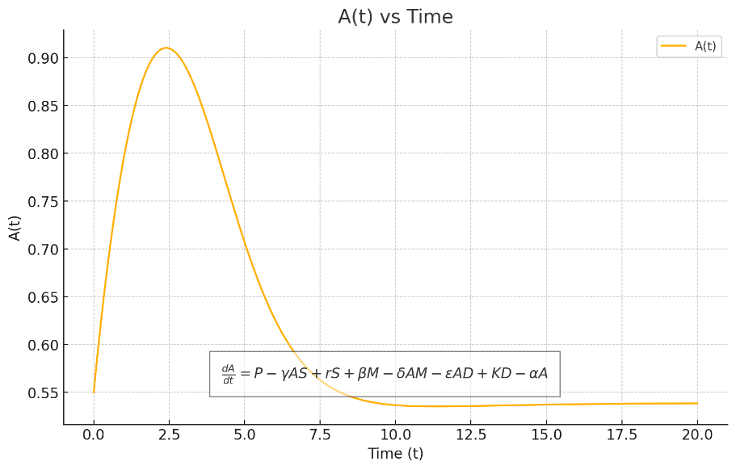

***Figure 1: the population of individuals with addition skill A(t) against time,t.***

Initially, A(t) increases indicating rapid growth due to the influence of positive terms in the equation, such as P and rS. After reaching a peak, A(t) experiences a sharp decline, suggesting that negative feedback mechanisms, including interactions with S, M, and D, become dominant over time. Eventually, A(t) stabilizes at a lower value, achieving a balance between the positive and negative terms in the equation.

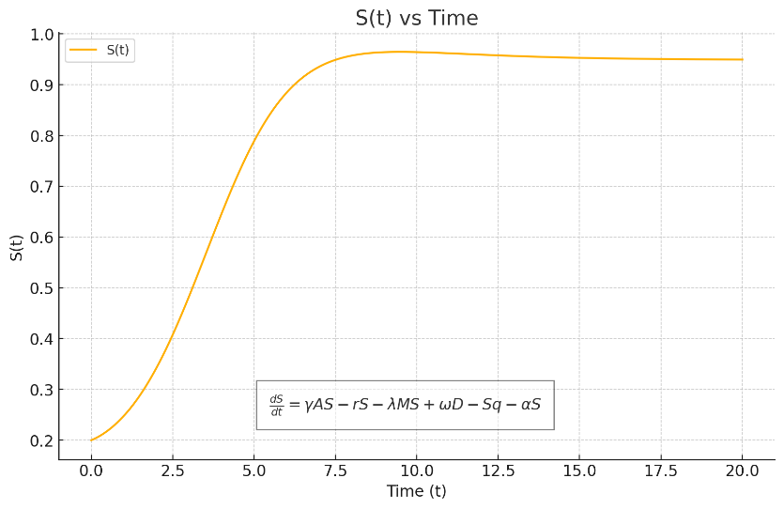

***Figure 2: the population of individuals with subtraction skill S(t) against time,t.***

At the start, S(t) increases rapidly from its initial value, driven by positive terms like γAS and ωD. The growth then slows down and stabilizes, indicating that the negative terms, such as rS and λMS, counterbalance the growth, leading to a new equilibrium state.

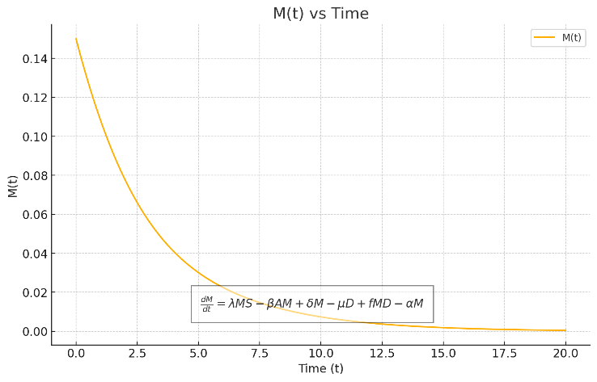

***Figure 3: the population of individuals with multiplication skill M(t) against time, t***

Initially, M(t) starts monotonically decreasing almost immediately, suggesting the dominance of negative terms, such as βAM and αM. Over time, M(t) continues to decrease and approaches zero, indicating a lack of sufficient positive feedback to sustain or increase its value. 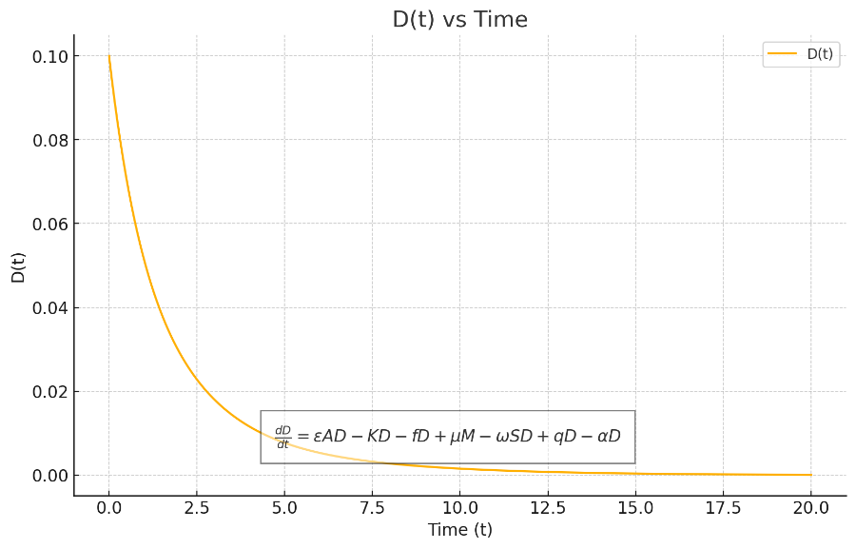

***Figure 4: the population of individuals with division skill D(t) against time,t***

Initial Decline: D(t) decreases rapidly, showing the initial dominance of negative terms such as KD and αD. Approaching Zero: D(t) continues to decline and approaches zero, indicating that the system does not support sustained or increased values of D(t) under the given parameters.

1. **Discussion and Interpretation of Results**

These results revealed dynamic and nonlinear interactions among the variables A(t), S(t), M(t) and D(t). The initial conditions and parameter values led to a scenario where:

A(t) and S(t) exhibit transient behavior, with A(t) exhibited a normal distribution population by peaking and then stabilizing at a lower value, while S(t) grows and stabilizes at a higher value asymptotically. Both M(t) and D(t) exhibit a continuous exponential decline approaching zero, indicating that they cannot sustain their initial values under the influence of the given interactions and parameters. The system exhibits nonlinear dynamics and chaos for specific parameter ranges. Chaotic behaviour is characterized by: Sensitivity to initial conditions, Unpredictability Complex, and a periodic behaviour. The system's behaviour is sensitive to changes in parameters γ, δ, ε, and K. The sensitivity analysis reveals: γ and ε have the largest impact on the system's behaviour; δ and K have moderate impacts; and R has a significant impact on the system's behaviour. These results can guide parameter estimation, model refinement, and control strategy development. The investigation demonstrated that: LSE and MLE can effectively estimate parameters, MLE provides more accurate estimates and Gradient-based optimization converges faster. The analysis also revealed that: the estimates have reasonable uncertainty, Bootstrap resampling provides a robust uncertainty estimate and CIs and SEs provided a concise uncertainty summary. The basic operations achievement in mathematics increases with student engagement and mathematical knowledge. Difficulty level or contents negatively impacts mathematics achievement. However, the results from this study are in conformity with [1, 18, 19, 23, 29, 30].

**Conclusion/Recommendations**

The model showed that basic operations in mathematics are epidemic and should be given serious attention at all levels of education from primary, secondary and tertiary schools as to reduce the rate of poor performance at school. This study will help mathematics teachers and learners to enhance the understanding of basic operations by spending time to impart knowledge. Hence, this paper recommends that curriculum planner should give more time to teaching and learning the concept of elementary mathematics skills, trained teachers of mathematics should teach the learners effectively and efficiently from simple to difficult concepts and mathematics teachers should not look down on these skills as been simple to learn. Using a combination of analytical and numerical methods, we investigated the model's behavior, exploring the impact of parameter variations on basic operation skills trajectories and achievement outcomes. The results provided valuable insights into the complex interplay between cognitive and affective factors, highlighting the critical role of engagement, difficulty level, and cognitive load in facilitating or hindering skills development. This research contributes to the growing body of literature on mathematical modeling in education, offering a novel framework for understanding the nonlinear dynamics underlying basic operations skills acquisition. The findings have implications for educational practice, suggesting targeted interventions to optimize student learning and improve mathematical achievement. Using a combination of analytical and numerical methods, we investigate the model's behavior, exploring the impact of parameter variations on skill acquisition trajectories. The results provide valuable insights into the complex interplay between cognitive and affective factors, highlighting the critical role of engagement and difficulty level in facilitating or hindering skill development. This research contributes to the growing body of literature on mathematical modeling in education, offering a novel framework for understanding the dynamic processes underlying basic operation skills in mathematics. The findings have implications for educational practice, suggesting targeted interventions to optimize student learning and improve mathematical achievement. The acquisition of basic operations skills, such as arithmetic and algebraic manipulations, forms the foundation of mathematical proficiency. Understanding the complex processes underlying this skills acquisition is crucial for developing effective educational strategies and improving student achievement. Traditional approaches to modeling skills acquisition often overlook the nonlinear interactions and dynamic transitions inherent in the learning process. Policy Implications are to increase student engagement through interactive teaching methods, improve mathematical knowledge through targeted interventions and adjust difficulty levels or contents to optimize student learning outcomes. The physical/real-world applications of this study are found in the daily life activities around our environment, business areas, academic (teaching –learning) environment whereby some individuals can add and subtract numbers but when it comes to division and multiplication of numbers they start to encounter difficulties. This study did not incorporate external factors, socioeconomic status, nonlinear relationships and so on.

**Authors’ contributions**

This work was carried out in collaboration among the authors. All authors read and approved the

final manuscript.

Disclaimer (Artificial intelligence)

Author(s) hereby declare that NO generative AI technologies such as Large Language Models (ChatGPT, COPILOT, etc.) and text-to-image generators have been used during the writing or editing of this manuscript.

**CONFLICT OF INTEREST**

The authors declared that there is no conflict of interest and the study is not supported nor funded by any grant.

**References**

# Alkhudhari *et al.* (2014). Sensitivity analysis of the parameters of a cholera model. *J. Appl. Sci. Environ. Manage.* 22(4), 477-481.

# Altuntaş, M., Ay, Z. S., & Çetin, I. (2024). Mathematical modeling in online learning environments: Student challenges.Bolu Abant İzzet Baysal Üniversitesi Eğitim Fakültesi Dergisi, 24(2), 1049-1075. https://dx.doi.org/10.17240/aibuefd.2024..-1407578

1. Appiah, J. B., Korkor, S., Arthur, Y. D., & Obeng, B. A. (2022). Mathematics achievement in high schools, the role of the teacher-student relationship, students’ self-efficacy, and students’ perception of mathematics. *International Electronic Journal of Mathematics Education, 17*(3), em0688. https://doi.org/10.29333/iejme/12056.
2. Arthur, Y. D., Asiedu-Addo, S., & Assuah, C. (2017). Students’ perception and its impact on Ghanaian students’ interest in mathematics: Multivariate statistical analytical approach. *Asian Research Journal of Mathematics, 4*(2), 1-12. https://doi.org/10.9734/arjom/2017/33023
3. Bhagavathi, R. Kufoalor, D.K.M. & Hasan, A.(2023). Digital twin-driven fault diagnosis for autonomous surface vehicles. *IEEE Access,* 11,41096-41104
4. Boada, Y., Flores, F. J., & Vignoni, A. (2024). Integrating mathematical modeling into synthetic biology education: A comprehensive approach through webinars and syllabus development. *Frontiers in Education*, *9*, 1486293. https://doi.org/10.3389/feduc.2024.1486293
5. Bočková, V. & Rumanová, L. (2024). Mathematical Modeling Approach and Exploration of Geometric Properties as Part of an Outdoor Activity for Primary-School Pupils in Out-of-School Learning. Educ. Sci. 14(12), 1304; https://doi.org/10.3390/educsci14121304
6. Bonne, L., & Lawes, E. (2016). Assessing students’ maths self-efficacy and achievement. *Set: Research Information for Teachers, 2*, 60-64. https://doi.org/10.18296/set.0048
7. Brunton, S.L. & Kutz, J.N.(2019). Data-Driven Science and Engineering: Machine Learning, Dynamical Systems and Control. *Cambridge University Press*
8. Callaman, R. A., & Itaas, E. C. (2020). Students’ mathematics achievement in Mindanao context: A meta-analysis. *Journal of Research and Advances in Mathematics Education, 5*(2), 148-159. https://doi.org/10.23917/jramathedu.v5i2.10282
9. Dahal, N., Luitel, B. C., & Pant, B. P. (2019). Teacher-students relationship and its potential impact on mathematics learning. *Mathematics Education Forum Chitwan, 4*(4), 35-53. https://doi.org/10.3126/mefc.v4i4.26357
10. Daud, A. S., Adnan, N. S. M., Aziz, M. K. N. A., & Embong, Z. (2020). Students’ perception towards mathematics using APOS theory: A case study. *Journal of Physics: Conference Series, 1529*, 032020. https://doi.org/10.1088/1742-6596/1529/3/032020
11. Dominguez, A. (2024). Teaching dynamics to enhance critical thinking and knowledge socialization in the mathematics classroom. *Frontiers in Education*, *9*, 1388720. https://doi.org/10.3389/feduc.2024.1388720
12. El Bhih, A., Benfatah, Y., Hassouni, H., Balatif, O., & Rachik, M. (2024). Mathematical modeling, sensitivity analysis, and optimal control of students awareness in mathematics education. *Partial Differential Equations in Applied Mathematics*, *11*, 100795. https://doi.org/10.1016/j.padiff.2024.100795
13. Grune, L. & Pannek, J. (2017). Nonlinear Model Predictive Control. *Springer*
14. Hasan, A., Widyotriatmo, A. Fagerhaug, E. & Osen, O. (2023). Predictive digital twins for autonomous ships, 2023 IEEE Conference on Control Technology and Applications (CCTA) 1128-1133
15. Hasan, A., Widyotriatmo, A. Fagerhaug, E. & Osen, O.(2023). Predictive digital twins for autonomous surface vessels. *Ocean Eng.*, 288, 116046
16. Hasan, A. (2024).WyNDA: A method to discover mathematical models of dynamical systems from data.*ELSEVIER, Method X,* 12(1), https://doi.org/10.1016/j.mex.2024.102625
17. Haciomeroglu, G. (2019). The relationship between elementary students’ achievement emotions and sources of mathematics self-efficacy. *International Journal of Research in Education and Science, 5*(2), 548-559.
18. Hughes, J., & Kwok, O. (2007). Influence of student-teacher and parent-teacher relationships on lower achieving readers’ engagement and achievement in the primary grades. *Journal of Educational Psychology, 99*(1), 39-51. https://doi.org/10.1037/0022-0663.99.1.39
19. Julie, H., Sanjaya, F. & Anggoro, Y. (2017): The Students’ Ability in Mathematical Literacy for Uncertainty Problems on the PISA Adaptation Test *AIP Conference Proceedings* (Yogyakarta: Universitas Negeri Yogyakarta)
20. Kaasila, R. T., Hannula, M. S., Laine, A., & Pehkonen, E. (2006). Facilitators for change of elementary teacher student’s view of mathematics. In *Proceedings of the 30th Conference of the International Group for the Psychology of Mathematics Education* (pp. 385-392).
21. Kline, R. B. (2011). Convergence of structural equation modeling and multilevel modeling. In M. Willams, & W. P. Vogt (Eds.), *The SAGE handbook of innovation in social research methods* (pp. 562-289). SAGE. https://doi.org/10.4135/9781446268261.n31
22. Lasalle J. & Lefschetz S. (1976). The stability of dynamical systems. *SIAM*, Philadelphia
23. Molly, M. (2013). Computational Skills retrieved from SpringerReference. Items. America: Brown Center on Education Policy, The Brookings Institution Press.
24. Mutodi, P., & Ngirande, H. (2014). The influence of students’ perceptions on mathematics performance. A case of a selected high school in South Africa. *Mediterranean Journal of Social Sciences, 5*(3), 431-445. https://doi.org/10.5901/mjss.2014.v5n3p431
25. Nelles, O. (2020). Nonlinear dynamic system identification. *Springer*
26. Owoyemi, A. E., Sulaiman, I. M., Mamat, M. & Olowo, S. E. (2021). "Stability and Bifurcation Analysis in a Fractional-order Epidemic Model with Sub-Optimal Immunity, Nonlinear Incidence and Saturated Recovery Rate." *IAENG International Journal of Applied Mathematics* 51, no. 3 (2021).
27. Owoyemi,A. E., Sulaiman, I. M., Mamat, M. & Olowo, S. E. (2021), Stability and Bifurcation Analysis in a Fractional-order Epidemic Model with Sub-Optimal Immunity, Nonlinear Incidence and Saturated Recovery Rate. *IAENG International Journal of Applied Mathematics* (Accepted Journal - Ref no. - IJAM_2020_06_07a).
28. Owoyemi, A. E., Sulaiman, I. M., Kumar, P., Govindaraj, V. & Mamat, M. (2023). Some novel mathematical analysis on the fractional-order 2019-nCoV dynamical model. *Journal of Mathematics Methods in Applied Sciences.* 2022. [doi.org/10.1002/mma.8772](https://doi.org/10.1002/mma.8772).
29. Okuonghae D. (2019). Theoretical analysis of a mathematical model for the dynamics of corruption: a guide from epidemiological modelling. Journal of the Nigerian Society for Mathematical Biology, Vol 2: 1-13.
30. Rizki, L. M. & Priatna, N. (2019). Mathematical literacy as the 21st century skill. International Conference on Mathematics and Science Education (ICMScE 2018), IOP Conf. Series: Journal of Physics: Conf. Series 1157 , 042088; IOP Publishing, doi:10.1088/1742-6596/1157/4/042088
31. Sideris, T.C. (2013). Ordinary Differential Equations and Dynamical Systems. *Springer*
32. Prasad, P. V., & Kalinec-Craig, C. (2021). Creating a democratic mathematics classroom: The interplay of the rights and responsibilities of the learner. *Democracy & Education, 29*(1), Article 2. https:// democracyeducationjournal .org/ home/ vol29/ iss1/ 2
33. Sjöblom, M. (2022). *Promoting mathematical dialogue: Students’ and teachers’ listening, questioning and participation* [Doctoral dissertation, Malmö Universitet]. https://doi .org/ 10 .24834/ isbn .9789178772100
34. Spooner, K., Nomani, J. & Cook, S., 2024. Improving high school students' perceptions of mathematics through a mathematical modeling course. Teaching Mathematics and its Applications: *International Journal of the IMA*, 43(1), pp.38-50.
35. Sudha , P. et al (2024), Mathematical Applications And Modelling In Higher Education , Educational Administration:Theory and Practice. 30(7), 318- 323Doi: 10.53555/kuey.v30i7.6665A [accessed Feb 19 2025].
36. Teklu, S. W., & Terefe, B. B. (2022). Mathematical modeling analysis on the dynamics of university students animosity towards mathematics with optimal control theory. *Scientific Reports*, *12*(1), 1-19. https://doi.org/10.1038/s41598-022-15376-3
37. Tella, A. (2008). Teacher variables as predictors of academic achievement of primary school pupils’ mathematics. *International Electronic Journal of Elementary Education, 1*(1), 16-33. https://doi.org/10.4314/ifep.v16i2.23806
38. Toropova, A., Johansson, S., & Myrberg, E. (2019). The role of teacher characteristics for student achievement in mathematics and student perceptions of instructional quality. *Education Inquiry, 10*(4), 275-299. https://doi.org/10.1080/20004508.2019.1591844
39. van den Bosch,P.P.J. & van der Klauw, A.C.(2016). Modeling, Identification and Simulation of Dynamical Systems. *Taylor & Francis*
40. Wijaya, A. (2016): Students’ Information Literacy: A Perspective from Mathematical Literacy *IndoMS Journal Mathematics Education* 7, 73 – 82.
41. Xu, Z. Z., & Qi, C. (2019). The relationship between teacher-student relationship and academic achievement: The mediating role of self-efficacy. *EURASIA Journal of Mathematics, Science and Technology Education, 15*(10), em1758. https://doi.org/10.29333/ejmste/105610
42. Zimmerman, B. J. (1990). Self-regulating academic learning and achievement: The emergence of a social cognitive perspective. *Educational Psychology Review, 2*(2), 173-201. https://doi.org/10.1007/BF01322178