Analysis of Heat and Mass Transfer of Second Grade Fluid Flow with effects of Hall current, viscous dissipation and Chemical reaction
Abstract: This study presents a mathematical model to analyze the influence of thermophoresis on the unsteady flow of a non-Newtonian second-grade fluid, incorporating heat and mass transfer through a porous medium near a permeable, infinite vertical plate. The governing partial differential equations (PDEs) are derived and converted into a dimensionless form using similarity variables. The resulting nonlinear PDEs are solved numerically using the shooting method combined with a sixth-order Runge-Kutta scheme. The model integrates Hall current and magnetic effects into the continuity, momentum, energy, and concentration equations. Computational simulations are performed using Maple mathematical software. The formulated equations incorporate multiple physical phenomena, such as thermal radiation, heat generation, thermal diffusion (Soret effect), viscous dissipation, and chemical reactions. These dimensionless equations are solved numerically as functions of relevant physical parameters. The numerical solutions provide insights into the velocity components (u and w), temperature (θ), and concentration (C), as well as the Nusselt number (Nu) and Sherwood number (Sh). The findings are graphically illustrated and thoroughly discussed. The analysis highlights the impact of key physical parameters on the flow and transport characteristics. For instance, an increase in the heat source parameter (ϕ) boosts both primary and secondary velocities, while also elevating the temperature profile. Similarly, a rise in the chemical reaction parameter (γ) leads to higher velocities and significantly enhances the concentration distribution. These results are visually represented through graphs, offering a comprehensive understanding of the system's behavior under varying conditions
Keywords: Second-grade fluid, Thermo diffusion, Heat and mass transfer, Viscous dissipation,
Thermophoresis, Hall urrent, Thermal radiation, unsteady

Nonmenclature
P initial hydrostatic pressure ν kinematic viscosity of the fluid
$μ$ dynamic viscosity of the fluid ρ density of the fluid
$α_{1}$ and $α_{2}$ second material constants g gravitational acceleration
$A_{1}$ and $A_{2}$ fluid kinematic Ericksen tensors , $β_{T}$ coefficient of thermal expansion
d/dt time derivative material $β_{c}$ coefficient of volumetric expansion
E* $E^{*}$ field electric vector intensity $T^{*}$ fluid temperature
H magnetic field strength vector $T_{w}^{*}$ plate temperature
$P_{e }$ electron fluid pressure $T_{∞}^{*}$ far away plate temperature
$ω_{e}$ frequency of the electron $σ^{*}$ Boltzmann- Stefan constant,
$J_{x}^{*}$ and $J_{z}^{*}$ fluid current electric density $v^{*}$ velocity of the suction
${ V}_{T}$ velocity of thermophoretic $v_{0}$ average suction velocity
$T_{r}$ fluid temperature reference $α$ viscoelastic figure
$k_{t}v$ diffusivity thermophoretic $Gr$ Grashof parameter
${ K}_{n}$ fluid thermal conductivity $Gc$ modified Grashof parameter
$K_{2}$ fluid chemical parameter $M$ magnetic parameter
$M$ magnetic parameter $K$ Darcy figure
$C_{w}^{*}$ Solute concentration $Pr$ Prandtl parameter
$C_{∞}^{*}$ far away concentration of the plate $Nr$ thermal radiation value
K porous medium permeability $Ec$ Eckert parameter figure
Κ medium thermal conductivity $∅$ source of heat parameter figure
Cp constant pressure (specific heat) $Sc$ Schmidt parameter figure
m Hall current value $Sr$ Soret parameter figure
$D_{m}$ diffusivity of the chemical molecular $γ$ non-dimensional chemical reaction
$q_{r}$ heat flux radiative parameter $τ$ thermophoretic parameter.
u(t, y). profile of the primary velocity w(t, y) profile of the secondary velocity
$k^{*}$ average coefficient absorption C(t, y) profile of the concentration

1. Introduction
The study of viscoelastic second-grade fluids flowing through porous media, coupled with heat and mass transfer, holds immense importance across various fields, including natural processes, industrial applications, and biomedical sciences. These fluids are integral to geothermal energy extraction, soil science, and drug delivery systems, such as transdermal drug permeation. Given their wide-ranging applications, researchers from disciplines like mathematics, physics, geology, and chemistry have extensively investigated their behavior under various influences, such as heat generation/absorption, thermal radiation, chemical reactions, and Hall currents. This review synthesizes key findings from prior studies to provide a comprehensive understanding of the subject.
Hayat et al. (2020) conducted simulations to model entropy-optimized magnetohydrodynamic (MHD) flow of second-grade fluids, focusing on dissipation effects. Piazza (2008) explored thermophoresis, a process where particles migrate due to thermal gradients, which has applications in macromolecular fractionation, microfluidic systems, and colloidal structure manipulation. Chamkha and Issa (2000) investigated the influence of heat generation and thermophoresis on hydromagnetic flow with heat and mass transfer over a flat surface. Raees et al. (2023) analyzed non-similar mixed convection in the magnetic flow of second-grade nanofluids over a vertically stretching sheet. Alam, Rahman, and Sattar (2007) examined the combined effects of thermophoresis and chemical reactions on unsteady free convection and mass transfer near an inclined porous plate, considering heat generation/absorption. Bhuvanavijaya (2014) studied thermophoretic effects on convective heat and mass transfer over a vertical porous plate in a rotating system with suction and injection.
Further studies have explored these phenomena in diverse fluid models. Hayat et al. (2021) investigated the impact of an induced magnetic field on second-grade nanofluid flow past a convectively heated stretching sheet. Animasaun (2015) analyzed free convective heat and mass transfer in a non-Darcian MHD dissipative Casson fluid, incorporating thermophoresis, variable viscosity, and thermal conductivity. Das, Jana, and Kundu (2015) studied thermophoretic MHD slip flow over a permeable surface, while Fagbade, Falodun, and Boneze (2015) examined Darcy–Forchheimer mixed convection flow in a porous medium under a magnetic field, considering viscous dissipation and thermophoresis. Khan et al. (2020) focused on irreversibility analysis and heat transport in squeezing nanoliquid flow of non-Newtonian (second-grade) fluids between infinite plates, incorporating activation energy.
Flow over permeable plates is particularly relevant in geophysics and industries such as nuclear engineering, where magnetic fields significantly influence fluid dynamics. Chemical reactions play a pivotal role in heat and mass transfer, with applications in food processing and polymer production. Eldabe et al. (2015) investigated the Hall effect in third-order fluid flow through a porous medium with heat and mass transfer. Kumar et al. (2016) studied unsteady free convective heat and mass transfer of a Walters-B viscoelastic fluid over a vertical cone, incorporating thermal radiation, thermophoresis, and higher-order chemical reactions. Earlier, Eldabe (1986) and Kim (2000) examined unsteady MHD free convective flow over an infinite vertical porous plate with variable suction. Kalaivanan et al. (2020) explored the role of Arrhenius activation energy in second-grade nanofluid flow with active and passive control of nanomaterials.
Chamkha, Mansour, and Aly (2011) extended previous work by including Hall current, thermal radiation, and chemical reaction effects. Vempati and Laxmi-Narayana-Gari (2010) investigated the influence of Soret and Dufour effects on unsteady MHD flow past a porous plate with thermal radiation. Reddy, Raju, and Reddy (2015) analyzed unsteady MHD free convection of a Kuvshinski fluid past a vertical porous plate, considering chemical reactions and heat sources/sinks. Khan et al. (2021) examined the effects of nonlinear thermal radiation and activation energy on modified second-grade nanofluids using Cattaneo–Christov expressions. Eldabe, El-Saka, and Fouad (2004) discussed thermal-diffusion and diffusion-thermo effects on mass transfer boundary layer flow in non-Newtonian fluids.
Oahimire and Olajuwon (2013) and Reddy et al. (2014) studied the combined effects of Hall current and thermal radiation on unsteady chemically reacting micropolar fluids, later extended by Olajuwon, Oahimire, and Ferdow (2014) to include viscoelastic models. Pandya and Shukla (2016) investigated the combined influence of thermophoresis, Dufour effects, Hall current, and radiation on unsteady MHD flow past an inclined plate, incorporating viscous dissipation, chemical reactions, and heat generation/absorption. Abbas, Sajid, and Asghar (2007) examined the role of thermal radiation in MHD flow of a second-grade fluid, while Nadeem and Siddiqui (2005) explored unsteady second-grade fluid flow in a rotating system influenced by Hall current. Waqas et al. (2020) studied activation energy and bioconvection in generalized second-grade nanofluids over a Riga plate.
Hayat and Nawaz (2011) analyzed three-dimensional second-grade fluid flow under Hall and ion slip effects. Cortell (2007) investigated mass transfer in second-grade fluid flow over a stretching sheet in a porous medium, while Hayat, Mustafa, and Pop (2010) studied heat and mass transfer with Soret and Dufour effects in viscoelastic fluids. Rashidi et al. (2014) and Chaudhary and Jain (2006) examined Hall current effects on MHD mixed convection flow of viscoelastic fluids past a vertical porous plate with mass transfer and radiation. Reddy et al. (2022) explored the dynamics of MHD second-grade nanofluid flow with activation energy across a curved stretching surface. Kumar and Chand (2011) studied slip conditions in unsteady MHD flow of a viscoelastic fluid past an infinite porous plate embedded in a porous medium.
Sahoo (2013) analyzed heat and mass transfer in MHD viscoelastic fluid flow through a porous medium bounded by an oscillating porous plate in a slip flow regime. Das (2013) investigated unsteady two-dimensional viscoelastic fluid flow in a porous channel with radiative heat and mass transfer. Jha et al. (2014) examined Soret and Hall current effects on MHD mixed convection of viscoelastic fluids, while Das et al. (2016) studied thermophoresis and thermal radiation effects in second-grade MHD fluid flow past a semi-infinite stretching sheet with convective surface heat flux. VeeraKrishna and Swarnalathamma (2016) investigated Hall effects on unsteady MHD free convection of a conducting second-grade fluid in a porous medium over an infinite rotating vertical plate with heat sources/sinks and chemical reactions. Subbarao et al. (2022) analyzed entropy generation in a second-grade nanoliquid influenced by an exponential space-dependent heat source and Arrhenius activation energy.
Sudhakar et al. (2012) studied heat and mass transfer in unsteady free convection of a Walters-B viscoelastic fluid under thermophoresis effects. Nayak and Panda (2013) presented insights into mixed convective MHD flow of second-grade fluid past a vertical infinite plate, incorporating mass transfer, Joule heating, and viscous dissipation. Reza-E-Rabbi et al. (2024) examined non-linear radiative second-grade nanofluid flow with sinusoidal magnetic force and Arrhenius activation energy. Ahmed (2015) investigated Hall current effects on unsteady MHD viscoelastic fluid flow with radiative heat flux and heat sources in a porous medium.
Despite extensive research, certain aspects remain underexplored. Specifically, the combined effects of thermophoresis, Soret effects, Hall currents, thermal radiation, heat generation/absorption, viscous dissipation, and chemical reactions on second-grade fluid flow through porous media require further investigation. This study aims to address these gaps by extending the work of Nayak and Panda (2013, 2015) and Nabil (2017), exploring the interplay of these factors in fluid flow dynamics.
The findings reveal that in the absence of a magnetic field, no flow occurs along the Z-axis. Increasing the thermophoretic parameter (τ) reduces primary and secondary velocities and the temperature profile while enhancing concentration. The concentration profile C(t,y) remains unaffected by the Soret parameter (Sr) within the range 0.6 ≤ y ≤ 0.7 but shows Sr’s influence outside this range. Higher values of the heat source parameter (ϕ) and the chemical reaction parameter (γ) increase both velocities, with γ also significantly boosting concentration.

2. Model Formulation
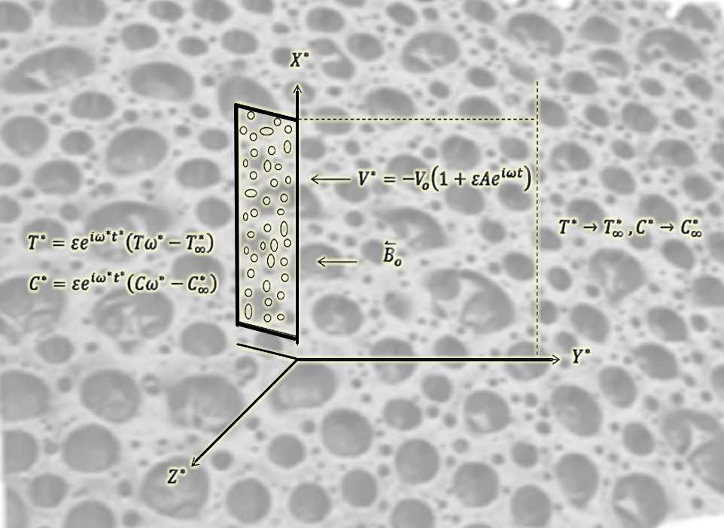
FIG 1: Flow Geometry
Maxwell's equations provide a foundational framework for understanding electromagnetic fields. Specifically, the divergence equation of the magnetic field, ∇·B = 0, leads to the conclusion that By∗=B, assuming a uniform magnetic field and a very small magnetic Reynolds number (Rem​=μm​σvL≪1). Under this condition, the induced magnetic field becomes negligible compared to the applied magnetic field, resulting in B_{x∗}=B_{z∗}=0, Bx∗​=Bz∗​=0. Consequently, the magnetic field can be expressed as B=(0, B₀, 0). Here, L represents the characteristic length, and μm denotes the magnetic permeability. In the study of fluid dynamics, significant attention has been given to understanding the thermodynamical and mechanical behavior of non-Newtonian fluids. Among these, second-grade fluids have been extensively investigated due to their theoretical and experimental relevance. For such fluids, the relationship between the Cauchy stress tensor T and the fluid motion is described by the work of Truesdell and Noll (1965). This relationship is crucial for modeling the complex behavior of these fluids under various conditions.
$T=-PI+{μA}_{1}+α_{1}A_{2}+α_{2}{{A_{2}∇}_{1}}^{2} .$ (1)

The spherical stress component, denoted as −PI, arises from the incompressibility constraint, while P represents the hydrostatic pressure. The dynamic viscosity is given by μ, and α₁ and α₂ are material-specific constants. Additionally, A₁ and A₂ correspond to the Rivlin-Ericksen tensors, which describe kinematic behavior.
$A_{1}=\left(∇V\right)+{(∇V)}^{T}, A_{2}= \frac{dA_{1}}{dt}+ A_{1}\left(∇V\right)+{(∇V)}^{T}A_{1},$ (2)

The material time derivative is denoted by d/dt . For a second-grade fluid governed by Eq. (1) to align with thermodynamic principles, it must satisfy the Clausius–Duhem inequality under all conditions. Additionally, if the specific Helmholtz free energy of the fluid is assumed to reach its minimum when the fluid is locally at rest, the coefficients m, a1​, and a2​ must adhere to specific constraints. These coefficients represent viscosity, visco-elasticity, and cross-viscosity, respectively.
$μ≥0, α_{1}≥0, α_{1}+α_{2}=0 ,$ (3)

When $α_{1 }= α_{2}=0$, the constitutive equation for a second-grade fluid reduces to that of a viscous fluid. If E* $E^{*}= \left(E_{x}^{*}, E_{y}^{*},E_{z}^{*}\right)$ represents the electric field vector, it becomes zero because no polarization voltage is applied to the flow field, and no energy is either added to or extracted from the fluid by the electric field. The velocity vector of the fluid, denoted as VV, has components u∗,v∗,w∗. The current density vector J has components $J_{x}^{*}, J_{y}^{*}, J_{z}^{*},$​. From the charge conservation equation ∇⋅J=0, it follows that Jy∗​ is constant. This constant is zero because the plate is non-conductive. Using Maxwell's equations, we can further derive the following:
$∇∧E=$0, $∇∧H=J, ∇.B=0,$ (4)

The intensity of the magnetic field vector is denoted by H. According to the Generalized Ohm's Law
$J= \frac{σ}{ene} \left[{en}_{e}\left(E+V∧B\right)-\left(J∧B\right)+∇P_{e}\right],$ (5)
In scenarios where the magnetic field strength is extremely high, the generalized Ohm’s law can be adapted to account for the Hall current. This modification is applicable under conditions where the electric field is absent, and effects such as ion-slip and thermoelectric pressure are negligible, particularly in weakly ionized gases. Under these assumptions, Equation (5) can be rewritten in the following form:
$J= σ\left(V∧B+ \frac{1}{{en}_{e}}∇ P_{e}\right)+ \frac{ω_{e}τ_{e}}{B_{0}} \left(B ∧J\right),$ (6)
The electron pressure and frequency are denoted by Pe​ and ωe​, respectively. The collision time of the electron is represented by τe​, and ne​ stands for the electron number density. Additionally, s signifies the fluid's electrical conductivity. The Hall parameter, m, is defined as m=ωe​τe​. This parameter contributes to the generation of the Lorentz force in the z-direction, which in turn induces a cross flow along the same axis. As a result, the flow field becomes three-dimensional. From the above, equation (6) can be derived as follows:
$J_{x}^{*}= \frac{σB_{0}}{\left(1+m^{2}\right)} \left(mu^{*}- w^{*}\right), J_{z}^{*}= \frac{σB_{0}}{\left(1+m^{2}\right)} \left(u^{*}+mw^{*}\right) ,$ (7)

The electric current densities along the x∗-axis and z∗-axis are denoted as Jx∗​ and Jz∗​, respectively. According to the research conducted by Wu and Greif in 1996, the thermophoretic velocity, represented as VT​, was calculated.
$V_{T}= \frac{-K_{t}V}{T_{r}}, ∇T=\frac{-K_{t}V}{T_{r}} \frac{∂T}{∂y},$ (8)

The reference temperature is denoted by Tr​. The thermophoretic diffusivity is represented by kt​v, where kt​ is the thermophoresis coefficient. According to Batchelor and Shen (1985), the value of kt​ typically falls within the range of 0.2 to 1.2. Additionally, Talbot, Cheng, Schefer, and Willis (1980) have also contributed to the understanding of this parameter.
$k_{t}=\frac{2c_{s}\left(\frac{⋋_{g}}{⋋_{p}} +C_{t}K_{n}\right) \left[K_{n}\left(C_{1}+C_{2}\exp^{\frac{-C_{3}}{K_{n}}}\right)\right]}{2\left(1+3C_{m}K_{n}\right) \left(C_{t}K_{n} + \frac{⋋_{g}}{⋋_{p}} + \frac{1}{2}\right)},$ (9)
In the given context $C_{s},{ C}_{t,}{ C}_{1, }C_{2,} C_{3,}{ C}_{m}$​,​ represent constants, while λg​, λp​, and Kn​ denote the thermal conductivities of the fluid, diffused particles, and the Knudsen number, respectively. Additionally, the thermophoretic parameter t can be expressed as follows:
$τ= \frac{k_{t }\left(T_{w}- T_{∞}\right)}{T_{r}},$ (10)

The parameter τ commonly takes on values such as 0.01, 0.05, and 0.1. These values correspond to approximate temperature differences $(T_{w} -T_{∞})$ of 3K, 15K, and 30K, respectively, when the reference temperature Tr is set to 300K. Within this context, the flow dynamics are described by governing partial differential equations under the standard Boussinesq approximation. These include the continuity equation, which is expressed as follows:
The continuity model:
$\frac{∂v^{*}}{∂y^{*}}=0,$ (11)
The momentum model in the x axis
$$\frac{∂u^{*}}{∂t^{*}}+v^{*}\frac{∂u^{*}}{∂y^{*}}=v\frac{∂^{2}u^{*}}{∂y^{*2}}+\frac{α_{1}}{ρ}\left(\frac{∂^{3}u^{*}}{∂t^{*}∂y^{*2}}+v^{*}\frac{∂^{3}u^{*}}{∂y^{*3}}\right)+{gβ}_{T} \left(T^{*} -{T^{*}}_{∞}\right)+{gβ}_{c}\left(c^{**}-c_{∞}^{*}\right)$$
$-\frac{σB_{0}^{2}\left(u^{*}+mw^{*}\right)}{ρ\left(1+m^{2}\right)}-\frac{ν}{k}u^{*}+v\frac{∂^{2}u^{*}}{∂x^{*2}} +-\frac{σB_{0}^{2}\left(u^{*}-mw^{*}\right)}{ρ\left(1-m^{2}\right)}$ (12)
The momentum model in the z axis:
$\frac{∂w^{*}}{∂t^{*}}+v^{*}\frac{∂w^{*}}{∂y^{*}}=v\frac{∂^{2}u^{*}}{∂y^{*2}}+v\frac{∂^{2}u^{*}}{∂x^{*2}}+\frac{α_{1}}{ρ}\left(\frac{∂^{3}w^{*}}{∂t^{*}∂y^{*2}}+v^{*}\frac{∂^{3}w^{*}}{∂y^{*3}}\right)-\frac{σB_{0}^{2}\left(w^{*}-mu^{*}\right)}{ρ\left(1+m^{2}\right)}-\frac{ν}{k}u^{*},$ (13)
The temperature model:
$\frac{∂T^{*}}{∂t^{*}}+v^{*}\frac{∂T^{*}}{∂y^{*}}=\frac{k}{{ρc}_{ρ}}\frac{∂^{2}T^{*}}{∂y^{*2}}+\frac{α_{1}}{{ρc}_{ρ}}\left(v^{*}\frac{∂u^{*}}{∂y^{*}}\frac{∂^{2}u^{*}}{∂y^{*2}}+\frac{∂w^{*}}{∂y^{*}}\frac{∂^{2}w^{*}}{∂y^{*2}}\right)+\frac{μ}{{ρc}_{ρ}}\left[{\left(\frac{∂u^{*}}{∂y^{*}}\right)}^{2}+{\left(\frac{∂w^{*}}{∂y^{*}}\right)}^{2}\right]=\frac{Q_{0}}{{ρc}_{ρ}}\left(T^{*} -T_{∞}^{*}\right)-\frac{1}{{ρc}_{ρ}}\frac{∂q_{r}}{∂y^{*}}+v^{*}\frac{∂T^{*}}{∂x^{*}}+\frac{v}{{ρc}_{ρ}}\left(v^{*}\frac{∂v^{*}}{∂x^{*}}\frac{∂^{2}v^{*}}{∂x^{*2}}+\frac{∂w^{*}}{∂x^{*}}\frac{∂^{2}w^{*}}{∂x^{*2}}\right)$ (14)
Mass concentration model
$\frac{∂C^{*}}{∂t^{*}}+v^{*}\frac{∂C^{*}}{∂y^{*}}+v^{*}\frac{∂C^{*}}{∂x^{*}}=D_{m}\frac{∂^{2}C^{*}}{∂y^{*2}}+D_{m}\frac{∂^{2}C^{*}}{∂x^{*2}}-\frac{∂v_{T}\left(C^{*} -C_{∞}^{*}\right)}{∂y^{*}}+\frac{D_{m}k_{T}}{T_{m}}\frac{∂^{2}T^{*}}{∂y^{*2}}-k_{c}\left(C^{*} -C_{∞}^{*}\right)$ (15)
Boundary conditions for the model are:
$\left.\begin{aligned}{at y}^{*}=0, { u^{*}=0, w}^{*}=0, T^{*}=T_{∞}^{*}+(1+εe^{iω^{*}t^{*}})(T_{w}^{*} -T_{∞}^{*}) \\ C^{*}=C_{∞}^{*}+(1+εe^{iω^{*}t^{*}})(C_{w}^{*}{-C}_{∞}^{*}) \\ As y→∞, u^{*}→0, \frac{∂u^{*}}{∂y^{*}}→0, w^{*}→0, \frac{∂w^{*}}{∂y^{*}}→0, T^{*}→ T_{∞}^{*}, C^{*}→C_{∞}^{*}\end{aligned}\right\}$ (16)
ν represents the kinematic viscosity, ρ denotes the fluid density, g stands for gravitational acceleration.,β_{T} and βc are the thermal expansion volumetric coefficient and the volumetric coefficient of concentration expansion, respectively, T* refers to the dimensional temperature of the fluid, T_{w}* is the temperature at the plate, T∞* represents the temperature far from the plate, C_{w}* indicates the dimensional concentration of the solute at the plate, C∞* is the concentration of the solute far from the plate, k signifies the permeability of the porous medium, C_{p} is the specific heat at constant pressure, κ denotes the thermal conductivity of the medium, m is the Hall current parameter, D_{m} represents the chemical molecular diffusivity..
The Rosseland radiation approximation is given by:
$q_{r}=-\frac{4σ^{*}}{3k^{*}}\frac{∂T^{*4}}{∂y^{*}},$ (17)
The radiative heat flux, denoted as qr​, is influenced by the mean absorption coefficient k∗ and the Stefan-Boltzmann constant σ∗σ∗. By employing a Taylor series expansion, T^{∗4} can be approximated as a linear function of temperature. This is achieved by expanding T^{∗4} around T∞​ and disregarding the higher-order terms in the series.
$T^{*4}≅4T^{*}T_{∞}^{*3}-3T_{∞}^{*4}$ (18)
by substitution from eq.(18) into eq.(17), then eq.(14) become
$\frac{∂T^{*}}{∂t^{*}}+v^{*}\frac{∂T^{*}}{∂y^{*}}=\frac{k}{{ρc}_{ρ}}\frac{∂^{2}T^{*}}{∂y^{*2}}+\frac{α_{1}}{{ρc}_{ρ}}\left(v^{*}\frac{∂u^{*}}{∂y^{*}}\frac{∂^{2}u^{*}}{∂y^{*2}}+\frac{∂w^{*}}{∂y^{*}}\frac{∂^{2}w^{*}}{∂y^{*2}}\right)+\frac{μ}{{ρc}_{ρ}}\left[{\left(\frac{∂u^{*}}{∂y^{*}}\right)}^{2}+{\left(\frac{∂w^{*}}{∂y^{*}}\right)}^{2}\right]=\frac{Q_{0}}{{ρc}_{ρ}}\left(T^{*} -T_{∞}^{*}\right)+\frac{16σ^{*}T_{∞}^{*3}}{3{ρc}_{ρ}k^{*}}\frac{∂^{2}T^{*}}{∂y^{*2}}+v^{*}\frac{∂T^{*}}{∂x^{*}} + \frac{k}{{ρc}_{ρ}}\frac{∂^{2}T^{*}}{∂x^{*2}}$ (19)
From Equation (11), it is evident that v∗ can either remain constant or vary as a function of time. Consequently, by considering the suction velocity to oscillate around a non-zero mean value, it can be reasonably assumed that...
$v^{*}=-v_{0}\left(1+ε{Ae}^{iω^{*}t^{*}}\right),$ (20)
The mean suction velocity is represented by v0​, where v₀​>0. The suction parameter, denoted by A, is a positive real constant. Additionally, ϵ and ϵA are small quantities, both less than unity. The frequency of the oscillatory suction velocity is given by w∗.
To derive the dimensionless partial differential equations, the following non-dimensional variables are introduced:
$\left. \begin{aligned}u=\frac{u^{*}}{v_{0}} w=\frac{w^{*}}{v_{0}}, y=\frac{v_{0}y^{*}}{v}, t=\frac{t^{*}v_{0}^{2}}{4v} \\ ω=\frac{4vω^{*}}{v_{0}^{2}}, C=\frac{\left(C^{*} -C_{∞}^{*}\right)}{C_{w}^{*}{-C}_{∞}^{*}}, θ=\frac{\left(T^{*} -T_{∞}^{*}\right)}{T_{w}^{*}{-T}_{∞}^{*}}\end{aligned}\right\}$ (21)
By employing the dimensionless parameters defined earlier, the governing equations (12, 13, 19) and (15), along with their corresponding boundary conditions (16), can be transformed into a dimensionless framework as follows:
$\frac{1}{4}\frac{∂u}{∂t}-\left(1+εAe^{iωt}\right)\frac{∂u}{∂y}=\frac{∂^{2}u}{∂y^{2}}+α\left[\frac{1}{4}\frac{∂^{3}u}{∂t∂y^{2}}-\left(1+εAe^{iωt}\right)\frac{∂^{3}u}{∂y^{3}}\right]+Grθ +GcC$
$-\frac{M}{1+m^{2}}\left(u+mw\right)-\frac{∂^{2}u}{∂y^{2}}+\left(1-εAe^{iωt}\right)\frac{∂u}{∂x}\frac{u}{k},$ (22)
$\frac{1}{4}\frac{∂w}{∂t}-\left(1+εAe^{iωt}\right)\frac{∂w}{∂y}=\frac{∂^{2}w}{∂y^{2}}+α\left[\frac{1}{4}\frac{∂^{3}w}{∂t∂y^{2}}- \left(1+εAe^{iωt}\right)\frac{∂^{3}w}{∂y^{3}}\right]$
$-\frac{M}{1+m^{2}}\left(w-mu\right)-\left(1-εAe^{iωt}\right)\frac{∂w}{∂y}+\frac{∂^{2}w}{∂x^{2}}\frac{w}{k} ,$ (23)
$\frac{1}{4} \frac{∂θ}{∂t}-\left(1+εAe^{iωt}\right)\frac{∂θ}{∂y}=\frac{1}{Pr}\left(1+Nr\right)\frac{∂^{2}θ}{∂y^{2}}-Ecα\left(1+εAe^{iωt}\right)\left[\frac{∂u}{∂y} \frac{∂^{2}u}{∂y^{2}}+\frac{∂w}{∂y}\frac{∂^{2}w}{∂y^{2}}\right]+$
$Ec[{\left(\frac{∂u}{∂y}\right)}^{2}+{\left(\frac{∂w}{∂y}\right)}^{2}+\left(1-εAe^{iωt}\right)\frac{∂θ}{∂x}+\frac{1}{Pr}\left(1+Nr\right)\frac{∂^{2}θ}{∂y^{2}}+∅θ$ (24)
$\frac{1}{4}\frac{∂c}{∂t}- \left(1+εAe^{iωt}\right)\frac{∂C}{∂y}=\frac{1}{Sc}\frac{∂^{2}C}{∂y^{2}}+Sr\frac{∂^{2}C}{∂x^{2}}-τ\left(\frac{∂^{2}θ}{∂y^{2}}C+\frac{∂C}{∂y}\frac{∂θ}{∂y}\right)+Sr\frac{∂^{2}C}{∂y^{2}}\frac{∂C}{∂y}\frac{∂θ}{∂y}-γC$ (25)
The relevant corresponding boundary conditions in view of dimensionless form are reduce to:
$\left. \begin{aligned}u=0, w=0, θ=1+εAe^{iωt} \\ C=1+εAe^{iωt} \\ as y →∞, u→0,\frac{∂u}{∂y}→0, w→0, \frac{∂w}{∂y}→0, θ→0, C→0\end{aligned}\right\}$ (26)
The parameters are: $α=\frac{α_{1}v_{0}^{2}}{ρv^{2}}$ parameter of viscoelastic, $Gr={gβ}_{T}\frac{\left(T_{w}^{*} -{T^{*}}_{∞}\right)}{v_{0}^{3}}$ Grashof parameter, $Gc=\frac{{gβ}_{c}\left(C_{w}^{*}-c_{∞}^{*}\right)}{v_{0}^{3}}$, is the modified Grashof parameter, $M=\frac{σB_{0}^{2}v}{ρv_{0}^{2}}$ is the magnetic number, $K=\frac{kv_{0}^{2}}{v^{2}}$ is the Darcy parameter, the Prandtl parameter $Pr=\frac{μC_{p}}{ϑ}$, $Nr=\frac{16σ^{*}T_{∞}^{*3}}{3ϑk^{*}}$ thermal radiation mumber,$Ec=\frac{v_{0}^{2}}{C_{p}\left(T_{w} -T_{∞}\right)}$ is the Eckert parameter, $∅=\frac{vQ_{0}}{v_{0}^{2}C_{p}}$ heat source number, the Schmidt parameter $Sc=\frac{v}{D_{m}}$ , $Sr=\frac{D_{m}K_{T}}{T_{m}v}\left(\frac{T_{w}^{*}{-T}_{∞}^{*} }{C_{w}^{*}{-C}_{∞}^{*}}\right)$ Soret number, $γ=\frac{k_{c}v}{v_{0}^{2}}$ chemical reaction number and $τ=\frac{K_{T}}{T_{r}}\left(T_{w}^{*}{-T}_{∞}^{*}\right)$ is the thermophoretic number.

NUSSELT NUMBER
The temperature distribution within the system allows the heat transfer rate between the plate and the fluid to be quantified using the dimensionless Nusselt number. This relationship provides a way to characterize the thermal interaction between the surface and the surrounding medium.
$q_{w}= - ϑ\frac{∂θ}{∂y}= ϑ$where the Nusselt number is given by:
$$Nu={\left.\left(\frac{∂θ}{∂y}\right)\right\rceil }_{y=0} ,$$
SHERWOOD NUMBER
The mass transfer rate between the plate and the fluid within the concentration field can be characterized using the dimensionless Sherwood number. This relationship provides a way to quantify the transfer process effectively.
$j_{m}=ρD\frac{∂C}{∂y}= ρDSh$where the Sherwood number is given by:
$$Sh={\left.\left(\frac{∂C}{∂y}\right)\right\rceil }_{y=0},$$
The Sherwood number (Sh) is a dimensionless parameter commonly applied in mass transfer studies, serving a similar purpose to the Nusselt number in the context of heat transfer. It quantifies the relationship between convective mass transfer and diffusive mass transport mechanisms. This parameter plays a critical role in various industrial and chemical processes, including absorption, drying, and reactions where mass transfer is a key factor. Its significance lies in its ability to characterize and analyze mass transfer efficiency in these applications.

3. Numerical Solution
The set of highly nonlinear partial differential equations, specifically equations (22), (23), (24), and (25), along with the boundary conditions outlined in equation (26), are solved using a numerical approach. The shooting method, combined with a sixth-order Runge-Kutta technique, is employed to analyze the system for various moderate values of flow, heat, and mass transfer parameters. To enhance the accuracy of the initial guesses and ensure the boundary conditions at infinity are satisfied, the Broyden method is implemented. The entire numerical procedure is coded and simulated using Maple software.

4. Results and Discussion
“For the physical significance, a program was designed by using Maple software to simulate the numerical solutions of the system of the partial differential equations which describe our problem after separating time variable. The purpose of these numerical computations to illustrate the influence of various governing physical parameters such as: the viscoelastic parameter , the Grashof number Gr, the modified Grashof number Gc, the magnetic field parameter M, Hall parameter m, the permeability of the porous medium parameter K, the Eckert number Ec, the heat source parameter , Soret (thermal diffusion) parameter Sr, the non-dimensional chemical reaction parameter  and the thermophoretic parameter  on the velocities, the temperature and the concentration fields which have been done at the following values” (El-Dabe et al. 2017):
α= 0.6, m = 0.7, M = 2.9, Gr = 3, K = 2, γ = 3, φ = 1.3, Ec = 1.2, τ= 1.0, Sr = 1.1, ω= 8, t = 1, t = $\frac{3π}{4}$
The impact of different parameters is visually depicted in Figures (2–14).
The Soret number, a dimensionless parameter, plays a significant role in thermodiffusion (or thermal diffusion) research. It measures the relationship between mass diffusion caused by temperature gradients and standard molecular diffusion. This phenomenon, known as the Soret effect, results in the migration of particles from areas of higher temperature to lower temperature, or the reverse, depending on the specific characteristics of the material.
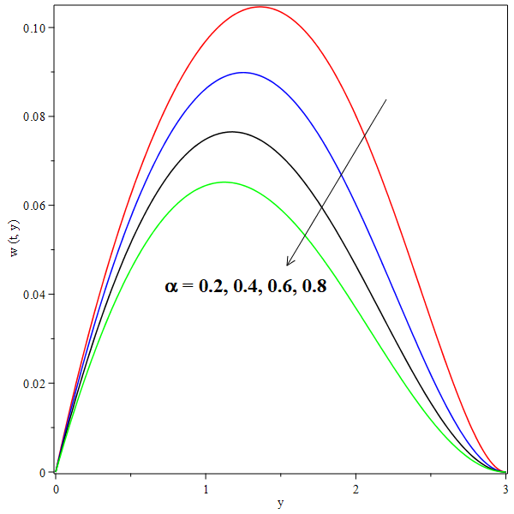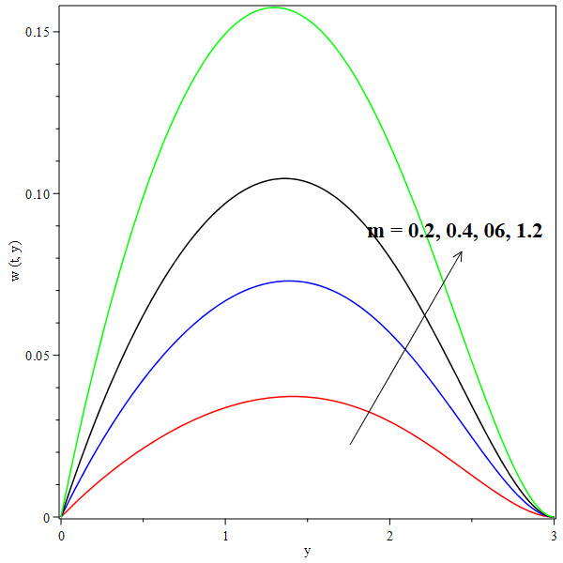
Fig 2: Effect of on velocity profile w(t, y). Fig 3: Effect of Hall parameter m on w(t, y).

The analysis reveals that an increase in the second-grade viscoelastic parameter (α) results in a reduction of both the secondary velocity profile, w(t,y), and the primary velocity, u(t,y). Furthermore, as illustrated in Figure 4, the Hall parameter (m) has a positive correlation with the velocities u(t,y) and w(t,y), causing them to rise as m increases. Similarly, the application of a magnetic field parameter (M) enhances the velocities u(t,y) and w(t,y), as depicted in Figure 5. This phenomenon can be attributed to the Lorentz force, which is generated when a magnetic field is applied perpendicular to the flow direction in an electrically conductive fluid. The Lorentz force acts in opposition to the flow, thereby influencing the velocity profiles. Additionally, it is observed that the primary velocity u(t,y) exhibits an upward trend with an increase in the heat source parameter (ϕ). This behavior is evident in the corresponding graphical representation. Moreover, viscous dissipation plays a significant role in fluid dynamics, as it involves the conversion of mechanical energy, such as kinetic energy, into thermal energy. This process occurs due to the internal friction within the fluid, which arises from its viscosity. The interplay of these factors—viscoelasticity, magnetic fields, heat sources, and viscous dissipation—collectively influences the velocity profiles in the fluid system under investigation.

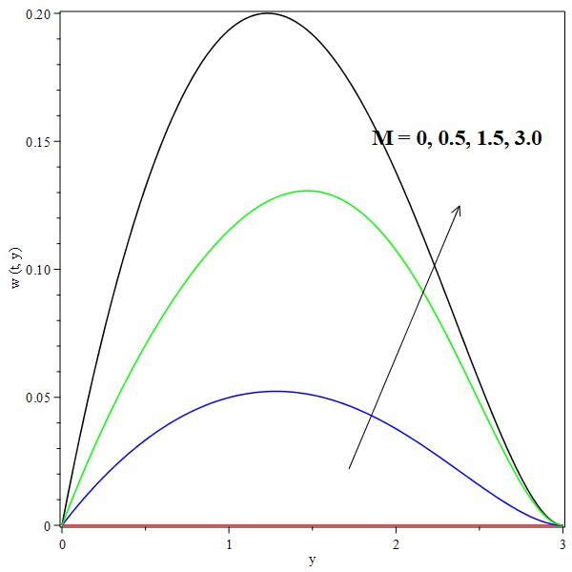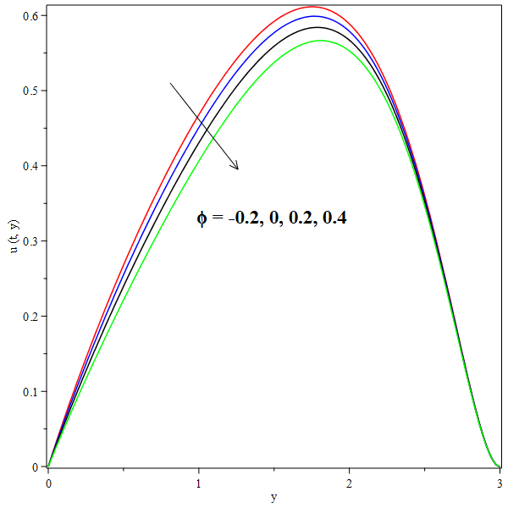
Fig 4: Effect of M on w(t, y). Fig 5: Effect on primary u(t, y).
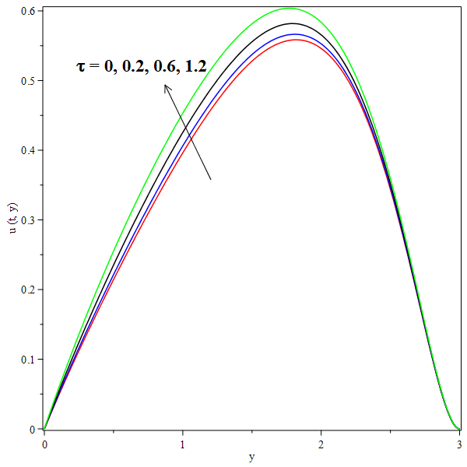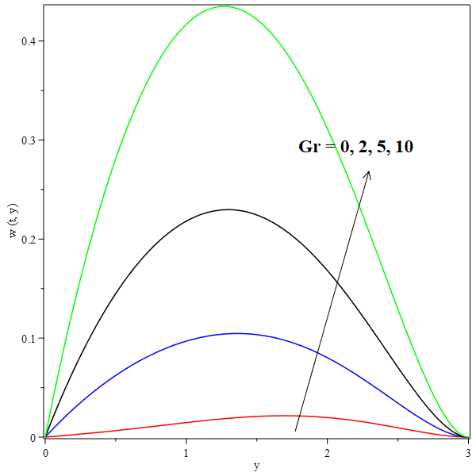
Fig 6: Effect of on u(t, y). Fig 7: Effect of Gr on w(t, y).
The analysis reveals that the function u(t,y) exhibits a declining trend as the thermophoretic parameter ττ increases. Eventually, u(t,y) converges to lower values, forming decreasing curves with higher values of ττ. A similar pattern is observed for w(t,y), where the influence of τ produces analogous effects in the simulations. The Grashof number Gr is assigned both positive and negative values to reflect different thermal conditions. Specifically, Gr<0 corresponds to symmetric heating of the plate, while Gr>0 indicates symmetric cooling. Both the primary and secondary velocities demonstrate an upward trend as the Grashof number GrGr and the modified Grashof number increase. This behavior is illustrated in Figures 7 and 8, respectively. Additionally, it is observed that w(t,y) rises with an increase in the Darcy parameter K.

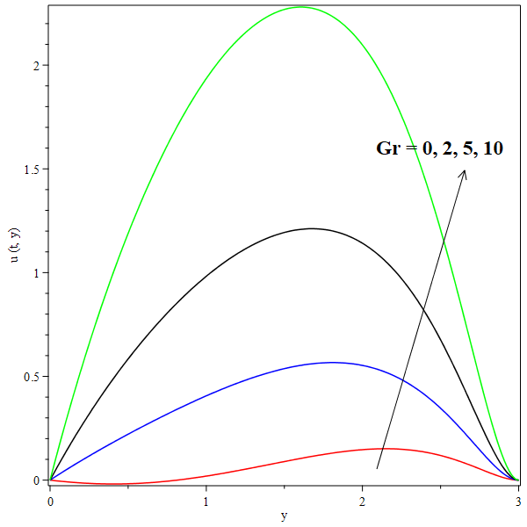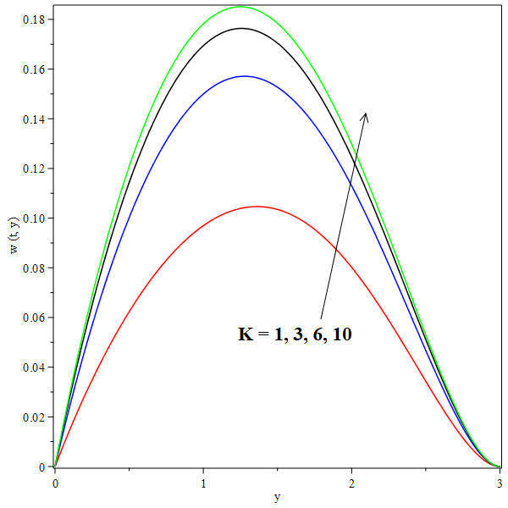
Fig 8: Effect Gr on u(t, y) Fig 9: Effect of K on w(t, y).
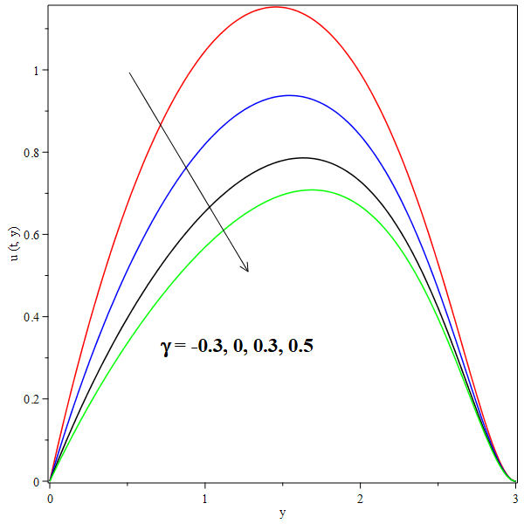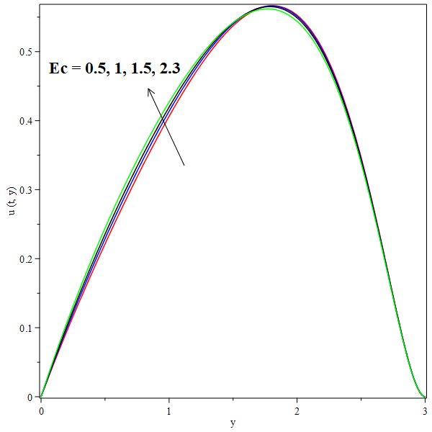
Fig 10: Effect of on u(t, y). Fig 11: Effect of Ec on u(t, y).
The analysis reveals that both u(t,y) and w(t,y) exhibit an upward trend as the chemical reaction parameter γγ increases. Additionally, the Eckert number Ec plays a significant role in influencing the velocity profiles. Specifically, an increase in Ec results in enhanced values of u(t,y), as illustrated in Figure 11. This enhancement is attributed to the rise in viscous dissipative heat, which becomes more pronounced at higher Eckert numbers. Furthermore, the behavior of the primary velocity u(t,y) and secondary velocity w(t,y) is observed to vary with proximity to the plate. As the fluid moves closer to the plate, both velocities increase; however, they tend to decrease as the fluid moves farther away. This trend is consistent across various physical parameters and aligns with expected physical phenomena, as demonstrated in Figures 2 through 14.
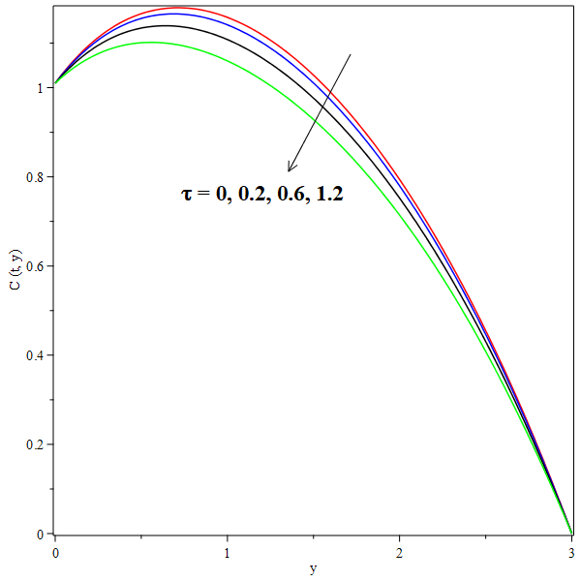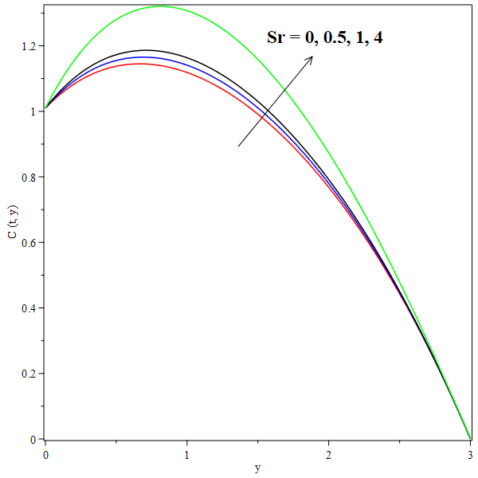
Fig 12: Effect of on C(t, y). Fig 13: Effect of Sr on C(t, y).
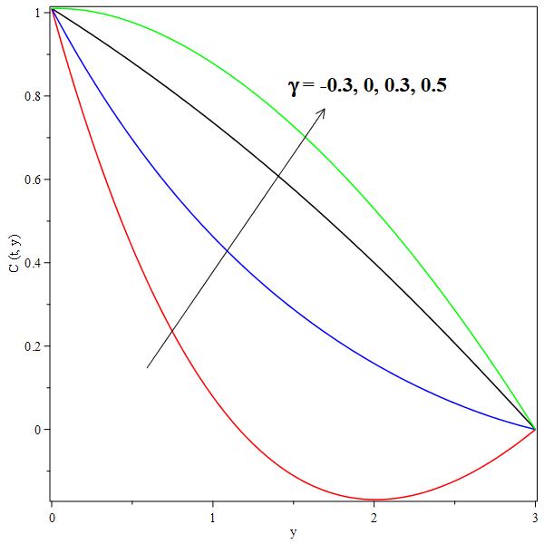
Fig 14: Effect of on C(t, y).
The concentration profiles C(t,y) exhibit a decline as the thermophoretic parameter ττ increases, with the curves approaching a quasi-linear trend. This behavior is particularly evident at τ=1.2, as illustrated in Fig. 12. From Fig. 13, it is observed that the Soret parameter SrSr influences the concentration profiles C(t,y) differently across two distinct regions: 0≤y<0.6 and 0.6<y≤2.5. These regions intersect neary=0.6, where the impact of Sr on C(t,y) is minimal. In the first region 0≤y<0.6, the effect of Sr is pronounced, particularly for Sr=0 and Sr=4. Here, the curves exhibit two inflection points, with a critical point at y=0.4 for Sr=0, where the trend shifts from increasing to decreasing. Conversely, the influence of Sr in this region is reversed. In the second region 0.6<y≤2.5, the concentration curves C(t,y) decrease as y increases for all values of Sr, eventually becoming regressive. Furthermore, the chemical reaction parameter γγ has a significant effect on the concentration distributions C(t,y). As γ increases through the values,−0.3,0,0.3, and 0.5, the concentration profiles rise and gradually approach a quasi-linear form. At γ=0.5, the curve becomes fully linear, as depicted in Fig. 14.
5. Conclusion
When the magnetic field is absent, there is no flow in the Z-axis direction. The thermophoretic parameter (τ) has a notable impact on the system: as τ increases, both primary and secondary velocities decrease, and the temperature profile is reduced, while the concentration profile is enhanced. Interestingly, the concentration C(t,y) remains unaffected by the Soret parameter (Sr) within the specific range of 0.6≤y≤0.7. However, outside this range, the influence of Sr becomes evident. The heat source parameter (ϕ) has a positive effect on the system, increasing both primary and secondary velocities, as well as elevating the temperature profile. Similarly, the chemical reaction parameter (γ) contributes to higher velocities and plays a significant role in boosting concentration. On the other hand, simultaneous increases in the magnetic parameter (M), thermal radiation parameter (Nr), Eckert number (Ec), second-grade parameter (α), and heat source parameter (ϕ) collectively reduce the heat transfer rate. The Sherwood number (Sh) exhibits a decrease at the same rate as the increase in the Schmidt number (Sc), thermophoretic parameter (τ), Soret parameter (Sr), and chemical reaction parameter (γ). However, Sh increases with a rise in the thermophoretic parameter (τ). Additionally, the Hall Current is defined as the electric current generated within a conductor or semiconductor when it carries a current and is subjected to a magnetic field that is perpendicular to the direction of the current flow.

Acknowledgement
The author would like to thank the Isaac Newton Institute for Mathematical Sciences, Cambridge, United Kingdom for support and hospitality during the programme [Modern History of Mathematics] where work on this paper was undertaken. This work was supported by EPSRC grant no EP/K032208/1.

Disclaimer (Artificial intelligence)
Option 1:
Author(s) hereby declare that NO generative AI technologies such as Large Language Models (ChatGPT, COPILOT, etc.) and text-to-image generators have been used during the writing or editing of this manuscript.
Option 2:
Author(s) hereby declare that generative AI technologies such as Large Language Models, etc. have been used during the writing or editing of manuscripts. This explanation will include the name, version, model, and source of the generative AI technology and as well as all input prompts provided to the generative AI technology
Details of the AI usage are given below:
1.
2.
3.

REFRENCES
Ahmed, A., Uwanta, I. J and. Sarki, M. N (2015). Hall Current Effects on Unsteady MHD Fluid Flow with Radiative Heat Flux and Heat Source over a Porous Medium. British Journal of Mathematics and Computer Science
Alam, M. S., Rahman, M. M and Sattar, M. A (2007). Effects of Thermophoresis and Chemical Reaction on Unsteady Hydro Magnetic Free Convection and Mass Transfer Flow Past an Impulsively Started Infinite Inclined Porous Plate in the Presence of Heat Generation/Absorption. International Journal of Science and Technology.
Animasaun, I.l, (2015). Effects of Thermophoresis, Variable Viscosity and Thermal Conductivity on Free Convective Heat and Mass Transfer of Non-Darcian MHD Dissipative Casson Fluid Flow with Suction and nth Order of Chemical Reaction. Journal of the Nigerian Mathematical Society.
Bhuvanavijaya, R. (2014). Thermophoretic Effect on Convective Heat and Mass Transfer Flow over a Vertical Porous Plate in a Rotating System with Suction/Injection International Journal of Engineering Sciences and Research Technology
Chamkha, A. J. and Issa, C. (2000). Effects of heat generation/absorption and thermophoresis on hydromagnetic flow with heat and mass transfer over a flat surface. International Journal of Numerical Methods for Heat and Fluid Flow.
Chaudhary, R.C. and Jain, P. (2006). Hall Effect on MHD mixed convection flow of a viscoelastic fluid past an infinite vertical porous plate with mass transfer and radiation. Theoretical and Applied Mechanics
Cortell, R. (2007). MHD flow and mass transfer of an electrically conducting fluid of second grade in a porous medium over a stretching sheet with chemically reactive species Chemical Engineering and Processing
Das, K. Jana, S. and Kundu, P.K. (2015). Thermophoretic MHD slip flow over a permeable surface with variable fluid properties Alexandria Engineering Journal.
Das, U. J.(2013). Viscoelastic Effects on Unsteady Two-Dimensional and Mass Transfer of a Viscoelastic Fluid in a Porous Channel with Radioactive Heat Transfer Engineering.
Eldabe, N.T. (1986). Heat and mass transfer in a hydromagnetic flow between two parallel permeable plates. Canadian Journal of Physics
Eldabe, N.T., El-Saka, A.G. and Fouad, A. (2004). Thermal-diffusion and diffusion-thermo effects on mixed free-forced convection and mass transfer boundary layer flow for non-Newtonian fluid with temperature dependent viscosity. Applied Mathematics and Computation.
El-dabe, N.T., Refaie Ali, A., El-shekhipy, A. A. and. Shalaby., G. A (2017). Non-Linear Heat and Mass Transfer of Second Grade Fluid Flow with Hall Currents and Thermophoresis Effects. Appl. Math. Inf. Sci. 11, No. 1, 267-280 (2017) 267. http://dx.doi.org/10.18576/amis/110133
Fagbade, A. I., Falodun, B.O. and Boneze, C. U. (2015). Influence of Magnetic Field, Viscous Dissipation and Thermophoresis on Darcy-Forcheimer Mixed Convection Flow in Fluid Saturated Porous Media. American Journal of Computational Mathematics.
Hayat, T. Abbas, Z. Sajid, M. and Asghar, S. (2007). The influence of thermal radiation on MHD flow of a second grade fluid. International Journal of Heat and Mass Transfer
Hayat, T. and Nawaz, M. (2011). Soret and Dufour effects on the mixed convection flow of a second grade fluid subject to Hall and ion-slip currents. International Journal for Numerical Methods in Fluids
Hayat, T. Mustafa, M. and Pop, I. (2010). Heat and mass transfer for Soret and Dufour’s effect on mixed convection boundary layer flow over a stretching vertical surface in a porous medium filled with a viscoelastic fluid. Communications in Nonlinear Science and Numerical Simulation
Hayat, T., Khan, S.A., Alsaedi, A. (2020). Simulation and modeling of entropy optimized MHD flow of second grade fluid with dissipation effect, J. Mater. Res. Technol. 9 (5), 11993–12006
Hayat, T., Khan, W.A., Abbas, S.Z., Nadeem, S., Ahmad, S.(2020).Impact of induced magnetic field on second-grade nanofluid flow past a convectively heated stretching sheet, Appl. Nanosci. 10, 3001–3009.
Hayat, T., Nadeem, S. Asghar, S. and Siddiqui, A. M.(2005). Effects of Hall Current On Unsteady Flow Of A Second Grade Fluid In A Rotating System Chemical Engineering Communications.
Jha, A.K., Choudhary, . K. and Sharma, A.(2014). Influence of soret effect on MHD mixed convection flow of visco-elastic fluid past a vertical surface with hall effect. International Journal of Applied Mechanics and Engineering.
K. Das, (2013). Effects of thermophoresis and thermal radiation on MHD mixed convective heat and mass transfer flow. African Mathematical Union and Springer.
Kalaivanan, R., Ganesh, N.V., Al-Mdallal, Q.M. (2020). An investigation on Arrhenius activation energy of second grade nanofluid flow with active and passive control of nanomaterials, Case Stud, Therm. Eng. 22, 100774
Kalidas Das, RamPrakashSharma and AmitSarkar, (2016). Heat and mass transfer of a second grade magnetohydrodynamic fluid over a convectively heated stretching sheet. Journal of Computational Design and Engineering.
Khan, M.I. Qayyum, S., Kadry, S., Khan, W.A., Abbas, S.Z. (2020). Irreversibility analysis and heat transport in squeezing nanoliquid flow of non-Newtonian (second-grade) fluid between infinite plates with activation energy, Arab. J. Sci. Eng. 45, 4939–4947.
Khan, S.U., Tlili, I., Waqas, H., Imran, M. (2021). Effects of nonlinear thermal radiation and activation energy on modified second-grade nanofluid with Cattaneo–Christov expressions, J. Therm. Anal. Calorim. 143, 1175–1186.
Kim, Y. J. (2000). Unsteady MHD Convective Heat Transfer past a Semi-Infinite Vertical Porous Plate with Variable Suction. International Journal of Engineering Science.
Kumar, R. and Chand, K. (2011). Effect of Slip Conditions and Hall Current on Unsteady MHD Flow of a Viscoelastic Fluid Pass an Infinite Vertical Porous Plate through Porous Medium. International Journal of Engineering Science and Technology.
Nabil T. M. Eldabe, Ahmed Y. Ghaly, Sallam N. Sallam, Khaled Elagamy and Yasmeen Younis, (2015). Hall Effect on Peristaltic Flow of Third Order Fluid in a Porous Medium with Heat and Mass Transfer. Journal of Applied Mathematics and Physics.
Nabil T. M. Eldabe, Ahmed Y. Ghaly, Sallam N. Sallam, Khaled Elagamy and Yasmeen Younis, (2015). Hall Effect on Peristaltic Flow of Third Order Fluid in a Porous Medium with Heat and Mass Transfer. Journal of Applied Mathematics and Physics
Nayak, A. and Panda, S.(2013). Mixed Convective MHD Flow of Second Grade Fluid with Viscous Dissipation and Joule Heating Past a Vertical Infinite Plate with Mass Transfer Mathematical Theory and Modeling
Oahimire, J.I., Olajuwon and B.I. (2013). Micropolar Fluid Behavior with Constant Pressure, Permeability, Heat and Mass Transfer. Journal of King Saud University - Engineering Sciences.
Olajuwon, B.I. Oahimire, J.I. and Ferdow, M. (2014). Effect of thermal radiation and Hall current on heat and mass transfer of unsteady MHD flow of a viscoelastic micropolar fluid through a porous medium. International Journal of Engineering Science and Technology
Pandya, N.Shukla and A. K, (2016). Effects of Thermophoresis, Dufour, Hall and Radiation on an Unsteady MHD Flow past an Inclined Plate with Viscous Dissipation, Chemical Reaction and Heat Absorption and Generation. Journal of Applied Fluid Mechanics.
Piazza, R.(2008). Thermophoresis: moving particles with thermal gradients. Soft matter - Royal Society of Chemistry.
Raees, A., Farooq, U., Hussain, M., Khan, W.A., Farooq, F.B. (2023) Non-similar mixed convection analysis for magnetic flow of second-grade nanofluid over a vertically stretching sheet, Commun. Theor. Phys. 73 (6), 065801.
Rashidi, M. M., Ali, M., Rostami, B., Rostami, P., and Xie, G. (2015). Heat and mass transfer for MHD viscoelastic fluid flow over a vertical stretching sheet with considering Soret and Dufour effects. Mathematical Problems in Engineering.
Reddy, S.C., Asogwa, K.K., Yassen, M.F., Iqbal, Z., Ali, B., KM, S.(2022). Dynamics of MHD second-grade nanofluid flow with activation energy across a curved stretching surface, Front. Energy Res. 10, 1007159.
Reddy, S.H, .Raju and E. K. Reddy, (2015). Unsteady MHD Free Convection Flow of a Kuvshinski Fluid Past a Vertical Porous Plate in the Presence of Chemical Reaction and Heat Source/Sink. International Journal of Engineering Research in Africa.
Reza-E-Rabbi, Md Yousuf Ali, Sarder Firoz Ahmmed. (2024). Non-linear radiative second- grade nano fluid with sinusoidal magnetic force and arrhenius activation energy: A computational exploration. Alexandria Engineering Journal 104 (2024) 66–84
Rushi Kumar, B. Sreedhara Rao Gunakala , Sivaraj, R. and VictorM. Job, (2016). Time-dependent hydromagnetic free convection nanofluid flows within a wavy trapezoidal enclosure Special Topics and Reviews in Porous Media: An International Journal DOI: 10.1615/.2016017320
Sahoo, S. N. (2013). Heat and mass transfer effect on MHD flow of a viscoelastic fluid through a porous medium bounded by an oscillating porous plate in slip flow regime. International Journal of Chemical Engineering
Subbarao, K., Elangovan, K., Gangadhar, K. (2022). Entropy analysis in a second-grade nanoliquid influenced by an exponential space-dependent heat source and Arrhenius activation energy, Heat. Transf. 51 (6), 5679–5699.
Sudhakar, C., Reddy, B., Vasu, N. B and. Prasad, V. R. (2012). Thermophoresis Effect on Unsteady Free Convection Heat and Mass Transfer in a Walters-B Fluid past a Semi Infinite Plate. International Journal of Engineering Research andApplications
Veera Krishna, M.and B.V.Swarnalathamma, (2016). Convective heat and mass transfer on MHD peristaltic flow of Williamson fluid with the effect of inclined magnetic field. IOSR Journal of Mathematics (IOSR-JM).
Vempati, S. R. and Laxmi-Narayana-Gari, A. B. (2010). Soret and Dufour effects on unsteady MHD flow past an infinite vertical porous plate with thermal radiation. Applied Mathematics and Mechanics.
Waqas, H., Khan, S.U., Shehzad, S.A., Imran, M., Tlili, I. (2020). Activation energy and bioconvection aspects in generalized second-grade nanofluid over a Riga plate: a theoretical model, Appl. Nanosci. 10, 4445–4458.
El-Dabe, N. T., Ali, A. R., El-Shekhipy, A. A., & Shalaby, G. A. (2017). Non-linear heat and mass transfer of second grade fluid flow with hall currents and thermophoresis effects. Appl. Math. Inf. Sci, 11(1), 267-280.

