**Estimation of risk factors and haemoglobin in early pregnancy as predictors of diabetes in pregnancy at Benghazi Medical Center, Libya: A prospective cross-sectional study**

**ABSTRACT**

* **Introduction:** Hyperglycemia that is first detected at any time during pregnancy can be classified as either diabetes in pregnancy (DIP) or gestational diabetes mellitus (GDM). DIP may be an undiagnosed type 2 diabetes mellitus (T2DM) or “overt diabetes” identified in the first trimester while GDM develops in the second and third trimesters. Globally, an estimated 21.1 million live births were exposed to some forms of hyperglycemia in pregnancy, of which 80.3% were due to GDM.
* **Aim and objective**-: To determine whether elevated hemoglobin levels during the early pregnancy is associated with the risk of gestational diabetes mellitus.

##### Materials and methods:

A prospective cross-sectional study; include a pregnant woman in early pregnancy (gestational age <14 weeks) enrolled in the study who is visiting outpatient’s department of Obstetrics and Gynecology in Benghazi medical center for 6 months (1- 7-2022-to31-12-2022).

* **Result:** mean age of participant was 28.9 years old, with mean body weight 76.1Kg

high HB level in first trimester more than 11.5 associated with high FBS more than 126. p value 0.03 that mean less than 0.05 which mean mild significance.

* **Conclusion:** GDM is more likely to develop in women with high hemoglobin levels in the first trimester of pregnancy**.**

#### Introduction

Hyperglycemia that is first detected at any time during pregnancy can be classified as either diabetes in pregnancy (DIP) or gestational diabetes mellitus (GDM) (1). DIP may be an undiagnosed type 2 diabetes mellitus (T2DM) or “overt diabetes” identified in the first trimester while GDM develops in the second and third trimesters (2–5). Globally, an estimated

21.1 million live births were exposed to some forms of hyperglycemia in pregnancy, of which 80.3% were due to GDM (6). GDM prevalence is generally considered to be somewhere from 1 to 28% of all pregnancies. The variation in prevalence rates could also be related to the diversity of the populations studied, the screening methods, and the diagnostic criteria used. Nevertheless, with the increasing prevalence of T2DM, the incidence of GDM is also on the rise wherever the rate of obesity is prevalent (7–9). In the current global epidemic of diabetes, the age of onset has decreased significantly, which concurrently affects a significant proportion of reproductive-age women (7–9).

In 2016, the national surveillance on Maternal and Child Health reported that the prevalence of hyperglycemia during pregnancy in Malaysia was 13.5% (10)

Gestational diabetes mellitus (GDM) and gestational hypertension (GH) significantly contribute to maternal, fetal, and neonatal morbidity and mortality. The prevalence of GDM is rising worldwide and ranges from 1% to 20%. During normal pregnancy, progressive insulin resistance develops during mid-pregnancy and progresses through the third trimester. Globally, hypertensive disorders of pregnancy (HDP) are one of the leading causes of peripartum morbidity and mortality. HDP complicates up to 2.73% of all pregnancies and is responsible for 10-15% of all U.S. maternal mortality. It is associated with a spectrum of severity, ranging from mild pregnancy-induced hypertension to eclampsia. Moreover, it is among the most significant and intriguing problems in obstetrics. Early diagnosis of GDM and GH can improve prenatal care for pregnant women during pregnancy and result in a satisfactory pregnancy outcome. (11)

Hemoglobin (Hb) measurement is a standard test among pregnant women during the first perinatal visit that is used to evaluate physical status and anemia. According to the World Health Organization (12), anemia is diagnosed when a blood test shows an Hb value of less than 110 g/L in pregnant women. Observational studies have found that anemia during pregnancy is associated with detrimental pregnancy.

outcomes, including preterm birth, low birth weight, infection and hemorrhage. (13) Additionally, several studies have even reported that high Hb levels during pregnancy could also be a predictor or cause of some pregnancy complications. (14-16)

However, studies focusing on Hb levels and pregnancy outcomes are scarce, and the findings are inconsistent due to a wide variation in study designs, sample sizes, populations and the time of Hb testing. Moreover, high maternal Hb has not received the same attention as anemia because it is more likely to be perceived as a symbol of good nutrition status.

Furthermore, previous studies indicated that Hb levels during pregnancy were significantly associated with body mass index (BMI). (17) However, few studies to date have assessed the effects of maternal Hb values in the first trimester stratified by pre-pregnancy BMI on pregnancy complications.

Thus, in this large sample study, we aimed to conduct stratified analyses modified by pre- pregnancy BMI and to evaluate whether associations exist between Hb levels in the first trimester and the risk of GDM, PE, and preterm birth. (18)

Hemoglobin (Hb) measurement is a routine standard test for evaluating physical status among pregnant women in their first visit to primary health care clinics [19]. Throughout normal pregnancy, blood volume expands by an average of 50% compared with the non-pregnant state [20].

This rapid expansion of blood volume starts in the first trimester of pregnancy [21]. Moreover, plasma volume increases more than the increase in red blood cell (RBC) mass, which produces a net decline in hemoglobin concentration during the first half of pregnancy. This is known as the physiologic anemia of pregnancy. Hb concentration reaches the nadir in the second trimester of pregnancy because a concurrent increase does not match the increase in plasma volume in RBC mass increase [22].

Based on the World Health Organization (WHO) and the U.S. Centers for Disease Control and Prevention (CDC) guidelines, anemia in pregnancy has different cutoffs based on the trimester (first trimester: <11.0 g/dl; second trimester: <10.5 g/dl; and third trimester: <11 g/dl) [23] while normal values are assigned from 11 to <12.5 g/dl [24]. Physicians and health care providers give more attention to maternal anemia than high blood levels. Previous studies demonstrated that elevated Hb levels in the first trimester indicate possible pregnancy complications and should not be mistaken for good iron status [25-32].

They also indicated that Hb levels during early pregnancy play a role in predicting the risk of GDM and PE [26-29]. Studies investigated the association between high maternal Hb levels and adverse pregnancy outcomes are scarce and controversial, with no absolute cut-off values for high Hb levels [25-31]. The cutoffs used to define low or high hemoglobin concentrations in these studies differed considerably, which may have affected the likelihood of detecting relations with the outcomes [32]. Most often, only the most extreme cutoffs were significantly associated with pregnancy complications.

#### Aims of the Study

To determine whether elevated hemoglobin levels during the early pregnancy is associated with the risk of gestational diabetes mellitus.

#### Review of Literature

A longitudinal study was carried out by- Rayis DA,et al to investigate the prevalence and risk factors (including hemoglobin levels) for gestational diabetes mellitus (GDM) in Khartoum, Sudan. The study was carried out at Saad Abuelela Hospital (Khartoum, Sudan) during February to November 2017 using a questionnaire. The women were then followed up, where

a pregnant woman in early pregnancy (gestational age <14 weeks) were enrolled in the study. The detailed medical and obstetrics history was recorded for each participant

75-g oral glucose tolerance test was performed at 24 - 28 weeks of gestation. Of 290 women,

259 (89.3%) completed the follow-up. The mean (standard deviation [SD]) of the age, gravidity and gestational age at enrolment were 28.02 (5.7) years, 2.37 (2.42) and 10.86 (2.63) weeks, respectively. Forty-eight women (18.5%) had GDM. Binary regression showed that while age, parity, residence, education and body mass index (BMI) were not associated with GDM, a high haemoglobin level was the only factor associated with GDM (OR = 1.52, 95% confidence interval [CI] = 1.07 - 2.16, *p* = .019). Women with haemoglobin > 10.8 g/dl were at a higher risk of GDM (OR = 2.52, 95% CI = 1.02 - 6.27, *p* = .044). There is a high prevalence of GDM, especially (33) among women with high haemoglobin levels.

Impact statement **What is already known on this subject?** Gestational diabetes mellitus (GDM) is one of the most common complications during pregnancy, contributing significantly to maternal, perinatal morbidity and mortality and can lead to adverse consequences for the health of both mother and offspring later in life. The rate of GDM varies with the various settings and populations, and a prevalence of 1-14% has been reported depending on the population studied. High haemoglobin levels were recently reported to be associated with GDM**. what do the results of this study add?** There is a high prevalence of GDM in Khartoum, Sudan, especially among women with high haemoglobin levels in early pregnancy. What are the implications of these findings for clinical practice and/or further research? Haemoglobin levels could be used as reliable markers to detect GDM. These markers could be used in the prevention of GDM. (33)

**Abumohsen H,et al--**conducted study, they hypothesized that high Hb levels (≥12.5 g/dl) in the first trimester (6-13 gestational weeks, GW) are associated with increased risk of fasting blood sugar (FBS) ≥126 mg/dl, systolic blood pressure (SBP) ≥140 mmHg, and diastolic blood pressure (DBP) ≥90 mmHg among pregnant Palestinian women visiting prenatal clinics in Palestine. Methods: Medical records (N=5263) were reviewed for singleton

pregnancies who had their first maternity care clinic visit (6-13 GW) at primary healthcare centers of the Palestinian Ministry of Health in the north of the West Bank in 2018 and 2019. Women were excluded if they had FBS ≥92 mg/dl, SBP ≥140 mmHg, DBP ≥90 mmHg, ultrasound-based gestational age >13 weeks, or who were previously diagnosed with diabetes mellites, GDM, hypertension, GH, taking drugs for these conditions, or were smoking during pregnancy. Hb levels in g/dl were divided to low (<11.0), normal (11-12.49), and high (≥12.5). The associations between high hemoglobin levels and pregnancy complications in pregnant women were assessed by calculating the odds ratios (OR) and their 95% confidence intervals (CIs) using logistic regression. P-values of <0.05 were considered significant. Results: The final number of eligible records was 2565. Pregnant women with high Hb levels in the first trimester were at higher risk of high FBS (≥126 mg/dl; OR=2.99, 95%CI, [1.675- 5.368]) and high systolic blood pressure (≥140 mmHg; OR=3.048, 95%CI, [1.252-7.421]) at 24 GW. Gravidity was significantly associated with decreased risk of high FBS (OR=0.838, 95%CI [0.704-0.991]). Conclude their findings suggest that Hb level at registration could be utilized in predicting the risk of GDM and HP among Palestinian women who never had a previous history of these conditions. The results of this study could have important clinical implications for early screening, which could improve preventive and curative health services to promote the health of pregnant women and children. (34)

**Chen Wang et al--**conducted study aimed to determine whether Hb levels in early pregnancy were associated with the risk of gestational diabetes mellitus (GDM), pre-eclampsia (PE) and preterm birth. Methods: A hospital-based retrospective study was conducted among 21,577 singleton, non-smoking pregnancies between June 2013 and January 2015. The demographic data and medical information of each participant were collected individually through questionnaires and patient medical records. Odds ratios were generated using a multivariate logistic regression analysis to evaluate the relative risk of GDM, PE and preterm birth continuously and across different hemoglobin ranges in the overall population and in women from different pre-pregnancy body mass index (BMI) categories, respectively. The level of statistical significance was set at 0.05. Results: For women who were underweight, normal- weight, overweight and obese, early pregnancy Hb levels were 127.8 ± 10.1 g/L, 129.6 ± 9.7 g/L, 132.2 ± 9.5 g/L and 133.4 ± 9.4 g/L, respectively. Women with GDM and PE had significantly increased Hb levels during early pregnancy compared with controls, whereas women with preterm birth processed significantly decreased Hb levels. After adjusting for confounders, the risks for GDM and PE increased with high maternal Hb (OR: 1.27 for Hb

130–149; OR: 2.06 for Hb ≥ 150 g/L), and the risk for preterm birth decreased with high maternal Hb (OR: 1.30 for Hb 130–149; OR: 2.38 for Hb ≥ 150 g/L) and increased with low maternal Hb (OR: 1.41 for Hb < 110 g/L). Among women whose BMI was < 24 kg/m2 , high GDM (OR: 1.27 for Hb 130–149; OR: 1.84 for Hb ≥ 150 g/L) and low preterm rates (OR: 0.77 for Hb 130–149; OR: 0.23 for Hb ≥ 150 g/L) were observed with high Hb, whereas in women whose BMI was ≥24 kg/m2 , only high GDM rates were observed with Hb > 150 g/L (OR: 2.33). Conclusion: These findings suggest that Hb levels during early pregnancy play a role in predicting the risk of GDM, PE and preterm birth. (35)

##### Hongmei Jin Shanghai 2019

the predictive value of glycosylated hemoglobin (HbA1c), microalbuminuria (24 h mAlb) and serum cystatin C (Cys-C) levels on the outcome of pregnancy in patients with gestational diabetes mellitus (GDM) was investigated. Samples of 144 females with GDM and 117 normal pregnant females as controls were selected for retrospective analysis. The following parameters were compared between the two groups: Levels of HbA1c, Cys-C and 24 h mAlb, maternal pregnancy outcome and adverse pregnancy rate. The predictive value of elevated 24 h mAlb, HbA1c and Cys-C regarding an adverse pregnancy outcome was then determined. Cys-C, 24 h mAlb and HbA1c levels in the GDM group were significantly higher than those in the control group (P<0.001). The adverse pregnancy rate in the GDM group was significantly higher than that in the control group (40.97 vs. 16.24%; P<0.001). Logistic regression and receiver operating characteristics (ROC) analyses indicated that, in subjects with GDM, HbA1c, Cys-C and 24 h mAlb levels were closely associated with adverse pregnancy outcomes (P<0.050) and may be considered as predictors for an adverse pregnancy outcome (risk ratio >1). Linear correlation analyses indicated that HbA1c, Cys-C and 24 h mAlb were negatively correlated with the neonatal Apgar scores (r=-0.509, -0.954 and -0.954, respectively; P<0.001). According to ROC analysis, the combined predictive sensitivity of HbAlc, Cys-C and 24 h mAlb for adverse pregnancy outcome in patients with GDM was 96.49% and the specificity was 77.19%. The increase in HbAlc, Cys-C and 24 h mAlb levels is expected to be an effective predictor of adverse pregnancy outcomes in high-risk pregnant women (36)

**Sulhariza HZ** conclude Unchanged Hb level from booking to second trimester was significantly associated with GDM risk in Model 1 (AOR: 2.55; 95% CI: 1.20, 5.44; *p* <

0.05), Model 2 (AOR: 2.45, 95% CI: 1.13, 5.34; *p* < 0.05) Model 3 (AOR: 2.42; 95% CI:

1.11, 5.27; *p* < 0.05), and Model 4 (AOR: 2.51; 95% CI: 1.15, 5.49; p < 0.05). No significant

associations were observed between maternal Hb levels and GDM in the study (37)

**Wu *et al****.* A total of 1911 singleton mothers were included. After multivariable adjustment, Hb levels > 130 g/L in the second trimester increased the risk of LBW (odds ratio [OR], 2.54; 95% confidence interval [CI], 1.12–5.76). In the third trimester of gestation, compared with women whose Hb levels between 110 and 119 g/L, women with Hb levels > 130 g/L had an increased risk of LBW (OR, 2.20; 95% CI, 1.07–4.51) and SGA (OR, 2.00; 95% CI, 1.05–

3.80). When we compared the highest and lowest quartiles of changes in the Hb across the second and third trimesters, the adjusted ORs were 0.35 (95% CI: 0.18–0.68) for PTB and

0.47 (95% CI: 0.23–0.98) for LBW. (38)

**Guifang Deng:-** In addition, recent reviews have shown that the relationship between Hb levels and adverse pregnancy events is mainly affected by the time point of Hb determination (39). Some studies have shown that anemia in first – trimester was significantly related to adverse pregnancy outcomes (40, 41, 42) , while other studies have shown that this relationship was more significant in the second or third trimesters (43). Furthermore, there have been few studies on the changes of Hb levels between the second and third trimester of gestation on maternal and infant pregnancy outcomes. Interestingly, previous studies have only measured Hb concentrations at single time points and have few tracked changes over time during pregnancy.

#### Methodology

##### Study Design:

**Type of study:** A prospective cross-sectional study; include a pregnant woman in early pregnancy (gestational age <14 weeks) enrolled in the study who is visiting outpatient’s department of Obstetrics and Gynecology in Benghazi medical center for 6 months (1-7-2022- to 31-12-2022).

**Population** Pregnant women in early pregnancy (gestational age <14 weeks).

**Study-sitting:** Outpatients department of Obstetrics and Gynecology in Benghazi medical center.

##### Procedure:

The patients’ characteristics and detailed medical and obstetrics history recorded for each participant, needed investigation asked as HB level, FBS using a questionnaire.

The women followed up, where a 75-g oral glucose tolerance test performed at 24 − 28 weeks of gestation. Hemoglobin will divided as follow:

Low (<11.0), normal (11-12.49), and high (≥12.5).

##### Data collection:

Data recorded on Performa, including demographic characteristics and clinical features. Results of investigation will be recorded.

##### Exclusion criteria:

Women were excluded if they had FBS ≥92 mg/dl, SBP ≥140 mmHg, DBP ≥90 mmHg-and ultrasound-based gestational age >14 weeks, or who were previously diagnosed with diabetes mellitus.

**Data Analysis:** Data analyzed using (SPSS) statistical package of social science program version 23. The statistical analysis included:

1. Descriptive Statistics: Including (Mean value, Standard deviation, Number and Percentage.
2. Inferential Statistics: will be used when needed as t- test and Chi-square, P-value will be considered significant when ≤ 0.05.

Data presented in form of tables and figures, where the figures done by Microsoft Excel 2010.

##### Approval:

Approval of the study obtained from the manager of the hospital and consent obtained from the pregnant mothers.

#### Result

The study population were 95 pregnant term ladies.

##### Table 1: distribution of age among participant.

|  |  |
| --- | --- |
| **Age** | **Percentage** |
| 19-23 | 26.1% |
| 24-28 | 22.1% |
| 29-33 | 29.47% |
| 34-38 | 11.58% |
| 39-43 | 10.5% |
| Total | 100% |

Table 1: shows the most frequent age between 29-33 years while least frequent between age 39- 43 years old.

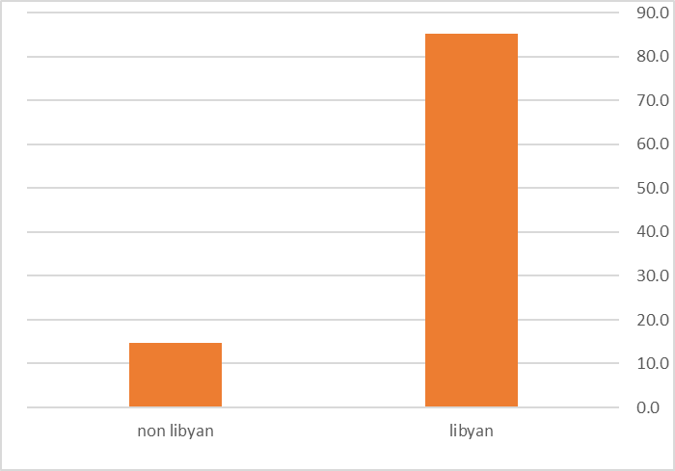

**Figure 1:** Shows Distribution of Nationality Among Participant.

##### Table 2: distribution of participant according to resident

|  |  |
| --- | --- |
| **Residence** | **%** |
| Benghazi | 95.8% |
| Outside Benghazi | 4.2% |

Table 2 shows most of participant are from Benghazi.

##### Table3: distribution of participant according to education.

|  |  |  |
| --- | --- | --- |
| **Education** | **Frequency** | **Percentage** |
| Secondary | 10 | 10.5% |
| University | 85 | 89.5% |

Table 3 shows 89.5% of participant are highly educated.

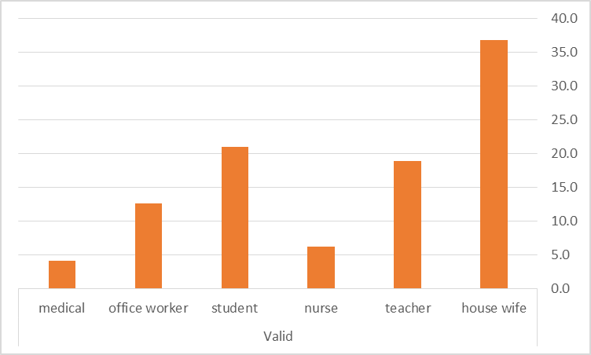

**Figure 2**: Shows distribution of participant according to occupation.

##### Table 4: distribution of participant according to medical history.

|  |  |  |
| --- | --- | --- |
| **Medical history** | **Frequency** | **Percentage** |
| Free | 98 | 71.6% |
| Asthmatic | 18 | 18.9% |
| Other | 9 | 9.5% |

This table shows 71.6% of participant are medically free.

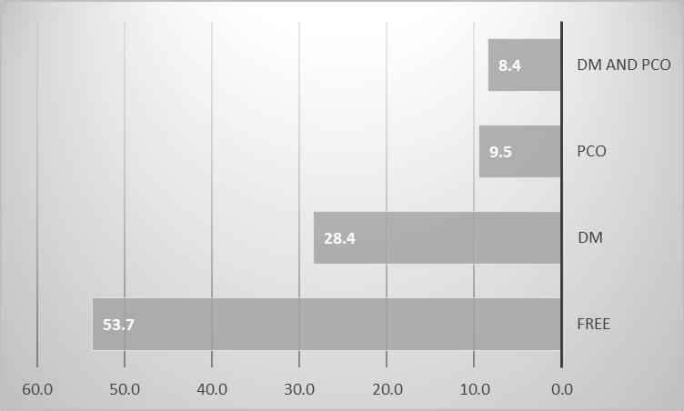

Figure 3: distribution of participant according to family history.

##### Table 5: distribution of participant according to income.

|  |  |
| --- | --- |
| **Income** | **Percentage** |
| Good | 38.9% |
| Faire | 60% |
| Poor | 1.1% |

This table shows that 60% of participant are faire income.

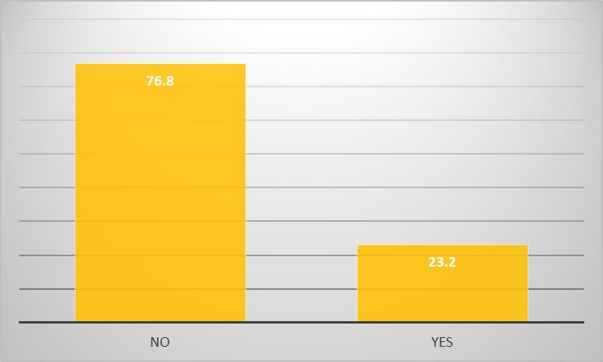

Figure 4: distribution of participant according to history of consanguinity.

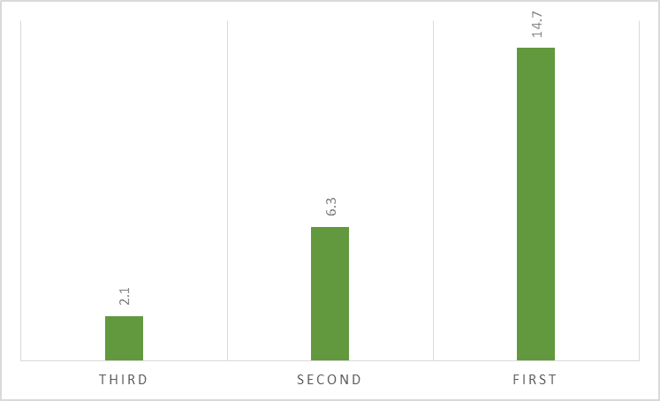

Figure5: distribution of degree of consanguinity.

##### Table 6: distribution of participant according to obstetric history.

|  |  |  |  |  |
| --- | --- | --- | --- | --- |
| **Obstetric history** | **Minimum** | **Maximum** | **Mean** | **SD** |
| Gravida | 1 | 7 | 3.63 | 1.61 |
| Para | 0 | 6 | 2.26 | 1.35 |
| Abortion | 0 | 2 | 0.38 | 0.62 |
| Gestational age | 34 | 41 | 37.38 | 1.38 |

This table shows maximum parity among participant 6 at mean about 2.26, mean gestational age 37.38 weeks.

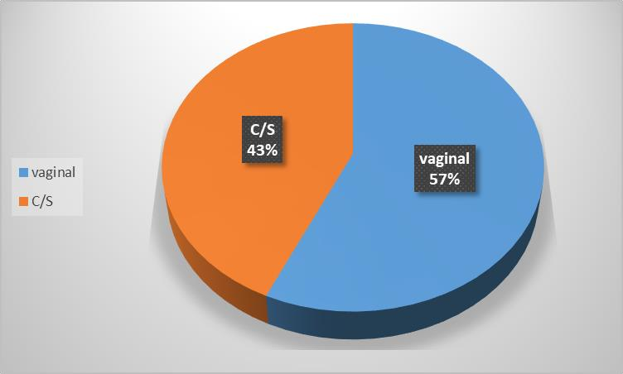

Figure 5: mode of delivery among participant.

##### Table7: distribution of participant according to height and weight.

|  |  |
| --- | --- |
|  | Mean |
| Height | 163.28 |
| Weight | 76.11 |
| BMI | 28.65 |

This table shows mean BMI 28.65 (over weight).

##### Table 8: distribution of participant according to blood pressure.

|  |  |
| --- | --- |
| **Blood pressure** | **Mean** |
| Systolic | 117.58 |
| Diastolic | 74.73 |

This table shows mean systolic blood pressure 117.58 and mean diastolic are 74.73.

##### Table 9: distribution of HB among participant in first trimester.

|  |  |  |
| --- | --- | --- |
| **HB** | **Frequency** | **Percentage** |
| Less than 11.5 | 2 | 2.11% |
| More than 11.5 | 93 | 97.89% |

This table shows most of participant HB more than 11.5.

##### Table10: distribution of HB among participant in second trimester.

|  |  |  |
| --- | --- | --- |
| **HB** | **Frequency** | **Percentage** |
| Less than 11.5 | 31 | 32.632% |
| More than 11.5 | 64 | 67.37% |

This table shows that 67.37% of cases HB more than or equal 11.5.

##### Table11: distribution of HB among participant in third trimester.

|  |  |  |
| --- | --- | --- |
| **HB** | **Frequency** | **Percentage** |
| Less than 11.5 | 29 | 41.05% |
| More than 11.5 | 66 | 58.95% |

This table shows that 58.95% of participant HB more than or equal 11.5.

##### Table 12: distribution of participant with GDM according to age, BMI, HB in first trimester.

|  |  |  |  |
| --- | --- | --- | --- |
| **Group** | **age** | **BMI** | **Hb in first trimester** |
| GDM | 28 | 28.98 | 12.95 |
| Not diabetic | 29 | 27.24 | 12.44 |

This table shows mean age in ladies with GDM was 28, mean BMI 28.98., and Hb level in first trimester was 12.95.

##### Table 13: distribution of participant according to mean HB in first trimester and FBS.

|  |  |  |
| --- | --- | --- |
| **FBS** | **Mean HB level** | **p. value** |
| Less than or equal 120 | 12.44 | 0,030* |
| More than 120 | 12.95 |  |

This table shows significance, high HB level in first trimester associated with gestational diabetes p value less than 0.05.

#### Discussion

Gestational diabetes mellitus is a significant health concern, affecting up to 15% of all pregnancies globally (Guariguata et al., 2014). It is associated with adverse outcomes for both the mother and the infant, including an increased risk of cardiovascular disease, type 2 diabetes, preterm birth, and macrosomia. Interestingly, recent studies have suggested a potential link between high hemoglobin levels in early pregnancy and the development of gestational diabetes.

**Our** study was conducted in a tertiary hospital (Benghazi Medical Center) in Benghazi, Libya. this study included 95 participants. Age of participant distributed between 19-43 years old most of them 29.47% are between 29-33 years old, with mean 28.9 years old age and mean age in ladies with GDM was 28 years old while studies conducted in China and Palestine mean age of participant were about 27 years old (33,35)

Previous studies consistently reported that maternal age, ethnicity and BMI at first prenatal visit are significantly associated with the risk of GDM (18,45,46).

The study done by **Vincenzo** show significant association between early Hb concentration and GDM risk was observed among women aged 35 years old and above, non-Malays and overweight/obese. Normal ageing is associated with the deterioration of endocrine functions such as decreasing β-cell function and insulin sensitivity (47). Thus, older pregnant women with higher Hb concentration may have further reduced insulin sensitivity that could increase the risk for GDM. In the present study, a higher percentage of non-Malay were overweight/obese (44·7 %) compared with Malays (37·1 %).

More than 80% of cases in our study are Libyan and 95%of participant from Benghazi that mean most of participant resident in town that in agreement with study conducted in China (35).

In our study 95.8% of participant are highly educated, and they distributed according to occupation in to (more than 35% are house wife, about 22% are student, 18% teacher, 15% office worker, 5% nurse and less than 5% are doctor).

In our study 71.6% of participant are medically free, 18.9% asthmatic, while 9.5% of participant complain of other medical problem.

In our study participant distributed according to family history 53.7% are free, 28.4% has family history of diabetes, 9.5% family history of PCO, while 8.4% has family history of both DM and PCO.

60% of participant has fair income, 38.9% good income while 1.1% has poor income

In our study 76.8% of cases has no history of consanguinity while 23.2% has history of consanguinity, 14,7% of participant has first degree of consanguinity,

In our study mean gravidity about 4, while mean gravidity in study done in Palestine was about 3(33), mean parity in our study 2, and mean gestational age are 37 weeks while mean gest age in study conducted in China was 38 weeks.

The participant in our study distributed according to mode of delivery into, 57% delivered vaginally while 43% of them delivered by cesarean section.

- Other studies analyzed the relation between high Hb in first trimester and increases the risk of developing GDM later in pregnancy due to some factors associated with the Causes OF GDM like endocrine dysfunction, insulin - resistance, while Fe demands increase dramatically throughout pregnancy, with a peak during second trimester in order to support placental and fetal growth.

Increased body fat might increase the development of insulin resistance and further lead to a greater risk of hyperglycemia (48,49)

Expansion of plasma volume, rather than actual blood volume expansion to help the blood circulation in the placenta occurs at 6–12 weeks of gestation and further increases and reaches the peak at 24–26 weeks of gestation (50,51), the increase in plasma volume results in the drop of Hb concentration in the first and second trimester and stabilize thereafter in the third trimeste.in pregnancy.

The finding that women with higher Hb concentrations at early pregnancy and lower Hb concentrations thereafter were at higher risk for GDM could mean that they were already experiencing oxidative stress, and its consequent damage to pancreatic β-cells that impairs insulin synthesis and secretion. (52)

Some previous observational studies revealed that high Hb levels during pregnancy were related to a higher prevalence of GDM(26),(33**)**,and pregnant women with Hb concentrations of 13 g/dl and above had increased risk of GDM and the association became more significant when the Hb concentrations exceeded 15·0 g/dl so this is in agreement with our results indicated that women who had high Hb (≥12.5 g/dl) at registration were at higher risk to have high FBS (≥126 mg/dl) at 24 GW]

Additional work is needed to characterize excess Fe during early pregnancy that is associated with risk of GDM. If elevated Hb in early pregnancy is confirmed to be a risk factor for GDM, then Hb in the first trimester of pregnancy could serve as a simple screening tool to identify women at risk of developing GDM

The mean BMI in participant is 28.65, that mean most of the participant overweight, while mean BMI in ladies with gestational diabetes was 28.98, the mean body weight of participant was 76.1 Kg while mean body weight of participant in study conducted in Chinghai was

60.55 Kg (35).

A study done by Wang C, Lin L, Su R, et al among the women whose pre-pregnancy BMI was ≥24 kg/m2, only Hb levels higher than 150 g/L during the first trimester were associated with a significantly higher GDM risk and lower rates of preterm birth

.A multicenter cohort study showed that overweight and obese pregnant women had at least two fold odds of developing GDM compared with nonobese women.,(53),(54) Mokkala K, Paulin N, Houttu N, et al, Wei YM, Yang HX, Zhu WW, et al.regarding to Wu K etal study that showed a strong positive association between pre-pregnancy Hb and increased risk of GDM, and that pre-pregnancy BMI ≥30 kg/m2 had higher risk of GDM when pre-pregnancy Hb level was

≥123 g/L as compared with <123 g/L.

Overweight and obesity are generally accepted as major risk factors contributing to GDM (53,55), Maternal pregnancy BMI is associated with the risk of GDM regardless of singleton or twin gestations., a multicenter cohort study showed that overweight and obese pregnant women had at least twofold odds of developing GDM compared with nonobese women. (54,56)

Mean systolic and diastolic blood pressure among participant 117.6, and 74.7 respectively that in agreement with study conducted in Palestine. (33)

our study 2.11% of participant are anemic HB level less than 11.5, in second trimester 32.63% are anemic, while 41.05% of participants are anemic in third trimester.

While women who have HB level. More than 11.5 g/dl in first, second and third trimester was, 97.89%, 67.37%, and 58.95% respectively.

Mean Hb level in first trimester among participant with GDM was 12.95 in agreement with other studies conducted in Sudan and Palestine, our results indicate there is an association between high HB level in first trimester and high FBS more than 126, p value 0.03 that mean less than 0.05 which mean mild significance (33,34) (2018).

Also in agreement with our study, the finding of Vasegh etalstudy, which indicated that high hemoglobin level before14 weeks of gestational age may be considered to be. a risk factor for developing gestational diabetes, what may be. accounted for by increased amounts of iron stored in these women

Similar to our results, an earlier observational study of 730 Chinese pregnant women revealed that high maternal Hb levels (> 130 g/L) in the first trimester were associated with a significantly higher incidence of GDM

On the other hand, Gungor et al., (2007) (57)] did not observe a significant relationship between high Hb level of first trimester and gestational diabetes. However, many confounding variables were not controlled in the Gungor study and hemoglobin levels were assessed in 28-30 weeks of gestations when the iron supplements received during the second half of pregnancy had probably obscured the true difference of hemoglobin level among the groups, while in our study controlled the confounding variables appropriately and assessed hemoglobin levels during the first trimester.

Understanding the effects of haemoglobine levels during the first trimester of pregnancy on gestational diabetes mellitus (GDM) will be aided by additional research. In the end, this will lessen the effects of GDM, such as jaundice, high birth weight, shoulder dystocia, birth traumas, and neonatal hypoglycemia (44)

### CONCLUSION

GDM is more likely to develop in women with high hemoglobin levels in the first trimester of pregnancy.

### RECOMMENDATION

We recommended taking into account Libyan women’s high Hb at registration as a risk factor for developing GDM later in pregnancy.

We recommended carrying out more study to assess the prognosis of unfavorable pregnancy conditions (GDM) when high Hb at a risk factor to the risk variables that are currently recognized.

Furthermore, since Hb measurements are an inexpensive and widely available test, we recommend conducting further research for the association between high maternal Hb and other adverse outcomes and fetal complications.

#### References

1. World Health Organization. *Diagnostic criteria and classification of hyperglycemia first detected in pregnancy*. Geneva: World Health Organization (2013).
2. International Association of Diabetes and Pregnancy Study Groups. International Association of Diabetes and Pregnancy Study Groups recommendations on the diagnosis and classification of hyperglycemia in pregnancy. *Diabetes Care*. (2010) 33:676–82. doi: 10.2337/dc09-1848.
3. International Diabetes Federation In: D Cavan, JR Da Fernandes, L Makaroff, K Ogurtsova and S Webber, editors. *IDF Diabetes Atlas*. *7th* ed. Brussels, Belgium: International Diabetes Federation (2015).
4. Mirghani Dirar A, Doupis J. Gestational diabetes from a to Z. *World J Diabetes*. (2017) 8:489–511. doi: 10.4239/wjd.v8.i12.489.
5. American Diabetes Association. Diagnosis and classification of diabetes mellitus. *Diabetes Care*. (2014) 37:S81–90. doi: 10.2337/dc14-S081.
6. International Diabetes Federation. *IDF Diabetes Atlas*. *10th* ed. Brussels, Belgium: International Diabetes Federation (2021). 136 p.
7. Zhu Y, Zhang C. Prevalence of gestational diabetes and risk of progression to type 2 diabetes: a global perspective. *Curr Diab Rep*. (2016) 16:1–11. doi: 10.1007/s11892-015- 0699-x.
8. American Diabetes Association. 2. Classification and diagnosis of diabetes: standards of medical care in diabetes 2019. *Diabetes Care*. (2019) 42:S13–28. doi: 10.2337/dc19-S002.
9. Vounzoulaki E, Khunti K, Abner SC, Tan BK, Davies MJ, Gillies CL. Progression to type 2 diabetes in women with a known history of gestational diabetes: systematic review and meta-analysis. *BMJ*. (2020) 369:1–11. doi: 10.1136/bmj.m1361.
10. Institute for Public Health. *National Health and morbidity survey: Maternal and child health (MCH). Volume II, National Institues of Health*. Ministry of Health Malaysia. (2016).
11. Abumohsen H, Bustami B, Almusleh A, et al. (October 17, 2021) The Association Between High Hemoglobin Levels and Pregnancy Complications, Gestational Diabetes and Hypertension, Among Palestinian Women. Cureus 13(10): e18840. doi:10.7759/cureus.18840.
12. Nutritional anaemias. Report of a WHO group of experts. WHO Tech Rep Ser. 1972;503:1–29.
13. Annamraju H, Pavord S. Anaemia in pregnancy. Br J Hosp Med. 2016;77: 584–8. https://doi.org/10.12968/hmed.2016.77.10.584.
14. Huisman A, Aarnoudse JG. Increased 2nd trimester hemoglobin concentration in pregnancies later complicated by hypertension and growth retardation.

Early evidence of a reduced plasma volume. Acta Obstet Gynecol Scand. 1986; 65:605–8. https://doi.org/10.3109/00016348609158396.

1. Phaloprakarn C, Tangjitgamol S. Impact of high maternal hemoglobin at first antenatal visit on pregnancy outcomes: a cohort study. J Perinat Med. 2008;36:115–9. https://doi.org/10.1515/JPM.2008.018.
2. Tarim E, Kilicdag E, Bagis T, Ergin T. High maternal hemoglobin and ferritin values as risk factors for gestational diabetes. Int J Gynaecol Obstet. 2004;84: 259–61. <https://doi.org/10.1016/S0020-7292(03)00341-2>.
3. Rasmussen S, Bergsjø P, Jacobsen G, Haram K, Bakketeig LS. Haemoglobin and serum ferritin in pregnancy–correlation with smoking and body mass

index. Eur J Obstet Gynecol Reprod Biol. 2005;123:27–34. https://doi.org/10. 1016/j.ejogrb.2005.02.012.

1. Chen Wang , Li Lin1 , Rina Su1 , Weiwei Zhu1,2, Yumei Wei1 , Jie Yan1 , Hui Feng1 , Boya Li1 , Shuang Li1 and Huixia Yang1.Hemoglobin levels during the first trimester of pregnancy are associated with the risk of gestational diabetes mellitus, pre-eclampsia and preterm birth in Chinese women: a retrospective study. BMC Pregnancy and Childbirth (2018) 18:263 https://doi.org/10.1186/s12884-018-1800-7
2. Alkhatib A: The role of laboratory medicine for health during pregnancy. EJIFCC. 2018, 29:280-284.
3. Pritchard JA: Changes in the blood volume during pregnancy and delivery. Anesthesiology. 1965, 26:393-9. 10.1097/00000542-196507000-00004
4. Soma-Pillay P, Nelson-Piercy C, Tolppanen H, Mebazaa A: Physiological changes in pregnancy . Cardiovasc J

Afr. 2016, 27:89-94. 10.5830/CVJA-2016-021.

1. Vricella LK: Emerging understanding and measurement of plasma volume expansion in pregnancy . Am J

Clin Nutr. 2017, 106:1620S-5S. 10.3945/ajcn.117.155903.

1. Tandon R, Jain A, Malhotra P: Management of iron deficiency anemia in pregnancy in India . Indian J

Hematol Blood Transfus. 2018, 34:204-15. 10.1007/s12288-018-0949-6.

1. Morrison J, Parrish M: Anemia associated with pregnancy. Glob Libr Women's Med. 2016. 10.3843/GLOWM.10164.
2. Scanlon KS, Yip R, Schieve LA, Cogswell ME: High and low hemoglobin levels during pregnancy: differential

. risks for preterm birth and small for gestational age. Obstet Gynecol. 2000, 96:741-748. 10.1016/s0029- 7844(00)00982-0.

1. Wang C, Lin L, Su R, et al.: Hemoglobin levels during the first trimester of pregnancy are associated with the risk of gestational diabetes mellitus, pre-eclampsia and preterm birth in Chinese women: a retrospective study. BMC Pregnancy Childbirth. 2018, 18:263. 10.1186/s12884-018-1800-7.
2. Mehrabian F, Hosseini SM: Comparison of gestational diabetes mellitus and pre- eclampsia in women with high hemoglobin in the first trimester of pregnancy: a longitudinal study. Pak J Med Sci. 2013, 29:986-90.10.12669/pjms.294.4012.
3. Lao TT, Chan LY, Tam KF, Ho LF: Maternal hemoglobin and risk of gestational diabetes mellitus in Chinese women. Obstet Gynecol. 2002, 99:807-812. 10.1016/s0029- 7844(02)01941-5.
4. Tarim E, Kilicdag E, Bagis T, Ergin T: High maternal hemoglobin and ferritin values as risk factors for

gestational diabetes. Int J Gynaecol Obstet. 2004, 84:259-261. 10.1016/s0020- 7292(03)00341-2.

1. Díaz-López A, Ribot B, Basora J, Arija V: High and low haemoglobin levels in early pregnancy are associated

to a higher risk of miscarriage: a population-based cohort study. Nutrients. 2021, 13:1578.10.3390/nu13051578.

1. Dewey KG, Oaks BM: U-shaped curve for risk associated with maternal hemoglobin, iron status, or iron supplementation. Am J Clin Nutr. 2017, 106:1694S-702S. 10.3945/ajcn.117.156075.
2. Ministry of Health Malaysia. National plan of action for nutrition of Malaysia. Putrajaya: Ministry of Health Malaysia (2016).
3. Rayis DA, Musa IR, Al-Shafei AI, Moheldein AH, El-Gendy OA, Adam I. High haemoglobin levels in early pregnancy and gestational diabetes mellitus among Sudanese women. J Obstet Gynaecol. 2021 Apr;41(3):385-389. doi: 10.1080/01443615.2020.1741522. Epub 2020 Jun 4. PMID: 32496157.
4. Abumohsen H, Bustami B, Almusleh A, et al. (October 17, 2021) The Association Between High Hemoglobin Levels and Pregnancy Complications, Gestational Diabetes and Hypertension, Among Palestinian Women. Cureus 13(10): e18840. doi:10.7759/cureus.18840.
5. Chen Wang , Li Lin1 , Rina Su1 , Weiwei Zhu1,2, Yumei Wei1 , Jie Yan1 , Hui Feng1 , Boya Li1 , Shuang Li1 and Huixia Yang1.Hemoglobin levels during the first trimester of pregnancy are associated with the risk of gestational diabetes mellitus, pre-eclampsia and preterm birth in Chinese women: a retrospective study. BMC Pregnancy and Childbirth (2018) 18:263 <https://doi.org/10.1186/s12884-018-1800-7>.
6. HONGMEI JIN, Increased levels of glycosylated hemoglobin, microalbuminuria and serum cystatin C predict adverse outcomes in high-risk pregnancies with gestational diabetes mellitus, EXPERIMENTAL AND THERAPEUTIC MEDICINE 19: 1281-1287, 2020.
7. Sulhariza HZ, Zalilah MS and Geeta A (2023) Maternal hemoglobin change from early pregnancy to second trimester is associated with risk of gestational diabetes mellitus: a retrospective cohort study. *Front. Nutr.* 10:1197485. doi: 10.3389/fnut.2023.1197485.
8. Lanlan Wu, Ruifang Sun, Yao Liu, Zengyou Liu, Hengying Chen, Siwen Shen, Yuanhuan Wei and, High hemoglobin level is a risk factor for maternal and fetal outcomes of pregnancy in Chinese women: A retrospective cohort study *BMC Pregnancy and Childbirth (2022) 22:290* <https://doi.org/10.1186/s12884-022-04636-9>.
9. Young MF, Oaks BM, Tandon S, Martorell R, Dewey KG, Wendt AS. Maternal hemoglobin concentrations across pregnancy and maternal and child health: a systematic review and meta-analysis. Ann N Y Acad Sci.2019;1450(1):47–68.
10. Scanlon KS, Yip R, Schieve LA, Cogswell ME. High and low hemoglobin levels during pregnancy: differential risks for preterm birth and small for gestational age. Obstet Gynecol. 2000;96(5 Pt 1):741.
11. Zhang Q, Ananth CV, Zhu L, Smulian JC. Maternal anaemia and preterm birth: a prospective cohort study. Int J Epidemiol. 2009;38(5):1380–9.
12. Zhang Q, Ananth CV, Rhoads GG, Zhu L. The impact of maternal Anemia on perinatal mortality: a population-based, prospective cohort study in China. Ann Epidemiol. 2009;19(11):793–9.
13. Ronkainen J, Lowry E, Heiskala A, Uusitalo I, Koivunen P, Kajantie E, et al. Maternal hemoglobin associates with preterm delivery and small for gestational age in two Finnish birth cohorts. Eur J Obstet Gynecol Reprod Biol. 2019;238:44–8.
14. Kaaja,R.,& Ronnemaa,T. (2008).Gestational diabetes :pathogenesis and consequences to mother and offspring. The review of diabetes studies : RDS, 5(4), 194-202., http:/doi.org/10.1900/RDS.2008.5.194.

45- Kui Wu,* Hui-Hui Ke,* Wei Gong, Hua Hu, Li Chen, mpact of Pre-Pregnancy Hemoglobin Level on the Association Between Pre-Pregnancy Body Mass Index and Gestational Diabetes Mellitus: A Retrospective Cohort Study in a Single Center in China, Department of Obstetrics and Gynecology, Shanghai Pudong Hospital, Fudan University Pudong Medical Center, Shanghai, 201399, People’s Republic of China M.

46-A Nusrat Sultana, Hasanat 1, Sharmin-Jahan 1, Mashfiqul-Hasan 1, Yasmin-Aktar 1, Sandesh-Panthi 1, M Atiqur-Rahman 1, M Fariduddin 1 Association of Risk Factors in Gestational Diabetes Mellitus among Pregnant Mothers Attending at a Tertiary Care Hospital in Bangladesh

1Department of Endocrinology, Bangabandhu Sheikh Mujib Medical University (BSMMU).

1. Vincenzo, DT (2014) Age-related impairment of pancreatic beta-cell function: pathophysiological and cellular mechanisms. Front Endocrinol 5, 138.Google Scholar.
2. Castro, Kolka and Kim 4 Castro AVB, Kolka CM, Kim SP, et al. (2014) Obesity, insulin resistance and comorbidities? Mechanisms of association. Arq Bras Endocrinol Metabol 58, 600–609 2.
3. Scholl27, Goonewardene, Shehata and Hamad28) . Scholl, TO (2011) Maternal iron status: relation to fetal growt, length of gestation, and iron endowment of the neonate. Nutr Rev 69, S23–29.CrossRefGoogle ScholarPubMed.
4. Chandra, Tripathi and Mishra48). Best Pract Res Clin Obstet Gynaecol 26, 3– 24.CrossRefGoogle ScholarPubMed.
5. Bernstein, IM, Ziegler, W & Badger, GJ (2001) Plasma volume expansion in early pregnancy. Obstet Gynecol 95, 669–672.Google Scholar.

52_ Zhu, C.; Yang, H.; Geng, Q.; Ma, Q.; Long, Y.; Zhou, C.; Chen, M. Association of oxidative stress biomarkers with gestational diabetes mellitus in pregnant women: A case- control study. PLoS ONE 2015, 10, e0126490. [Google Scholar] [CrossRef] [PubMed.

1. Mokkala K, Paulin N, Houttu N, et al. Metagenomics analysis of gut microbiota in response to diet intervention and gestational diabetes in overweight and obese women: a randomised, double-blind, placebo-controlled clinical trial. Gut. 2021;70(2):309–318. doi:10.1136/gutjnl-2020-321643.
2. Wei YM, Yang HX, Zhu WW, et al. Risk of adverse pregnancy outcomes stratified for pre-pregnancy body mass index. J Matern Fetal Neonatal Med. 2016;29(13):2205–2209. doi:10.3109/14767058.2015.1081167.

55-(Bedell S, Hutson J, de Vrijer B, Eastabrook G. Effects of maternal obesity and gestational diabetes mellitus on the placenta: current knowledge and targets for therapeutic interventions. Curr Vasc Pharmacol. 2021;19(2):176–192. doi:10.2174/1570161118666200616144512

1. Ram M, Berger H, Lipworth H, et al. The relationship between maternal body mass index and pregnancy outcomes in twin compared with singleton pregnancies. Int J Obes. 2020;44(1):33–44. doi:10.1038/s41366-019-0362-8.
2. (Gungor E, Danisman N, Mollamahmutoglu L. Maternal serum ferritin and hemoglobin values in (patients with gestational diabetes mellitus. Saudi Med J. 2007, 28, 478-480.