**Economic Analysis of Banana Cultivation: A Comparative Study of Kollegala Horticulture Farmers Producer Company Limited (KHFPC) Members and Non-Members in Kollegala, Karnataka**

**Abstract**

Banana cultivation plays a significant role in the agricultural economy of India, particularly in regions like Karnataka, Tamil Nadu, Kerala, which is well-suited for banana farming due to its fertile soils and favourable climatic conditions. The study evaluates the economics of cultivation for banana farmers who are members of the Kollegala Horticulture Farmers Producer Company Limited (KHFPC) compared to non-members. Data were collected from 400 farmers, equally split between KHFPC members and non-members, to estimate key cost components such as labor, fertilizers, plant protection chemicals (PPC) and machinery usage. Results revealed that membership in the KHFPC significantly reduces input costs due to collective procurement of inputs, technical guidance and resource-sharing mechanisms. Human labor costs for members are ₹34,000 per acre, compared to ₹38,000 for non-members, while machine labor expenses decrease by 36.8%. Input costs for fertilizers, including DAP, Urea, MOP and PPC, are consistently lower for members owing to bulk purchase discounts and advisory support. KHFPC members also benefit from improved resource management, which enhances productivity. The yield per acre for members is 11 tons, compared to 9.3 tons for non-members, resulting in a gross return of ₹3,30,000 for members against ₹2,60,400 for non-members, a 26.67% increase. Net returns for members, at ₹2,00,841, are significantly higher, reflecting a 77.32% increase over non-members. Statistical analysis, including t-tests, confirms the significance of these differences, emphasizing the financial advantages of FPC membership. These findings underscore the role of Farmer Producer Companies in optimizing input costs, promoting modern farming practices and enhancing market access.

**Keywords:** Banana cultivation, KHFPC, Cost of cultivation, FPC, Farmers.

**Introduction**

Banana is one of the most commercially significant horticultural crops in India, contributing substantially to both the nation's economy and the dietary needs of its people. As the largest producer of bananas globally, India accounts for nearly 25% of total world production (Food and Agriculture Organization of the United Nations [FAOSTAT], 2024). Bananas serve not only as a staple food for millions but also as a critical cash crop for farmers, particularly in states such as Tamil Nadu, Maharashtra and Karnataka (Shastri et al., 2025). Due to its relatively quick returns, consistent market demand and adaptability to diverse agro-climatic zones, banana cultivation plays a pivotal role in sustaining the livelihoods of smallholder farmers across the country.

The Kollegala region in Karnataka, renowned for its fertile soils and favorable climatic conditions, is one of the state’s leading banana-producing areas (Hosamani et al., 2024). Within this region, farmers have come together under the Kollegala Horticulture Farmers Producer Company Limited (KHFPC) to leverage the benefits of collaborative farming practices. KHFPC operates under the broader Farmer Producer Company (FPC) model, actively promoted by the Indian government as a strategy to empower small and marginal farmers. By functioning as registered legal entities, FPCs combine the cooperative approach with the operational efficiency of private businesses, enabling farmers to procure inputs collectively, access modern agricultural practices and negotiate better market prices.

Indian smallholder farmers face persistent challenges that limit their profitability, including fragmented land holdings, high input costs and poor access to markets and infrastructure (Rahman et al., 2017). Traditional agricultural practices often lead to higher costs of cultivation (COC), as individual farmers are unable to procure inputs in bulk or adopt advanced farming techniques. Furthermore, fragmented market access and limited bargaining power make smallholder farmers vulnerable to price volatility and exploitation by intermediaries. In response, Farmer Producer Companies like KHFPC have emerged as a transformative solution to address these challenges. By providing a platform for collective action, FPCs empower farmers to access better resources, improve production efficiency and establish stronger market linkages.

KHFPC facilitates the bulk procurement of essential inputs such as seeds, fertilizers and plant protection chemicals (PPC) at discounted rates, thereby reducing overall input costs for its member farmers. By promoting sustainable farming practices and modern techniques, KHFPC has helped members increase productivity while reducing dependency on costly external resources (Likhitha et al., 2024). KHFPC offers technical guidance on soil health management, water conservation and the efficient use of fertilizers and pesticides, which has a direct impact on cost efficiency and profitability in banana cultivation.

The primary focus of this study is to examine the cost of cultivation (COC) for banana farmers who are members of KHFPC in comparison to non-member farmers in the Kollegala region. By analyzing key cost components such as labor, seeds, fertilizers and PPC, this research aims to highlight the financial benefits of FPC membership. The KHFPC model enables farmers to optimize their costs through collective procurement and improved resource management, significantly enhancing their profitability.

This research addresses a critical question in agribusiness: Does membership in an FPC, such as KHFPC, significantly lower the cost of cultivation and enhance profitability for smallholder farmers? By focusing on banana cultivation in the Kollegala region, this study contributes to the growing body of knowledge on the economic advantages of farmer collectives and highlights the transformative potential of FPCs in advancing smallholder agriculture in India.

**Materials and Methods**

Current study was conducted in the Kollegala region of Karnataka, a prominent banana-growing area known for its production volume and farmer participation in Farmer Producer Companies (FPCs). Data were collected from 400 banana farmers, comprising 200 members of the Kollegala Horticulture Farmers Producer Company Limited (KHFPC) and 200 non-members. Structured interviews were used to gather data on input costs, yields and other cultivation practices. The interviews aimed to capture detailed data on variable and fixed costs, particularly focusing on key inputs such as labor (both human and machine), seed costs, fertilizers and plant protection chemicals (PPC). The data collection spanned multiple growing seasons to ensure a comprehensive analysis.

The cost of cultivation (COC) for banana cultivation was calculated following agricultural economics methodologies. Costs were divided into variable costs and fixed costs. Variable costs included expenses related to human labor, machine labor, seed, fertilizers, PPC and interest on working capital. Fixed costs considered in the analysis were related to depreciation of machinery, land rent and miscellaneous expenses, such as irrigation setup maintenance.

Variable costs:

* Human Labor: Labor costs were calculated by multiplying the number of man-days required for tasks like planting, watering and harvesting with the prevailing wage rate in the region.
* Machine Labor: The cost of machine labor was calculated based on the number of hours of use for tasks such as tilling and plowing, along with the cost per hour for hiring the machinery.
* Seed (Saplings): The cost of banana saplings was determined by the number of saplings used per acre and the cost per sapling.
* Fertilizers: The costs of organic and chemical fertilizers were considered, including Diammonium Phosphate (DAP), Urea, Muriate of Potash (MOP) and micronutrients like Boron, Zinc and Iron. These inputs were critical to the cultivation process and influenced the yield and quality of the banana crop.

**Data Analysis**

Descriptive statistics were used to summarize and compare the costs of cultivation between KHFPC members and non-members. In addition to calculating the total variable and fixed costs, the gross returns were estimated by multiplying the yield per acre by the market price. Net returns were then calculated by subtracting the total cost of cultivation from the gross returns (Kumar et al., 2018).

A t-test was conducted to determine if there were statistically significant differences between the COC for KHFPC members and non-members. This analysis assessed whether membership in the FPC provided a cost advantage. The impact of KHFPC on cultivation cost reduction and profitability was calculated as a percentage difference between the two groups.

**Impact of KHFPC (%)**

The impact of KHFPC membership on reducing the cost of cultivation was calculated by comparing the average COC between members and non-members, using the following formula (Islam & Farjana, 2024):

$$Impact of KHFPC \left(\%\right)=\frac{COC \left(Non-members\right)-COC \left(Members\right)}{2COC\left(Non-members\right)}×100$$

**t-Statistic Calculation**

The t-statistic was calculated to assess the statistical significance of the difference between the two groups (members and non-members) in terms of COC. The formula for the t-statistic is as follows:

$$t=\frac{{\overline{X}}_{1}-{\overline{X}}_{2}}{\sqrt{\left(\frac{S_{1}^{2}}{n_{1}}\right)+\left(\frac{S_{2}^{2}}{n_{2}}\right)}}$$

Where:

* ${\overline{X}}_{1}$ = Mean COC for KHFPC members
* ${\overline{X}}_{2}$ = Mean COC for non-members
* $S_{1}^{2}$ = Variance in COC for KHFPC members
* $S_{2}^{2}$ = Variance in COC for non-members
* $n_{1}$ and $n_{2}$ = Sample sizes of the two groups (150 each in this study)

The results from the t-test provide insights into whether the observed differences in costs between KHFPC members and non-members are statistically significant, helping to verify the economic benefits of FPC membership.

**Results and Discussion**

The analysis of the cost of cultivation (COC) for banana farmers highlights significant differences across various inputs between KHFPC members and non-members. Labor remains one of the most substantial expenses, yet it is notably reduced for KHFPC members, costing ₹34,000 per acre compared to ₹38,000 for non-members. This reduction can be attributed to collective labor management and resource-sharing strategies facilitated through Farmer Producer Companies (FPCs), which enhance labor efficiency and affordability (Babu & Patoju, 2021; Hyera & Isango, 2024). Similarly, machine labor costs are lower for members due to the availability of shared machinery or favorable rental agreements negotiated through collective action. In contrast, non-members bear higher costs for individual machine usage (Kundu, P., Ghosh, S. S., & Sahu, N. C., 2022).

Differences in fertilizer and plant protection chemical (PPC) costs further emphasize the benefits of FPC membership. KHFPC members gain access to bulk procurement discounts and expert technical guidance, which significantly reduces input costs. For instance, the costs of organic fertilizers and chemical fertilizers, such as DAP, Urea and MOP, are consistently lower for members, comprising 15.61% of total costs compared to 17.23% for non-members (Patel & Desai, 2022). The use of biofertilizers has also been recognized as a cost-effective and sustainable approach to improving soil health and reducing dependency on chemical fertilizers, further enhancing economic and environmental benefits (Beleri, 2023) PPC expenses are reduced for KHFPC members due to efficient resource management and expert advisory support, further minimizing variable costs (Gurung et al., 2024). These findings underscore the economic efficiency of FPCs in optimizing input costs through collective procurement, technical training and improved advisory services, ultimately enhancing profitability for member farmers compared to non-members (Debnath et al., 2024).

**Table 1: Cost Comparison Between KHFPC Members and Non-Members**

|  |  |  |  |  |
| --- | --- | --- | --- | --- |
| **Particulars** | **KHFPC Members**  **(₹)** | **Non-Members**  **(₹)** | **Impact of KHFPC**  **(%)** | **t-Statistic** |
| Human Labor (Man-days) | 34,000.00 | 38,000.00 | -10.53 | 7.61 |
| Machine Labor (Hours) | 2,400.00 | 3,800.00 | -36.84 | 2.66 |
| Seeds (Saplings) | 17,760.00 | 17,760.00 | 0.00 | - |
| Organic Fertilizer (Tons) | 8,000.00 | 9,900.00 | -19.19 | 3.62 |
| Chemical Fertilizers - DAP | 7,065.00 | 7,912.80 | -10.73 | 1.61 |
| Chemical Fertilizers - Urea | 2,297.60 | 3,949.00 | -41.80 | 3.14 |
| Chemical Fertilizers - MOP | 10,800.00 | 13,500.00 | -20.00 | 5.14 |
| Micronutrients - Boron | 2,400.00 | 3,150.00 | -23.81 | 1.43 |
| Micronutrients - Zinc | 4,025.00 | 4,560.00 | -11.75 | 1.02 |
| Micronutrients - Iron | 5,600.00 | 6,300.00 | -11.11 | 1.33 |
| Plant Protection Chemicals (ltr) | 9,300.00 | 11,500.00 | -19.13 | 4.19 |
| **Total Variable Cost** | **1,10,902.93** | **1,28,755.03** | **-13.88** | **33.98** |
| **Fixed Cost** | **18,256.00** | **18,407.44** | **-0.82** | **0.29** |
| **Total Cost (i+ii)** | **1,29,158.93** | **1,47,162.47** | **-12.26** | **-16.3** |

The clustered bar graph (Figure 1) illustrates the comparative analysis of key input costs Human Labor, Machine Labor, Organic Fertilizer, DAP, Urea, MOP and Plant Protection Chemicals (PPC) between KHFPC members and non-members. The findings reveal that KHFPC members consistently incur lower costs across all major input components due to the advantages of collective procurement, resource-sharing strategies and technical support provided by the Farmer Producer Company (FPC). For example, human labor costs for members are ₹34,000, which is lower than the ₹37,000 reported for non-members. Similarly, machine labor expenses for members are ₹2,400, significantly lower compared to ₹3,800 for non-members, primarily due to shared machinery and cost-effective rental agreements negotiated by the FPC (Kundu et al., 2021).

The analysis further highlights substantial cost savings for fertilizers and plant protection chemicals among KHFPC members. For instance, the costs of DAP (₹7,065 vs ₹7,912), Urea (₹2,297 vs ₹3,949), MOP (₹10,800 vs ₹13,500) and PPC (₹9,300 vs ₹11,500) are consistently lower for members as a result of bulk purchasing benefits and technical advisory services (Gurung et al., 2024; Patel & Desai, 2022). These reductions collectively contribute to a significant decrease in the overall input costs for KHFPC members, underscoring the economic benefits of FPC membership. By optimizing input management through collective action, KHFPC enables member farmers to achieve greater cost-efficiency and profitability compared to their non-member counterparts (Debnath et al., 2024; Hyera & Isango, 2024).

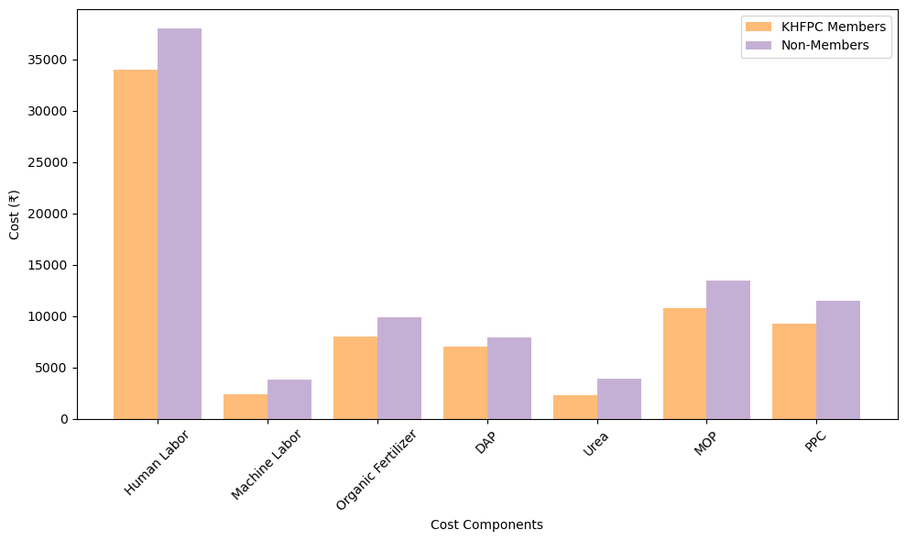 **Figure 1: Bar graph showing Cost Comparison Between KHFPC Members and Non-Members**

KHFPC members demonstrated a significantly higher yield of 11 tons per acre compared to 9.3 tons for non-members, which resulted in substantially greater gross and net profitability. The gross returns for KHFPC members reached ₹3,30,000 per acre, while non-members earned only ₹2,60,400 per acre, indicating a 26.67% increase. Similarly, net returns for KHFPC members were ₹2,00,841.07, nearly 77.32% higher than the ₹1,13,237.53 recorded for non-members (Debnath et al., 2024; Kundu, P., Ghosh, S. S., & Sahu, N. C., 2022). This significant profitability difference highlights the financial benefits of Farmer Producer Company (FPC) membership, which is driven by optimized input costs, bulk procurement of resources and access to technical guidance on improved agricultural practices (Kotyal, K. 2023; Gurung et. al, 2024; Babu & Patoju, 2021). FPCs like KHFPC enhance productivity through resource-sharing, cost-efficient management and stronger market linkages, enabling smallholder farmers to achieve greater economic sustainability (Patel & Desai, 2022; Hyera & Isango, 2024). These findings underscore the pivotal role of FPCs in improving farmer livelihoods and strengthening the financial viability of smallholder agriculture.

**Table 2: Yield, Gross Returns and Net Returns Comparison**

|  |  |  |  |  |
| --- | --- | --- | --- | --- |
| **Particulars** | **KHFPC Members**  **(₹)** | **Non-Members**  **(₹)** | **Impact of KHFPC**  **(%)** | **t-Statistic** |
| Yield (tons) | 11.00 | 9.30 | +18.28 | 7.93** |
| Gross Returns | 3,30,000.00 | 2,60,400.00 | +26.67 | 26.3** |
| Net Returns | 2,00,841.07 | 1,13,237.53 | +77.32 | 124** |

The visualization in Figure 2 highlights significant differences in Gross Returns, Net Returns and Yield proportions between KHFPC members and non-members. The bar graph reveals that Gross Returns for KHFPC members are ₹3,30,000, reflecting a 26.67% increase compared to ₹2,60,400 for non-members. Similarly, Net Returns for KHFPC members are ₹2,00,841.1, which is 77.32% higher than the ₹1,13,237.5 recorded for non-members. This considerable improvement can be attributed to reduced input costs, efficient resource management and access to technical guidance facilitated by the Farmer Producer Company (FPC), which enables farmers to optimize production and minimize expenses (Gurung et. al, 2024; Babu & Patoju, 2021). The accompanying pie chart demonstrates the Yield Comparison, where KHFPC members contribute 54.2% of the total yield compared to 45.8% for non-members, indicating an 18.28% increase in productivity for FPC members. This productivity boost reflects the adoption of improved practices and better input utilization supported by the FPC (Kunduet al., 2022; Debnath et al., 2024). Overall, these results emphasize the economic and productivity benefits of FPC membership, showcasing the role of collective action, optimized resource management and technical support in enhancing farmer profitability and productivity (Patel & Desai, 2022; Hyera & Isango, 2024).

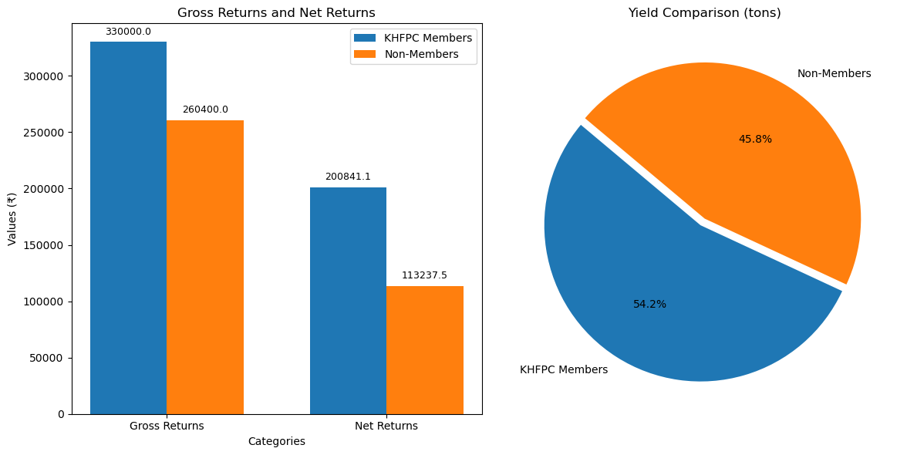

**Figure 2: Comparison of Gross Returns, Net Returns and Yield Proportions Between KHFPC Members and Non-Members**

**Conclusion**

The comparative analysis of banana cultivation in the Kollegala region highlights the significant economic advantages for farmers involved with the Kollegala Horticulture Farmers Producer Company Limited (KHFPC). By leveraging collective procurement, resource-sharing, and technical support, KHFPC members benefit from reduced input costs, including labor, machinery, fertilizers and plant protection chemicals. This leads to higher yields, with KHFPC members achieving an average of 11 tons per acre, compared to 9.3 tons for non-members. As a result, KHFPC members experience substantial increases in both gross returns (26.67%) and net returns (77.32%). The findings underscore the transformative impact of Farmer Producer Companies in improving the economic sustainability of smallholder farmers by addressing key challenges like high costs, limited technical knowledge, and fragmented market access. Promoting and expanding such collective farming models can enhance profitability, resource management, and market opportunities, making them a sustainable strategy for improving farmer livelihoods and strengthening agricultural communities.

COMPETING INTERESTS DISCLAIMER:

Authors have declared that they have no known competing financial interests OR non-financial interests OR personal relationships that could have appeared to influence the work reported in this paper.

**Disclaimer (Artificial intelligence)**

Option 1:

Author(s) hereby declare that NO generative AI technologies such as Large Language Models (ChatGPT, COPILOT, etc.) and text-to-image generators have been used during the writing or editing of this manuscript.

**References**

Anand, G., Kalaiselvi, P., Paul Sebastian, S., Senthil Kumar, M., Amuthaselvi, G., Porkodi, G., Suganya, K., & Malathi, G. (2025). Evolution and growth of Farmer Producer Organizations (FPOs) in agriculture. *International Journal of Agricultural Extension and Social Development*, *8*(1), 442-452. [https://doi.org/10.33545/26180723.2025.v8.i1g.1566](https://www.google.com/search?q=https://doi.org/10.33545/26180723.2025.v8.i1g.1566)

Babu, C., & Patoju, S.K.S. (2021). Impact of Farmer Producer Companies on Marginal and Small Farmers: A Study of Osmanabad District of Maharashtra. *Grassroots Journal of Natural Resources, 4*(2), 23-33. <https://doi.org/10.33002/nr2581.6853.040202>

Beleri, P. S. (2023). Microbial solutions to soil health: The role of biofertilizers in sustainable agriculture. *Environmental Reports*, 5(2), 6–9. <https://doi.org/10.51470/ER.2023.5.2.06>

Debnath, S., Jalawadi, S., Swain, S., Modi, P., Mendhe, A. R., Deka, B., Manju, P. R., Ramanadam, G., Panda, A., Uma, S., Devi, P., Gutam, S., & Patil, P. (2024). Low-cost farmers’ friendly technology for propagation of banana: A strategic seed system approach for banana cultivation in India. *Fruits, 1*(1), 1–16. <https://doi.org/10.17660/th2024/003>

Food and Agriculture Organization of the United Nations. (2024). *FAOSTAT*. (2024) <https://www.fao.org/common-pages/search/en/?q=banana>

Gautam, S., & Mallaiah, L. C. (2024). Enhancing Farmer’s Income and Farmer Producer Organizations’(FPOs) in India. *Saudi J Econ Fin*, *8*(4), 91-101. <http://dx.doi.org/10.36348/sjef.2024.v08i04.001>

Government of India. (2020). *Status of Farmer Producer Companies in India*. Ministry of Agriculture and Farmers’ Welfare Report. <https://agriwelfare.gov.in/Documents/annual-report-2020-21.pdf>

Gurung, R., Choubey, M., & Rai, R. (2024). Economic impact of farmer producer organisation (FPO) membership: empirical evidence from India. *International Journal of Social Economics*, *51*(8), 1015-1028. <https://doi.org/10.1108/IJSE-06-2023-0451>

Hosamani, V., Venkateshalu, K., Gangadharappa, P. M., Patil, D. R., Lokesh, M. S., Ramanagouda, S. H., & Doddabasappa, B. (2024). Incidence of banana pseudostem weevil, *Odoiporous longicollis* Olivier (Coleoptera: Curculionidae) in major banana growing districts of Northern Karnataka, India. *Journal of Advances in Biology & Biotechnology*, 27(11), 1040-1046. <https://doi.org/10.9734/jabb/2024/v27i111688>

Hyera, D. W., & Isango, E. S. (2024). Boosting productivity: The impact of improved sesame varieties on small-scale farmers in Mtwara, Tanzania. *NG Journal of Social Development*, *14*(1). <https://dx.doi.org/10.4314/ngjsd.v14i1.4>

Islam, M. K., & Farjana, F. (2024). Impact of climate-smart agriculture practices on multidimensional poverty among coastal farmers in Bangladesh. Communications Earth & Environment, 5, 417. <https://doi.org/10.1038/s43247-024-01570-w>.

Jose, A. E., Raj, N., Chavan, N., Lakshmi, K. V., Ngasainao, C., Kruparani, P., & Shaiza, M. (2024). Extension strategies and models in Agri trading through farmer producer companies (FPCs): a way towards sustainability. *J Exp Agric Int*, *46*(7), 638-648. <https://doi.org/10.9734/jeai/2024/v46i72617>

Kotyal, K. (2024). Circular agriculture: Sustainable farming practices for zero waste. *Environmental Reports, 5*(1). <https://doi.org/10.51470/ER.2023.5.1.08>

Kotyal, K. (2024). Sustainable waste management in the circular economy: Challenges and opportunities. *Environmental Reports*, 5(2), Article 01. <https://doi.org/10.51470/ER.2023.5.2.01>

Kumar, A., Singh, R. K. P., Singh, K. M., & Mishra, J. S. (2018). Economics of paddy (Oryza sativa) production: A comparative study of Bihar and Punjab. *The Indian Journal of Agricultural Sciences*, *88*(2), 314-319. <https://doi.org/10.56093/ijas.v88i2.79225>

Kundu, P., Ghosh, S. S., & Sahu, N. C. (2022). Case Study of a Farmer Producer Organization: Bhangar Vegetable Producer Company Limited. *Journal of Agricultural Extension Management*, *23*(1), 259-259. <https://epubs.icar.org.in/index.php/JAEM/article/view/159188>

Likhitha, S., Perumal, A., Nithyashree, M. L., Kumar, P., & Jha, G. K. (2024). [Article Title - if available, please add]. *Journal of Community Mobilization and Sustainable Development*, *19*(3), 692-697. [https://doi.org/10.5958/2231-6736.2024.00160.1](https://www.google.com/search?q=https://doi.org/10.5958/2231-6736.2024.00160.1).

Naik, A. K., Moolimane, C. B., DM, M., & Sri, K. K. (2024). Economic Efficiency of Banana Production in Uttara Kannada District of Karnataka, India. *Asian Research Journal of Agriculture*, *17*(2), 106-115. <https://doi.org/10.9734/arja/2024/v17i2427>

National Institute of Agricultural Extension Management (MANAGE). (2018). *Farmer Producer Companies – Issues and Challenges*. <https://www.manage.gov.in/publications/edigest/jun2018.pdf>

Özalp, B., & Ören, M. N. (2024). Political economy of input–output markets of groundnut: A case from the groundnut value chain of Turkey. *Journal of Agrarian Change*, *24*(2), e12568. <https://doi.org/10.1111/joac.12568>

Rahman, S. A., Sunderland, T., Roshetko, J. M., & Healey, J. R. (2017). Facilitating smallholder tree farming in fragmented tropical landscapes: Challenges and potentials for sustainable land management. *Journal of Environmental Management*, *198*(Part 1), 110-121. <https://doi.org/10.1016/j.jenvman.2017.04.047>

Ritter, T., Álvarez, D., Mosquera, L. E., Martey, E., & Mockshell, J. (2024). A socioeconomic and cost benefit analysis of Tropical Race 4 (TR4) prevention methods among banana producers in Colombia. *Plos one*, *19*(10), e0311243. <https://doi.org/10.1371/journal.pone.0311243>

Sahoo, S. L., Das, S., & Sahoo, B. (2022). Impact of Farmer Producer Organization (FPOs) on economic empowerment of the member farmers. *Indian Research Journal of Extension Education, 22*(2), 1-10. <https://seea.org.in/irjee/view-content/impact-of-farmer-producer-organization-fpos-on-economic-empowerment-of-the-member-farmers>

Shastri, H., Trivedi, V., & Thakker, M. (2025). Comparative Productivity and Profitability of Banana Intercropping with Vegetables: Banana-Vegetable Intercropping Benefits.*SAARC Journal of Agriculture,*22(2), 43–53. <https://doi.org/10.3329/sja.v22i2.73679>

Shelake, C., Shelake, M. K. R., & Deore, P. (2022). Socio-Economic Impact of Farmer Producer Company on its Members.*Journal of Agricultural Extension Management*, 23(1), 73. <https://epubs.icar.org.in/index.php/JAEM/article/view/159088>