Behaviour-based Safety as a Strategic Instrument for Accident Reduction in the Nigerian Petroleum Industry

.

ABSTRACT

|  |
| --- |
| **Aims:** This study was carried out to test the impact of behaviour-based safety (BBS) implementation on accident rates. Specifically, the study aimed to identify whether the implementation of BBS programme led to the reduction in accidents among workers in the petroleum industry in Nigeria.  **Study design:** This study was based on a multiple case study design.  **Place of Study:** The study was carried out on petroleum industry in the Nigerian Niger Delta region.  **Methodology:** Questionnaire was deployed as the research instrument and was distributed to 50 workers in the Nigerian petroleum industry. Stratified random sampling technique was utilized to select the workers. The data obtained were analyzed using descriptive statistics and correlation.  **Results:** Findings from the study indicated that the implementation of BBS programme was effective in reducing accidents. Therefore, organizations that aim to address unsafe acts, at-risk behaviours, and accidents due to human frailties and performance difficulties can adopt BBS as a safety tool to drive improved safety culture.  **Conclusion:** This study established that implementation of BBS resulted in the reduction of accident rate in the Nigerian petroleum industry. The implication is that organizational leaders can deploy BBS as an instrument to drive positive changes in safety culture to reduce accidents. Though this study concluded that implementation of BBS contributes to reduction in accident, further study is recommended to address the proportion of accidents that the implementation of BBS impacts. |

*Keywords: Accidents, behaviour-based safety, health, safety, safety management, human vulnerabilities, loss prevention observation*

1. INTRODUCTION

Accident is one of the most undesirable events in the different industries (Jacobson & Mottiar, 1995; Kovtun & Galkina, 2023). The impact of accident can be devastating with potential for loss of lives and reduction in organizational profitability. (Jacobson & Mottiar, 1995; Kovtun & Galkina, 2023). In the past, several strategies have been implemented to reduce and eliminate accidents in the different industries (Kovtun & Galkina, 2023; Simanjuntak, Ginting & Nasution, 2023; Toma, Negura, Moraru, Mureşan & Racautanu, 2024). Many safety professionals accept that accidents are preventable (Sushmitha, Arun & Sharma, 2022). In the petroleum industry, many organization aspire to achieve “zero hurt.” As Fabiano (2017) and Wang and Griffis (2018) noted, the “zero hurt” aspiration relies on the concept that all accidents are preventable. The implication is that having a workplace where nobody gets hurt should be the target safety goal of any organization.

Accidents are considered as the products of at-risk behaviours and unsafe conditions (Esitikot, Umoh, Ekong, Ofon, Akadi, & Obadimu, 2024; Reason, 1997). Over the years, the strategies adopted to reduce accidents include improvements in engineering designs, facility inspection programmes, personnel training, and deployment of health, safety and environment management system (Toma et al., 2024; Wang & Griffis, 2018; Esitikot et al., 2024; Hussain, Shoukat & Shamail Haider, 2019). Though each strategy improved health and safety culture and reduced accidents, the observation was that each matured over time and resulted in no further drop in accident rate (Toma et al., 2024; Esitikot et al., 2024). The rationale for no further reduction in accident rate had been attributed to the human components in accident causation (Fabiano, 2017; Kaila, 2018; Reason, 1997; HSE, 1997). As Tamu et al. (2024) noted, it became necessary to explore the human dynamics of occupational health and safety and to identify the human components that need to be managed to significantly improve safe performance of tasks. The drive to deal with the human element in accident causation necessitated the introduction of behaviour-based safety (BBS) as a strategic instrument to monitor workers at worksite, identify and reinforce positive behaviours and and address observed at-risk behaviours (Esitikot et al.,, 2024; Tamu et al., 2024). In studies by Esitikot et al., (2024) and Agwu (2013), the researchers concluded that implementation of behaviour-based safety was effective in reducing at-risk behaviours in the chemical process industry.

Sushmitha et. al. (2022) noted that the strong cause of any accident is unsafe human behaviour and so recommended psychological dealings to bring about a permanent attitudinal changes to achieve the desire safety expectations. The concept of behaviour-based safety relies on behavioural psychology to enhance improvements in organizational safety culture (Sushmitha et. al., 2022; Kaila, 2018). Behavioural safety interventions are aimed at changing safety-related behaviours in alignment with behavioural principles and various strategies (Bowdler, Steijn & van der Beek, 2023; Carra, Bottani, Vignali, Madonna, & Monica, 2024). Driving improvements in safety behaviours generally results in improved safety performance, better worker productivity and increased organizational profitability (Kaila, 2018).

As noted by Esitikot et al (2024), some organizations deploy loss prevention observation (LPO) as the instrument for implementation of behaviour-based safety. The tool involves observation of a worker while performing a task. The intent is to identify safe behaviours requiring positive reinforcement and unsafe acts that need follow up actions to address (Esitikot et al., 2024). The focus of the worker carrying out the observation is to establish if the worker performing the task followed the relevant company guidelines or procedures for safe performance of the task (Baharuddin, Fachrin & Putri, 2023; Kaila, 2014; Yang, Kim & Rodgers 2024). Based on the identified deviations from expected actions, causal factors are usually determined and corrective actions or required safety intervention established (Esitikot et al., 2024; Bowdler, et al., 2023).

Different organizations within the petroleum industry have means of measuring the effectiveness of the BBS programme (Esitikot et al., 2024). Researcher do not agree on how effective BBS is as an instrument for improving workplace safety. However, Esitikot et al., (2024) and Agwu (2013) found out that implementation of BBS resulted in reduction of at-risk behaviours in the chemical process industry, Though it is generally perceived that reduction in unsafe behaviours results in reduction in accidents (Simanjuntak, 2023; Ghahramani & Amirbahmani, 2021; Ghani & Ridho, 2024; Lim, Ham, Bak & Lee, 2022), this study specifically aimed to establish whether implementation of BBS has positive influence on accident rate in the petroleum industry in Nigeria.

2. RESEARCH METHODOLOGY

**Study Design:** This study was based on a multiple case study design. According to Lederer, Kurz, and Lazarov (2017), Saunders and Rojon (2015) and Yin (2014), multiple case study design is suitable when the research question involves multiple cases and is suitable for answering a research question involving multiple cases. Lederer et al. (2017), Saunders and Rojon (2015) and Yin (2014) also identified multiple case study design as suitable for any study that requires contrasting data from different sources. Considering that this study required collecting and comparing data from different companies in the petroleum industry, the multiple case study design was considered appropriate.

**Study Population:** As Mcqueen and Knussen (2006) noted, population refers to the set of individuals of interest to the researcher. For this study, the population was the workers in the petroleum industry of the Niger Delta region of Nigeria. The petroleum industry was considered appropriate for the study since organizations in the industry have deployed BBS as a tool for improving safety culture (Agwu, 2013).

**Selection Criteria:** According to Mcqueen and Knussen (2006), sample refers to a representative part of the study population that is used for a research. A sample is normally selected from the accessible population which is a portion of the target population (Vanderstoep & Johnston, 2009). For this study, 50 workers in the petroleum industry were selected. The workers selected were those that have been involved in BBS implementation.

**Sampling Technique:** The sampling technique adopted was stratified random sampling, a technique recognized to enhance collection of rich and representative samples (Howell et al., 2020). To ensure a variability of 10% at 5% margin error based on Watson’s *Table for Finding a Base Sample Size* (Watson, 2001), the researcher followed up with respondents to ensure the return of all questionnaires shared. This maximized the data gathered.

**Research Instrument:** Questionnaire was deployed as the instrument for data collection. Questionnaire was used it made it possible to easily collect multiple data from a large group of people within a short time. In line with the recommendation of Jenn (2006), the questions were worded to enable clear understanding of the rationale for each question. It was designed to enable the researcher obtain a fair representation of how the workers perceived the concept being studied using a five-point Likert-type scale (Strongly disagree = 0; Disagree = 1; Neutral = 2; Agree = 3; Strongly Agree = 4). The wordings of the questions made it such that “Strongly disagree” indicated negative relationship between applicable variables while “Strongly agree” indicated a positive relationship between the variables. The ‘Neutral’ option was given for workers who did not have sufficient information to justify an opinion, were indifferent to the subject, or considered the good and bad points to be about equal (Currie, 2005).

**Data Analysis:** The data collected were analyzed using descriptive statistics and correlation. These methods were considered suitable in line with the recommendation of Vanderstoep and Johnston (2009).

3. results and discussion

Table 1 shows a summary of the demographic characteristics of all the respondents in the research.

**Table 1. Summary of Demographic Characteristics of Respondents**

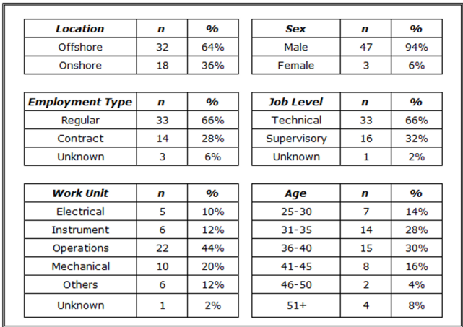

Since the oil industry is made of both offshore and onshore installations and workers, table 1 indicates that data was collected from both locations, hence the research conclusion would be representative of what is obtainable in the sector. The data was also collected from different categories and levels of workers and across different vocations to enhance the reliability of the research conclusion.

Figure 1 compares supervisors’ responses with the responses of other (technical) workers. This helps to show whether there is any difference between supervisors’ level of awareness, training and involvement in BBS compared to other workers. From the data, it is obvious that both the supervisors and the technical workers are involved in BBS, hence the research conclusions will not be skewed towards a particular level of workers.

**Figure 1. Comparison of Supervisor and Technical Workers Awareness and Involvement in BBS**

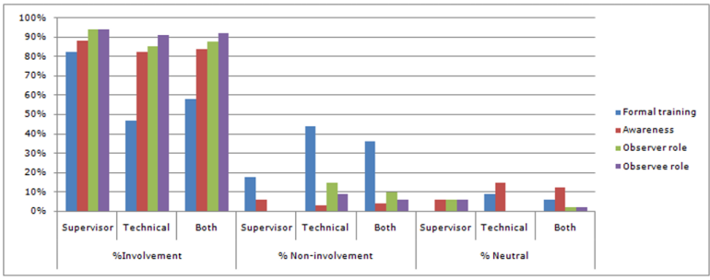

Table 2 compared the responses from supervisors on the effectiveness of LPO with those from other workers in relation to reduction in accident. This is helpful in evaluating if the perception of BBS effectiveness was related to the job position of the study respondents.

**Table 2: Comparison of Supervisors and Technical Workers Perception of the effectiveness of BBS programme.**

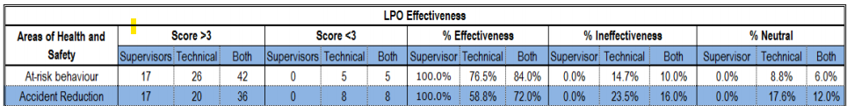

To confirm that the data obtained in this study were not due to sampling error, the Excel CHITEST function was used to test the difference in the typical data for supervisors and other (technical) workers. Thus, the probability of the differences between the observed (actual) frequencies and expected frequencies were calculated. Table 3 shows the test of independence for the responses on how LPO contributed to the reduction in accidents. Generally, in CHITEST, a probability (*P*) of 0.05 or less is considered to be significant. Thus, with a probability (*P*) of 0.0023 (which is far less than 0.05), it was clear that the difference was not due to sampling error.

Table 3 also shows the test of independence for the supervisor and technical workers responses on impact of LPO on the reduction in accidents. With a probability (*P*) of 0.01 (which is less than 0.05), it was also concluded that these responses were not due to sampling error.

**Table 3. Test of Independence of Responses to Reduction in Accidents.**

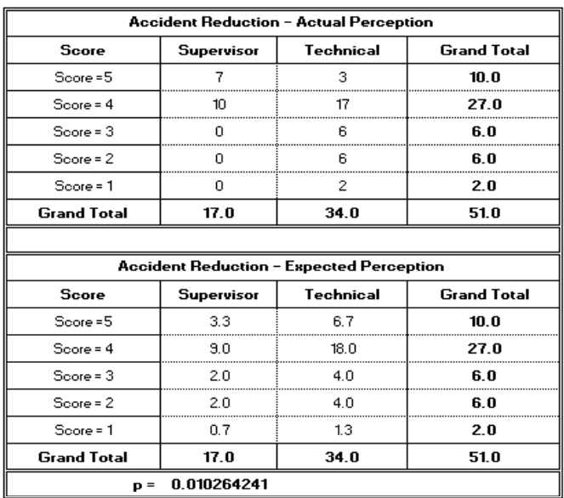

The following factors were considered while testing for the relationship between implementation of BBS and reduction in accidents:

Fo – Observed frequency

Fe – Expected frequency

df - Degree of freedom

r - The number of levels of the first independent variables

c - The number of levels of the second independent variables

α = 0.05

χ2 – Chi- square

χt2 - Critical value (from Chi-square statistical table)

The following hypotheses postulated were tested:

Null Hypothesis, 2H0: Implementation of BBS does not result in reduction in accidents

Hypothesis of relationship, 2H1: Implementation of BBS results in reduction in accidents

The data in table 4 were used for the test.

Degree of freedom, df = (r – 1)(c-1), where r =2 and c =5

df = (2-1)(5-1)=4.

Χt2 = X20.05 = 9.49

**Table 4. Computation of Chi-square Critical Computed Value (Xc2) from Table 3.**

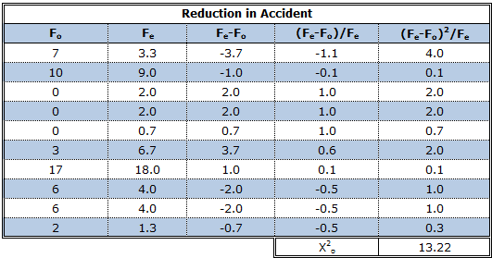

Since X02 is greater than Xt2

(that is, 13.22 > 9.49), the null hypothesis, 2H0, that implementation of BBS does not result in reduction in accidents is rejected while the alternative hypothesis that implementation of BBS results in reduction in accidents is accepted. This is in line with European Agency for Safety and Health at Work (2001) declaration and the research findings of Krause, Seymour and Sloat (1999) that examined the effects of BBS in seventy-three organisations and observed a significant decrease in accident rate after implementation of the programme. The finding also aligns with the research conclusion of Esitikot et al. (2024) that implementation of BBS resulted in reduction in at-risk behaviour. The implication is that reduction in at-risk behaviour should result in reduction in accident rates. However, this study finding is at variance with the research conclusions of Agraz-Boeneker, Groves and Haight (2009) that there is no relationship between the implementation of BBS programme and the occurrence of accidents. It is also not consistent with Naso’s (2002) conclusion that BBS is not relevant in health and safety management.

As Ahmed and Waqas (2017), Akano, Hanson, Nwakile and Esiri (2024) and Nor, Ting, Osman, Leong and Asif (2025) noted, workers generally prefer organizations with low accidents rates to organizations with high accidents rates. The implication is that workers prefer organisations with positive safety culture to organizations with negative safety culture. Since BBS is intended as a tool for improving safety culture, this study also tested if the implementation of BBS had influence on workers preference to work in certain organizations. Unlike Cooper’s (2003) study that showed over 92% of respondents wanting to work in a company using BBS, only 58% of respondents in this research agreed or strongly agreed that they liked their organisation because of their BBS programme. 20% were indifferent to BBS contributing to their likeness for the organisation.

Also, about 69% of the respondents claimed they would choose an organisation that has BBS if they were to change employer while 17% were indifferent. This portrays that though BBS contributes to workers likeness of their organisation, BBS is yet to be generally accepted by the workforce as major determinant in choice of employer. This may be due to the evolving nature of BBS that has seen different models being in use at different times (Cooper 2003; Agwu 2013; Daniels 2013). Thus, the cultural model of BBS which is in use presently (Agwu 2013; Cooper 2009), though focused on organisation's safety management system and aimed at management-employee partnership, has not yet fully consolidated the employer-employee bond (Clancy 2013; Howe 1998). This calls for a holistic approach and concerted effort, as recommended by Cooper (2009) and Hopkins (2005).

Though this study concluded that implementation of BBS contributes to reduction in accident, further study is recommended to address the proportion of accidents that the implementation of BBS impacts.

4. Conclusion

Among researchers, there is no consensus on the effectiveness of BBS as an instrument for reducing accidents (Cooper 2009). While some researchers conclude that BBS implementation contributes significantly to the reduction in workplace accidents (Daniels 2013; Hopkins 2005; Cooper et al. and Cox and Cox cited in Cox, Jones & Rycraft 2004; Krause et al., 1999), other researchers consider the gains from implementation of BBS as only temporary with no long-term impact on the effectiveness of safety and health management system (Agraz-Boeneker et al., 2009). However, the drive to use BBS as a tool for safety improvement centres on the conclusions of Heinrich (1941) and Wagenaar and Groeneweg (1987) that human errors are the source of most accidents and hence the need to use people-focused approach to eliminate human errors (Cooper 2003; Geller 2005).

This research established that implementation of BBS results in reduction in accidents in line with the research conclusions of Agwu (2013), Krause et al. (1999) and Cooper (2002). This implies a positive effect on health and safety management unlike the perspective of Agraz-Boeneker et al. (2009).

This research also established that most workers in the petroleum industry prefer to work for organisations that have BBS programme in place as an indicator of a positive safety culture.

Finally, though this research has established that BBS contributes to reduction in accidents, further study is needed to identify the proportion of accident that can be reduced through the implementation of BBS. Such data can be helpful in making helpful predictions on expected gains from BBS implementation

**Disclaimer (Artificial intelligence)**

Authors hereby declare that NO generative AI technologies such as Large Language Models (ChatGPT, COPILOT, etc.) and text-to-image generators have been used during the writing or editing of this manuscript.

References

1. Jacobson, D., & Mottiar, Z. (1995). The introduction of programmes to prevent accidents at work: A strategic analysis. Irish Journal of Management, 16, 115
2. Kovtun, M., & Galkina, E. (2023). Reduction of occupational accidents at industrial enterprises. In E3S Web of Conferences (Vol. 389, p. 09019). EDP Sciences. https://doi.org/10.1051/e3sconf/202338909019
3. Simanjuntak, R. S., Ginting, C. N., & Nasution, A. N. (2023). Factors related to unsafe behaviour among construction workers: An update literature review. Jurnal Aisyah: Jurnal Ilmu Kesehatan, 8(2). https://doi.org/10.30604/jika.v8i3.2039
4. Toma, A., Negura, F. G., Moraru, R. I., Mureşan, F., & Racautanu, M. (2024). Behavior-Based Safety, the Right Long-term approach to address Workplace Safety. In *MATEC Web of Conferences* (Vol. 389, p. 00003). EDP Sciences. https://doi.org/10.1051/matecconf/202438900003
5. Sushmitha, P. R., Arun, P. A., & Sharma, M. (2022). Implementation of behaviour-based safety management in achieving inclined driver safe behaviour. In *Advances in Construction Safety: Proceedings of HSFEA 2020* (pp. 289-296). Singapore: Springer Nature Singapore. https://doi.org/10.1007/978-981-19-4001-9_25
6. Fabiano, B. (2017). Loss prevention and safety promotion in the process industries: issues and challenges, Process Safety and Environmental Protection, 110, 1-4. https://doi.org/10.1016/j.psep.2017.08.030
7. Wang. Y. & Griffis, F. (2018). The theory of zero incident safety management. Journal of Civil, Construction and Environmental Engineering, 3(3), 83-98. https://doi.org/10.11648/j.jccee.20180303.15
8. Esitikot, E. L., Umoh, M. U., Ekong, A. E., Ofon, U. A., Akadi, A., & Obadimu, C. O. (2024). Impact of Implementation of Behaviour-Based Safety Programme on At-Risk Behaviours in the Nigerian Chemical Process Industry. International Journal of Research and Innovation in Applied Science, 9(11), 174-182. https://doi.org/10.51584/IJRIAS.2024.911014
9. Reason, J. (1997). Managing the risks of organisational accidents. Aldershot: Ashgate
10. Kaila, H. L. (2018). Behavioural intervention in safety management of Indian Corporates. Journal of Psychosocial Research, 13(1), 165–188. https://doi.org/10.32381/jpr.2018.13.01.17
11. Hussain, U., Shoukat, M. H., & Shamail Haider, M. (2019). Analysis of Safety Awareness, Accident Prevention and Implementation of Behavior Based Safety Program in Energy Utility. 2019 6th International Conference on Frontiers of Industrial Engineering (ICFIE), Frontiers of Industrial Engineering (ICFIE), 2019 6th International Conference On, 84–88. https://doi.org/10.1109/ICFIE.2019.8907683
12. HSE (1997). Successful health and safety management. HSE: London
13. Agwu, M. O. (2013). Perception survey of the impact of behaviour based safety on accident in the Bonny NLNG construction project, Nigeria. British Journal of Management, Economic and Trade, 3(1), 48-59. https://doi.org/10 .9734/BJEMT/2013/2391
14. Bowdler, M., Steijn, W. M. P., & van der Beek, D. (2023). Effective components of behavioural interventions aiming to reduce injury within the workplace: a systematic review. Safety, 9(3), 46. https://doi.org/10.3390/safety9030046
15. Carra, S., Bottani, E., Vignali, G., Madonna, M., & Monica, L. (2024). Implementation of behavior-based safety in the workplace: A review of conceptual and empirical literature. Sustainability, 16(23), 10195. https://doi.org/10.3390/su162310195
16. Baharuddin, A., Fachrin, S. A. & Putri, W. E. (2023). Behavior based safety implementation using the DO IT method at Pertamina in Makassar City. Diversity, 30–36. https://doi.org/10.24252/diversity.v4i1.40918
17. Kaila, H. L. (2014). Emerging issues and outcomes of behavior based safety (BBS) implementation. Journal of the Insurance Institute of India, 2(1), 98–102
18. Yang, E., Kim, Y., & Rodgers, C. (2024). Effects of a behavior-based safety observation program: Promoting safe behaviors and safety climate at work. Work, 77(1), 133–145. https://doi.org/10.3233/WOR-220465
19. Ghahramani, A., & Amirbahmani, A. (2021). A study of the causes of occupational accidents in manufacturing companies. Archives of Trauma Research, 10(2), 64-72
20. Ghani, H. N., & Ridho, F. M. (2024). Identifying and Analyzing Factors Influencing Occupational Accidents in the Construction Sector: A Review of 10-year Research. Pasak: Jurnal Teknik Sipil dan Bangunan, 1(2), 34-48. https://doi.org/10.32699/pasak.v1i2.6738
21. Lim, H. K., Ham, S. E., Bak, G. Y., & Lee, Y. H. (2022). Extended Analysis of Unsafe Acts violating Safety Rules caused Industrial Accidents. Journal of the Korean Society of Safety, 37(3), 52-59. https://doi.org/10.14346/JKOSOS.2022.37.3.52
22. Kwon, H. R., & Silva, E. A. (2020). Mapping the landscape of behavioral theories: systematic literature review. Journal of Planning Literature, 35(2), 161-179. https://doi.org/10.1177/0885412219881135
23. Kadau, I. (2022). Behaviourism theory in teaching and learning English as a second language in primary schools. International Journal of English and Literature, 13(3), 33-38. https://doi.org/10.5897/IJEL2022.1511
24. Lederer, M., Kurz, M., & Lazarov, P. (2017). Usage and suitability of methods for strategic business process initiatives: A multicase study research. International Journal of Productivity Management and Assessment Technologies, 5(1), 40–51. https://doi.org/10.4018/IJPMAT.2017010103
25. Saunders, M. N. K., & Rojon, C. (2015). There’s no madness in my method: Explaining how your research findings are built on firm foundations. Coaching: An International Journal of Theory, Research and Practice, 7, 74–83. https://doi.org/10.1080/17521882.2014.889185
26. Yin, R. K. (2014). Case study research: Design and methods (5th ed.). Sage.
27. Mcqueen, R. A. & Knussen, C., (2006). Introduction to research methods and statistics in psychology. Pearson Education Limited: Essex
28. Vanderstoep, S. W. & Johnston, D. D. (2009) Research methods for everyday life blending qualitative and quantitative approaches. Jossey-Bass: San Francisco
29. Howell, C.R. et al. (2020). Area based stratified random sampling using geospatial technology in a community-based survey. BMC Public Health 20, 1678 (2020). https://doi.org/10.1186/s12889-020-09793-0
30. Watson, J. (2001). How to determine a sample size: tipsheet #60. Penn State Cooperative Extension: Pennsylvania.
31. [24] Jenn N. C. (2006). Designing a questionnaire. Malaysian Family Physician, 1(1), 32-5
32. European Agency For Safety And Health At Work (2001). How to reduce workplace accidents. [online]. Available from: https://osha.europa.eu/en/publications/reports/306/
33. Krause, T. R., seymour, K. J. and Sloat, K. C. M. (1999). Long-term evaluation of a behaviour-based method for improving safety performance: A meta-analysis of 73 interrupted time series replications. Safety Science, 32(2), 1-18
34. Agraz-Boeneker, R., Groves,W. A. & Haight, J. M. (2009). An examination of observations and incidence rates for a behavior based safety program. Journal of SH&E Research, 6(1)
35. Naso, M. (2002). Change in Behavior: The Decline of behavior-based safety gives way to safety management initiatives. Safety & Health, December edition, 33-39
36. Chandler, B. & Huntebrinker, T.A. (2003). Multisite Success with Systematic BBS: A case study. Professional Safety, 48(6), 35-42
37. Howe, J. (1998). Warning: behaviour-based safety can be hazardous to your health and safety program. Occupational Health and Safety – Newsletter of the UAW Health and Safety Department, 4.
38. Hopkins A. (2006). What are we to make of safety behavior programs? Safety Science, 44(8), 583-597
39. Ahmed, S., & Waqas, H. (2017). Occupational injuries and employees turnover intention: a moderating effect of safety culture. Pakistan Business Review, 18(4), 960-977
40. Akano, O. A., Hanson, E., Nwakile, C., & Esiri, A. E. (2024). Improving worker safety in confined space entry and hot work operations: Best practices for high-risk industries. Global Journal of Advanced Research and Reviews, 2(02), 031-039. https://doi.org/10.58175/gjarr.2024.2.2.0056
41. Nor, M. M., Ting, I. W. K., Osman, A. A., Leong, M. Y., & Asif, J. (2025). Safety management in construction sites: Improper safety practices and employee turnover intention. International Journal of Industrial Management, 19(1), 29-39. https://doi.org/10.15282/ijim.19.1.2025.10953