**Enhancing the Language Environment Within Healthcare: The Case of Healthy China Initiative**

**Abstract:** The Healthy China initiative gives priority to the development of people’s health and integrates health into all health. It urgently necessitates the enhancement of language capabilities within the medical domain of the public health service system. The linguistic landscape in the medical field reflects the multifaceted interactions among its participants. This paper, grounded in a framework of place semiotics and supplemented by surveys of both physical and virtual linguistic landscapes of 6 hospitals along with 60 valid questionnaires, examines the current state of the linguistic landscape in Hefei’s medical field and endeavors to define it. This study investigates the evident language usage of hospitals. It shows the role of language in medical contexts and how it reflects public service goals, internationalization, and accessibility issues. This study comes at a time when the focus on health communication is growing and the need for hospital signs to be multilingual is critical. It makes the important contribution of explaining how public policy objectives and patient experiences in healthcare services can be achieved through the management of linguistic landscapes. However, the study identifies several issues, including a lack of language signs targeting specific populations and a low prevalence of language intelligent devices, which provide insights for the scientific, digital, and standardized management of the linguistic landscape in the medical field and if necessary, medical artificial intelligence devices are provided.

Keywords: Linguistic Landscape; Medical Field; Management

**1.Introduction**

To thoroughly implement the national strategies of “Healthy China” and “Yangtze River Delta Integration,” and to better promote the high-quality development of the health and well-being endeavors in the Yangtze River Delta, hospitals, as vital components of urban infrastructure, provide medical services to city residents. Their language signs not only represent the exterior environment of the medical space but also reflect the core cultural values of medical institutions. Landry and Bourhis (1997) define linguistic landscapes as the visibility and salience of language texts on public and commercial signs within a given territory or region. Xiaolei (2017) examines public road signs, billboards, street names, place names, commercial store signs, and public language signs on government buildings, proposing improvements for mistranslations or inconsistencies in the translation. Sebba (2010) expands the scope of linguistic landscape research to include dynamic domains and non-fixed texts, with research subjects encompassing rolling subtitles. Linguistic landscape research has now evolved into an interdisciplinary field, integrating sociology, semiotics, public health, and other disciplines, to analyze the dominant language codes of specific communities and explore underlying language policies, cultural diversity, and identity recognition.

A search through Google Scholar and the WOS literature database reveals only four articles related to public health linguistic landscapes in foreign research. One scholar argues that the production of language signs should clarify local language policies (Mdukula, 2018). Top-down language landscapes dominate in hospitals (Mdukula, 2021). However, if the language codes in the language landscape do not comply with local official language policies and are solely in English, it can impede some audiences’ access to medical information (Benedicto & Tibategeza, 2021). Most domestic attention has been focused on commercial cultural districts (Yumeng, 2023) and tourist attractions (Yucun, 2023). On CNKI, only three related papers address the theme in medical field, indicating a lack of research interest. Zhulin and Mengyu (2021) analyzed whether hospital sign translations are standardized, Xiaomin (2024) examined the linguistic forms and symbolic functions of the language landscape in Kunming hospitals, and Wen Yao (2021) conducted a three-dimensional analysis of the websites of 50 top-tier hospitals nationwide. This study conducts a virtual linguistic landscape survey of six tertiary hospitals in various districts of Hefei and their corresponding five official websites, combined with a questionnaire survey, to propose reference suggestions for the management and planning of linguistic landscapes in medical field.

**2 Research Design**This study conducted a field survey in six hospitals located within the jurisdiction of Hefei City from January to April 2024 and collected 60 questionnaires on citizens’ satisfaction with the medical field linguistic landscape from June to August 2024.

**2.1 Research Subject**

Hefei, situated in the central part of Anhui Province in the eastern region of China, currently governs four districts: Yaohai District (Xinzhan District), Luyang District, Shushan District (including government affairs, economic development, and high-tech zones), and Baohe District (Binhu New District) as shown in Fig. 1. It is an important city in the Yangtze River Delta urban agglomeration, with a significant increase in the number of foreign-funded enterprises and foreign residents, and the number of international sister cities and friendly cooperative cities has exceeded 40 for the first time.

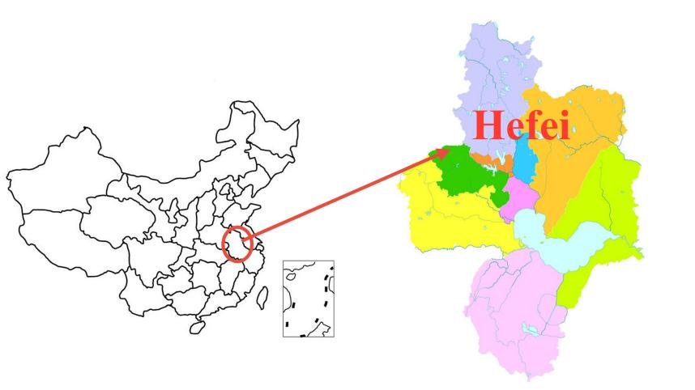

**Fig. 1.** Geographical location of Hefei and its included districts and counties

Aiming to build a modern central city and become an international metropolis, Hefei actively responds to the integrated development plan of health and health in the Yangtze River Delta, constructing a batch of high-level international hospitals. The number of top-tier hospitals is closely related to the per capita GDP of the population in the area. According to the population data released by the Hefei Municipal People’s Government in 2023 (**Table 1**) and the GDP of each district in Hefei released by Sohu (**Table 2**), the per capita GDP of the four districts from high to low is: Shushan District (20.55 billion yuan/10,000 people), Luyang District (17.43 billion yuan/10,000 people), Baohe District (13.22 billion yuan/10,000 people), and Yaohai District (8.58 billion yuan/10,000 people).

The six hospitals surveyed in this study are all top-tier hospitals that have passed the provincial health department’s assessment, achieving a high level in medical services, technology, and equipment. Hospital information mainly comes from the 99 Hospital Database, which compiles information on top-tier hospitals nationwide, and the Healthy Hefei APP, managed by the Hefei Municipal Health and Health Commission. When selecting research subjects, if a hospital has a main campus and branches, the main campus, which is older than the branches, is chosen; if a hospital is divided into the First, Second, and Third People’s Hospitals, the First People’s Hospital is selected. Ultimately, the research subjects are determined to be the First Affiliated Hospital of Anhui University of Chinese Medicine, the 901st Hospital of the Joint Logistics Support Force of the Chinese People’s Liberation Army, Hefei First People’s Hospital, the First Affiliated Hospital of the University of Science and Technology of China, Anhui Children’s Hospital, and Hefei BOE Hospital as survey points.

**Table 1** Population data released by the Hefei Municipal People’s Government

|  |  |
| --- | --- |
| District | Population（ten thousand） |
| Yaohai District | 88.9 |
| Luyang District | 73.3 |
| Shushan District | 110.5 |
| Baohe District | 131.2 |
| Gaoxin District | 31.9 |
| Jingkai District | 61.5 |
| Xinzhan District | 51.8 |

**Table 2** GDP of each district in Hefei announced by Sohu

|  |  |
| --- | --- |
| District | GDP (Million RMB) |
| Baohe District | 1735.5 |
| Jingkai District | 1409.9 |
| Shushan District | 1401.0 |
| Gaoxin District | 1371.7 |
| Luyang District | 1278.9 |
| Yaohai District | 761.0 |
| Xinzhan District | 446.4 |

**2.2 Research Questions**This study adopts a combination of quantitative and qualitative methods to conduct field research on the medical field linguistic landscape in Hefei City, recording and describing the basic situation and prominent characteristics of the medical field linguistic landscape, analyzing the current shortcomings and their causes, and proposing targeted solutions.

**2.2.1 Research Questions**(1) How should the physical and virtual language landscapes in the medical field be defined?  
(2) What is the current state and representation of the language landscape in the medical field in Hefei?  
(3) What are the shortcomings and causes of the language landscape in the medical field in Hefei, and how can targeted solutions be implemented?

**2.2.2 Research methodology**

The theory of Place Semiotics was developed by Scollon and Scollon in the book *Discourse in Place.* They argue that signs in places are helpful to comprehensively analyze the social function and cultural significance of linguistic landscape. The following are the theoretical framework of place-semiotics and its core elements: Code Preference, Inscription, and Placement*.* Code orientation focuses on the priority relationship, primary and secondary status in the order and spatial position of different languages in bilingual or multilingual signage. At first, inscription studies the presentation of linguistic landscapes, including materials, fonts, colors, states, etc. It focuses on how the physical characteristics of language signage affect its meaning and function. In addition, placement is the core element of place semiotics, concerned with the spatial location of linguistic landscapes and their socio-cultural significance. It explores whether linguistic landscapes are socially recognized and their symbolic significance in regional Spaces.  
**2.2.3 Data Processing**Symbols are recognizable texts within a space (Backhaus, 2007). Any form of symbolic text, from graffiti on the ground to hospital promotional materials, can serve as sample data for the linguistic landscape in medical field. Pinyin is counted as Chinese language code, while uppercase English abbreviations are counted as English. For example, "floor" in English is abbreviated as “F”. Using statistical software SPSS, the collected field survey data and questionnaire data are organized according to variables such as language type, number of syllables, and creators, and duplicate and invalid data are removed.

**3. Current Status of the Medical Field Linguistic Landscape in Hefei City**

Linguistic landscapes can be categorized based on different carriers, into physical linguistic landscapes that rely on material carriers such as buildings and sculptures, and virtual linguistic landscapes that rely on non-material carriers like signs (Baicheng, 2015), which aid in a better understanding of the application of languages in globalization and digitalization; according to the different establishers of language signs, they can be divided into top-down official linguistic landscapes and bottom-up private linguistic landscapes (Guowen & Shouhui, 2014).

**3.1 Physical and Virtual Linguistic Landscapes**

The physical linguistic landscape in the medical field primarily refers to all the displays of language and text within the hospital environment, including directional signs, bulletin boards, notice boards, department names, guidance signs, and scrolling content on electronic screens. These not only reflect the external image of the medical field but also influence the medical experience of patients. In Hefei’s medical field, language signs are predominantly in Chinese, with the “Chinese + English” language code combination ranking second, as shown in **Table 3**.

**Table 3** Language Categories and Their Respective Percentages

|  |  |  |  |
| --- | --- | --- | --- |
|  | | Number | Percentage of the Total |
| Validity | Chinese | 380 | 58.5 |
| Chinese+ English | 266 | 41.0 |
| English | 3 | 0.5 |
| Total | 649 | 100.0 |

The virtual linguistic landscape mainly includes the text, images, animations, audio, video, hyperlinks, navigation bars, and buttons on hospital websites, depicting the linguistic community and the virtual signage of language status, in order to explore the power relations between coexisting language choices.Due to the lack of carrier restrictions, it is possible to switch links by clicking on the page's language code, which directs to the official portal websites of various hospitals. Due to the search restrictions of 901 Hospital, information from the official websites of five hospitals was investigated. Each language interface only used Chinese, and only Anhui Provincial Hospital of Traditional Chinese Medicine had a bilingual interface (**Fig. 2** and **3**). Although the website interface of the First Affiliated Hospital of the University of Science and Technology of China had an English hyperlink switch module (**Fig. 4**), it could not switch to the English interface.

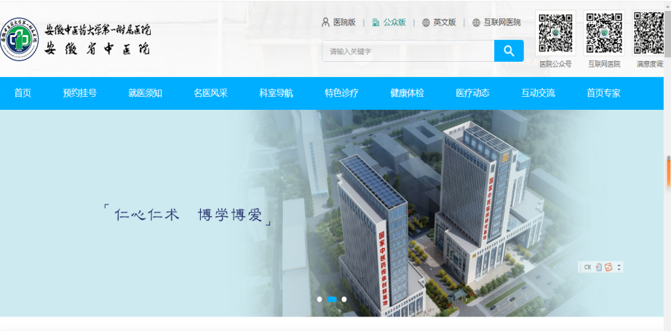

**Fig. 2.** Chinese Interface of Anhui Provincial Hospital of Traditional Chinese Medicine

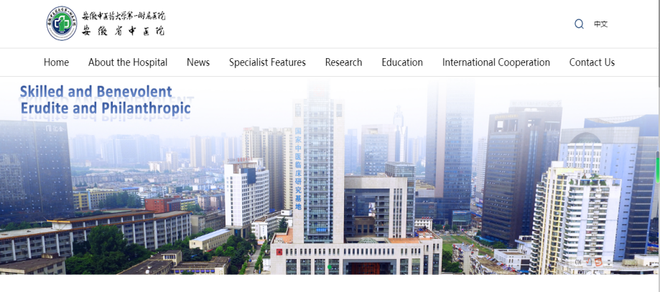

**Fig. 3.** English Interface of Anhui Provincial Hospital of Traditional Chinese Medicine

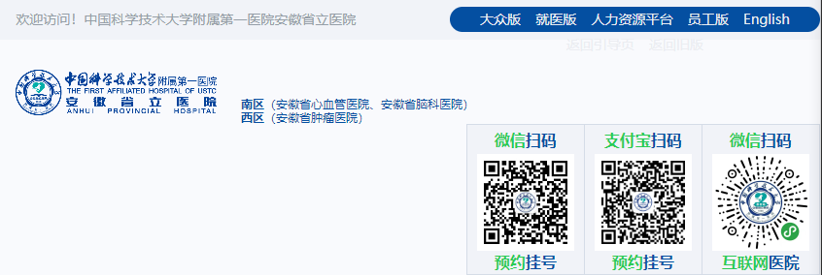

**Fig. 4.** Chinese Interface of the First Affiliated Hospital of University of Science and Technology of China

Hospital portals often utilize Chinese interfaces for two primary reasons. First, the majority of users seeking information about the hospital are Chinese residents. A Chinese website caters to local residents by providing localized services, allowing for intuitive and convenient access to domestic users. Additionally, embedded translation software on the pages can provide foreign individuals with the necessary hospital-related information. Second, a Chinese interface ensures the integrity of information dissemination. Beyond treatment information, hospital websites also display medical policies and insurance procedures. During translation, there may be misunderstandings or omissions of unique local Chinese information, which could hinder users from obtaining complete medical information.

**3.2 Official Linguistic Landscape and Private Linguistic Landscape**

The establishment of language signs is primarily by official institutions or private entities. In the medical field, official sign creators are the government or hospital authorities, while private sign creators are often individual businesses or enterprises (Ben-Rafael et al, 2006), accounting for only 20.4% . The Hefei BOE Hospital, established by the BOE Technology Group, is also part of the private linguistic landscape.

The official linguistic landscape in public hospitals is dominant, accounting for 79.5%, as shown in **Table 4**. First, it reflects the essential attribute of healing. Public hospitals, as authoritative institutions providing public medical services, offer accurate medical diagnoses and feasible treatment advice, focusing on social benefits. Their language signs primarily serve to convey information about medical services and treatments, aiming to provide necessary information and guidance services to patients in the shortest time possible. These signs are characterized by being concise, clear, distinctive, unified in style, and well-coordinated in color. In contrast, private shops within the hospital focus on market benefits, and their language signs are mostly for sales purposes. Second, it reflects the public welfare characteristics of public services. The hospital’s language signs provide medical public services to visitors, and their informative, warning, and prohibitive signs ensure the consistency and professionalism of the language, such as the translation of department names and disease names. The official timely updates or modifications of the language signs simplify the medical process, providing patients with convenient and efficient medical services.

**Table 4** Creator of Linguistic Signs

|  |  |  |  |
| --- | --- | --- | --- |
|  | | Number | Percentage of the Total |
| Validity | The Official | 516 | 79.5 |
| The Personal | 133 | 20.5 |
| Total | 649 | 100.0 |

**4. Characteristics of the Medical Field Linguistic Landscape**

The medical field linguistic landscape, from the perspectives of visual effects and information conveyance, is characterized by a multimodal and code-oriented representation that includes text, sound, and images, as well as the elements of typography and placement in the study of place semiotics.

**4.1 Multimodal Representation**

“Multimodality” is a medium for meaning exchange, and multimodal linguistic landscapes integrate multiple meaning systems based on text, conveying more information to users. In the medical field of Hefei City, multimodality is dominant, with the “text + color” multimodality (N=628, 96.8%) being particularly significant. Color coordination is an essential element of slogan design, with the top five single colors being white (N=406, 33.2%), blue (N=266, 21.7%), black (N=170, 13.9%), red (N=160, 13.1%), and yellow (N=126, 10.3%). Different colors express different emotions and meanings, having a healing effect on patients in different situations (Jing et al, 2020), and can intuitively display the hospital’s service philosophy and spirit.

Black symbolizes solemnity and mystery, while white implies fairness and purity, commonly used in hospital identification and wayfinding systems to convey a professional and clear image. The “black + white” color combination (N=53, 8.2%) (**Fig. 5**) aligns with the hospital’s positioning of “fairness, selflessness, purity,” and is dominant in hospital linguistic landscape design. Blue is a non-aggressive color, commonly used as the main color in medical settings, representing health, peace, safety, and trust, giving people a sense of tranquility, comfort, and relaxation (Tingting et al, 2014). The “white + blue” color combination accounts for 30.0% (**Fig. 6**), showcasing the professionalism and knowledge of doctors, evoking positive emotions, meeting patients’ expectations of medical staff, and conveying the hospital’s warmth. Hospital warning signs use red as the background color; red can convey danger signals and has a warning effect, as shown in **Fig. 7**: “No Smoking,” used to highlight important information or emergency signs, conveying urgency and warning utility, ensuring patients comply with hospital regulations and maintaining good public order in the hospital.

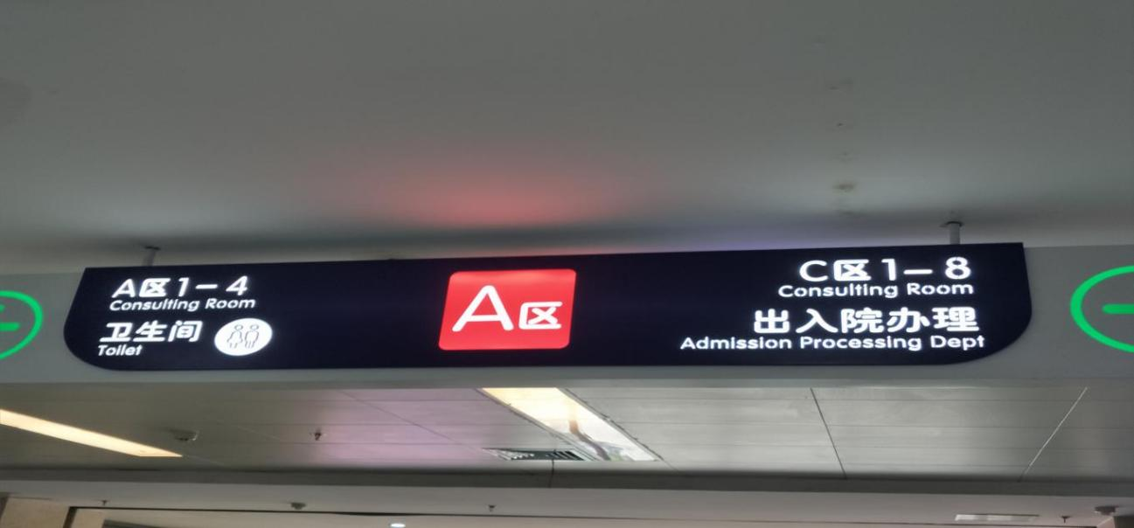

**Fig. 5.** “Black + White” Multimodal Language Sign

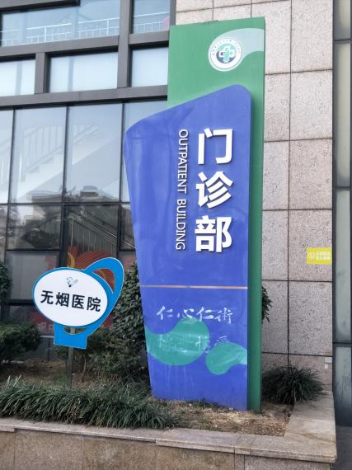

**Fig. 6.** “White + Blue” Multimodal Language Sign

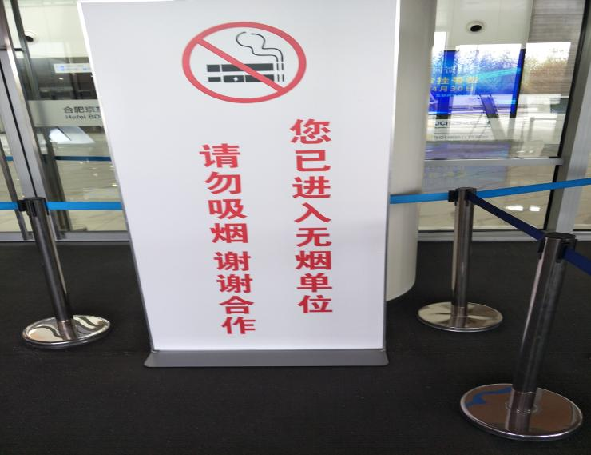

**Fig. 7.** Red Multimodal Language Sign

During the survey, yellow (N=47) accounted for only 7.2%, but the overall linguistic landscape of the First People’s Hospital of Hefei is predominantly yellow (**Fig. 8**), with the hospital’s walls, department names, and ground directional signs mainly in yellow for the following reasons. First, it echoes the hospital’s emblem, reflecting design consistency. Second, it triggers positive psychological effects. A monochromatic black and white environment can be depressing, while yellow symbolizes vitality, warmth, and energy, creating a more optimistic and positive medical environment, which can help enhance patients’ appetite and resistance. Third, it has visual prominence. Yellow is a bright color that easily attracts attention, often used in hospital wayfinding systems for warning signs, marking key areas to remind people of dangers or precautions, with high contrast against black or dark text, helping people identify and find the required information more quickly.

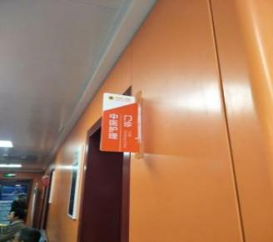 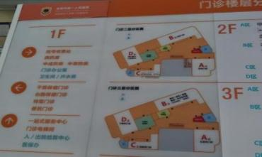 

**Fig. 8.** Department signs, wayfinding maps, and hospital emblem of Hefei First People's Hospital

**4.2 Semiotic Representation of Place**

The semiotic analysis of place includes elements such as code orientation, typography, placement, and the discourse of time and space (Scollon & Scollon, 2003).

**4.2.1 Code Orientation**

Code orientation refers to the prioritization of different languages in a multilingual environment (Scollon & Scollon, 2003). The dominant language usually occupies a leading or prominent position. In bilingual or multilingual arrangements, the dominant language is often placed at the top or left side of the sign, while the secondary language is placed at the bottom or right side. In the investigation of the medical field linguistic landscape in Hefei City, the languages are Chinese (59.6%), Chinese + English (39.9%), and English (0.5%), as shown in **Table 1**. Chinese is the dominant language, and English is the only foreign language. When presenting bilingual codes, the Chinese font occupies more space than English and is placed in the center, top, or left side of the sign (**Fig. 10**). The “Specifications for the English Translation of Chinese Signs in Public Places of Medical and Health Institutions” issued by the Beijing Municipal Market Supervision Administration (2020) provides guidance for the translation of bilingual signs. The proportion of complete translations of Chinese and English is only 35.7% (N=232) (**Table 5**), which has a gap with the “Chinese + English” code (N=266, 41%), mainly due to the incomplete correspondence between the content presentation and translation content of some bilingual signs, such as the “MDT Outpatient” sign at Anhui Provincial Children’s Hospital (**Fig. 9**).

**Table 5** Degree of Code-Switching in Translation

|  |  |  |  |
| --- | --- | --- | --- |
|  | | Number | Percentage of the Total |
| Validity | Partial translation | 6 | 0.9 |
| Complete translation | 232 | 35.7 |
| No translation | 411 | 63.3 |
| Total | 649 | 100.0 |

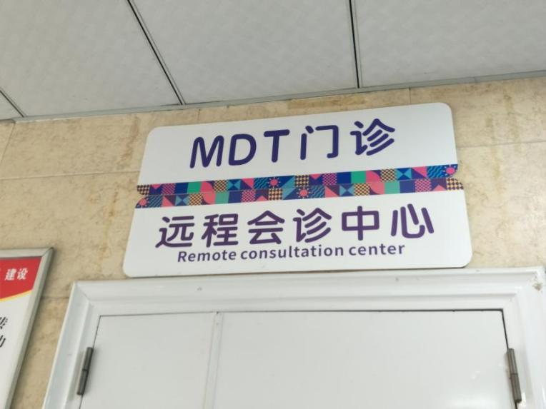

**Fig. 9.** No translation Language Sign

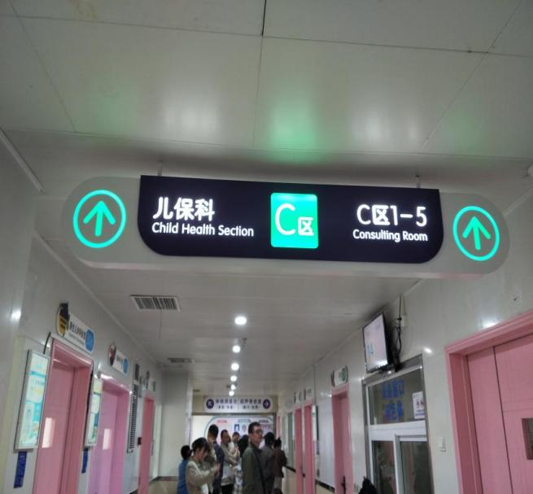

**Fig. 10.** Navigation Sign

English, as a global lingua franca, symbolizes the internationalization and professionalism of hospitals. First, it conforms to the trend of internationalization. Promoting the upgrade and facilitation of medical services for foreigners, such as increasing the proportion of bilingual signs, can enhance the international level of hospitals. This provides more convenient and efficient medical security services for foreign high-level talents and permanent residents working and living in Hefei, contributing to the urban internationalization process of Hefei’s beautiful vision for 2035. Second, it reflects the professionalism of the medical industry. The professional medical terms involved in the medical field language signs, such as department names and bulletin board announcements, have clear and internationally recognized definitions in English. Medical staff’s professional and scientific research require browsing foreign English literature of significant medical value to keep pace with international leading medical research.

**4.2.2 Code Function**

Linguistic landscapes have an explicit informational function and an implicit symbolic function. The language on the linguistic landscape is closely linked to social culture. Through the text on public language signs, one can infer the identity of the sign creators and users, and even glimpse into the language policies and language ideologies of the region through these signs. According to the role undertaken by linguistic landscapes, the informational function is the fundamental function of linguistic landscapes, which can be divided into informative, behavioral regulation, interaction, and cognitive functions (Yajie & Yingxin, 2024) (**Table 6**).The language signs with informative functions include providing registration processes, waiting times, etc., accounting for as much as 70.3%, mainly due to: First, it helps optimize the allocation of medical resources and improve the efficiency of medical services. Patients may visit for the first time or be unfamiliar with the hospital layout and department distribution, requiring corresponding and necessary signs, maps, and guidance services to guide them to the correct departments, such as signs indicating the destination for patients or medical staff, which to some extent reduces the waste of medical resources. Second, it reduces patient anxiety and promotes patient-doctor communication. The medical environment may cause anxiety, and clear graphic instructions can help patients with poor language communication to overcome language barriers, improving the effectiveness and convenience of information transmission, enabling patients to receive treatment orderly and reducing psychological pressure. Third, meet the needs of special groups. Third, it meets the needs of special groups. For people with disabilities who have difficulty accessing medical services, barrier-free guidance is needed to ensure their safe and convenient arrival at the destination department (**Fig. 11**). Behavioral regulation functions refer to signs that can regulate people’s behavior in specific environments (**Fig. 12**), such as “No Smoking in Smoke-Free Hospitals” and “No Piling Up Debris Under Rolling Doors”. Interactive functions mainly reflect the hospital’s humanistic care, providing warm reminders to patients, such as “Watch Your Step” (**Fig. 13**) and “Caution: Slippery Floor”. In the medical field, cognitive functions (N=109, 16.8%) mainly involve popularizing medical-related health knowledge (**Fig. 14**) and disseminating the professional ethics of medical staff, conveying the hospital’s purpose and philosophy.

**Table 6** Code-Switching Functions

|  |  |  |  |
| --- | --- | --- | --- |
|  | | Frequency | Percentage |
| Validity | Interaction | 44 | 6.8 |
| Cognition | 109 | 16.8 |
| Information | 456 | 70.3 |
| Behavioral regulation | 40 | 6.2 |
| Total | 649 | 100.0 |

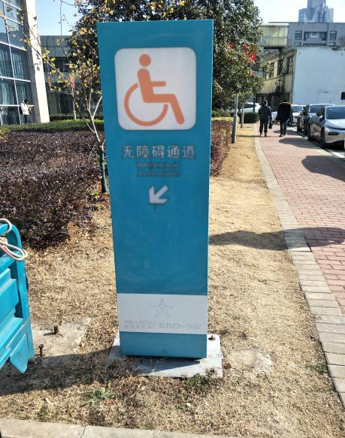

**Fig. 11.** Informative Sign

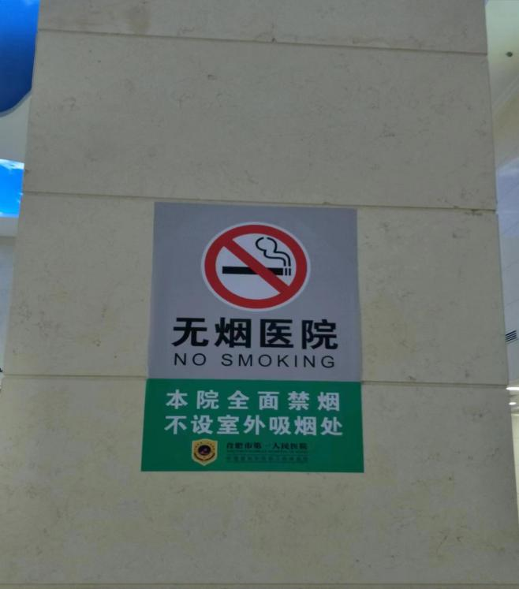

**Fig. 12.** Behavior regulation Sign

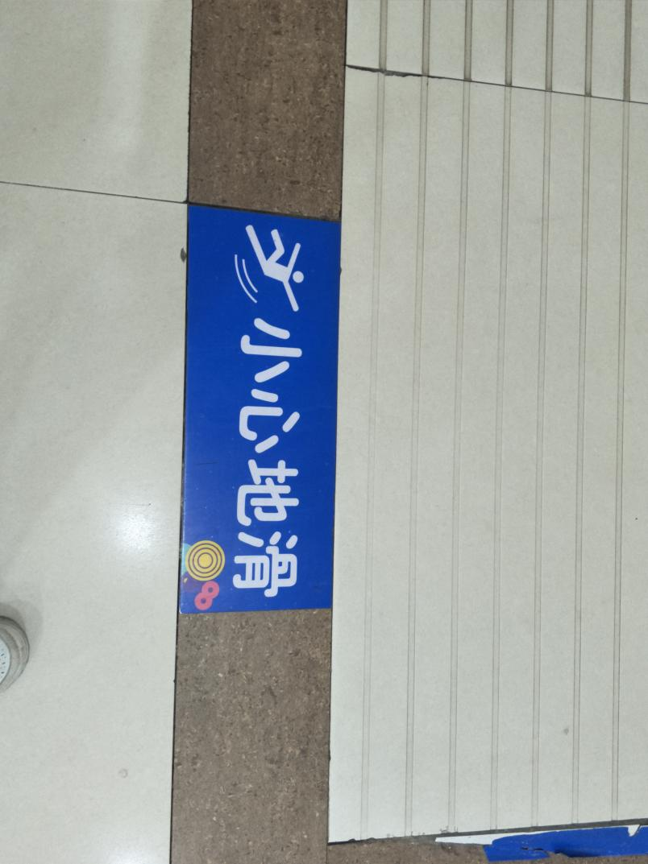

**Fig. 13.** Interactive Sign

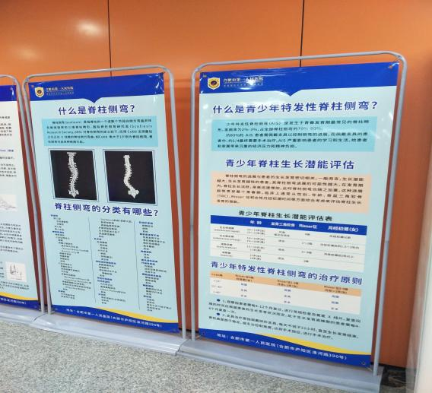

**Fig. 14.** Cognitive Sign

**4.2.3 Inscription**

Inscription refers to the way language is presented on signs, conveying different meanings through the materials and fonts they carry. The subjects of the linguistic landscape include the creators, producers, and users of the signs. As shown in Table 6, the average number of Chinese characters used in medical field signs in Hefei is 7.57 , and the mode, which is the most frequent number of characters, is 4 characters (25.3%). A few signs have as many as 60 Chinese characters, such as: “Promoting Patriotism and Popularizing Disease Knowledge.” While waiting for treatment or during rest breaks, patients can also learn some daily health tips and the hospital’s operational philosophy through bulletin boards, such as the Heimlich maneuver, strengthening the hospital’s positive image of responsibility in the hearts of patients and actively responding to the national call for “health promotion”.

The main reasons for the medical field signs having three to eight Chinese characters are: First, the informative function is dominant, with most guide signs being 3 or 4 characters of department names, such as Emergency Pediatrics, General Surgery, and Gastric Lavage Room. Second, the economic principle of behavioral regulation signs, the public space attribute of hospitals requires people to comply with corresponding public order, conveying sufficient information with concise text, such as “No Smoking in Smoke-Free Hospitals” and “Peaceful You is the Most Beautiful”. Third, it reflects the hospital’s humanistic care. The medical field often uses four or eight-character language signs carrying interactive functions, such as “Caution: Slippery”.

**Table 7** Chinese Character Usage

|  |  |
| --- | --- |
| Mean | 7.57 |
| Median | 5.00 |
| Mode | 4 |

The language and text on medical field signs need to be emphasized and highlighted. The fonts used in the survey samples include Heiti, Songti, Kaiti, and Huawen Xinwei, with Heiti being the most frequently used (N=562, 86.8%). Song has thin strokes (**Fig. 16**), while Black has thick and uniform strokes (**Fig. 15**), with a clear shape to highlight importance, easy to recognize from a distance or in poor visibility, conforming to the common use of Chinese titles, and showing more authority and professional standardization.

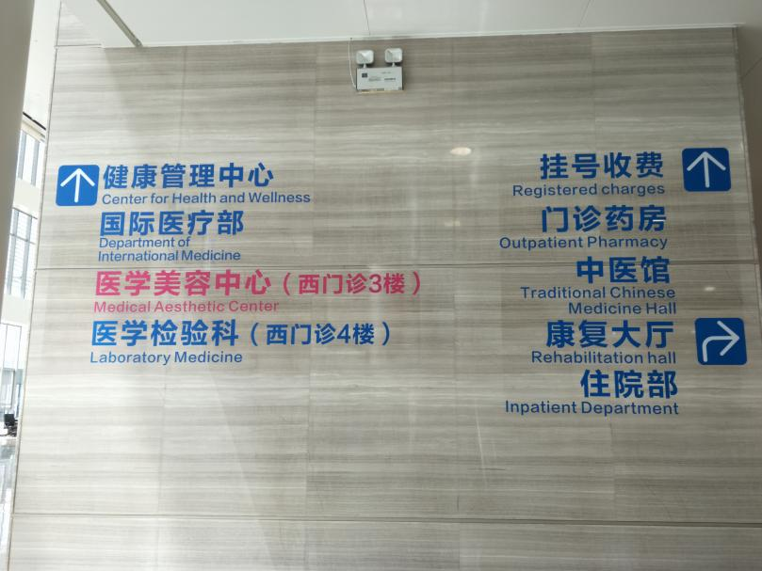

**Fig. 15.** Bold Language Sign

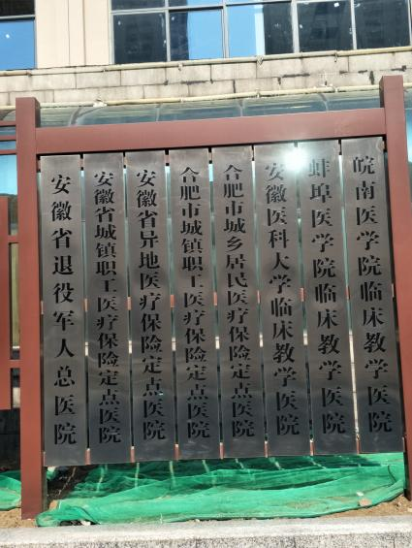

**Fig. 16.** Songti Language Sign

**4.2.4 Placement**

Placement refers to the physical location of language signs and their relevance to the meaning or function they express, focusing primarily on the relationship between language signs and their surrounding environment, including forms such as contextualization, decontextualization, and transgression (Scollon & Scollon, 2003). The survey sample indicates that language signs in the medical field tend to be contextualized (N=595, 91.7%) (see **Fig. 17**and **18**), mainly because contextualized signs can provide location information in a timely manner. As a complex public space, the design and placement of language signs in hospitals must follow relevant regulations. Visitors to the hospital are often anxious to receive medical treatment, and language signs or sign combinations related to their current location that clearly and coherently point to specific medical departments provide convenience for medical services, reduce the cost of information acquisition, and to some extent, alleviate their psychological pressure. In case of emergencies, contextualized language signs ensure the continuity of navigation and the consistency of information, allowing for timely evacuation and guidance to safe locations.

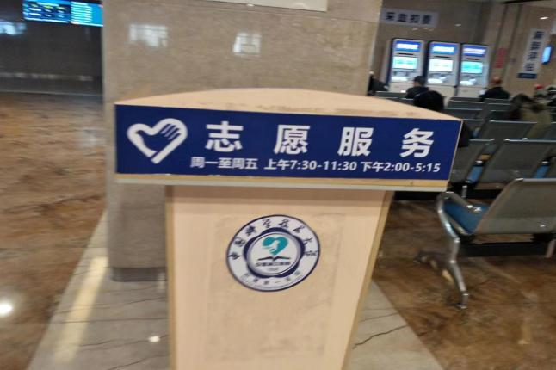

**Fig. 17.** Contextualized Language Sign

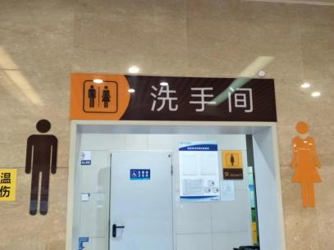

**Fig. 18.** Contextualized Language Signage

**5. Issues and Improvement Measures in the Medical Field Linguistic Landscape of Hefei City**

The linguistic landscape of the medical field fully reflects the public service attributes of hospitals and the humanitarian essence of healing and saving lives. The subjects of the questionnaire survey are relatively satisfied with the current state of the linguistic landscape in Hefei’s hospitals, with only 11.7% of participants believing that there is still room for improvement in hospital language signs.

**5.1 Lack of Attention to Special Groups**

The survey found that only one hospital uses signs with simple text or graphic elements for “Elderly Only” (**Fig. 19**). There is a lack of language signs in Hefei’s medical field targeting the elderly, with some signs placed too high, especially department navigation signs. Iron signs with multiple consultation room names marked have dense content, which is not easily recognizable for the elderly with low vision, prolonging the time needed for sign recognition and the time spent searching for the target consultation room. Only one hospital has a language sign for a “Wheelchair Accessible” (FIG 19). Although hospitals pay attention to people with disabilities, there is a lack of dedicated barrier-free signs equipped with braille or audio prompts for visually and hearing-impaired individuals.

The digital and intelligent applications in the medical field need to pay special attention to special groups. Based on the characteristics of the elderly population, such as poor physical condition, insufficient information ability, and inability to access the internet conveniently, the linguistic landscape should be adapted to meet the needs of the elderly, providing them with humanized and considerate services. Hospitals have limited space, which can lead to closely arranged language signs. Hospital managers should use contextualized language signs as much as possible and place conspicuous yellow language signs at guidance desks, such as “Orange Heart Assists the Elderly”, while increasing barrier-free language signs, adding braille at key locations like elevator entrances, and providing sign language translation services at guidance service desks.

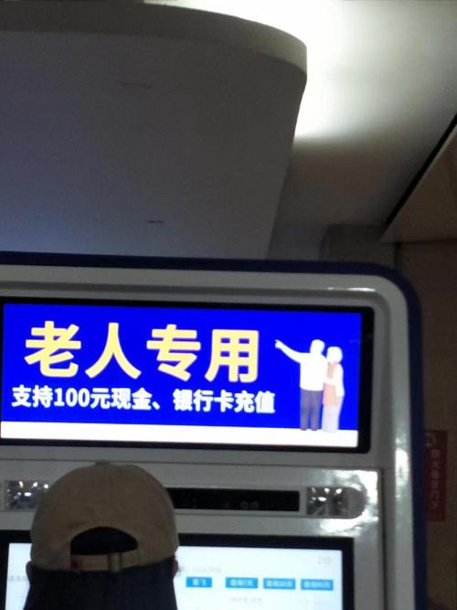

**Fig. 19.** “Elderly Only” Sign

**5.2 Maintenance and updates are not timely**

Some medical field language landscapes are outdated or missing.Due to exposure to wind, sun, and human wear, some ground signs (**Fig. 20**) and outdoor department name signs (**Fig. 21**) that have been placed in high-traffic areas for a long time lack regular maintenance and optimization updates. This has led to a decline in the signs' visibility, making them unclear and even difficult to read, thus failing to provide clear navigation and service experience for patients.

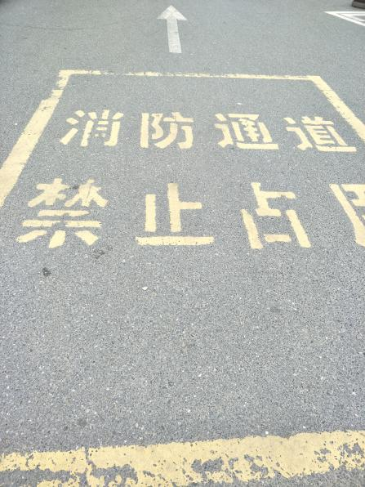

**Fig. 20.** Landmark

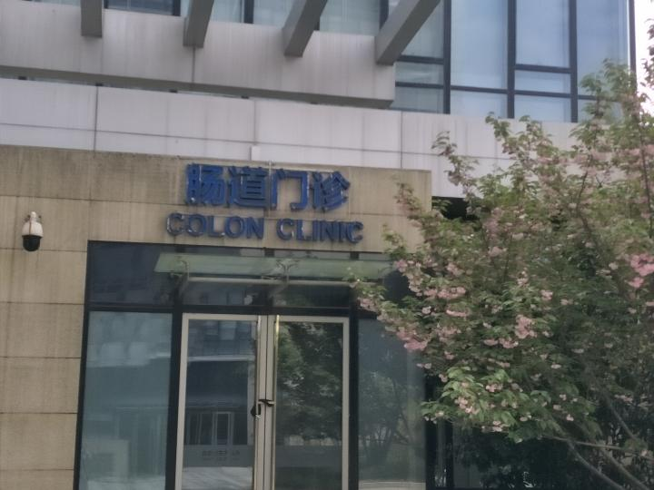

**Fig. 21.** Department Signage

**5.3 Insufficiency of Linguistic Intelligent Devices**

In the era of digital intelligence, human-computer interaction technology is becoming increasingly sophisticated. The widespread implementation of linguistic intelligent devices can promptly update navigation systems. Relying on various language packages equipped through online and offline channels such as medical institution windows and WeChat public accounts, services can be provided by switching to the target language according to the needs of patients. A questionnaire survey revealed that a minority (24.3%) believe that the application of linguistic intelligent devices is insufficient. Linguistic intelligent display devices can quickly respond to the needs of patients, such as providing the exact location of the target department, reducing the time cost for patients(Xue-Bo, Z., et al, 2025). Traditional language signs are mostly static, and any change in information requires redesigning the old signs, which is time-consuming and labor-intensive, with high input costs. Intelligent language display devices can reduce the financial and human resource costs for hospitals to maintain equipment.

**6 Conclusion**

This paper records and describes the combination of symbols and their representations in the linguistic landscape of Hefei’s medical field based on the elements of place semiotics and multimodality. It combines the views and suggestions of people with different educational backgrounds on medical language landscapes through questionnaire surveys, analyzing the language ecology of Hefei’s medical field. The study found that, first, the essential public service attribute of hospitals reflects the public service nature of official language signs, which have a higher proportion than private language signs, and their production and placement follow principles of convenience and standardization. Chinese is in a dominant position, more prominent compared to other codes. Second, medical field language signs exhibit characteristics of being concise, clear, professional, uniform in style, and well-coordinated in color. Third, there is a lack of language signs targeting special groups, some language signs are not maintained and updated in a timely manner, and the application of linguistic intelligent devices is insufficient. Hospitals need to improve or add necessary language signs, popularize intelligent medical equipment, and save on human and financial resources. Fourth, localization and internationalization are combined, hospitals can maintain local service characteristics while better providing bilingual medical services for foreign residents, enhancing the hospital’s international image and competitiveness.

The construction of the public health service system urgently needs to improve the level of public health language services. The linguistic landscape of the medical field is the carrier of information transmission in public health services. The scientific, informatized, and standardized construction and management of the medical field linguistic landscape can further meet the multi-level and diverse health needs of the people.

**Ethical Approval:**

As per international standards or university standards written ethical approval has been collected and preserved by the author(s).

Disclaimer (Artificial intelligence)

Option 1:

Author(s) hereby declare that NO generative AI technologies such as Large Language Models (ChatGPT, COPILOT, etc.) and text-to-image generators have been used during the writing or editing of this manuscript.

**References**

Backhaus, P. (2007). *Linguistic Landscapes: A Comparative Study of Urban Multilingualism in Tokyo*. Clevedon: Multilingual Matters.

Benedicto, G., & Tibategeza, E. R. (2021). The Linguistic Landscape of Regional Hospitals in Tanzania: Language Choice on Signage. *Studies in Linguistics and Literature*, 4, 70-93.

Ben-Rafael, E., et al. (2006). Linguistic Landscape as Symbolic Construction of the Public Space: The Case of Israel. *International Journal of Multilingualism*, 3(1), 7-30.

Baicheng, Z. (2015). An Overview of Linguistic Landscape Study in China and the Prospect. *Contemporary Foreign Language Studies*, (12), 14-18+77.

Guowen, S. & Shouhui, Z. (2014). Linguistic landscape studies: Perspectives, theories and approaches. *Foreign Language Teaching and Research*, 46(02), 214-223+320.

Jing, Z., et al. (2020). Application of Color Therapy in Postpartum Depression Nursing. *Electronic Journal of Practical Clinical Nursing Science,* 5(21), 121.

Landry, R., & Bourhis, R. Y. (1997). Linguistic Landscape and Ethnolinguistic Vitality: An Empirical Study. *Journal of Language and Social Psychology*, 16(1), 23-49.

Mdukula, P. C. (2018). Linguistic Landscape of Public Health Institutions in Tanzania: The Case of Muhimbili National Hospital. , Tanzania: University of Dar es Salaam.

Mdukula, P. (2021). The Linguistic Landscape of Public Health Institutions in Tanzania. In G. Niedt & C. A. Seals (Eds.), *Linguistic Landscapes Beyond the Language Classroom* ,77–96.

Scollon, R., & Scollon, S. (2003). *Discourses in Place: Language in the Material World*. London: Routledge.

Sebba, M. (2010). Linguistic Landscapes: A Comparative Study of Urban Multilingualism in Tokyo. *Writing Systems Research*, 2, 73-76.

Ting, W., et al. (2014). The Priming Effects of Red and Blue on the Emotion of Chinese. Application of color therapy in the care of postpartum depression. Acta Psychologica Sinica, 46(06), 777-790.

Wenyao, Liu (2021). Research on Linguistic Landscape of Hospital Official Websites Based on Three-dimensional Analysis Theory. Wuhan: Wuhan University.

Xiaolei, W. (2017). Investigation of Urban Bilingual Language Landscape and Transcribing Study. *Journal of Heihe University*, 8(03), 198-199.

Xiaomin, N. (2024). Study on Virtual Language Landscape of Kunming Hospital Official Website. *Comparative Study of Cultural Innovation*, 8(19), 16-21.

Xue-Bo, Z., et al.(2025) Trends and Insights in Digital Medicine development. Chinese Bulletin of Life Sciences, (01), 67-76.

Yajie, Z., & Yingxin, M. (2024).Survey on the Linguistic Landscape of Cangzhou “Grand Canal Cultural Landscape Belt”. *Intelligent Building & Smart City*, (03), 14-16.

Yucun, Z. (2023). Exploring the Linguistic Landscape in Three-Dimensional Space —A Case Study of Red Tourist Sites in Shanghai. Shanghai: Shanghai International Studies University.

Yumeng, H. (2023). A Study on the Linguistic Landscape of Historical and Cultural Blocks under the 3D Analysis Theory: The Case of Guilin Dong-Xi Alley. Nan Fang Lun Kan, (05), 87-89.

Zhulin, L & Mengyu, L. (2021). A Survey on the Translation of Hospital Linguistic Landscape from the Perspective of “Telling China’s Stories”. Journal Elegance and Classic, (05), 84-88+156.