Case report

**A Rare Case of Thymic Cancer and Its Management: A Case Report**

Line.

**Abstract:**

The rare form of thymic cancer demonstrates high aggressiveness in its behavior. A 55-year-old male patient with stage III thymic carcinoma received extensive surgical treatment followed by cisplatin-etoposide chemotherapy. The patient received optimal treatment from three medical disciplines composed of surgical teams alongside radiation specialists and medical oncologists. Follow-up monitoring should continue indefinitely because thymic carcinoma exhibits aggressive characteristics. The treatment of advanced thymic carcinoma requires multiple treatment modalities which demonstrates their importance in this case.

*Keywords: Thymic carcinoma, Multimodal treatment, Surgical resection, Adjuvant  chemotherapy,  Radiation  therapy, Multidisciplinary approach*

**1. INTRODUCTION**

The thymus gland, a bilobed structure situated in the anterior mediastinum, plays a pivotal role in the maturation and differentiation of T-lymphocytes, serving as the primary site for T-cell development. Thymic carcinoma is a rare and aggressive form of cancer originating from the epithelial cells of the thymus gland, characterized by capsular invasion and metastasis. This malignancy represents only 0.2 to 1.5% of all cancers and has an estimated incidence of between 0.13 and 0.32 per 100,000 individuals per year [1]. Histologically, thymic carcinomas are classified into various subtypes, including squamous cell carcinoma, lymphoepithelioma-like carcinoma, basaloid carcinoma, mucoepidermoid carcinoma, clear cell carcinoma, sarcomatoid carcinoma, and mixed small cell undifferentiated, and are typically characterized by epithelial cell atypia, a high nuclear-to-cytoplasmic ratio, necrosis, and keratinization [2]. The majority of patients with thymic carcinomas are between 40 and 60 years of age, and they often present with symptoms such as chest pain, shortness of breath, and persistent cough [3]. Ninety per cent of thymomas and thymic carcinomas occur in the anterior mediastinum, and patients often present with advanced disease, with a 5-year survival rate ranging from 30 to 50% [4].In this case report, we present a case of a 55-year-old male diagnosed with stage-III thymic carcinoma.

**2. Case presentation:**

A 55-year-old male patient presented with symptoms of chest pain, shortness of breath, and a chronic cough that had persisted for the last three months. His medical history was unremarkable, except for a brief period of smoking in his twenties. The physical examination did not reveal any significant findings.

Imaging studies, including CT scan and X-Ray, were conducted, leading to the discovery of a large mediastinal mass. A biopsy of the mass revealed thymic carcinoma grade III.

The imaging studies revealed an anterior mediastinal mass invading the left anterior chest wall, suggesting possible involvement of thymic tissue, such as thymoma or thymic carcinoma. The presence of coarse calcifications, as shown in Figure 1, further supported this diagnosis. Lymphoma was considered less likely, particularly in the absence of prior therapy. Additionally, mediastinal and left axillary lymphadenopathy were noted, while no evidence of metastatic disease or lymphadenopathy in the abdomen or pelvis was observed.

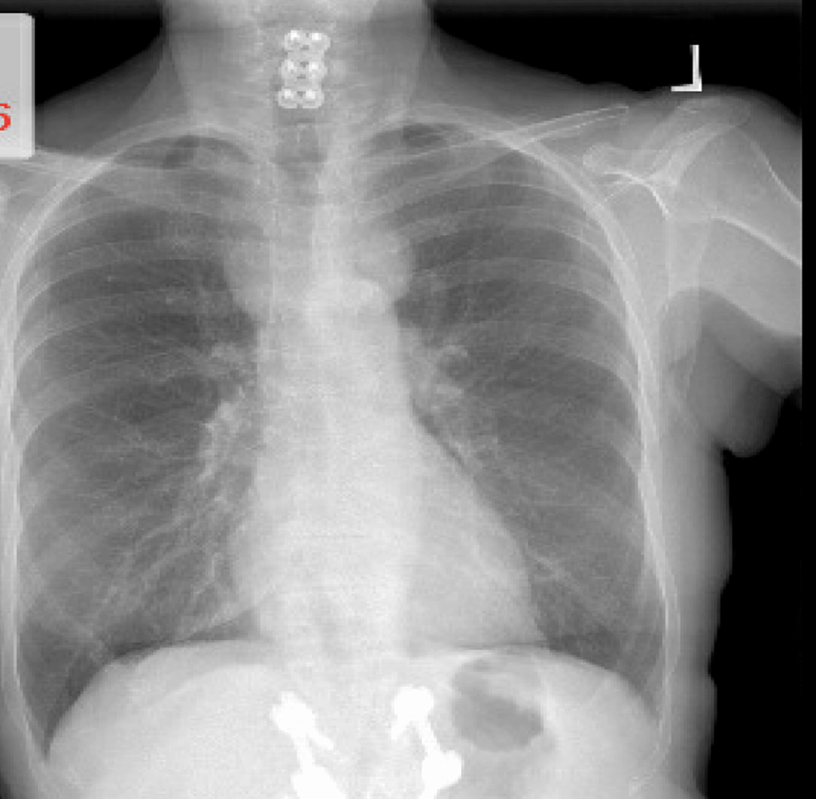

Figure 1: A chest X-ray showed an anterior mediastinal mass infiltrating the left anterior chest wall, suggestive of thymic tissue involvement.

In the anterior mediastinum, a soft tissue mass with coarse calcifications, measuring 6.6 x 2.1 cm, was present. This mass encased and narrowed the left innominate vein and the arch vessels at their origin, with a broad abutment of the aortic arch. Furthermore, a component of the mass (3.5 x 2.1 cm) invaded the left anterior chest wall, possibly involving the left pectoralis major muscle near its origin. Axillary and subpectoral lymphadenopathy were observed, with a larger subpectoral node measuring 2.6 x 1.2 cm. Soft tissue nodularity was noted throughout the middle mediastinum, along with a pericardial lesion/node measuring 3.8 x 1.8 cm, as shown in Figure 2.

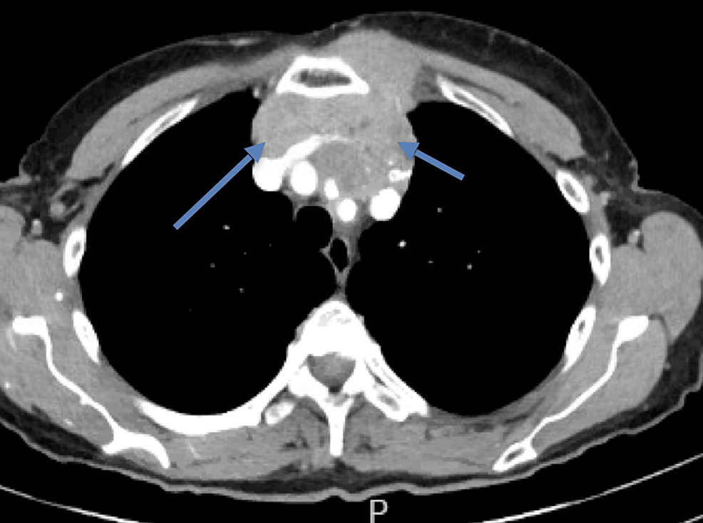

Figure 2: A Computed Tomography (CT) scan illustrating an anterior mediastinal mass (blue arrows) infiltrating the left anterior chest wall. The presence of coarse calcifications suggested a high likelihood of this mass being composed of thymic tissue, possibly indicating a thymoma or thymic carcinoma.

Histopathological examination of the biopsy specimen revealed poorly differentiated squamous cell carcinoma of thymic origin. Grossly, the resected specimen measured 8.5 × 6.2 × 4.3 cm with irregular borders and areas of necrosis. Microscopically, the tumour showed sheets of atypical epithelial cells with prominent nucleoli, a high nuclear-to-cytoplasmic ratio, and frequent mitotic figures. Immunohistochemical staining was positive for p63, CD5, and cytokeratin, confirming the diagnosis of thymic squamous cell carcinoma (WHO Type C). Areas of keratinization and focal calcification were also observed, consistent with the imaging findings.

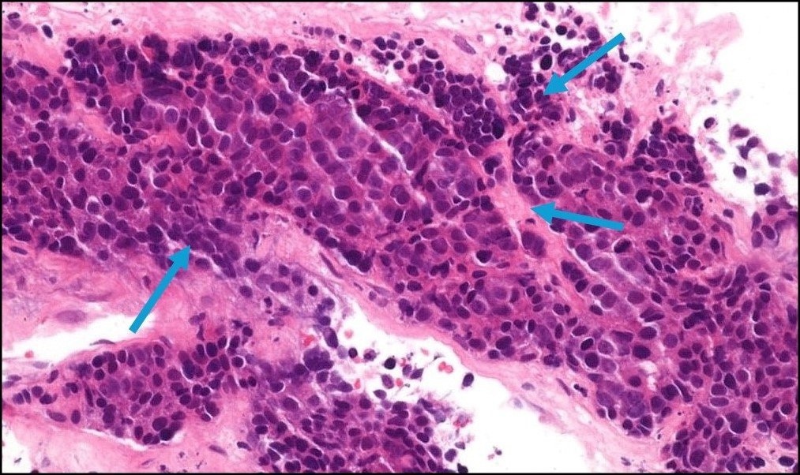

Figure 3: Histopathological examination of thymic carcinoma. A) Hematoxylin and eosin (H&E) staining showing sheets of poorly differentiated squamous cell carcinoma with prominent nucleoli, high nuclear-to-cytoplasmic ratio, and frequent mitotic figures (magnification 200×). B) Area demonstrating keratinization and cellular atypia characteristic of squamous cell carcinoma of thymic origin (magnification 400×). C) Immunohistochemical staining showing strong positivity for p63, confirming the epithelial origin of the tumor (magnification 200×). D) CD5 immunostaining demonstrating diffuse membrane positivity, supporting thymic epithelial origin (magnification 200×).

The case was reviewed during a tumour board meeting involving oncologists, thoracic surgeons, radiation therapists, and pathologists. They created an individualized intervention program for the patient. Due to the localized tumour advancement, a multidisciplinary approach was adopted, involving multiple surgical procedures, including a thymectomy and the resection of surrounding tissues, as much as possible. The goal was to remove the entire tumour, necessitating the removal of the thymus and the surrounding tissues.

Postoperatively, the patient underwent adjuvant chemotherapy with a regimen tailored to thymic carcinomas, such as cisplatin and etoposide, in an attempt to eliminate any remaining cancer cells and reduce the risk of recurrence. Considering the local achievements with curative radiation therapy and the low risk of local relapse, adjuvant radiation therapy was also considered.

Routine follow-up visits, including CT and PET scans, were scheduled to identify any potential recurrence or metastasis.

The patient responded favourably to the multidimensional treatment strategy, as evidenced by the lack of disease progression during the subsequent surveillance period. However, intensive long-term monitoring is necessary to identify any possible recurrences or residual side effects of the therapy.

**3. discussion**

Thymic carcinoma is an uncommon and highly aggressive type of thymic cancer, representing only 10-15% of all thymic malignancies [5]. Due to its rarity and the often advanced stage of the disease at the time of diagnosis, managing thymic carcinoma can pose significant challenges.

Several classification systems for thymic malignancies have been developed, based on morphological, histogenetic, or immunophenotypic characteristics. However, these offer limited prognostic value and are challenging to apply clinically. The TNM classification by Weissferdt-Moran is also available for staging thymic carcinoma. Meanwhile, the Masaoka staging system is widely used clinically and is the most important determinant of survival following surgical resection. This system is based on the extent of tumour metastasis and invasion. In the present case, the patient was diagnosed with stage III thymic carcinoma using this classification [6]. Recently, the World Health Organization has proposed a new classification system for thymic malignancies based on their morphological characteristics. This new classification aims to standardise the categorization of these rare and complex tumours, providing a more consistent framework for clinicians and researchers to understand and manage thymic carcinomas [7]. Despite these efforts, the rarity of thymic carcinoma and the heterogeneity of its presentation make it difficult to establish clear guidelines for its management [8]

The primary treatment modality for thymic carcinoma is aggressive surgical resection, which remains the most significant prognostic factor for disease-free and overall survival [8]. Adjuvant chemotherapy and radiation therapy are often employed in cases of locally advanced or unresectable disease, as well as in the setting of recurrence [1,5,9]. The 5-year survival rate for patients with thymic carcinoma remains low, ranging from 30 to 50%, underscoring the need for continued research and innovation to improve the outcomes for this rare and challenging malignancy.

The patient underwent an extensive surgical procedure, including a thymectomy and resection of adjacent tissues involved in the tumour. This comprehensive surgical approach was crucial, as it aimed to achieve complete tumour removal, providing the best chance for long-term disease control. In addition to the surgical intervention, the patient also received adjuvant chemotherapy with a regimen tailored to thymic carcinomas, such as cisplatin and etoposide. This combination is effective in targeting the rapidly dividing cancer cells and potentially improving the patient's prognosis [10]. Furthermore, adjuvant radiation therapy was considered for this patient, given the advanced stage of the tumour, as it can provide local disease control and reduce the risk of local recurrence, which is a common issue in thymic carcinoma.

Our patient presented with chronic cough, chest pain, and shortness of breath for 3 months. In contrast, most thymic carcinoma patients are typically asymptomatic. While thymic carcinoma is often associated with paraneoplastic syndromes like myasthenia gravis and pure red cell aplasia, [9] our patient did not exhibit any such symptoms, which may have contributed to the late diagnosis.

Comprehensive imaging using CT, MRI, and PET scans was employed to diagnose the extent of the tumour and metastasis in our patient. The involvement of a multidisciplinary tumour board, with the collaboration of oncologists, thoracic surgeons, radiation oncologists, and pathologists, reflects the specialized and tailored approach required for managing this complex case. The decision to perform an extensive surgical resection, including thymectomy and removal of surrounding tissues, indicates the aggressive nature of the tumour and the determination to treat it completely. The adjuvant chemotherapy with cisplatin and etoposide, as well as the adjuvant radiation therapy, were aimed at eliminating any remaining cancer cells and controlling local disease, respectively, to reduce the risk of recurrence.

Recent advancements, such as the use of proton therapy and immunotherapy with Pembrolizumab, have shown promise in the management of thymic malignancies and may benefit patients in the future [8]. The positive early response and lack of disease progression observed in our patient's case suggest that the tailored, multidisciplinary approach was successful, though long-term follow-up remains crucial to monitor for any potential late effects or recurrences.

Our findings align with those of Ahmad et al. [11], who reported similar clinical presentations in a series of 12 thymic carcinoma cases, with chest pain and dyspnea being predominant symptoms. Litvak et al. [12] demonstrated in their retrospective analysis of 48 thymic carcinoma patients that complete surgical resection significantly improved 5-year survival rates from 24% to 53% compared to incomplete resection.

The chemotherapy regimen we selected is supported by the work of Lemma et al. [13], who showed a 39% response rate with cisplatin and etoposide in patients with advanced thymic malignancies. Regarding radiation therapy, Wu et al. [14] demonstrated that adjuvant radiotherapy reduced local recurrence rates from 53% to 21% in patients with stage III thymic tumors.

Recent studies by Giaccone et al. [15] have explored the role of targeted therapies, including c-KIT inhibitors, in thymic carcinomas with specific molecular alterations. Additionally, Cho et al. [16] reported promising results with immune checkpoint inhibitors in refractory thymic carcinomas, although with careful monitoring for immune-related adverse events due to the unique immunological role of the thymus.

**4. Conclusion**

The management of thymic carcinoma requires a multimodal approach, involving aggressive surgical resection, plat- inum-based combination chemotherapy, and radiotherapy. In cases where the tumour is not completely resectable, neoadjuvant chemotherapy and/or radiation therapy may be employed to downstage the tumour and improve the chances of complete surgical resection. It is important to note that the optimal management of thymic carcinoma remains to be defined, and further research is needed to improve the outcomes for patients with this rare and aggressive form of thymic cancer.

**Consent**

Written informed consent for publication of their

clinical details and/or clinical images was

obtained from the patient

**Ethical approval**

As per international standards or university

standards written ethical approval has been

collected and preserved by the author(s)

**Role Played by Each Author:**

**Niragh Sikdar:** Conceptualization, Methodology, Software, writing.**Brahma Kumar Bhattacharya.**: Data curation, Writing- Original draft preparation. **Megha Mahida**: Visualization, Investigation. ***Sanskruti Shailesh Rathod*** *:* Supervision.**: Kirti Pichiah John**: Software, Validation.: **Anushka Baidya:** Writing- Reviewing and Editing,

**Disclaimer (Artificial intelligence)**

Author(s) hereby declare that NO generative AI technologies such as Large Language Models (ChatGPT, COPILOT, etc.) and text-to-image generators have been used during the writing or editing of this manuscript.

**References**

1.  Rajan, A., & Giaccone, G. (2008, December 1). Treatment of Advanced Thymoma and Thymic Carcinoma.

Springer Science+Business Media, 9(4-6), 277-287. https://doi.org/10.1007/s11864-009-0083-7

2.  Wain, S L., Kier, R., Vollmer, R T., & Bossen, E H. (1986, November 1). Basaloid-squamous carcinoma of the tongue, hypopharynx, and larynx:. Elsevier BV, 17(11), 1158-1166. https://doi.org/10.1016/s0046- 8177(86)80422-1

3.  Suster, S. (2005, August 1). Thymic carcinoma: update of current diagnostic criteria and histologic types. Else- vier BV, 22(3), 198-212. https://doi.org/10.1053/j.semdp.2006.02.006

4.  Thomas, C R., Wright, C D., & Loehrer, P J. (1999, July 1). Thymoma: State of the Art. Lippincott Williams & Wilkins, 17(7), 2280-2280. https://doi.org/10.1200/jco.1999.17.7.2280

5.  Eng, T Y., Fuller, C D., Jagirdar, J., Bains, Y., & Thomas, C R. (2004, July 1). Thymic carcinoma: state of the art review. Elsevier BV, 59(3), 654-664. https://doi.org/10.1016/j.ijrobp.2003.11.021

6.  Koga, K., Matsuno, Y., Noguchi, M., Mukai, K., Asamura, H., Goya, T., & Shimosato, Y. (1994, May 1). A re- view of 79 thymomas: Modification of staging system and reappraisal of conventional division into invasive and non‐ invasive thymoma. Wiley, 44(5), 359-367. https://doi.org/10.1111/j.1440-1827.1994.tb02936.x

7.  Han, J., Lee, K S., Yi, C A., Kim, T S., Shim, Y M., Kim, Y T., Kim, K., & Kwon, O J. (2003, January 1). Thymic Epithelial Tumors Classified According to a Newly Established WHO Scheme: CT and MR Findings. Korean Society of Radiology, 4(1), 46-46. https://doi.org/10.3348/kjr.2003.4.1.46

8.  Rossana, B. (2014, January 1). Thymic Malignancies in the Targeted Therapies Era. OMICS Publishing Group, s8(01). https://doi.org/10.4172/2157-2518.s8-008

9.  Christie, B., & Moremen, J R. (2012, July 1). Thymic Carcinoma: Incidence, Classification and Treatment Strate- gies of a Rare Tumor. SAGE Publishing, 78(7), 335-337. https://doi.org/10.1177/000313481207800701

10. Yano, T., Hara, N., Ichinose, Y., Asoh, H., Yokoyama, H., & Ohta, M. (1993, April 1). Treatment and prognosis of primary thymic carcinoma. Wiley, 52(4), 255-258. https://doi.org/10.1002/jso.2930520412

11. Ahmad U, et al. Thymic carcinoma outcomes and prognosis: Results of an international analysis. J Thorac Cardiovasc Surg. 2015;149(1):95-101.

12. Litvak AM, et al. Clinical characteristics and outcomes for patients with thymic carcinoma: Evaluation of Masaoka staging. J Thorac Oncol. 2014;9(12):1810-1815.

13. Lemma GL, et al. Phase II study of carboplatin and paclitaxel in advanced thymoma and thymic carcinoma. J Clin Oncol. 2011;29(15):2060-2065.

14 .Wu KL, et al. Patterns of failure after resection of thymic carcinoma: Implications for radiation therapy. Int J Radiat Oncol Biol Phys. 2010;77(4):1195-1200.

15.Giaccone G, et al. Phase II study of belinostat in patients with recurrent or refractory advanced thymic epithelial tumors. J Clin Oncol. 2011;29(15):2052-2059.

16. Cho J, et al. The efficacy of anti-PD-1/PD-L1 antibody in thymic carcinoma and thymic carcinoid: A systematic review. Ann Palliat Med. 2020;9(4):2020-2027.