# Spatial Variability of Soil Chemical Properties within a KVK Farm of Budgam in Lesser Himalayas

**Abstract**

Assessing the spatial variability of soil chemical properties is essential for optimizing crop productivity and ensuring sustainable land management. This study evaluated the spatial distribution of key soil fertility indicators at KVK Farm, Budgam, in the Lesser Himalayas. A total of 21 soil samples were collected from a 0–30 cm depth across different land uses and analyzed for organic carbon (OC),nitrogen (N), phosphorus (P) and potassium (K). Results revealed moderate variability for OC, N and K, while P showed high variability (>50%). Spatial variability maps generated using geostatistical techniques and GIS tools indicated that land use significantly influences soil fertility. All the studied soil properties (OC, N, K, P) exhibited patchy distribution, with excess accumulation in some areas and deficiencies in others. These findings highlight the need for site-specific nutrient management to optimize fertilizer use and enhance soil fertility. Precision agriculture approaches can improve resource utilization and promote sustainable agricultural practices in similar agroecosystems.

**Keywords**: Spatial variability; GIS; Kriging; organic carbon; nitrogen, phosphorus, potassium.

**Introduction**

In nature, soil is inherently variable due to the variations in soil-forming processes at different spatial scales. Additionally, anthropogenic influences such as land use, cultivation, and erosion further contribute to soil variability. As a result, soil properties change across both space and time due to **geochemical processes** and **soil management practices** such as fertilization and irrigation (Buol et al., 2011; Davatgar et al., 2012; Arunkumar et al., 2023). This variability has significant implications for soil management, particularly in optimizing agricultural input requirements to enhance productivity, profitability, and environmental sustainability.

Soil fertility properties must be analyzed to understand the impact of **land use and management systems** on soil functions (Denton et al., 2017; Mansour et al., 2019). Recognizing and quantifying this variation is crucial, as it helps determine the extent to which soil characteristics reflect **long-range environmental and anthropogenic influences.** Consequently, soil management recommendations should ideally differ between farms and even between fields within the same farm. A site-specific approach allows for **more efficient, cost-effective, and environmentally sustainable** use of agricultural inputs (Brevik et al., 2016; Bogunovic et al., 2017; Shukla et al., 2017; Abd-Elmabod et al., 2019). A better understanding of soil fertility variation can thus assist farmers in enhancing soil productivity while advancing the principles of **sustainable agriculture** (Paragi et al., 2024, Abd-Elmabod et al., 2017; Buttafuoco et al., 2017).

A study by Franzluebbers and Hons (1996) compared the distribution of available soil nutrients in fields under different farming systems and recommended the importance of soil information as a foundation for effective soil management. Farming decisions should be guided by soil management zones to support precision agriculture ([Kathumo, 2007](https://pmc.ncbi.nlm.nih.gov/articles/PMC9424958/" \l "bib34); [Ali et al., 2022](https://pmc.ncbi.nlm.nih.gov/articles/PMC9424958/#bib4)). These management zones delineate farms on the basis of soil attributes, helping to optimize fertilizer application ([Fridgen et al., 2004](https://pmc.ncbi.nlm.nih.gov/articles/PMC9424958/" \l "bib27); [Bao-wei et al., 2018](https://pmc.ncbi.nlm.nih.gov/articles/PMC9424958/#bib8); [Ali et al., 2019](https://pmc.ncbi.nlm.nih.gov/articles/PMC9424958/#bib3); [McEntee et al., 2020](https://pmc.ncbi.nlm.nih.gov/articles/PMC9424958/#bib50); [Ali et al., 2022](https://pmc.ncbi.nlm.nih.gov/articles/PMC9424958/#bib4)). Consequently, an estimation of geographical variability of soil parameters is vital for management of crop and assessment of field research studies (Ramzan et al., 2017).

One of the well-established techniques for categorizing the **spatial variability** of soil properties is **spatial interpolation of soil parameters** based on point measurements using geostatistics (Liu et al., 2006). Shoma Hore et al., (2025) praposed exploration of sustainable remediation technologies, and integration of emerging technologies such as remote sensing and geographic information systems (GIS) to accelerate data collection.

In regions such as **Kashmir,** inappropriate land management practices, including the indiscriminate application of **blanket fertilizers**, remain a challenge. **Site-specific crop management** requires detailed mapping of essential **macronutrients** (Mazur et al., 2022) to optimize soil fertilization ((Bhanuvally et al., 2024) and ensure balanced nutrient application. Consequently, assessing the **spatial variability** of key nutrients is essential for identifying and delineating **critical nutrient-deficient zones.** Thus, the objectives of this study were:

1) To determine trends and long-range variations in soil fertility those justify differentiated soil management recommendations across the study area.

2) To map soil fertility properties exhibiting spatial dependence using geostatistics and Geographic Information System (GIS) tools.

# Materials and methods

***Study Area:***The study was carried out in the month of October 2024 during the autumn season at the KVK Farm (34.0619, 74.7092), located in Budgam district of Kashmir division. The farm covers a total area of 20 ha and consists of diverse land uses, including apple and walnut orchards, cereal crops, and vegetable cultivation. The climate of the study area is temperate, characterized by an average annual rainfall of approximately 585 mm and an average temperature of 14°C. Figure 1 shows the location of the study area in the Google Earth along with the illustration of different land uses on the farm. The farm is divided into distinct sections, including apple and walnut orchards, cereal crops, vegetable blocks, and various research plots. Additionally, infrastructure such as chain-link fencing, vermicompost units, a meteorological station, and nursery blocks are marked, providing a detailed spatial representation of the farm layout. This visual representation aids in understanding the spatial distribution of land use types and their relevance to the study.

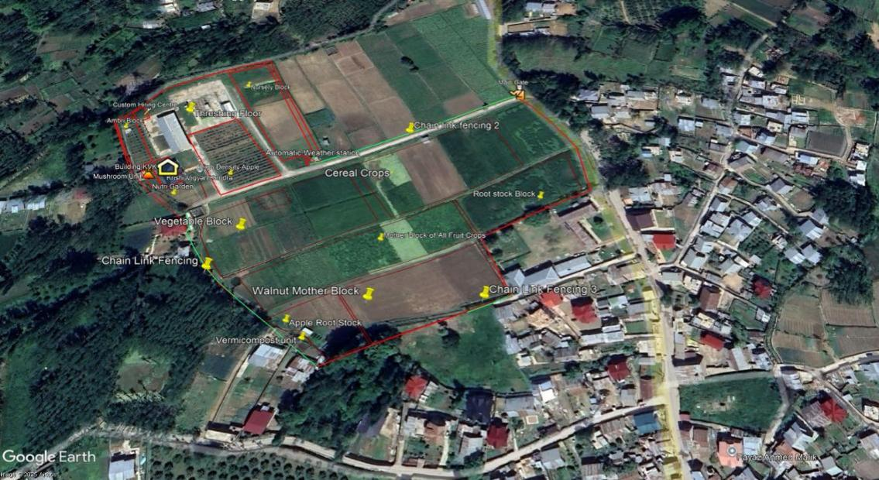

**Figure 1: Google Earth view of the KVK Farm, Budgam, showing different land use zones.**

***Soil Sampling and Analysis:***

The primary goal of soil sampling was to accurately characterize the spatial variability of nutrients in the soil. Sample locations in KVK Field were geo**-**referenced using a GPS to facilitate the correlation of soil test results with spatial details of the soil sample (Figure 2).

Samples were collected at a depth of 0 to 30 cm from 21 sampling points across the farm ensuring representation based on different land uses. Areas with non-typical features, such as field edges, were excluded from sampling. At each site, a composite soil sample was obtained by thoroughly mixing multiple subsamples. From this mixture, 500 grams of soil was retained, properly labeled, and transported to the laboratory for preparation, which included air-drying and sieving. The soil samples were analyzed using Near-Infrared (NIR) Spectroscopy with the Bhu Parikshak rapid soil testing device, allowing for the rapid and precise assessment of soil fertility parameters.

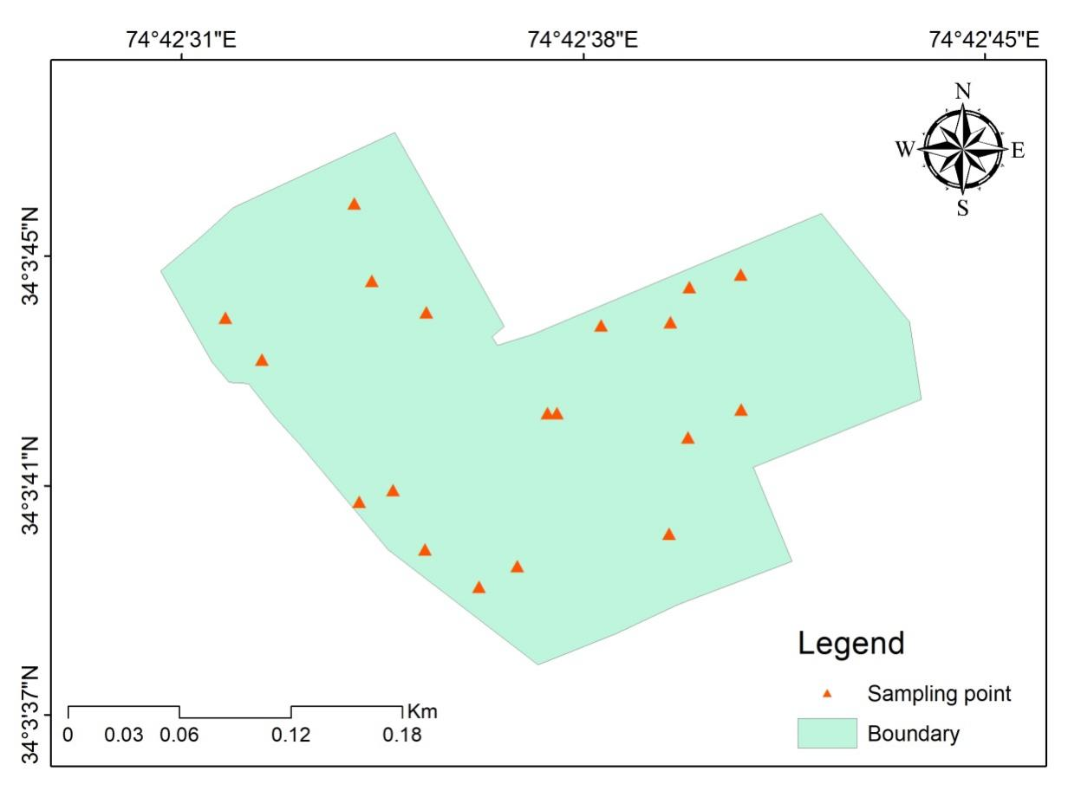

**Figure 2: Location map of study area with the soil sampling points.**

***Exploratory Statistical Analysis:***Descriptive statistical parameters, including mean, minimum, maximum values, standard deviation, coefficient of variation (CV), skewness, and kurtosis, were computed using SPSS 20.0 (2011). Additionally, Pearson’s correlation coefficients were calculated to determine relationships between soil properties at 1% and 5% significance levels.

***Geostatistical Analysis:***To assess the spatial variability of soil properties, geostatistical method was applied using ArcGIS 10.2. The analysis involved generating variograms to evaluate the spatial distribution of soil properties and determine the necessary parameters for kriging interpolation, which was used to estimate soil properties in unsampled areas and create spatial variability maps.

# Results and discussion

Table 1 summarizes descriptive statistics of soil physicochemical properties for the soil samples collected from KVK Budgam farm. Organic Carbon varies from 0.32 to 1.93 % with a mean value of 1.07%. The available nitrogen (N) ranged from 180.3 to 442.5 kg/ha, with a mean value of 296.02 kg/ha. Available phosphorus (P) ranged from 8.4 to 76.6 kg/ha, with a mean value of 128.7 kg/ha, while exchangeable potassion (K) ranged from 135.4 to 590.9 kg/ha, with mean value of 248.54 kg/ha. The extent of spatial variability of the properties was assessed using the coefficient of variation (CV) based on the guideline of Warrick (1998) who classified <15% as low, 15**-**50% as medium and >50% as high.

**Table 1: Descriptive statistics for the measured soil parameters.**

|  |  |  |  |  |  |  |  |
| --- | --- | --- | --- | --- | --- | --- | --- |
| **Soil Parameter** | **Minimum** | **Maximum** | **Mean** | **Std. Deviation** | **CV (%)** | **Skewnes** | **Kurtosis** |
| OC (%) | 0.32 | 1.93 | 1.070 | 0.64 | 60.69 | 0.38 | -1.88 |
| N (kg/ha) | 180.30 | 442.50 | 296.02 | 110.32 | 37.27 | 0.38 | -1.94 |
| P (kg/ha) | 8.40 | 76.60 | 39.91 | 23.62 | 59.18 | -0.16 | -1.87 |
| K (kg/ha) | 135.40 | 590.90 | 248.54 | 128.70 | 51.78 | 1.09 | 0.67 |

In this study, soil nitrogen showed moderate variation (37.27%), while organic carbon (60.967%), phosphorus (59.181%) and potassium (51.783%) showed high variability (Table 1). The high variation of soil organic matter (SOM), P and K observed in this study aligns with findings from other agricultural regions, such as Croatia (Bogunovic et al., 2017) and Sri Lanka (Rosemary et al., 2017). These variations can be attributed to long-term interactions between soil-forming factors and soil management practices.

**Spatial Variability of Soil Parameters**

**Organic Carbon**

The spatial distribution map (Figure 3) generated through **ordinary kriging** indicate that the organic carbon (OC) levels across the study site were generally high (>0.75%), with only small patches of low levels (<0.5%) observed in certain areas of KVK Budgam farm. A medium range of organic carbon (0.5–0.75%) was found towards the northeastern end of the study site. Organic carbon is generally considered a stable parameter. However, the medium to high variability observed in this study can be attributed to pedogenic processes influenced by micro-topography over different time scales (Ajayi and Okonokhua, 2024). Additionally, variations in land use contribute significantly to differences in soil organic carbon (SOC) content (Xiong et al., 2016; Lei *et al*., 2019; Guillaume *et al*., 2021).

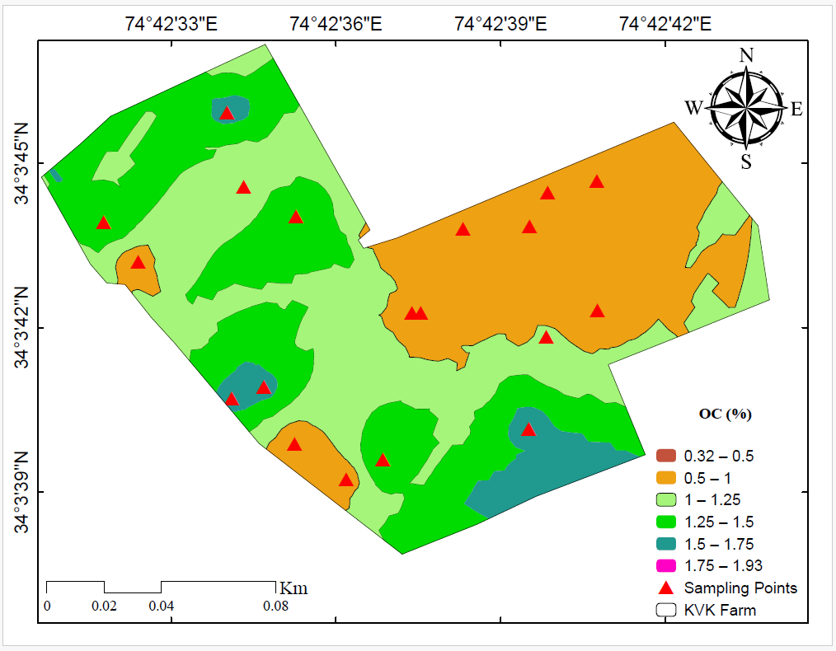

**Figure 3: Spatial variability of Organic Carbon across the study area.**

The lowest SOC levels recorded in the **northeastern** region of the study area may be due to the **depletion of organic matter** caused by continuous cultivation, removal of crop residues, and limited organic input applications. Continuous cultivation has been shown to deplete soil organic matter and reduce SOC content, leading to diminished soil fertility and biological activity (van Beek *et al.*, 2018; Kartini *et al*., 2024). Consequently, a reduction in soil organic matter impacts **nutrient retention, water-holding capacity, and soil biological activity,** all of which are essential for maintaining soil health (Corsi *et al*., 2012).

In contrast, higher SOC levels in the central and southeastern parts of the study area could be attributed to greater inputs of organic residues, possibly due to differences in crop management practices. This suggests that land use and soil management practices significantly influence organic carbon distribution across the farm.

**Major Nutrients**

**Nitrogen (N)**

The spatial distribution map (Figure 4) of available nitrogen across the KVK farm showed medium to high concentrations (>250 kg/ha), with isolated patches of low nitrogen content (<250 kg/ha) in the northeastern parts of the farm. Nitrogen deficiency in these areas may be linked to the long-term cultivation of heavy feeder crops, such as maize, coupled with the insufficient application of nitrogenous fertilizers. Similar results were also observed by Bhanuvally et al. (2024) where all the studied soils of Bellary district of Karnataka's Northern Dry Zone (Zone-3) were low in available N status irrespective of type of farming and cropping system.

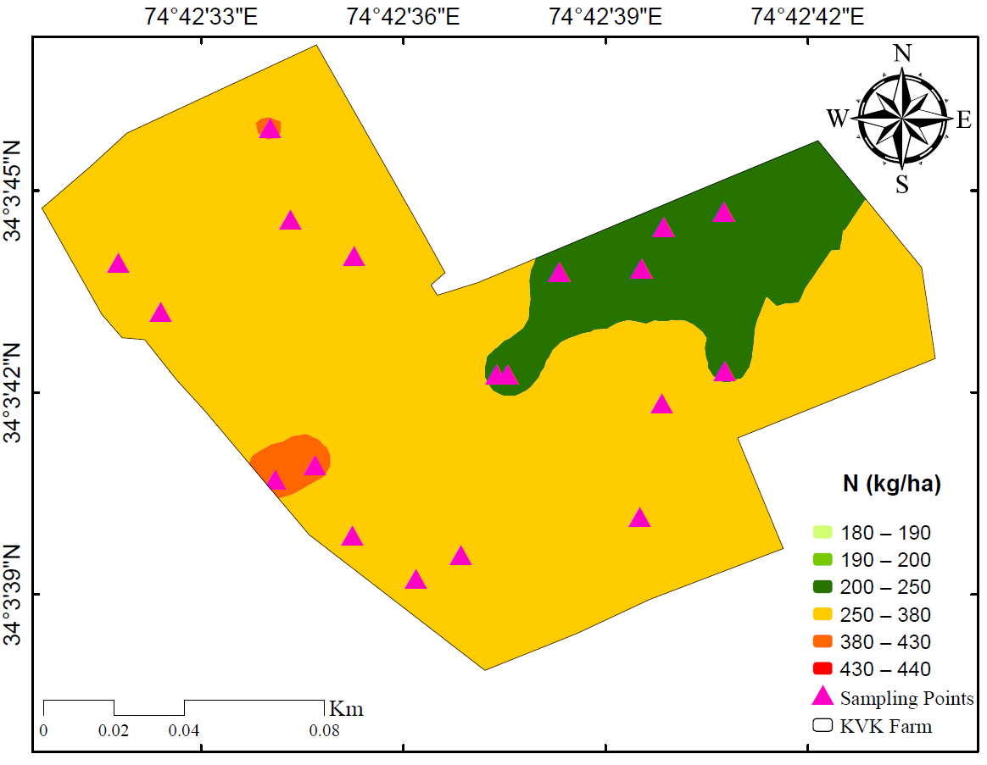

**Figure 4: Spatial variability of Nitrogen across the study area.**

**Phosphorus**

The spatial distribution map (Figure 5) of available phosphorus exhibited a **patchy distribution** across the farm. The **northeastern** region showed **high phosphorus content (50–60 kg/ha)**, which may be attributed to the **excessive application of phosphatic fertilizers**. However, approximately one-third of the study area (particularly in the southeastern region and a small portion of the southwestern region) had phosphorus levels below the critical limit of 23 kg/ha, which is considered insufficient for optimal agricultural production. These findings indicate the need for targeted phosphorus management strategies to correct deficiencies and enhance soil fertility. High spatial variability of available phosphorus were also indicated by several researchers (Zhiguo Li et al., 2020; Denton Oluwabunmi Aderonke and Ganiyu Adeniyi Gbadegesin, 2013).

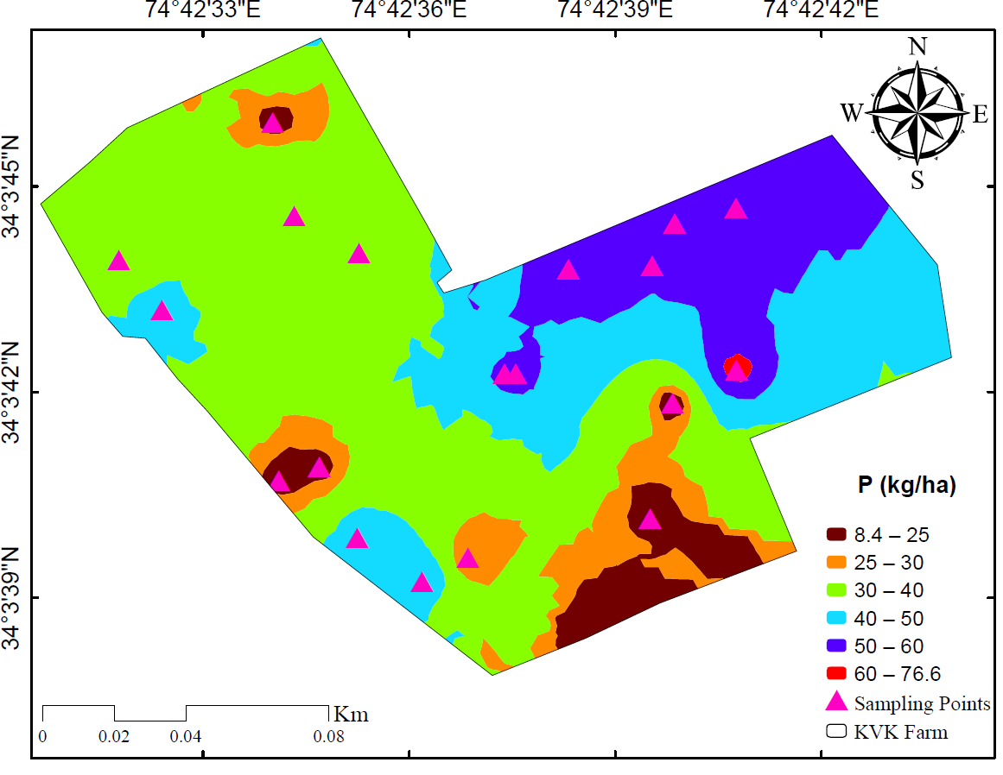

**Figure 5: Spatial variability of Phosphorus across the study area.**

**Potassium**

Potassium concentrations across the study area were generally in the **medium to high range (>130 kg/ha) as depicted in Figure 6.** The highest K values were recorded near the **northwestern boundary** of the farm. The spatial variability of potassium content is influenced by **land use practices, soil type, and environmental factors,** aligning with findings from Zhang et al. (2022). Similar studies in various agricultural ecosystems have demonstrated that soil nutrient distribution is controlled by a combination of **the** climate (Li et al., 2020), topography (Karchegani et al., 2012), soil type (Tajik et al., 2020), fertilization practices (Tang et al., 2020), cropping system (Xie et al., 2021) and tillage method (Shahriari et al., 2011).

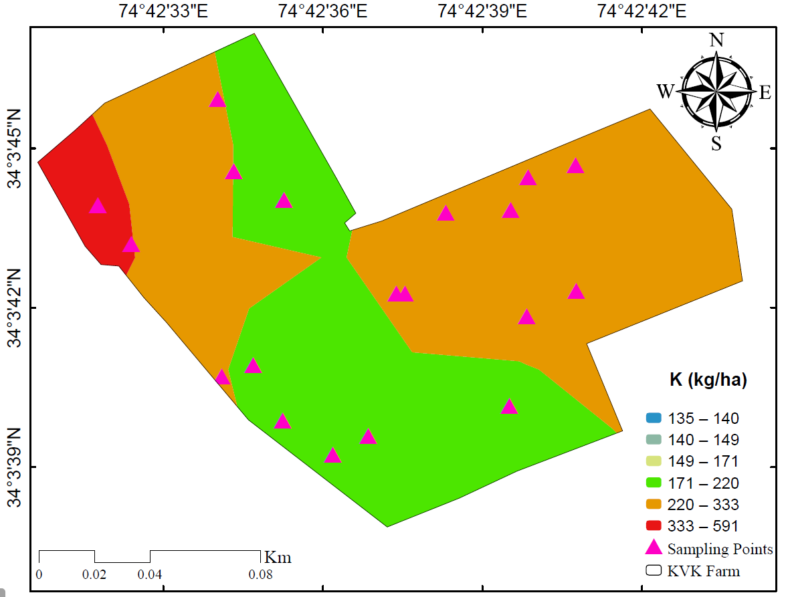

**Figure 6: Spatial variability of Potassium across the study area.**

**Conclusion**

This study assessed the spatial variability of key soil chemical properties at KVK Farm, Budgam, and highlighted the impact of land use on soil fertility. The results revealed significant spatial heterogeneity in organic carbon, nitrogen, phosphorus, and potassium levels across the farm. Organic carbon and phosphorus showed the highest variability. Nitrogen indicated moderate variability, with deficiencies linked to long-term cultivation and inadequate fertilization. Potassium levels were found to be mostly adequate, with variations influenced by cropping systems and soil management practices. The geostatistical analysis demonstrated that land use and management practices significantly influence soil fertility patterns, even within a relatively small agricultural area. These findings underscore the necessity for precision agriculture approaches, including site-specific nutrient management and targeted fertilizer application, to enhance soil productivity while minimizing environmental impacts. Future research should focus on integrating long-term monitoring and remote sensing techniques to further refine soil fertility assessments and enhance decision-making in soil management.

**Disclaimer (Artificial intelligence)**

Option 1:

Author(s) hereby declare that NO generative AI technologies such as Large Language Models (ChatGPT, COPILOT, etc.) and text-to-image generators have been used during the writing or editing of this manuscript.

Option 2:

Author(s) hereby declare that generative AI technologies such as Large Language Models, etc. have been used during the writing or editing of manuscripts. This explanation will include the name, version, model, and source of the generative AI technology and as well as all input prompts provided to the generative AI technology

Details of the AI usage are given below:

1.

2.

3.

## REFERENCES

## Abd-Elmabod, S. K., Fitch, A. C., Zhang, Z., Ali, R. R., & Jones, L. (2019). Rapid urbanisation threatens fertile agricultural land and soil carbon in the Nile delta. *Journal of environmental management*, *252*, 109668.

## Abd-Elmabod, S. K., Jordán, A., Fleskens, L., Phillips, J. D., Muñoz-Rojas, M., van der Ploeg, M., Anaya-Romero, M., El-Ashry, S., & de la Rosa, D. (2017). Modeling agricultural suitability along soil transects under current conditions and improved scenario of soil factors. In *Soil mapping and process modeling for sustainable land use management* (pp. 193-219). Elsevier.

Ajayi, A.A. and Okonokhua, B.O., 2024. Spatial Variability of Soil Chemical Properties of an Undulating Site within a University Farm at Okha, near Benin City in Nigeria. *Journal of Applied Sciences and Environmental Management*, *28*(7), pp.2241-2248.

Ali, A., Martelli, R., Lupia, F., & Barbanti, L. (2019). Assessing multiple years’ spatial variability of crop yields using satellite vegetation indices. *Remote sensing*, *11*(20), 2384.

Ali, A., Rondelli, V., Martelli, R., Falsone, G., Lupia, F., & Barbanti, L. (2022). Management zones delineation through clustering techniques based on soils traits, NDVI data, and multiple year crop yields. *Agriculture*, *12*(2), 231.

## Arunkumar, V., Yuvaraj, M., Sakthivel, K., Jamuna, E., & Ananthi, K. (2023). Assessment of spatial variability of soil properties using geospatial techniques for enhanced productive capacity of agricultural systems in India. *International Journal of Environment and Climate Change*, *13*(8), 1014-1027.

Bhanuvally M, Sunitha N. H., Sharanabasava, Ravi S., Mahadevaswamy. Effect of Organic Farming Practices on Soil Chemical Properties. Int. J.Environ. Clim. Change. [Internet]. 2024 Feb. 12 [cited 2025 Mar. 4];14(2):470-81. Available from: <https://journalijecc.com/index.php/IJECC/article/view/3962>.

Bao-wei, S., Geng-xing, Z., & Chao, D. (2018). Spatio-temporal variability of soil nutrients and the responses of growth during growth stages of winter wheat in the north of China. *bioRxiv*, 398701.

## Bogunovic, I., Pereira, P., & Brevik, E. C. (2017). Spatial distribution of soil chemical properties in an organic farm in Croatia. *Science of the total environment*, *584*, 535-545.

## Brevik, E. C., Calzolari, C., Miller, B. A., Pereira, P., Kabala, C., Baumgarten, A., & Jordán, A. (2016). Soil mapping, classification, and pedologic modeling: History and future directions. *Geoderma*, *264*, 256-274.

## Buol, S. W., Southard, R. J., Graham, R. C., & McDaniel, P. A. (2011). *Soil genesis and classification*. John Wiley & Sons.

## Buttafuoco, G., Castrignanò, A., Cucci, G., Lacolla, G., & Lucà, F. (2017). Geostatistical modelling of within-field soil and yield variability for management zones delineation: a case study in a durum wheat field. *Precision Agriculture*, *18*, 37-58.

Corsi, S., Friedrich, T., Kassam, A., Pisante, M., & Sà, J. D. M. (2012). *Soil organic carbon accumulation and greenhouse gas emission reductions from conservation agriculture: a literature review* (pp. x+-89).

## Davatgar, N., Neishabouri, M.R. and Sepaskhah, A.R., 2012. Delineation of site specific nutrient management zones for a paddy cultivated area based on soil fertility using fuzzy clustering. *Geoderma*, *173*, pp.111-118.

## Denton, O. A., Aduramigba-Modupe, V. O., Ojo, A. O., Adeoyolanu, O. D., Are, K. S., Adelana, A. O., Oyedele, A.O., Adetayo, A.O. & Oke, A. O. (2017). Assessment of spatial variability and mapping of soil properties for sustainable agricultural production using geographic information system techniques (GIS). *Cogent Food & Agriculture*, *3*(1), 1279366.

## Franzluebbers, A. J., & Hons, F. M. (1996). Soil-profile distribution of primary and secondary plant-available nutrients under conventional and no tillage. *Soil and Tillage Research*, *39*(3-4), 229-239.

Fridgen, J. J., Kitchen, N. R., Sudduth, K. A., Drummond, S. T., Wiebold, W. J., & Fraisse, C. W. (2004). Management zone analyst (MZA) software for subfield management zone delineation. *Agronomy Journal*, *96*(1), 100-108.

Guillaume, T., Bragazza, L., Levasseur, C., Libohova, Z., & Sinaj, S. (2021). Long-term soil organic carbon dynamics in temperate cropland-grassland systems. *Agriculture, ecosystems & environment*, *305*, 107184.

Karchegani, P. M., Ayoubi, S., Mosaddeghi, M. R., & Honarjoo, N. (2012). Soil organic carbon pools in particle-size fractions as affected by slope gradient and land use change in hilly regions, western Iran. *Journal of Mountain Science*, *9*, 87-95.

Kartini, N. L., Saifulloh, M., Trigunasih, N. M., Sukmawati, N. M. S., & Mega, I. (2024). Impact of Long-Term Continuous Cropping on Soil Nutrient Depletion. *Ecological Engineering & Environmental Technology (EEET)*, *25*(11).

Kathumo, V. M. (2007). *Establishment of soil management zones based on spatial variability of soil properties for precision agriculture using GIS in Katumani, Machakos district of Kenya* (Doctoral dissertation, University of Nairobi).

Lei, Z., Yu, D., Zhou, F., Zhang, Y., Yu, D., Zhou, Y., & Han, Y. (2019). Changes in soil organic carbon and its influencing factors in the growth of Pinus sylvestris var. mongolica plantation in Horqin Sandy Land, Northeast China. *Scientific reports*, *9*(1), 16453.

Li, X., Shang, B., Wang, D., Wang, Z., Wen, X., & Kang, Y. (2020). Mapping soil organic carbon and total nitrogen in croplands of the Corn Belt of Northeast China based on geographically weighted regression kriging model. *Computers & Geosciences*, *135*, 104392.

Liu, D., Wang, Z., Zhang, B., Song, K., Li, X., Li, J., Li, F., & Duan, H. (2006). Spatial distribution of soil organic carbon and analysis of related factors in croplands of the black soil region, Northeast China. *Agriculture, ecosystems & environment*, *113*(1-4), 73-81.

## Mansour, H. A., Abd-Elmabod, S. K., & Engel, B. A. (2019). Adaptation of modeling to the irrigation system and water management for corn growth and yield. *Plant Archives*, *19*(Supplement 1), 644-651.

Mazur, P., Gozdowski, D., & Wnuk, A. (2022). Relationships between soil electrical conductivity and sentinel-2-derived NDVI with pH and content of selected nutrients. *Agronomy*, *12*(2), 354.

McEntee, P. J., Bennett, S. J., & Belford, R. K. (2020). Mapping the spatial and temporal stability of production in mixed farming systems: An index that integrates crop and pasture productivity to assist in the management of variability. *Precision Agriculture*, *21*(1), 77-106.

Paragi NS, Prajapati BJ, Viradiya MB, Chaudhary R. 2024. Delineation of Soil Physical and Chemical Properties of Mahisagar District of Gujarat, India. Int. J. Plant Soil Sci. ;36(2):71-80. Available from: <https://journalijpss.com/index.php/IJPSS/article/view/4366>.

Ramzan, S., Wani, M. A., & Bhat, M. A. (2017). Assessment of spatial variability of soil fertility parameters using geospatial techniques in temperate Himalayas. *International journal of Geosciences*, *8*(10), 1251-1263.

Rosemary, F., Indraratne, S. P., Weerasooriya, R., & Mishra, U. (2017). Exploring the spatial variability of soil properties in an Alfisol soil catena. *Catena*, *150*, 53-61.

Shahriari, A., Khormali, F., Kehl, M., Ayoubi, S., & Welp, G. (2011). Effect of a long-term cultivation and crop rotations on organic carbon in loess derived soils of Golestan Province, Northern Iran.

Shoma Hore, Mosharof Al Alim, Ripon Hore. 2025.Post-earthquake soil chemical analysis: Mechanisms, Challenges, and pathways for sustainable recovery. *Frontiers in Applied Engineering and Technology* ; 2(01): 101-108. DoI: 10.70937/faet.v2i01.59.

## Shukla, A. K., Sinha, N. K., Tiwari, P. K., Prakash, C., Behera, S. K., Lenka, N. K., Singh, V.K., Dwivedi, B.S., Majumdar, K., Kumar, A., & Siddiqui, S. (2017). Spatial distribution and management zones for sulphur and micronutrients in Shiwalik Himalayan region of India. *Land Degradation & Development*, *28*(3), 959-969.

Tajik, S., Ayoubi, S., & Zeraatpisheh, M. (2020). Digital mapping of soil organic carbon using ensemble learning model in Mollisols of Hyrcanian forests, northern Iran. *Geoderma Regional*, *20*, e00256.

Tang, H., Li, C., Xiao, X., Pan, X., Cheng, K., Shi, L., Li, W., Wen, L., & Wang, K. (2020). Effects of long-term fertiliser regime on soil organic carbon and its labile fractions under double cropping rice system of southern China. *Acta Agriculturae Scandinavica, Section B—Soil & Plant Science*, *70*(5), 409-418.

van Beek, C. L. C., Elias, E., Selassie, Y. G., Gebresamuel, G., Tsegaye, A., Hundessa, F., Tolla, M., Mamuye, M., Yemane, G, & Mengistu, S. (2018). Soil organic matter depletion as a major threat to agricultural intensification in the highlands of Ethiopia. *Ethiopian Journal of Science and Technology*, *11*(3), 271-285

Xie, E., Zhang, Y., Huang, B., Zhao, Y., Shi, X., Hu, W., & Qu, M. (2021). Spatiotemporal variations in soil organic carbon and their drivers in southeastern China during 1981-2011. *Soil and Tillage Research*, *205*, 104763.

Xiong, X., Grunwald, S., Corstanje, R., Yu, C., & Bliznyuk, N. (2016). Scale-dependent variability of soil organic carbon coupled to land use and land cover. *Soil and Tillage Research*, *160*, 101-109.

Zhang, B., Niu, L., Jia, T., Yu, X., & She, D. (2022). Spatial variability of soil organic matter and total nitrogen and the influencing factors in Huzhu County of Qinghai Province, China. *Acta Agriculturae Scandinavica, Section B—Soil & Plant Science*, *72*(1), 576-588.

Zhiguo Li, Runhua Zhang, Chuang Liu, Runqin Zhang, Fang Chen, Yi Liu. Phosphorous spatial distribution and pollution risk assessment in agricultural soil around the Danjiangkou reservoir, China. [*Science of The Total Environment*](https://www.sciencedirect.com/journal/science-of-the-total-environment). 2020. [Volume 699](https://www.sciencedirect.com/journal/science-of-the-total-environment/vol/699/suppl/C). <https://doi.org/10.1016/j.scitotenv.2019.134417>