Case report

Left Sided Appendicitis: Review of 17 cases

## Abstract

Left-sided appendicitis is a rare condition caused by congenital abnormalities such as situs inversus totalis (SIT) or midgut malrotation (MM). In some cases, an unusually long appendix on the right side may extend into the left lower quadrant of the abdomen, leading to an atypical presentation.

Patients typically present with pain in the left lower quadrant of the abdomen, along with nausea, vomiting, and fever. Diagnosis is based on well-established clinical symptoms, supported by radiological findings from ultrasonography, CT abdomen, and chest X-ray to detect dextrocardia. Diagnostic laparoscopy may also be performed for confirmation.

We report 17 cases of left-sided appendicitis, At Jatal Hospital and Research Centre, Latur, Maharashtra, India. Our 35 years of surgical experience, 12 patients underwent open laparotomy, while 5 patients underwent laparoscopic surgery. All procedures were performed successfully, with no morbidity or mortality.

## Key words

Left sided appendicitis, Midgut Malrotation, Situs Inversus Totalis, Left lower quadrant pain

## Introduction

Midgut malrotation (MM) results from abnormal rotation of the midgut during the 8th to 10th weeks of embryonic development. When the ascending colon and cecum rotate in the opposite

direction, the appendix becomes ectopically positioned in the left lower quadrant. If left untreated, an inflamed appendix can progress to suppuration and perforation, leading to periapendicular abscess, peritonitis, septic shock, and, in severe cases, life-threatening complications. [1,2,3]

Situs inversus totalis (SIT) is a rare congenital condition in which the thoracic and abdominal organs are transposed. In such cases, symptoms of acute appendicitis may present in the left lower quadrant,

making diagnosis particularly challenging. If a patient presents with left lower quadrant pain and an X-ray reveals dextrocardia, left-sided appendicitis should be considered. Imaging modalities such as abdominal CT or ultrasonography can aid in an accurate diagnosis, reducing the likelihood of misdiagnosis and complications, including perforation and abscess formation. Emergency laparoscopic surgery remains the definitive treatment after confirmation. [1,2,4]

Laparoscopic appendectomy in patients with SIT presents a technical challenge due to the mirrored anatomical structure, requiring adjustments in surgical approach and technique.

## Aim

This study provides an overview of left-sided acute appendicitis associated with situs inversus totalis (SIT) and midgut malrotation (MM) based on a review of the literature and new cases from a single center.

## Case presentation

We present 17 new cases of left-sided acute appendicitis managed at our center. This study spans 35 years, from April 15, 1989, to December 30, 2024. Additionally, we conducted a literature review of left- sided acute appendicitis, retrieving relevant publications in English from the PubMed and Google Scholar databases.[1,2]

The analysis included articles providing adequate patient details such as age, sex, symptom

localization, congenital anomalies, and the choice between open laparotomy and laparoscopic surgery. [3]

## Literature Review and Case Analysis

Our literature search, covering publications from 1893 to July 2010, identified 95 cases of left-sided acute appendicitis. Adding our 17 newly reported cases, the total now stands at **112 cases** of left-sided acute appendicitis. [2,3,6]

Table 1. Summary of 17 reported cases of left-sided acute appendicitis associated with situs inversus totalis (SIT) and midgut malrotation (MM).

|  |
| --- |
| Demographics and Clinical Presentation |
| * Age range: 7–75 years |
| * Sex distribution: 12 males, 5 females (male-to-female ratio: 2:1) |
| Congenital anomalies: |
| * 12 patients had midgut malrotation (MM) |
| * 5 patients had situs inversus totalis (SIT) [1,2,3] |
| Symptom Localization |
| * Left lower quadrant pain – 7 cases |
| * Right lower quadrant pain – 5 cases |
| * Periumbilical pain – 3 cases |
| * Left upper quadrant pain – 2 cases [2] |
| Diagnosis and Surgical Management |
| * Preoperative diagnosis of acute appendicitis: 5 cases |
| * Intraoperative diagnosis of left-sided acute appendicitis: 12 cases |
| * Surgical approach: |
| * Open laparotomy – 12 patients |
| * Laparoscopic appendectomy – 5 patients [2,3,] |

Additionally, one patient who underwent open surgery for acute cholecystitis with multiple gallstones also had an appendectomy performed.

**Case Reports**

# Case 1: Left-Sided Acute Appendicitis with Midgut Malrotation

We present the case of a 40-year-old female patient who was admitted with left lower quadrant abdominal pain and vomiting of one-day duration. On physical examination, she exhibited tenderness and rebound tenderness in the left lower quadrant of the abdomen.

Laboratory tests revealed: Total leukocyte count: 12,500/mm³ (with 83% neutrophils), Platelet count: 220,000/mcL, Liver and kidney function tests: Normal. Ultrasonography (USG): Showed a non-compressible, inflamed tubular appendix (8 mm in diameter) in the left iliac fossa. Chest X- ray: No evidence of dextrocardia. CT Abdomen: Confirmed an inflamed appendix (8 mm in

diameter) located in the left lower quadrant.

An emergency laparotomy was performed via a lower midline incision below the umbilicus. Intraoperative findings revealed: Colon completely positioned in the left hemi-abdomen. Small bowel shifted entirely to the right side. Appendix located on the left side, acutely inflamed.

An appendectomy was performed, and the abdomen was closed in layers. The patient's postoperative course was uneventful, and she was discharged on the 8th postoperative day without complications. **( Fig 1-6)**

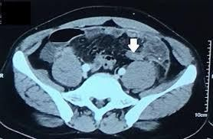

**Fig-1 CT abdomen shows Left sided appendicitis**

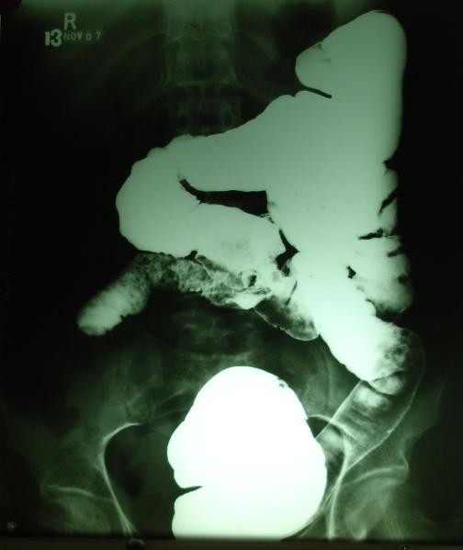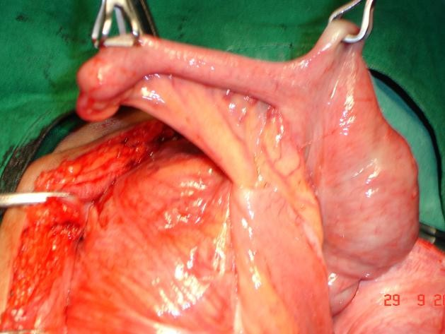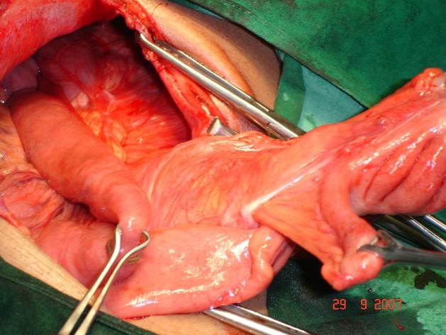

**Fig-2 Barium enema shows midgut malrotation**

**with caecum at left iliac fossa**

**Fig-4 Intraoperative photograph showing inflamed**

**left side appendix with mesentery**

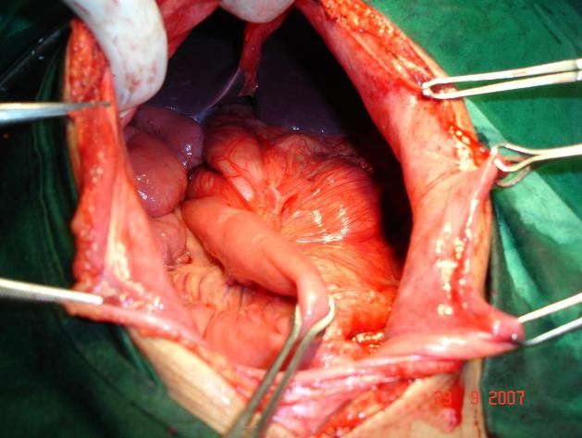

**Fig-3 Intraoperative photograph showing left lobe of liver and left sided appendix**

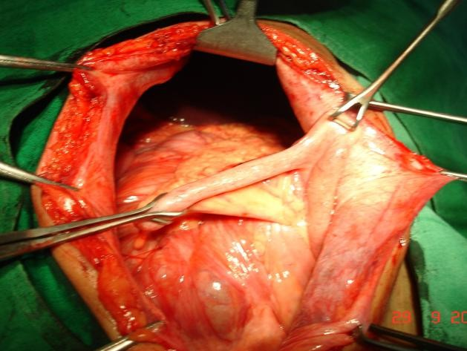

**Fig-5 Intraoperative photograph showing left side appendix with mesentery**

**Fig-6 Intraoperative photograph showing midgut malrotation with acute appendicitis**

# Case 2: Left-Sided Acute Appendicitis in Situs Inversus Totalis (SIT)

A 12-year-old boy was admitted to our center on October 20, 2022, with complaints of left lower abdominal pain for three days, fever, and vomiting.

Clinical Examination and Investigations: On physical examination, he had tenderness, guarding, and rebound tenderness in the left lower abdomen, along with a palpable lump in the left iliac fossa. Ultrasonography (USG): Revealed an appendicular lump in the left iliac fossa with a

swollen appendix (approximately 1 cm in diameter) covered by omentum. CT Abdomen: Showed a swollen, left-sided appendix with an associated omental mass. Chest X-ray: Revealed dextrocardia, confirming situs inversus totalis (SIT).

Laboratory findings: Total leukocyte count: 17,500/mm³ (with 80% neutrophils), Liver and kidney function tests: Normal

A laparoscopic appendectomy was planned after obtaining anesthesia clearance.

Surgical Approach: A 10 mm umbilical port was inserted using the Veress needle technique. Intra-abdominal CO₂ pressure was maintained at 12–14 mmHg. A 30-degree endoscope was introduced, confirming situs inversus totalis with the following findings: Gallbladder and right lobe of the liver on the left side beneath the diaphragm. Spleen and stomach on the right side. Cecum and ascending colon positioned on the left. Appendicular lump covered by omentum with an edematous, inflamed appendix extending toward the left lateral flank.

A second 10 mm port was inserted in the suprapubic region, and a third 5 mm working port was placed in the right iliac fossa (near McBurney’s point) for triangulation.

The operating surgeon and camera assistant were positioned on the right side of the patient, with the video cart on the left side.

The omentum was carefully separated, revealing a 12 mm diameter, long, edematous appendix with a perforated tip. The mesoappendix was dissected using a harmonic scalpel. The base of the appendix was ligated with 2-0 Vicryl, and a laparoscopic appendectomy was

performed. The appendix was extracted through the 10 mm port. The postoperative course was uneventful, and the patient was discharged on the 5th postoperative day without complications. **(Fig 7-16)**

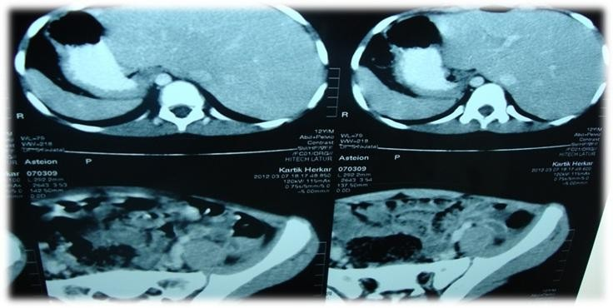

**Rt. Lobe Liver**

**A**

**B**

**Fig 8 CT abdomen shows a. spleen and stomach on right side**

**and right lobe of liver on left side (SIT).**

**b. inflamed left sided appendix**

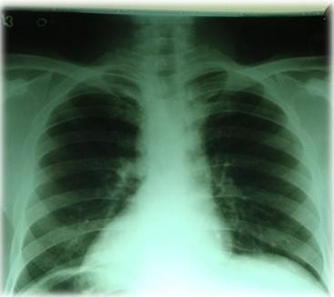

**Fig-7 X-ray Chest dextrocardia**

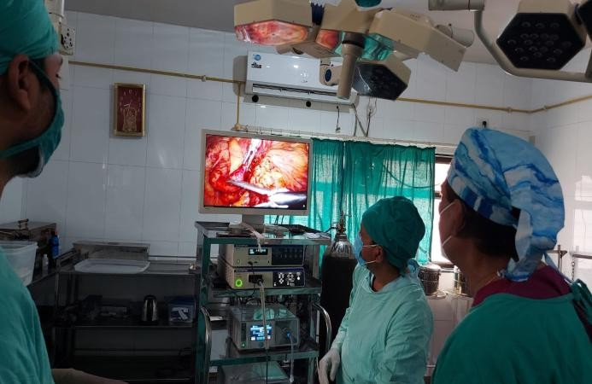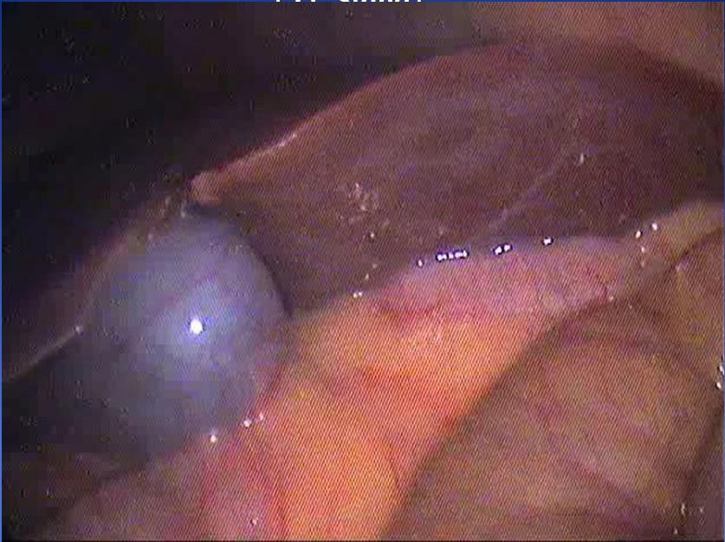

**Fig-9 Photograph showing operating surgeon and assistant on the right side and video cart on the left side**.

**Fig-10 Laparoscopic photograph showing Left side GB and right lobe liver (SIT) mirror image**

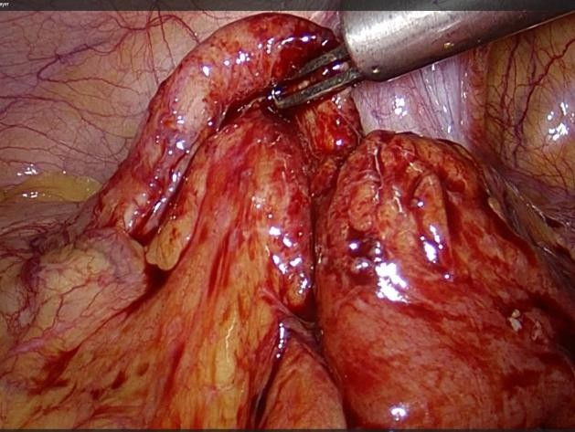

**Fig-11 Laparoscopic photograph showing left sided inflamed appendix with lump**

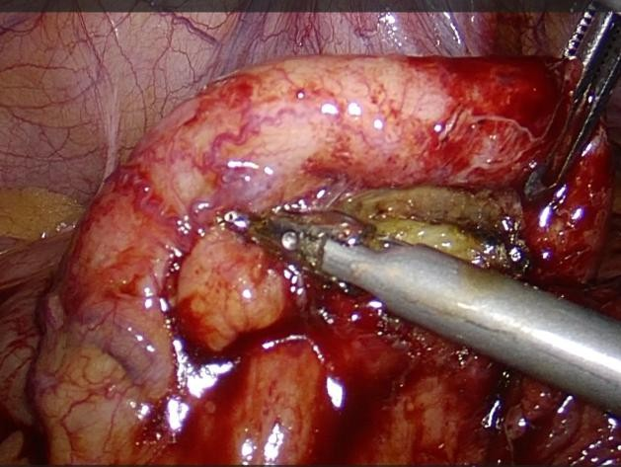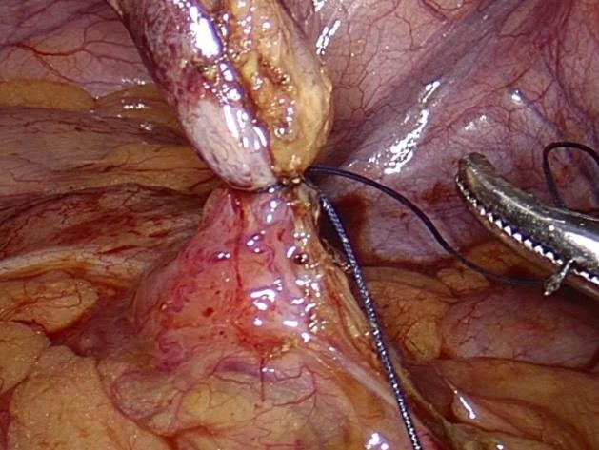

**Fig-12 Laparoscopic photograph showing left sided inflamed appendix with lump**

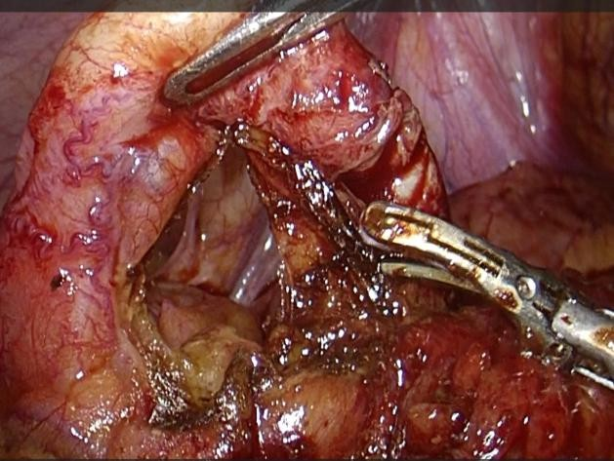

**Fig-13 Laparoscopic photograph showing left sided mesoappendix dissected using a harmonic scalpel**

**Fig-3 Laparoscopic Photograph showing**

**appendectomy**

**Fig-14 Laparoscopic photograph showing left sided appendix ligated with 2-0 Vicryl and appendectomy**

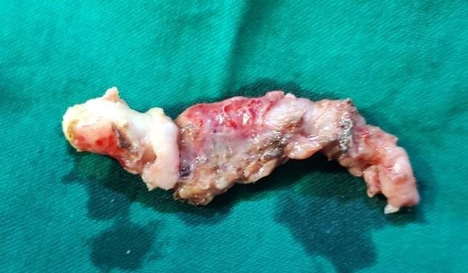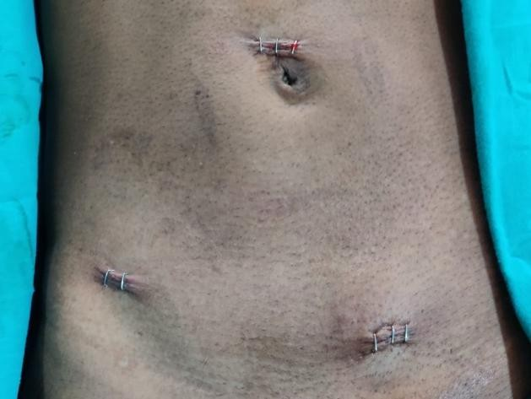

**Fig-15 Photograph showing gross specimen of**

**inflamed appendix**

**Fig-16 Photograph showing port site**

## Discussion

Left-sided appendicitis is a rare condition often associated with congenital anomalies such as situs inversus totalis (SIT) or midgut malrotation (MM), both of which may necessitate emergency surgery. Midgut malrotation refers to a spectrum of congenital positional abnormalities of the intestine, resulting from nonrotation or incomplete rotation of the primitive intestinal loop around the superior mesenteric artery (SMA) during fetal development. [1,2,3]

Situs inversus totalis (SIT) is a rare congenital condition in which the thoracic and abdominal organs are arranged as mirror images of their normal anatomical positions. The incidence of midgut malrotation reported in the literature ranges from 0.03% to 0.5% in live births. [4,5,6]

Situs inversus totalis (SIT) is a congenital condition caused by a single autosomal recessive gene with incomplete penetrance, occurring in approximately 1 in 5,000 to 10,000 live births. In complete situs inversus totalis, both thoracic and abdominal organs are transposed to mirror their normal anatomical positions. The reported incidence of SIT in the general population ranges from 0.0001% to 0.01%, while the incidence of acute appendicitis associated with SIT is estimated to be between 0.016% and 0.024%.

The differential diagnosis for left lower quadrant abdominal pain includes diverticulitis, left-sided renal colic, ruptured ovarian cyst, Meckel’s diverticulitis, ectopic pregnancy, strangulated hernia, bowel obstruction, testicular torsion, epididymitis, and pelvic inflammatory disease. [7,9,10]

The diagnosis of acute appendicitis in patients with SIT or midgut malrotation (MM) can be established through physical examination, electrocardiogram (ECG), chest X-ray, barium studies, ultrasonography

(USG), computed tomography (CT) scan, and diagnostic laparoscopy. A plain chest X-ray may reveal dextrocardia, while a plain abdominal X-ray may show a right-sided gastric bubble, aiding in the

identification of SIT. Additionally, elevated C-reactive protein (CRP) levels and an increased white blood

cell (WBC) count in peripheral blood have been found to have high sensitivity and accuracy in diagnosing acute appendicitis. [11,13]

A barium enema with gastrografin can help identify midgut malrotation (MM) or situs inversus totalis (SIT) and assist in diagnosing acute left lower quadrant pain. While ultrasonography (USG) is widely used for diagnosing appendicitis, it has significant limitations. In contrast, computed tomography (CT) scans have been well-documented as highly effective in diagnosing left-sided acute appendicitis, with a

reported accuracy of 90–99%. [1,2]

Once SIT or MM has been diagnosed, the surgical treatment options include:

1. Open laparotomy – via a sub-umbilical midline incision
2. Laparoscopic appendectomy

The first laparoscopic appendectomy for left-sided appendicitis was performed by Contini et al. in 1998. Since then, a total of 20 cases have been reported, with 5 cases from our center, bringing the total number of laparoscopic appendectomies for left-sided appendicitis to 25 cases by 2024. [1,2,7]

In our study, we performed 12 cases of open surgery and 5 cases of laparoscopic appendectomy. One patient underwent open cholecystectomy along with an open appendectomy in the same surgical session. We believe laparoscopy is highly valuable for both establishing a differential diagnosis and performing definitive surgical treatment. To the best of our knowledge, a total of 95 cases have been reported in the literature, including PubMed and Google Scholar. With 17 cases from our center, the

cumulative number of documented left-sided appendicitis cases will reach 112 by December 2024. [2,10,12]

## Conclusion

Left-sided appendicitis is a rare condition that is often misdiagnosed, potentially leading to serious complications and endangering the patient’s life. To ensure accurate diagnosis, a comprehensive evaluation, including laboratory tests and a CT scan, is essential. If a definitive diagnosis remains uncertain, timely laparoscopic exploration should be performed.

Diagnostic and therapeutic laparoscopy remains the gold standard for accurately identifying and effectively treating left-sided appendicitis, ensuring optimal patient outcomes.

**Ethical Approval:**

As per international standards or university standards written ethical approval has been collected and preserved by the author(s).

**Consent**

As per international standards or university standards, patient(s) written consent has been collected and preserved by the author(s).

Disclaimer (Artificial intelligence)

Option 1:

Author(s) hereby declare that NO generative AI technologies such as Large Language Models (ChatGPT, COPILOT, etc.) and text-to-image generators have been used during the writing or editing of this manuscript.

Option 2:

Author(s) hereby declare that generative AI technologies such as Large Language Models, etc. have been used during the writing or editing of manuscripts. This explanation will include the name, version, model, and source of the generative AI technology and as well as all input prompts provided to the generative AI technology

Details of the AI usage are given below:

1.

2.

3.

## References

1. Hu Q, Shi J, Sun Y. Left-sided appendicitis due to anatomical variation: A case report. Front Surg. 2022 Aug 24;9:896116. doi: 10.3389/fsurg.2022.896116. PMID: 36090346; PMCID: PMC944887
2. Akbulut S, Ulku A, Senol A, Tas M, Yagmur Y. Left-sided appendicitis: review of 95 published cases and a case report. World J Gastroenterol. 2010 Nov

28;16(44):5598-602. doi: 10.3748/wjg.v16.i44.5598. PMID: 21105193; PMCID: PMC2992678.

1. Welte, F.J., Grosso, M. Left-sided appendicitis in a patient with congenital gastrointestinal malrotation: a case report. *J Med Case Reports* **1**, 92 (2007). <https://doi.org/10.1186/1752-1947-1-92>
2. Abebe WM, Workalemahu DM, Leta RA, Asefa MA, Alemu HT, Molla YD. Left- sided perforated appendicitis in a patient with situs inversus totalis, a case

report. *SAGE Open Medical Case Reports*. 2024;12. doi:[10.1177/2050313X241266522](https://doi.org/10.1177/2050313X241266522)

1. Di Buono, G., Buscemi, S., Galia, M. *et al.* Acute appendicitis and situs viscerum inversus: radiological and surgical approach—a systematic review. *Eur J Med Res* **28**, 85 (2023). <https://doi.org/10.1186/s40001-023-01059-w>
2. Franklin ME, Almeida JA, Perez ER, Michaelson RLP, Majarrez A. Cholecystectomy and appendectomy by laparoscopy in a patient with situs inversus totalis: a case report and review of the literature. Asociacion Mexicana de Cirugia Endoscopica. 2001;2(3):150–3.
3. Zübeyr Üçüncü M, Üçüncü MM. Left sided acute appendicitis in pregnant woman: a case report. Turk J Colorectal Dis.

2016;26(136):138. <https://doi.org/10.4274/tjcd.08860>.

1. Pipal D K, Pipal V, Yadav S (March 08, 2022) Acute Appendicitis in Situs Inversus Totalis: A Case Report. Cureus 14(3): e22947. doi:10.7759/cureus.22947
2. Aassouani F, Charifi Y, Hajjar C, Bouardi NE, Haloua M, Alami B, Lamrani MYA,

Bouabdallah Y, Maaroufi M, Boubbou M. Left-sided appendicitis revealing a

common mesentery: A Case Report. Radiol Case Rep. 2022 Aug 4;17(10):3718- 3721. doi: 10.1016/j.radcr.2022.07.009. PMID: 35957662; PMCID: PMC9357839.

1. Lu-yao Z, et al. Usefulness of sonography in evaluating children suspected of malrotation: comparison with an upper gastrointestinal contrast study. J

Ultrasound Med. 2015;34(10):1825–1832. doi: 10.7863/ultra.14.10017

1. Sami A, Ulku A, Senol A, TAS M, Yagmur Y, et al. Left-sided appendicitis: review of 95 published cases and a case report. World J Gastroenterol. 2010;16(44):5598. doi: 10.3748/wjg.v16.i44.5598. [[DOI](https://doi.org/10.3748/wjg.v16.i44.5598)] [[PMC free article](https://pmc.ncbi.nlm.nih.gov/articles/PMC2992678/)] [[PubMed](https://pubmed.ncbi.nlm.nih.gov/21105193/)] [[Google](https://scholar.google.com/scholar_lookup?journal=World%20J%20Gastroenterol&title=Left-sided%20appendicitis%3A%20review%20of%2095%20published%20cases%20and%20a%20case%20report&author=A%20Sami&author=A%20Ulku&author=A%20Senol&author=M%20TAS&author=Y%20Yagmur&volume=16&issue=44&publication_year=2010&pages=5598&pmid=21105193&doi=10.3748/wjg.v16.i44.5598) [Scholar](https://scholar.google.com/scholar_lookup?journal=World%20J%20Gastroenterol&title=Left-sided%20appendicitis%3A%20review%20of%2095%20published%20cases%20and%20a%20case%20report&author=A%20Sami&author=A%20Ulku&author=A%20Senol&author=M%20TAS&author=Y%20Yagmur&volume=16&issue=44&publication_year=2010&pages=5598&pmid=21105193&doi=10.3748/wjg.v16.i44.5598)]
2. Kong, FB., Dong, CC., Deng, QM. *et al.* Left-Sided Acute Appendicitis: a Case Report and a Review of Literature. *Indian J Surg* **81**, 65–69 (2019). <https://doi.org/10.1007/s12262-018-1832-2>
3. Gans SL, Atema JJ, Stoker J, Toorenvliet BR, Laurell H, Boermeester MA. C-reactive protein and white blood cell count as triage test between urgent and nonurgent conditions in 2961 patients with acute abdominal pain. Medicine (Baltimore). 2015 Mar;94(9):e569. doi: 10.1097/MD.0000000000000569. PMID: 25738473; PMCID: PMC4553955.

COMPETING INTERESTS DISCLAIMER:

Authors have declared that they have no known competing financial interests OR non-financial interests OR personal relationships that could have appeared to influence the work reported in this paper.