*Case report*

Prevention, causes and management of entrapped central venous line after mitral valve replacement: A rare case report and review of literature.

.

ABSTRACT

|  |
| --- |
| **Objectives**: Management of entrapped central venous line by a suture after mitral valve replacement in the context of a rare clinical case report. Possible causes and preventive measures are explored to prevent the occurrence of a similar complication of cardiac surgery.  **Presentation of case**: After an uneventful cardiac surgery for mitral valve replacement and a single coronary artery bypass grafting, the patient was extubated few hours after the procedure and had minimal inotropic support. On the third postoperative day, the patient was transferred to the ward. Decision was taken to remove the central venous catheter one week postoperatively. Nurses and physicians noticed that the CVC was stuck and could not be removed. The patient was transferred to the catheterization laboratory where the interventional radiologists tried to explore the cause of the CVC entrapment under fluoroscopy using contrast enhanced venography. The radiologists concluded that the CVC was entrapped into a cardiac structure. After explaining the situation to the patient and family, consent was obtained from the patient to reopen the chest under general anaesthesia. During the exploratory re-sternotomy, cardiopulmonary bypass using bi-caval venous cannulation was initiated. Subsequently, the heart was arrested using aortic cross clamp and cardioplegia solution. It was noticed that the CVC was low lying in the right atrium and was inadvertently stitched by the suture line for left atrial closure. After cutting the sutures, the CVC was easily removed by the anaesthetist. The patient recovered in few days and was discharged home. The two main causes of the entrapment of CVC during cardiac surgery are deep advancement of the CVC further than the cavo-atrial junction by the anaesthetist and unrecognising the catheter during atrial closure by the surgeon. Prevention of this complication is by ensuring that the tip of the CVC is located in the superior vena cava (SVC) and is above the cavo-atrial junction. For this purpose, we suggest using mathematical formulae based on patients’ height and the use of imaging. |

*Keywords: Anaesthesia, Cardiac Surgery, Central Venous Catheter, Entrapment*

1. INTRODUCTION

Central venous catheters (CVC) are routinely inserted in cardiac surgery for perioperative fluid management, real-time monitoring of filling pressures and inotrope infusions. The desired site of insertion by most anaesthetists is the right internal jugular vein; as it provides a straight course of the catheter from the internal jugular vein and through the innominate vein to the superior vena cava.¹ ² The tip of a CVC is normally to be positioned in the proximity of the cavo-atrial junction (CAJ) where the lower third of the superior vena cava (SVC) and the upper right atrium (RA) is located. ³ This position is above the level of pericardial reflection. ⁴ However, in cardiac surgeries involving dual caval cardiopulmonary bypass cannulation the tip of the CVC is suggested to be better located at a higher (more proximal) position in the proximal SVC. Rarely, CVC malposition can lead to serious complications. ⁵ ⁶ There are many reports of the complication by the central venipuncture, but there are very few reports about its entrapment in atrial sutures during cardiac surgeries in the literature.⁷ ⁸ Herein; in this case report we describe here how a CVC inserted through the right internal jugular vein became inadvertently entrapped during left atrial closure by suturing after a mitral valve replacement surgery. We also describe a suggested stepwise approach to manage this complication.

2. PRESENTATION OF CASE

A 49 year old male patient with severe mitral valve regurgitation and coronary artery disease was presented for mechanical mitral valve replacement (MVR) and a single coronary artery bypass grafting (CABG). The surgery was uneventful, the patient was extubated on the same day in the Intensive Care Unit (ICU) and inotropes were discontinued. One week later; it was decided to remove the CVC. The nurses and doctors reported difficulty in removing the catheter. Postoperative chest X-ray showed the CVC descending from the right internal jugular vein to the right atrium. Tip of CVC was noticeably distal to the level of the carina. (Image 1) Consultation with interventional radiology was made. The patient was transferred to the interventional radiology laboratory where venography using contrast under fluoroscopy was performed and it was concluded that the CVC catheter is stuck and is likely to be sutured with the cardiac tissue. (Image 2)

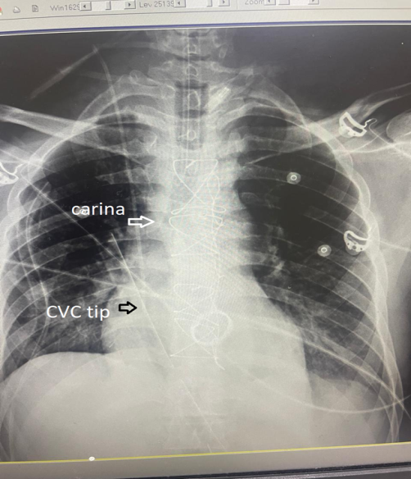  
Fig. 1: Postoperative chest-x-ray showing tip of CVC in right atrium

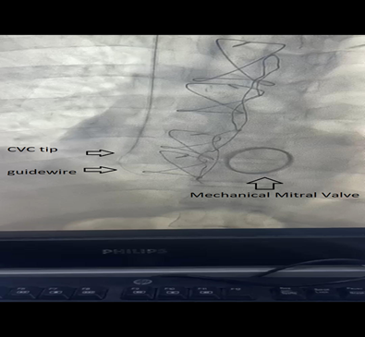

Fig. 2: Fluoroscopy and venography of the CVC

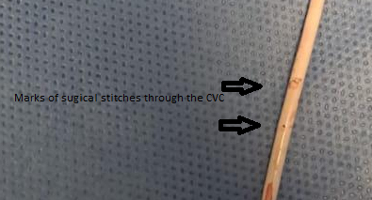

Fig. 3: Needle marks through the CVC

The status was explained to the patient and his family and consent was taken to explore the chest and to remove the CVC surgically. Few days later, the patient was re-operated with redo mid-sternotomy under general anaesthesia and transoesophageal echocardiography showed the tip of the CVC down in the right atrium near the inferior vena cava. With the aid of cardiopulmonary bypass (CPB) machine with bi-caval venous canullae and an aortic canulla CPB was initiated. Aortic cross clamp was placed and one litre of anterograde crystalloid cold potassium based cardioplegia (St.Thomas) infused to arrest the heart in diastole. Mild hypothermia (32 degrees Celsius) was applied as a precaution. The continuous sutures used to close the left atrium were cut and removed. The CVC was easily pulled out by the anaesthesia team and the atrium was closed again. After de-airing of the heart and rewarming the aortic clamp was removed. After ensuring that the heart was in normal sinus rhythm and the patient is normo-thermic; the patient was weaned from CPB easily, CPB canullae removed and chest closed in layers.

Examination of the removed CVC revealed that the CVC was stitched and needle mark that resembles penetration of the CVC was evident. (Image 3) Postoperatively, the patient was extubated within few hours from arrival to the ICU, had normal haemodynamics with no inotropic or vasopressor support. Next day, he was discharge from the ICU to the ward. He had good recovery and was discharged home.

3. discussion

Entrapment of central venous catheter is an extremely rare complication of central venous cannulation in cardiac surgery. ⁹ Few case reports in literature are available for stuck CVC by different mechanisms such as thrombosis, fibrin sheath formation, due to infectious process, knotting or catheter looping. ¹⁰ Another less described mechanism of entrapment is suturing the line with cardiac tissue intraoperatively by the cardiac surgeon. ¹¹ During cardiac surgery, if the CVC was placed and fixed at a length further distally than the recommended; the CVC tends to lie against the lateral or the posterior wall of the right atrium, where it may be caught by a suture of the purse-string of the venous cannulation for CPB; however, suturing of a CVC to the heart and vessels by cardiac sutures has rarely been reported. .¹² In addition, most of the reported cases of entrapped catheter described Swan-Ganz/ pulmonary artery catheters (PACs) which could be explained by their increased length of insertion through different cardiac and vascular structures that make them more amenable to knotting and looping. ¹³ However; this is not the case with CVCs.

There is no gold standard for estimating the insertion depth of a CVC. ¹⁴ It is essential to check the correct position of the catheter tip before use. ¹⁵ The assessment of the tip of CVC can be performed during and after the insertion by surface landmarks, simple mathematical formulae, fluoroscopy (chest-X-ray, right atrial electrocardiography, vascular ultrasound, transthoracic echocardiography (TTE) and transoesophageal echocardiography (TOE). ¹⁶ Among these methods; the Peres’ height formula in predicting the correct insertion depth of CVC is most commonly used by anaesthetists. ¹⁷ Although all of these mentioned methods can be useful in general; they are not always valid in cardiac anaesthesia. Manudeep et al. compared Peres’ formula and radiological landmark formula for optimal depth of insertion of right internal jugular venous catheters on 102 patients and found that radiological landmark formula is superior to Peres’ formula for measuring optimal depth of insertion of right internal jugular venous catheter. ¹⁸ Nowadays; transoesophageal echocardiography (TOE) is more commonly used during cardiac surgery, especially for heart valve surgery to assess heart valves before and after repair or replacement. The anaesthetist can also make use of the TOE to assess the optimal position of the tip of the CVC intraoperatively. This can be accomplished using mid-oesophageal (ME) bicaval view by increasing the multiplane transducer angle forward to 90° – 120° and turning the probe to the right (clockwise), until the IVC in the left side of the display and the SVC appears in the right side. (Image 4

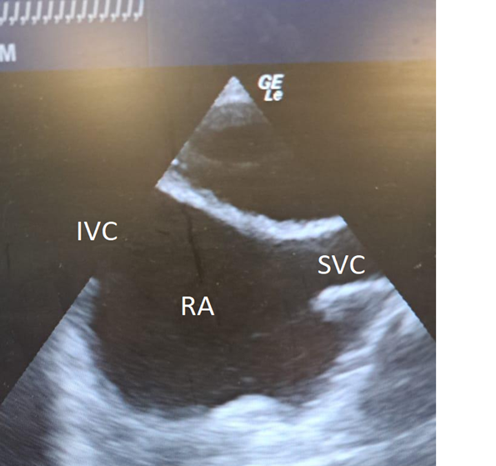

Fig.4: M.E. Bicaval view using T.O.E.

It is one of the responsibilities of the cardiac anaesthetists to plan and perform the vascular lines according to the individual patient, type of surgery or procedure. Patient factors that may determine length of CVC insertion are age, gender, and height and body habitus. Surgical factors are type of surgery and variabilities in conduct of cardiopulmonary bypass (CPB). For example, Glenn and Fontan procedures that involve superior vena cava anastomosis with the pulmonary artery mandate shorter CVC with more proximally located tip. Similarly, if the conduct of CPB involves bi-caval venous cannulation, the CVC tip should be positioned more proximally not to intervene with CPB SVC cannula.

It is also one of the responsibilities of the cardiac surgeon to identify the location of the tip of the CVC catheter if the surgery involves the right side of the heart to avoid inadvertent suturing of the catheters to cardiac tissue.

In cases of stuck CVC after cardiac surgery we advise the following approach: 1) Imaging, 2) Interventional radiology consultation, 3) Insertion of another CVC at an alternative site if needed, 4) multi-disciplinary planning that involves cardiac and vascular surgeons, cardiac anaesthetists and perfusionists. Since there was a risk of opening the suture line or of a rupture while trying to remove the catheter by nonsurgical methods, we preferred the surgical method.

Preventive measures for entrapped CVCs in cardiac surgery involve planning and understanding of the procedure, considering patient, surgical and CPB factors. In addition, radiological imaging and using ultrasound for insertion and tip position confirmation is highly recommended.

4. Conclusion

Removal of central venous catheter (CVC) after cardiac surgery should be done carefully. If resistance was met on CVC withdrawal or removal after cardiac surgery, inadvertent entrapment of CVC by a surgical suture should be considered as a possible cause; although it is a rare and unusual complication. Forceful traction of stuck CVC may lead to catastrophic bleeding due to disruption of suture lines or rupture of vessels.

Competing interests

Authors have declared that no competing interests exist.

Consent

All authors declare that ‘written informed consent was obtained from the patient for publication of this case report and accompanying images.

Ethical approval

The study was approved by the Institutional Ethics Committee

**Disclaimer (Artificial intelligence):**

Author(s) hereby declare that NO generative AI technologies such as Large Language Models (ChatGPT, COPILOT, etc.) and text-to-image generators have been used during the writing or editing of this manuscript.

References

1) Hicks MA, Popowicz P, Lopez PP. Central Line Management. [Updated 2023 May 26]. In: StatPearls [Internet]. Treasure Island (FL): StatPearls Publishing; 2025 Jan-. Available from: https://www.ncbi.nlm.nih.gov/books/NBK539811/

2) Kehagias E, Galanakis N, Tsetis D. Central venous catheters: Which, when and how. Br J Radiol. 2023 Nov;96(1151):20220894. doi: 10.1259/bjr.20220894. Epub 2023 May 25. PMID: 37191031; PMCID: PMC10607393.

3) Şahinkaya HH, Parlak M, Tekgul ZT. Assessment of the Tip Position of Central Venous Catheters Inserted Using Peres' Height Formula. Cureus. 2022 Nov 28;14(11):e31988. doi: 10.7759/cureus.31988. PMID: 36589175; PMCID: PMC9797751.

4) Vesely TM. Central venous catheter tip position: a continuing controversy. J Vasc Interv Radiol. 2003 May;14(5):527-34. doi: 10.1097/01.rvi.0000071097.76348.72. PMID: 12761305.

5) Maddali MM, Al Aliyani KRS, Arora NR, Sathiya PM. Central Venous Catheter Tip Malposition After Internal Jugular Vein Cannulation in Pediatric Patients With Congenital Heart Disease. J Cardiothorac Vasc Anesth. 2022 Aug;36(8 Pt A):2483-2487. doi: 10.1053/j.jvca.2022.01.033. Epub 2022 Jan 25. PMID: 35184958.

6) Tanrikulu N, Haspolat A, Koprulu AS. Very rare malposition of central venous catheter in cardiac surgery patients. Cardiovasc J Afr. 2023 Nov-Dec 23;34(5):321-324. doi: 10.5830/CVJA-2022-062. Epub 2023 Feb 6. PMID: 36745004; PMCID: PMC11040467.

7) Anvaripour A, Yazdanian F, Totonchi MZ, Shahryari H. Inadvertent Entrapment of a Central Venous Catheter by a Purse-String Suture during Cardiopulmonary Bypass: A Case Report. Case Rep Anesthesiol. 2011;2011:760426. doi: 10.1155/2011/760426. Epub 2011 Dec 18. PMID: 22606393; PMCID: PMC3350122.

8) Desai SS, Konanur M, Foltz G, Malaisrie SC, Resnick S. An Endovascular Approach to the Entrapped Central Venous Catheter After Cardiac Surgery. Cardiovasc Intervent Radiol. 2016 Mar;39(3):453-7. doi: 10.1007/s00270-015-1251-8. Epub 2015 Dec 10. PMID: 26662293.

9) Makhija N, Choudhury M, Kiran U, Chowdhury U. The stuck central venous catheter: a word of caution. Heart Lung Circ. 2008 Oct;17(5):432-4. doi: 10.1016/j.hlc.2007.05.012. Epub 2007 Jul 12. PMID: 17625965.

10) Tomaszek K, Rahman F. Case review and imaging: Treatment of central venous catheter associated fibrin sheath and chronic thrombus with the ClotTriever system. Radiol Case Rep. 2023 Nov 24;19(2):553-566. doi: 10.1016/j.radcr.2023.10.062. PMID: 38074433; PMCID: PMC10709125.

11) Kong, H., Chen, S. & Wen, X. Suture of the right internal jugular vein catheter in a mitral valve replacement: a case report. J Med Case Reports 8, 129 (2014). https://doi.org/10.1186/1752-1947-8-129

12) Nair HC, Banakal S, Parachuri VR, Shetty DP. Entrapped central venous catheter after mitral valve replacement and its surgical retrieval. Interact Cardiovasc Thorac Surg. 2012 Sep;15(3):566-7. doi: 10.1093/icvts/ivs245. Epub 2012 Jun 11. PMID: 22687430; PMCID: PMC3422952.

13) Alsatli R. Pulmonary artery catheter entrapment in cardiac surgery. Saudi J Anaesth. 2010 May;4(2):114-6. doi: 10.4103/1658-354X.65125. PMID: 20927274; PMCID: PMC2945509.

14) Neumann C, Breil M, Schild A, Schenk A, Jakobs P, Mikus M, Schindler E. Central venous catheter tip positioning using ultrasound in pediatric patients-A prospective observational study. Paediatr Anaesth. 2024 Jun;34(6):551-558. doi: 10.1111/pan.14864. Epub 2024 Feb 22. PMID: 38389210.

15) Ängeby E, Adrian M, Bozovic G, Borgquist O, Kander T. Central venous catheter tip misplacement: A multicentre cohort study of 8556 thoracocervical central venous catheterisations. Acta Anaesthesiol Scand. 2024 Apr;68(4):520-529. doi: 10.1111/aas.14380. Epub 2024 Feb 13. PMID: 38351546.

16) Krishnan AK, Menon P, Gireesh Kumar KP, Sreekrishnan TP, Garg M, Kumar SV. Electrocardiogram-guided Technique: An Alternative Method for Confirming Central Venous Catheter Tip Placement. J Emerg Trauma Shock. 2018 Oct-Dec;11(4):276-281. doi: 10.4103/JETS.JETS_122_17. PMID: 30568370; PMCID: PMC6262658.

17) Chopra S, Luthra N, Kathuria S, Saggar K, Gupta S, Singh T. Optimal positioning of right internal jugular venous catheter: A randomised study comparing modified Peres' height formula and distance between insertion point and right third intercostal space. Indian J Anaesth. 2022 Aug;66(8):585-590. doi: 10.4103/ija.ija_879_21. Epub 2022 Aug 22. PMID: 36274797; PMCID: PMC9580582.

18) Manudeep AR, Manjula BP, Dinesh Kumar US. Comparison of Peres' Formula and Radiological Landmark Formula for Optimal Depth of Insertion of Right Internal Jugular Venous Catheters. Indian J Crit Care Med. 2020 Jul;24(7):527-530. doi: 10.5005/jp-journals-10071-23478. PMID: 32963434; PMCID: PMC7482340.