**Glomus tumor of the wrist : a case report**

**ABSTRACT**

Introduction

Glomus tumors are rare benign lesions that arise from a neuro-myo-arterial structure. While they are typically located in the fingers, they can also occur in other regions of the body which can delay accurate diagnosis.

Case presentation

We report a rare localization of a glomus tumor in the dorsal wrist, discovered by a painful mass. The aim of this article is to raise awareness in the scientific community and elaborate a review of the literature.

Conclusion

Extradigital glomus tumors of the extremities are extremely rare. Their diagnosis is often overlooked due to their incomplete clinical presentation. This case highlights the diagnostic challenges and treatment options associated with extradigital glomus tumors.

**Key words :** **Glomus tumor, wrist, tissue tumors, Malignant glomus tumors**

**INTRODUCTION**

Glomus tumors are infrequent benign neoplasms originating from neuromyoarterial glomus bodies, representing less than 2% of soft tissue tumors [1]. Malignant glomus tumors are extremely,jk rare, comprising as high as 2.9% of all glomus tumors [2]. Typically, glomus tumors manifest in the hand and can be diagnosed relatively easily based on the classic triad of pain, tenderness, and cold hypersensitivity. However, they may also arise in other locations, such as the thigh [3], the leg [4] and the wrist, where they’re more challenging to diagnose.

**CASE PRESENTATION**

A 58-year-old, right-handed housewife, with a history of hypertension, presents to our hand surgery consultation with a painful soft tissue mass on the dorsal side of her right wrist. Pain was magnified on palpation or wrist mobilisation causing electrical-shock-like sensation. There was no hypersensitivity to cold.

Furthermore, there is no history of trauma.

Inspection revealed no signs of local inflammation or changes in skin color. Palpation identified a soft, mobile, painful mass on the postero-medial aspect of wrist, measuring less than one centimeter. Range of motion of the right wrist was within normal limits [figure 1].

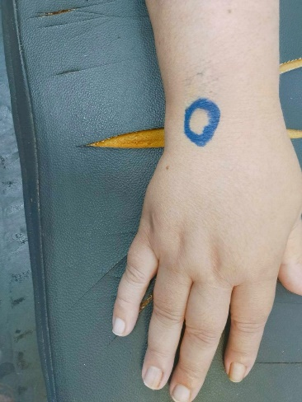

Figure 1 : Clinical aspect of the mass

A standard radiograph was obtained with normal findings. Ultrasound revealed a round hypoechoic lesion with non-specific characteristics.

Surgical resection of the mass was performed under local anesthesia. A dorsal approach was used. The perioperative appearance showed a 5mm mass, slightly reddish, rounded, and firm [figure 2(A-B)].

Histological analysis concluded to a glomus tumor.

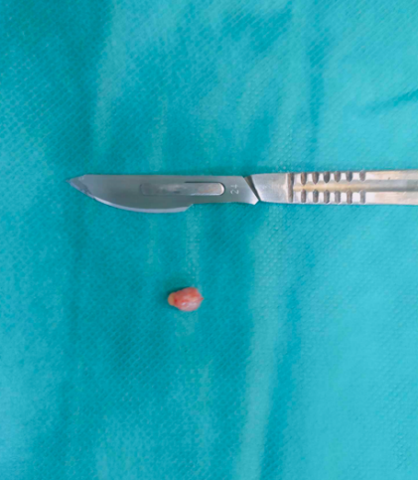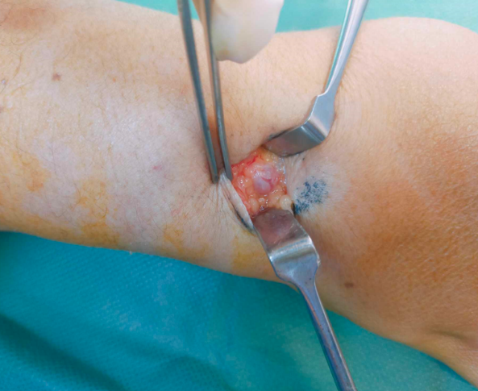

Figure 2(A-B) : Resection of the tumor with a dorsal approach

In the post operative course, pain has completely disappeared and the patient demonstrated full-range mobility of the wrist joint. There were no evidence of recurrence at the 4 month check-up [figure 3(A-B)].

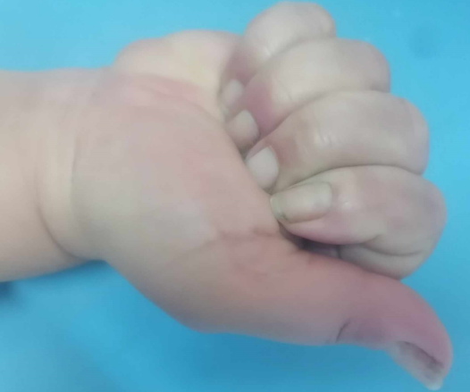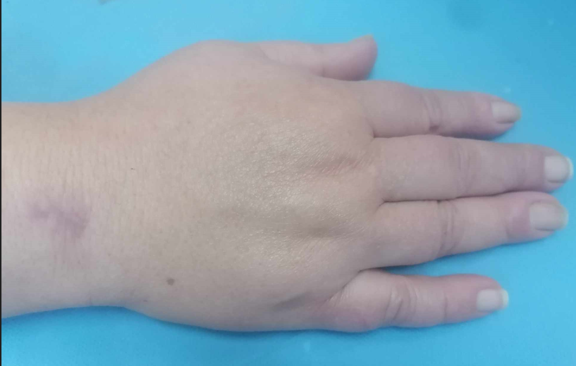

Figure 3(A-b) : The aesthetic and functional result was assessed as good at 4 month follow-up

**DISCUSSION**

Glomus tumors represent 2% of all soft tissue tumors. The World Health Organization recently classified glomus tumors into three types : benign, intermediate glomangiomatosis, and malignant [1].

The glomus body, situated in the reticular dermis, is a contractile structure composed of neuromyoarterial components. It is predominantly located in the distal regions of the fingers. Reports of extradigital glomus tumors are relatively uncommon [3]. Literature is mainly in the form of case report of lesions located at the shoulder [7], buttock [8], para-achillean region [9], thigh [8], the leg [4] and foot [11]. Deeper infiltrations have been documented in visceral organs, bones [14], radial nerve [16] and rotator cuff [17].

Glomus tumor typically presents as a painful, reddish-blue, firm lesion in a 30- to 40-year-old woman. It is often subungual.

Patients presenting with extradigital glomus tumors are generally within the age range of 20 to 40 years, with no significant gender predilection. However, some series have reported a male predominance in extradigital forms [19].

A notable characteristic of these tumors is the long delay between symptom onset and definitive diagnosis. For patients with digital lesions, this period ranges from 1 to 22 years while for those with extradigital tumors, it was more prolonged ranged from (five to 25 years) [18]. Correct diagnosis was missed in 31% of cases [20].

A history of local trauma is a common finding in these patients [20]. Researchers reviewed the characteristics of eight patients who had an extradigital glomus tumor all of whom had experienced local trauma with an interval of 2 weeks to 21 years before the tumor was diagnosed. Types of injuries included previous surgeries, ruptured tendon repairs, puncture wounds, glass injuries and low-level trauma. A history of trauma or injury was not identified in our patient.

The classical clinical triad comprising pain and hypersensitivity to cold is classical, although hypersensitivity to cold is less commonly reported [22]. Superficial lesions typically exhibit a faintly violaceous coloration.

The wrist is an uncommon site for extradigital glomus tumor.

In this case, there have been at least 21 documented patients [20,23]. Like other extradigital glomus tumors, those found on the wrist were more frequently observed in older men. While all tumors were tender, four patients did not experience increased pain in response to cold.

A retrospective analysis of 56 extradigital glomus tumors revealed that the most frequently differentiel diagnosis were hemangioma, neuroma, and neurofibroma [6].

Imaging studies, while not providing unequivocal confirmation, can raise suspicion for glomus tumors. Radiographs are usually unremarkable except in rare instances involving osseous or subungual formations [14,27]. Ultrasound examinations generally reveal a well-circumscribed, encapsulated hypoechoic lesion [16]; however, some studies have reported hyper-echoic lesions [7]. MRI findings typically demonstrate an intermediate signal intensity on T1-weighted images that enhances following gadolinium administration and appears hyperintense on T2-weighted images [5,13]. Ultrasound may be the preferred method for evaluation, as MRI has a specificity around 50%, is more time-consuming, and incurs higher costs. Furthermore, a glomus tumor can still exist even if the MRI results are negative.

In all cases reviewed, surgical intervention remains the primary treatment modality and involves complete excision including the joint capsule in articular locations to avoid recurrence followed by histological examination which can lead to total relief of pain as demonstrated in our case. Three histologic types of glomus tumors have been observed: solid, glomangioma, and glomangiomyoma.

While recurrences have been documented for digital glomus tumors, the limited number of cases involving extradigital forms precludes a reliable risk assessment for recurrence in this context [27].

Although multiple [33] or malignant [2] variants have been described, they are exceedingly rare; such possibilities should be particularly considered when evaluating large deep-seated tumors.

**CONCLUSION**

Glomus tumors located in the wrist are an unusual manifestation of extradigital glomus tumors, which are already quite rare. Symptoms such as pain and cold hypersensitivity, should prompt consideration of glomus tumors. This case highlights the diagnostic challenges and treatment options associated with extradigital glomus tumors.

**Ethical Approval:**

As per international standards or university standards written ethical approval has been collected and preserved by the author(s).

**Consent**

As per international standards or university standards, patient(s) written consent has been collected and preserved by the author(s).

Disclaimer (Artificial intelligence)

Option 1:

Author(s) hereby declare that NO generative AI technologies such as Large Language Models (ChatGPT, COPILOT, etc.) and text-to-image generators have been used during the writing or editing of this manuscript.

Option 2:

Author(s) hereby declare that generative AI technologies such as Large Language Models, etc. have been used during the writing or editing of manuscripts. This explanation will include the name, version, model, and source of the generative AI technology and as well as all input prompts provided to the generative AI technology

Details of the AI usage are given below:

1.

2.

3.

**REFERENCES**

1. Wu RC, Gao YH, Sun WW, Zhang XY, Zhang SP. Glomangiomatosis - immunohistochemical study: A case report. World J Clin Cases. 6 juin 2022;10(16):5406‑13.

2. Sacchetti F, De Gori M, Grossi S, Bonadio GA, Capanna R. An exceptional case of malignant glomus tumor and a review of the literature. Acta Orthop Traumatol Turc. juill 2019;53(4):313‑7.

3. Sbai MA, Benzarti S, Gharbi W, Maalla R. A Rare Case of Glomus Tumor of the Thigh with Literature Review. J Orthop Case Rep. 2018;8(5):22‑4.

4. Sbai MA, Benzarti S, Gharbi W, Khoffi W, Maalla R. Glomus tumor of the leg: a case report. Pan Afr Med J. 2018;31:186.

5. Temiz G, Şirinoğlu H, Demirel H, Yeşiloğlu N, Sarıcı M, Filinte GT. Extradigital Glomus Tumor Revisited: Painful Subcutaneous Nodules Located in Various Parts of the Body. Indian J Dermatol. 2016;61(1):118.

6. Schiefer TK, Parker WL, Anakwenze OA, Amadio PC, Inwards CY, Spinner RJ. Extradigital glomus tumors: a 20-year experience. Mayo Clin Proc. oct 2006;81(10):1337‑44.

7. Abela M, Cole AS, Hill GA, Carr AJ. Glomus tumor of the scapular region. J Shoulder Elbow Surg. 2000;9(6):532‑3.

8. McDonald J, Moonka R. Extra-digital glomus tumor as a Cause of Buttock Pain. Orthopedics 2000;23(8):851–2 - Recherche Google [Internet]. [cité 29 janv 2025]. Disponible sur: https://www.google.com/search?q=McDonald+J%2C+Moonka+R.+Extra-digital+glomus+tumor+as+a+Cause+of+Buttock+Pain.+Orthopedics+2000%3B23(8)%3A851%E2%80%932&rlz=1C1CHBF_frTN934TN934&oq=McDonald+J%2C+Moonka+R.+Extra-digital+glomus+tumor+as+a+Cause+of+Buttock+Pain.+Orthopedics+2000%3B23(8)%3A851%E2%80%932&gs_lcrp=EgZjaHJvbWUyBggAEEUYOdIBBzMxOWowajeoAgCwAgA&sourceid=chrome&ie=UTF-8

9. Nakamura K. Multiple glomus tumors associated with arteriovenous fistulas and with nodular lesions of the finger joints. Plast Reconstr Surg. oct 1992;90(4):675‑83.

10. Amillo S, Arriola FJ, Muñoz G. Extradigital glomus tumour causing thigh pain: a case report. J Bone Joint Surg Br. janv 1997;79(1):104‑6.

11. Koti M, Bhattacharryya R, Ewen SW, Maffulli N. Subungual glomus tumor of the hallux. A case report. Acta Orthop Belg. juin 2001;67(3):297‑9.

12. Mohler DG, Lim CK, Martin B. Glomus tumor of the plantar arch: a case report with magnetic resonance imaging findings. Foot Ankle Int. oct 1997;18(10):672‑4.

13. Quigley JT. A glomus tumor of the heel pad. A case report. J Bone Joint Surg Am. avr 1979;61(3):443‑4.

14. Bahk WJ, Mirra JM, Anders KH. Intraosseous glomus tumor of the fibula. Skeletal Radiol. déc 2000;29(12):708‑12.

15. González-Llanos F, López-Barea F, Isla A, Fernández-Prieto A, Zubillaga A, Alvarez F. Periosteal glomus tumor of the femur: a case report. Clin Orthop Relat Res. nov 2000;(380):199‑203.

16. Smith KA, Mackinnon SE, Macauley RJ, Mailis A. Glomus tumor originating in the radial nerve: a case report. J Hand Surg Am. juill 1992;17(4):665‑7.

17. Yoshikawa G, Murakami M, Ishizawa M, Matsumoto K, Hukuda S. Glomus tumor of the musculotendinous junction of the rotator cuff. A case report. Clin Orthop Relat Res. mai 1996;(326):250‑3.

18. Abou Jaoude JF, Roula Farah A, Sargi Z, Khairallah S, Fakih C. Glomus tumors: report on eleven cases and a review of the literature. Chir Main. sept 2000;19(4):243‑52.

19. Senhaji G, Gallouj S, El Jouari O, Lamouaffaq A, Rimani M, Mernissi FZ. Rare tumor in unusual location - glomus tumor of the finger pulp (clinical and dermoscopic features): a case report. J Med Case Rep. 8 juill 2018;12(1):196.

20. Jabir S, Rodrigo T, Petkar M, Iwuagwu F. Glomus tumours of the upper limb and hand. A clinicopathological review of cases over two decades. J Hand Surg Eur Vol. avr 2022;47(4):419‑20.

21. Lee DW, Yang JH, Chang S, Won CH, Lee MW, Choi JH, et al. Clinical and pathological characteristics of extradigital and digital glomus tumours: a retrospective comparative study. J Eur Acad Dermatol Venereol. déc 2011;25(12):1392‑7.

22. Cohen PR. Glomus Extradigital Tumor: A Case Report of an Extradigital Glomus Tumor on the Wrist and Comprehensive Review of Glomus Tumors. Cureus. mai 2023;15(5):e38737.

23. Larsen N, Pavlidakey P, Harada S, Prieto-Granada CN. Cutaneous malignant glomus tumor with an MIR143(CARMN)::NOTCH2 fusion. J Cutan Pathol. févr 2023;50(2):101‑3.

24. Rozmaryn LM, Sadler AH, Dorfman HD. Intraosseous glomus tumor in the ulna. A case report. Clin Orthop Relat Res. juill 1987;(220):126‑9.

25. Bessho Y, Kataoka O, Sho T, Kitazawa S, Okada S. Intraosseous glomus tumor in the upper thoracic spine complicating compression myelopathy. A case report. Spine (Phila Pa 1976). août 1991;16(8):988‑90.

26. Nakamura Y, Nomura T, Ookubo M, Adati T, Harada D. Extradigital glomus tumor causing para-Achilles tendon pain. A case report. Acta Orthop Belg. déc 2000;66(5):503‑6.

27. Theumann NH, Goettmann S, Le Viet D, Resnick D, Chung CB, Bittoun J, et al. Recurrent glomus tumors of fingertips: MR imaging evaluation. Radiology. avr 2002;223(1):143‑51.

28. De Maerteleire W, Naetens P, De Smet L. Glomus tumors. Acta Orthop Belg. avr 2000;66(2):169‑73.

29. Moor EV, Goldberg I, Westreich M. Multiple glomus tumor: a case report and review of the literature. Ann Plast Surg. oct 1999;43(4):436‑8.