Short Research Article
The Rhinoplasty Satisfaction Puzzle: Analyzing Sociodemographic and Surgical Factors

Abstract
In a one-year period, 46 consecutive rhinoplasties were performed in the Maxillofacial Surgery Department of Charles Nicolle Hospital, Tunis. A retrospective analysis revealed a high overall satisfaction rate, with an average Rhinoplasty Outcome Evaluation (ROE) score of 69.6 (±18.6) at 6 months postoperatively. Women were twice as satisfied as men, and patients under 35 years old reported higher satisfaction than older patients. Smokers and immunocompromised patients were less satisfied than healthy non-smokers (70% vs. 30%, p = 0.082). Surgical revisions were required in 15.2% of primary rhinoplasty cases, with no revisions needed for secondary procedures. Patients with post-traumatic nasal deformities were more satisfied than those with congenital anomalies (53% vs. 11%, p = 0.379). These results highlight the importance of addressing patient expectations and tailoring surgical approaches to improve outcomes.
Introduction : Rhinoplasty is a surgical procedure that alters both the external and internal structure of the nose, impacting facial appearance and respiratory function. It aims to correct deformities, whether congenital, post-traumatic, or age-related. The concept of aesthetic rhinoplasty emerged in the 19th century, and since then, surgical techniques have continuously evolved. In the 1970s, prominent surgeons like Sheen, Tardy, and Rees revolutionized aesthetic rhinoplasty by shifting from a systematic reduction approach to a more personalized technique that combines both augmentation and reduction. The evolution of these techniques is the result of over a century of progress, emphasizing the need for a comprehensive understanding of nasal anatomy, surgical expertise, and artistic perception, alongside ongoing training for surgeons. Prior to performing aesthetic rhinoplasty, a thorough preoperative evaluation is essential, considering patient expectations as well as the limits of their desires. However, even with the most refined techniques, aesthetic and functional outcomes are not always guaranteed. Patient satisfaction remains the primary goal of surgery, and it plays a crucial role in determining the success of the procedure. The factors influencing satisfaction are complex and intertwined, requiring statistical analysis to understand their correlation and identify modifiable elements that could enhance patient experiences. Rhinoplasty is frequently performed at the Maxillofacial Surgery Department of Charles Nicolle Hospital in Tunis, and the demand for such procedures continues to rise. This study aims to investigate patient satisfaction after rhinoplasty to analyze the factors contributing to it.
Material and Methods: This is a monocentric cross-sectional descriptive study of patients who underwent rhinoplasty in the Maxillofacial Surgery Department of Charles Nicolle Hospital in Tunis from January 01, 2022 to December 31, 2022.
We studied the epidemiological, clinical and therapeutic profiles of the patients .
Next, we collected patient satisfaction levels using the specific “Rhinoplasty Outcome Evaluation” questionnaire.
Finally, we carried out a factorial analysis to study satisfaction in relation to multiple factors that could influence it.
Results and discussion
Our study was exhaustive and included 46 patients, 25 were men (54%) and 21 were women (46%) (Figure 1). The mean age of our patients was 30.9 years (range 16-52 years). Among the 46 patients studied, 7 (15.2%) had a primary education level or less, while 39 patients (84.8%) had secondary education or higher (Table I) . A total of 14 patients (30%) were active smockers. Rhinoplasty was primary in 91.3% of cases (42 patients) and secondary in 8.7% of cases (Figure 2). A total of 13 patients (28%) requested a pure aesthetic procedure. Twelve patients had congenital deformities (26.1%) and 34 (73.9%) had suffered nasal trauma (Figure 3).

Figure 1 Distribution of patients by gender.

Education Level | Number of Patients | Percentage %
Primary or less | 7 | 15.2%
Secondary | 17 | 37.0%
University | 22 | 47.8%

Table I : Distribution of patients according to education level

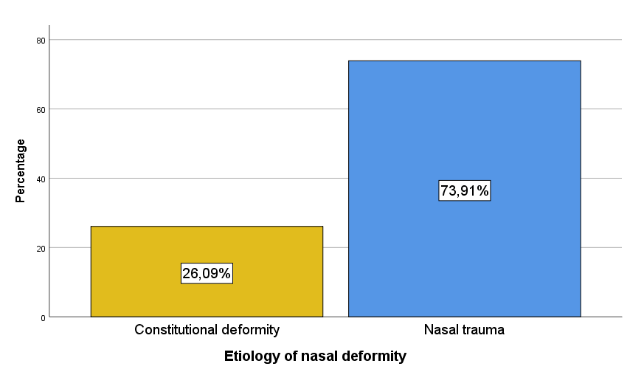
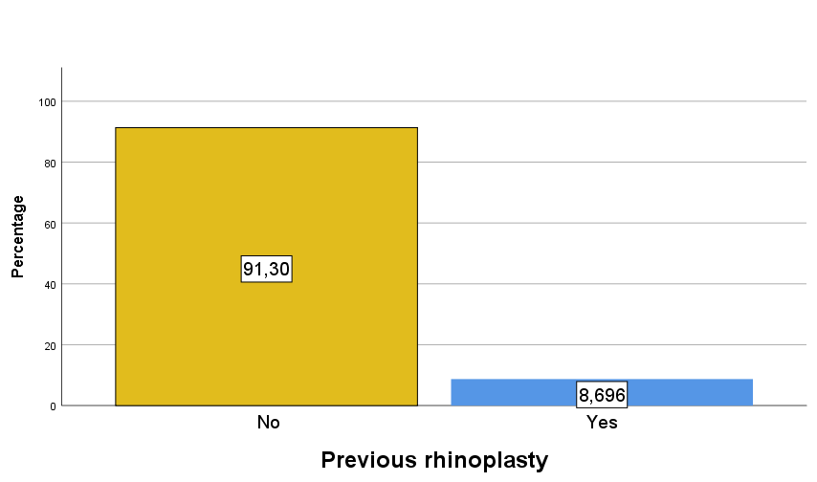
Figure 3 Distribution of patients according to the etiology of nasal deformity.
Figure 2 Distribution of patients with a previous rhinoplasty
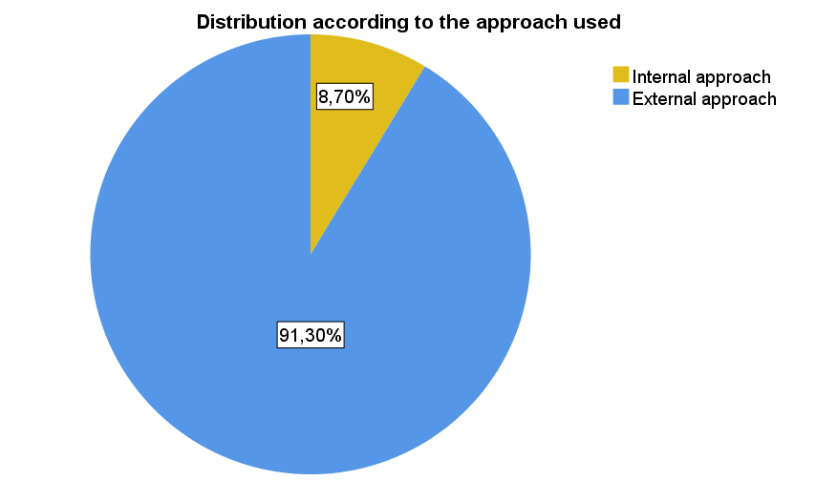
Surgical procedures The majority of patients 42 (91.3%) benefited from an external Rethi approach, 30 (65.2%) patients had a procedure on the nasal dorsum and the tip was harmonized in 42 patients (91.3%) (Figure 4).
Figure 4: Distribution of patients according to the approach used.

Residual anatomical/ aesthetic problems
The most common findings were a wide and deviated nasal ridge in 2 patients (4.3%), followed by a hooked nose in 1 patient (2.2%), and a step deformity in 1 patient (2.2%). Additionally, 1 patient (2.2%) presented with a bulbous and drooping nasal tip.
Despite these aesthetic concerns being identified during follow-up consultations, only a few patients requested further corrective procedures, demonstrating an overall satisfaction rate among the studied group.
Revision operations A surgical revision was required in 7 patients who underwent primary rhinoplasty, representing 15.2% of the cases. No surgical revisions were needed for patients who underwent secondary rhinoplasty.
Discussion
Among all aesthetic surgeries, rhinoplasty has the lowest satisfaction rate (1). In primary rhinoplasty, unsatisfactory results are found in 15 to 30% of cases (2). The dissatisfaction rate among patients after revision surgeries varies from 5 to 10% according to different series (3).In our series, the average score at 6 months or more postoperatively was 69.6, with a standard deviation of 18.6. (table 2)
Table 2 –Details of aesthetic surgeries

Authors | Sample size | ROE mean value |  | Range
Sena(4) | 107 | 81,9±17,1 |  | 25-100%
Faidiga(5) | 69 | 73,5 |  | 25-100%
Abbasset et al.(6) | 168 | 76,7±11,5
Our case series | 46 | 69,6±18,6 |  | 20,8-91,7%

Satisfaction Based on Patient-Related Criteria
Gender In our series, women were twice as satisfied as men. The study by Khansa showed a significantly higher satisfaction rate in women compared to men (87.6% vs. 56.1%, p < 0.001) (7). Similarly, Schwitzer et al. found statistically significant improvements in social confidence and psychological well-being in women, showing better quality of life after the surgery(8). In contrast, the Sena series (4) did not find a significant difference. Although the results of our study align with those of other published studies, the issue of gender in aesthetic surgery needs further investigation to provide a clearer explanation of the differences observed between men and women.
Age According to Schwitzer et al., patients over 35 years old were significantly less satisfied than those under 35 years old (8). This age difference aligns with the results of our study.
Education Level In Khan et al.'s study, the level of satisfaction was inversely proportional to the patients' understanding and knowledge of the surgical procedure. In their series, about 28 patients had a low literacy level (ninth grade and below), while 52 had a higher literacy level (postgraduate and above). The average postoperative score for patients with low literacy was 81.4 ± 4.6, compared to 72.5 ± 2.7 for those with a higher literacy level(7). However, our findings do not align with this study, as we observed lower satisfaction in patients with a lower education level.
Previous Rhinoplasty In our series, patients who underwent primary rhinoplasty were more satisfied than those who had secondary rhinoplasty, although this difference was not significant. Sena's series also did not find a significant difference (4). Dziewulski et al.'s study reported a lower revision rate after primary rhinoplasty (9). These results can be explained by several factors: technical difficulty due to potential lack of native tissue, changes in anatomical landmarks, fibrous remodelling of previously operated tissues, and the loss of skin elasticity due to repeated trauma. Additionally, the demands of patients requesting a correction of the final result may be higher than those of patients undergoing a first surgery.
Etiology of Nasal Deformity The study by Khansa et al. showed a higher satisfaction rate in patients who underwent post-traumatic rhinoplasty(10). Similarly, Dziewulski et al. reported a lower revision rate for post-traumatic noses(9). Our results align with these findings, as patients undergoing post-traumatic rhinoplasty were more satisfied than those with constitutional anomalies (53% vs. 11%, p = 0.379).
Healing Factors Despite the detrimental effects of smoking on skin texture and nasal breathing, Kotzampakis et al.'s study (11) found that smokers were more satisfied than non-smokers (84.5% vs. 79.5%, p = 0.26). Similarly, Andrews et al.'s study on 530 patients found no difference in complication and revision rates between smokers and non-smokers(12). In our series, smokers or immunocompromised patients were less satisfied than healthy non-smokers (70% vs. 30%, p = 0.082).
Respiratory Symptoms Erdogan's study on 50 patients who underwent aesthetic and functional rhinoplasty showed significant improvement in postoperative respiratory symptoms using the NOSE (Nasal Obstruction Symptoms Evaluation) questionnaire(13). Our results align with the literature, demonstrating a higher satisfaction rate among patients with nasal obstruction (48% vs. 16%, p = 0.720). However, the lack of a standardized questionnaire like NOSE for our patients limits the comparison of our results with those from other literature reviews.
Nature of the Request A Brazilian study including 60 patients who underwent rhinoplasty found a higher satisfaction rate in patients with purely aesthetic concerns (88.3%) compared to those with both aesthetic and functional issues (85.48%) (14). Similarly, Meningaud's study reported a non-significant improvement in the ROE score (p = 0.75), but a more significant improvement in aesthetic rhinoplasty compared to aesthetic and functional rhinoplasty(15). In our series, satisfaction was higher in patients with both aesthetic and functional requests (48% vs. 17%, p = 0.806).
Skin Thickness Skin thickness can be a major factor influencing rhinoplasty outcomes. However, few studies have addressed the impact of nasal skin thickness on aesthetic rhinoplasty results. A Korean study involving 77 patients who underwent CT scans to measure nasal skin thickness before undergoing tip rhinoplasty found that excellent results were attributed to the group with thin skin, while those with thick skin showed inadequate results(16). However, in our series, patients with medium skin thickness showed the highest percentage of satisfaction. This discrepancy may be explained by ethnic differences between the two populations studied. Another limitation of our study is the subjective evaluation of skin thickness, while more sophisticated methods, such as 20 MHz ultrasound or optical coherence tomography, could offer more precise assessments.
Satisfaction Based on Surgical Technique-Related Criteria ApproachUsed
A recent study by Gupta et al. included all published studies and trials comparing aesthetic and functional satisfaction between two groups of patients who underwent surgery through either an external or hidden approach(17). This study concluded that no definitive conclusion could be drawn as to whether one approach resulted in better aesthetic or functional outcomes. However, in our series, we observed higher satisfaction in patients who underwent surgery through the external approach (OR = 5.62).
Technique for Reducing the Bump Arslan et al.'s study, which included 68 patients who underwent dissection of the bony vault and separation of the upper lateral cartilages before bone and cartilage removal as a monoblock, revealed highly satisfactory results with no revisions(18). Camirand's study, conducted on a series of 50 patients, showed a low satisfaction rate in patients who had a bump reduction using a rasp. Our results align with the literature, as we found a significant difference between the group that had an osteocartilaginous bump reduction through osteotomy and the group that had a reduction using a rasp (48% vs. 2%, p = 0.021).
Type of Graft Lee et al. conducted a systematic review of the literature, including 74 articles on augmentation rhinoplasties(19). This study demonstrated that autologous cartilage grafts are the preferred method by most surgeons. According to the latest international consensus on aesthetic and functional rhinoplasty, septal cartilage is used in 95% of augmentation rhinoplasties due to its reliability and good results(20). For our patients, we used cartilage grafts in augmentation rhinoplasties, yielding a high satisfaction rate.
Conclusion:
The success of aesthetic rhinoplasty is directly linked to patient satisfaction, and invites a return to feeling. Evaluating and analyzing their satisfaction reflects the quality of our care, and enables us to modulate it as needed.

I hereby declare that this work is original and has not been submitted for publication or presented elsewhere. All sources and references used have been properly acknowledged.
Written consent of the patient has been collected and preserved by authors.
As per international standard or university standard written ethical approval has been collected and preserved by the author(s).
Authors have declared that no competing interests exist.

Disclaimer (Artificial intelligence)
Option 1:
Author(s) hereby declare that NO generative AI technologies such as Large Language Models (ChatGPT, COPILOT, etc.) and text-to-image generators have been used during the writing or editing of this manuscript.

REFERENCES
1. Freiberg A, Giguère D, Ross DC, Taylor JR, Bell T, Kerluke LD. Are Patients Satisfied with Results from Residents Performing Aesthetic Surgery?: Plast Reconstr Surg. déc 1997;100(7):1824‑31.
2. Guyuron B, Bokhari F. Patient satisfaction following rhinoplasty. Aesthetic Plast Surg. mars 1996;20(2):153‑7.
3. Foda HMT. External rhinoplasty: a critical analysis of 500 cases. J Laryngol Otol. juin 2003;117(6):473‑7.
4. Sena Esteves S, Gonçalves Ferreira M, Carvalho Almeida J, Abrunhosa J, Almeida E Sousa C. Evaluation of aesthetic and functional outcomes in rhinoplasty surgery: a prospective study. Braz J Otorhinolaryngol. sept 2017;83(5):552‑7.
5. Faidiga GB, Carenzi LR, Yassuda CC, Silveira F, Lago TD, Leite MGJ, et al. Avaliação tardia em rinoplastia estética em um centro acadêmico de referência. Braz J Otorhinolaryngol. août 2010;76(4):437‑41.
6. Abbas OL, Kurkcuoglu A, Aytop CD, Uysal C, Pelin C. Perception of Symmetry in Aesthetic Rhinoplasty Patients: Anthropometric, Demographic, and Psychological Analysis. Perception. oct 2017;46(10):1151‑70.
7. Khan N, Rashid M, Khan I, Ur Rehman Sarwar S, Ur Rashid H, Khurshid M, et al. Satisfaction in Patients After Rhinoplasty Using the Rhinoplasty Outcome Evaluation Questionnaire. Cureus. 11(7):e5283.
8. Schwitzer JA, Albino FP, Mathis RK, Scott AM, Gamble L, Baker SB. Assessing Demographic Differences in Patient-Perceived Improvement in Facial Appearance and Quality of Life Following Rhinoplasty. Aesthet Surg J. sept 2015;35(7):784‑93.
9. Dziewulski P, Dujon D, Spyriounis P, Griffiths RW, Shaw JD. A retrospective analysis of the results of 218 consecutive rhinoplasties. Br J Plast Surg. 1995;48(7):451‑4.
10. Khansa I, Khansa L, Pearson GD. Patient Satisfaction After Rhinoplasty: A Social Media Analysis. Aesthet Surg J. janv 2016;36(1):NP1‑5.
11. Kotzampasakis D, Mantalos P, Kotzampasakis S, Danias N, Nikolopoulos T. Assessment of Aesthetic Results of 100 Patients Who Underwent Rhinoplasty—Rhinoplasty Outcome Evaluation. Plast Reconstr Surg - Glob Open. sept 2017;5(9):e1404.
12. Andrews JE, Jones NN, Moody MP, Vincent AG, Teixeira JC, Thomas RF, et al. Nasoseptal Surgery Outcomes in Smokers and Nonsmokers. Facial Plast Surg Aesthetic Med. 1 août 2021;23(4):283‑8.
13. Erdogan BA, Avseren E, Paksoy M, Bora F, Altin G. Assessing quality of life in septorhinoplasty patients with two different instruments.
14. Zojaji R, Keshavarzmanesh M, Arshadi H, Farsi Baf M, Esmaeilzadeh S. Quality of Life in Patients Who Underwent Rhinoplasty. Facial Plast Surg. 14 nov 2014;30(05):593‑6.
15. Meningaud JP, Lantieri L, Bertrand JC. Rhinoplasty: An Outcome Research: Plast Reconstr Surg. janv 2008;121(1):251‑7.
16. Cho GS, Kim JH, Yeo N, Kim SH, Jang YJ. Nasal Skin Thickness Measured Using Computed Tomography and Its Effect on Tip Surgery Outcomes. Otolaryngol Neck Surg. avr 2011;144(4):522‑7.
17. Gupta R, John J, Ranganathan N, Stepanian R, Gupta M, Hart J, et al. Outcomes of Closed versus Open Rhinoplasty: A Systematic Review. Arch Plast Surg. sept 2022;49(05):569‑79.
18. Arslan E, Aksoy A. Upper Lateral Cartilage‐Sparing Component Dorsal Hump Reduction in Primary Rhinoplasty. The Laryngoscope. juin 2007;117(6):990‑6.
19. Lee MR, Unger JG, Rohrich RJ. Management of the Nasal Dorsum in Rhinoplasty: A Systematic Review of the Literature Regarding Technique, Outcomes, and Complications. Plast Reconstr Surg. nov 2011;128(5):538e‑50e.
20. Albert S, Simon F, Tasman AJ, Chua D, Grigg R, Jaklis A, et al. International consensus (ICON) on functional and aesthetic rhinoplasty. Eur Ann Otorhinolaryngol Head Neck Dis. févr 2018;135(1):S55‑7.

