# Case report

# A rare case of Entero-Enteric Intussusception Recurrence on lipoma

# Abstract :

Intestinal intussusception caused by a lipoma is a rare etiology of acute intestinal obstruction in adults. Lipomas are benign tumors composed of adipose tissue, they can induce intussusception, particularly when they reach a significant size. We report the case of a 49-year-old woman presenting with recurrent entero-enteric intussusception due to a small bowel lipoma, following a prior surgical intervention for an ileo-colic intussusception on lipoma. A CT scan revealed the invagination and a 21 mm lipoma inside it. Segmental resection was successfully performed, and the patient experienced a favorable postoperative course.The pathology examination of the resected specimen showed a 2.5 cm lipoma with safe margins.. A close fellow-up with medical consultation every three months is undergoing since one year, for detecting an eventual recurrency and haven’t show any anomaly yet.Recurrence of intestinal lipomas is common, particularly after incomplete resection or in cases of multiple lipomas, but the recurrence of intussusception is rare. Studies suggest that approximately 20% of intestinal lipomas may lead to obstruction, with larger lesions (>4 cm) being more likely to cause complications [1]. Regular monitoring through clinical examinations and imaging are essential for early detection of recurrences [2]. Optimal management relies on preventive surgery for large lipomas and a multidisciplinary approach [3]. Despite their benign nature, intestinal lipomas can lead to serious complications, necessitating careful medical follow-up.

Key words: Intestinal intussusception, lipoma, tumors, Entero-Enteric Intussusception

Introduction :

Small bowel intussusception is an uncommon condition, accounting for approximately 1% of acute intestinal obstructions in adults [4]. It can be caused by benign or malignant tumors, foreign bodies, or Meckel’s diverticulum. Although pedunculated small bowel lipomas are benign, they can lead to acute obstruction, recurrent abdominal pain, and, in some cases, ischemia, which may threaten the patient’s prognosis [1] . Studies indicate that intestinal lipomas account for 4% of all benign tumors of the intestine and are more commonly found in the colon than in the small intestine [5]. While often asymptomatic, their size can precipitate severe complications [5]. Intestinal lipomas have a tendency to recur, particularly after incomplete resection or in patients with multiple lipomas. Regular medical surveillance, including clinical examinations and imaging studies, is crucial for early detection of recurrences. The management of intestinal lipomas involves surgical intervention for symptomatic cases and continuous monitoring for asymptomatic lesions.

# Case Presentation:

A 49-year-old woman, who had undergone surgery for ileo-colic intussusception secondary to a lipoma three years prior the pathology examination of the resected specimen showed a 2cm lipoma with safe margins, presented with a recurrence. She was admitted to the emergency department with complaints of abdominal pain, nausea, and vomiting persisting for 15 days. Physical examination revealed non-distended abdomen with no palpable masses and no tenderness . A CT scan showed a 14.5 cm ileo-ileal intussusception with thickening of the invaginated bowel loop. A 21 mm nodular mass, consistent with a lipoma, was identified inside the intussusception (Figure 1).

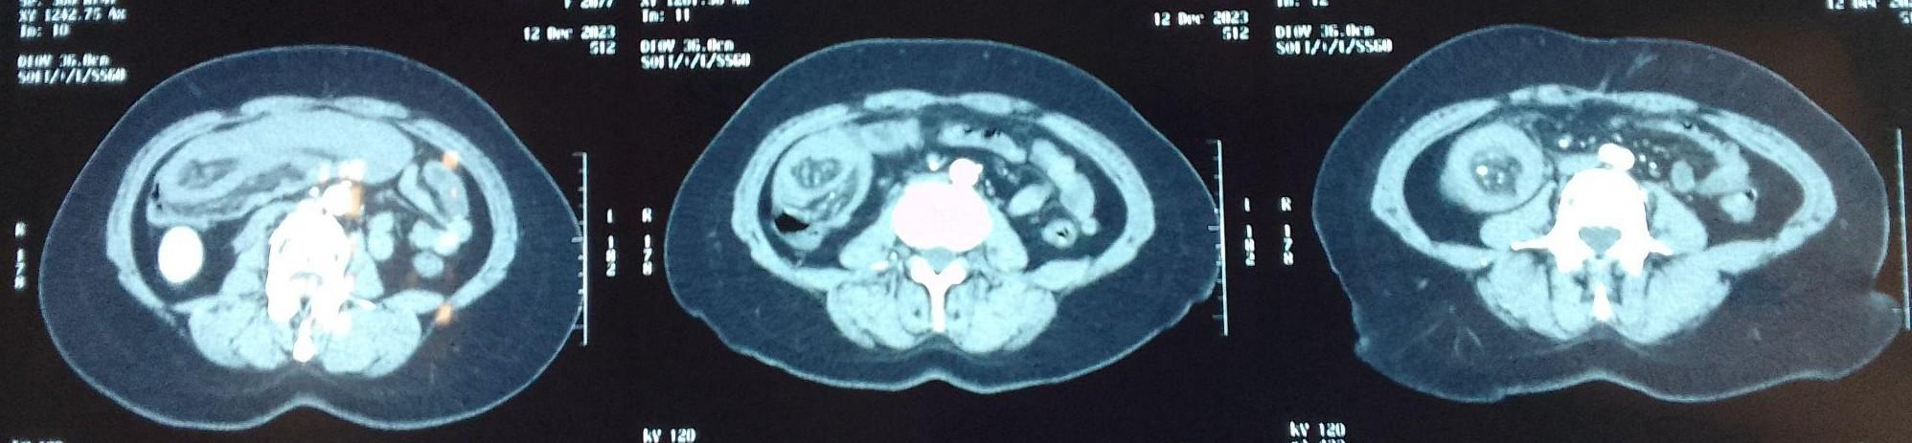

***Figure 1****: CT scan image of ileal intussusception on lipoma with the hot-dog sign.*

Emergency surgical intervention was performed, the surgical exploration found the intussuscepted bowel without sign of ischemia and without distended bowels (Figure 2) , the intervention was a segmental resection of the affected small bowel with end-to- end anastomosis. The pathology examination of the resected specimen showed a 2.5 cm lipoma with safe margins. The postoperative course was uneventful, and the patient was discharged after five days of recovery. A close fellow-up with medical consultation every three months is undergoing since one year, for detecting an eventual recurrency and haven’t show any anomaly yet.

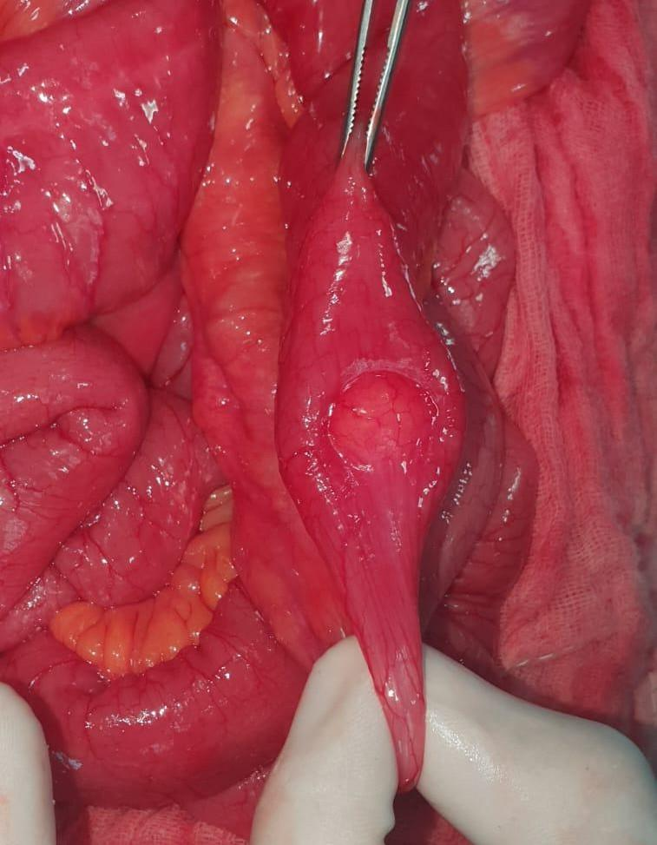

***Figure 2:*** *Intraoperative image of the ileal lipoma responsible for the intussusception.*

# Discussion :

Intussusception result of the telescoping of a segment of bowel into an adjacent segment, causing an obstruction, inflammation, ischemia and necrosis of both segments. Although intussusception is the leading cause of intestinal obstruction in children, it is relatively rare after childhood, accounting for less than 5% of bowel obstruction in adults [6]. Intussusception is found in 1 % of adult patients with occlusive syndrome, the average age of affected individuals is 50 years, and the male/female ratio is 1:5.The main cause of intestinal intussusception is tumors [7]

CT remains the gold standard for diagnosis, as it enables accurate localization of the intussusception and identification of lipomas [6]. CT imaging, having a high sensitivity and specificity for showing the intussusception presenting the typical image known as the “target sign” or “sign of donut”.[8]. In our case the CT scan was a rapid test that permitted the diagnostic.

This case underscores several critical aspects of the management of intestinal intussusception caused by a lipoma. It is essential to consider common causes when evaluating acute abdominal pain, particularly in patients with a history of benign tumors.

Studies have shown that lipomas smaller than 2 cm are less likely to cause intussusception, while those exceeding 4 cm present a higher risk of obstruction and require surgical intervention [5].

Preventing recurrence of intestinal lipomas is challenging. While no definitive method exists to eliminate the risk of recurrence, periodic clinical monitoring and regular imaging are vital. Studies indicate that recurrence rates of intestinal lipomas post-resection range from 10% to 15%, particularly in cases of incomplete excision or multiple lesions [8]. Surgical treatment, particularly segmental resection, remains the preferred therapeutic approach for addressing intussusception and restoring intestinal continuity [9]. Considering the high rate of primary adenocarcinoma, intestinal intussusception should be resected en bloc without reduction to avoid potential intraluminal seeding or venous tumor dissemination.[10]

The decision to operate should consider the lipoma’s location and the patient’s overall clinical status. Long-term follow-up is necessary to identify potential recurrences or postoperative complications, such as intestinal stenosis or fistula formation [11]. Further research is warranted to elucidate risk factors and refine management strategies for this rare condition [10].

# Conclusion :

This case highlights the importance of clinical vigilance in managing this rare form of intestinal intussusception, frequently caused by a lipoma. It underscores the necessity of a multidisciplinary approach involving gastroenterologists, radiologists, and surgeons to optimize treatment outcomes. Long-term follow-up is imperative for preventing recurrence and managing potential complications. Additional research is crucial to enhance our understanding of this condition, identify risk factors, and improve treatment protocols.

**CONSENT**

As per international standards or university standards, patient(s) written consent

has been collected and preserved by the author(s).

**ETHICAL APPROVAL**

Authors declare that the ethical approval has been exempted by my establishment

**DISCLAIMER (Artificial Intelligence)**

Author(s) hereby declare that NO generative AI technologies such as Large Language Models

and text-to-image generators have been used during writing or editing of manuscripts.

# References

1.Álvarez-Bautista F. E., Moctezuma-Velázquez P., Cisneros-Correa J. C., Aguilar-Frasco J. L., Vélez-Valle, A., Vergara-Fernández, O., & Salgado-Nesme, N. (2021). Colonic lipomas an uncommon cause of intussusception in adult patients: report of three cases and literature review. Cirugía y Cirujanos, 89(1), 9–14. <https://doi.org/10.24875/CIRU.20000622>

2.Manouras A., Lagoudianakis E., Dardamanis D., *et al.* Lipoma induced jejunojejunal intussusception. *World journal of gastroenterology: WJG*, 2007, vol. 13, no 26, p. 3641.

3. Amirhom E., Dondapati M., Horton N., & Pescovitz A. R. (2022). Large colonic lipoma as a lead point for intussusception in an adult. Journal of Surgical Case Reports, 2022(7), rjac327. <https://doi.org/10.1093/jscr/rjac327>

4. Brandt, E. J., & Bower C. E. (2021). Submucosal Sigmoid Lipoma Acting as Unusual Lead Point of Colocolic Intussusception. ACS Case Reviews in Surgery, 3(4). <https://doi.org/10.1093/acscr/>

5.Hu Q., Wu J., & Sun Y. (2022). Intussusception Related to Small Intestinal Lipomas: A Case Report and Review of the Literature. Frontiers in Surgery, 9, 915114. <https://doi.org/10.3389/fsurg.2022.915114>

6. Ozen O., Guler, Y., & Yuksel Y. (2019). Giant colonic lipoma causing intussusception: CT scan and clinical findings. Pan African Medical Journal,2019, 32, 27.

7 Lu T. & Chng Y. (2015) Adult intussusception. *The Permanente Journal*, 2015, vol. 19, no 1, p. 79.

8. Menegon T., Urraro F., Sciaudone G., Bagaglini G., Pagliuca F., Reginelli A., et al. (2021) Colonic Lipoma Causing Bowel Intussusception: An Up-to-Date Systematic Review. J Clin Med. 2021 Nov 2;10(21):5149. doi: 10.3390/jcm10215149

9. Amirhom  E., Dondapati M., Horton N., *et al* (2022)*.* Large colonic lipoma as a lead point for intussusception in an adult. *Journal of Surgical Case Reports*, 2022, vol. 2022, no 7, p. rjac327.

10. Hong K.D., Kim J., Ji W., *et al.* (2019) Adult intussusception: a systematic review and meta-analysis. *Techniques in coloproctology*, 2019, vol. 23, p. 315-324.

11. Álvarez-Bautista F. E., Moctezuma-Velázquez P. *et al.* Adult intussusception: still a challenging diagnosis for the surgeon. *Revista de Gastroenterología de México (English Edition)*, 2023, vol. 88, no 4, p. 315-321.