**PRIMARY MESENTERIC NEUROENDOCRINE TUMOR: A RARE CASE OF AGGRESSIVE PROGRESSION**

**ABSTRACT**

Mesenteric neuroendocrine tumors (NETs) are generally secondary localizations of small intestine tumors. However, primary mesenteric forms are rare.

We report the case of a 75-year-old patient who had been experiencing cholestatic jaundice for a month, along with epigastric pain. Initial imaging revealed a pancreatic neoplasm located at the uncinate process, with dilation of the common bile duct and the Wirsung duct. However, endoscopic ultrasound rather suggested early-stage chronic pancreatitis, without an identifiable mass.

Abdominal MRI revealed a 55 × 33 mm mesenteric lesion with spiculated and retractile borders, encasing the superior mesenteric vessels and distant from the pancreatic uncinate process. Its radiological characteristics were suggestive of a mesenteric carcinoid tumor. Suspected metastatic liver nodules, retroperitoneal lymphadenopathy, and pancreatic atrophy with mild ductal dilation were also present.

Laparotomy revealed a 10 cm mesenteric mass infiltrating the mesenteric vessels, making surgical resection impossible. No primary tumor of the small intestine or pancreas was identified. Histological analysis confirmed a well-differentiated grade 1 neuroendocrine tumor, with a proliferation index <1% and strong diffuse expression of chromogranin A, synaptophysin, and cytokeratin AE1/AE3.

The patient’s case was discussed in a multidisciplinary board meeting, in which chemotherapy was decided and initiated.

Despite this low proliferation index, the tumor progressed aggressively, with liver, lymph node, and pleural metastasis, as well as peritoneal carcinomatosis. This case highlights the occasionally aggressive evolutionary potential of primary mesenteric neuroendocrine tumors, even of low grade.

*Keywords:* mesenteric neuroendocrine, tumor, chronic pancreatitis, chemotherapy

1. **INTRODUCTION**

Neuroendocrine tumors (NETs) are a group of neoplasms arising from neuroendocrine cells and expressing neuronal markers such as synaptophysin or chromogranin A. They are primarily located in the gastrointestinal tract. Their presentation in the mesentery is rare, particularly in the absence of another primary lesion suggesting a metastatic origin.

Here, we report a case of a well-differentiated grade 1 primary mesenteric neuroendocrine tumor with aggressive behavior and review the literature on this entity.

1. **CASE PRESENTATION**

The patient was a 75-year-old man with a history of hypertension and inguinal hernia repair who had been presenting with generalized cholestatic jaundice for one month, associated with epigastric pain relieved by self-induced vomiting. There were no pruritus, neurological symptoms, gastrointestinal bleeding, nor bowel changes. His condition progressed in an afebrile context with general deterioration, including fatigue and weight loss.

Physical examination revealed generalized jaundice and epigastric tenderness, with no palpable mass.

An initial abdominal CT scan suggested a pancreatic neoplasm at the uncinate process, with dilation of the common bile duct (CBD) and Wirsung duct. To obtain histological confirmation, an endoscopic ultrasound was performed, which revealed findings suggestive of early-stage chronic pancreatitis, without an identifiable mass.

Abdominal MRI revealed a 55 × 33 mm mesenteric lesion with spiculated and retractile borders, showing finger-like extensions into the mesenteric fat. The lesion appeared hypointense on T1-weighted images, slightly heterogeneous hyperintense on T2-weighted images, and hyperintense on diffusion-weighted imaging, with contrast enhancement after gadolinium injection. It circumferentially involved the superior mesenteric artery and vein, and its upper pole was distant from the pancreatic uncinate process. These features suggested a mesenteric carcinoid tumor (Fig. 1).

Additionally, four hepatic nodules suspected of being metastasis and retroperitoneal lymphadenopathy measuring 7, 8, 12, and 20 mm in the largest dimension were present. The pancreas exhibited heterogeneous atrophy of the head and tail, with mild dilation of the Wirsung duct and secondary ducts. The common bile duct was slightly dilated, with no visible obstruction, and the pancreatic head appeared hypertrophied. Diffusion-weighted imaging findings were consistent with an acute pancreatitis flare-up on a background of chronic pancreatitis. No intraperitoneal fluid collection was observed.

Laparotomy revealed a 10 cm mesenteric tumor fixed to the posterior plane and encasing the mesenteric vessels, along with a dilation of the CBD to 12 mm. No small bowel or pancreatic tumor, visible hepatic nodules, peritoneal carcinomatosis, or ascites were identified intraoperatively. Due to the tumor’s size and vascular involvement, surgical resection was not feasible. A tumor biopsy was performed, along with a side-to-side choledochoduodenostomy.

Histopathological examination of paraffin-embedded sections revealed an organoid tumor proliferation within a fibrous stroma. Tumor cells were medium-sized, with monomorphic nuclei, "salt-and-pepper" chromatin, and eosinophilic cytoplasm. No mitosis was observed. The tumor stroma was fibroinflammatory (Fig. 2).

Immunohistochemical analysis showed strong and diffuse expression of chromogranin A, synaptophysin, and cytokeratin AE1/AE3. The proliferation index was <1%. The diagnosis was a well-differentiated grade 1 neuroendocrine tumor (Fig. 3).

The patient’s case was discussed in a multidisciplinary board meeting, in which a chemotherapy was decided and initiated. Three months later, follow-up thoraco-abdominopelvic CT scan revealed, in addition to previously known lesions, the appearance of a large-volume intraperitoneal effusion, associated with nodular and flame-shaped mesenteric fat infiltration, indicative of peritoneal carcinomatosis (Fig. 4). A small left pleural effusion with suspicious adjacent pleural thickening was also noted.

Thus, we concluded that this was a primary mesenteric neuroendocrine tumor with a low proliferation index, characteristic of grade 1 NETs, but exhibiting aggressive clinical behavior, with liver, lymph nodes, and pleural metastasis, as well as peritoneal carcinomatosis.

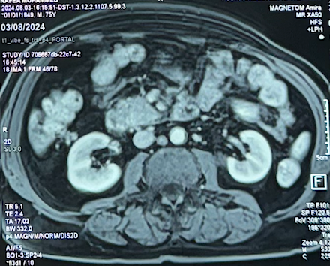

Figure 1: Magnetic resonance imaging showing the mesenteric tumour

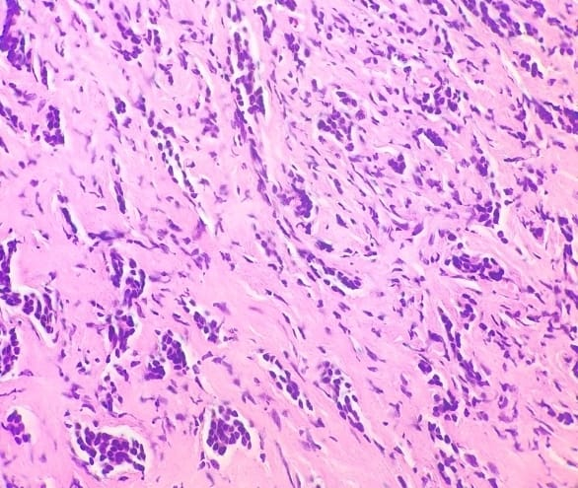

*Figure 2: tumour proliferation organised into clusters and strands (H&E, x200)*

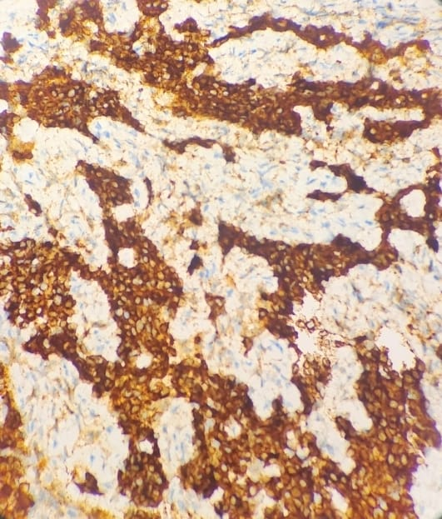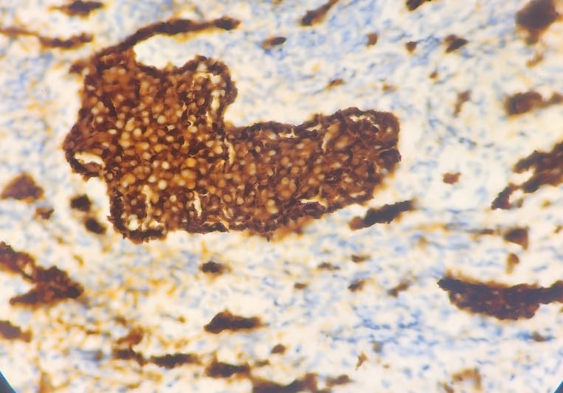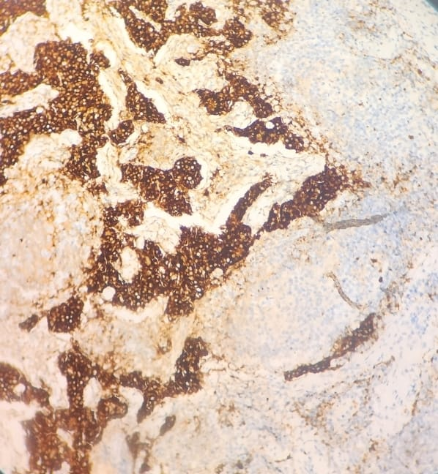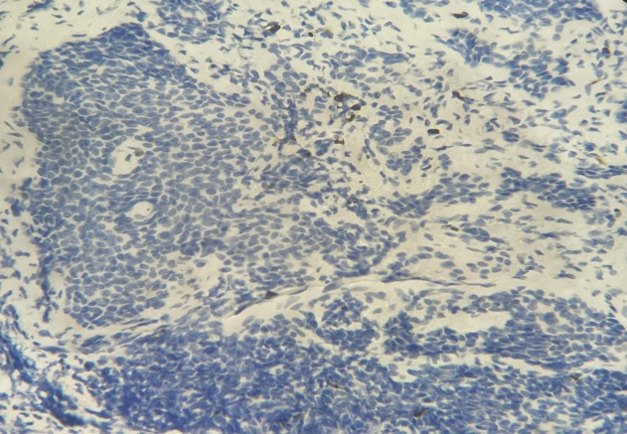

(b)

(a)

(d)

(c)

*Figure 3: Immunohistochemistry showing positive expression of pancytokeratin AE1/AE3 (a), synaptophysin (b), chromogranin A (c) and Ki67 estimated at 1% (d).*

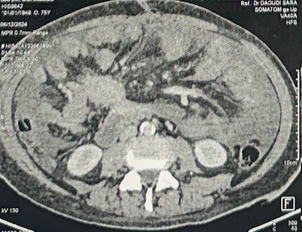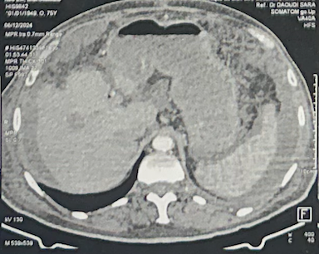

*Figure 4: CT scan three months later showing: (arrow) mesenteric tumour, (star) peritoneal carcinosis, (sun) liver nodule.*

1. **DISCUSSION**

Neuroendocrine neoplasms (NENs) are rare tumors whose incidence and prevalence are increasing worldwide (1). They represent approximately 2% of gastrointestinal tumors, according to the 2022 WHO classification, into well-differentiated neuroendocrine tumors (NETs) and poorly differentiated neuroendocrine carcinomas (NECs). This classification is based on the Ki-67 index, a key prognostic marker, and divides NENs into NET G1, G2, G3, and NEC G3. NECs are highly aggressive, whereas NET G1 tumors are generally indolent, with 2- and 5-year survival rates reaching 100% and 85%, respectively (2,3,4).

However, although NET G1 tumors are considered to have low aggressiveness, some studies suggest that they can, in certain cases, progress unexpectedly. Yamaguchi T. et al. reported metastasis even in patients with NET G1, primarily in the liver, lungs, and lymph nodes, despite a Ki-67 index ≤ 2% (5).

NETs are mainly located in the gastrointestinal tract, particularly in the small intestine, rectum, and appendix (6,7). Mesenteric NETs are most often secondary metastases from a primary tumor in the small intestine, whereas primary mesenteric NETs are an exceptionally rare entity (8).

Most mesenteric NETs are discovered accidentally and may present with small bowel obstruction, abdominal pain, or a palpable mass (9). The classic carcinoid syndrome is sometimes associated with sweating, flushing, and palpitations (10). However, some case reports have described carcinoid syndromes with unusual manifestations, such as skin rashes, diarrheal episodes, or liver metastasis (11,12,13). More rarely, endocrine syndromes, including ectopic Cushing syndrome, have been reported (14). However, these symptoms may be absent if the tumor is non-secreting or if the secreted substances are metabolized by the liver. Consequently, the majority of mesenteric NETs are already metastatic at the time of diagnosis (15).

To date, only 11 cases of primary mesenteric NETs have been reported in the literature (16–26) (Table 1). These cases involved patients with a median age of 61.3 years (48–74 years), with a slight female predominance. The tumors were located in the mesentery of the jejunum or ileum. Treatment primarly relies on surgical resection, which can be curative if complete excision (R0) is achieved.

| **Author** | **Year** | **Age/Sex** | **Location** | **Size (mm)** | **Grade** | **Surgery** |
| --- | --- | --- | --- | --- | --- | --- |
| Barnard | 1984 | 74/M | Ileum | 60 x 55 | NA | Ileal resection |
| Stone | 1993 | 48/F | Jejunum | 40 x 32 | NA | Tumor resection |
| Tsubaki | 2003 | 73/F | Ileum | 45 x 35 | NA | Tumor resection |
| Yamanuha | 2009 | 52/M | Ileum | 20 x 20 | NA | Ileal resection |
| Park | 2013 | 73/F | Jejunum | 82 x 73 | G1 | Tumor resection |
| Sakal | 2013 | 56/F | Ileum | 40 x 35 | G1 | Tumor resection |
| Jida | 2014 | 59/M | Jejunum | 77 x 77 | G1 | Jejunal resection |
| Ikenaga | 2014 | 59/F | Jejunum | 24 x 20 | G1 | Jejunal resection |
| Yasuda | 2017 | 72/M | Jejunum | 40 x 40 | G1 | Tumor resection |
| Tsuji | 2019 | 56/F | Duodenum | 16 x 16 | G2 | Laparoscopic tumor resection |
| Morishita | 2020 | 55/M | Ileum | 55 x 33 | G2 | Ileal resection |

**NA: Not available**

*Table 1: Resected cases of primary mesenteric NETs*

In our case, we diagnosed a well-differentiated grade 1 (G1) primary mesenteric neuroendocrine tumor, with no detectable lesion in the small intestine despite extensive investigations. Although NET G1 tumors are generally considered to be of low aggressiveness, our case stands out due to its atypical clinical behavior. Despite histological features indicating low aggressiveness (Ki-67 < 1%, absence of mitoses), the tumor exhibited aggressive progression, with lymphatic and liver metastases, vascular involvement, and, most notably, peritoneal carcinomatosis developing within only three months. These factors made curative surgical resection impossible.

1. **CONCLUSION**

This case highlights two key aspects: the rarity of primary mesenteric NETs and their potential for aggressive behavior, even in well-differentiated grade 1 tumors. It underestimates the necessity of rigorous follow-up, even for tumors traditionally considered indolent. These observations further emphasize the importance of a multidisciplinary approach to optimize patient management and monitoring.

**CONSENT**

As per international standards or university standards, patient(s) written consent has been collected and preserved by the author(s).

**ETHICAL APPROVAL**

As per international standards or university standards written ethical approval has been collected and preserved by the author(s).

**Disclaimer (Artificial intelligence)**

Author(s) hereby declare that NO generative AI technologies such as Large Language Models (ChatGPT, COPILOT, etc.) and text-to-image generators have been used during the writing or editing of this manuscript.

**REFERENCES:**

1. Morishita S, Yoshida S, Kamatani Y, Suzuhigashi S, Kitou M, Nasu T. Primary grade 2 neuroendocrine tumor of the ileal mesentery: a case report. *Surg Case Rep*. (2022) 8:146. doi: 10.1186/s40792-022-01482-x
2. Klimstra DS, Modlin IR, Coppola D, Lloyd RV, Suster S. The pathologic classification of neuroendocrine tumours: a review of nomenclature, grading, and staging systems. Pancreas. 2010;39(6):707–12
3. Elias D, Lefevre JH, Duvillard P, Goéré D, Dromain C, Dumont F, et al. Hepatic metastases from neuroendocrine tumours with a “thin slice” pathological examination: they are many more than you think. Ann Surg. 2010;251(2):307–10
4. Strosberg J, Nasir A, Coppola D, Wick M, Kvols L. Correlation between grade and prognosis in metastatic gastroenteropancreatic neuroendocrine tumours. Hum Pathol. 2009;40(9):1262–8
5. Yamaguchi T, Fujimori T, Tomita S, Ichikawa K, Mitomi H, Ohno K, et al. Clinical validation of the gastrointestinal NET grading system: Ki67 index criteria of the WHO 2010 classification is appropriate to predict metastasis or recurrence. Diagn Pathol. 2013;8:65
6. Pelage JP, Soyer P, Boudiaf M, et al. Carcinoid tumors of the abdomen: CT features. Abdom Imaging. 1999;24:240–5
7. Modlin IM, Kidd M, Latich I, et al. Current status of gastrointestinal carcinoids. Gastroenterology. 2005;128:1717–51
8. Sheth S, Horton KM, Garland MR, et al. Mesenteric neoplasms: CT appearances of primary and secondary tumors and differential diagnosis. Radiographics. 2003;23:457–73
9. Park IS, Kye BH, Kim HS, et al. Primary mesenteric carcinoid tumor. J Korean Surg Soc 2013; 84: 114–117
10. Karahan OI, Kahriman G, Yikilmaz A, et al. Gastrointestinal carcinoid tumors in rare locations: imaging findings. Clin Imaging 2006; 30: 278–282
11. Shogbesan O, Abdulkareem A, Pappachen B, Altomare J. Primary mesenteric carcinoid tumor presenting with carcinoid syndrome. *Case Rep Gastroenterol*. (2018) 12:396–401. doi: 10.1159/000490522
12. Agarwal A, Kaman L, Gupta A, Ramavath K, Vaiphei K. Primary mesenteric neuroendocrine tumour with liver metastasis: a common presentation of an uncommon tumour. *Trop Doct*. (2020) 50:65–8. doi: 10.1177/0049475519887657
13. Juanmartiñena Fernández JF, Fernández Urién I, Amat Villegas I, Prieto Martínez C. Liver metastasis secondary to primary mesenteric carcinoid. *Rev Esp Enferm Dig*. (2017) 109:211–2. PMID: 28256142
14. Mashoori N, Rabani A, Kazemeini A. Ectopic cushing’s syndrome due to a mesenteric neuroendocrine tumour. *Annals*. (2012) 94:e20–2. doi: 10.1308/003588412X13373405387492
15. Karahan OI, Kahriman G, Yikilmaz A, et al. Gastrointestinal carcinoid tumors in rare locations: imaging findings. Clin Imaging 2006; 30: 278–282
16. Park IS, Kye BH, Kim HS, Kim HJ, Cho HM, Yoo C, et al. Primary mesenteric carcinoid tumor. J Korean Surg Soc. 2013;84:114–7
17. Barnardo DE, Stavrou M, Bourne R, Bogomoletz WV. Primary carcinoid tumor of the mesentery. Hum Pathol. 1984;15:796–8.
18. Tsubaki MKH, Yamanaka M, Matsuoka K. A case of primary carcinoid tumor of the mesentery. J Jpn Surg Assoc. 2003;64:2613–7
19. Stone NN, Atlas I, Kim US, Kwan D, Leventhal I, Waxman JS. Renal angio- myolipoma associated with neurofibromatosis and primary carcinoid of mesentery. Urology. 1993;41:66–71
20. Yamanuha J, Ballinger R, Coon D, Navin J. Carcinoid tumor presenting as a primary mesenteric mass: a case report and review of the literature. Hawaii Med J. 2009;68:137–9
21. Sakai NIF, Seki M, Itoh H, Suwa T, Miyazaki M. A case of neuroendocrine tumor originating from the mesentery of the jejunum. J Jpn Surg Assoc. 2013;74:1899–903
22. Jida MTN, Ohashi R. A case of resected primary jejunal mesenteric carcinoid tumor. J Jpn Surg Assoc. 2014;75:467–72
23. kenaga M, Kim H, Matsuura Y, Hitora T, Hirota M, Murakami M, et al. A case of mesenteric carcinoid tumor (Neuroendocrine tumor: NET G1) with liver metastasis, coexisted with rectal cancer. J Jpn Coll Surg. 2014;39:971–8
24. Yasuda A, Kitagami H, Kondo Y, Nonoyama K, Watanabe K, Fujihata S,  
    et al. Primary mesenteric neuroendocrine tumor that changed its internal composition from cystic to solid: a case report. Clin J Gastroenterol. 2017;10:18–22
25. Tsuji A, Tomiyasu T, Kuramoto K, Iizaka M, Inomata Y, Baba H. Laparoscopic resection of a neuroendocrine tumor arising from the mesentery: a case report. J Jpn Surg Assoc. 2019;80:1152–7
26. Morishita et al. Surgical Case Reports (2022) 8:146 <https://doi.org/10.1186/s40792-022-01482-x> Primary grade 2 neuroendocrine tumor of the ileal mesentery: a case report