**A clinical case study on scarf pin ingestion: Diagnosis and Treatment**

**ABSTRACT**

Background: Foreign body ingestion, whether accidental or intentional, is a common occurrence and the second most frequent indication for emergency endoscopy. Symptoms can vary significantly depending on the patient, the type of foreign body, and its location, ranging from no clinical signs to severe and potentially life-threatening complications. However, another type of accidental ingestion—scarf pin ingestion—has been increasingly reported among young Muslim girls, drawing growing attention.

Patients and Methods: A retrospective study was conducted, including four patients who were admitted to the emergency department after swallowing a scarf pin.

Results: Four veiled young women were admitted to the emergency department after accidentally swallowing a pin they had been holding between their lips while adjusting their veils. Plain abdominal radiographs taken at admission revealed a needle-shaped metallic shadow in the gastric region in all patients. Endoscopic extraction was successfully performed in all cases. Follow-up endoscopy confirmed the absence of mucosal lacerations in the esophagus or stomach, allowing all patients to be discharged the same day.

Conclusion: Although this accident can be prevented, increasing public awareness of its potential complications is essential to reducing its occurrence.

***Keywords:***scarf pin ingestion**,** endoscopy, hijabi women, Diagnosis and Treatment

1. **INTRODUCTION**

Foreign body ingestion primarily results from the accidental swallowing of objects. While the exact frequency of this phenomenon is unknown, most cases occur in children, with the highest incidence between 6 months and 6 years [1]. In healthy adults, this type of incident is more common in individuals with psychiatric disorders, developmental delays, or those under the influence of alcohol. However, another type of accidental ingestion is becoming more significant, notably scarf pins, reported among young Muslim girls who hold them between their lips or teeth while adjusting their headscarves. The hijab pin is a pointed metal object about 3 cm long with a small plastic ball at one end (Fig. 1). Due to the sharp tip and length of the pin, this ingestion poses a particularly high risk of perforation, aspiration, or bleeding.  
We report the cases of four young women who accidentally swallowed a hijab pin and review the literature on this topic.

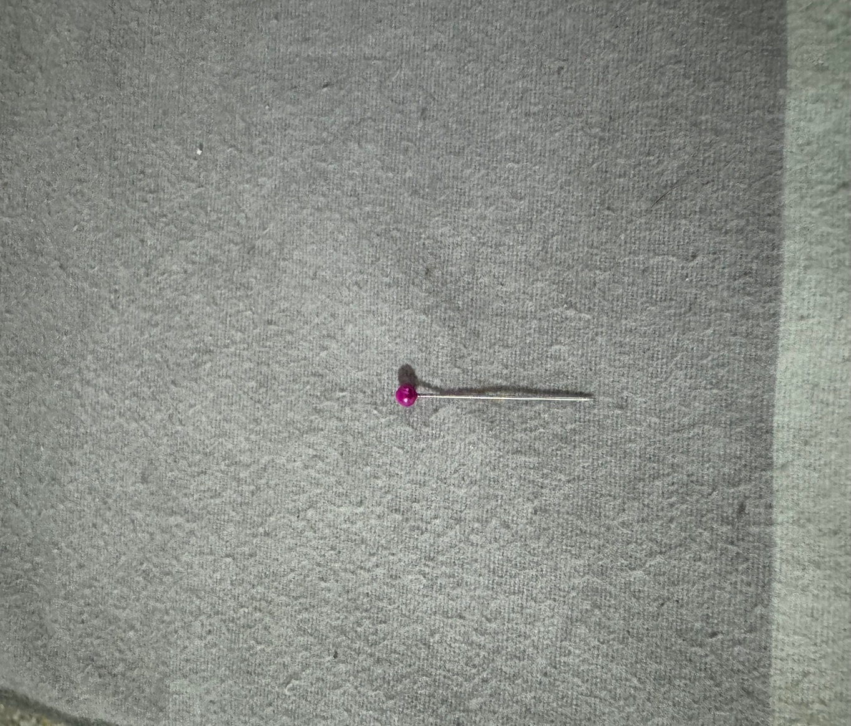

Figure 1: A hijab pin ∼3 cm in length with a plastic ball head.

1. **CASES PRESENTATION**

Four patients were admitted to the emergency department after accidentally swallowing a scarf pin. These pins are used to secure the hijab, a religious veil worn by Muslim women that covers the hair and neck. The patients, young Muslim women aged 18 to 20, explained that they usually held the pin between their teeth while adjusting their hijab. One of them mentioned holding the pin between her lips when she accidentally coughed while arranging her veil. Each patient had swallowed a single pin. The average consultation delay was three days, ranging from two to seven days. They had no significant medical history and were all asymptomatic, except for one who reported cervical discomfort when swallowing. Upon arrival, vital signs were normal, and clinical examination revealed no abnormalities.  
Plain abdominal radiographs taken at admission showed a needle-shaped metallic shadow in the area corresponding to the gastric region in all patients (Fig. 2).

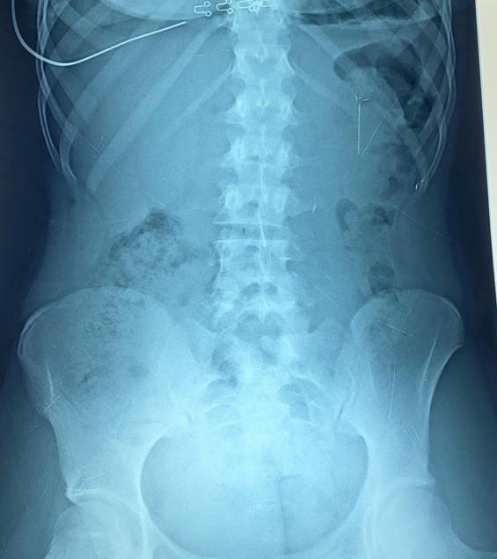

Figure 2 : An unprepared abdominal film showing a needle in an intragastric position.

One patient also underwent an abdominal CT scan, revealing a 23 mm linear foreign body in the antrum-pyloric region without detectable complications (Fig. 3).

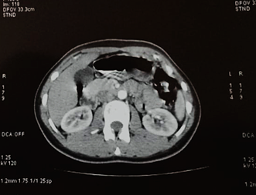

Figure 3 : A CT scan showing the presence of a linear foreign body in the antropyloric region.

Emergency esophagogastroduodenoscopy was performed under sedation for all patients. The scarf pins were located in the antral region in three patients, with one pin embedded (Fig. 4), and in the duodenal region in the fourth patient. No severe mucosal lesions were observed in the esophagus or stomach. Endoscopic extraction was performed using a polypectomy snare in one case (Fig. 5), a crocodile snare in another, and a rat-tooth snare in two cases. A follow-up endoscopy confirmed the absence of mucosal lacerations in the esophagus or stomach, allowing all patients to be discharged the same day.

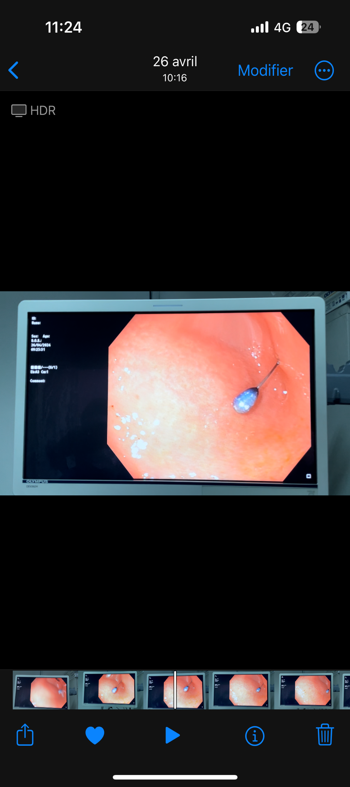

Figure 4: Pin embedded in the antrum.

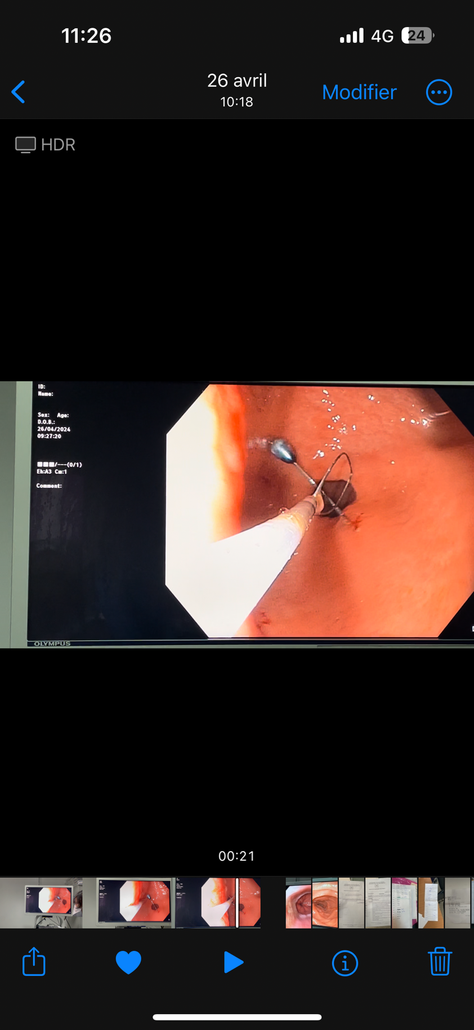

*Figure 5: Successful extraction of the needle using the polypectomy loop.*

1. **DISCUSSION**

Accidental scarf pin ingestion, though rare, is relatively common among young Muslim women, with most reported cases occurring in the 11 to 20 age group [2,3,4]. This situation often arises from the habit of holding pins between their teeth or lips while adjusting their hijab. It requires particular attention due to the risk of severe complications. These pins, classified as sharp foreign bodies, are particularly concerning due to the increased risk of intestinal perforation (15 to 35% of cases). Their impaction in the intestinal tract can cause local inflammation, leading to bleeding, obstructions, or erosions [2,5]. Rare complications, such as foreign body migration into the mediastinum and thorax, have also been reported [5]. The risk of complications is higher in patients with adhesions from previous abdominal surgery or pre-existing intestinal diseases, such as Crohn's disease [2].  
The removal of these foreign bodies is prioritized when they are located in the esophagus or stomach [6]. It is recommended to extract them as soon as possible to limit complications. If extraction fails, daily clinical monitoring and follow-up radiographs are necessary. Surgical intervention is considered if the object has not progressed within three days of ingestion [7]. Although some cases report spontaneous passage of sharp foreign bodies in adults [8], many severe complications have been observed, such as perforated appendicitis, transluminal migration into the peritoneum, liver abscesses, or colon and small intestine perforations [9,10]. An Indian study on 75 young Muslim girls who accidentally ingested a scarf pin showed a successful recovery by esophagogastroduodenoscopy in 48% of patients, while the others were treated conservatively. However, 2.6% of patients developed peritonitis requiring laparotomy, and one patient died [2].  
The study by Yogev et al. also demonstrated associated risks, with 208 patients having swallowed a hijab pin. Although the risk of catastrophic sequelae is low, it becomes significant if the pin remains impacted for several months [11]. Patients who recently ingested a pin or did so in the past few months should undergo a CT scan to rule out any infectious or mechanical risks [12].

The American Society for Gastrointestinal Endoscopy (ASGE) recommends urgent endoscopic extraction of foreign bodies that remain in the esophagus [13]. Once the object reaches the stomach, there is a limited window for endoscopic removal, as most foreign bodies are expelled within 4 to 6 days [3]. Similarly, the European Society of Gastrointestinal Endoscopy (ESGE) advises urgent endoscopic extraction of sharp foreign bodies in the esophagus, ideally within 2 to 6 hours. For those located in the stomach, intervention should occur within 24 hours of ingestion [7].

Endoscopic extraction requires access to various tools, including snares, polypectomy snares, Dormia baskets, and tripod forceps with "rat-tooth" or "crocodile" tips. Additionally, plastic protective caps are used to cover the tip of the endoscope, protecting the esophageal wall during the removal of sharp or pointed foreign bodies [14,15].

If endoscopic extraction is not feasible, close clinical monitoring with radiographic follow-up is essential. In cases of bleeding or perforation, immediate surgical exploration is required. An endoscopic examination is also recommended after foreign body removal to assess for any residual complications [7].

1. **CONCLUSION**

Foreign body ingestion in adults is rare, but cases of hijab pin ingestion are increasing, posing a potential cultural risk among women who wear the veil. Early endoscopic extraction can prevent complications such as hemorrhages or perforations. Although preventable, this issue requires health education to inform the public about the complications related to this accident.

**CONSENT**

As per international standards or university standards, patient(s) written consent has been collected and preserved by the author(s).

**Disclaimer (Artificial intelligence)**

Author(s) hereby declare that NO generative AI technologies such as Large Language Models (ChatGPT, COPILOT, etc.) and text-to-image generators have been used during the writing or editing of this manuscript.

**REFERENCE**

1. Quentin.V Foreign Bodies of the Upper and Lower Digestive Tract, Hepato-Gastro and Digestive Oncology / Volume 29; Number 2; February 2022.
2. Mir SA, Dar HM, Dogra V, Gilkar IA, Ahmad MM. Accidental ingestion of hairpins in adolescent Muslim girls while doing or undoing the headscarf. Int Surg J 2016;2:377‐80.
3. Goh J1, Patel N, Boulton R. Accidental hijab pin ingestion in Muslim women: an emergingendoscopic emergency? BMJ Case Rep 2014; 2014: bcr2013202336.
4. Akbulut S, Cakabay B, Sezgin A, Ozhasenekler A, Senol A. Careless use of turban pins: a possible problem for turbaned patients. J Gastrointest Surg 2009; 13(10): 1859-63.
5. Ozkan Z, Kement M, Kargı AB, Censur Z, Gezen FC, Vural S, et al. An interesting journey of an ingested needle: a case report and review of the literature on extra-abdominal migration of ingested foreign bodies. J Cardiothorac Surg 2011; 6: 77.
6. Bezabih YS, Getu ME Spontaneous passage of a metal nail accidentally ingested by an adult: Case Report. Int. J. Surg. Case Rep. 2022; 92: 106865. doi: 10.1016/j.ijscr.2022.106865.
7. Birk M., Bauerfeind P., Deprez PH, Häfner M., Hartmann D., Hassan C., Hucl T., Lesur G., Aabakken L., Meining A. Removal of foreign bodies in the upper gastrointestinal tract in adults: Clinical Guide of the European Society of Gastrointestinal Endoscopy (ESGE). Endoscopy. 2016; 48: 489–496. doi: 10.1055/s-0042-100456.
8. Butterworth JR, Wright K, Boulton RB, et al. Management of swallowed razor blades—retrieve or wait-and-see? Gut 2004;53:477, 486.
9. Glick WA, Simo KA, Swan RZ, et al. Pyogenic hepatic abscess secondary to endolumenal perforation of an ingested foreign body. J Gastrointest Surg 2012;16:885–7.
10. Klein K, Pegoli W Jr, Lee YH. Transluminal migration of ingested foreign body without peritonitis. J Pediatric Surg 2012;47:788–91.
11. Yogev D., Mahameed F., Gileles-Hillel A., Millman P., Davidovics Z., Hashavya S., Rekhtman D., Wilschanski M., Berkun Y., Slae M. Ingestion of hijab pins. Pediatrics. 2020; 145: e20193472. doi: 10.1542/peds.2019-3472.
12. Zong Y., Zhao H., Sun C., Ji M., Wu Y., Zhang S., Wang Y. Differences between intentional and accidental ingestion of foreign bodies in China. BMC Gastroenterol. 2020; 20: 90. doi: 10.1186/s12876-020-01224-z.
13. ASGE Standards of Practice Committee, Ikenberry SO, Jue TL, Anderson MA, Appalaneni V, Banerjee S, et al. Management of ingested foreign body and food impactions. Gastrointest Endosc 2011; 73(6): 1085-91.
14. Chen MK, Beierle EA. Gastrointestinal foreign bodies. Pediatr Ann 2001;30:736–42.
15. Kay M, Wyllie R. Techniques of foreign body removal in infants and children. Techniques in Gastrointest Endosc 2002; 4:188–95.