Case report

Navigating a Complex Clinical Conundrum: The Coexistence of Crohn’s Disease, Celiac Disease, and Ankylosing Spondylitis

.ABSTRACT

|  |
| --- |
| The coexistence of Crohn’s disease (CrD), celiac disease (CD), and ankylosing spondylitis (AS) is exceptionally rare and poses significant diagnostic and therapeutic challenges. We report the case of a 27-year-old woman with alpha-thalassemia and a nonspecific genetic disorder, who presented with chronic diarrhea, severe weight loss, and Koenig syndrome. Laboratory results confirmed malabsorption syndrome, anemia, hypoalbuminemia, and elevated inflammatory markers, with colonoscopy and biopsies diagnosing CrD and CD. Six months later, she developed peripheral arthritis, leading to a diagnosis of AS. Treatment with corticosteroids, azathioprine, a gluten-free diet, and infliximab led to clinical remission. . This case highlights the importance of a diagnostic approach in distinguishing overlapping autoimmune conditions and demonstrates the efficacy of infliximab in managing both gastrointestinal and rheumatologic manifestations. |

*Keywords: Crohn-Celiac-Ankylosing Spondylitis,* *Koenig syndrome,* *gluten-free diet,*

1. INTRODUCTION

Celiac disease (CD) is a chronic, systemic autoimmune disorder that affects genetically predisposed individuals and is triggered by the ingestion of gluten. It is characterized by histologically confirmed villous atrophy, lymphocytic infiltration, and clinical improvement following a gluten-free diet (GFD) [1]. On the other hand, Crohn’s disease (CrD) is a chronic inflammatory disorder of the gastrointestinal tract, which can involve any part of the digestive system, but most frequently affects the terminal ileum and proximal colon. The coexistence of these two diseases is rare, and reports in the literature are limited.

2. Case presentation

We present the case of a 27-year-old woman with a history of alpha-thalassemia and a nonspecific genetic disorder. She was referred for evaluation due to a six-month history of chronic diarrhea (approximately six stools per day), significant weight loss (20 kg), and abdominal pain consistent with Koenig syndrome. On initial physical examination, the patient appeared pale and emaciated, weighing 34 kg and standing 1.56 meters tall (BMI: 14 kg/m²). No peripheral lymphadenopathy or abdominal masses were noted.

**Medical and Surgical History**The patient had no prior history of gastrointestinal surgery or other chronic illnesses aside for alpha-thalassemia. Her family history was unremarkable for autoimmune diseases or gastrointestinal disorders. She denied previous hospitalizations or significant medical interventions, apart from routine management of alpha-thalassemia.

**Family History**The patient's family history revealed no known autoimmune conditions, celiac disease, or inflammatory bowel disease among first-degree relatives. Genetic testing for her nonspecific genetic disorder provided inconclusive results.

**Initial Presentation of Illness**The patient reported chronic diarrhea for six months, characterized by loose, watery stools occurring six to seven times daily. This was accompanied by abdominal cramping, fatigue, and a marked reduction in body weight from 54 kg to 34 kg. She also reported intolerance to fatty foods and occasional bloating. No fever or vomiting was noted during this period.

**Laboratory Investigations**  
Blood tests revealed microcytic hypochromic anemia (hemoglobin: 7.9 g/dL, normal: 12-15.5 g/dL; MCV: 76 fL, normal: 80-100 fL; MCHC: 29%, normal: 33-36%), hypoalbuminemia (28 g/L, normal: 35-50 g/L), hypocholesterolemia (0.8 g/L, normal: 1.6-2.5 g/L), and an elevated C-reactive protein (CRP) level of 66 mg/L (normal: <5 mg/L). Thrombocytosis (460,000/mm³, normal: 150,000-400,000/mm³) and ferritin elevation (250 ng/mL, normal: 30-200 ng/mL) were also observed. Liver function tests, renal function tests, and electrolyte levels were within normal ranges. Stool cultures and parasitology were negative for pathogenic organisms.

**Imaging and Endoscopy Findings**Colonoscopy revealed inflammatory changes in the right and left colon with ulceration in the cecum. The terminal ileum, transverse colon, and rectum appeared normal. Histopathological examination of biopsies showed non-specific colitis. Testing for Mycobacterium tuberculosis was negative.

Magnetic resonance imaging (MRI) showed terminal ileal thickening consistent with Crohn’s disease (Figure 1).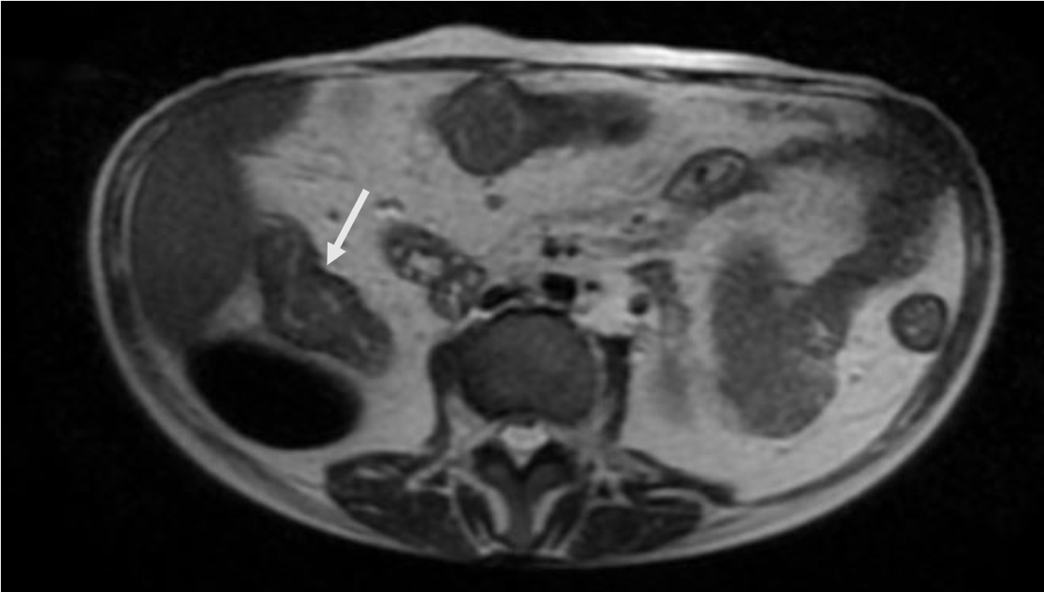

*Figure 1: Axial T1-weighted post-contrast MRI showing thickening of the terminal ileal loop (indicated by the white arrow).*

Upper gastrointestinal endoscopy demonstrated a mosaic pattern and total villous atrophy in the descending duodenum. Duodenal biopsies confirmed villous atrophy with intraepithelial lymphocytosis (40%), consistent with celiac disease. Immunology tests revealed elevated IgA anti-tissue transglutaminase antibodies (57 U/mL) and positive endomysial antibodies (1:302), confirming the CD diagnosis (figure 2).

*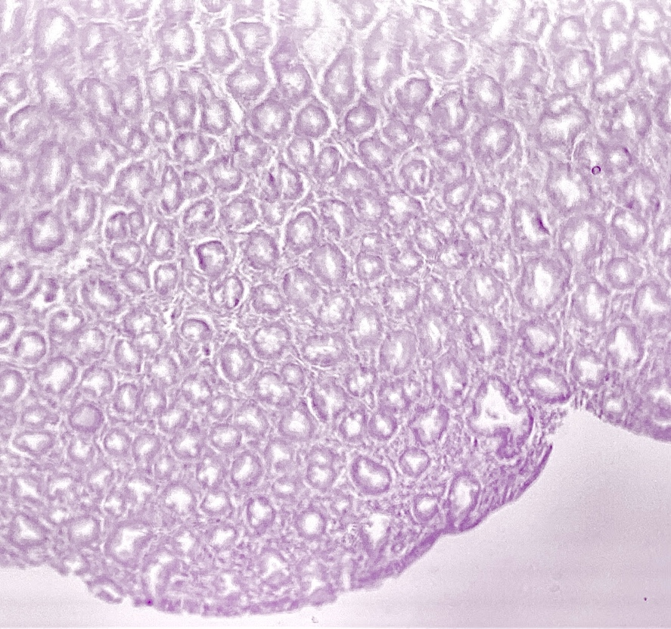  
Figure 2: Image of microscopic examination (H&E stain, x25), revealing the presence of a total villous atrophy in the duodenal mucosa*

**Management and Follow-Up**The patient was initially treated with parenteral corticosteroids for five days, followed by oral corticosteroids and azathioprine. A strict gluten-free diet was initiated, resulting in symptomatic improvement and a 4 kg weight gain over three months.

**Outcome**   
Six months later, she presented with bilateral knee pain and morning stiffness lasting more than one hour. Rheumatological evaluation revealed peripheral arthritis and enthesitis. Imaging and clinical findings confirmed a diagnosis of ankylosing spondylitis (AS). Infliximab was added to her treatment regimen alongside azathioprine, leading to significant clinical remission. She regained an additional 6 kg over the following six months and reported no further gastrointestinal or joint symptoms.

3. discussion

Celiac disease (CD) and inflammatory bowel diseases (IBD) such as Crohn’s disease (CrD) are both chronic inflammatory conditions affecting the gastrointestinal tract [2]. Their co-occurrence was first described in 1967, but reports remain scarce in the literature [3]. Recent studies suggest an increasing incidence of IBD in patients with celiac disease. Bardella et al. demonstrated that patients with CD are eight times more likely to develop IBD compared to the general population [4,5].

Diagnosing both conditions in the same patient can be challenging, particularly when symptoms overlap. In Crohn’s disease, upper endoscopy may reveal duodenal scalloping, a feature typically associated with celiac disease due to villous atrophy [6].   
Moreover, anti-tissue transglutaminase antibodies (IgA-tTG) may occasionally be elevated in IBD patients, complicating the diagnosis.

Despite these diagnostic challenges, the presence of endomysial antibodies and significant intraepithelial lymphocytosis (≥30%) remains specific for celiac disease.

Pathophysiologically, both conditions share autoimmune features, and are associated with other autoimmune diseases, such as thyroiditis and vitiligo.   
Genetic predisposition has also been suggested, with familial forms observed in both diseases.   
A 2011 systematic review identified four susceptibility genes common to both CD and CrD : IL18RAP (interleukin-18 receptor accessory protein in 2q12), PUS10 (pseudouridylate synthase 10 on 2p16), TAGAP (T-cell activation Rho GTPase activating protein in 6q25), and PTPN2 (tyrosine-protein phosphatase non-receptor type 2 in 18p11) [7].

Latiano et al. also highlighted the role of the MYO9B gene, typically associated with CD, in patients with IBD [8].

Finally, the association between IBD and ankylosing spondylitis (AS) is well documented, with AS affecting 2-3% of IBD patients, particularly those with CrD.

The relationship between HLA associations and autoimmune diseases is notable, particularly in CD and AS. In coeliac disease, HLA-DQ2/DQ8 is strongly linked to the disease, while in ankylosing spondylitis HLA-B27 in commonly associated [9] [10].

The introduction of biologic therapies, specifically anti-TNF agents like infliximab [11] has revolutionized treatment for patients with AS and concomitant IBD, as seen in our case [12].

This highlights the importance of comprehensive treatment strategies in managing complex cases of overlapping autoimmune disorders.

4. Conclusion

The coexistence of Crohn’s disease and celiac disease is rare, with most cases of Crohn’s disease occurring after a pre-existing diagnosis of celiac disease. In this case, both diseases were diagnosed concurrently during the same hospitalization. While the association between ankylosing spondylitis and IBD is well-documented, to our knowledge, this is the first report of the coexistence of Crohn’s disease, celiac disease, and ankylosing spondylitis in a single patient.

Consent

All authors declare that ‘written informed consent was obtained from the patient for publication of this case report and accompanying images.

ethical approval

As per international standards or university standards written ethical approval has been collected and preserved by the author(s).

Disclaimer (Artificial intelligence)

Author(s) hereby declare that generative AI technologies such as Large Language Models, etc. have been used during the writing or editing of manuscripts. This explanation will include the name, version, model, and source of the generative AI technology and as well as all input prompts provided to the generative AI technology

Details of the AI usage are given below:

1.I used Chatgpt to correct some minor grammatical errors

References

|  |  |
| --- | --- |
| [1] | M. Bonatto et al, «Endoscopic evaluation of celiac disease severity and its correlation with histopathological aspects of the duodenal mucosa », *Endoscopy international open,* 2016. |
| [2] | G. Casella et al, «Celiac disease, non-celiac gluten sensitivity and inflammatory bowel disease,» *Minerva Gastroenterologica E Dietologica,* 2015. |
| [3] | G. Kitis et al, «Association of celiac disease and inflammatory bowel disease»,*Gut,* 1980. |
| [4] | A. Tursi et al, «High prevalence of celiac disease among patients Detected by Crohn’s disease», I*nflammatory Bowel Disease,* 2005. |
| [5] | M. Bardella et al, «Autoimmune disorders in patients detected by celiac sprue and inflammatory bowel disease», *Annals of medicine,* 2009. |
| [6] | A. Culliford et al, «Scalloping of duodenal mucosa in Crohn’s disease », *Bowel disease,* 2004. |
| [7] | G. Lawlor et al, «New genetic data support an association between celiac disease and inflammatory bowel disease», *Inflammatory Bowel disease,* 2011. |
| [8]  [9]  [10] | Latiano et al, «The association of MYO9B gene in Italian patients with inflammatory bowel diseases», Alimentary Pharmacology & Therapeutics, 2008.    Lunardi C, Tampoia M, Kapsogeorgou EK, et al. HLA-DQ2 and HLA-DQ8 in coeliac disease: A review of their role and mechanisms. *J Autoimmun*. 2020;112:102491. doi: 10.1016/j.jaut.2020.102491.  Tait BD, Reveille JD. HLA-B27 subtypes predisposing to ankylosing spondylitis: A study of their intracellular behavior. *Front Immunol*. 2020;11:290. doi: 10.3389/fimmu.2020.00290. |
| [11]  [12] | M. Rudwaleit et al, «Ankylosing spondylitis and bowel disease», Best Practice & Research Clinical Rheumatology, 2006.  Hammoudi D, Sanyaolu A, Nagarsheth N, Kimbel J, Abioye A. TNF-α Inhibitor Treatment for Crohn’s Disease: Comparative Review of Post Therapy Malignancy between Infliximab and Adalimumab. J. Pharm. Res. Int. [Internet]. 2014 Dec. 27 [cited 2025 Feb. 24];5(4):217-2. Available from: https://journaljpri.com/index.php/JPRI/article/view/647 |