**SPATIO-TEMPORAL PATTERNS OF LEOPARD (*PANTHERA PARDUS*) ATTACKS ON LIVESTOCK IN BUFFER ZONE OF BARDIA NATIONAL PARK, NEPAL**

**Abstract**

Human-wildlife conflicts, particularly predation on livestock by large carnivores, possess significant challenges to conservation. This research aims to examine the spatial-temporal variation of leopard attacks on livestock in the buffer zone of Bardia National Park from 2016-2020. The spatial-temporal variation of leopard attacks on livestock was calculated using on-site assessment, field verification, and risk zone categorization by hotspot mapping. The Pearson χ2 test was used to compare the frequency of livestock depredation by leopards. All total 700 conflict incidences of livestock depredation by leopard were recorded. The average economic loss was USD 23.758 per year per household. Significantly higher numbers of goat/sheep (66.6%) followed by pig (26.6%) losses per year were observed (Pearson X2df=16=55.754). There was a significant increase in the trend of livestock attack over the year (Pearson X2df=44=76.089). Livestock depredation was found to be completely dependent in year and season (Pearson X2df=12=27.986). Most of the leopard attacks occurred at night (80.29%) (Likelihood ratio X2df=4=14.331), and 89.29% of the livestock killing occurred within the coral house closer to (250m) the forest edge. We recommend using the risk zonation map developed in the research to prioritize preventive measures. Finding will aid in understanding spatial-temporal variation of leopard attacks on livestock.

**Keywords:** Human wildlife conflict, spatial-temporal pattern, leopard, Bardia National Park, Nepal

**1. Introduction**

Human-Wildlife Conflict (HWC) is defined as any adverse interaction between people and wildlife that has a detrimental impact on human social, economic, cultural life, and wildlife populations (Bhatta and Joshi, 2020). HWC is a frequent phenomenon that has become a severe threat to the survival of many endangered and rare species around the world (Ghimire, 2019; Redpath et al. 2015). One of the main obstacles in conservation efforts involves creating efficient approaches to foster cohabitation between humans and wildlife within landscapes utilized for multiple purposes (Salerno et al. 2020). The local community's lack of access to forest resources in buffer zones of protected areas has resulted in human-animal conflict between the people who live in these regions and wildlife (Dowie, 2011). Especially in the case of many rural communities, the impact of HWCs is severe, with leopards being the primary predators (Baral et al. 2021). In Nepal, most rural people rely on forest resources for agriculture and livestock husbandry for living (Neupane, 2014), increasing their chances of encountering with wild animals. Firewood, grass, lumber for construction, and fodder for cattle are the most important natural resources used by the locals around PAs. In these areas, competition for natural resources between local humans and wild animals is extremely fierce (Distefano, 2005). Therefore, it is essential to predict the temporal and spatial patterns of human-wildlife interactions (HWIs) to protect rural communities' livelihoods and promote wildlife tolerance (Pozo et al. 2021).

Leopard has a diverse range of habitats and exhibits exceptional flexibility (Jacobson et al. 2016). The leopard population has experienced notable decreases because of growing human activity, though, and as a result, it is now included as a vulnerable species on the IUCN's global red list (International Union for Conservation of Nature) (Stein et al. 2023). The leopard is classified in CITES Appendix I, indicating its endangered status and rigors protection from commerce. Remarkably, the leopard does not get priority protection under the National Parks and Wildlife Conservation Act of Nepal (Jnawali, 2011).

Most attacks in Nepal occur in the midland regions (terai, mid-hills, and lesser Himalayas) (Maskey *et al.* 2001). Leopards are among the most resilient big felids, with only 17% of their current distribution range protected because of habitat loss and victimization (Jacobson *et al*. 2016). According to a study from the Bardia and Chitwan National Parks, people in and around the parks experience the most serious problems from predator attacks on livestock, with tigers and leopards killing 118 and 123 livestock respectively, every year (Lamichhane *et al*. 2018). Furthermore, in the vicinity of BNP, the likelihood of leopard attacks on livestock was substantially higher (85% of all livestock lost to depredation) than that of tiger attacks (8%; Upadhyaya *et al*. 2020). Mitigation of livestock loss to wild animals is one of the park manager's most difficult challenges (Tamang and Baral, 2008). Leopards are opportunistic creatures with very flexible diets unlike the tiger (*Panthera tigris*) and are pushed towards fringes (Odden *et at*. 2010). This scenario may contribute to increasing livestock depredation in peripheral areas (Odden *et al*. 2010), resulting in dissatisfaction among local people, which may lead to retaliatory killing of leopards (Khan *et al*. 2018).

There is a lack of insight into the spatial and temporal occurrences of human-leopard conflicts (HLC) in Nepal (Lamichhane et al. 2023). This facilitates the development and application of efficient mitigating strategies (Kandel et al. 2023). The causes of conflicts are often more intricate than anticipated, and it's important to acknowledge the factors that can influence human behavior in such a situation (Yadav et al. 2021). Leopard (*Panthera pardus*) populations are experiencing habitat isolation because of landscape fragmentation and growing human activity in Nepal (Stein et al. 2023; Jnawali, 2011). Consequently, interactions between leopards, livestock, and humans are on the rise in numerous regions, raising concerns about the conservation costs associated with leopard (Kandel et al. 2023; Lamichhane et al. 2023; Baral et al. 2021). Apart from that, study from Bardia National Park, Nepal revealed social dominance by tiger (*Panthera tigris tigris*), where leopards are being possibly displaced. Although it is true that species are expected to gain from the conservation measures implemented for the preservation of tigers (Jnawali, 2011), examining the spatiotemporal patterns of leopards at the site level could provide important information. Understanding the spatiotemporal patterns of leopards at the site level is essential for managing ecosystems and promoting conservation. We can identify important habitat areas, evaluate interspecies interactions with tigers, reduce human-leopard conflicts, and track population trends by knowing where and when leopards are active.

With establishment of BNP, the core area of the park was strictly protected by Nepal army. As the need of support of local communities was in demand to be an integral aspect of conservation, local communities living on the vicinity of BNP were involved in conservation activities. For that, Government of Nepal (GoN) has endorsed buffer zone policy in 1996 with a provision of 30-50% collected revenue to respective buffer zones (GoN, 1996). The concept had gradually created an opportunity to save wildlife through community forest growth, keeping the core area intact with strict protection. However, the human density and wildlife population density has increased, and intensity of human wildlife conflict is on the rise around BNP. Large carnivores like tigers and leopards are responsible for livestock depredation (Shahi et al. 2022), resulting a frequent confrontation between the park managers and residents over damage caused by wildlife (Tamang and Baral, 2008). And the overall, human carnivore conflicts confrontations are rising in Nepal's BNP (Bhattrai and Fisher, 2014), yet an understanding of the scale of these conflicts is lacking.

Here we assessed human- leopard conflict around BNP, describing the time of year and frequency of occurrence for five years from 2016 to 2022. To resolve human-carnivore conflict, it is critical to have a clear understanding of patterns of livestock depredation (Dar et al. 2009) to identify places and times of high depredation. Therefore, the study aimed to examine the ecological dimensions of seasonal and temporal patterns of livestock loss with trends, quantification of economic loss of local communities towards leopards in the BNP. This research also includes spatial conflict risk zonation, which is utilized to provide insights into environments where leopards attack livestock using both qualitative and graphical guidance, as well as to aid in the prioritization of management actions and mitigation measures. For BNP it is an important prerequisite for scientific guidance with evidence-based conservation. To full-fill our objectives during the study, we have hypothesized that:

1. There is equal distribution of frequency of attacks by leopard among year, season and time,
2. There is significant decreasing trend of livestock depredation by leopard, and
3. The village nearer to the park boundary and forest edges lose more livestock in coral house.

**2. Study area**

The research region extends 80°10′ to 80°30′E and 28°15′ to 28°40′N with elevations ranging from 152m (Manaughat) to 1564m (Banspani Peak). Bardia National Park (BNP) was established in 1976 A.D. and has the largest national park in Terai Arc Landscape (TAL) with an area of 968 km2 ((Fig. 1)). BNP is recognized as the best environment for tiger conservation and is classified as II by the IUCN (Walston *et al*. 2010). The park's buffer zone, which covers 507 km2, was established in 1996. According to laws, the park allocates 30-50% of its revenue in buffer zone communities to reduce the negative impact on wildlife habitat (Baral and Heinen 2007). The study area was carried out by three buffer zone user committees, including Thakurbaba (ward no. 8, 9), Shibapur Ekikrit (ward no. 6, 7) from Thakurbaba Municipality, and Suryapatawa (ward no. 1) from Madhuban Municipality ((Fig. 1)). The study area of high tiger density (4.7) (DNPWC 2018) and prey density is 68.04 (Dhakal *et al*. 2014) but even highly livestock depredation by a leopard was record supported conservation in-charge, field coordinator, and park rangers.

Many endangered species live in BNP, including the one-horned rhinoceros (*Rhinoceros unicornis*), tiger (*Panthera tigris*), asian elephant (*Elephas maximus*), swamp deer (*Rucervus duvaucelii*), gharial crocodile (*Gavialis gangeticus*), and gangetic dolphin (*Platanista gangetica*). In and around the park, various types of vegetation such as sal (*Shorea robusta*) woodland, khair-sissoo (*Acacia-Dalbergia*) forest, wet riverine forest, mixed hardwood forest, forested grassland, floodplain grassland, and plants can be found (SR 1993). Leopard population counts in Bardia have not been examined recently, however densities of 5 individuals/100 km2 have been calculated (Wegge *et al*. 2009).

There are four distinct seasons: winter (December-February), spring (March-May), summer (June-August), and autumn (September-November). The maximum temperature is 45 °C, and the yearly rainfall is 1500 mm. The buffer zone is primarily populated by indigenous Tharu people, especially Brahmin. According to the 2011 census, the population was 426,576 (210/km2) (CBS 2012). The vast majority of households raised cattle and grazed in forests and grasslands (Karki 2013). During the monsoon season, individuals in the buffer zone primarily farm rice and maize. Winter crops include wheat, mustard, and lentils (Studsrod and Wegge 1995).

**3. Methods**

*3.1. On-site assessment*

From 2016 to 2020 on-site verification was done to gather information about leopard-livestock incidents from selected study areas. Additionally, to develop the spatial-temporal pattern of leopard-livestock patterns, we collected and compiled data on livestock attacks from BZUCs recorded information. The livestock attacks data type included (killed or injured) with date, location, and GPS (global positioning system) coordinates of livestock depredation The livestock data were categorized into cattle (ox and cow), buffalo, goat/sheep, and pigs for each study area. During the onsite study the data were compiled including victim’s name, address, respective BZUCs, financial year, sort of loss, time, and received their ethnicity.

*3.2. Field Verification*

Since the first author of this research is from the study area, whenever author has time, he has visited the victim’s household who lost livestock household in last five years with NTNC/BCP wildlife technicians. Verified from the field work livestock attack sites were coral house, community forest, agriculture land, grazing area, and settlement area. Further during our on-site verification and data from BZUCs recorded information we have interviewed the victims and tally our data. Finally, livestock depredation data included livestock types cattle, buffalo, goats/sheep or pigs, date, location (Village Development Committee/Municipality of buffer zone), site of predation (Coral house, Grazing area, or community forest), and time of the attack was rechecked from field verification.

*3.3. Livestock depredation risk zonation mapping:*

In order to understand spatial interaction between leopard and livestock, spatial and geospatial analyses can’t be avoided. A spatial statistical approach identified high-priority conflict hotspots. The spatial risk model can quantify landscape attributes that correlate with the incident sited. However, these models mainly supported incident data and described the possible risk that was related to the examined landscape attributes. The spatial risk model revealed the locations that are related to the precise land use category.

On site assessment or by field verification all incident sites were recorded with the help of the victim or victim’s representatives/ or eye witnesses. Within the beginning, we examined appropriate spatial statistics parameters using ArcGIS spatial statistics tools. Within the case of livestock attacks, GIS analysis enables the identification of events hotspots used is kernel density by considered discrete point values bearing information about these events. The kernel is a type of estimator that works by generalizing or smoothing discrete point data into an infinite area (Chainey 2002; Hart and Zandbergen 2014; Ruda *et al.* 2018; Silverman 2003). As a result of KDE procedures, the surface indicates the strength of the occurrences. Assuming that s1... sn are the event sites, then (s), the event intensity, is frequently approximated (Bailey and Gatrell 1995) by:

$λτ(s)=\sum_{i}^{n}{K/ τ2 [(s - si)/τ}]$,

Where, τ is the bandwidth or the dimensions of the kernel, and k is that the kernel functions determining the form of the kernel. The kernel function may be a bivariate probability density function, which can take different forms (e.g., quartic kernel); different specifications of the function can provide equally reasonable results. However, the dimensions of the kernel, or the bandwidth, may have a more significant impact on the results. Generally, employing a smaller bandwidth will limit the density estimation to the local situation. The intensity that was estimated for the locations limited to the events or density within the immediate neighbor, if a comparatively small bandwidth was used. Generating the intensity surface of a given event was quite useful for exploratory data analysis, not just in event mapping. Often, the density surface identifies or exposes hotspots when events are spatially clustered to an area, or cold spots, where the events are much less frequent within the area (Ruda *et al*. 2018).

*3.4 Research design*

The research design has outlined several key components. First, the data was collected by recording GPS coordinates for each incident site, which allows for precise location information. After that, the statistical explanation of the data involves hotspot mapping using kernel density estimation. This technique helps identify areas with higher incident density, indication potential hotspot of risk. Then, classify risk categories based on the occurrence of incidents. By analyzing the frequency and severity of incidents, different risk categories can be established, providing a comprehensive understanding of the varying levels of risk. To further enhance analysis, the research design incorporates overlaying the risk categories with land-use types. This step allows for the identification of degrees of risk within specific land-use type. Lastly, the result interpretation phase involves analyzing the findings and drawing meaningful conclusions (Fig. 2).

Habitat features determine the movement of territorial animals; sometimes they reduce and expand the size of their habitat in search of food, space, cover, and water. Sometimes, human and animal competing for resources and sharing a common landscape. By visualizing the occurrence data, we will conclude which one is highly influenced land-use region. Based on occurrence, the risk of each land-use class will differentiate in a particular study (Ruda *et al*. 2020) and use the risk factor from 1 to 3 (1=very high risk, 2=moderately risk and 3=very low risk) (Table 1).

**4. Results**

*4.1. Extent of livestock predation by leopards*

The average number of livestock attacks per household from 2016 to 2020 was 0.74 per year. Leopard, tiger and crocodile are the species involved in predation in Thakurbaba, Shivapur Ekikrit, and Suryapatawa buffer zone user committees. Most losses were associated with leopards, 97.2%, followed by tiger 2.1% (Fig. 3).

Overall, goat/sheep predation by leopard during the study period in three BZUCs was 66.57%, followed by predation of pig and cattle around 27% and 4% respectively (Table 2). Leopard predation on buffalo and chicken/duck was also same at around 1.5% (Table 1). Compared to three different BZUCs Thakurbaba BZUC lost insignificantly more livestock than Shivapur Ekikrit and Suryapatawa respectively (X2df=8=12.359, p=0.136).

*4.2. Seasonal & temporal patterns of livestock loss*

Almost similar patterns of conflict were observed in the study area, with high percent of conflict of about 28% in spring, 26% in winter, 27% in summer and 22% in Autum (Fig. 4). We found a significant association between seasons and years of livestock loss (X2df=6 =28.745, P<0.05). Whereas more livestock was killed in the Thakurbaba BZUCs (X2df=6 =28.745, P<0.05). About 33.4% and 5.7% of the total livestock loss occurred in the Shivapur ekikrit and Suryapatawa BZUCs respectively (Table 3).

The overall trend of livestock depredation from 2016 to 2020 shows a significant increasing trend of the leopard attacks on livestock with a significant variation over the year (X2df=44=76.089, p<0.05) (Fig. 5).

*4.3. Livestock size predation by leopard*

Leopard was accounted predation of livestock, 97.86% of small prey size (goat/sheep, pig, and chicken/duck livestock) predation and occasional killing of only 2.14% of large size prey (cattle and buffalo) predation (Fig. 6).

*4.4. Economic loss*

In the study area, the total average economic loss due to livestock depredation was Rs.2873 (USD23.59) from 2016 to 2020. Multiplying the total household of livestock killed in 5 years yielded a total economic loss of Rs.10, 055,500 (USD82595.877). According to the surveyor’s valuation technique, more than two-thirds of total economic loss was contributed by goat/sheep (68.3%). The economic impact of livestock losses was higher in the Thakurbaba BZUCs (61.7%).

*4.5. Landscape features on leopard attacked on livestocks*

Here, most of the leopard attacked occurred inside the corral house and were the highest (Fig. 7). More than two-thirds of attacks (89.29%) occurred in corral houses, followed by community forest (8.86%), settlement (1.57%), and agricultural land (0.29%) with a standard deviation is 0.471. Significantly more livestock was killed in a coral house in the Thakurbaba BZUCs (Pearson X2df=45.170, p<0.05). The livestock killing occurred mostly (60.71%) nearby occurred within <250m of the forest edges (Fig. 8a) and 29.71% nearby park boundary (Fig. 8b).The patterns of attacks were significantly uneven association across the park boundary and forest edges (Pearson X2df=33=41.539, p=0.146 and Pearson X2df=33=19.316, p=0.972).

*4.5. Risk Zonation Map of Leopard Livestock Conflict*

According to the result from the Global Moran’s Index statistics, given the z-score of 12.86 and there was less than 1% likelihood that this clustered pattern could be the result of random chance. The p-value was less than 0.01 which means the distribution dealing with the number of livestock attack datasets was spatially clustered. Because of geospatial analysis, we used kernel density tool to calculate a magnitude of per unit area from the attacked dataset, to fit a smoothly tapered surface to each point and suitable reclassification generated a significant zone showing a high probability of leopard attacks. The standard distance 1014.95m was used, which determined the kernel band (hopt= [2/3n] ^1/4*σ). The K.D. of attack raster layer was reclassified using the geometric interval algorithm into five categories: very high risk, high risk, moderate risk, low risk, and very low risk. As a result of the weighted overlay of different parameters (LULC, Hot spot), we can conclude with the final risk zone map (Figs. 9a and 9b).

**5. Discussion**

We presented the foremost comprehensive analysis of leopard attacks on livestock that specialize in spatial-temporal patterns within the buffer zone of BNP. The risk zonation of leopard livestock conflict map shows spatial clustering, with very high risk in Shivapur ekikrit and Thakurbaba BZUCs compared to Suryapatawa BZUCs. The annual loss of livestock attributable to leopards was 0.74 livestock per household per year. Significantly higher number of goat/sheep (66.6%) followed by pig (26.6%) losses per year was observed during the study (Pearson X2df=16=55.754, p<0.05). The average economic loss due to livestock depredation by leopard was Rs.2873 (USD23.59) from 2016 to 2020 in our study area. This was due to continual sustaining livestock depredation by leopard every year. Although the number of attacks fluctuated over the year, the overall trend of livestock depredation shows an insignificant decline. Based on the landscape features on leopard attack on livestock’s, occurred inside coral house most within <250m of the forest edges predated mostly small prey size (goat/sheep, pig, and chicken/duck).

*5.1. Livestock depredation*

Our results revealed, during our study time from three different BZUCs from BNP leopard was the most conflict creating carnivores with 97.2% depredation of domestic livestock’s (Fig. 3). About 97.86% of small prey size (goat/sheep, pig, and chicken/duck livestock) predation was done of leopard (Fig. 6). Especially, leopards mostly depredated smaller livestocks, such as goats (66.6% of all killings) during 2016-2020 comparable to that reported in other areas (Sangay and Vernes 2008; Dar *et al.* 2009). In the study conducted in Shuklaphanta National Park which is adjacent national park to our study area also revealed high proportion of depredation of goat and sheep during summer (Pant *et al.* 2023). Leopards are found to preyed on goat (57.3%)) and sheep (27.8%) from Machiara National Park, Pakistan (Dar *et al*. 2009).

Although leopards’ prey on a wide range of species, from arthropods to adult sambar (*Rusa unicolor*) or gaur (*Bos gaurus*; Seidensticker, 1976), they generally prefer prey species weighing between 10–40 kg (Hayward *et al*. 2006) and 2–25 kg (Lovari *et al.* 2013). The optimal body size of goats (5–25 kg; Lovari *et al*. 2013) combined with their high abundance in the whole livestock population found around CNP (72.7%), their non-defensive behavior, and the relative ease of killing and dragging them may have contributed to higher rate of goat depredation. Similar to our results of under-killing of cattle (2.14%), whose weight exceeds the optimal body size preferred by leopards (Hayward *et al*. 2006; Lovari *et al*. 2013), has been reported in Bhutan, India, Nepal and Pakistan (Sangay and Vernes 2008; Tamang and Baral 2008; Athreya *et al*. 2014; Khan *et al*. 2018). A study from (Tamang and Baral 2008) shows that tiger killed larger livestock such as cattle and buffalo while leopards killed sheep, goats, and pigs which similar to the research study. The finding from the Annapurna Conservation area (Koirala *et al*. 2012) also showed leopard select low livestock size as compare to tiger similar finding from CNP (Lamichhane *et al.* 2018). This is consistent with previous findings that predators show selectivity among prey (Johnsingh 1983); tigers prefer large prey whereas leopards’ prey includes smaller animals.

Tharu people reported maximum losses of livestock (68.86%), even though other ethnic groups have similar types of livestock. Typically, Thiru ethnicity has been lived for a long but their poor economic status attributed to poor husbandry techniques, such as open sheds. Villagers with a lower socio-economic status lost significantly more livestock compared to villagers who could afford better protection measures and husbandry techniques such as predator-proof corrals (Saberwal *et al*. 1994). People from marginalized groups are severely affected by such financial losses (Manral *et al*. 2016). In the present study, goat/sheep followed by pigs had lost significantly more, and especially in Thakurbaba BZUCs were lost higher as compared to other BZUCs.

*5.2. Temporal patterns of livestock-leopard conflict*

Our study showed that a significant association between seasons and years of livestock loss was observed in our study area. The highest livestock loss occurred in the spring and winter followed by the summer season. This result corroborates with a study in Bardia National Park (Tamang and Baral 2008) that livestock loss occurred in the hot dry season, just before the rainy monsoon. The reason could be that the events coincide with the harvesting and planting of major crops such as maize, wheat, and paddy. The animals which come to crop field in search of crop and vegetable, accordingly leopard may also follow these animals and as usually, leopard enter settlement and encounter with livestock. During these months, local community members are often not available to guard livestock. Livestock grazing is also higher during spring and at evening time leopard may attack livestock. However, significant livestock loss occurs during the rainy season (Bhadauria and Singh 1994; Kolowski and Holekamp 2006; Patterson *et al*. 2004; Srivastav 1997; Woodroffe and Frank 2005) which similar to our research study. Also, another reason may that excessive flooding occurs throughout the study area during the monsoon and restricts the movement of both livestock and predators. Villagers have ample grass and fodder to feed their livestock during the monsoon season, and, as most grazing lands remain under water in this season, livestock is kept in stalls.

The average livestock lost per household was 0.15 livestock between 1993 and 1998 (Tamang and Baral 2008), 0.26 livestock between 2006 and 2008 (Shahi *et al*. 2022), 0.4 livestock on average in 2017, whereas we found that each household lost 0.74 livestock on average in between 2016 to 2020. The increase in wildlife population in the periphery of the park and buffer zone forests perhaps explains this increase in livestock depredation over the years (Wegge *et al.* 2018). The economic loss due to livestock depredation was high due to the high dependence of respondent families on livestock rearing for their subsistence livelihood. As opposed to previous studies, where tigers caused the highest number of livestock depredations (Bhattrai and Fischer 2014; Tamang and Baral 2008). We found that leopards caused the majority of livestock loss around Bardia National Park. In contrast to (Upadhyaya *et al*. 2020) reported that leopard contributed 85% of livestock depredation in BNP, and also (Acharya *et al*. 2016) who reported that leopards contributed to 21% of livestock depredation in the Nepal. Studies have shown that common leopards are more adaptable to human use landscapes, often venture into the settlements to opportunistically access the resources (e.g., pigs) (Adhikari *et al*; 2019; Odden *et al*. 2014). Especially, leopard depredation of livestock was a common proportion of the annual attack was higher during night time mostly in coral house and which also reported by (Tamanag and Baral 2008).

*5.3. Spatial patterns of livestock-leopard conflict*

Consistent with our hypothesis, there was an insignificant relationship between the numbers of attacks in reference to forest edges. Particularly, there was a variation of livestock killed in relation to park and forest boundary. Because after 1996, local communities have taken responsibility for conserving forests, and wildlife habitats have improved (Budhathoki 2003; Gurung *et al*. 2008). Acharya *et al.* (2016) reported that attacks were spatially concentrated within park boundary; this is different from our findings. The footprint and scat of leopard was the sing which used to identify the predation by the leopard. As similar, signs of leopards were found primarily near the edge of the park in Bardia (Studsrod and Wegge 1995; Tamang and Baral 2008; Upadhyaya *et al*. 2020) which has also been reported in Chitwan National Park (Bhattrai and Kindlman 2012; Silwal *et al*. 2017), Macharia National Park, Pakistan (Dar *et al*. 2009).

In our study area, a village near forest edge till now- traditional practice of making coral house was used. Most of the cases that livestock depredation found from poor-coral house. This was made from a wooden structure and sometimes from the wire-fenced cage but improperly managed. Our results also showed that opening practices of livestock at night were ineffective in reducing leopard attacks, we aware people from poor corral structures contributed to livestock losses to leopards inside villages (Dar *et al*. 2009; Kabir *et al*. 2014). In our study area corrals lacked adequate doors, windows, walls, and often roofs. Woven plastic bags stitched together were frequently used as door and window coverings of corrals, facilitating entry by leopards. Hence, corrals were located closer to the park boundary, but they were poorly kept so predators could easily break into them.

We defined a total of three major landscape features (settlement, forest, and agriculture land) for three buffer zone user committees based on their conflict occurrence to model a risk zonation. According to Moran’s I, clustering data was fined because the conflict happened frequently where leopard predation occurred. Thakurbaba was seen very high-risk conflict area, as our opinion Thakurbaba is near the park boundary as well as surrounded by community forest. Most of the village was close to the park boundary and live a marginal group (Tharu and Dalit). As a poor economic status, their livestock husbandry practice was poor and prone to leopard conflict. Very high-risk conflict followed by Shivapur Ekikrit BZUCs. As an above region, typical Tharu people, who live near to the forest edge. Suryapatawa shows a significantly very low risk of conflict. The potential reason is that, the area was high movement activities of Tiger. Khata corridor may have a potentially high number of animal activities and we conclude that the high prey densities also. In this area may be the leopard displaced by tiger and number of conflicts increase of tiger, but in this research, only the leopard cases are included. That’s why very few areas found high-risk conflict zone.

**6. Conclusions**

To minimize livestock depredation by leopards in the buffer zone of BNP and long-term conservation of leopards we recommend; (a) improvement in enclosure and husbandry practices by constructing predator proof corrals, improving stock guarding, increasing night vigilance (Dar *et al*. 2009), (b) reduction in the number of livestock by diversifying the economy, (c) implementation of a community-based livestock insurance program, and (d) establishment of an early warning system such as the deployment of motion sensors around corrals and mobile alerts. We expect that our findings will be of value to wildlife managers and other conservation authorities in the region, to help predict where predation by a leopard is most likely to occur, and design intervention strategies that can reduce financial losses caused by common leopard. Finally, while leopards can be found in higher concentrations in areas with significant domestic animal availability (Athreya *et al*. 2014), maintaining a healthy wild prey base will be critical to reducing conflict (Khorozyan *et al*. 2015; Khan *et al*. 2018). Park authorities, in partnership with communities impacted by leopard depredation, should develop and implement a conflict management strategy to aid leopard conservation while minimizing livestock losses.

**Statements & Declarations**

**Competing Interests** The authors have no relevant financial or non-financial interests to disclose.

**Data availability** The datasets used and/or analyzed during the current study are available from the corresponding author on reasonable request.

**COMPETING INTERESTS DISCLAIMER:**

Authors have declared that they have no known competing financial interests OR non-financial interests OR personal relationships that could have appeared to influence the work reported in this paper.

Disclaimer (Artificial intelligence)

Option 1:

Author(s) hereby declare that NO generative AI technologies such as Large Language Models (ChatGPT, COPILOT, etc.) and text-to-image generators have been used during the writing or editing of this manuscript.

Option 2:

Author(s) hereby declare that generative AI technologies such as Large Language Models, etc. have been used during the writing or editing of manuscripts. This explanation will include the name, version, model, and source of the generative AI technology and as well as all input prompts provided to the generative AI technology

Details of the AI usage are given below:

1.

2.

3.

**References**

Acharya, K.P., Paudel, P.K., Neupane, P.R., and Kohl, M. (2016). Human-Wildlife Conflicts in Nepal: Patterns of Human Fatalities and Injuries Caused by Large Mammals*. PloS ONE* **11**(9), p.e0161717.

Adhikari, B., Odden, M., Adhikari, B., and Pantha, S. (2019). Livestock husbandry practices and herd composition influence leopard-human conflict in Pokhara Valley, Nepal. *Taylor & Francis* **25**(1), 62–69. <https://doi.org/10.1080/10871209>

Athreya, V., Odden, M., Linnell, J.D., Krishnaswamy, J., and Karanth, K.U. (2016). A cat among the dogs: leopard *Panthera pardus* diet in a human-dominated landscape in western Maharashtra, India. *Oryx* **50**(1), pp.156-162.

Athreya, V.R., Thakur, S.S., Chaudhuri, SUJOY., and Belsare, A.V. (2004). A Study of the Man-Leopard Conflict. *Junnar Forest Division:* Junnar, India.

Bailey, T.C., and Gatrell, A.C. (1995). Interactive spatial data analysis. In *Interactive spatial data analysis*. https://doi.org/10.2307/2265559.

Baral, K., Sharma, H.P., Kunwar, R., Morley, C., Aryal, A., Rimal, B. and Ji, W., 2021. Human wildlife conflict and impacts on livelihood: A study in community forestry system in mid-hills of Nepal. Sustainability, 13(23), p.13170.

Baral, N., and Heinen, J.T. (2007). Resources use, conservation attitudes, management intervention and park-people relations in the Western Terai landscape of Nepal. *Environmental conservation* **34**(1), pp.6472.doi:https://doi.org/10.1017/S0376892907003670.

Bhadauria, R.S., and Singh, A.N. (1994). Cyclic pattern of predation on domestic livestock by the tigers of Corbett National Park, UP, India. *Tiger paper (FAO)*.

Bhatta, M., and Joshi, R. (2020). Analysis of human-wildlife conflict in Buffer Zone Area: A case study of Shuklaphanta National Park, Nepal. *Bhatta, M. and Joshi.* pp.28-45. doi: <https://doi.org/10.33002/nr2581.6853.03033>

Bhatta, S. (2003). Draft report on elephant-human conflict in Nepal Terai Park areas with particular emphasis to Western Terai Arc Landscape. A report submitted to Terai Arc Landscape Strategic Plan (2004–2014).His Majesty Government of Nepal, Ministry of Forest and Soil Conservation, Kathmandu, Nepal.

Bhattarai, B.P., and Kindlmann, P. (2012). Interactions between Bengal tiger (*Panthera tigris*) and leopard (*Panthera pardus*): implications for their conservation. *Biodiversity and Conservation* **21**, pp.2075-2094.

Bhattarai, B.R., and Fischer, K. (2014). Human–tiger *Panthera tigris* conflict and its perception in Bardia National Park, Nepal. *Oryx* **48**(4), pp.522-528.

Buddhathoki, P. (2003). Partnerships and lived-in landscapes: an evolving US system of parks and protected areas. *Parks* ***13***(2), 31–41.

Carter, N.H., Shrestha, B.K., Karki, J.B., Pradhan, N.M.B., and Liu, J. (2012). Coexistence between wildlife and humans at fine spatial scales. Proceedings of the National Academy of Sciences 109(38), pp.15360-15365.

CBS (2013). ‘Environment statistics of Nepal 2013.’ (Central Bureau of Statistics: Kathmandu, Nepal.)

Chainey, S., Reid, S., and Stuart, N. (2002). When is a hotspot a hotspot? A procedure for creating statistically robust hotspot maps of crime. *Innovations in GIS* **9**, pp.21-36.

Dar, N.I., Minhas, R.A., Zaman, Q., and Linkie, M. (2009). Predicting the patterns, perceptions and causes of human–carnivore conflict in and around Machiara National Park, Pakistan. *Biological Conservation* **142**(10), pp.2076-2082.

Dhakal, M., Thapa, M., Jnawali, S., Subedi, N., Pradhan, N.M.B., Malla, S., Lamichhane, B.R., Pokheral, C.P., Thapa, G.J., Oglethorpe, J., and Subba, S.A. (2014). Status of tigers and prey in Nepal Department of National Park and Wildlife Conservation. *Nepal, Kathmandu Google Scholar*.

Distefano, E. (2005). Human-Wildlife Conflict worldwide: collection of case studies, analysis of management strategies and good practices. Food and Agricultural Organization of the United Nations (FAO), Sustainable Agriculture and Rural Development Initiative (SARDI), Rome, Italy. Available from*: FAO Corporate Document repository* http://www. fao. org/documents.

DNPWC, DFSC (2018). ‘Status of tigers and prey in Nepal.’(Dep. Natl. Park. Wildl. Conserv. Dep. For. Soil Conserv. Minist. For. Environ. Kathmandu, Nepal.)

Dowie, M. (2011). Conservation refugees:the hundred-year conflict between global

Fernando, P., Wikramanayake, E., Weerakoon, D., Jayasinghe, L.K.A., Gunawardene, M., and aJanaka, H.K. (2005). Perceptions and patterns of human–elephant conflict in old and new settlements in Sri Lanka: insights for mitigation and management. *Biodiversity & Conservation* **14**, pp.2465-2481.https://doi.org/10.1007/s10531-004-0216-z

Ghimire, P. (2019). Analysis of human wildlife conflict in buffer zone area: a study from Chitwan National Park, Nepal. *International Journal of Natural Resource Ecology and Management* **4**(6), pp.164-172. Doi: 10.11648/j.ijnrem.20190406.12

GoN. Buffer Zone Management Rules 2052 (1996). Kathmandu: Government of Nepal, Department of Printing; 1996.

Graham, K., Beckerman, A.P., and Thirgood, S. (2005). Human–predator–prey conflicts: ecological correlates, prey losses and patterns of management. *Biological conservation* **122**(2), pp.159-171.

Gurung, B., Smith, J.L.D., McDougal, C., Karki, J.B., and Barlow, A. (2008). Factors associated with human-killing tigers in Chitwan National Park, Nepal. *Biological Conservation***141**(12), pp.3069-3078.

Hart, T., and Zandbergen, P. (2014). Kernel density estimation and hotspot mapping: Examining the influence of interpolation method, grid cell size, and bandwidth on crime forecasting. Policing*: An International Journal of Police Strategies & Management*, **37**(2), pp.305-323.

Hayward, M.W., Henschel, P., O'Brien, J., Hofmeyr, M., Balme, G., and Kerley, G.I. (2006). Prey preferences of the leopard (Panthera pardus). *Journal of Zoology* **270**(2), pp.298-313.

Hudu, B., Shuvani, T., Nabin, B., Kandel, R.C., Sudarshan, C., Shankar, C., Niroj, T., Windhorst, K., Karky, B.S., Adhikari, M.D., and Pokheral, C.P. (2017). Mitigating human-wildlife conflict in Nepal: a case study of fences around Chitwan National Park. *ICIMOD Working Paper* (2017/14).

Inskip, C., and Zimmermann, A. (2009). Human-felid conflict: a review of patterns and priorities worldwide. *Oryx* **43**(1), pp.18-34.

Jacobson, A.P., Gerngross, P., Lemeris, J.R., Schoonover, R.F., Anco, C., Breitenmoser-Würsten, C., Durant, S.M., Farhadinia, M.S., Henschel, P., Kamler, J.F., Laguardia, A., Rostro-García, S., Stein, A.B., and Dollar, L. (2016). Leopard (*Panthera pardus*) status, distribution, and the research efforts across its range. *PeerJ* **2016**(5), 1–28. https://doi.org/10.7717/peerj.1974.

Jnawali, S.R. (1993). Space and habitat use by a small reintroduced population of Greater One-horned Rhinoceros (*Rhinoceros unicornis*) in Royal Bardia National Park in Nepal-a preliminary report. In *Rhinoceros biology and conservation.* Proceedings of an international conference. Zoological Society of San Diego, San Diego, CA, 1993.

Jnawali, S.R., 2011. The status of Nepal mammals: The national red list series

Johnsingh, A.J.T. (1983). Large mammalian prey--predators in Bandipur. *Journal of the Bombay Natural History Society*.

Kabir, M., Ghoddousi, A., Awan, M.S., and Awan, M.N. (2014). Assessment of human–leopard conflict in Machiara National Park, Azad Jammu and Kashmir, Pakistan. *European Journal of Wildlife Research* **60,** pp.291-296.

Kandel, S.R., Neupane, B., Miya, M.S., Sadadev, B.M., Khatri, N.D. and Dhami, B., 2023. An emerging issue of human-leopard conflict in the human-dominated landscape of mid-hills: a case study from Tanahun District of Nepal. *International Journal of Zoology*, *2023*, pp.1-12.

Karki, S.T. (2013). Do protected areas and conservation incentives contribute to sustainable livelihoods? A case study of Bardia National Park, Nepal. *Journal of environmental management* **128**, pp.988-999.

Katuwal, H.B., Basent, H., Sharma, H.P., Koirala, S., Khanal, B., Neupane, K.R., Thapa, K.B., Panta, D.B., Parajuli, K., Lamichhanem, S., and Rai, M. (2020). Wildlife assessment of the Chandragiri hills, Kathmandu: Potentiality for ecotourism. *European Journal of Ecology* **6**(1), pp.27-50.

Khan, M.Z., Khan, B., Awan, M.S., and Begum, F. (2018). Livestock depredation by large predators and its implications for conservation and livelihoods in the Karakoram Mountains of Pakistan. *Oryx* **52**(3), pp.519-525.

Khan, U., Lovari, S., Ali, Shah., S, and Ferretti., F. (2018). Predator, prey and humans in a mountainous area: loss of biological diversity leads to trouble. *Biodiversity and Conservation* **27**, pp.2795-2813.

Khorozyan, I., Ghoddousi, A., Soofi, M., and Waltert, M. (2015). Big cats kill more livestock when wild prey reaches a minimum threshold. *Biological Conservation* **192**, pp.268-275.

Koirala, R.K., Aryal, A., Parajuli, A., and David, A. (2012). Human-common leopard (Panthera pardus) conflict in lower belt of Annapurna Conservation Area, Nepal. *Journal of Research in Conservation Biology* **1,** pp.005-012.

Kolowski, J.M., and Holekamp, K.E. (2006). Spatial, temporal, and physical characteristics of livestock depredations by large carnivores along a Kenyan reserve border. *Biological conservation***128**(4), pp.529-541.

Lamichhane, B.R., Persoon, G.A., Leirs, H., Poudel, S., Subedi, N., Pokheral, C.P., Bhattarai, S., Thapaliya, B.P., and De, Iongh., H.H. (2018). Spatio-temporal patterns of attacks on human and economic losses from wildlife in Chitwan National Park, Nepal. *PLoS ONE,* **13**(4), 1–18. https://doi.org/10.1371/journal.pone.0195373

Lamichhane, B.R., Pokheral, C.P., Poudel, S., Adhikari, D., Giri, S.R., Bhattarai, S., Bhatta, T.R., Pickles, R., Amin, R., Acharya, K.P., and Dhakal, M. (2018). Rapid recovery of tigers *Panthera tigris* in Parsa wildlife reserve, Nepal. *Oryx* **52(**1), pp.16-24.

Lovari, S., Ventimiglia, M., and Minder, I. (2013). Food habits of two leopard species, competition, climate change and upper treeline: a way to the decrease of an endangered species? *Ethology Ecology & Evolution* **25**(4), pp.305-318.

Manral, U., Sengupta, S., Hussain, S.A., Rana, S.A.K.S.H.I., and Badola, R.U.C.H.I. (2016). Human wildlife conflict in India: A review of economic implication of loss and preventive measures. *Indian Forester* **142**(10), pp.928-940.

Manual, H.W.C. (2005). Wildlife Management Series, WWF-World Wide Fund for Nature (formerly World Wildlife Fund) Southern African Regional Programme Office (SARPO).

Maskey, T.M., Bauer, J., and Cosgriff, K. (2001). Village children, leopards and conservation. Patterns of loss of human live through leopards (*Panthera pardus*) in Nepal. A Report submitted to Department of National Parks and Wildlife Conservation/Sustainable Tourism CRC, Kathmandu, Nepal.

Michalski, F., Boulhosa, R.L.P., Faria, A., and Peres, C.A. (2006). Human–wildlife conflicts in a fragmented Amazonian Forest landscape: determinants of large felid depredation on livestock. *Animal conservation* **9**(2), pp.179-188.

Neupane, B. (2014.) Caste-wise differences in livelihood activities that affected adaptation against extreme weather events and climate variability. *Journal of Agricultural and Crop Research***2**(4), pp.71-82.

Odden, M., Athreya, V., Rattan, S., and Linnell, J.D. (2014). Adaptable neighbours: movement patterns of GPS-collared leopards in human dominated landscapes in India. *PLoS One* **9**(11), p.e112044.

Odden, M., Wegge, P., and Fredriksen, T. (2010). Do tigers displace leopards? If so, why?. *Ecological research* **25**, pp.875-881.

Ogra, M., and Badola, R. (2008). Compensating human–wildlife conflict in protected area communities: ground-level perspectives from Uttarakhand, India. *Human Ecology***36**, pp.717-729.

Pandey, P., Shaner, P.J.L., and Sharma, H.P. (2016). The wild boar as a driver of human-wildlife conflict in the protected park lands of Nepal. *European journal of wildlife research* **62**, pp.103-108.

Pant, B., Sharma, H.P., Dahal, B.R,, Regmi, S., and Belant, J.L. (2023). Spatio-temporal patterns of human-wildlife conflicts and effectiveness of mitigation in Shuklaphanta National Park, Nepal. *Plos one* **18**(4), p.e0282654.

Patterson, B.D., Kasiki, S.M., Selempo, E., and Kays, R.W. (2004). Livestock predation by lions (Panthera leo) and other carnivores on ranches neighboring Tsavo National Parks, Kenya. *Biological conservation* **119**(4), pp.507-516.

Polisar, J., Maxit, I., Scognamillo, D., Farrell, L., Sunquist, M.E., and Eisenberg, J.F. (2003). Jaguars, pumas, their prey base, and cattle ranching: ecological interpretations of a management problem. *Biological conservation* **109**(2), pp.297-310.

Pozo, R.A., LeFlore, E.G., Duthie, A.B., Bunnefeld, N., Jones, I.L., Minderman, J., Rakotonarivo, O.S. and Cusack, J.J., 2021. A multispecies assessment of wildlife impacts on local community livelihoods. Conservation Biology, 35(1), pp.297-306.

Redpath, S.M., Bhatia, S., and Young, J. (2015). Tilting at wildlife: reconsidering human–wildlife conflict. *Oryx* **49**(2), pp.222-225.Doi <https://doi.org/10.1017/S0030605314000799>

Ripple, W.J., Estes, J.A., Beschta, R.L., Wilmers, C.C., Ritchie, E.G., Hebblewhite, M., Berger, J., Elmhagen, B., Letnic, M., Nelson, M.P., and Schmitz, O.J. (2014). Status and ecological effects of the world’s largest carnivores. *Science* **343**(6167), p.1241484.

Ruda, A., Kolejka, J., and Silwal, T. (2018). GIS-assisted prediction and risk zonation of wildlife attacks in the Chitwan National Park in Nepal. *ISPRS International Journal of Geo-Information***7**(9), p.369.

Ruda, A., Kolejka, J., and Silwal, T. (2020). Spatial concentrations of wildlife attacks on humans in Chitwan National Park, Nepal. *Animals* **10**(1), p.153.

Saberwal, V.K., Gibbs, J.P., Chellam, R., and Johnsingh, A.J.T. (1994). Lion‐human conflict in the Gir Forest, India. *Conservation Biology*  **8**(2), pp.501-507.

Salerno, J., Bailey, K., Gaughan, A.E., Stevens, F.R., Hilton, T., Cassidy, L., Drake, M.D., Pricope, N.G. and Hartter, J., 2020. Wildlife impacts and vulnerable livelihoods in a transfrontier conservation landscape. Conservation Biology, 34(4), pp.891-902.

Sangay, T., and Vernes, K. (2008). Human–wildlife conflict in the Kingdom of Bhutan: patterns of livestock predation by large mammalian carnivores. *Biological Conservation* **141(**5), pp.1272-1282.

Seidensticker, J. (1976). On the ecological separation between tigers and leopards. *Biotropica*, pp.225-234.

Shahi, K., Khanal, G., Jha, R.R., Joshi, A.K., Bhusal, P. and Silwal, T., 2022. Characterizing damages caused by wildlife: Learning from Bardia national park, Nepal. *Human Dimensions of Wildlife*, *27*(2), pp.173-182.

Shahi, K., Khanal, G., Jha, R.R., Joshi, A.K., Bhusal, P., and Silwal, T. (2022). Characterizing damages caused by wildlife: Learning from Bardia national park, Nepal. *Human Dimensions of Wildlife* **27**(2), pp.173-182.

Silwal, T., Kolejka, J., Bhatta, B.P., Rayamajhi, S., Sharma, R.P., and Poudel, B.S. (2017). When, where and whom: assessing wildlife attacks on people in Chitwan National Park, Nepal. *Oryx* **51**(2), pp.370-377.

Srivastav, A. (1997). Livestock predation by Gir lions and ecodevelopment. *Tiger paper* (FAO).

Stein, A.B., Athreya, V., Gerngross, P., Balme, G., Henschel, P., Karanth, U., Miquelle, D., Rostro-García, S., Kamler, J.F., Laguardia, A., Khorozyan, I. & Ghoddousi, A. 2023. Panthera pardus. The IUCN Red List of Threatened Species 2023:

Studsrød, J.E., and Wegge, P. (1995). Park-people relationships: the case of damage caused by park animals around the Royal Bardia National Park, Nepal. *Environmental conservation* **22**(2), pp.133-142.https://doi.org/10.1017/S0376892900010183.

Tamang, B., and Baral, N. (2008). Livestock depredation by large cats in Bardia National Park, Nepal: Implications for improving park–people relations. *The International Journal of Biodiversity Science and Management* **4**(1), pp.44-53. https://doi.org/10.1080/17451590809618182.

Thapa, T.B., and P.h.D., Thesis. (2011). Habitat Suitability Evaluation for Leopard (*Panthera Pardus*) Using Remote Sensing and GIS in and Around Chitwan National Park, Nepal. Saurashtra University, Rajkot, India.

Treves, A. (2007). Balancing the needs of people and wildlife: when wildlife damage crops and prey on livestock. Land Tenure Center, Nelson Institute of Environmental Studies, University of Wisconsin.

Treves, A., and Karanth, K.U. (2003). Human‐carnivore conflict and perspectives on carnivore management worldwide. *Conservation biology* **17**(6), pp.1491-1499.

Upadhyaya, S.K., Musters, C.J.M., Lamichhane, B.R., De, S.,noo, G.R., Dhakal M, and De Iongh, H.H. (2020). Determining the risk of predator attacks around protected areas: the case of Bardia National Park, Nepal. *Oryx* **54**(5), pp.670-677.

Vedeld, P., Jumane, A., Wapalila,and Songorwa, A. (2012). Protected areas, poverty and conflicts: A livelihood case study of Mikumi National Park, Tanzania. *Forest policy and economics* **21**, pp.20-31.31. https://doi.org/10.1016/j.forpol.2012.01.008

Walston, J., Robinson, J.G., Bennett, E.L., Breitenmoser, U., Da, Fonseca, G.A., Goodrich, J., Gumal, M., Hunter, L., Johnson, A., Karanth, K.U., and Leader-Williams, N. (2010). Bringing the tiger back from the brink—thesixpercentsolution. *PLoSbiology* **8**(9), p.e1000485.https://doi.org/10.1371/journal.pbio.1000485.

Wang, S.W., and Macdonald, D.W. (2006). Livestock predation by carnivores in Jigme Singye Wangchuck national park, Bhutan. *Biological conservation* **129**(4), pp.558-565.

Wegge, P., Odden, M., Pokharel, C.P., and Storaas, T. (2009.) Predator-prey relationships and responses of ungulates and their predators to the establishment of protected areas: A case study of tigers, leopards and their prey in Bardia National Park, Nepal. *Biological Conservation* **142**(1), 189–202. https://doi.org/10.1016/j.biocon.2008.10.020.

Woodroffe, R., and Frank, L.G. (2005). February. Lethal control of African lions (Panthera leo): local and regional population impacts. In *Animal Conservation Forum* (Vol. **8**, No. **1**, pp. 91-98), Cambridge University Press.

Yadav, N., Areendran, G., Sarma, K., Raj, K. and Sahana, M., 2021. Susceptibility assessment of human–leopard conflict in Aravalli landscape of Haryana using geospatial techniques. *Modeling Earth* Systems and Environment, 7, pp.1459-1473.

**Table 1.** Land use risk category

|  |  |  |
| --- | --- | --- |
| SN | Land use category | Risk factor |
| 1 | Forest | 2 |
| 2 | Agriculture/Farmland | 3 |
| 3 | Settlement | 1 |

**Table 2.** Number of different types of livestock predation incident by the leopard in five year’s period

|  |  |  |  |  |  |
| --- | --- | --- | --- | --- | --- |
| Year | Types of livestock | | | | |
|  | Goat/Sheep | Pig | Cattle | Buffalo | Chicken/Duck |
| 2016 | 55 | 3 | 7 | 1 | 0 |
| 2017 | 93 | 24 | 4 | 1 | 6 |
| 2018 | 110 | 58 | 4 | 2 | 2 |
| 2019 | 90 | 40 | 9 | 0 | 2 |
| 2020 | 118 | 61 | 3 | 6 | 1 |
| Percentage | 66.57 (SE=1.8) | 26.57 (SE=1.7) | 3.86 (SE=0.7) | 1.43 (SE=1.43) | 1.57  (SE=0.4) |

**Table 3.** Seasonal livestock losses in the three buffer zone user committees from 2016 to 2020

|  |  |  |  |  |  |
| --- | --- | --- | --- | --- | --- |
| BZUCs | Winter | Spring | Summer | Autumn | Total |
| Shivapur Ekikrit | 64 | 84 | 55 | 31 | 234 (33.4%) |
| Thakurbaba | 110 | 103 | 111 | 102 | 426 (60.9%) |
| Suryapatawa | 9 | 3 | 13 | 15 | 40 (5.7%) |
| Total | 183 (26.1%) | 90 (27.2) | 179 (25.6%) | 148 (21.1%) | 700 (100%) |

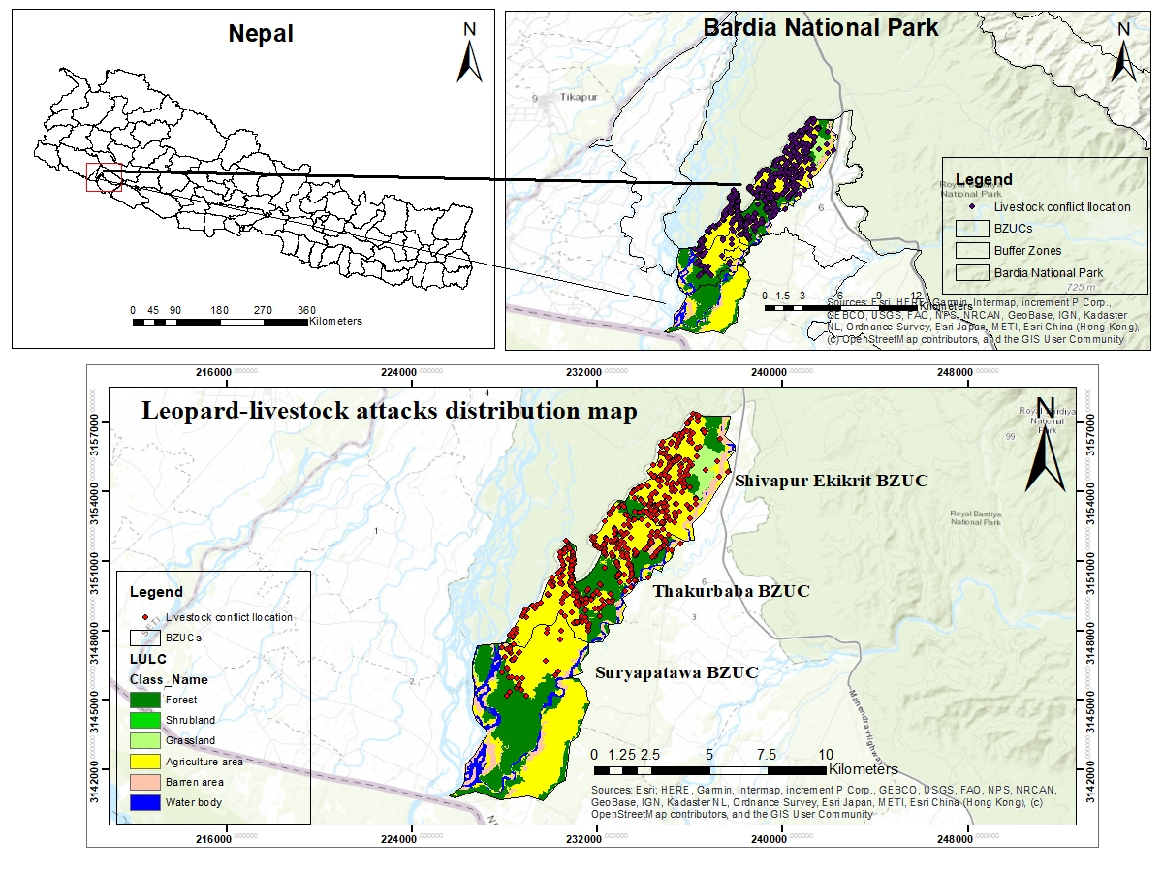

Fig. 1. Study area showing leopard-livestock attacks distribution.

Fig. 2. Research design framework

Fig. 3. Livestock losses by type of predator

Fig.4. Seasonal attacked of livestock by leopard in different year

Fig.5. Trend of livestock predation over five-year duration

Fig. 6. Livestock prey selection by leopard

Fig. 7. Livestock attacks occurred in different locations

Fig. 8a. Numer of livestock killed by leopard in the distance from the park boundary

Fig. 8b. Number of livestock killed by leopard in the distance from the forest edges

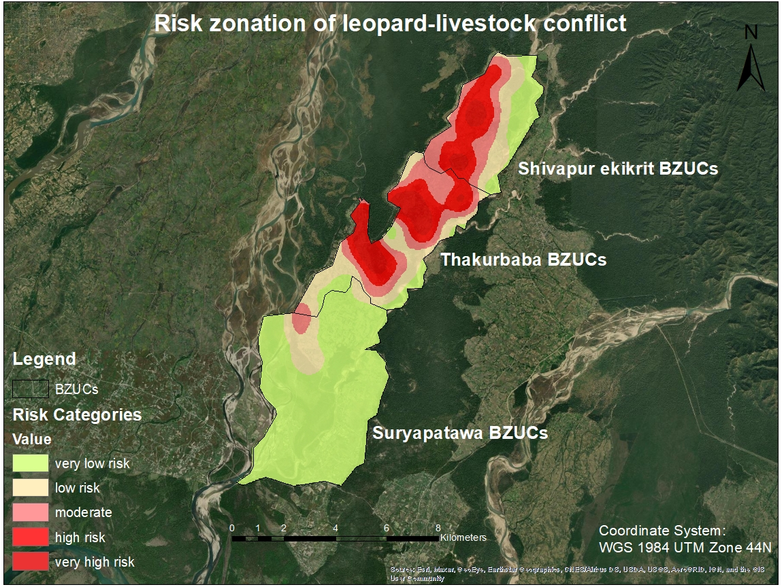

Fig. 9a. Risk zone mapping of leopard-livestock conflict

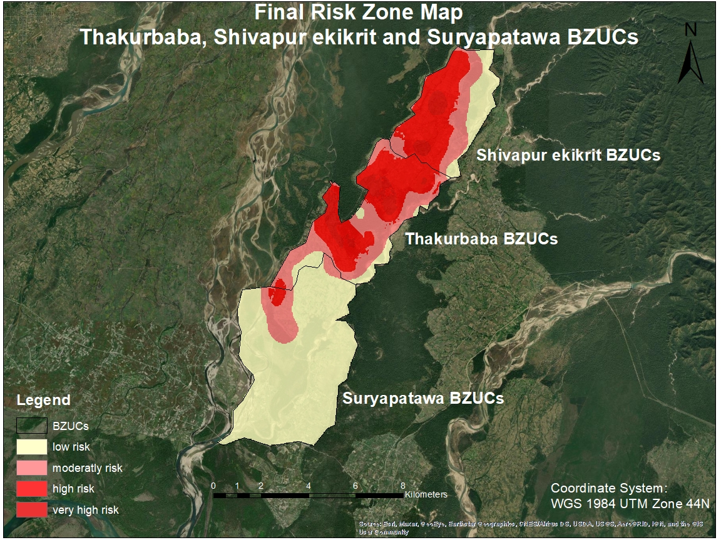

Fig. 9b. Final risk zone mapping of leopard-livestock conflict