**Attenuation of Induced Oxidative Stress and Neurological Deficit in Tramadol Use by Co-administration with Ribena drink and Vitamin E in Male Wistar Rats**

**ABSTRACT**

Tramadol appears to exert its analgesic effect by binding to the μ‑opioid receptor (MOR) and modulating the noradrenergic, serotonergic activities as a serotonin‑norepinephrine reuptake inhibitor, and also, gamma‑aminobutyric acid (GABA) ‑ergic system. These multiple effects on different neurotransmitter systems can complicate the effects of tramadol and its addiction. It has been established that tramadol addiction is associated with structural and functional changes in prefrontal cortex. However, the mechanism through which these changes are induced is not clear. The aim of this study is to determine the attenuation of induced oxidative stress and neurological deficit in tramadol use by co-administration with ribena drink and vitamin E in male Wistar mice. Forty male wistar rats (22.0±2.0 g) were divided into group A (control) received deionized water 2mls/kg/bw, treatment groups, **group A**: Tramadol 50mg/kg/bw, group **B**: Tramadol + Ribena 2mls/kg **group C:** Tramadol (50mg/kg) + Ribena (2mls/kg), **group D**: Tramadol (50mg/kg) + Ribena (2mls/kg) + Viatmin E (100mg/kg) orally administered daily for 28days. Motor functions as well as brain oxido stress biomarkers, was assessed. Histology sections of the Motor cortex were also examined and the data analyzed using descriptive statistics and anova at p=0.05.Oral exposure to tramadol induces behavioral deficits, with no histoarchtectural changes in the prefrontal cortex, however, Vitamin E and Ribena possess neuroprotective potential via antioxidant mechanism in the brain of mice. These observations confirm the neuroprotective and beneficial effects and therapeutic effect.

***Keywords:****Ribena; tramadol; prefrontal cortex; vitamin E*

**INTRODUCTION**

Drug abuse is a significant public health issue that has an impact on practically every community and household. Millions of people suffer significant diseases or injuries as a result of drug abuse every year. Methamphetamine, anabolic steroids, club drugs, cocaine, heroin, and inhalants are some of the drugs that are abused [1]. Use of Opioid drugs use outside of medicinal prescription is a global public health issue that needs to be addressed. Numerous subregions around the world, including the Middle East, West, Central, and North Africa, as well as other countries of Asia, Europe, and North America, have reported rising tramadol misuse [2]. Most countries in Africa are experiencing increased and socially disruptive substance abuse which has contributed to the increasing incidence of psychosocial problems among the youth. Also, drug abuse plays Use of Opioid drugs use outside of medicinal prescription is a global public health issue that needs to be addressed. Numerous subregions around the world, including the Middle East, West, Central, and North Africa, as well as other countries of Asia, Europe, and North America, have reported rising tramadol misuse[1].

It appears that the way that tramadol relieves pain is by attaching itself to the μ‑opioid receptor (MOR) and altering serotonergic and noradrenergic function as a serotonin‑norepinephrine reuptake inhibitor, and also, gamma‑aminobutyric acid (GABA) ‑ergic system [3]. Tramadol's effects and addiction may become more complicated as a result of these various impacts on various neurotransmitter systems. It has been established that anatomical and functional alterations in the prefrontal cortex are linked to tramadol addiction. However, the mechanism through which these changes are induced is not clear [3]. Due to the neuroprotective properties of vitamin E and considering the promising results obtained from previous animal studies in preventing neuronal death and delaying ageing, the effect of vitamin E on the prefrontal cortex is being examined.

However, vitamin E also shows non‑antioxidant features that regulate cell signaling and inflammation [4]. Since chronic inflammation is associated with neurodegenerative diseases, it is important to understand how vitamin E inhibits inflammation. Research demonstrates that taking supplements of vitamin E reduces the production of prostaglandin E2, which is a mediator of inflammation. This is caused by inhibiting the enzymatic activity of cyclooxygenase 2 (COX‑2), which is a rate limiting enzyme involved in the conversion of arachidonic acid to prostaglandins [5].

The prefrontal cortex (PFC) engages in a range of higher cognitive activities like planning, reasoning, and decision-making. As a result, it is believed that the prefrontal cortex is a key brain region for exploring the roots of human intelligence and creativity. Plenty of evidence have been gathered to support this theory. For instance, the prefrontal cortex makes up 29% of the cerebral cortex in humans, which is the highest proportion of any ape or animal species [6].

A component of the reward system, the medial prefrontal cortex (mPFC) has been linked to addiction, particularly tramadol addiction, and is known to have strong modulatory effects on the mesocorticolimbic dopaminergic system[7]. Other reward circuit regions, such as the nucleus accumbens and ventral tegmental area, provide input to the mPFC. These regions are likely to be impacted by tramadol because they are susceptible to the direct or indirect effects of the adrenergic and serotonergic neurotransmitter systems [8].Scientists can learn more about the potential efficacy and safety of novel medicines according to the findings of this investigation. Since laboratory animals and humans have numerous genetic and biological similarities. This study therefore isto evaluate the neurological impact of ribena as solvent in administration of tramadol and vitamin E on the Prefrontal cortex of male wistar mice.

**MATERIALS AND METHODS**

**Experimental animals**

Forty (40) adult male wistar rats were used for the study with average body weight of 20.0 ± 2.0 g. The rats were obtained from the Animal House, Faculty of Basic Medical Sciences, Delta State University, Abraka. The mice were acclamatized for 2 weeks and housed in cages under good ventilation and illumination conditions at room temperature (24°C ± 2° C), humidity (68%) under 12 hours light-dark cycle during the period of the experiment and provided with free access to water and diet *ad libitum*. All experimental measures were performed in a strict guideline according to the recommendations for the care and use of laboratory animals as approved by the Institutional Animal Care and Use Committee at Delta State University, Abraka

**Apparatus/Equipments**

Plastic cages, oro-gastric tubes, feeding troughs, syringes (2 ml) and needles, weighing balance, micropipette, dissecting board, EDTA bottles, cotton wool, analytical weighing balance, stop watch, laboratory coats, refrigerator, sample bottles, facemasks, hand gloves, centrifuge, microtome knife, test tubes, tube racks, spectrophotometer.

**Chemicals/Reagents**

Normal saline, buffered formalin solution, soft paraffin, ethanol, hematoxylin and Eosin, tramadol 50mg, Ribena soft drink,vitamin Eand sterile water.

**Ethical approval**

Before the commencement of the research work, appropriate ethical approval shall be obtained from the Animal Ethics Committee of the Faculty of Basic Medical Sciences, Delta State University, Abraka.

**Experimental Design**

The forty (40) rats were weighed and randomized into four equal groups (n = 10/group) and treated respectively;

*Group I: Control Group*. The rats received 1ml/kg/day body weight of sterile water (i.e only vehicle).

*Group II: Tramadol Group:* The rats received 50 mg/kg body weight /day tramadol dissolved in sterile water orally with a gastric tube

*Group III: Tramadol Group + Ribena:* The rats received 50mg/kg body weight /day tramadol dissolved in ribena orally with a gastric tube.

*Group IV: Tramadol + vitamin E + Ribena Group*: The rats received 50mg/kg body weight /day tramadol dissolved in ribena, and 100mg/kg vitamin E orally with a gastric tube.

The dose of tramadol was chosen based on a previous study [9]. The duration of treatments was 4 weeks (28days). At the end of the experiment, the rats were euthanized via compressed gas in their home cage by trained personnel.

**Biochemical tests**

**Determination of superoxide dismuthase (SOD) activity**

The levels of SOD activity was determined by the method of Misra and Fridovich[10], which involves inhibition of epinephrine autoxidation, in an alkaline medium. The brain supernatant (0.5 ml) was added to 0.5ml 0f 0.05M carbonate buffer (pH 10.2) to equilibrate in the spectrophotometer and the reaction started by addition of 0.5 ml of freshly prepared 0.3mM adrenaline to the mixture which quickly mixed by inversion. With the reference cuvette containing the mixture above, the rate of increase of absorption per minute (i.e 60 s intervals) for 3 min was measured at 480nm. The ability of SOD to inhibit the autoxidation of Epinephrine to produce adrenochrome at pH 10.2 was determined and expressed as unit of adrenaline consumed per minutes per mg of protein [11,12].

**Estimation of brain level of malondialdehyde (MDA)**

The brain level of the lipid peroxidation biomarker (MDA) was assayed using previous protocol by Adam-Vizi and Seregi methods (1982), using thiobarbituric acid (TBA) and trichloroacetic acid (TCA). Briefly, 0.1 mL of the brain supernatants 1.6 ml 0.15 M Tris-KCl buffer and mixed with TCA (0.5 mL, 30%) and TBA (0.5 mL, 0.75%). The mixture was heated for 45 min in a water bath at 80 oC. The reaction mixture was cooled, centrifuged for 5 min at 4000 rpm and the absorbance of the supernatant was read at 532 nm using a spectrophotometer. MDA concentrations were calculated from the molar extinction coefficient (1.56 x 10-5/M/cm) and expressed as nmol MDA/g tissue [13].

**Histological studies**

Brain tissues were dissected carefully and washed with physiological saline (0.9% NaCl), then immersed in neutral buffered formalin solution 10%. Tissue specimens of the brain were dehydrated in ethyl alcohol, cleared in xylol, impregnated in soft paraffin, and embedded in hard paraffin. Sections of 4–6 μm were cut and mounted on clear and dry glass slides. The obtained slides were stained with Hematoxylin and Eosin (H & E) for histopathological examination using a digital camera connected to the light microscope using 10, 20, 40 objective lenses [14].

**Behavioral Tests**

The following behavioral tests were performed to evaluate the effect of using ribena as vehicle for administration tramadol and/or vitamin E on rat’s activity and memory. Three rats per group were used for each test.

## *Assessment of Spatial Short term working Memory - Y-Maze Test*:

Spontaneous alternation was tested using the Y-maze. The arms are marked as A, B, and C; then, each rat is placed at the beginning of (A) arm and left for eight minutes and then cleaning maze with 70% alcohol after each rat. Overlapping triplet sets (i.e., successive entry into the 3 arms such as ABC, CBA, BCA etc) were recorded as alternation. Arm-entry sequence and time spent on each arm was recorded. An arm entry is recorded when the hind paws of the rat are placed in the arm. Percentage alternation is the number of arm entries divided by the maximum possible alternations (i.e the total number of arms entered minus 2) expressed as a percentage [15].

# **RESULTS**

# **Effect of the** **Tramadol, Vitamin E co-administration on working memory of Wistar rats**



**Figure 1. Shows the effects of Tramadol, Vit E administration on working memory of Wistar rats**

*Values are expressed as Mean ± SEM. Data analyzed by ANOVA followed by LSD’s Post Hoc tests. Significance is measured at P<0.05. CTRL; Control, TM; Tramadol, RIB; Ribenna drink, H2O: Distilled water*

*\*: Significantly different from control*

*a: Significantly different from TM*

*b: Significantly different from TM+RIB*

The result above shows that memory assessed using Y-Maze is decreased (non-significantly) in rats administered with Tramadol + distilled water when compared with control. Co-administration of Ribenna drink with Tramadol significantly increased memory in these animals when compared with rats administered with only Tramadol + distilled water.

# **Effect of the Tramadol, Vitamin E co-administration on Malondialdehyde (MDA) level of Wistar rats**

**Figure 2. Shows the effects of Tramadol, Vit E administration on Malondialdehyde (MDA) level of Wistar rats**

*Values are expressed as Mean ± SEM. Data analyzed by ANOVA followed by LSD’s Post Hoc tests. Significance is measured at P<0.05. CTRL; Control, TM; Tramadol, VE; Vitamin E, H2O: Distilled water*

*\*: Significantly different from control*

*a: Significantly different from TM*

Result of tramadol administered group showed significantly increased malondialdehyde (MDA) level of Wistar rats when compared with control. Similar result is also observed for experimental groups administered with Vit E and distilled water when compared with control. However, administration of Vit E and distilled water did not cause significantly difference in the MDA levels of Wistar rats when compared to rats administered with Tramadol alone.



**Figure 3. Shows the effects of Tramadol, Vit E administration on Superoxide Dismutase (SOD) enzyme level of Wistar rats**

*Values are expressed as Mean ± SEM. Data analyzed by ANOVA followed by LSD’s Post Hoc tests. Significance is measured at P<0.05. CTRL; Control, TM; Tramadol, VE; Vitamin E, H2O: Distilled water*

*\*: Significantly different from control*

*a: Significantly different from TM*

*b: Significantly different from TM+VE*

Result shows that tramadol causes decreased level of SOD level (non-significantly) of Wistar mice when compared with control. SOD level is significantly decreased in rats administered with Vitamin E and distilled water when compared to rats administered with Tramadol alone.

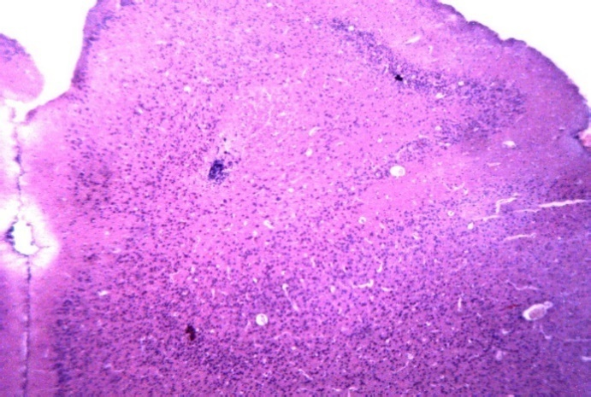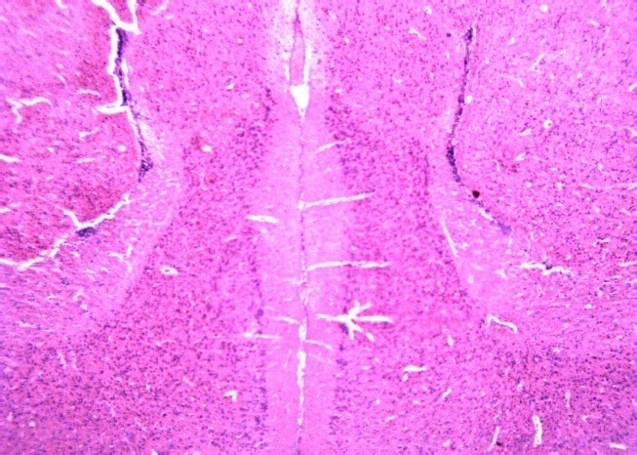

**A**

**B**

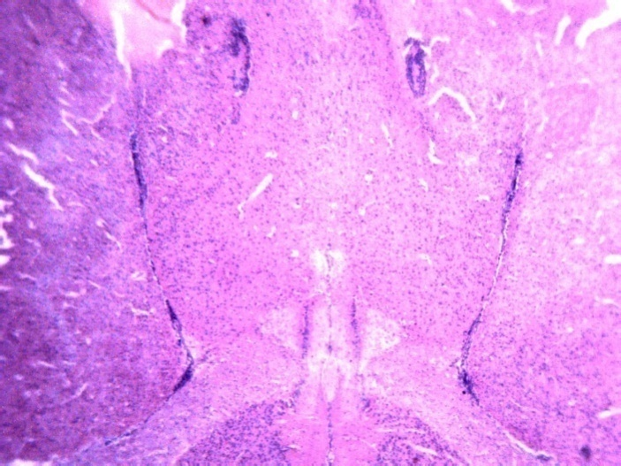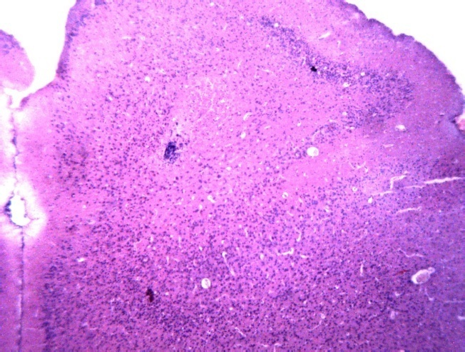

**C**

**D**

**Plate 1 3 a-d representative photomicrograph of the neurological impact of ribena as a solvent in administration of tramadol and vitamin E on the Pre-frontal cortex of male wistar rats. A: Control (2ml/kg/bw), B: Tramadol (50mg/kg/bw) with distilled water, C: Tramdaol 50mg/kg/bw) with Ribena (2mls/kg/bw) D: tramadol 50mg/kg/bw) with Ribena (2mls/kg/bw)and Vitamin E 100mg/kg/bw. H & E stain: Mag: x 40**

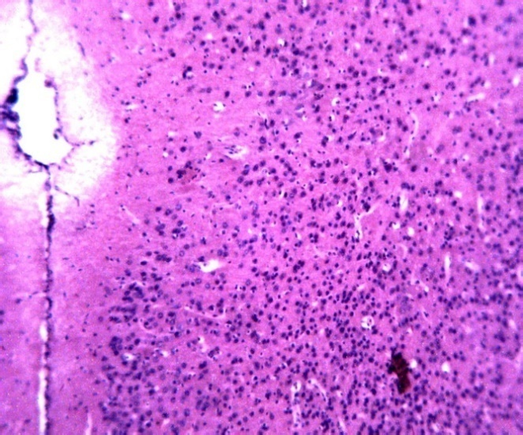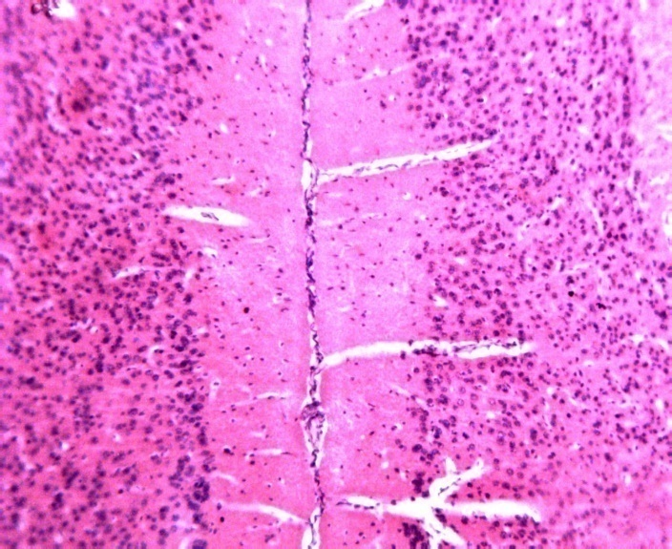

**A**

B

**C**

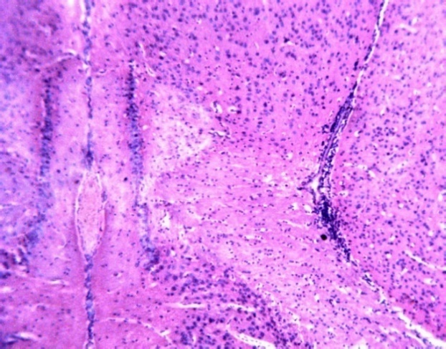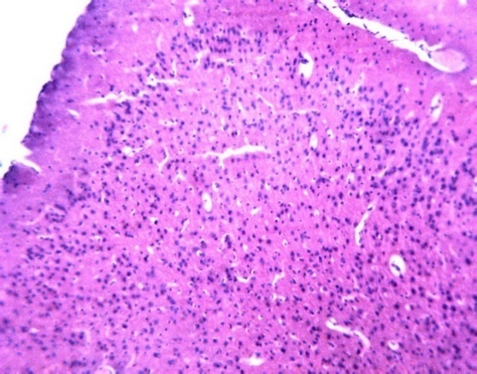

**C**

**D**

**Plate 23 a-d representative photomicrograph of the neurological impact of ribena as a solvent in administration of tramadol and vitamin E on the Pre-frontal cortex of male wistar rats. A: Control (2ml/kg/bw), B: Tramadol (50mg/kg/bw) with distilled water, C: Tramdaol 50mg/kg/bw) with Ribena (2mls/kg/bw) D: tramadol 50mg/kg/bw) with Ribena (2mls/kg/bw) and Vitamin E 100mg/kg/bw. H & E stain: Mag: x 100.**

# **DISCUSSION**

From this study there was no observable changes in the photomicrographs in the treatment groups while comparing with the control, however there was functional manifestation evidenced in the neurobehavioral test, this may be due to early onset changes which are yet to visible at the microscopic level. The findings from this result, the Y-Maze test, is used as a basic assessment tool for evaluating neurologic effects of various drugs on short term spatial memory in rodents. The result showed that there was a non-significant decrease in spatial memory in rats administered with Tramadol and distilled water when compared with control, however, co-administration of Ribenna drink with Tramadol significantly increased memory in these animals, on comparism with the control and group with only tramadol and distilled water.

Neurologic effect to the brain occurs, through various pathways, such as oxidation, vascular mechanism etc. Several intracellular defense mechanisms, such as Super oxide dismutase enzyme, helps in ameliorating the oxidative stress on the brain, superoxide dismutase (SOD) level is one of the indices of antioxidant status in the body. Decrease in the activity of this enzyme may lead to deleterious effects as a result of superoxide and hydrogen peroxide assimilation. The obtained results showed significant decrease in brain tissue SOD in rats treated with tramadol only compared to the control. This was further decreased. However, brain tissue antioxidant enzyme (SOD) activities were markedly decreased in rats treated with in both TM and RIB and TM + RB + VE groups compared to tramadol only. The results suggest that coadministration with Ribenna and/or vitamin E did not improve but rather worsen tramadol effect on in the brain anti-oxidant enzymes. Decreased SOD activity observed in the present study in could be an indication of the potential of tramadol in the pathogenesis of oxidative stress and related conditions.

Malondialdehyde (MDA), a marker of lipid peroxidation [3,16, 17, 18, 19, 20]. Result of tramadol administered group showed significantly increased malondialdehyde (MDA) level of Wistar mice when compared with control. Similar result is also observed for experimental groups administered with Vit E and distilled water when compared with control. However, administration of Vit E and distilled water did not cause significantly difference in the MDA levels of Wistar rats when compared to rats administered with Tramadol alone.

**CONCLUSION**

It can be concluded from the behavioral test that tramadol could cause a significant decline in both learning and memory compared to the vehicle-treated rats (control) and Co-administration with Ribenna soft drink can significantly improve tramadol induced memory impairment. However, coadministration with Ribenna and/or vitamin E could not improve but rather worsen tramadol effect on in the brain antioxidant enzymes and lipid peroxidation markers. Furthermore, this study has demonstrated the potential neuroprotective effect of Vitamin E and Ribena in rats following administration for 28days. Together the results of our study as well as that of other investigators provide evidences which suggest that treatment with vitamin e might render neuro-protection from the potential neurotoxic effect of tramadol through antioxidant defense system.

Disclaimer (Artificial intelligence)

Option 1:

Author(s) hereby declare that NO generative AI technologies such as Large Language Models (ChatGPT, COPILOT, etc.) and text-to-image generators have been used during the writing or editing of this manuscript.

Option 2:

Author(s) hereby declare that generative AI technologies such as Large Language Models, etc. have been used during the writing or editing of manuscripts. This explanation will include the name, version, model, and source of the generative AI technology and as well as all input prompts provided to the generative AI technology

Details of the AI usage are given below:

1.

2.

3.

**REFERENCES**

1. Abi-Dargham A, Xu X, Thompson JL, Gil R, Kegeles LS, Urban NB, *et al*. Increased prefrontal cortical D1 receptors in drug naive patients with schizophrenia: a PET study with [11C] NNC112. Journal of Psychopharmacology. 2021; 26:794-805.
2. Herrnsdorf EA, Holmsted A, Håkansson A. Tramadol misuse in treatment-seeking adolescents and young adults with problematic substance use – Prediction of treatment retention.Addictive Behaviors Reports. 2022; 16:100446.
3. Mohamed YA, Elrassas HH, Ahmed ZM, Mohamed AT. Cognitive Impairment in Tramadol & Synthetic Cannabinoids Use Disorder Patients. An International Journal of Medicine. 2021; 114(1): i215.
4. Icer MA, Arslan N and Gezmen‑Karadag M.. Effects of vitamin E on neurodegenerative diseases: An update, Acta Neurobiologiae Experimentalis. 2021; 81:21-33.
5. Lewis ED, Meydani SN, Wu D. Regulatory role of vitamin E in the im‑mune system and inflammation. IUBMB Life. 2019; 71: 487-494.
6. Funahashi S. Working Memory in the Prefrontal Cortex.Brain Sciences. 2017;7:49.
7. Adekomi DA, Adegoke AA, Olaniyan OO, Ogunrinde AEW, Ijomone OK. Effects of alcohol and tramadol co-treatment on cognitive functions and neuro-inflammatory responses in the medial prefrontal cortex of juvenile male rats.Anatomy 2019;13(1):1-12.
8. Ahmad EHK, Darweesh AEM, Hassaan HMS, Nooman M, Shaaban I and Sayed MS. The effect of duration of dependence and daily dose of tramadol in tramadol dependent patients on cognitive performance. Middle East Current Psychiatry. 2019; 26:5
9. Xia W, Liu G, Shao Z, Xu E , Yuan H, Liu J & Gao L. Toxicology of tramadol following chronic exposure based on metabolomics of the cerebrum in mice. Scientific Reports. 2020; 10:11130.
10. Misra HP and Fridovich I. The role of superoxide anion in the autoxidation of epinephrine and a simple assay for superoxide dismutase. Journal of Biological Chemistry. 1972; 247(15):3170-3175.
11. Friday ET, Alabi OJ and Akpa M. Investigation effect of free radical generated from cement dust on antioxidant enzymes activities on cement factory Workers.International Journal of Biochemistry & Physiology. 2016; 6:1(1):000103.
12. Igben VO, Josiah Iju WJ, Itivere OA, Oyem JC, Akpulu PS and Ahama EE.*Datura metel*stramonium exacerbates behavioral deficits, medial prefrontal cortex, and hippocampal neurotoxicity in mice via redox imbalance.Laboratory Animal Research. 2023; 39:15.
13. Anachuna KK, Moke GE, Iyare C, Katchy N, Ben-Azu B, Adeniyi B, Nwogueze BC, Iyare E. Prenatal and Early Postnatal Food Restrictions Cause Changes in Brain Oxidative Status and Orexigenic/Anorexigenic Hormones in the Offspring of Rats: Prevention by Quercetin and Kaempferol. Curr. Res. Pharmacol. Drug Discovery. 2020;1:39-52.
14. Kandeil MA, Mohammed ET, Radi RA, Khalil F, Abdel-Razik AH, Abdel-Daim MM and Safwat GM. Nanonaringenin and Vitamin E Ameliorate Some Behavioral, Biochemical, and Brain Tissue Alterations Induced by Nicotine in Rats.Hindawi Journal of Toxicology. 2021:1-15.
15. Zebedee LU,Bariweni, M, Oboma Y,Ilegbedion I. (2022). Tramadol abuse and addiction: effects on learning, memory, and organ damage. Egyptian Pharmaceutical Journal. 2022; 21.
16. Omogbiya A, Moke EG, Ojieh AE, Enaohwo MT, Umukoro EK, Anachuna KK, Omilo CU. [Evaluation of perception, attitude, and impact of club-house noise pollution on mental health of individuals living within proximity of club-houses in Abraka, Delta State, Nigeria](https://scholar.google.com/scholar?oi=bibs&cluster=13854705964413008017&btnI=1&hl=en). Journal of Applied Sciences and Environmental Management.2020;24(6):1009-1013.
17. Moke EG, Ekuerhare B, Enaohwo MT, Asiwe JN, Ofulue OO, Umukoro EK, Isibor NP. Resistant Hypertension. Journal of Drug Delivery and Therapeutics. 2020; 12(3):230-235.
18. Onoriode AU, Trust AI, Lucky OO and Godswill OO. Alfavaca Aqueous Leaf Extract Protective and Ameliorative Effects on Lead Induced Hippocampus in Wistar Rats.Asian Journal of Medicine and Health.2023; 21(11):8-15.
19. Udi OA, Moronkeji A, Nwaokoro IC, Ekakite OO. Okoro GO, Oshojobi OM. Investigating the protective effects of ascorbic acid against paracetamolinduced liver toxicity in Wistar Rats. Asian Journal of Research in Medical and Pharmaceutical Sciences. 2024;13(4):1-8.
20. Udi OA, Okoro OG, Lucky OO, Ahama EE, Enaohwo TM, Igben VO, Chris-Ozokor LE and Ogba GO. The impact of pumpkin seed extracts on the histology of the hypothalamus and testosterone level of Alloxan induced diabetic male rats. Asian Journal of Medicine and Health. 2022; 20(12):1-7.