***Case report***

**Extrapulmonary multidrug-resistant tuberculosis at the Yalgado Ouédraogo University Hospital: about 2 cases**

**Abstract:**

Tuberculosis is a highly contagious infectious disease. It poses a major public health problem. While pulmonary forms are the most frequent in our countries, extra-pulmonary forms are rare in our daily practice. This may be due to their rarity, on the one hand, and to the difficulties of diagnosis and management, on the other. We report here on our experience with two (2) clinical cases of extrapulmonary tuberculosis diagnosed in the Pneumophthisiology Department of the Yalgado Ouédraogo University Hospital in Ouagadougou (Burkina Faso). The Xpert MTB/ Rif test was a key element in the diagnosis of tuberculosis. Management is highly complex, with a long treatment course. Multidrug-resistant extra pulmonary tuberculosis is rare and highly complex. These cases illustrate the problem of resistance to anti-tuberculosis drugs and raise the role of genotypic testing in the diagnosis of extra pulmonary tuberculosis.

**Key words:** Tuberculosis, Extrapulmonary, Multiresistant, Antituberculosis drugs.

**INTRODUCTION**

Tuberculosis is a highly contagious infectious disease. It poses a major public health problem. One of the new features of the epidemic is an increase in multi-resistant strains [1]. Drug-resistant tuberculosis (DR-TB) is defined as tuberculosis in which the patient excretes bacilli resistant to at least one anti-tuberculosis drug [2]. In 2020, the World Health Organization estimated that there would be 558,000 cases of multidrug-resistant or rifampin-resistant tuberculosis worldwide, including 3.5% new patients and 19.5% patients already on treatment [2]. Burkina Faso is a tuberculosis-endemic country, with 85 cases of DR-TB in 2021, according to data from the national tuberculosis control program [2]. While pulmonary forms are very common in our country, extra pulmonary forms are rare in our daily practice. Rare in our daily practice. This may be due to their low frequency, on the one hand, and to diagnostic difficulties, on the other.

We report here on our experience with two (2) cases of extra-pulmonary multidrug-resistant tuberculosis treated in the pneumo-phthisiology department of the Yalgado Ouédraogo University Hospital.

**CASE PRESENTATION**

**Case 1:** Mr MK, a 28-year-old farmer, was treated for pott's sore. He was put on first-line antituberculosis treatment (combined form of Rifampicin/ Isoniazide/ Pyrazinamide/ Ethambutol). After 3 months of treatment, the evolution was marked by the appearance of progressive dyspnea. Paraclinical investigations revealed extensive pericarditis, which was subsequently drained. The Xpert MTB/Rif test performed on pericardial fluid revealed the genome of *Mycobacterium tuberculosis* complex, with rifampicin resistance. Culture and LPA1 and 2 showed resistance to rifampicin and isoniazid. The diagnosis of multidrug-resistant tuberculosis with pericardial and vertebral localization was made. The Xpert MTB/Rif sputum test was negative. Biological tests were unremarkable. Retroviral serology was negative. He had benefited from a second-line antituberculosis treatment protocol lasting 18 months 6 Lfx-Bdq-Lzd-Cs-Cfz / 14 Lfx-Cs-Cfz

**Bdq:** Bédaquiline, **Cs:** Cycloserine, **Lzd:** Linézolide, **Lfx:** levofloxacine, **Cfz:** Clofazimine

**Case 2:** Mrs. BA, a 32-year-old housewife with no known pathological history, was seen for right basithoracic pain, a cough producing mucous sputum and an altered general condition, all evolving in a febrile, chronic context. On admission, the patient was found to be in altered general condition, stage IV performance status of the World Health Organization, with a GCS of 11, fever of 39°C, hypotension of 100/65 mmhg, chest pain syndrome, muffled heart sounds and a left pleural effusion syndrome. Exploratory pleural puncture yielded citrine-yellow fluid. A frontal chest X-ray showed a liquid pleural effusion on the left, and cardiomegaly with the appearance of a decanting heart(**Figure 1**). Emergency cardiac ultrasound at the patient's bedside revealed a large pericardial effusion, requiring placement of a drain. Xpert MTB/Rif testing of the pericardial and pleural fluid was ordered, which revealed the *Mycobateruim tuberculosis* complex genome with rifampicin resistance. Xpert/XDR showed no other resistance. Absence of germs on cytobacteriological examination of fluids. HIV serology was positive type 1. The diagnosis of rifampin-resistant extrapulmonary tuberculosis co-infection with HIV type 1 in the pleura and pericardium was accepted. Unfortunately, the patient died 7 days after starting second-line anti-tuberculosis treatment (6 Lfx-Bdq-Lzd-Cs-Cfz / 14 Lfx-Cs-Cfz).

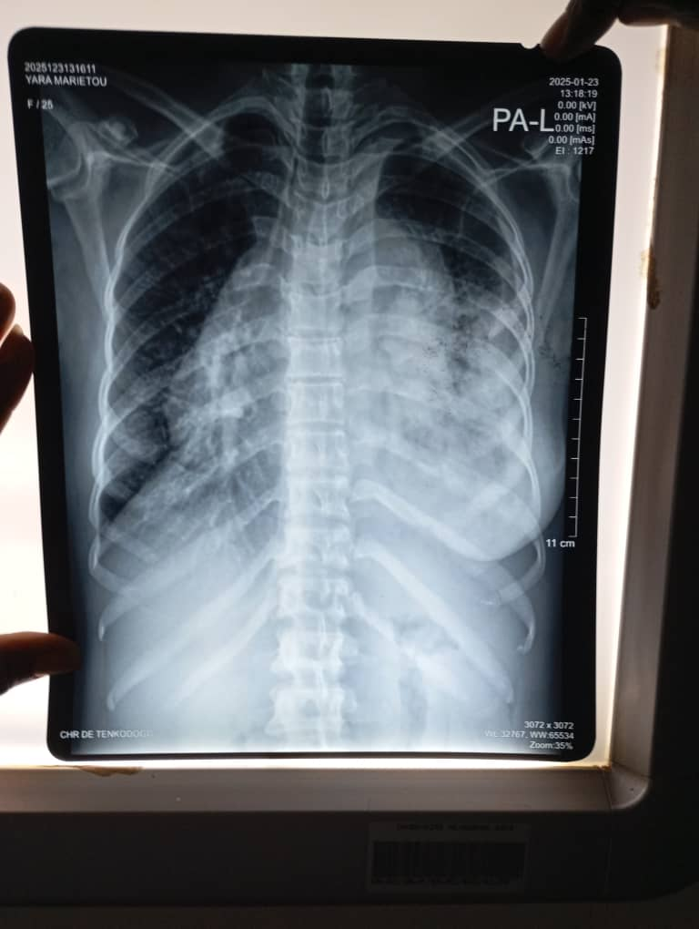

**Figure 1:** the frontal chest X-ray showed a homogeneous, water-dense opacity on the left (pleurisy), cardiomegaly with the appearance of a decanting heart.

**Bdq:** Bédaquiline, **Cs:** Cycloserine, **Lzd:** Linézolide, **Lfx:** levofloxacine, **Cfz:** Clofazimine.

**DISCUSSION**

Multidrug-resistant tuberculosis (MDR-TB) is caused by strains of *Mycobacterium tuberculosis* resistant to at least rifampicin and isoniazid, the major anti-tuberculosis drugs for drug-susceptible tuberculosis [2]. Among multidrug-resistant tuberculosis, a distinction is made between “pre-XDR” tuberculosis, which refers to multidrug-resistant tuberculosis associated with additional resistance to any fluoroquinolone (levofloxacin or moxifloxacin), and “XDR” tuberculosis, which refers to multidrug-resistant tuberculosis with additional resistance to fluoroquinolones and at least one other group A drug (Bedaquiline, levofloxacin or moxifloxacin, linezolid) [2].

Primary multidrug-resistant tuberculosis of extrapulmonary origin is a rare form of the disease, even in HIV-infected patients [3]. There have been a few reports of extrapulmonary MDR-TB involving lymph nodes, peritoneum, meninges, ribs and spine [3-9].

*Mycobacterium tuberculosis* has the ability to mutate into resistant mutants. Diagnosis of multidrug-resistant tuberculosis is based on identification of *Mycobacterium tuberculosis* by Xpert MTB/Rif and/or culture, followed by testing for resistance to anti-tuberculosis drugs, including isoniazid and rifampin. At least one sample must be collected. In the case of extrapulmonary tuberculosis, other samples may be analyzed (lymph nodes, pleural fluid, pericardial fluid, abdominal fluid, urine, etc.). Culture is an important test, contributing both to the positive diagnosis of tuberculosis by identifying the pathogenic agent, and to monitoring the progress of patients undergoing treatment [10]. It is difficult to monitor multidrug-resistant extra pulmonary patients on treatment in our context.

HIV-infected people are more likely to suffer from multidrug-resistant tuberculosis [11]. HIV also favours tuberculosis relapse, and mortality is increased if the diagnosis is not made early [12].

Treatment of multidrug-resistant tuberculosis is the same, regardless of the patient's serological status [10].

The suggestive signs and symptoms are similar to those of patients with drug-sensitive tuberculosis. Because it is diagnosed late, it may have a more severe clinical and radiological presentation, and a slower evolution [13].

The cases we reported were very complex; the diagnosis was made after testing for the bacillus in pleural fluid, pericardial effusion fluid. The Xpert MTB/Rif and Xpert/XDR tests had shown resistance to first-line anti-tuberculosis drugs, notably Rifampicin and Isoniazid.

After initiation of treatment, the evolution was favorable in the first case and unfavorable in our second patient, who died. It should be noted that the first patient was treated as an outpatient, with monthly follow-up, despite the fact that there was no standard follow-up for extrapulmonary multidrug-resistant patients.

The prognosis of MDR-TB has improved in recent years, thanks to the creation of specialized teams, the introduction of personalized treatment protocols, and the prescription of new antibiotics active against *Mycobacterium tuberculosis*, such as linezolid and bedaquiline [14]. There are no current data or studies showing the evolution of patients undergoing second-line anti-bacillary treatment for resistant extra pulmonary tuberculosis [15].

**CONCLUSION**

Multidrug-resistant extrapulmonary tuberculosis is rare and highly complex, often unrecognized and underdiagnosed, posing a real problem for diagnosis and management. These cases illustrate the problem of resistance to anti-tuberculosis drugs and raise the role of genotypic testing in the diagnosis of extra pulmonary tuberculosis.

**COMPETING INTERESTS**

Authors have declared that no competing interests exist.

**Disclaimer (Artificial intelligence)**

**Option 1:**

Author(s) hereby declare that NO generative AI technologies such as Large Language Models (ChatGPT, COPILOT, etc.) and text-to-image generators have been used during the writing or editing of this manuscript.

**REFERENCES**

1. Control EC for DP and, Europe WHORO for. Tuberculosis surveillance and monitoring in Europe 2015 [Internet]. World Health Organization. Regional Office for Europe & European Centre for Disease Prevention and Control; 2015 [cité 8 oct 2023]. Disponible sur : <https://iris.who.int/handle/10665/156007>

2. The PNT. Guide for the management of drug-resistant tuberculosis. 4th edition. Burkina Faso; 2022.

3. Rawat J, Sindhwani G, Dua R. Primary drug-resistant tuberculous lymphadenitis in a patient infected with HIV. Indian J Tuberc 2009;56:157-9.

4. Asgeirsson H, Blöndal K, Blöndal T, Gottfredsson M. Multidrug-resistant tuberculosis in Iceland - case series and literature review. Laeknabladid 2009;95:499-507.

5. Sofia M, Maniscalco M, Honoré N, Molino A, Mormile M, Heym B, et al. Familial epidemic of disseminated multidrug-resistant tuberculosis and meningitis. Int J Tuberc Lung Dis 2001;5:551-8.

6. DeVincenzo JP, Berning SE, Peloquin CA, Husson RN. Multidrug-resistant TB meningitis: clinical problems and second-line anti-TB drug concentrations. Ann Pharmacother 1999;33:1184-8.

7. Sarkar S, Maity GN, Mukhopadhyay KK, Acharyya B, Ghoshal AG. Primary multidrug-resistant tuberculosis. Lung India 2007; 24 : 97-9.

8. Krishnan H, Chan KL. Multidrug-resistant tuberculosis involving the collarbone, spine, and ribs. Malays Orthop J 2011;5:71-4.

9. Pawar UM, Kundnani V, Agashe V, Nene A, and Nene A. Multidrug-resistant tuberculosis of the spine: is this the beginning of the end? A study of twenty-five patients with multidrug-resistant tuberculosis in the spine, which has been proven to be resistant by culture. Spine 2009; 34:E806-10.

10. Tritar F., Daghfous H., Ben Saada S., Slim-Saidi S.: Management of multidrug-resistant tuberculosis Rev Pneumol Clin 2014.05.001

11. Alexander PE, De P. The emergence of extensively drug resistant tuberculosis (TB): TB/HIV coinfection, multidrugresistant TB and the resulting public health threat from extensively drug-resistant TB, globally and in Canada. Can J Infect Dis Med Microbiol. 2007 Sep ; 18(5) :289- 91.

12. Fuhrman C, Veziris N, Herer B, Bonnaud F. What attitudes should be adopted in the face of tuberculosis sequelae highlighted on a Rev Mal Respir chest X-ray. 2004; 21: 3S65-3S73.

13. Sylvie Audrey Diop, Aminata Massaly, Daye Ka, Noel Magloire Manga, Louise Fortes-Déguénonvo, Cheikh Tidiane Ndour et al. Use of the GeneXpert test for the diagnosis of tuberculosis in the infectious diseases department of the CHNU of Fann. The Pan African Medical Journal. 2016; 23:244

14. Maitre T, Aubry A, Jarlier V, Robert J, Veziris N, CNR-MyRMA. Multidrug and extensively drug-resistant tuberculosis. Med Mal Infect. 2017 Feb ; 47(1) :3-10.

15. Haddaoui H., MrabetFZ., Aharmim M, Bourkadi JE. Multidrug-resistant extrapulmonary tuberculosis: about 7 cases. Pan Afr Med J. 2019 Apr 23 ; 32 :196