Original Research Article
Zeuxine seetharamii (Orchidaceae): A new species from the Western Ghats, India

ABSTRACT
Zeuxine seetharamii has been discovered from the Anshi National Park, Uttara Kannada district, Karnataka, India. It is dissimilar to other species with thick rhizome, dwarf nature, compactly arranged small flowers, ovary structure and seeds. Labellum is similar to Zeuxine reflexa having reflexed structure, but pollinarium structure with tegula varies in all Zeuxine species from Karnataka and India. The species need to be conserved and further need extensive survey of this species in Anshi National Park, Uttara Kannada district.
KEYWORDS: Leaf litter, Pollinarium, Pubescent inflorescence, Reflexed labellum, Threatened Orchid
INTRODUCTION
Orchidaceae is one of the most renowned diversified family among the Angiosperm families, with estimated count 27500 species in the World with 697 genera (Mabberley, 2017; POWO, 2025). Tribe Goodyerine includes 74 species of 13 genera in India. The word Zeuxine is derived from the Greek word ‘Zeuxis’ which means partial fusion of column and labellum or pollinial fusion called ‘Yoke’. India has been recorded 19 Zeuxine species within two sections called Zeuxine and Psychechilos. Zeuxine section: Zeuxine includes three species and Zeuxine section Psychechilos includes 16 species in India (Bhattacharjee & Chowdhery, 2018). Singh et al., (2019) reported 18 species of Zeuxine in India. Nayar et al., (2014) reported seven Zeuxine species (Z. affinis, Z. blatteri, Z. chowdheryi, Z. flava, Z. gracilis, Z. longilabris and Z. strateumatica) from Western Ghats of India. Lakshminarsimhan et al., (2019) recorded 182 species of Wild Orchids, in that they have included three Zeuxine species i.e. Z. gracilis (Breda) Blume, Z. longilabris (Lindl.) Trimen, and Z. strateumatica (L.) Schltr. Punekar & Lakshminarsimhan (2011) documented two Zeuxine species (Z. gracilis (Breda) Blume & Z. longilabris (Lindl.) Trimen) from Anshi National Park. Karnataka records three Zeuxine species in the year 2021 (Sanjappa & Sringeshwara, 2019; Ravikumar et al., 2021). Zeuxine reflexa King & Pantling from Anshi National Park, which is a new report to Peninsular India next to Assam and West Bengal from India (Shreyas & Kotresha, 2022).
During a botanical survey at Anshi National Park, the collection of a Zeuxine species was done which was not similar to the four Zeuxine species (Z. reflexa King & Pantl., Z. gracilis (Breda) Blume, Z. longilabris (Lindl.) Trimen and Z. strateumatica (L.) Schltr.). This newly identified species is differentiated by many characters mainly the size of the plant, the inflorescence densly packed, bract with 5-nerved, labellum reflexed, Pollinarium wit tegula and Seeds. Then it is slightly similar to Z. clandestina Blume, which is distributed in Assam and Arunachal Pradesh, but varies in having characters like plant size, leaves, bract, petals, anther cap and Pollinarium. It is not similar to Zeuxine flava (Wall. ex Lindl.) Trimen, which is different from the yellow coloration and rounded front lobes of labellum (Bhattacharjee & Chowdhery, 2018). Z. mooneyi and Z. andamanica are not similar to our species as they vary with height of the plant, bracts, flower arrangement and lobes of labellum (Misra, 2012; Bhattacharjee & Chowdhery, 2018). Hence, the species is diagnosed as new and named as Zeuxine seetharamii from Anshi National Park, Uttara Kannada district, Karnataka. Orchid seeds are minute and are wind spread often looks like ‘dust seeds’. A link of morphology and dispersal properties was discussed by Arditti et al., (1980).
MATERIAL & METHODS
The mature seeds were collected from the naturally dehiscing capsules from the natural habitats of different species from North Karnataka. The seeds were washed in 70% alcohol and dried for the measurement process. Dried Seeds are spread on carbon stub, were gold plated and photographed under JEOL 100 CXII ASID 4d model scanning electron microscope at 10-20kv. Measured the seed length and breadth in micrometers and nanometers. Testa cells length and breadth is also measured (Arditti & Ghani, 2000).
The specimen will pressed and dried with the help of Rao and Jain method (1976). The dried specimens will be poisoned with alcohol and mercuric chloride mixture (2%) to keep away from fungal attack and insects (Ravindrnath & Premnath, 1997). They are submitted to the Herbarium of Karnataka Science College (HKCD) and GKVK, Banglore for future references.
TAXONOMIC TREATMENT
Zeuxine seetharamii Betageri & Kotresha sp. nov., (Figure 1, 2 & 3)
Typus:
India, Karnataka, Uttarkannada District, Anshi National Park, near Nujji village, 03rd February 2022, Shreyas B. & K. Kotresha, (Holotype: UASB 5600); - Same locality, 23rd February 2023, Shreyas B., (Paratype: HKCD1910).
Diagnosis
The Zeuxine seethramii is very distinct from other Zeuxine species with thick rhizome, dwarf nature compared to Zeuxine gracilis and Zeuxine reflexa, compactly arranged small flower, ovary structure is dissimilar to Z. gracilis and similar to Z. reflexa. Labellum is similar to Zeuxine reflexa having reflexed structure, but Pollinarium structure and tegula varies in all Zeuxine species of Karnataka (including Z. strateumatica (L.) Schltr.) (Figure 4, 5, 6 & Table 1).
Results and discussion
Terrestrial herbs c. 19 ̶ 22 cm tall. Rhizome with root hairs, green, 3 ̶ 4 cm long. Stem unbranched, erect, 3-5 × 1.2-1.5 cm across, sheathing leaf bases, pinkish-brown, and absence of hairs. Leaves 3-5, scattered around the stem or one above the other sheds during flowering, c. 4 × 1.5 cm, obovate-lanceolate with acute apex. Inflorescence raceme, pubescent, flowers 8-12, 15-16 cm tall, clumped at one place. Bract hairy, brownish-yellow, c. 8 × 5 mm across, with 5-veined, obtuse-lanceolate with acute tip. Flowers unpubescent, ovary pubescent, c. 9 × 6 mm across, cream yellow. Sepals free, greenish-yellow, unpubescent. Dorsal sepal c.3 mm long, obtuse at base and blunt tip, unpubescent. Lateral sepals c. 4 mm long, greenish-yellow, unpubescent, obtuse base and acute apex. Petals transparent white, c. 3 mm long, broad at the apex, entire, thin at the end. Labellum Y-shaped, c. 4 × 3 mm across, hypochile saccate, creamy yellow with yellowish tinge. Epichile 2-lobed, lobules oblong, creamy white to pale yellowish, slightly reflexed. Labellum saccate has a pair of curved glands with fluid in it. Column c. 2 mm long. Anther cap reddish-yellow, cone-shaped c. 1.5 mm long with two sacks in it. Pollinarium c. 2.2 mm long with transparent caudicle, pollinia more in number, bifid. Tegula oblanceolate and viscidium are both transparent, c. 1 mm in length. Ovary sessile, 9 × 4 mm across, greenish-yellow, less pubescent, lanceolate, with spiral ridges on it. Capsule c. 1.1 × 0.3 cm across, pubescent, brownish-yellow.
Habitat: Semi-evergreen and Evergreen forests under shades with leaf litter grown with Zeuxine longilabris (Lindl.) Trimen and Dicliptera cuneata Nees sometimes.
Flowering & Fruiting: January-February
Etymology: Seetharamii is a specific epithet named after an eminent taxonomist Y. N. Seetharam of the Department of Botany, Gulbarga University, Kalaburagi, Karnataka, India.
Species Examined: INDIA, KARNATAKA, Uttara Kannada district, Anshi National Park, near Nujji village, 03rd February 2022, 15°04'45.0"N 74°21'50.4"E c. 150 meters surrounding at this DMS, 574-600 m, by Shreyas B. & K. Kotresha (0042 & 0111).
Key to Zeuxine species in Karnataka, India:
1. Flowers white with pale green labellum Z. strateumatica
1. Flowers olive green with whitish or yellowish orange labellum 2
2. Labellum c. 1.5 cm long, lobes dentate Z. longilabris
2. Labellum c. 3-6 mm long, lobes erose or incised 3
3. Labellum reflexed, c. 6 mm long, yellow tinged, lobes erose Z. reflexa
3. Labellum not reflxed, 3-4 mm across, Orange tinged, lobes incised 4
4. Pollinarium with tegula ovate, Ovary elliptic and more pubescent Z. gracilis
4. Pollinarium with tegula oblanceolate, Ovary lanceolate and
less pubescent Z. seetharamii
Key to Seed morphometric variations in Zeuxine species of Karnataka, India:
- Seeds long linear 2
- Seeds short, not linear Z. strateumatica
- Seed testa cells are small Z. longilabris
- Seeds testa cells long 3
- Seed testa cells rectangular 4
- Seed testa cells not cuboidal Z. seethramii
- Seed testa cells 0.08-0.1 mm long Z. reflexa
- Seed testa cells 0.05-0.07 mm long Z. gracilis
CONSERVATION STATUS
As the species collected on roadside forest edge at riverine habitat, Anshi national Park, 100 meters survey counted 2-3 individuals. Totally, our survey recorded 25-30 individuals. Collected two individuals for analysis and submission of herbarium (Fig. 07). Based on above data the species is at endangered condition and need to be analyzed in future.

CONCLUSION
As species are located in less number at one location only. So further botanical survey in the Anshi National Park, Uttara Kannada district is required to explore some more individuals. And this species need to be multiplied using laboratory techniques (Tissue culture) in future days to conserve it.
ACKNOWLEDGEMENT
Authors are mainly thankful to the USIC DST SAIF Scanning Electron Microscope analysis, Karnatak University Dharwad for SEM photographs and measurements. Authors are thankful to the Karnataka University for conducting this research programme and providing student research Scholarship (URS). Authors are thankful to Dr. A. N. Sringeshwara, Curator, University of Agricultural Science, Bangalore for herbarium processing and submission. In addition, authors are thankful to Mr. Prashant K. for helping during the botanical survey and collection of the specimen.
CONFLICTS OF INTEREST
“The authors declare that there are no conflicts of interest”.
Disclaimer (Artificial intelligence)
Option 1:
Author(s) hereby declare that NO generative AI technologies such as Large Language Models (ChatGPT, COPILOT, etc.) and text-to-image generators have been used during the writing or editing of this manuscript.
Option 2:
Author(s) hereby declare that generative AI technologies such as Large Language Models, etc. have been used during the writing or editing of manuscripts. This explanation will include the name, version, model, and source of the generative AI technology and as well as all input prompts provided to the generative AI technology
Details of the AI usage are given below:
1.
2.
3.
REFERENCES:
Arditti, J. & Ghani, A. K. A. (2000). Numerical and physical properties of orchid seeds and their biological implications. New Phytol, 145: 367-421. DOI: 10.1046/j.1469-8137.2000.00587.x.
Arditti, J.. Michaud, J. D. & Heavley, P. L. (1980). Morphometry of Orchid Seeds. II. Native California and Related Species of Calypso, Cephalanthera, Corallorhiza and Epipactis. American Journal Botany. 67 (3): 347-360.
Bhattacharjee, A. & Chowdhery, H. J. (2018). Fascicles of flora of India. orchidaceae: orchidoideae: cranichidae: subtribe goodyerinae. 28: 140-188.
Laxminarasimhan, P., Dash, S.S., Singh, P., Singh, N.P., Vasudeva, M.K., Rao, P.S.N. & Mao, A. A. (2019). Flora of Karnataka, monocotyledons. Botanical Survey of India. Vol. 3.: 24.
Mabberley, D. J. (2017). A portable dictionary of plants, their classification and uses. Fourth Edition. 652-654.
Misra, S. (2012). A new species of Zeuxine (Orchidaceae) from Rebana Forest of Odisha, India. Nelumbo. 54: 17-19.
Nayar, T. S., Rasiya Beegam, A. & Sibi, M. (2014). Flowering Plants of Western Ghats, India. Vol. 2: Monocots. Jawaharlal Nehru Tropical Botanic Garden and Research Institute, Kerala. 1108-1109.
POWO (2024). Plants of the World Online. Facilitated by the Royal Botanic Gardens, Kew. Published on the internet: https://powo.science.kew.org//. Retrieved November 2024.
Punekar, S. & Laxminarashimhan, P. (2011). Flora of Anshi National Park, Western Ghats-Karnataka. Botanical Survey of India. 481.
Ragvendra, R. & Jain, S. K. (1976). A Handbook of Field and Herbarium Methods. Scholarly Publications.
Ravindranth, S. & Premnath, S. (1977). Biomass studies: Field methods for monitoring biomass. Mohan Primlani for Oxford and IBH Publishing Co.
Ravikumar, K., Tangavelou, A. C. & Page, N. (2021). Seed Plants of Karnataka, India: A Concise Dictionary. FRLHT-TDU. Bangalore. 528-530.
Singh, S. K., Agrawala, D. K., Jalal, J. S., Dash, S. S., Mao, A. A. & Singh, P. (2019). Orchids of India, a pictorial compendium. Botanical Survey of India. 514-518.
Shreays, B. & Kotresha, K. (2022). Zeuxine reflexa (Orchidaceae-goodyerinae), a new addition to peninsular India, Rheedea. 32(3): 218-221.
Sringeshwara, A. N. & Sanjappa, M. (2019). Flora of Karnataka, a Checklist. Vol II. Gymnosperms and Angiosperms. Karnataka Biodiversity Board, Bangalore. 532.
World topographic map (2024). Karnataka Topographic Map, Karnataka, India. Published on the internet: https://en-gb.topographic-map.com/map-gk8tf/Karnataka Retrieved November 2024.

Table. 1: Morphological comparison between Zeuxine reflexa, Zeuxine gracilis and Zeuxine seetharamii Betageri & Kotresha sp. nov.
Characters | Zeuxine gracilis | Zeuxine reflexa | Zeuxine seetharamii
Habit | Herbs are tall in size up to 32-34 cm | Herbs are tall in size up to 30-40 cm | Herbs are small in size up to 19-22 cm
Rhizome | Not elongated, below ground | Not elongated, below ground | Elongated, above ground
Leaves | Leaf base obtuse, acute apex and entire margin | Leaf base obtuse, acute apex and entire margin | Leaf base attenuate, attenuate apex and repand margin
Inflorescence | Raceme with loosely arranged flowers, 15-18 flowers | Raceme with loosely arranged flowers, 12-15 flowers | Raceme with compactly arranged flowers, 8-12 flowers
Bract | c. 5 mm length, ovate-lanceolate, acute at tip, 1-veined | c. 6 mm length, ovate-lanceolate, acuminate at apex, 1-veined | c. 8 mm length, obtuse-lanceolate with acute apex, 5-veined
Flower | Flowers pubescent, c. 9 mm in length, greenish-yellow | Flowers pubescent, 0.8-1 cm in length, brownish-yellow | Flowers less pubescent, c. 9 mm in length, greenish-yellow
Labellum | Not Y-shaped, c. 3.6 x 3 mm across, hypochile orange, white, oblong. | Y- shaped, c. 6 x 4 mm across, hypochile white, cream yellow, reflexed | Y- shaped, c. 4 x 3 mm across, hypochile orange, white, slightly reflexed, dentate at two lobes.
Anthercap | Anther cap reddish orange cone, 2mm long, lower beak like structure not elongated, with 2 sacs | Anther cap reddish orange cone, 2mm long, lower beak like structure slightly elongated, 2 sacs | Anther cap reddish orange cone, 1.5 mm long, lower beak like structure is elongated to hold tegula, 2 sacs
Pollinarium | 1 pair with, tegula ovate | 1 pair, tegula lanceolate | 1 pair, tegula oblanceolate
Ovary | c. 1 x 0.8 cm across, pubescent, green, narrowly spiral white ridges, elliptic | c. 1.1 x 0.2 cm across, pubescent, brownish-yellow, straight white ridges, ellipsoid | c. 7 x 4 mm across, brownish-yellow, straight white ridges, less pubescent, lanceolate
Seed | Seeds long, linear, testa cells not cuboidal, 0.05-0.07 mm long | Seeds long, linear, testa cells cuboidal, 0.08-0.1 mm long | Seeds long, linear, testa cells cuboidal, 0.05-0.07 mm long

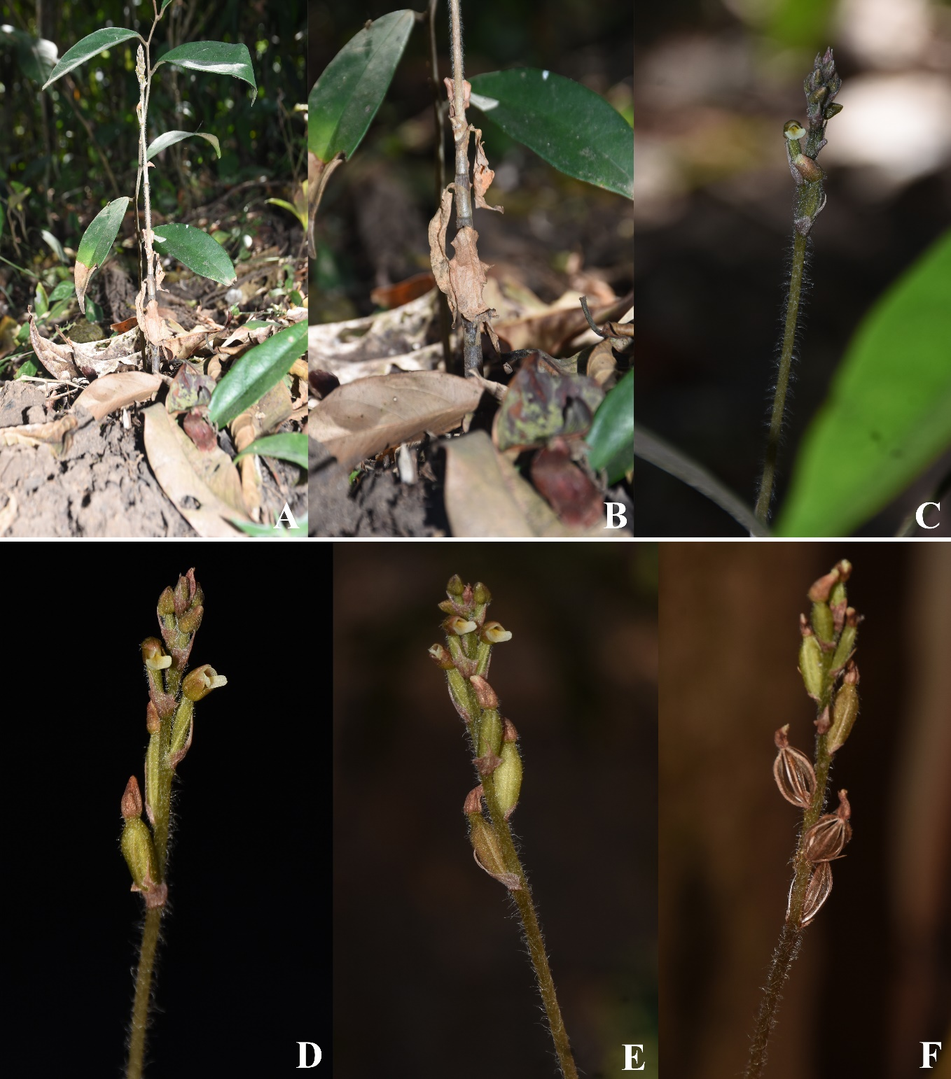

Fig. 1. Zeuxine seetharamii Betageri & Kotresha sp. nova. in Natural habitat images: A. Habitat; B. Rhizome and stem above ground; C. Inflorescence; D. Flowers; E. Flowers and fruits; F. Dehisced capsules (Photos by Shreyas Betageri).

Fig. 2. Zeuxine seetharamii Betageri & Kotresha sp. nova. A. Flowering habit. B. Vegetative habit. C. Rhizome. D. Inflorescence. E. Flower bud. F. Front view. G. Lateral view. H. Bract. I. Column with Ovary. J. Column. K. Curved gland. L. Dorsal sepal. M. Lateral sepal. N. Petal. O. Dorsal view of labellum. P. Ventral view of labellum. Q. Lateral view of labellum. R. Dorsal & Ventral view of Anthercap. S. Dorsal & Ventral view of Pollinarium. T. ovary. U. Dispersed capsule. (Photos by Shreyas Betageri).
Fig. 3. Zeuxine seetharamii Betageri & Kotresha sp. nov.: A. Habit, B. Lateral view of flower. C. Front view of flower. D. Bract. E. Dorsal sepal. F. Petal. G. Lateral sepal. H. Dorsal view of labellum. I. Ventral view of labellum. J. Lateral view of labellum. K. Curved gland. L. Column. M. Dorsal view of labellum. N. Ventral view of labellum. O. Pollinarium. P. Ovary. (Illustrated by Shreyas Betageri).

Fig. 4. Comparitive account of Zeuxine species in Karnataka: Vegetative habit of A1. Zeuxine longilabris Trimen, A2. Zeuxine gracilis (Breda) Blume, A3. Zeuxine reflexa King & Pantl., A4. Zeuxine seetharamii sp. nova. Flowering habit of B1. Zeuxine longilabris Trimen, B2. Zeuxine gracilis (Breda) Blume, B3. Zeuxine reflexa King & Pantl., B4. Zeuxine seetharamii sp. nova., Inflorescence enlarged, of C1. Zeuxine longilabris Trimen, C2. Zeuxine gracilis (Breda) Blume, C3. Zeuxine reflexa King & Pantl., C4. Zeuxine seetharamii Betageri & Kotresha sp. nov., Lateral view of flower and bract D1. Zeuxine longilabris Trimen, D2. Zeuxine gracilis (Breda) Blume, D3. Zeuxine reflexa King & Pantl., D4. Zeuxine seetharamii sp. nova. (Photos by Shreyas Betageri).

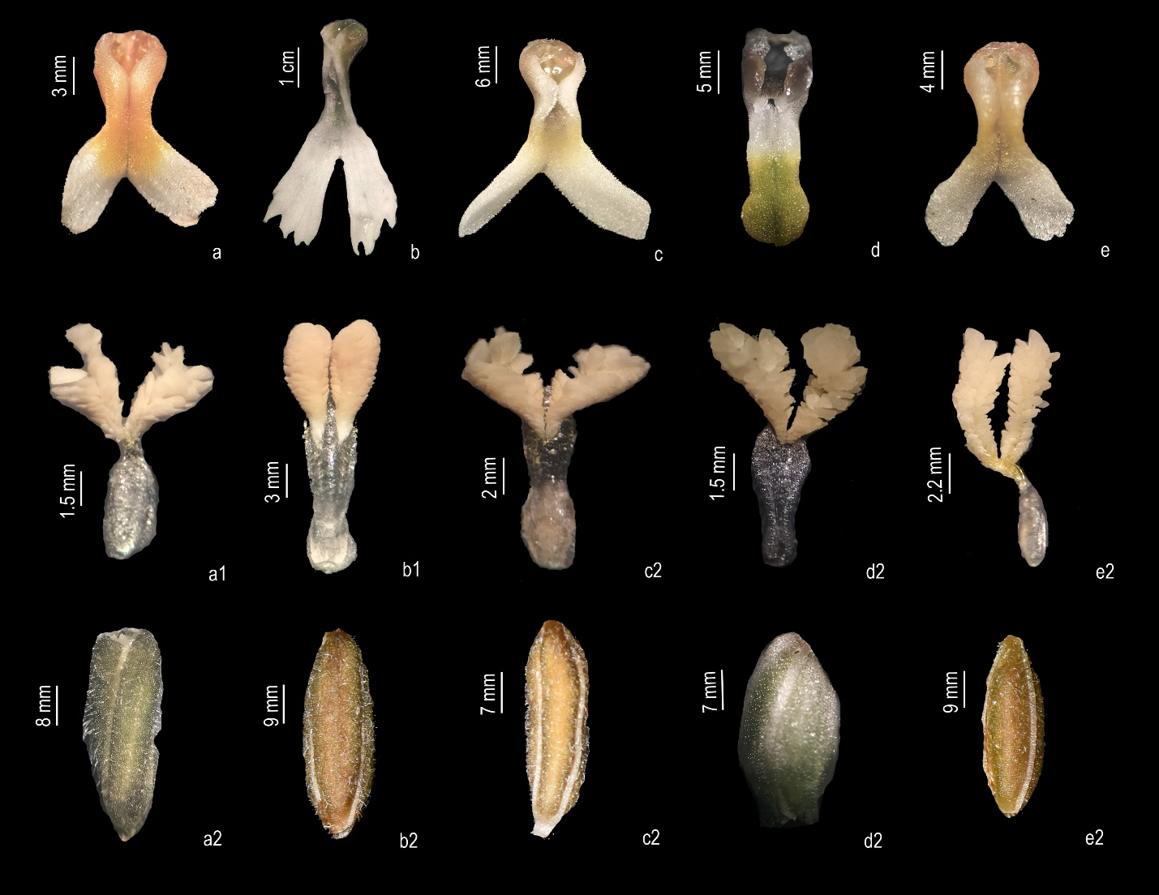
Fig. 5. Comparative account of Labellum, Pollinarium & Ovary of Zeuxine species in Karnataka: A. F. K. Zeuxine gracilis (Breda) Blume, A. Dorsal view of labellum. F. Pollinarium. K. Ovary. B. G. L. Zeuxine longilabris Trimen, B. Dorsal view of labellum. G. Pollinarium. L. Ovary. C. H. M. Zeuxine reflexa King & Pantl., C. Dorsal view of labellum. H. Pollinarium. M. Ovary. D. I. N. Zeuxine strateumatica (L.) Schltr. D. Dorsal view of labellum. I. Pollinarium. N. Ovary. E. J. O. Zeuxine seetharamii Betageri & Kotresha sp. nov. E. Dorsal view of labellum. J. Pollinarium. O. Ovary. (Photos by Shreyas Betageri).

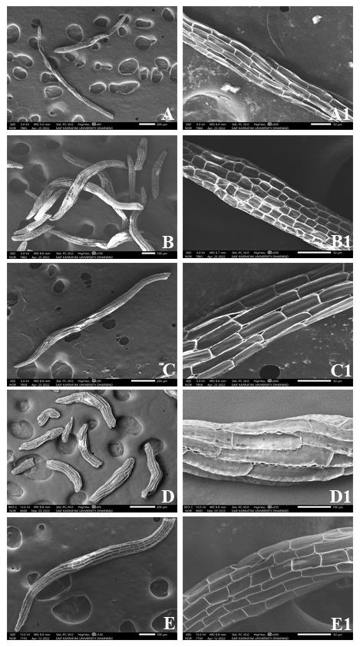
Fig. 6. Seed morphometric variations in Zeuxine species of Karnataka: A. A1. Z. gracilis; B. B1. Z. longilabris; C. C1. Z. reflexa; D. D1. Z. straetumatica; E. E1. Z. seetharamii Betageri & Kotresha sp. nov.
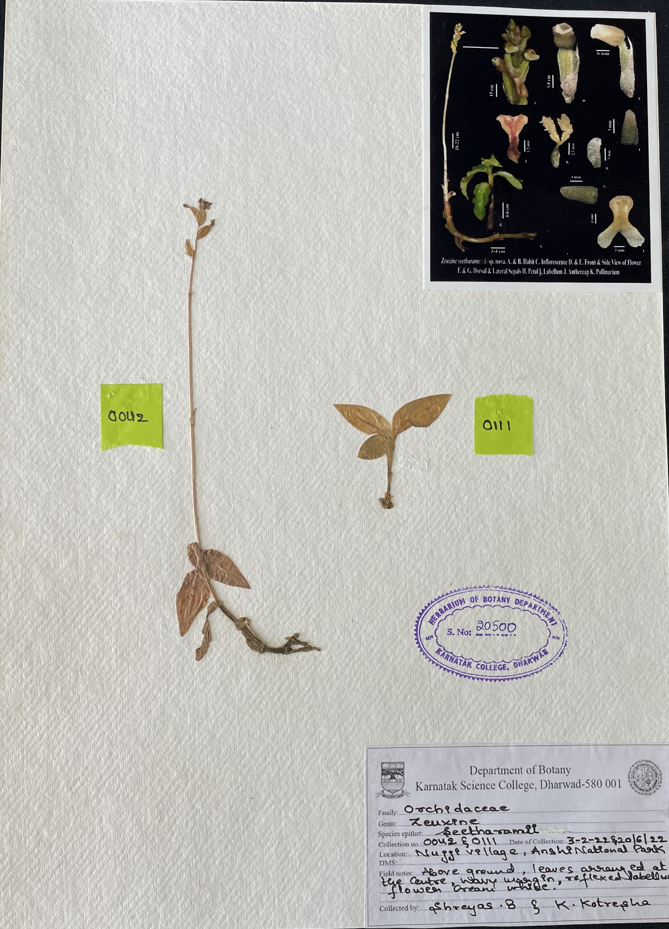
Fig. 7: Herbarium specimen of Zeuxine seetharamii Betageri & Kotresha sp. nov.

