Salt Stress Mitigation on Seedling Establishment, Antioxidant Capacity, Ion Homeostasis of Maize by Seed Priming with Melatonin

ABSTRACT
The study was done at the Department of Laboratory, China. To examine the influence of melatonin priming in mitigating the harmful effect of salt stress on seedling growth of maize (Zea mays L.). Maize seeds were individually primed by 1000 μM of melatonin before germination for 20 h and after germinated at four-leaf-stage exposed to 150 and 300 mM of NaCl. Six doses were employed: CK: Control; M: 1000 μM of melatonin, ST1: 150 mM NaCl only; ST2: 300 mM NaCl only; M+ST1: melatonin+150 mM NaCl; M+ST2: melatonin+300 mM NaCl. The treatments were laid in a Randomized Complete Block Design (RCBD) with four replications.
Characters calculated under study were statistically analyzed by SPSS (SPSS Inc, Chicago, IL). Means of significantly different of the calculated data were separated at the 0.05 probability level by Duncan’s Multiple Range Test (DMRT). The results demonstrated that salt stress lead to considerable reduction in shoot and root length, Fresh and dry weight of shoot and root, relative water (RWC) and soluble sugar concentrations of shoot and root, whereas melatonin priming alleviated these decline. Furthermore, salt stress decreased chlorophyll, carotenoid, and K+ contents, antioxidant activities; however melatonin priming lead to improved these parameters. Also we found that salt stress seedlings higher in reactive oxygen species (ROS) malondialdehyde (MDA), hydrogen peroxide (H₂O₂) concentrations, superoxide (O₂-) , proline , abscisic acid (ABA) , and sodium (Na⁺) contents, whereas seed primed with melatonin lowered these characters. Then, priming seed with 1000 μM of melatonin expected to be a best alternative to mitigate harmful effects of salts stress at seedling establishment stage in maize.
Keywords: melatonin priming, antioxidant enzymes, reactive oxygen species, maize (Zea mays L.), salt stress
1. Introduction
Salinity has debilitated approximately of 20% global cultivated soil, the area is speedily increasing because of irregular climate changes and anthropogenic activities [1]. “Nevertheless, sensitivity of crops to salt stress might vary according to its developmental stage. Germination of seed and early seedling growth stages are established to be extremely vulnerable to salt harm” [2, 3, and 4]. “Stress of salt decrease germination of seed and seedling growth by decreasing the present of water and availability of minerals to plants throughout ionic and osmotic toxicity” [5]. Also, salinity leads to causes oxidative stress injuries important structures of cellular, induced biochemical metabolic and physiological processes to be disturbed [6, 7].
“Melatonin (N-acetyl-5-methoxytryptamine) is crucial biological hormone played imperative part in numerous essential life developments, as well as the entrainment of circadian rhythms” [8], immunological improvement [9], seasonal reproduction physiology [10], and activity of antioxidant [11]. “in addition, one of the most repeatedly reported melatonin functions is measured to be an antioxidant for defense against biotic and a biotic stress in the plants” [12], like drought stress [13], salinity stress [14], cold stress [15], low temperature stress [16]] , and heavy metal stress [17].
Also melatonin functions in the protection system of antioxidant broadly been investigated in several environmental stresses in very important plants [13, 15, 17, 18].
“Maize (Zea mays L.), is a cereal crop of the Poaceae family, is the very essential crops world wide, it is the staple food crop in several areas. At the same time, it is also most important industry raw materials and biofuels in the world” [19]. Maize is important crop because it can persevere in harsh environmental conditions. Nevertheless, harsh environmental and climatic conditions may induce the growth, establishment, and production of maize crop [20, 21].
The present research, aimed to study the influence of seed priming with melatonin on seedling growth, accumulation of ROS, antioxidant enzymes, photosynthetic pigment, ion homeostasis in maize seedling under stress of salt.

2. Material and Methods
2.1 Experimental Layout and Design
The experiment was conducted at the department of Laboratory, china. Uniform seed of maize (Zea mays L.) were chosen and sterilized with 2.5% sodium hypochlorite for 10 min and rinsed seven times by sterile distilled water, after that air-dried at room temperature (25°C). Two treatments were arranged by seeds soaking in distilled water as control and 1000 μM of melatonin solution for 20 h, respectively. After priming, maize seeds were air-dried at the shade for 12 h before being sundried to reinstate their natural weight. The soaked 30 seeds were set on a filter paper in petri dishes. The dishes were incubated at 22±0.5 ⁰C for germination, after seed germination, when two leaves fully expanded maize plants were transplanted to plastic containers (45 cm in length, 35 cm in width and 18 cm in height). The planting density was 20 plants in each container. The Hoagland nutrient solution was used for hydroponic culture. At the four-leaf stage, plants were subjected to salt stress (NaCl 58.44) with concentrations of 150 mM NaCl and 300 mM NaCl, respectively. Six treatments formed: CK: Control; M: 1000 μM of melatonin, ST1: 150 mM NaCl only; ST2: 300 mM NaCl only; M+ST1: melatonin+150 mM NaCl; M+ST2: melatonin+300 mM NaCl. The experiment treatments were laid in a Randomized Complete Block Design (RCBD) with four replications. Seedling were sampled at 8 days after salt treatments applied for measurements of the physiological, biochemical parameters , seedling shoot and root lengths, and fresh and dry weights of shoot and root.
2.2 Lengths, Fresh and Dry Weight of Shoot and Root
The lengths of shoot and root of five randomly chosen plants from each replicate were calculated by the tape measure. Shoots and roots of five randomly chosen seedlings from each experimental unit, weighted immediately using digital balance. Final fresh weight was determinate in (g plant⁻¹). The sample of fresh five plants was left to dry in an oven at 80 ⁰C for 36 h after that weighted with digital balance to calculate final dry weight.
2.3 Chlorophyll and relative water content
Chlorophyll (Chl) and carotenoid were extracted from fresh leaves by 80% (v/v) acetone and calculated spectrophotometrically using the method of [22]. Relative water content (RWC) for both shoot and root was measured according to the following formula: RWC = (fresh weight - dry weight) / (turgid weight - dry weight) ×100 % following the method described by [23].
2.4 Soluble sugar and proline content
Soluble sugar was extracted from shoot and root by water boiling and its concentration were measured using the method of Arthur-Thomas [24]. Proline content in fresh shoot and root was calculated using the method of [25].
2. 5 Contents of malondialdehyde (MDA), H₂O₂, and O₂₋ production rate
The extraction of malondialdehyde (MDA), hydrogen peroxide (H₂O₂), and superoxide (O₂₋) in seedling leaves were measured following the method of [26]. Fresh samples of leaves (500 mg) were homogenized into powder by 5 ml of ice-cold extraction buffer (50 mM potassium phosphate buffer, pH 7.0, 0.4 % polyvinylpoly pyrrolidone) at four℃. The extract centrifuged at 10,000 g for 30 min, and the supernatant employed as crude extract. MDA concentration calculated using the method mentioned by [27]. H₂O₂ content determined by the method of [28], the production rate of O₂₋ conducted following the method of [29].
2.6 Estimation of antioxidant enzymes
To conduct enzymes of antioxidant fresh leaves 0.5 g of maize were grounded in the ice-cold extraction buffer that contained 25 mM Hepes (pH 7.8), 2% (w/v) polyvinylpyrrolidone (PVP), 2 mM ascorbate and 0.2 mM EDTA on ice. After centrifugation (12 000 g for 30 min at 4°C), the supernatants were employed for the subsequent enzyme. The activity of superoxide dismutase (SOD), peroxidase (POD) calculated according the method of [26], ascorbate peroxidase (APX) determined following the method described by [30].
2.7 Determination of endogenous abscisic acid (ABA) concentration
The content of ABA in maize leaves was done following the method described by [31]. The leaves were ground in liquid nitrogen and homogenized by 80% methanol. After 30 min incubation at 4°C, the samples centrifuged 10 min at 12 000 g at 4°C and the pellets were extracted. The extracts were freeze-dried using the Scientz-10N (Ningbo Scientz Biotechnology CO. LTD., Ningbo, China), and after that were resolved in 20% methanol follow by filtration through 0.2 μm syringe filters. ABA was estimated by liquid chromatography system (1290 LC, Agilent Technologies Inc., Santa Clara, CA) couple to a mass spectrum system (6470 LC-MS/MS, Agilent Technologies Inc., Singapore).
2.8 K⁺ and Na⁺ concentrations in seedling plants
Contents of K⁺ and Na⁺ in shoot and root of maize seedlings measured following the method of [32]. In brief, 100 mg oven-dried powder of shoot and root sample was incubated in 5 ml concentrated sulphuric acid to fully digest and supplementary in 200 μl 30% H2O2 a catalyst. K⁺ and Na⁺ contents determined by an atomic absorption spectrometer (Beijing Purkinje General Instrument Co., Ltd., China)

Statistical analyses
In the present study, all data revealed as the mean values ± SD (standard deviations). At least three independent replicates done for each experiment. Data were analyzed with the one-way ANOVA by SPSS (SPSS Inc, Chicago, IL). Means of significantly different of the calculated data separated at the 0.05 probability level using Duncan’s Multiple Ranges Test.

3. Results
3.1 Growth Parameters
The plant growth was considerably declined with salt stress, maize seedlings indexes growth were significantly enhanced with melatonin priming compared to no melatonin treatment, as demonstrated by declined shoot and root length, and plant biomass, and reduction was more severe under level of salt stress (ST2) than level of (ST1) (Table 1). However, the exogenous of 1000 μM melatonin significantly (P < 0.05) alleviates this response. The plant growths of seedlings from primed seeds by melatonin (M+ST1, M+ST2) were less inhibited than from non-primed seeds under both salt stresses, respectively.
3.2. Relative Water Content (RWC) , Total Soluble Sugar, Proline Content of shoot and root
RWC decrease under salt stress both in shoot and root when compared with control plants while seed priming by 1000 μM melatonin confirmed considerable (P < 0.05) enhancement in RWC in both organs compared to salt-stressed ones alone and enlarged more in root than that in shoot (Table 2). Contrasted to the control soluble sugar content significantly reduced with salt stress the declined level was much higher under ST2 than that under ST1 (Table 2). In the meantime, melatonin priming application (M+ST1, M+ST2) demonstrated superior soluble sugar content than the corresponding salt stress treatment. Conversely, contrasted to the control plants, proline concentration significantly improved in the maize seedling shoot and root under salt stress, but melatonin priming significantly (P < o.o5) declined this content under salt stress (Table 2.).

Table 1. Influence of melatonin priming on seedling length, fresh and dry weight of shoot and root of four- leaf-stage seedling grown under salt stress in maize
Length (cm) |  |  | Fresh weight (g plant⁻¹) |  | Dry weight (g plant⁻¹)
Treatments | Shoot | Root | Shoot | Root | Shoot | Root
CK | 30.56b | 32.72b | 4.52b | 4.22b | 1.21b | 0.95ª
M | 32.67a | 35.19ª | 5.79ª | 5.19a | 1.47a | 0.97ª
ST1 | 20.18. e | 22.65e | 3.18e | 2.89e | 0.71e | 0.59d
ST2 | 17.83f | 20.19f | 2..98f | 2.44e | 0.67e | 0.52d
M+ST1 | 28.53c | 30.44c | 4.13c | 3.67c | 0.98c | 0.87b
M+ST2 | 26.32d | 28.87d | 3.89d | 3.11d | 0.91d | 0.82c
Means with different small letters in the same column are significant difference at P < 0.05 level, CK = control, M = 1000 μM of melatonin, ST1 = 150 mM of salt (NaCl), ST2 = 300 mM of salt (NaCl), M + ST1 = 1000 μM of melatonin +150 mM of salt (NaCl), M+ST2= 1000 μM of melatonin +300 mM of salt (NaCl)
Table 2. Influence of melatonin priming on RWC, Soluble sugar and proline concentrations of shoot and root of four- leaf-stage seedling grown under salt stress in maize
RWC (%) |  |  | Soluble sugar content(mg g⁻¹DW) |  | Proline content (mg g⁻¹FW)
Treatments | Shoot | Root | Shoot | Root | Shoot | Root
CK | 90.56b | 93.27a | 25.38b | 20.87b | 18.21e | 15.21e
M | 91.67a | 93.88ª | 27.63a | 22.19fa | 16.33f | 13.34f
ST1 | 78.18e | 81.65d | 20.66e | 16.11e | 21.56b | 18.67b
ST2 | 76.83f | 78.19e | 18..98f | 14.44f | 23.45a | 20.71a
M+ST1 | 88.53c | 90.41b | 24.13c | 20.13c | 19.21d | 16.39d
M+ST2 | 86.32d | 88.71c | 22.89d | 18.89d | 20.42c | 17.91c
Means with different small letters in the same column are significant difference at P < 0.05 level, CK = control, M = 1000 μM of melatonin, ST1 = 150 mM of salt (NaCl), ST2 = 300 mM of salt (NaCl), M + ST1 = 1000 μM of melatonin +150 mM of salt (NaCl), M+ST2= 1000 μM of melatonin +300 mM of salt (NaCl)
3.3 Chlorophyll and Caroteniod Contents
Under salt stress condition, chlorophyll and caroteniod concentrations were radically (P < 0.05) decreased compared to unstressed plants (Fig. 1 a and b). While 1000 μM of melatonin application clearly alleviated the harmful effect of 150 and 300 mM NaCl salt stress on these pigments, and caused additional augments in chlorophyll and caroteniod contents.
3.4 Concentrations of MDA, H₂O₂ and O₂⁻ Production Rate
Compared to the control, salt stress considerably enlarged the concentrations of MDA and H₂O₂ of maize seedling (Fig. 2 a and b). However, seeds primed with 1ooo μM of melatonin significantly (P < 0.05) inhibited concentrations of these attributes compared with salt stress alone. The production rate of O⁻ 2 showed the same pattern as similar to H₂O₂ and MDA accumulation during the maize seedling growth (Fig. 2 c).
3.5 Activities of Antioxidant Enzymes
The activities of antioxidant enzymes of SOD, POD, and APX, in leaves of maize seedling were radically declined by salt stress when compared to control, mainly under the severe salt stress of ST2 (Figure 3 a-c). In contrast, pretreatment of melatonin remarkably (P < 0.05) enhanced SOD, POD, and APX activities
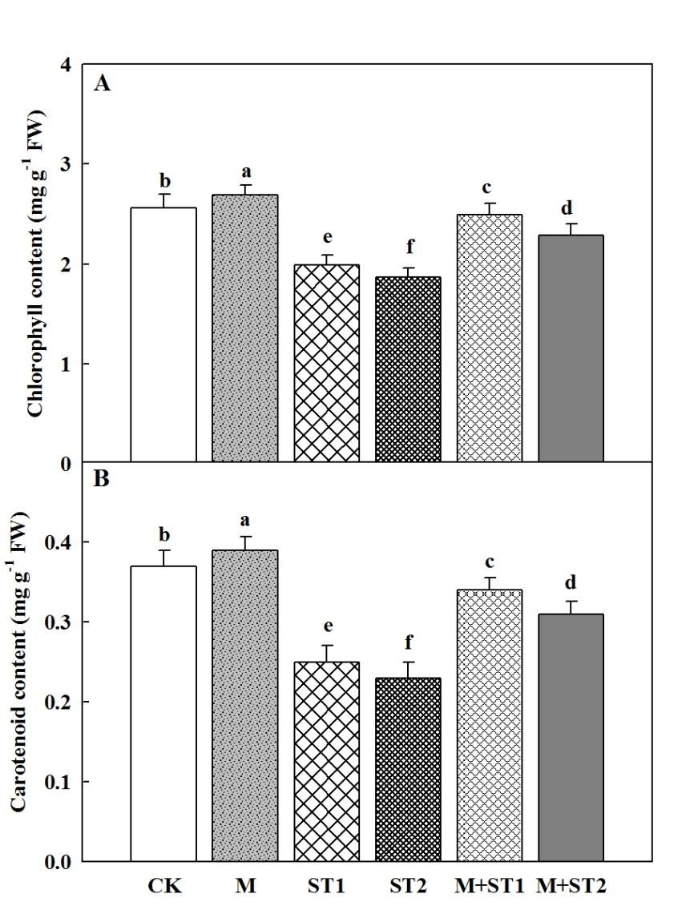
Figure. 1. Influence of melatonin priming on contents of chlorophyll (A) and carotenoid (B) in top leaf of four-leaf-stage seedling under salt stress in maize. Means with different small letters indicate significant differences between treatments at P < 0.05

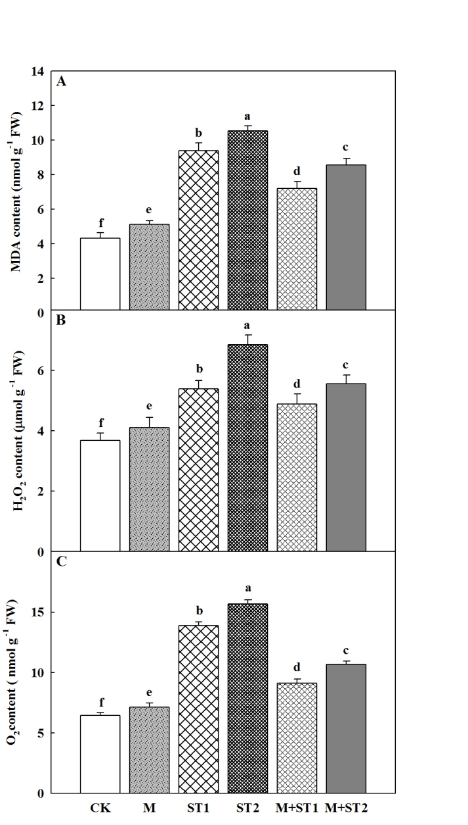
Figure. 2. Influence of melatonin priming on contents of malondialdehyde (MDA) (A), hydrogen peroxide (H₂O₂) (B), and O2 -Production rate (c) in top leaf of four-leaf- stage seedling under salt stress in maize. Means with different small letters indicate significant differences between treatments at P < 0.05

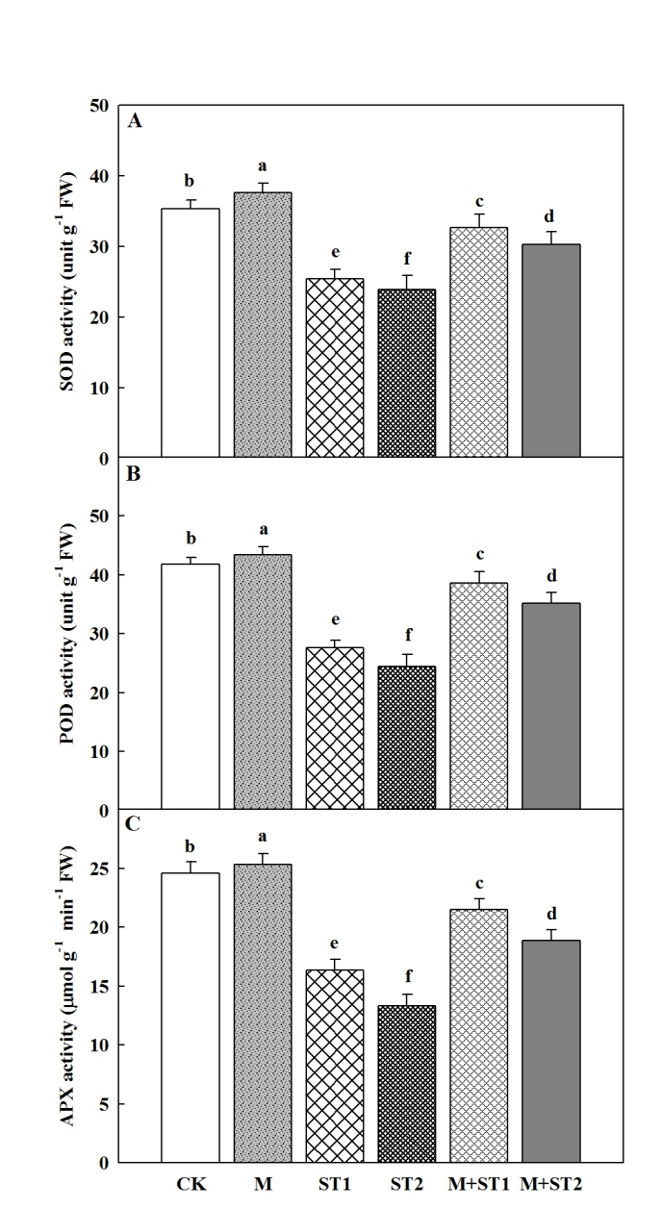
Figure. 3. Influence of melatonin priming on activities of superoxide dismutase (SOD) (A), peroxidase (POD) (B), and ascorbate peroxidase (APX) (C) in top leaf of four-leaf- stage seedling under salt stress in maize. Means with different small letters indicate significant differences between treatments at P < 0.05

3.6 ABA Concentration
The ABA content of maize seedlings increased under salt stress when contrasted by control in both 150 and 300 mM of NaCl. (Fig. 4). However, under salt stress melatonin priming significantly (P < 0.05) improved maize seedlings ABA content in both levels of salt stress (Fig. 4). In general, under salt stress melatonin priming had higher levels of ABA in maize seedling as compared to both control and melatonin alone.

3.7 Na⁺ and K⁺ concentrations and K⁺/Na⁺ ratio
As revealed in Fig. 5, concentration of Na⁺ significantly increased while K⁺ concentration reduced in maize shoot and roots under both 150 and 300 mM of salt stress and subsequently resulted in reduction of K⁺/Na⁺ ratio in seedlings. However, under stress of salt, priming of 1000 μM of melatonin remarkably (P < 0.05) increased contents of K⁺ and reduced Na⁺ concentration in both shoot and roots subsequently lead to increased in K⁺/Na⁺ ratio in maize shoot and roots compared to control (Fig 5 a-f).

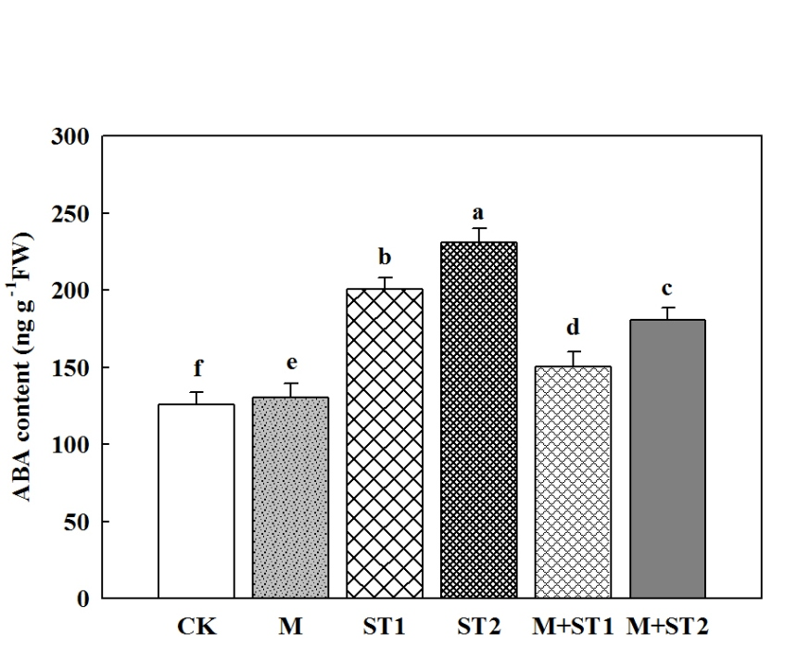
Figure. 4. Influence of melatonin priming on abscisic acid content in top leaf of four- leaf- stage seedling under salt stress in maize. Means with different small letters indicate significant difference between treatments at P < 0.05

4. Discussion
“Salt stress obviously reduced plant growth and more harmful during germination, and seedling growth stages in a plant life. Also salt stress significantly disrupts various physiological, biochemicals, ion homeostasis; oxidative reductive and metabolic processes consequence in the decline yield of crop” [33, 34]. “Melatonin, well-known as a type of new growth regulator of plant, is contemplation to be occupied in numerous biotic and a biotic stress responses. In addition, the potentiality of melatonin for salt tolerance inducing during germination and early seedling stage in various crops is well recognized” [35, 36]. “In the present study, the positive defensive role of melatonin on physiological elucidation in terms of morphology, metabolism, photosynthesis, and antioxidation in maize seedlings against salt stress was examined. Earlier studies confirmed that melatonin may possibly play an essential regulatory function in plant enlargement and improvement” [37, 38]. In the present work, the development of maize seedling particularly inhibited when exposed to salt stress; however reduction of growth was clearly enhanced with melatonin exogenous (Table 1). This might be the early completion of pre-germination metabolic activities through seed treatment with melatonin. [39]. reported that 1000 μM melatonin pretreatment increased the growth attributes of maize seedling under salt stress, which is consistent with our findings. The relative water content (RWC) is important pointer of water relation for evaluate salt stress tolerance. Though, we also establish that salt stress notably (P < 0.05) decreased the. RWC of shoot and root in maize plants (Table 2). Moreover, we found that seeds priming by melatonin markedly maintain a better shoot and root water level of maize plants under salt stress, demonstrating that melatonin may possibly play considerable role in maize water relation in salt stress and support the plants to absorb more water for salt tolerance. The a biotic stress usually led to reduce leaf water levels and enhance in osmotic regulator [40]. In agreement among these consequences, we found that salt stress led to decrease RWC and soluble sugar and increased concentration of proline (Table. 2).
Numerous studies mentioned that melatonin possibly inhibit the reduction of the photosynthetic pigments in numerous environmental stresses [38, 41]. These results were established by our findings. Under salt stress level, seed priming with melatonin illustrated higher concentration of photosynthetic pigments compared to control (Fig. 1 a , b), this observed decline of pigments could attributed not only to an augmented degradation but also to decreased chlorophylls creation due to salinity.
The highest cellular creation of reactive oxygen species (ROS), mostly hydrogen peroxide (H₂O₂), enhance lipid peroxidation of cellular membranes [42], consequential in generation of largest MDA in plant tissues caused by salt stress. In present research, salt stress enhanced H₂O₂, MDA, and O⁻2 production rate concentration in maize leaves (Fig. 2a- c) but, melatonin priming radically decreased hydrogen peroxide (H₂O₂) MDA content, and production rate of O₂⁻. Comparable diminutions in the production of H₂O₂ and MDA with melatonin exogenous in maize during salt stress were mentioned by [43], demonstrating that melatonin may keep cell membranes against oxidative harm stimulated by salt [18]. Furthermore, our present study confirmed that a lower rate of cell death was obtained in melatonin priming plants under salt stress, demonstrating that melatonin may mitigate cell death via declining ROS accumulation under salt stress in maize seedling
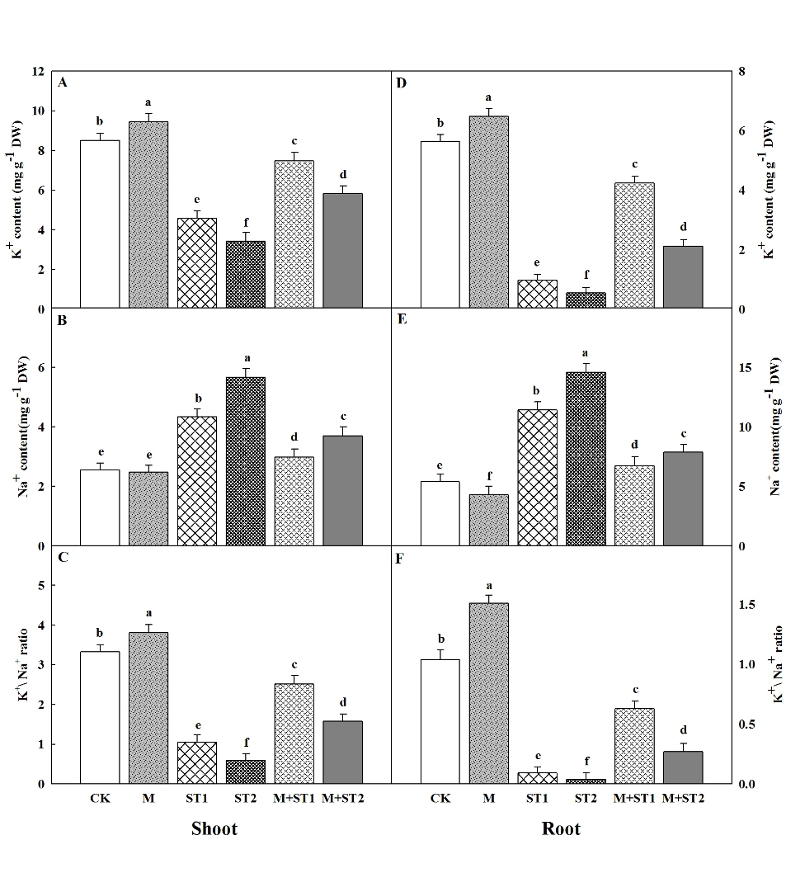
Figure. 5. Influence of melatonin priming on contents of K+ and Na+ in maize shoot and root during seedling growth under salt stress. Means with different small letters indicate significant differences between treatments at P < 0.05

The salt stress tolerance in plants is indicated through enhanced activities of antioxidant enzymes [44]. In the plants, melatonin recommended to be an essential antioxidant that can scavenge oxygen free radicals efficiently [14, 16]. Numerous studies have showed that application of melatonin can augment antioxidant enzyme activities of (POD, SOD, and APX) under a biotic stress in plants [16, 18]. Constantly, we found that melatonin priming improved the antioxidant enzymes activities of maize seedlings under salt stress (Fig. 3 a-c). The high activities of SOD, POD and APX in present study under salt stress in existence of melatonin can possibly mainly related to the synergistic effects of the combination of salt stress and exogenous of melatonin. Up-regulation antioxidants enzymes of (POD, APX, and SOD) protection system by melatonin exogenous was also pointed with [45]. In addition, [46] exposed that priming of melatonin improved the genes encoding expression of antioxidant enzymes under stress of salt.
It established that abscisic acid (ABA) could stimulate the augment of osmotic regulators such as soluble sugar and proline under environmental stresses. In the current research, the ABA concentration proportionally increased with the increase in salt stress level (Fig 4). Previous study reported that melatonin application might decrease ABA contents under drought stress [47]. This finding was further confirmed by our study under salt stress. on the other hand, exogenous of melatonin decreased the reduce in water status of leaf, demonstrating melatonin may augment the water absorbing or holding capacity, possibly during regulating ABA content and declining the concentration of Na⁺ [18].
Growth inhibition induced by salt stress generally pointed phenomenon in many species, can mostly related to specific ion imbalance, ion toxicity or interruption of ion homeostasis [48, 49]. External high salinity stimulated Na⁺ concentration, motivated water deficit, mineral nutrient insufficiency and ion imbalance in the cytosol [50, 51]. [52]. Furthermore, high level of Na⁺ accumulations lead to reduced of K⁺ uptake and disrupt cellular integrity and finally causes cell death, hence a high level of K⁺/Na⁺ ratio can enhance salt stress tolerance to plant [52,53]. Several study showed that melatonin priming considerably reduced concentration of Na⁺ then lead to in an observable augment of K⁺ level and K⁺\ Na⁺ ratio of maize shoots under stress condition[18]. On the other hand, our present study confirmed this occurrence found in both shoot and root under stress condition after 8 days of salt stressed maize plants (Fig. 5 a, b, e and d). Additionally, the role of melatonin in acquirement of salinity tolerance by plants when exogenous to salinity stress may well elucidate superior K⁺\ Na⁺ ratios are preserves with it, these results were mentioned via [19] and [54], who established that exogenous of melatonin under salinity stress defied maize seedlings hence in the highest K⁺\ Na⁺ ratios

5. Conclusions
The present study established that salinity stress negatively influenced seedling development of maize, whereas seed treatment by melatonin efficiently mitigated harmful causes on maize seedlings. In addition it was revealed that, under salt stress seed exogenous to melatonin performed better in terms of relative water content (RWC), total soluble sugar, and total contents of proline. Moreover, seed priming with 1000 μM of melatonin promoted maize seedling development under salinity stress through delay leaf chlorophyll humiliation and superior preservation of ion balance between K⁺ and Na⁺, and promote improved photosynthesis of leaf and mitigated the oxidative harm through enhancing antioxidant enzymes activities to decline ROS production. Subsequently melatonin recommended as prospective material of priming seed used for enhancement of salinity stress throughout seedling establishment stages in maize.

Disclaimer (Artificial intelligence)
Author(s) hereby declare that NO generative AI technologies such as Large Language Models (ChatGPT, COPILOT, etc.) and text-to-image generators have been used during the writing or editing of this manuscript.

References
- Arora, D. and S.C. Bhatla. 2017. Melatonin and nitric oxide regulate sunflower seedling growth under salt stress accompanying differential expression of cu/zn sod and mn sod. Free Rad. Biol.& Med., 106: 315-328.
- Saleem, M.H., S. Ali, M.F. Seleiman, M. Rizwan, M. Rehman, N.A. Akram, L. Liu, M. Alotaibi, I. Al-Ashkar and M. Mubushar, 2019. Assessing the correlations between different traits in copper-sensitive and copper-resistant varieties of jute (Corchorus capsularis L.). Plants, 8(12): 545.
- Afzal, J., X. Wang, M.H. Saleem, X. Sun, S. Hussain, I. Khan, M.S. Rana, S. Ahmed, S.A. Awan, S. Fiaz, O. Aziz, K.A. Kubar, S. Ali and C. Hu. 2021. Application of ferrous sulfate alleviates negative impact of cadmium in rice (Oryza sativa L.). Biocell, 45(6): 1631-1649.
- Nawaz, M., X. Wang, M.H. Saleem, M.H.U. Khan, J. Afzal, S. Fiaz, S. Ali, H. Ishaq, A.H. Khan, N. Rehman, S. Shaukat and S. Ali. 2021. Deciphering plantago ovata forsk leaf extract mediated distinct germination, growth and physio-biochemical improvements under water stress in maize (Zea mays L.) at early growth stage. Agronomy, 11(7): 1404.
- Mohamed, I.A., N. Shalby, A. MA El-Badri, M.H. Saleem, M.N. Khan, M.A. Nawaz, M. Qin, R.A. Agami, J. Kuai and B. Wang, 2020. Stomata and xylem vessels traits improved by melatonin application contribute to enhancing salt tolerance and fatty acid composition of Brassica napus L. Plants. Agronomy, 10(8): 1186.
- Ali, M., M. Kamran, G.H. Abbasi, M.H. Saleem, S. Ahmad, A. Parveen, Z. Malik, S. Afzal, S. Ahmar, K.M. Dawar, S. Ali, S. Alamri, M.H. Siddiqui, R. Akbar and S. Fahad. 2020. Melatonin-induced salinity tolerance by ameliorating osmotic and oxidative stress in the seedlings of two tomato (Solanum lycopersicum L.) cultivars. J. Plant Growth Reg., https://doi.org/10.1007/s00344-020-10273-3.
- Kong, H., Z. Zhang, J. Qin and N.A. Akram, 2021. Interactive effects of abscisic acid (aba) and drought stress on the physiological responses of winter wheat (Triticum aestivum L.). Pak. J. Bot., 53(5): 1545-1551.
- Hardeland R, Madrid JA, Tan DX, Reiter RJ (2012). Melatonin, thecircadian multioscillator system and health: the need for detailedanalyses of peripheral melatonin signaling. J Pineal Res 52:139–166.
- Calvo JR, Gonzalez-Yanes C, Maldonado MD (2013). The role of melatonin in the cells of the innate immunity: a review. J Pineal Res 55:103–120.
- Barrett P, Bolborea M (2012) Molecular pathways involved in seasonal body weight and reproductive responses governed by melatonin. J Pineal Res 52:376 388.
- Reiter RJ, Tan DX, Osuna C, Gitto E (2000) Actions of melatonin in the reduction of oxidative stress a review. J Biomed Sci 7:444–458.
- Tan DX, Hardeland R, Manchester LC, Korkmaz A, Ma S, Rosales- Corral S, Reiter RJ (2012). Functional roles of melatonin in plants, and perspectives in nutritional and agricultural science. J Exp Bot 63:577–597.
- Wang P, Sun X, Li C, Wei Z, Liang D, Ma F (2013). Long-term exogenous application of melatonin delays drought-induced leaf senescence in apple. J Pineal Res 54:292–302.
- Wei W, Li QT, Chu YN, Reiter RJ, Yu XM, Zhu DH, Zhang WK, Ma B, Lin Q, Zhang JS, Chen SY (2015). Melatonin enhances plant growth and abiotic stress tolerance in soybean plants. J Exp Bot 66:695–707.
- Bajwa VS, Shukla MR, Sherif SM, Murch SJ, Saxena PK (2014). Role of melatonin in alleviating cold stress in Arabidopsis thaliana. J Pineal Res 56:238–245.
- Shi H, Jiang C, Ye T, Tan D, Reiter RJ, Zhang H, Liu R, Chen Z (2015). Comparative physiological, metabolomic, and transcriptomic analyses reveal mechanisms of improved abiotic stress resistance in bermudagrass [Cynodon dactylon (L). Pers.] by exogenous melatonin. J Exp Bot 66:681–694.
- Posmyk MM, Kuran H, Marciniak K, Janas KM (2008). Presowing seed treatment with melatonin protects red cabbage seedlings against toxic copper ion concentrations. J Pineal Res 45:24–31 Posmyk MM, Bałabusta M, Wieczorek M, Sliwinska E, Janas KM.
- Jiang C, Cui Q, Feng K, Xu D, Li C, Zheng Q (2016). Melatonin improves antioxidant capacity and ion homeostasis and enhances salt tolerance in maize seedlings. Acta Physiol Plant 38: 1–9.
- Chen Y-E, Mao J-J, Sun L-Q, Huang B, Ding C-B, Gu Y, Liao J-Q, Hu C, Zhang Z-W, Yuan S (2018). Exogenous melatonin enhances salt stress tolerance in maize seedlings by improving antioxidant and photosynthetic capacity. Physiol Plant 164(3): 349–363.
- Lv S, Yang X, Lin X, Liu Z, Zhao J, Li K, Mu C, Chen X, Chen F, Mi G (2015) .Yield gap simulations using ten maize cultivars commonly planted in Northeast China during the past five decades. Agric Forest Meteorol 205: 1–10.
- Ma L, Huang Z, Li S, Ashraf U, Yang W, Liu H, Xu D, Li W, Mo Z (2021). Melatonin and nitrogen applications modulate early growth and related physio-biochemical attributes in maize under Cd stress. J Soil Sci Plant Nut 21(2): 978–990.
- Arnon DI (1949). Copper enzymes in isolated chloroplasts. Polyphenoloxidase in Beta vulgaris. Plant Physiol 24:1–15.
- Chen YE, Cui JM, Su YQ, Yuan S, Yuan M, Zhang HY (2015). Influence of stripe rust infection on the photosynthetic characteristics and antioxidant system of susceptible and resistant wheat cultivars at the adult plant stage. Front Plant Sci 6: 779.
- Thomas TA (1977). An automated procedure for the determination of soluble carbohydrates in herbage. J Sci Food Agric 28: 639–642.
- Bates L, Waldren R, Teare I (1973). Rapid determination of free proline for water-stress studies. Plant Soil 39: 205–207.
- Tan W, Liu J, Dai T, Jing Q, Cao W, Jiang D (2008). Alterations in photosynthesis and antioxidant enzyme activity in winter wheat subjected to post-anthesis water-logging. Photosynthetica 46:21-27. doi: 10.1007/s11099-008-0005-0 .
- Madhava-Rao K, Sresty T(2000). Antioxidative parameters in the seedlings of pigeonpea (Cajanus cajan (L.) Millspaugh) in response to Zn and Ni stresses. Plant Sci 157(1):113-128. doi: 10.1016/s0168-9452(00)00273-9 .
- Moloi MJ, Van-der-Westhuizen AJ (2006). The reactive oxygen species are involved in resistance responses of wheat to the Russian wheat aphid. J Plant Physiol 163:1118-1125.
- Sui N, Li M, Liu X-Y, Wang N, Fang W, Meng Q-W (2007). Response of xanthophyll cycle and chloroplastic antioxidant enzymes to chilling stress in tomato over-expressing glycerol-3-phosphate acyltransferase gene. Photosynthetica 45(3):447-454. doi: 10.1007/s11099-007-0074-5.
- Fryer M, Andrews J, Oxborough K, Blowers D, Baker N (1998). Relationship between CO2 assimilation, photosynthetic electron transport, and active O2 metabolism in leaves of maize in the field during periods of low temperature. Plant Physiol 116:571-579. doi: 10.1104/pp.116.2.571.
- Carvajal F, Palma F, Jiménez-Muñoz R, Jamilena M, Pulido A, Garrido D (2017). Unravelling the role of abscisic acid in chilling tolerance of zucchini during postharvest cold storage. Postharvest Biol Tec 133: 26–35.
- Zheng C, Jiang D, Liu F, Dai T, Liu W, Jing Q, Cao W (2009). Exogenous nitric oxide improves seed germination in wheat against mitochondrial oxidative damage induced by high salinity. Environ Exp Bot 67(1):222-227. doi: 10.1016/j.en vexpbot.2009.05.002.
- Kaya, C., D. Higgs, M. Ashraf, M.N. Alyemeni and P. Ahmad. 2020. Integrative roles of nitric oxide and hydrogen sulfide in melatonin-induced tolerance of pepper (Capsicum annuum L.) plants to iron deficiency and salt stress alone or in combination. Physiol.Plant., 168(2): 256-277.
- Zafar, S., Z. Hasnain, S. Perveen, N. Iqbal and M.A. Zafar. 2021. Deciphering physio-biochemical characteristics of znso4 primed wheat (triticum aestivum L.) plants grown under salt stress. Pak. J. Bot., 53(6): 1943-1952.
- Jiang, D., B. Lu, L. Liu, W. Duan, L. Chen, J. Li and Z. Bai. 2020. Exogenous melatonin improves salt stress adaptation of cotton seedlings by regulating active oxygen metabolism. Peer J., 8: e10486. https://doi.org/10.7717/peerj.10486.
- Arun, M.N., S.S. Hebbar, B. Bhanuprakash, T. Senthivel, A.K. Nair, G. Padmavathi, P. Pandey, A. Singh. 2022. Seed priming: The way forward to mitigate abiotic stress in crops. In: (eds. M. Hasanuzzaman and K. Nahar), plant stress. Phys. Persp. Agric. Intech Open.
- Tan DX, Hardeland R, Manchester LC, Korkmaz A, Ma S, Rosales-Corral S, Reiter RJ (2012). Functional roles of melatonin in plants, and perspectives in nutritional and agricultural science. J Exp Bot 63: 577–597.
- Wei W, Li QT, Chu YN, Reiter RJ, Yu XM, Zhu DH, Zhang WK, Ma B, Lin Q, Zhang JS (2015). Melatonin enhances plant growth and abiotic stress tolerance in soybean plants. J Exp Bot 66: 695–707.
- Syed Saqlain Hussaini, Muhammad Rasheedi, Muhammad Hamzah Saleem, Zammurad Iqbal Ahmedi, Aqsa Hafeez, Ghulamjllani, Saad Alamri, Mohamed Hashem, and Shafaqat Ali (2023).Salt tolerance in maize with melatonin priming to achieve sustainability in yield in salt affected soils. Pak. J. Bot., 55(1): 19-35.
- Xu C, Huang B (2010). Differential proteomic responses to water stress induced by PEG in two creeping bentgrass cultivars differing in stress tolerance. J Plant Physiol 167: 1477–1485.
- Shi H, Jiang C, Ye T, Tan D, Reiter RJ, Zhang H, Liu R, Chan Z (2015). Comparativephysiological, metabolomic, and transcriptomic analyses reveal mechanisms of improved abiotic stress resistance in bermudagrass [Cynodon dactylon (L). Pers.] by exogenous melatonin. J Integr Plant Biol 66: 681–694.
- Kazemi, R., A. Ronaghi, J. Yasrebi, R. Ghasemi-Fasaei and M. Zarei. 2019. Effect of shrimp waste–derived biochar and arbuscular mycorrhizal fungus on yield, antioxidant enzymes, and chemical composition of corn under salinity stress. J. Soil Sci. & Plant Nutri., 19(4): 758-770.
- Chen, X., R. Zhang, Y. Xing, B. Jiang, B. Li, X. Xu and Y. Zhou. 2021. The efficacy of different seed priming agents for promoting sorghum germination under salt stress. Plos One, 16(1): e0245505.
- Farhangi-Abriz, S. and S. Torabian. 2018. Nano-silicon alters antioxidant activities of soybean seedlings under salt toxicity. Protoplasma, 255(3): 953-962.
- Zafar, S., Z. Hasnain, S. Anwar, S. Perveen, N. Iqbal, A. Noman and M. Ali. 2019. Influence of melatonin on antioxidant defense system and yield of wheat (triticum aestivum L.) genotypes under saline condition. Pak. J. Bot., 51(6): 1987-1994.
- Zhang, N., H.J. Zhang, B. Zhao, Q.Q. Sun, Y.Y. Cao, R. Li, X.X. Wu, S. Weeda, L. Li and S. Ren. 2014. The rna-seq approach to discriminate gene expression profiles in response to melatonin on cucumber lateral root formation. J. Pineal Res., 56(1): 39-50.
- Li C, Tan DX, Liang D, Chang C, Jia DF, Ma FW (2015). Melatonin mediates the regulation of ABA metabolism, free-radical scavenging, and stomatal behaviour in two Maluspecies under drought stress. J Exp Bot 66: 669–680.
- Zhao GQ, Ma BL, Ren CZ (2007). Growth, gas exchange, chlorophyll fluorescence, ion content of naked oat in response to salinity. Crop Sci 47:123–131.
- Jiang CQ, Quan LT, Shi F, Yang N, Wang CH, Yin XM, Zheng QS (2014). Distribution of mineral nutrients and active ingredients in Aloe vera irrigated with diluted seawater. Pedosphere 24:722–730.
- Mobeen, X. Wang, M.H. Saleem, A. Parveen, S. Mumtaz, A. Hassan, M. Adnan, S. Fiaz, S. Ali, Z. Iqbal Khan, S. Ali and G. Yasin, 2021. Proximate composition and nutritive value of some leafy vegetables from faisalabad, pakistan. Sustainability, 13(15): 8444.
- Saleem, M.H., X. Wang, S. Ali, S. Zafar, M. Nawaz, M. Adnan, S. Fahad, A. Shah, M.N. Alyemeni, D.I. Hefft and S. Ali. 2021. Interactive effects of gibberellic acid and npk on morpho-physio-biochemical traits and organic acid exudation pattern in coriander (Coriandrum sativum L.) grown in soil artificially spiked with boron. Plant Physiol. & Biochem., DOI https://doi.org/10.1016/ j.plaphy. 2021.09.015.
- Munns R, Tester M (2008). Mechanisms of salinity tolerance. Annu Rev Plant Biol 59: 651–681.
- Shabala S, Cuin TA (2008). Potassium transport and plant salt tolerance. Physiol Plant 133:651–669.
- Chen, L., L. Liu, B. Lu, T. Ma, D. Jiang, J. Li, K. Zhang, H. Sun, Y. Zhang and Z. Bai. 2020. Exogenous melatonin promotes seed germination and osmotic regulation under salt stress in cotton (Gossypium hirsutum L.). PloS One, 15(1): e0228241.

